THE PHYTOCHEMICAL SCREENING OF OKRA EXTRACT
BY:

DAUDA RAMOTA IDOWU ND/23/SLT/PT/0276
BEING A RESEARCH PROJECT SUBMITTED TO THE DEPARTMENT OF SCIENCE LABORATORY TECHNOLOGY, INSTITUTE OF APPLIED SCIENCES, KWARA STATE POLYTECHNIC, ILORIN
IN PARTIAL FULFILLMENT OF THE REQUIREMENT FOR THE AWARD OF HIGHER NATIONAL DIPLOMA (HND) IN SCIENCE LABORATORY TECHNOLOGY

JULY, 2025.

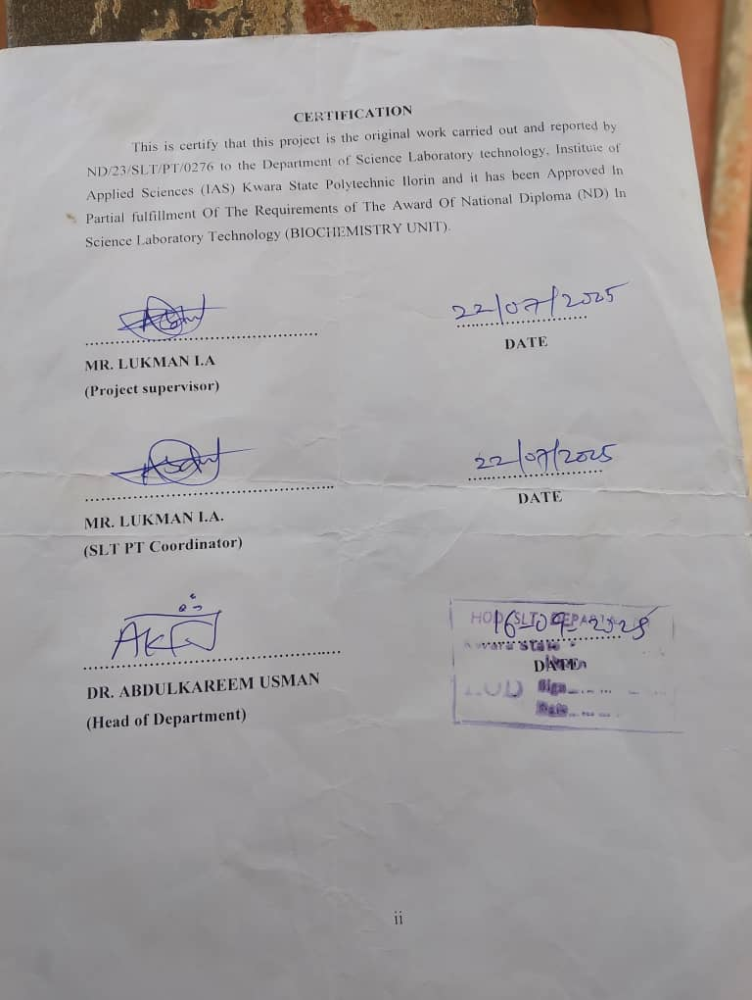

DEDICATION
This research work is dedicated to God Almighty, who has made it possible. It is also dedicated to my beloved parents for their invaluable contributions and unwavering support that made this program a success.

ACKNOWLEDGEMENTS

I would like to express my sincere gratitude to all these individuals for mentoring and supporting me in completing this project

My supervisor, Mr. Lukman for providing me with invaluable insights and direction.

To my parents my sisters and friends their constant encouragement, patience, and understanding have been the pillars of my success

I am grateful to my friends and sister who contributed ideas and perspectives that enriched the project.

Thank you everyone for shaping this project and enhancing my learning experience.

ABSTRACT
Okra (Abelmoschus esculentus) is traditionally recognized for its medicinal value, especially in the management of oxidative stress-related conditions. This study aimed to systematically investigate the phytochemical composition of okra extract, validate its traditional therapeutic applications, and assess its potential as a source of natural antioxidants.
The main objectives were to (1) identify and characterize the major phytochemical constituents present in okra extract, (2) measure the concentration of these bioactive compounds using validated analytical techniques, and (3) evaluate the implications of the findings for oxidative stress management and nutraceutical development.
Fresh okra pods collected from Ilorin, Nigeria, were processed using cold maceration with 70% ethanol, yielding a crude extract of 12.3%. Qualitative phytochemical screening detected the presence of alkaloids, flavonoids, steroids, triterpenoids, saponins, and phenolics, while tannins, proteins, reducing sugars, and glycosides were absent in the extract. Quantitative analysis using UV-Vis spectrophotometry revealed significant concentrations of key bioactives: triterpenoids (18.12 ppm), steroids (15.92 ppm), flavonoids (12.74 ppm), alkaloids (9.59 ppm), total phenolics (9.14 ppm), and saponins (4.45 ppm).
These results underscore the richness of okra in antioxidant and anti-inflammatory compounds, supporting its traditional use for the mitigation of oxidative stress. In conclusion, cold maceration effectively preserves heat-sensitive phytochemicals, establishing okra as a valuable candidate for nutraceutical applications. Future research should focus on further chemical characterization, in vivo assessments, and clinical product development to realize the full therapeutic potential of okra extract as a natural antioxidant agent.

TABLE OF CONTENTS
Title Page i
Certification ii
Dedication iii
Acknowledgements iv
Abstract v
Table of Contents vi

CHAPTER ONE: INTRODUCTION 8
  - Background of the Study 8
  - Statement of the Problem 9
  - Significance of the Study 10
  - Scope and Limitation of the Study 11
  - Aim and Objectives of the Study 12
  - Definition of Terms 13

CHAPTER TWO: LITERATURE REVIEW 14
  - Overview of Okra (Abelmoschus esculentus) 14
  - Phytochemicals: Definition and Types 15
  - Traditional and Medicinal Uses of Okra 18
  - Methods of Phytochemical Screening 23
  - Empirical Review 25

CHAPTER THREE: MATERIALS AND METHODS 27
  - Materials 27
  - Sample Collection and Preparation 27
  - Extraction of Okra 28
  - Qualitative Phytochemical Screening Procedures 28
  - Quantitative Phytochemical Analysis 29

CHAPTER FOUR: RESULTS AND DISCUSSION 33
  - Results of Qualitative Phytochemical Screening 33
  - Results of Quantitative Analysis 34

CHAPTER FIVE: DISCUSSION, CONCLUSION, AND RECOMMENDATIONS
  - Discussion 37
  - Conclusion 38
  - Recommendations 38
References 40

