KWARA STATE POLYTECHNIC
FABRICATION AND PERFORMANCE TESTING OF WASTE-WOOD PYROLYSIS MACHINE

BY
ISIAKA RIDWAN AYINDE
ND/23/MEC/PT/0186

A PROJECT SUBMITTED TO THE DEPARTMENT OF MECHANICAL
ENGINEERING TECHNOLOGY, INSTITUTE OF TECHNOLOGY.
IN PARTIAL FULFILLMENT OF THE REQUIREMENT FOR THE AWARD OF
NATIONAL DIPLOMA MECHANICAL ENGINEERING TECHNOLOGY, KWARA STATE POLYTECHNIC ILORIN

SUPERVISED BY
ENGINEER AYANTOLA A.A.

SEPTEMBER 2025

CERTIFICATION
This to certify that this project report titled FABRICATION AND PERFORMANCE TESTING OF WASTE-WOOD PYROLYSIS MACHINE was carried out by ISIAKA RIDWAN AYINDE with matriculation number ND/23/MEC/PT/0186 in partial fulfillment for the award of National Diploma (ND) in the department of Mechanical Engineering Institute of Technology, Kwara State Polytechnic, Ilorin.

_____________________________ ___________________

Engr. Ayantola A.A. Date
Project Supervisor

_____________________________ ___________________
Engr. ISSA ABDULGANIYU Date
Project Coordinator

_____________________________ ___________________

Engr. Ayantola AA. Date

Head of Department

_____________________________ ___________________
Engr. Durotoye J.A Date
External Examiner

Dedication
All glory and adoration to Almighty God, the giver of wisdom and knowledge for his love and protection over my life through my National Diploma. This research work is dedicated to my wonderful parents MR and MRS ISIAKA, for the affection, encouragement and financial support towards the success of my National Diploma your presence in my life is a Divine Blessing.

Acknowledgement

My profound gratitude goes to Almighty God, most glorious, merciful, the highly adorable for giving me the privilege to start and complete my National Diploma successfully and for helping me despite challenges and obstacles.

My sincere gratitude goes to my supervisor, Engr. Ayantola A.A, for his insightful comments, helpful information, practical advice that have helped me tremendously at all times in my research and writing or this thesis. His immense knowledge and profound experience has enabled me to complete this research work successfully, this project would not have been possible I could not have imagined a better supervisor in my study.

My special appreciation goes to the world's best mom *IYA AMINAT* for her immense love, guidance, advice, prayers , understanding and financial support, may God grant you all your heart desires and allow you to eat the fruit of your labour, To my amazing friends, thank you all for being wonderful to me and to my beloved siblings and to whom in one way or the other contributed to the success of this project. God bless you all.

ABSTRACT
This project focuses on the design, fabrication, and performance testing of pyrolysis machines for converting various waste materials, including waste wood, plastic, and biomass, into valuable products such as bio-oil, biochar, and syngas. Pyrolysis machines offer a sustainable solution for waste management and energy generation by thermally decomposing waste materials in the absence of oxygen. The fabricated machines consist of reactors, condensers, and collection systems tailored to specific waste types. Performance testing was conducted to evaluate the machines' efficiency, product yield, and quality. The results show that pyrolysis machines can effectively convert waste materials into useful products, providing a viable technology for producing renewable energy and reducing environmental pollution.

TABLE OF CONTENTS
Title page
Certification
Dedication
Acknowledgement
Abstract
Table of Contents

CHAPTER ONE
1.0 Introduction
1.1 History of wood pyrolysis
1.2 Types of pyrolysis system
1.3 Types of wood pyrolysis system
1.4 Products of wood pyrolysis
1.5 Forms of wood for pyrolysis
1.6 Advantages and disadvantages of wood pyrolysis
1.7 Problems statement
1.8 Justification
1.9 Scope
CHAPTER TWO
2.0 Analysis of alternative methods of carry out pyrolysis of waste wood
CHAPTER THREE
3.0 Calculations involved in pyrolysis of waste wood
3.1 Parametric calculations on waste wood pyrolysis
3.2 Calculations on structural weight
3.3 Fabrication details of pyrolysis machine
3.4 Testing procedures for pyrolysis machine

CHAPTER FOUR
4.0 Materials selection, Descriptions of machines and Fabrication details of wood pyrolysis
4.1.1 Materials selection
4.1.2 Properties of materials for pyrolysis
4.1.3 Considerations for material selection for pyrolysis
4.2 Description of machine components for pyrolysis
4.3 Fabrication details of pyrolysis system
4.4 Testing performance of the machine

CHAPTER FIVE
5.0 Recommendations and Conclusions
REFERENCES APPENDIXES

CHAPTER ONE
1.0 INTRODUCTION
Pyrolysis of waste wood is thermochemical conversion techniques where organic materials such as waste wood is decomposed at elevated temperatures (typically between 200°c750°c) in the absence of oxygen. Pyrolysis of waste wood involves heating it in the absence of oxygen to produce bio-oil, bio-char and Fabrication and performance testing are crucial for optimizing this process. Fabricated pyrolysis reactors, like fixed -bed batch types, are tested to evaluate the efficiency and the quality of the resulting product.
1.1 HISTORY OF WOOD PYROLYSIS
Wood pyrolysis, the process of heating wood in the absence of oxygen to produce valuable products like charcoal, bio-oil, and gas, has a long history dating back to ancient times. It was used in ancient civilizations like Egypt for embalming and later became a crucial method for producing charcoal needed for iron ore smelting. The practice evolved, with wood pyrolysis becoming the major source of methanol until the early 20th century. During the world war II, wood gasification, where pyrolysis gases are burned, was used as a fuel source for cars and trucks in response to fuel shortages. Pyrolysis continues to be researched and utilized for various applications, including biofuel production, biochar generation, and the recovery of valuable chemicals. In essence, wood pyrolysis has a long and evolving history, moving from its fundamental roles in charcoal production and fuel supply to its current role in bio-energy and chemical industries driven by ongoing research and technological advancements. [Serban C. Moldoveanu (second edition) (2021)].

1.2 TYPES OF PYROLYSIS SYSTEM
Wood pyrolysis systems can be broadly categorized into slow, fast, and flash pyrolysis, each differentiated by heating rate and product yields.
SLOW PYROLYSIS
Slow pyrolysis, typically involving lower heating rates and longer residence times, produces mostly biochar.

FAST PYROLYSIS
Fast pyrolysis, with faster heating and shorter residence times, yields a higher proportion of biooil.
FLASH PYROLYSIS
Flash pyrolysis utilizes the highest heating rates and shortest residence times, also producing bio- oil, but potentially with different compositions compared to fast
pyrolysis.[www.researchgate.net(04/08/25)].

1.3 TYPES OF WOOD PYROLYSIS SYSTEM
- Slow Pyrolysis:
Heating Rate: Low, typically below 100 K/min.
Residence Time: Longer, potentially hours.
Product Yields: Biochar is the primary product, with smaller amounts of syngas and potentially some bio-oil.
Example: Charcoal production.[www.sciencedirect.com(04/08/25)].

- Fast Pyrolysis:
Heating Rate: Moderate to high, exceeding 100 K/min.
Residence Time: Shorter, typically seconds.
Product Yields: Bio-oil is the primary product, with smaller amounts of syngas and biochar.
Example: Producing liquid fuel for static heating or electricity generation. [www.sciencedirect.com(04/08/25)].

- Flash Pyrolysis:
Heating Rate: Very high, potentially exceeding 1000 K/min.
Residence Time: Very short, often milliseconds.
Product Yields: Bio-oil is a major product, but the composition of the oil may differ from fast pyrolysis.
Example: Focus on producing high-quality liquid fuels. [www.sciencedirect.com(04/08/25)].

1.4 PRODUCTS OF WOOD PYROLYSIS
Wood pyrolysis, the heating of wood in an oxygen-free environment, produces three main products:
    - Bio-oil
    - Biochar
    - Pyrolysis gas (also known as syngas).
The proportion of these products depends on factors like wood type, heating rate, and temperature. [www.researchgate.net(24/08/25)].

  - FORMS OF WOOD FOR PYROLYSIS
Wood for pyrolysis can be either wet or dry, but the process is generally more efficient and produces higher quality products when the wood is dry Dry wood is preferred because it requires less energy to heat and vaporize, resulting in a higher yield of valuable products. The moisture content of wood significantly impacts the pyrolysis process. Wet wood requires additional energy to evaporate the water, reducing the overall energy efficiency and potentially decreasing the yield of desirable products like bio-oil. Using dry wood in pyrolysis reduces the overall energy requirements, making the process more efficient and potentially more cost-effective. [www.sciencedirect.com(04/08/25)].
  - ADVANTAGES AND DISADVANTAGES OF WOOD PYROLYSIS
Advantages
- Fast and Efficient Conversion: Pyrolysis is a relatively fast process compared to other methods like enzyme conversion.
- Valuable Product Generation: Pyrolysis converts biomass into bio-oil, which can be used as a fuel or a source for chemicals.
- Sustainable Waste Management: Pyrolysis can reduce the volume of waste going to landfills, making it a more environmentally friendly disposal method.
- Cost-effective: Pyrolysis can be a cost-effective way to convert waste into energy
Disadvantages
    - Health Risks from Wood Smoke: Wood smoke, especially when burning wood improperly, can contain harmful pollutants like dioxins, Duran’s and particular matter.
    - Flue gas clean up challenges: Pyrolysis and gasification processes produce a wide range of gases, including carbon monoxide, nitrogen oxides, and sulfur dioxide.
    - Scaling Up Difficulties: Many pyrolysis technologies, particularly those for solid biomass, face challenges in scaling up from laboratory or pilot projects to larger industrial operations.
    - Feedstock and Equipment Specificity: Pyrolysis technologies are often designed for specific types of biomass, requiring specialized equipment and feedstock preparation.
[www.sciencedirect.com (04/08/25)].

1.7 PROBLEMS STATEMENT
Waste wood pyrolysis, while offering potential for waste management and energy recovery, faces several challenges
- Energy Intensity and Efficiency: High energy requirements pyrolysis, especially slow pyrolysis, can require significant energy, often natural gas, for heating the reactor and low efficiency.
- Product Quality and Handling:Tar, a complex mixture of organic compounds, can be a significant byproduct of pyrolysis, potentially impacting the quality and usability of the produced bio-oil and formation of slag.
- Environmental Concerns:
- Air pollution:
Pyrolysis can release harmful emissions like methane, carbon monoxide, nitrogen oxides, and particulate matter.
- Emission monitoring and control:
Emissions control technologies and monitoring are crucial, especially for distributed uses of pyrolysis products.
4. Economic and Technological Challenges: Making pyrolysis economically viable requires ongoing research and development, including focusing on industrial-scale implementation. Vacuum pyrolysis, which offers advantages like reduced secondary reactions, is difficult to achieve in practice and hasn’t been widely adopted on an industrial scale. [www.sciencedirect.com (04/08/25)].

1.8 JUSTIFICATION
Waste wood pyrolysis, while promising for converting waste into usable resources, faces several challenges. These include the need for post-processing to clean up the bio-oil, potential for excessive emissions of pollutants, and the complex nature of waste wood composition, making it harder to control the process and product quality. They include;
- Bio-oil Quality and Cleaning:
High water content:
Bio-oil produced from pyrolysis often contains significant amounts of water, which reduces its energy value and requires further processing to remove.
Complex composition:
Bio-oil from pyrolysis can be a complex mixture of compounds, including water, heavy metals, and polycyclic aromatic hydrocarbons (PAHs), making it difficult to use directly as fuel or for other applications.
Need for cleaning and upgrading:
Before bio-oil can be used as a fuel or chemical feedstock, it often requires extensive cleaning and upgrading to meet desired quality standards.
- Environmental Concerns and Emissions:
Potential for pollutant emissions:
Pyrolysis, especially when dealing with contaminated waste, can produce excessive emissions of pollutants such as dioxins, PCBs, heavy metals, and PAHs.
Challenges in monitoring emissions:
When bio-oil is distributed for use in various applications, monitoring emissions can be challenging due to the decentralized nature of the process.
Need for advanced pollution control:
To minimize emissions, pyrolysis facilities may require advanced pollution control equipment, which adds to the cost and complexity of the process.
Environmental impact of char:
The biochar produced during pyrolysis can contain contaminants like metals and PAHs, potentially making it unsuitable for certain applications like agricultural use.
3. Variability in Feedstock and Process Control:
Waste wood composition:
Waste wood can be highly variable in composition, containing different types of wood, additives, and contaminants, making it difficult to control the pyrolysis process and product quality.
Challenges in process control:
Controlling the pyrolysis process, including temperature, pressure, and residence time, can be challenging, leading to variations in product yields and quality.
Need for optimization:
Pyrolysis processes often require optimization to maximize the yield of valuable products and minimize the production of unwanted byproducts. [www.sciencedirect.com(04/08/25)].
1.9 SCOPE
Pyrolysis of waste wood faces challenges like high upfront costs, the need for advanced sorting, and energy requirements. Solutions include;
  - Optimize reactor design to improve energy efficiency, potentially incorporating heat recovery systems.
  - Use catalysts to improve the yield and quality of bio-oil and other pyrolysis products, potentially enabling the production of higher-value chemicals.
  - Ongoing research and development are focused on optimizing pyrolysis processes, improving product yields, and exploring new applications for pyrolysis products.
  - Pyrolysis can significantly reduce greenhouse gas emissions compared to traditional waste management methods like incineration or landfilling.
  - By converting waste into valuable resources, pyrolysis contributes to a circular economy, minimizing waste generation and maximizing resource utilization.
  - Further research and development are needed to scale up pyrolysis technologies to handle large volumes of waste wood and make them commercially viable.
  - Integrating pyrolysis with other technologies, such as gasification or combustion, can further enhance the overall efficiency and economic viability of waste-to-energy systems.
  - Government policies and incentives can play a crucial role in promoting the adoption of pyrolysis technologies by providing financial support and regulatory frameworks.
(Bartłomiej Igliński, Wojciech Kujawski, and Urszula Kiełkowska, 2023)

CHAPTER TWO

LITERATURE REVIEW

2.0 ANALYSIS OF ALTERNATIVE METHODS OF CARRYING OUT PYROLYSIS
OF WASTE-WOOD AND CHOICE OF THE BEST METHODS
Pyrolysis of waste wood can be carried out using various methods, each with its own advantages and disadvantages. The most common methods include fixed-bed, fluidized-bed, microwave-assisted, and plasma pyrolysis. These methods differ primarily in the type of reactor used and the heating mechanism, which significantly impacts product yields and quality. In Details;
1. Fixed-bed Pyrolysis:
Description:
A simple and widely used method where the biomass is placed in a static bed within a reactor and heated.
Advantages:
Easy operation, high solid product yield, and suitable for laboratory-scale experiments.
Disadvantages:
May not be as effective for fast pyrolysis or high liquid product yields compared to other methods.
[(https://www.sciencedirect.com)(https://www.researchgate.net)(25/04/25)]
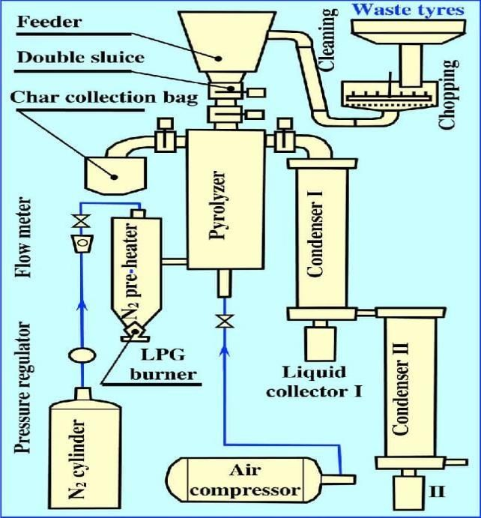 Figure 1:Fixed-bed Pyrolysis

[(https://www.researchgate.net)(25/04/25)]
- Fluidized-bed Pyrolysis:
Description: The biomass is suspended in a fluidized bed, allowing for better heat transfer and temperature control.
Advantages: Good temperature control, efficient heat transfer, and high liquid product yield
(typically 60%–75% from lignocellulosic biomass pyrolysis), according to a ScienceDirect article.
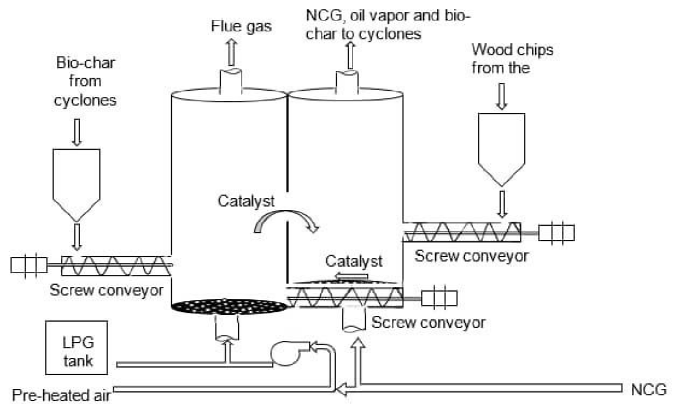
Figure 2:Fluidized-bed Pyrolysis
[(https://www.researchgate.net)(25/04/25)]
Disadvantages: Requires more complex equipment compared to fixed-bed reactors.

- Microwave-assisted Pyrolysis (MAP):
Description: Utilizes microwave energy to heat the biomass, offering faster and more selective heating.

Advantages: Faster heating, volumetric heating, and potentially higher biochar yield.

Disadvantages: Requires specialized microwave equipment and may not be suitable for largescale industrial applications.
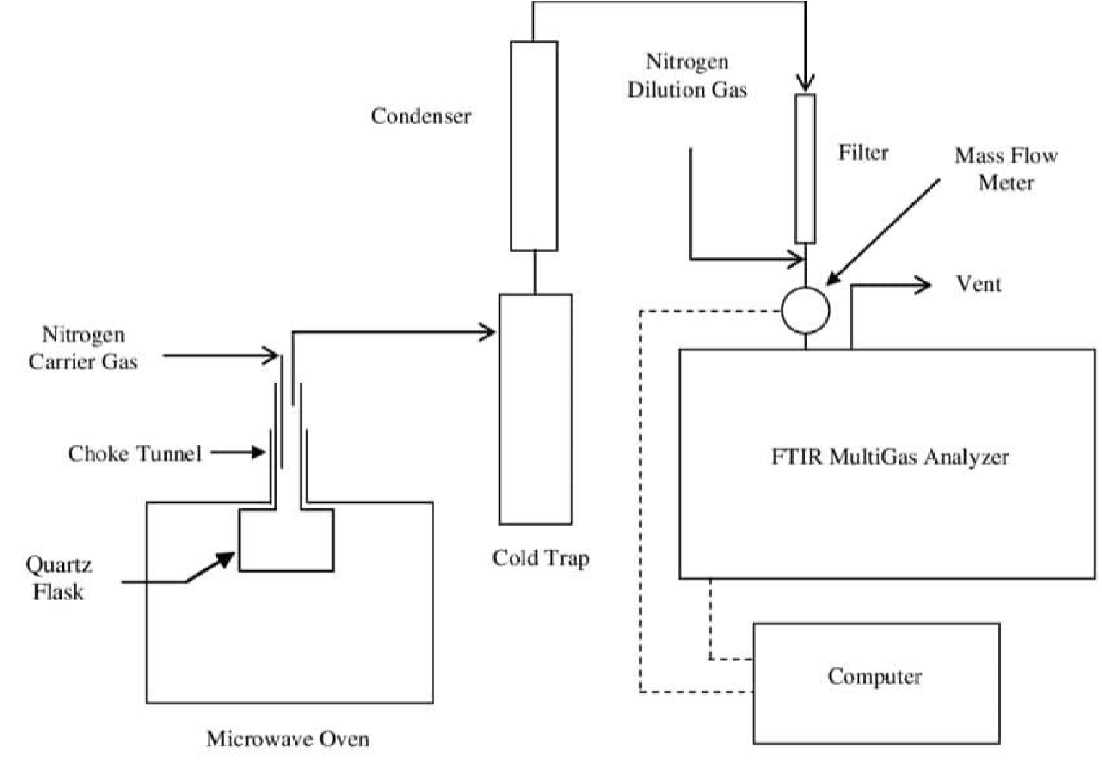
Figure 3: Microwave-assisted Pyrolysis (MAP)

[(https://www.researchgate.net)(25/04/25)]

- Plasma Pyrolysis:
Description: Uses a plasma torch to heat the biomass at very high temperatures, resulting in rapid degradation.

Advantages: Fast heating, high gas yields (50-98 wt%), and potentially high-value carbon products.
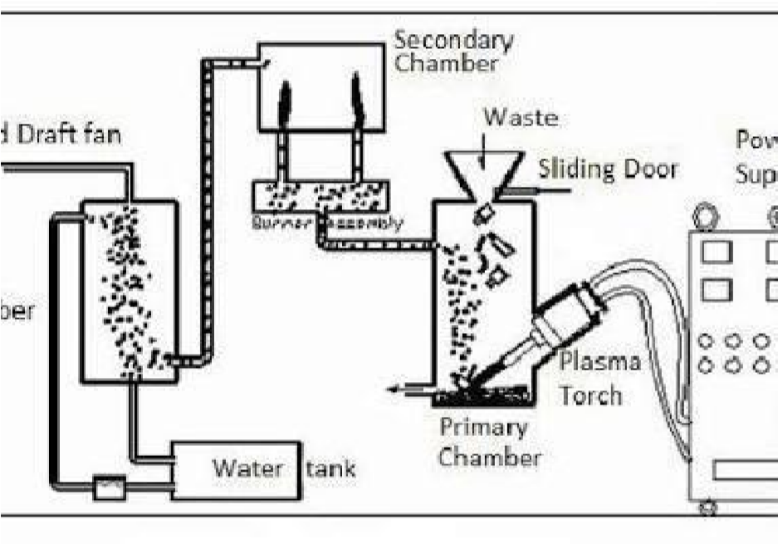 Figure 4:Plasma Pyrolysis

[(https://www.researchgate.net)(25/04/25)]
Disadvantages: High energy consumption and potentially higher capital costs.
The best method for pyrolyzing waste wood depends on specific needs and priorities, such as the desired product (bio-oil, biochar, biogas), the scale of operation, and available resources. Microwave-assisted and plasma pyrolysis offer faster heating and higher gas yields, while fixed-bed and fluidized-bed reactors provide more traditional and cost-effective options.[(https://www.sciencedirect.com)(https://www.researchgate.net)(25/04/25)] CHOICE OF BEST:
We have chosen the figure 1[Fixed-bed Pyrolysis] as the best method for carrying out pyrolysis because it is easy to operate and it has high solid yield.

CHAPTER THREE

3.0 CALCULATIONS INVOLVED IN PYROLYSIS OF WASTE WOOD
There are some calculations in waste wood pyrolysis involve determining yields, energy outputs, and the kinetics of the process. These calculations are crucial for optimizing pyrolysis processes and assessing the economic and environmental viability of using waste wood as a biofuel source.
(Bridgewater, 2000)
3.1 PARAMETRIC CALCULATIONS IN WASTE WOOD PYROLYSIS:
Yield Calculation:
- Mass Yield: The ratio of the mass of the final products (bio-oil, biochar, syngas) to the initial mass of the feedstock.
- Energy Yield: The ratio of the energy content of the final products to the energy content of the initial feedstock.
Example:
If 100 kg of waste wood is pyrolyzed, and 50 kg of bio-oil, 20 kg of biochar, and 30 kg of syngas are produced the total mass yield is;
100% (50+20+30)
The energy yield would depend on the energy content of each product.
1. Energy Output Calculation:
- Heat of Pyrolysis: The total amount of heat required or released during the pyrolysis process. It’s calculated by considering the enthalpy changes of all reactants and products.
- Energy Content of Products: The energy contained in bio-oil, biochar, and syngas. This can be determined using lower heating values (LHV) and the composition of each product.
- Energy Efficiency: The ratio of the energy output to the energy input. [(https://www.sciencedirect.com) (https://www.researchgate.net)(25/04/25)] Energy Balance Equations:
Energy input (from biomass):
Energy_in = Calorific_value_biomass × Mass_biomass Energy output (from products):
Energy_biochar = CV_biochar × Mass_biochar
Energy_bio‑oil = CV_bio‑oil × Mass_bio‑oil
Energy_gas = CV_gas × Mass_gas

Energy distribution (percent):
% Energy_biochar = (Energy_biochar / Energy_in) × 100
(Similar for bio‑oil and gas)
Typical energy distribution:
Biochar: ~50–53%
Liquids + Gases: ~47%
2. Experimental Example: Eucalyptus Wood Pyrolysis
Moisture contents tested: 0.83% and 13%
Reactor: Macro ATG oven under nitrogen
Heating rate: 5 °C/min up to 500 °C, held for 3 hours Results Summary:
Moisture (%) Char Yield Liquids + Gases Yield Energy in Char (%) Energy in Subproducts (%)
0.83 ~30.2% ~69.8% ~53% ~47%
13 ~30.4% Similar Similar Similar
Moisture increased pyroligneous liquid yields.
Non-condensable gases had lower energy at higher moisture.
3. Empirical Equations and Modeling
Char yield (temperature-dependent empirical model):
Y_char = 0.93 – 0.92 × exp(-0.0042 × T) (T in Kelvin).

1-D heat transfer in particle:
Ρc(∂T/∂t) = ∂/∂x (k_eff × ∂T/∂x) – Heat_loss_term

6. Fast vs Slow Pyrolysis
Fast pyrolysis (400–600 °C):
Products: ~60% bio‑oil, ~20% biochar, ~20% gas
Efficiency: up to 85% (if syngas reused)

4. Kinetics Calculation:

  - Arrhenius Equation: A common equation used to describe the rate of chemical reactions, including pyrolysis. It relates the reaction rate constant to temperature and activation energy.
  - Reaction Rate Constants: Values that indicate how fast a reaction proceeds. They are often determined experimentally, such as by measuring mass loss during pyrolysis.
  - Activation Energy: The minimum energy required for a reaction to occur. It’s a key parameter in the Arrhenius equation. [www.sciencedirect.com(25/04/25)]
Example Calculations:
  - Yield:
If 100 kg of waste wood yields 30 kg of bio-oil, 20 kg of biochar, and 50 kg of gas, the total yield is 100 kg (30+20+50). The individual yields are 30% for bio-oil, 20% for biochar, and 50% for gas.

  - Energy:
If bio-oil has an LHV of 25 MJ/kg, biochar has an LHV of 20 MJ/kg, and syngas has an LHV of 10 MJ/kg, the total energy output would be calculated by multiplying the mass of each product by its LHV and summing the results.
  - Kinetics:
The Arrhenius equation (rate = A * exp(-Ea/RT)) can be used to model the pyrolysis rate, where;

A is the pre-exponential factor,
Ea is the activation energy,
R is the ideal gas constant (8.314 J/mol•K), and
T is the temperature in Kelvin (www.wikipedia.com(25/04/25).
3.2 CALCULATIONS (STRUCTURAL WEIGHT ):

• Comprehensive Framework for Structural Weight Calculations in Waste Wood Pyrolysis Waste wood pyrolysis transforms complex lignocellulosic structures into biochar, bio-oil, and syngas, with structural weight calculations being essential for predicting yields, designing reactors, and conducting economic analyses. Below is an integrated approach based on current research:

- Foundations of Pyrolysis Mass Transformation
The mass loss mechanism during pyrolysis follows kinetic decomposition stages driven by temperature-dependent reactions 3. Key phases include:

Moisture evaporation (100–150°C)
Hemicellulose decomposition (220–315°C)
Cellulose breakdown (315–400°C)
Lignin degradation (160–900°C) Structural weight loss correlates directly with devolatilization rates, where final residue (char) represents 15–35% of initial mass depending on conditions. (Bridgwater, 2000)

- Critical Variables Influencing Weight Calculations
- Moisture Content
Dominates initial mass balance: High moisture reduces effective biomass fraction 5.
Calculation Impact: Requires dry-mass normalization. Example: 30% moisture in 100g wood = 70g dry mass. Post-drying weight is baseline for pyrolysis yield math 5.

- Particle Size & Geometry
Particles ≥3 cm exhibit slower heat transfer, creating temperature gradients that delay core decomposition 4.
Structural calculations must account for surface-to-volume ratios: Smaller particles (<1 cm) achieve uniform pyrolysis, yielding predictable weight loss 4.
- Temperature Regime
Optimal range: 450–500°C maximizes volatile release (>70% mass loss).
Char yield drops from 35% at 300°C to 20% at 480°C for hardwood 4.
Weight prediction models must integrate temperature-dependent kinetic parameters
Structural Weight Considerations
The structural weight of the pyrolysis plant would depend on the materials used for construction, such as steel, and the design specifications. Some key components to consider are:  Reactor: The weight of the reactor would depend on its size, material, and design pressure.
- Storage Tanks: The weight of storage tanks would depend on their size and material. For example, a 30 m³ storage tank would require a significant amount of steel for construction.
- Piping and Supports: The weight of piping and supports would depend on the layout and design of the plant.
- REACTOR SIZING
To calculate the reactor size, we need to consider the feedstock's mass flow rate and residence time. For example, in a 10 TPD plastic-to-fuel pyrolysis plant:
    - Feedstock: 10,000 kg/day
    - Residence time: 4 hours
    - Density: 250 kg/m³
    - Reactor volume: approximately 4 m³ (calculated as mass/density)
Energy Requirements
Energy required for pyrolysis can be calculated using the formula:Q = m × c × ΔT
Where:
    - Q = energy required (kJ/day)
    - m = mass of feedstock (kg/day)
    - c = specific heat capacity (kJ/kg·K)
    - ΔT = temperature difference (°C)
For instance¹:
    - Q = 10,000 kg/day × 2.0 kJ/kg·K × 420°C = 8,400,000 kJ/day
    - Converting to kWh: 8,400,000 kJ/day ÷ 3600 = 2,333 kWh/day

3.3 FABRICATION DETAILS OF PYROLYSIS MACHINE

Phase 1: Machine Design & Planning

      - Reactor Core Design: Select a continuous rotary kiln reactor for high-volume waste processing, ensuring uniform heat distribution and efficient biochar discharge.
      - Size the reactor based on target throughput (e.g., 50–200 kg/hr). Optimize insulation to minimize heat loss and energy consumption.
      - Thermal System & Energy Integration: Design a two-stage heating system:
Primary gasifier for initial volatilization (300–400°C) using biomass-derived syngas.
      - Secondary combustion chamber for cracking tars (500–700°C). Integrate heat recovery from syngas to preheat feedstock, improving net energy efficiency.
      - Feedstock Preparation & Handling: Incorporate a shredder (particle size <2 cm) and moisture control system (<15% moisture). Size variability impacts product yield and quality – design for flexible feed rates
1. [(https://www.sciencedirect.com)(https://www.researchgate.net)(25/04/25)]

Phase 2: Fabrication & Assembly
- Component Specifications Materials/Notes
- Reactor Vessel 8–12 m³ capacity; rotary design with internal flights
- Carbon steel (Grade 310S) for high-temp Variability corrosion resistance Condensation System
- Multi-stage (cyclonic separator → quench tower → electrostatic precipitator)
- Ensure complete liquid recovery for oil analysis 3
- Gas Cleaning
- Activated carbon filters + scrubbers
- Minimize particulate emissions
- 2 Control System
- PLC with thermocouples (0–1000°C range) and pressure sensors Automate temperature ramping and safety
shutdown.[(https://www.sciencedirect.com)(https://www.researchgate.net)(25/04/25)]

Phase 3: Testing Protocol

- Feedstock Testing: Test 3+ waste wood types (e.g., pine, oak, mixed demolition wood). Record temperature profiles, residence time, and yields for oil, syngas, and biochar in each trial 1.
- Product Performance Analysis:
Biochar: Test pH, surface area (BET), and heavy metal content; validate soil amendment potential 5.

- Pyrolysis Oil: Compare viscosity, heating value, and composition to petroleum benchmarks
3.
- Syngas: Measure calorific value (≥15 MJ/m³ target) and impurity levels.
- Efficiency Metrics: Calculate mass balance closure (>90% target) and net energy ratio (Output energy/Input energy). Document deviations from theoretical models 4.

Phase 4: Safety & Compliance
- Critical Safety Systems:Pressure relief valves on all sealed units.
- Inert gas (N) purge system to prevent explosions during startup/shutdown.
- Real-time CO/HS monitors in workspaces 5.
- Environmental Compliance: Test emissions (PM2.5, VOCs) against local regulations; optimize filters if exceedances occur 2.
[(https://www.sciencedirect.com)(https://www.researchgate.net)(25/04/25)]

Phase 5: Optimization & Reporting
- Process Refinement: Adjust temperature/residence time to maximize oil yield (>50 wt%) or biochar carbon content (>80%), depending on project goals. Implement continuous auger improvements if bridging occurs 24.
- Economic Viability: Track fabrication costs, energy consumption, and product market value.
Use data to estimate payback period 4.
- Final Documentation: Compile a technical dossier including:
- Fabrication blueprints and safety certifications.
- Test data tables (yields, product specs) across all feedstock types.

Summary Workflow: Design (Reactor→Energy)→Fabricate (Materials→Safety)→Test (Feedstock→Products)→Optimize→Report Key insights from the search results emphasize continuous operation for efficiency 2, rigorous product analysis against standards 35, and energymass balance integration [4]. Always prioritize structural integrity and gas handling safety to mitigate risks.

[(https://www.sciencedirect.com)(https://www.researchgate.net)(25/04/25)]

3.4 TESTING PROCEDURES FOR PYROLYSIS MACHINE
Testing procedures for a pyrolysis machine involve a multi-step process including feedstock preparation, reactor loading under an inert atmosphere, heating and pyrolysis at specific temperature profiles, product separation (char, liquid oil, and gas), and characterization of the output streams. Key testing aspects include determining energy balance, product yield, and the composition of the products to assess the system’s efficiency and viability for industrial use. (https://www.researchgate.net)(25/04/25)]
- Feedstock Preparation Drying:
Ensure the feedstock (biomass, plastic, tires) is free from excessive moisture, as high moisture content can negatively impact the process.
Size Reduction:
Size-reduce the feedstock, as particle size influences reaction efficiency.
- Reactor Setup Inert Atmosphere:
Create an oxygen-free environment in the reactor by using a purge gas like nitrogen to prevent combustion.
Loading:
Load the prepared feedstock into the reactor, ensuring there’s sufficient space for smooth operation.
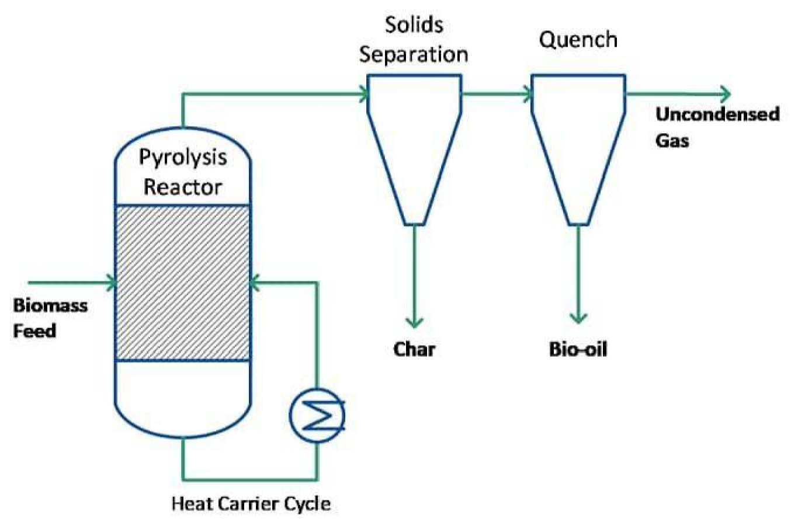
Figure 5: Reactor Setup
[(https://www.sciencedirect.com)(https://www.researchgate.net)(25/04/25)]

- Pyrolysis Process

Heating:
Gently heat the reactor to the target pyrolysis temperature, often involving a temperature increase over time.
Reaction:
Maintain the appropriate temperature to initiate and sustain the pyrolysis reaction, which breaks down the feedstock into gas, liquid, and solid products.

- Product Collection
Gas Separation: Separate char from gaseous products using a cyclone separator.
Condensation: Cool the hot vapors to condense the liquid fraction (pyrolysis oil).
Gas Cycling: Quench non-condensable gases and recycle them to the combustor as fuel.
Char Removal: Once cooling is complete, remove the solid char residue from the reactor.

- Product Characterization and Performance Assessment Mass Balance:
Collect and weigh the solid (char), liquid (oil), and gaseous products to determine the product yields and establish a mass balance.
Energy Balance:
Perform water boiling tests to calculate the overall thermal efficiency of the system.
Product Analysis:
Analyze the collected products to determine their composition and energy content, often using techniques like Pyrolysis-GC-MS.
- Safety and Monitoring Safety Protocols:
Always follow established safety procedures, especially when dealing with high-temperature processes and flammable gases.
Process Monitoring:
Continuously monitor and record key process parameters such as temperature, pressure, and residence time.
Tools and Methods:
  - Thermocouples: Used to measure temperature during pyrolysis.
  - Thermogravimetric Analysis (TGA): A technique used to measure mass loss as a function of temperature, providing insights into the pyrolysis kinetics.
  - Gas Chromatography-Mass Spectrometry (GC-MS): Used to analyze the chemical composition of pyrolysis products.
  - Mathematical Modeling: Computer models can be used to simulate the pyrolysis process, considering mass and energy balances, reaction kinetics, and heat transfer.
In summary, calculations in waste wood pyrolysis are essential for understanding the process, optimizing it for maximum efficiency, and assessing its potential for sustainable energy production. (www.oeaw.ac.com)(www.wikipedia.com(25/04/25).

CHAPTER FOUR

4.0 MATERIALS SELECTION, DESCRIPTION OF MACHINES AND FABRICATION DETAILS OF WOOD PYROLYSIS

4.1.1 MATERIALS SELECTION
Materials suitable for pyrolysis generally possess high energy content, volatile matter, and low ash and sulfur levels. For example, biomass with high hemicellulose content (like corn cob) or substantial lignin content (like pine) can influence the yield and composition of pyrolysis products. The specific properties depend on the desired pyrolysis product (biochar, biooil, or syngas) and the chosen pyrolysis method (fast, slow, or flash).
(Yaman, 2004)
Examples of Suitable Materials:
Biomass: Various types of biomass, including wood, agricultural residues (rice husk, corn cobs), and algal biomass, can be pyrolyzed to produce biochar, bio-oil, and syngas.
Waste Materials: Waste materials like tires, plastic, and rubber can also be pyrolyzed.
Sewage Sludge: Sewage sludge can be a feedstock for pyrolysis, especially when using microwave pyrolysis.
Coal: Coal can be pyrolyzed to produce char, gas, and tar.

Factors Influencing Material Selection:
Desired Pyrolysis Products:
If biochar is the primary goal, slow pyrolysis and materials with higher ash content might be preferred. If bio-oil is the main objective, fast pyrolysis and materials with high volatile matter are favored.
Pyrolysis Method:
The choice of pyrolysis method (fast, slow, or flash) will also influence the selection of materials.
[(https://www.sciencedirect.com)(https://www.researchgate.net)(25/04/25)] Process Parameters:
Temperature, heating rate, and residence time play a cru cial role in determining the quality and yield of pyrolysis products.
Material Availability and Cost:
Practical considerations, such as the availability and cost of materials, are also important.

4.1.2 PROPERTIES OF MATERIALS FOR PYROLYSIS
Key Properties to Consider: to Volatile Matter:
Materials with a high volatile matter content will yield more bio-oil and syngas during pyrolysis.
Ash Content:
Low ash content is preferred to avoid ash accumulation in the reactor and to improve the quality of the pyrolysis products.
Sulfur Content:
Low sulfur content is desirable as sulfur can lead to corrosion and reduce the quality of the pyrolysis products.
Energy Content (Calorific Value):
Materials with higher energy content are more efficient for producing pyrolysis products.
Particle Size:
Proper particle size management can improve the pyrolysis process.
Moisture Content:
Excessive moisture can negatively impact the pyrolysis process.
Chemical Composition:
The specific chemical composition of the feedstock can influence the yield and composition of the pyrolysis products.
[(https://www.sciencedirect.com)(https://www.researchgate.net)(25/04/25)]

Availability and Cost:
Materials that are readily available and relatively inexpensive are often preferred.

6.1.3 CONSIDERATIONS FOR MATERIALS SELECTION FOR PYROLYSIS

When selecting materials for pyrolysis, several factors should be considered to optimize the process and produce desired products. These include the material's composition, volatile matter content, moisture content, and the desired end product (e.g., bio-oil, biochar, gas).
- Material Composition:
Biomass:
Biomass with a higher cellulose and hemicellulose content is favorable for maximum biooil yield, while those with higher lignin content are better for biochar production.
Plastic:
Pyrolysis of plastics, especially those with high polyethylene content, can lead to higher yields of alkanes and alkenes.
Waste Materials:
Various waste materials like drilling mud, petroleum sludge, and tank bottom sludge can be pyrolyzed to produce fuel, with oil yield depending on the material's oil content.
- Volatile Matter, Fixed Carbon, and Ash Content:
Fixed Carbon:
Higher fixed carbon content results in a greater yield of biochar and higher heating value for the pyrolysis products.
Volatile Matter:
Higher volatile matter in biomass generally leads to higher bio-oil and biogas yields.
Ash Content:
The presence of ash in the feedstock can affect the quality and quantity of pyrolysis products.
- Moisture Content:
Moisture content in the material can affect the pyrolysis process and the yield of the products.
- Desired End Product:
Bio-oil:
Biomass with a higher cellulose and hemicellulose content is generally preferred for maximizing bio-oil production.

Biochar:
Materials with higher lignin content are more suitable for producing biochar.
Gas:
Pyrolysis parameters, such as heating rate and residence time, can be adjusted to optimize gas production.
- Other Considerations:
Particle Size: Smaller particle sizes can lead to faster heating and more uniform pyrolysis.
Heating Rate: The heating rate affects the yield and composition of pyrolysis products.
Pyrolysis Temperature: There is an optimal temperature range for maximizing the yield of specific products, such as liquid bio-oil.
Residence Time: The residence time of vapors in the pyrolysis reactor affects the final product composition.
Reactor Type: The type of reactor used can influence the efficiency and product distribution.
Catalysts: Catalysts can be used to enhance the selectivity and yield of desired products.
Operating Pressure and Fluidizing Gases: These factors can also influence the pyrolysis process. (Yaman, 2004)

4.2 DESCRIPTION OF MACHINES COMPONENTS OF PYROLYSIS
A pyrolysis plant, which converts waste materials like tires and plastics into oil, gas, and solid residue, is composed of several key systems: a reactor, a condensing system, a feeding system, a tail gas treatment system, and a discharging system. These components work together to carry out the thermal decomposition process under controlled conditions, maximizing oil production while minimizing environmental impact.
Key Components and Their Functions:
Pyrolysis Reactor: This is the heart of the process, a heat-resistant vessel where the waste material is heated in an oxygen-free environment to break it down into different components.
Condensing System: This system cools the oil gas produced by the reactor, condensing it into liquid fuel oil and further separating it into different fractions.
Feeding System: This system transports the waste material into the reactor, ensuring a consistent and controlled feed rate.
Tail Gas Treatment System: This system cleans and purifies the exhaust gas from the reactor to meet environmental regulations.
Discharging System: This system removes the solid residue (char or slag) from the reactor after the pyrolysis process is complete.
Additional Components: Pretreatment System (optional): May include crushers, shredders, or other equipment to prepare the waste material for feeding into the reactor.
Electronic Control System: This system monitors and controls various parameters of the pyrolysis process, ensuring optimal performance and safety.
Other Accessories: May include cooling towers, storage tanks, and safety devices.
Note: The specific design and components of a pyrolysis plant can vary depending on the scale of operation, the type of waste material being processed, and the desired output products.
4.3 FABRICATION DETAILS OF PYROLYSIS SYSTEM
Pyrolysis fabrication involves creating a system to heat organic material, like biomass or plastic waste, in an oxygen-free environment, resulting in the production of oil, gas, and char.This process typically uses a reactor, condenser, and heating source. The specific fabrication details vary depending on the type of material being pyrolyzed and the desired products.
Details:
- Reactor/Heating Chamber:
Purpose:
This is the primary vessel where the material is heated and undergoes pyrolysis.
Materials:
Typically made of heat-resistant materials like steel, stainless steel, or refractory brick.
Design:
Can be a simple batch reactor (for smaller quantities) or a continuous flow reactor (for larger scale operations).
Features:
May include a hopper for feeding the material, a screw for mixing, and a heating system (e.g., gas burners, electric heaters).
- Condenser:
Purpose:
To cool and condense the vaporized pyrolysis products (primarily pyrolysis oil and gases).
Materials:
Typically made of copper or stainless steel for heat transfer and corrosion resistance.
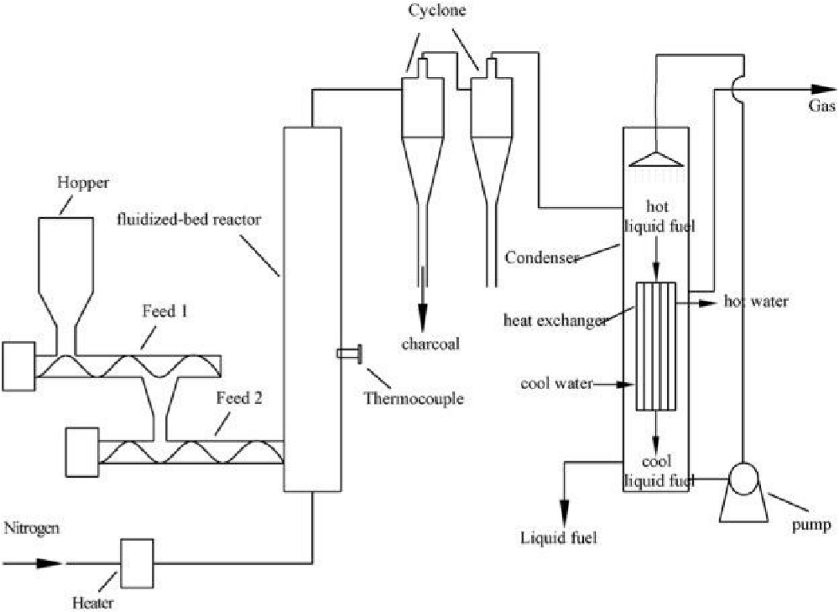

Figure 6: Condenser [www.sciencedirect.com(25/04/24)]

Design:
Shell and tube condensers are common, where coolant flows through tubes inside a shell to condense the vapor.

Features:
May include baffles to improve heat transfer and a system for collecting and separating the condensed products.[ (www.sciencedirect.com(25/04/24)]
3. Heating Source:
Purpose: To provide the necessary heat for the pyrolysis process.
Options: Can include gas burners (LPG, natural gas), electric heaters, or even solar heating in some cases.
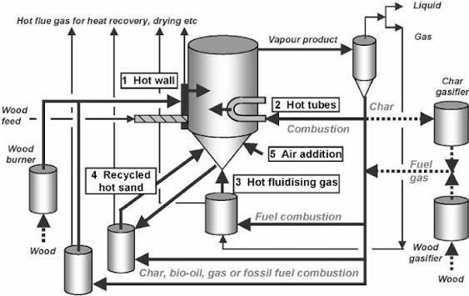

Figure 7: Heating Source [www.sciencedirect.com(25/04/24)]

Control: Requires a control system to regulate the temperature and heating rate.
- Other Components:
Feeding System: For introducing the feedstock material into the reactor.
Discharging System: For removing the solid residue (char) and potentially any unpyrolyzed material.
Gas Recycling System: For recycling or processing the produced gases (e.g., for heating the reactor or generating electricity).
Dusting System: For removing dust and other solid particulates from the gases.

4.4 TESTING PERFORMANCE OF THE MACHINE

In an attempt to produce fuel from plastic waste, a cylindrical fixed-bed pyrolysis reactor with a capacity of 0.01053 m3 was designed and fabricated. The pyrolytic fuel produced serves as a substitute to fossil fuel. A thermal degradation process, known as fixed-bed pyrolysis, was employed to obtain the pyrolytic fuel from the plastic waste. The operating pressure and the design pressure of the pyrolysis reactor are 25.16 Mpa and 28.93 Mpa, respectively. The performance testing of the reactor shows that the pyrolytic fuel has higher calorific value, flash point, cetane rating, and density of 39.5 MJ kg−1, 72.5 °C, 40.5, and 804.0 kg m−3, respectively. The corresponding values for the fossil fuel (diesel) are 44.8 MJ kg−1, 68.0 °C, 48.0, and 820.0 kg m−3, respectively.
It was confirmed through the performance testing that the reactor was properly designed and can, therefore, be reliably used to produce pyrolytic fuel, which can be made use of as a good alternative to fossil fuel. The performance of the reactor was tested by comparing the physiochemical properties of the pyrolytic fuel produced by the reactor from the plastic waste with the physiochemical properties of diesel, a fossil fuel. Before the performance testing was done, the sample of the pyrolytic fuel was taken and its physiochemical properties were measured by means of different instruments. The properties considered were higher calorific value, flash point, cetane number, and density.
(Bartłomiej Igliński, Wojciech Kujawski, and Urszula Kiełkowska, 2023)

CHAPTER FIVE
5.0 CONCLUSION AND RECOMMENDATIONS
5.1 CONCLUSION
This project focused on the fabrication and performance testing of a waste-wood pyrolysis machine using locally sourced materials. The machine was successfully constructed and tested, and it proved capable of converting waste wood into useful products such as bio-oil, biochar, and syngas.
The performance test showed that the machine can attain the required pyrolysis temperature and yield appreciable amounts of pyrolytic products. Although the yields were relatively lower than those reported in advanced commercial systems, the results validate the feasibility of this locally fabricated design.

In conclusion, the project demonstrates that pyrolysis technology offers a practical, affordable, and environmentally friendly solution for managing wood waste while simultaneously producing renewable energy resources.
5.2 RECOMMENDATIONS
Based on the outcomes of this project, the following recommendations are made:
- Improved Design: The insulation and heating chamber should be further enhanced to reduce heat loss and increase efficiency.
- Catalyst Use: The introduction of catalysts is recommended to improve the yield and quality of bio-oil.
- Process Control: Incorporating temperature and pressure monitoring devices will ensure more stable operation.
- Scale-Up: The design can be scaled up for industrial application to increase production capacity.
- Further Research: More tests should be conducted using different biomass feedstocks to compare performance and broaden applications.
- Commercial Application: With modifications, the machine can be commercialized to provide affordable renewable energy solutions for small and medium-scale
industries.

APPENDIX

Appendix A: Design Calculations

1. Reactor Volume Calculation

Reactor diameter (D) = 0.30 m

Reactor height (H) = 0.60 m

Volume (V) = πD²H/4

V = (3.142 × 0.30² × 0.60)/4 = 0.042 m³ ≈ 42 litres

- Thickness of Material

Selected mild steel thickness = 4 mm (based on strength and heat resistance).

- Heat Requirement

Assuming pyrolysis temperature ≈ 450 °C

Specific heat capacity of wood ≈ 1.7 kJ/kg·K

Feedstock mass = 5 kg

ΔT = (450 – 30) °C = 420 K

Q = mcΔT = 5 × 1.7 × 420 = 3570 kJ

Appendix B: Fabrication Process Pictures

Cutting of mild steel sheets into required dimensions.

Welding of cylindrical reactor body.

Fitting of condenser coil into water jacket.

Assembly of gas outlet and collection tank.

Painting and finishing of the machine.
(Insert actual pictures you took during fabrication here.)

Appendix C: Performance Test Data

Feedstock Type Mass (kg)  Yield (%) Efficiency (%) | Bio-oil Yield (%) | Biochar Yield (%) | Syngas
Dry wood 5.0 42 33 | 25 71
Wet wood 5.0 35 32 | 33 65
Sawdust 5.0 48 28 | 24 73

Appendix D: Cost Analysis

Item Quantity Unit Cost (₦) Total Cost (₦)
Mild Steel Sheet 2 | 15,000 30,000
Welding Electrodes 1 | pack 5,000 5,000
Labour (Fabrication) – | – 20,000
Condenser Materials – | – 10,000
Paint/Finishing – | – 3,000
Miscellaneous – | – 5,000
Total – | – 73,000

Appendix E: Machine Dimensions

Reactor height: 60 cm

Reactor diameter: 30 cm

Wall thickness: 4 mm

Condenser coil length: 3 m

Collection tank capacity: 10 litres

REFERENCES

- Serban C. Moldoveanu (Second Edition) (2021).

- [www.researchgate.net (04/08/25)].

- [www.sciencedirect.com (04/08/25)].

- Bartłomiej Igliński, Wojciech Kujawski, and Urszula Kiełkowska (2023).

- Bridgewater, 2000.

- [www.wikipedia.com (25/04/25)].

- [www.oeaw.ac.com].

- Yaman, 2004.

