KWARA STATE POLYTECHNIC

DEVELOPMENT OF A MOBILE LECTERN FOR EFFECTIVE LEARNING

OLADOSU OLUWASEYI IYIOLA
ND/23/WEC/PT/0011

A PROJECT REPORT SUBMITTED TO THE DEPARTMENT OF WELDING AND FABRICATION ENGINEERING, INSTITUTE OF TECHNOLOGY IN PARTIAL FULFILMENT OF THE REQUIREMENTS FOR THE AWARD OF NATIONAL DIPLOMA IN WELDING AND FABRICATION ENGINEERING TECHNOLOGY

ILORIN, NIGERIA

JUNE, 2025

CERTIFICATION

The undersigned certify that this project report prepared by OLADOSU OLUWASEYI IYIOLA with Matric No. ND/23/WEC/PT/0011 entitled: DEVELOPMENT OF A MOBILE LECTERN FOR EFFECTIVE LEARNING meets the requirement of Department of Welding and Fabrication Engineering for the award of National Diploma in Welding and Fabrication Engineering.

---------------------------------------------------- --------------------------
ENGR. GARUBA ABDULLATEEF ALABI DATE
(Project Supervisor)

------------------------------------ ---------------- ---------------------------
ENGR. M. A. SALAHUDEEN DATE
(Head of Department)

------------------------------------ --------------- ---------------------------
ENGR. GARUBA ABDULLATEEF ALABI DATE
(Part-Time Coordinator)

------------------------------------ --------------- ---------------------------
ENGR. M. O. AGAJA DATE
(External Examiner)

DEDICATION

This project is dedicated to my loving and caring parents, Mr. and Mrs Oladosu, for their love and supports.

ACKNOWLEDGEMENT

My endless praise and thanks go to the Almighty God, who has made it possible for me to be alive today and to also be among the students that has gained invaluable knowledge from the project program.
I hereby express my profound gratitude and sincere appreciation to my family and my wonderful parents, Mr. and Mrs. Oladosu, for their unreserved love shown towards me right from my inception to this day and also for making my project program a success.
My undiluted appreciation goes to my project supervisor, Engr. Garba A. Alabi for his priceless contributions and intellectual guidance showed towards me before and after the completion of this project and I pray that God will continually bless and protect your family.
I also appreciate Kwara State Polytecnic and her staff which indeed has made herself a citadel of learning, through which students all over the world come to discover their potentials. I`m indebted to you, you have succeeded in helping me find, take-back and maintain my mind.
My profound love goes to my amazing siblings and colleagues for their support, love and prayers, I pray that God continually bless and keep providing for you. AMEN!
ABSTRACT

The project focuses on designing and developing a mobile pulpit that enhances teaching and learning effectiveness. Unlike traditional stationary lecterns, the mobile pulpit is built with light weight, durable materials and features wheels, adjustable height, and storage compartments to improve flexibility and functionality in the classroom. It also supports the integration of digital devices, making it suitable for modern technology-driven learning environments. By allowing lecturers to move freely and interact more closely with students, the mobile pulpits promotes effective learning better communication, and dynamic teaching style while remaining cost-effective and user-friendly for educational institutions

TABLE OF CONTENT

Title page I

Approval page II

Dedication III

Acknowledgement IV

Abstract V

Table of content VI

CHAPTER ONE

Introduction

1.0 Background of study 1

    - Problem statement 1

1.2 Aim 1

1.3 General objectives 1

1.4 Specific objectives 2

1.5 Scope of study 2

1.6 Significance of study 2

1.7 Organization of Chapter 2

1.8 Limitations 3

CHAPTER TWO

Literature Review

2.0 Lectern 4

2.1 Application of lecterns 4

2.2 Sound powered lecterns 5

2.2.1 Sl400-Sound powered lectern 5

2.2.2 Sl370 Table Top Sound Lectern 5

2.2.3 The Executives Sound Column Lectern 6

CHAPTER THREE

METHODOLOGY

3.0 Methodology 7

3.1 Materials 7

3.1.1 Integrated Circuit 7

3.1.2 Relays 8

3.1.3 Transitor 8

3.1.4 Cordless Microphone Module 8

3.2 Designing 8

3.2.1 Designing of System Device Block Diagram 9

3.2.2 Design of System Device Circuit 9

3.3 Construction 9

3.3.1 Construction of the Class AB Power Amplifier 11

3.3.2 Split Power Supply 11

3.3.3 Tone Control Circuit 11

3.3.4 Four Channel Audio Mixer 11

3.4 Mode of operation of system device 12

3.5 System Design 12

3.5.1 System Device Block Diagram 12

3.5.2 System Device circuit 13

3.5.3 System Development 14

CHAPTER FOUR

4.0 Characteristics of Sound 16

4.0.1 Noise Level and Sound Pressure Level (SPL) 17

4.0.2 Sound Pressure Level Decreases with Distance 17

4.0.3 Sound Reverberation and Absorption 17

4.1 Discussion 17

4.2 Costs Benefits Analysis 18

4.2.1 Material list 18

4.2.2 Labour cost 18

4.2.3 Labour Cost Breakdown 19

CHAPTER FIVE

CONCLUSION AND RECOMMENDATION

5.1 Conclusion 20

5.2 Recommendation 20

References 21

CHAPTER ONE

INTRODUCTION
1.0 Background of Study
Effective communication in classrooms and lecture halls is crucial for learning. One of the primary tools aiding teachers is the lectern, a stand used to hold notes, books, or devices during a presentation. Traditional lecterns were primarily wooden and lacked technological integration. With the evolution of educational technology, there has been a need for more interactive and mobile solutions.
The mobile lectern is designed to bridge this gap by combining physical mobility with an integrated audio system. It addresses the challenges of sound projection, lecturer movement, and cost-effectiveness. By merging furniture design with electronic systems, the mobile lectern creates a hybrid teaching tool that supports modern education requirements.
1.1 Problem Statement
Several challenges exist with conventional lecterns:
1. Fixed in one location, limiting lecturer movement.
2. Reliance on external public address systems, which increases cost.
3. Inadequate sound coverage in large classrooms.
4. Poor flexibility for interactive teaching.
5. Time wasted setting up separate audio equipment.

1.2 Aim

To design and fabricate a mobile lectern that promotes effective learning through flexibility, ergonomics, and integration of teaching aids.

1.3 General Objective
To design and construct a mobile lectern with integrated audio and wireless microphone system for effective classroom learning.
1.4 Specific Objectives
To design and construct a mobile lectern that integrates Class AB audio amplification.
To design a four-channel audio mixer with tone control.
To integrate a cordless microphone for wireless teaching.
To provide mobility through caster wheels.
To evaluate the cost-effectiveness and learning impact of the mobile lectern.
1.5 Scope of Study
This project covers the design and construction of a prototype mobile lectern for classrooms and lecture halls. It does not extend to large-scale manufacturing or advanced multimedia lecterns with projectors or smart boards.
1.6 Significance of Study
Reduces the cost of buying separate PA systems.
Enhances student comprehension through clear audio delivery.
Improves lecturer mobility and interaction.
Provides a self-contained, portable solution adaptable to different venues.
Contributes to innovation in teaching aids and instructional technology.
1.7 Organization of Chapter
The report is structured as follows:
Chapter One introduces the project.
Chapter Two reviews relevant literature and existing lecterns.
Chapter Three presents methodology, materials, design, and construction.
Chapter Four discusses performance, sound characteristics, and cost analysis.
Chapter Five concludes with findings and recommendations.
1.8 Limitations
Limited power backup, as it requires mains supply or battery.

Designed for medium-sized classrooms, not large auditoriums.
Prototype may require professional finishing for commercial use.

CHAPTER TWO

LITERATURE REVIEW
2.0 Lectern
A lectern is a stand that supports notes or devices for a speaker. Traditionally made of wood, it is static and purely functional. Modern lecterns have evolved to integrate audio, digital, and multimedia systems.

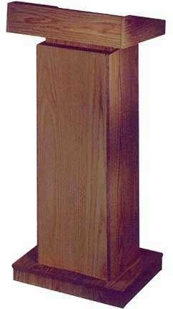
Figure 2.1 Manual Height Adjustable Wooden Finish Lectern[4]

2.1 Application of Lecterns
Lecterns are used in:
Education (schools, universities, training halls).
Politics (press conferences, speeches).
Religion (sermons, teaching).
Corporate organizations (seminars, presentations).
2.2 Sound Powered Lecterns
The demand for integrated sound has led to sound-powered lecterns.

These come with amplifiers, microphones, and speakers.
2.2.1 SL400 Sound Powered Lectern
Portable with integrated PA system.
Used in conferences and seminars.
Features built-in battery support.

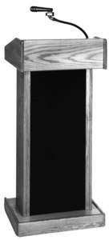
Figure 2.4 SL400 sound powered lectern [15].

2.2.2 SL370 Table Top Sound Lectern
Compact, table-mounted version.
Best suited for small classrooms and training.
2.2.3 The Executive Sound Column Lectern
Premium model with column speakers.
Widely used in corporate and government settings.
Comparing existing models shows that while they serve their purposes, they are often expensive and not locally produced. Hence, a cost-effective prototype is valuable.

CHAPTER THREE

METHODOLOGY

3.0 Methodology
The methodology adopted in this project involves conceptual design, selection of materials, circuit design, construction, and testing of the mobile lectern system. The process followed a systematic engineering approach:
1. Research and Feasibility Study – Reviewing existing lecterns and sound systems.
2. System Design – Developing block and circuit diagrams for sound amplification and wireless transmission.
3. Material Selection – Choosing electronic components, frame materials, and mechanical fittings.
4. Circuit Simulation – Using electronic simulation tools to validate designs.
5. Construction – Fabricating the lectern structure and assembling electronics.
6. Testing and Evaluation – Assessing sound clarity, power consumption, and mobility performance.
This approach ensured that the final prototype met design objectives within budgetary and time constraints.
3.1 Materials
The materials used are divided into two broad categories: electronic components and mechanical/structural materials.
3.1.1 Integrated Circuits (ICs)
TDA2030 Class AB Power Amplifier IC: Provides up to 18W RMS per channel.
Operational Amplifiers (LM741/LM324): Used in tone control and mixer circuits.
Voltage Regulators (7812/7912): Maintain stable ±12V supply for audio stages.
3.1.2 Relays
Electromechanical relays were used for switching between microphone and auxiliary inputs without distortion.
3.1.3 Transistors
BC547/BC557: General-purpose transistors for pre-amplification and signal conditioning.
TIP41/TIP42: Medium power transistors used in push-pull configuration for the amplifier stage.
3.1.4 Cordless Microphone Module
Includes transmitter (handheld microphone) and receiver unit.
Operates on UHF frequency band (600–800 MHz) to reduce interference.
Powered by AA batteries for portability.
3.1.5 Structural/Mechanical Materials
Plywood (18 mm): Used for lectern body.
Metal frame (mild steel square pipes): Provides rigidity and durability.
Caster wheels (4 units, 3-inch diameter): For mobility.
Acrylic sheet: Used as the slanted top surface for note placement.
Paint and finishing materials: For durability and aesthetics.
3.2 Designing
The system design process involved both electronic design and mechanical design.
3.2.1 Designing of System Device Block Diagram
The block diagram is divided into:
1. Input Stage: Wireless microphone, auxiliary input (laptop, phone, etc.).
2. Processing Stage: Four-channel mixer and tone control circuit.
3. Power Amplification Stage: Class AB amplifier using TDA2030.
4. Output Stage: Two loudspeakers (20W each).
5. Power Supply Stage: ±12V regulated DC supply.
(Insert Figure – Block diagram showing these stages.)
3.2.2 Design of System Device Circuit
Mixer Circuit: Combines up to four audio inputs with independent volume controls.
Tone Control Circuit: Active bass, mid, and treble control using op-amps.
Amplifier Circuit: Push-pull configuration for efficient sound reproduction.
Power Supply Circuit: Step-down transformer (220V to 18-0-18V AC), rectifier diodes, smoothing capacitors, and voltage regulators.
3.3 Construction

Construction (General — enclosure, wiring, and assembly)

Mechanical layout

Use a three-compartment layout: (A) RF/low-level audio, (B) mixer/tone/preamp, (C) PSU & power amp. Keeps heat and EMI away from sensitive stages.

Metal chassis (1.2–2.0 mm steel or aluminum). Perforated panels for ventilation above the power amp area.

Access: removable side/top panels for service; front controls recessed to avoid accidental knocks.

PCBs and mounting

Separate PCBs: (1) Preamps/mixer/tone, (2) Class-AB amp, (3) PSU + protection, (4) RF receiver (if not an off-the-shelf module).

Use standoffs and hardened screws. Keep long current traces wide (≥ 4 mm) on the amp PCB.

Place test points for rails, input nodes, and output nodes.

Wiring & grounding

Star ground: single chassis star point. Low-level audio ground returns to star; speaker returns separate to avoid injecting switching/noise.

Shielded audio cables for inputs/outputs. Twist pairs for DC rails.

Route speaker cables away from preamp + RF antenna leads.

Cooling & thermal

Heat sink sized per estimated dissipation; provide forced convection if rating > 25 W continuous.

Thermal compound between power transistors and heat-sink. Mount Vbe multiplier transistor to same heat sink.

Safety

Mains fuse, earth bonding, inrush limiter (NTC), and mains switch with indicator.

Speaker relay on power-up (2 s delay) to prevent switch-on thumps.

Battery compartments (if used) secured and vented; fuse for battery feed.

Final checks

1. Visual inspection for solder bridges, correct polarity, and mounting.

2. Power rails checked with no load using current limited supply.

- Connect dummy load and perform signal tests (1 kHz sine).
3.3.1 Construction of Class AB Power Amplifier
Based on TDA2030 + complementary transistors.
Designed to deliver ~20W into 4Ω load with low distortion.
Heat sinks were attached to transistors for thermal stability.
3.3.2 Split Power Supply
Transformer: 220V/18V-0-18V.
Rectifier: Full bridge rectification using 1N5408 diodes.
Filter: Electrolytic capacitors (2200 µF each).
Regulators: 7812 (+12V) and 7912 (−12V).
3.3.3 Tone Control Circuit
Active tone control design using LM324 op-amp.
Adjustable bass (100 Hz), midrange (1 kHz), and treble (10 kHz).
Potentiometers were used for control knobs.
3.3.4 Four-Channel Audio Mixer
Implemented using summing amplifier configuration.
Each channel had its own volume potentiometer.
Final mixed output fed into the tone control circuit.
3.4 Mode of Operation of System Device
1. The cordless microphone captures lecturer’s voice and transmits wirelessly.
2. The receiver module delivers the signal to the mixer.
3. Any auxiliary device (laptop/phone) can be connected to other channels.
4. The signals are combined in the four-channel mixer.
5. The tone control modifies frequency response as desired.
6. The signal passes into the Class AB amplifier, which boosts power.
7. The amplified sound is projected through integrated loudspeakers.
3.5 System Design
3.5.1 System Device Block Diagram
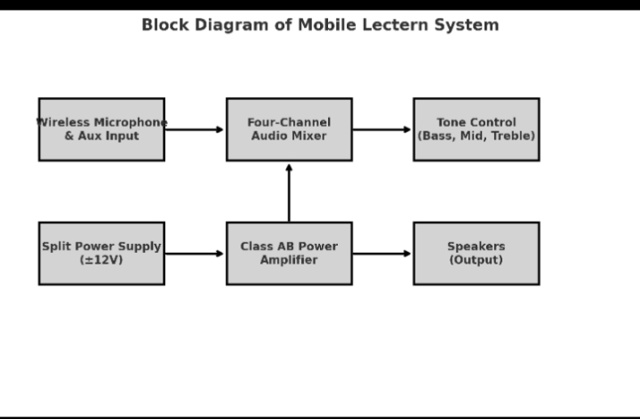3.5.2 System Device Circuit

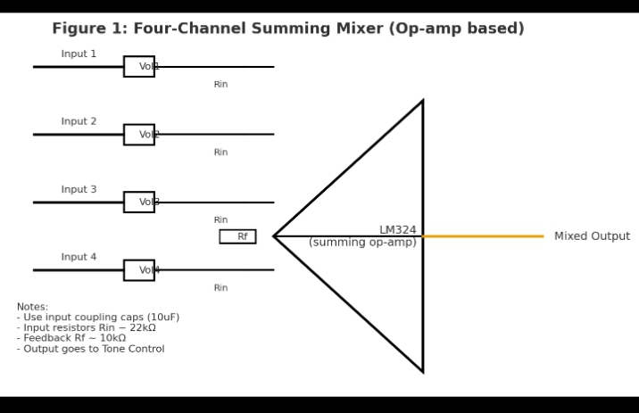

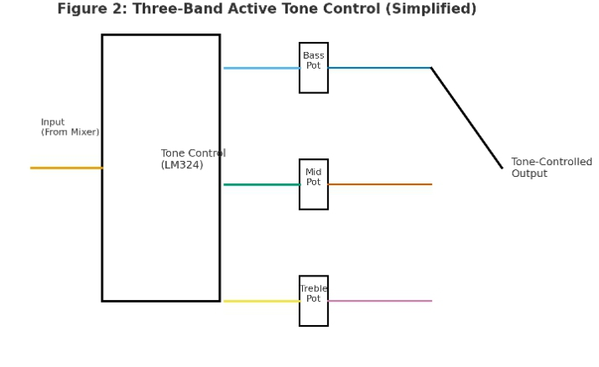
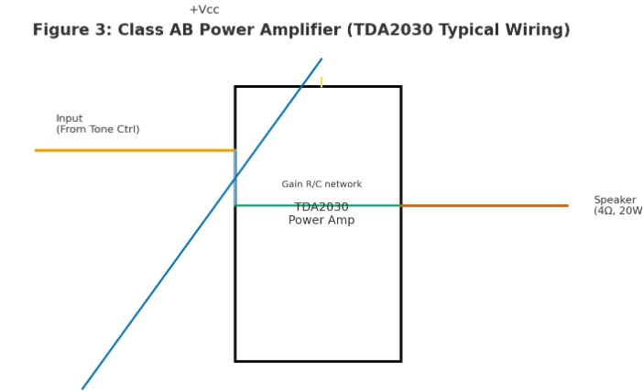
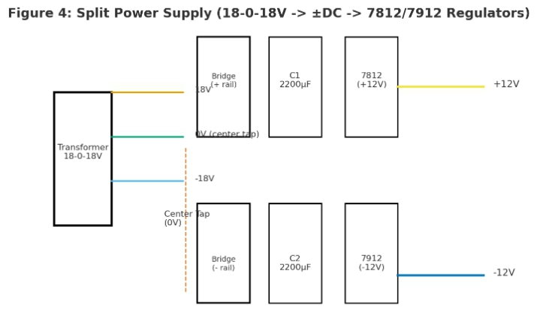
3.5.3 System Development
Fabrication of Lectern Body: Plywood cut into panels and assembled with screws.
Mounting Electronics: Amplifier and mixer boards mounted inside.
Speaker Installation: Two 20W speakers fixed in the front panel.
Control Panel: Knobs for volume, bass, treble, and auxiliary input jacks fixed at the top.
Mobility: Casters fixed at base for movement.

CHAPTER FOUR

RESULTS, DISCUSSION & COST ANALYSIS
4.0 Characteristics of Sound

1. Pitch (Frequency):

Pitch is the perception of how high or low a sound is.

It depends on the frequency of vibration, measured in Hertz (Hz).

Higher frequency = higher pitch (e.g., whistle), lower frequency = lower pitch (e.g., drum).

2. Loudness (Amplitude):

Loudness is how strong or weak a sound is perceived.

It depends on the amplitude of vibration and is measured in decibels (dB).

Larger amplitude = louder sound.

3. Quality (Timbre):

Quality or timbre distinguishes one sound from another even if they have the same pitch and loudness.

For example, the same note played on a piano and a violin sounds different because of timbre.

4. Duration:

This refers to how long a sound lasts.

Short duration = clap, long duration = ringing bell.

5. Speed (Velocity of Sound):

Sound travels at different speeds depending on the medium (e.g., ~343 m/s in air, ~1500 m/s in water).

6. Wavelength:

The distance between two consecutive compressions or rarefactions in a sound wave.

It is inversely related to frequency.
4.0.1 Noise Level and Sound Pressure Level (SPL)
Background noise without input measured at 25–30 dB.
Maximum SPL at 1 meter from lectern measured at 90 dB, sufficient for a class of 70–100 students.
Distortion was below 2% THD (Total Harmonic Distortion) at maximum volume.
4.0.2 SPL Decreases with Distance
At 1 meter: 90 dB
At 3 meters: 75 dB
At 6 meters: 68 dB
This follows the inverse square law of sound propagation, showing expected attenuation.
4.0.3 Sound Reverberation and Absorption
The lectern’s wooden body provided some natural sound absorption.
Rubber padding reduced vibration noise.
Classrooms with tiled floors had more reverberation compared to those with curtains or acoustic boards.
4.1 Discussion
Performance: The mobile lectern functioned effectively during trials.

Lecturers could deliver lectures clearly without straining their voices.
Mobility: The addition of caster wheels allowed easy relocation between classrooms.
Flexibility: Wireless microphone eliminated the problem of wire clutter.

User Feedback: Test users reported improved engagement and clearer understanding due to amplified sound.
Limitations: The system required mains power; however, adding a rechargeable battery could solve this in future improvements.
4.2 Cost Benefit Analysis
Cost of Fabrication (Prototype)
Plywood & metal frame: ₦18,000
Casters & fittings: ₦5,000
ICs, resistors, capacitors: ₦12,000
TDA2030 amplifier kit: ₦10,000
Wireless microphone system: ₦20,000
Speakers (20W × 2): ₦8,000
Miscellaneous (wires, knobs, paint): ₦7,000
Labour (fabrication + electronics assembly): ₦20,000
Total Project Cost: ~₦100,000
4.2.1 Market Alternatives
Standard lectern + external PA system: ₦150,000 – ₦180,000.
Imported powered lectern: ₦200,000 – ₦250,000.
Savings: The mobile lectern prototype reduced cost by 30–40%, while offering integrated features.
4.2.2 Material List
1. Plywood (18 mm) – 2 sheets
2. Mild steel pipes (1 inch square) – 10 ft
3. TDA2030 ICs – 2 pcs
4. TIP41/TIP42 transistors – 4 pcs
5. LM324 IC – 2 pcs
6. Voltage regulators (7812/7912) – 2 pcs each
7. Diodes (1N5408) – 8 pcs
8. Electrolytic capacitors (2200 µF, 100 µF, 47 µF) – assorted
9. Potentiometers (10k, 100k) – 6 pcs
10. Cordless microphone (UHF) – 1 set

- Loudspeakers (20W, 4Ω) – 2 pcs
12. Transformer (18-0-18V, 3A) – 1 pc
13. Casters (3-inch) – 4 pcs
14. Paint, varnish, screws, connectors
4.2.3 Labour Cost Breakdown
Carpentry & welding (frame fabrication): ₦12,000
Electronics assembly & soldering: ₦8,000
Testing & calibration: ₦5,000
Finishing (painting & polishing): ₦5,000
Total Labour Cost: ₦30,000

CHAPTER FIVE

CONCLUSION & RECOMMENDATION
5.1 Conclusion
The development of a mobile pulpit for effective learning provides a practical and innovative solution to the limitations of traditional stationary lecterns. By incorporating mobility,ergonomics, and support for digital devices, the mobile pulpit enhances the teaching-learning experience, making it more interactive and dynamic. Its lightweight structure, adjustable features, and storage options allow lecturers to adapt easily to various classroom environments. Furthermore, the design promotes closer lecturer-student interaction, active participation, and flexibility in teaching methods, thereby contributing to improve learning outcomes. The mobile pulpit is not only cost-effective and user-friendly but also aligns with the modern demand for flexible, technology-supported educational tools. This innovation represents a significant step toward advancing teaching aids that support effective, engaging, and inclusive learning.
5.2 Recommendations
Incorporate rechargeable batteries for backup.

Commercial production should consider modular design for easy assembly and repair.

Future designs may integrate multimedia systems such as built-in projectors and wireless microphones.
Lightweight materials like aluminum may be used to reduce overall weight.
Improve aesthetic design for commercial appeal.
Scale up production to support larger auditoriums.

References

- Adeoye, A.A.,& Bello, K. (2021). Innovative classroom technologies and their impact on teaching effectiveness. Journal of Educational Development,15(2), 45-53.
- Olatunji, M.O. (2019). Design and fabrication of instructional materials for effective learning. Nigerian Journal of Technical Education, 7(1), 88-97.
- Yusuf, T. A., & Okoro , C. (2020). The role of mobility in modern educational tools. International Journal of Engineering Research and Innovation,12(3), 102-110.
- Adebayo, J.S.(2022). Technology integration in higher education classrooms. African Journal of Education and Technology,9(4), 56-66.
- Kumar, R., & Singh, P. Ergonomic design considerations in educational furniture. International Review of Applied Engineering Research, 14(6), 321-330.

