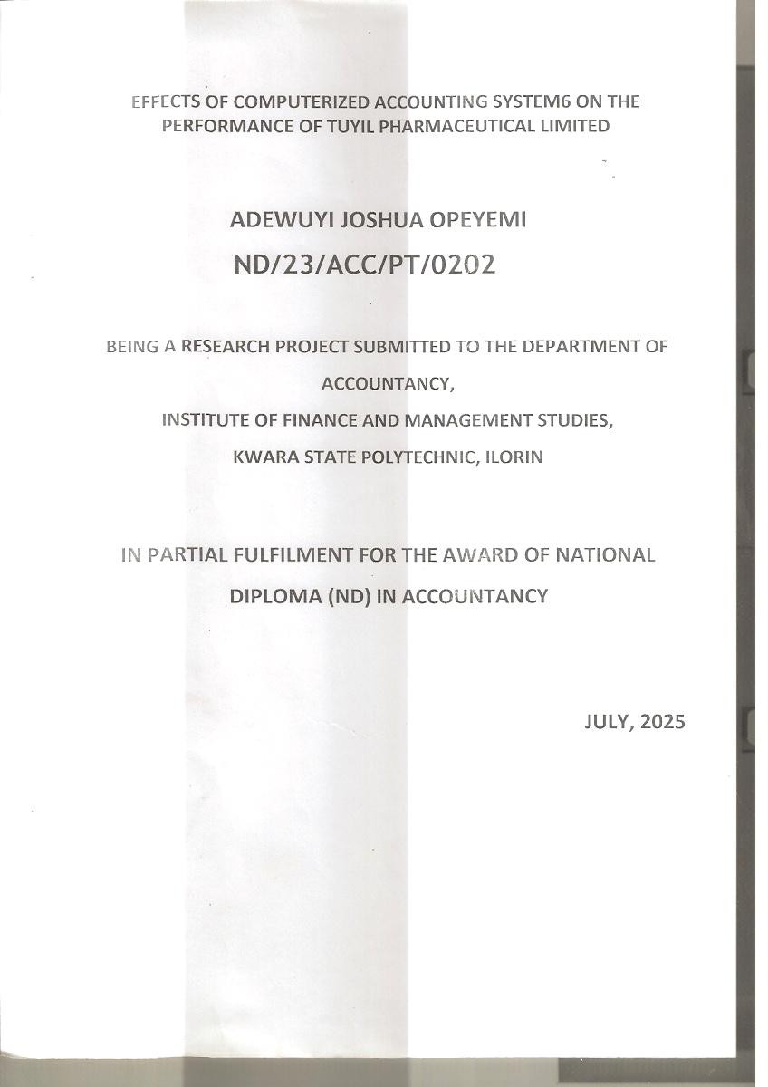







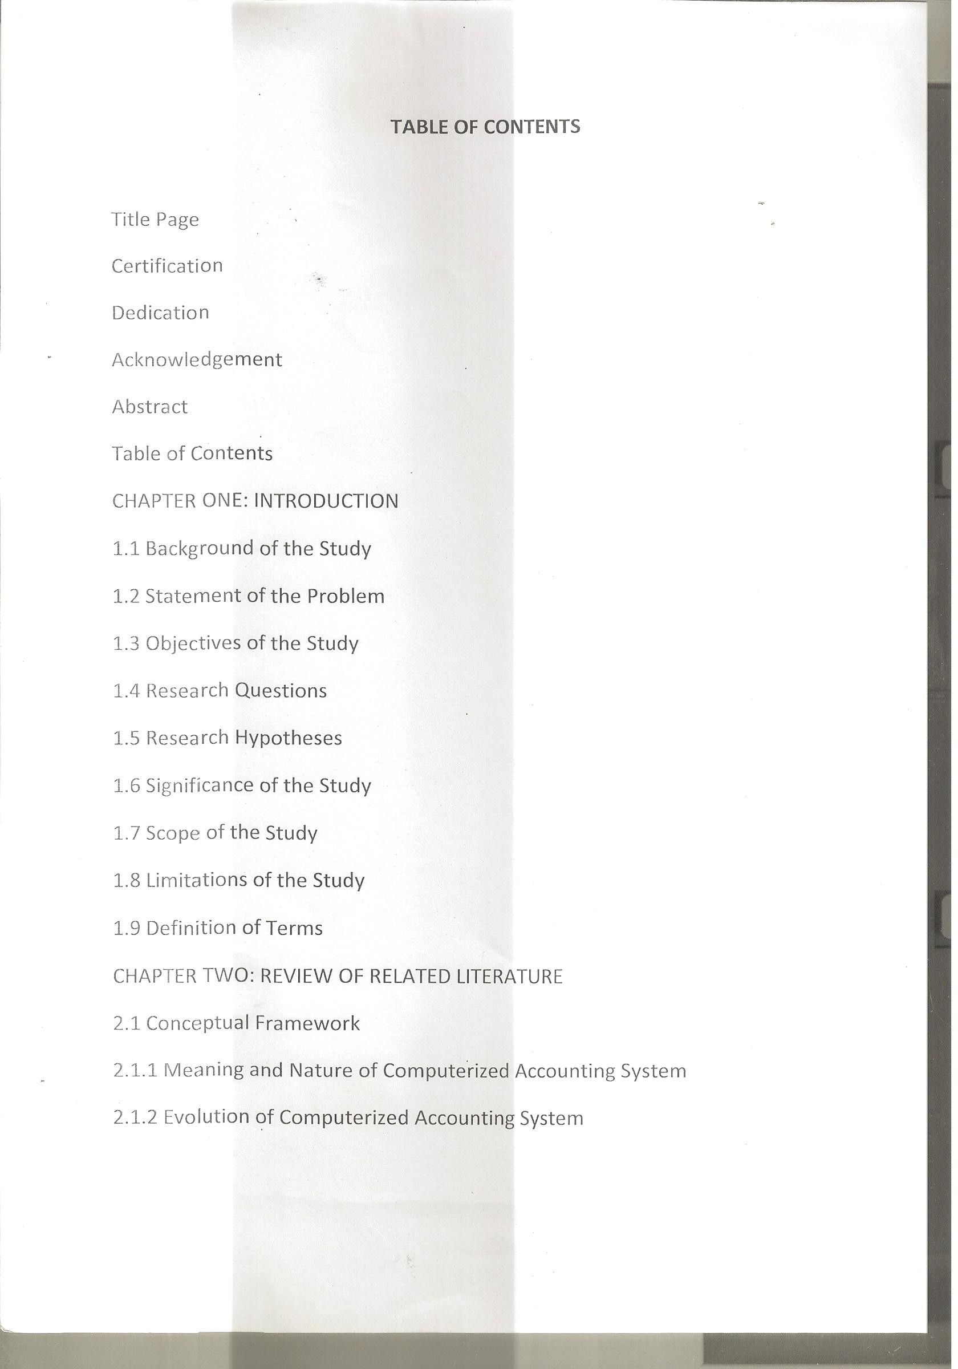

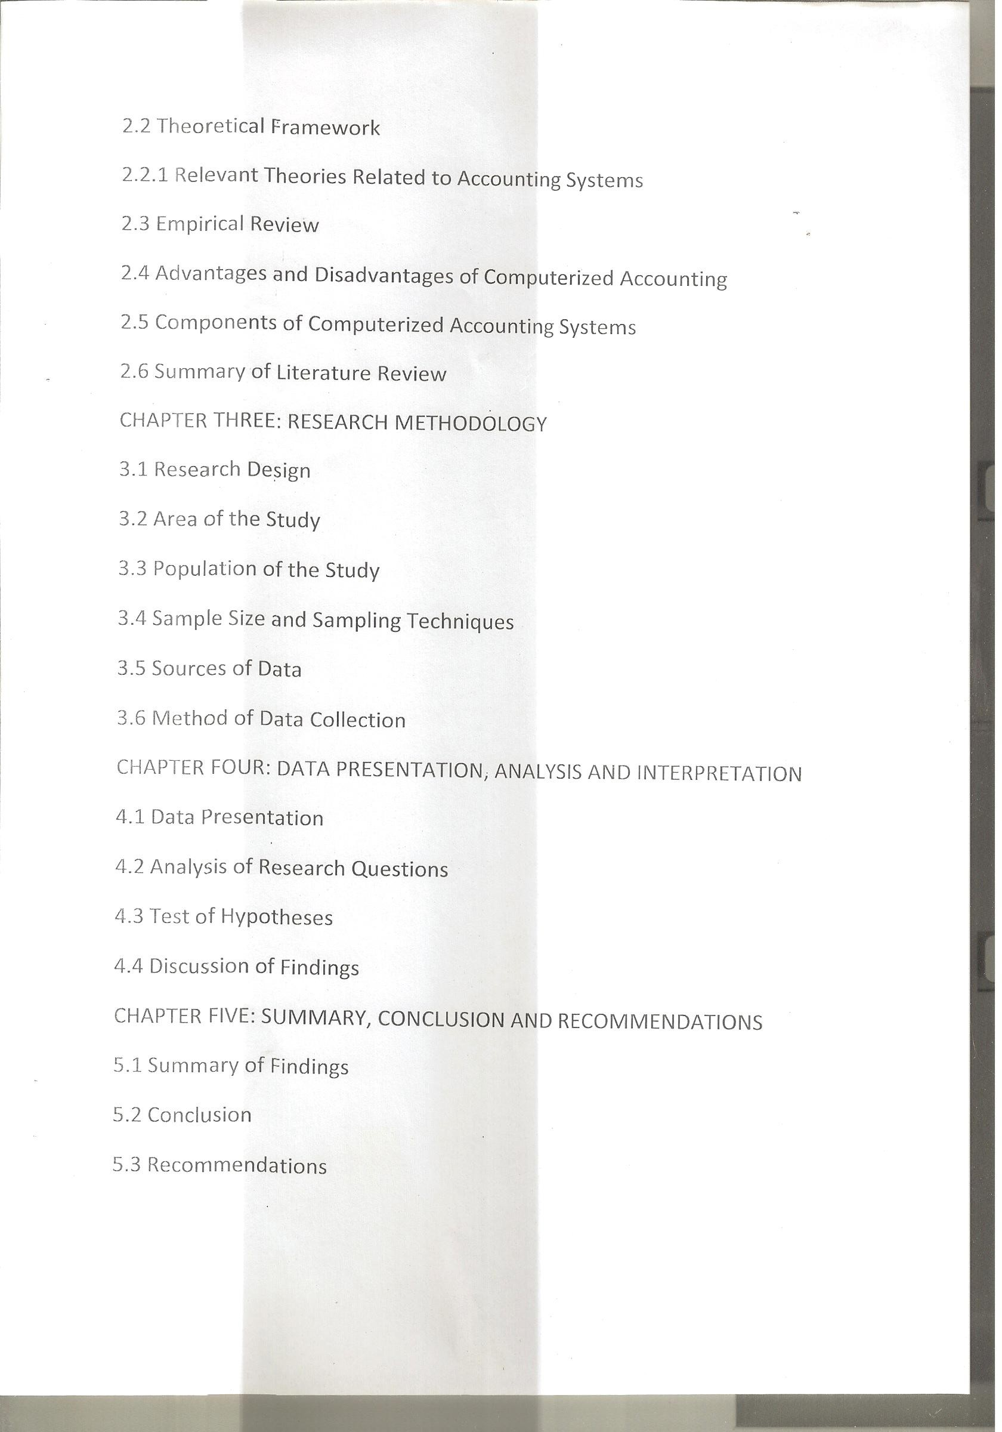



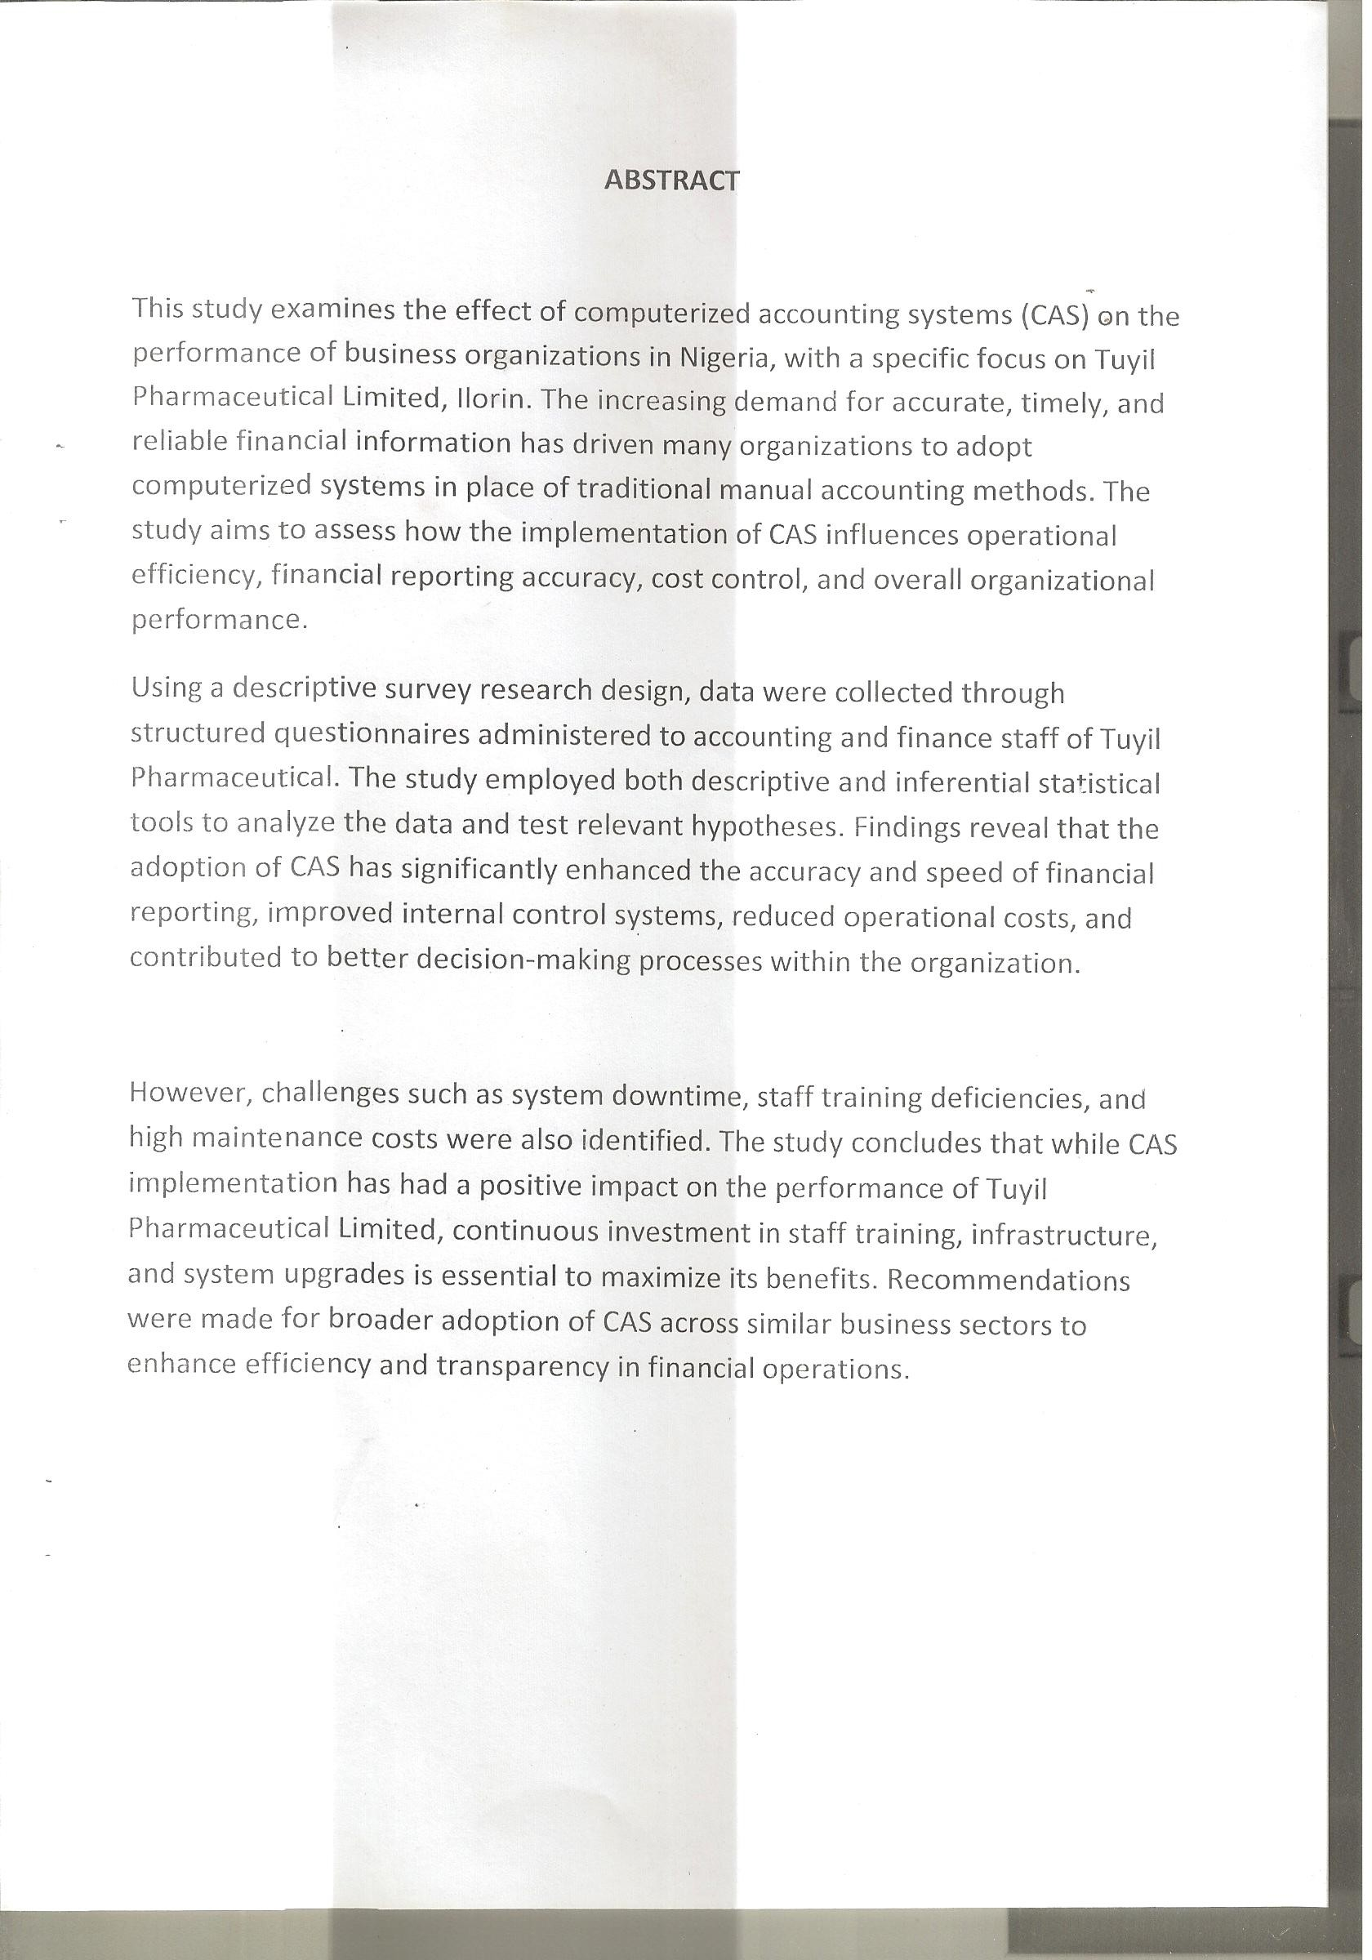

CHAPTERONE
INTRODUCTION

BackgroundtotheStudy
In today’s dynamic business environment, accounting information plays a critical role in guiding business decisions, evaluating performance, and ensuring transparencyandaccountability.Traditionally,accountingsystemsweremanually operated, often resulting in delays, errors, and inefficiencies. However, with advancements in information and communication technology, businesses have increasingly adopted Computerized Accounting Systems (CAS) to streamline operations and enhance decision-making processes.
A Computerized Accounting System is an integrated software application used for recording,classifying,analyzing,andpresentingfinancialtransactionsinreal-time. These systems are designed to improve the accuracy, speed, and efficiency of accounting operations while reducing the risk of human error. In the Nigerian businessenvironment,theadoptionofCAShasbecomemorewidespreadasfirms seek competitive advantages, regulatory compliance, and improved financial management.
TuyilPharmaceuticalLimited,aleadingpharmaceuticalfirmbasedinIlorin,Kwara State, represents a critical case for examining the role of CAS in enhancing businessperformance.Asanorganizationthathandlesalargevolumeoffinancial transactions and operates in a highly regulated industry, the implementation of a computerized accounting system is expected to influence not only the quality of its financial reporting but also its overall operational efficiency.
This study seeks to investigate the extent to which the adoption of CAS has impactedtheperformanceofTuyilPharmaceuticalLimited,focusingonareas such as financial accuracy, internal control, cost management, and decision- making.

StatementoftheProblem
Despite the numerous advantages associated with the use of computerized accounting systems, some organizations in Nigeria, including those in the pharmaceuticalsector,continuetofacechallengesinfullyrealizingthebenefits. These may include lack of technical expertise, resistance to change, inadequate infrastructure, high installation and maintenance costs, and cybersecurity risks.
In the case of Tuyil Pharmaceutical Limited, while the organization has embraced computerizedsystems,questionsremainastohoweffectivelythesesystemshave enhanced organizational performance. Are the systems improving the accuracy and timeliness of financial reporting? Have they led to better cost control and operational efficiency? Are there measurable improvements in decision-making and internal control structures?
Thestudyaimstobridgethisknowledgegapbyempiricallyassessingtheeffectof CAS on the performance of Tuyil Pharmaceutical Limited.

ObjectivesoftheStudy
Thebroadobjectiveofthisstudyistoevaluatetheeffectofcomputerized accounting systems on the performance of Tuyil Pharmaceutical Limited.
Thespecificobjectivesareto:
- Assesstheimpactofcomputerizedaccountingsystemsontheaccuracyand timeliness of financial reporting.
- DeterminetheextenttowhichCAShasimprovedinternalcontrolmechanisms within the organization.
- ExaminetherelationshipbetweenCASandcostmanagementefficiency.
- EvaluatetheinfluenceofCASonmanagerialdecision-makingprocesses.

- Identifythechallengesfacedintheimplementationandoperationof computerized accounting systems.

ResearchQuestions
Toguidethestudy,thefollowingresearchquestionsareposed:
- How has the adoption of computerized accounting systems affected the accuracyandtimelinessoffinancialreportingatTuyilPharmaceuticalLimited?
- TowhatextenthasCASimprovedinternalcontrolsintheorganization?
- WhatistheeffectofCASoncostmanagementand efficiency?
- HowdoesCASinfluencemanagerialdecision-makingatTuyilPharmaceutical Limited?
- WhatarethemajorchallengesencounteredintheimplementationofCAS?

ResearchHypotheses
Thefollowingnullhypotheseswillbetestedinthecourseofthis study:
H₀₁:Computerizedaccountingsystemshavenosignificanteffectontheaccuracy and timeliness of financial reporting.
H₀₂:Computerizedaccountingsystemsdonotsignificantlyimproveinternal control mechanisms.
H₀₃:ThereisnosignificantrelationshipbetweenCASandcostmanagement efficiency.
H₀₄:Computerizedaccountingsystemshavenosignificantinfluenceon managerial decision-making.

SignificanceoftheStudy
Thisstudyissignificantforseveralreasons:

ItprovidesempiricalevidenceontheeffectivenessofCASinenhancingbusiness performance, especially in the pharmaceutical sector.
ItofferspracticalinsightsformanagersandstakeholdersofTuyilPharmaceutical Limited on areas for improvement in accounting operations.
ThefindingscanguideotherNigerianbusinessesconsideringthetransitionfrom manual to computerized systems.
Itcontributestotheexistingbodyofacademicliteratureonaccounting information systems in developing economies.

Scopeofthe Study
This study is limited to Tuyil Pharmaceutical Limited, located in Ilorin, Kwara State, Nigeria. The focus is on assessing the effects of computerized accounting systems on selected performance metrics such as financial reporting, internal controls,costefficiency,anddecision-making.Theresearchcoversaperiodpost- adoptionofCASandinvolvesrelevantaccountingandmanagerialstaffwithinthe organization.

DefinitionofKeyTerms

ComputerizedAccountingSystem(CAS):Asoftware-basedsystemusedfor recording and processing financial transactions electronically.
Performance:Theeffectivenessandefficiencyofbusinessoperations,often measured in terms of profitability, cost control, and decision-making.
InternalControl:Mechanismsandproceduresimplementedtoensureintegrityin financial reporting and safeguard company assets.
FinancialReporting:Theprocessofpreparingfinancialstatementsthatprovide information about a company’s financial position and performance.

Decision-making:Theprocessofchoosingamongalternativesbasedonfinancial data and other relevant information.
WouldyoulikemetohelpdraftChapterTwo(LiteratureReview)orcreatethe questionnaire instrument next?

CHAPTERTWO
LITERATUREREVIEW

Introduction
This chapter presents a review of existing literature related to computerized accounting systems (CAS) and their impact on organizational performance. The reviewisstructuredunderconceptual,theoretical,andempiricalframeworks.It also highlights gaps in the literature that this study seeks to fill.

ConceptualFramework
ConceptofComputerizedAccountingSystem
AComputerizedAccountingSystem(CAS)isanautomatedmethodofrecording, storing, and analyzing financial transactions of a business. Unlike the manual system, CAS leverages software such as Sage, QuickBooks, Tally ERP, and SAP to process accounting data more efficiently. These systems generate financial reports with minimal human input, reducing errors and increasing reliability.
CAS typically includes modules for general ledger, accounts payable, accounts receivable,payroll,inventorymanagement,andfinancialreporting.Byintegrating financial activities, the system provides accurate and timely financial information to internal and external stakeholders.

OrganizationalPerformance
Organizationalperformancereferstohoweffectivelyacompanyachievesits objectives. In accounting studies, it is often measured using:
Financialperformanceindicators(profitability,costreduction,ROI) Operational efficiency (speed, accuracy, resource utilization) Decision-making support

Internalcontroleffectiveness
Inthepharmaceuticalindustry,timelyreporting,inventorymanagement,cost control, and compliance with financial regulations are vital for performance.

FeaturesofCAS
Keyfeaturesofcomputerizedaccountingsystemsinclude: Real-time data processing
Errordetectionandcorrection Automated calculations Integrated reporting systems Audit trail capabilities
Datasecurityandbackup
Thesefeaturesareessentialforenhancingbusinessperformance,especiallyin data-intensive industries like pharmaceuticals.

TheoreticalFramework
Thestudyisunderpinnedbytwoprimarytheories:

TheSystemsTheory
Systemstheoryviewsanorganizationasaninterrelatedsetofelementsworking toward a common goal. Within this framework, CAS is considered a subsystem that contributes to the broader organizational system. The theory suggests that improvements in the accounting system (e.g., automation, speed, accuracy) should translate into improved overall performance.

AccountingInformationSystem(AIS)Theory
AIStheoryfocusesontheuseoftechnologytoenhancefinancialinformation processing. The theory posits that a well-structured AIS, like CAS, improves:
Qualityoffinancialreports Internal controls
Decision-makingprocesses Stakeholder confidence
AIStheorysupportstheideathatCASshouldpositivelyinfluenceorganizational performance if implemented effectively.
EmpiricalReview

StudiesintheNigerianContext
SeveralstudieshaveexaminedtherelationshipbetweenCASandbusiness performance in Nigeria:
Okpara & Nwanne (2020) conducted a study on manufacturing firms and found thatCASsignificantlyimprovedfinancialreportingaccuracyandinternalcontrol systems.
Yunusa(2021)examinedthebankingsectorandreportedastrongcorrelation between CAS implementation and improved service delivery, customer satisfaction, and profitability.
Chude&Chude(2022)foundthatCASenhancedfinancialaccountabilityand efficiency in oil and gas firms in Port Harcourt.
Itang(2021)focusedonSMEsandconcludedthatCASsignificantlyimprovedthe relevance, accuracy, and reliability of financial information.

While these studies demonstrate the benefits of CAS, most are centered on banking,oilandgas,ormanufacturingsectors.Limitedresearchhasbeendoneon its effects in pharmaceutical firms, particularly in the North Central region of Nigeria.

InternationalStudies
Globally,CAShasbeenlinkedwithimprovementsin:
Reportingtransparency(Nasiretal.,2020)
Internal control compliance (David & Inyang, 2019) Real-timedecision-making(Kaplan&Norton,2016)
Thesestudiesreinforcethevalueofcomputerizedsystemsinenhancing organizational performance regardless of industry.

BenefitsofComputerizedAccountingSystems
Studies and industry reports highlight the following benefits: Accuracy:CASreduceshumanerrorsincomputationandposting.
Efficiency:Automatedprocessingsavestimeandimprovesproductivity. Speed: Transactions and reports can be processed in real-time.
ImprovedInternalControls:CASallowsbettermonitoringofaccess,transactions, and approvals.
RegulatoryCompliance:Itenablestimelypreparationoffinancialreportsfortax and audit purposes.
CostReduction:Overtime,CAShelpslowercostsassociatedwithdelays, misreporting, and inefficiencie
ChallengesinImplementingCASinNigeria Despitethebenefits,somechallengespersist:

HighInitialCostofsoftware,hardware,andtraining.
PowerSupplyInstabilityaffectingsystemaccessanddatasecurity Lack of Skilled Personnel to operate and maintain CAS.
Resistance to Change from employees used to manual methods. CybersecurityRisksandpotentialdatalossifnotbackedupregularly.
Thesechallengesmustbeaddressedtomaximizetheperformancebenefitsof CAS.

GapinLiterature
While numerous studies support the effectiveness of CAS, few have focused on pharmaceuticalfirmsinNigeria,particularlyinIlorin.Mostpreviousresearchhas concentrated on banks, oil companies, or general manufacturing industries.
Additionally,manystudieslackin-depthcaseanalysisoninternalcontrol improvements and decision-making impact.
ThisstudyfillsthegapbyfocusingonTuyilPharmaceuticalLimited,providing sector-specific insights into how CAS affects performance in a regulated and operationally complex industry.

SummaryofLiteratureReview
The literature reviewed highlights that CAS has the potential to significantly improvetheperformanceofbusinessorganizationsthroughenhancedfinancial reporting, improved internal controls, cost savings, and informed decision- making.However,properimplementationandcontinuoussystemupgradesare critical to achieving these benefits. The review also identifies a lack of research focused on pharmaceutical firms, which justifies this case study.
WouldyouliketoproceedwithChapterThree(Methodology)oradraft questionnaire next?

CHAPTER THREE RESEARCHMETHODOLOGY

Introduction
This chapter outlines the research design, methodology, population, sample size, datacollectioninstruments,andanalysistechniquesusedtoexaminetheeffectof computerized accounting systems (CAS) on the performance of Tuyil Pharmaceutical Limited, Ilorin. The methodology is designed to ensure the reliability and validity of the data collected and the conclusions drawn.

ResearchDesign
The study adopts a descriptive survey design combined with a case study approach.Thedescriptivemethodisusedtogatherdetailedinformationfromthe respondents through questionnaires, while the case study enables an in-depth examination of the specific operations and effects of CAS within Tuyil Pharmaceutical Limited. This combination allows for both quantitative and qualitative insights into the subject matter

PopulationoftheStudy
Thepopulationforthisstudyconsistsoftheaccounting,finance,internalaudit,IT, and selected management staff of Tuyil Pharmaceutical Limited, Ilorin. These individuals are directly involved with or knowledgeable about the company’s accounting systems and operational performance.
Estimatedpopulationsize:50staffmembers(basedoninternalrecordsor assumption for study purposes).

SampleSizeandSamplingTechnique
Giventhemanageablesizeofthepopulation,thestudyemploysthecensus samplingtechnique,wheretheentirepopulationisstudied.Thiseliminates sampling bias and ensures more accurate and comprehensive results

Samplesize=50staff members

SourcesofData
Twotypesofdatawereusedinthestudy:
PrimaryData:Obtainedthroughstructuredquestionnairesadministeredto respondents at Tuyil Pharmaceutical.
SecondaryData:Sourcedfromcompanydocuments,

