DESIGN AND IMPLEMENTATION OF CAR PARK MONITORING SYSTEM USING RFID SENSOR

(A CASE STUDY OF COMPUTER SCIENCE DEPARTMENT KWARA STATE PLYTECHNIC, ILORIN)

By

GBADEYANKA IBRAHIM OLAWALE
ND/23/COM/PT/0092
A PROJECT SUBMITTED TO
THE DEPARTMENT OF COMPUTER SCIENCE, INSTITUTE OF INFORMATION AND COMMUNICATION TECHNOLOGY, KWARA STATE POLYTECHNIC, ILORIN.
IN PARTIAL FULFILLMENT OF THE REQUIREMENTS FOR THE AWARD OF HIGHER NATIONAL DIPLOMA (HND)
IN
COMPUTER SCIENCE.

JULY, 2024
CERTIFICATION
This is to certify that this project was carried out by GBADEYANKA IBRAHIM OLAWALE , with Matriculation Number ND/23/COM/PT/0092 in the Department of Computer Science, Information and Communication Technology, Kwara State Polytechnic, Ilorin, Nigeria.

----------------------- -------------------------
MR ABIODUN E.T Date
(Project supervisor)

----------------------------- --------------------------
MR OYEDEPO F.S Date
(Head of department)

--------------------------- ------------------------
(External Examiner) Date

DEDICATION
This project work is dedicated to al-mighty God in whose mercy we dwell

ACKNOWLEDGEMENT
Gratitude is the least of all virtues and the researchers are deeply indebted to almighty God who sailed me throughout the period of my programme.
My unreserved gratitude equally goes to my supervisor in person of MR ABIODUN E.T for her relentless effort, high level of tolerance, suggestion and above all foe her intellect energy in supervising this project more grease to your elbow.
My deep gratitude goes to my parent, MR & MRS OMOGBOYE for their support, financing my education especially this project. God will replenish your pockets and bless you all.
My senior brothers and sister, I say a big thank you for your support financially may God bless you all
I still believe strongly that GOD will continue to help me in my future career. (Amen)

LIST OF FIGURES
Figure 4.1: Main menu interface; the page shows the interface of the software 15
Figure 4.2: Vehicle verification; this is the page is used to verified the vehicle 15
Figure 4.3: vehicle registration interface ; the page where registration take plae 16
Figure 4.4: Registration interface; this is where are vehicle are register 17

LIST OF TABLES
Table 4.6: Database for the vehicle registration 18
Table 4,.7: Database for registration 18

TABLE OF CONTENT

TITLE PAGE I
CERTIFICATION PAGE II
DEDICATION III
ACKNOWLEDGEMENT IV
LIST OF FIGURES V
LIST OF TABLES VI
TABLE OF CONTENT VII
ABSTRACT X

CHAPTER 1 – GENERAL INTRODUCTION
1.1 BACKGROUND OF THE STUDY 1
1.2 STATEMENT OF THE PROBLEM 1
1.3 AIM AND OBJECTIVES 2
1.4 SIGNIFICANCE OF THE STUDY 3
1.5 SCOPE OF THE STUDY 4
1.6 ORGANIZATION OF THE REPORT 4
CHAPTER 2 - LITERATURE REVIEW
2.1 Review Of The Past Work/Related To The Work 5
2.2 Overview Of General Text 6
CHAPTER 3: RESEARCH METHODOLOGY
3.1 Research Methodology 10
3.1.1 Analyzing Of The Existing System 10
3.2 Problem Of The Existing System 11
3.3 Problem Of The Proposed System 12
3. 4 Description Of The Proposed System 12
3.5 Advantage Of The Proposed System 13
CHAPTER 4: DESIGN AND IMPLEMENTATION AND DOCUMENTATION OF THE SYSTEM
4.1 Design Of The System 15
4.1.1 Output Of System 16
4.1.2 Input System 17
4.1.3 Database Design 17
4.1.4 Procedure Design 18
4.2 Implementation Of The System 18
4.2.1 Choice Of Programming Language 19
4.2.2 Hardware Support 19
4.2.3 Change Over Techniques 19
4.3 System Documentation 20
4.3.1 Documentation Of The Program 21
4.3.2 Operating System 21
4.3.3 Maintaining The System 22
4.4 Summary 23

CHAPTHER 5: SUMMARY CONCLUSION AND RECOMMENDATION
5.1 Summary 24
5.2 Conclusion 24
5.3 Recommendation 25
References 26
APPENDIXES
Appendix 1: Main Menu Flowchart
Appendix 2: Vehicle Registration Flowchart
Appendix 3: Vehicle Verification flowchart
Appendix 4: Source Code

ABSTRACT
This project deals with an effective way of finding empty spaces and managing the number of vehicles moving in and out in complex multi storeyed parking structures by detecting a vehicle using IR sensors and thus providing a feedback. The fully automated smart car parking system is rudimental and does not require heavy lines of code nor expensive equipment. It is a simple circuit built for the exact need of purpose. This automated system is used to find the vacancy in parking spaces available and navigate the driver to reach the desired space using visuals and in an effective manner, thus reducing search time. This system is required for malls, multi storey parking structures, IT hubs and parking facilities. This makes sure the requirement of labour is insubstantial.

CHAPTER ONE
GENERAL INTRODUCTION
  - BACKGROUND OF THE STUDY
The number of motor vehicles is rapidly increasing worldwide and therefore the parking problem is attracting a lot of attention. It becomes very difficult to find a vacant parking spot in a densely populated area especially during peak hours. Drivers keep on circling the complete parking lot to find a single empty spot. Leaving the vehicle in an unauthorized space has its own security and legal issues. At times people avoid travelling by their private vehicles and prefer the discomfort of traveling by public vehicles just to avoid the problems faced in parking their vehicles. Different centralised agencies take charge of the parking lots and charge heavily in order to allot a parking spot to the users. Here centralized agency refers to some third-party contractors that are given charge of parking spot allocation to the users, Vikas, et al. (2020).
There have been various works in recent years to improve the problem of parking slot allocation. However, most of these works are based on the predictions on historical data. With the increase of the number of vehicles, the nature of vehicular network is also getting highly dynamic, and therefore the prediction models fail to give high accuracy most of the times. The dynamic nature of vehicular network refers to the difficulty of predicting the number of parking requests in a particular area at a particular time,(Bowen, et al. 2020).
There are various Internet of Things (IoT) applications being developed in order to direct the vehicles towards an empty parking spot. Although such applications appear to solve the problem to some extent, they involve a lot of infrastructure changes, sensor deployments, data collection, etc., which ends up in enormous expenditures. The expenditures are in the form of installation expenditure and various maintenance related expenditures. Furthermore, these applications are limited to the parking lot premises where these are installed. For instance, there is no provisioning to inform or warn an approaching vehicle about the saturation of parking slots in a particular zone and redirecting the user to another parking zone. All these solutions are limited to the particular area and do not provide an end-to-end parking allotment solution to the users. Due to the centralized nature of parking slot allocation, there is no provision for small garages or open parking spaces to get registered and be used for parking vehicles by other people.
The distributed platform proposed in this study can help anyone register a space to be used for parking through which he can earn monetary benefits. The users looking for parking space can also choose the nearest available space and will not have to drive far from the required destination just to park the vehicle. The system will eventually be cost-optimal both for the users and the parking lot owners. This will also reduce the monopoly of few big parking lot owners and will prevent them from charging high price for parking vehicles, Vipul, et al. (2017).

  - STATEMENT OF THE PROBLEM
The average loss of time in finding a parking spot per driver is 20 hours annually in Nigeria. Millions of naira is spent in some years back in the form of fines for parking the vehicles in unauthorized places in Nigeria. Apart from the losses related to time and money, there are various other non-economic and health related loses reported in the survey report Nigeria. Many female drivers in Nigeria have reported stress and anxiety issues as a result of not being able to find a suitable parking slot. Almost every car owner of the people in Nigeria has reported the issue of missing an important meeting or an appointment with a doctor due to parking issues. There also have been cases of fight and arguments with fellow drivers due to frustration caused by lack of suitable parking space. These statistics show that with the increase in the number of vehicles, parking problem is becoming more intense in terms of time, money, environment, health and social relationships. Therefore, it is highly imperative to improve the basic architecture of the parking system and to make is completely distributed, fair, secure and cost-optimal.

1.3 AIM AND OBJECTIVES OF THE STUDY
The main aim of this project is to design and implement a system that would provide parking occupancy estimation and the objectives are to
- Design a system for parking slot allocation system and fee payment method,
- Create a parking permit management system
- Give pre-notification to the users is case of parking zone saturation is incorporated to avoid unwanted jamming or queues outside the parking zones.

1.4 SIGNIFICANCE OF THE STUDY
This work is motivated by the need to have a platform or a framework that can help people easily book a spot to park their vehicle before they actually reach in destinations. They do not have to search for a spot in a big parking zone and can directly move to the allotted spot and park their vehicle at the allotted price.

1.5 SCOPE OF THE STUDY
The scope of this project is to develop a prototype of a car parking space allocation system which is able to locate parking space for drivers and show the occupied space too. This will allow modifications and corrections to be done to the program in the nearest feature. This project is limited to computerization and information for car parking only.

1.6 ORGANIZATION OF THE STUDY
For easy study and proper understanding of this project write-up, It is planned and organized into five chapters. The description of what each chapter contains is explained below:
Chapter One: This contains an Introduction to the whole write-up, the problem of the study, aims and objectives of the study, the significant of the study, the scope and limitation of the study, and organization of the report.
Chapter Two: It focuses on the literature review of the study, organization of theboard of director, computerization of the current state of the art.
Chapter Three: It presents data collection method employed, analysis of data and existing system, advantages of the proposed system, design and implementation, programming language used with reasons, hardware and software support.
Chapter Four: It deals with the system design implementation and documentation, design of the system, output design, input design, file system, procedural design, and documentation of the new system.
Chapter Five: This centres on the summary, experienced gained, recommendation and conclusion.

CHAPTER TWO
LITERATURE REVIEW
2.1 REVIEW OF RELATED WORK
Hassija, et al, (2020) wrote an article on “A Parking Spot Allocation Framework Based on Virtual Voting and Adaptive Pricing Algorithm” Parking lot allocation problem has received much attention in recent years. There have been various works in the literature that target the parking lot allocation problem. However, most of these works use algorithms that run on centralized servers and are based on some predictions on historical data. Due to the dynamic nature of vehicular networks, the accuracy of such prediction models is not high which ends up in a chaotic situation for the parking lot owners as well as the vehicle owners. Therefore, a distributed Parking spot Allocation Framework based on Adaptive Pricing Algorithm and Virtual Voting is proposed in this paper. The proposed model is based on virtual voting and hashgraph consensus algorithm. Using the model, all users and parking lot owners can easily come to consensus finality about the allocation of a parking spot with the use of minimal bandwidth. The proposed model provides a fair, fast and cost-optimal parking spot allocation method. The perfect ordering of allocation requests is also maintained based on consensus timestamp. Further, an adaptive pricing model is proposed to enhance the overall revenue of the parking lot owners and comfort of the users. The proposed model is deterministic and can reduce the average parking cost and time. Performance evaluations reveal that the proposed model outperforms its counterparts in terms of accurate parking slot allocation, reduced cost and parking lot resource utilization.
Sewagudde (2019) “The design and implementation of a smart-parking system for Helsinki Area” The strain on the parking infrastructure for the general public has significantly grown as a result of the ever rising number of vehicles geared by the rapid population growth in urban areas. Consequently, finding a vacant parking space has become quite a challenging task, especially at peak hours. Drivers have to cycle back and forth a number of times before they finally find where to park. This leads to increased fuel consumption, air pollution, increased likelihood of causing accidents, to mention but a few. Paying for the parking is not straight forward either, as the ticket machines, on top of being located at a distance, in many times, they have several payment methods drivers must prepare for. A system therefore, that would allow drivers to check for the vacant parking places before driving to a busy city, takes care of the parking fee for exact time they have used, manages electronic parking permit, is right direction towards to toppling these difficulties. The main objective of this project was to design and implement a system that would provide parking occupancy estimation, parking fee payment method, parking permit management and parking analytics for the city authorities. The project had three phases. The first and the second phases used qualitative approaches to validate our hypotheses about parking shortcoming in Helsinki area and recruitment of participants to the pilot of the project, respectively. The third phase involved the design, implementation and installation of the system. The other objective was to study the challenges a smart parking system would face at different stages of its life cycle. The objectives of the project were achieved and the assumption about the challenges associated with parking in a busy city were validated. A smart parking system will allow drivers to check for available parking spaces beforehand, they are able to pay for the parking fee, they can get electronic parking permits, and the city authority can get parking analytics for the city planning.
Zhang, et al. (2020) “Developed a free Parking Space Prediction and Reliability Analysis Based on Big Data Analysis” the number of free parking spaces (FPSs) is highly dynamic and stochastic, calling for a parking guidance model that enables the driver to find the right parking lot. This paper explores the distribution of FPSs number in parking lots, predicts the number of FPSs, and proposes a parking guidance model with a solving algorithm. Firstly, the number of FPSs from several parking lots was subjected to big data analysis, revealing that the hourly number of FPSs obey similar trends on different weekdays. On this basis, the data on the FPSs number of the parking lots were classified by hourly, weekly and holiday features. Whereas the FPSs number obeys the normal distribution, a parking guidance model was established with the most reliable path to forecast the number of FPSs. Then, the solving algorithm was proposed based on the reliability boundary. Finally, the effectiveness of the model and algorithm was verified through simulation. Compared with the actual data, the prediction accuracy of the model is more than 95%. The research results shed new light on the development of parking guidance systems.
Bowen, et al. (2020) presented a “Research on Optimization of Stereo Garage Parking Location Based on Genetic-Tabu Search” In order to solve the disadvantages of long queue and low efficiency of vehicles access in the plane mobile stereo garages. A hybrid algorithm of genetic algorithm to optimize tabu search is proposed to optimize the parking space allocation strategy of the garage. Aiming to shorten the vehicle average waiting time and the working distance of the carrier in the process of vehicle access, the mathematical model of the stereo garage is established through the investigation and data extraction of the actual running stereo garage. The study compared the experimental simulation data of the genetic-tabu search hybrid algorithm and the tabu search algorithm. The experimental results indicate that: the Genetic-Tabu search hybrid algorithm has better convergence, which can effectively optimize the location allocation mode of the stereo garage, shorten the vehicle average waiting time and the working distance of the carrier. It has important application value.
More, et al. (2022) Presentation “Automatic Car Parking System using RFID” In recent times the number of vehicles are consistently rising and parking space is becoming a major issue in urban and semi urban cities so there is needs to design a parking system which will reduce manual work as well as reduce the problem of cars parked on streets. Since in modern world, where space has become a very big problem and in the era of miniaturization it has become a very important to avoid the wastage of space in modern, big companies and apartments etc. Automatic Car Parking enables the parking of vehicles-floor after floor and thus reducing the space used. In this paper we implemented the concept of Microcontroller Based car parking system. As we see in the modern world everything is going automation, here we have deployed an automatic microcontroller based system which is used to sense the presence & movement of cars and depending on availability of space it allows parking and same is displayed on LCD panel. There is also RFID module that will provide security as users who have authority can swap the RFID cards and get entry otherwise not. It will also be used to settle the parking fee that has to be paid by the user. The project is designed for automatically parking a car into the desired parking spot in a multi-floor parking lot.
Gupta, et al. (2020) “Smart Vehicular Parking System” In today’s world, ever growing population adds up increasing numbers of cars. Especially, in metro cities with limited spaces for parking, innovative measures are the need of the hour. Our paper focuses on this specific aspect of acute shortage of parking spaces. In this paper, we are proposing a smart vehicular parking model, that takes into account registered or non-registered users parking at the same time. Additionally, it also takes help of image processing to classify the available space based on the size of the vehicle, making it an optimized real-time parking prototype. Using RFID to authenticate each user, the model uses Internet of Things (IoT), cloud storage to makes it convenient for each and every individual to locate and remotely book a parking spot via a smart phone. It works to its full potential by securing cashless transaction via e-wallet. The efficiency of our prototype has been further established by improving parking area by 28 % under any given circumstance. Hence this novel idea excels in every aspect by providing an optimized parking space.
Ahmed and Guang Weis (2014) “Study on Automated Car Parking System Based on Microcontroller” This paper has shown the concept of an automatic car parking system. Everything in the modern world is going automatic, thus a system is built which can automatically sense the entry and exit of cars through the gate and then display the number of cars in the parking lot. This automated car parking system reduces the time taken to check the space for vehicles by displaying the available spaces for parking on a LCD displayer by using infrared (IR) sensors installed at the entrance and exit. This project is developed using 89c52 microcontroller.
Rui Zhou, et al. (2021) “presented article titled “Research on Automatic Parking System Strategy” the development of the automobile industry and the increase in car ownership has brought great traffic pressures to the city, among which, the difficulty of parking has become a serious problem to the majority of drivers. An automatic parking system can help drivers to complete parking operation or automatic parking task, and a decision control system is an important part of automatic parking system. In this paper, a strategy for generating the shortest parking path based on a bidirectional breadth-first search algorithm combined with a modified Bellman–Ford algorithm is proposed for automatic parking systems. Experimental results show that this scheme can improve the performance of an automatic parking system, especially in a complex environment.
Thomas and Kovoor (2017) wrote and presented a journal titled “A Genetic Algorithm Approach to Autonomous Smart Vehicle Parking system”the shopping malls are source of entertainment and pleasure for the public during weekends. People struggling to park their vehicle in parking bay of shopping mall is a usual scenario witnessed at those peak times. Customer precious time and fuel is wasted and they get only few time for shopping. Authorities find it difficult to cope up with this situation even after appointing more employees to manage the traffic experienced in the bay. A smart car parking system that could elevate this problem is an urgent requirement for the shopping mall. This paper falls light on this issue by proposing a new prototype for the smart vehicle parking system. A genetic algorithm approach has been taken to address the issue of scheduling the vehicle to the parking bay.
Joshi, et al. (2020) Developed a “Smart Car Parking System” This project deals with an effective way of finding empty spaces and managing the number of vehicles moving in and out in complex multi storeyed parking structures by detecting a vehicle using IR sensors and thus providing feedback. The fully automated smart car parking system is rudimental and does not require heavy lines of code nor expensive equipment. It is a simple circuit built for the exact need of purpose. This automated system is used to find the vacancy in parking spaces available and navigate the driver to reach the desired space using visuals and in an effective manner, thus reducing search time. This system is required for malls, multistory parking structures, IT hubs and parking facilities. This makes sure the requirement of labour is insubstantial.

2.2 OVERVIEW OF PARKING SYSTEM
Transport systems provide a variety of services allowing users to partake in desired activities. The provision of parking facilities is an integral part of the system and has an important role to play in providing the required services, and therefore enhancing the In providing an efficient parking service to satisfy the coherent demand, the design of parking lots and the management of the facilities should be taken into account The design of the proposed intelligent parking system will involve a number of fields that need to be critically considered if the intelligent parking system is to have useful results. These include, data capturing from the parking spots by sensing activity at the spot using sunSPOT motes, channeling the data through a gateway, displaying, storing, and dissemination of the information.
In recent years, the advances in information and communication technology (ICT) have enabled the development of systems and applications aimed at supporting rehabilitation therapy and, therefore, contributing to the enrichment of patients’ life quality. The creation and implementation of web-enabled communication, patient services, and other e-Health initiatives have been significantly developed and enhanced in order to improve the quality of health services and maintain a competitive advantage. Consequently, the quality of health care has significantly improved. Traditionally, technology has supported health professionals by providing instruments, diagnosis, and different therapeutic treatments. Moreover, the information and communication technologies have expanded their application to management and planning activities of health areas. Thus, companies involved in the health area must expand their capabilities to all stakeholders, including patients and the public in general towards robust, efficient, and friendly telemedicine systems.

2.3 THE NEED FOR TECHNOLOGIES AND COMMERCIAL SOFTWARE FOR COLLECTING VEHICLE REGISTRATION DATA
A variety of technologies have been tested and used by many law enforcement agencies in Nigeria. The technologies used in data collection and processing include a variety of systems such as optical scanners, Mobile Phones, printers, optical storage disks, portable computers, and digital cameras.
The current computer technologies allow shareholders to pay their collection/renewal bills at the designated banks or existing offices, electronically transfer the payment to the state agency account and provide deposit slips for the collection of receipts at the state agencies. The use of on – line error checks, and subsequently the needs for reentering Vehicle detailed data are not inevitable. At the beginning, these devices seem to be the best solution to all the registration problems because it tackles the issues of payment of vehicles registration dues into the government’s cover.
However, it still has its limitation, as they have not met up with the demands to the masses that spend endless time anxiously waiting for their demands to be met at the Licensing/Commission offices. Hence, the full computerization has not been effected as expected while technology and software programming has advanced in other countries.

2.3.1 SOME PARKING SYSTEM TECHNOLOGIES
A number of technologies have been deployed in an endeavour to solve the parking problem. While some parking solutions are deployed as stand-alone technologies in some situations, in other situations multiple technologies are combined to achieve a given goal. These technologies include
(1) Camera-based sensor technology
(2) Infrared sensor technology and
(3) Ultrasonic sensor technology.

- Camera-based sensor technology
Access control systems have been developed and installed in various parking lots. At the airport in Cape Town, an access control point was put in place. It works in such a way that a driver requests for a ticket at the entrance of the parking by pressing a button. When a ticket is issued, the driver is granted access to enter the parking bay. The ticket issued is marked with a code that records the time of entrance to the bay. At the time of exit, the driver has to pay for the time the car spent in the bay. Payment is done by inserting the ticket in another machine which reads the code on the ticket and calculates the amount of time spent. Then a parking fee is charged according to the time spent.
Sensors are used at entrance and exit points to keep track of the cars in and out. A display board (variable message sign) is used at the entrance to show whether the bay is full or still has unused slots. This technology helps with the management of payment of use of the parking bays. It also gives users a general idea of the number of available parking slots by displaying a message like “level 1 full”.
- Infrared sensor technology
In Cavendish shopping mall in Claremont, Cape Town, the access control system is used as well as another system that checks the status of each parking point. The system uses an infrared sensor to detect if a car is parked in a place. A light is fitted above each parking point to show the status. The light operates in the same way as the traffic lights on the road. However the meaning attached to the light colors is slightly different. A red light means that there is a car parked while a green light is used to express a free parking. There is a section designated for parents with kids. This section has an orange light to show that parking is meant for parents with children. This section also uses the red and green lights to show whether the parking spot is free or used. Another section is reserved for the disabled. It is marked with a blue light. This section also uses the red and green light to show the status of the parking.
This system is helpful to the drivers once they go through the entrance. It is relatively easy for the driver to look ahead and figure out where there are green lights in the bay. However, this is only possible for the corridor in which the driver is moving through. The driver has to keep looking until they can land on a green light. However, there is still a likely flaw that a driver may see a green light yet find it red and in-use by the time he reaches the spot.

- Ultrasonic sensor technology
Siemens AG developed a similar system (SIPARK) that uses ultrasound sensors. These are installed above every single parking to determine whether the parking space is occupied or not. This has been used in more than 70,000 parking spaces. The system is being used with better pay points that accept a wide range of payment options ranging from cash to non-cash options such as credit cards.

In a report by M. Crowder and C. Michael Walton, the need for intelligent transportation systems (ITS) is examined across a wide range of places. These include business districts, airports, and transit stations. The report emphasizes that university premises are yet a new pressure zone with an increasing need for a parking solution. This report further details the need for real time provision of information to motorists as a remedy to reduction in traffic
congestion. Among the systems examined in this report are: Saint Paul Advanced Parking Information system (St Paul APIS) in Minnesota, Phoenix Arizona intelligent parking system, Seattle center APIS, and a few others.

CHAPTER THREE
RESEARCH METHODOLOGY AND ANALYSIS OF THE EXISTING SYSTEM
3.1 RESEARCH METHODOLOGY
Tabu Search algorithm is a heuristic random search algorithm. The tabu search algorithm starts from an initial feasible solution and selects a series of specific search directions as the trial to move the objective function value to the global optimal solution. The process of tabu search algorithm can be described as: first, a set of neighborhood solutions is generated by the initial solution, and then a certain number of candidate solutions are determined in the neighborhood solution; If the objective function value corresponding to the best candidate solution is better than the current optimal solution, the contraindication criterion is ignored, the candidate solution is replaced with the current optimal solution, and the corresponding object is added to the tabu list. If the candidate solution does not exist, the non-tabu optimal solution is selected as the new current solution in the candidate solution, and the corresponding object is added to the tabu list. Repeating the iterative search process above until the stop criterion is met.
How Tabu Search Algorithm Work with The System
1. Initialize.
  - Determine search neighborhood(s) to be used and solution evaluation criteria.
  - Define tabu list(s) structure(s) and processes.
1.3 Define aspiration criteria and memory structures to employ.
1.4 Create initial solution to problem.
2. Local search. Examine and evaluate neighboring solutions. Select best non tabu neighbor or best tabu neighbor that meets aspiration criteria.
3. Implement move to the selected neighbor. Update tabu list structures (and other memory structures used). Return to Step 2 if stopping conditions are not met.
4. Return best solution found.
The method is achieved through the following steps:
- Application for allocating parking space for drivers is proposed.
- Application that keep record of the vehicles venue
- The application is designed in Adobe CS4 Dreamweaver web development package which involves the use of PHP server-side scripting language, MYSQL for database management and HTML (with other embedded functionalities) for the page design and layout settings. Hence, the program testing simply involves running it directly from a Mozilla Firefox web browser on local host server provided by Apache 2.0 in WampServer 2.0 application.
A. Application Design
The User enters the login details in the app and selects the vehicle type as shown in Fig.3. The dimension of the vehicle are retrieved from the database and availability of space is checked.
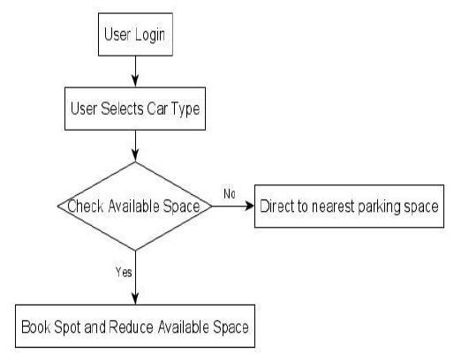
Figure 1: Application Flowchart
The parking system can have multiple scenarios

Scenario 1: Registered user with booking through application
1. User Enters and RFID is scanned
2. System checks for booking
3. Booking is available and user enters
4. RFID is scanned at exit
5. Total time the vehicle was parked is calculated
6. Bill is displayed on app and message is sent

Scenario 2: Registered user without booking through application
1. User Enters and RFID is scanned
2. System checks for booking
3. Booking is not available
4. System Read dimension of vehicle from database.
5. System checks for space availability.
6. If Space is available then user enters else “No Parking” is displayed.
7. RFID is scanned at exit.
8. Total time the vehicle was parked is calculated.
9. Bill is displayed on app and message is sent.

3.2 ANALYSIS OF THE EXISTING SYSTEM
The manual method of Car parking system involves supervisor having to check each time weather there is an empty space and confirms their departure to avoid any form of collision. The driver would select the parking spaces based on his own demand and judgment. If it comes to the popular parking spaces within the urban area, drivers are likely to make the similar decisions. This situation will lead the parking demand to exceed the parking capacity. Meanwhile, too many vehicles searching for parking spaces will cause traffic congestion in peak time. The temporal utilization of car parks is influenced by the arrival and departure rates of vehicles. Drivers’ choice behavior is influenced by driver characteristics as well as the attributes of car parks and PGI signs.
3.3 PROBLEMS OF THE EXISTING SYSTEM
Presently, the mode of storage is both in paring form and in digitized (i.e computer) form. Owing to lack of proper database maintenance plan, database recovery plan coupled with the increase in the vehicle registration, various problem raise their ugly heads in various fashions. The problems are itemized below.
- Poor performance experienced during information retrieval, due to Lack of efficient storage of data.
- Lack of proper, correct, accurate and concise information about the car owner.
- The delay associated with the registration, because of the manual methods of operation.
- Lack of proper and accurate keeping of information about old records that have been stored for some time.
- The issue of security of records.
- Time wastage: some activities are time consuming in the system for instance, searching for a particular car owner’s record will take some time.
- As different people are in charge of registration, it is possible for registration anomalies to result.
- The problem of work monotony and tediousness that result from doing the same thing repeatedly.

3.4 ANALYSIS OF THE PROPOSED SYSTEM
The system checks for availability of each and every parking spot using proximity sensor in every two minutes. If the spot is empty then the wireless sensors nodes transmit the location of the spot to the cloud, the user can then book the parking spot and pay online. The system we have built is an amalgamation of various technologies. Image recognition is being used in our model to measure vehicle dimensions and it serves as a parameter for booking a parking spot.This Automated car parking system enables the parking of vehicles and thus reduces the time taken to check the space to be used by displaying the spot where the space for parking is available on an LCD display by using IR sensors at the entrance

3.5 ADVANTAGES OF THE NEW SYSTEM OVER THE EXISTING SYSTEM
New system, which is computerized, has so many benefits that will obviate the problem experience in the current system. The need for this new system cannot be over emphasized as it is aimed at achieving;
- Accuracy of Computation: Measures of accuracy will be achieved since the computer system will maintain stability in assigning fees based on assessment and making of accurate calculation.
- Neatness/Reduced Use of Paper: Computerization gives room for production of a very neat job. Besides, since the vast volume of paper, which is used in keeping/storing information, will no longer be needed, it will help in keeping a very neat office.
- Reduction of Cost: The computerized system will keep in reducing cost of operation due to constant production of forms and registers for keeping records as less form will be used.
- Use of Less Space for Record Storage: There will be elimination of much space used in storing records by introducing a computer storage media (disks) which can keep vast volume of information in a less space.

CHAPTER FOUR
DESIGN , IMPLEMENTATION AND DOCUMENTATION OF THE SYSTEM
4.1 DESIGN OF THE SYSTEM
Design of the system is a stage where various program modules are designed which are used as an alternative for solving the problem. This new system of online application consists of four major functions, which include, and registration of stolen car, giving response to report made on stolen car, updating the status of car stolen record and giving report of both stolen cars and found car.
The main activities undertaken in this stage include which take responsibility of all the above listed function are Output design, input design, file design and procedure design for the new system.
4.1.1 OUTPUT DESIGN
The output design show design of all information that would be displayed after input have been supplied into the system through the input design, these report are;
- Immediate response of report make display
- Giving report of both stolen cars and found cars
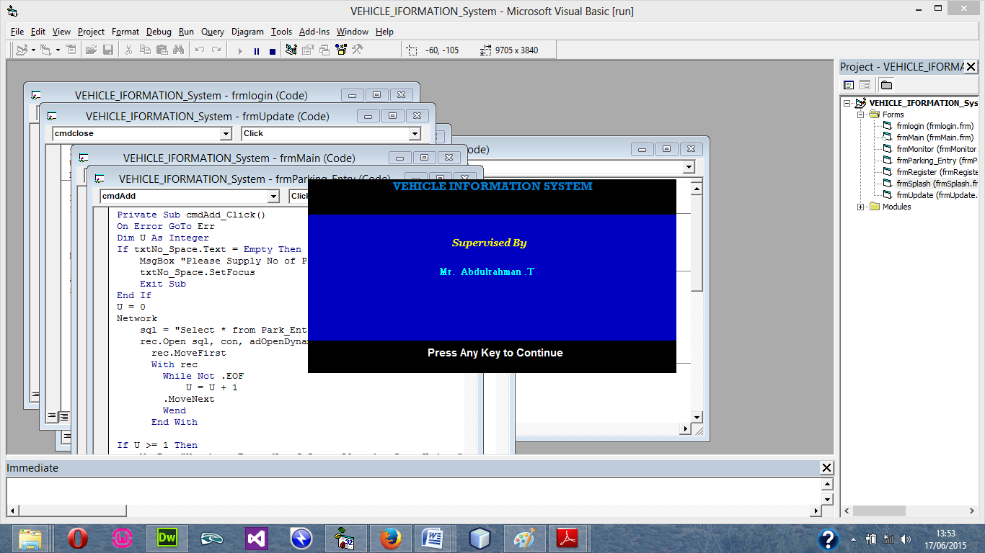
Mr Abiodun E.T
Figure 1: Splash Show
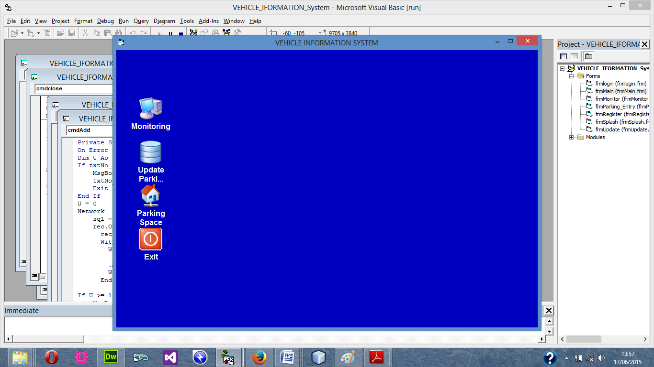
Figure 2: Main Menu
    - INPUT DESIGN
This design deals basically on data that are being input in the system, Input data are raw data that need to be processed in order to produce information for output.
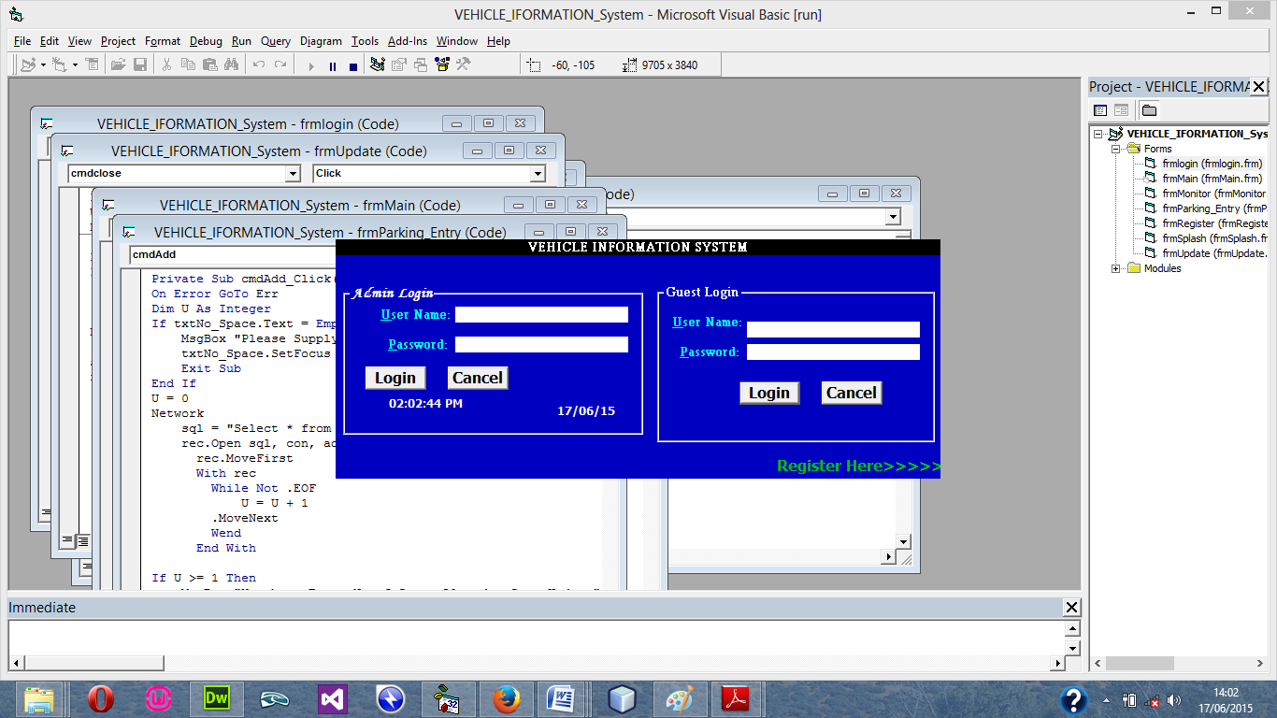
Figure 3: Login Menu
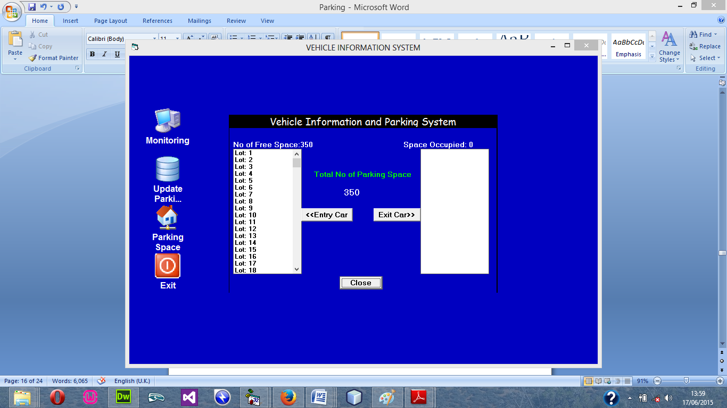
Figure 4: Car Entry Menu
4.1.3 DATABASE DESIGN
File Design involve the organization and structure of each file used in the system. It refers to the methods of creating, arranging, storing, retrieving and updating of records on the file.
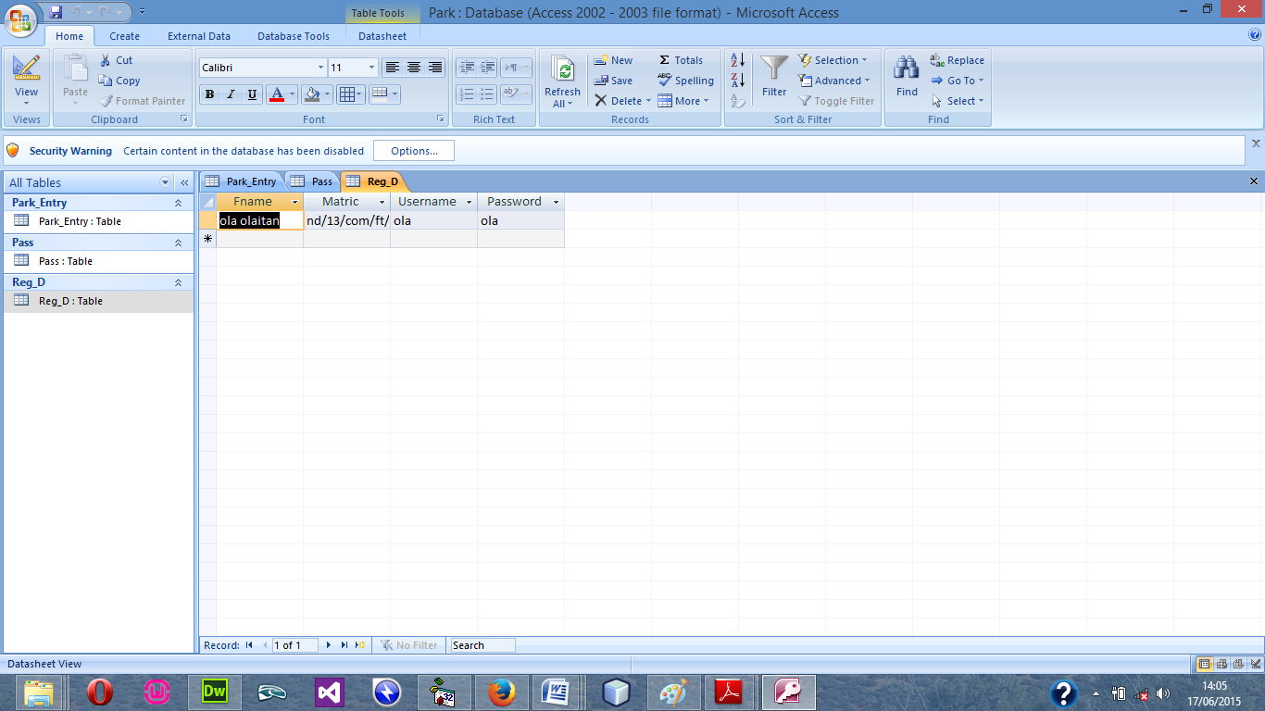
Figure 5: Registration design
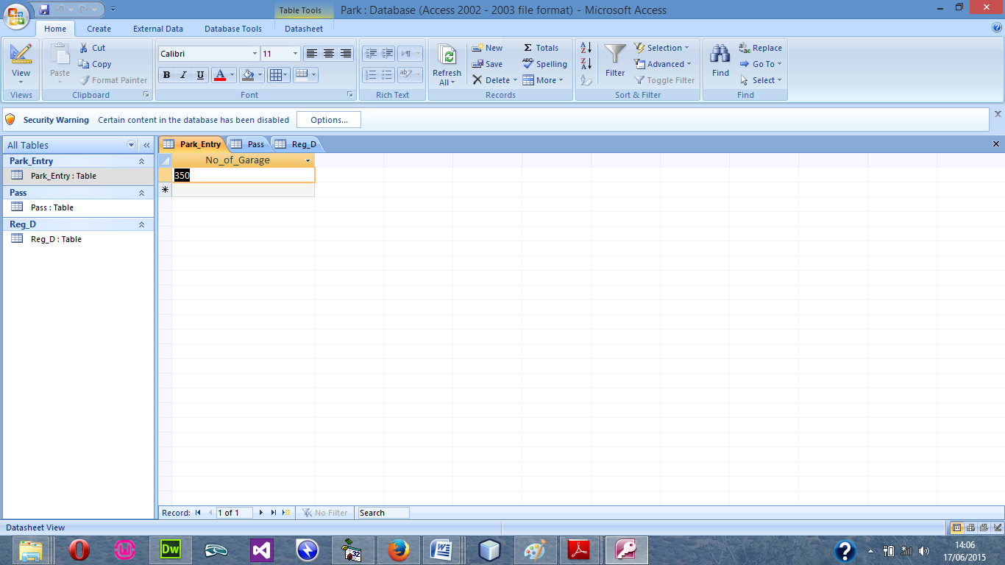
Figure 6: Cars Record table design view
    - PROCEDURE DESIGN
The procedural design describes the system generally. It describes the various main programs in the system as well as the relationship that exist between all subprograms included. The procedural designs in this new system are of 5 menus of which each menu has it sub menu.
The application also contains several modules of which each module has its own specific function. The purpose of dividing the program into modules is because it enhances maintainability, readability and easy debugging.
  - IMPLEMENTATION OF THE SYSTEM
The implementation of this system is majorly entails the coding aspects of the system. That is the means through which program are written before the system can be run and tested or debugged for correction. Tools that would be used in this aspect of implementation involve various application medias that are meant to serve the purpose or program requirement.
4.2.1 PROGRAMMING LANGUAGE USED
Visual basic 6.0 is the chosen programming language for the implementation of the proposed system because of its pedagogy and open source help when needed. As well it has a support for variety of database application like sql server, sqllite, mysql, and Microsoft access but Microsoft Access is selected.
4.2.2 Hardware Requirement
Hardware is the physical components of the computer system. The hardware needed is
- CPU with at least Pentium III processor, 600 MHZ Processor speed
- 14” monitor with resolution of 1024X768, VGA Card/SVGA
- CD ROM Drive/CD writer
- 10 GB free space hard disk
- UPS to prevent abrupt power supply
4.2.3 Software Requirement
The software support for the design of the proposed system involves operating system, Microsoft visual basic 6.0, Microsoft Access as well as an anti-virus software which prevents the system from being infected by virus.
4.2.3 Implementation Techniques Use in Detail
After the new system had been well developed, the next step is to put it into implementation. The implementation is the co-ordination in getting the new system into operation. The process should generate specification that will be employed and used to develop an information system that solves the problems defined during the system analysis.
The implementation techniques are parallel Implementation. Under this approach, the existing system and the new system would be used together until the DPM working on the system is able to use the new system very well it change from existing system to it proposed system be made at once. The old systems is on a predetermined data and it implemented system is conducted.
4.3 DOCUMENTATION OF THE SYSTEM
Program documentation is a written description of what each program modules does and the interrelationship within them. It guides the user how to go about using the system. Below are the three (3) main discussions under documentation of this research work
4.3.1 Operating the System
The program is design with the facilities of a website lunch on the web through a host account, the host provide space for the
STARTING/RUNNING THE PROGRAM
Before the system can be lunch, the user has to com
4.3.2 Maintenance of the System
The last stage in the system life cycle is the maintenance, which can be described as the periodically evaluation and modification of the system. This is done from time-to-time to see whether a system is meeting the goals and providing the services which it’s designed for.
This software can easily be maintained by adding more modules to it or removing existing module that is found to be irrelevant to the user’s need. Also the database allows for data resilience and portability. Maintenance at program refers to the correction, addition, or deletion of part of the program with ease program that has structure and features of maintainability which is referred to as a good ‘structured program’.
Generally, to be able to do any modification to each module in the program, one needs Ato open the program theenvironment. In the design environment of visual BASIC, double click on each module of visual BASIC, double click on each module to take you to its respective coding environment where necessary amendments could be made and the changes will be implemented immediately. This allows the maintenance of the program to be very easy.

CHAPTER FIVE
SUMMARY, CONCLUSION AND RECOMMENDATIONS
5.1 Summary
Car security systems have become extremely advanced. Having one installed in a car is one of the ways that you can avoid someone tampering with it. This is also a great way to get lower premiums on car insurance. There are many kinds of systems to choose from and most of them are really affordable. Check online for the best deal you can get. Sometimes car owners leave personal items in their cars like CD players, purses, and suitcase. These are temptations that a thief might not be able to pass up. Never leave these kinds of items in your car where they are visible to someone walking by. Tinted windows may also be something you might want to have for your car. This would be the best way to keep the interior more private.
Due to the fact that man cannot work beyond his capacity, there is reduction in the total output of the existing system of stolen vehicles recovery. The incidences that gave rise inefficiencies of the existing system and need for developing a new software based strategy include inability of workers to keep accurate account of record of stolen car, confirmation of stolen car if seen would not be easily confirmed, report would have to be made to the record room before such car can be confirmed, and this process might take a long time and inadequate storage facilities for keeping stolen car record. Therefore this exclusive project (software) has been design to take appropriate care of such problems listed.

5.2 Conclusion
In this study the development of a computerized parking system with recognition, parking lots status and guidance parking system and electronic billing system is successfully implemented. The performance of the developed of algorithms for Localization and lots. Recognition is acceptable range. The developed algorithms accurately localize and recognize in different location of the license plate. Electronic billing system performance is also acceptable and recommended for commercial use. This system has many advantages such as large capability, wide areas range, low operation costs, effective, Strong expandability and Easy to use in vehicle traffic administration. Upgrading any form of existing vehicle parking system is very easy which makes it open to future a requirement which also makes it more efficient.
5.3 Recommendations
Current methods of monitoring vacancies in parking lots have achieved varying levels of success, but most do not adequately deal with instances with severe vehicular occlusion. This system is a computerised vehicle information system for motor park. The aim of this research is to develop and implement a computerised parking system that will increase convenience and security of the public parking lot as well as collecting parking fee without hassles of using magnetic card. The computerised parking system will be able to have less interaction of humans and use no magnetic card and its devices. In additions to that, it has parking guidance system that can show and guide user towards a parking space. Overall, the systems run with pre-programmed controller to make minimum human involvement in parking system and ensure access control in restricted places. This project presents algorithm technology based method for computerized system that will be so the manual way of allocation space for drivers in a parking organisation

References
Diya&Binsu, (2018)International Conference on Smart Computing and Communications, ICSCC 2017, 7-8.
Zhenyu&Tian (2015)Mei and Tian EURASIP Journal on Wireless Communications and Networking 2011, 2011:104 http://jwcn.eurasipjournals.com/content
Romit (2016) Department of Computer Science, St. Xavier’s College (Autonomous), Kolkata
Zhendong et al (2021) Wireless Communications and Mobile Computing Volume 2021, Article ID 6639558, 6 pages https://doi.org/10.1155/2021/6639558
Natalia (2021) E3S Web of Conferences 284, 06012 (2021) TPACEE-2021 TPACEE-7
Minna (2016) Mechanical Engineering, Donghua University, Shanghai 201620, China; zhsun@dhu.edu.cn(Z.S.);2201136@mail.dhu.edu.cn(Y.L.);2201137@mail.dhu.edu.cn
Lödige (2018) Trycktav: Reprocentralen ITC IT 18 007 Examinator: JarmoRantakokkoÄmnesgranskare: OlleGällmo
Mustapha (2016)HAL Id: tel-01273151 https://tel.archives-ouvertes.fr/tel-01273151
Aashish et al (2020) International Journal of Engineering Research & Technology (IJERT) ISSN: 2278-0181 http://www.ijert.org
Yifei et al (2018) Urban and Traffic Planning Design Institute, Shanghai Urban Construction Design and Research Institute Sustainability 2019, 12, 120; doi:10.3390/su11010120
Hui Hu and Lian Fang (2009). “Design and Implementation of Vehicle Monitoring System Based on GPS/GSM/GIS” Third International Symposium on Intelligent Information Technology Application.
Lerdorf. R, (2007). “GSM-Based Mobile Tele- Monitoring and Management System for Inter-Cities Public Transportations”, International Conference on Industrial Technology (ICIT), Sharjah, UAE.
Thuong (2010).“Routing and Tracking System for Mobile Vehicles in Large Area”, Fifth IEEE International Symposium on Electronic Design, Vietnam.
Tim Berners-Lee, Muhammad UsmanAsad and AsimIqbal (2013).“GPS-GSM Integration for Enhancing Public Transportation Management Services”. Punjab, Lahore.

