EVALUATION OF NEEM LEAVE POWDER AS AN ALTERNATIVE PRESERVATION FOR COWPEA

BY
MUHAMMED ASHIAT ARIYO
ND/23/ABE/PT/0033

A RESEARCH PROJECT SUBMITTED TO THE DEPARTMENT OF AGRICULTURAL AND BIO-ENVIRONMENTAL ENGINEERING TECHNOLOGY, CENTRE FOR CONTINUING EDUCATION, KWARA STATE POLYTECHNIC, ILORIN.

IN PARTIAL FULFILMENT OF THE REQUIREMENTS FOR THE AWARD OF NATIONAL DIPLOMA IN AGRICULTURAL AND BIO-ENVIRONMENTAL ENGINEERING TECHNOLOGY

AUGUST, 2025

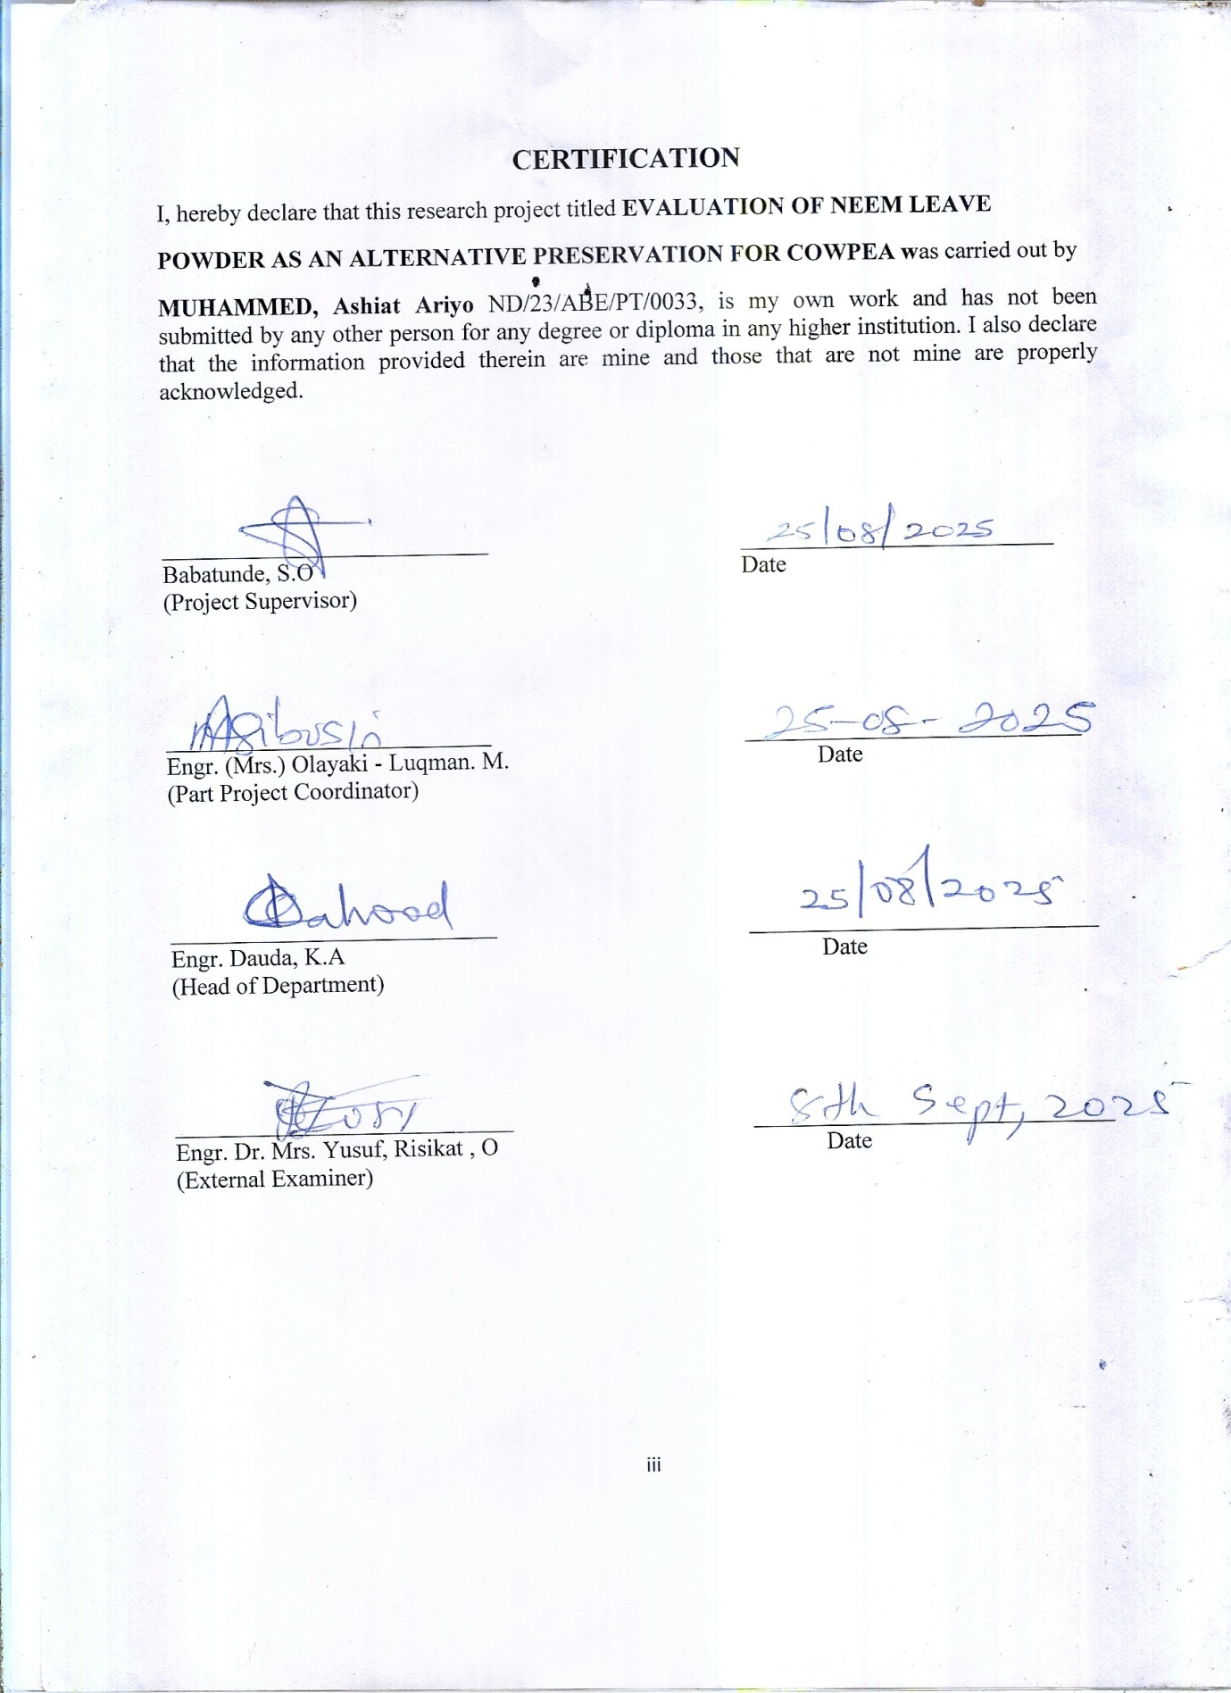

DEDICATION
This project is dedicated to Almighty Allah for his knowledge , protection and guidance and to my parent Mr and Mrs Muhammed for their support throughout my days in school

Acknowledgement
All thanks and adoration are to Allah for making this program a success.
Making use of this great opportunity to thank and appreciate my humble supervisor Engr Babatunde, S.O for her guidance in leading me to the right path, Thank you for the care Ma, may you Excel in your entire endeavour (Amen). And to all my lecturers, I say a big thank you.
With heart of gratitude, I acknowledge the effort of my parents Mr and Mrs Muhammed for their parental role in my life , and in making this project a successful one . May Allah continue to bless them.
Lastly, my gratitude goes to my family, friends and relatives and all my well wishers, thank you all for your invaluable instructions, financial support, words of encouragements during my stay in school.

TABLE OF CONTENTS
CHAPTER ONE - INTRODUCTION
1.1 Background to the Study 1
1.2 Problem Statement 2
1.3 Aims and Objectives 3
1.4 Project Justification 3
1.5 Scope of the Study 4
CHAPTER TWO LITERATURE REVIEW
2.1 Origin of cowpea 5
2.2 Nutritional composition of cowpea 5
2.3 Constituents of cowpea 5
2.4 Agronomy of neem plant 8
2.5 Effect of chemical on cowpea storage and human consumption 10 2.6 Pest management 10
2.7 Medicinal value of neem 10
CHAPTER THREE - MATERIALS AND METHODS
3.1 Materials used in the stud 11
3.2 Methodology 14
3.3 Proximate composition of cowpea 15
CHAPTER FOUR - RESULTS AND DISCUSSION
4.1 Result 20
4.2 Discussion 24
CHAPTER FIVE - CONCLUSION AND RECOMMENDATION
5.1 Conclusion 29
5.2 Recommendation 29
References

CHAPTER ONE
INTRODUCTION
1.1 Background to the Study
Cowpea (vigna unguiculata L.) is a vital legume crop in sub-saharan African, serving as a primary source of nutrition for millions of people (Langyintuo et al…, 2003). In Nigeria, cowpea is a staple food, providing essential protein, carbonhydrate and micro nutrients fort both rural and urban population (Ajeigbe et al…,2018) the crop plays a significant role in food security, income generation, and poverty eradication.
Cereals such as wheat, maize and rice, together comprise at least 75% of the world grain production and they are among the world’s most important staple foods (FAO, 2008).They constitute the major sources of food in the world and are usually seasonally cultivation with single harvesting per year in some regions. With the seasonality of cultivation, preserving is of high importance to ensure sustenance to their economic valve, continuous supply at stable price and maintain constraint their nutritional valve. Post-harvest losses are recognized as a major constraint in Africa, with storage damage sometimes as high as 40%. For example, nearly US$4 billion of the staple food, maize’ is lost annually in Africa to insects (Stevenson, 2014).
In spite of their efficacy, their repeated use for several decades have disrupted biological control systems, which have led to outbreaks of resistant insect pests, undesired effect on non-target organisms and environmental and human concerns.
However, Cowpea production is threatened by significant post harvest losses due to pests like the cowpea weevils (callosobruchus maculatus) (keba et al…,2023). These losses not only affect seed quality but also impact famer livelihoods, as they result in reducing income and food availability.
Chemical insecticides have been widely used to control cowpea pests, but there are use has raised concerned about environmental pollution, human risks, and the development of pest resistance (Williamson et al…,2011). The negative impact of chemical insecticide on the environment and human health has led researchers to explore eco-friendly alternatives.
Neem (AzadirachtaIndica) leaf powder has emerged as a promising natural preservative due to its insecticidal properties (Isman, 2006) studies have demonstrated the efficacy of neem leaf extracts and powder in controlling cowpea weevils (Ukatu et al…, 2020; Isinkaye and Ode, 2020).
- Aim and Objectives
Aim
The aim of the study is to evaluate the effectiveness of neem leaf powder as a natural preservative in controlling callosobruchus maculatus infestation and maintaining the quality of stored cowpea seeds.
Objectives
The specific objectives of this study are:-
- To determine the efficacy of neem leaf powder in controlling callosobruchus maculatus infestation in stored cowpea seeds
- To identify the optimal dosage of neem leaf powder that minimize pest damage while maintaining seed quality.
- To assess the potential of neem leaf powder as sustainable and eco-friendly alternative to chemical insecticides in cowpea storage.

  - Problem Statement
Cowpea suffer significant post-harvest losses due to insect attacks and microbial spoilage during storage, while chemical preservatives raise concerns about safety and environmental impact. The widespread use of chemical insecticides in cowpea storage has led to health and environmental concerns, including pest resistance. This research aims to investigate the effectiveness of neem leaf powder as a safer plant-based preservation alternative. Cowpea, a vital food crop, is vulnerable to pests like the cowpea weevil during storage, with chemical pesticides offering short-term solutions but posting health and ecological risks. As the demand for chemical-free and organic storage solutions increases, this study focuses on neem leaves powder as a potential natural preservative to extend the shelf life and protect the quality of cowpea during storage.
1.4 Justification
This study is justified because:-
- Improving food security:- Reducing cowpea post-harvest losses can enhance food availability and security.
- Eco-friendly Alternative:- Exploring neem leaf powder as a natural preservative can reduce reliance on chemical insecticides
- Sustainable agriculture:- the study promotes environmentally friendly pest management practices
- Economic benefits:-effective pest control can minimize economic losses for farmers and the agricultural industry
1.5. Scope of the Study
The scope of this study is to investigate the effectiveness of neem leaf powder as a natural preservative in controlling callosobruchus maculatus infestation and maintaining the quality of stored cowpea seeds.
CHAPTER TWO
LITERATURE REVIEW
2.1. Origin of Cowpea
Cowpea (vigna unguiculate) is believed to have originated in west Africa, specifically in the regions now known as Nigeria and Niger (Steptoe et al….,2007). According toPadulosi and Ng(1997), cowpea has been a staple crop in many African countries for centuries, providing a vital source of protein and nutrients.

2.2 Nutritional Composition of Cowpea
Most of the nutrient composition data is based on cowpea whole grain, although there is a limited amount of data for dehulled grains, sprouted grains and leaves. Whole grains include the seed coat which represents 6% of grain dry matter (Aremu, 1990).
The cowpea is morphologically variable and adapted to different environments, resulting in a wide range of local varieties (OECD, 2015). The nutritional composition of cowpea is impacted by genetic characteristics, agro-climatic conditions, biotic stresses and postharvest management (Goncalves et al., 2016; Murdock et al., 2003; Oluwatosin, 1998; Silveira et al., 2001). The cowpea is highly nutritious and has potential health benefits because of its high protein, high fibre and low glycaemic index, (OECD, 2018).

2.3 Constituents of Cowpea
The proximate composition of a large number of cowpea varieties is listed in Tables 2.2 and 2.3 below as reviewed by different researchers.

Carbohydrates and Fibres
The cowpea contains a high proportion of carbohydrates, representing the majority of the dry weight of the grain, leaves, and sprouts (Goncalves et al., 2016). Eight sugars (simple carbohydrates) have been reported in the cowpea, namely, sucrose (11-19 g/kg), glucose (4-5 g/kg), fructose (1-2 g/kg), galactose (≤ 15 g/kg), maltose (≤ 11 g/kg); and three carbohydrates considered to be anti-nutrients, stachyose (17-60 g/kg), verbascose (6-13 g/kg), and raffinose (5-10 g/kg) The crude fibre (complex carbohydrates) content of whole cowpeas ranges from 2.5% to 32% of total dry matter. The crude fibre content decreases when the seed coat is removed. The means for total, insoluble and soluble dietary fibre of dehulled cowpeas reported by Khan et al. (2007) are 18.2%, 14.8%, and 3.3% of dry matter respectively. Total dietary fibre includes cellulose (6%), hemicellulose (3.9%), lignin (2%), and pectin (1.8%) (Khan et al., 2007).

Protein
The cowpea provides a source of protein (Boukar, Massawe and Muranaka, 2011) with the whole grain containing levels ranging from 16% to 31%. The seed coat contains 12% protein (Aremu, 1990). Most of the cowpea grain proteins consist of globulins with lower levels of albumins, glutens, and protamine (Goncalves et al., 2016; Vasconcelos et al., 2010).
The amino acid composition of the cowpea is rich in lysine, leucine, arginine and other essential amino acids and can largely fulfill the essential amino acid requirements of a human diet. However, cowpeas are low in the sulphur amino acids (methionine and cysteine) compared to cereals and animal products and thus, for a balanced diet, cowpeas need to be supplemented with cereals or vegetables, meat and/or dairy products (Iqbal et al., 2006; Uzogara and Ofuya, 1992; Hussain and Basahy, 1998; FAO, 2004).

Lipids/fatty acids
According to (Goncalves et al., 2016) the lipid content of cowpea whole grain ranges from 0.5% to 3.9%. The lipid profile of cowpea indicates a predominance of triglycerides (41.2% of total fat), followed by phospholipids (25.1% of total fat), monoglycerides (10.6% of total fat), free fatty acids (7.9% of total fat), diglycerides (7.8% of total fat), sterols (5.5% of total fat) and hydrocarbons and sterol esters (2.6% of total fat) With respect to fatty acids, linoleic acid and palmitic acid predominate followed by oleic acid, stearic acid and linolenic acid (Thangadurai, 2005; Goncalves et al., 2016).

Minerals
Cowpeas are a source of essential minerals, calcium, magnesium, potassium, iron, zinc and phosphorus. Low availability of soil phosphorus is a primary constraint to cowpea production in developing countries (Burbidgeet al., 2016). Levels of grain phosphorous, potassium and manganese vary widely due to environmental conditions (Adebooye and Singh, 2007). Most minerals are at higher concentrations in leaves (Gerrano et al., 2015) and immature green pods (Gerrano, Jansen van Rensburg and Adebola, 2017) compared to grain (Belane and Dakora, 2012; Madodeet al., 2011). Some minerals are lost when the seed coats are removed, (Mamiroet al., 2011).

Vitamins
Cowpeas are a source of thiamin and niacin, and also contain reasonable amounts of other water-soluble vitamins such as riboflavin. Vegetative tissues including germinated grain tend to have higher levels of niacin, thiamin and riboflavin than grain (Nnanna and Phillips, 1989; Goncalves et al., 2016). Seed coat removal results in up to 30% loss in niacin content, while thiamin is reduced 41% by cooking (Nnanna and Phillips, 1989). Vitamin C values are higher in leaves than grains and increased by 4 to 38-fold after grains sprout (Devi, Kushwaha and Kumar, 2015. Cooking in an alkaline solution containing “kanwa” (naturally-occurring rock-salt) decreases thiamin, niacin and riboflavin levels compared to cooking without “kanwa” (Uzogaraet al., 1991). Fermentation results in a significant increase in the levels of thiamin and niacin (Akinyele and Akinlosotu, 1991).
2.4 Agronomy of Neem Plant
Azadirachta indica A. Juss., commonly called ‘Neem by the English, it called dogonyaro in Hausa, Igbos calls it Akun shorop and Yorubas calls it Awe kasha, this has been used in traditional medicine since antiquity, is regarded as ‘holy tree’ ( Dharmendraet al.,2016) . Neem trees grow generally 15-20 m tall and have a life span of 150-300 years. Fruits are green that turns yellow on the time of ripening. It is sensitive to frost and restricted to warmer parts of the world (21-32ºC).
Neem (azadirachta indica) is native to the arid regions of the Indian subcontinent, where it grows to 12-24m high at attitude between 50 and 100m with 130mm of sufficient rainfall per annum for its growth. Indian, been is known for its use and is more utilized in beans cultivation. Neem is also called 'arista' sanskrit a word that means 'perfect' complete and 'imperishable’. The Sanskrit name 'nimbi' comes from the term 'nimbatisy-asthyamdadati' which means to give good health. The seeds bark and leaves contain compounds with proven antiseptic, antiviral, antipyretic, anti-inflammatory, anti-ulcer and antifungal uses (Adeyeba, 2014).
Azadirachta indica can be propagated easily by seeds, or 9 to 12 month -old neem seedlings can also be transplanted. Fresh fruit yield per neem tree ranges between 37 and 50kg per year. Forty kg fruit yield nearly 24kg of dry fruit (60%),which in turn gives 11.52kg of pulp(48%),1.1kg of seed coat (4.5%), 1kg of husk (25%)and 5.5kg of kernel (23%).the kernel gives about 2.5kg of neem oil(45%) and 3.0kg of neem cake(55%) neem is recognized today as a natural product which has much to offer in solving global agricultural environmental and public health problems. Researchers worldwide are now focusing on the importance of neem in the agricultural industry .the magical tree and hundreds of their active compounds are used manufacture a number of products natural properties of neem do not have any toxic reactions, so they are helpful in ant protection and management. All the parts of neem like seed flowers barky and leaf can be used to produce high quality product Adeyeba (2014).
2.3 Neem
Neem (Azadirachataindica) is a tree known of its insecticidal and medicinal properties. According to isman (2006), Neem extracts have been widely used as natural pesticides.

2.4 Antimicrobial properties of Neem leaves
Neem leaves exhibit antimicrobial properties, effective against various bacteria, fungi and viruses (senthil Nathan, 2007). This makes them useful for protesting stored cowpea from microbial infestation
2.5 Effect of chemicals on cowpea storage and human consumption
The use of synthetic chemicals in cowpea storage can have adverse effects on human health and the environment. According to Garcia et al…,(2012), natural alternatives like neem extracts offer safer options for pest control.
2.6 Pest management methods
Synthetic insecticides are commonly used to control pests in stored cowpea seeds (Golo ,2007). However, their uses poses environmental, health and economic concern (William et al…,2017).
2.6.1 Neem leaves as a natural preservative.
Neem leaves contain bioactive compounds like Azadirachtin which have insecticidal properties (koul et al…,1990) studies have shown neem’s effectiveness against various pests, including callosobruchus maculatus (Pascualvillabos&Robledo, 1998).
2.7 Medicinal value of Neem leaves
Neem leaves possess medicinal properties, including anti-inflammatory, antioxidant, and antimicrobial activities (subapriya&Nagini 2005). They have been used in traditional medicine for various purposes.

CHAPTER THREE
3.0 MATERIALS AND METHODS
3.1 Materials Used in the Study
The following material, apparatus and equipment are used during the research work:
- Neem leaves
- Plastic container with lid
- Electronic weighing scale
- 10mm Sieve
- Thermometer
- Digital spoon scale
- Electric blender
- Neem powder
3.1.1 Neem Leaves and Neem Powder
The neem leaves also known as wonder leaves or holy leave was use to preserve the grain. It was pounded. Plate 3.1 shows the pictorial view of Neem Leave and neem powder.
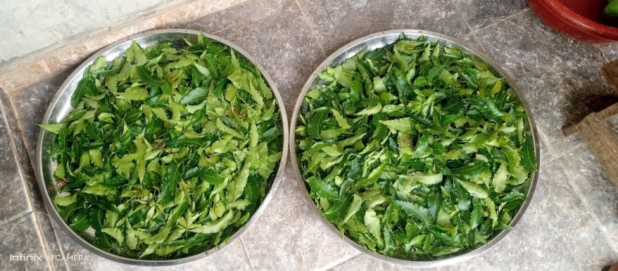
Plate 3.1 Neem leaves
3.1.2 Electronic weighing Scale
This is used to measure the neem powder extracted from the neem leaves. Plate 3.2 shows the pictorial view of the electronic weighing scale.
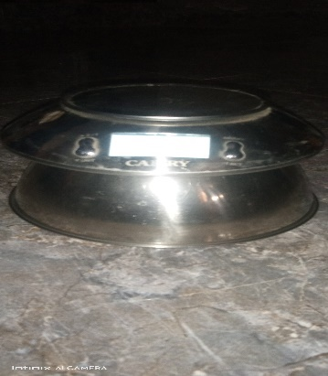
Plate 3.2 Electronic weighing Scale
3.1.3 Plastic container with lid
This was used for storing the grains (treated and un-treated) during the experiment. Plate 3.3 shows the pictorial view of the plastic container with lid.
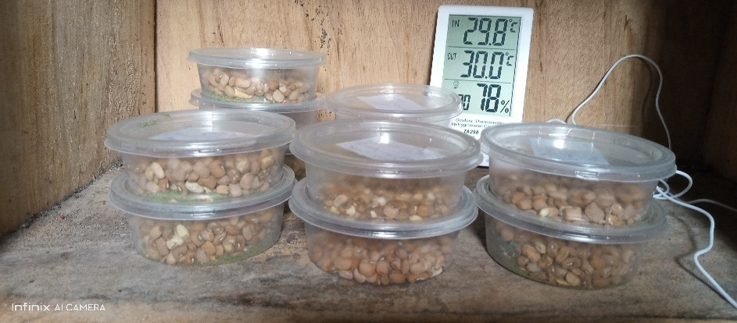
Plate 3.3: plastic container
3.1.4 Thermometer:
This is used to measure the amount of temperature in the room where the neem leaves were kept. Plate 3.5 shows the pictorial view of Thermometer
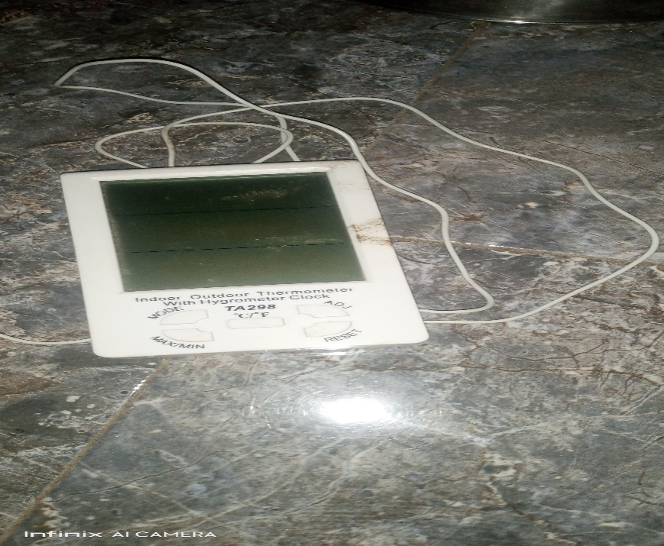
Plate 3.1.4: Thermometer
3.1.5 Digital spoon Scale
This was use to give us the correct amount of neem powder need in the jar as preservative
Plate 3.6 shows the pictorial view of Digital spoon scale
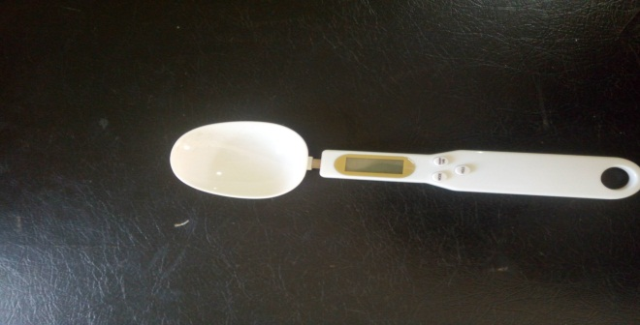
3.1.6 Electric Blender
This was use to blend the dry neem leaves into powder form. Plate 3.7 shows the pictorial view of the electric blender

3.2 Methodology
3.2.1 Sourcing of Experiment Materials
The cowpea was purchased from Mandate market in Ilorin West Local Government area of Kwara State. The neem leave was gotten from the back of Kwar State Polytechnic mini campus. The fresh neem leaves were dried under room temperature for nine days and the dried neem leaves were blended to neem powder.
3.2.2 Sample Preparation
The cowpeas were sorted to remove damage grains and unwanted particles. The wholesome grains were cleaned by manual winnowing. The grains were divided into potion by weighing them with electronic weighing scale into plastic containers. The neem was prepared in a room temperature (28ºC) and the dried neem leaves were blended into neem powder.
3.2.3 Experimental Procedure
The clean cowpea was divided into ten (10) portions of 100g for four samples each, 50g for four samples and two samples were used as control with the following descriptions into the plastic container.
- Two (2) containers of 50g each contains infected and non-infected cowpea with 5g neem powder
- Two (2) containers of 50g each contains infected and non-infected cowpea with 10g neem powder
- Two (2) containers of 100g each contains infected and non-infected cowpea with 5g neem powder
- Two (2) containers of 100g each contains infected and non-infected cowpea with 10g neem powder
- Two (2) jars of 100g each contain infected and non-infected cowpea with no preservation (no neem powder) which was used as control
3.2.4 Experimental Design
Proximate composition was done on the fresh cowpea before the addition of preservative and storage. The cowpea was preserved and stored for a period of twelve weeks. The proximate composition was conducted on the 4th and 6th , 8th, 10th and 12th weeks of storage in order to determine the effect of the preservatives on the stored cowpea
3.3 Proximate composition of Cowpea
This study aimed at determining the proximate composition, mineral constituents and tyrosine inhibitory activity of the cultivar. Cowpea presents (100g): 24.5 protein, 51.4 carbohydrates, 16.6 insoluble fibers and 2.7 soluble fibers, 2.6 ash; major mineral constituents.
3.3.1 Initial and Final Moisture Content Determination on Dry Basis (db)
Fresh beans sample of 100g were placed in pre-weighed electro weighing balances and mixed with neem powder, temperature of 70c for 6h at 26.1HG vacuum in a thelco 29 vacuum oven (precisions scientific, Chicago, IL) dishes were removed and placed immediately in desiccators to allow temperature to equilibrate before weighing.
The weighing used for the scale had an accuracy of 0.01g. All moisture measurement for each trial were replicated twice and moisture contents were calculated on dry basis using the following formula to obtain the initial moisture content of the samples.
MC (%db) = (W₁-W_{F}) x 100
W_{F}
W_{I} =initial weight of the sample 3.1
W_{F} =final weight of the sample
The final moisture of the dried samples was the determined using infrared moisture determination balance AD/4714A,(centurion scientist limited). Following manual recommendation, 5g of each sample was weighed into a cleaned dried dish. The sample was then placed in the infrared mixture determination balance. The temperature regulated to 105Oc. The mixture content was indicated automatically by the reading on the machine.
3.3.2 Determination of Fat Contents
About 5g of each of the sample weighted and wrapped in a filter paper and placed in an extraction thimble. The thimble weighed before the additional of the sample, (W₁), the thimble with sample (W₂) was then inserted in soxhlet apparatus. Extraction under reflux was carried out with petroleum ether (30-60⁰C boiling range) for 5hrs. At the end of the extraction thimble was dried in an oven for about 180s at 100⁰c for the evaporation of the solvent and the thimble was allowed to cool in a desiccators and later weighed (W₃) (AOAC,2005)
%Fat = (weight loss of a sample {extracted fat})– (original weight of sample) x 100 (W₂ – W₃) – (W₂ –W₁) x 100
3.3.3 Determination of Carbohydrate Contents
The carbohydrate contents were determined by the subtraction of the summation of crude protein, crude fiber, and ash, fat contents in percentage from 100 percent.
3.3.4 Determination of Ash Contents
The ash content was determined as described in association of official analytical chemists (AOAC) official standard and methods (2005). A know weigh of the beans was charred in a low flame. Thereafter, the sample was transferred to the furnace regulated at 600_{o}c for about 30min. the sample was then cooled and reweighed the procedure was respected until gray ash was resulted. The ash content was calculated as shown in equation developed by AOAC (2005).
C_{ASH} = W_{ASH} x 100
W_{AS}
Where,
C_{ash} = the ash content in %
_{ASH} = ash weigh, kg 3.3
W_{as} = sample weigh, kg
3.3.5 Determination of Crude Fibre Contents
The fibre content was determined by the method described in AOAC, (2005). Two grams of the samples were accurately weighed into fibre flask and 100 ml of 0.255 N H₂SO₄ was added. The mixture was then heated under reflux for one hour with the heating mantle and the hot mixture was filtered through fibre sleeve cloth. The filtrate was thrown of while the residue was returned to the fibre flask to which 100ml of 0.313 NNAOH was added and heated under reflux for another 1hr. The mixture was filtered through a fibre sleeve cloth and 100ml of acetone was added to dissolve ant organic constituent. The residue was washed with some hot water twice on the sleeve cloth before it was finally transferred into a crucible. The crucible containing the residue was cooled in the desiccators and later weighed to obtain weight W₂
The different W₁-W₂ gives the weight of fibre and the percentage fibre was obtained as

% Fibre = W₁-W₂ x 100
Weight of sample 3.4
3.3.6 Determination of Crude Protein Content
Protein content of the test sample was determined using micro kjedhel method as described by AOAC (2005). One gram of test sample was weighed into digestion tube, 15ml of concentrated H₂SO₄ and one tablet of selenium catalyst was added. The mixture was digested on an electro-thermal heater until clear solution is obtained. The flask was allowed to cool after which the solution was diluted with distilled water to 50ml, 5ml of this was transferred into the distillation apparatus, 5ml of 2% boric acid was pipette into a 100ml conical flask (the receiving flask) and 4 drop of screened methyl red indicator was added 50% N_{a}OH was continually added to the digested sample until the solution turned cloudy and this indicates the alkalinity of the solution. The distillation was carried out the acid solution in the receiving flask with the delivery tube below the acid level. As the distillation is going on, the pink color solution of the receiving flask turned blue. Distillation was continued was continued until the content of the round bottom flask is about 50ml. The resulting solution in the conical flask was titrated with 0.1 M HCI.
% Nitrogen = Titre value x 0.1 HCI x 0.014 x 100 x ⁵⁰/₅
Original weight of sample
% Protein = %Nitrogen x protein conversion factor.

CHAPTER FOUR
4.0 RESULTS AND DISCUSSION
4.1 RESULTS
The average results of a proximate composition of the cowpea before storage and preservation is presented in table 4.1 while that of freshly prepared neem powder is presented in table 4.2.
Table 4.3-4.6 shows the average results of the proximate composition of the treatment applied to the cowpea after eight (6) weeks of the experiment for the different quantities of neem powder applied.
Table 4.7 shows the average result of the proximate composition of cowpea before storage and preservation, the freshly prepared neem powder and when different treatment were applied to the cowpea are present in the appendix A-L
Table 4.1 Average Proximate Composition of Cowpea before Storage

Proximate Composition (%)
SAMPLE MC ASH FAT FIBREPROTEIN CHO
COWPEA 14.02 3.3 3.2 3.1 5.1 71.3

Table 4.2 Average Proximate Composition of Neem Powder

Proximate Composition (%)
NEEM
POWDER MC ASH FAT FIBRE PROTEIN CHO

14.12 1.06 3.8 3.07 1.02 76.95

Table 4.3 Average Proximate Composition of Cowpea with Neem Treatment under Ambient Storage

Proximate Treatment Applied Preserved
Composition (%) Infested with Insect
MC 14.32 15.16
PROTEIN 5.71 5.10
CARBONHYDRATE 76.14 71.48

Table 4.4 Average Proximate Composition of Cowpea (50g) with Neem Powder (5g) under Ambient Storage

Proximate Composition (%)
SAMPLE MC PROTEIN CHO
COWPEA 14.21 5.90 76.23

Table 4.5 Average Proximate Composition of Cowpea (50g) with Neem Powder (10g) under Ambient Storage

Proximate Composition (%)
SAMPLE MC PROTEIN CHO
COWPEA 15.10 5.40 74.28

Table 4.6 Average Proximate Composition of Cowpea (100g) with Neem Powder (5g) under Ambient Storage
Proximate Composition (%)
SAMPLE MC PROTEIN CHO
COWPEA 15.03 5.62 75.06

Table 4.7 Average Proximate Composition of Cowpea with no Neem Powder
Proximate Composition (%)
Cleaned Cowpea Cowpea with Insect
MC 14.52 15.32
PROTEIN 5.94 5.42
CARBOHYDRATE 76.11 70.03

4.2 Discussions
4.2.1 Effect of Neem powder on cowpea
Tables 4.3-4.6 revealed the effect of different quantities of neem powder added to preserve the cowpea. In all the results presented the moisture content increases as well as the protein. It was also observed that there was no emergence of insects which are responsible for feeding on the carbohydrate. Therefore, the decrease on the carbohydrate was negligible when compared with the fresh cowpea before storage and preservation.
4.2.2 Effect of Carbohydrate on Cowpea
Table 4.3-4.6 show the result of the carbohydrate of the cowpea when neem powder was applied and when insect was introduced.
The carbohydrate ranged between 70.03 to 76.28% when neem powder was applied. The highest value recorded was when 10g neem powder was applied to the cowpea while the lowest carbohydrate was recorded when no treatment was applied to the cowpea with infested insects.
The value recorded for the cowpea which treated with 5g of neem powder is still higher with the value recommended for carbohydrate in cowpea by (Mainaet al., 2000) which ranged between 68-73%.
4.2.3 Effect of Moisture Content on Cowpea
The moisture content recorded in this study ranged between 14.08 to 15.32%. The highest recorded was when no treatment was applied to the cowpea (control). The lowest moisture content was when 5g of neem powder was added to the cowpea. This implies that increase in moisture content will reduce the storage life of cowpea. This will cause insect multiplication in the cowpea under study. The reverse is the case when there is decrease in the moisture content,

4.2.4 Effect of protein on Cowpea
The protein content on the non-infested cowpea ranged between 5.71 to 6.10% and the protein content in the infested cowpea ranged between 5.10 to 5.62%. The protein content with 5g of neem powder was the highest recorded and the least was when 2g of neem powder was applied. The infested cowpea when 2g of neem powder was the lowest and 5g of neem powder was the highest. The protein content when 5g of neem powder favors the infested and non-infested cowpea.
4.2.5. Effect of neem powder on Cowpea
It was also observed that the cowpea infested with insect and preserved with various quantity of neem powder were found dead and there were no multiplication of insect. Also the cleaned and healthy cowpea preserved with various quantity of neem powder remains clean and fresh without any emergency of insect. Thus, the neem powder had persevered the shelf life of the cowpea throughout the experiment thereby prohibiting insect multiplication and no detection of life insect during the period of study.
4.2.1 Effect of Neem powder on cowpea
Tables 4.3-4.6 revealed the effect of different quantities of neem powder added to preserve the cowpea. In all the results presented the moisture content increases as well as the protein. It was also observed that there was no emergence of insects which are responsible for feeding on the carbohydrate. Therefore, the decrease on the carbohydrate was negligible when compared with the fresh cowpea before storage and preservation.

4.2.2 Effect of Carbohydrate on Cowpea
Table 4.3-4.6 show the result of the carbohydrate of the cowpea when neem powder was applied and when insect was introduced.
The carbohydrate ranged between 70.03 to 76.28% when neem powder was applied. The highest value recorded was when 3g neem powder was applied to the cowpea while the lowest carbohydrate was recorded when no treatment was applied to the cowpea with infested insects.
The value recorded for the cowpea which treated with 5g of neem powder is still higher with the value recommended for carbohydrate in cowpea by (Maina et al., 2000) which ranged between 68-73%.
4.2.3 Effect of Moisture Content on Cowpea
The moisture content recorded in this study ranged between 14.08 to 15.32%. the highest recorded was when no treatment was applied to the cowpea (control). The lowest moisture content was when 5g of neem powder was added to the cowpea. This implies that increase in moisture content will reduce the storage life of cowpea. This will cause insect multiplication in the cowpea under study. The reverse is the case when there is decrease in the moisture content,
4.2.4 Effect of protein on Cowpea
The protein content on the non-infested cowpea ranged between 5.71 to 6.10% and the protein content in the infested cowpea ranged between 5.10 to 5.62%. The protein content with 5g of neem powder was the highest recorded and the least was when 2g of neem powder was applied. The infested cowpea when 2g of neem powder was the lowest and 5g of neem powder was the highest. The protein content when 5g of neem powder favors the infested and non-infested cowpea.
4.2.5. Effect of neem powder on Cowpea
It was also observed that the cowpea infested with insect and preserved with various quantity of neem powder were found dead and there were no multiplication of insect. Also the cleaned and healthy cowpea preserved with various quantity of neem powder remains clean and fresh without any emergency of insect. Thus, the neem powder had persevered the shelf life of the cowpea throughout the experiment thereby prohibiting insect multiplication and no detection of life insect during the period of study.

CHAPTER FIVE
5.0 CONCLUSIONS AND RECOMMENDATIONS
5.1 Conclusions
The effect of organic preservatives for the treatment of insects and pest in agricultural crops was investigated, based on the experiment conducted, the following conclusion was drawn:
- Neem powder in different quantity of 2g, 3g, 4g, and 5g were applied to cowpea under ambient storage of 28ºc using infested and non-infested cowpea.
- Neem powder favors the non-infested cowpea when 5g of neem powder is applied and also showed no emergence of life insect throughout the experiment.
- The infested cowpea showed no further emergence of insect and confirmed death of the entire insect introduced when 5g of neem powder was used.
- Neem powder can be used as an alternative preservative for cowpea.
5.2 Recommendations
The following recommendation were made at the end of the study for further work
- Famers should be encourage and educated on the effectiveness of use of neem powder.
- The awareness of the use of neem powder as an alternative to chemical should be advocated.
- Other agricultural crop can be tested and treated with the neem powder.

REFERENCES
Boeke, S. J., Boersma, M. G., Alink, G. M., van Loon, J. J. A., van Huis, A., Dicke, M.,
&Rietjens, I. M. C. M. (2004).* "Safety evaluation of neem (Azadirachtaindica) derived pesticides." Journal of Ethnopharmacology, 94(1), 25-41.
Isman, M. B. (2006).* "Botanical insecticides, deterrents, and repellents in modern
agriculture and an increasingly regulated world." Annual Review of Entomology, 51,
45-66.
Grzywacz, d., stevenson, p. C., belmain, s. R., wilson, k., 2014. The use of indigenous ecological resources for pest control in africa. Food security 6, 71–86

Heuzé, v. And g. Tran (2015), “cowpea (vigna unguiculata) seeds”, feedipedia: a programme by inra, cirad, afz and fao, http://www.feedipedia.org/node/232,

Hollinger, f. And j.m. Staatz (2015), agricultural growth in west africa. Market and policy drivers, food and agriculture organization of the united nations (fao) and african development bank, rome.

Hussain, m.a. And a.y. Basahy (1998), “nutrient-composition and amino acid pattern of cowpea (vigna unguiculata (l.) Walp, fabaceae) grown in the gizan area of saudi arabia”, international journal of food sciences and nutrition, vol. 49, pp. 117

Hussain, m.a. And a.y. Basahy (1998), “nutrient-composition and amino acid pattern of cowpea (vigna unguiculata (l.) Walp, fabaceae) grown in the gizan area of saudi arabia”, international journal of food sciences and nutrition, vol. 49, pp.

Ileke, k.d. And m.o. Oni, 2011. Toxicity of some plant powders to maize weevil, sitophilus zeamais (motschulsky) [coleopteran: curculiondae] on stored wheat grains (triticum aestivum). Afr. J. Agric. Res., 6: 3043-3048.

Ileke, k.d. And m.o. Oni, 2011. Toxicity of some plant powders to maize weevil, sitophilus zeamais (motschulsky) [coleopteran: curculiondae] on stored wheat grains (triticum aestivum). Afr. J. Agric. Res., 6: 3043-3048.

Imam hashmat, effects of neem on hepatic glycogen in rats. Indian j. Pharmacol., 25, 174-175 2000 indigenous agricultural practices among tribal women indian j. Tradit. Knowl., 5 (2006), pp. 114-117

Khan, a.r. (2007), “dietary fiber profile of food legumes”, sarhad journal of agriculture, vol. 23,pp. 763766, https://www.aup.edu.pk/sj_pdf/dietary%20fiber%20profile%20of%20food%20legumes.pdf.

Khan, m.a, gumbs, f.a., 2003. Repellent effect of ackee (blighia sapida koenig) component fruit parts against stored product insect pests. Journal of tropical agriculture 80, 19-27.
Koul, O., &Isman, M. B. (2012).* "New strategies in insect pest management." Journal of
Insect Science, 12(4), 1-14.
Senthil Nathan, S. (2007).* "The use of Eucalyptus oil as a botanical insecticide for the
control of stored product pests." Journal of Stored Products Research, 43(4), 538-543.
Pascual-Villalobos, M. J., & Robledo, A. (1998).* "Screening for anti-insect activity in
Mediterranean plants." Industrial Crops and Products, 8(2), 141-148.

