DESIGN AND IMPLEMENTATION OF HOSPITAL MANAGEMENT PORTAL
(A CASE STUDY OF ORELOPE HOSPITAL)

BY

AJAYI TIMILEYIN
ND/23/COM/PT/0253

SUBMITTED TO THE DEPARTMENT OF COMPUTER SCIENCE,
INSTITUTE OF INFORMATION AND COMMUNICATION TECHNOLOGY
KWARA STATE POLYTECHNIC, ILORIN.

IN PARTIAL FULFILLMENT OF THE REQUIREMENTS FOR THE AWARD OF NATIONAL DIPLOMA (ND) IN
COMPUTER SCIENCE

JULY, 2025.
CERTIFICATION
This is to certify that this project was carried out by AJAYI TIMILEYIN of Matriculation Number: ND/23/COM/PT/0253 in the Department of Computer Science, Institute of Information Communication Technology, Kwara State Polytechnic, Ilorin, Kwara State.

…………………………………. ….………………………
MR. ABIODUN E.T. Date
Project Supervisor

…………………………………. ….………………………
MR. OYEDEPO F.S Date
Head of Department

…………………………………. ….………………………
External Examiner Date

DEDICATION
I dedicate this project work to Almighty God who inspired me and directed my ways during my academic stay in the polytechnic.

ACKNOWLEDGEMENT
All praise is due to Almighty God the Lord of universe. I praise him and thank him for giving me the strength and knowledge to complete my ND program and also for our continued existence on the earth.
I appreciate the utmost effort of our supervisor, Mr. Abiodun A. T. whose patience, support and encouragement have been the driving force behind the success of this research work. He gave useful corrections, constructive criticisms, comments, recommendations, advice and always ensures that an excellent research is done. My sincere gratitude goes to Head of Department and other members of staff of the Department of Computer Science, Kwara State Polytechnic, Ilorin, for their constant cooperation, constructive criticisms and encouragements throughout the programme.
Special gratitude to my parents and siblings, who exhibited immeasurable financial, patience, support, prayers and understanding during the period in which I was busy tirelessly on mystudies, special thanks go to my lovely siblings
My sincere appreciation goes to my friends and classmates.

TABLE OF CONTENTS
Title page i
Certification ii
Dedication iii
Acknowledgements iv
Table of contents v
Abstract vi
CHAPTER ONE: GENERAL INTRODUCTION
1.1 Background to the Study 1
1.2 Statement of the Problem 2
1.3 Aim and Objectives 2
1.4 Significance of the Study 3
1.5 Scope of the Study 3
1.6 Organization of the Report 3
CHAPTER TWO: LITERATURE REVIEW
2.1 Review of Related Works 5
2.2 Review of Related Concepts 14
2.3 Overview of Hospital Management 15
2.4 Overview of Online Appointment System 16
CHAPTER THREE: RESEARCH METHODOLOGY AND ANALYSIS OF THE SYSTEM
  - Research Methodology 18
  - Problem of the Existing System 19
  - Analysis of the Existing System 19
  - Analysis of the Proposed System 21
  - Advantage of the Propose System 21

CHAPTER FOUR: DESIGN, IMPLEMENTATION AND DOCUMENTATION OF THE SYSTEM
  - Design of the System 23
    - Output Design 22
    - Input Design 25
    - Database Design 27
    - Procedure Design 28
  - Implementation of the System 29
    - Choice of programming language 29
    - Hardware support 30
    - Software Support 30
  - System Documentation 30
    - Operating the System 30
    - Maintaining of the System 31
CHAPTER FIVE: SUMMARY CONCLUSION AND RECOMMENDATION
5.1 Summary 32
5.2 Conclusion 32
5.4 Recommendations 32
References 34

ABSTRACT
Hospital Management System provides the benefits of streamlined operations, enhanced administration and control, superior patient care, strict cost control and improved profitability. HMS is powerful, flexible, and easy to use and is designed and developed to deliver real conceivable benefits to hospitals. More importantly it is backed by reliable and dependable support. Human Body is a very complex and sophisticated structure and comprises of millions of functions. All these complicated functions have been understood by man him, part-by-part their research and experiments. Both administrators and doctors in these lifesaving avenues spend an awful lot of time handling and manually processing patients’ medical records, and other related details. Handling this kind of activities is becoming harder and harder, due to the exponential growth of the number of patients that are trooping into school, government and private hospitals seeking for medical attention. The project ‘Hospital Management System’ is based on the database, object oriented and networking techniques. As there are many areas where we keep the records in database for which we are using MY SQL software which is one of the best and the easiest software to keep our information. This project uses Visual Basic 6.0 as the front-end software Programming and has connectivity with MY SQL. Hospital Management System is custom built to meet the specific requirement of the mid and large size hospitals across the globe.

CHAPTER ONE
GENERAL INTRODUCTION
1.1 INTRODUCTION OF THE STUDY
Hospital Management System provides the benefits of streamlined operations, enhanced administration and control, superior patient care, strict cost control and improved profitability. HMS is powerful, flexible, and easy to use and is designed and developed to deliver real conceivable benefits to hospitals. More importantly it is backed by reliable and dependable support. Human Body is a very complex and sophisticated structure and comprises of millions of functions. All these complicated functions have been understood by man him, part-by-part their research and experiments. As science and technology progressed, medicine became an integral part of the research. Gradually, medical science became an entirely new branch of science. As of today, the Health Sector comprises of Medical institutions i.e. Hospitals, HOSPITALs etc. research and development institutions and medical colleges. Thus the Health sector aims at providing the best medical facilities to the common man (Ibrahim and Ledrman, 2020).
Clinic appointment registration system has been one of the key barriers for hospitals to improve their service quality. Especially for those high-level comprehensive hospitals with a large amount of outpatients, outpatient congestion is a common phenomenon. Online medical consultation system to see a doctor will be implements to solve the setback face in hospital.
The technology for making an online medical consultation is getting mature. Domestically, only a few hospitals are in the pilot phase in trying the online registration system. The project is to follow the software life cycle, through stages of demand analysis, system design, system implementation, system testing and maintenance, to design and develop an outpatient appointment registration system. It provides learning programs for the experimental teaching courses of “Medical Informatics” and “Hospital Information System” for students majored in computer science focused on medical informatics in our school. It can also be used in medium and small hospitals as an outpatient appointment registration system (Smith and Gert van der Pijl, 2021).
The project ‘Hospital Management System’ is based on the database, object oriented and networking techniques. As there are many areas where we keep the records in database for which we are using MY SQL software which is one of the best and the easiest software to keep our information. This project uses Visual Basic 6.0 as the front-end software Programming and has connectivity with MY SQL. Hospital Management System is custom built to meet the specific requirement of the mid and large size hospitals across the globe. All the required modules and features have been particularly built to just fit in to your requirement. The package is highly customizable and can be modified as per the needs and requirements of our clients. Prolonged study of the functionalities of the hospital and its specific requirement has given it a wonderful shape both technically and usability wise. It covers all the required modules right from Patient Registration, Medicine details, Doctor, Wards, , Admin, Store, Patient appointment, bill payment, record modification, discharge details etc.
1.2 STATEMENT OF THE PROBLEM
Both administrators and doctors in these lifesaving avenues spend an awful lot of time handling and manually processing patients’ medical records, and other related details. Handling this kind of activities is becoming harder and harder, due to the exponential growth of the number of patients that are trooping into school, government and private hospitals seeking for medical attention.
1.3 AIM AND OBJECTIVES OF THE STUDY
The aim of this project is to develop hospital management system. The project has the following objectives:
- Develop a system that will administer patient’s information and admission
- That monitors medicine inventory of the hospital pharmacy.
- Manage admission bills and pharmaceutical payments
- Increasing receipt generating efficiency
1.4 SIGNIFICANCE OF THE STUDY
The study is important to the hospital patients since they could have medical information without experiencing delays and incorrect information. If they wanted to access their medical history, they would not be going through a difficult process. The hospital especially the pharmacy and billing department would not go through a lot of paper reports when it comes to payments and accounting records. The use of paper would still be there but it could be reduced so that excessive paper loads would not be a problem. This project is significant to the hospital in patient appointment record management of hospital in the sense that it helps the hospital in efficiently managing the patients file in terms of ease of activities, speed of processing data, effective and secure storage of patient information. The patient information management is important to the patients in the aspect of ease in medical consultancy and ease of accessing their records when requiring for doctor’s attention. It also allow the patients to have detail knowledge of their medical history with the hospital at any time of need.
1.5 SCOPE AND LIMITATION
Although computer could be relevant or applied to the entire medical operational activities, but for the purpose of this study, the scope is centered on some selected medical operations. The scope mainly covers the management of patient consultation record in the hospital as well as providing a comprehensive information about each patient stating their personal details and medical history. The application does not include diagnosis and treatment of diseases in the field of medical science and the remedy given to cure each type of diseases.
  - ORGANISATION OF THE REPORT
Chapter one contains the general introduction which is the chapter that sheds a clear light on what the project is all about i.e the objective of the project as well as the limitations to this project. Definition of some technical terms relating to medicine is also enumerated.
Chapter two deals with the literature review and discussion of other related issues to patient record management.
Chapter three talks about the project methodology i.e the overview of the system in practice in the hospital is looked into, its advantages and shortcomings is also stated in this chapter. The new system is well defined so also are the merits of this new system highlighted in this chapter. Also the choice of programming language used is also stated here.
Chapter four is the chapter that enumerates the design implementation and documentation of the system is stated here also, the output, input file and procedure design is considered here. So also is the hardware and software supported by this project is explained as well.
Chapter five is concluding part which also has the summary of the whole chapters and recommendation is also made.

CHAPTER TWO
LITERATURE REVIEW
2.1 REVIEW OF REALATED WORKS
Ahmed & Ali, et al. (2021) hospital management system design and implementation. A hospital management information system (HMIS) is an element of health informatics that focuses mainly on the administration needs of hospitals. In many implementations, this is a comprehensive, integrated information system designed to manage all the aspects of a hospital. One of the most important issues is health care services. Hospital management information system (HMIS) is a province-wide initiative designed to improve access to patient information through a central electronic information system. HIS goal is to streamline patient information flow and its accessibility for doctors and other health care providers. These changes in service will improve patient care quality and patient safety over time. The patient carries system record patient information, patient laboratory test results, and patient doctor information. Doctors can access easily person information, test results, and previous prescriptions. Patient schedule organization and early warning systems can be provided by related systems.
Premkumar&Kalpana, et al. (2020) e-hospital management & hospital information systems changing trends. The rapid growth in Information & Communication Technology (ICT), and the power of Internet has strongly impacted the business and service delivery models of today‘s global environment. E-Hospital Management Systems provide the benefits of streamlined operations, enhanced administration & control, superior patient care, strict cost control and improved profitability. Globally accepted health care systems need to comply with Healthcare Insurance Portability and Accountability Act (HIPAA) standards of the US and that has become the norm of the Healthcare industry when it comes to medical records management and patient information privacy. The study is focused on understanding the performance indicators of Hospital information systems (HIS), summarizing the latest commonly agreed standards and protocols like Health Level Seven (HL7) standards for mutual message exchange, HIS components, etc… The study is qualitative and descriptive in nature and most of the data is based on secondary sources of survey data. To arrive at a conclusive idea of the larger picture on E- Hospital Management and Hospital information systems, existing survey data and specific successful case studies of HIS are considered in the study. With so many customized versions of E – hospital management solutions (E – HMS) and Hospital Information systems (HIS) available in the market, a generic module wise version of E – Hospital management system is charted out to give a clear understanding for researchers and industry experts. From the specific successful case studies analyzed in the study, the success factors and challenges faced in successful E-HMS implementation are highlighted. Some of the mandatory standards like HIPAA are discussed in detail for clarity on Healthcare system implementation requirements. Index Terms Information & Communication Technology (ICT), Health Level Seven (HL7), Healthcare Insurance Portability and Accountability Act (HIPAA), E – hospital management solutions (E – HMS), Hospital Information systems (HIS).
Samirah, et al. (2019) successful billing strategies in the hospital industry. Failure to collect reimbursement because of changing regulations negatively impacts hospital profitability. A multiple case study approach was used to explore the successful strategies billing managers employed to collect reimbursement for all legitimate Medicare claims. The target population for this study included 5 hospital billing managers from 3 organizations in the Northern New Jersey region. The complexity theory was used as a framework for assessing changing Medicare regulations and how the managers adapted to them. The data collection process for this study involved gathering data from participant interviews, documentation from the organizations of the participants, and government documented regulations and manuals. The logical and sequential order of data analysis for this study embraced Yin’s 5-steps data analysis that includes compiling data, disassembling data, reassembling data, interpreting the data, and concluding. The successful strategies billing managers used that emerged as themes were remaining up to date with Medicare changing compliance regulations; enhancing communication with staff, multiple departments, and Medicare; and adopting a robust billing system and other systems that compliment billing. The implications of this study for social change include the potential to ensure access to patient care for benefiting families and communities through the sharing of successful strategies for Medicare claims.
Sura, et al (2019) hospital management system. Hospital Management System provides the beneﬁts of streamlined operations, enhanced administration, control, superior patient care, strict cost control and improved proﬁtability. HMS is powerful, ﬂexible, and easy to use and is designed and developed to deliver real conceivable beneﬁts to hospitals. More importantly it is backed by reliable and dependable support. The project ‘Hospital Management System’ is based on the database, object oriented and networking techniques. As there are many areas where we keep the records in database for which we are using MY SQL software which is one of the best and the easiest software to keep our information. This project uses JAVA as the front-end software which is an Object Oriented Programming and has connectivity with MY SQL. Hospital Management System is custom built to meet the speciﬁc requirement of the mid and large size hospitals across the globe. All the required modules and features have been particularly built to just ﬁt in to your requirement. This package has been widely accepted by the clients in India and overseas. Not stopping only to this but they are highly satisﬁed and appreciating. Entire application is web based and built on 3 tier architecture using the latest technologies. The sound database of the application makes it more users friendly and expandable. The package is highly customizable and can be modiﬁed as per the needs and requirements of our clients. Prolonged study of the functionalities of the hospital and its speciﬁc requirement has given it a wonderful shape both technically and usability wise. It covers all the required modules right from Patient Registration, Medicine details, Doctor, Wards, , Admin, Store, Patient appointment, bill payment, record modiﬁcation, discharge details etc. Human Body is a very complex and sophisticated structure and comprises of millions of functions. All these complicated functions have been understood by man him, part-by-part their research and experiments. As science and technology progressed, medicine became an integral part of the research. Gradually, medical science became an entirely new branch of science. As of today, the Health Sector comprises of Medical institutions i.e. Hospitals, HOSPITALs etc. research and development institutions and medical colleges. Thus the Health sector aims at providing the best medical facilities to the common man. Problem Statement Since Hospital is associated with the lives of common people and their day-to-day routines so we decided to work on this paper. The manual handling of the record istime consuming and highly prone to error. The purpose of this work is to automate or make online, the process of day to-day activities like Room activities; Admission of New Patient, Discharge of Patient, Assign a Doctor, and ﬁnally compute the bill etc. we have tried our best to make the complicated process Hospital Management System as simple as possible using Structured Modular technique Menu oriented interface. we have tried to design the software in such a way that user may not have any diﬃculty in using this package further expansion is possible without much eﬀort. Even though we cannot claim that this work to be entirely exhaustive, the main purpose of our exercise is perform each Hospital’s activity in computerized way rather than manually which is time consuming. We are am conﬁdent that this software package can be readily used by non-programming personal avoiding human handled chance of error.
Nazia and Ekta, et al. (2023) prepared a journal on a project titled “Online Appointment Scheduling System for Hospitals–An Analytical Study” Appointment scheduling systems are used to manage access to service providers. Many factors affect the performance of appointment systems which include arrival and service time variability, patient and provider preferences, available information technology and the experience level of the scheduling staff .Thus a proper scheduling system has to develop by considering all these factors which will increase patient satisfaction, which in turn increases profit. An online scheduling system allows individuals to conveniently and securely book their appointments online. Compared to the usual queuing method, the web-based appointment system could significantly increase patient's satisfaction with registration and reduce total waiting time effectively. This paper focuses on detailed study of online appointment scheduling system with architecture and merits.
Shafaq, et al. (2014) prepared a journal on a project titled “A Doctor Appointment Application System” Life is becoming too busy to get medical appointments in person and to maintain a proper health care. The main idea of this Work is to provide ease and comfort to patients while taking appointment from doctors and it also resolves the problems that the patients has to face while making an appointment. The android application Mr.Doc acts as a client whereas the database containing the doctor’s details, patient’s details and appointment details is maintained by a website that acts as a server.
Hylton and Sankaranarayanan, et al. (2019) prepared a journal on a project titled “Application of Intelligent Agents in Hospital Appointment Scheduling System” Normally when we want to make an appointment with the hospital staff, it becomes really tedious and time consuming. Over the past considerable amount of work have been done by using software Agents in areas like m-commerce, e-commerce, telemedicine etc. Agent based systems have also been developed for the hospital service, for searching and fixing appointment over mobile phones which gives a direct reply when the appointment is made or the next available date(s) or cancelled. However, no facility like priority appointment of patients has been developed. Also the appointment does not take into consideration emergency situations like Accidents and so on and the scheduling reported is only for general patient appointment only. Taking these important aspects into consideration, we here have developed an intelligent agent based system towards negotiating and collaborating with the agents of doctors and the hospital for the appropriate appointment time for the patient which would take the above factors into consideration. In addition the meetings of the junior staff like the duty doctor and nurse with the chief doctor regarding patients would also carried out again while taking into consideration the medical condition of the patient admitted and so on. These agents developed would function based on fuzzy preference rules, to make a proper decision regarding making an appointment for patient and other hospital staff , which is very unique and first of its kind.
Mohammed, et al (2021) prepared a journal on a project titled “An Integrated Framework for Hospital Appointment Management” There are many medical specialties within the NHS which have a standard pathway for patients to follow whilst requiring hospital treatment. This could mean a treatment continues for several days or even several weeks with regular appointments required for patients at fixed intervals. Also the specific treatment carried out on one of the days may be a standard treatment which requires a specific duration. For example initially a patient may be given an injection by a nurse and then after fifteen minutes a nurse may give the patient an examination. It is a very complex problem scheduling the patients such that they follow their required pathway (multiday pattern) accurately whilst utilizing hospital resources to full potential such as nurses and doctors. It is imperative to schedule patients in away in which nurses and doctors can be allocated systematically to each patient within their normal working hours and also not to have any clashes. It is also important for the patients to have their treatments in accordance to the prescribed medical procedures. This shows an example of a twenty-one day multiday pattern, where a patient is required to visit hospital on days 1, 10, 15 and 21; on day 10, visit 2 the appointment duration (intraday pattern) is 3 hours and 45 minutes with 4actions performed on them which are shown by the shaded slots.
Noorsyahira et al., (2020) presented a journal titled “Medical Appointment Application” The current standard operating procedure in healthcare environment for patient registration and appointment scheduling are time consuming and somehow troublesome. Medical Appointment Application is a web-based mobile application develop for managing appointment-booking process for a few medical organizations, regardless of the type of service they schedule in Parit Raja and BatuPahat area. The practices will have to sign up on the online appointments portal themselves and can view the appointment made by user, the patients. It will help user, the patients to book their appointment using the Medical Appointment application. Furthermore, Prototype Model is used to develop this system. As for the hardware and software used to develop this system is MySQL Database and programming language use is PHP and JavaScript. By developing this system, it will reduce the number of calls for an appointment and avoid the morning rush for an urgent appointment. Also, it will potentially reduce the need for extra reception staff, a significant reduction in labor. Furthermore, it helps user in time saving and avoiding the need to negotiate with the receptionist for a convenient appointment time. This technology can transform the current daunting appointment process and enable them to run more efficiently, effectively and profitably.
Peng, et al. (2024) wrote journal on “Applying Simulation and Genetic Algorithm for Patient Appointment Scheduling Optimization” In this study, we discuss the implementation of integrated simulation and genetic algorithm for patient scheduling optimization under two different settings, namely the “traditional” scheduling system and the “open access” scheduling system. Under the “traditional” setting, we propose a two-phase approach for designing a weekly scheduling template for outpatient clinics providing multiple types of services. Our results demonstrate that the two phase approach can efficiently find the promising weekly appointment scheduling templates for outpatient clinics. Under the “open access” setting, we propose a discrete event simulation and genetic algorithm (DES-GA) approach to find the heuristic optimal scheduling template for the clinic allowing both open access and walk-in patients. The solution provides scheduling templates consisting of not only the optimal number of reservations for open access appointments and walk-ins, but also the optimized allocation of these reserved slots, by minimizing the average cost per admission of open access or walk-in patient.
Sudeet, Rohit&Disha, et al. (2019) writes a journal on “Improved System for Appointment Scheduling In Hospitals” This system aims to develop a computer-based appointment system, which would integrate with the existing clinical information system and help improve the patient access to the services offered by both General Practioners (GPs) and Allied Health Professional (AHPs) in the primary health care centres. To achieve this it requires the development of an understanding of the features and processes of the patient booking in the primary health care environment. The aim of this system is to provide patient full access to manage there hospital appointment which facilitate with there online service for appointment reservation, updating and canceling the appointment and meeting all the customer requirements. This system will provide an efficient and effective communication between patient –doctor and providing the feasible solution to there problems. Compare to the usual queing method Web based appointment System could significantly increase patient satisfaction with registration and reduce total waiting time effectively.
Irin, Mahalakshmi and Sujatha, et al. (2019) wrote a report titled “Online Appointment Reservation and Scheduling for Healthcare- a Detailed Study”. Explains that Appointment reservation and scheduling systems in healthcare are used to maintain and manage the access to service providers which are the hospitals. In many aspects it might affect the administration of appointment scheduling systems which includes the arrival time and consultation time variance, doctor preferences, dates and other information relating to the technology and the maturity level of the administration staff. Hence an appropriate scheduling and reservation system has to be developed by considering necessary factors and features which will elevate the patient hope and satisfaction, which in turn increases the profit margin. An online reservation and scheduling system will allow individuals to securely and safely make their appointment reservations online. Comparing to the existing scheduling methods, the web-based appointment and reservation system could powerfully escalate patients’ satisfaction with initial registration and reduced waiting time. This paper majorly focuses on analytical study of online appointment reservation and scheduling system with its architecture and benefits.
Shafaq,et al., (2022) wrote a report on “Mr. Doc: A Doctor Appointment Application System”. Life is becoming too busy to get medical appointments in person and to maintain a proper health care. The main idea of this work is to provide ease and comfort to patients while taking appointment from doctors and it also resolves the problems that the patients has to face while making an appointment. The android application Mr.Doc acts as a client whereas the database containing the doctor’s details, patient’s details and appointment details is maintained by a website that acts as a server.

Ping-Shun et al., (2022) write an article on “Scheduling Patients’ Appointments: Allocation of Healthcare Service Using Simulation Optimization”. In the service industry, scheduling medical procedures causes difficulties for both patients and management. Factors such as fluctuations in customer demand and service time affect the appointment scheduling systems’ performance in terms of, for example, patients’ waiting time, idle time of resources, and total cost/profits. This research implements four appointment scheduling policies, i.e., constant arrival, mixed patient arrival, three-section pattern arrival, and irregular arrival, in an ultrasound department of a hospital in Taiwan. By simulating the four implemented policies’ optimization procedures, optimal or near-optimal solutions can be obtained for patients per arrival, patients’ inter-arrival time, and the number of the time slots for arrived patients. Furthermore, three objective functions are tested, and the results are discussed. The managerial implications and discussions are summarized to demonstrate how outcomes can be useful for hospital managers seeking to allocate their healthcare service capacities.

2.2 REVIEW OF RELATED CONCEPTS
The health care industry now is one of the largest and most important industries in most countries. It provides individuals access to medical and non-medical services that are aimed at improving that individual’s quality of life. In many health care facilities, however, there exists a severe need for improvement in quality of service and patient waiting times. These needs must be met with an efficient and a practical solution. This solution must make use of the hospitals‟ valuable resources, such as medical experts‟ time, in the most efficient manner. Hospitals are continuously fighting a scheduling problem that causes either a waste in medical experts‟ time or a decrease in patient satisfaction and staff morale. Many scheduling systems have been developed and implemented in order to improve such operations in individual hospitals or even groups of health care facilities called health care networks. The internet initially revolutionized communication and access to information; however, in more recent times it has been the rapid improvements in mobile technology that has further expanded the communicative abilities of individuals and businesses alike. These mobile technologies, combined with the use of the internet have pushed mankind to a new frontier of information distribution and gathering. Here presents interaction system for doctor and patient communication. It has an exceptional administration of several nodes through which doctors and patients interact with each other. The patients can easily access the hospital server nodes. Here the patients are allowed to interact with the doctors about their symptoms. The doctors can list and track their patients who are geographically dispersed and provide a diagnosis on the needful. Proposing a new system from where the patients can easily book their appointments online and the doctors can view and manage them. Here the patients book their appointments online depending on the doctor’s availability and their time feasibility. The doctors on the other hand can either extend or reduce their working hours depending on the number of patients arriving for that day. In addition, the approximate time of arrival for the patients is also approximately calculated and notified to the registered number. Any other information can also be fabricated at installation and hence removes the need for a technician install the software. The target population for this study included 5 hospital billing managers from 3 organizations in the Northern New Jersey region. The complexity theory was used as a framework for assessing changing Medicare regulations and how the managers adapted to them. The data collection process for this study involved gathering data from participant interviews, documentation from the organizations of the participants, and government documented regulations and manuals. The logical and sequential order of data analysis for this study embraced Yin’s 5-steps data analysis that includes compiling data, disassembling data, reassembling data, interpreting the data, and concluding.
2.3 OVERVIEW OF HOSPITAL MANAGEMENT
Human Body is a very complex and sophisticated structure and comprises of millions of functions. All these complicated functions have been understood by man him, part-by-part their research and experiments. As science and technology progressed, medicine became an integral part of the research. Gradually, medical science became an entirely new branch of science. As of today, the Health Sector comprises of Medical institutions i.e. Hospitals, HOSPITALs etc. research and development institutions and medical colleges. Thus the Health sector aims at providing the best medical facilities to the common man.
2.4 OVERVIEW OF ONLINE APPOINTMENT SYSTEM
Online appointment system is a system through which a user or guest or simply, patients can access the website of the doctor, and through the online software, patients can easily make their appointments. In addition to that, patients can also provide additional information to the doctor, making the doctor aware of their situation and giving the doctor time to prepare the necessary information for when the patient’s arrives. An online scheduling system allows individuals to conveniently and securely book their appointments online. Compared to the usual queuing method, the web-based appointment system could significantly increase patient's satisfaction with registration and reduce total waiting time effectively.
Online Appointment System that uses a web-platform that makes the task of making an appointment from the doctor easy and reliable for the users. One module is the application designed for the patient that contains a login screen. The patient has to register himself before logging in to the application. After logging in, the patient can select a hospital and can view the hospital details. The patient has the option of selecting a doctor from the list of doctors and can view the doctor’s details. The patient can request for an appointment on his/her preferred day/time. The selected day/time slot will be reserved and patient will receive the notification of the successfully added appointment. The patient can view the location of the hospital on map. In addition, the patient can contact to the hospital and the doctor by making a call or may send an email to the doctor. The second module is the admin module that is designed on the website. The admin views all details of doctors and all appointments by the admin. The admin can add doctor, view patient’s details and doctor’s details and can view appointments also. All the doctors of the specific clinic are registered by the admin. Doctors cannot register themselves.

CHAPTER THREE
RESEARCH METHODOLOGY AND ANALYSIS OF THE EXISTING SYSTEM
  - RESEARCH METHODOLOGY
The project ‘Hospital Management System’ is based on the database, object oriented and networking techniques. As there are many areas where we keep the records in database for which we are using MY SQL software which is one of the best and the easiest software to keep our information. This project uses Visual Basic 6.0 as the front-end software Programming and has connectivity with MY SQL. Hospital Management System is custom built to meet the specific requirement of the mid and large size hospitals across the globe. All the required modules and features have been particularly built to just fit in to your requirement. The package is highly customizable and can be modified as per the needs and requirements of our clients. Prolonged study of the functionalities of the hospital and its specific requirement has given it a wonderful shape both technically and usability wise. It covers all the required modules right from Patient Registration, Medicine details, Doctor, Wards, , Admin, Store, Patient appointment, bill payment, record modification, discharge details etc.

SQL Language elements
The SQL language is based on several elements. For the convenience of SQL developers all necessary language commands in the corresponding database management systems are usually executed through a specific SQL command-line interface (CLI).
Receipt No Generation steps
int temp; C1 1 C1
for (int j = 0; j < 9; j++) {
j++) {
if (check[i][j]==0){
temp = grid[i][j] + 1;
maju = true;
for (int k = temp; k<=10; k++) {
if (isSafe(i, j, k)) {
grid [i][j] = k;
break; }}
if (grid[i][j]>9) {
grid [i][j] = 0; i][j] = 0; C4 n 2 C4n 2 j
maju = false; }
if (j<-1 &&i>0) {
i--;
j = 7; }
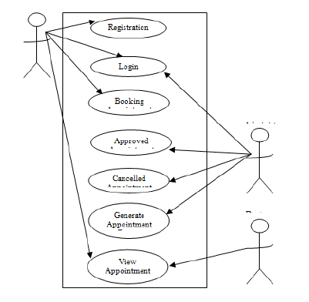
Figure 3.1: Medical Appointment Booking System architecture

3.2 ANALYSIS OF EXISTING SYSTEM
Lack of immediate retrievals: -The information is very difficult to retrieve and to find particular information like- E.g. - To find out about the patient’s history, the user has to go through various registers. This results in inconvenience and wastage of time. Error prone manual calculation: - Manual calculations are error prone and take a lot of time this may result in incorrect information. For example: calculation of patient’s bill based on various treatments. In traditional system, patient has to come to the hospitals and queue at the appointment window to make the appointment. But they usually end up waiting for very long periods of time. The patient can, however decide to schedule an appointment, but this option does not usually work well for all parties involved. Parties involved includes: the patient, the doctor and the administrator. The patient wishes for readily available and convenient appointment times. When they do not find a close enough appointment time they experience long periods of indirect waiting time (time between scheduling the appointment and that appointment becoming available). The patient also wishes to be seen either immediately or within minutes of their arrival (whether they scheduled an appointment or not). The time that the patient waits from the scheduled start time of their appointment to the time that they actually receive service is called direct waiting time.
3.3 PROBLEM OF THE EXISTING SYSTEM
The use of paper work does not ensure security of every record. It increases the redundancy of data and gives various facilities. It leads to loss of data. There is no convenience in booking appointment manually. It takes more effort and physical space to keep track of paper documents, to find information and to keep details secure. When mistakes are made or changes or corrections are needed, often a manual transaction must be completely redone rather than just updated. With manual or partially automated systems information often has to be written down and copied or entered more than once. Systemization can reduce the amount of duplication of data entry.Another impact of manual systems is on Customer service. Customer queries can be difficult to respond to as information is stored in different places and may even require that you find the right person before being able to respond.
Problems existing with the current manual processing information in the hospital are:
- Slow receipt processing of information.
- Errors are easily made and hardly detected when making a payment
- The manual system does not ensure durability of record storing.
- Information is not well maintained.
- Time consumption due to the use of calculator, pen and paper to compute the patients’ bills.
3.4 DESCRIPTION OF THE PROPOSED SYSTEM
The information processing system itself is assessed with system quality attributes (e.g., usability, accessibility, ease of use). Information quality attributes (e.g., accuracy, completeness, legibility), concern the input and output of the system. Usage refers to system usage, information usage, or both. Examples of attributes of usage are number of entries and total data entry time. User satisfaction can concern the system itself or its information, although they are hard to disentangle.

3.5 ADVANTAGE OF THE PROPOSED SYSTEM
- Medical billing enables a healthcare service to efficiently claim for the services provided. Web-based Medical Billing in a healthcare system ensures that the practice receives reimbursement for the work the providers perform smoothly.
- Cloud based Medical Billing service is a win-win situation if you are dealing with a responsible, financially strong, and efficient company because for cloud based service you pay as you go, and it is charged per user, per month and you never have to deal with the cost up-front. It saves you a lot of money.
- Web-based Electronic Billing requires limited customization while software based customization is tedious and rigid.
- Increase Staff Productivity: The average phone call to schedule, reschedule, or cancel an appointment takes over eight minutes. Eliminate wasted time by implementing an online, automated scheduling software. Patients schedule appointments and receive reminders directly from the software, freeing your staff to focus on patients at the office.
- Decrease Front Office Distractions: Multiple studies show it takes an average of 23 minutes and 15 seconds to return to the original task after an interruption. Phone scheduling calls keep your staff unfocused and distracted most of the day. Distractions often lead to costly errors and mistakes. Your front office has many duties to perform throughout the day, including customer service, greeting patients, answering questions, clerical tasks, and collecting and processing patient forms. Constant appointment scheduling often interrupts these important duties. Streamlining the scheduling process frees staff to complete their required jobs.
- Create Loyal and Engaged Patients: Patients benefit from the ease of online scheduling. They can complete essential forms, schedule appointments, and check appointment status all without contacting your office. According to research by Accenture a significant number of patients believe that the ability to self-schedule their appointment is a priority. Accenture says, “Of patients who were not chronically ill, 77 percent feel that self-scheduling electronically is important, and 89 percent of chronically ill patients feel it is important.”
- Reduce the Expense of Scheduling Patients: With new advances and the low cost of scheduling technology you can cut back on the unnecessary expense of a human appointment scheduler. Expand your practice’s patient capacity while freeing your existing staff to focus on more important tasks. Online scheduling also improves communication among staff for more effective and efficient work.

CHAPTER FOUR
DESIGN, IMPLEMENTATION AND DOCUMENTATION OF THE SYSTEM
  - DESIGN OF THE SYSTEM
The proposed system is designed in modules with each modules working together to perform the electronic voting system in order to enhance the performance of the existing system as earlier discussed in chapter three.
The ability to analyze and give focus to the system is explained in the following formats which are output design, input design, database design and procedure design.
    - OUTPUT DESIGN
The output and output to be extracted from the proposed system are as shown below

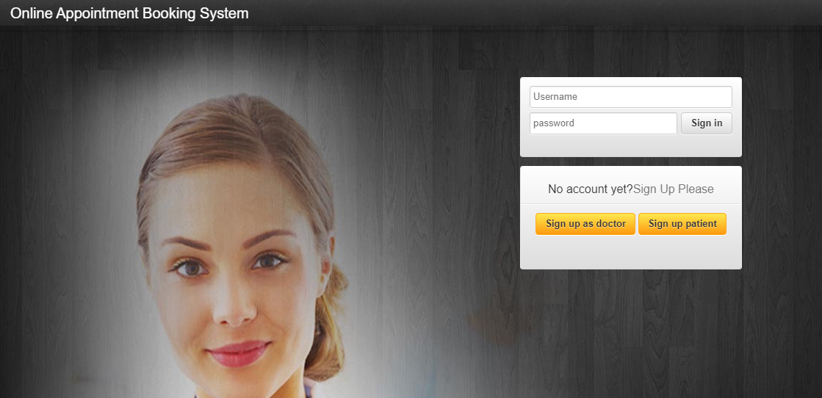
Figure 4.1: Index Page
This Page is the welcome page that displays the welcome content

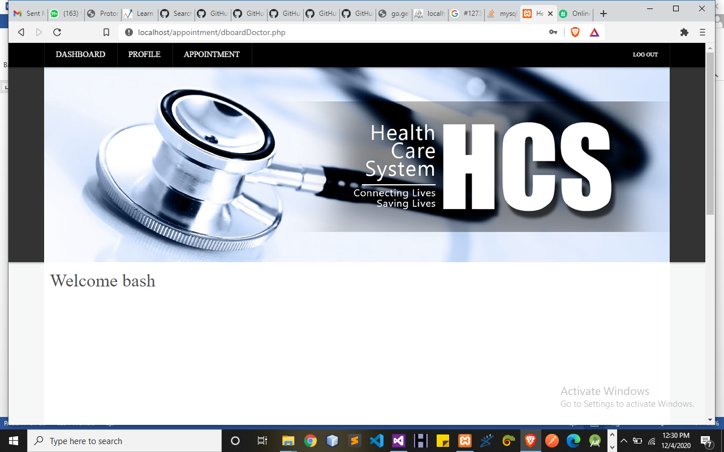
Figure 4.2: Doctor Dashboard Page
This Page Display all operations that can be perform by Admin using this system.

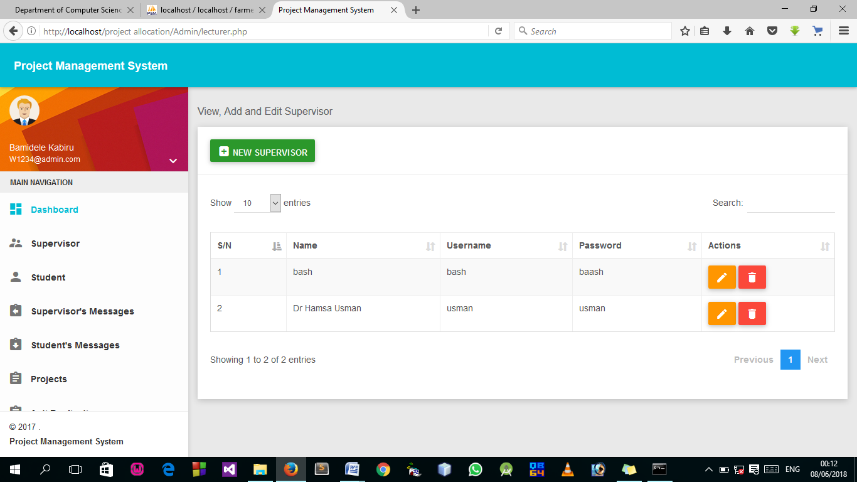
Figure 4.3: List of All Registered Patient Page
This page display all Patient added.

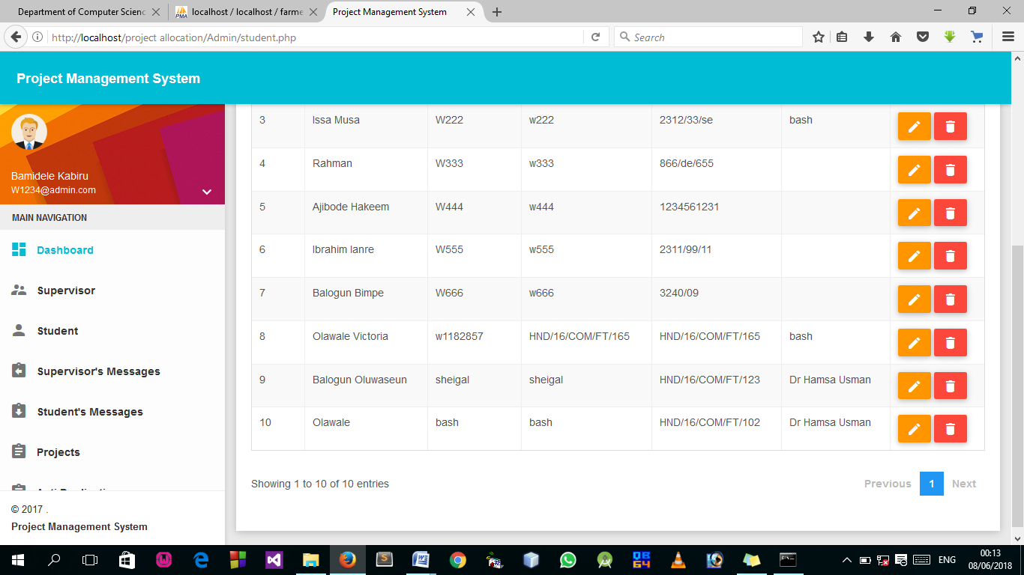
Figure 4.4: List of all Appoint booked Page
This Page Display all appoint booked by the patient.

4.1.2 INPUT DESIGN

It is also necessary to denote that data inputted in the computer for processing determines what the output will be. The inputs are use in collecting information the student through the keyboard. Inputs are necessary information needed for processing so as to produce the expected outputs; which are supplied through the keyboard.
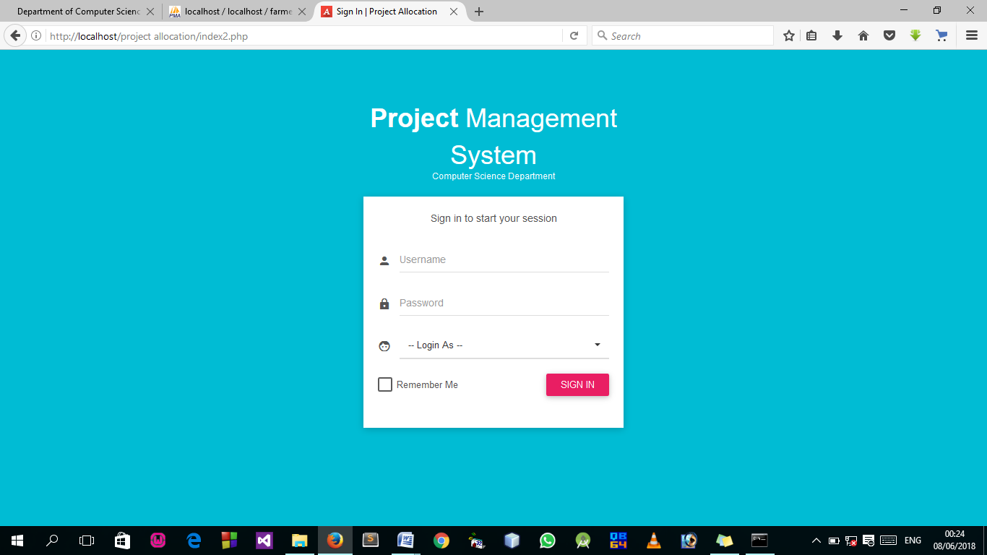
Figure 4.5: Login Page
This Page allow authorized user to log into the system.
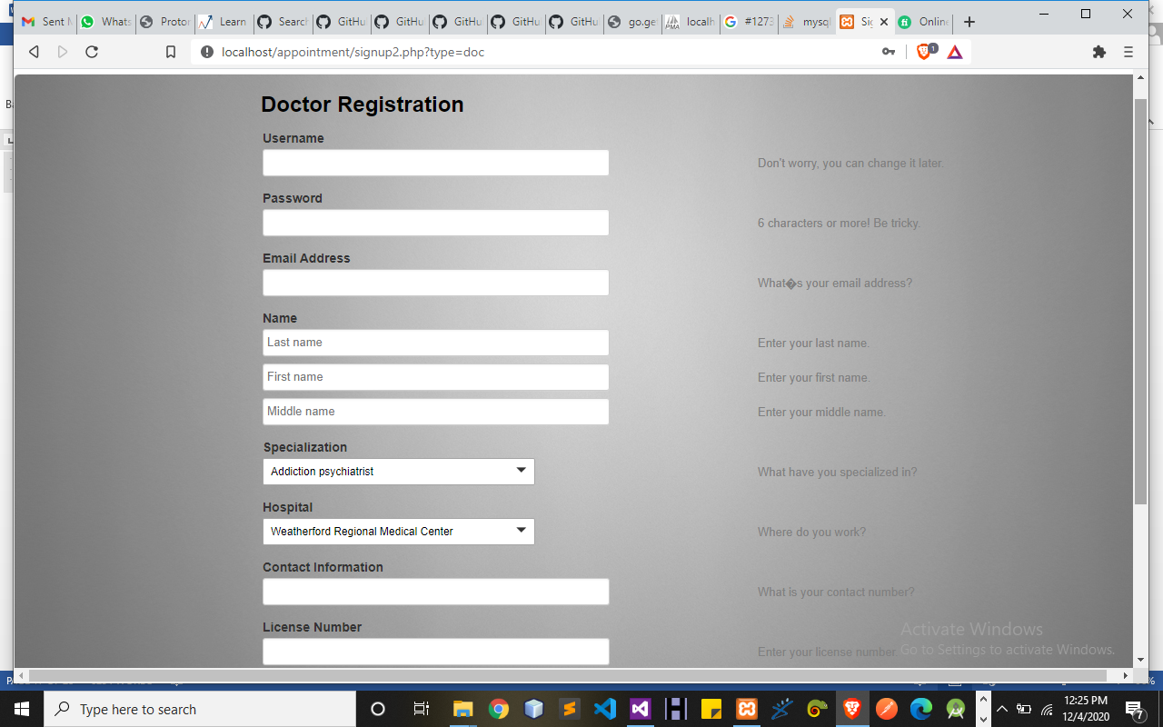
Figure 4.6: Doctor Registration Page
This Page allow doctor to get access to the system.
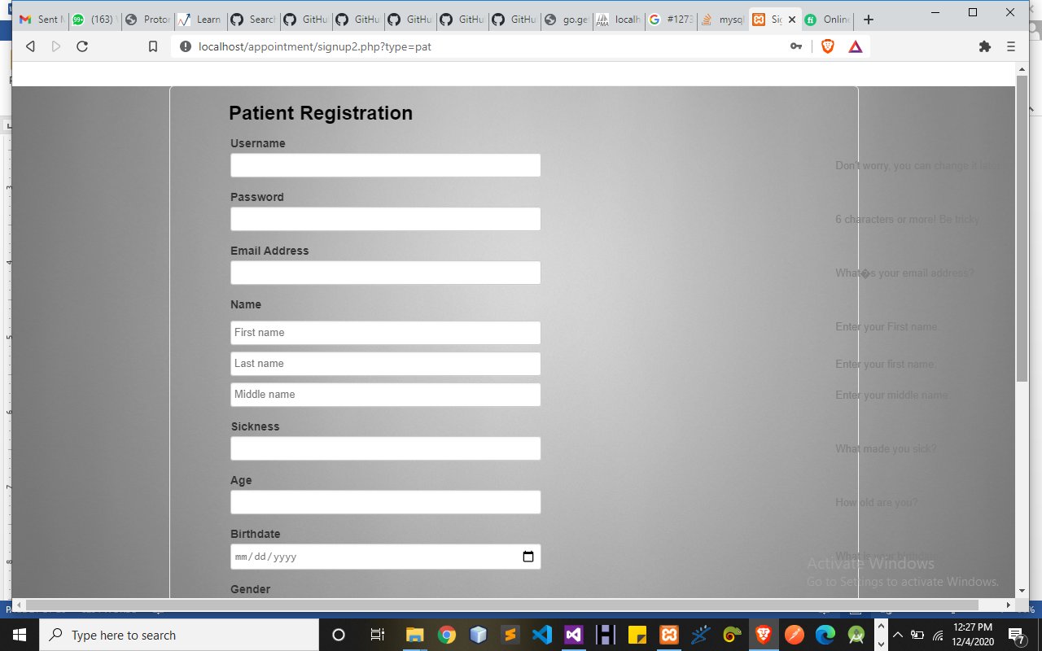
Figure 4.7: Patient Registration Page
This Page allows all patients to register and get access into the system.
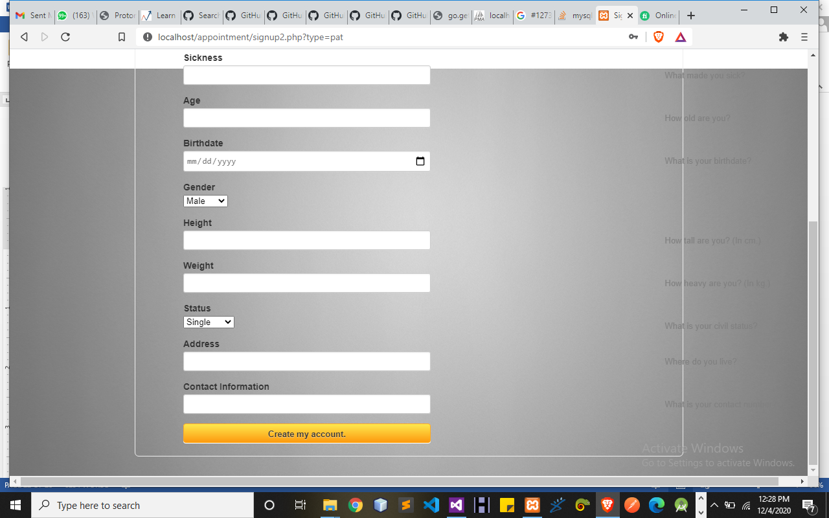
Figure 4.10: Add New Patient Page
4.1.3 DATABASE DESIGN
A database table is used for storing information about the files. The database use for this application is mysql database. The files and their respective modes of access as well as information they hold are given below;
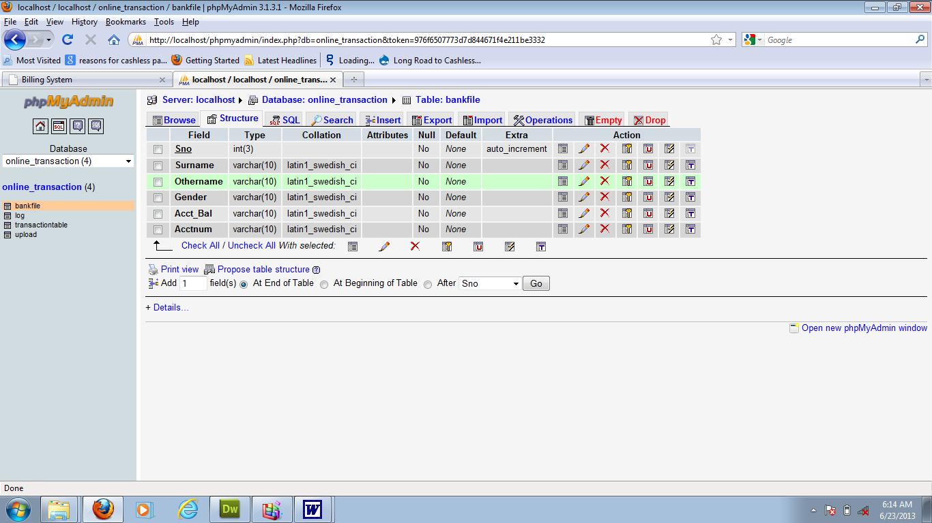
Table 4.1: Doctor Registration structure

Table 4.2: Admin Login Table structure
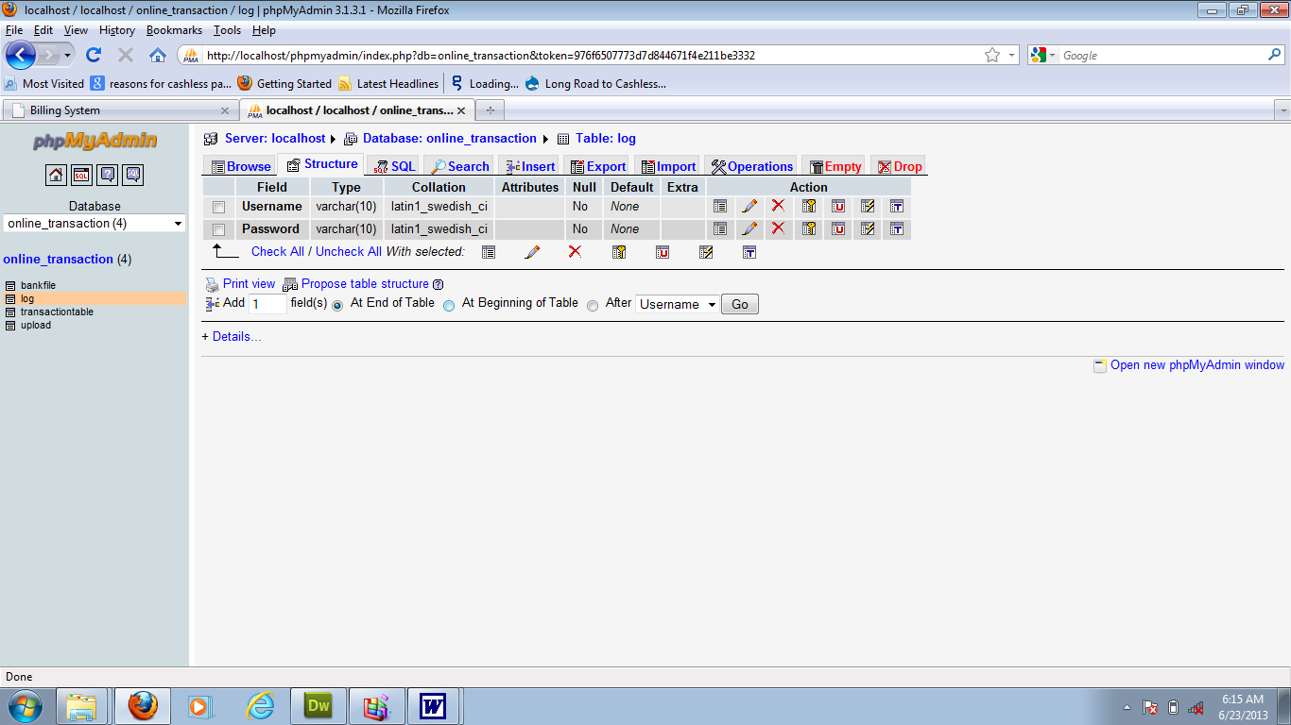

Table 4.3: Student Personal Data table
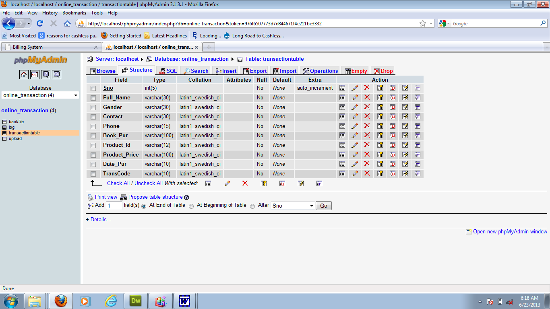
4.1.3 PROCEDURE DESIGN
Procedures are steps which verify the whole process i.e which are everything put together to produce the desired output. This involves the organization of the source document and end with the output result.
Documents are sent to various departments to be filled by the employees and later returned to the personnel department which are analysed to determine which record goes into the computer.
After selecting the necessary data, this serves as input to the computer system.

4.2 IMPLEMENTATION OF THE SYSTEM
It is always good to develop new ideas, to implement them on a computer and eventually to relish the satisfaction of achieving a successful result. The implementation process involves converting the system design into a complete and tested that is fully operational and that can be used by the system users to meet their business needs. During implementation phase, the hardware and the software must be implemented.
Implementation of a system can be explained in six steps:-
- Review design specification
- Code, test and document programs
- Train users
- Perform system test
- Convert to new system
- Evaluate and maintain the new system
4.2.1 CHOICE OF PROGRAMMING LANGUAGE
The application is designed in Sublime web development package which involves the use of PHP server-side scripting language, MYSQL for database management and HTML 5(with other embedded functionalities) for the page design and layout settings. Hence, the program testing simply involves running it directly from a Mozilla Firefox web browser on local host server provided by Apache 2.0 inWampServer 2.0 application.
In the preparation for the installation of the new system, the method of changeover is given serious consideration to determine the success of the new system. Suitable changeover technique for this system is pilot changeover. The pilot changes over and operates by applying the new system bit-by-bit until it covers the whole of the operations. The result obtained from using the pilot method on a small portion of the operations would be used in determining the suitability of the need system for the rest of the operations. This method is similar to testing small sample of a distribution if the test yields a good result then the whole system because fully operational and the manual/existing system is eliminated.
4.2.2 HARDWARE SUPPORT
i. Minimum of Microcomputer Pentium II- Intel 533 MHZ processor, 128 MB RAM, 3.5GB HDD, 3.5”FDD, 14” VGA Monitor Windows 2000 Enhanced keyboard, mouse and pad.
ii. Scanner
iii. Printer
iv. HP DeskJet 3820c series
4.2.3 SOFTWARE
I. Interface Design Language, windows Notepad for help interface design Hypertext Mark-up Language (HTML 5)
ii. MY SQL Database Management Software
iii. Programming PHP (Hypertext Pre-processor)
iv. Operating system window 07 professional
v. Graphic software paint shop and choosing these two formats GIF (Graphic Image Format)
vi. Scanner software, Mira scan
Web browser software MOZILLA

4.3 PROGRAM DOCUMENTATION
4.3.1 OPERATING THE SYSTEM
Step 1: Boot your computer and click on start button on task bar
Step 2: Launch wamp server
Step 3: Login to your Application
Step 4: Click on Options
4.1 Click on Dashboard (to view operations)
4.2 Click on Appointment (to add new Appointment)
4.3 Click on Edit (to make update)
Step 5: Logout

4.3.3 MAINTAINING THE SYSTEM
The use of the term maintenance for software is different from other references to maintenance. Unlike the tires on your car, software does not “wear out”. If this is the case, then why does software maintenance account for such a high percentage of the Total Cost of Ownership for software?
The software maintenance definition refers to changes for defect correction, performance improvements, or adaptations to a changed environment (enhancements). According to this definition, if we build software that is defect-free, performs well, and contains user-controlled parameters to adjust processing rules in response to changing requirements then most maintenance would not be necessary.
Why does this happen? There are many reasons but the most common reasons are time constraints and lack of experience. Adding validation logic takes time. So, people make assumptions about the quality of in-bound data. Assumptions are also made about the volume of transactions and the impact on performance and the stability of the automated business processes. Finally, it is common for new software to be developed by younger developers who don’t understand the maintenance impacts of their designs.
The reality is that business requirements change and most of these assumptions are flawed. Transaction volumes increase, changing business processes require new transactions or new validation criteria, and software users will use the software incorrectly. The cost of software maintenance and the total cost of ownership can dramatically be reduced if developers build software that adjusted to changes in transaction volumes; validated all inbound data and provide user-configurable options for decision logic and data validation

CHAPTER FIVE
SUMMARY, CONCLUSION AND RECOMMENDATIONS
5.1 SUMMARY
The aim of this project was to design and develop a software prototype which integrates with an external scheduling component to manage clinic appointments for patient. The application has been designed to be used by patients to assist them with scheduling. A software development methodology was determined and followed to ensure the successful completion of the project. A number of different tools were researched to develop the solution. The requirements of the system were established which were then used in the development phase. Following the successful implementation of the system, the application was tested and evaluated for usability and functionality to see overall how successful the project had been. The final solution developed met all the minimum requirements and also included some additional features. The report covers the whole project from start to finish, including the requirements analysis, background reading, design, implementation, testing and evaluation stages.
5.2 CONCLUSION
One of the biggest reasons that online appointment scheduling is getting popular day by day is that it helps the patients to make the appointment to their doctors, department in an easier way. It makes it through the computer, access a website or software and makes an appointment, than to go to the department, wait in a line for a number of hours, just to make an appointment with the doctor for the next week or next month. And through this, patients can also involve in the clinic decisions that they have to make. They can make an appointment to another lecturer other than theirs, by nothing more than a click.
5.3 RECOMMENDATIONS
Computer has become an indispensable tool to all fields of human Endeavour. For the management to be able to perform the functions which include planning, organizing, controlling, directing, coordinating and decision making? There is need for a computerized system.
When patient appointment records are computerized, it will go a long way to help the clinic. I therefore, recommend this software to every firm that gives appointment.

REFERENCES
Akinode,JohnLekan&Oloruntoba S.A (2013). Design and Implementation of a Patient Appointment and Scheduling System.
Ambulatory Care Services
Arthur H. & Suresh S. (2012) wrote an article on “Application of Intelligent Agents in Hospital Appointment Scheduling System” Under the guidance of Dr. Edith HemaspaandraRochester Institute of Technology
Marwa E, Saleh (2016). Online Appointment Management System.
Maryam Tufail (2018). Online Polyclinic Appointment And Database Management System
Mohammed J. A. (2016) wrote an article on “An Integrated Framework for Hospital Appointment Management”
Nazia S. &Ekta S. (2014) wrote an article on “Online Appointment Scheduling System for Hospitals” International Journal of Computer Applications (0975 – 8887) Volume 180 – No.22, February 2014
Shafaq M., Nargis B., Sehrish K., Razia S., Sadaf A. (2017) wrote an article on “A Doctor Appointment Application System”.
TugbaCayirli and Emre A. Veral (2006). Designing Appointment Scheduling Systems for
Weiping Y., Xiaowen Y., Hao H.&Yitao W. (2013) wrote an article on “Use of Hospital Appointment Registration Systems in China”
Xiuju Zhan, Xiufeng Liu (2012). Design and Implementation of Clinic Appointment Registration System.

