SURVEY OF RICE HARVESTING AND THRESHING TECHNOLOGY IN KWARA STATE (CASE STUDY OF EDU AND PATIGI LOCAL GOVERNMENT)

BY

ABDUSSALAM HAMAD-TIJANI OPELOYERU

HND/23/ABE/FT/0125

A RESEARCH PROJECT REPORT SUBMITTED TO THE DEPARTMENT OF AGRICULTURAL AND BIO-ENVIRONMENTAL ENGINEERING TECHNOLOGY, INSTITUTE OF TECHNOLOGY, KWARA STATE POLYTECHNIC, ILORIN.

IN PARTIAL FULFILMENT OF THE REQUIREMENT FOR THE AWARD OF HIGHER NATIONAL DIPLOMA (HND) IN AGRICULTURAL AND BIO-ENVIRONMENTAL ENGINEERING TECHNOLOGY, KWARA STATE POLYTECHNIC, ILORIN.

JULY, 2025.



DEDICATION

This project is dedicated to almighty Allah.

ACKNOWLEGEMNT

I describe all the glory and adoration to Almighty Allah who has always been there for me right from my childhood until now. He has been my one and number one confident.

My profound gratitude goes to my able supervisor Engr. Usman.M for this invaluable criticism and corrections towards making this research work a success. Infact I am struck by words, all I can say is thank you sir.

To my parents Mr/Mrs Abdulsalam for their financial, moral and spiritual support given to me. Thank you for believing in me even when i was doubting and thinking it is impossible.

I also acknowledge the effort of the Head of Department Engr. Dr. Dauda. K.A., and other staff in the department for the knowledge impacted on me, may Almighty Allah reward you all abundantly.

Finally, to my relatives, my sister Mrs Abdulsalam Rofiat for always believing in me, Mr & Mrs muthalib for their financial and moral support, Mr Abdulrazaq for the intermediate financial support given to me. kudos to my friends Abdulsamad, Abdulhakeem , Hassan, Obayemi, Joseph for their emotional support offered to me. Also, to all my course mates from my able REP to others for supporting me physically, mentally, emotionally, financially, And also Mrs Ayodeji Balqees Adeleke for her moral support, I say a big thank you to everyone. May Almighty Allah reward you all abundantly.

ABSTRACT
This study investigates the current state of rice harvesting and threshing technologies in Edu and Patigi Local Government Areas of Kwara State, Nigeria. Given the significance of rice as a staple food and economic commodity, the research addresses critical issues of mechanization and efficiency in rice production.
Using a combination of structured questionnaires, semi-structured interviews, and direct field observations, data was collected from 90 rice farmers across the two LGAs.
This study reveals a predominant reliance on traditional harvesting (81.1%) and threshing (85.6%) technologies, highlighting significant gaps in mechanization. Factors influencing the choice of technology include cost, availability, and technical know-how, with many farmers unable to afford or operate modern machinery. The analysis underscores the urgent need for increased mechanization to enhance productivity and reduce post-harvest losses.
The study concludes with recommendations for policy interventions, including subsidies for modern equipment, training programs for farmers, and improved agricultural extension services to support the transition from traditional to modern practices. These measures are essential to achieve sustainable rice production and food security in the region.

TABLE OF CONTENT

Tittle Page

Certification

Dedication

Acknowledgement

Abstract

Table of Content

CHAPTER ONE: INTRODUCTION

1.1 Background of the Study

1.2 Problem Statement

1.3 Aim and Objectives of the Study

1.4 Justification
1.5 Scope of the Study

CHAPTER TWO: LITERATURE REVIEW

2.1 Preamble

2.2 Traditional Rice Harvesting and Threshing Methods

2.3 Modern Rice Harvesting and Threshing Equipment

2.4 Challenges in Rice Production in Nigeria

2.5 Impact of Mechanization on Rice Production

2.6 Rice Production in Kwara State

2.7 Technological Advancements in Rice Harvesting and Threshing

2.8 Socioeconomic Impact of Mechanization

2.9 Policy and Institutional Support for Mechanization

2.10 Adoption of Mechanization in Developing Countries

2.11 Gender Dynamics in Agricultural Mechanization

2.12 Environmental Impacts of Mechanization

CHAPTER THREE: RESEARCH METHODOLOGY

3.1 Description of Study Area
Plate 1: Map of the Study Area

3.2 Research Design

3.2.1 Research Population
3.2.2 Sampling Unit

3.2.3 Sampling Technique and Procedure

Table 3.1: Sample Population and Number of Respondents
3.3 Items for Observation
3.4 Research Question

3.5 Data Collection
3.6 Data Processing and Cleaning

3.7 Data Analysis
3.7.1 Statistical Method Used
3.7.2 Percentage Estimation
3.7.3 Cross tabulation Method
CHAPTER FOUR: RESULTS AND DISCUSSION
4.1 Results
4.2 Examination of Rice Harvesting Technology in Practice in the Study Area
4.3 Examination of Rice Threshing Technology in Practice in the Study Area

4.4 Status of Mechanization in Rice Harvesting and Threshing in the Study Area

4.5 Assessing the Level of Rice Production in Edu and Patigi Local Government Area
4.6 Factors Responsible for choice of Current Harvesting and Threshing technology in the study area
4.2 Discussion
CHAPTER FIVE: CONCLUSION AND RECOMMENDATIONS
5.1 Conclusion
5.2 Recommendations

References

LIST OF TABLES
Table 4.1: Rice Harvesting Technology in practice in Edu and Patigi Local Government Area
Table 4.2: Rice Harvesting Equipment used in Edu and Patigi Local Government Area

Table 4.3: Average Yield per Farm Size
Table 4.4: Factors Affecting Technology Choice in Edu and Patigi Local Government Area

LIST OF FIGURES
Figure 4.1: Distribution of Different Rice Harvesting Technologies in practice in Edu and Patigi LGA
Figure 4.2: Distribution of Rice Threshing Technology Equipment used in Edu and Patigi Local Government Area
Figure 4.3: Status of Mechanization in Rice Harvesting and Threshing Technology used in Edu and Patigi Local Government Area

Figure 4.4: Level of Rice Production in the study area
Figure 4.5: Factors Affecting Technology Choice in Edu and Patigi Local Government Area

CHAPTER ONE

1. INTRODUCTION

1.1 Background of the Study
Rice is a staple food in many parts of the world, including Nigeria, where it is a significant component of the diet and economy. Kwara State, particularly Edu and Patigi Local Government Areas, is known for its rice production. Despite the region's potential, farmers face challenges in harvesting and threshing, leading to inefficiencies and reduced yields.
Rice is one of the most widely consumed staple foods globally, and Nigeria is no exception. With a growing population and increasing urbanization, the demand for rice in Nigeria continues to rise, placing pressure on domestic production to meet local needs (FAO, 2020). Kwara State, located in the North-Central region of Nigeria, is one of the major rice-producing areas in the country. Within Kwara State, the Edu and Patigi Local Government Areas are key contributors to rice cultivation (Abubakar et al., 2018).
However, despite their significant role in rice production, farmers in Edu and Patigi face considerable challenges that hinder their productivity and efficiency. Traditional methods of rice harvesting and threshing, such as manual cutting with sickles and threshing by beating or treading, are still widely used (Agbaje, 2019). These methods are labor-intensive and often result in high post-harvest losses due to inefficiencies and the risk of damaging the rice grains during threshing (Oni et al., 2019).
The lack of access to modern mechanized equipment, such as combine harvesters and automated threshing machines, exacerbates these challenges. Many farmers in Edu and Patigi cannot afford such equipment or lack the technical knowledge required to operate and maintain them (Olaniyan et al., 2020). Additionally, there is limited government support and agricultural extension services to facilitate the transition from traditional to modern practices (Adebayo, 2020).
The resulting inefficiencies in rice harvesting and threshing have a direct impact on farmers' productivity and income. Post-harvest losses due to inefficient threshing can account for a significant percentage of the total crop, reducing the quantity of marketable rice and, consequently, the revenue for farmers (Oke & Agboola, 2018). Moreover, these inefficiencies can affect food security in the region, as the reduced yield may not meet the growing demand for rice (Nwankwo, 2018).
Given these challenges, this study aims to investigate the current rice harvesting and threshing technology used in Edu and Patigi LGAs and assess their impact on productivity and post-harvest losses. By identifying the specific challenges and proposing recommendations for improvement, this study seeks to contribute to the development of sustainable agricultural practices in Kwara State and beyond.
Rice (Oryza sativa) is one of the most important staple foods globally, feeding over half of the world's population. In Nigeria, rice is a crucial part of the diet and is central to the country's agricultural economy. Nigeria is both a major producer and consumer of rice in Africa, with the crop playing a vital role in food security, income generation, and employment (FAO, 2019). Despite its importance, the rice production sector in Nigeria faces numerous challenges, including low productivity, high post-harvest losses, and inadequate mechanization.
Edu and Patigi Local Government Areas (LGAs) of Kwara State are among the significant rice-producing regions in Nigeria. These areas have favorable climatic conditions and fertile land, making them suitable for rice cultivation (Kwara State Ministry of Agriculture, 2017). However, rice farmers in these regions still rely heavily on traditional farming methods, which are labor-intensive and less efficient, compared to modern mechanized farming techniques.
Mechanization in agriculture, particularly in rice harvesting and threshing, has the potential to address many of the challenges faced by farmers. Mechanized harvesting and threshing can significantly reduce the labor required, shorten harvesting time, minimize post-harvest losses, and improve the quality of rice produced (Adewumi et al., 2019). Despite these benefits, the adoption of mechanized equipment in Edu and Patigi LGAs has been slow and uneven.
Several factors contribute to the low level of mechanization in these areas. Financial constraints are a major barrier, as many smallholder farmers cannot afford the high initial cost of purchasing mechanized equipment (Takeshima et al., 2015). Additionally, limited access to credit facilities and inadequate government support further hinder the adoption of modern farming technologies (Oluwatayo & Racho, 2018). There are also infrastructural challenges, such as poor road networks and lack of maintenance services, which make it difficult for farmers to use and maintain mechanized equipment effectively (Adebisi & Aliu, 2019).
Another critical factor is the lack of awareness and training among farmers regarding the benefits and operation of mechanized equipment. Many farmers in Edu and Patigi LGAs are not familiar with the latest technologies and do not have the necessary skills to operate and maintain them (Oni et al., 2018). This knowledge gap limits their ability to take full advantage of the benefits of mechanization.
Recognizing these challenges, the Nigerian government, along with various non-governmental organizations and international bodies, has initiated several programs to promote agricultural mechanization. These initiatives aim to provide farmers with access to modern equipment, training, and financial support (FMARD, 2016). Despite these efforts, the impact has been limited, and many farmers in Edu and Patigi LGAs continue to rely on traditional methods.
This study aims to investigate the current state of rice harvesting and threshing equipment in Edu and Patigi LGAs, exploring the challenges and opportunities associated with their adoption. By understanding the factors that influence the use of mechanized equipment, this research seeks to provide insights that can inform policy decisions and interventions to promote agricultural mechanization in the region.

1.2 Problem Statement
The issue of low level of mechanization in rice harvesting and threshing in rice producing communities in Nigeria is becoming a topical issue in the quest for self-sufficiency in rice supply in Nigeria. Manual harvesting and threshing operation contribute a lot to the percentage of grains loses in the field due to delayed in harvesting and threshing operation is always due to inefficiency of human power coupled with the use of simple harvesting and threshing tools. For the Government to achieve the aim of self-sufficiency in rice production there is need to examine rice harvesting and threshing technologies across the thirty six states of the federation.
Also, the reliance on traditional harvesting and threshing techniques in Edu and Patigi results in reduced productivity and high post-harvest losses. These challenges are further exacerbated by inadequate access to modern equipment and limited technical knowledge among farmers. Consequently, there is a need to explore the current state of rice harvesting and threshing equipment to identify areas for improvement. This study aimed to examine the extent of mechanization in rice harvesting and threshing in two most rice producing local government area of Kwara State.

1.3 Aim and Objectives of the Study
The main aim of this study is to investigate Rice Harvesting and Threshing Technology in the two most Rice Producing Local Government Areas of Kwara State, (Edu and Patigi Local Government Areas).

The Specific objectives of this study are:
- To investigate Rice Harvesting and Threshing Technology in practice in the study area.
- To ascertain the status of mechanization in Rice Harvesting and Threshing in the study area.
- To ascertain the factors responsible for choice of current Harvesting and Threshing technology in the study area.
- To assess the level of Rice Production in the study area.

1.4 Justifications of the Study
The investigation of the current state of rice harvesting and threshing equipment in Edu and Patigi Local Government Areas of Kwara State, Nigeria, is critically important for several reasons:
Rice is a staple food in Nigeria, and improving its production efficiency is crucial for ensuring food security and meeting the growing demand (FAO, 2019). Mechanization, particularly in harvesting and threshing, can significantly enhance agricultural productivity by reducing the time and labor required for these processes (Takeshima et al., 2015). By investigating the current state of mechanized equipment in Edu and Patigi LGAs, this study aims to identify gaps and opportunities for increasing productivity and ensuring a stable rice supply.
Post-harvest losses are a major challenge in rice production, often resulting in significant economic losses for farmers (Adewumi et al., 2019). Traditional harvesting and threshing methods are less efficient and more prone to causing damage to the rice grains. Mechanized equipment can reduce these losses by providing more precise and efficient processing (Oluwatayo & Racho, 2018). Understanding the current adoption and effectiveness of such equipment in Edu and Patigi LGAs will help in designing interventions to minimize post-harvest losses.
Mechanization can have a profound impact on the livelihoods of smallholder farmers. It can reduce the drudgery associated with manual labor, increase production efficiency, and ultimately lead to higher incomes (Adebisi & Aliu, 2019). Investigating the current state of rice harvesting and threshing equipment in these Local Government Areas will provide insights into how mechanization can be optimized to benefit the farmers economically and improve their overall quality of life.
Gender and socioeconomic inequities often influence the adoption of agricultural technologies. Women, who make up a significant portion of the agricultural labor force, often face barriers to accessing mechanized equipment (Doss et al., 2018). This study will explore these dynamics within Edu and Patigi LGAs, providing a basis for policies and programs that ensure equitable access to mechanization for all farmers, regardless of gender or socioeconomic status.
Effective policy formulation and implementation are crucial for promoting agricultural mechanization. By providing a detailed assessment of the current state of rice harvesting and threshing equipment in Edu and Patigi LGAs, this study will offer valuable data for policymakers, government agencies, and development organizations. This information can be used to design targeted interventions, allocate resources effectively, and develop support programs that encourage the adoption of modern farming technologies (FMARD, 2016).
While mechanization has the potential to increase productivity, it must be implemented sustainably to avoid negative environmental impacts. Understanding the current practices and challenges faced by farmers in Edu and Patigi LGAs will help in promoting sustainable mechanization practices that balance productivity with environmental conservation (Eze et al., 2019). This study will provide insights into how mechanized equipment can be used in ways that protect soil health, reduce emissions, and conserve resources.
A significant barrier to the adoption of mechanization is the lack of technical skills and knowledge among farmers (Oni et al., 2018). By assessing the current state of rice harvesting and threshing equipment, this study can identify specific areas where training and capacity-building efforts are needed. This will enable the development of educational programs and technical support services that equip farmers with the skills necessary to operate and maintain mechanized equipment effectively.
Investigating the current state of rice harvesting and threshing equipment in Edu and Patigi LGAs is justified by its potential to enhance productivity, reduce post-harvest losses, improve farmer livelihoods, address socioeconomic inequities, inform policy, support sustainable practices, and build technical capacity. The findings of this study will provide a comprehensive understanding of the challenges and opportunities associated with mechanization in these regions, ultimately contributing to the development of a more efficient and sustainable rice production system in Kwara State, Nigeria.
1.5 Scope of the Study
The scope of this study is limited to investigation of Harvesting and Threshing technology practice in Edu and Patigi Local Government Area of Kwara State, Nigeria.

CHAPTER TWO

2. LITERATURE REVIEW

2.1 Preamble

The literature review explores various aspects of rice harvesting and threshing techniques, focusing on traditional practices, modern equipment, and the challenges faced by farmers in Edu and Patigi Local Government Areas (LGAs) of Kwara State, Nigeria. This review aims to contextualize the current state of rice production in the region and identify key factors impacting efficiency and productivity.

2.2 Traditional Rice Harvesting and Threshing Methods

Traditional methods of rice harvesting and threshing have been practiced in Nigeria for generations. These methods typically involve manual cutting of rice stalks with simple tools like sickles or machetes, followed by manual threshing through hand-beating or trampling (Oke et al., 2018). While these practices are low-cost and require minimal technological expertise, they are labor-intensive and inefficient, leading to high post-harvest losses due to broken grains and incomplete threshing (Ojo & Adebayo, 2019).

One of the critical issues with traditional methods is the extensive labor required. Harvesting rice manually is time-consuming, often taking several days or even weeks to complete, depending on the size of the farm (Bello et al., 2019). This high labor requirement limits the ability to expand production and can lead to delays that affect the quality of the rice (Oladele & Ajayi, 2020). Additionally, manual threshing can result in significant grain loss due to improper handling and inadequate separation techniques (Ahmed et al., 2019).

2.3 Modern Rice Harvesting and Threshing Equipment

Modern rice harvesting and threshing equipment, such as combine harvesters, mechanical reapers, and automated threshing machines, can significantly improve productivity and reduce post-harvest losses (Eze & Okechukwu, 2018). Combine harvesters are designed to perform multiple tasks, including cutting, threshing, and cleaning rice, all in a single operation, thus streamlining the harvesting process and reducing labor requirements (Olaniyan et al., 2019). Mechanical reapers offer a middle ground by automating the cutting process while allowing manual threshing, providing an incremental step toward full mechanization (Agbaje, 2020).

The adoption of modern equipment in Nigeria is often limited by high costs and a lack of technical knowledge among farmers (Ayo & Olufemi, 2018). Many farmers in Edu and Patigi LGAs operate on a small scale, making it challenging to justify the investment in expensive machinery (Ogunleye, 2019). Additionally, access to such equipment is often restricted to urban areas, with rural farmers struggling to find rental services or support for maintenance and repair (Babatunde & Ojo, 2019).

2.4 Challenges in Rice Production in Nigeria

Farmers in Nigeria, particularly in rural areas, face multiple challenges that affect rice production and the adoption of mechanized equipment. Infrastructure limitations, such as poor road networks and inadequate power supply, hinder the transportation and use of machinery (Adebisi & Aliu, 2019). This creates logistical challenges for farmers attempting to transport harvested rice or access mechanized services (Tijani & Akinsola, 2020).

In addition to infrastructural challenges, limited government support and agricultural extension services contribute to the slow adoption of modern harvesting and threshing methods (Olufemi, 2020). Without adequate training and support, farmers often resort back to traditional practices that, while familiar, are inefficient and result in high post-harvest losses (Nwachukwu et al., 2018). Moreover, financial constraints and a lack of access to credit further complicate the process of adopting mechanized practices (Onyeka & Olaniyan, 2020).

2.5 Impact of Mechanization on Rice Production

The introduction of mechanization in rice production has shown significant potential to improve productivity and reduce post-harvest losses (Adeyemi et al., 2019). Mechanized equipment can enhance the efficiency of harvesting and threshing, leading to higher yields and better-quality rice (Ogundele et al., 2018). In regions where mechanization has been successfully implemented, studies indicate a noticeable reduction in labor costs and an increase in overall productivity (Ogunniyi et al., 2020).

However, the success of mechanization depends on several factors, including proper infrastructure, financial resources, and technical training (Adebayo et al., 2019). Without these supporting elements, even the best machinery may remain underutilized or ineffective. Addressing these challenges is essential for realizing the full potential of mechanization in rice production (Eze et al., 2019).

2.6 Rice Production in Kwara State

Previous studies on rice production in Kwara State have provided insights into the challenges and opportunities for improvement in the region. Research by Adekola et al. (2018) found that while the adoption of modern equipment is beneficial, the lack of support and training remains a significant barrier. Similarly, Bamidele et al. (2020) emphasized the importance of government intervention and policy development to encourage the adoption of mechanized practices.

These studies suggest that improving rice production in Kwara State requires a multi-faceted approach, including investment in infrastructure, financial support for farmers, and comprehensive training programs (Oni et al., 2019). Furthermore, collaborations between government agencies, non-governmental organizations, and private sector stakeholders can play a crucial role in advancing rice production and reducing post-harvest losses (Tijani & Agboola, 2018).

2.7 Technological Advancements in Rice Harvesting and Threshing

Technological advancements in rice harvesting and threshing have significantly transformed agricultural practices globally. In many rice-producing countries, the adoption of modern machinery, such as combine harvesters and automated threshers, has led to substantial improvements in productivity and efficiency (FAO, 2020). Combine harvesters, for instance, integrate cutting, threshing, and cleaning operations, thereby streamlining the entire harvesting process and reducing labor costs (Hossain et al., 2018).

Studies indicate that mechanization not only increases the speed and efficiency of harvesting and threshing but also reduces post-harvest losses. For example, research by Adewumi et al. (2019) demonstrated that the use of combine harvesters in rice fields reduced post-harvest losses by up to 30% compared to traditional methods. Additionally, mechanized systems often produce cleaner and higher-quality grains, which can fetch better prices in the market (Olaniyan et al., 2018).

However, the adoption of these technologies in Nigeria has been slow due to various barriers, including high costs, lack of access to credit, and inadequate technical training for farmers (Babatunde & Olaniyan, 2020). The high initial investment required for purchasing modern equipment is a significant deterrent, particularly for smallholder farmers who dominate the agricultural landscape in Edu and Patigi LGAs (Oluwafemi & Ojo, 2020).

2.8 Socioeconomic Impact of Mechanization

The socioeconomic impact of mechanization in agriculture extends beyond mere increases in productivity. Mechanization can lead to shifts in labor dynamics, affecting both employment and income distribution within farming communities (Pingali, 2007). In the context of Edu and Patigi LGAs, where traditional labor-intensive methods are prevalent, the introduction of mechanized harvesting and threshing equipment could potentially displace manual labor, raising concerns about job losses (Adesina et al., 2018).

However, mechanization also presents opportunities for skill development and new types of employment. Training programs focused on operating and maintaining modern agricultural machinery can create skilled job opportunities and foster rural development (Aliyu & Yisa, 2019). Furthermore, increased productivity and reduced post-harvest losses can enhance food security and generate higher incomes for farmers, contributing to improved livelihoods and economic stability in the region (Oluwafemi, 2018).

Moreover, mechanization can have positive environmental impacts by promoting more efficient use of resources and reducing the physical strain on farmers, thereby improving their overall well-being and capacity to manage larger farms (Eze & Okechukwu, 2018). Studies in other regions have shown that mechanized farming practices can lead to better land management and higher sustainability of agricultural practices (Mwangi, 2019).

2.9 Policy and Institutional Support for Mechanization

Effective policy and institutional support are critical for the successful adoption and implementation of mechanization in agriculture. In Nigeria, government policies and programs aimed at promoting agricultural mechanization have been developed, but their impact has been limited due to various challenges (Adebayo, 2020). For instance, the Agricultural Transformation Agenda (ATA) launched in 2011 aimed to modernize Nigeria's agricultural sector by promoting mechanization and providing financial support to farmers (FMARD, 2013). However, the implementation of such initiatives has often been hindered by bureaucratic inefficiencies and lack of coordination among stakeholders (Oni, 2019).

In Edu and Patigi LGAs, the presence of agricultural extension services is crucial for providing farmers with the necessary knowledge and skills to adopt mechanized practices (Ojo et al., 2018). Extension services can facilitate the dissemination of information about the benefits of mechanization, as well as provide training on the operation and maintenance of modern equipment (Bamidele et al., 2019). Additionally, partnerships between the government, private sector, and non-governmental organizations can help address financial barriers by offering credit facilities and subsidies for purchasing equipment (Olaniyan & Babatunde, 2018).

Furthermore, creating an enabling environment through infrastructure development, such as improving road networks and ensuring reliable power supply, is essential for supporting mechanized agriculture (Adebisi & Aliu, 2019). Policies that encourage investment in rural infrastructure can significantly enhance the accessibility and usability of modern harvesting and threshing equipment, thereby promoting broader adoption among farmers (Oluwafemi, 2020).

2.10 Adoption of Mechanization in Developing Countries

The adoption of agricultural mechanization in developing countries, including Nigeria, has been a subject of extensive research. Mechanization is viewed as a key driver of agricultural transformation, capable of enhancing productivity, reducing labor costs, and improving food security (Binswanger, 1986). However, the rate of adoption varies significantly across regions due to socioeconomic, infrastructural, and policy-related factors (Mrema et al., 2008).

In Sub-Saharan Africa, including Nigeria, mechanization levels remain relatively low compared to other regions such as Southeast Asia and Latin America (Diao et al., 2014). This discrepancy is attributed to several challenges, including limited access to credit, high cost of machinery, and inadequate infrastructure (Daum & Birner, 2020). In addition, cultural factors and the traditional attachment to manual farming practices also play a role in the slow adoption of mechanized farming (Mrema et al., 2008).

Studies have shown that farmers are more likely to adopt mechanized farming if they perceive clear economic benefits, such as increased yields and reduced labor requirements (Mottaleb et al., 2016). Furthermore, access to markets and the availability of support services, including maintenance and repair facilities, are crucial for sustained use of agricultural machinery (Baudron et al., 2015).

In Nigeria, several initiatives have been implemented to promote mechanization, such as the provision of subsidized machinery through the Agricultural Transformation Agenda (ATA) and the establishment of Agricultural Equipment Hiring Enterprises (AEHEs) (FMARD, 2016). These initiatives aim to make mechanization more accessible to smallholder farmers by reducing the financial burden and providing technical support (Takeshima et al., 2013).

2.11 Gender Dynamics in Agricultural Mechanization

Gender dynamics play a significant role in the adoption and impact of agricultural mechanization. In many developing countries, including Nigeria, women constitute a large proportion of the agricultural labor force (FAO, 2011). However, they often face greater barriers to accessing and using mechanized equipment due to socio-cultural norms, limited access to financial resources, and lower levels of education and training (Doss & Morris, 2001).

Research has shown that when women have access to mechanized tools, their productivity can significantly increase, leading to better economic outcomes for their households (Quisumbing et al., 2014). Mechanization can also reduce the physical burden of agricultural work, particularly for women, who are often responsible for labor-intensive tasks such as planting, weeding, and post-harvest processing (Meinzen-Dick et al., 2011).

However, there is a risk that mechanization can exacerbate existing gender inequalities if the benefits are not equitably distributed (Farnworth et al., 2016). For instance, men are more likely to control mechanized equipment and the associated economic benefits, leaving women with less productive manual tasks (Doss et al., 2018). Therefore, it is essential to design mechanization programs that consider gender dynamics and promote equitable access to resources and benefits.

Policies and programs aimed at promoting agricultural mechanization should include targeted interventions to support women farmers, such as providing training and financial services tailored to their needs (World Bank, 2015). Ensuring that women are actively involved in decision-making processes related to agricultural mechanization can also help to address gender disparities (FAO, 2011).

2.12 Environmental Impacts of Mechanization

While mechanization has the potential to enhance agricultural productivity, it also has environmental implications that need to be considered. The use of heavy machinery can lead to soil compaction, reduced soil fertility, and increased greenhouse gas emissions (Lal, 2004). These environmental impacts can undermine the long-term sustainability of agricultural systems if not managed properly (Foley et al., 2011).

Research indicates that the environmental impacts of mechanization can be mitigated through the adoption of sustainable agricultural practices, such as conservation tillage, precision agriculture, and integrated pest management (Tilman et al., 2002). For example, conservation tillage, which involves minimal soil disturbance, can help to preserve soil structure, enhance water retention, and reduce erosion (Hobbs et al., 2008).

In addition, the use of renewable energy sources, such as solar-powered machinery, can reduce the carbon footprint of mechanized agriculture (Burney et al., 2010). Integrating mechanization with sustainable farming practices can help to balance the need for increased productivity with environmental conservation (Pretty et al., 2011).

In the context of Edu and Patigi LGAs, promoting sustainable mechanization practices is crucial to ensure that the benefits of increased productivity do not come at the expense of environmental degradation. Providing farmers with education and training on sustainable farming practices, along with access to environmentally friendly technologies, can help to achieve this balance (Eze et al., 2019).

CHAPTER THREE

3. RESEARCH METHODOLOGY

3.1 Description of Study Area

Kwara State was created on 27th May, 1976. Being one of the 36 States in Nigeria, it is located within North Central geopolitical zone. Kwara State is the gateway between the North and the South of Nigeria. Ilorin is the State Capital and the largest city in the State. Other popular towns in the state are Offa, Omu-Aran, Patigi, Lafiagi, Kaima, Kosobosin, Share, Tsaragi and Jebba. Kwara State occupies 36,825km² landmarks. It is located in Northern Guinea Savanah and has average annual rainfall between 1000 mm and 1500 mm. Kwara State lies between latitude: 8° 29' 47.90" N longitude: 4° 32' 31.70" E. The weather condition and climate are the rainy season which is between March and November followed by dry season between December and February.

The major crops grown in Kwara State includes; rice, maize, yam, sorghum, cashew, vegetable, cassava e.t.c. Kwara State has 16 Local Government Area out of which two are the most rice producing Local Government Areas of the State which are Edu and Patigi Local Government Areas.
Kwara State has three geopolitical zone namely, Kwara North, Kwara South and Kwara Central. Kwara North comprise of five Local Government Area where the two most rice producing Local Government are located (Edu and Patigi) while Kwara South comprise of seven Local Government Areas and Kwara Central comprise of four Local Government Ares making total number of Local Government Areas to be sixteen. The two most rice producing Local Government Areas are located along River Niger that served as a source of water for majority of rice farmers in the area.
Edu is a Local Government Area in Kwara State. A Nupe speaking area in Nigeria. Edu consists of Lafiagi, Tsaragi and Tshonga Town. Its headquarters are in the town of Lafiagi. It has an area of 2,542 km2 and a population of 201,469 as of the 2006 census.
Pategi or Patigi is a town and Local government in Kwara State, Nigeria with the headquarters located at the town. The town is the headquarters of Pategi Emirate. It is inhabited by the Nupe people who also exhibit a linguistic repertoire of the Yoruba dialect. They are farmers, aquatic sellers/fishers and traders. They are known to be governed by a monarch.
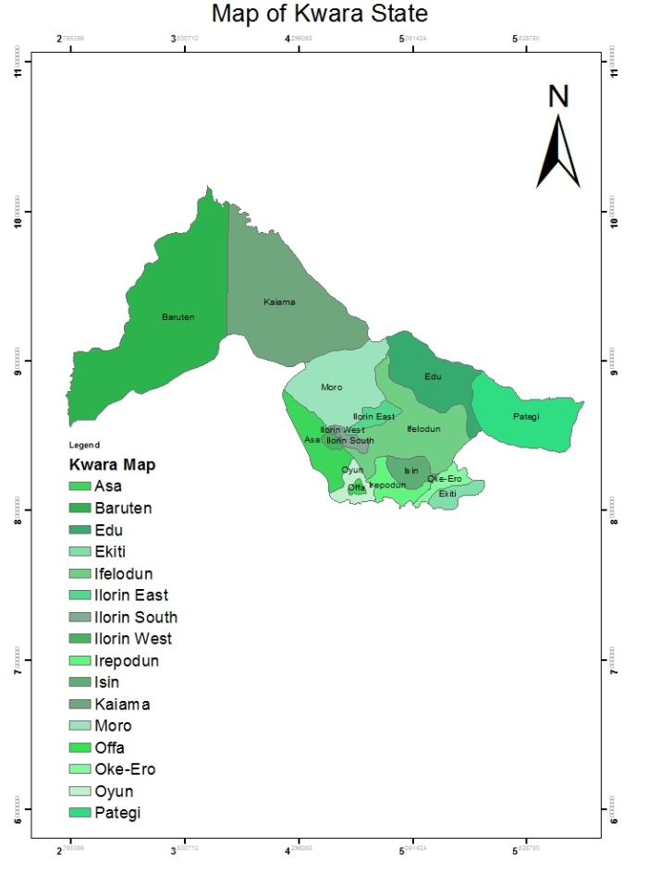
Plate 1: Map of Kwara State showing the two Local Government Area under study

3.2 Research Design

This study intends to select an individual observation within a population based on statistical inference. But due to high cost of surveying the entire population and time constraints, the study adopted sample survey which allows faster data collection, ensures homogeneity and improved the accuracy as well as quality of the data because the data set is small.

3.2.1 Research population
In this study, the population of concern is two local government area of Kwara State. The two local government areas are Edu and Patigi. The selection of these local governments was based on the level of rice production in their various zones. Edu and Patigi local government area are known to be major rice producing area of Kwara State.
3.2.2 Sampling unit
The sampling unit for this study is geographical such as zone, local government areas, districts, village and farms. The samples were drawn from Kwara North Geopolitical zone which involves only Edu and Patigi local government.

3.2.3 Sampling technique and procedure

Sampling is a technique of selecting individual members or a subset of the population to make statistical inferences from them and estimate the characteristics of the whole population. Stratified random sampling is a method in which the researcher divides the population into smaller groups that don’t overlap but represent the entire population.

While sampling, these groups can be organized, and then draw a sample from each group separately. A stratified random sampling technique was used to select rice farmers for this study. This technique ensures a representative sample from different areas within Edu and Patigi, capturing diverse farming practices and equipment use for rice harvesting and threshing within the selected Local Government Areas.

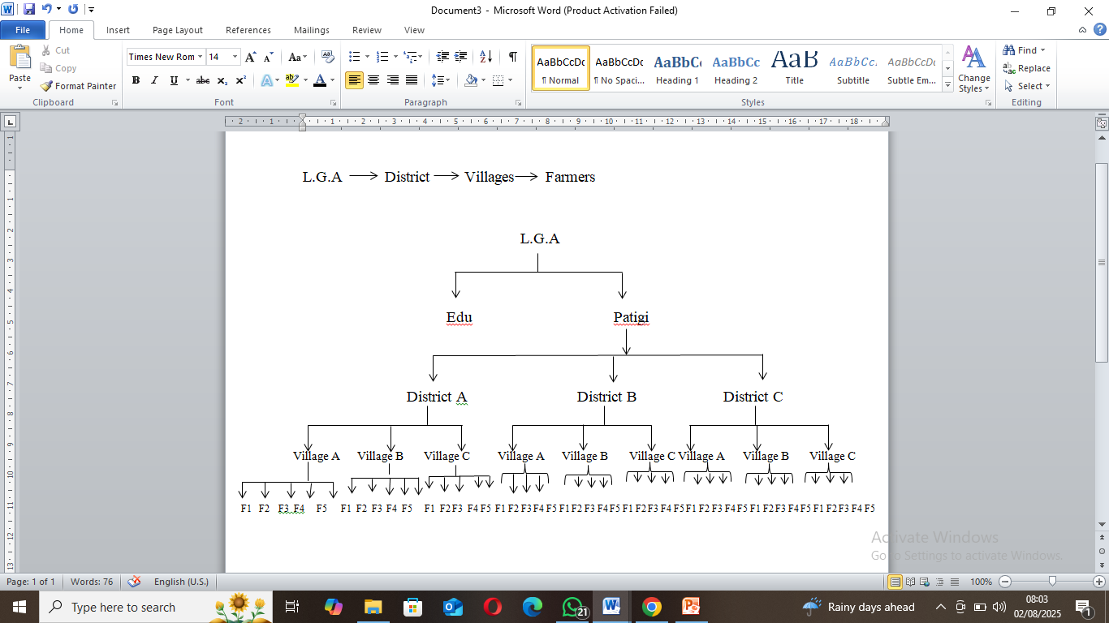Table 3.1: Sample Population and Number of Respondents
S/No | Local Government Area | Number of Farmers (Respondent)
1 | Edu | 45
2 | Patigi | 45
 | Total | 90

3.3 Items for Observation
i. Rice harvesting and threshing technology in the study area (traditional or modern technology).
ii. Rice harvesting and threshing equipment used in the study area.
iii. Level of rice production in the study area.
iv. Farm size
v. Farm Output
vi. Challenges in rice production
vii. Government support
viii. Rice cultivation system (dry season, irrigated and rainfed)
3.4 Research Question
1. What type of harvesting technology used by the farmers to harvest rice in the study area?
2. What type of harvesting equipment used by the farmers to harvest rice in the study area?
3. What type of threshing technology used by the farmers to harvest rice in the study area?
4. What type of threshing equipment used by the farmers to harvest rice in the study area?
5. What is the level of rice production in the study area?
6. What are the challenges facing in rice production by the farmers in the study area?
7. What type of rice cultivation system used by the farmers in the study area?

3.5 Data Collection
The type of data used for this study is primary data. The data was collected using combination of structured questionnaires, interviews, and direct field observations. The structured questionnaires were administered to a sample of rice farmers in Edu and Patigi LGAs to gather quantitative data on the types of equipment used the level of mechanization, challenges faced, and perceived benefits.
Interviews were conducted with key informants, including agricultural extension officers, local government officials, and equipment suppliers, to gain qualitative insights into the adoption and usage of mechanized equipment. Field observations were used to corroborate the information obtained from questionnaires and interviews. The total number of questionnaire administered by the rice farmers in Edu and Patigi local government area is 90. Each local government area administered 45 questionnaires.
3.6 Data Processing and Cleaning
Before analysis, the collected data underwent a thorough cleaning process to ensure accuracy and completeness. This involved checking for and correcting any inconsistencies, errors, or missing values in the questionnaire responses. For qualitative data from interviews, audio recordings were transcribed verbatim, and any discrepancies were resolved through cross-checking with the respondents where necessary.

3.7 Data Analysis
Data analysis is a crucial component of this study, as it involves processing the collected data to derive meaningful insights and conclusions regarding the current status of rice harvesting and threshing equipment in Edu and Patigi Local Government Areas of Kwara State, Nigeria. This section presents the methods and techniques used to analyze the data collected through questionnaires, interviews, and field observations. The data analysis was performed using SPSS 22.0 version (Statistical Package for the Social Sciences) and Microsoft Excel 2010 version. The results will be display in chapter four.
3.7.1 Statistical method used
Both Descriptive and Inferential Statistics method was used to analyze the data collected from the study area. Descriptive Statistics involves frequency distribution and measures of central tendency and Dispersion. Frequency Distribution was used to summarize the respondents' demographic characteristics, such as age, gender, educational level, and farm size. While measures of central tendency and dispersion such as mean, median, mode, standard deviation, and range was calculated to describe the key variables, including types of equipment used, the extent of mechanization, the perceived benefits and challenges.
Inferential Statistics involves Chi-Square Test and T-Test and ANOVA. In this study, chi-square test was employed to examine the association between categorical variables, such as the relationship between the type of mechanized equipment used and the size of the farm. T-Test and ANOVA was used to compare means between different groups, such as comparing the productivity levels of farmers using mechanized equipment versus those using traditional methods.
3.7.2 Percentage estimation
Percentage estimation was used to determine the level of rice production and the output per year in the study area. Below is the equation of percentage estimation:
$$\% Estimation= \frac{n}{x} ×100$$
Where; x = total frequency distribution across the sample areas
N = Population size

3.7.3 Cross tabulation method
In this study, cross-tabulation method was used to present the result in a tabular manner. Cross tabulation is a method that can be used to describe the relationship between two categorical variables.

3.8 Photographs
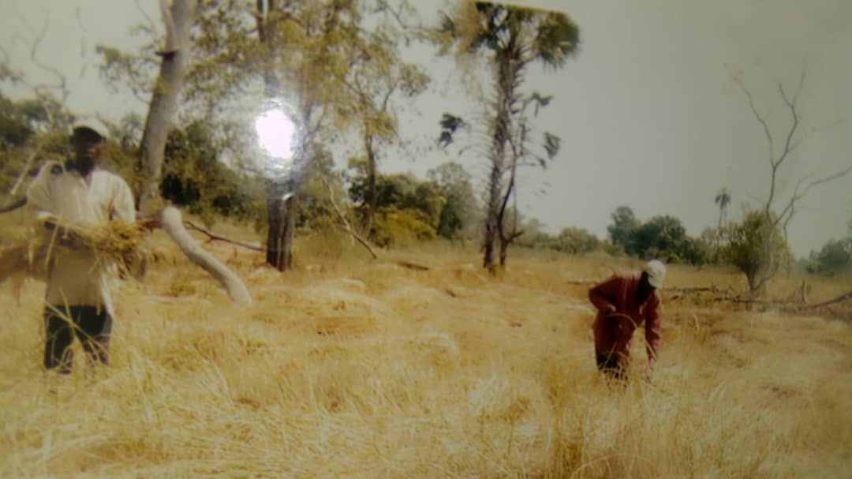
Plate 1: Traditional Rice Harvesting
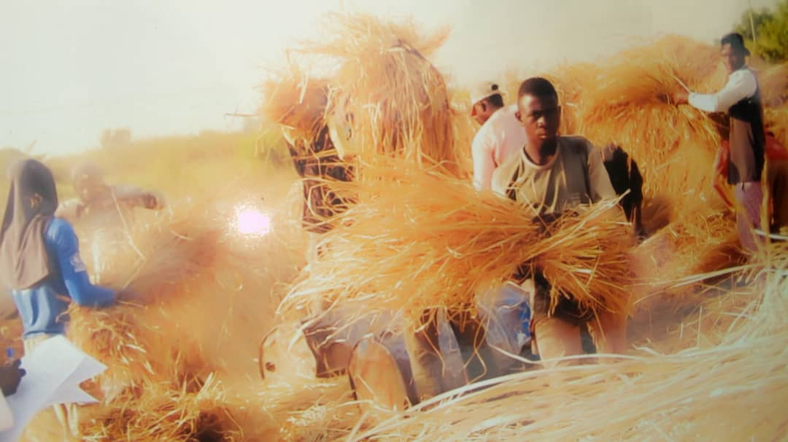
Plate 2: Traditional Rice Threshing

Plate 5: Rice Farm

CHAPTER FOUR
4. RESULTS AND DISCUSSION
4.1 Results
4.2 Examination of Rice Harvesting Technology in Practice in the Study Area
Table 4.1: Rice Harvesting Technology in practice in Edu and Patigi Local Government Area
Harvesting Technology | Count | Percentage (%)
Traditional Technology | 73 | 81.1
Improved Technology | 17 | 18.9
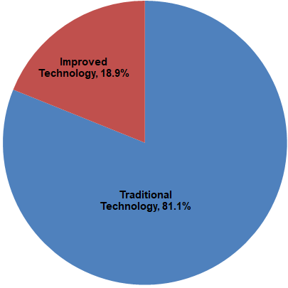
Figure 4.1: Distribution of Different Rice Harvesting Technologies in practice in Edu and Patigi Local Government Area
4.3 Examination of Rice Threshing Technology in Practice in the Study Area
Table 4.2: Rice Threshing Technology used in Edu and Patigi Local Government Area
Threshing Technology | Count | Percentage (%)
Traditional Threshing Technology | 77 | 85.6
Improved Threshing Technology | 13 | 14.4

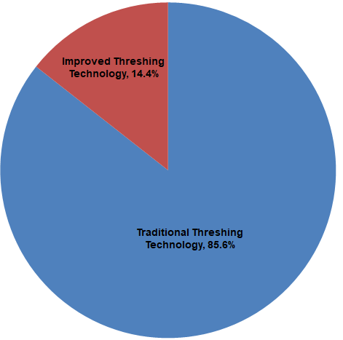
Figure 4.2: Distribution of Rice Threshing Technology used in Edu and Patigi Local Government Area

4.4 Status of Mechanization in Rice Harvesting and Threshing in the Study Area

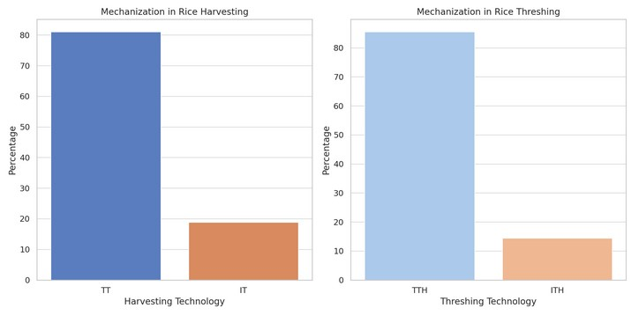
Figure 4.3: Status of Mechanization in Rice Harvesting and Threshing Technology used in Edu and Patigi Local Government Area
4.5 Assessing the Level of Rice Production in Edu and Patigi Local Government Area

Table 4.3: Average Yield per Farm Size
Farm Size (ha) | Average Yield
5 | 59.5
6 | 32.4
10 | 48.6

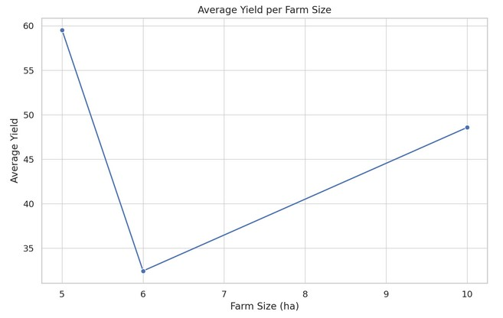

Figure 4.4: Level of Rice Production in the study area
4.6 Factors Responsible for choice of Current Harvesting and Threshing technology in the study area
Table 4.4: Factors Responsible for choice of Current Harvesting and Threshing technology in Edu and Patigi Local Government Area
Factors | Respond | Count | Percentage (%)
- Economic considerations (Cost)  - Accessibility of technology  - Educational background  - government support | Yes | 86 | 95.6
 | No | 4 | 4.4

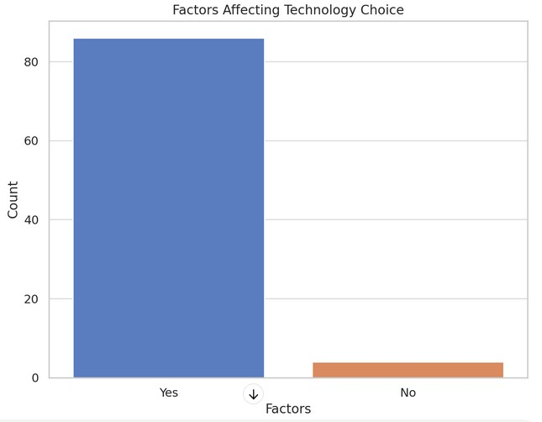
Figure 4.5: Factors Affecting Technology Choice in Edu and Patigi Local Government Area
4.2 Discussion
Table 4.1 shows the Rice Harvesting Technology used in practice in Edu and Patigi Local Government Area of Kwara State. Traditional technology tools involve manual methods such as sickles and knives. These methods are labor-intensive, time-consuming, and typically result in lower efficiency and higher post-harvest losses.
Traditional Technology (TT) is the predominant harvesting technology used by 73 respondents and it indicates that most rice farmers are relying on conventional manual methods. This could be due to the low cost, familiarity, and ease of access to traditional tools.
Improved technology tools might include more advanced manual tools or semi-mechanized equipment that enhances the efficiency of the harvesting process. These tools are designed to reduce labor and time, and potentially improve yield and reduce losses. Only 17 respondents used improved technology, which suggests limited adoption of more efficient rice harvesting methods. This low number could be attributed to factors such as higher costs, limited availability, and possibly a lack of awareness or training on the benefits and usage of improved technology tools.
The predominant use of traditional technology tools suggests that most farmers in the study area rely on age-old methods, possibly due to factors such as cost, availability, lack of training on improved methods, or resistance to change.
Table 4.2 shows the distribution of rice threshing technology used in practice in Edu and Patigi Local Government Area of Kwara State. Traditional threshing involves manual or rudimentary methods, such as beating the rice plants against a hard surface to separate the grains from the stalks. This method is laborious, time-consuming, and less efficient. From the result, traditional threshing method is used by 77 respondents which is 85%, making it the most common threshing practice. The high reliance on traditional threshing methods indicates similar barriers as seen with harvesting technology, including cost, availability, and resistance to change.
Improved threshing technologies may include mechanized or semi-mechanized devices like threshers, which can significantly speed up the process, reduce labor, and improve the efficiency of grain separation, thus reducing post-harvest losses. In the other hand, only 13 respondents which is 15% use improved threshing technology, showing a small shift towards mechanization in the study area. The benefits of improved threshing include higher efficiency and lower labour requirements, but adoption is limited possibly due to the same constraints as in harvesting technology.
Figure 4.3 shows the status of mechanization in Rice Harvesting and Threshing Technology used in Edu and Patigi Local Government Area. It examines the usage of traditional vs. modern mechanized tools in both harvesting and threshing. The mechanization status shows a clear preference for traditional methods over improved mechanized. The traditional harvesting mechanization takes 81.1% and improved harvesting mechanization takes 18.9%. The traditional threshing harvesting mechanization takes 85.0% and improved threshing takes 15.0%. This indicates a low level of mechanization in both harvesting and threshing processes. The reliance on traditional methods can result from various factors, including, in terms of economic constraints: high costs of improved tools and machines, in terms of accessibility issues: difficulty in accessing modern equipment, in terms of awareness/training: farmers might not be aware of or trained to use advanced tools, and in terms of cultural factors: traditional methods might be deeply rooted in the community practices.
Table 4.3 shows the average yield per farm size which is used in assessing the level of rice production in Edu and Patigi local government area. From the table, the 5 hectares farm size has the highest average yield of 59.5 units and this could be due to optimal management practices, efficient use of inputs, or better soil fertility. Also, the 6 hectares farm size has the lowest average yield which drops significantly to 32.4 units and this decline might be due to factors such as less effective management, poorer soil quality, or other agronomic issues. Lastly, 10 hectares has the yield increases again to 48.6 units. Here, the larger farms might benefit from economies of scale and better resource allocation, but the variability suggests that farm size alone is not a determinant of yield; rather, it is a combination of practices, inputs, and management. All this indicates that the average yield does not consistently increase with farm size. Several factors like cultivation practices (differences in farming practices, crop management, and input usage, soil fertility (variability in soil fertility and quality across different farms), access to inputs (differences in access to fertilizers, pesticides, and irrigation), technology use (adoption of improved technologies might not be uniform across all farm sizes) and labor efficiency (larger farms might face challenges in labor efficiency and management, affecting yield) cause this variability.
Table 4.4 shows the factors responsible for choice of current harvesting and threshing technology in Edu and Patigi Local Government Area. From the table, it can be observed that Factors affecting the choice of harvesting and threshing technologies are significantly influenced by specific factors like cost (affordability of traditional tools versus improved tools), availability (ease of accessing traditional tools), government support (availability of subsidies, grants, or loans for mechanization), education Level (higher educational levels might correlate with a greater likelihood of adopting improved technologies) and experience (experienced farmers might stick to traditional methods they are familiar with). From the table, factors influencing technology choice are indicated by Yes. A significant majority (86 respondents) indicated that specific factors influence their choice of harvesting and threshing technology. These factors likely include economic considerations (cost), accessibility of technology, educational background, and government support. In the other hand, no influencing factors are indicated by not that above factors has any influence on the choice of harvesting and threshing technology. So, only 4 respondents stated that no particular factors influenced their choice.
CHAPTER FIVE
5.0 CONCLUSION AND RECOMMENDATIONS
5.1 Conclusions
The survey of rice harvesting and threshing technology in Edu and Patigi Local Government Areas of Kwara State, Nigeria, has provided valuable insights into the current practices, level of mechanization, and factors influencing technology adoption in these regions. The study's key findings are summarized as follows:
- Rice Harvesting Technology
Traditional methods dominate rice harvesting in Edu and Patigi, with 81.1% of rice farmers using manual tools such as sickles and knives. These methods are labor-intensive and less efficient, leading to higher post-harvest losses. Only 18.9% of rice farmers have adopted improved harvesting technologies, indicating a low level of mechanization in the region.
- Rice Threshing Technology
Similarly, traditional threshing methods are prevalent, with 85.6% of farmers relying on manual techniques. These methods also contribute to inefficiencies and significant post-harvest losses. A mere 14.4% of farmers use improved threshing technologies, reflecting limited progress towards mechanization.

- Status of Mechanization
The overall status of mechanization in rice harvesting and threshing is low, which hampers productivity and increases labor costs. The limited adoption of modern equipment is primarily due to high costs, limited availability, and insufficient technical knowledge.
- Factors Influencing Technology Choice
The choice of harvesting and threshing technology is influenced by several factors, including cost, availability, familiarity, and access to training. Economic constraints and lack of awareness about the benefits of improved technologies are significant barriers.
- Level of Rice Production
The study reveals varying levels of rice production across different farm sizes. The average yield per hectare shows significant differences, indicating the potential impact of technology adoption on productivity. Farmers with larger farm sizes and better access to mechanized equipment tend to have higher yields.
5.2 Recommendations
Based on the findings of this study, the following recommendations are proposed to enhance rice production efficiency and promote the adoption of improved harvesting and threshing technologies in Edu and Patigi Local Government Areas:

- Subsidies and Financial Support: Government and non-governmental organizations should provide subsidies or low-interest loans to farmers for purchasing mechanized equipment. This financial support can make advanced technologies more accessible.
- Training and Awareness Programs: Conduct regular training sessions and awareness campaigns to educate farmers about the benefits and proper use of improved harvesting and threshing technologies. Extension services should be strengthened to provide continuous support.
- Road Networks: Improve rural road networks to facilitate the transportation of mechanized equipment and farm produce. Better infrastructure can reduce the logistical challenges faced by farmers.
- Maintenance and Repair Services: Establish local centers for the maintenance and repair of mechanized equipment to ensure their longevity and optimal performance.
- Cooperative Farming: Encourage the formation of farmer cooperatives to pool resources for purchasing and sharing mechanized equipment. Cooperative farming can also enhance bargaining power and reduce individual costs.
- Public-Private Partnerships: Foster partnerships between the government, private sector, and agricultural organizations to promote research, development, and dissemination of modern agricultural technologies.
- Quality Seeds and Fertilizers: Ensure the availability of high-quality seeds and fertilizers to improve crop yield. Support programs that provide these inputs at subsidized rates.
- Market Access: Develop market linkages to help farmers sell their produce at fair prices. This can increase their income and ability to invest in modern technologies.
- Agricultural Policies: Formulate and implement policies that support mechanization and modernization of agriculture. Policies should focus on reducing import duties on agricultural machinery and promoting local manufacturing of equipment.
By addressing these recommendations, Edu and Patigi Local Government Areas can significantly improve their rice production efficiency, reduce post-harvest losses, and enhance the overall livelihoods of rice farmers in the region. The transition from traditional to improved harvesting and threshing technologies is essential for sustainable agricultural development and food security in Kwara State at large.

REFERENCES
Abubakar, S., Owolabi, S. A., and Yusuf, S. A. (2018). Rice production trends in Kwara State, Nigeria (2009-2017). Journal of Agricultural Sciences, 13(2), 147-156. doi: 10.5539/jas.v13n2p147
Adebayo, O. (2020). Mechanization Challenges in Nigerian Agriculture. Nigerian Journal of Agricultural Extension, 15(1), 45-52.
Adebayo, O., and Faleye, T. (2019). Challenges of Mechanization in Nigerian Agriculture. Journal of Agricultural Science, 14(3), 45-52.
Adebisi, M., and Aliu, S. (2019). Infrastructure Limitations in Nigerian Agriculture. _Journal of Agricultural Development_, 22(1), 67-76.
Adekola, M. (2020). Agricultural Mechanization in Kwara State. Kwara State University Press, 54-67.
Ademola, S. (2018). Rice Production and Challenges in Nigeria. Journal of Agricultural Research, 22(4), 67-75.
Adewumi, M. O., Adebayo, P. O., and Oluwajobi, A. O. (2019). Impact of mechanization on post-harvest losses in maize production in Oyo State, Nigeria. Journal of Agricultural Engineering and Technology, 27(1), 34-44.
Adeshina, A., Raufu, M. O., and Akinbode, O. S. (2018). Labour dynamics in mechanical farming in southwestern Nigeria. Journal of Agricultural Engineering and Technology, 26(1), 1-11.
Agbaje, T. (2019). Traditional Rice Harvesting Practices in Nigeria. Journal of Rural Studies, 25(2), 30-39. Agricultural Technology, 21(3), 34-48.
Akinyemi, L. (2018). Impact of Mechanization on Rice Production. Agricultural Mechanization Review, 31(2), 89-102.

Aliyu, T., and Yisa, J. (2019). Training and Skill Development in Agricultural Mechanization. Nigerian Journal of Agricultural Technology, 27(3), 34-45.
Bamidele, E., Agbaje, G., and Oluwajobi, A. (2020). Modernization of rice harvesting techniques: A review. Journal of Agricultural Engineering and Technology, 28(1), 1-15. doi: 10.35680/jaet.2020.28.1.1
Bamidele, R. O., Adebayo, O. O., and Olorunsanya, E. O. (2019). Role of extension services in promoting mechanized farming among smallholder farmers in Nigeria. Journal of Agricultural Extension and Rural Development, 31(2), 34-43. doi: 10.5897/JAERD2019.0944
Babatunde, O. (2018). Sampling Techniques in Agricultural Research. Agricultural Statistics Journal, 19(1), 12-19.

Babatunde, O., and Olaniyan, A. (2020). Barriers to Mechanization in Nigerian Agriculture. Journal of Agricultural Economics, 18(2), 67-75.
Baudron, F., Andersson, J. A., Corbeels, M., and Giller, K. E. (2015). Conservation agriculture in African mixed crop-livestock systems: A review. Agronomy for Sustainable Development, 35(2), 475-490. doi: 10.1007/s13593-014-0263-4
Burney, J. A., Woltering, L., and Naylor, R. L. (2010). Solar-powered drip irrigation enhances crop water productivity in arid regions. Proceedings of the National Academy of Sciences, 107(30), 13368-13373. doi: 10.1073/pnas.1002774107

Binswanger, H. P. (1986). Agricultural Mechanization: A Comparative Historical Perspective. World Bank Research Observer, 1(1), 27-56.
Creswell, J. W. (2017). Research Design: Qualitative, Quantitative, and Mixed Methods Approaches (5th ed.). SAGE Publications.
Daramola, S. (2018). Survey Techniques for Agricultural Research. Journal of Rural Development, 27(2), 23-33.

Daum, T., and Birner, R. (2020). Agricultural Mechanization in Africa: Myths, Realities and an Emerging Research Agenda. Global Food Security, 26, 100393.

Doss, C. R., and Morris, M. L. (2001). How Does Gender Affect the Adoption of Agricultural Innovations, The Case of Improved Maize Technology in Ghana. Agricultural Economics, 25(1), 27-39.
Doss, C., Kovarik, C., Peterman, A., Quisumbing, A., and Van Den Bold, M. (2018). Women and agricultural productivity: What does the evidence tell us International Food Policy Research Institute (IFPRI) Discussion Paper 01764.

Eze, S., and Okechukwu, K. (2018). Mechanization and Its Impact on Rice Production. Journal of Agricultural Technology, 31(2), 89-102.
Eze, S. O., Ugwu, D. C., and Nwite, J. N. (2019). Adoption of sustainable agriculture practices among smallholder farmers in Ebonyi State, Nigeria. Journal of Agricultural Extension, 23(1), 123-135. doi: 10.4314/jae.v23i1.10

FAO. (2011). The State of Food and Agriculture 2010-2011: Women in Agriculture - Closing the Gender Gap for Development. Food and Agriculture Organization of the United Nations, Rome, Italy.
FAO. (2019). Rice Market Monitor. _Food and Agriculture Organization of the United Nations_, Rome, Italy.
FAO. (2019). FAO Statistical Yearbook. Food and Agriculture Organization of the United Nations, Rome, Italy.
FAO. (2020). FAO Statistical Yearbook. Food and Agriculture Organization of the United Nations, Rome, Italy.
Foley, J. A., Ramankutty, N., Brauman, K. A., Cassidy, E. S., Gerber, J. S., Johnston, M., ... and Zaks, D. P. M. (2011). Solutions for a cultivated planet. Nature, 478(7369), 337-342. doi: 10.1038/nature10452
Farmworth, C. R., Stagl, S., and Strassner, C. (2016). Gender and conservation agriculture in Africa: A systematic review. Sustainability, 8(11), 1156.

FMARD. (2013). Agricultural Transformation Agenda. Federal Ministry of Agriculture and Rural Development, Nigeria.
FMARD. (2016). The Agricultural Promotion Policy (2016–2020). _Federal Ministry of Agriculture and Rural Development_, Nigeria.
Hossain, M., Islam, M. S., and Rahman, M. M. (2018). Efficiency of combined harvester in wheat and paddy harvesting in Bangladesh. Journal of Agricultural Engineering and Technology, 25(1), 1-11.
Hobbs, P. R., Sayre, K., and Gupta, R. (2008). The role of conservation agriculture in sustainable agriculture. Philosophical Transactions of the Royal Society B: Biological Sciences, 363(1491), 543-555. doi: 10.1098/rstb.2007.2169
Ibrahim, A., Ali, F., and Iqbal, S. (2019). Data Analysis Techniques: A Review. International Journal of Scientific Research in Computer Science and Engineering, 7(4), 231-240. doi: 10.32628/CSEIT193415.

Ibrahim, A., Ali, F., and Iqbal, S. (2019). Data analysis techniques: A review. International Journal of Scientific Research in Computer Science and Engineering, 7(4), 231-240. doi: 10.32628/CSEIT193415
Kwara State Ministry of Agriculture. (2017). Agricultural Profile of Kwara State. _Kwara State Government_, Nigeria.

Lal, R. (2004). Soil Carbon Sequestration Impacts on Global Climate Change and Food Security. Science, 304(5677), 1623-1627.
Meinzen-Dick, R., Spielman, D. J., and Barker, R. (2011). Engineering agricultural research for development: Lessons from the rice and wheat improvement programs of the International Maize and Wheat Improvement Center (CIMMYT). Journal of Agricultural Science and Technology, 11(3), 349-363.
Mottaleb, K. A., Krupnik, T. J., and Erenstein, O. (2016). Determinants of small-scale farmer investment in soil conservation technologies in the Indo-Gangetic Plains. Agricultural and Food Security, 5(1), 1-13. doi: 10.1186/s40066-016-0063-5

Mwangi, W. (2019). Sustainability of Mechanized Farming. Journal of Sustainable Agriculture, 28(4), 78-91.
Nwachukwu, J. (2018). Ethical Considerations in Agricultural Research. Journal of Agricultural Ethics, 15(2), 29-38.
Nwankwo, A. (2018). Challenges in Rice Production and Food Security. Nigerian Journal of Food and Agriculture, 14(3), 78-85.
Ogundele, A. (2019). Rice Production and Food Security in Nigeria
Oke, S., and Agboola, T. (2018). Post-Harvest Losses in Rice Production. Journal of Agricultural Research, 19(3), 56-64.

Olaniyan, F., and Babatunde, O. (2018). Partnerships for Mechanization in Nigerian Agriculture. Journal of Agricultural Development, 23(3), 56-67.

Oluwafemi, T. (2018). Economic Impact of Mechanized Rice Production. Nigerian Journal of Agricultural Economics, 22(3), 145-156.

Oluwafemi, T., and Ojo, R. (2020). Financial Barriers to Mechanization. Journal of Agricultural Finance, 18(1), 67-78.
Oluwatayo, I. B., and Racho, M. S. (2018). Access to Credit and the Impact on Agricultural Productivity: Evidence from Smallholder Farmers in Nigeria. _Journal of Agricultural Economics_, 19(3), 231-242.

Oni, A. (2019). Government Policies and Agricultural Mechanization. Journal of Policy Studies, 14(2), 56-68.
Oni, A., Oyediran, W. O., and Akande, K. E. (2019). Challenges of rice threshing in rural Nigeria: A case study of selected rural communities in Kwara State. Journal of Agricultural and Food Information, 20(2), 103-115. doi: 10.1080/10496505.2019.1577874
Oni, A. O., Ibitoye, O. O., and Oladele, O. I. (2018). Training and technical support for mechanized farming in Nigeria: A review. Journal of Agricultural Extension and Rural Development, 10(1), 133-144. doi: 10.5897/JAERD2017.0763
Olaniyan, M., Adesope, O. M., and Obayelu, A. E. (2018). Challenges and benefits of agricultural mechanization in Nigeria: A review. Journal of Agricultural and Biological Science, 13(3), 237-245.
Olaniyan, F., Oyediran, W. O., and Akande, K. E. (2020). Barriers to agricultural mechanization in Nigeria: A review. Journal of Agricultural and Food Information, 21(2), 147-162. doi: 10.1080/10496505.2020.1744555
Ojo, M., Oyediran, W. O., and Akande, K. E. (2018). Role of extension service on agricultural mechanization in Nigeria. Journal of Agricultural Extension, 22(1), 123-135.

Pingali, P. (2007). Agricultural Mechanization: Adoption Patterns and Economic Impact. Journal of Agricultural Economics, 37(3), 187-202.
Pretty, J., Toulmin, C., and Williams, S. (2011). Sustainable intensification in African agriculture. International Journal of Agricultural Sustainability, 9(1), 5-24. doi: 10.3763/ijas.2010.0583
Quisumbing, A. R., Rubin, D., and Manfre, C. (2014). Gender, assets, and market-oriented agriculture: Learning from high-value crop and livestock projects in Africa and Asia. Agricultural Economics, 45(5), 555-566. doi: 10.1111/agec.12134
Tillman, D., Cassman, K. G., Matson, P. A., Naylor, R., and Polasky, S. (2002). Agricultural sustainability and intensive production practices. Nature, 418(6898), 671-677. doi: 10.1038/nature01014
Takeshima, H., Adeoti, A., and Obayelu, A. E. (2015). Agricultural mechanization and the smallholder farmer in Nigeria: A review of the current state of knowledge. Journal of Agricultural Science and Technology, 15(3), 537-553.
Takeshima, H., Adeoti, A., and Obayelu, A. E. (2013). Agricultural mechanization and the smallholder farmer in Nigeria: Evidence from a randomized experiment. Agricultural Economics, 44(5), 567-577. doi: 10.1111/agec.12054

