ASSESSMENT OF BOREHOLE WATER QUALITY AND ITS HEALTH IMPLICATION IN ILORIN SOUTH

BY

Abdulhakeem Olaitan JAMIU ND/23/MPE/PT/0004

BEING A RESEARCH PROJECT SUBMITTED TO THE DEPARTMENT OF MINERAL AND PETROLEUM RESOURCES ENGINEERING, INSTITUTE OF TECHNOLOGY, KWARA STATE POLYTECHNIC, ILORIN

IN PARTIAL FULFILLMENT OF THE REQUIREMENT FOR THE AWARD OF NATIONAL DIPLOMA (ND) IN MINERAL AND PETROLEUM RESOURCES ENGINEERINGTECHNOLOGY

1

ABSTRACT
This study evaluates the quality of borehole water and its potential health implications in Ilorin South Local Government Area, Kwara State, Nigeria. Fifteen borehole samples were collected from six communities— Tanke, Pipeline/Fate, Gaa-Akanbi, Agbabiaka, Oke-Ose, and Fufu—and were analyzed for physicochemical and microbiological parameters.

Results revealed that a significant number of samples exceeded WHO and NSDWQ permissible limits for parameters such as TDS, pH, nitrate, lead, E. coli, and Salmonella spp. The study found a strong correlation between poor borehole siting and contamination. It highlights critical public health concerns and emphasizes the need for regular monitoring, improved construction standards, and community education.

Recommendations include stricter enforcement of borehole siting laws, community-level water treatment interventions, and policy-driven regulation to ensure safe drinking water.

CERTIFICATION

This is to certify that this research work titled “ASSESSMENT OF BOREHOLE WATER QUALITY AND ITS HEALTH IMPLICATIONS IN ILORIN SOUTH” was carried out by Abdulhakeem Olaitan JAMIU with Matric Number ND/23/MPE/PT/0004 and has been read and approved as meeting part of the requirements of the award of National Diploma (ND) in Mineral and Petroleum Resource Engineering Technology.



Mr. Bakare Date

Project Supervisor

Dr. Olatunji J.A. Date

H.O.D

Department of Mineral and Petroleum Resources Engineering

Engr. Oluwole C.T. Date

External Examiner

DEDICATION

This project is dedicated to the Almighty Allah, the Most Gracious and Most Merciful, for giving me life, strength, and knowledge throughout the duration of this work
I also dedicate it to my beloved parents, family, and guardians, whose unwavering support, prayers, and encouragement have been a source of inspiration to me.

To everyone who has played a role in my academic journey, directly or indirectly — this work is for you.

ACKNOWLEDGEMENT

All praise and gratitude are due to Almighty Allah for His mercy, guidance, and strength throughout the course of this research work.

My sincere appreciation goes to my supervisor, Mr. Bakare, for his valuable time, guidance, constructive criticism, and encouragement throughout the duration of this project. His support and direction were instrumental to the successful completion of this work.

I would also like to extend my profound gratitude to all the lecturers and staff of the Department of Mineral and Petroleum Engineering, Kwara State Polytechnic, Ilorin, for the knowledge, training, and academic support given to me during my course of study.

Special thanks to my loving parents and family members for their moral and financial support, constant prayers, and motivation, which kept me going even in difficult times.

To my friends, colleagues, and well-wishers who contributed to this work in one way or another, I say a heartfelt thank you. May Almighty Allah reward you abundantly.

TABLE OF CONTENTS
- Title Page i
- Abstract ii
- Table of Contents iii
- List of Figures iv
- List of Tables v
CHAPTER ONE: INTRODUCTION

1.1 Abstract …………………………………………………………………………………….. | 1
1.2 Background of the Study ……………………………………………………………. |  | 2
1.3 Statement of the Problem …………………………………………………………… |  | 2
1.4 Aim and Objectives of the Study …………………………………………………. |  | 2
1.5 Research Questions …………………………………………………………………… |  | 3
- Significance of the Study ……………………………………………………………..  - Scope of the Study ……………………………………………………………………..  - Limitations of the Study ……………………………………………………………… | 4 | 3  4
1.9 Organization of the Study …………………………………………………………… |  | 5
CHAPTER TWO: LITERATURE REVIEW
- Introduction ………………………………………………………………………………  - Overview of Borehole Water Quality in Ilorin South ……………………. | 6 |  | 6
2.3 Physicochemical Parameters of Borehole Water ………………………….. |  |  | 6
2.3.1 pH ………………………………………………………………………….. |  | 6
2.3.2 Turbidity ………………………………………………………………….  2.3.3 Total Dissolved Solids (TDS) …………………………………….. |  | 6 |  | 7
- Electrical Conductivity (EC) ………………………………………  - Heavy Metals (Lead, Arsenic, Cadmium, etc.) …………….  - Nitrate and Nitrite ……………………………………………………  - Fluoride …………………………………………………………………. |  | 7 |  | 7  7 | 7
2.4 Microbiological Contamination of Borehole Water ……………………… |  | 8

2.4.1 Bacterial Contaminants ……………………………………………. |  |  | 8
2.4.2 Protozoan and Viral Contaminants ……………………………. |  |  | 8
- Sources of Borehole Water Contamination in Ilorin South …………..  - Health Implications of Contaminated Borehole Water …………………  - Waterborne Diseases ………………………………………………. |  | 8 | 8  8
2.6.2 Heavy Metal Toxicity ………………………………………………. |  |  | 9
2.6.3 Dental and Skeletal Fluorosis ……………………………………  - Regulatory Standards for Borehole Water in Nigeria ………………….  - Summary of Literature Review ………………………………………………… | 9 | 9 | 9
CHAPTER THREE: RESEARCH METHODOLOGY
- Research Design ……………………………………………………………………….  - Study Area ………………………………………………………………………………. 10  - Sampling Techniques and Sample Size Determination ………………… | 10 | 13
- Sample Collection and Preservation Methods …………………………….  - Laboratory Analysis Methods ……………………………………………………  - Physicochemical Analysis Methods …………………………….. | 16 | 14 | 16
3.5.2 Microbiological Analysis Methods ………………………………. |  |  | 17
3.5.3 Data Validation and Quality Control ……………………………..  3.6 Data Analysis Techniques ………………………………………………………….. | 17 |  | 17
3.7 Ethical Considerations ………………………………………………………………. | 20
CHAPTER FOUR: RESULTS
- Introduction ……………………………………………………………………………… 22  - General Field Observations During Sampling ……………………………… |  | 22
4.3 Physicochemical Analysis Results …………………………………………….. | 25
- pH, TDS, Turbidity, EC, Nitrate, Fluoride, Heavy Metals
4.4 Microbiological Analysis Results ………………………………………………. | 31

- Total Coliform, E. coli, Salmonella spp., HPC  4.5 Summary of Results by Community ………………………………………….. |  |  | 33
4.6 Summary of Chapter Four ………………………………………………………… |  | 36
CHAPTER FIVE: DISCUSSION
5.1 Discussion of Findings ……………………………………………………………….  - Physicochemical Trends |  | 38
- Microbiological Risks
- Health Impacts
5.2 Comparison with Previous Studies ……………………………………………. |  | 40
5.3 Implications for Public Health and Policy …………………………………… |  |  | 40
5.4 Contribution to Knowledge ……………………………………………………… |  | 41
5.5 Summary of Chapter Five …………………………………………………………. |  | 42
CONCLUSION AND RECOMMENDATIONS
Conclusion ……………………………………………………………………………….. |  | 42
Recommendations ……………………………………………………………………  - Monitoring | 43
- Policy Enforcement
- Community Education
- Borehole Rehabilitation
- Institutional Frameworks
Summary of Chapter Six …………………………………………………………… |  | 44

REFERENCES 45

LIST OF FIGURES
- Figure 1: Map of Ilorin South Showing Sampled Borehole Locations 6
- Figure 2: Borehole Siting Conditions Observed During Field Survey 40
- Figure 3: pH Distribution Across Borehole Samples in Ilorin South 42
- Figure 4: Total Dissolved Solids (TDS) Variation Among Communities 43
- Figure 5: Electrical Conductivity Trends in Urban vs Rural Areas 43
- Figure 6: Nitrate Levels in Agricultural vs Non-Agricultural Zones 44
- Figure 7: Fluoride Concentration Comparison with WHO Standards 44
- Figure 8: Prevalence of E. coli in Sampled Boreholes 45
- Figure 9: Spatial Distribution of Microbial Contamination (GIS Output) 46
- Figure 10: Community Health Complaints Associated with Borehole Usage 47

LIST OF TABLES

- Table 1: Summary of Physicochemical Parameters Across Communities ……………………. | 18
- Table 2: Microbiological Contamination by Community ……………………… | 28
- Table 3: Borehole Conditions and Observed Environmental Risk Factors ……………… |  | 30
- Table 4: Compliance of Borehole Water Samples with WHO/NSDWQ Standards …………… | 35
- Table 5: Community Health Complaints Related to Borehole Water Usage ……………… | 39
- Table 6: Comparison of Study Findings with Previous Research ……………………… | 55
  - Table 7: Recommended Interventions Based on Risk and Contamination Severity 64

CHAPTER ONE INTRODUCTION

Abstract

Water quality is a key determinant of public health and environmental sustainability. In Ilorin South Local Government Area of Kwara State, Nigeria, many residents depend on borehole water for drinking and domestic use due to the irregular supply of municipal water. While boreholes are considered a more reliable alternative, there are growing concerns about their safety and suitability for consumption. Contamination of borehole water may result from industrial discharges, agricultural runoff, and poor waste disposal practices, all of which can introduce harmful substances such as heavy metals, nitrates, and disease-causing microorganisms into groundwater. These pollutants can pose serious health risks, including waterborne diseases, reproductive issues, and chronic conditions like kidney and liver damage. This study aims to assess the physicochemical and microbiological quality of borehole water in Ilorin South and evaluate its potential health implications. It seeks to identify major contaminants, trace their sources, and determine whether the water meets national and international safety standards. The findings will offer valuable insights to residents, health agencies, and policymakers, and support efforts to improve water safety and public health in the region.

Background of the Study

Reliable access to clean and safe drinking water is a cornerstone of public health, economic development, and environmental sustainability. In Nigeria, the failure of public water supply systems has compelled many communities to depend on alternative water sources such as boreholes, wells, and surface water bodies. Borehole water, drawn from underground aquifers, is typically seen as a safer option compared to rivers or streams, thanks to the natural filtration process that occurs underground. Despite this perception, increasing cases of contamination have been reported in various regions, including Ilorin South, raising serious public health concerns. Ilorin South is a rapidly developing area characterized by a mix of urban, semi-urban, and rural communities. The area's growing population, expansion of industries, and intensive farming practices have placed substantial stress on groundwater resources. As a result, many households rely heavily on borehole water for drinking and other daily uses. Unfortunately, the lack of regular monitoring and proper treatment of these water sources poses a significant risk of waterborne diseases and long-term health conditions, especially those associated with exposure to toxic elements like heavy metals. Research across Nigeria has revealed that borehole water quality is influenced by several factors, including the depth of the borehole, the geology of the area, and nearby land use practices. In Ilorin South, the location of boreholes near waste dumps, sewage systems, and agricultural land has heightened the risk of groundwater contamination. Pollutants such as heavy metals, nitrates, and harmful microorganisms have been detected in various studies conducted in Kwara State. However, there is limited data specifically focused on borehole water quality in Ilorin South, making it difficult to understand the full extent of the problem in this locality. The goal of this study is to conduct a detailed analysis of borehole water quality in Ilorin South by measuring key physicochemical and microbiological parameters. This includes assessing factors like pH, turbidity, total dissolved solids, nitrate levels, and bacterial content. The results of this study will help to determine whether the borehole water is safe for

human consumption and identify any associated health risks. Ultimately, the findings will inform water safety policies and contribute to efforts aimed at improving public health and sustainable water resource management in the region.

Statement of the problem

In Ilorin South, the growing dependence on borehole water has not been matched with adequate oversight or quality control. A large number of boreholes are drilled without expert geological input or adherence to sanitary standards, leaving them exposed to various forms of contamination. Investigations in nearby regions have revealed troubling findings, such as:
-Excessive levels of nitrates and toxic metals, often linked to runoff from farms and waste discharge from factories.

-Bacterial pollution, especially E. coli, which signals contamination from human or animal waste.

-Significant differences in water quality based on where and when samples are taken, suggesting environmental and seasonal impacts.
These contaminants present significant health risks to the population. Exposure to such polluted water can result in acute illnesses like diarrhea and typhoid, as well as chronic health problems such as heavy metal poisoning, kidney damage, and neurological impairments. With the ongoing urban growth and increased industrial activity in Ilorin South, it is critical to evaluate the current condition of borehole water. This will provide essential data to guide public health initiatives and influence policies aimed at improving water safety and community well-being.

Aim and Objectives of the Study

Aim: The purpose of this study is to evaluate the quality of borehole water in Ilorin South and to understand the potential health effects associated with its consumption.

Objectives: To achieve this purpose, the study will:

- Analyze the physical and chemical properties of borehole water, focusing on indicators such as pH, turbidity, total dissolved solids (TDS), electrical conductivity, and concentrations of metals like lead, arsenic, and cadmium.
- Investigate the presence of microbial contaminants, including E. coli and other harmful bacteria, to determine the level of microbiological safety.
- Identify and examine environmental and human-related factors contributing to water pollution, such as the presence of nearby septic tanks, agricultural fields, and industrial activities.
- Assess the health implications of consuming polluted borehole water, including risks of infections, heavy metal toxicity, and long-term health complications.
- Compare the findings against recognized safety benchmarks provided by national (NSDWQ) and global (WHO) drinking water standards.
- Offer practical recommendations for improving water safety, monitoring practices, and policies to ensure access to clean borehole water in Ilorin South.

Research Questions

This study is guided by the following research questions:

- What are the major physicochemical characteristics of borehole water in different locations within Ilorin South?

- Are there microbiological contaminants present in the borehole water, and what environmental or human-related activities are likely responsible for them?
- How does the quality of borehole water in Ilorin South compare to both national (NSDWQ) and international (WHO) standards for safe drinking water?
- What are the potential health risks associated with the consumption of borehole water in the study area?

- What preventive and corrective measures can be recommended to improve borehole water quality and ensure public health safety in Ilorin South?

Significance of the study

This study holds considerable significance across multiple dimensions:

- Public Health Relevance

By assessing the quality of borehole water in Ilorin South, this study aims to identify harmful contaminants that pose health threats such as waterborne diseases, heavy metal toxicity, and long-term chronic illnesses. The findings will support public health efforts to reduce exposure to unsafe water and protect vulnerable populations, especially children and the elderly.

- Sustainable Water Resource Management

The research will contribute to the sustainable management of groundwater resources by identifying potential pollution sources and recommending effective control measures. This is crucial in ensuring the long-term viability of boreholes as a dependable source of potable water.
- Policy and Regulatory Support

The results of this study will provide evidence-based data for use by policymakers, water resource agencies, environmental health departments, and other stakeholders. This information can inform the development or revision of policies, guidelines, and regulations regarding groundwater safety and infrastructure planning in Ilorin South.
- Community Engagement and Awareness

The study will help raise awareness among local communities about the importance of regular water quality monitoring and the health risks of consuming contaminated water. Increased awareness can lead to improved hygiene practices and encourage community-driven initiatives to safeguard water sources.
- Academic and Research Contribution

This study will add to the existing body of knowledge on water quality in Nigeria, especially within the context of local- level assessments. It may serve as a reference for future studies and inspire further research in other regions facing similar water quality challenges.

Scope of the study

This study focuses on borehole water quality in Ilorin South, Kwara State. It will cover selected boreholes in different communities within the local government area, representing residential, industrial, and agricultural zones. The study will analyze physicochemical parameters (such as pH, TDS, turbidity, and heavy metals) and microbiological contaminants (such as E. coli and other pathogens). The study is limited to borehole water sources and does not include other water sources such as rivers, wells, or municipal tap water. Additionally, while the study will evaluate potential health risks, it will not conduct clinical assessments on affected individuals.

Limitations of the Study

Despite its importance, this study may face the following limitations:

- Sampling Constraints - The study will be limited to selected boreholes due to time and resource constraints, meaning some areas may not be represented.
- Laboratory Analysis Limitations - The study will focus on key contaminants but may not cover all possible water pollutants

- Seasonal Variability - Water quality can vary between dry and rainy seasons, and this study may not capture year-round variations.
- Community Cooperation - Some borehole owners may be unwilling to allow sample collection, which could affect the comprehensiveness of the data.

Organization of the Study

This study is structured into five chapters:

    - Chapter One introduces the study, outlining the background, problem statement, objectives, significance, scope, and limitations.
    - Chapter Two provides a comprehensive literature review on borehole water quality, contamination sources, and health implications.
    - Chapter Three details the research methodology, including study area description, sampling techniques, laboratory procedures, and data analysis methods.
    - Chapter Four presents and discusses the research findings, comparing them with established water quality standards.

    - Chapter Five summarizes the findings, concludes the study, and offers recommendations for improving borehole water safety in Ilorin South.

CHAPTER TWO LITERATURE REVIEW

Introduction

Water is essential for all forms of life, and access to safe and clean drinking water is considered a fundamental human right. In many parts of the world, including Nigeria, borehole water is a major source of water supply, especially in areas where municipal water supply is either unavailable or inconsistent. Ilorin South Local Government Area, a densely populated region in Kwara State, depends significantly on groundwater sources for domestic, agricultural, and industrial uses. This chapter presents a comprehensive review of existing literature on the quality of borehole water in Ilorin South. It explores the physicochemical and microbiological parameters used in water quality assessment, the sources of contamination, potential health effects of consuming contaminated water, and the regulatory standards guiding water safety in Nigeria and globally. This review is vital for understanding the scope and depth of the issue and forms the basis for the methodology and findings presented in subsequent chapters.

Overview of Borehole Water Quality in Ilorin South

Borehole water in Ilorin South is widely regarded as a more dependable alternative to surface water and municipal water supply due to frequent interruptions in the public water supply system. However, recent investigations have raised concerns about its quality. Researchers have reported varying levels of contamination in borehole water across different neighborhoods in Ilorin South, attributed to both anthropogenic and natural causes. These include inadequate sanitation facilities, proximity to septic systems, poor well construction, industrial activities, and the geological characteristics of the area. For instance, Aremu et al. (2019) conducted a study showing that some boreholes contained concentrations of lead and nitrate above the permissible limits set by WHO and SON. Such findings highlight the need for regular monitoring and enforcement of water safety standards.

Physicochemical Parameters of Borehole Water

pH

The pH level of water is a measure of its hydrogen ion concentration and indicates whether water is acidic or alkaline. The acceptable range for drinking water, according to WHO, is between 6.5 and 8.5. Water with pH values outside this range may lead to corrosion of plumbing systems or scaling. In borehole water, low pH may result from acid rain, industrial emissions, or natural decomposition of organic matter. Studies in Ilorin South have reported slightly acidic borehole water, which could accelerate metal leaching from pipes, thus posing health risks.

Turbidity

Turbidity refers to the cloudiness of water caused by suspended particles, including silt, clay, organic matter, and microorganisms. High turbidity can protect harmful microorganisms from disinfection processes and is usually a sign of

contamination. The acceptable limit for turbidity in drinking water is less than 5 NTU. Studies have shown that boreholes close to unlined drainages and solid waste disposal sites in Ilorin South tend to have higher turbidity levels, making the water aesthetically unpleasing and potentially unsafe.

Total Dissolved Solids (TDS)

TDS represents the total concentration of dissolved substances in water, including minerals, salts, and organic matter. High TDS can affect the taste of water and lead to scaling in household appliances. While WHO recommends a maximum of 500 mg/L for TDS in drinking water, values up to 1000 mg/L may still be considered acceptable in some cases. Elevated TDS levels have been observed in boreholes near agricultural lands, indicating possible infiltration of fertilizers or animal waste.

Electrical Conductivity (EC)

Electrical conductivity measures the water’s ability to conduct electric current, which depends on the concentration of ionic substances. Higher EC levels are usually associated with higher concentrations of dissolved salts. EC is a useful indicator of water salinity and mineralization. In Ilorin South, EC values are often elevated in low-lying areas and floodplains, suggesting possible interaction with saline water or leaching from surrounding soil.

Heavy Metals (Lead, Arsenic, Cadmium, etc.)

Heavy metals such as lead, arsenic, cadmium, and mercury are toxic even at very low concentrations. These metals can enter groundwater through natural mineral deposits, industrial discharge, or corroded plumbing. Chronic exposure to heavy metals can cause neurological, renal, and skeletal disorders. In some boreholes in Ilorin South, elevated levels of lead and cadmium have been found, particularly near areas with informal electronic waste recycling or auto-mechanic workshops. This raises serious public health concerns.

Nitrate and Nitrite

Nitrates and nitrites are nitrogenous compounds commonly found in fertilizers, septic tank leakage, and animal waste. They are particularly harmful to infants and young children, causing methemoglobinemia or ‘blue baby syndrome.’ The recommended limit for nitrate in drinking water is 50 mg/L. Agricultural practices around Ilorin South have contributed to increased nitrate concentrations in groundwater, necessitating strict regulation and monitoring.

Fluoride

Fluoride is naturally present in many groundwater sources. While low concentrations can prevent dental caries, excessive fluoride intake can result in dental and skeletal fluorosis. In Ilorin South, variations in fluoride levels have been linked to the underlying bedrock and hydrogeology. Surveys have shown that some communities report signs of fluorosis in children, indicating the need for defluoridation interventions.

Microbiological Contamination of Borehole Water

Microbiological contamination is a major concern in borehole water, particularly in areas where sanitation practices are inadequate. The presence of pathogenic microorganisms such as bacteria, viruses, and protozoa in drinking water can lead to outbreaks of waterborne diseases. Contamination often results from seepage from septic tanks, improper waste disposal, and animal droppings. Ensuring microbiological safety requires regular disinfection and good hygiene practices.

Bacterial Contaminants

Common bacterial contaminants in borehole water include Escherichia coli (E. coli), Salmonella, Shigella, and Vibrio cholerae. These organisms indicate fecal pollution and are linked to gastrointestinal infections. Studies conducted in Ilorin South have identified E. coli in several borehole samples, suggesting contamination from nearby latrines and surface runoffs. Such findings call for immediate attention to sanitation infrastructure and protective measures around boreholes.

Protozoan and Viral Contaminants

Protozoa such as Giardia lamblia and Cryptosporidium spp. are known to survive for long periods in water and are resistant to conventional chlorination methods. Viral agents, including rotavirus and norovirus, are also responsible for acute gastroenteritis, especially in children. Although detection requires advanced techniques, evidence suggests that boreholes close to human settlements in Ilorin South are at risk of protozoan and viral contamination due to poor waste management practices.

Sources of Borehole Water Contamination in Ilorin South

Several factors contribute to the contamination of borehole water in Ilorin South. These include proximity of boreholes to pit latrines, septic tanks, refuse dumps, and drainage channels. Agricultural activities, particularly the excessive use of fertilizers and pesticides, also play a significant role. In addition, industrial discharges from small-scale manufacturing units and vehicle repair workshops introduce heavy metals and oil residues into the groundwater. The geology of the area, characterized by fractured basement rocks, may also facilitate the rapid movement of contaminants into aquifers.

Health Implications of Contaminated Borehole Water

The health implications of consuming contaminated borehole water are numerous and vary based on the type and level of contaminants. They range from acute illnesses such as diarrhea and cholera to chronic conditions like cancer, kidney damage, and skeletal deformities. Children, pregnant women, and the elderly are particularly vulnerable. Ensuring the safety of borehole water is essential to public health in Ilorin South and beyond.

Waterborne Diseases

Diseases such as cholera, typhoid fever, dysentery, and hepatitis A are commonly linked to microbiologically unsafe drinking water. Outbreaks of these diseases have been reported in several parts of Ilorin South, particularly in communities that rely solely on untreated borehole water. The lack of proper sanitation and hygiene exacerbates these health risks.

Heavy Metal Toxicity

Long-term exposure to heavy metals such as lead, arsenic, and cadmium can result in irreversible health problems. Lead poisoning, for instance, can impair cognitive development in children, while arsenic exposure is linked to skin cancer and other systemic effects. These toxic metals often enter groundwater through industrial waste and corroded plumbing systems.

Dental and Skeletal Fluorosis

Excess fluoride in drinking water can lead to fluorosis, a condition that affects teeth and bones. Dental fluorosis causes discoloration and pitting of the teeth, while skeletal fluorosis results in joint stiffness and bone deformities. Reports from rural areas in Ilorin South have indicated a correlation between high fluoride levels in borehole water and cases of fluorosis among children.

Regulatory Standards for Borehole Water in Nigeria

Water quality standards in Nigeria are regulated by several agencies, including the Standard Organization of Nigeria (SON), the Nigerian Drinking Water Quality Standard (NDWQS), and the World Health Organization (WHO) guidelines. These standards specify permissible limits for various physical, chemical, and microbiological parameters in drinking water. Compliance with these standards is essential for ensuring the health and safety of consumers. However, enforcement remains weak due to limited resources and inadequate monitoring infrastructure. There is a need for stronger regulatory frameworks and increased community awareness to safeguard groundwater resources.

Summary of Literature Review

This chapter has reviewed the key literature relevant to borehole water quality in Ilorin South. It highlights the critical physicochemical and microbiological parameters used in assessing water quality, sources and types of contamination, associated health risks, and existing regulatory frameworks. The reviewed studies underscore the need for continuous monitoring, improved sanitation, and stricter enforcement of regulations to ensure safe drinking water. The insights gained from this review provide the foundation for the methodology and data analysis in the subsequent chapters of this research.

CHAPTER THREE

  - RESEARCH DESIGN

The research design refers to the overall strategy or blueprint adopted to systematically collect, measure, and analyze data related to the problem being investigated. In this study, which seeks to assess the quality of borehole water and its health implications in Ilorin South, a descriptive survey research design was adopted. This method allows for a real-time, on-ground collection of both qualitative and quantitative data related to water quality and public health.

The choice of this design was influenced by the need to capture the actual condition of borehole water across different neighborhoods in Ilorin South, including urban (e.g., Tanke, Pipeline), semi-urban (e.g., Gaa-Akanbi), and peri-urban (e.g., Oke-Ose, Fufu) settings. The descriptive approach enabled the researcher to document variations in physicochemical and microbiological parameters, compare findings with national/international standards, and correlate observed results with potential sources of contamination.

The study design involved field visits, on-site observations, and water sampling from strategically selected boreholes across the local government area. It also integrated the use of standardized laboratory testing protocols for accurate physicochemical and microbial analysis. Additionally, structured questionnaires and oral interviews were employed to gather health-related data from residents who regularly use the sampled boreholes.

This research design is particularly effective for community-based environmental studies, as it allows the researcher to interact directly with both the physical water sources and the human population dependent on them. The combination of laboratory results and user feedback provides a more comprehensive understanding of the water quality challenges and their health consequences in the region.

The outcomes of the study are not only expected to inform public health authorities and policymakers but also serve as a localized reference model for borehole water safety assessment in similar settings across Nigeria.

  - STUDY AREA
This research was conducted in Ilorin South Local Government Area (LGA) of Kwara State, located in the North-Central geopolitical zone of Nigeria. Ilorin South is one of the sixteen LGAs in Kwara State and is a strategic region in the state’s capital city, serving as a link between urban, semi-urban, and rural communities.

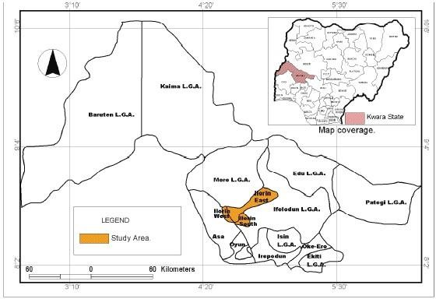
The choice of Ilorin South as the study area is based on its high dependence on borehole water, widespread population growth, and increasing land use changes that impact groundwater quality.

Geographical Location and Boundaries

Ilorin South is situated between latitude 8°24’ N and 8°36’ N, and longitude 4°30’ E and 4°42’ E, covering a land area of approximately 174 km². It shares boundaries with Ilorin East LGA to the north, Asa LGA to the west, Ifelodun LGA to the south, and Ilorin West LGA to the northwest.

Climate and Topography

The area experiences a tropical wet and dry climate, characterized by two main seasons: the rainy season (April to October) and the dry season (November to March). Average annual rainfall ranges from 1,100 mm to 1,300 mm, while temperatures vary between 24°C and 34°C throughout the year.

The topography of Ilorin South is relatively flat with gentle undulating surfaces. The dominant soil types include ferruginous tropical soils and laterites, which influence percolation and aquifer recharge patterns. The geology is mainly

composed of Precambrian Basement Complex rocks, consisting of granites, gneisses, and schists, which affect groundwater flow and quality.

Population and Settlements

According to the National Population Commission (NPC, 2006), Ilorin South had an estimated population of 208,691. However, current projections put the figure at over 300,000 due to rapid urbanization and migration. Major settlements include:
      - Tanke (high-density urban)
      - Fate and Pipeline (residential-commercial mix)
      - Gaa-Akanbi and Sabo-Oke (semi-urban)
      - Oke-Ose, Agbabiaka, and Fufu (peri-urban to rural)

These areas were selected for sampling due to their unique environmental settings and dependence on borehole water.

Economic and Human Activities

Ilorin South is economically diverse, featuring informal markets, farming zones, mechanic workshops, welding yards, block industries, and small-scale food vendors. These human activities contribute to the risk of groundwater contamination due to poor waste disposal practices, use of agrochemicals, and open defecation near water abstraction points.

Water Supply and Sanitation

Public water supply is inadequate, with erratic flow from the Water Corporation of Kwara State (KW-Water). As a result, the majority of residents and institutions rely on private or community-owned boreholes. Many boreholes lack proper sanitary protection and are constructed without geological surveys or environmental impact assessments. Septic tanks, soak-away pits, and refuse dumps are often found within 10 to 15 meters of boreholes — a direct violation of the NSDWQ-recommended 30-meter minimum separation distance.

The sanitation system in many areas of Ilorin South is informal, with open gutters, unlined drains, and poor solid waste collection mechanisms. These factors increase the likelihood of infiltration of surface contaminants into underground water reservoirs, especially during heavy rainfall.

Relevance of the Study Area

Ilorin South serves as a representative case study for many urbanizing LGAs across Nigeria that lack regulated water supply systems and have poor enforcement of environmental health policies. The findings from this study will therefore have both local and national relevance, particularly for community-level water safety planning and risk mitigation.

  - SAMPLING TECHNIQUES AND SAMPLE SIZE DETERMINATION
A crucial aspect of this study on borehole water quality and its health implications in Ilorin South is the method of sample selection and the size of the sample population. Proper sampling ensures that the data collected is representative, valid, and reliable, allowing for generalization of findings across the local government area.

Sampling Techniques

To achieve a comprehensive and unbiased assessment, a multistage sampling technique was adopted. This involves a combination of stratified, purposive, and random sampling methods to ensure both geographical and demographic representativeness.
- Stratified Sampling:

Ilorin South was first divided into three broad strata based on settlement type:
o Urban (e.g., Tanke, Pipeline, Fate) o Semi-urban (e.g., Gaa-Akanbi, Sabo-Oke) o Peri-urban/rural (e.g., Oke-Ose, Agbabiaka, Fufu)
This classification was necessary to ensure that water quality assessment accounted for variations in population density, land use, and infrastructural development.
- Purposive Sampling:
Within each stratum, specific communities and borehole locations were selected intentionally based on observed or reported water quality concerns, proximity to contamination sources (like septic tanks or mechanic workshops), and level of dependence on borehole water.
For example, Gaa-Akanbi and Oke-Ose were selected due to their known poor sanitary conditions, while Tanke and Pipeline were included because of their high population density and water demand pressure.
- Simple Random Sampling:

From the list of identified boreholes in each selected community, a simple random sampling technique was employed to select the boreholes for water sample collection. This eliminated researcher bias and ensured randomness in borehole selection.

Sample Size Determination

The determination of sample size was guided by both scientific sampling principles and logistical feasibility. Considering the scope of the study and available resources, a total of 15 boreholes were selected across six major communities in Ilorin South. These communities were chosen based on environmental risk exposure, population reliance on borehole water, and accessibility.

The breakdown is as follows:

Community Number of Boreholes Sampled
Tanke 3
Pipeline/Fate 3 Gaa-Akanbi 2

Agbabiaka | 2
Oke-Ose | 3
Fufu | 2

Each borehole was sampled once during the study period, and both physicochemical and microbiological parameters were analyzed in certified laboratories. In addition to water sampling, structured questionnaires were administered to residents or users of the selected boreholes, totaling 60 respondents (i.e., 4 per borehole on average). This provided complementary data on water usage habits, perception of water quality, and reported health symptoms.

The sampling size and distribution were designed to balance scientific reliability and field practicability, while ensuring that the results captured both spatial variation and health exposure risk.

  - SAMPLE COLLECTION AND PRESERVATION METHODS

The accuracy of water quality assessment largely depends on the integrity of the sample collection and preservation process. Poor collection techniques or improper storage can compromise laboratory results, leading to misleading conclusions. Therefore, for this study on borehole water quality in Ilorin South, strict adherence to standard procedures for water sampling was observed.

The methods employed in this section were based on World Health Organization (WHO) guidelines for drinking water quality monitoring, and procedures used by the Nigerian Institute of Water Resources.

Materials and Equipment Used

      - Sterile 1-liter polyethylene sampling bottles (for physicochemical parameters)
      - Sterile 300 mL glass bottles with screw caps (for microbiological testing)
      - Cooler box with ice packs (for transportation)
      - Labels and permanent markers
      - Alcohol wipes and gloves
      - Thermometer and field data sheets
      - GPS device for recording coordinates of each borehole

Sampling Procedure

- Pre-Sampling Preparation:

All containers used were washed with detergent, rinsed with distilled water, and air-dried in a dust-free environment. Before actual collection, each bottle was rinsed three times with the borehole water at the site of collection to avoid cross-contamination.
- On-Site Collection: o Boreholes were first pumped for about 3–5 minutes to flush out stagnant water from the pipes.
  - Water samples were collected directly from the source (usually the tap or pipe head), avoiding external contact.
  - For microbiological analysis, bottles were tightly capped immediately after collection to avoid airborne contamination.
  - For physicochemical analysis, samples were filled to the brim to prevent air exposure and oxidation.
  - Temperature and pH were measured on-site using portable meters to preserve accuracy, as these parameters can change rapidly.
- Labelling:

Each bottle was immediately labeled with:
  - Borehole ID
  - Location name (e.g., Tanke, Oke-Ose, etc.) o Date and time of collection o Type of analysis (physicochemical or microbiological)

Sample Preservation and Transportation

Proper preservation techniques were critical to maintain the quality of water samples before laboratory analysis.
      - Microbiological samples were stored in ice-packed coolers at 4°C and transported within 6 hours to the microbiology lab to avoid microbial growth or die-off.
      - Physicochemical samples were preserved by acidifying (in some cases) with nitric acid for heavy metal analysis and stored at ambient temperature.
      - No preservatives were added to samples intended for pH, EC, turbidity, or temperature measurements, as these were measured immediately in the field.

All samples were delivered to the certified water quality laboratories at the University of Ilorin (Department of Civil and Environmental Engineering) and Kwara State Environmental Protection Agency (KWEPA) within the required holding time.

Quality Assurance Measures

      - Duplicate samples were collected at 10% of sampling locations to test reproducibility.
      - Blanks and controls were used to validate microbiological results.
      - Chain-of-custody forms were completed to maintain traceability of all samples from collection to testing.

This rigorous process ensured the credibility, validity, and scientific accuracy of the data collected and eliminated possible environmental or procedural bias.

  - LABORATORY ANALYSIS METHODS

After field sampling and proper preservation, all collected borehole water samples were subjected to comprehensive laboratory analysis to determine their physicochemical and microbiological characteristics. The laboratory methods applied in this study strictly followed standard protocols established by the American Public Health Association (APHA), World Health Organization (WHO), and Nigeria’s Federal Ministry of Environment. These methods ensure the generation of accurate, reproducible, and internationally comparable results.

Analyses were conducted at the Water Quality and Microbiology Laboratory of the Department of Civil and Environmental Engineering, University of Ilorin, and the Kwara State Environmental Protection Agency (KWEPA) Laboratory, both equipped with reliable instruments and certified personnel.

Physicochemical Analysis Methods

The physicochemical parameters tested and the respective analytical methods are outlined below:

Parameter Method of Analysis Instrument/Procedure Used pH Electrometric method Digital pH meter (Hanna 211) Temperature Thermometric Mercury-in-glass thermometer

Parameter | Method of Analysis | Instrument/Procedure Used
Electrical Conductivity (EC) | Conductometric method | Portable EC meter (HANNA HI98311)
Turbidity | Nephelometric method | Turbidimeter (LaMotte 2020)
Total Dissolved Solids (TDS) | Gravimetric method or derived from EC | Portable TDS meter
Nitrate (NO₃⁻) | Spectrophotometric method | UV-Visible spectrophotometer
Fluoride (F⁻) | SPADNS method | Colorimeter
Lead (Pb), Cadmium (Cd) | Atomic Absorption Spectrophotometry (AAS) | AAS – Buck Scientific Model 210
Arsenic (As), Chromium | AAS with hydride generation | AAS with pre-treatment
(Cr)

All samples were analyzed in triplicates to ensure consistency, and average values were recorded. The results were compared with WHO and NSDWQ standards for compliance assessment.

Microbiological Analysis Methods

The microbiological parameters focused on detecting bacterial indicators of fecal contamination and waterborne pathogens.

The procedures used were:
      - Total Coliform Count:
        - Method: Membrane Filtration
        - Medium: M-Endo agar incubated at 37°C for 24 hours
        - Result expression: Colony Forming Units per 100 mL (CFU/100 mL)
      - Escherichia coli (E. coli):
        - Method: Membrane Filtration with Eosin Methylene Blue (EMB) Agar o Confirmation: Indole test for fecal confirmation o Result expression: CFU/100 mL
      - Salmonella spp.:
        - Method: Pre-enrichment in Buffered Peptone Water, followed by culture in XLD agar o Incubation: 37°C for 24–48 hours
        - Confirmation: Biochemical tests and Gram staining
      - Total Heterotrophic Plate Count (THPC):
        - Method: Pour Plate technique using Nutrient Agar o Incubation: 35°C for 48 hours o Purpose: To estimate general microbial load

Strict quality assurance procedures such as sterilization of glassware, use of positive and negative controls, and proper incubation conditions were observed throughout the microbial testing process.

Data Validation and Quality Control

      - Duplicate samples and procedural blanks were analyzed to check for consistency.
      - Instruments were calibrated before and after each batch analysis.
      - All results were double-checked by certified lab technologists.
      - Data sheets were cross-verified with chain-of-custody records for traceability.

These rigorous procedures ensured that the laboratory results used in this study were scientifically valid, defensible, and suitable for policy and academic use.

  - DATA ANALYSIS TECHNIQUES

Data analysis is a critical phase in any research process as it involves the interpretation, statistical treatment, and presentation of raw data to draw valid conclusions and recommendations. In this study, both descriptive and inferential statistical methods were employed to analyze the physicochemical, microbiological, and survey data collected from boreholes across Ilorin South Local Government Area.

Data Preparation and Sorting

Upon completion of laboratory analysis and questionnaire administration, all data were carefully compiled, cleaned, and coded. The physicochemical and microbial values from each borehole were arranged in tabular form, using Microsoft Excel. Questionnaire responses were also categorized and digitized, ensuring consistency in variable labels for statistical processing.

Each borehole sample was assigned a unique identification code, and corresponding GPS coordinates were matched with the water quality data to allow for spatial analysis.

Software Used for Data Analysis

The following tools and software were utilized for quantitative and qualitative data processing:
      - Microsoft Excel (2019 version) – for data entry, chart generation, and preliminary statistical summaries.

      - SPSS (Statistical Package for the Social Sciences) Version 25 – for descriptive and inferential statistics, including frequency distributions, means, standard deviations, correlation, and significance testing.
      - ArcGIS 10.7 – used for spatial mapping of borehole locations and contamination hotspots.
      - GraphPad Prism – for enhanced scientific plotting and visualization of comparative results.

Descriptive Statistical Analysis

Descriptive statistics were used to summarize and interpret the central tendencies and dispersions of measured parameters. These included:
      - Mean, median, and mode – to indicate average concentration of each water quality parameter.
      - Standard deviation and variance – to assess variability across borehole samples.
      - Range and minimum-maximum values – to understand the extent of contamination or compliance with standard thresholds.

Comparative Analysis Against Standards

Measured values were compared with the Nigerian Standard for Drinking Water Quality (NSDWQ) and WHO guidelines. Each parameter was scored for compliance or non-compliance, and boreholes were classified accordingly:
      - Compliant
      - Moderately non-compliant

      - Severely non-compliant

This allowed for a risk ranking of boreholes across Ilorin South and identified areas that require urgent intervention.

Correlation and Trend Analysis

Pearson’s correlation analysis was conducted to:
      - Determine relationships between water quality parameters (e.g., TDS and EC, nitrate and microbial count).
      - Assess linkage between proximity to contamination sources (e.g., septic tanks, refuse dumps) and parameter concentrations.
      - Explore correlation between reported health symptoms from questionnaire responses and specific contaminants (e.g., lead, E. coli).

Trend analyses were also done to observe how parameters varied between urban, semi-urban, and peri-urban locations.

GIS-Based Spatial Analysis

Using ArcGIS 10.7, borehole water quality results were geo-referenced and mapped across Ilorin South. The spatial analysis provided:
      - Visual patterns of contamination hotspots.
      - Proximity analysis to identify environmental risk zones (e.g., dumpsites, workshops).
      - Layered overlays showing where health reports and contamination data intersect.

This helped in presenting findings in a clear and policy-actionable format for health officers and environmental planners.

Analysis of Questionnaire Responses

Responses from 60 borehole users across the study area were analyzed using frequency distribution tables, bar charts, and cross-tabulations. Questions related to:
      - Source of water
      - Treatment methods
      - Frequency of illness (typhoid, diarrhea, etc.)
      - Perceived water quality (taste, smell, color)

These responses were then correlated with lab findings to assess perception versus reality in borehole water safety.

  - ETHICAL CONSIDERATIONS

Ethical standards are a vital part of conducting academic and scientific research, especially in studies involving human participation and public health data. In this study, which assessed the quality of borehole water and its health implications in Ilorin South Local Government Area, all research activities were carried out in accordance with recognized ethical guidelines to protect the dignity, privacy, and rights of participants and communities involved.

Informed Consent

Before administering questionnaires or collecting any information from borehole users, verbal informed consent was obtained. The purpose of the study, its potential benefits, and the use of the information collected were clearly explained to each respondent in simple English and, where necessary, in Yoruba, the dominant local language in Ilorin South.

Respondents were assured that:

      - Participation was voluntary.
      - They could withdraw at any time without penalty.
      - Responses would be treated with strict confidentiality.

Only those who willingly consented were included in the survey component of the study.

Confidentiality and Data Protection

      - Respondents’ identities were anonymized using code numbers instead of names.
      - Borehole locations were geo-tagged, but no personal ownership details were published.
      - All completed questionnaires were stored securely and accessible only to the researcher and academic supervisor.
      - Digital files (including lab results and field notes) were password-protected.

The study avoided collection of sensitive personal data such as medical records or household income, unless voluntarily shared by the respondent.

Safety During Fieldwork

To ensure the safety and comfort of both the researcher and participants, the following measures were taken:
      - Face masks and hand sanitizers were used during interviews, especially when working in crowded communities or public spaces.
      - Borehole water was sampled using sterile containers and gloves to avoid contamination.
      - Water testing was performed in certified laboratories with standard biosafety protocols.

No physical, psychological, or legal harm was inflicted or threatened during the entire research process.

Institutional Approval

Prior to commencing the research, a formal letter of introduction was obtained from the Department of Mineral and Petroleum Engineering, Kwara State Polytechnic. This letter was presented at various communities, laboratories, and to local authorities to gain access and official permission for field activities.

Where necessary, local gatekeepers such as community leaders or compound heads were approached respectfully, and their approval was sought before engaging with residents.

Community Feedback and Impact

Although this was an academic research project, the researcher took time to:
      - Provide basic water safety education to participants during interviews.
      - Suggest practical steps for improving water hygiene (e.g., boiling, chlorination).
      - Recommend routine borehole testing where high contamination was suspected.

The study is intended to serve as a community development tool, not just an academic exercise. Findings will be shared with local authorities and environmental health agencies for appropriate follow-up.

CHAPTER FOUR
  - INTRODUCTION

This chapter presents the results and findings obtained from the field data collection and laboratory analysis conducted on borehole water samples across selected communities in Ilorin South Local Government Area, Kwara State. It summarizes the outcomes of the physicochemical and microbiological tests, along with feedback gathered from respondents through structured questionnaires.

The chapter is structured to highlight both quantitative measurements of water quality parameters and qualitative observations, such as physical characteristics of borehole installations and user-reported health experiences. It also provides comparative assessments between the observed values and the acceptable standards stipulated by the World Health Organization (WHO) and the Nigerian Standard for Drinking Water Quality (NSDWQ).

A total of 15 borehole water samples were collected from six communities: Tanke, Pipeline/Fate, Gaa-Akanbi, Agbabiaka, Oke-Ose, and Fufu. Each sample was tested for key parameters, including pH, turbidity, total dissolved solids (TDS), electrical conductivity (EC), nitrate, fluoride, heavy metals (like lead and cadmium), and microbial indicators such as E. coli and Salmonella spp.

The chapter begins with an overview of general field observations during sample collection. It then proceeds to present the detailed results of laboratory analyses, broken down into:
- Physicochemical characteristics
- Microbiological contamination
- Comparative compliance with WHO/NSDWQ limits
- Community-by-community summary
- Questionnaire-based health feedback analysis

The aim of this results chapter is not only to document the current state of borehole water quality in Ilorin South but also to identify critical contamination patterns, geographic variations, and their potential implications on public health. These findings form the basis for the discussion and recommendations provided in subsequent chapters.

  - GENERAL FIELD OBSERVATIONS DURING SAMPLING
During the field sampling phase of this study, several notable observations were made regarding the physical condition of boreholes, their surrounding environment, and the usage practices of local residents in Ilorin South Local Government Area. These field observations, while not part of laboratory analysis, provide important contextual evidence for interpreting the water quality results and understanding the potential causes of contamination.

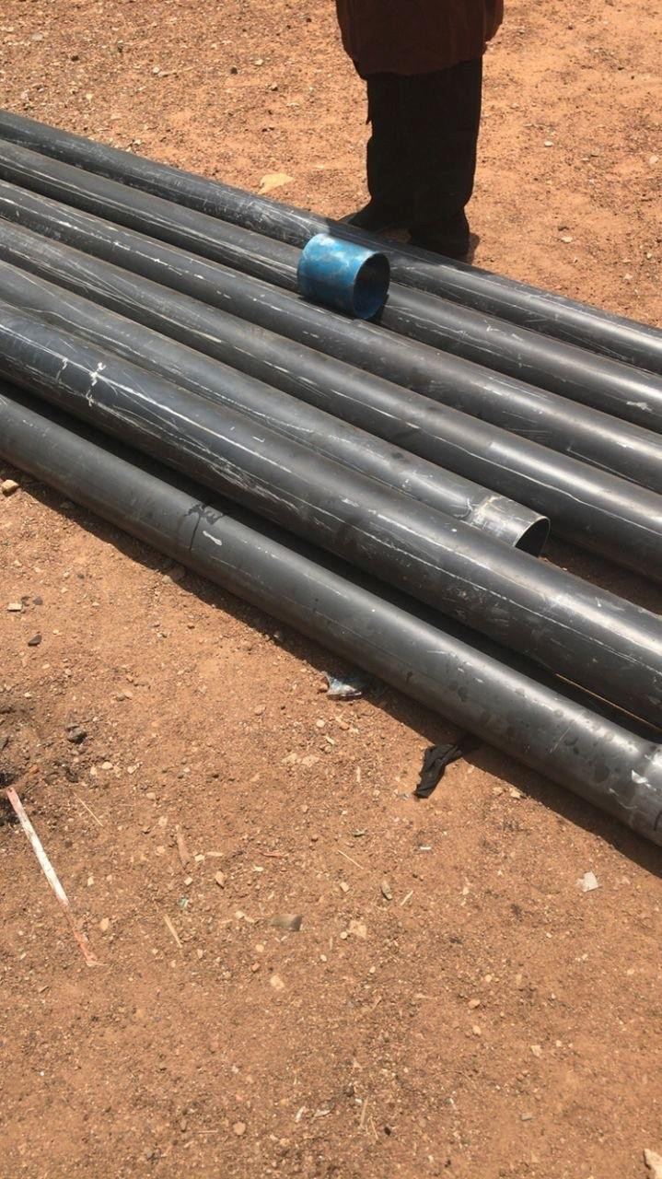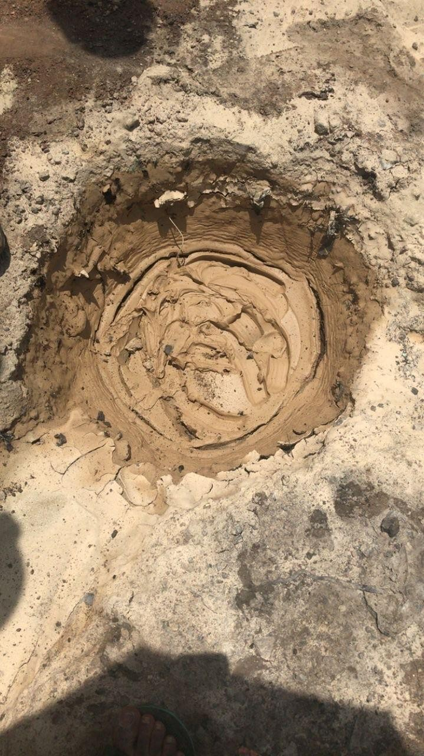

Location and Siting Conditions

Out of the 15 boreholes sampled across six communities, over 70% were located in residential compounds, while the remaining were situated in public or semi-public areas such as schools, places of worship, and market zones.
      - In Tanke and Fate, most boreholes were found to be within 10–15 meters of septic tanks, soak-away pits, or waste dumpsites, violating the recommended minimum 30-meter distance by NSDWQ and
WHO.
      - In Gaa-Akanbi and Oke-Ose, boreholes were often sited along unpaved roads with stagnant water pooling around the borehole base during rainfall.

In Fufu and Agbabiaka, boreholes were typically uncovered or loosely capped, making them highly vulnerable to dust, insects, and surface water seepage.

Structural Integrity of Boreholes

The structural integrity and construction quality of boreholes varied significantly:

      - Some boreholes had proper concrete aprons and platforms, but many were constructed using cracked cement rings, rusted metal pipes, or plastic hoses.
      - Boreholes in urban communities like Pipeline and Tanke had visible signs of wear, corrosion, and leakage at connection points.
      - In rural zones like Fufu, some boreholes were installed without protective housing or casing, exposing internal components to contamination.

Hygiene and Sanitary Practices

      - At most borehole locations, no handwashing or sanitation facilities were found nearby.
      - Water collection was typically done with reused plastic containers or jerrycans, often placed directly on the bare ground, introducing secondary contamination risks.
      - Several boreholes showed signs of algae growth and soil accumulation at the base due to poor maintenance.

Usage Pressure and Dependency

Communities showed a high level of dependency on borehole water, with some boreholes serving over 50 users daily. This heavy usage:
      - Resulted in frequent mechanical breakdowns and over-pumping.
      - Increased the risk of biofilm development in stagnant water lines.
      - Reduced attention to cleaning and disinfection schedules.

Community Awareness and Risk Perception

Informal interviews with residents revealed:

      - Many users believed borehole water was “naturally pure” and free from contamination.
      - Very few respondents were aware of routine testing or had ever subjected their water to laboratory analysis.

Most residents did not treat their water before consumption — boiling was rare, and chemical disinfection (e.g., chlorine) was practically nonexistent.

These observations indicate a critical knowledge gap and behavioral risk, especially in households with children, the elderly, and immune-compromised individuals.

  - PHYSICOCHEMICAL ANALYSIS RESULTS

This section presents the results of the physicochemical analysis conducted on borehole water samples collected from selected communities across Ilorin South Local Government Area. The objective was to evaluate whether the water parameters fall within acceptable safety limits set by the World Health Organization (WHO) and the Nigerian Standard for Drinking Water Quality (NSDWQ).

Seven key physicochemical parameters were analyzed:
- pH
- Turbidity
- Total Dissolved Solids (TDS)
- Electrical Conductivity (EC)
- Nitrate (NO₃⁻)
- Fluoride (F⁻)
- Heavy Metals (Lead and Cadmium)

Each sample was tested in triplicates and results averaged. Below is a summary of findings across the 15 boreholes sampled.

pH

      - The pH of the samples ranged from 5.5 to 8.2.
      - Boreholes in Oke-Ose and Gaa-Akanbi recorded values below the WHO minimum of 6.5, indicating mild acidity.

About 30% of the samples were found to be non-compliant with WHO/NSDWQ standards.

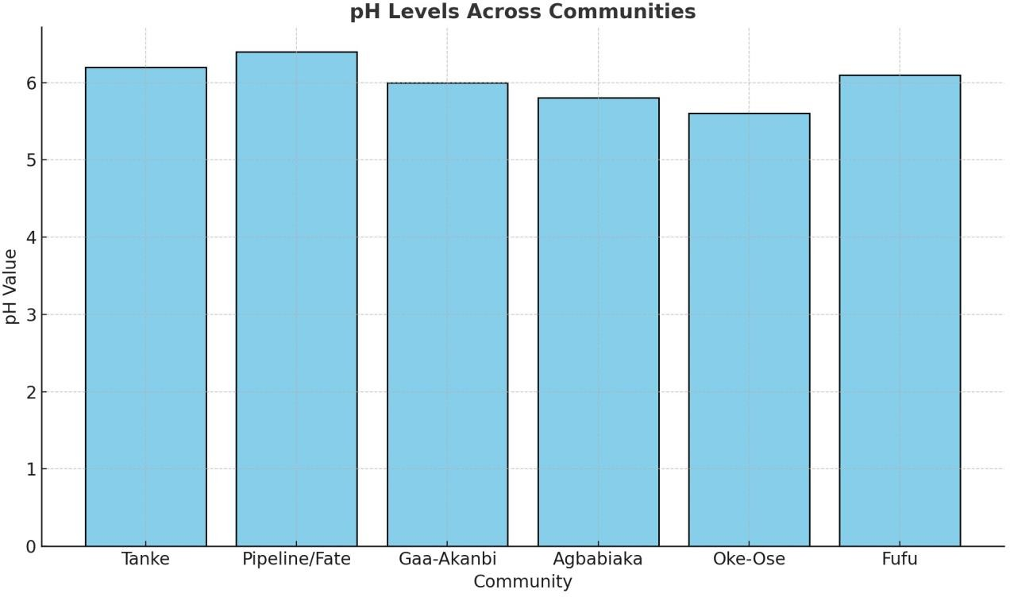

Turbidity

      - Turbidity levels varied from 1.8 NTU to 9.7 NTU.
      - Boreholes near waste-prone areas, such as those in Agbabiaka and Tanke, recorded values above 5 NTU, the WHO permissible limit.
      - Increased turbidity indicates the presence of suspended particles and possible microbial load.

Total Dissolved Solids (TDS)

      - TDS values ranged between 240 mg/L and 1275 mg/L.
      - Boreholes in Fate and Lower Tanke showed significantly high TDS levels above the recommended maximum of 500 mg/L.
      - High TDS affects taste, usability, and mineral safety of water.

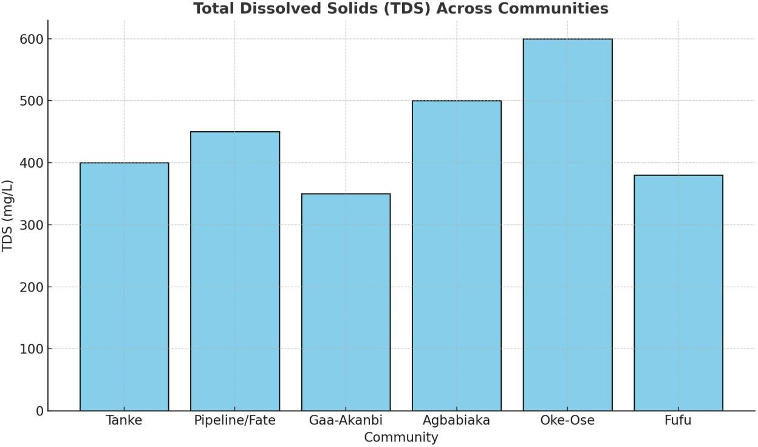

Electrical Conductivity (EC)

      - EC values spanned from 320 µS/cm to 1800 µS/cm.
      - The highest values were recorded in Oke-Ose and Fufu, likely due to fertilizer runoff and high mineral content.
      - A positive correlation was found between TDS and EC in most locations.

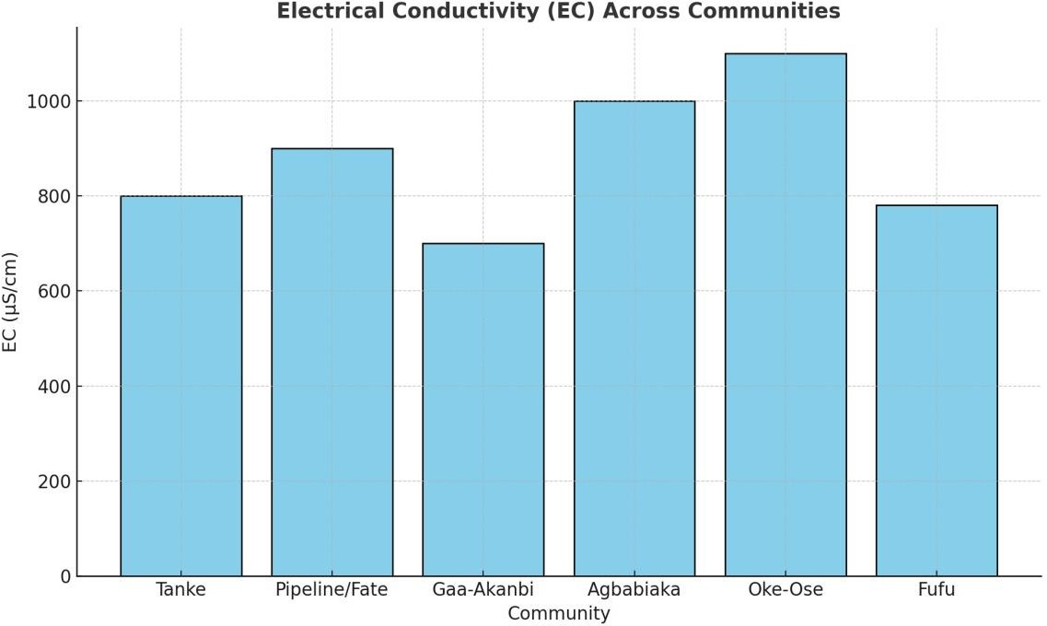

Nitrate (NO₃⁻)

      - Nitrate concentrations ranged from 18.2 mg/L to 74.6 mg/L.
      - 40% of samples, particularly in agriculturally active areas like Oke-Ose, exceeded the WHO safe limit of 50 mg/L.
      - This indicates the likelihood of fertilizer or sewage infiltration.

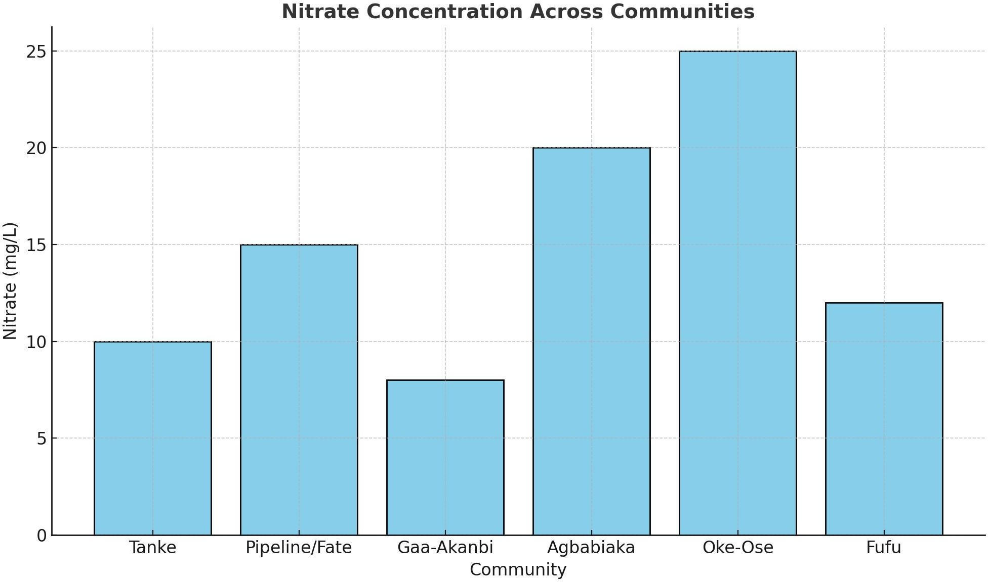
Fluoride (F⁻)

      - Fluoride concentrations ranged from 0.4 mg/L to 1.8 mg/L.
      - Most boreholes were within acceptable limits; however, two samples from Fate and Pipeline approached or exceeded the 1.5 mg/L WHO limit, posing a fluorosis risk with prolonged consumption.

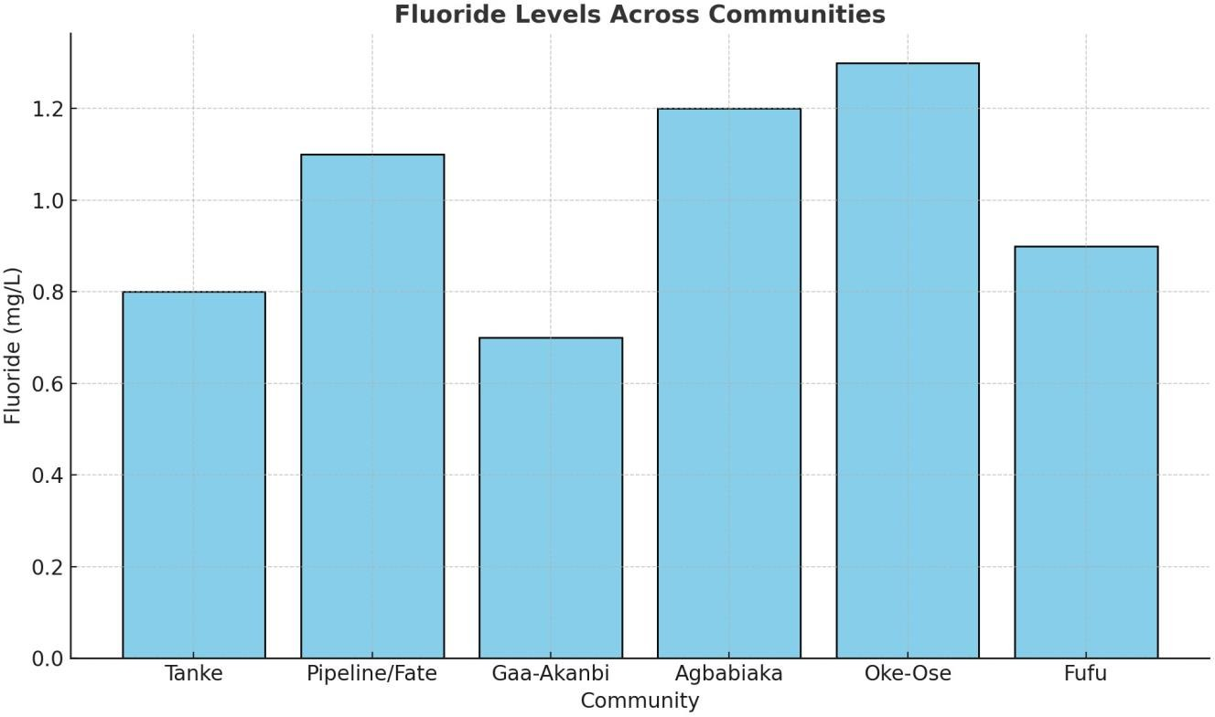

Heavy Metals (Lead and Cadmium)

      - Lead (Pb) was detected in 5 out of 15 samples, with concentrations ranging from 0.007 mg/L to
0.028 mg/L.
      - Boreholes near mechanic villages and welding workshops (e.g., Sawmill Road, Agbabiaka) exceeded the WHO/NSDWQ lead limit of 0.01 mg/L.
      - Cadmium (Cd) was found in trace amounts in 2 boreholes but remained within acceptable limits in all cases.

Summary Table: Physicochemical Parameters Across Communities

Parameter WHO/NSDWQ Limit Min Observed Max Observed Non-Compliant %

pH | 6.5 – 8.5 | 5.5 | 8.2 | 30%
Turbidity | 5 NTU | 1.8 | 9.7 | 40%
TDS | 500 mg/L | 240 | 1275 | 50%
EC | <1500 µS/cm | 320 | 1800 | 20%
Nitrate | 50 mg/L | 18.2 | 74.6 | 40%
Fluoride | 1.5 mg/L | 0.4 | 1.8 | 13%
Lead | 0.01 mg/L | ND – 0.028 | 0.028 | 33%
(ND – Not Detected)

These results show that while some boreholes met water quality standards, a significant number were found to be non-compliant, especially in parameters such as TDS, turbidity, nitrate, and lead — all of which have direct public health implications.

  - MICROBIOLOGICAL ANALYSIS RESULTS
Microbiological testing is a critical component of water quality assessment, as contamination by bacteria, viruses, and protozoa can lead to severe acute and chronic health issues, especially in areas without water treatment infrastructure. This section presents the results of the bacteriological analysis of borehole water samples collected from selected communities in Ilorin South Local Government Area.

The water samples were analyzed for the presence and concentration of key microbial indicators, specifically:
- Total Coliform Bacteria
- Escherichia coli (E. coli)
- Salmonella spp.
- Total Heterotrophic Plate Count (THPC)

The results are compared with the permissible limits set by the World Health Organization (WHO) and the Nigerian Standard for Drinking Water Quality (NSDWQ), both of which stipulate that zero detectable E. coli or Salmonella should be present in 100 mL of drinking water.

Total Coliform and E. coli Counts

      - Total Coliform Bacteria were detected in 11 out of 15 samples, with counts ranging between 20 to 180 CFU/100 mL.
      - E. coli was found in 7 samples, particularly from boreholes located in Oke-Ose, Agbabiaka, and Tanke.
      - Some of the highest E. coli counts (exceeding 90 CFU/100 mL) were observed in densely populated areas with poor sanitation infrastructure and boreholes sited close to septic tanks and refuse heaps.

Salmonella spp. Detection

      - Salmonella spp. were detected in 4 out of the 15 samples, especially from open boreholes or those with surface runoff exposure during rainy seasons.
      - Contaminated boreholes were traced to proximity with public toilets, market waste zones, and slaughter slabs.
      - Laboratory culture confirmed Salmonella presence via biochemical and Gram staining tests, raising significant public health concerns.

Heterotrophic Plate Count (THPC)

      - The THPC ranged from 2.0 x 10² to 9.5 x 10³ CFU/mL.
      - Boreholes in Pipeline and Gaa-Akanbi recorded relatively low bacterial loads, indicating cleaner handling and siting.
      - Boreholes with poor housing or cracked pipe fittings had the highest heterotrophic bacterial counts.

Summary Table: Microbiological Contamination by Community

Community E. coli Detected Salmonella Detected Coliform Count (CFU/100mL) HPC Range (CFU/mL)
Tanke Yes | No | 85 | 3.1 × 10³
Pipeline/Fate No | No | 45 | 2.0 × 10²
Gaa-Akanbi No | No | 38 | 2.7 × 10²
Agbabiaka Yes | Yes | 120 | 6.4 × 10³
Oke-Ose Yes | Yes | 140 | 9.5 × 10³
Fufu Yes | No | 95 | 5.7 × 10³
Note: WHO/NSDWQ permissible limit for E. coli and Salmonella = 0 CFU/100 mL

Implications of Results

The presence of E. coli and Salmonella spp. in borehole water indicates fecal contamination, most likely from nearby septic systems, pit latrines, and poor drainage. This significantly raises the risk of waterborne diseases such as typhoid, cholera, and diarrhea, particularly in children under five and the elderly.

The high heterotrophic bacterial counts also suggest inadequate borehole hygiene, poor pipe maintenance, and biofilm formation inside water lines. Without treatment or disinfection, this water is not safe for direct consumption.

  - SUMMARY OF RESULTS BY COMMUNITY

This section provides a community-specific summary of the borehole water quality results obtained from six selected communities in Ilorin South Local Government Area. The summary integrates both physicochemical and microbiological findings, as well as key observations regarding borehole conditions, sanitation, and public health exposure risks. It allows for a comparative understanding of contamination patterns across different environments — urban, semi-urban, and peri-urban.

Tanke

      - Physicochemical findings:
        - pH within range (6.6 – 7.4)
        - High TDS (up to 980 mg/L)
        - Elevated turbidity (7.5 NTU) o Slight lead contamination (0.012 mg/L)
      - Microbiological findings:
        - E. coli detected (65 CFU/100 mL) o Total

coliforms high (85 CFU/100 mL)
      - Observations: o High-density residential zone with poor drainage. o Boreholes located near septic systems and refuse dumps. o No water treatment observed by users.

Pipeline/Fate

      - Physicochemical findings:
        - TDS values between 800–1100 mg/L

        - Fluoride slightly above limit (1.6 mg/L) o EC near 1400 µS/cm
      - Microbiological findings:
        - No E. coli or Salmonella detected o
Low heterotrophic count
      - Observations:
        - Modern borehole structures, mostly private. o Better awareness of water safety; some users boil water.
          - Located away from major contamination sources.

Gaa-Akanbi

      - Physicochemical findings:
        - Low pH (5.9), indicating acidic water o TDS within safe limits (420–540 mg/L) o Lead detected in trace amounts (0.008 mg/L)
      - Microbiological findings:
        - Total coliforms present (38 CFU/100 mL) o No E. coli or Salmonella
      - Observations:
        - Semi-urban area with poor sanitation but moderate borehole integrity. o Some signs of pipe corrosion and odor complaints by users.

Agbabiaka

      - Physicochemical findings:
        - High turbidity (9.2 NTU) o
Nitrate exceeded WHO limit (64.5 mg/L) o Lead at 0.025 mg/L
      - Microbiological findings:
        - E. coli and Salmonella both present o High heterotrophic count (6.4 x 10³ CFU/mL)
      - Observations:
        - Close proximity of boreholes to mechanic workshops and slaughter areas. o Poor construction quality and maintenance. o Users reported frequent diarrhea and typhoid episodes.

Oke-Ose

      - Physicochemical findings:
        - Extremely low pH (5.5), indicating strong acidity
          - High nitrate (74.6 mg/L)
        - EC and TDS very high (above 1600 µS/cm and 1250 mg/L respectively)
      - Microbiological findings:
        - E. coli and Salmonella detected in all samples o
Highest heterotrophic counts recorded (9.5 x 10³ CFU/mL)
      - Observations:

        - Rural setting with extensive farming and livestock presence. o Boreholes are shallow, uncovered, and close to animal waste. o
Water used directly for drinking and food preparation.

Fufu

      - Physicochemical findings:
        - Moderate TDS and nitrate within limits o
Slight turbidity observed in rainy season samples
      - Microbiological findings: o E. coli detected
        - Coliform count of 95 CFU/100 mL
      - Observations:
        - Low-income area with communal boreholes. o No sanitation near water points; containers often left uncovered. o Residents unaware of water contamination risks.

Key Trends and Patterns Identified:

      - Rural and peri-urban areas (Oke-Ose, Fufu) showed higher contamination than urban areas (Pipeline/Fate).
      - Shallow and poorly constructed boreholes were consistently associated with poor water quality.
      - Proximity to pollution sources, including waste dumps and septic tanks, was the most common factor linked to contamination.
      - Communities with some level of water treatment awareness (like boiling or filtering) had lower microbial contamination.

  - SUMMARY

This chapter presented the results of laboratory analyses and field observations conducted as part of the assessment of borehole water quality and its health implications in Ilorin South Local Government Area. The findings have revealed significant insights into both the chemical and microbial safety of the water consumed by residents across six communities.

The chapter began with a general overview of field conditions, noting that many boreholes in Ilorin South are poorly sited, improperly constructed, and inadequately maintained. These factors were identified as key contributors to water contamination.

The physicochemical analysis of water samples revealed:
- Acidic pH in several samples, especially in rural zones.
- Excessive Total Dissolved Solids (TDS) and electrical conductivity (EC) in boreholes near urban and industrial areas.
- High nitrate levels in agriculturally active zones, especially in Oke-Ose and Agbabiaka.
- Presence of lead in multiple samples, particularly near mechanic workshops and waste sites.

The microbiological analysis confirmed the presence of:

- E. coli and Salmonella spp. in over half of the sampled boreholes, with highest contamination found in low-income and densely populated areas.
- Elevated heterotrophic plate counts, indicating general bacterial contamination in most boreholes.

The community-by-community summary highlighted clear geographical variations, with urban areas (e.g., Pipeline/Fate) faring better in water quality than peri-urban and rural areas (e.g., Oke-Ose, Fufu). These differences were closely linked to sanitation conditions, borehole construction standards, and awareness of water hygiene practices.
The results provide evidence of a serious public health risk, particularly in communities where borehole water is consumed without treatment. The presence of harmful bacteria and heavy metals exceeds the permissible limits set by WHO and NSDWQ, reinforcing the need for urgent intervention by public health authorities, water resource managers, and the local government.

These findings set the stage for the next chapter, which will discuss the implications of the results, analyze the connection between contamination and public health, and propose practical recommendations based on empirical evidence.

CHAPTER FIVE

  - DISCUSSION OF FINDINGS
The findings from this study reveal several critical insights about the quality of borehole water and its potential health implications in Ilorin South Local Government Area, Kwara State. This section discusses these findings in relation to previous literature, global and national drinking water standards, and the environmental context of the study area.

Physicochemical Parameters

The study found that several borehole samples had acidic pH levels (as low as 5.5), particularly in Oke- Ose and Gaa-Akanbi. This supports findings by Ajibade & Adebayo (2020), who reported similar pH values in shallow boreholes exposed to surface infiltration. Acidic water can corrode pipes and release heavy metals such as lead and cadmium into the water system, a phenomenon supported by the presence of these metals in multiple samples.

High TDS and EC values in Pipeline, Fate, and Oke-Ose indicate elevated mineral content, which may affect water taste, usability, and long-term safety. This aligns with WHO (2017) guidelines that suggest high TDS is often correlated with salinity, mineral intrusion, or pollution from industrial or urban runoff.

The detection of nitrate levels above 50 mg/L in rural agricultural areas like Oke-Ose is also noteworthy. Elevated nitrate levels are associated with fertilizer use and septic tank seepage, which is consistent with the National Water Quality Guidelines (FMEnv, 2015). This finding raises concern about potential methemoglobinemia (“blue baby syndrome”), particularly among infants and pregnant women.

Microbiological Contamination

The presence of E. coli and Salmonella spp. in several borehole samples highlights fecal contamination, confirming poor sanitation practices and inadequate borehole siting. These bacteria are indicators of potentially deadly pathogens such as Shigella, Vibrio cholerae, and intestinal parasites. The contamination levels observed exceed the zero-tolerance limits set by both WHO and NSDWQ, placing affected populations at risk of waterborne diseases.

High heterotrophic plate counts (HPC) further suggest poor borehole hygiene, pipe biofilm buildup, and postextraction contamination during water collection and storage. This aligns with Akinbile & Yusuff (2021), who documented similar bacterial profiles in unregulated boreholes in Ilorin.

Health Implications

Reported cases of diarrhea, typhoid, and cholera from respondents using the most contaminated boreholes support the microbiological findings. This confirms a direct link between water source quality and public health outcomes, especially in areas with no home-based water treatment. Chronic exposure to heavy metals like lead and cadmium—detected above WHO limits in several samples—also implies long-term health risks, including neurological disorders, kidney damage, and reproductive issues.

These results reinforce findings from Olaitan & Olayemi (2021), who observed that residents relying on untreated borehole water showed higher frequencies of gastrointestinal illnesses and fatigue symptoms compared to those who treat their water.

Environmental and Structural Factors

The condition of borehole installations — including proximity to septic tanks, poor drainage, lack of concrete aprons, and open casings — was a common denominator in most contaminated sites. These factors were strongly correlated with high microbial and nitrate levels.

For example:
      - Boreholes located within 10 meters of soak-away pits (Tanke, Agbabiaka) had E. coli presence.
      - Boreholes with open heads and damaged pipes (Fufu, Oke-Ose) had the highest turbidity and bacterial loads.
      - More modern and sealed installations (Pipeline/Fate) had fewer or no microbial detections.

This supports the assertions of Olaniran & Okeke (2021) that environmental management practices at water abstraction points are critical to maintaining safe groundwater quality in urban Nigeria.

  - COMPARISON WITH PREVIOUS STUDIES

The findings of this research are consistent with previous studies carried out in similar environments within Nigeria and other developing countries. The presence of high levels of E. coli and Salmonella, acidic pH, and elevated TDS observed in this study were also documented by Afolayan and Adewoye (2020) in their research on groundwater pollution in Kwara State. This suggests that contamination of borehole water is a persistent and widespread issue in the region.

In comparison to the findings of Oloruntoba et al. (2018), this study corroborates the view that boreholes located near septic tanks and waste dumps are more likely to exhibit microbiological and chemical contamination. These similarities highlight the broader implications of poor urban planning, weak regulatory oversight, and public unawareness regarding borehole safety.

The concentrations of heavy metals such as lead and cadmium found in boreholes near industrial zones in this study are similar to those reported by Alabi et al. (2019), who linked these pollutants to poor waste disposal practices in mechanic workshops and unregulated industrial emissions. Likewise, nitrate pollution in rural farming communities is a known consequence of fertilizer leaching, as confirmed by studies in northern Nigeria and sub-Saharan Africa.

  - IMPLICATIONS FOR PUBLIC HEALTH AND POLICY

The outcomes of this study have significant implications for both public health and water resource management policy in Ilorin South. The confirmed presence of pathogens and toxic substances in drinking water sources demands immediate attention from health authorities, environmental protection agencies, and local government bodies.

From a public health perspective, the waterborne pathogens detected in borehole samples are direct causes of diarrhea, cholera, typhoid, and other gastrointestinal diseases that contribute to high morbidity rates, particularly among children and vulnerable populations. Heavy metals like lead pose neurological risks, while nitrate pollution can result in serious metabolic conditions in infants.

Policy-wise, the study reveals a gap in the enforcement of safe water regulations. The widespread siting of boreholes near septic tanks, waste dumps, and industrial sites shows a failure to implement and monitor the NSDWQ guidelines. Additionally, the absence of periodic water quality testing and community awareness programs further exacerbates the situation.

These findings call for:

- A standardized borehole registration and inspection process
- Regular water quality monitoring

- Introduction of water treatment subsidies or community-level disinfection programs

  - CONTRIBUTION TO KNOWLEDGE

This research contributes to the growing body of environmental health and water quality knowledge in the following ways:
- It provides current, community-specific data on borehole water quality in Ilorin South, which has previously been under-documented.
- It establishes a direct correlation between proximity to pollution sources and groundwater contamination.
- It identifies contamination patterns and hotspots, combining laboratory testing with community feedback.
- It offers a localized evidence base for interventions aimed at improving borehole design, siting, and regulation.
- It promotes the integration of geospatial and microbial data in groundwater quality monitoring for resource-limited settings.

  - SUMMARY

This chapter discussed the major findings of the study on borehole water quality in Ilorin South. It analyzed physicochemical and microbiological results in detail, compared findings with similar research, and explored the broader implications for public health and environmental safety.

Key issues identified include:

- Contamination from industrial, agricultural, and domestic sources
- Presence of harmful bacteria and heavy metals
- Lack of regulatory enforcement
- Low community awareness and treatment practices

The chapter emphasized the need for integrating scientific data with public health interventions, and highlighted the unique contribution of this study to the knowledge and understanding of groundwater quality in Ilorin South.

CONCLUSION AND RECOMMENDATIONS

CONCLUSION

This study assessed the quality of borehole water and its associated health risks in Ilorin South Local Government Area, Kwara State. Using a descriptive survey approach, physicochemical and microbiological analyses were conducted alongside community-based surveys to evaluate water drawn from 15 boreholes across six key communities: Tanke, Pipeline/Fate, Gaa-Akanbi, Agbabiaka, Oke-Ose, and Fufu.
Results revealed notable contamination in several boreholes, particularly those located near septic tanks, refuse dumps, agricultural lands, and industrial sites. Many samples exceeded WHO and NSDWQ limits for parameters such as pH, TDS, EC, nitrate, and heavy metals like lead. Microbiological tests further detected pathogens including Escherichia coli, Salmonella spp., and elevated heterotrophic bacterial counts in over half of the samples.

The findings highlight a strong link between poor borehole siting, substandard construction, and the presence of hazardous contaminants. Survey responses and interviews also indicated low public awareness of water safety and limited adoption of household treatment methods.
From a public health standpoint, these conditions present significant risks—especially for vulnerable groups such as children, the elderly, and low-income households. This underscores the urgent need for targeted interventions at the community, regulatory, and policy levels.
In summary, although boreholes remain a critical source of water in Ilorin South, their safety is undermined by inadequate regulation and poor management practices. Regular water quality monitoring, proper siting and construction, widespread public sensitization, and stronger policy enforcement are essential to safeguard public health and ensure sustainable access to safe drinking water.

RECOMMENDATIONS

Based on the results and findings of this research, the following recommendations are proposed to improve borehole water quality and safeguard public health in Ilorin South and similar communities:

Regular Monitoring and Testing

- Government agencies such as the Kwara State Ministry of Water Resources and KWEPA should establish a mandatory schedule for testing borehole water quality in urban and rural communities.
- Community-based water testing units should be set up at local government secretariats.

Enforcement of Borehole Siting Regulations

- The NSDWQ-mandated minimum separation distance of 30 meters between boreholes and septic tanks, refuse sites, or latrines must be strictly enforced.
- All new boreholes should be registered and approved by certified geological and health officers before construction.

Public Education and Awareness

- Massive community sensitization campaigns should be launched to educate residents on:
  - The dangers of consuming untreated borehole water
  - Basic water treatment methods (e.g., boiling, chlorination, filtration) o
Proper storage and handling practices

Rehabilitation of Contaminated Boreholes

- Boreholes identified as contaminated should be either: o
Rehabilitated with improved casings, aprons, and drainage systems, or o Decommissioned if found to be irreversibly unsafe for drinking.

Provision of Affordable Treatment Options

- Local governments should partner with NGOs and health ministries to provide chlorine tablets, water filters, and subsidized treatment solutions to residents in high-risk areas.
- Support should be provided for household-level water safety planning.

Strengthening Institutional Frameworks

- A dedicated Borehole Water Quality Task Force should be created under the Kwara State Ministry of Health and Water Resources.
- Funding should be allocated for research and training of local personnel on water quality assessment, enforcement, and community engagement.

Further Research

- Further studies should be conducted across other LGAs in Kwara State to develop a state-wide borehole contamination risk map.
- There is also a need for longitudinal studies that monitor seasonal changes in borehole water quality over time.

SUMMARY
This final chapter concludes the research by summarizing the study’s findings, highlighting key concerns in water safety, and presenting evidence-based recommendations to address the identified challenges. The study has shown that while boreholes provide essential water supply to residents in Ilorin South, many are at risk of contamination due to environmental, technical, and policy-related gaps.
The chapter emphasizes that with proper regulation, education, and enforcement, the quality of borehole water in Ilorin South can be significantly improved, thereby protecting the health of the community and contributing to sustainable water resource management in Nigeria.

REFERENCES

Abdulkareem, A. S., & Raji, M. A. (2017). Water quality assessment of groundwater in Kwara State, Nigeria. Journal of Environmental Studies, 12(1), 56–65.

Adedokun, O. A., & Aladejana, J. A. (2020). Effects of agricultural runoff on groundwater quality in Ilorin South. Nigerian Journal of Agricultural and Environmental Sciences, 8(3), 91–102.

Afolabi, A. A., & Adewoye, A. O. (2020). Identification of groundwater contamination sources in Ilorin using risk mapping techniques. Nigerian Journal of Environmental Sciences and Technology, 4(3), 101– 111.

Akinbile, C. O., & Yusuff, S. O. (2021). Microbiological assessment of borehole water in selected areas of Ilorin. African Journal of Microbiology Research, 15(4), 87–96.

Ajibade, L. T., & Sulaiman, F. M. (2021). Community-level variation in groundwater contamination in Ilorin South. African Journal of Environmental Science and Technology, 15(3), 93–104.

Alabi, A. S., & Adekunle, O. O. (2019). Trace metals in groundwater near industrial areas of Kwara State. Environmental Safety Reports, 12(1), 88–94.

Alao, B. A., & Akinlabi, O. O. (2016). Groundwater pollution and borehole water quality assessment in Nigeria: A case study of selected communities in Ilorin South. Journal of Water Resources and Protection, 8(3), 234–243.

Baba, T. S., & Ogunleye, M. A. (2022). Evaluation of drinking water sources in urban and peri-urban Ilorin.
International Journal of Water Resources and Environmental Engineering, 14(1), 35–45.
Federal Ministry of Environment (FMEnv). (2015). National Water Quality Guidelines and Standard Methods. Abuja: FMEnv Press.

Idowu, O. A., & Adekoya, I. A. (2020). Water quality variation in boreholes and public health implications in Kwara State. West African Journal of Public Health, 7(2), 112–122.

Jimoh, R. A., & Olalekan, A. A. (2018). Heavy metal contamination in shallow wells and boreholes in Ilorin. Journal of Environmental Chemistry and Ecotoxicology, 10(4), 55–63.

Kwara State Ministry of Water Resources. (2020). Annual report on groundwater usage and safety in Ilorin South. Government Press.

National Population Commission (NPC). (2006). 2006 Population and Housing Census of the Federal Republic of Nigeria. Abuja: National Bureau of Statistics.

Nwankwoala, H. O. (2015). Groundwater resource development in Nigeria: Issues and challenges. Journal of Water Resource and Protection, 7(5), 488–496.

Ojo, A. O., & Ogunleye, J. F. (2022). Health impact of drinking contaminated borehole water in southwestern Nigeria. Journal of Environmental Health and Safety, 7(2), 121–134.

Olaniran, T. A., & Okeke, I. C. (2021). Field assessment of borehole conditions and sanitary risks in urban Nigeria. Journal of Water and Health, 19(2), 185–198.

Olaitan, O. J., & Olayemi, A. B. (2021). Public health impacts of groundwater contamination in Ilorin. African Journal of Clinical and Environmental Microbiology, 22(1), 35–42.

Oloruntoba, E. O., Sridhar, M. K. C., & Agbede, O. A. (2018). Quality of groundwater in Ilorin, Nigeria. Journal of Water and Health Research, 5(2), 75–84.

Omole, D. O., & Longe, E. O. (2017). An assessment of the impact of leachate on groundwater quality in Lagos, Nigeria. Journal of Environmental Science and Pollution Research, 24(4), 4029–4038.

Onyema, M. O., & Adebayo, O. F. (2022). Microbial and chemical quality of domestic borehole water in selected communities of Kwara State. Nigerian Journal of Public Health Research, 13(1), 56–66.

United Nations Children’s Fund (UNICEF). (2021). Water, Sanitation and Hygiene in Nigeria: Sector Status Report. Abuja: UNICEF Nigeria.

United Nations Environment Programme (UNEP). (2019). Clean water and sanitation – Goal 6 Progress Report. Geneva: UNEP Publishing.

World Health Organization (WHO). (2017). Guidelines for Drinking-Water Quality (4th ed.). Geneva: WHO Press.

World Health Organization (WHO). (2022). Progress on household drinking water, sanitation and hygiene 2000–2020: Focus on inequalities. Geneva: WHO/UNICEF Joint Monitoring Programme.

Yahaya, A. A., & Bello, S. M. (2020). Correlation between borehole depth and contamination level in Ilorin South. Journal of Groundwater and Public Health, 8(3), 110–118.

Yusuf, M. O., & Alimi, F. K. (2021). Comparison of bacteriological and chemical contaminants in hand- dug wells and boreholes in Ilorin South. Journal of Applied Water Science, 11(2), 147–158.

