GEOPHYSICAL STUDIES FOR GROUNDWATER POTENTIALS WITHIN KWARA STATE POLYTECHNICS, ILORIN

PRESENTED BY:

AHMED RUKAYAT ODLND23SLT0005
ABUBAKAR MARYAM JUMMAI ODLND23SLT0115
MUHAMMED JAMIU ODLND23SLT0207
IBRAHIM BIDEMI KHALIQOT ODLND23SLT0355
OLANIYI ISLAMIYAT OLAIDE ODLND23SLT0444
SULAIMAN SAYEED OLADIMEJI ODLND23SLT0454
ODEJIDE MICHAEL ODLND23SLT0506

A RESEARCH PROJECT SUBMITTED TO THE DEPARTMENT OF SCIENCE LABORATORY TECHNOLOGY (PHYSICS UNIT), INSTITUTE OF APPLIED SCIENCES, KWARA STATE POLYTECHNIC, ILORIN

IN PARTIAL FULFILMENT OF THE REQUIREMENTS FOR THE AWARD OF NATIONAL DIPLOMA (ND) IN SCIENCE LABORATORY TECHNOLOGY, PHYSICS UNIT

JULY, 2025

CERTIFICATION
This is to certify that the project research done by, has been read, approved and submitted to the Department of Science Laboratory Technology Institute of Applied Sciences, Kwara State Polytechnic, Ilorin..

---------------------------------- --------------------------------
MR. BELLO A.M.A DATE
(Project Supervisor)

---------------------------------- --------------------------------
MR. SURAJUDEEN DATE
(ODFEL ND SLT Coordinator)

---------------------------------- --------------------------------
DR. USMAN ABDULKAREEM DATE
(H.O.D SLT)

---------------------------------- -------------------------------- EXTERNAL SUPERVISOR DATE

DEDICATION
This research is dedicated to Almighty God for the completion of my ND programme in a great citadel of knowledge (Kwara State Polytechnic, Ilorin) and to my lovely parents for their financial support throughout my programme.

ACKNOWLEDGEMENTS
Our profound gratitude goes to Almighty Allah the creator of the universe. This work is a synergistic product of many minds and we feel a deep sense of gratitude to our parents, brothers and sisters our friends for their encouragement and for being ever supportive.
Our sincere thanks go to our supervisor MR. BELLO A.M.A for his thorough assistance with this work. We are very grateful sir.
Our sincere gratitude goes to Head of Department SLT, the ODFEL Coordinator and other members of staff of the Department of Science Laboratory Technology, Kwara State Polytechnic. Ilorin for the constant cooperation, constructive criticisms, and encouragement throughout the programme.
We also acknowledge the Science Laboratory Technology (set 2024/2025) for their active verbal participation and suggestions towards the evolvement of this project work.

TABLE OF CONTENT
Title Page……………………………………………………………………………,,,,,,..i
Certification…………………………………………………..……………………….....ii
Dedication ………………….……………………………..…………………………..…iii
Acknowledgement……………………………………..………………………...……….iv
Table of Contents ………………………………………………………………………...v
Abstract ……………………………………………………...……………………………vii

CHAPTER ONE: INTRODUCTION
  - Background Information……………………………………………………..……….1
  - Location of the Project Area……………………………………………………….….3
  - Statement of Problem………………………….……………………………………...4
  - Justification…………………………………………………………………………...5
  - Aim and Objectives……………………………………………….…………………..5
CHAPTER TWO: LITERATURE REVIEW

2.1 Regional Geology of the Study Area ……..............................................................6
2.2 Ilorin East and Moro Local Government Area ……………………………..…7

2.3 The Principle of the Schlumberger Prospecting Method…………………….10

2.4 Theory of The D.C Resistivity (VES) Method …................…………..………..11

2.4.1 Basic Equation of Geoelectrical (VES) Resistivity Prospecting Technique....12

2.4.2 Resistivity Relation for the Schlumberger Configuration ......................…...14

2.5 Data Presentation …………………………………………..………………….… 14

CHAPTER THREE: MATERIALS AND METHODOLOGY
3.1 Introduction ………………………………………………………………………….15
3.2 Materials Used …………………………………………………………....................16
3.3 Field Work Investigation……………………………………………………………..17
3.4 Type Curves Associated With VES Resistivity Data……………..……………..18
3.5 Interpretation Procedure………………………….…………………………….……19
CHAPTER FOUR: RESULTS AND DISCUSSIONS

4.0 Results Of VES Data Interpretation, Analyses And Discussion……………………25

4.1 Geophysical Survey……………………………………………..………..………….25

4.2 Interpretation Of The Collected VES Data………………………..……..…………..25

4.3 Analyses of The Results of the Interpretations Of The Collected VES Data……….28

4.3.1 Lithologic Deductions…………………………………………….…….…............…28

4.3.2 Resistivity Curve Types Obtained in This Work………………….…….…………...28

4.3.3 Geoelectrical Resistivity Parameters…………………………………….………….28

4.3.4 Overburden Thickness…………………………………………………..………..…29
CHAPTER FIVE: SUMMARY, CONCLUSION AND RECOMMENDATION
5.1 Summary …………………………………………………………………………….34
5.2 Conclusion…………………………………………………………………………....35
5.3 Recommendation……………………………………………………………………..35
REFERENCES………………………………………………………………36

ABSTRACT
Six Vertical Electrical Soundings data were collected and interpreted to evaluate its groundwater potentials within parts of Kwara State Polytechnic Main Campus, Ilorin. The interpretations were carried out using RESISDINV2 IPI2WIN and Surferer Version 12. The interpreted VES data results revealed three and four data geo-electric layers of H (1), KH (5) and QH (1) resistivity type curves with probable or inferred lithlogic units / geologic sections of lateritic top soil, weathered bedrock, fractured bedrock and fresh basement. The overburden thickness values from 9.77 Ωm to 24.3Ωm, the resistivity of the weathered basement rocks vary from 38.7Ωm to 107.9Ωm and 525.0Ωm to 938.0Ωm. the aquifer exists within the weathered and fractured basement rocks. The second-order geoelectric parameters of total unit longitudal conductance, S, vary from 0.0859 to 0.2301Ω⁻¹ , the total unit transverse resistence, R-value range from 1308.877 to 11,236.52 Ωm⁻², the coefficient of emisotropy vary from 1.0323 to 2.0911. These values suggest that the groundwater potential in the study area of moderate evaluate of Kwara. The range RESISDINV2 Version 12. The overburden aquifer protective capacity is generally weak and the soil corrosively is potentially non-corrosive.

CHAPTER ONE

INTRODUCTION

1.1 Background Information
The raid increase in Socio-economic development of Nigeria has resulted in widening inadequate provisions of water for subtenant’s daily chores such as bathing, drinking, heating, cooking ablution and prayers. Groundwater is the largest available reservoir of fresh water. A majority of fresh water is locked away as ice in the polar ice caps, continent ice sheets and glaciers beneath the ground. Water in Rivers and lakes only account for less than 1% of the Worlds’ fresh water reserves (Caruthers, 1985; Bello, Makinde and Sambo 2005;Bello and Makinde 2009). It is among natural resources bestow the human race. There must be space between the rock particles for groundwater to flow and the Earth’s material becomes denser with more depth. Essentially, the weights of the rock above condense the rock below and squeeze out to open the pore spaces deeper in the Earth. That is why groundwater can only be found within a few kilometers of the Earth’s surface. Observation shows that groundwater comes from rain, snow, sheet and hail that soak into the ground and become the groundwater responsible for the spring, wells and bore holes (Idornighie and Olorunfemi 1992; Alisiobi and Ako 2012) Groundwater is water located beneath the ground surface in soil pore spaces and in the fractures of lithologic formations. A unit of rock or an unconsolidated deposit is called an aquifer when it can yield a usable quantity of water (Niwas and Singh, 1981; Tijani et al.,2018). The depth at which soil pore spaces or fractures and voids in rock become completely saturated with water is called water table.
It is generally known that groundwater is often withdrawn for agricultural, municipal and industrial use by constructing and operating extraction wells. Groundwater is also widely used as a source, for drinking supply and irrigation in food production (Zekster and Everett, 2004). Naturally, 53% of all population relies on groundwater as a source of drinking water. Electrical resistivity method of geophysical techniques happens to be the most preferred method in groundwater potential. Vertical Electrical Sounding (VES) is a geoelectrical common method to measure vertical alterations of electrical resistivity. The method has been recognized to be more suitable for hydrogeological survey of sedimentary basin (Kelly and Stanislav, 1993). The electrical resistivity technique involves the measurement of the apparent resistivity of soils and rock as a function of depth or position. The most common electrical technique needed in hydrogeologic and environmental investigations is vertical electrical soundings (resistivity sounding). During resistivity surveys, current is injected into the Earth through a pair of current electrodes, and the potential difference is measured between a pair of potential electrodes. The current and potential electrodes are generally arranged in a linear array. Common arrays include dipole-dipole array, pole-pole array, Schlumberger array and the Wenner array. The bulk average resistivity of all soils and rock influencing the current. It is calculated by dividing the measured potential difference by the input current and multiplying by a geometric factor specific to the array being used and electrode spacing. In a resistivity sounding, the distance between the current electrodes and the potential electrodes is systematically increased, thereby yielding information on subsurface resistivity from successively greater depth. The variation of resistivity with the depth is modeled using forward and inverse modeling computer software. Geophysical investigations which involve electrical resistivity and shallow seismic refraction methods have been used in the alluvial coastal belt of Digha, in the Eastern India for environmental study, to investigate the nature and status of subsurface saline water contamination (Kalpan et al., 2001).The vertical sounding method was chosen for this study because the instrument is simple, field logistics are easy and straight forward while the analysis of data is less tedious and economical (Ako and Olorunfemi, 1989). It also has capability to distinguish between saturated and unsaturated layers.

1.2 Location, Accessibility, Geology and Hydrogeology Of The Project Area
The project area is Ilorin located in Kwara State within the Nothern geographical and political zone but found in the Southwestern Nigeria Precambrian basement complex (Figure 1.1 and 1.2). It exist within latitudes 8.476441 to 8.564174 Northing (Degree North) and longitudes 4.616468 to 4.641521 Easting (Degree East) with mean elevation of ranging from 292 to 358 in above mean sea level. It is easily accessible with many tarred and untarred roads. Climatologically, the area is tropical and falls within the Guinea Savannah belt which is the transitional zone between the dry sudan savannah and the southerning lying rainforest.
The mean animal rainfall is between 1000 to 1250mm with annual temperature range of 24⁰C to 32⁰C. It is also characterized by two seasons namely the dry season otherwise referred to as Harmattan which last from early October to early March and the rainy season which commences in mid-March and stops in October (Kinola, 1986, Ajadi, 2010).
Geologically, the project area is underlain by the Precambrian crystalline rocks of the Nigeria Basement Complex which Rahaman (1976) classified into five lithostratigraphic units. The Migmatite – Gneiss – Quartzite MGQ complex in the main rock types which consist of banded gneiss and quartzite (Figure 1.3) and the younger met sediments of schist. In places where these rocks are not exposed, the fresh basement rock is overlain by the weathered basement saprolite which comprises lateritic and sandy clayey geologic materials derived from in-situ chemical weathering of the protolith and fractured bedrocks.
Hydro geologically, the area is drained by the dendrites rivers Oyun, Oyi with their tributaries and distributaries. The aquifers are constituted by the lateritic/sandy clayey aquifers, clayey weathered bedrocks and fractured bedrocks. These aquifers are usually found under the static water table SWT under confined and semi- confined conditions. The existence of fractures and faults in a geologic settings contribute to the enhancement of the hydro geological characteristics such as thickness of overburden reduction of the resistivities of the aquifers, hydraulic conductivity and transmissivity as well as promotion of the secondary permeability and porosity of the aquifer and structural control for groundwater flow.
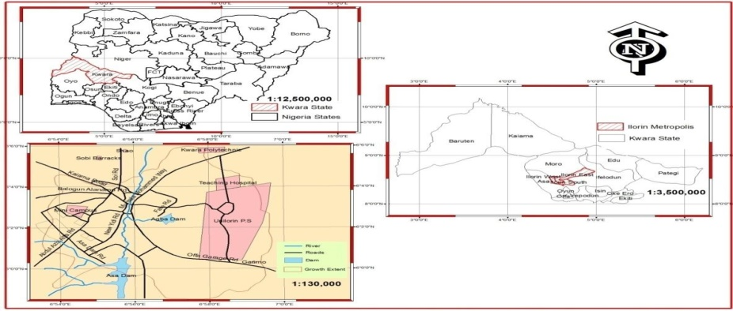
Figure 1:1 Location of Area of study within Nigeria
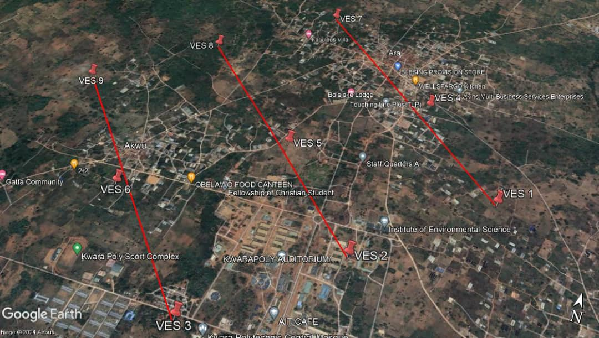
Figure.1:2 location of Area within Kwara Statement
1.3 Statement of Problem
The increasing number of human activities is gradually speeding up contamination and damage of fresh water resources. Pollution of surface and ground water is a great problem caused by urbanization, industrialization and anthropogenic activities (Vijay, 2016).
Domestic water such as well, borehole, stream are the common sources of water available to the inhabitants of Ilorin community, for drinking and domestic activities. It is used as an alternative to public water due its poor quality arising from lack of treatment. Some of these wells are usually left uncovered and the environment is poorly sanitized. Moreover, farming activities are also carry out in the area which involves the use of herbicides, fertilizers that could lead to contamination of the water. The topography of the area is rocky and degradation of some rocks use to occur as a result of building of which the minerals or heavy elements embedded inside the rocks can get leached to the wells by weathering process and lead to contamination.

1.4 Justification
The study will essentially provide vital information on the quality of domestic water samples available to the inhabitants of Ilorin Community, Ilorin, Kwara State to ensure that they are fit for consumption and guaranteed healthy living.
1.5 Aim and Objectives
The aim of this study is to evaluate assess the groundwater potentials in part of Kwara State Polytechnic Ilorin using geoelectrical techniques.
In furnace of this aim, the specific objectives are to--
- collect six Vertical Electrical Sounding (VES) obtained from previous geophysical surveys of the area
- interprete the collected VES data in order to determine first-order and second-order geoelectric parameters
- use the result of the interpretations of the VES data to evaluate the groundwater potentials of the study area
- generate some geophysical maps to assess the groundwater potentials of the study area

CHAPTER TWO

LITERATURE REVIEW

2.1 Regional Geology of the Study Area
Nigeria is located on the western part of the Africa continent. It falls at the Northern end of the Eastern branch of the East Africa Rift System. The total surface area of Nigeria is 93,768 km² which is covered by crystalline and sedimentary rocks nearly in equal proportion. Previous works by Oyawoye (1964), Odeyemi (1977), Grant (1978), Rahaman (1988) among others have given account of the geology of Nigeria.
Generally, the geology of Nigeria is classified mainly into the crystalline basement and sedimentary rocks. The basement complex is one of the three major litho-petrological components that make up the geology of Nigeria (Fig.2.1). It forms part of the pan-African mobile belt and lies between the West African and Congo craton and the south of the Tuareg shield (Black, 1970). It is intruded by the Mesozoic calc-alkaline ring complex also known as the younger granite of the Jos Plateau and overlain unconformably by Cretaceous and younger sediments. The crystalline basement rocks of Nigeria are classified into various lithological groups by Elueze (1982) and Rahman (1988). These groups are the
- Migmatite-Gneiss-Quartzite complex
- Charnokitic, Gabbroic and Dioritic rocks
- Unmetamorphosed Dolerite, Basic Dykes and Syenite Dykes
- Older Granite suite (Pan African Granitoids)
- Slightly Migmatized to Non-Migmatized Meta-Sedimentary and Metaigneous rocks
- Metamorphosed calc-alkaline volcanic and Hyperbysal rocks
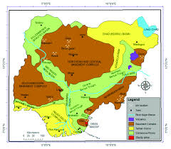

Figure 2.1 Geological sketch map of Nigeria showing the major geological components;
The Basement Complex, and Sedimentary Basins (Adapted from research gate).
The details of the lithostratigraphic unit of the basement complex of Nigeria are discussed in the works of Ajibade (1976), Odeyemi (1979), Rahaman (1988) and Olasehinde (1999).
2.2 Ilorin East and Moro Local Government Area
The aquifer units in this area are possibly composed of lateritic horizons (if thick), weathered and fractured bedrock (Amolegbe et al., 2015). Unlike for sedimentary terrains with primary permeable units of very porous alluvials and sandstone formations, the saturated groundwater-bearing zones of the Basement Complex consist of secondary permeable formations because of their relatively low porosity and permeability.
Bello et al.,(1997;2005) suggested that groundwater yields from fractured bedrock, though of higher quality than water from weathered bedrock, are however of limited quantity. Moreover, Wasiu and Abdulkadri(2020) have suggested that the overburden thickness of the regolith depends on:
- Low relief surface which minimizes erosion;
- tropical to sub-tropical humid climate with seasonally high or moderate incident rainfall;
- availability of weathered rocks due to their mineral composition;
- long time span of geologic and climatic stability during which deep weathering processes could take place without interruption. Discussed below is how the above conditions are satisfied in the study area of both Ilorin East and Moro LGA.
The gently undulating topography and low surface relief (less than 300 m) prevalent in this area favour a minimal surface runoff and erosion of lateritic top soil cover (Wasiu and Abdulkadri, 2020). The tropical humid climate of this area provides for a moderately high rainfall in the rainy season. However, local variations of rainfall and the lateritic capping will favour high runoff and low infiltration/percolation of water to the subsurface.Thus, development of thick weathered bedrock profile will be inhibited Consequently, as obtained in other basement areas (Clark,1985) aquifers in the study area are isolated without any inter-basin exchange and the groundwater resources in the region are limited . With a mean annual rainfall of about 1300mm recharge of the aquifer units in this basement complex is mainly through infiltration of rainfall .
In a crystalline rock terrain, degree and depth of weathering depends on the extent of prominence of stable and unstable minerals in a rock (Bello et al.,2005). According to Amadi and Nurudeen (1990),the presence of dark (mafic) unstable minerals like biotite, hornblende, olivine, augite mostly produce weathered bedrock rich in clay. On the other hand, light (felsic) stable minerals like quartz and feldsparsweather into porous and permeable coarse-sandy formations. Information from borehole logs collected for this work shows that substantial felsic minerals exist within the crystalline rock units in the southeastern and northeastern parts of both LGAs.This means that the eastern part of the LGAs most likely contains favourable coarse deposits with favourable groundwater storage capacities,
The permeability and porosity of crystalline rocks are usually improved by the presence of such structures like fractures, faults, fissures, joints etc, In addition, these structures control the flow of groundwater, determine the amount of recharge and discharge and sometimes store water themselves,especially where such features are of appreciable width and depth. Although, borehole log reports by M/S Biwater Shellabear (1985) and geophysical studies by Bello et al. (1997)have shown the existence of an integrated network of fractures at depth, within the crystalline rock units between Bode Saadu and Jebba, however three productive boreholes drilled around these areas at Ladeyo and Elemere gave low groundwater yields of 0.45 1/s and 0.401/s respectively at the two locations . The reason for this, is probably due to the limited extent of the fractured bedrocks without hydraulic continuity, Also, the prevalence of fine-grained materials like pelite, phyllite, schist,psammite, etc. which predominate the metasedimentary series of this area, might have caused these low yields.
These fine materials usually strongly adhere to the "capillary tubes" created by the pore spaces and prevent easy withdrawal of water.
Finally, the existence of stable geologic setting and climate over a long-time span seem to favour the presence of deeply weathered bedrocks whose weathering threshold varies from less than 1 m to about 60 m. A dendritic network of rivers like Oyi,Oyun, Moro occurs in these LGAs to recharge the aquifer units during the replenishment periods. Also, these large networks of rivers which are possibly prominent due to the low permeability of the crystalline rocks enable the rivers follow zones of weakness along the fractures and create favourable deep weathering processes with productive boreholes/well sites in place

2.3 The Principle Of The Schlumberger Prospecting Method.
In the Schlumberger configuration of electrical prospecting, the potential electrodes P₁ and P₂ are placed symmetrically about the midpoint (I.e. 0) between the current electrodes C₁ and C₂(fig 2.1). The electrodes P₁ and P₂ are usually kept sufficiently close together such that the distance between the potential electrodes (MN or b) is less than two-fifths of the current electrode separation (ie MN < 0.4AB). By so doing, the electric field E, between the potential electrodes can be considered constant (van Nostrand and Cook, 1996).
The field procedure involves expanding AB while MN is relatively kept constant. This process yields a rapidly decreasing p.d. almost equals zero. At this stage, MN is increased to about three times its former spacing and the procedure is repeated. The last one or value, in order to detect near-surface heterogeneity effect (or lateral variations in resistivity) and to partially correct for them.

r2
C1
P1
P2
r4
A
C2
M
N
B
r1
r3

Figure 2.1: Typical Arrangement of Vertical Electrical Soundings (VES) Using Schlumberger Array

2.4 Theory of The D.C Resistivity (VES) Method
The fundamental theory of d.c. resistivity prospecting is based on the validity of Laplace’s equation to obtain the electrical potential and the pattern of current flow about one or more current electrodes placed on or within the ground (van Nostrand and cook, 1996). This exercise involves mathematical analyses of electrical potential theory on stationary electric field and the solution of the Laplaces equation. Therefore, the main equation used in electrical resistivity prospecting was obtained as follows:

2.4.1 Basic Equation of Geoelectrical (VES) Resistivity Prospecting Technique
Consider a point source of current on the surface of a homogenous, isotropic and stratified earth extending to infinity in the downward direction (i.e. +z-axis) and having resistivity, ƿ (ohm-m). Also, consider steady state condition when instantaneous values of current, I (A) are practically the same in all directions of the circuit. Then, the differential form of ohm’s law gives the relation between the current density, J (Am⁻²), conductivity, o(Sm⁻¹ ) and the electric field intensity, E (vm⁻¹) as:
J = oE ….2.1
For a steady current flow, stationary electric fields which are conservative are generated outside the source,
E = -𝝯V …2.2
Where V is a scalar potential in volts (V).
Therefore, (2.1) and (2.2) imply current density, J is a function of potential, U. According to the law of conservation of electricity
.J = 0 2.3
This means, there is no current source and (or) no current sink between (say) two current electrodes. In other words, as much current enters through a current electrode C₁, so much leaves the circuit through a second current electrode C₂. That is the divergence of the current density vector, J must be zero everywhere except at the current source. Combining equations (2.1), (2.2) and (2,3) one obtains:
𝝯𝞂𝝯V +𝞂𝝯²V = 0
Since 𝞂is constant, = o
Therefore 𝝯²V = 0 …2.4
Which is known as Laplace’s equation.
In spherical polar coordinates, the Laplace’s equation is:
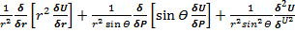 …2.5
For a considered single source of current, assuming that there is complete symmetry of current flow with respect to 𝞡 and V directions, then the potential at a distance r from the point source of current will only be a function of r. Hence equation (3.5) becomes:
+ = 0 2.6
Integrating equation (2.6) twice and then eliminating constants of integration, the solution of the equation is:
V = …2.7
Which is the basic equation of d.c. prospecting (Maillet, 1947). From equation (2.7), one obtains the resistivity for a medium or geologic formation as:
Ƿ = 2πr …2.8
Equation (2.8) gives the true earth resistivity for an homogeneous medium. However, in practice, the earth’s subsurface is usually an heterogeneous medium. Therefore, there is a need for a modified form of equation (2.8) as discussed below:

2.4.2 Resistivity Relation for The Schlumberger Configuration
The true earth resistivity equation obtained above (equation 2.8) is a simplified relation for a single source of current. In practice, the survey arrangement makes use of a pair of current electrodes as signal generator and a pair of potential electrodes to measure the effects (i.e. potential difference) produced by the impressed current. More so, since the earth is heterogeneous, then an appropriate relation is:
ƿ_{a} = K ….2.9
Where ƿ_{a =} apparentresistivity
K = geometrical factor which depends on the electrode configuration used during field measurements.
According to Keller and Frischknecht (1996) and van Nostrand and Cook (1996), for a Schlumberger array, ƿa is obtained as follows:
The p.d. (𝝯V) between the potential electrodes P₁ and P₂ is:
𝝯V = V₁ – V₂ ….2.10
Where V₁ = the potential at the positive potential electrode (say) M due to the two current electrodes C₁ (+ve) and C₂ (-ve);
And V2 = the potential at the negative potential electrode (say) N due to C₁ and C₂ at position A,B (fig.2.1).
From figure 2.1, V₁ and V₂ are obtained as:
V₁ = = 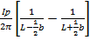 …2.11a
V₂ = = 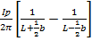 ….2.11b
Equations (2.10), (3.11a) and (3.11b) are combined to obtain the geometrical factor for the Schlumberger (C₁P₁P₂C₂) array as:
𝝯V = i.e. ƿ = π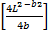 ….2.12
Comparing equations (2.9) and @.12), then the geometrical factor for Schlumberger configuration, Ks is given as:
Ks = …2.13
Therefore, Form equations (2.9) and (2.13), the apparent resistivity, ƿa of the earth for Schlumberger array is:
Ƿ = ….2.14
Since L = AB/2 and b = MN (Fig 3.1)
Then ƿ_{a} = ….2.15.

2.5 Data Presentation
Electrical resistivity data can be presented as profiles, stacked profiles, VES curves, pseudosection and maps. The HP data can be presented as profiles and maps when it involves more than three traverse lines. Profiles are generated by plotting resistivity values against station positions along a particular traverse line. The station position is determined by the electrode configuration used.
Maps are generated by posting the apparent resistivity values on their relative measuring positions and the values contoured. Maps give location of the target, geometry, width extent and strike length.
VES data are presented as a sounding curve - plot of apparent resistivity against spacing on log-log (bi-log) graph paper.
The combine HP and VES or 2D imaging data are presented as 2-D pseudosection. Such section gives the location of the target, lateral extent and orientation of the target.

CHAPTER THREE
MATERIALS AND METHODOLOGY
3.1 Introduction
Data acquisition utilizes geophysical techniques which is, Electrical resistivity method utilizing vertical electrical sounding, Ten traverses were established (6 running from South to North direction with maximum distance of about 150m and 6 running from East to West with maximum distance of about 150m). Nine vertical electrical sounding was conducted along the traverses. The current electrode (AB/2) was varied from 1-150m because of the limited space of spreading. Resistivity values were obtained by taking readings using Omega resistivity meter, four electrodes and connecting cables. Resistivity readings taking using the Schlumberger array was undertaken by keeping the center of the array fixed and expanding the current electrodes separation, thus obtaining the resistivity readings with depth. DC current was injected into the earth through the current electrodes C1 and C2, while the resulting potential was measured across the potential electrodes P1 and P2.The resulting potential difference to the current is displayed by the digital resistivity equipment as a resistance. The electrode spacing is progressively increased, keeping the center point of the array fixed. At small electrode spacing, the apparent resistivity is nearly the resistivity of the surface material, but as the current electrodes spacing increase the current penetrates deeper within the subsurface and so the apparent resistivity reflects the resistivity of the deeper layers as well. The apparent resistivity values are obtained by multiplying the measured resistance with an appropriate geometric factor. Different factors such as the subsurface layering, moisture content, salinity degree of weathering and fracturing of the bedrocks affect the resistivity in the subsurface (Telford et al, 1990).)
3.2 Materials Used
Since VES data are collected from geophysical surveys carried out within Kwara State Polytechnic, Ilorin in recent, years. These set of data were interpreted using softwares such as RESISDINV2, WINRESIST, Oasis Montery and Surferer Version 12.0. The interpretations were carriedmout using laptop computer. The first-order geoelectric parameters determined were member of layers, n, thickness of layers, h, resistivity of layers (S) and depth of layers (d).
These parameters were further preserved to determine the second-order geoelectric parameters of:
- overburden thickness, of
- Dar-Zarrouk Parameters, DZP of total longitudinal unit conduilence (s) and total transverse unit resistence ( R )
- Hydraulic conductivity (K)
- Transmissivity (Tr)
- Average longitudinal resistence ($l$l)
- Average transverse resistence ($l$t)
- Coefficient of Anisotropy ($γ$)
- Bedrock Coefficient (BC)
- Fracture or Resistence Contrast (Fe)
3.2.1 FIELD WORK INVESTIGATOIN
Schlumberger vertical sounding (VES) measurement ere conduct with maximum electrode spacing (AB/2) of 50 m. the method implied for this project is the vertical electrical sounding, which was used in other to determine the apparent resistivity change with depth at various location. This gives the prediction to determine ground water depth in various location of the VES points were located 5meter away from the Ara village. The location of each sounding station was recorded in universal traverse Mercator (UTM) coordination with the aid of a GERMIN 12 channel personal navigator (GPS) unit. The survey was carried out during the rainy conductivity of 200m at each location. Four VES station were separated by 5m interval. The ABEM SAS 300C tetrameter was to collect the VES data. Field resistivity structures of sounding data were determined by the software IPIWIN (version 3.0.1) development.
  - TYPE CURVES ASSOCIATED WITH VES RESISTIVITY DATA
Basically there are four of three-layer resistivity curves. These are types A, Q, H and K which are shown in 3.1. The electrical characteristics of these type curves are briefly discussed below:
- The A-type curve is an ever increasing curve which has the form p1 > p2 > p3;
- The Q-type curve is the ever decreasing curve (i.e. p1 > p2 p33);
- The H-type curve is called the minimum-type or bowl shaped curve which has p1 > p2 > p3 and
- The K-type curve is the maximum-type cases do exist where a given set of VES data may simple more than 3 geo electric layers. Such cases which are multi-layered curve do bear a combination of one or more of the basic type curves described above. Like the three-layered curves can be divided according to the relation of the resistivity of the individual layers.
The subdivision are subsequently marked with symbols which consist of the appropriate number of letter. Thus, the first letter usually indicated the connection between the frist three layer. The second letter will show the relationship between second , third and fourth layers . this mean, a 4-layer case with p1 > p2 > p3 > p4 > is an HA-type curve while a 5-layer case with p1 > p2 > p3 > p4 > p5 is a QHK type curve. These example show that for an n-layer curve and their description in terms of variation of resistivity with depth are shown in table 3.2
3.4 INTERPRETATION PROCEDURE
To interpret the VES data obtained for this project, the program of was modified in this work for use on a desktop compeer and a laptop computer. The processing of the VES data was done in two stages. The first stage, otherwise referred to as “preliminary” or “Indirect” interpretation involve the use curve matching technique (keller and frischknecht, 1966; olayinka and mbachi, a992; Idoringie and Olorunfemi, 1992) to obtain the initial/trial model parameters of the number of iteration necessary to arrive at the “best” fit between the computer and the field resistivity values, the curve matching method was used with aid of typical standard curves shown in figure 3.5 to determine the thickness and the resistivity is the layering’s beneath each VES location (Orellana and Mooney, 1966; Koefoed, 1979; Telford et al., 1976). The empirical method which , according to vanNostrand and cook (1966) and Shiftan (1970) is based on the view that at every turning point and at a maxima or a minima of a VES curve , the thickness of the upper layer is about one-quarter of the current electrode spacing, AB (m) was used. For example, considering a three-layer K-type curve, the point of inflexion at the initial branch of the apparent resistivity curve and the maximum point are noted then each AB/2-value corresponding to each of these turning point multiplied by half to give the estimate of the thickness of the corresponding resistivity value obtained from the figure 3.3: graph of standard curve for interpretation (Keller and Frischknecht,1966.

3.5 Analyses of Interpretations Of Collected VES Data
Primarily, the analyses of the interpreted VES data are done into two forms viz qualitative and quantitative. The first form involves the assessment of the resistivities variation lithologic by units and or subsurface layers at each VES location. The curve descriptions are then classified into curve-types under of layers and portable of inferred lithologic unit based on resistivity values associated with each layer. In this way, we can summarize the result derived from the interpretations of the VES data into numbers of layers n resistivity ƿ of layers and depth of layer that is, n, ƿ, h and d as first-order geoelectric parameters which are further analyzed to get us the second-order geoelectric parameters for example, regolith or overburden thickness, thickness of aquifer, resistivity of aquifer, depth of aquifer. These parameters are further analyzed to produce necessary data to profer the groundwater potentials of the study area. In this wise we obtain and use such values of longitudinal unit conductance S, transverse unit resistance R, total longitudinal unit conductance S, total transverse unit resistance R which are called Der-Zarrouk parameters DZP. We also usually as geophysicists use such other geoelectric parameters as transverse resistivity ƿ_{t}, longitudinal resistivity ƿ_{l}, reflection coefficient, resistivity constract, coefficient of anisotropy and bedrock relief, hydraulic conductivity K and transmissivity Tr. The equations and expressions used to derive and or obtain these various values are presented below.
- Total transverse unit resistance R is given by;
R = Ʃ h_{i}ƿ_{i} + h₂ƿ₂ + …… h_{n}ƿ_{n} ……(3.1)
Where:
hi = thickness of i-th layer
Ƿi = resistivity of i=th layer
- Total longitudinal unit conductance S is obtained using:
S = = 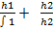 + ………. + …..(3.2)
- 𝞡 Regolith or Overburden thickness H is:
H + h1 + h2 = ………. +h3 ……….. (3.2)
- Resistivity and thickness of aquifer ƿ_{aq} and h_{aq} are usually given by the least values characterizing the particular layer and the associated thickness values for a particular VES point (Bello, Sambo and Makinde, 2005). (Ajayi and Hassan, 1990; Shemery and Osazuwa, 1991). However, is a recent work by Tijani et al (2018), they reported that the thickness of aquifer should be equivalent to the value of overburden thickness, H that is h_{af}= H …..(2.4) and the resistivity of the aquifer should be taken to be equal to the estimated value of the longitudinal resistivity ƿ_{l} given by:
Ƿl = …..(2.5)
We also have the transverse resistivity to be estimated using the expression:
Ƿt = …..(2.6)
Combinations of equations (2.5) and (2.6)
Find the formula for obtaining the value of coefficient of anisotropy λ to be:
λ = = ……(2.7)
0R λ = ……..(2.8)
The reflection coefficient Rc value for a particular VES point is given by the equation:
Rc = 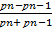 ……(2.9)
Where ƿn is the resistivity of the i-th layer and ƿn-1 is the resistivity of thr layer immediately inderlain by the i-th layer or which overlies the i-th layer.
The resistivity constrast Fc is obtained using:
Fc = ...….. (2.10)
The basement relief or the bedrock relief BR is given by the difference between the elevation of the surveyed area E and the elevation of a particular VES station. i.e:
BF = E -: …. (2.11)
Niwas and Singhal (1981) have established an analytical relationship between aquifer transmissivity and transverse resistance on the hand, and between transmissivity and aquifer longitudinal conductance on the other. From Darcy’s law. The fluid discharge Q is given by:
Q = KIA (2.12)
And the Ohm’s law: J =𝞂E (2.13)
Where K is the hydraulic conductivity, I is the hydraulic gradient, A is the area odf cross-section perpendicular to the direction of flow, J is the current density, E the electrical field intensity and 𝞂 the electrical conductivity ( 𝞂 = 1/ƿ, where ƿ is the resistivity). Taking into account a prism of aquifer material having unit cross-sectional area and thickness h, Niswas and Singhal (1981) combined equations (2.12) and (2.13) to get
Tr = K𝞂T = (2.14)
The transmissivity value Tr of a VES station is given using the DZP as follows:
Tr - Kaq R = K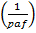 R
Where 𝞂aq = conductivity of aquifer …..(2.15)
Such that 𝞂aq = ……(2.16)
Where K = hydraulic conductivity is obtained using the following mathematical models.
K = …(2.14)
Which according to Singh (2006) and Adepelumi et al (2006) is representative of the nonlinear parametric equation that can be used to determine the hydraulic conductivity of the aquifer for a crystalline rock terrians .
The transmissivity of aquifer Tr is further obtained using:
TR = Khaq orTr = KH …..(2.15)
It has been demonstrated in the past, that T and S are powerful autonomous interpretational aides in groundwater surveys (Zhody, 1974; Henriet, 1976). Aside from defining the aquifer geometry (which the resistivity sounding enable us to do). We can make inferences or transmissivity and aquifer storage on the basis of T and S values, and their distribution in space across the survey area, More details about the sounding curves and their mode of interpretation have been given by Mbazi (1985).
According to Akhter and Hassan (2016), Tr can also be obtained based on the equation:
Tr = 5.26 …..(2.16)
To analyse the groundwater potentials characterizing a crystalline rock are Raji and Abdulkadri (2020) suggested the use of the equation: G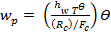
.….(2.17)
Where hw = haq, T= Tr and 𝞡 is porosity which is 0.0075
For the evaluation of the recharge condition of the overburden on the aquifer, Oladapo et al (2008) supported the use of the S. values to evaluate the aq overburden and or aquifer protective capacity as well as the use of the resistivity of the top layer to assess the contamination of the environment on the aquifer using the term called the soil corrosivity, The following tables have been designed for these assessments.
Table 3.1: Evaluation Rating of Overburden and or Aquifer protective Capacity (Oladapo et al 2008)

S/N | Total Longitudinal Unit Conductance, S(mho) | Protective Capacity
1 | >10 | Excellent
2 | 5-10 | Very God
3 | 0.7-4.9 | Good
4 | 0.2-0.69 | Moderate
5 | >0.1 | Weak
6 | < 0.1 | Poor

Table 3.2: Ratings of Soil Corrosivity of a VES Station (Adegoroye, 1996 Idornighie et al. 2008).
S/N | Resistivity of Top Soil, ƿ (Ω.m) | Soil Corrosivity
1 | <10 | Very Strophy Corrosive, VSC
2 | 10 to 60 | Moderately Corrosive, MC
3 | 60 to 80 | Slightly Corrosive, SC
4 | >180 | Practically Non Corrosive, PNC
Table 3.3: Transmissivity range for groundwater potential (Ofodile, 1983)

Range of transmissivity (m² / day) | Designated Potential
>500 | High Potential
50-500 | Moderate Potential
5-50 | Low potential
0.5-5 | Very low potential
<0.5 | Negligible Potential

CHAPTER FOUR

RESULTS AND DISCUSSIONS

4.1 Geophysical Survey
Table 4.1 shows the results of the geographical coordinate of the VES sites surveyed in this work Also, the interpretations of these 6 VES data are presented and discussed in this chapter.
TABLE 4.1: GEOGRAPHICAL DESCRIPTION OF THE VES LOCATIONS/SITES
VES  NO | LATITUDE | LONGITUDE LOCATION
1 | 8.562842⁰N | 4.632130⁰E Front of Chemistry Labs
2 | 8.562386⁰N | 4.632630⁰E Back of Biology Labs
3 | 8.564174⁰N | 4.633930⁰E Front Primary School
4 | 8 .56 4174”N | 4.633930”E Staff Quarters B
5  6 | 8.564602”N  -------------------------------- | 4.636456”E Staff Quarters A  ------------------ Staff Quarters A

4.2 Analyses of the Results of the Interpretations of the Collected VES Data

4.2.1 Lithologic Deductions
By making use of the result of the interpretations of the 6 collected VES data, and presented in Table 4.2, the geo-electric subsurface layers deduced from the study area. As shown in Table 4.2, the interpretation of the geo-electric soundings data acquired in the project area within the main campus of the Kwara State Polytechnic, Ilorin is composed of three to four geo-electric layers namely the top lateritic soil as first layer with resistivity values of 105 to 275 to ohm-m, the lateritic clayey or weathered basement layer with resistivity values ranging from 38.7 to 177Ω.m, the third layer is constituted by clayey weathered bedrock (47.9 to 30,681Ω.m), the fourth lithologic layer is composed of fractured bedrocks with resistivity range values of 525 to 41,351Ω.m and or fresh basement of 30,681 to 85,161Ω.m.
TABLE 4.2: RESULTS OF FIRST ORDER GEO-ELECTRIC PARAMETERS OBTAINED FROM INTERPRETED VES DATA COLLECTED OVER THE STUDY AREA
VES  NO | Number of layers | Resistivity of layers  ∫(Ω. m) | Thickness of  layers  h (m) |  | Depth of layers  d (m) | Curve Type | Inferred Lithology
1 | 1  2  3  4 | 202  1336  107  111943 | 0.5  7.47  10.8  ___ |  | 0.5  7.97  18.8  ____ | KH | Lateritic top soil  Lateritic sand  Weathered bedrock  Fresh basement
2 | 1  2  3  4 | 171  970  47.9  85160 | 0.814  2.8  6.91  ___ |  | 0.814  3.62  10.5  ___ | KH | Lateritic Top soil  Lateritic sand  Weathered bedrock (clayey)  Fresh basement
3 | 1  2  3 | 344  38.7  30681 | 3.05  6.71  ___ |  | 3.05  9.77  ___ | H | Lateritic top soil  Weathered basement (clayey)  Fresh basement
4 | 1  2  3  4 | 144  347  102  41351 | 1.11  0,996  22.2  ____ |  | 1.11  2.11  24.3  ___ | KH | Clayey top soil (Wet)  Lateritic sand  Weathered bedrock  Fresh basement
5 | 1  2  3  4 | 275  136  61.6  938 | 0.978  3.89  9.2  ___ |  | 0.978  4.87  14.1  ____ | QH | Lateritic top soil  Lateritic clay  Clayey weathered bedrock (clayey)  Fractured basement
6 | 1  2  3  4 | 105  3827  177  525 | 0.5  1.09  15  ___ |  | 0.5  1.59  16.6  ____ | KH | Lateritic top soil  Lateritic sand  Basement  Fractured

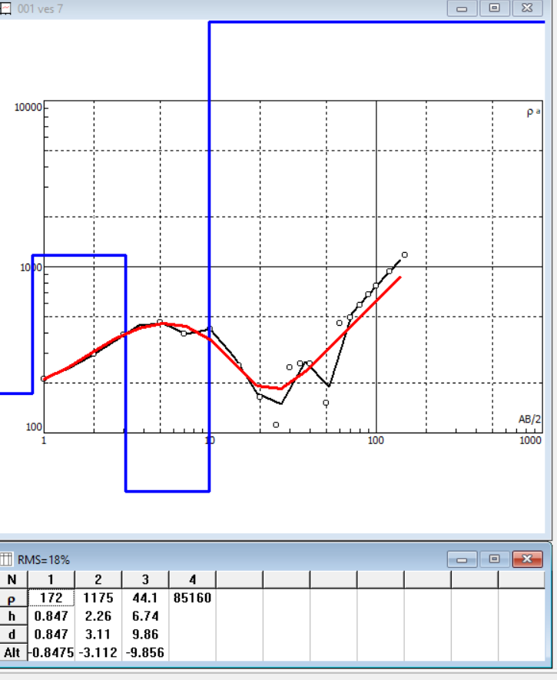
Figure 4.1: Typical Result of Interpretation of the Collected VES 1 Data
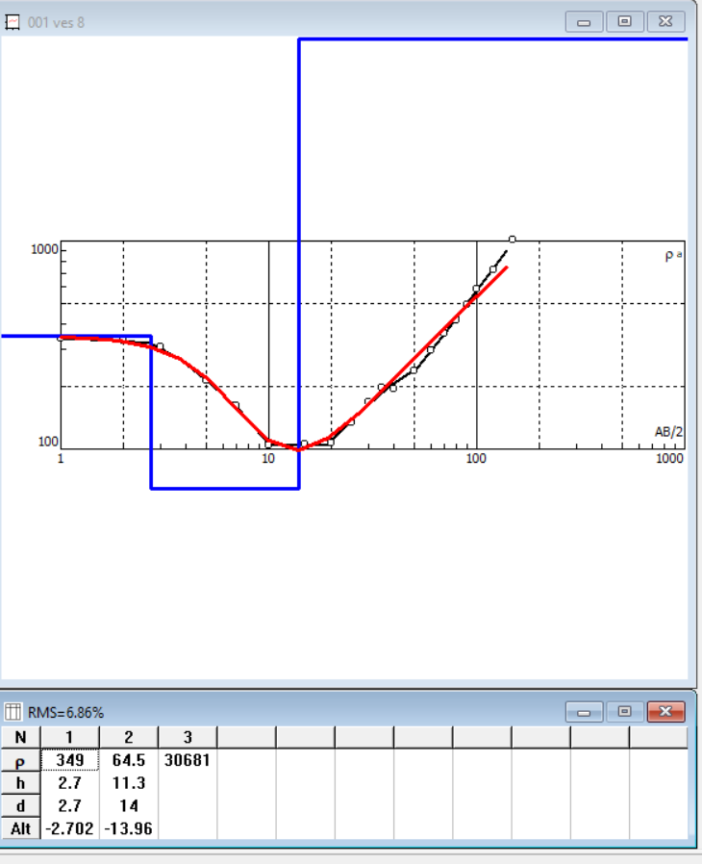
Figure 4.2: Typical Result of Interpretation of the Collected VES 2 Data
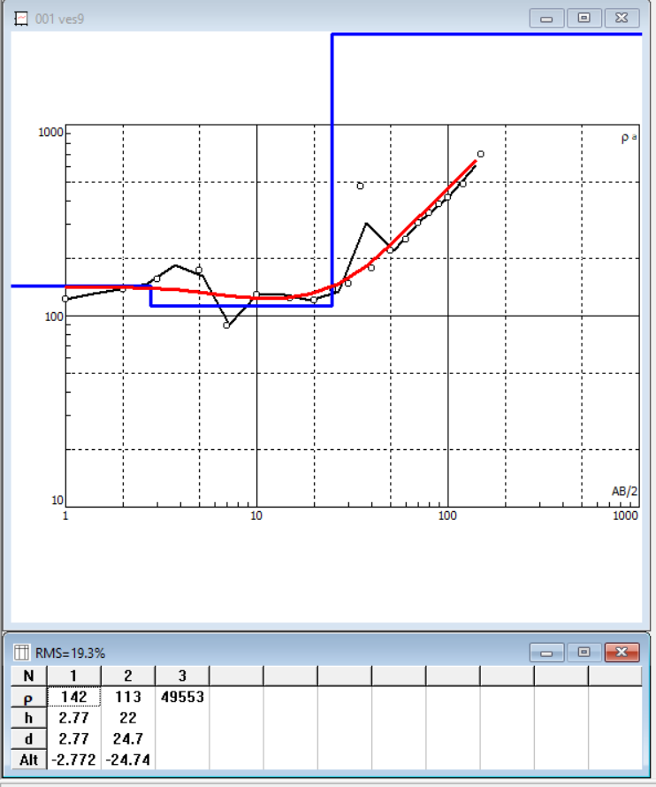
Figure 4.3: Typical Result of Interpretation of the Collected VES 3 Data
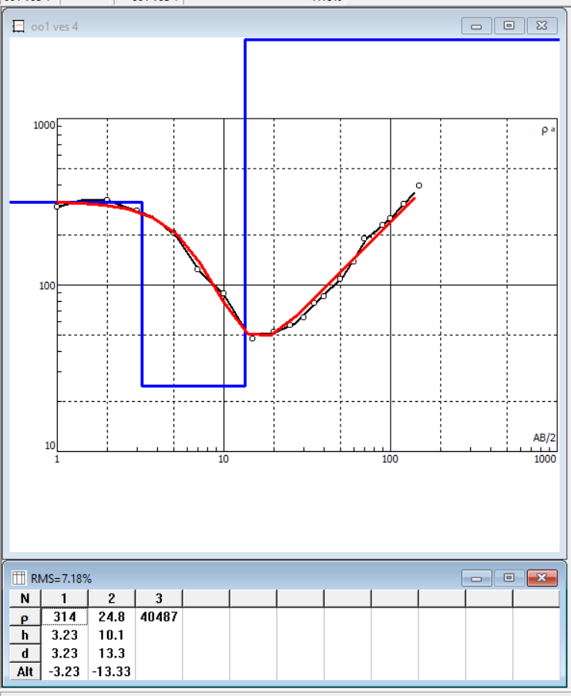
Figure 4.3: Typical Result of Interpretation of the Collected VES 4 Data
Figure 4.4: Typical Result of Interpretation of the Collected VES 5 Data
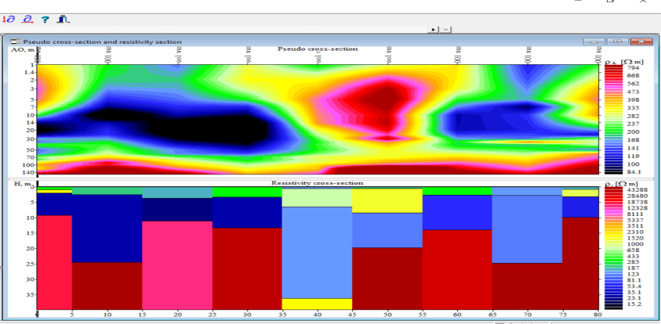
Figure 4.5: Pseudo-section of the Interpreted VES 6 Data

4.2.2 Resistivity Curve Types Obtained in This Work
Table 4.2 reveals that the VES sites or locations are characterized by four KH curve types ⍴₁ < ⍴₂ >⍴₃ < ⍴_{4,} one QH (⍴₁ > ⍴₂ >⍴₃ < ⍴₄ ), one H curve types (⍴₁ >⍴₂ <⍴₃). The curve characteristics and or curve descriptions of these various curve types are shown in table 4.2. The analysis of the curve types shows that about sixty-six point six-seven percent (66.67%) are of the KH curve types. Therefore, the KH curve types are the dominant sounding curves in the study area.

4.3 Geo-electrical Resistivity Parameters.
In this work, second-order geo-electric parameters namely overburden or regolith thickness (H), Resistivity of aquifer, aquifer units, weathered basement thickness and resistivity values, basement relief, resistivity contrast, reflection coefficient, total unit longitudinal conductance, total unit transverse resistance, Dar Zarrouk parameters, and hydraulic conductivity.

4.3.1 Overburden Thickness
The thickness of the overburden H which is also called the regolith thickness is the depth to the last layer, depth to the fresh basement and or the additions of the thickness values of the layers above the fresh or fractured basement. The results obtained are shown in Table 4.3 as part of the estimated values of the second-order geo-electric parameters. The results showed that the values of the overburden thickness range from 9.76m (VES3) to 24.31m (VES 4).

TABLE 4.3: ESTIMATIONS OF SECOND-ORDER GEOELECTRIC PARAMETERS
VES NO | REGOLITH OR OVERBURDEN THICKNESS H(m) | TOTAL UNIT LONGITUDINAL CONDUCTANCE  () | TOTAL UNIT TRANVERSE RESISTANCE  R(Ω.) | TRANVERSE RESISTIVITY  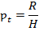 | LONGITUDINAL RESITIVITY  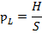 | = | 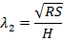
1 | 18.77 | 0.1090 | 11236.52 | 598.643 | 172.202 | 1.8645 | 1.8645
2 | 10.52 | 0.1520 | 3186.183 | 302.754 | 69.237 | 2.0911 | 2.0911
3 | 9.76 | 0.1822 | 1308.877 | 134.106 | 53.568 | 1.5822 | 1.5822
4 | 24.31 | 0.2301 | 2736.555 | 112.588 | 105.632 | 1.0323 | 1.0323
5 | 14.07 | 0.1824 | 1364.71 | 97.008 | 77.552 | 1.1184 | 1.1184
6 | 16.59 | 0.0869 | 6878.93 | 414.643 | 185.156 | 1.4964 | 1.4964

4.3.2 Overburden and or Aquifer Protective Capacity and Soil corrosivity
The values estimated for the total unit conductance, S (mho) obtained using the interpreted VES data results referred to as first-order geo-electric parameters (Table 4.2) have been used to assess the overburden and or aquifer protective capacity as well as soil corrosivity. These parameters are used to rate the infiltration rate of the overburden and their degree of contamination of the groundwater flow to the saturated groundwater zone called aquifer beneath each of the investigated VES sites. Using the ratings presented under Table 3.1 and 3.2. The degree of corrosivity of the aquifer beneath each VES sites using the apparent resistivity values of each VES site. The results of our assessment are presented under Table 4.4 below. The results indicate that most of the VES sites are characterized by mostly weak then moderate and poor overburden protective capacity. On the other hand, all the sites geo-electrically sounded are associated with partially non-corrosive ratings, PNC.
TABLE 4.4: Evaluation of the Rating of the Overburden and or Aquifer Protective Capacity and Soil Corrosivity of the Investigated VES Sites
VES NO | Resistivty of Top Layer ⍴ , | Total Longitudinal Conductance ⍴ (mho) | Overburden and or Aquifer Protective Capacity | Soil Corrosivity
1 | 202 | 0.1090 | Weak | PNC
2 | 171 | 0.1520 | Weak | PNC
3 | 344 | 0.1822 | Moderate | PNC
4 | 114 | 0.2301 | Weak | PNC
5 | 275 | 0.1824 | Moderate | PNC
6 | 105 | 0.0869 | Poor | PNC

4.3.3 Characteristics of the aquifer
In this work, it has been realized that the aquifers under the VES surveyed are constituted by clayey weathered bedrocks and highly fractured bedrock. The resistivity of the aquifer corresponds to the estimated value of the longitudinal resistivity as suggested by Tijani et. al., (2018) and the thickness of the aquifer are equivalent to the overburden thickness and or depth to the last layer (Fractured / fresh basement). The values of both parameters obtained in this project are presented in table 4.5.

Table 4.5 Characteristics of the Aquifer in the Project Area.
VES No | Resistivity of Aquifer of (Ω.m) | Thickness of Aquifer H (m) | Depth of Aquifer d (m) | Type of Aquifer
1 | 107 | 10.8 | 18.77 | Weathered bedrock
2 | 49.9 | 6.91 | 10.52 | Clayey Weathered bedrock
3 | 38.7 | 6.71 | 9.76 | Clayey Weathered bedrock
4 | 102 | 22.2 | 24.30 | Weathered bedrock
5 | 61.6 | 9.2 | 14.10 | Clayey Weathered bedrock
6 | 177 | 15 | 16.60 | Weathered / Fractured bedrock
4.3.4 Estimation of the Hydraulic Properties.
Table 4.6 below presents the values of estimations of the hydraulic conductivity and transmissivity of the aquifer associated with the project area. The hydraulic conductivity value was obtained
Table 4.6: Estimated Values of Hydraulic Conductivity and Transmissivity of Aquifer
VES | 𝝳aq | Ke | Ke𝝳aq | R | Ke𝝳aq R
1 | 0.00581 | 0.18570 | 0.00107 | 11236.520 | 12.0841
2 | 0.01444 | 0.08860 | 0.00128 | 3186.183 | 4.0764
3 | 0.01866 | 0.0791 | 0.00148 | 1308.871 | 1.9319
4 | 0.00947 | 0.1151 | 0.00677 | 2736.555 | 18.5319
5 | 0.01289 | 0.0940 | 0.00121 | 1364.710 | 1.6536
6 | 0.00540 | 0.2041 | 0.00110 | 6878.930 | 7.5815

4.4 Estimation of Hydraulic conductivity and transmissivity values.
The values of hydraulic conductivity characteristics on aquifer in bettr determined using pumping test data of a drilled borehole. However, it has been realized that these tests are usually not carried out by borehole drillers because most of the managers have been found not to be geologists, hydro geologists, hydrologogists or geologists. Moreover, these tasks have been found to be relatively expensive to be conducted as post-drilling or borehole endeavors. For these reasons, hydro geologists have usually resorted to the use of various mathematical models and interpreted VES.
Table 4.7 Estimated of Hydraulic conductivity and transmissivity using DZP and mathematical method of Singhal (2016)
VES | 𝝳aq | Ke | Ke𝝳aq | R | Ke𝝳aq R
1 | 0.00581 | 0.18590 | 0.00107 | 11236.520 | 12.0841
2 | 0.01444 | 0.08860 | 0.00128 | 3186.183 | 4.0764
3 | 0.01866 | 0. | 0.00148 | 1308.871 | 1.9319
4 | 0.00947 | 0.13899 | 0.00677 | 2736.555 | 18.5319
5 | 0.01289 | 0.13899 | 0.00121 | 1364.710 | 1.6536
6 | 0.00540 | 0.13899 | 0.00110 | 6878.930 | 7.5815
The expression: T = Ke H ……………………………(4.2)
Where K 0.0538e
The results obtained as shown in Table 4.7 revealed that the hydraulic conductivity and transmissivity values estimated for the VES sites investigated are highly varied. In table 4.8 below, the values of K_{p} are based on the use of pumping test data of Sule et. al., (2013), and Okunlola et. al., (2016) which resulted in the use of average value of hydraulic conductivity K_{p} = 49.1m/day.
Table 4.8: Estimation of transmissivity of aquifer using VES geologic (Sule et. al., 2013) and Interpreted VES data
VES | Conductivity of Aquifer 𝝳aq (Ωm)⁻¹ | Ke𝝳aq | Total Transwork unit resistance R (Ωm²) | Tr  Kp 𝝳aq R | Ke𝝳aq R
1 | 0.00581 | 0.28525 | 11236.520 | 11236.520 | 3205.2173
2 | 0.01444 | 0.07929 | 3186.183 | 3186.183 | 2259.9277
3 | 0.01866 | 0.91658 | 1308.877 | 1308.871 | 1199.6905
4 | 0.00947 | 0.46517 | 2736.55 | 2736.555 | 1272.9633
5 | 0.01289 | 0.63316 | 0.00121 | 1364.710 | 864.0798
6 | 0.00540 | 0.26525 | 0.00110 | 6878.930 | 1824.6362
4.6: Assessment of the groundwater potentials of the projects Area.
Table 4.2 to 4.8 revealed that the aquifers in this project area are constituted by weathered and fractured bedrock. The total unit longitudinal conductivity values (see table 4.3) suggest that the aquifers are elongery.
Table 4.10 revealed that the based on the inefficient of omissilogy values, the bedrocks are highly fractured beneath VES 7,8,9 slightly fractured and VES 11 and very poorly fractured at VES 12. Also based in the ratings of Offodile (1983), the groundwater potentials in the project area are constituted by very poor groundwater potentials. Furthermore, Wasiu and Abdulkadri suggested that the groundwater potential in crystalline rock torran as exist in the study area can be rated using the expression:
GW_{P} = H(T)
( ) ………………………….. (4.3)

Where GW_{p} = groundwater potential
H = thickness of aquifer
T = transmissivity value
Rc = reflection coefficient
And Fc = resistivity of or fracture constract
By using the resuls presented in appropriate tables obtained in this work, the results obtained are presented in Table 4.8.
Table 4.9: Estimated Values of the Reflection Coefficient, resistivity coefficient
VES NO | Reflection Coefficient, Rc | Resistivity or Fracture Contrast, Fc | Resistivity Coefficient and Coefficient of Anisotropy, λ
1 | 0.9981 | 1046.1963 | 1.865
2 | 0.9989 | 1777.8706 | 2.091
3 | 0.9975 | 992.7907 | 1.582
4 | 0.9951 | 405.4019 | 1.032
5 | 0.8768 | 15.2273 | 1.118
6 | 0.5781 | 2.9661 | 1.496

Table 4.10: Estimated values of Groundwater potentials
VES NO. | Groundwater Potentials (GW_{p})
1 | 2.0915
2 | 33.5484
3 | 28.2299
4 | 3.5879
5 | 2.6096
6 | 2.6505

CHAPTER FIVE
CONCLUSION AND RECOMMENDATION
5.1 Conclusion
In this project we have been able to successfully carry out detailed three day period. Geophysical survey in parts of the Kwara State Polytechnic, Ilorin.Main campus at Kilometre 10 off the old Ilorin-Jebba Trunk A Road.
The following conclusions can be drawn from the analyses of the collected VES data:
- it has been realized that the VES geophysical technique is an easy and rapid method of acquiring geophysical data.
- The interpretation of the collected VES data was analyzed to be underlain by three to five (3-4) geoelectric layers and thus 3 to 4lithologic unit and lateritic top soil (resistivity range of 126 to 297ohm.mm, Laterite/ Lateritic sand/ Lateritic Clay/ Weathered basement (29.1 to 1789Ω.m); Weathered basement/ fractured basement/ Fresh basement (28 to 84,022Ω.m), Fracutred basement/ Fresh basement (22.3 to 1687Ω.m) and fresh basement (1,687 to 18,677Ω.m).
- The clayey weathered basement and fractured basement were found to form the confined and semi-confined aquifers.
- The resistivity values and thickness values of the aquifers characterizing the project area 38.7 to171Ω.m and 6.71 to 15.00m respectively.
- The curve types associated with the uninvestigated area are KH (ƿ1<ƿ2>ƿ3<ƿ4) at VES,7,8,10,12, H (ƿ1>ƿ2<ƿ3) at VES2 and QH (ƿ1<ƿ2>ƿ3>ƿ4<ƿ5) obtained at VES 11 and VES5. These suggests that the aquifers are characterized by underately resistive groundwater productive zones. Also these curve types indicate that overburden are somewhat and characterized by loose unconsolidated geologic formations.
- The overburden capacity associated with the VES locations are moderate value the soil corrosivity are partially non corrosive
- The hydraulic conductivity values were estimated to be 0.0692 to 0.2058m/day and the transmisivity value ranges from 0.0340 to 10.629m²/day.
- The VES site located in IAS village was suggested to be characterized by the most productive groundwater aquifer.
5.2 Recommendations
It is recommended that future geophysical works should be extended to other parts of kwara State Polytechnic, Ilorin, in order to be able to profer solutions to the scarcity of water in this region.

REFERENCES
Adekunle, S. M., Adeoti, l., and Olasehinde, P.l.(2016):Geophysical Investigation of Groundwater potential of basement complex terrains using Audiomagnetotellurics (AMT) METHOD. Journal of African forth sciences, 114:125-139.
Adekunle, L.M., Adejumobi, M.A and Oyedele, K.F. (2018): Hydro geological characteristic of Basement couple Tertin :A case study of ogun state,Nigeria journal of African earth science,141;121-129
Aderogba, K. A. , Okesehinde, p.I, and Geophysical Investigation of basemen complex terrain: A case study of ondo state, Nigeria. Journal African earth science, 167: 1-10.
Ajani ,O. O., Olutona, G.O., Adeniyi, A.A.(2012):Empirical study of the Groundwater potential (overburden protection capacity ) and water Quality using the technical Resistivity method and a PG990 spectrometer Around Obafemi Awolowo University dumpsite, south western uiperic Iremien (Iranica) Journal of frorgy and Environment, 12(4): 358-366 Doi:5829/ ijeea. 2021.12.04.09.
Ajibade A.C (1976): Provisional classification and correlation of the schist belt in Northern Nigeria. Geology of Nigeria 9Edited by kogbe, C. A. ), Elizabethan pub. Co., lagos, pp. 85-90.
Ako, A.A., Ngatchoni, H.N., Nden, J.R. and Nkouathio, D.G. (2016): Gaxeletric Investigation for groundwater potential Evaluation in the North Region of Cameron. Journal of Africal forth sciences 114:112- 121.
Alisiobi, A.R and Ako, R.D. (2012): groundwater Investigation data complied Geophysical methods. Printe presentation at AAPG Convention and Exhibition, long beach, California April 22-25, 2012.
Bello, A.M.A and Makinde, V.A.(2005): Resistivity data compiled over the crystalline Basement and the Sedimentary Terrains of the West-Central part of Nigeria. Zuma Journal of pure and applied science, volume7, number2, pp140-143.
Bello, A.M.A and Makinde, V.A.(2007a): Typical Resistivity curve Types Associated with Geo-electric structures in the west-central part of Nigeria and their Importance.
Bello, A.M.A and Makinde, V.A.(2007b):Consumption patterns of water and domestic sate. Nigeria. Unpublished Report.
Bello, A.M.A and Makinde, V.A.(2014):Determination of Dar Zarrouk parameter from collected VES Data for groundwater studies in West-centre part of Nigeria Geological Terrain (Ilorin Area), (In press).
Bello, Abdulmajeed A. and Makinde, victor A. (2009):Declination of the aquifer in the South-Western part of the Nupe Basin, Kwara state, Nigeria academia Arena, volume 1, Number 3, pp38-46
Caruthers R.M. (1985): Review of geophysical Techniques for groundwater Exploration in Crystalline Basement Terrain. British Geophysical survey. Natural Environment Research council, Nottingham United Kingdom, Report RGRG 85/3.
Idornigie, A.I. and Olorunfemi, M.O. (1992): A Geoelectrical Mapping of Basement structure of the south-central park of the Bida Basin and its Hydrogeological
Oladapo, M.I., Ojo, J.S., Adekoye, A.D., Adegbola, R.A. and Awoyeni, m.o.(2019):Magnetotelloric Investigation of groundwater potential in part of Southwestern Nigeria . Arosian Journal of gasscinces, 12(14), 416. Lttps :// dvi.org / 10.1007/512517019-4659-2.

