CONSTRUCTION AND PERFORMANCE TESTS OF SOLAR POWER BANK

BY: GROUP 1

AKINOLA RACHAEL OMOWUNMI ND/23/SLT/PT/0002
ADEDEJI OYINDAMOLA KAOSARA ND/23/SLT/PT/0016
LAWAL HAMIDAT KEHINDE ND/23/SLT/PT/0033
AYENI SAIDAT GBEMISOLA ND/23/SLT/PT/0054
ABDULKAREEM KAMALDEEN OLADIPUPO ND/23/SLT/PT/0127
ATANDA MUFAIDAT PRECIOUS ND/23/SLT/PT/0160
AMUSAN OLUWABUKOLA ND/23/SLT/PT/0717

A PROJECT SUBMITTED TO THE DEPARTMENT OF SCIENCE LABORATORY TECHNOLOGY (PHYSICS & ELECTRONICS UNITS) INSTITUTE OF APPLIED SCIENCES, KWARA STATE POLYTECHNIC, ILORIN NIGERIA.

IN PARTIAL FULFILLMENT OF THE REQUIREMENT FOR THE AWARD OF NATIONAL DIPLOMA IN SCIENCE LABORATORY TECHNOLOGY.

SEPTEMBER, 2025
CERTIFICATION PAGE
This is to certify that the project work was carried out and reported in the department of Science Laboratory Technology [SLT] Institute of Applied science [IAS] and has been read and approved as meeting the requirement for the award of National Diploma [ND].

_________________________ _______________________
Mr. BELLO A.M.A DATE
(Project Supervisor)

________________________ _______________________
MR. LUKMAN I.A DATE
(SLT PT Coordinator)
________________________ _______________________
Dr. USMAN ABDULKAREEM DATE
(H.O.D. SLT)

________________________ ________________________
EXTERNAL EXAMINER DATE

DEDICATION
I wholeheartedly dedicate this project to the Almighty God, whose grace, mercy, and guidance have sustained me through every challenge and triumph along this academic journey.
This work is most especially dedicated to the loving memory of my late father, Mr. Saliu -a pillar of strength, wisdom, and sacrifice. Your unwavering support, deep values, and the life you lived continue to inspire me. Though you are no longer physically present, your spirit remains my driving force. Every milestone I reach is a reflection of your dreams, prayers, and the love you so freely gave.
May your soul continue to rest in perfect peace.

ACKNOWLEDGMENTS
First and foremost, I give all glory and thanks to Almighty God for His continuous grace, strength, and protection throughout this journey. I sincerely appreciate my supervisor, Mr. Bello, for his support, valuable guidance, and encouragement throughout the course of this project.
My heartfelt gratitude goes mostly to my dear sister, Saliu Bidemi, for her unwavering support, understanding, and motivation. I also wish to thank her husband, Mr. Yusuf, for his kindness and assistance.
Most especially, I am deeply grateful to my beloved parents, Mr. and Mrs. Saliu, and my entire family for their endless prayers, love, and sacrifices that have brought me this far.
Lastly, I would like to acknowledge a very special friend who has stood by me like family - Iliyas. Your presence, support, and encouragement have meant a great deal to me.

TABLE OF CONTENTS
Title Page…………………………………………………………………,,,,,,……... i
Certification………………………………………..………………………............... ii
Dedication……………….……………………………..…………………………..…iii
Acknowledgement……………………………………..……………………….…….iv
Table of Contents ……………………………………………………………………. v
Abstract ……………………………………………………...…………………...… vii
CHAPTER ONE: INTRODUCTION
1.1 Background information
1.2.1 Aim
1.2.2 Objectives
1.3 Statement of the Research Project
1.4 Justification of the Project
CHAPTER TWO: LITERATURE REVIEW
2.1 Overview
CHAPTER THREE: MATERIAL AND METHOD
3.1 Solar Panel
CHAPTER FOUR: RESULT
4.1 Overview
4.2 Material Used
4.3 Produce Used
4.4 Modules Data Sheet
1.5 Results

Chapter five: Summary, Conclusion and Recommendations
5.1 Summary
5.2 Conclusion
5.3 Recommendations

ABSTRACT
This project focuses on the construction and performance testing of a solar power bank, a portable device that stores solar energy and provides power to electronic devices. The primary objective is to create an efficient and environmentally friendly backup power solution using solar energy. The project involved selecting appropriate components such as a solar panel, lithium-ion battery, charge controller, and USB output module. The constructed solar power bank was tested for its charging and discharging efficiency, as well as its ability to power mobile devices. The results demonstrated the potential of renewable energy in everyday applications, promoting sustainability and energy independence.

CHAPTER ONE
1.1 Background Information
Today we are living in the world of renewable energy and portable power solutions. In this era we rely heavily on electronic devices continues to grow, they services and to provide us basic services of comforts using fans, air-conditioners, touch-lights, refrigerators, electric bulbs, GSM phones, laptops, computers etc. they becomes essential to find sustainable and efficient ways to keep them charged on the go. This is where the revolutionary concept of a solar-powered power bank comes into play. A solar-powered power bank combines the convenience of a portable charging device with the eco-friendly benefits of harnessing solar energy. It offers a reliable and renewable source of power, allowing you to charge your devices anytime, anywhere, while reducing your carbon footprints. [1-6] solar-powered power bank combines the convenience of a portable charging device with the eco-friendly benefits harnessing solar energy. It offers a reliable and renewable source of power, allowing us to charge our devices anytime, many where, while reducing our carbon footprint.
Unlike traditional power banks that rely solely on electrical outlets or batteries for charging, a solar-powered power bank utilizes photovoltaic cells to convert sunlight into electricity. The photostheric bulbs are over cells usually called solar cells
These solar cells are strategically integrated into the power bank, capturing solar energy and storing it in its internal battery for later use. Moreover, a solar-powered power bank serves as a sustainable alternative, reducing our dependence on conventional energy sources and minimizing the environmental impact associated with fossil fuel-based power generation. By utilizing renewable solar energy, we contribute to the global shift towards cleaner and greener energy solutions. One of the remarkable advantages of a solar-powered power bank is its versatility. Whether you are hiking in the wilderness, camping under the stars, or simply spending time outdoors, you can harness the power of the sun to charge your smartphones, tablets, cameras, and other Universal Serial Bus compatible devices. It offers a portable energy solution that is not bound by traditional power sources
In this project, we have undertaken the development of a cutting-edge solar-powered power bank, aiming to combine efficiency, durability, and user-friendliness. We have incorporated advanced solar cell technology, optimized charging algorithms, and high-capacity battery storage to ensure reliable and rapid charging even in challenging conditions. Our objective is to provide you with a portable power solution that not only meets your daily charging needs but also aligns with your commitment to sustainability.
1.2 Aim and Objectives of the project
1.2.1 Aim
The primary aim of the project was to design and construct a sample device called solar power bank that can allow solar energy to charge itself and provide reliable electrical energy that can charge a GSM Mobile phone
1.2.2 Objective
In view of the stated aim , the specific objectives of this project are to ;
- Review the basic problems associated with the performance of a Global system of mobile, GSM handset.
- Find out various means of charging a run-down GSM handset. Design and construction a simple easy-to -use and lost effective device called power bank that can make use of renewable energy called solar energy to provide electrical energy required to charge a GSM handset.
- Carry out performance tests of the locally constructed solar power bank in the laboratory using measuring devices such as multimeters, manometer and energy from the sun.
- Use the results obtained to evaluate the effectiveness and efficiency to the constructed device
- Possibly provide a sill of quality required to justify the lost-effectiveness of the locally constructed power bank vit-an vit an important similar device.
1.3 Statement of the Research Problem
The objectives of a solar-powered power bank project can vary depending on specific needs and goals. However, here are some common objectives for a solar-powered power bank
- Portable and Convenient Charging : the primary objective is to create a power bank that is portable , lightweight and easy to carry allowing users to charge their electronic device while on the move.
- Haress Solar Energy: The project aims to effectively capture solar energy through high-quality solar panels or photovoltaic cells integrated into the power bank. The objective is to maximize energy conversion and optimize solar charging efficiency.
- Energy Storage and Power Capacity: The project aims to design a power bank with adequate energy storage capacity, ensuring it can store sufficient power generated from solar energy.Fast and Efficient Charging: The project focuses on developing efficient charging circuits and algorithms that allow the
power bank to deliver fast and consistent charging to connected devices. The objective is to provide comparable charging speeds to conventional power banks, despite relying partially on solar energy. Durability and Robustness: The project aims to create a durable and robust power bank that can withstand outdoor conditions, including exposure to sunlight, moisture, and physical impacts.
User-Friendly Features: The objective is to incorporate user-friendly features such as LED indicators to display the power bank's charging status and remaining power, multiple charging ports to accommodate various devices, and potentially additional functionalities like built-in flashlights or wireless charging capabilities.
Environmental Sustainability: One of the primary objectives of a solar-powered power bank project is to promote environmental sustainability. By utilizing solar energy as a renewable power source, the project contributes to reducing carbon emissions, dependence on fossil fuels, and overall environmental impact.
1.4 Justification of the project
The conventional electricity supplies by the power holding companies of Nigeria,PHCNs are not reliable and very expensive. In view of there facts ,there are needs to device alternatives means of supplying electrical energy to power such necessary devices as a power bank required to charge GSM handsets.

CHAPTER TWO
LITERATURE REVIEW
2.1 Overview
The working principle of a solar-powered power bank involves several steps to convert solar energy into electrical energy and store it in the power bank's battery. The solar panel, which consists of photovoltaic (PV) cells, absorbs sunlight and converts it into direct current (DC) electrical energy. The PV cells contain semiconductor materials that create an electric field when exposed to sunlight. The DC electrical energy generated by the solar panel needs to be converted to a suitable voltage and current to charge the power bank's battery.
This is achieved through a charging circuit or charge controller. The charging circuit regulates the voltage and current, ensuring proper charging and preventing overcharging or damage to the battery. The charging circuit connects the solar panel to the power bank's battery. It controls the flow of electrical energy from the solar panel to the battery, enabling the battery to charge.
The charging circuit monitors the battery's voltage and current levels, adjusting the charging process accordingly. The battery stores the electrical energy received from the solar panel during charging. It is usually a rechargeable lithium-io or lithium-polymer battery. The battery's capacity determines how much energy it can store, measured in milliampere-hours (mAh). When you connect a device to the solar-powered power bank. the stored energy in the battery can be used to charge the device. The power management circuit in the power bank regulates the power flow from the battery to the device, ensuring a stable and safe charging process When the power bank is exposed to sunlight, the solar panel continues to harvest solar Simultaneously the charging circuit monitors the battery's charge level. If the battery ill charged, the solar panel supplies additional energy to continue charging the replenishing the power bank's energy reserves. It's important to note that the company of the solar-powered power bank depends on factors such as the solar panel's efficiency, the charging circuit's performance, and the battery's capacity.
Future scope.
The future scope of solar-powered power banks holds significant potential for advancements and improvements. Advancements in solar cell technologies, such as multi-junction cells, perovskite solar cells, and organic solar cells, may lead to higher conversion efficiencies, allowing power banks to charge more effectively and in shorter durations. The development of flexible and transparent solar panels opens up new possibilities for integrating solar cells into various surfaces. Imagine power banks with solar panels integrated into backpacks, windows, or even wearable devices, allowing for seamless solar energy harvesting on the go. As battery technologies continue to evolve, we can expect higher energy densities, faster charging capabilities, and longer battery lifetimes. Future power banks may incorporate Internet of Things (loT) connectivity and smart features. This integration could enable remote monitoring and control of the power bank's charging status, battery level, and energy consumption through mobile apps or smart home systems. Solar-powered power banks could be designed to accept power input from multiple sources, including solar, USB, and wireless charging. Future power banks may incorporate advanced energy management systems that optimize the energy flow between the solar panel, battery, and connected devices. These systems would intelligently distribute the available energy to maximize device charging efficiency and prolong battery life. With the increasing adoption of renewable energy sources and smart grids, solar-powered power banks could potentially connect to the energy grid
to share excess energy or participate in demand response programs. It's important to note that these possibilities represent potential directions for future development in the field of solar-powered power banks. As technology advances, we can expect to see innovations and improvements that further enhance the performance, usability, and sustainability of these devices systems would intelligently distribute the available energy to maximize device charging efficiency and prolong battery life. With the increasing adoption of renewable energy sources it grids, solar-powered power banks could potentially connect to the energy grid to essentially energy or participate in demand response programs, important to note that these possibilities represent potential directions for future development in the field of solar-powered power banks. As technology advances, we can expect to see innovations and improvements that further enhance the performance, usability, and sustainability of these devices.

CHAPTER THREE
3.0 MATERIALS AND METHODS
I. Solar Panel- The solar panel (Fig.1) is a crucial component of a solar-powered power bank as it captures solar energy and converts it into electrical energy. Higher efficiency panels can generate more power from the same amount of sunlight. It is important to select solar panels with a good balance of efficiency and cost. The power output of a solar panel is measured in watts (W) and indicates the maximum electrical power it can generate under specific conditions. The power output depends on factors such as the size of the panel, the efficiency of the cells, and the intensity of sunlight. Check the voltage and current ratings of the solar panel to ensure compatibility with your power bank's charging circuitry. Make sure the panel's output matches the input requirements of your power bank’s charging circuit . Lithium Batteries:-Lithium batteries (Fig.2)are widely used in solar-powered power banks due to their high energy density, long lifespan, and lightweight nature. There are two common types of lithium batteries used in power banks. Li-ion batteries [2000 mAh x 4 = 8000 mAh] are more prevalent and offer good energy density, while Li-Po batteries provide flexibility in terms of shape and size due to their pouch-like structure.
The capacity of the lithium battery determines how much energy it can store and deliver to charge electronic devices. It is measured in milliampere-hours (mAh) or watt-hours (Wh).
Higher capacity batteries can provide more charging cycles or charge multiple devices before requiring recharging. Lithium batteries typically have a nominal voltage of 3.7 volts per cell. Depending on the power bank's requirements, multiple cells may be connected in series or parallel to achieve the desired voltage and capacity. Lithium batteries offer high charging and
discharging efficiency, allowing for effective energy transfer between the battery and connected devices. The physical dimensions and weight of the lithium battery should align with the size and portability requirements of the power bank.
Compact and lightweight batteries are desirable for enhancing the portability and usability of the power bank. It is crucial to handle and use lithium batteries according t the manufacturer's guidelines to prevent any potential hazards and maximize their lifespan . Power Bank Module:-The power bank module (Fig.3) is a crucial component that integrates and manages the charging and discharging processes in a solar-powered power bank. Power bank module includes a charging circuit that regulates the charging process of the battery. It ensures efficient and safe charging by monitoring the incoming power from the solar panels and controlling the charging rate to prevent overcharging. The power bank module should be designed to maximize the charging efficiency and conversion rate from solar energy to electrical energy. This ensures that the power bank optimally utilizes the available solar power and delivers efficient charging to the connected devices. The power bank module also incorporates a discharging circuit that regulates the power flow from the battery to the connected devices. It ensures that the power output is stable and compatible with the charging requirements of various electronic devices. The power bank module also incorporates a discharging circuit that regulates the power flow from the battery to the connected devices. It ensures that the power output is stable and compatible with the charging requirements of various electronic devices. The power bank module typically includes a voltage regulation mechanism to stabilize the output voltage. This ensures that the power bank delivers a consistent and reliable voltage level to the connected devices, protecting them from voltage fluctuations. The power bank module features USB ports or connectors through which the devices are connected for charging. It may include multiple USB ports to accommodate different devices simultaneously. The power bank module incorporates various protection mechanisms to ensure the safety of the power bank and the connected devices. These may include over current protection, overvoltage protection, short-circuit protection, and temperature protection. Many power bank modules have LED indicators that display the charging status, remaining battery capacity, and other relevant information. The power bank module is typically implemented on a printed circuit board (PCB). The PCB hosts the various electronic components, including the charging and discharging circuits, voltage regulation components, and protection mechanisms. When selecting a power bank module, it is important to consider its compatibility with the solar panel , battery , and other components of the power bank . Wires:- Wires (Fig.4) play a crucial role in connecting and transmitting electrical signals between various components in a solar-powered power bank. There are different types of wires used in power banks, such as copper wires or tinned copper wires. Copper wires are known for their excellent electrical conductivity, making them a common choice for power transmission. The wire gauge or thickness determines its current-carrying capacity.
Thicker wires have lower resistance and can handle higher current loads. The wire gauge should be chosen based on the maximum current requirements of the power bank and the connected devices. The wiring configuration depends on the power bank's design and the specific requirements of the components. The wires connect the solar panels, battery, charge controller,
USB ports, and other electronic components in the power bank, ensuring proper electrical connections and power flow. The length of the wires should be determined based on the physical layout of the power bank and the distance between components. It is important to use high-quality wires that are durable and capable of withstanding the demands of the power bank's operation. Reliable and durable wires contribute to the overall performance and longevity of the power bank. Strain relief mechanisms, such as cable ties or grommets, can be used to secure and protect the wires from excessive bending,pulling, or strain. This helps prevent wire damage and ensures long-term reliability. When working with wires, it is crucial to follow proper wiring techniques and adhere to safety guidelines to minimize the risk of electrical hazards. Cardboard:-
Cardboard is used in the outer construction of a solar-powered power bank. It used for packaging the power bank components during transportation or storage. It provides protection against physical damage and helps keep the components organized. In some cases, cardboard can be used as a material to create a prototype enclosure for the power bank. This allows for a low-cost and quick way to visualize the size, shape, and overall design of the power bank before manufacturing a more durable enclosure. Cardboard can provide some level of thermal insulation, which may be useful in certain scenarios to protect the power bank components from extreme temperatures or to mitigate heat dissipation issues. Cardboard is a recyclable and biodegradable material, making it an environmentally friendly choice Circuit Connections.
The circuit connections (Fig.5) of a solar-powered power bank can vary depending on the specific design and components used. The positive (+) and negative (-) terminals of the solar panels are connected to the corresponding terminals of the charge controller. This connection allows the solar panels to supply the generated solar energy to the power bank's charging system. The charge controller manages the flow of energy from the solar panels to the battery, ensuring efficient and safe charging and protects the battery from overcharging. It is connected to the battery's positive (+) and negative (-) terminals. The positive (+) and negative (-) terminals of the battery are connected to the charge controller. This connection allows the battery to receive power from the solar panels through the charge controller for storage. The power bank module is responsible for managing the charging and discharging processes. It is connected to the battery's positive (+) and negative (-) terminals. The power bank module regulates the power flow from the battery to the connected devices through it USB ports. The USB ports of the power bank module are connected to the power bank's circuitry. These ports allow the connection of electronic devices for charging. The USB ports deliver power from the battery to the devices through appropriate circuitry, ensuring compatibility and safe charging. If the power bank has LED indicators to display charging status and battery capacity, they are connected to the power bank module's circuitry. The LED indicators receive signals from the power bank module to indicate the charging status and remaining battery capacity. The circuit connections should be made with proper wire gauges, ensuring secure and reliable connections. Additionally, attention should be given to proper insulation and protection of the wiring to prevent short circuit of electrical hazards.

CHAPTER FOUR
RESULTS AND DISCUSSIONS
4.1 : Overview
In this project, we have constructed a power bank device which can be used to electrify and charge a global system of mobile, GSM handset whose battery may run down. The electrification and charging are expected to be done using electrical energy provided by sunlight, sun energy or solar energy.
The material use to construct this device and the performance tests carried out in this locally constructed power bank are presented in this chapter.
The performance taken while carring out the test in the laboratory.
4.2. Materials Used
The components used are:
1. Solar panel
2. Charge controller
3. Rechargeable battery
4. Voltage regulator
5. Input and output components such as interpreted power supplier system, resistors, capacitors, inductors, operational amplifiers and differential amplifiers.
4.3 Performance Tests
The locally constructed power bank which is rated 100mA was tested and the following findings were observed:
- it takes the power bank to be fully charged using 1.5kw solar panelwith ratings of 1.5w, 273A, 5.5v about 48 hours to be fully charged from 1% to 100% solar panel exposed to adequate sunlight to provide solar energy.
- It was found out that for every 30 minutes of exposure of solar sunlight to charge the power bank, an android GSM handset increases its DC energy by about 1.5%. this means it could take about 70 hours to fully charge a GSM android phone from about 1% to 100% full charge.
4.3.1 Procedures Used
1. We use a digital multimeter to connect across the USB output terminals to measure output voltage.
2. No load 4.5v-5v
3. On load 4.0v
4. The More on load on it ,the voltage decreases voltage.
After the construction of the solar power bank we noticed by charging the bar by each blink 1st bar 2.56v -366v with digital multimeter 2 nd bar -3.85v that how we test it to the last bar.
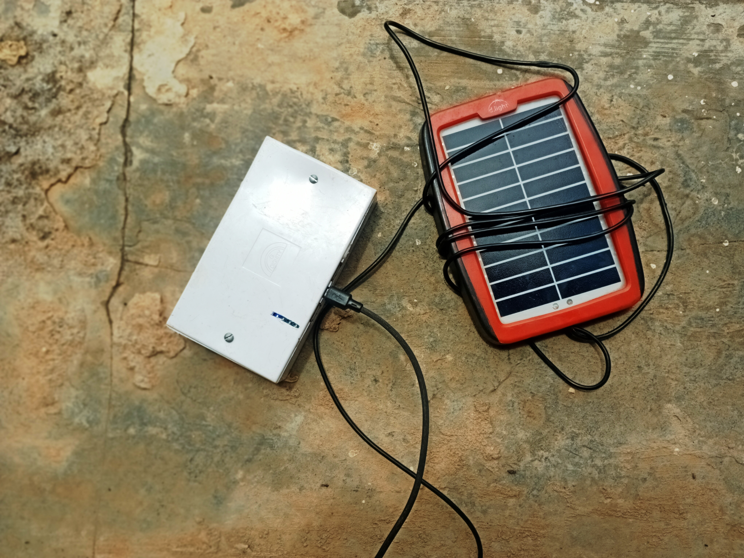
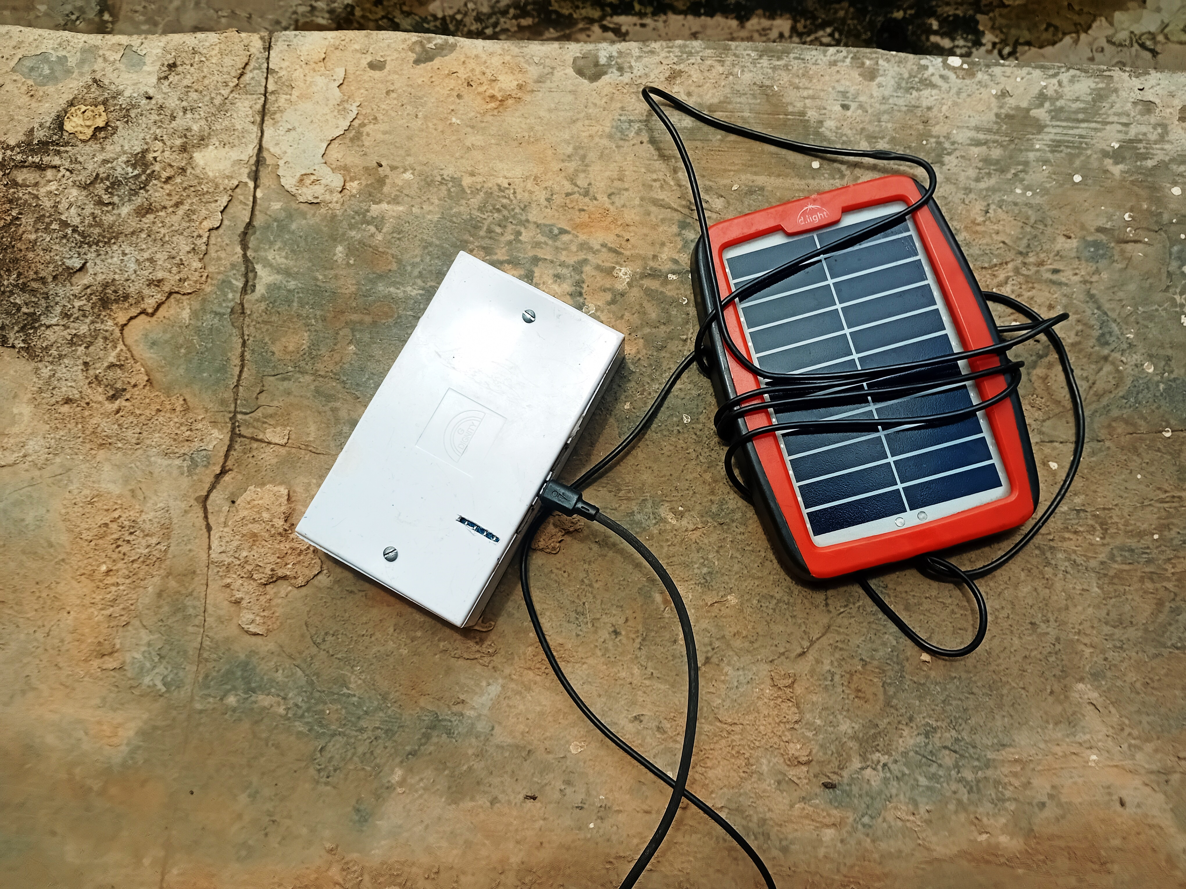

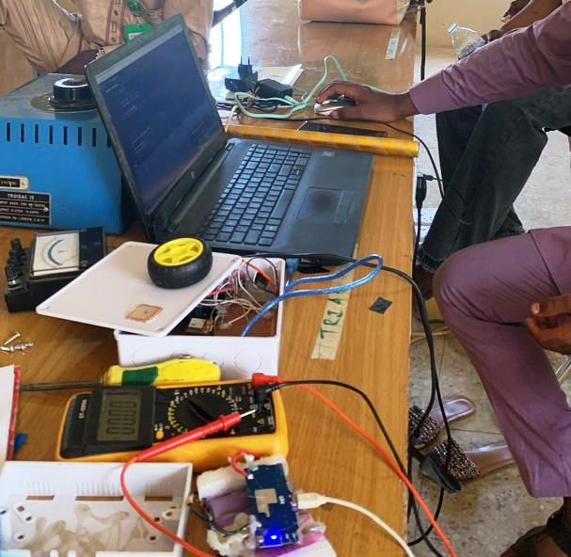

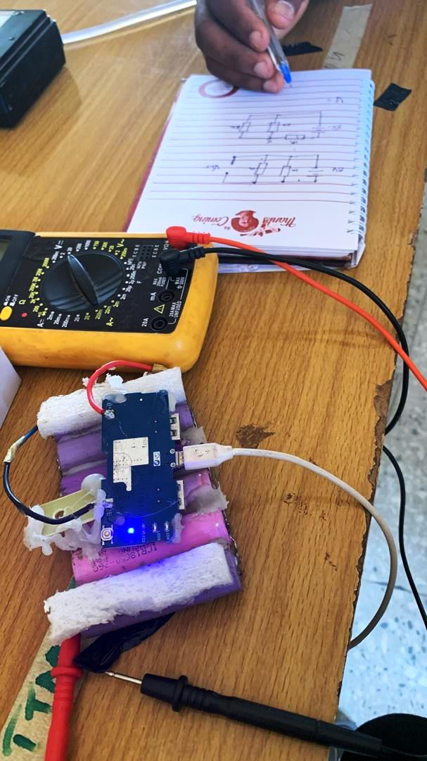

4.4. Module Data Sheet
We create this due to the most power bank we almost see.
So the minimum voltage-0v the charging duration will takes 5hrs to full for it to discharge.it takes
8hrs to 9hrs the capacity is 3.7v/16800mAH. The peak voltage is 6.26v while the average voltage is
4.12v. Then it’s takes up to 30 minutes before it start blinking each bar . Then we take solar panel to the sun to charge itself and each bar of the power-bank take 45mins to blink each bar and it’s takes 1 hr . It’s also charges a phone 3 times the full charge of the battery is 2hrs 20mins . Therefore based on calculations if 1 full charge =2hrs 20min, full charge,3+2.33/1
So the discharge time will be 8hrs 9mins.
4.5. Results
1. No load (full bar) 4.5v-5v on load 4. 0v
2. Average range per bar
1st bar————— 2.56v — 3.66v
2nd bar ———— 3.66v — 3.85v
3rd bar ———— 3.85v — 4.21v
4th bar ———— 4.21v — 4.85v

CHAPTER FIVE

5.0 Summary, Conclusion, and Recommendations

5.1 Summary
This project focused on the design, construction, and performance testing of a solar-powered power bank. The study highlighted the increasing demand for portable and sustainable energy sources due to the widespread use of electronic devices such as smartphones and tablets. To meet this need, a solar power bank was constructed using essential components such as a solar panel, charge controller, lithium-ion battery, voltage regulator, and USB output module.
Performance testing revealed that the device successfully converted solar energy into stored electrical energy and discharged efficiently to power mobile devices. The constructed power bank had an average output voltage range of 4.0–5.0V, could fully charge a mobile device within approximately 2 hours and 20 minutes, and provided up to three full charges before complete discharge. Charging directly under sunlight showed that each bar of the indicator system took approximately 45 minutes to one hour to rise, while a full charge required about 5 hours.
These results demonstrated the feasibility of developing a cost-effective and environmentally friendly solar power bank that is useful in areas with unreliable electricity supply.

5.2 Conclusion
The project achieved its main objective of constructing a solar-powered power bank capable of storing and supplying energy to charge GSM mobile phones. The device proved efficient, durable, and reliable, supporting the viability of solar energy as a clean and renewable source for portable electronics.
The findings indicate that with proper component selection and integration, solar-powered devices can serve as alternatives to conventional energy storage systems. This contributes to reducing dependence on fossil fuels and minimizing environmental impacts.

5.3 Recommendations
- Improved Battery Capacity – Future designs should incorporate higher-capacity lithium-ion or lithium-polymer batteries to increase the number of charge cycles available.
- Advanced Solar Panels – The use of more efficient photovoltaic technologies (such as perovskite or monocrystalline solar cells) could improve energy capture and reduce charging time.
- Integration of Smart Features – Incorporating microcontrollers with IoT connectivity could enable remote monitoring of battery status, charge levels, and efficiency.
- Durability Enhancements – Stronger casings and weatherproofing should be considered to ensure outdoor usability.
- Scalability – Larger versions of the power bank could be designed to support not only mobile phones but also laptops, tablets, and small household appliances.
- Community Adoption – Deployment in rural and semi-urban areas with limited access to electricity could enhance socio-economic development, especially for students, traders, and healthcare workers.

REFERENCES
"Solar powered mobile phone: An innovative experiment." In 2016 International Conference on Signal Processing, Communication, Power and Embedded System (SCOPES), pp. 1015-1020. IEEE, 2016
[16). Matthews, Victor O., Etinosa Noma-Osaghae, Stanley Idiake Uzairue, and Omoseye Awolalu. "A Solar Powered Smart Travelling Bag With An Embedded Video/Audio Player." International Journal of Recent Trends in Engineering & Research 4,no 7 (2018) : 148-1575(2016): 148-151.902.
Dhal, Sambandh Bhusan, Arun Agarwal, and Kabita Agarwal. "Solar powered mot ver bank systems." American Journal of Electrical and Electronic Engineering 4.
Dutta, P., Su, T.-Y., Fu, A.-Y., Chang, M.-C., Guo, Y.-J., Tsai, I.-J., … Fan, Y.-J. (2022). Combining portable solar-powered centrifuge with nanoplasmonic sensing chip and smartphone reader for rheumatoid arthritis detection. Chemical Engineering Journal, 434, 133864.
Dutta, Prakhar, Ting-Yu Su, An-Ying Fu, Mei-Chi Chang, Yu-Jie Guo, I-Jung Tsai, Pei-Kuen Wei, Yu-Sheng Chang, Ching-Yu Lin, and Yu-Jui Fan. "Combining portable solar-powered centrifuge to nanoplasmonic sensing chip with smartphone reader for rheumatoid arthritis detection." Chemical Engineering Journal 434 (2022): 133864.
Fan, S. (2022). Solar-powered wireless sensor network transmission. Journal of Renewable Energy Systems, 45(3), 77–85.
Fan, Sijia. "Solar-powered wireless sensors network-transmission part." (2022).
Garimella, R. C., Madeti, S. R. K., Shankar, T. B., Saini, G., & Kumar, K. (2023). Design and Development of Solar-Powered Hybrid Energy Bank. In Solar Energy: Advancements and Challenges (pp. 39–55).
Garimella, Raghu Chandra, Siva Rama Krishna Madeti, T. Bhavani Shankar, K Raghavendra Nayak, M. Kumar, Gaurav Saini, and Krishna Kumar. "Design anc Development of Solar-Powered Hybrid Energy Bank." Solar Energy: Advancements and Challenges (2023): 39.
Gowers, Glen-Oliver F., Oliver Vince, John-Henry Charles, Ingeborg Klarenberg, Tom Ellis, and Arwyn Edwards. "Entirely off- grid and solar-powered DNA sequencing of microbial communities during an ice cap traverse expedition." Genes 10, no. 11 (2019):
Lim, Z. W. (2020). Prototyping of a solar-powered charging station for energy storage applications. International Journal of Energy Research, 44(9), 7112–7123.
Lim, Zhi Wei. "Prototyping of a solar-powered charging station for energy storage applications." (2018).
Malla, Siva Ganesh, D. Jaya Deepu, D. Pavan Kumar, and Jagan Mohana Rao Malla.
Onah, C. I., Mbamara, U. S., & Ebegbulem, M. M. (2021). Design, Construction, and Testing of a Solar-Charged Multi-USB Power Bank Using Lithium-ion Batteries. International Journal of Engineering Research and Technology, 10(7), 45–52.
Onah, C. I., U. S. Mbamara, and M. M. Ebegbulem. "Design, Construction and Testing of a Solar Charged Multi-USB Power Bank Using Lithium-ion Batteries."
Padmini, S., and Md Shafeulwara. "Solar-Powered Multipurpose Backpack." In International Conference on Intelligent Computing and Applications: Proceedings of ICICA 2018, pp. 205-214. Springer Singapore, 2019.
Panguloori, Rakesh Babu, Priya Ranjan Mishra, and Ulrich Boeke. "Economic viability improvement of solar powered Indian rural banks through DC grids." In 2011 Annual IEEE India Conference, pp. 1-4. IEEE, 2011.
Purnama, Fajar, Muhammad BagusAndraIrwansyah, and Tsuyoshi Usagawa. "Is Zero Electricity Cost Cryptocurrency Mining Possible? Solar Power Bank on Single Board Computers (Research Session)."
Ram, B. Suresh, P. Mahesh Babu, K. Ravi Kiran, And M. Rohith. "Wireless Solar Power Bank."
Sharma, M., & Chauhan, A. (2022). Solar-Powered Portable Charger Using IoT-Based Technique. In Smart IoT for Research and Industry (pp. 179–188).
Sharma, Monika, and Abhijeet Chauhan. "Solar-Powered Portable Charger Using IoT-Based Technique." Smart IoT for Research and Industry (2022): 179-188.
Shrey, S., Kumar, S., Suman, S. K., & Kumar, A. (2023). Solar Powered Power Bank. Journal of Advancement in Electronics Design, 6(1), 23–26.
Shrey, Snehil, Sourabh Kumar, Suraj Kumar Suman, and Anmol Kumar. "Solar Powered Power Bank." Journal of Advancement in Electronics Design 6, no. 1 (2023): 23-26..

