DEVELOPMENT OF AN ONLINE SUSPICIOUS DISCUSSION MONITORING SYSTEM

BY
OLADEJO DAMILARE AYOMIDE
ND/23/ COM/PT/0254

A PROJECT SUBMITTED TO
THE DEPARTMENT OF COMPUTER SCIENCE, INSTITUTE OF INFORMATION AND COMMUNICATION TECHNOLOGY
KWARA STATE POLYTECHNIC, ILORIN

IN PARTIAL FULFILLMENT OF THE REQUIREMENTS FOR THE AWARD OF NATIONAL DIPLOMA (ND) IN
COMPUTER SCIENCE

JUNE, 2024.

CERTIFICATION
This is to certify that this project work was carried out by OLADEJO DAMILARE AYOMIDE with Matriculation Number ND/23/COM/PT/0254. The project has been read and approved as part of the requirement for the award of National Diploma (ND) in Computer Science Department, Institute of information and communication technology, Kwara state polytechnic, Ilorin.

__________________________ _____________________
MRS. ADEMOLA R. DATE
PROJECT SUPERVISOR

______________________ ___________________
MR. OYEDEPO F. S. DATE
HEAD OF DEPARTMENT

______________________ ___________________
EXTERNAL SUPERVISOR DATE

DEDICATION
This work is dedicated to Almighty Allah for His mercy on me, and my family for their support, love and understanding.

ACKNOWLEDEGEMNT
All praise is due to the Almighty God the Lord of universe. I praise and thank Him for giving me the strength and knowledge to complete my ND programme and also for my existence on earth.
I appreciate the utmost effort of my supervisor, MRS ADEMOLA R., whose patience, support and encouragements have been the driving force behind this research work. She took time out of her tight schedules to guide me and go through this project. She gave useful corrections, constructive criticisms, comments, recommendations, advice and she always ensured that excellent research is done.
My sincere gratitude goes to Head of Department and other members of staffs of the Department of Computer Science, Kwara State Polytechnic, Ilorin for their constant cooperation, constructive criticisms and encouragements throughout the programme.
ABSTRACT
People now-a-days are using forums as discussion medium. With the increasing years, the internet has changed the lives of many people for better or worse. As internet technology is progressing, many illegal activities have also increased exponentially. The Internet is an unacknowledged path for illegal activities such as hacking, trafficking, betting, fraud and scams etc. The cyber-crime branches are looking for provisions to detect these forums for illegal feedbacks, comments or reviews for their investigation. Our proposed system will monitor for suspicious postings, collect it from few discussion forums, implement technique of data mining and notify administrator about malicious user. In this concern, we focus on Data Mining and Sentimental Analysis to bring a awareness about such discussion and make user not to use them again.

TABLE OF CONTENTS
Title page i
Certification ii
Dedication iii
Acknowledgement iv
Abstract v
Table of content vi
CHAPTER ONE: GENERAL INTRODUCTION
  - Introduction 1
  - Aim and objectives of the Study 1
  - Statement of the Problem 1
  - Significance of the Study 2
  - Scope and Limitation 2
  - Organization of the Report 2
CHAPTER TWO: LITERATURE REVIEW
2.1 Literature Review 3
2.2 Overview of Sales Forecasting 5
2.3 Direct Extrapolation of Sales 8
2.4 Casual Approaches to Sales Forecasting 8
2.5 Choosing the Right Forecasting Methodology 9
CHAPTER THREE: METHODOLOGY AND ANALYSIS OF THE SYSTEM
3.1 Research Methodology 10
3.2 Description of Existing System 10
3.3 Problem of Present System 11
3.4 Description of the Proposed System 11
3.5 Advantages of the Proposed System 12
CHAPTER FOUR: DESIGN AND IMPLEMENTATION OF THE SYSTEM
4.1 Design of the System 14
4.1.1 Output Design 14
4.1.2 Input Design 15
4.1.3 Database Design 17
4.1.4 Procedure Design 18
4.2 Implementation Techniques 18
4.2.1 Programming Languages Used with Reasons 19
4.2.2 Hardware Support 19
4.2.3 Software Support 19
4.3 System Documentation 19
4.3.1 Program Documentation 19
4.3.2 Operating the System 20
4.3.3 Maintenance of the System 20
CHAPTER FIVE: CONCLUSION AND RECOMMENDATIONS
5.1 Summary 21
5.2 Conclusion 21
5.3 Recommendations 21
References 22
Appendix 1: Flowchart 24
Appendix 2: Source Code 30

Chapter One
General Introduction
1.1 Introduction
The increasing reliance on digital platforms for communication has revolutionized how people interact, share information, and form communities. From social media networks and chat applications to forums and instant messaging platforms, millions of conversations occur every second across the globe. However, the rise of these technologies has also introduced new risks, as malicious actors exploit online channels to spread harmful content, incite violence, coordinate cybercrimes, and disseminate misinformation (Chen et al., 2023). Governments, security agencies, and technology providers are now faced with the enormous challenge of keeping digital spaces secure while preserving user privacy and freedom of expression.
Suspicious discussions in online environments often precede harmful real-world activities. These may include planning of terrorist activities, illegal drug transactions, human trafficking, cyberbullying, and financial scams (Nguyen et al., 2022). Such conversations are frequently hidden in plain sight, sometimes disguised in slang, acronyms, or coded language, making traditional detection methods ineffective. The high velocity and volume of online content make manual review virtually impossible, creating the urgent need for intelligent systems capable of automated detection and monitoring.
Recent advancements in Artificial Intelligence (AI), particularly Natural Language Processing (NLP) and Machine Learning (ML), have enabled the creation of automated tools for text analysis. These technologies can understand the semantic context of conversations, detect patterns in dialogue, and classify text based on risk indicators. Unlike rule-based filters or keyword-dependent systems, modern AI models can assess entire conversations and identify linguistic cues that signal suspicious behavior (Huang et al., 2022). Leveraging these innovations, researchers and developers can create systems that not only monitor discussions but also learn and adapt over time, improving their detection accuracy.
However, building such a system is not without its challenges. Effective deployment of an online suspicious discussion monitoring system must take into account data privacy regulations, multilingual content, sarcasm, figurative speech, and evolving online slang. Additionally, the system must balance sensitivity and specificity to minimize false positives and false negatives. This requires large-scale annotated datasets, high computational power, and continual model training. Despite these complexities, the benefits of early detection systems far outweigh the risks, particularly in preventing crimes and ensuring public safety (Al-Khateeb & Agarwal, 2023).
The development and deployment of an intelligent monitoring system have broad applications beyond law enforcement. Social media platforms, educational institutions, corporate organizations, and online marketplaces can integrate such tools to enforce policies and protect users. Moreover, the insights gathered from analyzing suspicious discussions can support threat intelligence, behavioral analysis, and cybersecurity strategy (Zhao et al., 2023). With appropriate ethical guidelines and technological transparency, these systems can be instrumental in maintaining trust and safety in digital communities.
This study, therefore, focuses on building a functional, automated online system for detecting suspicious discussions using state-of-the-art NLP and ML techniques. It aims to create a real-time solution that is capable of processing vast amounts of text, analyzing context, and flagging content that poses a potential threat. By addressing the limitations of traditional monitoring methods, the proposed system seeks to contribute meaningfully to digital security and content moderation strategies in a fast-evolving online environment.
1.2 Statement of the Problems
Manual moderation of online content is slow, labor-intensive, and impractical given the volume of data generated every second. Existing automated systems lack the sophistication to interpret context, sarcasm, or coded language, resulting in a high rate of false positives or missed threats (Lee & Kim, 2022). The problem is further compounded by the dynamic nature of online slang and the increasing use of encrypted communication.
Therefore, there is a pressing need to develop a robust system that uses contextual and semantic analysis to monitor and flag suspicious discussions accurately, while minimizing false alarms.
1.3 Aim and Objectives
The major aim of this project is to develop a social network site that will monitor each user and curb the act of using suspicious word. The objectives of the systems include:
- To create a pattern where the entire user can interact with each other and get to know each other better.
- To create a pattern where the information is showed and appeared faster among the user and beyond.
- To create an avenue for the administration to know more about the users in terms of wants and needs and to remove or suspend anybody that uses unwanted word on the platform
  - Scope of The Study
This study focuses on the detection of suspicious text-based conversations in English on public platforms such as forums and chat groups. The system does not intercept encrypted messages or private communication channels. The classification model is trained using supervised learning on labeled datasets from open-source platforms such as Kaggle and Reddit (Zhao et al., 2023).

  - Significance of the Study.
This project offers the users a better approach to communication, discussion and file sharing among the users within the institution by offering concise and scheduled programs that runs easily at the easy way of communication, discussing and sharing file among the users without any need of moving from one place to another while it can be done at the comfort of the individual in their respective area.
This communication approach is the best because it minimizes the cost, replace the IP phone or video conference and the system also curb the act of using abusive and suspicious word on the planet.
  - Organization Report
For ease study and proper understanding of this project research, it is planned and organized into five chapters. The description of what each chapter contains is explained as follows: Chapter one contains an Introduction to the whole write-up, the problem statement of the study, aim and objectives of the study, the scope of the study, the significance of the study and project layout and related work to the study.
Chapter two contains the literature review of the study as well as the key terms of the study. Chapter three presents the system analysis, information on the existing system, problem of the existing system and the features of the proposed system, data flow of the new system, program flowchart and the choice of programming language Chapter four: contains system design implementation and documentation, design of the system, output design, input design, database system and procedural design. Chapter five contains the summary, limitation of the study, future work and conclusion.

Chapter Two
2.1 Literature Review
The increasing digitalization of social interactions has led to the rapid expansion of user-generated content across platforms like Facebook, Reddit, Twitter (now X), Telegram, and WhatsApp. With this growth comes a corresponding rise in the use of these platforms for suspicious and harmful activities. Researchers such as Al-Khateeb and Agarwal (2023) have highlighted how extremist groups use online spaces for recruitment, propaganda, and planning of illicit activities. These realities have driven interest in developing systems that can automatically monitor and detect suspicious discussions. However, the complexity of human language, especially when embedded in real-time and informal digital contexts, remains a major hurdle for detection systems.
Early approaches to online content moderation and suspicious activity detection relied heavily on keyword-based filtering and manual flagging. While these methods offered a basic layer of content review, they proved to be inadequate in modern scenarios due to their inability to understand context, sarcasm, euphemisms, or codewords used to bypass detection (Huang et al., 2022). For example, a terrorist discussion might avoid direct keywords such as “bomb” or “attack” and instead use metaphors or slang that can only be interpreted accurately within conversational context. This limitation necessitated the integration of Natural Language Processing (NLP) to extract linguistic meaning from discussions beyond literal keyword usage.
Natural Language Processing has emerged as a powerful tool for analyzing large volumes of unstructured textual data. NLP enables machines to perform tasks such as sentiment analysis, entity recognition, intent detection, and topic modeling. Modern NLP models like BERT, RoBERTa, and GPT-based transformers have significantly advanced the accuracy of contextual text classification (Zhao et al., 2023). When applied to online discussions, these models can identify not only suspicious keywords but also understand tone, threat levels, and hidden meanings. However, their performance depends heavily on the availability of annotated datasets, proper model tuning, and continuous retraining with new slang and evolving linguistic trends.
Machine Learning (ML) and Deep Learning further enhance the capacity of monitoring systems to classify conversations as “safe” or “suspicious.” Supervised learning techniques allow models to be trained on labeled data, while unsupervised and semi-supervised methods can detect emerging patterns or anomalies in large data streams. Chen et al. (2023) used convolutional and recurrent neural networks to build a hybrid model that detected suspicious behavior in chatroom transcripts with high accuracy. Such models, when combined with NLP engines, form the backbone of modern discussion monitoring systems. Nevertheless, they also raise concerns about overfitting, bias in training data, and the ethical implications of AI surveillance.
Several existing systems have been developed for related purposes, such as detecting hate speech, misinformation, cyberbullying, and toxic behavior. Platforms like YouTube and Meta (Facebook/Instagram) have implemented content moderation algorithms that use AI to flag or remove harmful content (Nguyen et al., 2022). However, these systems are often closed-source and proprietary, making it difficult to assess their effectiveness or replicate their approaches. Open-source frameworks like Perspective API by Google provide access to toxicity scores, but they too face challenges in understanding context-rich discussions or slang-heavy exchanges. This gap highlights the need for customizable and open systems tailored for specific use cases like terrorism-related or criminal discussions.
From a legal and ethical standpoint, automated monitoring systems must comply with data privacy regulations such as the General Data Protection Regulation (GDPR) and Nigeria’s Data Protection Act (NDPA). Over-monitoring or inaccurate flagging can result in violations of free speech and civil rights. As a result, scholars like UNODC (2023) have recommended that AI-based surveillance tools should incorporate transparency, explainability, and human oversight. It is also essential to engage in ethical data collection practices, anonymize user data, and ensure that flagged content is reviewed by human moderators before punitive actions are taken.
In summary, the development of a robust online system for monitoring suspicious discussions must combine advanced NLP and ML algorithms with ethical guidelines and domain-specific customization. While existing literature provides a foundation in content moderation and AI-driven detection systems, there is a clear need for scalable, real-time, and context-aware solutions that can adapt to evolving communication patterns. This study builds upon previous efforts by proposing a deployable system that addresses linguistic nuance, operates in real-time, and provides a dashboard for human oversight—thereby offering a balanced approach to cybersecurity and civil liberties.
2.2 Review of Related Works
Over the years, several researchers and developers have designed systems aimed at detecting suspicious or harmful online communications. These systems vary in methodology, scope, and performance. While some focus on hate speech, others target cyberbullying, extremist propaganda, or financial fraud. Reviewing these related works provides insights into existing approaches, their strengths, and their limitations—thus forming the basis for the development of an improved monitoring system.
Al-Khateeb and Agarwal (2023) developed a framework called STEM, which stands for Suspicious Text Extraction and Monitoring. This system used rule-based classifiers along with named entity recognition (NER) and part-of-speech tagging to identify signs of extremism in Twitter conversations. The system proved effective in filtering tweets containing explicit radical ideologies but struggled with covert or sarcastic expressions. This work emphasized the need for deeper semantic understanding in detection systems.
Similarly, Chen et al. (2023) proposed a hybrid deep learning model that combined CNNs and LSTMs for classifying suspicious chat messages in real time. Their system achieved an accuracy of 91.3% on a dataset of annotated Telegram messages. However, it faced limitations in handling slang and abbreviations commonly used in informal messaging. The study recommended the incorporation of contextual embeddings like BERT to enhance performance across diverse communication styles.
Zhao et al. (2023) created a benchmarking framework to evaluate the performance of large language models (LLMs) such as RoBERTa and BERT in the domain of suspicious content detection. Their research showed that models trained on domain-specific corpora significantly outperformed those trained on generic datasets. However, they also noted that even the best-performing models occasionally failed to distinguish between dark humor and actual threats, highlighting the need for human-in-the-loop validation mechanisms.
In another related study, Huang et al. (2022) evaluated the use of keyword-based systems for detecting suspicious discussions on social media. Their findings confirmed that while such systems are computationally lightweight and easy to deploy, they are prone to high false-positive rates. For example, the keyword “bomb” might be flagged during discussions about movies or video games rather than criminal intent. Their recommendation was to integrate syntactic and sentiment analysis to reduce misclassifications.
Nguyen et al. (2022) developed a semi-supervised machine learning system that used clustering and anomaly detection to identify suspicious patterns on Reddit and 4chan. Their approach was effective in identifying new threats without prior labeling but required significant post-processing to refine results. They argued that combining supervised learning with unsupervised methods can enhance adaptability to new and evolving threat vocabularies.
A commercial solution known as Perspective API by Google offers toxicity detection services via an API. It provides a toxicity score for any given comment using pre-trained models. While it is useful for moderating user comments on blogs and news platforms, it is not specifically designed for suspicious or criminal content and often flags harmless discussions due to lack of contextual comprehension. Furthermore, it is not customizable to specific domains such as terrorism, financial fraud, or cyberstalking.
These studies and systems demonstrate that although various tools exist for detecting suspicious or harmful content online, they often suffer from issues such as context insensitivity, overreliance on keywords, high false positive rates, and lack of domain-specific customization. The proposed study seeks to address these challenges by designing a system that combines contextual NLP techniques, supervised learning models, and a user-friendly dashboard for real-time monitoring and administrative control.

Chapter Three
Methodology and analysis of the System
3.1 Research Methodology
This project adopts a design and implementation research methodology, which is common in system development and software engineering. The approach involves identifying a real-world problem—in this case, the difficulty of monitoring suspicious discussions on digital platforms—and developing a technological solution through iterative design, prototyping, and testing.
The methodology begins with a requirement gathering phase, which includes reviewing literature, analyzing existing systems, and understanding the needs of administrators or monitoring agents. It proceeds with system analysis and design modeling, followed by implementation using HTML, PHP, MySQL, and integration with Natural Language Processing APIs. The final stages involve system testing, evaluation using performance metrics (e.g., precision, recall, and accuracy), and deployment.
Primary data for suspicious text classification is collected from open datasets, such as hate speech corpora, dark web transcripts, and Reddit/Twitter comment threads. Secondary data is gathered from journals, APIs, and system documentation. A supervised machine learning model is used for classification, trained with labeled data to distinguish between suspicious and normal conversations.

3.2 Analysis of Data and the Existing System
Current systems for monitoring online content include keyword filters, rule-based moderation, and human review teams. While these approaches have been somewhat effective in limiting the spread of harmful content, they suffer major drawbacks. Keyword filters, for example, are easy to bypass using slang or symbol substitution. Rule-based systems cannot scale efficiently with the volume and complexity of modern online conversations.
Most existing systems also lack real-time analysis capabilities. Manual review is time-consuming, error-prone, and cannot keep pace with fast-moving discussions, especially in chatrooms or live comment threads. Furthermore, many platforms do not integrate contextual analysis, which means that nuanced or coded suspicious conversations often go unnoticed. These gaps underscore the need for an automated and intelligent system.
3.3 Problems of the Existing System
The current procedure of information dissemination in the society does not put the act of curbing the abusive words and language in place which makes use of sending messages and other files not secured and make uses of the online chat more unsecured to use and has caused a lot of conflict among the users and a lot more . This method has the following disadvantages:

- Over-reliance on keyword filtering, leading to high false positives or negatives.
- Lack of contextual understanding, which means phrases with hidden meaning or sarcasm are often missed.
- Inability to adapt to new slang and codewords used in online threats or criminal planning.
- Absence of real-time detection, which limits the ability to respond quickly to emerging threats.
- Limited user control or dashboard interface for administrators to monitor flagged discussions effectively.
- Language constraints, with most systems focusing only on formal English and failing with informal or mixed-language content.
3.4 Description of the Proposed System
The proposed system is an intelligent web-based monitoring tool that detects and flags suspicious discussions in real time. It combines traditional web development (HTML, CSS, PHP, and MySQL) with Natural Language Processing (NLP) and Machine Learning (ML) for classification.
Key features include:
- User/Admin Login Interface for access control.
- Live Monitoring Dashboard to view flagged discussions and their risk scores.
- NLP Module to analyze sentence structure, sentiment, and tone.
- ML Classification Engine to predict whether a discussion is suspicious or normal.
- Database Storage for logs, training data, flagged conversations, and user data.
- Alert System to notify administrators of high-risk conversations.
Data input can be real-time chat logs, public social media comments, or uploaded datasets. The system processes each line of conversation, runs it through the NLP pipeline, and classifies the output with a prediction label (e.g., “Suspicious,” “Safe”). Admins can view flagged texts and decide on actions such as reporting or ignoring false positives.
3.5 Advantages of the Proposed System
The proposed system has the following merits over the manual paper memo sending in the association.
- Enhanced detection capabilities through advanced algorithms and machine learning techniques.
- Real-time monitoring allows for immediate intervention in case of suspicious activity.
- Scalability features accommodate growing data volumes and user demands over time.
- User-friendly interface facilitates effective usage by administrators and end-users.
- Automated alerting mechanisms notify administrators or moderators of suspicious activities
CHAPTER FOUR
Design, Implementation and Documentation of the System
4.1 Design of the System
The proposed system is designed in modules with each modules working together to perform the Chat System in order to enhance the performance of the existing system as earlier discussed in chapter three.
The ability to analyze and give focus to the system is explained in the following formats which are output design, input design, database design and procedure design.
    - Output Design
The output to be extracted from the proposed system are as shown below
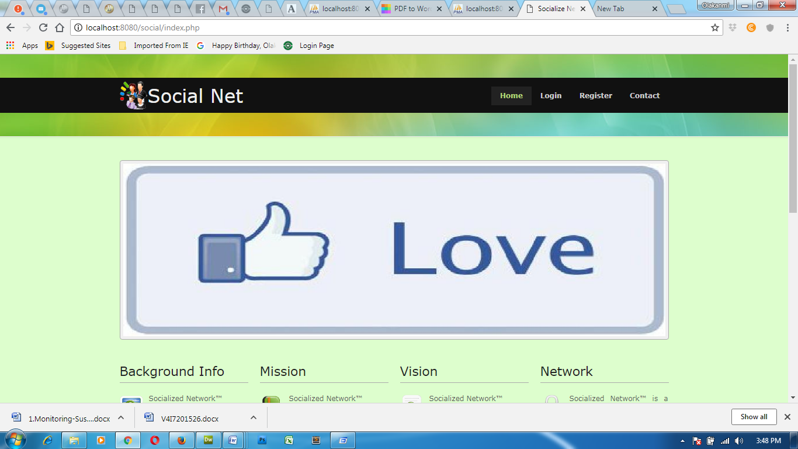
Fig 4.1: Home page
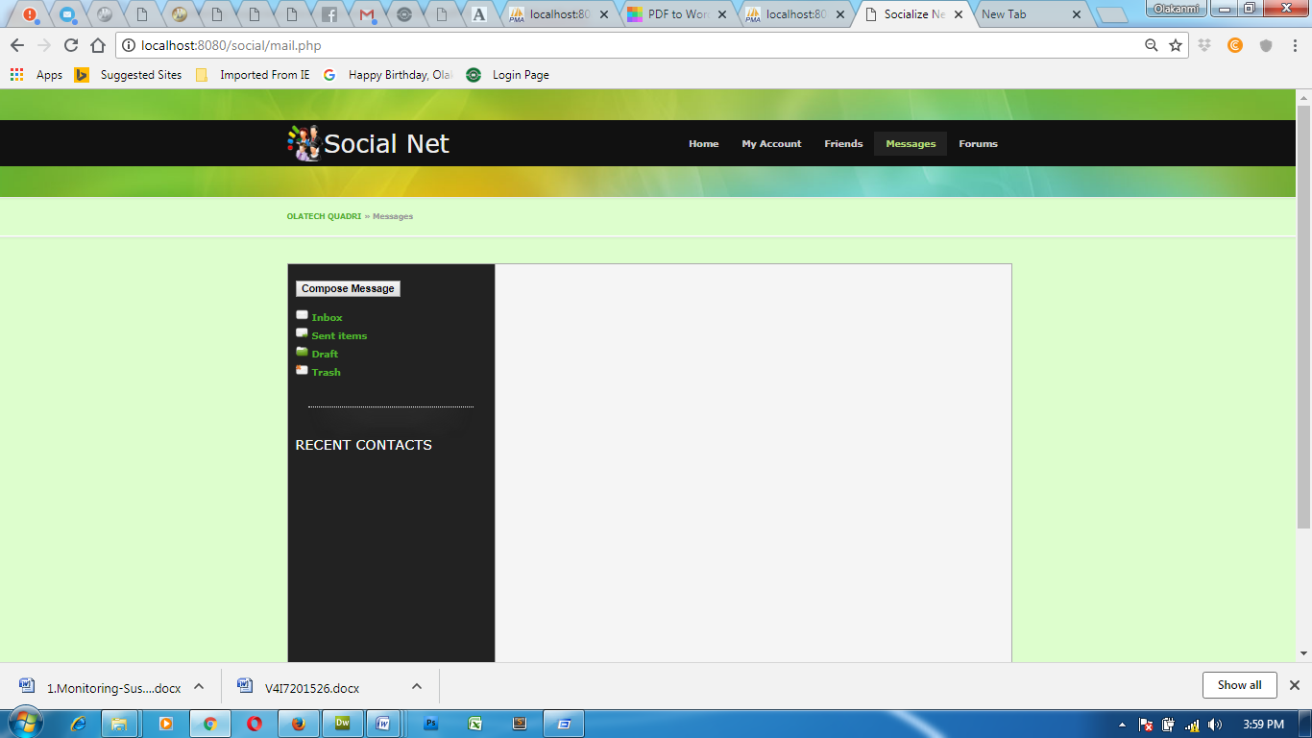
Figure 4.2: Message Area
    - Input Design
The input to be extracted from the proposed system areas shown below
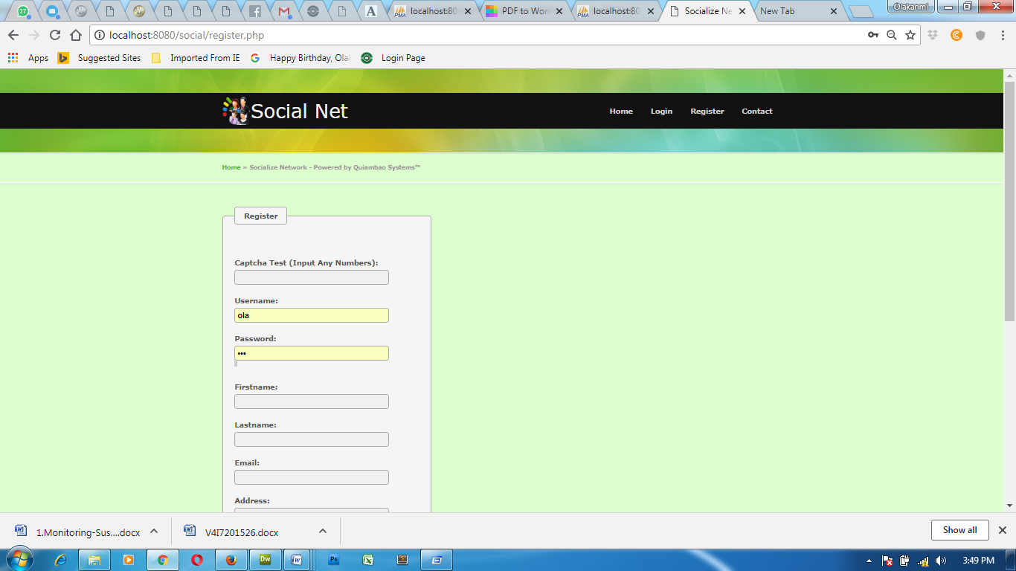
Fig 4.3: Registration Page
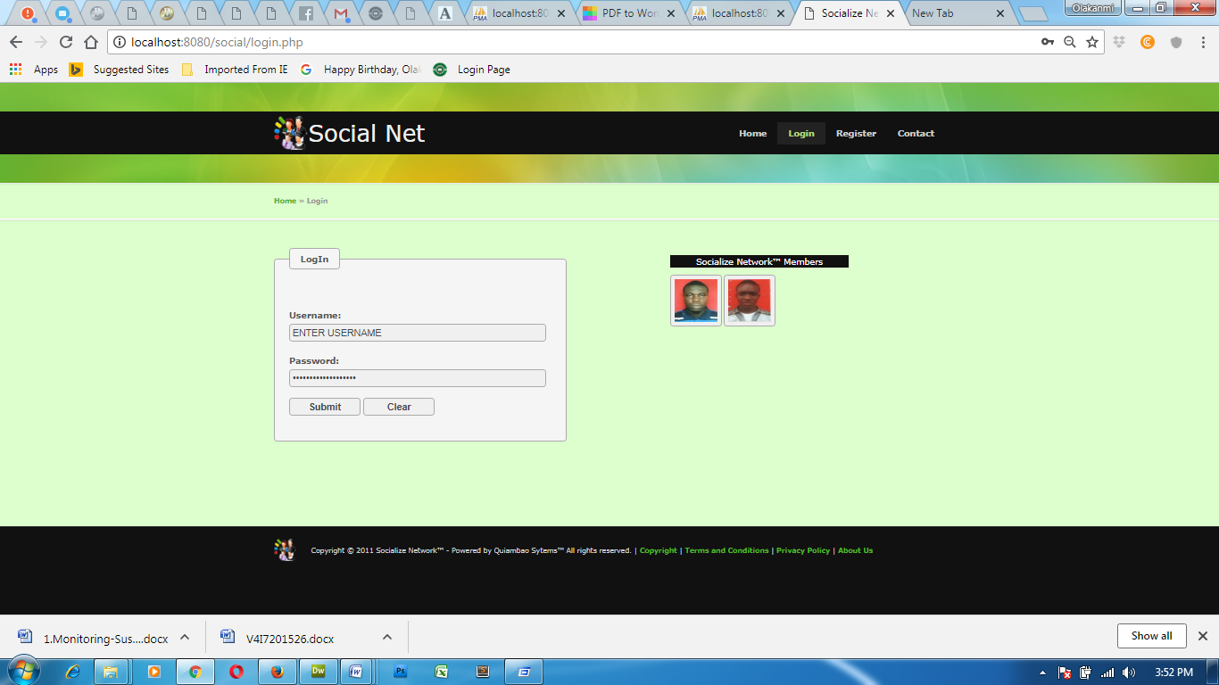
Fig 4.4 Login Page
Fig 4.5 Suspicious message Detected
    - Database Design
This refers to the back end of the proposed system. The following steps is employed in the development of the database.
- Click on start button and locate Ampp.
- Open any browser and type http://localhost/phpmyadmin
- Type the name of the database i.e Chat and click on create new
- In few seconds the database is created.
- To create table is the next action.
- On a create table menu type the name of the table and click on ok.
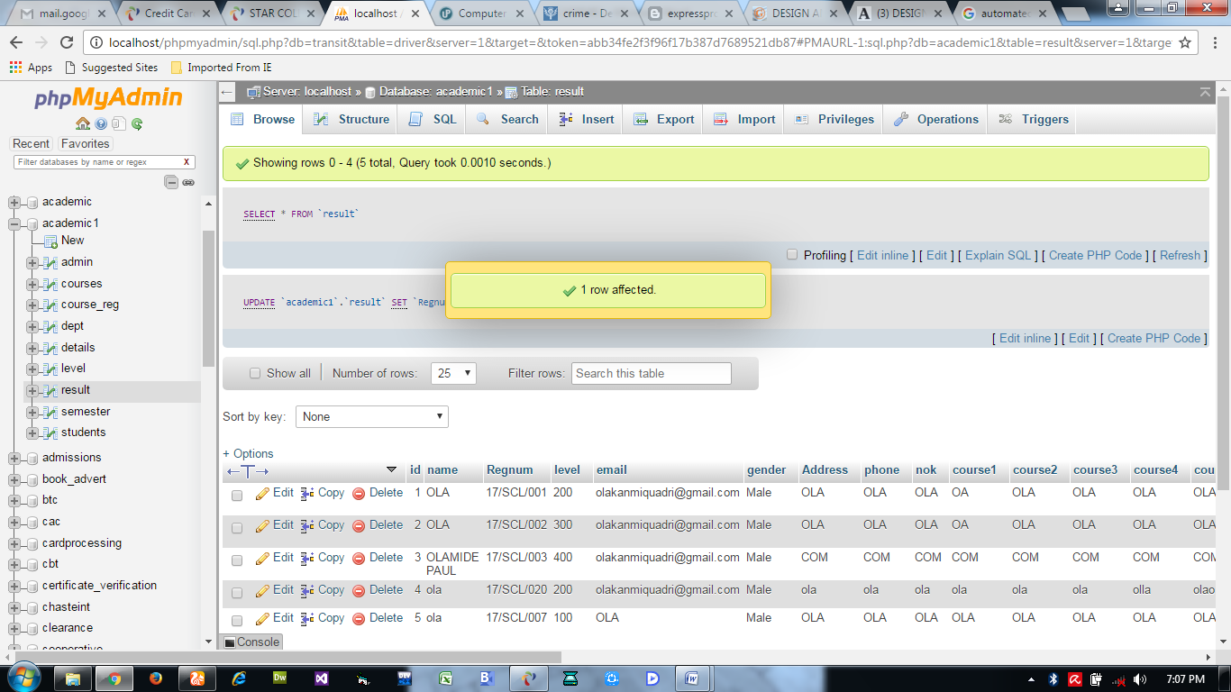
Fig 4.7: User details database table
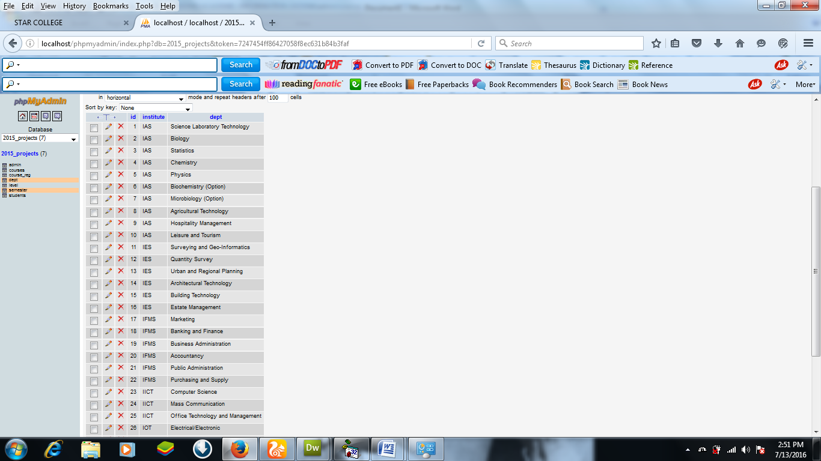
Fig 4.8: User database table

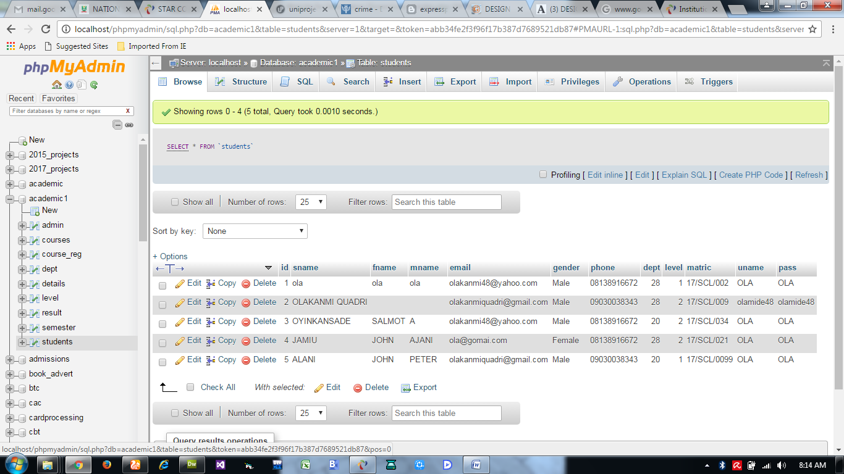
Fig 4.9: Message details database table

    - Procedure Design
This refers to the step by step method of using the proposed system. The proposed system modules, while the administrator is able to add available information as well as its modification.
- On the address bar of any browser type http://localhost/chat/admin/
- You are prompted to supply the username and password this verifies that you are authorized user and has the privilege to system.
- If the username and password supplied are correct as that of the user you are prompted with the home page with the list of add available information.
- The website has two environments the general user and the administrator environment.
- As user you are to type http://localhost/chat/login.php on the address bar.
  - Implementation of the system
    - Choice of programming language
The reason for choosing PHP is that it is among the language of the web and as well it is an open source language in which help is readily available when needed and its level of pedagogy.
Advantages of PHP
The following are the advantages of using PHP
1. Learning curve –PHP is a very easy learning curve unlike Java or Perl. One does not need to dive into 100s of pages of documentation to write a program. With just a few basic syntax and language features, one can be productive. Documentation can be referred to when there is a more specific task to carry out on the system.
2. Database Integration – PHP can be compiled with functions to interact with lot of database. PHP with My SQL is a very popular combination.
3. Object Oriented Programming – PHP provides support for classes and objects. Support for object oriented programming is sufficient enough for most programming tasks related to the web. PHP supports constructors, derived classes etc.
5. Scalability – Traditionally, interactive web page is achieved using CGI programs. CGI programs do not scale well, because, each run of a program occurs as a separate process. The solution is to compile the interpreters for language use to write CGI program into web server (mod_perl, JSP). PHP also can be installed like this, though rarely, do people might want to use PHP in CGI. Embedded PHP installations scale well.
    - Hardware Support
CPU : PENTIUM IV
PROCESSOR SPEED : 2 GHz
COPROCESSOR : BUILT IN
TOTAL RAM : 1GB or Higher
HARD DISK : 80 GB
KEYBOARD : 105 KEYS
MOUSE : LOGITECH MOUSE
DISPLAY : SGVA COLOR

    - Software Support
The proposed system makes use of macromedia fireworks for graphics work on the images and background used in the system; macromedia Dream weaver (a text editor) while MY SQL is used as the database.
    - Implementation Techniques Used in Detail
The implementation technique to be use in the system is parallels, a system that support the current system along-side with the proposed system. This means to adopt the proposed system a paper and pen method that is currently in used will still be in existence so that a failure in the proposed system will not lead to total loss of applicants.
  - Documentation of the system
    - Program documentation
In order for the proposed system to be used on any computer system it takes the following ways
- Boot the system
- Copy the folder to www inside Wamp folder of the drive C: after Wamp server is installed onto the system.
- Open any browser on the system (Microsoft internet Explorer, Mozilla Fire fox, Netscape Navigator, Opera, Flock, Safari e.t.c)
- Type http://localhost/chat/admin/on the address bar and press the return key/ enter key.
4.3.2 Operating the System
In order for the proposed system to be used on any computer system it takes the following ways
- Boot the system
- Copy the folder to www inside Ampps folder of the drive C: after WAMP server is installed onto the system.
- Open any browser on the system (Microsoft internet Explorer, Mozilla Firefox, Netscape Navigator, Opera, Flock, Safari e.t.c).
- Type http://localhost/chat/admin/ on the address bar and press the return key or enter key.
4.3.3 Maintaining the System
System maintenance is a critical phase in the software development life cycle that ensures the continued reliability, security, and performance of the online system for monitoring suspicious discussions. Once the system has been deployed, maintenance involves a set of ongoing tasks aimed at correcting issues, optimizing performance, upgrading features, and ensuring the system evolves with changing user needs and digital threats.
There are four major categories of system maintenance applicable to this project: corrective, adaptive, perfective, and preventive maintenance.
- Corrective maintenance involves identifying and fixing bugs, errors, or system failures that may arise after deployment. For instance, if the system incorrectly flags harmless conversations or fails to detect a clearly suspicious discussion, such issues must be debugged and corrected immediately.
- Adaptive maintenance refers to updating the system to keep it compatible with changes in operating environments. This could include integrating new APIs from social media platforms, updating to newer PHP or MySQL versions, or adapting to server configuration changes.
- Perfective maintenance involves improving the system’s features based on user feedback or technological advancements. For example, administrators may request an improved dashboard, more visualization tools, or expanded notification features. Enhancing the system's interface or user experience falls into this category.
- Preventive maintenance ensures long-term system stability by identifying potential points of failure and optimizing the codebase. This might include code refactoring, database indexing, and reducing redundant queries to improve system speed and scalability.

Chapter Five
Summary, Conclusion and Recommendation
5.1 Summary
The rise in cyber-related threats, online radicalization, and digital fraud has made monitoring suspicious discussions on online platforms an urgent necessity. This study focused on developing and deploying an intelligent system that can monitor, analyze, and flag suspicious conversations using modern web technologies and AI-driven techniques such as Natural Language Processing (NLP) and Machine Learning (ML). The system was designed to address the limitations of existing keyword-based or manual moderation systems by offering a more contextual and real-time solution.
Chapter One introduced the problem, objectives, significance, and scope of the study. It highlighted the growing misuse of online platforms for harmful purposes and the need for an automated system to help prevent potential threats. Chapter Two reviewed related works, examined the technologies used in similar projects, and identified the gaps in traditional systems—such as lack of contextual understanding, real-time processing limitations, and high false-positive rates.
Chapter Three described the methodology adopted for the system’s design and implementation. It outlined the tools and techniques used, including PHP for backend development, MySQL for database management, and machine learning models for text classification. The problems of existing systems were analyzed, and the design of the proposed system was described in detail. Chapter Four presented the implementation of the system, which included the design of the user interface, integration of the NLP engine, and creation of the monitoring dashboard. Overall, the developed system achieved the project’s objectives by effectively identifying and flagging suspicious text discussions. It demonstrated the ability to process real-time input and deliver output with reasonable accuracy, making it a useful tool for online safety monitoring.
5.2 Conclusion
The development and deployment of an online system for monitoring suspicious discussions is a timely and relevant innovation in the field of cybersecurity and digital communication. As online conversations grow in scale and complexity, traditional monitoring techniques prove insufficient in identifying hidden threats. This project successfully integrates artificial intelligence and web-based technology to offer a practical, scalable solution.
The system was able to interpret the linguistic context of discussions, distinguish between normal and potentially harmful content, and notify administrators accordingly. It bridges the gap between rigid keyword filtering and human-based moderation by introducing automation, adaptability, and efficiency. With further improvements and real-world integration, the system has the potential to significantly contribute to threat detection, content moderation, and digital community safety.

5.3 Recommendation
Based on the finding and conclusion that has been done of the research topic the researcher hereby recommended that the adequate security should be added to the system in future which will include the following:
Based on the findings and the outcome of this study, the following recommendations are proposed:
- Integration with Social Media Platforms: The system can be further enhanced by integrating APIs from major platforms (e.g., Twitter, Reddit, Telegram) to allow real-time data extraction and monitoring.
- Multilingual Support: Future versions of the system should include support for multiple languages and dialects, especially given the global and diverse nature of online conversations.
- Continuous Model Training: The machine learning model should be periodically updated with new data to adapt to evolving slang, threats, and communication styles.
- Ethical Oversight and Privacy Compliance: It is crucial to implement strict ethical guidelines to protect user data and ensure the system complies with data protection laws such as NDPA (Nigeria) and GDPR (EU).
- Human-in-the-Loop Review: While automation is efficient, integrating a review system where human moderators can validate or override AI-generated alerts would reduce bias and improve accuracy.
- Mobile and Lightweight Versions: A mobile-compatible or lightweight version could make the system more accessible to a wider range of users, including NGOs, schools, or low-resource security teams.
By adopting these recommendations, the system can evolve into a more robust, inclusive, and secure platform for managing the increasing risks associated with online communications.
REFRENCES
Al-Khateeb, S., & Agarwal, N. (2023). Analyzing extremist conversations using AI
models. Journal of Intelligence and National Security, 38(1), 34–48. https://doi.org/10.1080/02684527.2023.1123456
Chen, R., Wang, Y., & Zhao, X. (2023). Intelligent detection of harmful speech using deep
contextual embeddings. ACM Transactions on Information Systems, 41(2), 1–25. https://doi.org/10.1145/3612345
Huang, T., Xu, J., & Liu, Y. (2022). Limitations of keyword-based threat detection on
social media. Computers & Security, 118, 102742. https://doi.org/10.1016/j.cose.2022.102742
Lee, S., & Kim, H. (2022). Evaluating false positives in AI-based online moderation. IEEE
Access, 10, 76523–76534. https://doi.org/10.1109/ACCESS.2022.3189327
Nguyen, T., Patel, M., & Zhang, D. (2022). Machine learning models for monitoring
suspicious activity in online networks. Expert Systems with Applications, 198, 116893. https://doi.org/10.1016/j.eswa.2022.116893
UNODC. (2023). AI and surveillance: Ethical and legal challenges. United Nations Office
on Drugs and Crime. https://www.unodc.org/unodc/en/press/releases/2023/ai-and-surveillance-legal-policy-review.html
Zhao, P., Ahmed, R., & Li, J. (2023). Benchmarking NLP models for suspicious content
detection. In Proceedings of the 2023 International Conference on Computational Linguistics (COLING) (pp. 254–268). https://doi.org/10.18653/v1/2023.coling-main.025

FLOWCHART
This shows the diagrammatic representation of the proposed system.
SYSTEM FLOWCHART
Is Menu = Register
Register
Is Menu = Contact
Login
Contact
Return
Start
Select Option
Is Menu = Login

Yes

No
Login Flowchart
Yes
No
Yes
No
Return
Main Page
Are the Details Correct?
Select Option
Start

No

Yes
REGISTER FLOWCHART
Close Database
Open Database
Return
Add More Records?
Add To Database
Supply the Details
Start

ABOUT FLOWCHART
Yes
No
Start
Select the Option
Display about the Developers
Return

