WEB BASED HOSPITAL BILL PAYMENT AND RECEIPT GENERATION USING BACKTRACKING ALGORITHM

BY

AKINMADE, KARIMAT OLABISI
ND/23/COM/PT/0305
SUBMITTED TO THE DEPARTMENT OF COMPUTER SCIENCE, INSTITUTE OF INFORMATION AND COMMUNICATION TECHNOLOGY
KWARA STATE POLYTECHNIC, ILORIN

IN PARTIAL FULFILLMENT OF THE REQUIREMENTS FOR THE AWARD OF NATIONAL DIPLOMA (ND) IN
COMPUTER SCIENCE

JULY, 2025.

CERTIFICATION
This is to certify that this project work was carried out by AKINMADE KARIMAT OLABISI with Matric number ND/23/COM/PT/0305 in the Department of Computer Science, Institute of Information Communication Technology, Kwara State Polytechnic, Ilorin, Kwara State.

…………………………………. ….………………………
MR. BOLAJI-ADETORO D.F Date
Project Supervisor

…………………………………. ….………………………
MR. OYEDEPO F. S. Date
Head of Department

…………………………………. ….………………………
External Examiner Date

DEDICATION
I dedicate this project work to Almighty God who inspired me and directed my ways during my academic stay in the polytechnic.

ACKNOWLEDGEMENT
All praise is due to Almighty God the Lord of the universe. I praise him and thank him for giving me the strength and knowledge to complete my ND program and also for my continued existence on Earth.
I appreciate the utmost effort of my supervisor, Mr. Bolaji-Adetoro, D. F. whose patience, support, and encouragement have been the driving force behind the success of this research work. He gave useful corrections, constructive criticisms, comments, recommendations, and advice and always ensures that excellent research is done. My sincere gratitude goes to the Head of the Department Mr. Oyedepo F. S., and other members of staff of the Department of Computer Science, Kwara State Polytechnic, Ilorin, for their constant cooperation, constructive criticisms, and encouragement throughout the program.
Special gratitude to my parents, who exhibited immeasurable financial, patience, support, prayers, and understanding during the period in which I was busy tirelessly with my studies, special thanks go to my lovely siblings
My sincere appreciation goes to my friends and classmates.

TABLE OF CONTENTS
Title page i
Certification ii
Dedication iii
Acknowledgements iv
Table of contents v
Abstract vi
CHAPTER ONE: GENERAL INTRODUCTION
1.1 Background to the Study 1
1.2 Statement of the Problem 3
1.3 Aim and Objectives 3
1.4 Significance of the Study 3
1.5 Scope of the Study 3
1.6 Organization of the Report 4
1.7 Definition of Some Technical Terms 4
CHAPTER TWO: LITERATURE REVIEW
2.1 Review of Related Past Works 5
2.2 Review of Related Concepts 11
2.2.1 Overview of hospital Bill Payment 12
2.2.2. Billing System 13
2.2.3 Classification of Billing Errors with Respect to Responsibilities 13
2.2.4 Root Causes of the Critical Billing Errors 13

2.2.5 Outpatient Bill 13

2.2.6 Billing for Other Professional Services at Our Hospitals 14
2.2.7 Concept of Web Base Hospital Bill Payment 14

CHAPTER THREE: RESEARCH METHODOLOGY
AND ANALYSIS OF THE SYSTEM
  - Research Methodology 15
  - Analysis of the Existing System 16
  - Problem of the Existing System 16
  - Analysis of the Proposed System 17
  - Advantage of the Propose System 17
CHAPTER FOUR: DESIGN, IMPLEMENTATION AND
DOCUMENTATION OF THE SYSTEM
  - Design of the System 18
    - Output Design 18
    - Input Design 20
    - Database Design 22
    - Procedure Design 23
  - Implementation of the System 24
    - Choice of programming language 24
    - Hardware support 25
    - Software Support 25
  - System Documentation 25
    - Operating the System 25
    - Maintaining of the System 26
CHAPTER FIVE: SUMMARY CONCLUSION
AND RECOMMENDATION
5.1 Summary 27
5.2 Conclusion 27
5.4 Recommendations 27
References 28
Appendices
ABSTRACT
Hospital receipt generating system is a viable venture, its main purpose is to maintain more reliable records of money going in and out from the hospital, another thing matters weather it will be cash without remark balance or install mental, and how many installment it is going to be. The population in various countries is increasing rapidly every year, and a lot of people have seen the need of health care. Health care are one of the most essential needs of a man. The hospital financial administration, provision of services and, the consumption of materials and medications, will create the hospital bill and later, they will turn into currency. Hospital is associated with the lives of common people and their day-to-day routines so we decided to work on this paper. The manual handling of the record is time consuming and highly prone to error. The purpose of this paper is to automate or make online, the process of day to-day activities like Room activities; Admission of New Patient, Discharge of Patient, Assign a Doctor, and ﬁnally compute online the bill payment and generation system using back tracking algorithm. This subsystem was designed was developed in a form of web-based prototype using PHP and HTML languages as well as CSS with CodeIgniter framework and MySQL for database. The development of this billing subsystem applied a Rapid Application Development (RAD) model process that focused on the working model and obtained feedback from users to improve the system.

CHAPTER ONE
GENERAL INTRODUCTION
  - BACKGROUND TO THE STUDY
Hospital receipt generating system is a viable venture, its purpose is to maintain more reliable records of money going in and out from the hospital, another thing matters weather it will be cash without remark balance or installment, and how many installment it is going to be. The population in various countries is increasing rapidly every year, and a lot of people have seen the need of health care. Health care are one of the most essential needs of a man (Ahmed and Ali, 2020).
The hospital financial administration, provision of services and, the consumption of materials and medications, will create the hospital bill and later, they will turn into currency. It starts when the patient is admitted to the hospital, starting many care procedures related to the patient’s health needs, which should be documented in detail in the medical record by the multi-professional team. The adequate capture of these data will result in the charge. Therefore, there should be a flow of information to facilitate the invoice closing. In this perspective, the audit of hospital bills is crucial to prove the conduction of procedures performed to patients, through the constant documentation in the medical record, as it provides aids to bill the paying agencies. Public and private hospital institutions that provide services to operators of healthcare plans (OHCP) have invested in billing auditing foreseeing the adequate compensation for the provided attention. The audit can be conducted by different professionals (Premkumar and Kalpana, 2020).
Considering the international crises and the technological advances, economic and financial scenarios suffer constant changes resulting in companies losing their markets; decreasing of profit margins; increases of demands related to product’s quality, of the competition and, of the consumer market. In this dynamic environment, the institutions providing healthcare services, aiming to maintain their sustainability, need to economically develop through an efficient management of their many processes. Such institutions, considered complex companies, are obligated to continually adapt to political and financial scenarios, as well as, to become flexible to incorporate strategies capable of meeting internal and external users. It is noted that in the national scenario, the growing financing difficulties of the health sector and the high cost of services have worried funders, authorities, providers and, users. The billing in the hospital financial administration is a process that allows managers to know the rentability of health services and, to manage their costs, quality and, income. However, it has been increasingly consolidating as an important field for nursing operation. Besides verifying the compatibility between the conducted procedures and the charges of items that are in hospital bills, the auditor nurse has the potential to act as an educator for the health team. The auditor contributes with the knowledge to obtain positive financial results, avoiding the occurrence of glosses, and preserving ethical relationships between the contractee and contractor.
The manual system employed is not very efficient, a lot of paper work has to be done for patient bill receipt generation, irrespective of patients take a long period of time to prepare. Due to the voluminous number of drugs users, record of patients which serve as information for preparing managerial decision are very difficult to locate manually. A medical invoice template is designated for any licensed professional that cares for patients in any health-related field. Such designations include, but are not limited to, doctors (physicians), dentists, physical therapists, psychologists, psychiatrists, nurses, chiropractors, and any other medical professional.
Hospital Bill Management System provides the beneﬁts of streamlined operations, enhanced administration, control, superior patient care, strict cost control and improved proﬁtability. This is a powerful, ﬂexible, and easy to use and is designed and developed to deliver real conceivable beneﬁts to hospitals. More importantly it is backed by reliable and dependable support. The project ‘Hospital Bill Management System’ is based on the database, object oriented and networking techniques. As there are many areas where records are kept in database for which the system using MY SQL software which is one of the best and the easiest software to keep the information. This project uses HTML as the front-end software which is an Hyper Text Language and has connectivity with MY SQL. This system is a custom built to meet the speciﬁc requirement of the mid and large size hospitals across the globe. All the required modules and features have been particularly built to just ﬁt in to your requirement. This package has been widely accepted by the clients.
1.2 STATEMENT OF PROBLEM
Hospital is associated with the lives of common people and their day-to-day routines so we decided to work on this paper. The manual handling of the record is time consuming and highly prone to error. The purpose of this paper is to automate or make online, the process of day to-day activities like Room activities; Admission of New Patient, Discharge of Patient, Assign a Doctor, and ﬁnally compute online the bill payment and generation system using back tracking algorithm.
1.3 AIM AND OBJECTIVE OF THE STUDY
The primary aim of this study is to develop a web-based system for hospital bill payment and receipt generation. The specific objectives are:
- Create a user-friendly web interface that allows patients to easily navigate and make bill payments.
- Integrate a robust and secure online payment system to facilitate safe financial transactions.
- Develop an Automated Receipt Generation System
- Use a backtracking algorithm to accurately match payments with outstanding bills.
1.4 SIGNIFICANCE OF THE STUDY
The study is important to the hospital patients since they could have medical information without experiencing delays and incorrect information. If they wanted to access their medical history, they would not be going through a difficult process. The hospital especially the pharmacy and billing department would not go through a lot of paper reports when it comes to payments and accounting records. The use of paper would still be there but it could be reduced so that excessive paper loads would not be a problem.
1.5 SCOPE OF THE STUDY
The study focuses on the basic access and use of hospital-related information, most especially the computerization of management transactions for the hospital employees. The Malita District Hospital have departments operating in a day-to-day basis. However, the researchers would cater five departments namely: Administrative, Emergency, OutPatient, Pharmacy, and the Billing.

1.6 ORGANIZATION OF THE STUDY
This is the overall organizational structure of the work as presented in this project write-up. Chapter one of this project deals with the introduction to the general work in the project. It also entails the statement of the problem, aims and objectives of this project, the significance of the study, the scope and limitation of the study and organization of the report. Chapter two deals with the review related journals and books, historical background of of the study, as well as computerization current state of the art. Chapter three covers the methods used for data collection, description of the current procedure, problems of existing system, description of the proposed system and the basic advantages of the proposed web based application.
Chapter four entails design, implementation and documentation of the system. The design involves the system design, output design form, input design form, database structure and the procedure of the system. The implementation involves the implementation techniques used in details, choice of programming language used and the hardware and software support. The documentation of the system involves the operation of the system and the maintenance of the system. Chapter five deals with the summary, experience gained, conclusion, recommendation and references.
1.7 DEFINITION OF TECHNICAL TERMS
HOSPITAL: Is health care institution or a place where people who are sick, injured are given medical treatment and care.
BILLING: Is a process of showing an invoice how much one owes or has to pay for services rendered.
PATIENT: Is a person who receive or in need of treatment from a doctor in a hospital.

CHAPTER TWO
LITERATURE REVIEW
2.1 REVIEW OF RELATED CONCEPT
Ahmed & Ali (2020) hospital management system design and implementation. A hospital management information system (HMIS) is an element of health informatics that focuses mainly on the administration needs of hospitals. In many implementations, this is a comprehensive, integrated information system designed to manage all the aspects of a hospital. One of the most important issues is health care services. Hospital management information system (HMIS) is a province-wide initiative designed to improve access to patient information through a central electronic information system. HIS goal is to streamline patient information flow and its accessibility for doctors and other health care providers. These changes in service will improve patient care quality and patient safety over time. The patient carries system record patient information, patient laboratory test results, and patient doctor information. Doctors can access easily person information, test results, and previous prescriptions. Patient schedule organization and early warning systems can be provided by related systems.
Premkumar & Kalpana (2020) e-hospital management & hospital information systems changing trends. The rapid growth in Information & Communication Technology (ICT), and the power of Internet has strongly impacted the business and service delivery models of today‘s global environment. E-Hospital Management Systems provide the benefits of streamlined operations, enhanced administration & control, superior patient care, strict cost control and improved profitability. Globally accepted health care systems need to comply with Healthcare Insurance Portability and Accountability Act (HIPAA) standards of the US and that has become the norm of the Healthcare industry when it comes to medical records management and patient information privacy. The study is focused on understanding the performance indicators of Hospital information systems (HIS), summarizing the latest commonly agreed standards and protocols like Health Level Seven (HL7) standards for mutual message exchange, HIS components, etc… The study is qualitative and descriptive in nature and most of the data is based on secondary sources of survey data. To arrive at a conclusive idea of the larger picture on E- Hospital Management and Hospital information systems, existing survey data and specific successful case studies of HIS are considered in the study. With so many customized versions of E – hospital management solutions (E – HMS) and Hospital Information systems (HIS) available in the market, a generic module wise version of E – Hospital management system is charted out to give a clear understanding for researchers and industry experts. From the specific successful case studies analyzed in the study, the success factors and challenges faced in successful E-HMS implementation are highlighted. Some of the mandatory standards like HIPAA are discussed in detail for clarity on Healthcare system implementation requirements. Index Terms Information & Communication Technology (ICT), Health Level Seven (HL7), Healthcare Insurance Portability and Accountability Act (HIPAA), E – hospital management solutions (E – HMS), Hospital Information systems (HIS)
Samirah (2019) successful billing strategies in the hospital industry. Failure to collect reimbursement because of changing regulations negatively impacts hospital profitability. A multiple case study approach was used to explore the successful strategies billing managers employed to collect reimbursement for all legitimate Medicare claims. The target population for this study included 5 hospital billing managers from 3 organizations in the Northern New Jersey region. The complexity theory was used as a framework for assessing changing Medicare regulations and how the managers adapted to them. The data collection process for this study involved gathering data from participant interviews, documentation from the organizations of the participants, and government documented regulations and manuals. The logical and sequential order of data analysis for this study embraced Yin’s 5-steps data analysis that includes compiling data, disassembling data, reassembling data, interpreting the data, and concluding. The successful strategies billing managers used that emerged as themes were remaining up to date with Medicare changing compliance regulations; enhancing communication with staff, multiple departments, and Medicare; and adopting a robust billing system and other systems that compliment billing. The implications of this study for social change include the potential to ensure access to patient care for benefiting families and communities through the sharing of successful strategies for Medicare claims.
Sura (2019) hospital management system. Hospital Management System provides the beneﬁts of streamlined operations, enhanced administration, control, superior patient care, strict cost control and improved proﬁtability. HMS is powerful, ﬂexible, and easy to use and is designed and developed to deliver real conceivable beneﬁts to hospitals. More importantly it is backed by reliable and dependable support. The project ‘Hospital Management System’ is based on the database, object oriented and networking techniques. As there are many areas where we keep the records in database for which we are using MY SQL software which is one of the best and the easiest software to keep our information. This project uses JAVA as the front-end software which is an Object Oriented Programming and has connectivity with MY SQL. Hospital Management System is custom built to meet the speciﬁc requirement of the mid and large size hospitals across the globe. All the required modules and features have been particularly built to just ﬁt in to your requirement. This package has been widely accepted by the clients in India and overseas. Not stopping only to this but they are highly satisﬁed and appreciating. Entire application is web based and built on 3 tier architecture using the latest technologies. The sound database of the application makes it more users friendly and expandable. The package is highly customizable and can be modiﬁed as per the needs and requirements of our clients. Prolonged study of the functionalities of the hospital and its speciﬁc requirement has given it a wonderful shape both technically and usability wise. It covers all the required modules right from Patient Registration, Medicine details, Doctor, Wards, , Admin, Store, Patient appointment, bill payment, record modiﬁcation, discharge details etc. Human Body is a very complex and sophisticated structure and comprises of millions of functions. All these complicated functions have been understood by man him, part-by-part their research and experiments. As science and technology progressed, medicine became an integral part of the research. Gradually, medical science became an entirely new branch of science. As of today, the Health Sector comprises of Medical institutions i.e. Hospitals, HOSPITALs etc. research and development institutions and medical colleges. Thus the Health sector aims at providing the best medical facilities to the common man. Problem Statement Since Hospital is associated with the lives of common people and their day-to-day routines so we decided to work on this paper. The manual handling of the record is time consuming and highly prone to error. The purpose of this work is to automate or make online, the process of day to-day activities like Room activities; Admission of New Patient, Discharge of Patient, Assign a Doctor, and ﬁnally compute the bill etc. we have tried our best to make the complicated process Hospital Management System as simple as possible using Structured Modular technique Menu oriented interface. we have tried to design the software in such a way that user may not have any diﬃculty in using this package furtherexpansion is possible without much eﬀort. Even though we cannot claim that this work to be entirely exhaustive, the main purpose of our exercise is perform each Hospital’s activity in computerized way rather than manually which is time consuming. We are am conﬁdent that this software package can be readily used by non-programming personal avoiding human handled chance of error.
According to Agnes (2019) at the University of Nigeria; the hospital is an institution for health care that provides patient treatment by specialized staff and equipment. Hospitals are largely staffed by professional physicians, surgeons, and nurses. It is a place where patients visit for medical checkup or treatment. Hospital workflows are done within twenty-four hours. Due to this reason, the hospitals need efficient management. According to Toussaint (2015), hospitals can’t improve without better management systems. In Toussaint’s perspective, management is a significant part of today’s cost and quality crisis in health care. This is the reason why suitable hospital needs and appropriate medical management must be present to delive applicable healthcare facilities. However, there are still several hospitals in the country that uses paper works in the management. Therefore, the auditor should be informed and constantly updated regarding changes in assistance practice, being those related to medications or materials, so the auditor can address errors/flaws properly in registries and also, to guide the collaborators regarding problems/deficiencies encountered and, to point out corrective and/or preventive alternatives. The OHCP practice to gloss revenue items in hospital bills, due to flaws in registries, has impacted the budget of health organizations, resulting in financial losses caused by the lack of receiving adequate compensation for services provided. In the billing, the evasions of operational revenues can be related to the non-charging of materials and medications used; non-charging for diagnostic support services; not following deadlines to turn in revenues; not receiving for the services provided caused by glosses and outdated tables of procedures. Considering that the adequate hospital revenue is related to actions developed during internal auditing, that can detect flaws and intervene, so those are not recurrent, we conducted the present study aimed to map, describe and, validate the process of auditing and billing and, billing reports in a large general public hospital.
Tanze (2019) design and implementation of online cash receipt generating system for a supermarket. This work was centered on online cash receipt generating system. The current process of cash receipt generation is being operated manually and due to this procedure numerous problem are been encountered. A design was taken to computerized the manual process in order to check this problem. The problems were identified after series of interviews and examination of documents after which analysis was made and a computerized procedure recommended. This work will also suggest how to successfully implement the computerized procedure and to overcome the obstacle that would hinder the successful implementation of the system. The new system was designed using Microsoft asp.net server side language and HTML. This language was chosen because of its object oriented features and wealth of .NET class libraries for developing online based applications.
Raquel & Antônio (2020) Our study aimed to map, describe and, validate the audit, account billing and billing reports processes in a large, private general hospital. An exploratory, descriptive, case report study. We conducted nonparticipatory observation moments in Internal Audit Sectors and Billing Reports from the hospital, aiming to map the processes which were the study objects. The data obtained was validated by internal and external audit specialists in hospital bills. The described and illustrated processes in three flow-charts favor professionals to rationalize their activities and the time spent in hospital billing, avoiding or minimizing the occurrence of flaws and, generating more effective financial results. The mapping, the description and the audit validation process and billing and, the billing reports propitiated more visibility and legitimacy to actions developed by auditor nurses.
Erdi et al (2020) Hospital billing process is a crucial component for hospital management. Due to the complexity of the hospital billing processes, billing errors may result in costly financial losses. In Turkish social security system, Social Security Institution (SSI) provides health insurance, which ensures maintenance of health statuses of individuals and the financing of costs that arise in case the individuals experience health risks. Accordingly, SSI developed billing procedures for hospitals in financing the healthcare needs of individuals. Hospitals need to comply with the standards set by SSI in order to prevent stoppages and fines in financing their costs. In the following, Hacettepe University Hospitals’, where 95 % of the healthcare service payments are made by the SSI, are studied. Nevertheless, there is a huge amount of financial losses from SSI because of the errors occurring during billing process. Here, the aim is to minimize Hacettepe University Hospitals’ billing errors. To realize this aim, Lean Six Sigma framework and problem solving methods of DMAIC are used. The billing process of the hospital is studied first and critical points are determined. After meetings with the hospital IT personnel and hospital administration, some important data, including the past billing errors are retrieved. The main billing errors, their reasons and the financial costs of the errors are analyzed with statistical and graphical tools. To solve the problems and remove the errors, work flow and standard operating procedures of the hospital billing process is prepared.
Farida, et al., (2019) Hospital is one of veterinary medical service providers in Yogyakarta ad Central Java areas in which the transaction and the documentation managing process is still done manually. Therefore, Prof. Soeparwi VH needs a management information system that facilitate them in managing process and documentation of transactions, one of which is through billing or billing subsystem. This subsystem was designed using UML and was developed in a form of web-based prototype using PHP and HTML languages as well as CSS with CodeIgniter framework and MySQL for database. The development of this billing subsystem applied a Rapid Application Development (RAD) model process that focused on the working model and obtained feedback from users to improve the system. Results of this system's development were evaluated with a system feasibility test and functionality test. A system feasibility test was administered by distributing Likert scale questionnaire and analysed them based on a summated rating scale method which showed a result of 85.4%. That result indicates that users strongly agree that the system has met their needs. The system functionality was tested using a black box method and the result was that the system properly functioned. This billing subsystem could process transaction bills automatically included in the calculation. This system produced bills and reports that could be printed and exported. In addition, data was stored in a database so that it supported paperless documentation.
Matarlo and Oniot (2020) the population in various countries is increasing rapidly every year, and a lot of people have seen the need of health care. Health cares are one of the most essential needs of a man. It is a necessity according to Agnes (2019) at the University of Nigeria; the hospital is an institution for health care that provides patient treatment by specialized staff and equipment. Hospitals are largely staffed by professional physicians, surgeons, and nurses. It is a place where patients visit for medical check up or treatment.
Robert, et al., (2019) The broad policy consensus that payment methods for physicians and hospitals need to evolve from volume based to value based often implicitly assumes clear dividing lines between the two categories. However, most of what are considered value-based payment reform models are being implemented on top of current, volume-based payment approaches, or as HHS calls it, “fee-for-service architecture.” This points to our need to understand the attributes of all common payment approaches those long in use and more recent reforms to better judge not only their strengths and weaknesses as stand-alone payment methods but also how they likely interact with other payment methods. With this knowledge, we can adopt designs that improve the effectiveness of payment reform models. Accordingly, to gain a better understanding of payment reform opportunities, we explore not only the attributes of reform approaches but also payment methods that constitute their underlying architecture.
2.2 REVIEW OF RELATED CONCEPTS
The health care industry now is one of the largest and most important industries in most countries. It provides individuals access to medical and non-medical services that are aimed at improving that individual’s quality of life. In many health care facilities, however, there exists a severe need for improvement in quality of service and patient waiting times. These needs must be met with an efficient and a practical solution. This solution must make use of the hospitals‟ valuable resources, such as medical experts‟ time, in the most efficient manner. Hospitals are continuously fighting a scheduling problem that causes either a waste in medical experts‟ time or a decrease in patient satisfaction and staff morale. Many scheduling systems have been developed and implemented in order to improve such operations in individual hospitals or even groups of health care facilities called health care networks. The internet initially revolutionized communication and access to information; however, in more recent times it has been the rapid improvements in mobile technology that has further expanded the communicative abilities of individuals and businesses alike. These mobile technologies, combined with the use of the internet have pushed mankind to a new frontier of information distribution and gathering. Here presents interaction system for doctor and patient communication. It has an exceptional administration of several nodes through which doctors and patients interact with each other. The patients can easily access the hospital server nodes. Here the patients are allowed to interact with the doctors about their symptoms. The doctors can list and track their patients who are geographically dispersed and provide a diagnosis on the needful. Proposing a new system from where the patients can easily book their appointments online and the doctors can view and manage them. Here the patients book their appointments online depending on the doctor’s availability and their time feasibility. The doctors on the other hand can either extend or reduce their working hours depending on the number of patients arriving for that day. In addition, the approximate time of arrival for the patients is also approximately calculated and notified to the registered number. Any other information can also be fabricated at installation and hence removes the need for a technician install the software. The target population for this study included 5 hospital billing managers from 3 organizations in the Northern New Jersey region. The complexity theory was used as a framework for assessing changing Medicare regulations and how the managers adapted to them. The data collection process for this study involved gathering data from participant interviews, documentation from the organizations of the participants, and government documented regulations and manuals. The logical and sequential order of data analysis for this study embraced Yin’s 5-steps data analysis that includes compiling data, disassembling data, reassembling data, interpreting the data, and concluding.
2.2.1 Overview of Hospital Bill Payment
Human Body is a very complex and sophisticated structure and comprises of millions of functions. All these complicated functions have been understood by man him, part-by-part their research and experiments. As science and technology progressed, medicine became an integral part of the research. Gradually, medical science became an entirely new branch of science. As of today, the Health Sector comprises of Medical institutions i.e. Hospitals, HOSPITALs etc. research and development institutions and medical colleges. Thus the Health sector aims at providing the best medical facilities to the common man.
2.2.2 Billing System
This system is related to software and hardware that receive requests and special information services based on information from used. It creates management report and prints payments for user formed from interfaces, computers, software program, and information databases. Its functions include creating usage records, handling processes, calculating total costs, payment processes, and management reporting.
2.2.3 Classification of Billing Errors with Respect to Responsibilities
Errors were associated with responsible by using the general medical billing process. By identifying the locations and responsible of errors, it became easier to find and present accurate improvements. Table 2 shows classified errors with respect to responsible.
2.2.4 Root Causes of the Critical Billing Errors
Note that 8 critical errors were determined. After the completion of process analysis, root causes and locations of these critical billing errors were determined. Here;
Material-Barcode-KIK Error is the kind of error, which is caused by the lack of or the inappropriate invoices of medical materials used, by the missing barcode or by missing required KIK (Public Procurement Authority records) documentation.
Insufficient Epicrisis Error is the kind of billing error, which occurs because of missing result reports or the inappropriate result reports.

2.2.5 Outpatient Bill
Patients seen in a clinic or outpatient setting may receive separate invoices for some services. Your clinic or outpatient bill will include charges for use of the facility and any tests or procedures. For scheduling reasons, some tests and procedures may be performed at a later date and will be billed separately from your outpatient or clinic invoice.

2.2.6 Billing for Other Professional Services at Our Hospitals
In addition to a bill from your hospital, you may receive separate bills for professional services provided by outside physicians groups who have privileges at this hospital. Please note, we cannot guarantee that private physicians participate with your health insurance plan.
2.2.7 Concept of Web Base Hospital Bill Payment
The target population for this study included 5 hospital billing managers from 3 organizations in the Northern New Jersey region. The complexity theory was used as a framework for assessing changing Medicare regulations and how the managers adapted to them. The data collection process for this study involved gathering data from participant interviews, documentation from the organizations of the participants, and government documented regulations and manuals. The logical and sequential order of data analysis for this study embraced Yin’s 5-steps data analysis that includes compiling data, disassembling data, reassembling data, interpreting the data, and concluding.

CHAPTER THREE
RESEARCH METHODOLOGY AND ANALYSIS OF THE EXISTING SYSTEM
  - RESEARCH METHODOLOGY
This subsystem was designed was developed in a form of web-based prototype using PHP and HTML languages as well as CSS with CodeIgniter framework and MySQL for database. The development of this billing subsystem applied a Rapid Application Development (RAD) model process that focused on the working model and obtained feedback from users to improve the system.

SQL Language elements
The SQL language is based on several elements. For the convenience of SQL developers all necessary language commands in the corresponding data base management system are usually executed through a specific SQL command-line interface (CLI).
Receipt No Generation steps
int temp; C1 1 C1
for (int j = 0; j < 9; j++) {
j++) {
if (check[i][j]=0){
temp = grid[i][j] + 1;
maju = true;
for (int k = temp; k<=10; k++) {
if (isSafe(i, j, k)) {
grid [i][j] = k;
break; }}
if (grid[i][j]>9) {
grid [i][j] = 0; i][j] = 0; C4 n 2 C4n 2 j
maju = false; }
if (j<-1 && i>0) {
i--;
j = 7; }
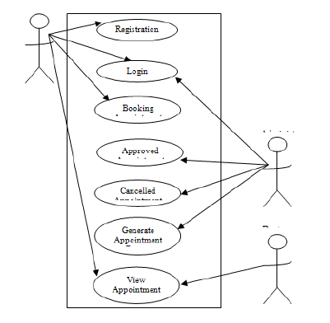
Figure 3.1: Medical Appointment Booking System architecture

3.2 ANALYSIS OF EXISTING SYSTEM
Lack of immediate retrievals: -The information is very difficult to retrieve and to find particular information like- E.g. - To find out about the patient’s history, the user has to go through various registers. This results in inconvenience and wastage of time. Error prone manual calculation: - Manual calculations are error prone and take a lot of time this may result in incorrect information. For example: calculation of patient’s bill based on various treatments.
3.3 PROBLEM OF THE EXISTING SYSTEM
Problems existing with the current manual processing information in the hospital are:
- Slow receipt processing of information.
- Errors are easily made and hardly detected when making a payment
- The manual system does not ensure durability of record storing.
- Information is not well maintained.
- Time consumption due to the use of calculator, pen and paper to compute the patients’ bills.
3.4 DESCRIPTION OF THE PROPOSED SYSTEM
The information processing system itself is assessed with system quality attributes (e.g., usability, accessibility, ease of use). Information quality attributes (e.g., accuracy, completeness, legibility), concern the input and output of the system. Usage refers to system usage, information usage, or both. Examples of attributes of usage are number of entries and total data entry time. User satisfaction can concern the system itself or its information, although they are hard to disentangle.

3.5 ADVANTAGE OF THE PROPOSED SYSTEM
- Medical billing enables a healthcare service to efficiently claim for the services provided. Web-based Medical Billing in a healthcare system ensures that the practice receives reimbursement for the work the providers perform smoothly.
- Cloud based Medical Billing service is a win-win situation if you are dealing with a responsible, financially strong, and efficient company because for cloud based service you pay as you go, and it is charged per user, per month and you never have to deal with the cost up-front. It saves you a lot of money.
- Web-based Electronic Billing requires limited customization while software based customization is tedious and rigid.
CHAPTER FOUR
DESIGN, IMPLEMENTATION AND DOCUMENTATION OF THE SYSTEM
  - DESIGN OF THE SYSTEM
The proposed system is designed in modules with each modules working together to perform the electronic voting system in order to enhance the performance of the existing system as earlier discussed in chapter three.
The ability to analyze and give focus to the system is explained in the following formats which are output design, input design, database design and procedure design.
    - OUTPUT DESIGN
The output and output to be extracted from the proposed system are as shown below
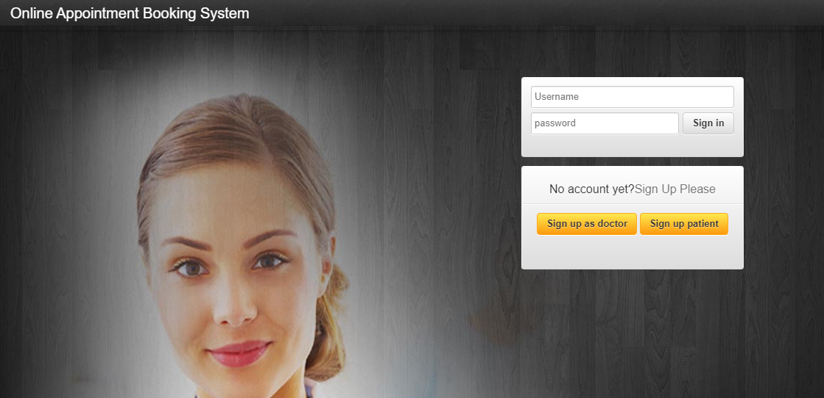
Figure 4.1: Index Page
This Page is the welcome page that displays the welcome content
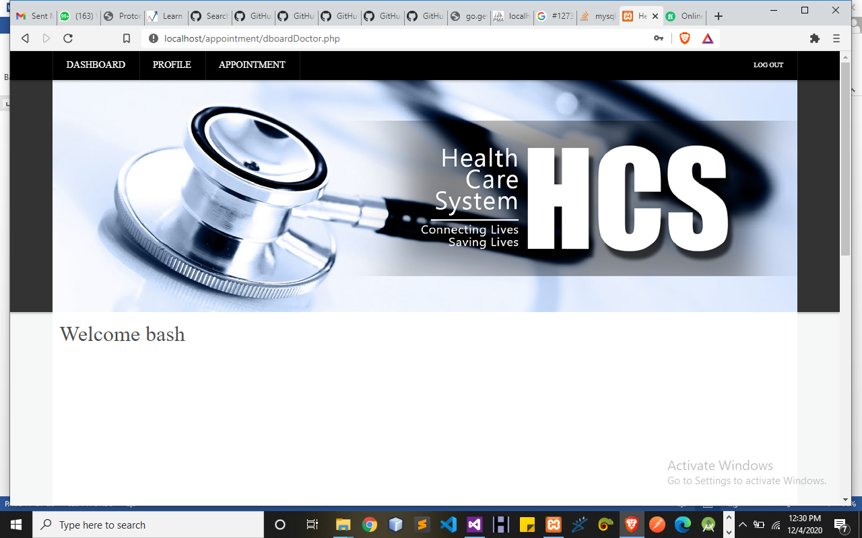
Figure 4.2: Doctor Dashboard Page
This Page Display all operations that can be perform by Admin using this system.
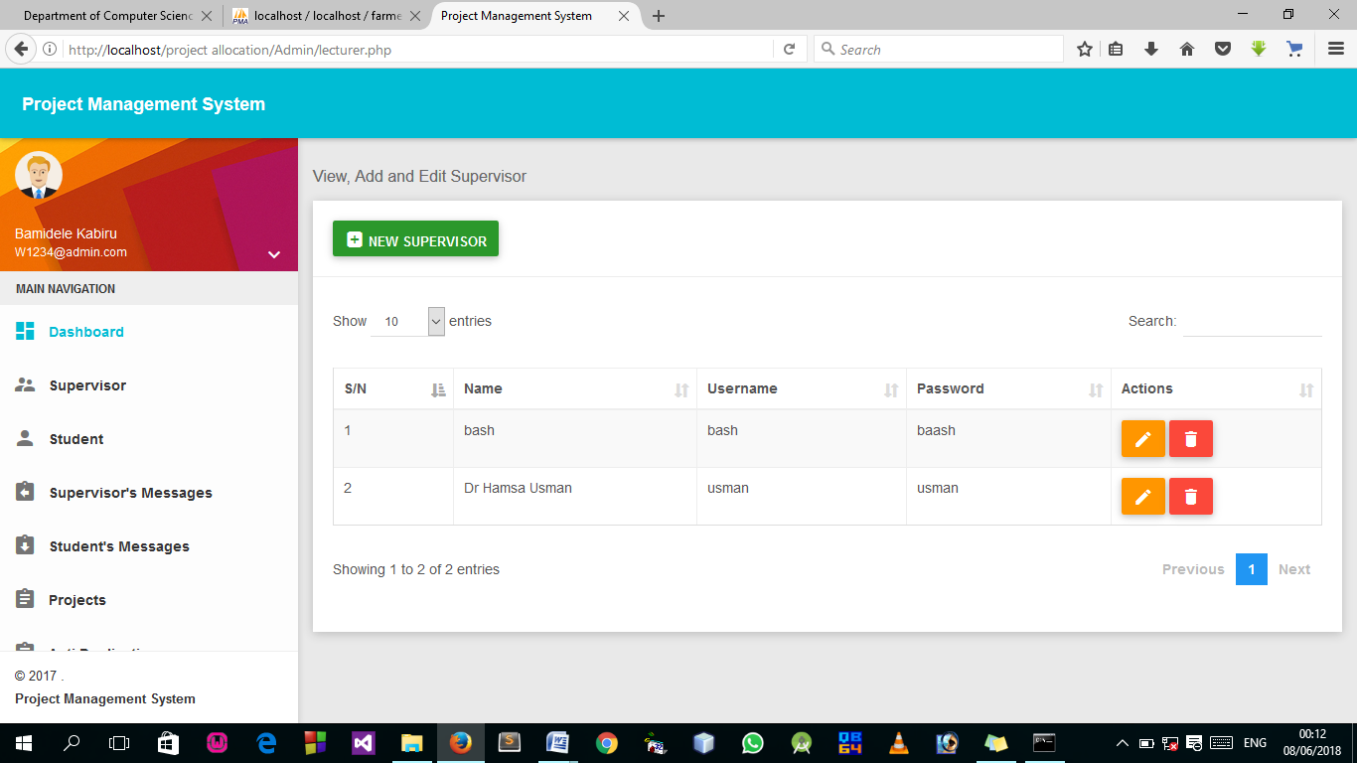
Figure 4.3: List of All Registered Patient Page
This page display all Patient added.
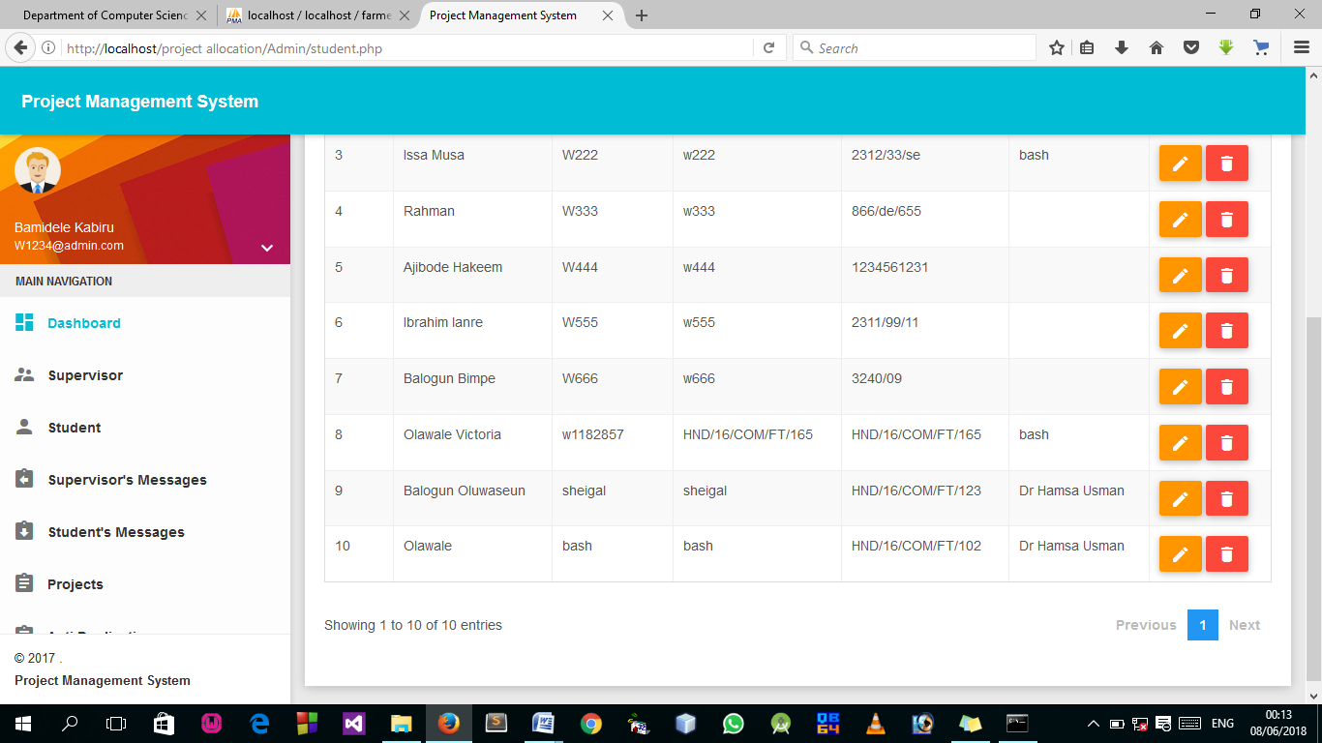
Figure 4.4: List of all Appoint booked Page
This Page Display all appoint booked by the patient.

4.1.2 INPUT DESIGN

It is also necessary to denote that data inputted in the computer for processing determines what the output will be. The inputs are use in collecting information the student through the keyboard. Inputs are necessary information needed for processing so as to produce the expected outputs; which are supplied through the keyboard.
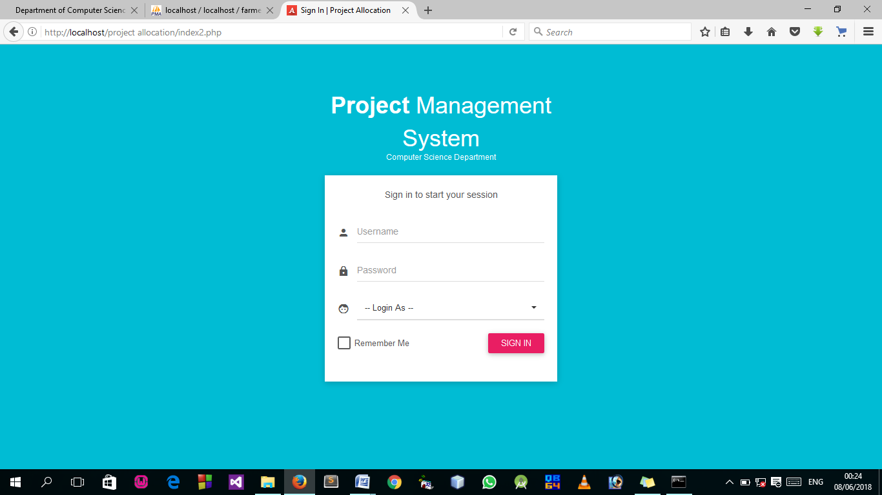
Figure 4.5: Login Page
This Page allow authorized user to log into the system.
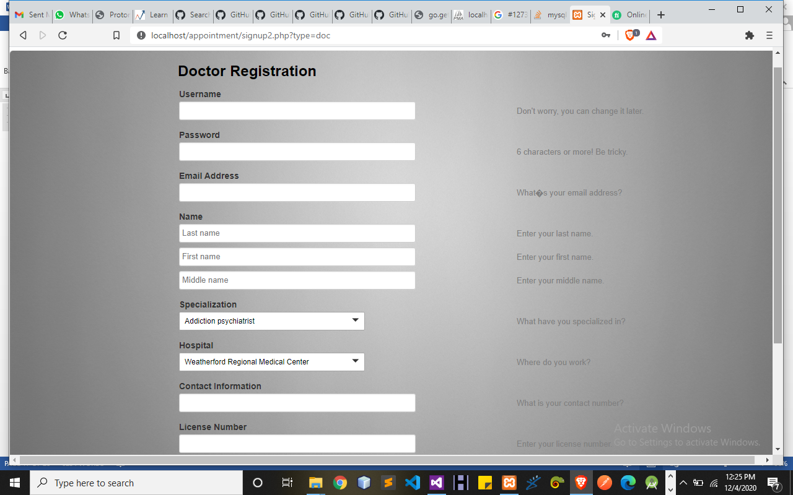
Figure 4.6: Doctor Registration Page
This Page allow doctor to get access to the system.
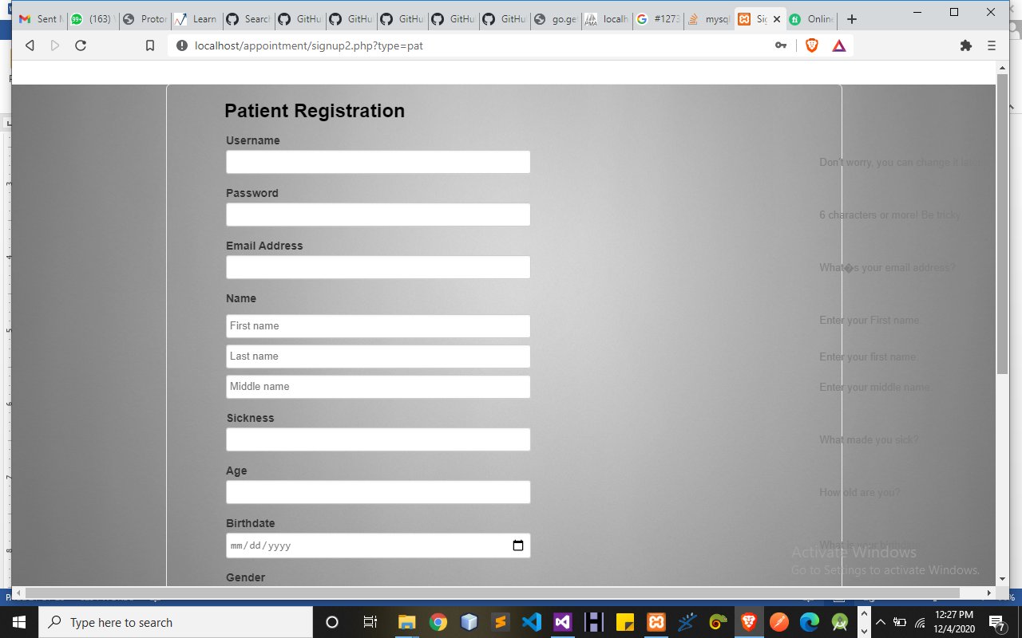
Figure 4.7: Patient Registration Page
This Page allows all patients to register and get access into the system.
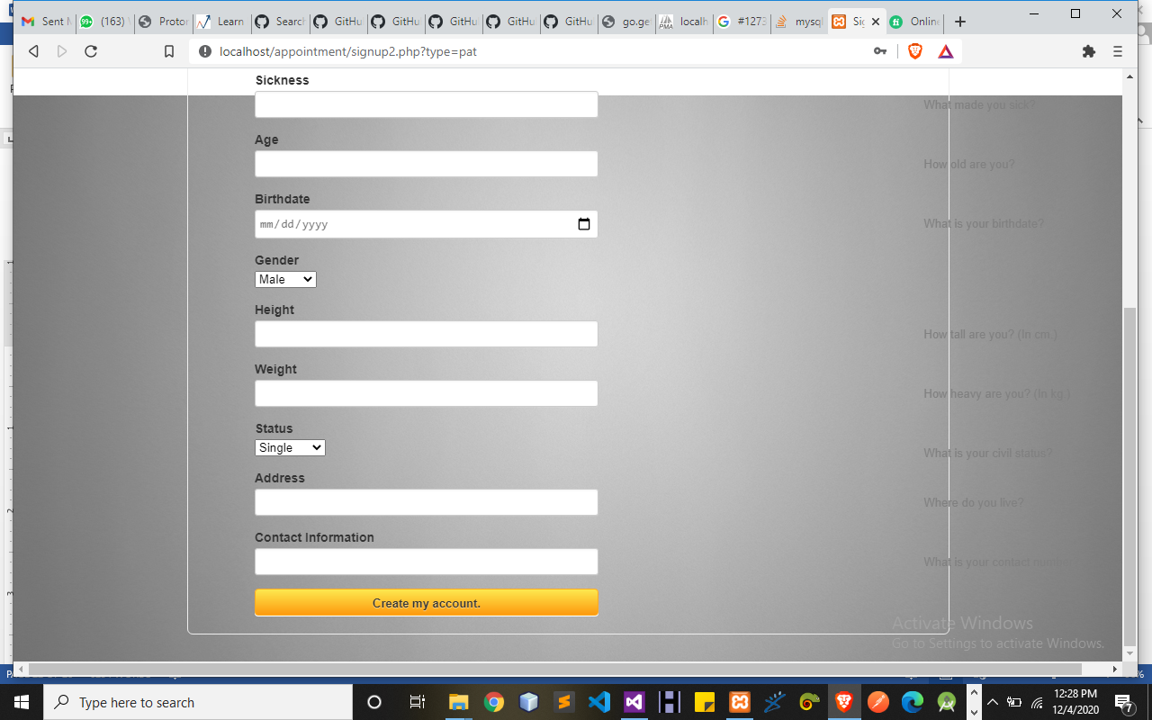
Figure 4.10: Add New Patient Page
4.1.3 DATABASE DESIGN
A database table is used for storing information about the files. The database use for this application is mysql database. The files and their respective modes of access as well as information they hold are given below;
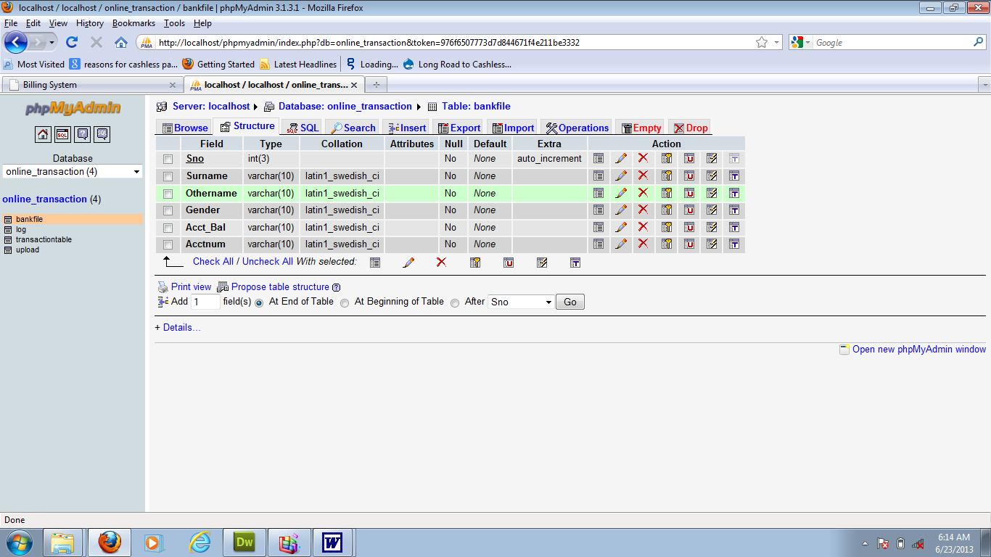
Table 4.1: Doctor Registration structure

Table 4.2: Admin Login Table structure
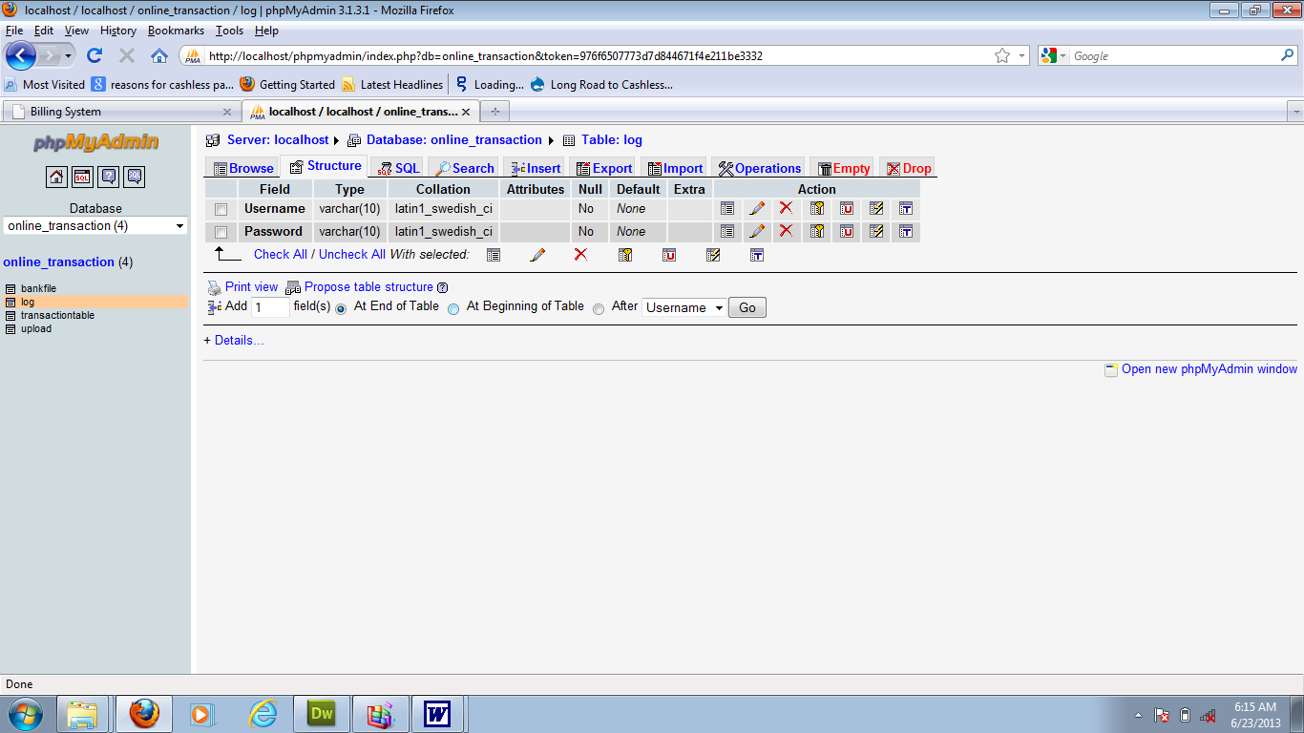

Table 4.3: Student Personal Data table
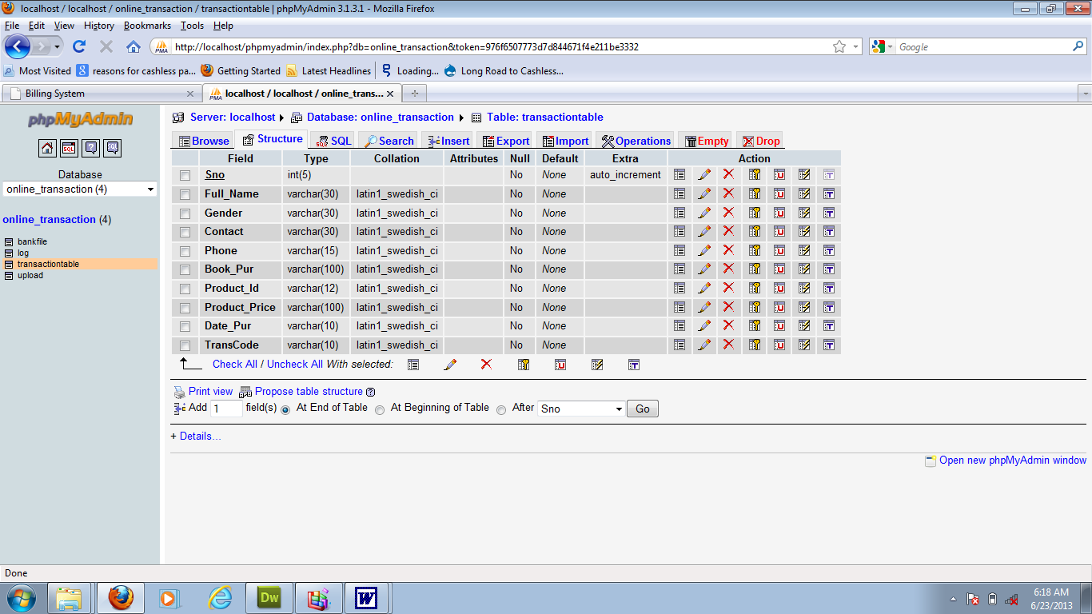

4.1.4 PROCEDURE DESIGN
Procedures are steps which verify the whole process i.e which are everything put together to produce the desired output. This involves the organization of the source document and end with the output result.
Documents are sent to various departments to be filled by the employees and later returned to the personnel department which are analysed to determine which record goes into the computer.
After selecting the necessary data, this serves as input to the computer system.

4.2 IMPLEMENTATION OF THE SYSTEM
It is always good to develop new ideas, to implement them on a computer and eventually to relish the satisfaction of achieving a successful result. The implementation process involves converting the system design into a complete and tested that is fully operational and that can be used by the system users to meet their business needs. During implementation phase, the hardware and the software must be implemented.
Implementation of a system can be explained in six steps:-
1. Review design specification
2. Code, test and document programs
3. Train users
4. Perform system test
5. Convert to new system
6. Evaluate and maintain the new system

4.2.1 CHOICE OF PROGRAMMING LANGUAGE
The application is designed in Sublime web development package which involves the use of PHP server-side scripting language, MYSQL for database management and HTML 5(with other embedded functionalities) for the page design and layout settings. Hence, the program testing simply involves running it directly from a Mozilla Firefox web browser on local host server provided by Apache 2.0 in WampServer 2.0 application.
In the preparation for the installation of the new system, the method of changeover is given serious consideration to determine the success of the new system. Suitable changeover technique for this system is pilot changeover. The pilot changes over and operates by applying the new system bit-by-bit until it covers the whole of the operations. The result obtained from using the pilot method on a small portion of the operations would be used in determining the suitability of the need system for the rest of the operations. This method is similar to testing small sample of a distribution if the test yields a good result then the whole system because fully operational and the manual/existing system is eliminated.
4.2.2 HARDWARE SUPPORT
i. Minimum of Microcomputer Pentium II- Intel 533 MHZ processor, 128 MB RAM, 3.5GB HDD, 3.5”FDD, 14” VGA Monitor Windows 2000 Enhanced keyboard, mouse and pad.
ii. Scanner
iii. Printer
iv. HP DeskJet 3820c series

4.2.3 SOFTWARE
I. Interface Design Language, windows Notepad for help interface design Hypertext Mark-up Language (HTML 5)
ii. MY SQL Database Management Software
iii. Programming PHP (Hypertext Pre-processor)
iv. Operating system window 07 professional
v. Graphic software paint shop and choosing these two formats GIF (Graphic Image Format)
vi. Scanner software, Mira scan
Web browser software MOZILLA

4.3 PROGRAM DOCUMENTATION
4.3.1 OPERATING THE SYSTEM
Step 1: Boot your computer and click on start button on task bar
Step 2: Launch wamp server
Step 3: Login to your Application
Step 4: Click on Options
4.1 Click on Dashboard (to view operations)
4.2 Click on Appointment (to add new Appointment)
4.3 Click on Edit (to make update)
Step 5: Logout
4.3.3 MAINTAINING THE SYSTEM
The use of the term maintenance for software is different from other references to maintenance. Unlike the tires on your car, software does not “wear out”. If this is the case, then why does software maintenance account for such a high percentage of the Total Cost of Ownership for software?
The software maintenance definition refers to changes for defect correction, performance improvements, or adaptations to a changed environment (enhancements). According to this definition, if we build software that is defect-free, performs well, and contains user-controlled parameters to adjust processing rules in response to changing requirements then most maintenance would not be necessary.
Why does this happen? There are many reasons but the most common reasons are time constraints and lack of experience. Adding validation logic takes time. So, people make assumptions about the quality of in-bound data. Assumptions are also made about the volume of transactions and the impact on performance and the stability of the automated business processes. Finally, it is common for new software to be developed by younger developers who don’t understand the maintenance impacts of their designs.
The reality is that business requirements change and most of these assumptions are flawed. Transaction volumes increase, changing business processes require new transactions or new validation criteria, and software users will use the software incorrectly. The cost of software maintenance and the total cost of ownership can dramatically be reduced if developers build software that adjusted to changes in transaction volumes; validated all inbound data and provide user-configurable options for decision logic and data validation

CHAPTER FIVE
SUMMARY, CONCLUSION AND RECOMMENDATIONS
5.1 SUMMARY
The aim of this project was to design and develop a software prototype which integrates with an external scheduling component to manage clinic appointments for patient. The application has been designed to be used by patients to assist them with scheduling. A software development methodology was determined and followed to ensure the successful completion of the project. A number of different tools were researched to develop the solution. The requirements of the system were established which were then used in the development phase. Following the successful implementation of the system, the application was tested and evaluated for usability and functionality to see overall how successful the project had been. The final solution developed met all the minimum requirements and also included some additional features. The report covers the whole project from start to finish, including the requirements analysis, background reading, design, implementation, testing and evaluation stages.
5.2 CONCLUSION
One of the biggest reasons that online appointment scheduling is getting popular day by day is that it helps the patients to make the appointment to their doctors, department in an easier way. It makes it through the computer, access a website or software and makes an appointment, than to go to the department, wait in a line for a number of hours, just to make an appointment with the doctor for the next week or next month. And through this, patients can also involve in the clinic decisions that they have to make. They can make an appointment to another lecturer other than theirs, by nothing more than a click.

5.3 RECOMMENDATIONS
Computer has become an indispensable tool to all fields of human Endeavour. For the management to be able to perform the functions which include planning, organizing, controlling, directing, coordinating and decision making? There is need for a computerized system.
When patient appointment records are computerized, it will go a long way to help the clinic. I therefore, recommend this software to every firm that gives appointment.

REFERENCE
Adams, G., et al. (2020). Investigating nurse practitioners in the private sector: A theoretically informed research protocol. Journal of Clinical Nursing, 26, 1608–1620. doi:10.1111/jocn.13492
Alavi, H., (2019). Addressing research design problem in mixed methods research. Management
Systems in Production Engineering, 21, 62–66. doi:10.12914/MSPE-10-01-2019
Alderfer C., & Sood G. (2019). Using qualitative research methods to improve clinical care in pediatric psychology. Clinical Practice in Pediatric Psychology, 4, 358–361. doi:10.1037/cpp0000164
Alice B., (2020).Thailand: successful e-health system lauded. FutureGov. Accessed
from: http://www.futuregov.asia/articles/2009/may/14/thail and-successful-e-health system-increase-healt/
Baum D., (2020). Creating the almost perfect medical practice: Part I. Journal of Medical
Practice Management, 34, 61–64. Retrieved from https://greenbranch.com/store/index.cfm
Bradley V. (2010). Guidance on De-identification of Protected Health Information. Office for Civil Rights.U.S. Department of Health & Human Services. Accessed from: http://www.hhs.gov/ocr/privacy/hipaa/understanding/coveredentities/De-identification/hhs_deid_guidanc e.pdf
Samirah, R. (2019) successful billing strategies in the hospital industry. I.J. Information Engineering and Electronic Business, 2020, 1, 50-58 Published Online May 2020 in MECS : https://www.researchgate.net/publication/256298039
Sura A., (2019) hospital management system. Hospital Management System provides the beneﬁts of streamlined operations.
Premkumar, B. & Kalpana Z. (2020) e-hospital management & hospital information systems changing trends. I.J. Information Engineering and Electronic Business, 2020, 1, 50-58 Published Online May 2020 in MECS, https://www.researchgate.net/publication/256298039.

SYSTEM FLOWCHART
Report
View appointment Table
Logout
Stop
Generate Appointment Time
Main Menu
Login
Splash Screen

Start

SPLASH SCREEN
Close Database

Open Database

Stop
Display Splash
Start

LOGIN
Open Database

Is Username and Password Correct?
Is any field empty?
Enter Username and Password
Start
Yes

All field are required to proceed

No
No
Invalid Username and Password

Yes
Main Menu
Close Database

Return

MAIN MENU
Is it option Logout?
Yes
Appointments
No
Yes
Patient
Is it option Patient
?
No
Yes
Report
Is it option Report
t?
No
Yes
Registration
Is it option Registration?
No
Yes
No
Close Database

Return
End Select
No
No
Logout
Open Database

Select option
Start

Is it option Appointments
?

GENERATE APPOINTMENT
Display case Details
Close Database

Open Database

All Field are required to Proceed
Is any Field Empty
?
Enter Case Details
Return
Start
Yes
No

Display case Details

Save to Database

VIEW APPOINTMENT
View appointment
Open Database

Open Database

Stop
Start

REPORT
Open Database

Open Database

Stop
Start
Report

VIEW APPOINTMENT TABLE
Open Database

Open Database

Stop
Start
View Appointment

LOGOUT
No
Close Database

Open Database

Main Menu
Welcome Page
Click on Login
Return
Do you want to Logout?
Start
Yes

Source Code
<?php
include("dashboard.php");
session_start();
?>
<div class="inner_content">
<!-- /inner_content_w3_agile_info-->

<!-- breadcrumbs -->
<div class="w3l_agileits_breadcrumbs">
<div class="w3l_agileits_breadcrumbs_inner">
<ul>
<li><a href="main-page.html">Home</a><span>«</span></li>
<li>Dashboard <span>«</span></li>
<li>Transfer</li>
</ul>
</div>
</div>
<!-- //breadcrumbs -->

<div class="inner_content_w3_agile_info two_in">
<h2 class="w3_inner_tittle">Sending by Email</h2>

<!--/forms-->
<div class="forms-main_agileits">

<div class="graph-form agile_info_shadow">
<h3 class="w3_inner_tittle two">Send Files </h3>
<div class="form-body">
<form method="post" action="send_process.php" enctype="multipart/form-data">
<div class="form-group">
<label for="exampleInputFile">Select File</label>
<input type="file" id="File" name="file">
</div>
<div class="form-group">
<label for="inputEmail3" class="col-sm-2 control-label">Your Email</label>
<div class="col-sm-9">
<input type="email" class="form-control" id="sender" name="sender" placeholder="Sender Email">
</div>
</div>
<div calss="form-group">
<label for="Space" class="col-sm-12 control-label"></label>
</div>
<div class="form-group">
<label for="inputEmail3" class="col-sm-2 control-label">To</label>
<div class="col-sm-9">
<input type="email" name="receiver" class="form-control" id="receiver" placeholder="Receiver Email">
</div>
</div>
<div calss="form-group">
<label for="Space" class="col-sm-12 control-label"></label>
</div>
<div class="form-group">
<label for="note" class="col-sm-2 control-label">Notes</label>
<div class="col-sm-9">
<textarea class="form-control" name"notes" id="notes"> </textarea>
</div>
</div>
<div calss="form-group">
<label for="Space" class="col-sm-12 control-label"></label>
</div>
<div class="col-sm-offset-2">
<button type="submit" class="btn btn-default">Send</button>
</div>
</form>
</div>

</div>
</div>
</div>
<?php include("footer.php");?>
<!--
author: W3layouts
author URL: http://w3layouts.com
License: Creative Commons Attribution 3.0 Unported
License URL: http://creativecommons.org/licenses/by/3.0/
-->
<!DOCTYPE html>
<html lang="zxx">
<head>
<title>Encryption</title>
<!-- custom-theme -->
<meta name="viewport" content="width=device-width, initial-scale=1">

</ul>
</li>
<li class="second top_bell_nav">
<ul class="top_dp_agile ">
<li class="dropdown head-dpdn">
<a href="#" class="dropdown-toggle" data-toggle="dropdown" aria-expanded="true"><i class="fa fa-bell-o" aria-hidden="true"></i></a>
<ul class="dropdown-menu">
</ul>
</li>

</ul>
</li>
<li class="second top_bell_nav">
<ul class="top_dp_agile ">
<li class="dropdown head-dpdn">
<a href="#" class="dropdown-toggle" data-toggle="dropdown" aria-expanded="true"><i class="fa fa-envelope-o" aria-hidden="true"></i></a>
<ul class="dropdown-menu">
</ul>
</li>

</ul>
</li>
<li class="second top_bell_nav">
<ul class="top_dp_agile ">
<li class="dropdown head-dpdn">
<a href="#" class="dropdown-toggle" data-toggle="dropdown" aria-expanded="false"><i class="fa fa-tasks"></i></a>
<ul class="dropdown-menu">
</ul>
</li>
</ul>
</li>

<li class="second w3l_search">
<form action="#" method="post">
<input type="search" name="search" placeholder="Search here..." required="">
<button class="btn btn-default" type="submit"><i class="fa fa-search" aria-hidden="true"></i></button>
</form>
</li>
<li class="second full-screen">
<section class="full-top">
<button id="toggle"><i class="fa fa-arrows-alt" aria-hidden="true"></i></button>
</section>
</li>

</ul>
<!-- //nav -->

</div>
<?php
include("dashboard.php");
session_start();
?>
<div class="inner_content">
<!-- /inner_content_w3_agile_info-->

<!-- breadcrumbs -->
<div class="w3l_agileits_breadcrumbs">
<div class="w3l_agileits_breadcrumbs_inner">
<ul>
<li><a href="main-page.html">Home</a><span>«</span></li>
<li>Dashboard <span>«</span></li>
<li>Operation</li>
</ul>
</div>
</div>
<!-- //breadcrumbs -->

<div class="inner_content_w3_agile_info two_in">
<h2 class="w3_inner_tittle">Encryption</h2>

<!--/forms-->
<div class="forms-main_agileits">

<div class="graph-form agile_info_shadow">
<h3 class="w3_inner_tittle two">Encrypt File </h3>
<div class="form-body">
<form method="post" action="encrypt.php" enctype="multipart/form-data">
<div class="form-group">
<label for="exampleInputFile">Select File</label>
<input type="file" id="File" name="file">
</div>
<div class="form-group">
<label for="rsakey"> RSA Key</label>
<input type="Text" name="rsakey" class="form-control" id="rsakey" placeholder="Key" required>
</div>
<button type="submit" class="btn btn-default">Encrypt in RSA</button>
</form>
<?php
echo @$_SESSION['redow4'];
?>
<form method="post" action="encryptfish.php" enctype="multipart/form-data">
<div class="form-group">
<label for="rsakey"> Blowfish Key</label>
<input type="Text" name="fishkey" class="form-control" id="fishkey" placeholder="Key" required>
</div>
<button type="submit" class="btn btn-default">Encrypt in Blowfish</button>
</form>
<?php echo @$_SESSION['redow5'];
echo @$_SESSION['redow1'];
?>
</div>
</div>
<?php include("footer.php");?>

<?php
unset($_SESSION['redow1']);
unset($_SESSION['redow4']);
unset($_SESSION['redow5']);
?>

