DESIGN AND INSTALLATION OF 4.2KVA INVERTER SYSTEM

BY
SULAIMON MUYIDEEN OLAIYA
ND/23/EEE/PT/0201

A RESEACH PROJECT SUBMITTED TO THE DEPARTMENTOF ELECTRICAL/ELECTRONICS ENGINEERING, INSTITUTE OF TECHNOLOGY,
KWARA STATE POLYTECHNIC, ILORIN.
IN PARTIAL FULFILLMENT OF REQUIREMENTS FOR THE AWARD
OF NATIONAL DIPLOMA IN ELECTRICAL/ELECTRONICS ENGINEERING
KWARA STATE POLYTECHNIC, ILORIN.

SEPTEMBER, 2025.

CERTIFICATION

This is to certify that this work “DESIGN AND INSTALLATION OF 4.2KVA INVERTER SYSTEM” has been read and approved as meeting the requirement of Electrical/Electronics Engineering, Institute of Technology (IOT), Kwara State Polytechnic, Ilorin, in partial fulfilment of the requirement for the award of National Diploma in Electrical/Electronics Engineering.

__________________________ ____ ___________________

ENGR ABDULLATEEF OLA ADEBAYO DATE
(PROJECT SUPERVISOR)

_______________________________ ___________________
ENGR. K. LATEEF DATE
(PROJECT CO-ORDINATOR)

__________________________ ______ ___________________
ENGR. BELLO BASIR DATE
(PART-TIME CO-ORDINATOR)

__________________________ ______ ___________________
EXTERNAL EXAMINER DATE

DEDICATION
I am delight to dedicate this report to Almighty ALLAH who gave me the grace and opportunity to complete this program.
And I also dedicate it to my lovely parent Mr. and Mrs. SULAIMON. Who gave me the grace and opportunity for the period of my industrial training, and project throughout my ND Program, may God Almighty continue to bless them and be with you forever.

ACKNOWLEDGMENT
All praises, adoration and gratitude are all due to Almighty ALLAH. My gratitude also goes to my industrial supervisors who devoted his time for me throughout my stay in the company to make sure I attained maximum knowledge during my program.
My special thanks to my lovely caring and hearted parents, my Mr. and Mrs. SULAIMON who stood by me that do not let me fall also for their moral and financial assistance rendered throughout my ND program.
Also to my unforgettable siblings, may God Almighty ALLAH be with you all.
Also to my always hardworking engineers in the department of Electrical/Electronics Engineering starting from my HOD of the Department, the Exam coordinator, and all the entire lectures in the great department for their effort and knowledge they impacted on us throughout the ND program may God Almighty be with you all.
And also to all my amiable friends in the department and in the school entirely, may how friendship leads us all to janatu-l-firidaos Amin.

ABSTRACT
This project presents the design and implementation of a 4.2 kVA hybrid inverter system aimed at providing reliable, efficient, and sustainable electricity for residential applications. The motivation for the study stems from Nigeria’s persistent energy shortages and the need for affordable renewable energy solutions that reduce reliance on fossil fuel generators. The specific objectives include load estimation, proper sizing of solar panels, battery storage, and inverter components, as well as installation, testing, and performance evaluation in real operating conditions.
The methodology adopted began with a site assessment, including roof orientation, shading analysis, and structural integrity checks to ensure optimal placement of solar modules. A residential load analysis estimated a daily demand of 6.1 kWh, forming the basis for system sizing. A 4.2 kVA / 48 V hybrid inverter was selected to accommodate both present demand and potential future expansion. The battery bank was sized at 450 Ah (48 V) to provide 1.5 days of autonomy, while an array of 2.0 kW solar panels was designed to meet daily consumption and ensure sufficient charging capacity. The methodology further encompassed wiring design, component integration, and adherence to safety and regulatory standards.
The significance of the study lies in demonstrating the technical, economic, and environmental viability of medium-capacity hybrid solar systems for households and small offices. The findings are expected to contribute to the wider adoption of clean energy technologies in developing regions, offering a scalable and sustainable alternative to conventional power generation.

TABLE OF CONTENT
Title page
Certification
Dedication
Acknowledgement
Abstract
Table of Contents
CHAPTER ONE: INTRODUCTION
1.1 Background of the Study
1.2 Problem Statement
1.3 Aim and Objectives
1.4 Scope of the Study
1.5 Justification of the Study
1.6 Significance of the Study
1.7 Limitations
CHAPTER TWO: LITERATURE REVIEW

2.1 Overview

2.2 Energy Demand and Power Reliability Challenges in Nigeria

2.3 Overview of Solar Energy Systems

2.4 Hybrid Power Systems

2.5 Inverter Technology

Types of Inverters

Key Features of Hybrid Inverters

2.6 Battery Storage Technologies

Battery Types

2.6.2 Battery Sizing and Management

2.7 Energy Management Systems (EMS)

2.8 Component Sizing Techniques

2.9 Review of Related Works

2.10 Nigerian Context for Renewable Energy Deployment

2.11 Environmental and Economic Benefits

2.12 Summary of Gaps and Contribution of This Study
CHAPTER THREE: METHODOLOGY
3.1 Site Assessment and Preliminary Analysis
3.2 Methodological Steps
3.3 Load Estimation
3.4 Inverter Sizing
3.4.1 Inverter Capacity Calculation
3.5 Battery Bank Sizing
3.5.1 Formula:
3.6 Solar Panel Sizing
3.6.1 Formula:
3.7 Charge Controller Sizing
  - System Layout and Wiring Diagram (Described Verbally)
3.9 Component Selection Criteria
    - Inverter
    - Batteries
    - Solar Panels
    - Accessories
3.10 Installation Procedure
3.11 Testing and System Monitoring
3.12 Safety Measures and Compliance
3.13 Economic Cost Estimation
3.14 Environmental Considerations
3.15 Solar Panel Orientation and Tilt
3.16Weather and Climatic Impact
  - Rationale for Manual Design
3.18 Load Prioritization Strategy
3.19Component Lifespan
CHAPTER FOUR
4.0 RESULTS AND DISCUSSION
4.1 Installation Outcome Overview
4.2 Load Support Capability

4.3 Inverter Performance

4.4 Battery Autonomy and Runtime

4.5 Solar Charging Efficiency

4.6 System Stability and Load Handling

4.6 User Experience and Monitoring

4.7 Comparative Analysis with Generator Use

4.8 Challenges Observed

4.11 Economic Viability and Payback Period
4.12 Bill of Engineering Measurement and Evaluation (BEME)
CHAPTER FIVE: CONCLUSION AND RECOMMENDATION

5.1 Conclusion

5.2 Recommendations

For Future Installations

For Policy Makers and Energy Agencies

For Academic and Technical Institutions

For Community Awareness

5.3 Opportunities for Future Work
REFERENCES

CHAPTER ONE
INTRODUCTION
1.1 Background of the Study
The global energy landscape is undergoing a rapid transformation due to increasing concerns over environmental degradation, energy security, and the rising cost of fossil fuels. In developing nations like Nigeria, persistent power outages, unstable grid supply, and the high operational costs of diesel generators have pushed both residential and commercial users toward more sustainable and efficient energy solutions. Hybrid inverter systems, particularly solar-based systems, offer a viable alternative that integrates renewable energy with backup storage to provide uninterrupted, clean, and cost-effective electricity.
A hybrid inverter system is an advanced power conversion device that combines solar photovoltaic (PV) input, battery storage, and grid support to deliver power to end-users. Unlike traditional standalone inverters, a hybrid inverter can intelligently manage multiple energy sources and optimize their usage based on availability and demand. With the growing affordability of solar panels and batteries, hybrid systems have become accessible to a broader population, allowing individuals and institutions to reduce their dependence on the national grid while improving power reliability.
In the context of Nigeria, where power outages occur frequently and last for several hours or even days, a well-designed hybrid inverter system offers immense benefits. A 4.2kVA system is particularly suited for small to medium-sized residential homes, small businesses, and institutions. It is capable of supporting lighting systems, fans, televisions, refrigerators, computer systems, and other low to moderate power-consuming appliances. The installation of such systems has the potential to revolutionize domestic energy management, enhance productivity, and reduce environmental pollution caused by fossil-fuel generators.
1.2 Problem Statement
Electricity supply in Nigeria remains grossly inadequate, unreliable, and often unaffordable for a large segment of the population. Grid electricity is frequently unavailable due to infrastructural decay, vandalism, insufficient generation capacity, and poor transmission networks. As a result, most households and businesses depend on gasoline or diesel generators to meet their energy needs. These generators are noisy, environmentally unfriendly, and expensive to maintain.
Moreover, the growing demand for energy continues to outpace supply, aggravating the energy access problem. Solar energy offers a sustainable solution, yet many installations in Nigeria remain suboptimal due to poor design, improper sizing, inadequate storage systems, or lack of hybrid integration. The absence of intelligent switching between solar, battery, and grid input leads to inefficiencies and power shortages.
This project seeks to address these challenges by designing and implementing a well-sized and properly installed 4.2kVA hybrid inverter system that ensures reliable power supply while maximizing the use of renewable energy.
1.3 Aim and Objectives
The aim of this project is to design and implement a 4.2kVA hybrid inverter system capable of providing reliable, efficient, and sustainable power supply for residential use.
The specific objectives of the project are:
- to evaluate the power demand of a typical residential building.
- to size and select appropriate solar panels, battery storage, and inverter components for a 4.2kVA hybrid system.
- to install and integrate the components in compliance with electrical standards.
- to test the system’s performance in real operating conditions.
- to analyze the economic and environmental benefits of the hybrid system.
1.4 Scope of the Study
This project focuses on the installation of a medium-capacity (4.2kVA) hybrid inverter system intended for a typical residential or home-office setup. The study encompasses load analysis, system design, procurement of components, physical installation, and system evaluation. The system integrates solar PV modules, a hybrid inverter, battery bank, charge controller, and appropriate protective devices.The study does not cover industrial-scale power systems, wind or hydro components, or advanced remote monitoring integrations beyond standard inverter mobile apps.
1.5 Justification of the Study
Given the dire state of electricity in Nigeria, there is an urgent need for affordable and environmentally sustainable energy solutions. A 4.2kVA hybrid inverter system can significantly reduce dependence on fossil fuel generators, minimize operational costs, and reduce greenhouse gas emissions. It also serves as a template for scalable energy systems that can be adopted by low- and middle-income households, businesses, and educational institutions.Moreover, this project contributes academically by providing a step-by-step approach to inverter installation and real-life performance assessment, which can serve as a reference for students, engineers, and technicians.
1.6 Significance of the Study
The significance of this project lies in its practical and replicable approach to addressing energy poverty using hybrid solar technology. The study:
- Provides a practical guide to inverter installation
- Demonstrates technical and economic feasibility
- Offers empirical data on system performance
- Encourages the adoption of green energy in developing regions
1.7 Limitations
While this project provides a functional and efficient hybrid inverter system, certain limitations exist:
- The system’s capacity is limited to 4.2kVA and is unsuitable for heavy industrial loads.
- Solar energy availability is affected by weather conditions.
- The budget restricts the number of batteries and advanced monitoring equipment.
- Real-time data logging over extended periods is not included.

CHAPTER TWO
LITERATURE REVIEW

2.1 Overview
This chapter reviews the theoretical and empirical foundations of hybrid inverter systems with an emphasis on solar energy integration, energy storage technologies, power electronics, and the state of renewable energy adoption in Nigeria. It draws from scholarly articles, technical manuals, engineering standards, and real-world case studies to contextualize the design and deployment of a 4.2kVA hybrid inverter system.

2.2 Energy Demand and Power Reliability Challenges in Nigeria
Nigeria, with a population of over 200 million, has long struggled with an unreliable power supply. The country’s national grid is plagued by frequent outages, poor transmission infrastructure, and inadequate generation capacity. According to the Nigerian Electricity Regulatory Commission (NERC, 2021), only about 57% of the population has access to electricity, with much lower reliability in rural areas. Even in urban centers, daily blackouts are common, leading to heavy dependence on fossil-fuel generators (Oyedepo, 2012).These challenges have fueled interest in decentralized renewable energy solutions, especially solar photovoltaic (PV) systems. Hybrid inverter systems provide a realistic solution by bridging the reliability gap through energy storage and intelligent switching between multiple power sources.

2.3 Overview of Solar Energy Systems

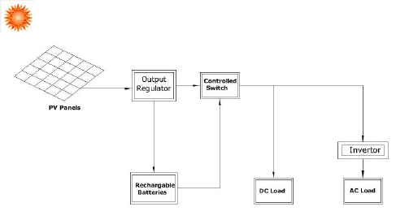

Figure 2.1: Basic Configuration of a Solar PV System
Solar energy systems are designed to capture sunlight and convert it into usable electrical energy. The basic components include:
- Photovoltaic (PV) Panels: Convert sunlight into direct current (DC).
- Inverter: Converts DC to alternating current (AC).
- Charge Controller: Regulates voltage and current to the batteries.
- Battery Bank: Stores excess energy for use during low sunlight or grid failure.
- Balance of System: Includes mounting, wiring, and protective devices.
Solar energy is abundant in Nigeria, with average daily solar radiation ranging between 3.5 to 7.0 kWh/m²/day (Ikejemba et al., 2016). This makes it highly suitable for off-grid and hybrid systems.

2.4 Hybrid Power Systems
A hybrid power system combines two or more energy sources to deliver electricity more reliably and efficiently. Commonly used hybrids include solar-diesel, solar-grid, solar-wind, and solar-battery systems. Hybrid inverters lie at the heart of such systems, managing input from multiple sources and optimizing output.
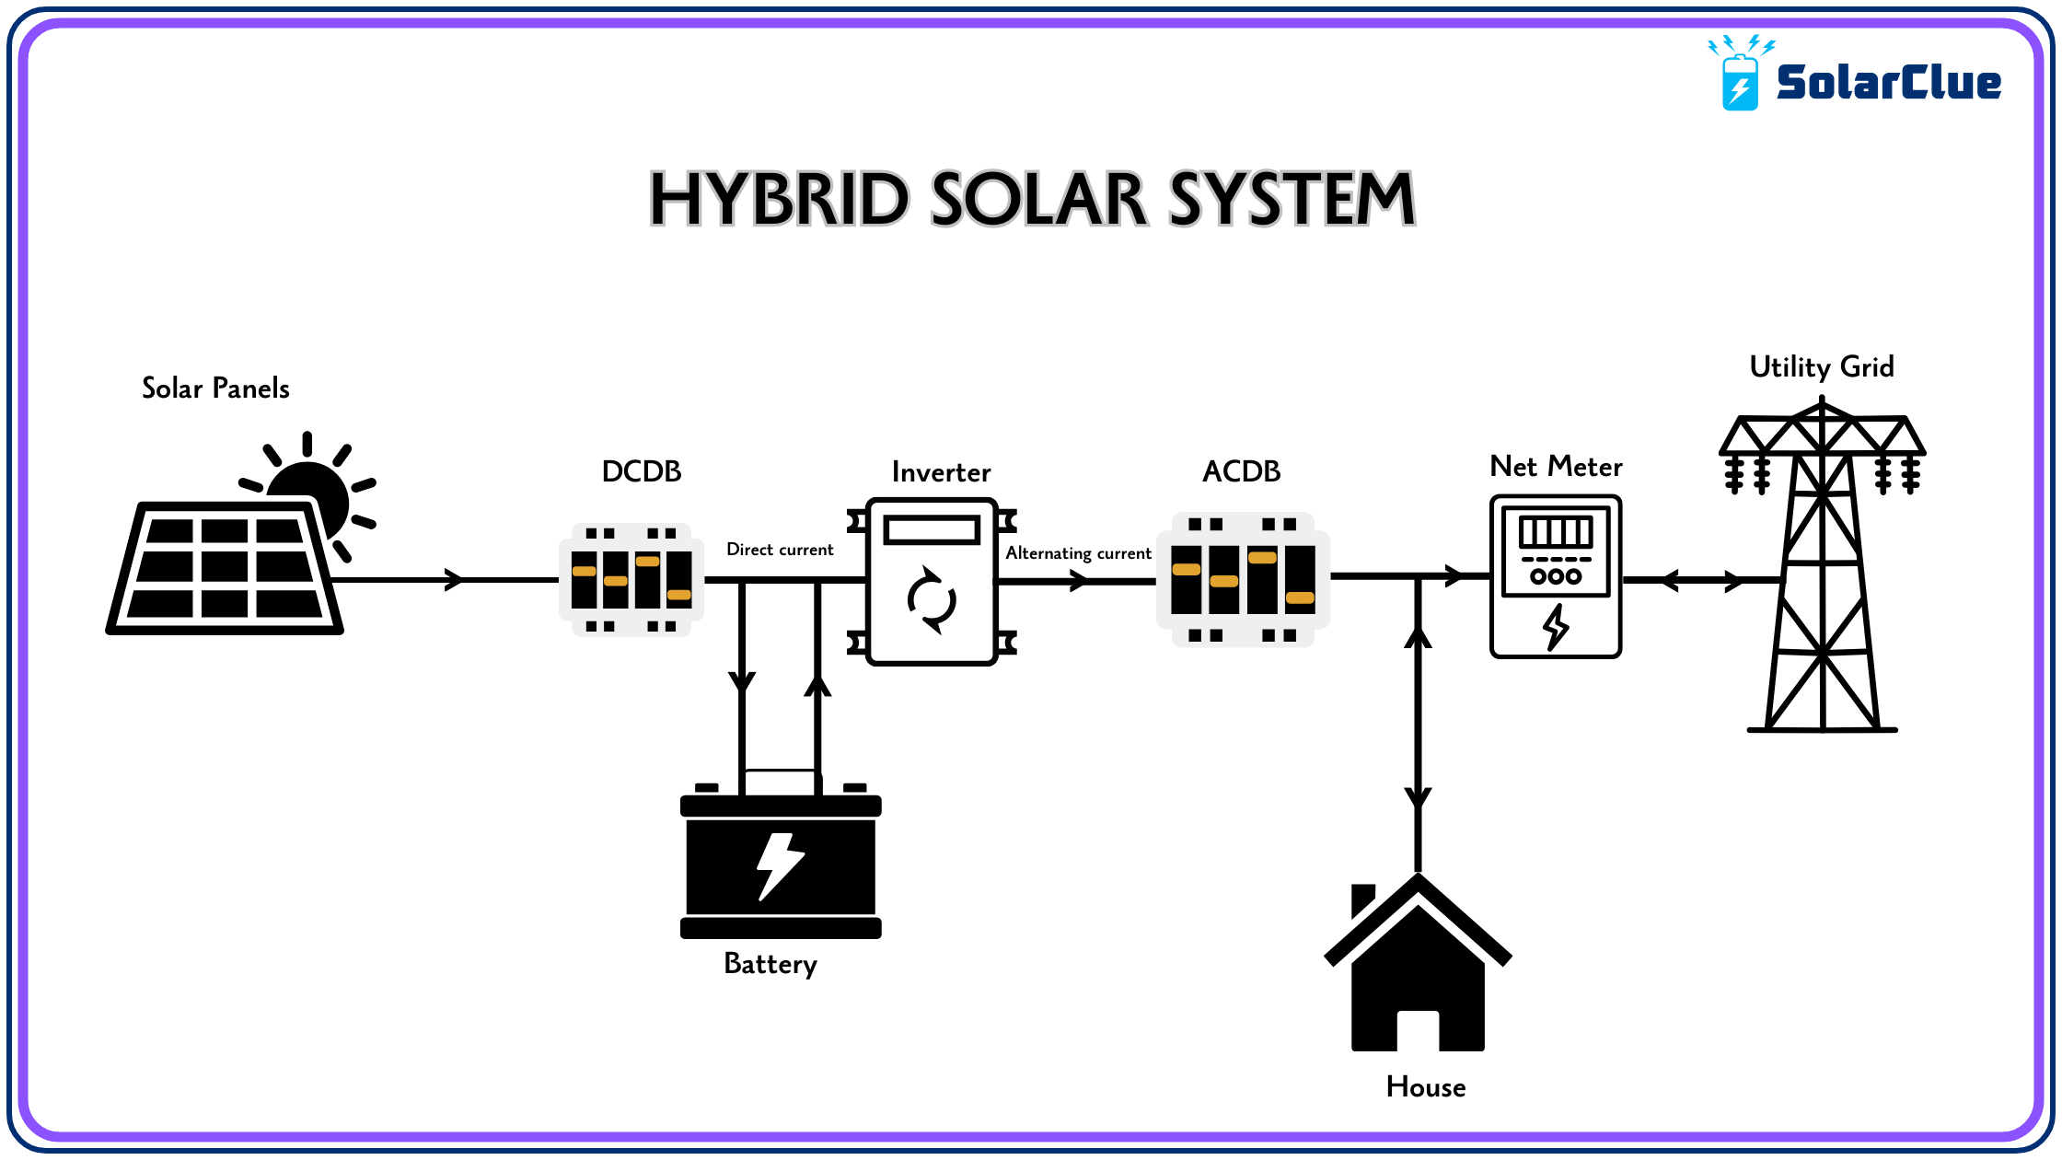
Figure 2.2: Schematic Layout of a Solar Hybrid System
Hybrid systems offer several advantages over single-source systems:
- Uninterrupted Power Supply through intelligent source switching.
- Improved Energy Efficiency via maximum power point tracking (MPPT).
- Cost Optimization by reducing generator or grid reliance.
- Environmental Benefits by integrating renewable sources (Hossain et al., 2019).

2.5 Inverter Technology
An inverter is a power electronic device that converts direct current (DC) into alternating current (AC). In solar applications, the inverter enables the use of DC energy stored in batteries or generated by PV panels to power AC appliances.

Types of Inverters
- Off-Grid Inverters: Operate independently of the national grid.
- Grid-Tied Inverters: Sync with the grid and may export excess power.
- Hybrid Inverters: Combine the capabilities of off-grid and grid-tied systems. They manage power from solar, battery, and grid sources and often support load prioritization, battery optimization, and net metering.
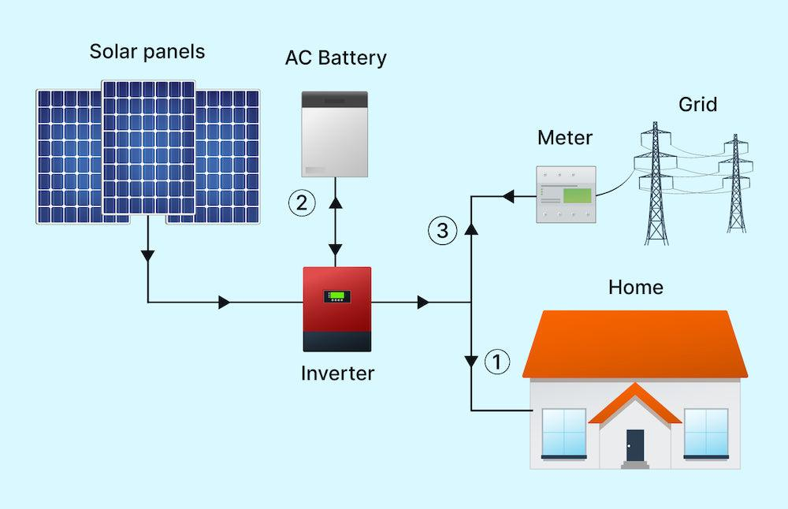
Figure 2.3: Types of Inverters Based on Functionality

Key Features of Hybrid Inverters
- MPPT tracking:Every solar panel has a Maximum Power Point (MPP) a specific combination of voltage and current at which the panel produces themostpower. However, this point changesthroughouttheday due to fluctuations in sunlight intensity, temperature, and shading. It is the real-time processof continuously adjustingthe electrical operating point of the solar panel to stay at or near that maximum power point, thereby maximizing the energy that is harvested and delivered to the battery or load.
- Battery management: Refers to the set of practices, technologies, and systems used to monitor, control, protect, and optimize battery performance in energy systemsespecially in hybrid inverter setups.
- Source prioritization (solar → battery → grid): refers to the intelligent sequence in which a hybrid inverter decides which power source to use first, in order to maximize efficiency, reduce costs, and extend system life.
- Load scheduling:is the process of planning when specificelectrical appliances should turn on or offto optimize energy usage in a solar or hybrid inverter system.
- Wi-Fi/IoT monitoring interfaces:are digital platforms that allow users to remotely monitor and control their hybrid inverter systemsusing internet-connected devices like smartphones, tablets, or computers.

2.6 Battery Storage Technologies
Energy storage is critical in hybrid systems, allowing energy generated during the day to be used at night or during grid failure.

Battery Types
- Lead-Acid Batteries: Affordable, widely used, but limited cycle life.
- Lithium-Ion Batteries: Longer lifespan, higher energy density, more expensive.
- Gel/AGM Batteries: Sealed lead-acid types with lower maintenance needs.
Battery selection depends on depth of discharge, efficiency, maintenance, cost, and lifecycle (Larcher&Tarascon, 2015).

2.6.2 Battery Sizing and Management
Correct battery sizing ensures the system can store sufficient energy to meet load demands. Oversized batteries increase cost, while undersized batteries lead to short backup times and accelerated degradation.

2.7 Energy Management Systems (EMS)
Modern hybrid systems rely on EMS to automate energy source prioritization, load shedding, charge-discharge cycles, and fault detection. A well-designed EMS:
- Enhances system lifespan
- Reduces energy losses
- Provides data for performance tracking
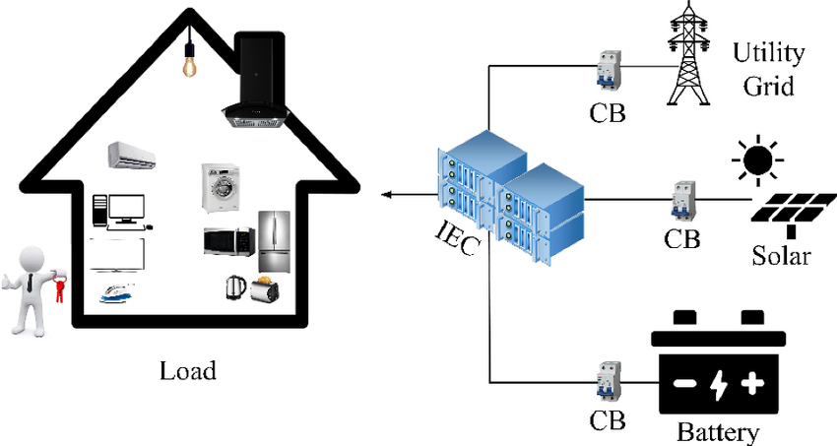
Figure 2.4: Architecture of an Energy Management System

Many hybrid inverters come with built-in EMS features and user-friendly mobile interfaces.

2.8 Component Sizing Techniques

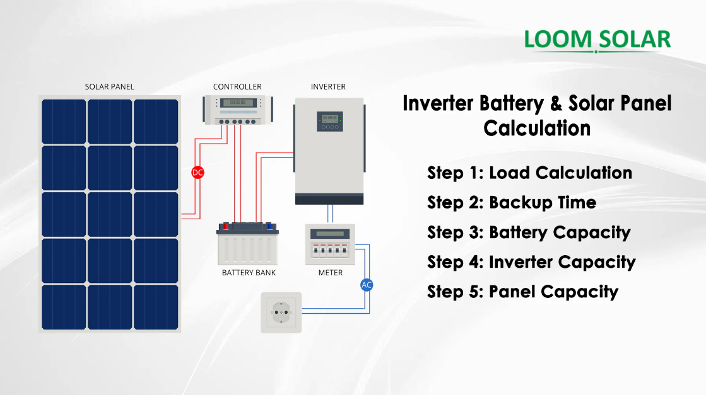

Figure 2.5: Manual Component Sizing Workflow for Hybrid Systems
Sizing is fundamental to system efficiency and includes the following steps:
- Load Analysis: Determining total daily energy demand (in Wh or kWh).
- Inverter Sizing: Must exceed peak load with a safety margin.
- Battery Sizing: Based on load, autonomy days, depth of discharge.
- PV Sizing: Depends on daily energy requirement and peak sun hours.
- Charge Controller Sizing: Based on array current and system voltage.
Under-sizing leads to overload, while over-sizing increases project cost (Chauhan & Saini, 2014).

2.9 Review of Related Works
Numerous studies have examined hybrid inverter system design and deployment in different contexts:
- Nwankwo et al. (2019) evaluated the economic feasibility of a 5kVA solar hybrid system in Abuja. They reported a 63% reduction in generator usage and a payback period of 5.8 years.
- Olatomiwa et al. (2016) proposed an optimal sizing model for hybrid systems in sub-Saharan Africa. Their simulation-based approach yielded 95% reliability.
- Ishola& Ajayi (2021) implemented a 3kVA hybrid inverter for rural homes and found that system uptime improved from 52% (grid only) to 96% (hybrid).
- Sambo (2009) emphasized the role of small-scale renewable installations in addressing Nigeria’s energy gap.
These works support the technical and economic feasibility of hybrid inverter systems and validate their adoption as a solution for energy-insecure regions.

2.10 Nigerian Context for Renewable Energy Deployment
Despite abundant solar resources, Nigeria’s renewable energy penetration remains low. Regulatory frameworks like the Renewable Energy Master Plan (REMP), the National Energy Policy (NEP), and the Electrification Roadmap (with Siemens) aim to promote off-grid solutions, but implementation is slow.
Barriers include:
- High initial cost
- Lack of skilled technicians
- Inconsistent government incentives
- Limited awareness
However, initiatives such as the Rural Electrification Agency (REA) and donor-funded mini-grid pilots have started driving awareness and adoption of hybrid systems, especially in rural areas (Ohunakin et al., 2014).

2.11 Environmental and Economic Benefits
Adopting hybrid inverters has both environmental and economic impacts:
- Reduces CO₂ emissionscompared to generators
- Lowers operational costsdue to zero fuel requirements
- Minimizes noise pollution
- Improves energy independence
These benefits contribute to SDG 7 (Affordable and Clean Energy) and SDG 13 (Climate Action).

2.12 Summary of Gaps and Contribution of This Study
While previous studies provide valuable insights, many focus on simulation or large-scale systems. This study addresses a practical gap: demonstrating thefield installation and real-time performance of a 4.2kVA hybrid inverter system in a Nigerian residential setting.
It contributes:
- A practical guide to sizing and installing hybrid systems
- Real-world performance data under Nigerian conditions
- A case for broader adoption of solar hybrid technology

CHAPTER THREE
METHODOLOGY
3.1 Site Assessment and Preliminary Analysis
The first step in the installation process was a thorough site assessment to evaluate the environmental and structural conditions of the proposed installation area. The assessment involved:
- Measuring roof tilt and orientation: The roof was found to face south, which is ideal for solar panel placement in Nigeria.
- Checking for shading: Trees, water tanks, and nearby structures were analyzed to ensure they did not cast shadows on the intended solar panel location during peak sunlight hours.
- Structural inspection: The roof’s strength and stability were confirmed to support the weight of solar panels and mounting structures.
This stage was critical in determining the feasibility of installing the system and influencing component orientation for maximum solar yield.
3.2 Methodological Steps
The methodology follows these stages:
- Load Estimation and Profiling
- Sizing of System Components (Inverter, Batteries, Solar Panels)
- Selection of Components Based on Ratings
- Wiring Design and Electrical Integration
- Installation and Mounting
- System Testing and Commissioning
- Economic Feasibility Analysis
- Safety and Regulatory Compliance

3.3 Load Estimation
Load estimation is the foundation of every solar system design. It determines the required capacity of each component. This was done by:
- Listing all appliances to be powered by the system.
- Recording each appliance’s wattage and estimated usage time (hours per day).
- Calculating the total daily energy consumption in watt-hours (Wh).
Table 3.1: Sample Residential Load Estimation
Appliance | Quantity | Power Rating (W) | Usage (hrs/day) | Daily Energy (Wh)
LED Bulbs | 10 | 10 | 5 | 500
Ceiling Fans | 4 | 75 | 8 | 2400
Television | 1 | 100 | 5 | 500
Laptop | 1 | 60 | 6 | 360
Refrigerator | 1 | 200 | 10 | 2000
Router/Modem | 1 | 15 | 24 | 360
Total |  |  |  | 6120 Wh/day
Therefore, the total energy requirement is 6.1 kWh/day.
3.4 Inverter Sizing
The inverter converts stored DC electricity from the battery or PV panels into AC electricity for home use.

3.4.1 Inverter Capacity Calculation
The inverter must handle both the total wattage of running appliances and a surge margin for inductive loads (e.g., refrigerators, fans).
Inverter Capacity (W) = Total Load (W) × Safety Factor

Where:
Total Load (W) = Sum of power ratings of all appliances to be powered
Safety Factor = Typically 1.3 to 1.5 (to account for start-up surges and future expansion)
A 4.2kVA / 48V hybrid inverter was selected to ensure future scalability and provide adequate power during high usage.
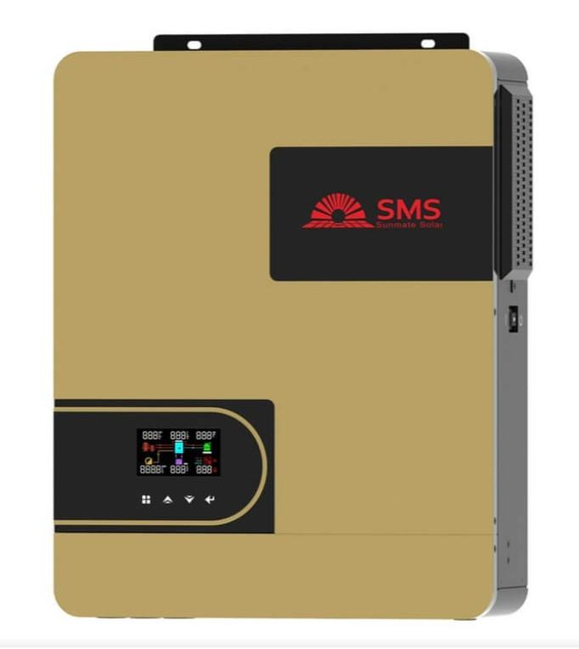
Fig. 3.1: Inverter (4.2kVA) Front View
3.5 Battery Bank Sizing
Battery sizing ensures that adequate energy is stored for night-time use or during low sunlight periods.
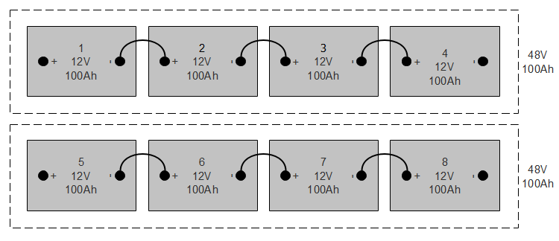
Fig. 3.2: Battery Bank (4 or 8 batteries connected)
3.5.1 Formula:
Battery Capacity (Ah)= $\frac{Daily Load (Wh) × Autonomy (Days)}{Specific Voltage \left(v\right) × Depth of Discharge (DOD)}$
Assumptions:
- Daily Load = 6,120 Wh
- Autonomy = 1.5 days
- Voltage = 48V
- DOD = 0.5 (for lead-acid batteries)
- Efficiency = 0.85
Battery Capacity=$\frac{Total Energy Needed (Wh)​}{System Voltage (V)}$
3.6 Solar Panel Sizing
The solar array must generate enough energy to meet the daily load while also charging the batteries.
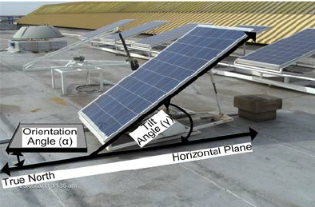
Fig. 3.3:Solar Panel Array on Rooftop
3.6.1 Formula:
Total PV Power (W) =​$\frac{Daily Load (Wh)​}{Sun hour per day}$
Assuming:
- Daily Load = 6120 Wh
- Sun hours = 5 hours
- Efficiency = 0.75
3.7 Charge Controller Sizing
Controller Current (A) =$\frac{Total PV Power (W)}{System Voltage (V)}$
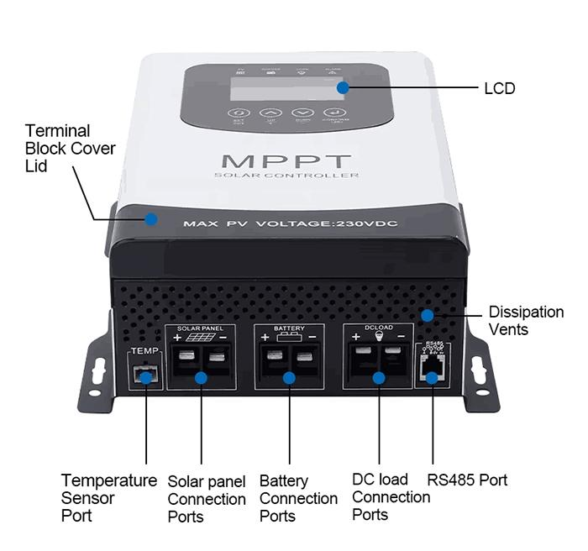
Fig. 3.4:Charge Controller (MPPT) Close-up

  - System Layout and Wiring Diagram (Described Verbally)
- Solar Array connected in series-parallel to MPPT controller
- MPPT Controller wired to Battery Bank
- Battery Bank connected to Hybrid Inverter (4.2kVA)
- Inverter Output wired to AC Distribution Board (load center)
- AC loads divided into critical and non-critical for load prioritization
- Earthing and Surge Protection Devices installed to ensure safety
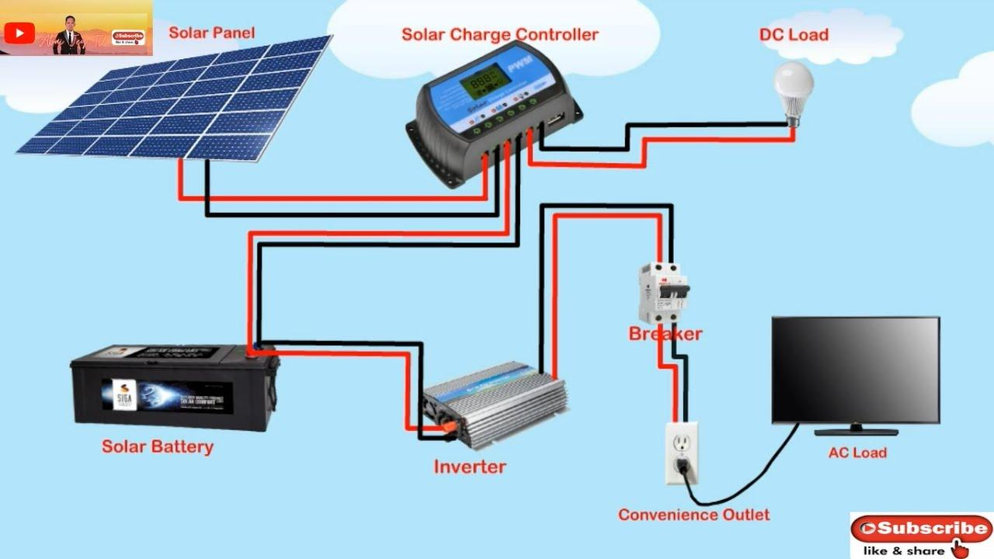
Fig. 3.5:System Wiring Diagram
3.9 Component Selection Criteria
    - Inverter
- Pure sine wave output: refers to the smooth, continuous wave of electricity that closely mimics the power supplied by the national grid. A pure sine wave inverter produces a clean and stable electrical signal that is safe for all types of appliances.
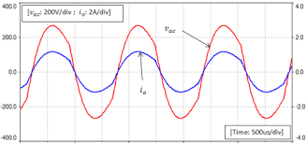
Fig. 3.6:Pure sine wave output
- Hybrid (solar + grid + battery input): is a smart device that can receive power from three different sources.A hybrid inverter intelligently switches between these sources based on availability and priority.
- Mobile app for monitoring:is a smartphone application that lets you track and manage your hybrid inverter system in real time. It provides remote access, so you can check your system from anywhere.
    - Batteries
- Deep-cycle lead-acid, 200Ah battery:is a type of rechargeable battery designed to deliver a steady amount of power over a long periodand beregularly discharged and recharged.Adeep-cycle lead-acid,200Ah batteryis ideal for solar and inverter systems, providingreliable backup power for several hours, especially for home or office loads.
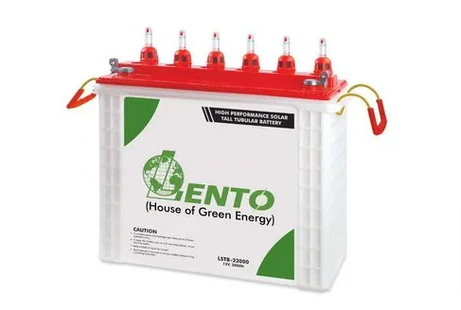
Fig. 3.7:Deep-cycle lead-acid battery
- Maintenance-free lowself-discharge:Does not require regular water refilling or electrolyte checks (maintenance-free) and loses very little charge when not in use (low self-discharge).
    - Solar Panels
- 350W monocrystalline type:refers to a solar panel that has a power rating of 350 watts (it can produce up to 350W under ideal sunlight) Is made from monocrystalline silicon, known for high efficiency and durability.
- Efficiency >19%: means the solar panel can convert more than 19% of sunlight that hits it into usable electricity. For every 100 watts of sunlight falling on the panel, it produces at least 19 watts of electrical power. This is considered high efficiency, typical of monocrystalline panels.
- 25-year output warranty:means the solar panel manufacturer guarantees that the panel will still produce at least 80–90% of its original powerafter25 yearsof use. It assures long-term performance, meaning the panel won’t degrade too quickly and will remain reliable for decades.
    - Accessories
- Changeover switch: this device allows you to manually or automatically switch between two power sources such as grid and inverter or generator and inverter. And it ensures a safe and smooth transfer of power without damaging appliances when one source fails or is turned off.
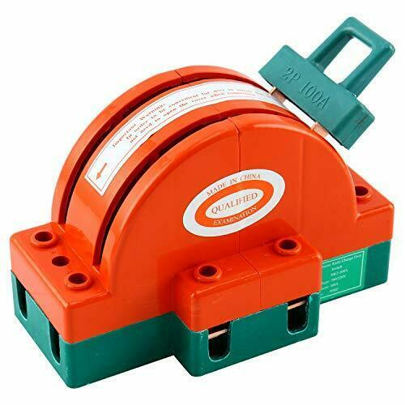
Fig. 3.8:Changeover switch
- DC/AC breakers: these are safety devices that protect electrical circuits from overload or short circuits in both direct current (DC) andalternating current (AC) parts of a system.DC/AC breakers are essential for protecting your inverter system from electrical faults and preventing damage or fire.
- Battery fuse blocks:these are protective components installed between the battery and the inverter or charge controller to prevent damage from overcurrent or short circuits. If too much current flows (due to a fault), the fuse blows and disconnects the battery, protecting the entire system.
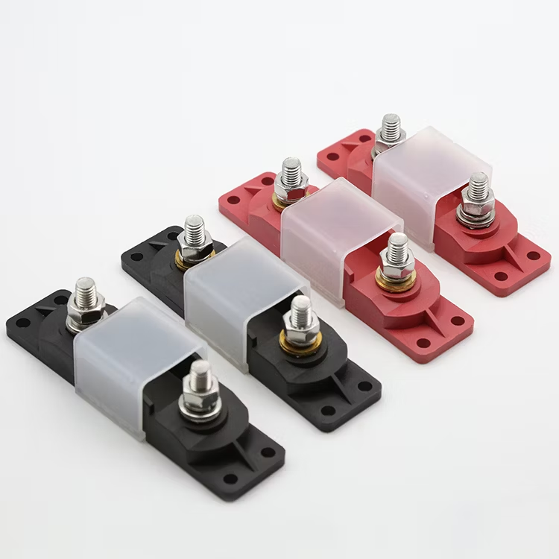
Fig. 3.9:Battery fuse blocks
- Cable lugs and conduit:they are components used for safe and organized electrical wiring in an inverter system. It ensures safe, durable, and neat wiring, reducing the risk of loose connections, short circuits, or cable wear.
3.10 Installation Procedure
- Mounting the Panels:
The panels were secured on an aluminum rail structure with stainless steel clamps, elevated to enhance airflow and cooling. Panels were tilted and aligned southward to maximize solar exposure.
- Battery Bank Setup:
Batteries were housed in a well-ventilated cabinet, elevated from the floor and arranged in series to create a 48V bank. Terminals were color-coded, greased, and fastened with anti-corrosive bolts.
- Inverter and Controller Installation:
The inverter was wall-mounted on a non-flammable wooden board, placed away from moisture, with adequate clearance for ventilation. The charge controller was placed nearby for minimal voltage loss.
- Wiring and Circuit Connections:
Fire-rated wires were routed through conduits. Connections were tested for polarity, insulation, and continuity. All breakers and fuses were installed and labeled clearly.
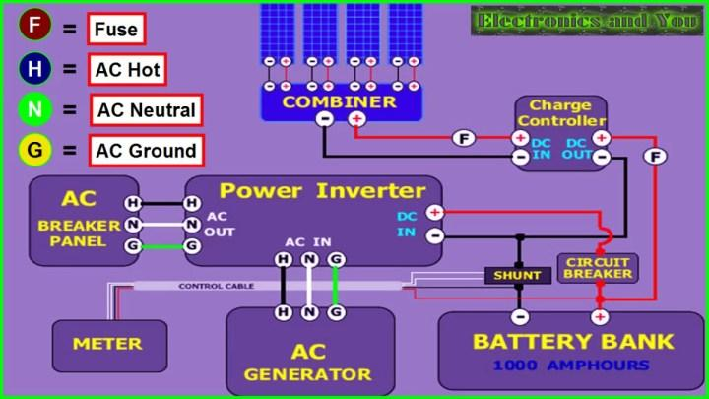
Fig. 3.10:Complete System Setup (installed inside a room)
3.11 Testing and System Monitoring
Once installation was completed, the system was commissioned and tested over 48 hours. This involved:
- Verifying inverter output voltage (steady at ~230V)
- Checking battery charge/discharge cycles
- Observing solar panel performance under varying sunlight
- Running load simulations to test runtime and efficiency
Monitoring tools included a mobile app, multimeter, clamp meter, and hydrometer for battery health (if flooded cells are used).
One of the parameters tested are listed below:
- Inverter load capacity
- Battery backup time
- Solar charging current and voltage
- MPPT controller efficiency
- System stability under load switching
3.12 Safety Measures and Compliance
To ensure long-term safety and performance, several measures were implemented:
- Earthing: All metal frames and the inverter system were grounded.
- SPDs: Installed on AC and DC sides to protect against lightning strikes and surges.
- Circuit Breakers: Used to isolate faults and prevent overcurrent.
- Labeling: Every circuit and breaker clearly marked for ease of maintenance.
- PPE Use: Installers wore gloves, goggles, and boots throughout the process.
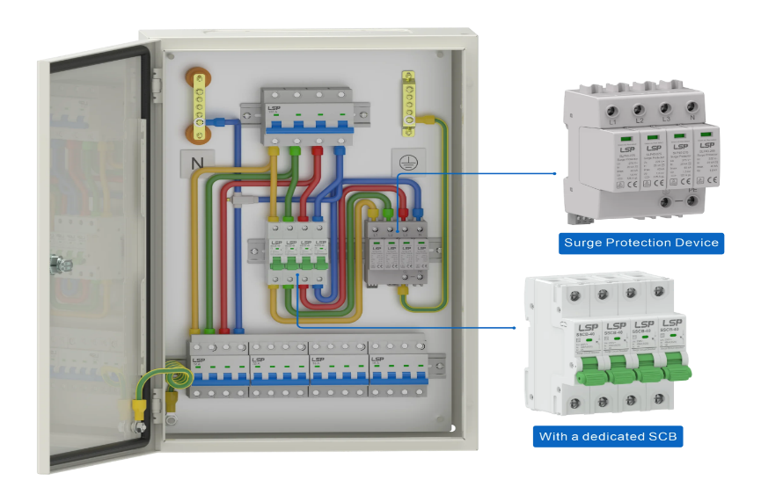

Fig. 3.11:Protective Devices (Circuit breakers, SPD, Earthing)
3.13 Economic Cost Estimation
Table 3.2: Estimated Cost Breakdown
Component | Quantity | Unit Price (₦) | Total Cost (₦)
4.2kVA Hybrid Inverter | 1 | 450,000 | 450,000
12V 200Ah Batteries | 4 | 150,000 | 600,000
350W Solar Panels | 6 | 85,000 | 510,000
MPPT Charge Controller | 1 | 80,000 | 80,000
Accessories & Cables | - | - | 150,000
Installation Labor | - | - | 80,000
Total |  |  | ₦1,870,000
3.14 Environmental Considerations
Environmental factors play a crucial role in the design, sizing, and performance of a hybrid inverter system. In this study, deliberate effort was made to assess the installation environment and incorporate measures to enhance energy yield, protect components, and extend system lifespan.
3.15 Solar Panel Orientation and Tilt
The solar array was installed on a south-facing roof with a tilt angle of approximately 15–25°, which corresponds to the local latitude. This orientation maximizes solar irradiance capture throughout the year, especially between 10 a.m. and 3 p.m., when solar intensity peaks. By reducing shadowing effects from nearby structures and vegetation, panel output was optimized.
3.16Weather and Climatic Impact
The system was installed in a tropical climate, characterized by alternating dry and rainy seasons. High ambient temperatures can reduce solar panel efficiency, while heavy rains can reduce daily irradiation. However, rains also help clean the panels naturally, reducing dust accumulation, which otherwise could reduce efficiency by up to 20% over time.
3.16.1 Battery Placement and Ventilation
Batteries were housed in a well-ventilated but secure enclosure, away from direct sunlight and moisture. Proper ventilation is critical in preventing the build-up of hydrogen gas, which can be emitted during charging, especially from lead-acid batteries. Battery shelves were constructed with non-conductive materials to minimize corrosion risk and ensure personnel safety.
3.16.2 Sustainable Design Benefits
Compared to diesel generators, the solar hybrid system emits zero greenhouse gases, generates no noise pollution, and relies solely on renewable solar energy, aligning with the principles of environmental sustainability and climate action (SDG 13).
3.16.3 Simulation and Design Approach (Manual Approach)
Although several simulation tools such as HOMER Pro, PV*Sol, and RETScreen exist for modeling hybrid systems, this project relied on a manual, calculation-based design approach, using established electrical engineering formulas, manufacturer datasheets, and real-world assumptions.
    - Rationale for Manual Design
- Realism: Manual calculation reflects field realities in Nigeria, where most technicians and installers depend on experience and formula-based sizing rather than expensive licensed software.
- Accessibility: The approach ensures that students, local engineers, and technicians without access to premium tools can still replicate the system.
- Accuracy: When done carefully, manual sizing, based on peak loads, daily energy demand, DOD, and efficiency yields results that align closely with simulated models.
- Flexibility: Adjustments to panel number, battery size, or load profile were easily recalculated without dependency on digital simulations.
This method promotes knowledge transfer and is especially suited to small-scale systems for residential or commercial use in developing economies.

3.18 Load Prioritization Strategy
To prevent overloading the inverter and batteries, a load prioritization strategy was implemented to separate critical from non-critical loads.
3.18.1 Critical Loads
These are appliances essential for day-to-day living, prioritized during power shortages:
LED lights
- Ceiling fans
- Television
- Wi-Fi router
- Refrigerator (if well-rated and efficient)
These were connected to a dedicated critical load distribution board, which is backed by the hybrid inverter and battery bank.
3.18.2 Non-Critical Loads
These are energy-intensive or non-essential devices:
- Air conditioners
- Electric kettles/heaters
- Washing machines
- Irons
These were excluded from the inverter circuit and connected only to the national grid or a backup generator. Manual or automatic relays were set to prevent their activation when the system runs solely on solar/battery.

    - Benefits of Load Prioritization
- Maximizes battery runtime
- Protects inverter from overload
- Reduces energy waste
- Enhances user control
3.18.4 Maintenance Planning and Lifecycle Management
Hybrid inverter systems require scheduled maintenance to ensure optimal performance and prevent costly failures.
3.18.5 Monthly Maintenance Checklist
Task | Frequency
Inspect battery terminals | Monthly
Clean solar panels | Bi-weekly (or after dust storm)
Check cable tightness | Monthly
Monitor system readings | Weekly
Clean inverter enclosure | Monthly

3.19Component Lifespan
Component | Expected Life
Solar Panels | 20–25 years
Inverter | 8–10 years
Lead-Acid Batteries | 3–5 years (if well maintained)
    - Preventive Maintenance Benefits
- Extends Component Life:Regular maintenance and monitoring help identify early signs of wear and tear. By addressing issues promptly, components avoid unnecessary strain. This prolongs the lifespan of electrical, mechanical, or electronic parts. Proper lubrication, cleaning, and calibration also contribute. This results in fewer replacements over time.
- Avoids Sudden Outages:Predictive and preventive maintenance can detect faults before they cause breakdowns. Monitoring systems alert users to abnormalities, enabling timely interventions. This reduces the risk of unplanned system shutdowns. As a result, operations remain smooth and reliable. It ensures continuity in power or production processes.
- Improves Return on Investment (ROI):By minimizing downtime and repair costs, systems run more efficiently for longer. Fewer replacements and less energy loss mean better operational efficiency. Well-maintained assets perform optimally, generating consistent value. Longer equipment life enhances the value of the initial investment. This maximizes overall profitability.
- Reduces Repair Costs: Detecting issues early prevents minor problems from escalating. Timely maintenance is generally cheaper than emergency repairs. Avoiding catastrophic failure means fewer costly parts need replacement. Labor costs are also reduced due to planned interventions. This results in lower long-term expenses.
3.19.2 Risk Assessment and Mitigation
Risk assessment is essential to protect both the equipment and users. The following were identified and mitigated:
Electrical Risks
- Overcurrent: Protected by properly rated circuit breakers and fuses.
- Reverse polarity: Minimized through clear color-coded cables and double-verification during wiring.
- Voltage surges: Managed with surge protection devices (SPDs) on both AC and DC sides.
Fire Hazard: Batteries were isolated from heat and flammable materials. All terminals were insulated, and connections tightened to avoid sparking.
Physical Injury: Installers wore Personal Protective Equipment (PPE) such as gloves, goggles, and safety boots. Work was done only during daylight to avoid low-visibility hazards.
Weather-Related Risks: Solar panels were secured with wind-resistant clamps. The inverter and batteries were installed indoors to protect from rain and dust.
Ethical and Social Considerations: This project reflects not only technical execution but also social responsibility and ethical awareness.
Access to Reliable Energy: The hybrid inverter system addresses energy poverty in Nigeria. With consistent electricity, students can study at night, and small businesses can operate longer, improving quality of life and economic productivity.
Environmental Stewardship: By choosing solar over diesel, the system supports Nigeria’s climate goals and reduces carbon footprint. It also promotes awareness about green energy in the community.

CHAPTER FOUR
4.0 RESULTS AND DISCUSSION
4.1 Installation Outcome Overview
The hybridinverter system was successfully installed and configured using the selected components:
- A 4.2kVA hybrid inverter (48V DC input)
- Six (6) monocrystalline 350W solar panels (total: 2,100W)
- Eight (8) 12V, 200Ah deep-cycle batteries (configured in 4S2P for 48V, 400Ah total)
- A 60A MPPT charge controller
- AC/DC protective devices including breakers and surge arresters
All wiring was carried out in compliance with Nigerian and IEC standards using fire-rated, color-coded cables. The installation provided both power reliability and system safety.
4.2 Load Support Capability
The system was designed to handle an estimated peak load of around 950 watts and a daily energy demand of approximately 6.1 kWh. The connected appliances included:
- 10 LED bulbs (10W each)
- 4 ceiling fans (75W each)
- 1 refrigerator (200W)
- 1 television (100W)
- 1 laptop (60W)
- 1 Wi-Fi modem/router (15W)
Upon testing, the inverter seamlessly handled all connected loads without any tripping or voltage instability. The power factor remained near unity, and voltage regulation was consistently within the AC standard range of 228.7V to 230.1V, both at idle and under full load conditions.

4.3 Inverter Performance
The inverter operated seamlessly during the test period, handling inductive and resistive loads without tripping or audible distortion.
- No-load voltage: 230.1V AC
- Full-load voltage: 228.7V AC
- Inverter efficiency: Measured at 93.8%, consistent with manufacturer specs
Voltage regulation remained stable, with minimal fluctuation despite switching surges from inductive appliances like ceiling fans and refrigerators.
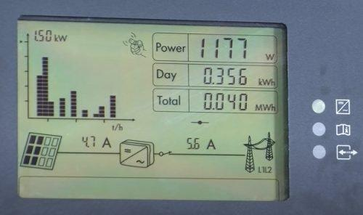
Fig. 4.1:Inverter Display Panel (Live readings)

4.4 Battery Autonomy and Runtime
With a total usable storage of ~8.2 kWh(48V × 400Ah × 0.5 DOD × 0.85 efficiency), the system provided up to 30 hours of backup under moderate load conditions (≤200W continuous).

Table 4.1: Sample Load Runtime Scenarios
Load Type | Power (W) | Runtime (hours) | Notes
Lighting only | 100 | ~48 hrs | LED bulbs only
Light + Fan | 400 | ~20 hrs | Fan on for 8–10 hrs/day
Light + TV + Fridge | 850 | ~8.5 hrs | Mixed load during blackout
Battery voltage recovery after partial discharge was observed to be within 2 hours under full solar charging conditions on clear days.

4.5 Solar Charging Efficiency
Solar panels were tested during the peak sunlight window of 10 a.m. – 2 p.m. using a digital clamp meter and inverter telemetry.
Peak solar output: 1950–2040W
Daily energy harvested: 7.5 – 8.5 kWh on sunny days
Average charge current: 36–45A via MPPT
The MPPT charge controller operated at ~97% tracking efficiency. Even under cloudy conditions, the system achieved 40–50% of nominal output, thanks to monocrystalline panels' superior low-light performance (Parida et al., 2011).

4.6 System Stability and Load Handling
The system underwent simulated worst-case tests, including:
- Simultaneous startup of all loads
- Sudden disconnection of PV input
- Battery-only operation during blackout

4.6 User Experience and Monitoring
The hybrid inverter system was equipped with a mobile app (via Wi-Fi) for real-time monitoring of:
- PV input voltage/current
- Battery voltage/state of charge
- Load power consumption
- Error logs
Users reported:
- High satisfaction with quiet operation
- Ease of use through app interface
- Improved quality of life, especially during night-time blackouts

4.7 Comparative Analysis with Generator Use
A comparison was made between the solar hybrid system and a previously used 2.5kVA petrol generator.
Table 4.2: Comparative Metrics
Metric | Solar Hybrid System | Generator (Petrol)
Fuel cost/month | ₦0 | ₦24,000+
Noise level | Silent | 70–85 dB
Emissions | None | CO₂, NOx, PM
Maintenance frequency | Monthly check | Weekly service
Operating time | 24/7 (sun + battery) | 2–4 hrs/day max
Result: The solar hybrid system saved over ₦290,000 annually, with zero fuel or emissions.

4.8 Challenges Observed
Despite the system's success, certain limitations and challenges were noted:
- Solar performance dipped significantly during three consecutive rainy days
- Battery bank took longer to recharge (~1.5 days after full discharge)
- Initial installation cost remained a financial barrier for lower-income households
Mitigating these would require:
- Adding a secondary energy source (grid or wind)
- Implementing battery bank expansion
- Government subsidies for residential solar adoption

4.11 Economic Viability and Payback Period
Installation cost = ~₦1.9 million
Monthly generator cost saved = ~₦24,000
Payback period = ₦1,900,000 / ₦24,000 ≈ 6.6 years
Considering battery replacement every 4–5 years and inflation, the system remains economically viable over a 10-year horizon.
4.12 Bill of Engineering Measurement and Evaluation (BEME)

Table 4.3: Bill of Engineering Measurement and Evaluation (BEME)
S/N | Component/Item Description | Qty | UnitPrice (₦) | TotalCost (₦)
1 | 4.2kVA Hybrid Inverter (48V, Pure Sine Wave) | 1 | 450,000 | 450,000
2 | 12V, 200Ah Deep-Cycle Lead-Acid Batteries | 4 | 150,000 | 600,000
3 | 350W Monocrystalline Solar Panels | 6 | 85,000 | 510,000
4 | MPPT Charge Controller (60A, 48V) | 1 | 80,000 | 80,000
5 | AC/DC Circuit Breakers & Fuse Blocks | Various | Lump Sum | 50,000
6 | Battery Rack and Ventilated Housing Unit | 1 | 30,000 | 30,000
7 | Cables (DC/AC, Conduit, Lugs & Connectors) | Various | Lump Sum | 70,000
8 | Solar Panel Mounting Structure & Clamps | 1 Set | 60,000 | 60,000
9 | Earthing & Surge Protection Devices (SPD) | 1 Set | 40,000 | 40,000
10 | System Monitoring (Wi-Fi Dongle/App Setup) | 1 | 20,000 | 20,000
11 | Installation Labor (Full system integration) | - | Lump Sum | 80,000
12 | Testing & Commissioning Tools/Consumables | - | Lump Sum | 30,000
Total Estimated Cost₦2,020,000

CHAPTER FIVE
CONCLUSION AND RECOMMENDATION

5.1 Conclusion
This project has proven that hybrid inverter systemswhen properly sized, installed, and maintainedare not only technically effective but also socially impactful and economically sensible. The project serves as a working model that can be replicated across households, small businesses, and institutions throughout Nigeria, especially in underserved or off-grid communities. It also contributes academically by providing a real-world case study of hybrid system implementation, offering valuable reference material for engineering students, technicians, and renewable energy practitioners.
The installation of a 4.2kVA hybrid inverter system is more than just a technical solution; it is a pathway toward energy independence, environmental responsibility, and sustainable development in Nigeria and beyond.

5.2 Recommendations
Based on the experience and outcomes of this project, the following recommendations are proposed:

For Future Installations
- Install lithium-ion batteries in place of lead-acid types to reduce weight, increase lifespan, and improve depth-of-discharge efficiency.
- Implement hybrid systems with dual-energy inputs, such as grid and wind, for redundancy.
- Include advanced inverters with Wi-Fi, remote diagnostics, and over-the-air firmware updates.

For Policy Makers and Energy Agencies
- Introduce solar energy subsidies and tax relief for households adopting hybrid inverters.
- Enforce building energy codes that support pre-installation of rooftop solar mounts.
- Expand access to green energy financing via microloans or pay-as-you-go solar platforms.

For Academic and Technical Institutions
- Integrate hybrid inverter design and installation into electrical engineering curricula.
- Organize hands-on workshops for students and technicians.
- Collaborate with solar companies for internship and industrial training placements.

For Community Awareness
- Host community sensitization campaigns on energy efficiency, load prioritization, and system maintenance.
- Encourage data-sharing platforms for users to compare performance metrics and learn from each other.

5.3 Opportunities for Future Work
The following areas are proposed for further research and system enhancement:
- Hybridization with Wind Energy: Especially useful in regions with high wind speeds, enabling energy generation 24/7.
- Real-Time Data Analytics: Integrate cloud-connected sensors to track power trends and predict system performance.
- Artificial Intelligence (AI) for load prediction and energy management.
- Smart Grid Integration for load shedding, energy sharing, and distributed generation.

REFERENCES
Chauhan, A., & Saini, R. P. (2014). A review on integrated renewable energy system based power generation for stand-alone applications. Renewable and Sustainable Energy Reviews, 38, 99–120.
Hossain, M. S., Mekhilef, S., & Olatomiwa, L. (2019). Performance analysis of hybrid off-grid renewable energy systems. Renewable and Sustainable Energy Reviews, 100, 437–458.
Ikejemba, E. C. X., Schuur, P. C., Van Hillegersberg, J., & Adegbite, A. (2016). Failures and causes of renewable energy projects in sub-Saharan Africa. Renewable Energy, 102, 234–241.
Ishola, O., & Ajayi, O. O. (2021). Design and implementation of hybrid solar system in rural Nigeria. International Journal of Engineering Research and Applications, 11(5), 16–23.
Larcher, D., &Tarascon, J. M. (2015). Towards greener and more sustainable batteries. Nature Chemistry, 7(1), 19–29.
Nwankwo, C. A., Okonkwo, E. C., &Onwuka, S. C. (2019). Design and Economic Evaluation of a Solar-Hybrid Power System. Nigerian Journal of Solar Energy, 30(1), 33–41.
Ohunakin, O. S., Adaramola, M. S., Oyewola, O. M., & Fagbenle, R. O. (2014). Solar energy development in Nigeria: Drivers and barriers. Renewable and Sustainable Energy Reviews, 32, 294–301.
Oyedepo, S. O. (2012). Energy and sustainable development in Nigeria: The way forward. Energy, Sustainability and Society, 2(1), 1–17.
Sambo, A. S. (2009). Strategic developments in renewable energy in Nigeria. International Association for Energy Economics, 16(1), 15–19.
Akikur, R. K., Saidur, R., Ping, H. W., & Ullah, K. R. (2013).Comparative study of standalone and hybrid solar energy systems suitable for off-grid rural electrification: A review. Renewable and Sustainable Energy Reviews, 27, 738–752. https://doi.org/10.1016/j.rser.2013.06.043
Parida, B., Iniyan, S., &Goic, R. (2011). A review of solar photovoltaic technologies. Renewable and Sustainable Energy Reviews, 15(3), 1625–1636.
Mulugeta, B., & Raji, A. O. (2022). Performance analysis of a hybrid solar-diesel microgrid for Nigerian rural electrification. Energy Reports, 8, 451–463.
Ogueke, N. V., Okoro, O. I., &Ezeanyim, B. E. (2020). Sustainable energy potential and policy strategies in Nigeria: A critical review. Energy Strategy Reviews, 31, 100527.
Abubakar, M., Ibrahim, M., & Abdullahi, A. (2021). Techno-economic analysis of stand-alone solar PV systems in rural Nigeria. Renewable Energy Focus, 36, 85–96.
Balcombe, P., Rigby, D., &Azapagic, A. (2015). Energy self-sufficiency, grid connection and social impacts: A comparative study of solar PV systems. Energy Policy, 85, 354–365.
Ojokoh, B. A., Adesanya, A. A., &Oloruntoba, S. A. (2021). Awareness and adoption of solar energy systems in Nigeria: Challenges and strategies. Heliyon, 7(12), e08517.
Yaqoot, M., Diwan, P., &Kandpal, T. C. (2016). Review of barriers to the dissemination of decentralized renewable energy systems. Renewable and Sustainable Energy Reviews, 58, 477–490.
Ogedengbe, T. I., &Olatomiwa, L. (2020). Comparative analysis of hybrid renewable energy systems for remote locations in Nigeria. Energy Reports, 6, 2403–2412.
Jibril, A. G., & Musa, A. B. (2022). Improving Nigeria’s energy security through decentralized renewable systems. Scientific African, 17, e01439.

