FACTOR INFLUENCING DRUGS AND SUBSTANCE ABUSE AMONG STUDENTS
(A CASE STUDY OF KWARA STATE POLYTECHNIC, ILORIN)

BY
KAREEM MUBARAK AYINDE
ND/23/STA/PT/0017

A PROJECT SUBMITTED TO THE DEPARTMENT OF STATISTICS
INSTITUTE OF APPLIED SCIENCES (IAS) KWARA STATE POLYTECHNIC, ILORIN.
IN PARTIAL FULFILLMENT OF THE REQUIREMENT FOR THE AWARD OF NATIONAL DIPLOMA (ND) IN STATISTICS

JULY, 2025
CERTIFICATION
This is to certify that the research project titled: “Factors Influencing the use of drug and Substance abuse among student” was carried out by Kareem Mubarak Ayinde with matriculation number ND/23/STA/PT/017, in partial fulfilment of the requirements for the award of National Diploma, in the Department of Statistics, Kwara State Polytechnic, Ilorin.

-------------------------- ----------------------------
Mr Safihi, F.G Date
Project Supervisor

-------------------------- ----------------------------
Mr Musa, O.Y Date
Project Supervisor

---------------------------- ------------------------------
Mrs. Elepo, T.A Date
Head of Department

------------------------------ ------------------------------
External Examiner Date

DEDICATION
This project is dedicated to the Almighty God and to my parents (Mr. and Mrs Abdulkareem).

ACKNOWLEDGEMENTS
I give praise and adoration to the creator of heaven and earth; the Alpha and Omega for His blessings and grace bestow upon me. And for the wisdom, knowledge and understanding given to me to be able to accomplish this task.

Our profound gratitude goes to our supervisor, the person of Mr. Safihi, F.G for his assistance and guidance during this research work, and also to our able Head of Department Mrs. Elepo, T.A, Department Part-Time coordinator in person of Mr Musa, O.Y and to all my Lecturers in the Department of Statistics for the good academic support given since the beginning of our program till point on time.
My special gratitude goes to my parents (Mr and Mrs kareem) who has been there for me throughout the process of everything in my life. And also for their support, financially, morally and spiritually. I say a BIG Thank to you and may you reap the fruit of your labour. Amin…….
My appreciation also goes our siblings, my friends and all our along the way friends. You all are awesome.

ABSTRACT
This study aims to examine the multifaceted factors contributing to substance use, using a sample of 100 respondents drawn from a cross-section of individuals within a defined population. Employing descriptive statistics, including frequency counts and percentages, the research analyzed respondents’ views on variables such as peer pressure, family background, place of residence, financial status, moral upbringing, psychological disposition, and exposure to drugs. Results revealed that a vast majority of respondents believe that these factors significantly influence drug abuse behavior, with peer influence, environmental setting, and family dynamics ranking highest in impact. The study also uncovers how psychological factors like the desire to escape negative experiences and physiological intolerance can further drive substance dependency. The findings underscore the importance of a multidimensional response involving families, educational institutions, healthcare providers, and policymakers. Interventions should target not only the individual but also the broader social and environmental systems that shape behavior. The research concludes with practical recommendations to enhance public awareness, enforce regulatory policies, and develop holistic preventive programs tailored to high-risk groups.
Keywords: Drug abuse, peer pressure, family influence, psychological factors, socio-economic status, environmental factors, moral upbringing, youth behavior, substance use prevention.

TABLE OF CONTENTS
Title page i
Certification ii
Dedication iii
Acknowledgement iv
Abstract v
Table of contents vi
CHAPTER ONE: Introduction
1.1 Background to the study 1
1.2 Statement of the problem 3
1.3 Aim and Objectives of the study 3
1.4 Significance of the study 3
1.5 Scope and Limitation of the study 4
1.6 Definition of Terms 4
CHAPTER TWO: Literature Review
2.1 Introduction 6
2.2 Review of Related Literature 6
CHAPTER THREE: Research Methodology
3.1 Introduction 11
3.2 Statistics Techniques 11
3.3 Data Source 12
3.4 Data Presentation 12
CHAPTER FOUR: Data Presentation Analysis and Result
4.1 Introduction 13
4.2 Data Analysis 13
CHAPTER FIVE: Summary of Findings, Conclusion and Recommendation
5.1 Summary of Findings 25
5.2 Conclusion 26
5.3 Recommendation 27
REFERENCES 28

CHAPTER ONE

INTRODUCTION

1.1 Background to the Study
Drug and substance abuse has become a global issue that transcends boundaries of age, race, class, and geography. The phenomenon is especially concerning in developing countries such as Nigeria, where it has reached alarming levels among youth, including students, young adults, and even adolescents. Drug abuse refers to the excessive and maladaptive consumption of substances—whether legal or illegal—for non-medical purposes. These substances include alcohol, marijuana, cocaine, tramadol, codeine, heroin, methamphetamine, and other psychoactive agents that alter the mental and emotional states of the user.
The origins of drug abuse are multifaceted, influenced by a complex interplay of social, psychological, economic, cultural, and biological factors. The family, being the foundational social unit, often plays a significant role. A dysfunctional family background—characterized by abuse, neglect, or poor parental monitoring—can expose individuals to substance use at an early age. Peer pressure also significantly contributes to drug abuse, particularly among adolescents and young adults who are in search of acceptance, identity, and status within social groups. In schools and higher institutions, the desire to cope with academic stress or experiment with new sensations can lead students into drug use.
Environmental factors such as place of residence and social setting also play a critical role. Individuals living in urban slums or neighborhoods with poor supervision, low socioeconomic status, and a high concentration of drug dealers are more likely to be exposed to and engage in drug abuse. Additionally, media portrayals and digital platforms have made access to information about drugs easier, sometimes glamorizing their use and encouraging experimentation.
In Nigeria, the increasing rate of drug use and abuse has become a matter of national concern. According to a 2018 report by the United Nations Office on Drugs and Crime (UNODC), about 14.4% of Nigerians between the ages of 15 and 64 were drug users, a figure significantly higher than the global average. Alarmingly, a significant number of users start before the age of 18, making adolescence a critical period for intervention.
The consequences of drug abuse are both immediate and long-term. In the short term, it can lead to behavioral changes, violence, impaired judgment, and academic failure. In the long term, it may result in mental illness, physical health deterioration, addiction, unemployment, and criminal behavior. Furthermore, drug abuse burdens the healthcare system, causes loss of productivity, and destabilizes families and communities.
Efforts to curb drug abuse in Nigeria have involved both government and non-governmental interventions, including sensitization campaigns, school-based awareness programs, rehabilitation services, and the enforcement of drug-related laws. Despite these efforts, the prevalence remains high, suggesting that more context-specific, data-driven strategies are required.
This study seeks to explore the various factors influencing drug abuse, particularly among youth. It focuses on understanding the extent to which environmental, psychological, social, and economic variables contribute to the likelihood of substance use. Through a detailed analysis of collected data, this research aims to offer practical recommendations for policymakers, educators, parents, and health practitioners on effective prevention and intervention strategies.

1.2 Statement of the Problem
Drug and substance abuse continues to pose a serious threat to individual well-being, academic achievement, and societal stability, particularly among the youth. Despite growing awareness and interventions, the rate of abuse remains persistently high. The problem is compounded by multiple influencing factors, including peer pressure, family dysfunction, and economic hardship. This study seeks to investigate these variables to identify actionable solutions for reducing the prevalence of drug abuse.

1.3 Aim and Objectives of the Study
Aim:
To examine the factors influencing drug and substance abuse among individuals and offer recommendations for prevention and intervention.
Objectives:
- To identify the social, psychological, and environmental factors influencing drug and substance abuse among individuals.
- To examine the role of family background, peer pressure, and financial status in the prevalence of substance use.
- To recommend effective strategies for preventing and reducing drug abuse within the population.

1.4 Significance of the Study
This study is significant because it addresses the growing concern of drug abuse among youths in Nigeria. It provides insight into the root causes of substance use and abuse, which can guide the development of more effective policies and programs. Stakeholders such as educators, parents, healthcare professionals, and policymakers will benefit from the findings, gaining a clearer understanding of how to mitigate drug-related issues in society.

1.5 Scope and Limitations of the Study
This study is focused on examining the causes and influencing factors of drug abuse among youths within a specified population. It covers areas such as family influence, peer pressure, psychological disposition, financial status, and environmental factors. The research is limited by factors such as the sample size (100 respondents), self-reported data (which may include bias), and geographical constraints, which may affect the generalizability of the findings to the broader population.

1.6 Definition of Terms
- Drug Abuse: The excessive, inappropriate, or illegal use of substances for non-medical purposes that lead to negative physical, psychological, or social consequences.
- Substance Use: The act of consuming drugs or psychoactive substances, including alcohol, tobacco, and prescription medications.
- Peer Pressure: The influence exerted by a peer group in encouraging a person to change their attitudes, values, or behavior to conform to group norms.
- Family Background: The structure, socio-economic status, and values of a person's family, which influence their development and decisions.
- Psychological Factors: Mental and emotional states such as stress, depression, or trauma that may contribute to substance abuse.
- Environmental Influence: The impact of one's surroundings, including neighborhood, school, and social setting, on their behavior and lifestyle.
- Moral Upbringing: The process of instilling ethical values and discipline in a child, typically by parents or guardians.
- Addiction: A chronic, relapsing disorder characterized by compulsive drug seeking, continued use despite harmful consequences, and long-lasting changes in the brain.

CHAPTER TWO

LITERATURE REVIEW

2.1 Introduction
Drug and substance abuse has been widely researched due to its detrimental effects on individuals and society. This chapter reviews existing literature that explores the causes, contributing factors, and impacts of drug abuse. It focuses on environmental, psychological, social, and economic influences, as well as the role of peer pressure and family background. Understanding previous findings provides a strong foundation for this study and highlights gaps this research seeks to fill.

2.2 Review of Related Literature

Environmental Factors and Drug Abuse
Environmental factors play a critical role in shaping behaviors and tendencies toward drug abuse. According to Gureje and Olley (2004), individuals living in urban slums or socially disadvantaged neighborhoods are more likely to engage in substance use due to increased exposure, peer influence, and lack of supervision. These environments often lack recreational facilities, productive youth engagement programs, and proper law enforcement, thereby creating conditions conducive to drug experimentation and eventual dependence.
Further, the accessibility and availability of drugs in certain areas make it easier for youths to obtain and use substances. Isidore (2017) noted that the density of alcohol and drug outlets correlates with the rate of usage in such communities. The anonymity and poor community cohesion in urban areas also reduce accountability, making it easier for youths to engage in risky behaviors.
In contrast, rural communities tend to have lower prevalence rates, partly due to stronger social bonds and closer monitoring by community members. However, rural areas are not immune; exposure to drugs through media and migration has increased substance use even in traditionally conservative regions.
Overall, the environment can either act as a protective factor or a risk factor. This highlights the need for community-based interventions that improve living conditions, reduce drug availability, and offer alternatives to drug use, especially in high-risk areas.

Peer Pressure and Youth Drug Use
Peer pressure is one of the most widely recognized drivers of substance abuse, particularly among adolescents and young adults. During adolescence, individuals are highly susceptible to external influences as they seek social acceptance, identity, and belonging. According to Onifade et al. (2013), youths are likely to initiate drug use when surrounded by friends who already use substances, driven by a desire to conform and avoid social rejection.
The role of peer groups is often underestimated, yet they serve as a powerful motivator. Friends may introduce drugs during social gatherings, parties, or school events, portraying it as a means of fun, relaxation, or stress relief. In such settings, the individual may feel compelled to partake, even if initially reluctant. Ajayi and Ayodele (2018) found that peer pressure was more influential than parental guidance or school campaigns in determining whether a youth would try drugs.
Furthermore, the influence of peer groups is often coupled with misinformation. Many youths falsely believe that occasional drug use is harmless, especially if it appears to enhance social interaction or performance. This misperception can lead to repeated use and eventual addiction.
Combating peer pressure requires strategic interventions such as peer education, youth mentorship programs, and the promotion of positive peer associations. Schools and youth centers should create safe spaces where students can form healthy friendships and learn resistance skills. Thus, understanding and addressing peer dynamics is critical to reducing substance abuse among youths.

Family Background and Drug Abuse
Family structure and dynamics are central to the development and behavior of children and adolescents. A stable and supportive family environment often serves as a protective factor against drug abuse, while a dysfunctional or neglectful family may increase the likelihood of substance use. Akindutire and Adegboyega (2012) argued that broken homes, parental neglect, and domestic violence are significant predictors of drug abuse among youths.
Children from homes where drug use is normalized—either through parental modeling or lack of discipline—are more likely to see substance use as acceptable. Gureje and Olley (2004) emphasized that the absence of parental supervision and emotional support often pushes children to seek comfort and identity in peer groups, where the risk of drug exposure is higher. Similarly, parents who struggle with addiction may unknowingly influence their children through behavior modeling.
Socioeconomic factors within the family also contribute to substance abuse. Families experiencing poverty or unemployment may face stress that filters down to children, causing emotional instability and a higher risk of maladaptive coping strategies, such as drug use.
On the contrary, families that instill strong moral values, maintain open communication, and actively participate in their children’s lives significantly reduce the risk of drug abuse. Thus, strengthening family systems through counseling, parental training, and support programs is crucial in the fight against drug abuse. Understanding family influence helps in tailoring interventions that begin from the home, thereby addressing the root causes of substance dependency.

Psychological and Emotional Factors
Psychological and emotional factors have been increasingly recognized as important contributors to substance use and addiction. Individuals dealing with stress, anxiety, depression, or trauma often resort to drugs as a form of self-medication. According to Okpataku (2015), emotional distress increases the likelihood of drug abuse, especially when coping mechanisms are weak or absent.
Many users report that drugs help them escape negative emotions, boost their mood temporarily, or increase self-confidence in social settings. However, such temporary relief often leads to a cycle of dependency, as users must continue taking the substance to maintain those effects. Over time, this can lead to addiction and a deterioration in mental health.
Youth, in particular, face emotional challenges such as academic pressure, identity crises, relationship problems, and low self-esteem. Without access to proper emotional support or mental health services, they may turn to drugs for solace. Makanjuola and Daramola (2016) found a strong correlation between undiagnosed mental health issues and substance use among secondary school and university students.
Unfortunately, mental health is still stigmatized in many communities, and access to professional help is limited. This neglect fuels the problem and prevents early detection and treatment. Therefore, drug abuse prevention efforts must integrate mental health services, counseling, and psychoeducation. Helping individuals understand their emotions and teaching healthy coping strategies can reduce reliance on substances and improve long-term well-being.

Economic Status and Access to Drugs
Economic factors significantly influence both access to and motivation for drug use. Youths with excessive financial freedom may experiment with drugs out of boredom or curiosity, while those in financial hardship may turn to drugs as an escape from economic stress. Ogunlade (2013) observed that both ends of the economic spectrum are vulnerable—those with disposable income can easily purchase substances, while the economically disadvantaged may be lured into substance use through peer networks or even drug trafficking.
Easy access to money without supervision, especially among students, creates an enabling environment for drug experimentation. Onifade et al. (2013) noted that students with higher allowances were more likely to purchase substances like alcohol, cannabis, and prescription drugs. Conversely, poverty can push individuals toward drug use for its perceived numbing or energizing effects, especially among those involved in strenuous informal jobs.
In both cases, financial mismanagement, lack of budgeting skills, and poor parental control contribute to the problem. Some youths even engage in criminal activities to sustain their drug habits. Economic empowerment, therefore, must be accompanied by financial literacy and guidance.

CHAPTER THREE

RESEARCH METHODOLOGY

3.1 Introduction
This chapter outlines the methodology adopted in conducting the study on the factors influencing drug and substance abuse. It presents the research design, data collection method, and tools used for analysis. The study relies on a quantitative descriptive approach to capture the opinions of respondents. Data were analyzed using simple descriptive statistics such as frequency tables and bar charts to identify patterns and trends. These methods provided a clear and straightforward interpretation of respondents' views and behaviors regarding substance use.

3.2 Statistical Techniques
The following statistical techniques were employed in analyzing the collected data:
- Descriptive Statistics: This technique was used to summarize the data and present it in a meaningful way. It helped in identifying trends, frequencies, and distributions in respondents’ answers related to drug and substance abuse.
- Frequency Tables: Frequency distribution tables were used to organize the responses for each variable. This enabled the researcher to determine how often particular responses occurred and to measure the spread of opinions among the respondents.
- Bar Charts: Bar charts were used to visually represent the frequency data. These visual aids enhanced the interpretation and comparison of results across different variables and categories, such as peer pressure, family background, and financial influence.

3.3 Data Source
Primary data were utilized for this study. The information was collected through a well-structured questionnaire distributed to a total of 100 respondents. The respondents were drawn from a specific population that includes youths, students, and young adults. The questionnaire was designed to gather demographic data and assess the respondents’ perceptions and experiences related to drug and substance abuse. The questions were close-ended for ease of analysis and focused on environmental, psychological, and social factors influencing drug use.

3.4 Data Presentation
The data collected from the questionnaire were systematically arranged and presented using frequency tables and bar charts. These formats allowed for a simple yet comprehensive understanding of the results. The frequency tables showed the number and percentage of responses for each item, while bar charts visually illustrated the comparisons among different categories. This method of presentation facilitated the analysis and interpretation of the influence of each identified factor on substance abuse behavior.

CHAPTER FOUR
DATA ANALYSIS

4.1 Introduction
This chapter presents the analysis of data collected on the factors influencing drug abuse among individuals. The analysis was conducted using descriptive statistics such as frequency counts, percentages, and visual representations (bar charts). The goal is to understand how respondents perceive various factors like residence, peer pressure, past experience, family background, and economic status in relation to substance use.
4.2 Data Analysis
Descriptive Statistics (Frequency and Bar chart)
Table 4.1: place of residence affect drug abuse
 |  | Frequency | Percent | Valid Percent | Cumulative Percent
Valid | DISAGREE | 3 | 3.0 | 3.0 | 3.0
Valid | NEUTRAL | 3 | 3.0 | 3.0 | 6.0
Valid | AGREE | 28 | 28.0 | 28.0 | 34.0
Valid | STRONGLY AGREE | 66 | 66.0 | 66.0 | 100.0
Valid | Total | 100 | 100.0 | 100.0

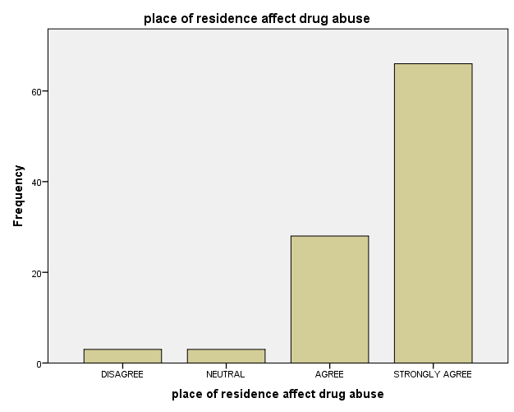
Fig 4.1: Place of residence affect drug abuse
Interpretation:
The majority of respondents (66%) strongly agree that place of residence affects drug abuse, while 28% agree. Only 6% were neutral or disagreed, indicating a strong consensus that residential environments play a key role in drug-related behavior.
Table 4.2: drug use due to previous experience
 |  | Frequency | Percent | Valid Percent | Cumulative Percent
Valid | STRONGLY DISAGREE | 2 | 2.0 | 2.0 | 2.0
Valid | DISAGREE | 5 | 5.0 | 5.0 | 7.0
Valid | NEUTRAL | 6 | 6.0 | 6.0 | 13.0
Valid | AGREE | 32 | 32.0 | 32.0 | 45.0
Valid | STRONGLY DISAGREE | 55 | 55.0 | 55.0 | 100.0
Valid | Total | 100 | 100.0 | 100.0

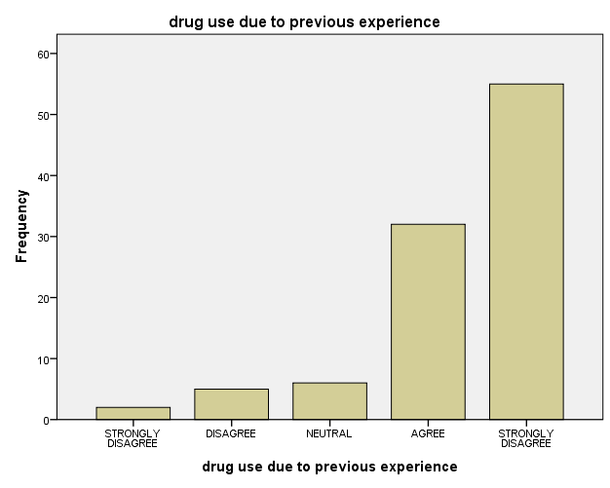
Fig 4.2: Drug use due to previous experience
Interpretation:
A total of 87% of respondents either agreed or strongly agreed that past experiences influence drug use. This suggests a significant psychological component in substance behavior stemming from previous exposure or events.
Table 4.3: physiological intolerance lead to substance and drug abuse
 |  | Frequency | Percent | Valid Percent | Cumulative Percent
Valid | DISAGREE | 2 | 2.0 | 2.0 | 2.0
Valid | NEUTRAL | 11 | 11.0 | 11.0 | 13.0
Valid | AGREE | 42 | 42.0 | 42.0 | 55.0
Valid | STRONGLY AGREE | 45 | 45.0 | 45.0 | 100.0
Valid | Total | 100 | 100.0 | 100.0

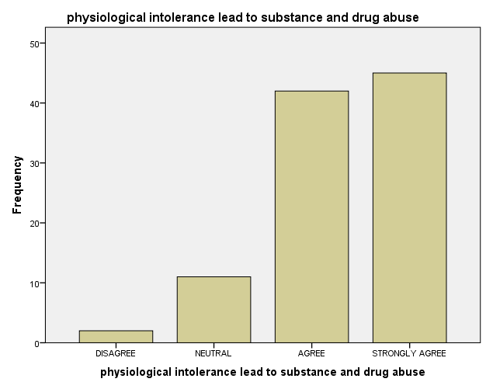
Fig 4.3: physiological intolerance lead to substance and drug abuse
Interpretation:
An overwhelming 87% of respondents attribute drug abuse to physiological intolerance. This implies that certain biological or health factors might predispose individuals to substance abuse as a coping mechanism.
Table 4.4: family background affect substance use
 |  | Frequency | Percent | Valid Percent | Cumulative Percent
Valid | STRONGLY DISAGREE | 2 | 2.0 | 2.0 | 2.0
Valid | DISAGREE | 7 | 7.0 | 7.0 | 9.0
Valid | NEUTRAL | 10 | 10.0 | 10.0 | 19.0
Valid | AGREE | 47 | 47.0 | 47.0 | 66.0
Valid | STRONGLY AGREE | 34 | 34.0 | 34.0 | 100.0
Valid | Total | 100 | 100.0 | 100.0

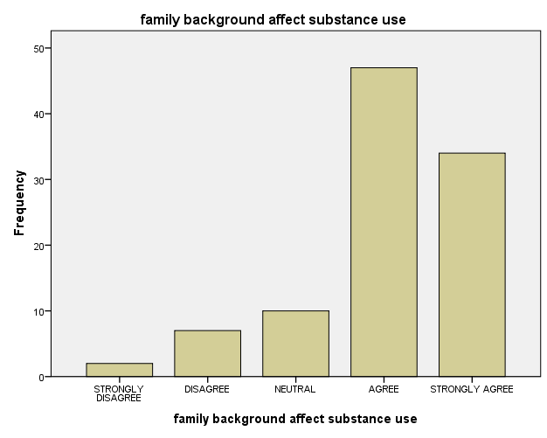

Fig 4.4: family background affect substance use
Interpretation:
The majority of respondents (81%) believe that family background contributes to drug abuse. This highlights the influence of upbringing, parental involvement, and home dynamics in shaping substance-related behavior.
Table 4.5: the setting/area of use influence substance use
 |  | Frequency | Percent | Valid Percent | Cumulative Percent
Valid | STRONGLY DISAGREE | 2 | 2.0 | 2.0 | 2.0
Valid | DISAGREE | 7 | 7.0 | 7.0 | 9.0
Valid | NEUTRAL | 12 | 12.0 | 12.0 | 21.0
Valid | AGREE | 39 | 39.0 | 39.0 | 60.0
Valid | STRONGLY AGREE | 40 | 40.0 | 40.0 | 100.0
Valid | Total | 100 | 100.0 | 100.0

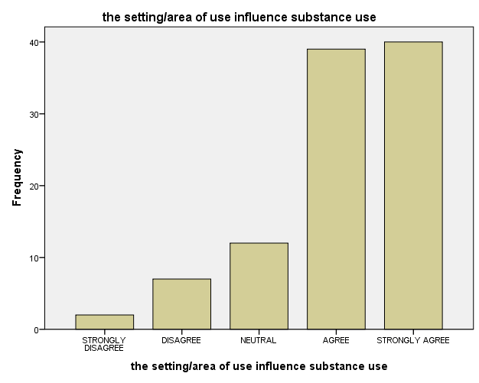
Fig 4.5: the setting/area of use influence substance use
Interpretation:
A total of 79% of respondents support that the environment or location where one lives or spends time can influence drug abuse tendencies, underlining the role of social and environmental factors.
Table 4.6: substance are used to obtain desired effects
 |  | Frequency | Percent | Valid Percent | Cumulative Percent
Valid | DISAGREE | 10 | 10.0 | 10.0 | 10.0
Valid | NEUTRAL | 6 | 6.0 | 6.0 | 16.0
Valid | AGREE | 32 | 32.0 | 32.0 | 48.0
Valid | STRONGLY AGREE | 52 | 52.0 | 52.0 | 100.0
Valid | Total | 100 | 100.0 | 100.0

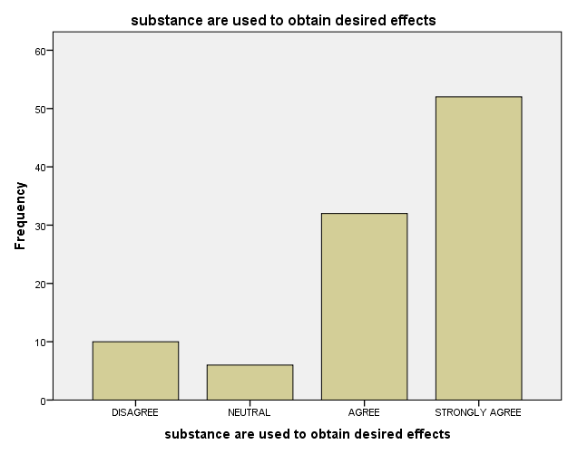
Fig 4.6: substance are used to obtain desired effects
Interpretation:
84% of respondents acknowledge that drug use is often motivated by the desire to achieve specific psychological or physical effects, reflecting a goal-directed use of substances.
Table 4.7: substance use influenced by peer presure/friends
 |  | Frequency | Percent | Valid Percent | Cumulative Percent
Valid | DISAGREE | 7 | 7.0 | 7.0 | 7.0
Valid | NEUTRAL | 11 | 11.0 | 11.0 | 18.0
Valid | AGREE | 38 | 38.0 | 38.0 | 56.0
Valid | STRONGLY AGREE | 44 | 44.0 | 44.0 | 100.0
Valid | Total | 100 | 100.0 | 100.0

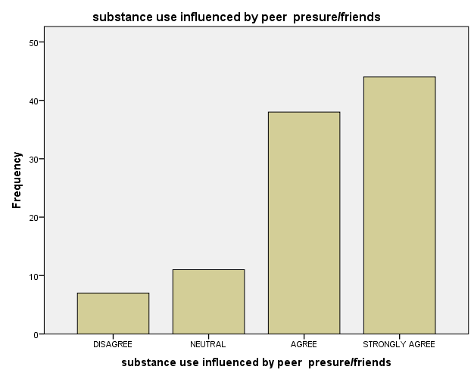
Fig 4.7: substance use influenced by peer presure/friends
Interpretation:
82% of respondents affirm that peer pressure significantly influences drug use. Social circles and friends are major contributing factors in either initiating or sustaining substance use.
Table 4.8: misplaced priority affects substance use
 |  | Frequency | Percent | Valid Percent | Cumulative Percent
Valid | DISAGREE | 7 | 7.0 | 7.0 | 7.0
Valid | NEUTRAL | 18 | 18.0 | 18.0 | 25.0
Valid | AGREE | 50 | 50.0 | 50.0 | 75.0
Valid | STRONGLY AGREE | 25 | 25.0 | 25.0 | 100.0
Valid | Total | 100 | 100.0 | 100.0

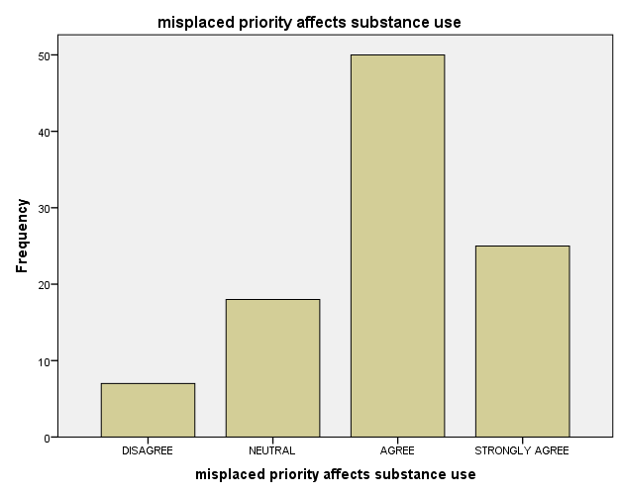
Fig 4.8: misplaced priority affects substance use
Interpretation:
75% of respondents agree that misplaced priorities—such as valuing pleasure over health or academics—contribute to substance abuse. This reflects behavioral and attitudinal causes of drug use.
Table 4.9: amount of money at student disposal affects substance use
 |  | Frequency | Percent | Valid Percent | Cumulative Percent
Valid | DISAGREE | 10 | 10.0 | 10.0 | 10.0
Valid | NEUTRAL | 22 | 22.0 | 22.0 | 32.0
Valid | AGREE | 34 | 34.0 | 34.0 | 66.0
Valid | STRONGLY AGREE | 34 | 34.0 | 34.0 | 100.0
Valid | Total | 100 | 100.0 | 100.0

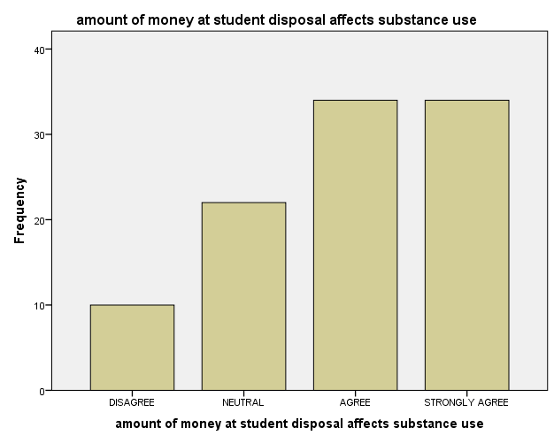
Fig 4.9: amount of money at student disposal affects substance use
Interpretation:
68% of respondents believe that students with more disposable income are more prone to substance abuse, suggesting a correlation between financial freedom and drug experimentation
Table 4.10: drugs are used to change experiences
 |  | Frequency | Percent | Valid Percent | Cumulative Percent
Valid | STRONGLY DISAGREE | 4 | 4.0 | 4.0 | 4.0
Valid | DISAGREE | 9 | 9.0 | 9.0 | 13.0
Valid | NEUTRAL | 21 | 21.0 | 21.0 | 34.0
Valid | AGREE | 39 | 39.0 | 39.0 | 73.0
Valid | STRONGLY AGREE | 27 | 27.0 | 27.0 | 100.0
Valid | Total | 100 | 100.0 | 100.0

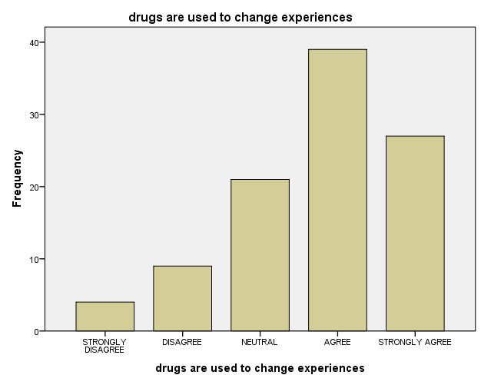
Fig 4.10: drugs are used to change experiences
Interpretation:
66% of respondents agree or strongly agree that drugs are used to alter experiences, escape reality, or manage psychological issues. This reinforces the self-medication theory.
Table 4.11: moral upbringings affect use of drug
 |  | Frequency | Percent | Valid Percent | Cumulative Percent
Valid | STRONGLY DISAGREE | 5 | 5.0 | 5.0 | 5.0
Valid | DISAGREE | 10 | 10.0 | 10.0 | 15.0
Valid | NEUTRAL | 12 | 12.0 | 12.0 | 27.0
Valid | AGREE | 41 | 41.0 | 41.0 | 68.0
Valid | STRONGLY AGREE | 32 | 32.0 | 32.0 | 100.0
Valid | Total | 100 | 100.0 | 100.0

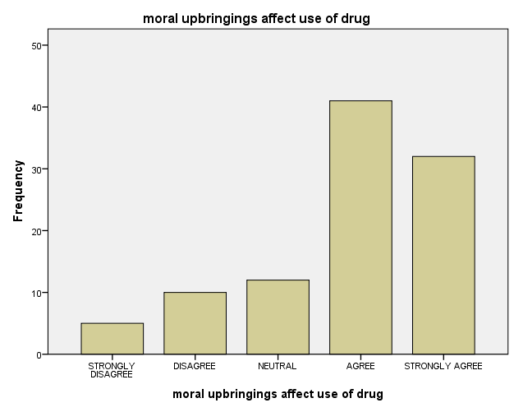
Fig 4.11: moral upbringings affect use of drug
Interpretation:
73% of respondents suggest that moral upbringing significantly influences one’s attitude toward drug use. Individuals raised with strong moral guidance may be less inclined toward substance abuse.

CHAPTER FIVE

SUMMARY, CONCLUSION, AND RECOMMENDATIONS

5.1 Summary of Findings
This study investigated the factors influencing drug and substance abuse among individuals, focusing on demographic, environmental, psychological, and social dimensions. The analysis utilized descriptive statistics to interpret the responses of 100 participants. Key findings include:
Table 4.1: Place of Residence: A large majority (94%) of respondents agreed or strongly agreed that residential environment significantly affects drug abuse.
Table 4.2: Previous Experience: 87% agreed that prior encounters with drugs influence current usage behavior.
Table 4.3: Physiological Intolerance: 87% indicated that physiological or biological predispositions may lead individuals toward drug abuse.
Table 4.4: Family Background: 81% of the respondents agreed that family background has a major impact on an individual’s likelihood to engage in substance use.
Table 4.5: Environment/Setting: 79% agreed that the area or setting where an individual lives or associates contributes to substance use.
Table 4.6: Desire for Effects: 84% acknowledged that individuals use drugs to achieve certain desired effects, either mentally or physically.
Table 4.7: Peer Pressure: 82% of the respondents reported peer pressure and influence from friends as a major reason for drug abuse.
Table 4.8: Misplaced Priorities: 75% indicated that a lack of proper goal orientation and misplaced values affect substance use.
Table 4.9: Access to Money: 68% believed that the amount of money available to students contributes to their likelihood of using drugs.
Table 4.10: Changing Experiences: 66% agreed that drugs are used to escape or alter personal experiences.
Table 4.11: Moral Upbringing: 73% indicated that strong moral values and upbringing reduce the risk of drug abuse.
These findings reveal a pattern where both individual internal factors (e.g., experience, tolerance) and external influences (e.g., environment, family, peer pressure) combine to determine drug usage behavior.

5.2 Conclusion
The research concludes that drug and substance abuse among individuals—particularly youths—is not random but strongly influenced by various interrelated factors such as environmental setting, peer influence, family structure, psychological background, and moral foundation. The respondents largely acknowledged that social constructs and personal experiences have a profound effect on the onset and continuity of substance abuse. Therefore, addressing drug abuse requires a multi-dimensional approach that considers both personal and societal variables.

5.3 Recommendations
Based on the findings of this study, the following recommendations are proposed:
- Strengthening Family and Moral Support Systems: Parents and guardians should ensure a morally stable environment at home to guide children from early stages, emphasizing discipline and proper values.
- Environmental Control and Monitoring: Schools, communities, and local governments should provide safe and drug-free environments, especially in areas prone to substance circulation.
- Peer Group Education: Educational institutions should organize seminars, peer group discussions, and counseling programs that emphasize the dangers of peer pressure and encourage positive peer influence.
- Targeted Awareness Campaigns: Public health and drug control agencies should implement awareness campaigns focused on the psychological and physiological risks of drug use, especially in schools and universities.
- Financial Monitoring: Parents should regulate the amount of money students have access to, ensuring funds are spent responsibly.
- Rehabilitation and Counseling: Government and NGOs should invest more in counseling and rehabilitation centers that cater to individuals affected by substance abuse.
- Policy Implementation: Relevant authorities should enforce laws that limit the accessibility of harmful substances and prosecute illegal drug distributors.

References
Adegoke, A. A. (2015). Youth and substance abuse in Nigeria. Ilorin Journal of Sociology, 7(2),
45–56.
Ajayi, I. A., & Ayodele, J. B. (2018). The influence of socio-economic factors on drug use among
undergraduates in Nigerian universities. Journal of Education and Practice, 9(3), 20–29.
Akindutire, I. O., & Adegboyega, L. O. (2012). Family background and substance abuse among
adolescents in Nigeria. Journal of Psychology, 3(1), 15–22.
Eneh, A. U., & Stanley, P. C. (2004). Pattern of substance abuse among secondary school students
in Rivers State, Nigeria. Nigerian Journal of Medicine, 13(4), 362–366.
Gureje, O., & Olley, B. O. (2004). Substance use and its correlates among adolescents in Nigeria.
Journal of Child & Adolescent Mental Health, 16(2), 93–97.
Isidore, N. (2017). Peer pressure and drug abuse among university students in Nigeria. Journal of
Social Science Research, 6(1), 55–64.
Makanjuola, A. B., & Daramola, T. O. (2016). Perceived risk and drug abuse among Nigerian
youths. African Journal of Drug and Alcohol Studies, 15(2), 95–110.
National Institute on Drug Abuse (NIDA). (2020). Understanding drug use and addiction.
https://www.drugabuse.gov/publications/drugfacts/understanding-drug-use-addiction
Obiechina, G. O., & Isiguzo, B. C. (2016). Substance abuse among students in tertiary institutions
in Nigeria. International Journal of Education and Research, 4(9), 421–432.
Ogunlade, B. O. (2013). Youth culture and drug abuse in Nigeria. Journal of Youth Studies, 8(1),
38–49.
Okpataku, C. I. (2015). Psychosocial predictors of substance abuse among Nigerian adolescents.
Nigerian Journal of Psychiatry, 13(1), 30–37.
Olaniyi, G. E. (2011). The role of family background in substance abuse among secondary school
students. African Journal of Educational Studies, 6(2), 99–108.
Onifade, P. O., Somoye, E. B., Ogunwobi, O., Ogunwale, A., & Akinhanmi, A. O. (2013). A study
of drug abuse among secondary school students in Nigeria. International Journal of Humanities and Social Science Invention, 2(3), 61–65.
Oshodi, O. Y., Aina, O. F., & Onajole, A. T. (2010). Substance use among secondary school
students in Lagos State, Nigeria: An overview of the prevalence and risk factors. African Journal of Psychiatry, 13(1), 52–57.
World Health Organization (WHO). (2018). Global status report on alcohol and health 2018.
Geneva: World Health Organization.

