Development of a Computerized System for Generating Academic Transcripts

BY
Osifule Babajide Jacob
ND/23/COM/PT/0248

A PROJECT SUBMITTED TO
THE DEPARTMENT OF COMPUTER SCIENCE, INSTITUTE OF INFORMATION AND COMMUNICATION TECHNOLOGY
KWARA STATE POLYTECHNIC, ILORIN

IN PARTIAL FULFILLMENT OF THE REQUIREMENTS FOR THE AWARD OF NATIONAL DIPLOMA (ND) IN
COMPUTER SCIENCE
JUNE, 2025

CERTIFICATION
This is to certify that this project work was carried out by OSIFULE BABAJIDE JACOB with Matriculation Number ND/22/COM/PT/0248. The project has been read and approved as part of the requirement for the award of National Diploma (ND) in Computer Science Department, Institute of information and communication technology, Kwara state polytechnic, Ilorin.

__________________________ _____________________
MRS. ADEMOLA R. DATE
PROJECT SUPERVISOR

______________________ ___________________
MR. OYEDEPO F. S. DATE
HEAD OF DEPARTMENT

______________________ ___________________
EXTERNAL SUPERVISOR DATE

DEDICATION
This project specially dedication to Almighty God for His love, protection, guidance and supports for me especially in my academic career. Also, to my beloved parents for their care and full support during my course, may Almighty God bless them abundantly (AMEN).

ACKNOWLEDEGEMNT
All praise is due to the Almighty God the Lord of universe. I praise and thank Him for giving me the strength and knowledge to complete my ND programme and also for my existence on earth.
I appreciate the utmost effort of my supervisor, MRS ADEMOLA R., whose patience, support and encouragements have been the driving force behind this research work. She took time out of her tight schedules to guide me and go through this project. She gave useful corrections, constructive criticisms, comments, recommendations, advice and she always ensured that excellent research is done.
My sincere gratitude goes to Head of Department and other members of staffs of the Department of Computer Science, Kwara State Polytechnic, Ilorin for their constant cooperation, constructive criticisms and encouragements throughout the programme.

ABSTRACT
The generation of academic transcripts is a critical administrative process in educational institutions, traditionally carried out manually, which is often time-consuming, error-prone, and inefficient. This project presents the design and implementation of a computerized system for generating academic transcripts, aimed at improving accuracy, efficiency, and accessibility. The proposed system automates the process of compiling students’ academic records, calculating grades and Grade Point Averages (GPA), and formatting them into official transcript documents. Developed using a relational database management system, the solution ensures secure storage, quick retrieval, and real-time updates of student data. It incorporates user authentication to prevent unauthorized access and provides a user-friendly interface for both administrative staff and authorized stakeholders. The system reduces processing time, minimizes human error, and enhances data integrity, thereby streamlining the transcript production workflow. Testing results indicate that the computerized system significantly improves performance compared to the manual approach, making it a viable solution for modern educational institutions seeking efficient and reliable transcript management.
Keywords: Academic Transcript, Computerized System, Automation, Database Management, GPA Calculation, Student Records.

TABLE OF CONTENTS
Title page i
Certification ii
Dedication iii
Acknowledgements iv
Abstract v
Table of Contents vi
CHAPTER ONE
1.1 Introduction 1
1.2 Aim and Objectives of the Study 2
1.3 Statement of the Problem 2
  - Significance of the Study 2
1.5 Scope and Limitation 3
1.6 Organization of the Report 3
CHAPTER TWO
2.1 Review of Related Works 4
2.2 Expert System 7
2.3 Description of E-Diagnosis 8
2.3 Types of Eye Problems 8
CHAPTER THREE
3.1 Research Methodology 12
3.2 Description of Existing System 12
3.3 Problem of Present System 13
3.4 Description of the Proposed System 14
3.5 Advantages of the proposed System 15
CHAPTER FOUR
4.1 Design of the System 16
4.1.1 Output Design 16
4.1.2 Input Design 17
4.1.3 Database Design 18
4.1.4 Procedure Design 19
4.2 Implementation of Techniques Used in Details 19
4.2.1 Programming Language Used with Reasons 19
4.2.2 Hardware Support 20
4.2.3 Software Support 20
4.3 System Documentation 20
4.3.1 Program Documentation 20
4.3.2 Operating the System 21
4.3.3 Maintenance of the System 21
CHAPTER FIVE
5.1 Summary 22
5.2 Conclusion 22
5.3 Recommendations 23
Reference 24
Appendix 1 Flowchart 25
Appendix 2 Source Code 30

CHAPTER ONE
1.0 INTRODUCTION
The manual processing of academic transcripts in many tertiary institutions often leads to inefficiencies, delays, and errors. With the growth of student populations and increased demand for quick access to academic records, institutions are gradually transitioning from traditional paper-based systems to computerized solutions. A computerized system for generating academic transcripts is designed to automate and streamline the process of compiling, calculating, and presenting student academic records accurately and efficiently.
Transcripts are official documents issued by academic institutions to reflect students’ performance over a specific period. These documents typically contain detailed information such as courses offered, grades obtained, Grade Point Averages (GPA), Cumulative Grade Point Averages (CGPA), and remarks. In traditional settings, the collation and generation of these documents are handled manually, involving multiple departments and stages of verification, which often results in delayed processing, high administrative costs, and sometimes data inaccuracies.
By implementing a computerized system, institutions can significantly reduce these drawbacks. The system ensures quick retrieval of student records, minimizes human errors, enhances data security, and promotes transparency. Moreover, it provides a platform for storing, updating, and managing student data digitally, which is essential in today’s technology-driven world.
This project aims at developing a robust and secure computerized system that automates the process of generating academic transcripts. The system will incorporate features such as student database management, course and result entry, automatic computation of GPAs and CGPAs, and transcript generation in printable formats.
1.2 STATEMENT OF PROBLEM
It is an established fact that after every assessment, examination or research work, a result must be obtained (Murdick, 1971). In every academic environment there is need to have results of student’s performance in order to generate the student’s transcript. To achieve this, there is need for bio-data registration of individual student, course registration by students and grading and recording of student examination result. Presently, all these activities are carried out manually. This has led to serious difficulty in processing student result and generating student transcript. This difficulty includes missing grades, course registration problem, slow processing of transcript and other related challenges.
1.3 AIM AND OBJECTIVES OF THE STUDY
The aim of this study is to design and implement transcript generating software to replace exiting manual method of transcript generation. The objective of the study is to:
- Store student results in a database management system for easy retrieval by authorized personnel.
- Reduce cost of generating transcripts and remove redundancy associated with manual processing.
- Ease the process of transcript generation hence more transcript can be generated within a period of time.
- Eliminate manual method of transcript generation hence piles of files can be face out.
1.4 SIGNIFICANCE OF THE STUDY
The significance of this study lies in its potential to address the longstanding challenges associated with the manual generation of academic transcripts in tertiary institutions. By introducing a computerized system, the study aims to enhance the speed, accuracy, and reliability of transcript processing. For academic institutions, the system will reduce administrative workload, minimize human errors, and improve overall efficiency in managing student records. It will also help in maintaining a centralized and well-organized database, making it easier to retrieve academic information when needed.
For students, the system ensures faster access to their transcripts, especially during critical periods such as job applications or postgraduate admissions, where timely and error-free transcripts are essential. The automated computation of GPA and CGPA eliminates inconsistencies and promotes transparency in academic evaluations. Administrative staff will benefit from the simplified process, as routine tasks like grade computation and transcript formatting are handled automatically by the system.
1.5 SCOPE OF THE STUDY
The scope of this study is limited to the design and development of a computerized system specifically for generating academic transcripts in a tertiary institution. The system will focus on automating core tasks such as storing student biodata, inputting and updating academic records, managing course details (including course codes, titles, and credit units), and computing Grade Point Averages (GPA) and Cumulative Grade Point Averages (CGPA) based on predefined grading standards. Additionally, the system will be capable of producing printable transcripts in a standardized format that can be issued to students on request.
The system will be developed as a standalone application that can be used within the institution’s examination or records department by authorized administrative staff. It will include basic user authentication features to control access to sensitive data and prevent unauthorized modifications to student records. The focus will be on ease of use, accuracy, data consistency, and efficiency in generating transcripts for both ongoing students and graduates.

1.7 ORGANIZATION OF WORK
This project is divided into five chapter, in order to simplify and proper understanding. Chapter one provides a general introduction, statement of the problem, aim and objectives, significance of the study, scope of the study, organization report and definition of technical terms. Chapter two deals with relevant informatory literature review in the subject like review of past works. Chapter three concentrates on project methodology which comprises of method of data, description of the existing system, problems of the existing system, description of the proposed and advantages of the proposed system. Chapter four deals with design and implementation, documentation of the system, it also deals with other aspect which includes: Hardware and software and project documentation. Chapter five consists of summary, recommendation, and conclusion.

CHAPTER TWO
2.0 LITERATURE REVIEW
The introduction of computer into information technology has massively improved the information need of organization; the success of this machine is dependent on the knowledge base. Therefore, one can be prompted to ask aloud “what is a computer”. Anigbogu (2022) defined a computer as an electronic device capable of accepting data and instructions, processing the data based on the instructions to generate results or output in such a manner that is yet to be equaled by any other known machine to mankind. In the technology age, no organization, company or institution can do without information processing system or organizational information system. Researchers have in one way or the other taken step towards analyzing the problems associated with manual result processing and the need for computerization of result processing systems.
Ukem et al, (2022.) state that the errors associated with the existing manual method of processing of students results in most universities in Nigeria, make it not only desirable but imperative that computerized approach be used in measuring students’ progress. According to the researcher, the manual methods employed suffer a number of setbacks; theseinclude time consuming process prone to error. In calculation, late publication of result wrong grades computation for students’ hence leading to wrong class of degree awarded. Such wrong computation could tarnish the image of the institution. The researcher conclude that the solution to the problem is to find a method of processing examination results with require accuracy in a reasonable time. Eludire (2023), observed that a number of problems associated with student academic record management include improper course registration, late release of students’ results, inaccurate grades calculation and inefficient, retriever of student records. The researcher that suggested the development of database concept as the answer to these problems. Mohini and Amar (2022) also agree that students results delay due to manual access. The delay in declaration of result put the students at a great disadvantage such as inability of graduation students to apply for job. Murdick, D. (2023),observed that, with the use of computers for information processing, the following are possible: instant access to students’ biodata, availability of course information, student information updating, automatic computation of the Grade Point Average (GPA), generation of the graduating students list, monitoring of failed courses, keeping an up-to-date record of the entire student in the institution, storing course information such as course code, course description, course unit, and scores for the purpose of GPA computation and user friendly interface for users.
2.1 PACKAGES USED FOR DESIGNING OF TRANSCRIPT MANAGEMENT SYSTEM
Different Programming Languages, Programming Packages and Database management system can be used to develop result processing software for computing students GPA (Grade Point Average) and CGPA (Cumulative Grade Point Average). Microsoft Excel spreadsheet program can be used to build an Intelligent Knowledge-Based System (IKBS), making use of various programming facilities provided by that application (Excel). The programming is hard coded into the cells, and cell referencing which could be applied to monitor and track students’ performance such as cumulative points (Ekpenyong, 2020). Personal Home Page Pre-Processor (PHP) is used to communicate with and manipulate the database. Adobe Dreamweaver, an Integrated Development Environment, is used to create the Graphic User Interface and to write the codes. MYSQL Server, a Relational Database Management System, is used to create the database tables and data. This application, though tested and found to be working as expected, has however not been put to use widely.
(Ukem an2023). Java is a programming language use to build programs that can work on stand-alone computers and on the internet, its primary features are that it is object-oriented and a cross platform language. By cross platform, it means that the programs can run across several platforms such as Microsoft Windows, Apple Macintosh, and Linux. MYSQL, a Relational Database Management System (RDBMS) is used to create database tables and data. MySQL is very fast, reliable, and easy to use, and its connectivity, speed, and security make it highly suited for accessing databases.
There are undoubtedly several other similar Programming Language and Database management system in existence. Some previous work has actually been carried out using several of such programming languages and packages which prove to be working fine in this area. Three of such are the work by Ukem, and Ofoegbu, Ekpenyong and that by Ukem and Onoyom-Ita. There is, however, always room for improvement. This new application is intended to have reduced complexity and greater ease of use, in order to enhance maintainability while still retaining good speed and accuracy.
2.2 THE ROLE OF MANAGEMENT INFORMATION SYSTEM IN DECISIONS MAKING IN THE UNIVERSITY.
The role of information in decision making cannot be overemphasized. Effective decision-making demands accurate, timely and relevant information. According to Aminu (2024), information resource is one of the major issues and indices of university planning. Where the relevant information required for planning are not available at the appropriate time, there is bound to be poor planning, inappropriate decision making, poor priority of needs, defective programming or scheduling of activities. Hence, the university system will not be efficient and effective in its operation. Poor management information system has been identified as a bottleneck in the successful management of universities in Nigeria.
The more complex an organization’s structure is, the greater the need for coordination within and between sections and departments. However, central to the needed coordination is information. This view is buttressed by Murdick and Ross (2023), that information is absolutely essential to the survival of an organization. As organization grow, the pressure of scale, complexity and an increased rate of change make adequate information processing capacity inevitable, if effective control, consequent upon coordinate of individual activities is to be achieved.
Thus, the information needed for effective decision making in universities cannot be provided from people’s often deficient memories. Moreover, it is impossible to plan activities over a long period of time effectively without effective information. Information is supposed to be created through the discipline of enquiry and research with peer moderation to ensure, validity and societal influence. The knowledge to be created or established must be stored to ensure continuity of reason, and adaptive academic pursuit. The stored information must then be recalled at will and be disseminated for use in taking decisions, which are in the interest of the society at large, (Knight, 2022).
There are mechanisms that drive continuous investment in bricks and mortar education and deny the expenditures that would establish virtual universities by means of telecommunication networks. Even if they wanted to, administrators are restricted in their freedom to move in this direction by traditional funding formulae. Promotion and tenure procedures are seen as banners in the universities. In many institutions, the primary requirements for promotion and for tenure procedures are publications in traditional journals and teaching in traditional classrooms. A major federal government contribution is it’s booster plan to computerized information in the United Schools (Ekere, 2023).
With these improvements, the information resource still presents a major issue on educational management in the country. Particularly with the universities, one wonders the essence of their acquiring communication gadgets and the scope of their applications. Studies have revealed that in most sophisticated organization both manual and computer-based system are used; in fact both are held to be complementary in information handling procedures (Sanders, 2023). stressed the need for management information systems in making effective decisions in education institutions. In recognition of the important role of information to the survival of the university system, the NUC introduced the computerized management information system to the Nigerian universities. The MIS idea was conceived during a conference jointly organized by NUC and the British Council in Kadun.
In conjunction with overseas Development Administration (ODA), the project started in 1989 with four pilot universities, namely Federal University of Technology, Mina, and University of Ilorin, University of Lagos and University of Nigeria, Nsukka. The importance of MIS in decision making can be realized from its aims and objectives. The aim of MIS is to develop a viable system to maximize the effective use of modern data approach to management practices. It is also aimed at assisting managers and operating personnel, to produce timely and accurate information not only to decide present and future operations, but also to pinpoint potential problems that need to be rectified.

CHAPTER THREE
RESEARCH METHODOLOGY
3.1 Research Methodology
The research methodology adopted for this study is primarily qualitative and developmental in nature. It involves the observation and analysis of existing manual processes of academic transcript generation, identifying gaps, and then developing a prototype system to address these challenges. The methodology includes system analysis, design, development, testing, and evaluation phases. Data was collected through interviews with administrative staff and students, as well as direct observation of transcript processing activities in a tertiary institution. The information gathered provided insights into the specific operations involved, time constraints, and common problems encountered during manual transcript generation. Based on these findings, the system requirements were defined, and appropriate technologies such as HTML, PHP, and MySQL were selected for the development of the computerized solution.
3.2 Analysis of Data and the Existing System
In analyzing the existing system, it was observed that transcript generation is primarily carried out manually by the academic records or exams and records unit. This process begins with the retrieval of student files, which involves sorting through large volumes of paper-based documents stored in cabinets or shelves. Each course, grade, and academic session is manually compiled, followed by the calculation of GPA and CGPA using calculators or spreadsheets. After verification by academic officers, the transcript is formatted and printed, sometimes multiple times due to corrections or formatting errors. This approach is slow, tedious, and error-prone, especially when handling multiple transcript requests simultaneously. Additionally, the risk of data loss, duplication, and delays is high due to human involvement in every step of the process.
3.3 Problems of the Existing System
The existing manual system has several notable problems that hinder effective academic transcript management. Firstly, the process is time-consuming and inefficient, particularly during peak academic periods or when students urgently need their transcripts. The likelihood of human error in grade computation and record retrieval is high, leading to inaccuracies and inconsistencies in the final output. There is also limited security and privacy of student records, as physical documents can be misplaced, damaged, or accessed without proper authorization. Furthermore, the manual method lacks scalability; as the number of students increases, the administrative burden grows significantly, putting strain on staff and infrastructure. Lastly, there is no centralized or automated backup system in place, increasing the risk of permanent data loss due to fire, theft, or misfiling.
3.4 Description of the Proposed System
The proposed system is a computerized transcript generation platform designed to automate the collection, processing, and presentation of student academic records in a structured and efficient manner. It will operate as a database-driven application, where student information such as personal details, course registrations, grades, credit units, and academic sessions can be entered, updated, and managed by authorized personnel. The system will automatically compute students’ Grade Point Average (GPA) for each semester and the Cumulative Grade Point Average (CGPA) across multiple sessions based on the institution's grading scale.
The system will also generate a formatted academic transcript document, which includes all relevant academic information in a printable layout. A login interface will be integrated to control access, ensuring that only authorized users, such as academic staff or records officers, can view or modify student data. Additionally, the system will support searching for student records by name, matriculation number, or department, and will have built-in validation checks to prevent data entry errors. Overall, the proposed system is designed to be user-friendly, secure, and scalable, with the potential for future integration with broader student information systems.
3.5 Advantages of the proposed system
The proposed computerized system offers several significant advantages over the traditional manual transcript processing method. First and foremost, it greatly enhances the speed and efficiency of transcript generation, reducing the time it takes to compile and produce accurate academic records. By automating the computation of GPA and CGPA, the system eliminates human errors associated with manual calculations, ensuring greater accuracy and consistency in academic evaluation.
Another advantage is data security and integrity. With secure login features and controlled access, the system protects sensitive student information from unauthorized access or manipulation. It also improves data management by storing all academic records in a centralized database, making it easy to retrieve, update, or back up records as needed.
Furthermore, the system reduces administrative workload, allowing staff to focus on other important tasks instead of repetitive data entry and verification processes. The standardized transcript format generated by the system ensures professional presentation, which is crucial for both local and international academic recognition. Lastly, the proposed system is scalable, meaning it can be upgraded in the future to include features like online transcript requests, payment integration, or external verification, thereby supporting the institution’s long-term digital transformation goals.

CHAPTER FOUR
DESIGN, IMPLEMENTATION AND DOCUMENTATION OF THE SYSTEM
4.1 DESIGN OF THE SYSTEM
The proposed system is designed in modules with each modules working together to perform the Design and Implementation of an Academic Information System in order to enhance the performance of the existing system as earlier discussed in chapter three.
The ability to analyze and give focus to the system is explained in the following formats which are output design, input design, database design and procedure design.
    - OUTPUT DESIGN
The output and output to be extracted from the proposed system are as shown below
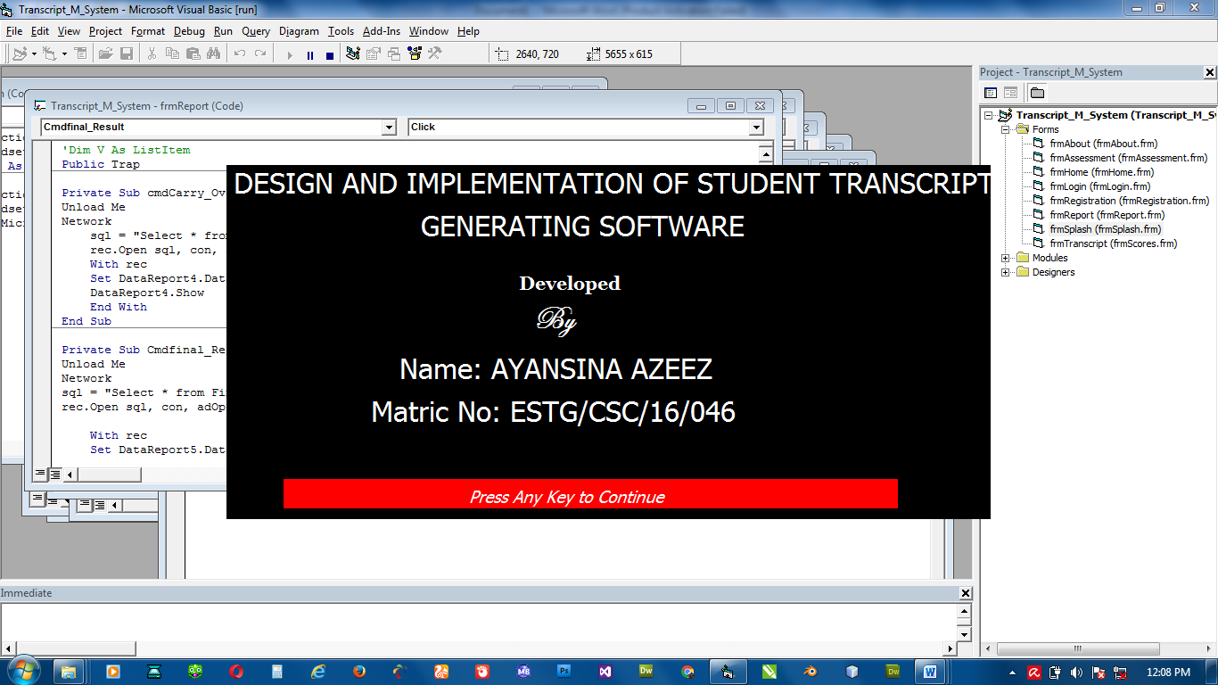
DEVELOPED BY
OSIFULE BABAJIDE JACOB
ND/23/COM/PT/0248
Figure 4.1: Welcome Screen
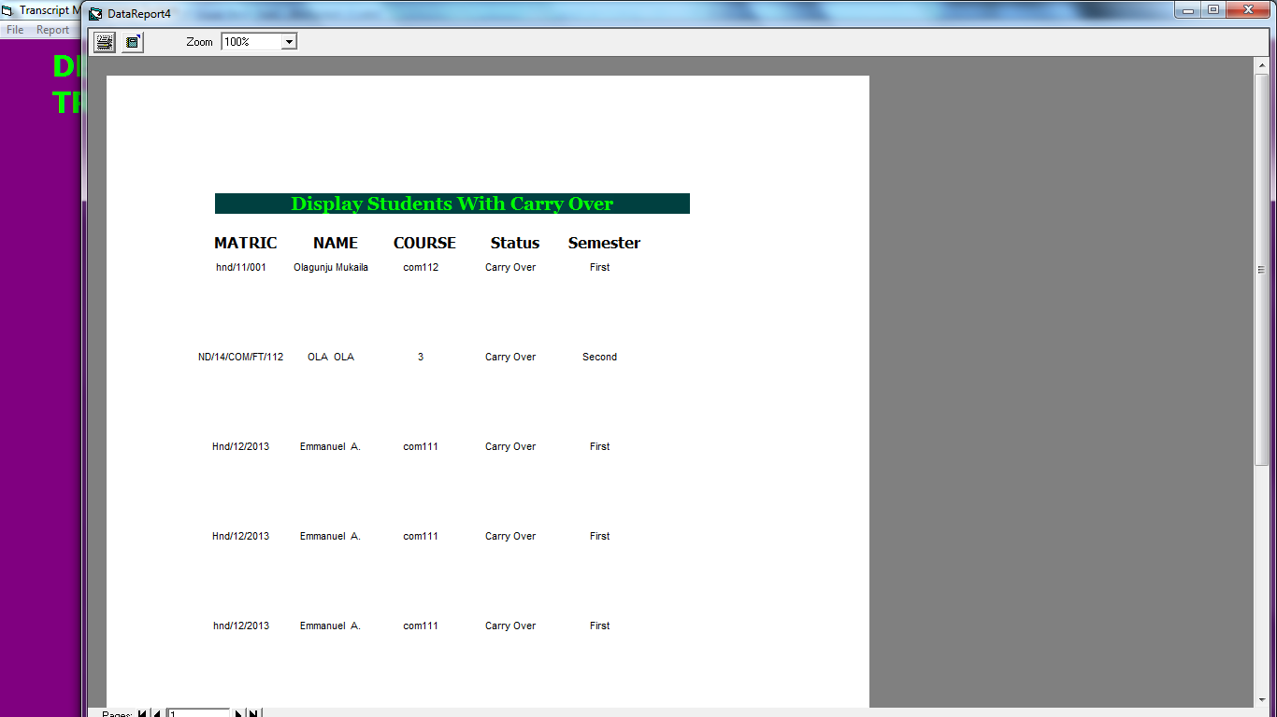
Figure 4.2: Students with Carry over report
    - INPUT DESIGN

The input and output to be extracted from the proposed system areas are shown below
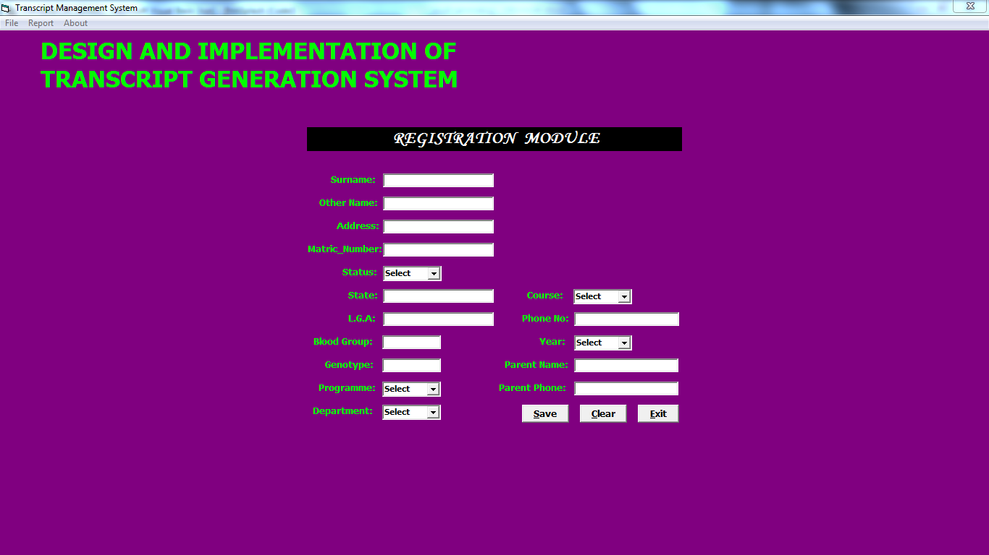
Fig 4.3: Profile registration Module

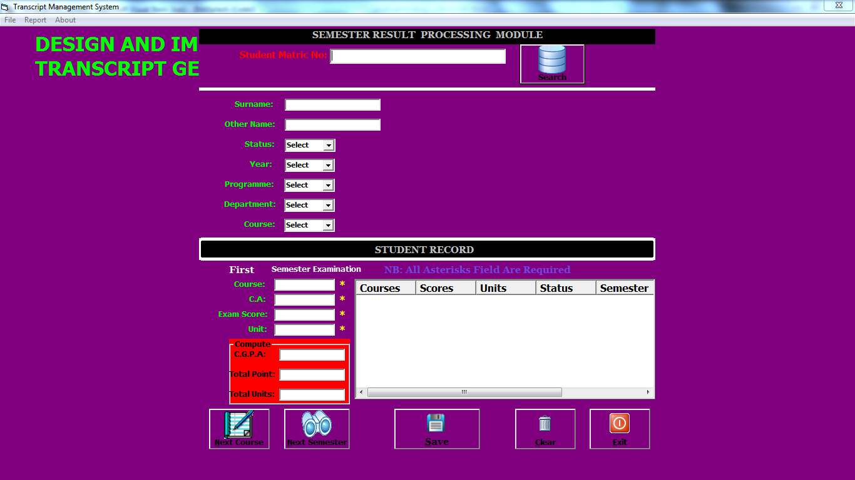
Fig 4.4. semester result processing module
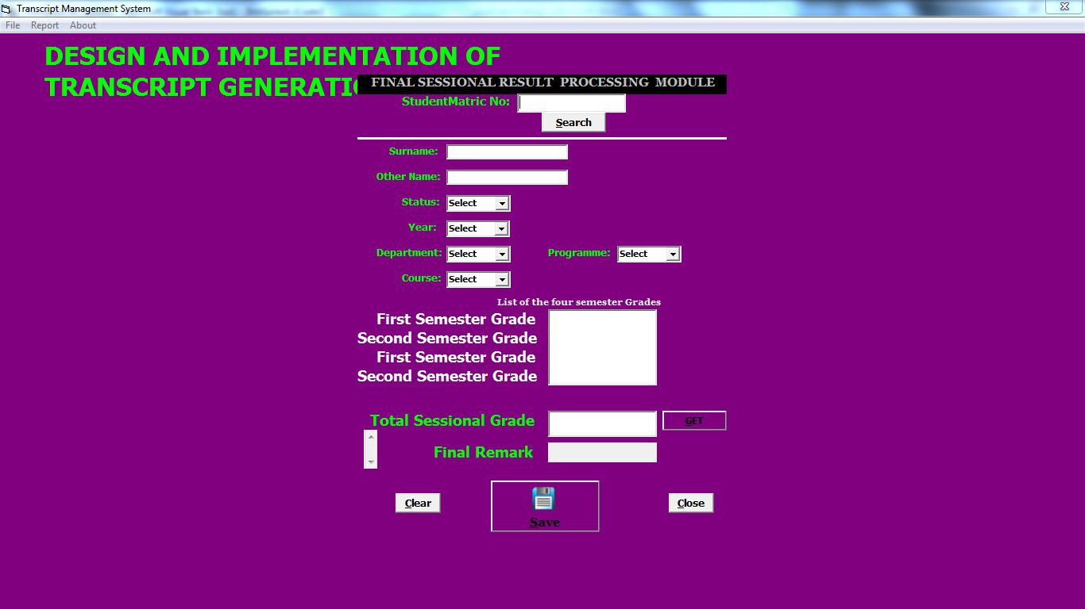
Fig. 4.5 Final sectional result processing module

4.1.3 SYSTEM DATABASE
A Database Management System is a software system that uses a standard method of cataloging, retrieving, and running queries on data. The DBMS manages incoming data, organizes it, and provides ways for the data to be modified or extracted by users or other programs (Tech Terms, 2014). Database is a collection of data which is related by some aspect. Data is a collection of facts and figures which can be processed to produce information e.g. Name, age, class and subjects of a student are data collected for record. Data represents recordable facts and it aids in producing information which is based on facts. Therefore, the process of storing these facts is handling by Database Management System (DBMS)(Tutorials point, 2014). A database management system stores data, in such a way that it is easier to retrieve, manipulate and helps to produce information.
The relational database was adopted because is made up of a group of logically connected tables (data that has a relationship to other data). Therefore, establishing a relational database management system is a great way to increase data integrity, efficiency, ask questions, sort and filter data, provide stronger security, and share information, ease of use, data independent among others (Goessl, L. 2009). Most of the commands used to implement processes and procedures are available in the Appendix. Some user and database table are show below
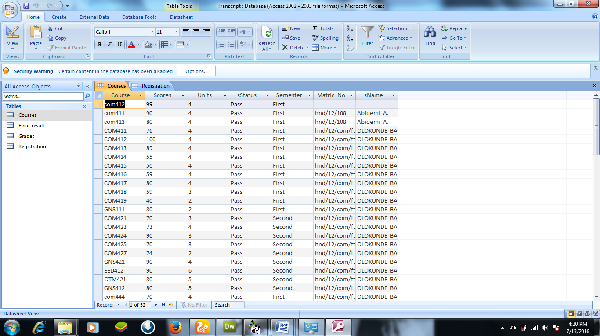
Table 4.1: Course Table
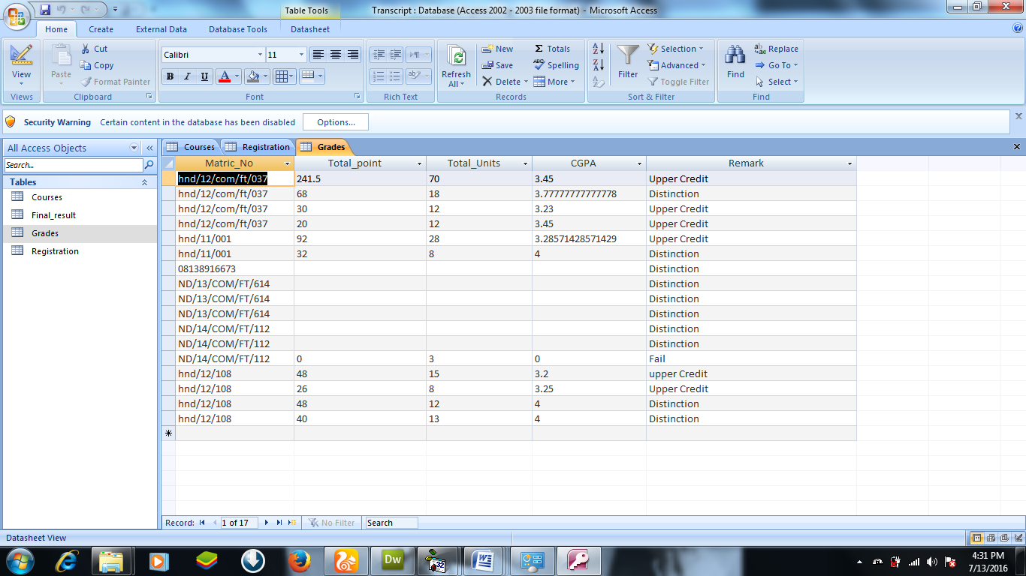
Table 4.2: Grade Table
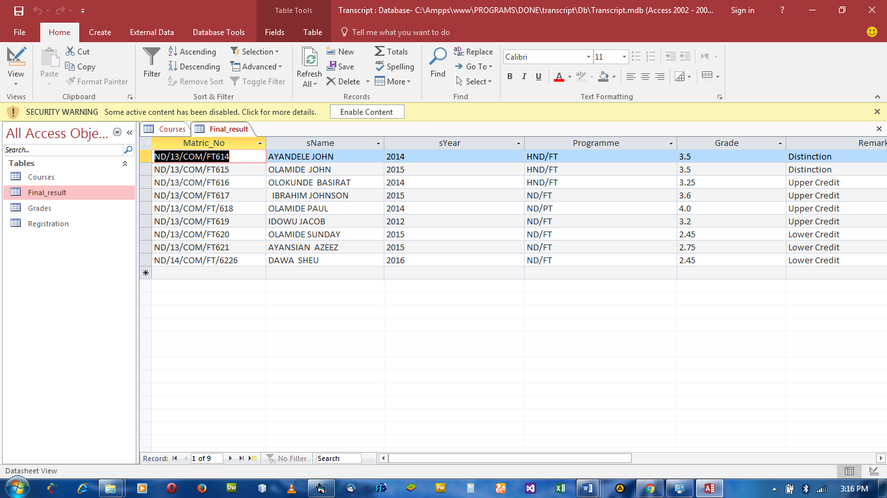
Table 4.3: Registration Table

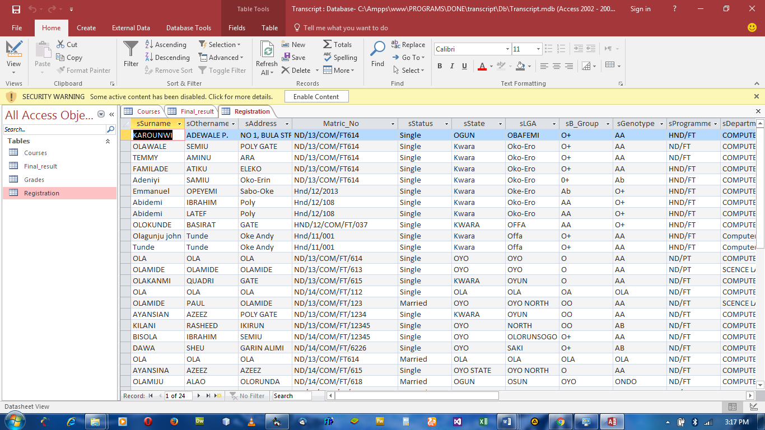
Table 4.4: Student Details Table

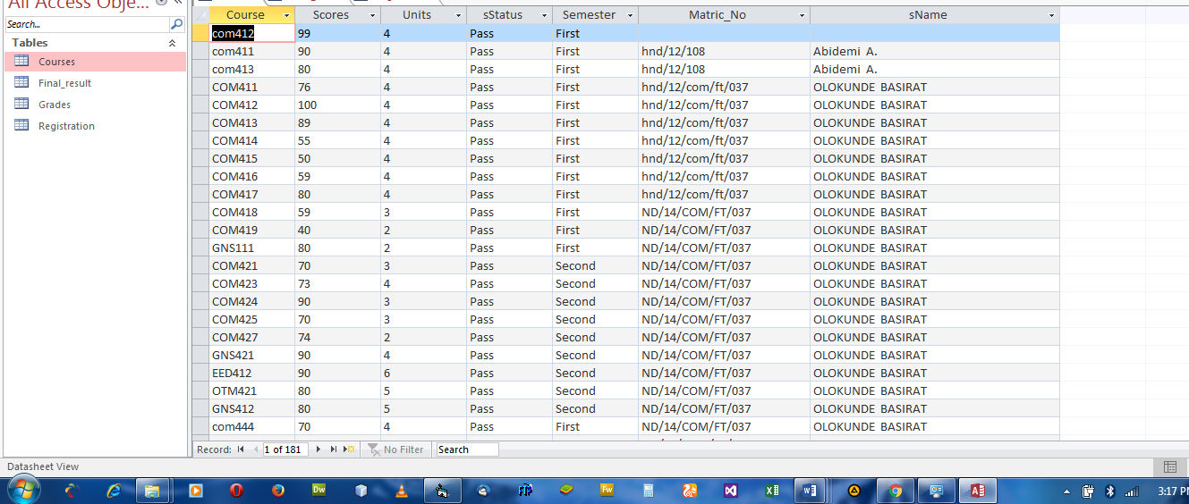
Table 4.5: Result Table

    - PROCEDURE DESIGN
This refers to the step-by-step procedure to implement the propose system. This system will be implemented using a parallel approach of system implementation i.e running the propose system alongside the existing system. The steps to the implementation of the proposed is listed as follows:
- Start the computer system.
- Point to the start menu.
- Select all programe
- Point to transcript management system.
- The program will be implemented in a few moments.
- And the authorized user will be able to input the result and generate the student transcript.
- Also, the authorized user will be edit, update the record at any point in time also he will be able to view both result report and the transcript report.
  - IMPLEMENTATION OF THE SYSTEM
    - CHOICE OF PROGRAMMING LANGUAGE
This is the collection of physical parts of a computer system. This includes the computer case, monitor, keyboard, and mouse. It also includes all the parts inside the computer case, such as the hard disk drive, motherboard, video card, and many others. Computer hardware is what you can physically touch. The minimum hardware requirement is:
CPU : DUAL CURE
PROCESSOR SPEED : 2 GHz
COPROCESSOR : BUILT IN
RAM : 1GB or Higher
HARD DISK : 80 GB
KEYBOARD : 105 KEYS
MOUSE : LOGITECH MOUSE
DISPLAY : SGVA COLOR MONITOR
    - SOFTWARE SUPPORT
The software support for the design of the proposed system involves windows operating system, Microsoft visual basic 6.0, Microsoft access 2007 as well as anti-virus software which prevent the system from being infected by virus.
    - IMPLEMENTATION TECHNIQUES USED IN DETAIL
The implementation technique to be use in the system is parallels, a system that support the current system along-side with the proposed system. This means that to adopt the proposed system a paper and pen method that is currently in used will still be in existence so that a failure in the proposed system will not lead to total loss of applicants.
REQUIREMENTS AND ANALYSIS:
The functional requirements of the system will be gathered in this stage. This includes inception and consequent elaboration on all the web services that the system will provide to the students and faculty members.
ARCHITECTURAL DESIGN:
The next step is to come up with the appropriate architectural model for the system. An appropriate Platform Independent Model (PIM) suitable for web-based development needs to be chosen. This will simply be an abstract view of the overall structure of the system, and will most probably consist of a heterogeneous style.
DOMAIN-SPECIFIC & COMPONENT DESIGN:
In this phase, we will concentrate on designing the Platform Specific Model (PSM). This will involve designing the system using various enterprise middleware styles based on the requirements defined in the initial phase. The system will most probably consist of a 3-tier or N-tier architecture. It will be designed in such a way so as to ensure proper separation of concerns between the different tiers as well as efficient communication between them. The result of this stage is a complete UML Component Diagram, where the functionalities of each component and their required and provided interfaces are properly defined.
SYSTEM INTEGRATION & TESTING
This phase involves integrating all the components together. Each component created will be combined together into web services. Then, each web services will be separately tested to ensure that they meet the required functionalities. Once this has been achieved, all the web services will be combined together and the system will be tested as a whole.
  - DOCUMENTATION OF THE SYSTEM
    - PROGRAM DOCUMENTATION
In order for the proposed system to be used on any computer system it takes the following ways
- Boot the system
- Copy the folder to www inside Wamp folder of the drive C: after Wamp server is installed onto the system.
- Open any browser on the system (Microsoft internet Explorer, Mozilla Fire fox, Netscape Navigator, Opera, Flock, Safari e.t.c)
- Type http://localhost/course/admin/on the address bar and press the return key/ enter key.
4.3.2 OPERATING THE SYSTEM
In order for the proposed system to be used on any computer system it takes the following ways
- Boot the system
- Copy the folder to www inside Ampps folder of the drive C: after WAMP server is installed onto the system.
- Open any browser on the system (Microsoft internet Explorer, Mozilla Firefox, Netscape Navigator, Opera, Flock, Safari e.t.c).
- Type http://localhostcourse/admin/ on the address bar and press the return key or enter key.
4.3.3 MAINTAINING THE SYSTEM
System maintenance is a critical aspect of ensuring the long-term functionality, reliability, and security of the computerized academic transcript generation system. After deployment, the system must be regularly monitored and updated to adapt to changes in institutional policies, academic grading standards, and user needs. Maintenance involves both corrective and preventive actions aimed at fixing bugs, optimizing performance, and safeguarding the system from potential threats such as data breaches or software corruption. Routine checks are essential to ensure that all features, including GPA computation, data storage, transcript formatting, and access control, function as intended.
One important area of system maintenance is data management. Regular backups of the student database must be scheduled to prevent data loss due to hardware failure, accidental deletion, or malicious attacks. These backups should be stored in secure locations, preferably using both onsite and cloud-based solutions for redundancy. In addition, user accounts and login credentials should be reviewed periodically to revoke access from unauthorized users and update security protocols like password strength and session timeouts.
Software updates are another key component of system maintenance. As new versions of the programming languages and frameworks used (e.g., PHP, MySQL) are released, they may include important security patches or performance enhancements. Failing to update the system could expose it to vulnerabilities. Therefore, the system administrator should ensure compatibility with the latest technologies and implement patches promptly.
Finally, user feedback should be collected continuously to identify areas that require improvement or additional features. A dedicated support channel should be available for administrators and users to report issues or request enhancements. Through regular evaluation, user training, and technical support, the system can be maintained efficiently and remain responsive to the evolving needs of the institution.

CHAPTER FIVE
SUMMARY, RECOMMENDATION AND CONCLUSION
5.0 SUMMARY
This project focused on the design and implementation of a computerized system for generating academic transcripts in a tertiary institution. The manual method of transcript processing was studied and analyzed, revealing several limitations such as delays, errors in computation, lack of data security, and inefficiency. In response, a web-based system was developed using HTML and PHP to automate core functions including student record management, GPA/CGPA computation, and printable transcript generation. The system provides a user-friendly interface for administrative staff to input and manage academic data securely and accurately, while reducing workload and improving service delivery to students.
5. 1 CONCLUSION
In conclusion, the computerized transcript generation system offers a modern, effective solution to the challenges associated with manual transcript handling. By automating calculations and formatting, it ensures improved speed, data accuracy, and consistency. The integration of user authentication also enhances security by restricting access to authorized personnel. Overall, the system contributes significantly to the digital transformation of academic administrative processes, providing a scalable platform that can be extended to support online transcript requests, payments, and integration with external verification services in the future.

5.2 RECOMMENDATION
Based on the success of this project, it is recommended that tertiary institutions adopt similar systems to improve academic record keeping and transcript issuance. Furthermore, regular training should be provided to administrative staff to ensure efficient use of the system. Institutions should also invest in routine system maintenance and data backup strategies to ensure long-term reliability and security. Finally, future upgrades should consider extending the system to support multi-campus operations, integration with student portals, and automated transcript delivery to external organizations for graduate verification and employment purposes.

REFERENCES
Anigbogu, S. O. (2000). Computer application and operation (First Edition) Awka; Anambra: Optimum Press.
Advon, (2002) Management Information System for Managers. Ado Ekiti :Green Line Publishers.
Eludire(2011).Echrome Transcript Management System. London: Princeton University Press.
Mohini and Amar (2011).School Computerization, 6th Edition. U.S.A: Kleen University Press.
Onoyom-Ita(2011).Management Information System. New Jersey: Prentice Hall Inc.
Aminu (1986).Program Systems Engineering Fundamentals.Institute of Mathematics and Informatics, Vol. 2. Vilnius, Literriania. Electronic School Information. (2010). Retrieved on 2010-08-13. From htt.p.//www.myschool.com.
Ross (1971), Evaluation of Management Information System in Universities. Lagos: Longman Publishers.
Fabunmi (2003), Analysis of Informatics Systems. Vilnius, Lithuania: Vilnius University Press.
Moses E. Ekpenyong. (2005) “A Real Time IKBS for Students Results Computation”, International Journal of Physical Sciences (Ultra Scientist of Physical Sciences) Volume 20, Number 3(M), September – December, 2008
Murdick, D. (1971). Management Theory of Computer. Osaula, E.C. (1978). Introduction to Research Methodology, Ikeja, Lagos State: Ekon Press. Oxford Advance Learner’s Dictionary of Current English.
Obi (2003), Computer Application.Abia: M. C. Publication Ltd.
Ghauri and Gronhaug (2005). Timesharing and multiprogramming .Ibadan: J&T Publishers.
Shuchi (2008) Creating database using Microsoft access. Mumbai: Krishpublication.
Goessl, L. (2009). How to Use VISUAL BASIC 6.0.First Edition.U.S.A, Indianapolis, Indiana 46290.Division of Macmillan Computer Publishing.
Ukem, B. O. and Ofoegbu, F. A (2012). A Software Application for University students results processing.Journal of Theoretical and applied information technology.2/07/20 12.
Ekpeyong, (2008). Packages used in designing result processing Volume 9 , issue 2):407-412.

