DESIGN AND IMPLEMENTATION OF EMOTIONAL RECOGNITION SYSTEM

By:
AYODELE SAMUEL OLUWAFEMI
ND/23/COM/PT/0162

A Project Submitted to the
Department of Computer Science,
Institute of Information and Communication Technology
Kwara State Polytechnic, Ilorin

In Partial Fulfillment of the Requirements for the award of National Diploma (ND) in Computer Science

July, 2025
CERTIFICATION
This is to certify that this project was carried out by AYODELE SAMUEL OLUWAFEMI with matriculation number ND/23/COM/PT/0162 as part of requirement for the award of National Diploma (ND) in the department of Computer Science.

------------------------------------- ----------------------
MR SAKA T. O. Date
(Project Supervisor)

--------------------------------- ----------------------
MR OYEDEPO F.S. Date
(Head of Department)

----------------------------------- ---------------------
External Supervisor Date

DEDICATION
I dedicate this project to Almighty God who's protect me, guide me through this work a big thanks to Almighty God.

ACKNOWLEDGMENT
All praise is due to Almighty God for His grace, guidance, and strength throughout the course of this project. I am profoundly grateful to numerous individuals and institutions whose support and contributions were vital to the successful completion of this work.
Foremost, I extend my sincere appreciation to Mr. Saka T. O. whose exceptional guidance, expertise, and unwavering support were instrumental in navigating the complexities of this research. His valuable insights and constructive feedback greatly shaped the direction and quality of this project. I am deeply thankful to my parents, Mr. and Mrs. Ayodele, for their constant encouragement, prayers, and moral support throughout this journey. Their words of wisdom and emotional backing kept me focused and motivated during challenging periods. My heartfelt appreciation also goes to my entire family and friends, whose patience and uplifting presence provided strength and inspiration at every stage of this endeavor.
I would also like to acknowledge the Head of the Department of Computer Science, Mr. Oyedepo F. S., along with other dedicated staff members of the department. Their insightful critiques and academic support were invaluable in refining the scope and content of this work.
Lastly, I am sincerely grateful to all the participants and respondents who willingly provided their time, data, and perspectives for this research. Their contributions played a crucial role in the empirical validation and practical relevance of this study.

ABSTRACTS

The area of face recognition can help to understand the emotional states of user, It explores the challenges faced in accurately detecting emotions from facial expressions, including lighting variations, occlusions, and cultural differences. Emotions are detected through feature extraction and data processing, A real live video is prepared, emotions such as anger, disgust, fear, happiness, sadness, surprise, and neutrality are categorized based on individual expressions. Various methodologies, from traditional machine learning to advanced deep learning approaches, are examined, highlighting their strengths and limitations. Common datasets for training emotion recognition models and performance are discussed. Emerging trends such as multimodal emotion recognition and real-time applications are explored, offering insights into the current state and future directions of the field. The review aims to provide valuable insights and suggest potential areas for further research and development in emotion detection using facial recognition technology.
TABLE OF CONTENTS
PAGE
TITLE PAGE i
CERTIFICATION ii
DEDICATION iii
ACKNOWLEDGEMENT iv
ABSTRACTS v
TABLE OF CONTENTS vi
CHAPTER ONE: GENERAL INTRODUCTION
1.1 BACKGROUND TO THE STUDY 1
1.2 STATEMENT OF THE PROBLEM 3
1.3 AIM AND OBJECTIVES 3
1.4 SIGNIFICANT OF THE STUDY 4
1.5 SCOPE AND LIMITATION 4
1.6 ORGANIZATION OF REPORT 5
CHAPTER TWO: LITERATURE REVIEW
2.1 REVIEW OF RELATED PAST WORKS 6
2.2 EMOTIONAL RECOGNITION SYSTEM (ERS) 7
2.3 FACE DETECTION AND EMOTION RECOGNITION 8
2.3.1 AI-BASED EMOTION RECOGNITION 9
2.4 APPLICATIONS OF EMOTIONAL RECOGNITION 10

CHAPTER THREE: RESEARCHMETHODOLOGY AND ANALYSIS OF THE EXISTING SYSTEM
3.1 RESEARCH METHODOLOGY 14
3.2 ANALYSIS OF THE EXISTING SYSTEM 16
3.3 DESCRIPTION OF THE EXISTING SYSTEM 16
3.4 DESCRIPTION OF THE PROPOSED SYSTEM 17
3.5 ADVANTAGES OF THE PROPOSED SYSTEM 18
CHAPTER FOUR: DESIGN, IMPLEMENTATION AND DOCUMENTATION OF THE SYSTEM

4.1 DESIGN OF THE SYSTEM 19 4.1.1 OUTPUT DESIGN 19 4.1.2 INPUT DESIGN 21 4.1.3 DATABASE DESIGN 21
4.1.4 PROCEDURE DESIGN 21
4.2 IMPLEMENTATION OF THE SYSTEM
4.2.1 CHOICE OF PROGRAMMING LANGUAGE 22 4.2.2 HARDWARE SUPPORT 22 4.2.3 SOFTWARE SUPPORT 22 4.2.4 CHANGE OF TECHNIQUE 22
4.3 DOCUMENTATION OF THE SYSTEM 23
4.3.1 PROGRAM DOCUMENTATION 23 4.3.2 OPERATING THE SYSTEM 24 4.3.3 MAINTAINING THE SYSTEM 24

CHAPTER FIVE: SUMMARY, CONCLUSION AND RECOMMENDATION
5.1 SUMMARY 25
5.2 CONCLUSION 25
5.3 RECOMMENDATION 26
REFERENCES
FLOWCHAT
SOURCE CODE
CHAPTER ONE
GENERAL INTRODUCTION

  - BACKGROUND OF THE STUDY

In recent years, the integration of emotional intelligence into computer systems has become a significant area of research, leading to the development of Emotional Recognition Systems (ERS). These systems are designed to detect and interpret human emotions using data collected from facial expressions, voice tone, physiological signals, and other behavioral cues. The primary objective of an ERS is to enhance human-computer interaction by enabling machines to understand and respond to users' emotional states appropriately. This has widespread applications in fields such as mental health, education, customer service, security, and entertainment (Picard, 2022).
The design and implementation of an emotional recognition system typically involve several components: data acquisition, preprocessing, feature extraction, classification, and response generation. Technologies such as machine learning, deep learning, and computer vision play a crucial role in accurately recognizing and classifying emotions. For instance, convolutional neural networks (CNNs) are commonly used for analyzing facial images, while recurrent neural networks (RNNs) or support vector machines (SVMs) are often employed for analyzing speech and other temporal data.Moreover, emotional recognition systems must consider the variability of emotional expression across individuals and cultures. Therefore, building robust datasets and ensuring ethical considerations, including privacy and consent, are essential in developing reliable and trustworthy systems. As emotional recognition continues to evolve, it promises to make machines more empathetic and responsive, thereby improving user experience and outcomes across various domains. However, the success of such systems depends heavily on the accuracy of emotion detection and the contextual understanding of human behavior (El-Ayadi, et al., 2021).

In education, such systems can be used to assess students' engagement and frustration levels in real-time, allowing educators or intelligent tutoring systems to adapt content delivery accordingly. Customer service platforms can also benefit by using ERS to gauge customer satisfaction or frustration, enabling automated systems to respond more appropriately or escalate issues to human agents when necessary (Calvo & D'Mello, 2020).
Furthermore, the study contributes to the growing body of research in artificial intelligence (AI), particularly in affective computing, by demonstrating the practical implementation of multimodal emotion recognition using facial and speech data. It offers insights into real-time application, model selection, and data handling techniques, making it valuable for developers and researchers working on human-centered AI systems (Picard, 2022).
Overall, this study plays a crucial role in promoting the development of emotionally intelligent systems that align more closely with human social and psychological needs, thereby broadening the functional and empathetic capabilities of technology in everyday life.
  - STATEMENT OF THE PROBLEM
Research on emotion detection is a very challenging field that target methods to make effective human computer interaction. Image signal contains huge amount of important information of the speaker (Krishna et al., 2022). It uses facial expressions not only to express our emotions, but also to provide important communicative cues during social interaction, such as the level of interest, the desire to take a speaking turn and a continuous feedback signaling about the understanding of the information conveyed. It is reported that facial expressions have a considerable effect on a listening interlocutor; the facial expression of a speaker accounts for about 55 percent of the effect of the communicated message 38 percent of the latter is conveyed by voice intonation and 7 percent by the spoken words (Mehrabian, 2021). This study presents a computationally efficient approach for edge detection which further leads to classification of facial expression recognition from static facial images.
  - AIM AND OBJECTIVES
The aim of this research work is to develop an emotional recognition system. In other to achieve this aim, the following specific objectives were formulated to:
- Design a model for the emotional recognition system
- Implement the model design in (i) using recognition detection system
- Test the performance of recognition detection in emotional system

  - SIGNIFICANT OF THE STUDY
The significance of designing and implementing an Emotional Recognition System (ERS) lies in its potential to bridge the gap between human emotions and machine intelligence, thereby enhancing the quality of human-computer interaction. Traditional computing systems often operate without understanding the emotional context of user inputs. However, integrating emotional awareness allows machines to respond in a more empathetic, adaptive, and context-aware manner, improving user experience across various domains.
  - SCOPE AND LIMITATION
The scope of this study encompasses the conceptualization, design, and practical implementation of an Emotional Recognition System (ERS) capable of identifying and interpreting basic human emotions through facial expressions and vocal inputs. The system focuses on detecting a set of core emotions—such as happiness, sadness, anger, fear, surprise, and neutrality—based on multimodal input data. The system is designed to operate in real-time or near real-time environments, making it suitable for practical applications such as virtual assistants, mental health monitoring tools, e-learning platforms, and customer service automation.

1.6 ORGANIZATION OF REPORT

Chapter one contains the background to the project, statement of the problem, the aim and objectives, significance of the study, scope of the study, and organization of the report. Chapter two entails the review of related past work, emotional recognition system (ERS), face detection and emotion recognition, AI-Based emotion recognition and applications of emotional recognition
More so, chapter three examines the method of the proposed system, the, the description and advantages of proposed system. Chapter Four, explains the implementation and documentation of the system which contains design, implementation techniques, documentation, hardware and software requirements.
Lastly, chapter five includes the summary, conclusions and recommendations.

CHAPTER TWO
LITERATURE REVIEW

2.1 REVIEW OF RELATED PAST WORKS

Allognon et al. (Allognon et al., 2020) present a method for continuous emotion detection using a CNN for feature extraction, a Convolutional Autoencoder for representation learning, and a Support Vector Regression (SVR) performed before the classification, achieving Concordance Correlation Coefficient (CCC) values of 51.6% for Valence and 26.4% for Arousal on the RECOLAdataset.
Tu et al. (2020) employ the Emotion6 Video Dataset and Ekman-6 Dataset, with distinct characteristics impacting model perfor mance. The Emotion6 Video Dataset is synthetic, created from static images with clearly labeled emotions, which led to a high accuracy of 99.7%. Conversely, the Ekman-6 Dataset features more naturalistic and varied emotional expressions, resulting in a lower accuracy of 49.3%. Both datasets were divided into 70% for training, 15% for validation, and 15% for testing.
Adding to these advancements, Sassi et al. (2023) employ an approach by combining feature extraction using a CNN with classification via a Random Forest, leading to a 71.86% accuracy on the FER-2013 dataset.
Muthamilselvan et al. (2023) employ a CNN-based method augmented with binary whale optimization to detect emotions, demonstrating accuracies of 64.98%, 98.35%, 96.6%, and 99.42% across the SFEW, CK+, JAFFE, and FERG datasets, respectively. The datasets were split into 80% for training, 10% for validation, and 10% for testing, using the Adam optimizer.
Alrowais et al. (2023) introduce a pipeline that employs a GoogleNet model for feature extraction and a quantum autoencoder for classification, achieving 98.91% accuracy on the CK+ dataset.
2.2 EMOTIONAL RECOGNITION SYSTEM (ERS)
Emotional Recognition Systems (ERS) are a vital innovation in the domain of affective computing, enabling machines to identify and interpret human emotional states. These systems aim to bridge the emotional disconnect between humans and computers by allowing technology to detect emotions using data from facial expressions, speech, body language, or physiological signals such as heart rate and skin temperature. The fundamental working principle of ERS involves capturing input data from users through cameras, microphones, or sensors, and processing this data using artificial intelligence (AI) and machine learning (ML) algorithms. For example, facial expression recognition relies on computer vision techniques and convolutional neural networks (CNNs) to detect features like eye movement, mouth curvature, or eyebrow position. Speech emotion recognition utilizes features such as pitch, tone, and rhythm analyzed through algorithms like support vector machines (SVM) or recurrent neural networks (RNNs). Multimodal ERS systems, which combine facial and vocal cues, are often more accurate and reliable (Picard, 2022).
ERS applications are expanding across industries. In healthcare, emotional recognition is being used for mental health assessments, helping to detect signs of depression or anxiety early. In education, it can monitor student engagement, providing feedback to teachers or adjusting e-learning content dynamically. In customer service, ERS helps AI agents or bots respond more empathetically to customer emotions, improving satisfaction. Other applications include driver safety monitoring, entertainment personalization, and security threat detection.
Despite its promise, ERS faces challenges such as cultural and individual differences in emotional expression, potential biases in training data, and privacy concerns related to the sensitive nature of emotional data. Emotions are subjective and context-dependent, making them difficult to classify accurately. Nonetheless, as AI and data science evolve, ERS is expected to become more accurate, ethical, and widespread, transforming human-machine interaction.
2.3 FACE DETECTION AND EMOTION RECOGNITION
- FACE DETECTION: Face localization aims to determine the image position of a single face; this is a simplified detection problem with the assumption that an input image contains only one face. The main concern of face detection is to identify all image regions which contain a face regardless of its orientation, background and lighting conditions. Such task is tricky since faces can have a vast assortment in terms of shape, color, size or texture (Yu-Ting et al., 2022). At present time a lot of automatic approaches involve detecting faces in an image. By using threshold to separate skin region from an image for face detection was chosen in this algorithm
- EMOTION RECOGNITION: The recognition of emotions is based on the calculation of distances between various features points. In this step comparison between distances of testing image and neutral image is done and also it selects the best possible match of testing image from train folder. It also classifies or recognizes the emotions on the basis other distances calculated. And the final results are displayed.
2.3.1 AI-BASED EMOTION RECOGNITION
- DeepMoji: DeepMoji is a deep learning model designed specifically for emotion recognition in text. It uses a combination of deep neural networks and transfer learning to understand and predict emotions based on textual content.
- Affectiva: Affectiva is a company that provides emotion recognition software and APIs and their models are based on deep learning and computer vision techniques, analyzing facial expressions and gestures for emotion detection.
- EmoReact: EmoReact is a deep learning model for emotion recognition in images and it uses convolutional neural networks (CNNs) to extract features from facial expressions and classify emotions.
- Facial Action Coding System (FACS): FACS is a manual coding system used for analyzing facial expressions. However, it has influenced the development of computer vision models for emotion recognition, especially in the early stages of research.
- VGG-Face: VGG-Face is a deep learning model designed for face recognition, but it has been adapted for emotion recognition tasks as well. It uses a deep convolutional neural network architecture to process facial features and classify emotions.
- Google Cloud VisionAPI: Google Cloud Vision API provides pre-trained models for facial emotion analysis. It uses deep learning techniques to detect and analyze faces in images, providing information about emotions expressed.
- penFace: OpenFace is an open-source toolkit that includes models for facial landmark detection, head pose estimation, and facial feature extraction. While not exclusively designed for emotion recognition, it can be used for such tasks by analyzing facial expressions.
- Microsoft Azure Face API: Microsoft Azure Face API includes emotion recognition as one of its features. It uses machine learning models to analyze facial expressions and provides information about detected emotions
2.4 APPLICATIONS OF EMOTIONAL RECOGNITION
Emotional Recognition Systems (ERS) have found significant relevance across multiple fields due to their ability to interpret human emotions using artificial intelligence. These systems enhance machine understanding of human behavior, leading to improved interactions, decision-making, and user experiences. Below are detailed applications of emotional recognition across various sectors:

Healthcare and Mental Health Monitoring: In the healthcare sector, ERS is increasingly used to monitor mental health conditions such as depression, anxiety, and stress. By analyzing facial expressions, voice tone, and physiological indicators, ERS can detect emotional distress or mood disorders early. For example:
- Telemedicine: During remote consultations, ERS can help doctors assess a patient's emotional state more accurately.
- Therapeutic Support: ERS can be integrated into mental wellness apps that track a user’s mood over time and provide recommendations or alerts when emotional instability is detected.
- Education and E-Learning: ERS enhances both traditional and digital learning environments by monitoring student engagement and emotional responses:
- Adaptive Learning: Intelligent tutoring systems use ERS to adjust content delivery based on students’ interest or frustration levels.
- Classroom Feedback: In physical classrooms, teachers can use ERS to gauge overall student engagement, allowing them to modify teaching methods in real time.
- Customer Service and Experience: Customer service platforms leverage ERS to improve communication between customers and service agents or automated systems:
- Call Centers: ERS analyzes customer voice tone to identify emotions like frustration or satisfaction, prompting human intervention when necessary.
- Chatbots and Virtual Assistants: Emotional recognition allows these systems to respond more empathetically, leading to more personalized and effective support.
- Human-Computer Interaction (HCI): ERS revolutionizes how humans interact with machines:
- Smart Assistants: Devices like Alexa or Siri can respond more naturally by recognizing when a user is angry, confused, or happy.
- Gaming and VR: Emotionally responsive games adjust difficulty or storyline based on player emotions, enhancing immersion and enjoyment.
- Security and Surveillance: In security settings, ERS can support law enforcement and public safety measures:
- Behavioral Analysis: ERS is used in airports, train stations, or public events to detect suspicious behavior based on unusual emotional responses.
- Lie Detection and Interviews: Law enforcement uses emotion recognition during interrogations to assess the authenticity of a suspect’s responses.
- Automotive Industry: ERS is now part of modern in-vehicle systems:
- Driver Monitoring Systems: ERS detects drowsiness, anger, or distraction in drivers and can trigger alerts or initiate corrective actions to prevent accidents.
- Marketing and Advertising
In marketing, emotional recognition is a valuable tool for consumer behavior analysis:
- Ad Testing: Companies use ERS to measure viewers’ emotional responses to advertisements, helping them understand what content resonates.
- Retail Analytics: In physical stores, cameras equipped with ERS analyze customer emotions to improve product placement or store layout.
- Entertainment and Media
ERS helps tailor content to individual emotional responses:
- Content Recommendation: Streaming platforms can use ERS to recommend shows or music that matches a user’s mood.
- Interactive Media: In filmmaking and interactive art, ERS allows stories to adapt based on audience emotional reactions in real time.

CHAPTER THREE
RESEARCH METHODOLOGY AND ANALYSIS OF THE EXISTING SYSTEM

3.1 RESEARCH METHODOLOGY
This project involves sequential stages: real-time video capture, face detection via the openCV model, emotion recognition utilizing the dataset, and classification and evaluation Detection model, the methodology unfolds as outlined below:

Emotional Intensity
Figure 3.1: Methodological Detection Model
Pre-Processing
Face Detection
Feature Extraction
Classification and Evaluation
Result Analysis

- Pre-processing In the pre-processing phase, the dataset is loaded, read, and pixel-converted. Each row is transformed into a 48x48 image with corresponding emotion labels. The input function then scales images between -1 and 1 by dividing by 255, subtracting 0.5, and multiplying by 2, enhancing compatibility with CNN models and computer vision.
- Face detection: In the face detection process, the openCV library is employed to analyze real-time video frames, identifying faces and features such as eyes and lips. Each frame, constituting an image composed of pixels, is examined for facial elements.
- Feature extraction: Features like eyes, teeth, eyebrows, and changes in facial expressions such as widened eyes and lips are extracted. Subsequently, the miniXception model is employed for face detection propagation and visualization, with the extracted features fed into the CNN model.it incorporates a standard architecture that includes fully connected layers. The functions employed for feature extraction encompass softmax and others.
- Classification and evaluation: In the final stage of emotional recognition, the classification and evaluation process involves comparing the learned features from the last convolution. Completing the pipeline with real-time video input, the CNN filters the image and identifies features such as teeth, eyebrows, widened eyes, and lips, with each feature assigned a fixed role in the process.

3.2 ANALYSIS OF THE EXISTING SYSTEM
Emotional Recognition Systems (ERS) have been widely studied over the last two decades. Previous work in this domain spans various modalities, algorithms, and applications. Analyzing earlier systems helps understand the evolution of the field, the strengths of different approaches, and the persistent challenges that remain.

Facial Expression Recognition (FER)
- Early Approaches: Many early ERS relied on 2D facial image analysis using handcrafted features like Local Binary Patterns (LBP), Haar cascades, and Gabor filters.
- Recent Advances: Modern systems employ deep learning architectures like CNNs and ResNets, achieving higher accuracy through automatic feature extraction.
- Limitation: Sensitivity to lighting, occlusions, and head pose variations.
3.3 PROBLEM OF THE EXISTING SYSTEM

Accuracy and Reliability Issues: ERS often struggle with accurately identifying emotions due to:
- Ambiguity in facial expressions and tone – the same expression may convey different emotions in different contexts.
- Cultural differences – emotional expressions vary across cultures, which may reduce system accuracy if not properly accounted for.
- Subtle or mixed emotions – many people express complex or subtle emotional states that are difficult to classify into basic categories.
3.4 DESCRIPTION OF THE PROPOSED SYSTEM
An Emotional Recognition System (ERS) is an advanced technological solution designed to identify, interpret, and respond to human emotions. Using various forms of artificial intelligence (AI) such as machine learning, computer vision, natural language processing, and signal processing, ERS can detect emotional states by analyzing facial expressions, vocal tones, body language, text, or physiological signals like heart rate and skin conductance.
At its core, an ERS functions by collecting input data from one or more sensors (e.g., cameras, microphones, EEG sensors), extracting relevant emotional features, classifying those features into recognizable emotional categories (such as happiness, sadness, anger, fear, surprise, or disgust), and responding or reporting accordingly.

Key Components:
- Data Acquisition: Collects visual, auditory, or biometric data through cameras, microphones, or sensors.
- Feature Extraction: Identifies emotional cues such as facial muscle movements, voice pitch and speed, or textual sentiment.
- Emotion Classification: Uses algorithms or pre-trained models to classify the emotion (e.g., using deep learning networks like CNNs or RNNs).
- Output/Response: Displays or acts upon the detected emotion, such as alerting a user, logging data, or adapting a system’s behavior.
3.5 ADVANTAGES OF THE PROPOSED SYSTEM
  - Enhanced Human-Computer Interaction: ERS enables machines to respond more naturally and empathetically, making interactions with virtual assistants, chatbots, and robots feel more human-like. This leads to more personalized and emotionally aware experiences.
  - Improved Mental Health Monitoring: ERS can detect signs of depression, anxiety, or stress by analyzing emotional cues, supporting early diagnosis and continuous mental health monitoring. It can serve as a tool for therapists and mental health apps in tracking patient mood patterns.
  - Boosted Educational Outcomes: In e-learning platforms and classrooms, ERS helps identify when students are bored, confused, or engaged. This allows for real-time adaptation of teaching strategies or content, resulting in more effective learning.
  - Better Security and Surveillance: ERS aids in identifying suspicious behavior in public spaces by analyzing emotional states such as nervousness or aggression, thereby enhancing public safety and threat detection.

CHAPTER FOUR
DESIGN AND IMPLEMENTATION OF THE SYSTEM
  - DESIGN OF THE SYSTEM
The proposed system is designed in modules with each modules working together to perform the electronic allocation system in order to enhance the performance of the existing system as earlier discussed in chapter three.
The ability to analyze and give focus to the system is explained in the following formats which are output design, input design, database design and procedure design.
    - OUTPUT DESIGN
Output design for the computerized system to go to the screen and the outputs are designed to present report in a meaningful way. The outputs of the system include import report and lying report.
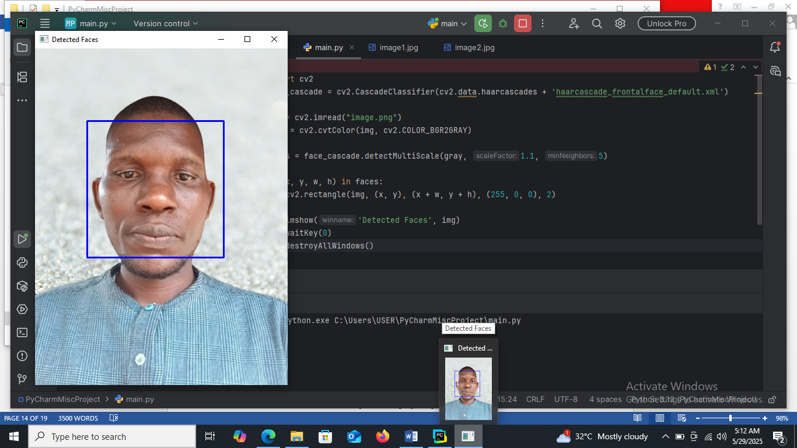
Figure 4.1: Natural Detected Face – 0001
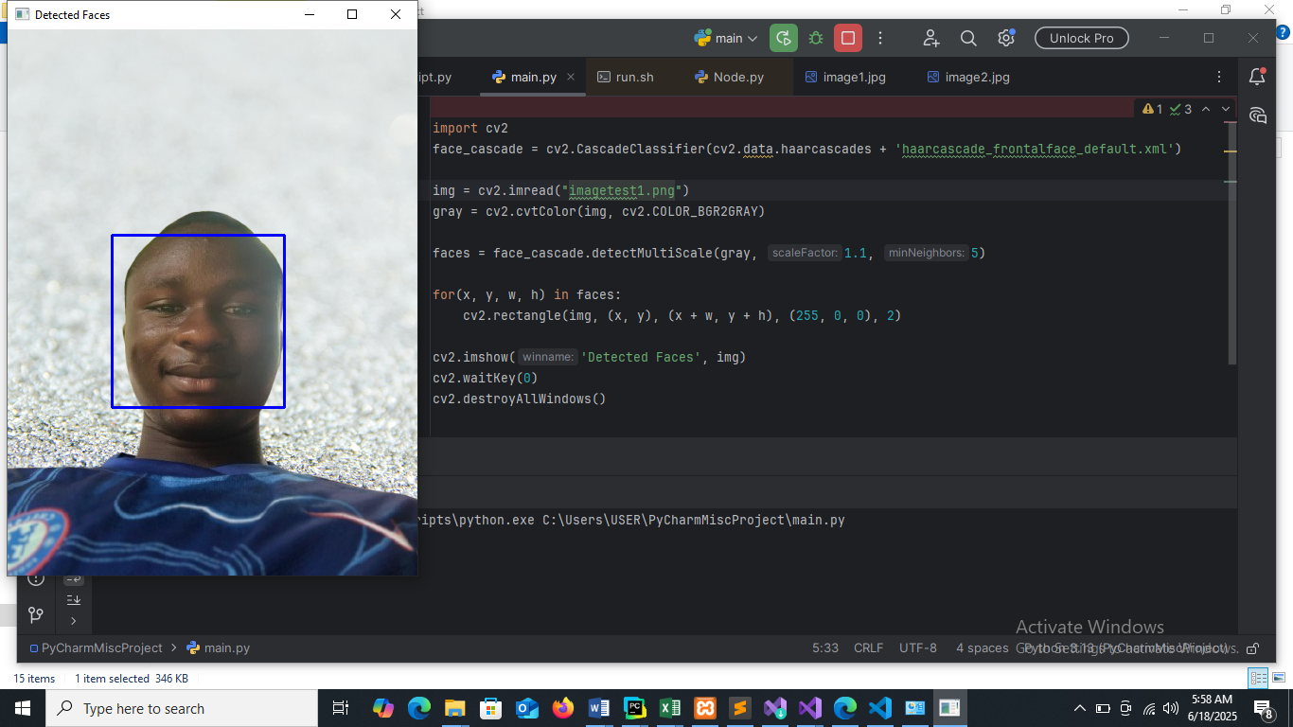
Figure 4.2: Happiness Detected Face – 0002

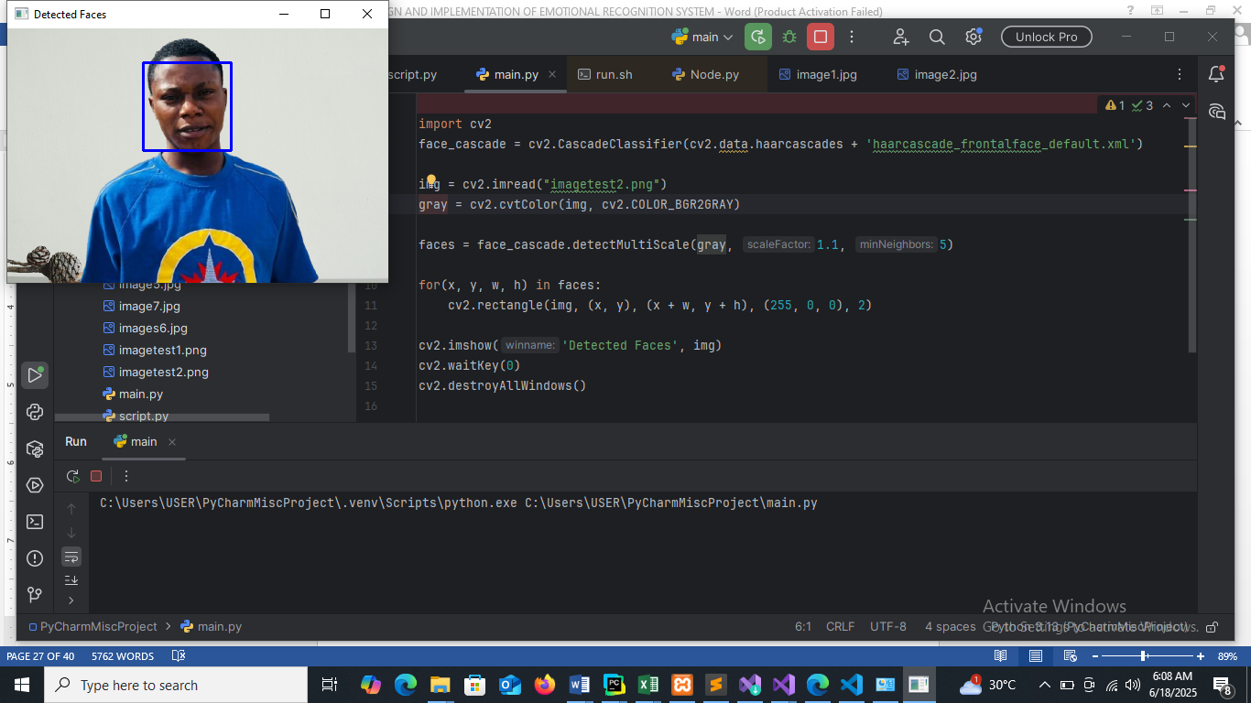
Figure 4.3: Happiness Detected Face – 0003
4.1.2 INPUT DESIGN
This aspect entails the description of the expected data input that will provide our output as described above. This section list out all the input required for the implementation of recognition System. Data entry is done through the keyboard and mouse selection where required.
4.1.4 PROCEDURE DESIGN
The administrator can perform the following
- Add image to the system
- Detect Image
- Display Detect Image
4.2 IMPLEMENTATION OF THE SYSTEM
4.2.1 CHOICE OF PROGRAMMING LANGUAGE
In determining a suitable programming language for the design of the online recognition system, the factors to be considered are:-
- The difficulty of the problem
- The technical skills required of the computer program
- The type of processing required
- The availability of sub-programming facilities
- The efficiency of the language translator
- Ease of maintaining and updating the program
- Hardware and software requirement
For the project work, the programming language to be used for the design of the system is PHP and MYSQL for database management system with embedded Structured Query Language (SQL) for database manipulation
4.2.2 HARDWARE SUPPORT
The hardware requirements for this program are:
- PC: The computer should be minimum of Pentium IV with 1000GHs processor speed but preferably Dual Core Processor for greater efficiency
- Memory: This system requires a Higher RAM not less than 512MG, 1GB RAM is recommended.
- Storage: the storage capacity must be 80GB and above.
- VDU: Visual Display Unit required should be a very high resolution not less than 1024 x 768 with 256 colour capability.
- Printer: This system also requires a printer
- Input: The input device required is a mouse, Optical Mouse should be provides for easy use.
4.2.3 SOFTWARE REQUIREMENTS
The software requirements for the operation of this program are as follows:
- Window Operating System
- XAMPP or WampServer (for Apache server on localhost)
- Web Browser e.g Mozila Firefox
- Macromedia dreamweaver
4.2.4 CHANGE OVER TECHNIQUE
The method used in the implementation of the proposed system is parallel, simply because parallel system supports the use of the existing system together with the proposed system and when there system failure information will not be totally lost and will not be back to square one for the users.
4.3 DOCUMENTATION OF THE SYSTEM
4.3.1 PROGRAM DOCUMENTATION
In order for the proposed system to be used on any computer system it takes the following ways
- Boot the system
- Copy the folder to www inside wamp folder of the drive C: after WAMP server is installed onto the system.
- Open any browser on the system (Microsoft internet Explorer, Mozilla Firefox, Netscape Navigator, Opera, Flock, Safari e.t.c)
- Type http://localhost/emotional/index.php on the address bar and press the return key or enter key.
4.3.2 OPERATING THE SYSTEM
This refers to the step by step method of using the proposed system. The proposed system comprises of. The steps to use the proposed system are as follows
- On the address bar of any browser type
- http://localhost/www. emotional /index.php
- You are prompted to supply the username and password this verifies that you are a registered voter and has the privileged to vote.
4.3.3 MAINTAINING THE SYSTEM
- Data cable should be plugged properly
- Repair or replacement of all damaged accessories, system cards, peripheral e.t.c.
- prevention from dust
- Prevention of system from heat and moisture
- Prevention from static charges
- Examination of the new system from time to time to ensure it is performing as specified.
- Operators and users to the system must constantly check the output of the system to make sure that it is working accordingly.
CHAPTER FIVE
SUMMARY, CONCLUSION AND RECOMMENDATION
5.1 SUMMARY
An Emotional Recognition System is a technological framework designed to identify and interpret human emotions based on data input such as facial expressions, voice tone, physiological signals, or text. Using artificial intelligence techniques such as machine learning, deep learning, and natural language processing, the system analyzes behavioral and biological cues to classify emotions like happiness, anger, sadness, fear, surprise, or disgust.
These systems are applied in various fields, including healthcare, human-computer interaction, marketing, education, and security. For instance, in mental health monitoring, they can help detect signs of depression or anxiety. In customer service, they enable more empathetic and responsive AI agents.
5.2 CONCLUSION
In the current context, conveying information about an individual's emotional states is essential. The application of this system extends beyond its current use, reaching into the clinical field to assess the emotional states of patients who might struggle to express themselves. Further advancements in predicting future emotional states will enhance accuracy and broaden the system's application. The integration of emotional recognition, without specific emphasis on intensity, will propel the field of affective computing to new heights.
5.3 RECOMMENDATION
Based on the study and implementation of the Emotional Recognition System, the following recommendations are proposed to enhance its effectiveness, accuracy, and ethical application:
- Integration with Real-Time Applications: The system should be integrated into real-time platforms such as virtual assistants, e-learning environments, and healthcare monitoring tools to improve user experience and responsiveness.
- Improvement of Data Diversity: Training datasets should include diverse demographic groups to reduce bias and improve the system’s ability to recognize emotions across different cultures, ages, and ethnic backgrounds.
- Use of Multimodal Emotion Detection: Combining multiple input sources—such as facial expressions, voice tone, body language, and physiological signals—can significantly increase the accuracy and reliability of emotion detection.
- Continuous Learning and Model Updates: Incorporating adaptive learning techniques will allow the system to evolve with new data and user behavior, improving its performance over time.
- Privacy and Ethical Considerations: Strict measures must be implemented to protect users’ personal data. Consent should always be obtained, and the system must comply with data protection regulations such as GDPR.
- User Feedback Mechanism: Implementing a feedback feature can help fine-tune emotion recognition models by learning from user corrections and experiences.

REFERENCES

Allognon, S.O.C.; Britto, A.S.D.; Koerich, A.L. (2020) Continuous Emotion Recognition via Deep Convolutional Autoencoder and Support Vector Regressor. In Proceedings of the International Joint Conference on Neural Networks, Glasgow, UK, 19–24 July 2020.
Alrowais, F.; Negm, N.; Khalid, M.; Almalki, N.; Marzouk, R.; Mohamed, A.; Duhayyim, M.A.; Alneil, A.A. (2023) Modified Earthworm Optimization With Deep Learning Assisted Emotion Recognition for Human Computer Interface.
Calvo, R. A., & D'Mello, S. (2020). Affect detection: An interdisciplinary review of models, methods, and their applications. IEEE Transactions on Affective Computing, 1(1), 18–37.
El-Ayadi, M., Kamel, M. S., & Karray, F. (2021). Survey on speech emotion recognition: Features, classification schemes, and databases. Pattern Recognition, 44(3), 572–587.
Krishna Mohan KudirP, Abas Md Said, M Yunus Nayan (2022) Emotion Detection Using Sub-image Based Features through Human Facial Expressions‖ International Conference on Computer & Information Science (ICCIS).
Mehrabian , A. (2021) Communication without words‖ , Psychology Today,1968, 53-56.
Muthamilselvan, T.; Brindha, K.; Senthilkumar, S.; Saransh; Chatterjee, J.M.; Hu, Y.C. (2023) Optimized face-emotion learning using convolutional neural network and binary whale optimization.
Picard, R. W. (2022). Affective computing. MIT Press.
Sassi, A.; Jaafar, W.; Cherif, S.; Abderrazak, J.B.; Yanikomeroglu, H. Video Traffic Analysis for Real-Time Emotion Recognition and Visualization in Online Learning.
Tu, G.; Fu, Y.; Li, B.; Gao, J.; Jiang, Y.G.; Xue, X. (2020) A Multi-Task Neural Approach for Emotion Attribution, Classification, and Summarization.
Yu-Ting Pai, Shanq-Jang Ruan, Mon-Chau Shie and Yi-Chi Liu, (2023 )A Simple And Accurate Color Face Detection Algorithm In Complex Background‖‖, Low Power Systems Lab, Department of Electronic Engineering, National Taiwan University of Science and Technology, No.43, Sec.4, pp. 1545 – 154.

SOURCE CODE
import cv2.cv2 as cv2
import numpy as np

from utils.image_classifier import ImageClassifier, NO_FACE_LABEL

# Color RGB Codes & Font
WHITE_COLOR = (255, 255, 255)
GREEN_COLOR = (0, 255, 0)
BLUE_COLOR = (255, 255, 104)
FONT = cv2.QT_FONT_NORMAL

# Frame Width & Height
FRAME_WIDTH = 640
FRAME_HEIGHT = 490

class BoundingBox:
def __init__(self, x, y, w, h):
self.x = x
self.y = y
self.w = w
self.h = h

@property
def origin(self) -> tuple:
return self.x, self.y
@property
def top_right(self) -> int:
return self.x + self.w

@property
def bottom_left(self) -> int:
return self.y + self.h

def draw_face_rectangle(bb: BoundingBox, img, color=BLUE_COLOR):
cv2.rectangle(img, bb.origin, (bb.top_right, bb.bottom_left), color, 2)

def draw_landmark_points(points: np.ndarray, img, color=WHITE_COLOR):
if points is None:
return None
for (x, y) in points:
cv2.circle(img, (x, y), 1, color, -1)

def write_label(x: int, y: int, label: str, img, color=BLUE_COLOR):
if label == NO_FACE_LABEL:
cv2.putText(img, label.upper(), (int(FRAME_WIDTH / 2), int(FRAME_HEIGHT / 2)), FONT, 1, color, 2, cv2.LINE_AA)
cv2.putText(img, label, (x + 10, y - 10), FONT, 1, color, 2, cv2.LINE_AA)

class RealTimeEmotionDetector:
CLAHE = cv2.createCLAHE(clipLimit=2.0, tileGridSize=(8, 8))

vidCapture = None

def __init__(self, classifier_model: ImageClassifier):
self.__init_video_capture(camera_idx=0, frame_w=FRAME_WIDTH, frame_h=FRAME_HEIGHT)
self.classifier = classifier_model

def __init_video_capture(self, camera_idx: int, frame_w: int, frame_h: int):
self.vidCapture = cv2.VideoCapture(camera_idx)
self.vidCapture.set(cv2.CAP_PROP_FRAME_WIDTH, frame_w)
self.vidCapture.set(cv2.CAP_PROP_FRAME_HEIGHT, frame_h)

def read_frame(self) -> np.ndarray:
rect, frame = self.vidCapture.read()
return frame

def transform_img(self, img: np.ndarray) -> np.ndarray:
# load the input image, resize it, and convert it to gray-scale
gray_img = cv2.cvtColor(img, cv2.COLOR_BGR2GRAY) # convert to gray-scale
resized_img = self.CLAHE.apply(gray_img) # resize
return resized_img

def execute(self, wait_key_delay=33, quit_key='q', frame_period_s=0.75):
frame_cnt = 0
predicted_labels = ''
old_txt = None
rectangles = [(0, 0, 0, 0)]
landmark_points_list = [[(0, 0)]]
while cv2.waitKey(delay=wait_key_delay) != ord(quit_key):
frame_cnt += 1

frame = self.read_frame()
if frame_cnt % (frame_period_s * 100) == 0:
frame_cnt = 0
predicted_labels = self.classifier.classify(img=self.transform_img(img=frame))
rectangles = self.classifier.extract_face_rectangle(img=frame)
landmark_points_list = self.classifier.extract_landmark_points(img=frame)
for lbl, rectangle, lm_points in zip(predicted_labels, rectangles, landmark_points_list):
draw_face_rectangle(BoundingBox(*rectangle), frame)
draw_landmark_points(points=lm_points, img=frame)
write_label(rectangle[0], rectangle[1], label=lbl, img=frame)

if old_txt != predicted_labels:
print('[INFO] Predicted Labels:', predicted_labels)
old_txt = predicted_labels

cv2.imshow('Emotion Detection', frame)

cv2.destroyAllWindows()
self.vidCapture.release()

def run_real_time_emotion_detector(
classifier_algorithm: str,
predictor_path: str,
dataset_csv: str,
dataset_images_dir: str = None):
from utils.data_land_marker import LandMarker
from utils.image_classifier import ImageClassifier
from os.path import isfile

land_marker = LandMarker(landmark_predictor_path=predictor_path)

if not isfile(dataset_csv): # If data-set not built before.
print('[INFO]', f'Dataset file: "{dataset_csv}" could not found.')
from data_preparer import run_data_preparer
run_data_preparer(land_marker, dataset_images_dir, dataset_csv)
else:
print('[INFO]', f'Dataset file: "{dataset_csv}" found.')

classifier = ImageClassifier(csv_path=dataset_csv, algorithm=classifier_algorithm, land_marker=land_marker)
print('[INFO] Opening camera, press "q" to exit..')
RealTimeEmotionDetector(classifier_model=classifier).execute()

if __name__ == "__main__":
"""The value of the parameters can change depending on the case."""
run_real_time_emotion_detector(
classifier_algorithm='RandomForest', # Alternatively 'SVM'.
predictor_path='utils/shape_predictor_68_face_landmarks.dat',
dataset_csv='data/csv/dataset.csv',
dataset_images_dir='data/raw'
)
print('Successfully terminated.')

