INTRUSION DETECTION SYSTEM USING MACHINE LEARNING

BY
IBRAHIM ADAM ADEIZA
ND/23/COM/PT/0019

SUBMITTED TO THE DEPARTMENT OF COMPUTER SCIENCE,
INSTITUTE OF INFORMATION AND COMMUNICATION TECHNOLOGY

KWARA STATE POLYTECHNIC, ILORIN.
IN PARTIAL FULFILLMENT OF THE REQUIREMENTS FOR THE AWARD OF NATIONAL DIPLOMA (ND) IN
COMPUTER SCIENCE

JULY, 2025.
CERTIFICATION
This is to certify that this project was carried out by IBRAHIM ADAM ADEIZA with matriculation number ND/23/COM/PT/0019 in the Department of Computer Science, Institute of Information Communication Technology, Kwara State Polytechnic, Ilorin, Kwara State.

…………………………………. ….………………………
MR. SADIQ, K. A. Date
Project Supervisor

…………………………………. ….………………………
MR. OYEDEPO, F. S. Date
Head of Department

…………………………………. ….………………………
External Examiner Date

DEDICATION
I dedicate this project work to Almighty God, who inspired me and directed my ways during my academic stay in the polytechnic.

ACKNOWLEDGEMENT
All praise is due to Almighty God, the Lord of the universe. I praise him and thank him for giving me the strength and knowledge to complete my ND program and also for our continued existence on Earth.
I appreciate the utmost effort of my supervisor, Mr. Sadiq, K. A., whose patience, support, and encouragement have been the driving force behind the success of this research work. He gave useful corrections, constructive criticisms, comments, recommendations, and advice, and always ensures that excellent research is done. My sincere gratitude goes to the Head of the Department, Mr. Oyedepo F. S., and other members of staff of the Department of Computer Science, Kwara State Polytechnic, Ilorin, for their constant cooperation, constructive criticisms, and encouragement throughout the program.
Special gratitude to my parents, who exhibited immeasurable financial patience, support, prayers, and understanding during the period in which I was busy tirelessly with my studies. Special thanks go to my lovely siblings
My sincere appreciation goes to my friends and classmates.

TABLE OF CONTENTS
Title page i
Certification ii
Dedication iii
Acknowledgments iv
Table of Contents v
Abstract vi
CHAPTER ONE: GENERAL INTRODUCTION
1.1 Background to the Study 1
1.2 Statement of the Problem 2
1.3 Aim and Objectives 3
1.4 Significance of Study 3
1.5 Scope of Study 4
1.6 Organization of the Report 4
CHAPTER TWO: LITERATURE REVIEW
2.1 Review of Related Past Works 5
2.2 Review of General Text 11
CHAPTER THREE: RESEARCH METHODOLOGY AND
ANALYSIS OF THE SYSTEM
  - Research Methodology 17
  - Analysis of the Existing System 19
  - Problem of the Existing System 20
  - Analysis of the Proposed System 21
  - Advantages of the Proposed System 21
CHAPTER FOUR: DESIGN, IMPLEMENTATION, AND
DOCUMENTATION OF THE SYSTEM
  - Design of the System 23
    - Output Design 23
    - Input Design 25
    - Database Design 29
    - Procedure Design 31
  - Implementation of the System 31
    - Choice of programming language 31
    - Hardware support 31
    - Software Support 32
    - Changeover Techniques 32
  - System Documentation 32
    - Operating the System 33
    - Maintenance of the System 33
CHAPTER FIVE: SUMMARY, CONCLUSION, AND
RECOMMENDATION
5.1 Summary 35
5.2 Conclusion 35
5.4 Recommendations 36
References 37

ABSTRACT
With the growth of the internet and the rise of computer networks, cyber threats and network intrusions have become a significant challenge for organizations. Traditional intrusion detection systems (IDS) rely on rule-based techniques that are limited in their ability to detect sophisticated attacks. As a result, there is a need for more advanced techniques that can detect unknown attacks and adapt to new threats. Machine learning (ML) algorithms offer a promising approach to intrusion detection, particularly in detecting anomalies in network traffic. In this paper, we explore the use of ML algorithms for anomaly-based network intrusion detection. The problem of network intrusion detection is a critical one for organizations that rely on computer networks. With the increasing sophistication of cyber-attacks, traditional rule-based IDS is becoming less effective. Anomaly-based IDS can detect unknown attacks by identifying deviations from normal network traffic patterns. However, existing anomaly-based IDS often suffer from high false positive rates and are not effective at detecting advanced attacks. ML algorithms offer a potential solution to these problems, but their effectiveness in network intrusion detection is still an open research question. The study will follow a quantitative research design and will use publicly available datasets for the evaluation of machine learning algorithms. The study will also involve a comparative analysis of the results obtained from different machine learning algorithms. The data analysis will be done using the Python programming language and relevant libraries such as scikit-learn, TensorFlow, and Keras. The studyP will also employ a rigorous evaluation methodology to ensure the reliability and validity of the findings.

CHAPTER ONE
GENERAL INTRODUCTION
  - Background to the Study
With the growth of the internet and the rise of computer networks, cyber threats, and network intrusions have become a significant challenge for organizations. Traditional intrusion detection systems (IDS) rely on rule-based techniques that are limited in their ability to detect sophisticated attacks. As a result, there is a need for more advanced techniques that can detect unknown attacks and adapt to new threats. Machine learning (ML) algorithms offer a promising approach to intrusion detection, particularly in detecting anomalies in network traffic. In this paper, we explore the use of ML algorithms for anomaly-based network intrusion detection (Palimote & Osuigbo, 2021).
Network intrusion has predominantly increased following the rapid growth of network or internet technologies in different areas of social networking, e-learning, e-business, etc. This has made the security of data from malicious Hackers more challenging. An Intrusion Detection System is an application used for monitoring the network and protecting it from the intruder. With the rapid progress in internet-based technology, new application areas for computer networks have emerged (Chibuzor & Bennett, 2018).
Intrusion is defined as any set of actions that attempt to compromise the integrity, confidentiality, or availability of system resources. Any real-world entity that tries to find a means to gain unauthorized access to information, causes harm, or engages in other malicious activities is known as an intruder or an attacker. The intrusion of computer networks has been on the high side and this is caused by unauthorized users of systems who attempt to gain further privileges for which they are not authorized, or authorized users who are guilty of a user policy violation (Pascal et al., 2020).
Intrusion detection, therefore, involves the gathering of intrusion-associated information while monitoring and analyzing the events triggering these attacks in a computer network to ascertain the intruders. Most intrusion occurs via a network utilizing network-related protocols to attack their targets. Though there are many types of attacks threatening the availability, integrity, and confidentiality of computer networks but the denial of service attack (DoS) is considered one of the most common harmful attacks (Palimote & Osuigbo, 2021).
The application of data analytics in the detection of intrusion in computer networks, therefore, involves the process of monitoring, protecting, capturing, and analyzing data to detect malicious activities in computer networks. This work by collecting information from different sources within the computer systems and networks, compares them to pre-existing patterns to verify if they are attacks or malicious activities. Machine learning using feature selection will be used to implement the design. Feature Selection (FS) is an important aspect that can profoundly impact the performance of the detection model. The main reason is that having a high volume of network traffic dataset which is made up of many features, it is crucial to identify those features which are more relevant than others as some of them are considered useless (noise) which can drastically affect the performance, in case they are used for building and training the IDS detection model.
1.2 Statement of the Problem
The problem of network intrusion detection is a critical one for organizations that rely on computer networks. With the increasing sophistication of cyber-attacks, traditional rule-based IDS are becoming less effective. Anomaly-based IDS can detect unknown attacks by identifying deviations from normal network traffic patterns. However, existing anomaly-based IDS often suffer from high false positive rates and are not effective at detecting advanced attacks. ML algorithms offer a potential solution to these problems, but their effectiveness in network intrusion detection is still an open research question.
1.3 Aim and Objectives of the Study
This study aims to develop an intelligent Intrusion Detection System (IDS) using Random Forest algorithm. The specific objectives of this study are to;
- To collect and preprocess a reliable intrusion detection dataset.
- To implement a supervised machine learning model (Random Forest Classifier).
- To develop a functional prototype of the intrusion detection system
1.4 Significance of the Study
The significance of this study lies in its potential to improve the effectiveness of network intrusion detection systems. ML-based IDS have the potential to detect unknown attacks that traditional rule-based IDS cannot. This study can help organizations in choosing the appropriate ML algorithm for their intrusion detection needs. It can also help researchers in developing more effective anomaly detection algorithms for network traffic.
1.5 Scope of the Study
This study will focus on the use of ML algorithms for anomaly-based network intrusion detection. The study will cover the following aspects:
- Literature review on anomaly-based network intrusion detection and ML algorithms.
- Evaluation of the effectiveness of different ML algorithms in detecting network anomalies.
- Comparison of the performance of ML-based IDS with traditional rule-based IDS.
- Investigation of the impact of different features and feature selection techniques on the performance of ML-based IDS.
- Proposed framework for ML-based anomaly detection in network traffic.

1.6 Organization of the Study
This is the overall layout of the work as presented in this project write-up. Chapter one of this project deals with the introduction to the general work of the project. It also entails the statement of the problem, aims, and objectives of this project, the significance of the study, the scope of the study, and the project layout. Chapter two deals with the review-related concept, as well as related works. Chapter three covers data acquisition, an explanation of the processed methodology, system design, algorithm, and process flow diagram Chapter four entails design, screenshots, an explanation of tables and values obtained during simulation, charts, etc. Chapter Five deals with the summary, conclusion, recommendation, and references.

CHAPTER TWO
LITERATURE REVIEW
2.1 Review of Related Past Works
According to Sharafaldin, Arash & Ali (2018) generating a new intrusion detection dataset and intrusion traffic characterization. Due to the lack of adequate datasets, anomaly-based approaches in intrusion detection systems are suffering from accurate deployment, analysis, and evaluation. There exist several such datasets such as DARPA98, KDD99, ISC2012, and ADFA13 that have been used by the researchers to evaluate the performance of their proposed intrusion detection and intrusion prevention approaches. Based on our study of eleven available datasets since 1998, many such datasets are out of date and unreliable to use. Some of these datasets suffer from a lack of traffic diversity and volumes, some of them do not cover the variety of attacks, while others anonymized packet information and payload which cannot reflect the current trends, or they lack feature sets and metadata. This paper produces a reliable dataset that contains benign and seven common attack network flows, which meet real-world criteria and is publicly available. Consequently, the paper evaluates the performance of a comprehensive set of network traffic features and machine learning algorithms to indicate the best set of features for detecting certain attack categories.
Chibuzor & Bennett, (2018) presented a journal on Intrusion Detection System Using machine learning algorithms. In this research, the KDDCup99 Test datasets are analyzed using certain machine learning algorithms (Bayes Net, J48, Random Forest, and Random Tree) to determine the accuracy of these algorithms by classifying these attacks into their various classes. A constructive research methodology is adopted throughout this research. The experimental results show that the Random Forest and Random Tree algorithms appear to be the most efficient in performing the classification technique on the Test dataset. The experimental tool used is WEKA which is used to perform a correlation-based feature selection on the dataset with a Best First search method, and the parameters used for the computation are Precision, Recall, and F-measure.
Taha & Mostafa, (2018) also presented a journal on building a fast intrusion detection system for high-speed networks: probe and DoS Attacks detection. Thus, detecting intrusions in such circumstances requires high levels of accuracy and efficiency, so that heavy losses are prevented. Many intrusion detection models in the literature do not propose real-time solutions to deal with the aforementioned obstacles. This motivates us to propose a lightweight intrusion detection system, for probe and DoS attack detection. We select the most important set of features using Information Gain (IG), and Correlation-based Feature (CFS) selection filters, applied on a resampled version of KDD’99. Furthermore, we employ four machine learning methods, namely C4.5, Naïve Bayes (NB), Random Forest (RF), and REPTree, as wrappers. Results show good detection and false positive rates, of around 99.6%, and 0.3% for DoS attacks, and 99.8% and 2.7% for Probe attacks. Processing time is also optimized when evaluated using the best-selected feature subset
Azween, et al (2019) wrote a comparison of various machine learning algorithms in a distributed denial of service intrusion. Machine learning (ML) is used for network intrusion detection because of its prediction ability after training with relevant data. ML provides a good method to detect new and unknown attacks. There are many types of attacks in network intrusion: however, this paper concentrates on distributed denial of service (DDoS). DDoS is similar to denial of service, the difference being that the attack comes from multiple sources instead of only one source. In this paper, various classification algorithms are used and their performances are compared. It was found that random forest (RT) gives the best accuracy at 99.97%, while the least accurate algorithm was support vector machine (SVM) at 63.25%.
Samriddhi & Nithyanandam (2020) opined a detailed analysis of intrusion detection using machine learning algorithms where a significant number of techniques have been developed which are based on machine learning approaches to detect these intrusion attacks. Even though these techniques are good, they are not good enough to detect all kinds of attacks. In this paper, the analysis of different machine learning algorithms will be performed on the NSL-KDD dataset with pre-processing steps like One-hot encoding, feature selection, and random sampling to use in different machine learning models to find the best-performing model to detect these attacks. The attacks from the datasets are classified into four types of attacks: Probe, DoS, U2R, and R2L while the non-attack is the Normal. The dataset is in two parts: KDD-Train and KDD-Test. The dataset is trained and tested to find accuracy and understand the performance of different machine learning algorithms and compare them. The Machine Learning algorithms used are Naive Bayes Classifier, Decision Tree Classifier, Random Forest Classifier, KNeighbours Classifier, Logistic Regression, SVM Classifier, and Voting Classifier. These techniques are compared according to their capability to detect the attacks. This comparison will help to find the algorithm which would work the best to detect different kinds of intrusion attacks.
Terungwa, Oluoha & Yakubu (2020) wrote about a data analytics system for network Intrusion detection using a decision tree. This research developed a data analytics system for network intrusion detection to combat the ever-growing threats as well as classify them to ease the task of data scientists and network administrators. Decision tree algorithm and Python programming language were used. KDD’99 was used as the data source. The decision tree assists the network administrator to decide about the incoming traffic, i.e., whether the coming data is malicious or not by providing a model that separates malicious and non-malicious traffic. It allows taking less number of attributes and provides acceptable accuracy in the reasonable account of time. From the results of the experiments, it is concluded that the system is more efficient concerning finding attacks in the network with less number of features and it takes less time to construct the model. Also, the efficiency of the system has little or no regard for the size of the dataset and the number of features used to construct the decision tree.
Pascal et al (2020). Also writes on detecting intrusions in computer network traffic with machine learning approaches. In this regard, in the previous work, we have used the NSL-KDD IDS dataset, Gain Ratio Feature Evaluator (GRFE), and Correlation Ranking Filter (CRF) feature selection methods coupled with various machine-learning techniques to detect intrusions in computer network traffic. While the experiment has demonstrated that GRFE selects the most relevant feature subsects over CRF, which results in different performances, the previous work can be extended as follows. First, the most relevant feature subset generated by GRFE in the previous work is employed to assess and compare the performance of a single machine learning technique (Lazy IBK, aka K-Nearest Neighbor) over an ensemble technique (Random Committee) while detecting intrusions in a computer network. Second, two distinct datasets (NSL-KDD and UNSW-NB15) are employed for better performance analysis. Third, limitations encountered in the domain of network intrusion detection are also discussed. The results reveal that the ensemble technique performs well over a single machine learning technique with a misclassification gap of 0.969% and 1.19% (obtained using the NSL-KDD dataset) and 1.62% and 1.576% (obtained using the UNSW-NB15 dataset).
Palimote & Osuigbo, (2021) presented a journal on a model to detect network intrusion using machine learning. The system aims in developing a model to detect network intrusion using a machine learning algorithm. The dataset consists of different categories of intrusions stimulated in a military environment. The dataset consists of raw TCP/IP data for a network by stimulating a typical US Air Force Lan. The dataset is made up of 41 Columns. The class column consists of two types, which are Normal Network Packets and Anomalous Network Packets. The dataset was pre-processed by converting some features that were characters as values to 0s and 1s by using the pandas.get_dummies function. After that, we applied feature extraction by dropping and adding some features. The number of columns increased to 112 columns after performing feature extraction. The dataset was split into a train and a testing set using the train_test_split function. We use two machine learning algorithms in building/training our model. These machine-learning algorithms are Random Forest Classifiers and Support Vector Machine. After training/building our models, the Random forest Classifier had the highest accuracy results which is about 99.78% while Support Vector Classifier had about 96.87%
AlMeshal, (2021) opined a comparative study for intrusion detection methods using machine Learning. Efficient intrusion detection is needed as a defense of the network system to detect attacks over the network. Intrusion detection is so much popular in the last two decades when intruders attempted to break into or misuse the system. There are many techniques used in IDS for protecting computers and networks from network-based and host-based attacks. This paper presents a comparative study for intrusion detection (IDs) using the machine learning (ML) methods, we spotlight the methods used and the results achieved.
Garcıa, et al (2018) opined that The Internet and computer networks are exposed to an increasing number of security threats. With new types of attacks appearing continually, developing flexible and adaptive security-oriented approaches is a severe challenge. In this context, anomaly-based network intrusion detection techniques are a valuable technology to protect target systems and networks against malicious activities. However, despite the variety of such methods described in the literature in recent years, security tools incorporating anomaly detection functionalities are just starting to appear, and several important problems remain to be solved. This paper begins with a review of the most well-known anomaly-based intrusion detection techniques. Then, available platforms, systems under development, and research projects in the area are presented. Finally, we outline the main challenges to be dealt with for the wide-scale deployment of anomaly-based intrusion detectors, with special emphasis on assessment issues
Tushar & Vishal (2017) argued that the booming contingency of network attacks is a devastating problem for network services. Various research works are already conducted to find an effective and efficient solution to prevent intrusion into the network to ensure network security and privacy. Machine learning is an effective analysis tool to detect any suspicious events occurred in the network traffic flow. In this paper, we developed a classifier model based on SVM and Random Forest based algorithms for network intrusion detection. The NSL-KDD dataset, a much-improved version of the original KDDCUP’99 dataset, was used to evaluate the performance of our algorithm. The main task of our detection algorithm was to classify whether the incoming network traffics are normal or an attack, based on 41 features describing every pattern of network traffic. The detection accuracy of more than 95 % was achieved using SVM and Random algorithms. The results of the two algorithms were compared and it is observed that the Random Forest algorithm is more effective than Support Vector Machine.
According to Ambreen (2020), Anomaly-based Intrusion Detection using Machine Learning Algorithms is a review that IDS is the most important field of network security, that monitors the state of software and hardware running in the network. In the past few years, Intrusion detection using machine learning techniques has captured the attention of most researchers, and every researcher proposes a different algorithm for the distinct features used in the dataset. KDD-Cup99 intrusion detection dataset plays a vital role in the network intrusion detection system and NSL-KDD is an updated or revised version of KDDCup99. The dataset which is mostly used by researchers working in the field of intrusion detection is KDD-Cup99. This paper presents an overview of various IDS and also detailed analyses of various machine learning techniques and datasets used for improving IDS.

Emrah et al (2021) discussed anomaly-based intrusion detection by machine learning as cybercriminals’ techniques get sophisticated, and information security professionals face a more significant challenge to protecting information systems. In today’s interconnected realm of computer systems, each attack vector has a network dimension. The present study investigates network intrusion attempts with anomaly-based machine learning models to provide better protection than the conventional misuse-based models. Two models, namely an ensemble learning model and a convolutional neural network model, were built and implemented on a data set gathered from a real-life, institutional production environment. To demonstrate the models’ reliability and validity, they were applied to the UNSW-NB15 benchmarking data set. The type of attack was limited to probing attacks to keep the scope of the study manageable. The findings revealed high accuracy rates, the CNN model being slightly more accurate.

2.2 Review of Related Text
Anomaly-based detection learns from the environment in which it is installed (usually the network) as to what is normal traffic (Di Pietro & Mancini, 2019). The normal traffic is either represented by statistical models that depict the normal traffic levels or with the help of user-profiles where a profile is created for every user in the network. Such profiles are built based on normal user activity on the network such as file access, login attempts, administrative activities, etc. The longer the system is in the network, the more effective it will become. This is because, over time, the system’s understanding of the environment will improve. Such anomaly-based systems are of particular interest to this research.
Many systems use an anomaly score that will represent the level of an anomaly in the network traffic. There are threshold levels configured in the IDS that will dictate how much deviation from the normal is allowed. If the anomaly score goes beyond the predefined threshold levels, then it means an intrusion has occurred (Peddabachigari, Abraham, Grosan, & Thomas, 2019). If the detected intrusion is found to be a false positive, then the security officer flags the intrusion as a false positive. Some IDS have mechanisms for incorporating false positives in normal traffic profiles. By this, the next instance of such traffic will not be considered an anomaly. One of the main problems that such systems face is the high rate of false positives. This occurs with the IDS considering normal traffic anomalous. The security officer or the network administrator who manages the network will eventually become insensitive to such false alarms and end up ignoring most of them (Lundin & Jonsson, 2020).
This tendency would lead the security officer to miss important attacks and intrusions. Even though the false negative rate is low, the tendency of the security officer to neglect detected anomalies eventually leads to a low detection rate. Researchers like J. Zhang and Zulkernine (2016) claim that such anomaly-based IDS have high false positive rates because of their inability to accurately model normal traffic and activities. In other words, such systems cannot accurately differentiate self from non-self-traffic - self-being the normal traffic and non-self being the anomalous traffic. There is a need for a clear differentiation of self and non-self along with a need for an effective representation of self (Spathoulas & Katsikas, 2019).

2.2.1 Machine learning techniques
- Pattern classification
Pattern recognition is the action to take raw data and activity on data category (Michalski, Bratko, & Kubat, 1998). The methods of supervised and unsupervised learning can be used to solve different pattern recognition problems (Theodoridis & Koutroumbas, 2006, 2006). In supervised learning, it is based on using the training data to create a function, in which each of the training data contains a pair of the input vector and output (i.e. the class label). The learning (training) task is to compute the approximate distance between the input–output examples to create a classifier (model). When the model is created, it can classify unknown examples into learned class labels.

- Single classifiers
The intrusion detection problem can be approached by using one single machine learning algorithm. In literature, machine learning techniques (e.g. k-nearest neighbor, support vector machines, artificial neural networks, decision trees, self-organizing maps, etc.) have been used to solve these problems.
- K-nearest neighbor K-nearest neighbor (k-NN) is one of the most simple and traditional nonparametric techniques to classify samples (Bishop, 1995; Manocha & Girolami, 2007). It computes the approximate distances between different points on the input vectors and then assigns the unlabeled point to the class of its K-nearest neighbors. In the process of creating a K-NN classifier, k is an important parameter and different k values will cause different performances. If k is considerably huge, the neighbors used for prediction will make a large classification time and influence the accuracy of the prediction. K-NN is called instance-based learning, and it is different from the inductive learning approach (Mitchell, 1997). Thus, it does not contain the model training stage, but only searches the examples of input vectors and classifies new instances. Therefore, k-NN ‘‘online” trains the examples and finds out the k-nearest neighbor of the new instance.
- Support vector machines: Support vector machines (SVM) are proposed by Vapnik (1998). SVM first maps the input vector into a higher dimensional feature space and then obtains the optimal separating hyper-plane in the higher dimensional feature space. Moreover, a decision boundary, i.e. the separating hyper-plane, is determined by support vectors rather than the whole training samples and thus is extremely robust to outliers. In particular, an SVM classifier is designed for binary classification. That is, to separate a set of training vectors that belong to two different classes. Note that the support vectors are the training samples close to a decision boundary. The SVM also provides a user-specified parameter called the penalty factor. It allows users to make a tradeoff between the number of misclassified samples and the width of a decision boundary
- Artificial neural networks: The neural network is an information processing unit that mimics the neurons of the human brain (Haykin, 1999). Multilayer perceptron (MLP) is the widely used neural network architecture in many pattern recognition problems. An MLP network consists of an input layer including a set of sensory nodes as input nodes, one or more hidden layers of computation nodes, and an output layer of computation nodes. Each interconnection has associated with it a scalar weight which is adjusted during the training phase. In addition, the backpropagation learning algorithm is usually used to train an MLP, which is also called a back propagation neural network. First of all, random weights are given at the beginning of training. Then, the algorithm performs weight tuning to define whatever hidden unit representation is most effective at minimizing the error of misclassification.
- Self-organizing maps Self-organizing map (SOM) (Kohonen, 1982) is trained by an unsupervised competitive learning algorithm, a process of self-organization. SOM aims to reduce the dimension of data visualization. That is, SOM projects and clusters high-dimensional input vectors onto a low-dimensional visualized map, usually 2 for visualization. It usually consists of an input layer and the Kohonen layer which is designed as the two-dimensional arrangement of neurons that maps n-dimensional input to two dimensions. Kohonen’s SOM associates each of the input vectors with a representative output. The network finds the node closest to each training case and moves the winning node, which is the closest neuron (i.e. the neuron with minimum distance) to the training case. That is, SOM maps similar input vectors onto the same or similar output units on such a two-dimensional map. Therefore, output units will self-organize to an ordered map and those output units with similar weights are also placed nearby after training.
- Decision trees: A decision tree classifies a sample through a sequence of decisions, in which the current decision helps to make the subsequent decision. Such a sequence of decisions is represented in a tree structure. The classification of a sample proceeds from the root node to a suitable end leaf node, where each end leaf node represents a classification category. The attributes of the samples are assigned to each node, and the value of each branch is corresponding to the attributes (Mitchell, 1997). A well-known program for constructing decision trees is CART (Classification and Regressing Tree) (Breiman, Friedman, Olshen, & Stone, 1984). A decision tree with a range of discrete (symbolic) class labels is called a classification tree, whereas a decision tree with a range of continuous (numeric) values is called a regression tree
.
- Hybrid classifiers
In the development of an IDS, the ultimate goal is to achieve the best possible accuracy for the task at hand. This objective naturally leads to the design of hybrid approaches for the problem to be solved. The idea behind a hybrid classifier is to combine several machine learning techniques so that the system performance can be significantly improved. More specifically, a hybrid approach typically consists of two functional components. The first one takes raw data as input and generates intermediate results. The second one will then take the intermediate results as the input and produce the final results (Jang, Sun, & Mizutani, 1996). In particular, hybrid classifiers can be based on cascading different classifiers, such as neuro-fuzzy techniques. On the other hand, hybrid classifiers can use some clustering-based approach to pre-process the input samples in order to eliminate unrepresentative training examples from each class. Then, the clustering results are used as training examples for classifier design. Therefore, the first level of hybrid classifiers can be based on either supervised or unsupervised learning techniques. Finally, hybrid classifiers can also be based on the integration of two different techniques in which the first one aims at optimizing the learning performance (i.e. parameter tuning) of the second model for prediction.

- Ensemble classifiers
Ensemble classifiers were proposed to improve the classification performance of a single classifier (Kittler, Hatef, Duin, & Matas, 1998). The term ‘‘ensemble” refers to the combination of multiple weak learning algorithms or weak learners. The weak learners are trained on different training samples so that the overall performance can be effectively improved. Among the strategies for combining weak learners, the ‘‘majority vote” is arguably the most commonly used one in the literature. Other combination methods, such as boosting and bagging, are based on training data resampling and then taking a majority vote of the resulting weak learners.

CHAPTER THREE
RESEARCH METHODOLOGY AND ANALYSIS OF THE NEW SYSTEM
3.1 Research Methodology
The study will follow a quantitative research design and will use publicly available datasets for the evaluation of machine learning algorithms. The study will also involve a comparative analysis of the results obtained from different machine learning algorithms. The data analysis will be done using Python programming language and relevant libraries such as scikit-learn, TensorFlow, and Keras. The studyP- will also employ a rigorous evaluation methodology to ensure the reliability and validity of the findings.
- Problem formulation: The first step will involve defining the problem statement and research questions. This will include a review of existing literature on anomaly-based network intrusion detection and machine learning algorithms.
- Data collection: Data collection will involve the gathering of network traffic data from different sources. The data will be preprocessed to remove irrelevant and redundant features and to balance the dataset to reduce bias.
- Feature extraction: This step will involve the extraction of relevant features from the network traffic data. Different feature extraction techniques will be used to identify the most discriminative features for machine learning models.
- Machine learning algorithms: Different machine learning algorithms will be applied to the dataset to evaluate their performance in detecting network anomalies. The algorithms to be used will include decision trees, neural networks, support vector machines, and clustering algorithms.
- Evaluation metrics: Performance evaluation metrics such as accuracy, precision, recall, F1-score, and area under the curve (AUC) will be used to assess the effectiveness of the machine learning algorithms in detecting network anomalies.
- Comparison of results: The results obtained from the different machine learning algorithms will be compared with traditional rule-based intrusion detection systems to identify the most effective approach for network intrusion detection.
- Proposed framework: Based on the findings from the study, a framework for machine learning-based anomaly detection in network traffic will be proposed.
Algorithm
1. Collect the dataset, N
2. IF (A belong to class B) {Classify attack = B; Mark N as class C; Give decision; Return N; } 3. For I =1 to n
4. Split dataset
5. Yb= training attributes
6. ya = testing attribute
7. N.ya = attributes having highest features
8. If (N.ya == continuous) {Find threshold}
9. For (Each A in splitting of A)
10. If (T is empty) {Attack feature is void ;} Else {child of N = is an attack category}}
11. Build Decision tree classifier
12. Evaluate the classification error rate of Node N
13. Return N;
14. End

Process Flow
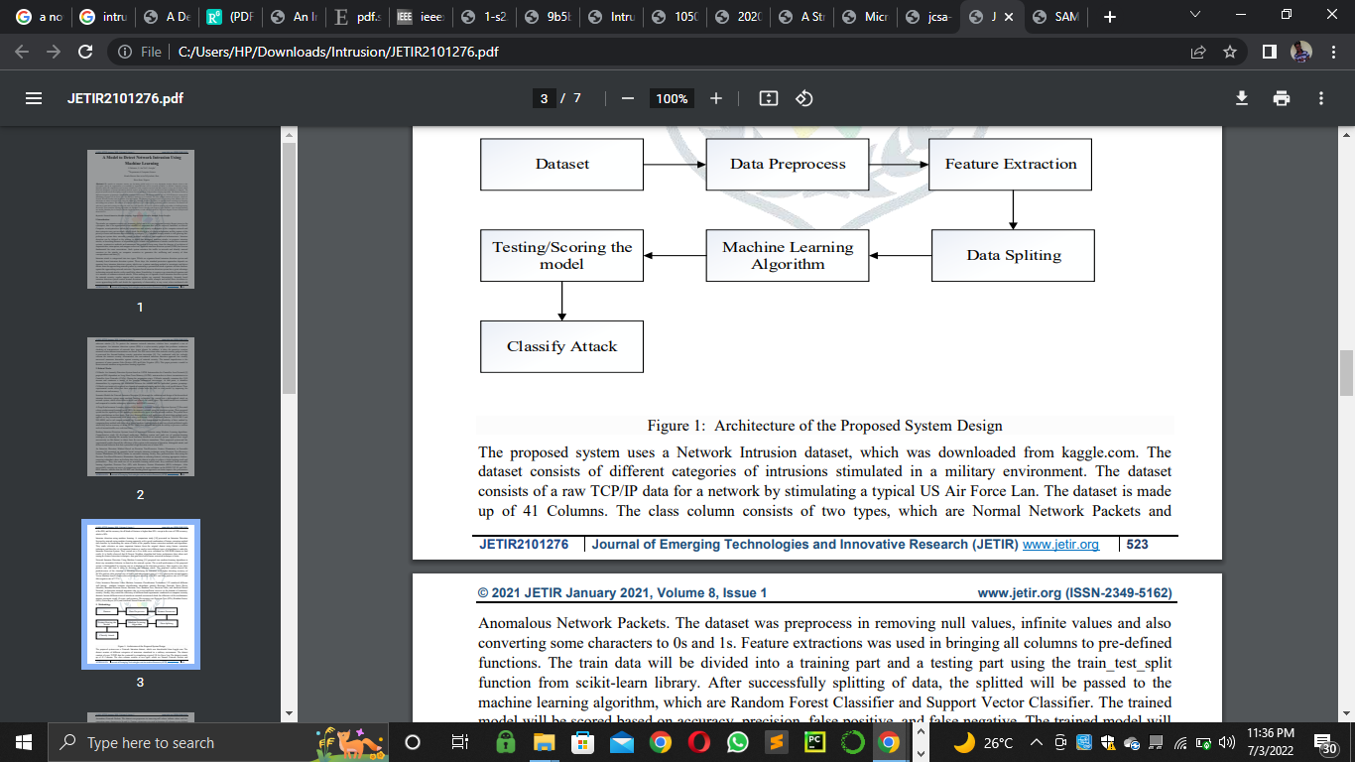
Figure 3.1: Architecture of the Proposed System Design
3.2 Analysis of the Existing System
Security is the condition of being protected against danger, loss, and criminals. In the general sense, security is a concept similar to safety. The slight difference between the two is an added importance on being protected outside threats or dangers. Individuals or actions that go or act against the general rules of protection are responsible for the breach of security. Security can also be seen as:
- A condition that results from the establishment and maintenance of protective measures that ensures a state of inviolability from hostile acts or influences.
- With respect to classified matter, the condition that prevents unauthorized persons from having access to official information that is safeguarded in the interests of national security.
- Security has to be compared and contrasted with other related concepts: Safety, continuity, reliability.
The key difference between security and reliability is that security must take into account the actions of people attempting to cause destruction. There is an immense literature on the analysis and categorization of security. It is common knowledge as with all systems that the "weakest link in the chain" is the most important. This can also be incorporated in security systems. The situation is asymmetric since the defender must cover all points of attack while the attacker need only identify a single weak point upon which to concentrate.

3.3 Problems of the Existing System
- Crime Prevention through Environmental Design and mechanical
Layer which include gates, doors, and locks. This makes the system effective to some extent but largely ineffective and vulnerable to attacks and manipulation both from within and without the system. The system bases its physical security on two main features namely, people (Security Men and Women) and Structures (Walls and locks). These two features are easy to bypass and this is evident by the high rates of theft and manipulation of security men by students to do their biddings.

- Ease of Access through Breaking of Locks
All doors in our immediate environment are based on the cylindrical lock mechanism. This lock mechanism is very common and this fact makes it easy to breakdown by either breaking the lock or duplicating the keys. This makes the system rather unsafe for all users
- Lack of Intrusion Detection Alerts
All intrusion alerts are based dependent on discovery by individuals i.e. either security personnel’s or students. This delay gives the culprit enough time to dispose of whatever has been stolen and more than enough time to cover his tracks. This leads to a string of an ever increasing number of unsolved cases of theft.
- Inefficient Monitoring Method
Monitoring one’s belongings are left to the vigilance on the path of the security officials and the owners of such goods. This can prove to be ineffective considering the fact that as human beings, we tend to get bored performing monotonous tasks.
3.4 Analysis of the Proposed System
The challenge for increased system effectiveness is to develop a system that detects close to 100 percent of intruders with minimal false positives. We are still far from achieving this goal. Placing security surveillance at critical locations lets administrators detect intrusions against the school departments as a whole. That is, the sensing security surveillance is able to provide an integrated, “big picture” view of the intruders. A person that might appear irrelevant might be extremely dangerous when considered from the security. It’s now time for operating systems and network software to integrate intrusion detection sensors. Intrusion detection will no doubt become a default feature, rather than an esoteric option.

3.5 Advantages of the New System over the Existing System
Despite the documented contributions intrusion detection make to security, in many organizations one must still justify the acquisition of intrusion detection.
- When surveillance is continuous with no visible break, it tends to deter the less desperate thieves and thereby reducing the theft rate.
- To prevent problem behaviors by increasing the perceived risk of discovery and punishment for those who would attempt theft or otherwise disobey the school rules,
- To detect attacks and other security violations that are not prevented by other security measures,
- It reduce the theft rates by increasing the security of such areas by making them “safe rooms”
- To act as quality control for security design and administration,
- To provide useful information about intrusions that do take place, allowing recovery of lots pro perties etc.

CHAPTER FOUR
DESIGN, IMPLEMENTATION, AND DOCUMENTATION OF THE SYSTEM
4.1 Design of the System
The proposed system is designed in modules with each module working together to perform the goal of the access control system to enhance the performance of the existing system as earlier discussed in chapter three. The ability to analyze and give focus to the system is explained in the following formats which are output design, input design, database design, and procedure design.
4.1.1 Output Design
The outputs to be extracted from the proposed system are as shown below:
4.0 Screenshot
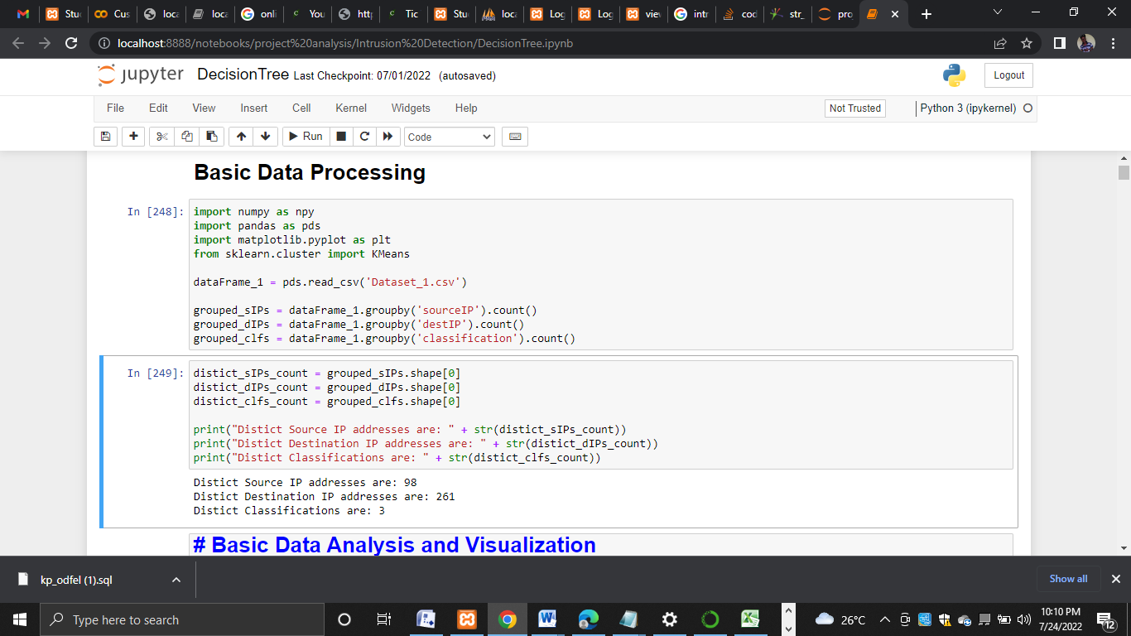
Figure 4.1 Basic Data Processing
Data preprocessing is perfomed here
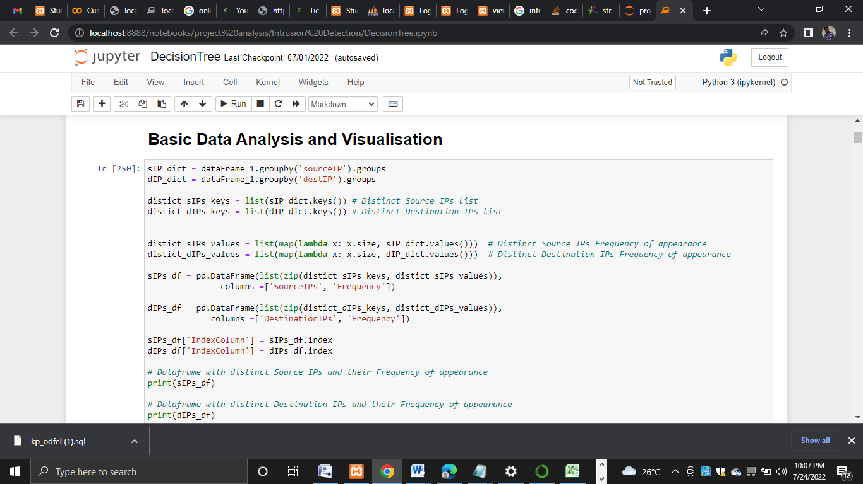
Figure 4.2 Basic Data analysis and Visualization
Analysis and Visualization are done using Python Pandas package
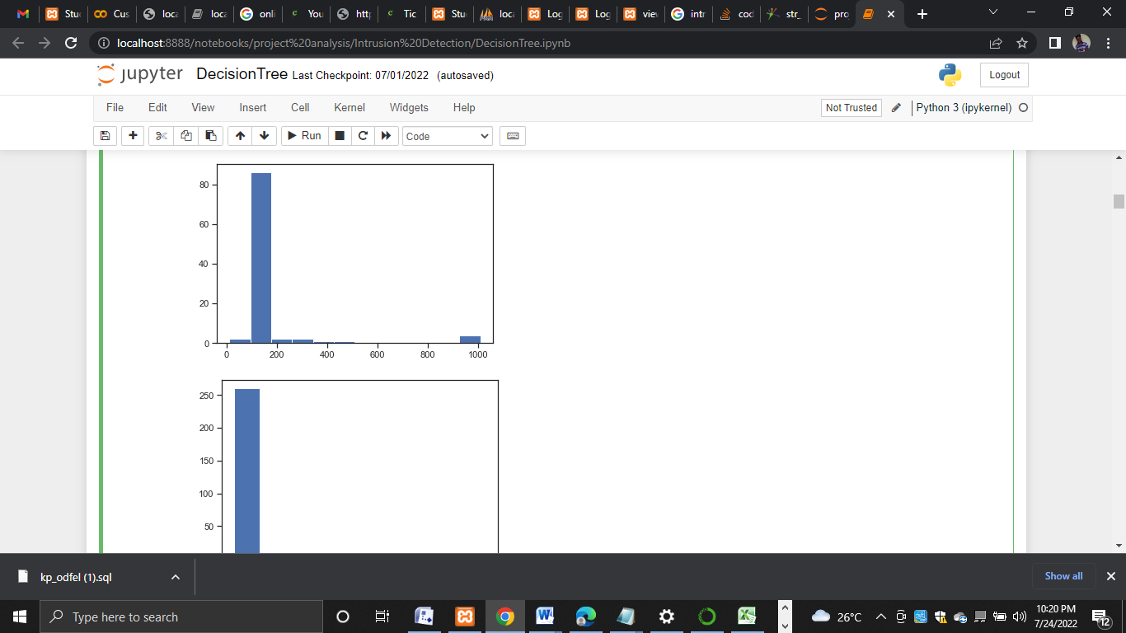
Figure 4.3 Historical Plots
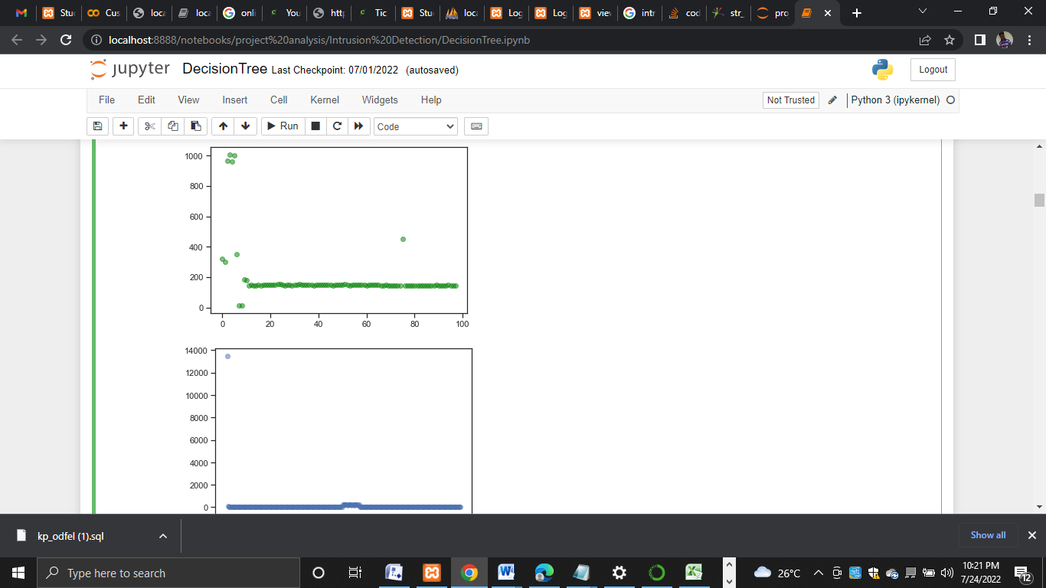
Figure 4.4 Scatter Plots
4.1.2 Input Design
The inputs to be extracted from the proposed system are as shown in the figure below:
Data distribution Scatter Plots of Destination and Source IPs
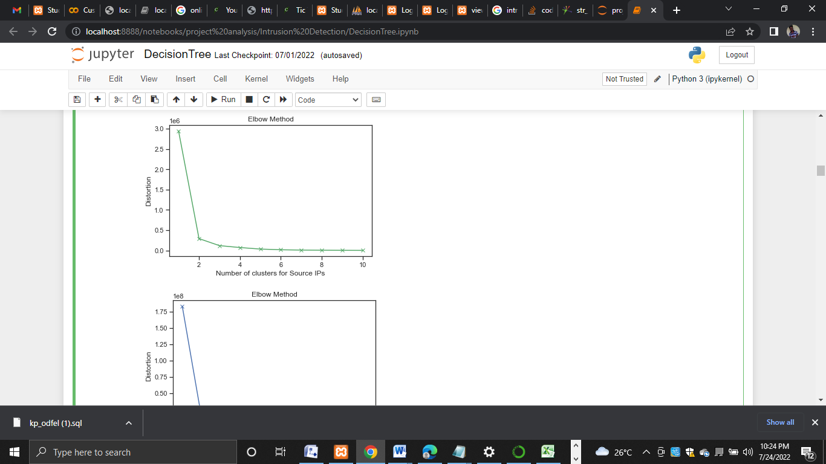
Figure 4.5 Scatter Plots
K-means: Finding the optimal number of clusters with Elbow Plot


Figure 4.6: Source and Destination IPs
K-means clustering with 4 clusters for both Source and Destination IPs
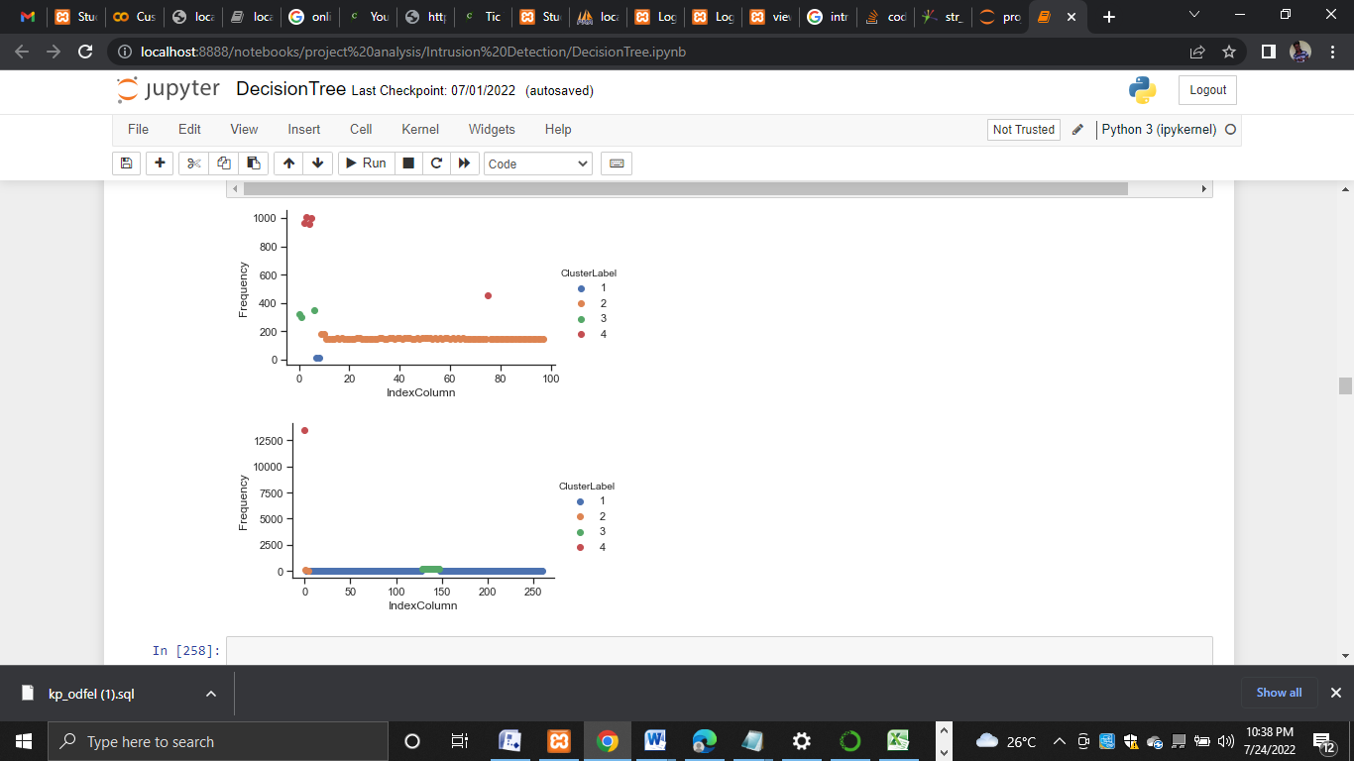
Figure 4.7: Relationship
CReate a new column with cluster labels for SourceIPs and CReate a new column with cluster labels for DestinationIPs then Plot the clusters now
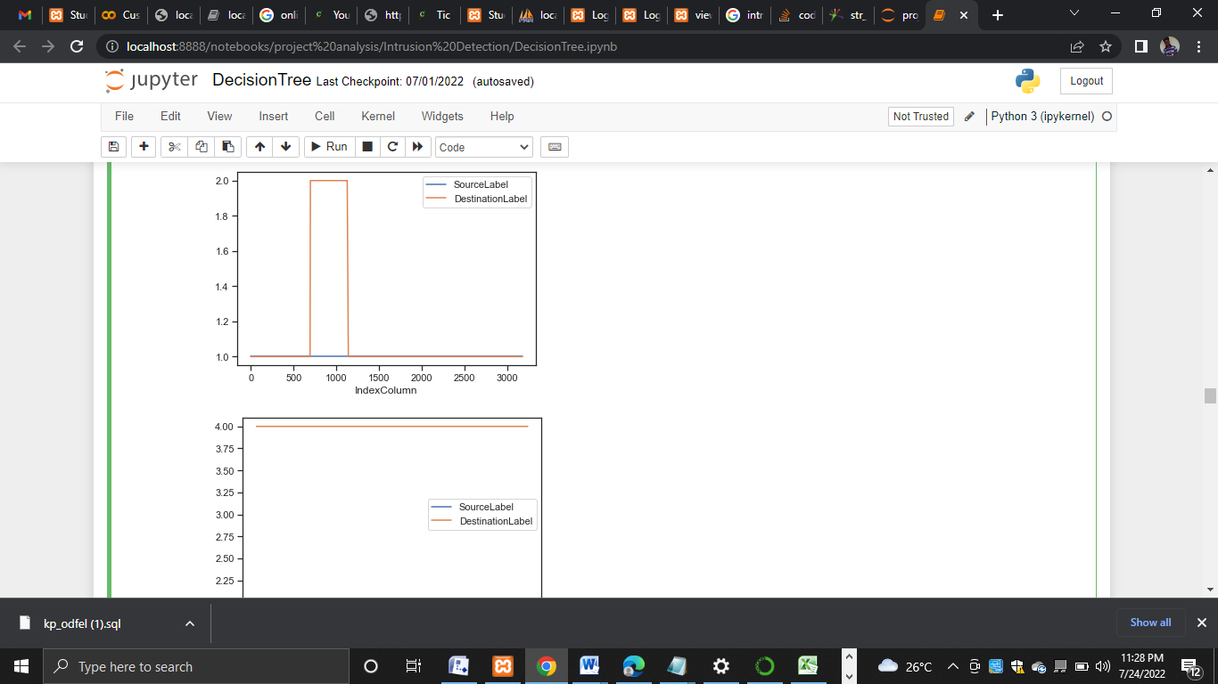
Figure 4.8: Source and Destination Clusters Relationship.

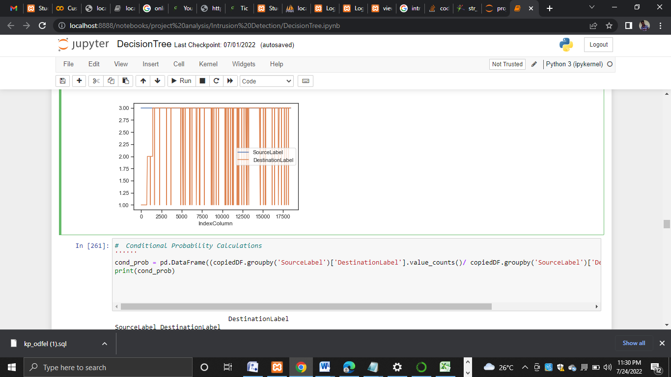
Figure 4.9: Source and Destination Clusters Relationship
Table 4.1 Source IP Table
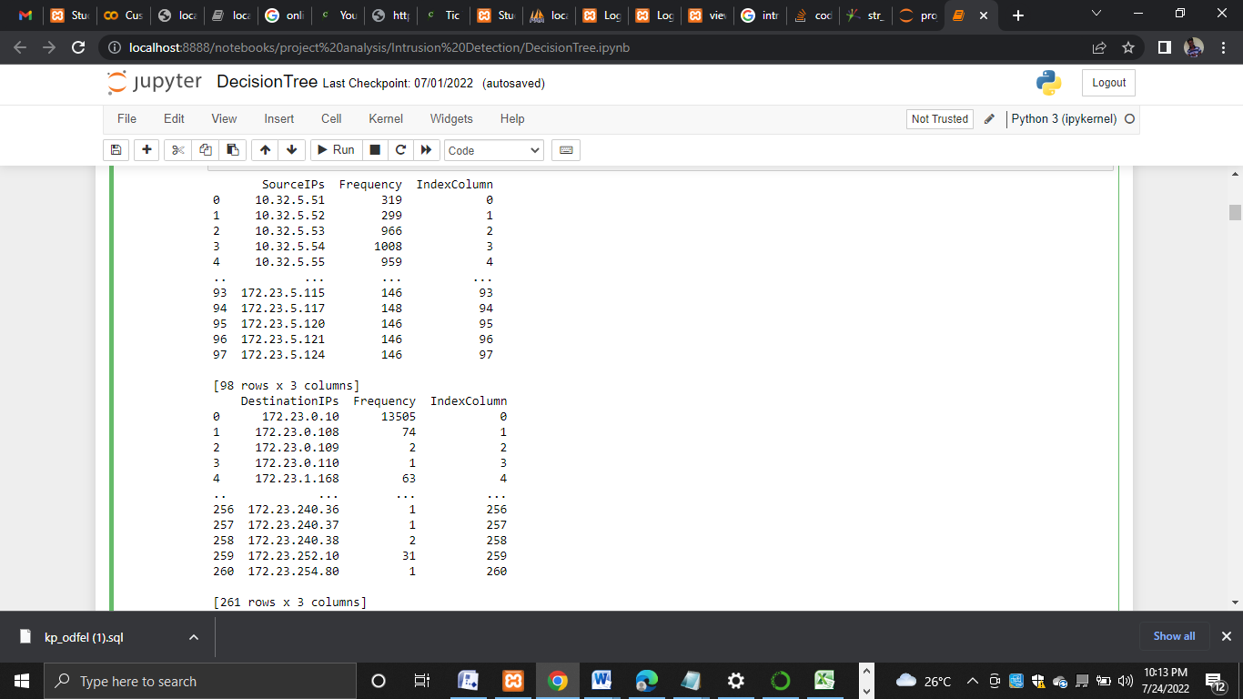
Dataframe with distinct Source IPs and their Frequency of appearance
Table 4.2 Relationship Table
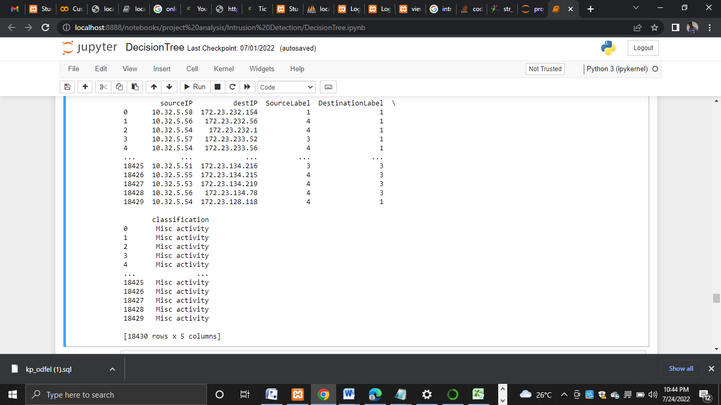

4.1.3 Database Design
This involves the list of tables used in the database design the tables are listed as follows
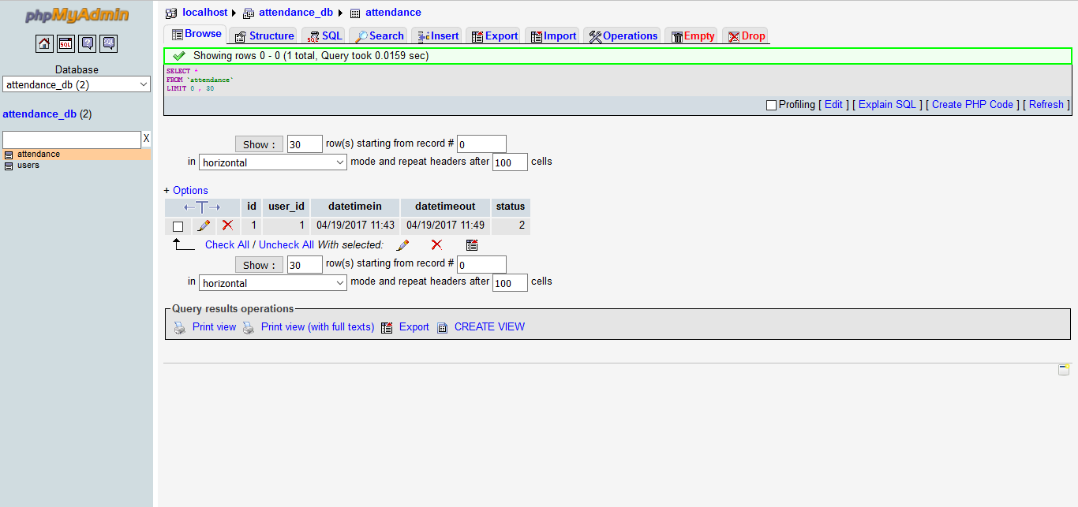
Table 4.1: Attendance database
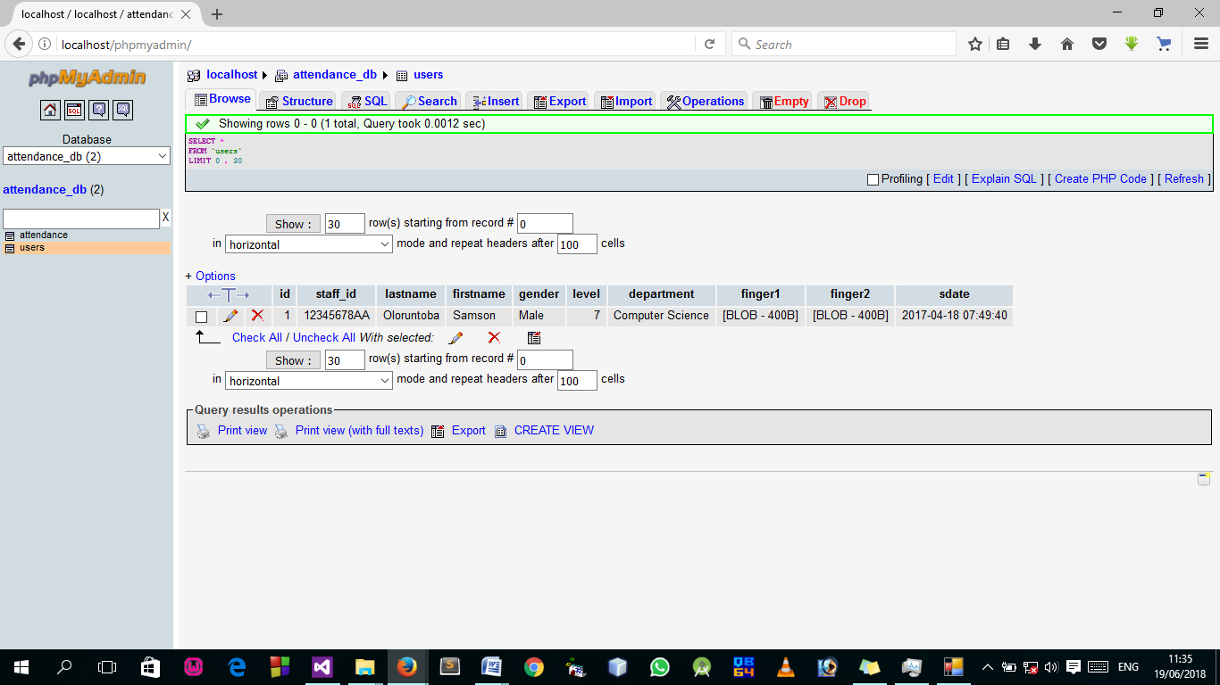
Table 4.2: RegDB database
MYSQL database: There are two databases designed using the MYSQL database. The databases are named “regDB” in (table 2) and “attendance”. The “regDB” in Table 2) database stores information of registered users. This information is used by the administration to identify and manipulate attendance information. On the other hand, the “attendance” in (table 1) database stores all attendance-related data. Besides that, three tables inside the “attendance” database act as temporary data storage which are “users ID”, “data_time_in” and “data_time_out”. These tables are essential to the program flow. The database has a login password that allows access.

4.1.4 Procedure Design
Procedure design is the arrangement, steps, and flow of a program. It involves how the commands and instructions are grouped to form the whole program. The methodology used for the program is an event-driven programming language which makes the program more efficient in terms of execution, development time, storage utilization, and maintenance.

4.2 Implementation of the System
This section deals with the implementation and documentation of the new system. It involves the physical requirement of the machines on which it can run i.e. memory capacity and operating system. It also provides a comprehensive user manual or guide with various screens (forms) as displayed to the user during the run-time.
4.2.1 Choice of Programming Language Used
The programming language used in the development of this student monitoring system is Microsoft Visual Studio as the compiler C# as the programming language and also coupled with the MSQL database.
4.2.2 Hardware Supports
For proper implementation of this system, the following requirements are recommended for the system on which this application is to be executed. An IBM compactable PC with the following configuration.
- Minimum of 586D x process or with 300MHz speed and 6.4 GD HDD
- Minimum of 64MB RAM
- VGA (640 x 480 x 16 or higher) color monitor
- Dot Matrix or laser printer
- Stabilizer, UPS
- Serial mouse, 101 key enhanced keyboard
- Air-conditioning
- 52 x CD-ROM Drive and diskettes
- Headphone
- RFID

4.2.3 Software Support
The following are the minimum software required:-
- Window 10 Professional
- Microsoft VISUAL Studio
- MYSQL Database

4.2.4 Implementation Techniques Used In Details
The implementation technique used is parallel change over the mode of implementation, modes which support only the proposed system and leave the old system of operation.
  - Documentation of the System
After the program has been well tested with input that the output has already been known, the next is to install the software into the computer system for use.
The processes of installation are stated below
i. Insert the CD into the system through the CD-ROM after the computer is switched on
ii. Locate the CD drive directory in my computer and click it to open
iii. After opening, locate setup.exe, and then click to install the program by following the necessary step in installing the program.
iv. Ensure full installation of the software for the effective operation of the system.
After the program has been fully installed. The next thing is to locate the package installed to put it into operation, to locate the package for expiration purposes the following step is to be taken.
i. Click on the start menu from the taskbar. Then select all program
ii. From the display sub-option, select by locating the software installed named Dependency to load the software.
iii Follow the next instruction to operate the software

    - Operating the System
Proper and adequate documentation is part of the quality of a good program hence working with the software. You click on the start button then locate all programs and click on Staff on the login screen, input your password, and username; the welcome page will be displayed, and then the home page. So you can select any menu from the list provided in other to perform any operation you desired to perform.
    - Maintaining the System
Proper maintenance of the system is required in other for the system to perform up to expectation at all times to maintain the system properly the following measures should be taken.
- Keep away from unauthorized users:- by password or encoding the system to prevent unwanted users from having access to the system.
- The software package should not be disposed to dust:- to prevent viruses and also make use of antivirus in the system where the packages are to be used to prevent the program from corrupting.
- You must have UPS: to prevent an uninterrupted power supply from the system.

CHAPTER FIVE
SUMMARY, CONCLUSION ANND RECOMMENDATIONS
5.0 Summary
The attacks on computer security are becoming global and it is a very important security threats issues to the cyberspace, that if an organization is not mindful of, important data will be accessed, modified, or deleted. The proposed system uses Dataset_1 and Dataset_2 are logfiles from, downloaded from kaggle.com that consists of 18431 data. A simulation with 0.1 rate of learning is applied and is run for 1000 number used for training and benchmarking the network. For comparison purposes, the training is done on the same dataset with several other classical machine learning algorithms and Decision tree and J48 Classifiers of layers ranging from 1 to 5. The results were compared and concluded that Decision tree and J48 Classifiers of 3 layers has superior performance over all the other classical machine learning algorithms. The whole experiment has been conducted using decision tree machine learning tool. From the dataset, 18,431 samples are selected randomly which contains 9,220 normal and 9,211 anomaly samples. 80% of the numbers of samples are used for training and rest of them are used for testing the algorithm. Features extraction was applied by dropping and adding some features. The number of columns increased to 112 columns after performing feature extraction. The dataset was split into a train and a testing set using the train_test_split function. After training/building our models, the Classifier had the highest accuracy results which is about 99.78%.

5.1 Conclusion
Network intrusion detection is one of the crucial security components and defence mechanisms of network security systems. This project research proposed IDS methods to evaluate the efficiency and effectiveness of machine learning approach on network-based while detecting intrusions. The performance was tested using the best feature subset selected from the recent network traffic datasets. The developed model was able to successfully classify and analysed the rate of network intrusion across and within the network. The dataset used was pre-processed and cleaned using the data cleaning and data enriching techniques. The various attributes contained in the dataset was transformed so as to boast the accuracy of the result.
5.2 Recommendations
Further research work can be done using a combination of a very low number of features that can reduce the time to detect an anomaly in the network traffic. Furthermore, Artificial Neural network will be applied to the dataset to evaluate the performance and compare with the proposed detection algorithm.

REFERENCES
AlMeshal, R. (2021) A comparative study for Intrusion Detection Methods Using Machine Learning The Public Authority for Applied Education and Training (PAAET) Email: reem_almeshal@hotmail.com
Azween, A., et al (2019) A Comparison of Various Machine Learning Algorithms in a Distributed Denial of Service Intrusion International Journal of Engineering Research and Technology. ISSN 0974-3154, Volume 12, Number 1 (2019), pp. 1-7 © International Research Publication House. http://www.irphouse.com School of Computer and IT (SoCIT), Taylor’s University, Malaysia. 3Research & Innovation Management Centre, SEGi University, Malaysia. ORCIDs: 1 (0000-0001-9477-8988) 2 (0000-0003-4425-8604) 3 (0000-0002-3294-3324) 4 (0000-0001-7611-9540) 5 (0000-0002-3734-0899)
Chibuzor, J. & Bennett, O., (2018) An Intrusion Detection System Using Machine Learning Algorithm International Journal of Computer Science and Mathematical Theory ISSN 2545-5699 Vol. 4 No.1 2018 www.iiardpub.org
Palimote, J. & Osuigbo, E. (2021) A Model to Detect Network Intrusion Using Machine Learning © 2021 JETIR January 2021, Volume 8, Issue 1 www.jetir.org (ISSN-2349-5162) Department of Computer Science Kenule Beeson Saro-wiwa Polytechnic, Bori, River State, Nigeria
Pascal, M., et al (2020) Detecting Intrusions in Computer Network Traffic with Machine Learning Approaches Department of Information Technology, Christian University of Rwanda, 6821, Rwanda 2Department of Information Technology, Vaal University of Technology, 19000, South Africa 3 Department of Information Technology
Samriddhi, V. & Nithyanandam, P. (2020) Detailed Analysis of Intrusion Detection using Machine Learning Algorithms International Journal of Recent Technology and Engineering (IJRTE) ISSN: 2277-3878 (Online), Volume-9 Issue-1, May 2020
Sharafaldin, I., Arash, H. & Ali, G., (2018) Toward Generating a New Intrusion Detection Dataset and Intrusion Traffic Characterization. DOI: 10.5220/0006639801080116 In Proceedings of the 4th International Conference on Information Systems Security and Privacy (ICISSP 2018), pages 108-116 ISBN: 978-989-758-282-0 Copyright © 2018 by SCITEPRESS – Science and Technology Publications, Lda. All rights reserved
Taha, A. & Mostafa, E., (2018) Building A Fast Intrusion Detection System For High-SpeedNetworks: Probe and DoS Attacks Detection The First International Conference On Intelligent Computing in Data Sciences University of Abdelmalek Essaadi, Faculty of Sciences and Techniques, Old road of Airport, Km10, PB.416, 90000, Tangier, Morocco Procedia Computer Science 127 (2018) 521–530
Terungwa, S., Oluoha, O. & Yakubu, M (2020) A Data Analytics System for Network Intrusion Detection Using Decision Tree Journal of Computer Sciences and Applications, 2020, Vol. 8, No. 1, 21-29 Available online at http://pubs.sciepub.com/jcsa/8/1/4 Published by Science and Education Publishing DOI:10.12691/jcsa-8-1-4

