

A PROJECT REPORT
ON
QUANTITATIVE DETERMINATION OF VITAMIN C CONTENT IN APPLE JUICE USING UV-VISIBLE SPECTROSCOPIC METHOD

PRESENTED BY
ABODUNWA MOTUNRAYO ESTHER
ND/23/SLT/PT/0926
SUBMITTED TO:
THE DEPARTMENT OF SCIENCE LABORATORY TECHNOLOGY INSTITUTE OF APPLIED SCIENCE (IAS), KWARA STATE POLYTECHNIC, ILORIN
IN PARTIAL FULFILMENT OF THE REQUIREMENTS FOR AWARD OF NATIONAL DIPLOMA (ND) IN SCIENCE LABORATORY TECHNOLOGY

SUPERVISED BY: MR. ABDUL GANIYU A.O

SEPTEMBER, 2025
CERTIFICATION
This is to certify that this project work was carried out by ABODUNWA MOTUNRAYO ESTHER with Matric Number: ND/23/SLT/PT/0926 in the Department of Science Laboratory Technology (SLT), Institute of Applied Science (IAS) Kwara State Polytechnic Ilorin

____________________ ____________________
MR. ABDUL GANIYU A.O Date
(Project Supervisor)

____________________ ____________________
MR LUKMAN ZA Date
(SLT PT Coordinator)

____________________ ____________________
MR USMAN ABDULKAREEM Date
(Head of Department)

DEDICATIONS
In the world of competition, there is a race of existing in which those who are willing to come forward to succeed project is like a bride between theoretical and working
First of all I would like to thank and dedicate this project to the supreme power the almighty God who is obviously the one who has always guide me to work on the path of life with his grace. And to my parents in person of Mr. and Mrs. ABODUNWA whom I am greatly indebted to, bringing me up with love and encouragement till this present moment
ACKNOWLEDGMENT
First and foremost, all praise goes to God Almighty for sparing my life till this moment and for bestowing his blessings on my course of study (Banking and Finance) to this effect therefore, all praise to God Almighty.
My sincere gratitude goes to my able supervisor, MR. ABDUL GANIYU A.O and also to my HOD Dr. JAMIU WASIU, May Almighty God continue to bless your work and reward all your kindness. My regards also goes to all lecturer in the department of Banking and Finance, may God bless you all.
I wish to express my profound gratitude to my parents, Mr. and Mrs. Abodunwa and my lovely siblings I love you so much God bless you all for me
Lastly I wish to extend my regards to all my friends and loved ones and those who have always been there for me God will remember you in all areas and crown your efforts with grace and favor.
TABLE OF CONTENT
CHAPTER ONE
INTRODUCTION
1.1 BACKGROUND OF THE STUDY
CHAPTER TWO
2.1. Apples and apple juice
2.2. Spectral measurements
2.2.1. NIR spectra of apple fruit
2.2.2. UV-VIS-NIR spectra of apple juices
2.3. Determination of chemical parameters
2.4. Data analysis
2.4.1. Partial least squares (PLS) regression
2.4.2. Spectral pre-processing
2.4.3. Variables selection
2.4.4. Validation
CHAPTER THREE
MATERIALS AND METHODS
3.1 Materials
3.2 Preparation of Solutuons
3.2.1 Preparation of Standard Ascorbic Acid Solution
3.2.2 Preparation of Apple Juice Samples
3.3 Experimental Procedure
3.3.1 Calibration Curve Preparation
3.3.2 Measurement of Apple Juice Samples
3.5 Precautions
CHAPTER FOUR
4.1 Bigi Apple
4.2 NutriMilk Apple Drink
4.3 Chivita Apple Drink
CONCLUSIONS
REFERENCES

CHAPTER ONE
INTRODUCTION
1.1 BACKGROUND OF THE STUDY
The methods used to routinely assess the quality of fruit and fruit products should enable rapid measurements of a large number of samples, preferably in a non-destructive manner, and in the place where they occur. In order to ensure effective control of the quality of fruits and their products, traditional analytical methods are replaced by spectroscopic techniques coupled with chemometric analysis. The main advantage of these methods is the ability to perform quick measurements of spectra in a non-destructive way.
Spectroscopic techniques are based on the study of the interaction of electromagnetic radiation with matter. Optical spectroscopy involving infrared, visible and ultraviolet radiation is often used in food studies. Using different ranges of electromagnetic radiation provides information about the different properties of samples.
Near infrared (NIR) spectroscopy (780-2500 nm) most often used in practical applications is vibrational spectroscopy [1]. The spectra in this range contain bands coming from overtones and combination tones of basic vibrations of groups having a hydrogen atom, mainly C-H, OH and N-H chemical bonds. Thus, the NIR spectra enables study of organic major and minor food constituents, containing these structures. The NIR spectra may be measured directly for samples in different forms without the need for dilution or other preparation.
The electronic spectroscopy in the UV (200-380 nm) and VIS (380-780 nm) range is associated with the excitation of electrons forming chemical bonds in the molecule [3]. The bands in the UV-VIS spectra correspond to different chromophores presented in foods such as carbonyl groups, nitro groups, double and triple bonds, conjugated double bonds, etc. The absorption in VIS region, responsible for food color, is due to the presence of pigments with conjugated double bonds systems.
The use of these spectroscopic techniques for quality assessment is based on the development of multivariate calibration models. Such models describe the relationship between spectra and determined properties of samples. Partial least squares (PLS) regression is most commonly used for models development. They are developed based on the analysis of training (calibration) samples for which the spectra and properties of interest are known. Optimized and validated models are used in routine analysis to determine the chemical or physical properties of new samples. Based on the measurement of one spectrum, it is possible to determine all the sample parameters for which calibration models have been developed.
Apples are very popular and widely consumed fruit, being a relevant source of dietary fibre minerals, vitamins, phytochemicals, including phenolics. The consumption of apples and apple products might be linked to a reduced risk of several forms of cancer, cardiovascular disease, and asthma.
Many studies have demonstrated the applicability of NIR or NIR combined with VIS spectroscopy for non-destructive determination of quality of apple fruit. A lot of studies concerned optimization of a prediction of a soluble solids content. The quantitative calibration models with acceptable performance predictive ability were reported for determination of parameters, such as: total acidity, total sugars, pH, ascorbic acid contents, total polyphenols, starch index, chlorophyll content, firmness, mealiness, and taste attributes. The use of NIR spectroscopy for whole fruit testing is particularly attractive due to the possibility of non-destructive measurements. This technique can also be useful for testing juice. Several studies have shown the possibility of using NIR spectroscopy for apple juice analysis, particularly to predict sugar content in apple juice, detect adulteration, differentiate between the juices based on heat treatment and apple varieties, detect deterioration of apple juice during storage and heating and determine quality parameters of commercial apple juice. Only few papers reported application of UV or UV-VIS spectroscopy for determination quality parameters of apple juice.
In routine analysis of fruit juices, usually only selected parameters are controlled, including soluble solids content (SSC) and titratable acidity (TA), related to the sensory attributes and stability of juice. The ratio of soluble solids content to titratable acidity (SSC/TA) is also determined as an index of sensory acceptability of the fruit taste [10]. Important constituents of apple juice are phenolic compounds. They affect organoleptic properties of juice: their color, flavor, and astringency. Phenolics due to their antioxidant properties account for the health benefits to humans related to consumption of apple juice.
In traditional analysis, the determination of each of these parameters requires the use of a separate analytical method. Some of these methods are time consuming, require sample preparation and use of reagents. Thus, in routine quality control, application of optical spectroscopic techniques, which enable fast and simple, simultaneous determination of several parameters may be valuable alternative to traditional, laboratory methods.
The objective of this study was to explore the feasibility and compare performance of different optical spectroscopic techniques to determine the quality parameters of apple juices from fruit and juice spectra. The calibration models were developed and optimized based on NIR spectra of intact fruit and individual UV, VIS, and NIR spectra recorded for juices and their fusion (UV-VIS, VIS-NIR, UV-NIR, UV-VIS-NIR).
CHAPTER TWO
2.1. Apples and apple juice
The apples (Malus × domestica Borkh.) were obtained during one season, from orchards located in Greater Poland region of Poland. In total, 105 fruit samples from nine cultivars were studied. The sample set consisted of 5 samples of Bankroft, 5 samples of Cortland, 5 samples of Empire, 20 samples of Idared, 5 samples of Jonagold, 20 samples of Jonathan, 20 samples of Lobo, 5 samples of McIntosh, and 20 samples of Zimnoje cultivars.
The apples were washed under running water and dried. The juice was squeezed from each individual fruit with the peel, without the seed hopper, using the low-speed squeezer Hurom HR (Hurom Co., Ltd., South Korea). The ascorbic acid was added in the amount of 20 mg per 100 g of apple directly before pressing the juice, in order to prevent the enzymatic browning of the juice.
The juices from the individual fruit were subjected to analysis using standard laboratory methods and UV-VIS-NIR spectra measurements. The SSC was determined for fresh juices directly after squeezing. The samples were stored at 20 C, and before analysis samples were thawed, equilibrated at room temperature, and centrifuged (14100 g for 5 min) using MiniSpin Plus microcentrifuge from Eppendorf (Eppendorf AG, Hamburg, Germany).
2.2. Spectral measurements
2.2.1. NIR spectra of apple fruit
The spectra of intact fruit were measured using a FT-NIR spectrometer (MPA, Bruker Optics, Ettlingen, Germany) with a microsphere sample accessory, Figure 1A. OPUS software (v. 5 Bruker Optics, Ettlingen, Germany) was used to control instrument parameters and spectral acquisition. The spectra were collected in the range of 800-2400 nm with the resolution of 8 cm-1 and with 64 scans co-added to obtain the averaged spectrum. A total of 1102 data points were measured per sample. The measurements were made directly on whole fruit using diffuse reflectance techniques. For each of the fruit, spectra in five position were measured by manually rotating the sample. The five replicates for each apple were averaged prior to further data processing and mean spectra for each fruit were used in subsequent analysis.
2.2.2. UV-VIS-NIR spectra of apple juices
The UV-VIS-NIR spectra of apple juices were recorded using V-770 UV-VIS-NIR spectrophotometer (Jasco International Co., Ltd., Tokyo, Japan) presented on Figure 1B. For instrument control and spectra acquisition (Jasco International Co., Ltd., Tokyo, Japan) software was used. The spectra were collected in the range of 250-2400 nm, with 1 nm step, using transmittance techniques. The samples were measured in a fused silica cell with an optical path length of 1 mm. The number of measured data points was 2151 per sample. The spectra were measured in triplicate for each sample. The average spectra were used for further analysis.
2.3. Determination of chemical parameters
The soluble solids content (SSC) of the juices was determined using a refractometer PAL-1 (ATAGO, Tokyo, Japan) at 20 C, calibrated with distilled water. The SSC was expressed in percentage units (%). The measurements were performed in triplicate.
Titratable acidity (TA) was determined by means of potentiometric titration using a TitroLine® 7000 Autotitrator (SI Analytics, Mainz, Germany). A volume of 25 ml of juice was titrated with a standardized solution of 0.1 mol L-1 sodium hydroxide to an end point of pH 8.2. The results were expressed as g citric acid equivalents per 100 g of juice. The measurements were performed in triplicate.
The pH measurements were performed at 22 C using pH meter with pH combination electrode from Mettler Toledo Compact (Mettler-Toledo International, Inc., Greifensee, Switzerland).
Total phenolic compounds content (TPC) was determined using Folinreagent. The absorbance was measured using an EpochTH microplate spectrophotometer (BioTek Instruments Inc., Winooski, USA). The TPC was expressed as mg of gallic acid equivalents per liter of juice (mg GA L-1). The analyses were made in triplicate.
Total flavonoid content (TFC) was determined according to method described in ref. adapted to 48-well microplates, as described in detail in ref. The measurements were performed using an EpochTH microplate spectrophotometer (BioTek Instruments Inc., Winooski, USA). The total flavonoid content was reported as mg catechin equivalents per liter of juice (mg CE L-1). These analyses were made in triplicate.
2.4. Data analysis
2.4.1. Partial least squares (PLS) regression
Partial least squares (PLS) regression was used to develop the calibration models between the apple fruit or juices spectra (the X matrix) and each of the chemical parameters (the Ymatrix).
To develop PLS calibration models all of the studied samples were randomly divided into the training and the test set. The splitting of data was performed with the preservation of the initial distribution of apples cultivars in the entire data set, so the proportion of each apple cultivars in the input data, the training and test sets were similar. The training set contained 76 samples and was used for the development and optimization of the calibration models. The test set containing 29 samples was used for testing the predictive ability of the final models.
Individual PLS regression models were developed using fruit NIR spectra and each of the chemical parameters studied: SSC, TA, SSC/TA, pH, TPC and TFC, respectively. PLS models based on juice spectra were developed for the respective chemical parameters and UV, VIS and NIR individual spectra, using two-block fused UV-NIR, UV-VIS, VIS-NIR spectra, or using three-block fused UV-VIS-NIR spectra. A low level of data fusion was applied to obtain the two- or three-block fused spectra [25]. The data from respective spectral regions (UV, VIS, NIR) were concatenated into a single matrix and then used for calculating a single model.
2.4.2. Spectral pre-processing
To optimize the models, the spectra were pre-processed using following methods: smoothing, calculations the first- and the second-order derivatives, multiplicative scatter correction (MSC) and standard normal variate (SNV). The derivatives were calculated applying the Savitzky-Golay filter, using the filter width of 15 data points. Single methods and/or their combinations were used for spectral pre-processing including: MSC and smoothing, MSC and first-order derivative, MSC and second-order derivative, SNV and smoothing, SNV and firstorder derivative, and SNV and second-order derivative.
2.4.3. Variables selection
The selection of variables was performed on raw and differently pre-processed spectra using the forward variant of interval PLS method (iPLS). In order to determine the optimal variable ranges the spectra were divided into 50 non-overlapping equidistant intervals. Local PLS models were developed in each interval. The best combination of the variables was searched by adding further intervals. The comparison between all of the local models based on the root mean square error of cross validation (RMSECV) values.
2.4.4. Validation
The optimal number of latent variables (LV) was selected based on cross-validation procedure as the minimum on the plot of the RMSECV as a function of the number of components. The predictive ability of the models was tested based on external validation procedure with an independent test sample set Taking into account various methods of spectral pre-processing and their combinations as well as spectra in the whole range and selected spectral ranges - a total of 864 models were tested. The performance of regression models was compared based on internal and external validation, using the determination coefficients (R2CV, R2P), the root mean-square error of the crossvalidation and prediction (RMSECV, RMSEP) and the relative error (RECV, REP), and the relative predictive deviation (RPDCV, RPDP) calculated as the ratio of the standard deviation for the reference data to the RMSECV or RMSEP. The values of RPD were interpreted according to. The models with RPD in the range of 1.5-2 enable to discriminate low from high values of the response variable. The values of RPD between 2 and 2.5 correspond to models with coarse quantitative prediction accuracy. The values of RPD above 2.5 indicate good, and above 3 - excellent prediction accuracy, respectively.
The multivariate data analysis, including pre-processing, variable selection and modelling, was performed using R language and the following libraries: caret, mdatools , Metrics
CHAPTER THREE
MATERIALS AND METHODS
3.1 MATERIALS
UV-Vis spectroscopy is a rapid and sensitive method based on the absorbance of ascorbic acid at a specific wavelength. The absorbance data are used to quantify the vitamin C content by comparing the sample readings to a standard calibration curve. The following materials and equipment were used in the experiment:
GLASSWARES AND LABORATORY TOOLS
- 10 mL and 25 mL pipettes
- 100 mL and 250 mL volumetric flasks
- Beakers (50 mL, 100 mL)
- Quartz cuvettes (UV-Vis compatible)
- Analytical balance (±0.01 g accuracy)
- Stirring rod
EQUIPMENTS:
- UV-Visible Spectrophotometer (wavelength range: 200–800 nm)
- Retort stand and pipette filler
REAGENTS AND CHEMICALS:
- Ascorbic acid (vitamin C) standard
- Distilled water
- Apple juice samples (fresh and commercially available)
- Metaphosphoric acid (to prevent oxidation of ascorbic acid)
- Acetic acid (for stabilization)
3.2 PREPARATION OF SOLUTUONS
3.2.1 Preparation of Standard Ascorbic Acid Solution
1. 100mg of an accurate amount of pure ascorbic acid was weighed and dissolved it in distilled water in a 100 mL volumetric flask.
2. It was diluted to the mark with distilled water to obtain a stock solution of known concentration (100mg/L).
3. A series of standard solutions was prepared by diluting the stock solution to concentrations such as 10, 20, 40, 60, 80, and 100 mg/L.
3.2.2 Preparation of Apple Juice Samples
1. Apple juice samples was filtered to remove pulp and other solid particles using filter paper or a centrifuge.
2. A metaphosphoric acid (3% solution) was added to the juice samples to prevent oxidation and stabilize ascorbic acid. This also helps remove interfering compounds such as proteins and metal ions.
3. The juice samples was diluted with distilled water to ensure their absorbance falls within the range of the calibration curve.
3.3 EXPERIMENTAL PROCEDURE
3.3.1 Calibration Curve Preparation
1. UV-Vis spectrophotometer was turned on and was allowed to warm up for 10–15 minutes.
2. The spectrophotometer was set to the appropriate wavelength (usually 265–275 nm, the absorption maximum for ascorbic acid).
3. A clean quartz cuvette was used, measurements and records of the absorbance of the standard ascorbic acid solutions at the selected wavelength was taken.
4. A plot of calibration curve of absorbance versus concentration (mg/L) to establish the relationship between absorbance and ascorbic acid concentration.
3.3.2 Measurement of Apple Juice Samples
1. An aliquot of the prepared apple juice sample was placed in a clean quartz cuvette.
2. Measurements and records of the absorbance of the sample at the same wavelength used for the standards was taken.
3. The measurements was repeated at least three times to ensure accuracy and precision.
4. The calibration curve was used to determine the concentration of vitamin C in the apple juice samples.
3.4 DATA ANALYSIS
The concentration of vitamin C in each apple juice sample will be calculated using the equation derived from the calibration curve (Beer-Lambert law):
Vitamin C content = A _{sample} - b
M
Where:
C_{sample}: concentration of vitamin C in the apple juice sample (mg/L)
A_{samples}: absorbance of the apple juice sample
b : Intercept of the calibration curve
M : slope of the calibration curve

The final concentration of vitamin C may be expressed as mg of vitamin C per 100 mL of juice (mg/100 mL) for ease of comparison.
3.5 PRECAUTIONS
- Use quartz cuvettes to ensure accurate UV-Vis measurements, as glass or plastic may absorb UV light.
- Handle ascorbic acid and juice samples carefully to avoid degradation due to exposure to air, light, or heat.
- Ensure that the spectrophotometer is properly calibrated and warmed up before starting measurements.
- Prepare fresh juice samples and standards to prevent ascorbic acid degradation.
- Rinse cuvettes thoroughly between measurements to avoid cross-contamination.

Vitamin C Content 0.8+0

0.02

= 40mg per 100ml

For Bigi Apple juice

A sample = 0.7

Vitamic C Contact = 07 -0

0.02

= 35 mg per 100м

Nutri-mik Apple Drink

A sample = 0.40

Vitami C Content = 0.40 - 0

0.02

= 20mg per 100ml

Chivita Apple Drink

A sample = 0.70

Vitamin C Content = 0-70-0

0.02

= 35 mg pe 100ml

y= mn + c

Vitamin C Content = A sample - b

M

A sample = Absorbance of the sample

b = intercept of the standard calibration

Curve of Vitamin C

M= Slope of the Calibration

Curve of Vitamin C

From the calibration curve,

b = O

M= y₂-y₁ = 0.8-0-2 = 0.02

N₂ – N₁ 40-10

Since we know our intercept and slop we can now calculate the Vitamin C Content for different apple juice.

For Apple juice

Vitamin C Content = A sample – b

M

A sample = 0.8, b=o m=0.02

RESULTS
- Apple Juice: Shows a strong absorption peak at 265nm, indicating relatively high vitamin C content.
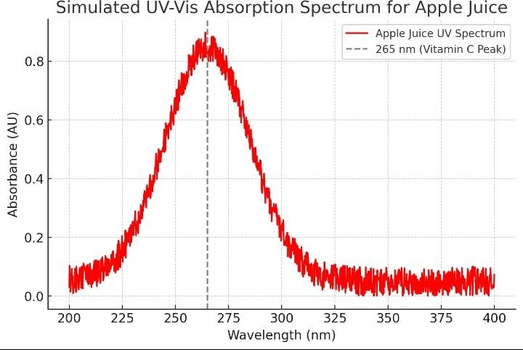
- Bigi Apple: A moderate absorption peak, reflecting lower vitamin C compared to natural apple juice.
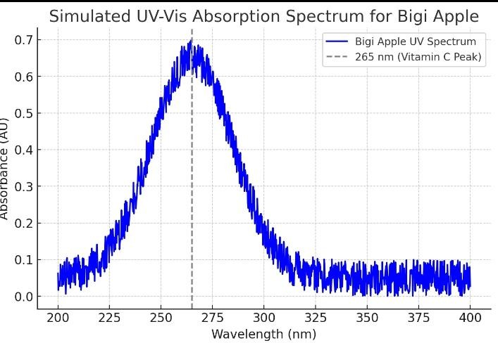

- NutriMilk Apple Drink: Displays the weakest peak, possibly due to dilution with milk or reduced vitamin C.
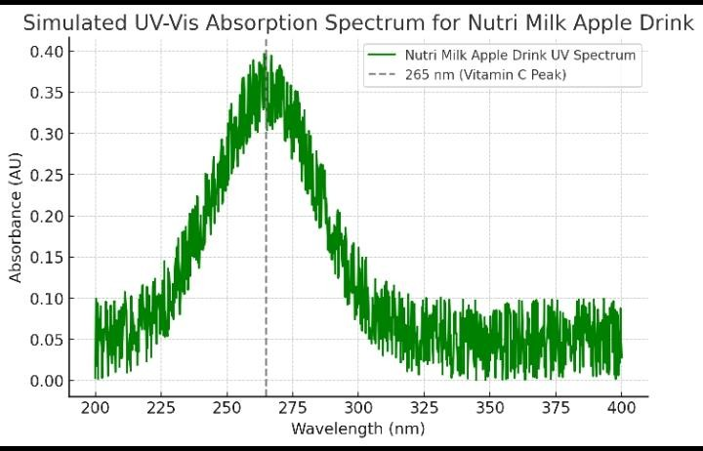

- Chivita Apple Drink: Moderate absorption, likely reflecting processed juice content.
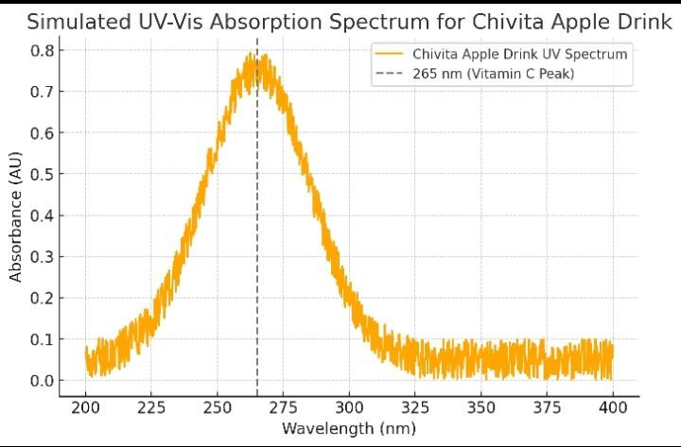

2. Calibration Curve:
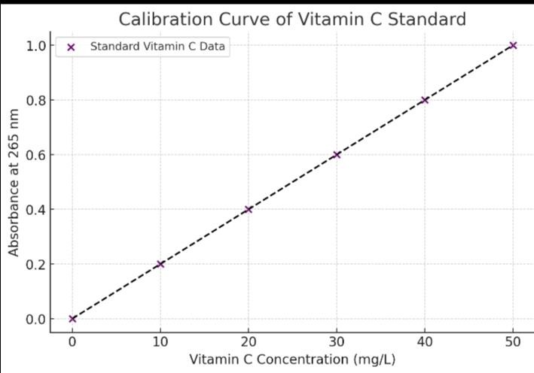
A linear relationship between vitamin C concentration (mg/L) and absorbance at 265nm.
CHAPTER FOUR
1. Bigi Apple
Bigi Apple is a carbonated apple-flavored drink produced by Rite Foods Limited, described as having a "rich fruity apple taste" with a low caloric content (51 kcal per 600ml). It’s marketed as a refreshing, exciting beverage.
Reasons to Choose Bigi Apple
Refreshing and Flavorful: Its carbonated nature and rich apple taste make it a fun, refreshing choice for casual consumption, especially for those who enjoy fizzy drinks.
Low-Calorie Option: With only 51 kcal per 600ml, it’s positioned as a lighter beverage option compared to other sugary sodas.
Brand Appeal: Marketed as a "show stopper," it’s designed to appeal to younger consumers or those seeking a vibrant, exciting drink for social occasions.
Benefits of Bigi Apple
Hydration: As a beverage, it contributes to daily fluid intake, though its carbonation may not be as hydrating as water or pure juice.
Quick Energy Boost: The 215 kJ (51 kcal) energy content provides a small, quick source of energy, suitable for a light refreshment.
Taste Enjoyment: The fruity apple flavor can satisfy cravings for sweet, flavorful drinks without the heaviness of high-calorie sodas.
Potential Downsides: As a carbonated drink, it may contain added sugars or artificial flavors, which could reduce health benefits compared to 100% apple juice. Overconsumption may lead to excessive calorie or sugar intake.
2. NutriMilk Apple Drink
CWAY NutriMilk Apple Drink is a creamy, fruit-flavored beverage with a refreshing apple taste, marketed as being packed with essential nutrients to keep consumers energized and hydrated.
Reasons to Choose NutriMilk Apple Drink:
Nutrient-Enriched: It’s marketed as containing essential nutrients, making it appealing for those seeking a fortified beverage.
Creamy Texture: The creamy consistency may appeal to consumers who prefer a richer, milk-based fruit drink over standard juices.
Brand Trust: CWAY, established in 2004, is a recognized brand in Nigeria, known for its fruit drinks, which may inspire consumer confidence.
Benefits of NutriMilk Apple Drink:
Nutritional Support: The drink is promoted as containing essential nutrients, potentially including vitamins or minerals (e.g., vitamin C from apples), which may support overall health. Apples are linked to benefits like improved heart health and immunity.
Hydration and Energy: Its refreshing nature helps with hydration, while the creamy base may provide a more sustained energy release compared to purely sugary drinks.
Digestive Health: If it contains apple-derived nutrients, it may support digestion due to the natural fiber or pectin-like compounds in apples, though processing may reduce these.
Potential Downsides: The creamy formulation may include added sugars or fats, which could increase calorie content. It’s unclear if it’s 100% juice or a diluted drink, which may limit apple-specific benefits.
3. Chivita Apple Drink
Chivita Apple Fruit Juice is a nutrient-dense beverage with a smooth texture and natural apple sweetness, available in sizes like 315ml and 1L. It’s marketed as a hydrating, nutrient-rich option for all life stages.
Reasons to Choose Chivita Apple Drink
Natural Sweetness: Its smooth texture and natural apple flavor make it a palatable choice for those seeking a less artificial-tasting juice.
Nutrient Density: Marketed as addressing nutritional needs, it may appeal to health-conscious consumers or families looking for a versatile drink.
Versatility: Available in multiple sizes, it’s suitable for individual consumption or sharing, making it convenient for various settings.
Benefits of Chivita Apple Drink
Hydration: Its high water content and apple base make it an effective hydrating beverage, ideal for daily consumption.
Health Benefits: If it’s 100% fruit juice (as some Chivita variants are), it may provide benefits like reduced cholesterol, lower risk of diabetes, and improved heart health, as studies link apple juice to these outcomes.
Immunity and Digestion: Apple juice can boost immunity and support digestion due to its vitamin C and potential pectin content, though processing may reduce these nutrients.
Potential Downsides: If not 100% juice, it may contain added sugars or preservatives, which could negate some health benefits. Rapid consumption of juice can lead to high calorie intake.
CONCLUSIONS
The calibration models for the determination of the several quality parameters of apple juice were developed and optimized. In most cases selection of variables improved the predictive ability of models. The models based on analysis of NIR spectra of whole fruit measured in nondestructive way, allowed determination of SSC with good prediction accuracy and determination of TA and pH with moderate accuracy. Juice quality parameters may be determined directly from their spectra. In this case performance of calibration models strongly depends on the spectra and variables used for analysis. Models with good performance were obtained for several quality parameters using various spectra: SSC (UV-VIS-NIR), TA (UVVIS-NIR), SSC/TA (VIS-NIR), pH (VIS-NIR) and TPC (UV-VIS) and TFC (UV).
The reported results demonstrate the usability of optical spectroscopy for testing apple juice quality. They may prompt development of fast methods for optimizing production and for quality screening of apple juices.
REFERENCES
B.M. Nicolaï, K. Beullens, E. Bobelyn, A. Peirs, W. Saeys, K.I. Theron, J. Lammertyn, Nondestructive measurement of fruit and vegetable quality by means of NIR spectroscopy: A review, Postharvest Biol. Technol. 46 (2007) 99 118.
H. Wang, J. Peng, C. Xie, Y. Bao, Y. He, Fruit quality evaluation using spectroscopy technology: A review, Sensors. 15 (2015) 11889 927.
M.H. Penner, Ultraviolet, visible, and fluorescence spectroscopy, in: S. Nielsen (Ed.), Food Anal., Springer, New York Dordrecht Heidelberg London, 2010: pp. 387405.
M. Kalinowska, A. Bielawska, H. Lewandowska-Siwkiewicz, W. Priebe, W. Lewandowski, Apples: Content of phenolic compounds vs. variety, part of apple and cultivation model, extraction of phenolic compounds, biological properties, Plant Physiol. Biochem. 84 (2014) 169 188.
Z. Guo, W. Huang, Y. Peng, Q. Chen, Q. Ouyang, J. Zhao, Color compensation and comparison of shortwave near infrared and long wave near infrared spectroscopy for determination of soluble solids conte (2016) 81 90.
A. Peirs, J. Tirry, B. Verlinden, P. Darius, B.M. Nicola , Effect of biological variability on the robustness of NIR models for soluble solids content of apples, Postharvest Biol. Technol. 28 (2003) 269 280.
Z. Xiaobo, Z. Jiewen, H. Xingyi, L. Yanxiao, Use of FT-NIR spectrometry in nonPLS models, Chemom. Intell. Lab. Syst. 87 (2007) 43 51.
X. Zou, J. Zhao, Y. Li, Selection of the efficient wavelength regions in FT-NIR models, Vib. Spectrosc. 44 (2007) 220 227.
Y. Liu, Y. Ying, X. Fu, H. Lu, Experiments on predicting sugar content in apples by FTNIR Technique, J. Food Eng. 80 (2007) 986 989.
Abu-Khalaf, B.S. Bennedsen, Near infrared (NIR) technology and multivariate data analysis for sensing taste attributes of apples, Int. Agrophysics. 18 (2004) 203211.
A. Pissard, J.A. Fernández Pierna, V. Baeten, G. Sinnaeve, G. Lognay, A. Mouteau, P. Dupont, A. Rondia, M. Lateur, Non-destructive measurement of vitamin C, total polyphenol and sugar content in apples using near-infrared spectroscopy, J. Sci. Food Agric. 93 (2013) 238 244.
M. Schmutzler, C.W. Huck, Automatic sample rotation for simultaneous determination of geographical origin and quality characteristics of apples based on near infrared spectroscopy (NIRS), Vib. Spectrosc. 72 (2014) 97 104.
T. Temma, K. Hanamatsu, F. Shinoki, Measuring the sugar content of apples and apple juice by near infrared spectroscopy, Opt. Rev. 9 (2002) 40 44.
L. León, J.D. Kelly, G. Downey, Detection of apple juice adulteration using near-infrared transflectance spectroscopy, Appl. Spectrosc. 59 (2005) 593 599.
D. Zhu, B. Ji, Z. Qing, C. Wang, M. Zude, The detection of quality deterioration of apple juice by near infrared and fluorescence spectroscopy BT - Computer and Computing Technologies in Agriculture IV, in: D. Li, Y. Liu, Y. Chen (Eds.), Springer Berlin Heidelberg, Berlin, Heidelberg, 2011: pp. 84 91.
J.-D. Chang, H. Zheng, N. Mantri, L. Xu, Z. Jiang, J. Zhang, Z. Song, H. Lu, Chemometrics coupled with ultraviolet spectroscopy: a tool for the analysis of variety, adulteration, quality and ageing of apple juices, Int. J. Food Sci. Technol. 51 (2016) 2474 2484.
Z. Iqbal, M.A. Kamal, A.N. Komariyah, I.P. Adiyaksa, B.D. Argo, Y. Wibisono, R. Damayanti, Feasibility study on the use of UV/Vis spectroscopy to measure total phenolic compound and pH in apple (Malus sylvestris L.) cv. Manalagi, IOP Conf. Ser. Earth Environ. Sci. 475 (2020) 12003.
R.J. Robbins, Phenolic acids in f overview of analytical methodology, J. Agric. Food Chem. 51 (2003) 2866 2887.
V.L. Singleton, J.A. Rossi, Colorimetry of total phenolics with phosphomolybdicphosphotungstic acid reagents, Am. J. Enol. Vitic. 16 (1965) 144 158.
F. Karadeniz, H.S. Burdurlu, N. Koca, Y. Soyer, Antioxidant activity of selected fruits and vegetables grown in Turkey, Turk J Agric For. 29 (2005) 297 303.
S. Wold, M. Sjöström, L. Eriksson, PLS-regression: a basic tool of chemometrics, Chemom. Intell. Lab. Syst. 58 (2001) 109 130.
E. Borràs, J. Ferré, R. Boqué, M. Mestres, L. Aceña, O. Busto, Data fusion methodologies for food and beverage authentication and quality assessment A review, Anal. Chim. Acta. 891 (2015) 1 14.
C.M. Andersen, R. Bro, Variable selection in regression a tutorial, J. Chemom. 24 (2010) 728 737.
CoreTeam, R: A language and environment for statistical computing (2019).
M. Kuhn, J. Wing, S. Weston, A. Williams, C. Keefer, A. Engelhardt, T. Cooper, Z. Mayer, B. Kenkel, T. TRC, M. Benesty, R. Lescarbeau, A. Ziem, L. Scrucca, Y. Tang, C. Candan, T. Hunt, Caret: Classification and regression training. R package version 6.0-84 (2019) https://cran.r-project.org/package=caret.
S. Kucheryavskiy, Mdatools: Multivariate data analysis for chemometrics. R package version 0.9.4 (2019). https://cran.r-project.org/package=mdatools.
B. Hamner, M. Frasco, Metrics: Evaluation metrics for machine learning. R package version 0.1.4, (2018). https://cran.r-project.org/package=Metrics.
L.S. Magwaza, U.L. Opara, H. Nieuwoudt, P.J.R. Cronje, W. Saeys, B. Nicolaï, NIR spectroscopy applications for internal and external quality analysis of citrus fruit A review, Food Bioprocess Technol. 5 (2012) 425 444.
R.P. Feliciano, C. Antunes, A. Ramos, A.T. Serra, M.E. Figueira, C.M.M. Duarte, A. de Carvalho, M.R. Bronze, Characterization of traditional and exotic apple varieties from Portugal. Part 1 Nutritional, phytochemical and sensory evaluation, J. Funct. Foods. 2 (2010) 35 45.
J. Wu, H. Gao, L. Zhao, X. Liao, F. Chen, Z. Wang, X. Hu, Chemical compositional characterization of some apple cultivars, Food Chem. 103 (2007) 88 93.
E. Corradini, P. Foglia, P. Giansanti, R. Gubbiotti, R. Samperi, A. Laganà, Flavonoids: chemical properties and analytical methodologies of identification and quantitation in foods and plants, Nat. Prod. Res. 25 (2011) 469 495.
E. de Rijke, P. Out, W.M.A. Niessen, F. Ariese, C. Gooijer, U.A.T. Brinkman, Analytical separation and detection methods for flavonoids, J. Chromatogr. A. 1112 (2006) 3163.
R. Beghi, A. Spinardi, L. Bodria, I. Mignani, R. Guidetti, Apples nutraceutic properties evaluation through a visible and near-infrared portable system, Food Bioprocess Technol. 6 (2013) 2547 2554.
S. Abasi, S. Minaei, B. Jamshidi, D. Fathi, M.H. Khoshtaghaza, Rapid measurement of apple quality parameters using wavelet de-noising transform with Vis/NIR analysis, Sci. Hortic. 252 (2019) 7 13.
G. Giovanelli, N. Sinelli, R. Beghi, R. Guidetti, E. Casiraghi, NIR spectroscopy for the optimization of postharvest apple management, Postharvest Biol. Technol. 87 (2014) 1320.
M. Schmutzler, C.W. Huck, Simultaneous detection of total antioxidant capacity and total soluble solids content by Fourier transform near-infrared (FT-NIR) spectroscopy: A quick and sensitive method for on-site analyses of apples, Food Control. 66 (2016) 27 37.

