LITHOLOGICAL LOGGING AND THIN SECTION PETROGRAPHIC STUDY OF SANDSTONES IN GBUGBU,
Northern Bida Basin, Kwara State, North Central, Nigeria

BY
OLANREWAJU HABEEB AJIBOLA
ND/23/MPE/PT/0024

A PROJECT REPORT SUBMITTED TO THE DEPARTMENT OF MINERAL AND PETROLEUM ENGINEERING,
KWARA STATE POLYTECHNIC, ILORIN,

IN PARTIAL FULFILLMENT OF THE REQUIREMENTS FOR THE AWARD OF THE NATIONAL DIPLOMA (ND) IN MINERAL AND PETROLEUM ENGINEERING.

JULY, 2025
CERTIFICATION
This is to certify that this project titled “Lithological Logging And Thin Section Pertrographic Study Of Sandstones In Gbugbu, Northern Bida Basin, Kwara State, North Central, Nigeria.” was carried out by '"Olarenwaju Habeeb Ajibola " of the Department of Minerals and Petroleum Resources Engineering, Kwara State Polytechnic, Ilorin, under my supervision.

_______________________ _______________
Mr. Raji J. K. Date
Project Supervisor

_______________________ _______________
Dr. Olatunji .A. Date
Head of Department (HOD)

_______________________ _______________
External Examiner Date

DEDICATION
This project is dedicated to the Almighty Allah, the Most Gracious and the Most Merciful, for His unending love, guidance, and protection throughout the course of my academic journey. I also dedicate this work to my beloved parents, Mr. & Mrs. OLANREWAJU, for their prayers, sacrifices, and endless support. To my big brother, OMOGBOLAHAN, your encouragement and guidance mean the world to me.
To all my younger ones, thank you for being my inspiration to strive for success. May this work serve as motivation to pursue excellence in all that you do.
To all my lecturers and colleagues in the Department of Mineral and Petroleum Engineering, Kwara State Polytechnic, Ilorin – thank you for being part of this journey.

ACKNOWLEDGEMENT
All praises and thanks are due to the Almighty Allah, the Most Merciful and the Most
Gracious, for granting me the strength, wisdom, and perseverance to successfully complete this research work.
My sincere gratitude goes to my project supervisor, Mr. Raji J..K, for his valuable guidance, encouragement, constructive criticism, and support throughout the duration of this project.
I also appreciate Dr. Olatunji . A, Head of Department, for his academic leadership, and all the lecturers and staff of the Department of Mineral and Petroleum Engineering, Kwara State Polytechnic, Ilorin, for their commitment to excellence and the knowledge they imparted during my course of study.
Special thanks to my beloved parents, Mr. and Mrs. Olanrewaju, for their constant prayers, love, and moral support. To my big brother, Omogbolahan, thank you for your motivation and backing throughout this academic journey.
To all my friends, colleagues, and younger ones — thank you for your support, encouragement, and companionship. This achievement would not have been possible without all of you.
May Allah reward you all abundantly.

TABLE OF CONTENT
Title page i
Certification ii
Dedication iii
Acknowledgement iv
Table of content v
List of Figures vii
List of Tables
Abstract v
CHAPTER ONE
1.1 BACKGROUND OF THE STUDY 1
1.2 Statement of the Problem 3
1.3 Aim and Objectives 3
1.4 Significance of the Study 4
1.5 Scope of the Study 4
1.6 Location of the Study Area 5
CHAPTER TWO
2.1 REVIEW OF PREVIOUS WORKS 6
2.2 Geological Setting of the Bida Basin 9
2.3 Regional Stratigraphic Setting of the Bida Basin 12
2.4 Overview of Sedimentary Rocks and Classification 13
2.5 Sedimentary Rock Textures 14
2.6 Deposition and Depositional Environment 15
2.7 Sedimentary Structures 16
2.8 Study of the Rocks 17
CHAPTER THREE
3.1 MATERIALS AND METHODS 19
3.2 Sample Collection and Field Study 19
3.3 Laboratory Analysis 19
3.3.1 Petrographic Analysis 20
CHAPTER FOUR
4.1 LITHOLOGICAL DESCRIPTION AND DEPOSITIONAL ENVIRONMENTS 21
4.2 Thin Section Petrography Interpretation 25
4.2.1 Provenance Interpretation 27
4.2.2 Textural and Compositional Maturity Interpretation 28
4.2.3 Depositional Environment Interpretation 29
4.2.4 Importance of Petroleum Exploration 35
CHAPTER FIVE
5.0 CONCLUSION AND RECOMMENDATIONS
5.1 Conclusion 37
5.2 Contribution to Knowledge 37
5.3 Recommendations 38
REFERENCE 39

LIST OF FIGURES
Figure 1.1: Map showing the study area
Figure 2.1: Geological Map of Nigeria showing the location of the Bida Basin Figure 2.2: Showing the Lithostratigraphic unit
Figure 2.3: Showing Stratigraphic setting
Figure 2.4: Classifications of the Rock
Figure 2.5: Showing Sedimentary Rock
Figure 2.6: Showing Sedimentary Deposition
Figure 2.7: Showing Sedimentary Structures
Figure 4.1: Showing field work
Figure 4.2: Showing field work
Figure 4.3: Showing field work
Figure 4.4: Showing laboratory results
Figure 4.5: Showing laboratory results
Figure 4.6: Showing laboratory results
Figure 4.7: Showing laboratory results

LIST OF TABLES
TABLE 4.1: Showing the formation of gubgub environment
TABLE 4.2: Showing the Maturity of the soil

ABSTRACT
This study presents a comprehensive lithological and petrographic investigation of sandstones from Gbugbu, located in the Northern Bida Basin of Kwara State, Nigeria. The primary aim was to characterize the lithofacies, interpret the depositional environments, and evaluate the textural and compositional maturity of the sandstones to gain insights into their provenance and petroleum exploration significance.
Fieldwork involved systematic lithological logging and sampling, while laboratory analyses included thin section petrography under a polarizing microscope. The lithological units encountered were mainly composed of fine to medium-grained sandstones with occasional siltstones and mudstones. Textural analysis revealed moderately sorted, subangular to subrounded grains, suggesting fluvial to deltaic depositional environments.
Petrographic analysis indicated a predominance of quartz with minor feldspars and lithic fragments, classifying the sandstones primarily as subarkose to quartz arenite. The maturity levels, both textural and compositional, reflect moderate transport and reworking, likely from a continental interior or recycled orogen provenance.
The findings suggest that the Gbugbu sandstones were deposited in a dynamic fluvio-deltaic environment with implications for reservoir quality in petroleum exploration. The study contributes to the geological understanding of the Bida Basin and enhances the knowledge of its sedimentary processes and reservoir potential.

CHAPTER ONE
INTRODUCTION
  - Background of the Study
Sedimentary rocks are crucial archives of Earth’s surface history, recording environmental changes, tectonic processes, and biological evolution over geologic time. Among these, sandstone stands out due to its abundance, durability, and capacity to preserve sedimentary structures, textures, and fossil content. The study of sandstones provides valuable insight into past depositional environments, provenance, diagenetic history, and the tectonic setting of sedimentary basins.
The Bida Basin, also referred to as the Mid-Niger Basin, is a Cretaceous intracratonic basin situated in North Central Nigeria. It is one of the inland basins that evolved during the break-up of Gondwana and the opening of the South Atlantic. The sedimentary infill of the basin reflects a complex interplay of tectonics, climate, sea-level changes, and sediment supply. Sandstones exposed at gbugbu in the northern part of the basin provide a unique opportunity to investigate these processes at a local scale.
Previous regional studies have broadly described the Bida Basin as consisting of non-marine and shallow marine sediments deposited in fluvial, deltaic, and estuarine settings. However, specific sedimentological investigations at the local scale particularly around Gbugbuare limited. Detailed facies analysis, sedimentary logging, and interpretation of depositional environments are needed to better understand the paleogeographic evolution of this part of the basin.
This study therefore focuses on the sedimentological characteristics and depositional environment of sandstone units exposed in the Gbugbu area. By examining the lithofacies, sedimentary structures, grain size distribution, and field relationships, this research aims to reconstruct the depositional setting and infer the paleoenvironment during the time of deposition.
The Bida Basin is bounded to the northwest by the Basement Complex of Nigeria and to the southeast by the Anambra Basin. It forms part of the larger West African rift system and is considered to be genetically linked to the Benue Trough. Stratigraphically, the basin is subdivided into two sub-basins the Northern Bida Basin and the Southern Bida Basinseparated by a northeast-southwest trending structural high.
The basin fill consists of thick sequences of sandstones, siltstones, shales, and laterites, with the sandstone units being dominant in many outcrop areas. These sandstones are generally coarse- to fine-grained, and often show evidence of cross-bedding, ripple marks, mud drapes, and other sedimentary structures that can be used to infer depositional settings.
In the Gbugbu area, the sandstone exposures occur as isolated outcrops, road cuts, and stream channels. They are typically massive or bedded and occasionally show ferruginization and weathering effects. These characteristics provide important clues about depositional energy, transport mechanisms, and post-depositional changes.

1.2 Statement of the Problem
Despite the geological importance of the Bida Basin and its economic potential, many parts of the basin, especially the Gbugbu area, remain poorly studied in terms of detailed
Lithostratigraphic and petrographic analyses. Existing works tend to focus more on the southern part of the basin, leaving a gap in data for the northern areas. There is limited published information on the vertical lithological variation and petrographic composition of the sandstones exposed in Gbugbu.
This lack of comprehensive data hinders a proper understanding of the sedimentological evolution and potential reservoir quality of the sandstones in the northern part of the basin. A detailed lithological and petrographic study will help fill this gap and contribute to broader geological mapping and basin evaluation efforts.
1.3 Aim and Objectives
Aim:
To carry out lithological logging and thin section petrographic analysis of sandstones in Gbugbu, Northern Bida Basin, to interpret their depositional characteristics and diagenetic history.
Objectives:
- To describe and log the vertical lithological succession of sandstone outcrops in the study area.
- To collect representative sandstone samples for petrographic analysis.
- To prepare and examine thin sections to identify mineral components and textures.
- To interpret the depositional environment and diagenetic processes affecting the sandstones.
- To compare findings with previous studies in the Bida Basin.
1.4 Significance of the Study
This research contributes to the growing geological understanding of the Bida Basin, especially the understudied northern region. The study will help:
- Provide detailed lithological and petrographic data that can be used for stratigraphic correlation within the basin.
- Improve the understanding of depositional environments, which is essential for hydrocarbon, groundwater, and mineral exploration.
- Support academic and research institutions in developing local geological models.
- Serve as a baseline study for further geochemical, reservoir quality, or sedimentological analysis.
1.5 Scope of the Study
This project is restricted to the Gbugbu area in the Northern Bida Basin, Kwara State. The study focuses specifically on:
- Lithological logging of exposed sandstone outcrops.
- Petrographic analysis of selected sandstone samples using thin sections.
- Interpretation of depositional environment based on field and laboratory observations.
Other aspects such as geochemical, geophysical, or paleontological studies are outside the scope of this work.
1.6 Location of the Study Area
Gbugbu is a town located in Edu Local Government Area of Kwara State, North Central Nigeria. It lies within the Northern Bida Basin, which is part of the Nigerian inland basins. The study area is accessible via major roads connecting Lafiagie and New Bussa.
The coordinates of Gbugbu fall approximately within latitude 9°00’ to 9°20’ N and longitude 5°10’ to 5°30’ E. The area is characterized by a tropical climate, and the landscape consists predominantly of sedimentary rock outcrops, including sandstones, siltstones, and claystones. The exposure of sandstone units in river cuts, road cuts, and quarry sites provides an excellent opportunity for field logging and sample collection.

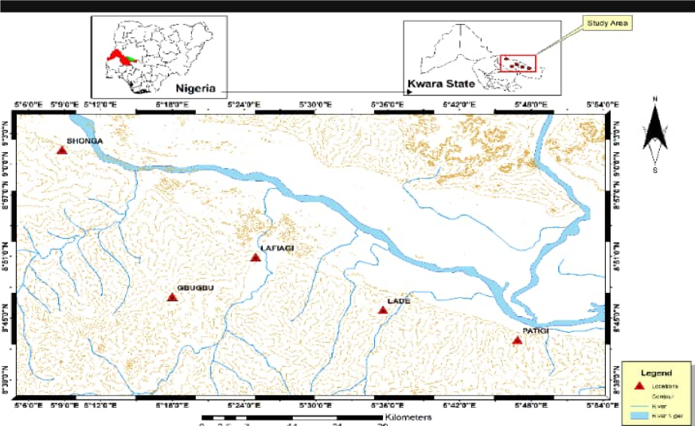
Figure 1.1 Map showing the study area

CHAPTER TWO
2.1 REVIEW OF PREVIOUS WORKS
In his work Geology and Mineral Resources of Nigeria, Obaje described the Bida Basin as a Late Cretaceous, intracratonic basin dominated by fluvial and deltaic sedimentation. He noted that sandstones in the basin are compositionally mature, predominantly quartzose, and often cemented by ferruginous or siliceous materials Obaje (2009).
Obaje (2009) discussed the general stratigraphy of the Bida Basin, identifying the Maastrichtian-aged Lokoja and Patti Formations as major fluvial-deltaic to shallow marine sandstones. He emphasised the dominance of medium to coarse-grained, poorly to moderately sorted sandstone indicative of braided fluvial depositional settings.
Adeleye (1971) first mapped and described the Bida Basin lithostratigraphy, noting the occurrence of cross-bedded, ferruginized sandstones that reflect high-energy depositional environments such as braided rivers and deltas. His work laid the foundation for subsequent sedimentological and petrographic studies.
Nwajide (2013) highlighted the sedimentary facies and structural framework of the Bida Basin, linking the sandstone units to syntectonic deposition in a foreland basin setting. He attributed the high variability in sandstone texture and composition to shifting fluvial regimes during basin evolution.
Udensi and Osazuwa (2004) used aeromagnetic data to define the subsurface architecture of the Bida Basin, correlating tectonic lineaments with depositional patterns. Their findings suggest that tectonics played a major role in controlling sediment influx and channel migration, especially in the northern sector around Gbugbu.
Akande et al. (2005) carried out petrographic analysis of the Lokoja Formation sandstones and concluded they were texturally immature, derived from nearby basement sources. The presence of feldspar and lithic fragments also suggests rapid deposition in proximal fluvial systems.
Akinyemi and Lar (2015) studied the geochemical signatures of Bida Basin sandstones and inferred a passive margin setting with moderate weathering. Their elemental ratios supported deposition under oxidising conditions, likely within braided river systems.
Ola-Buraimo and Boboye (2011) analysed the palynoflora of the Patti and Lokoja Formations, interpreting the depositional environment as alternating freshwater swamp, fluvial, and marginal marine systems. These environments fluctuated due to regional transgressive-regressive cycles during the Late Cretaceous.
Mamuda et al. (2020) integrated sedimentological logging and facies analysis along the Gbugbu area and identified a succession of conglomerates, pebbly sandstones, and planar-laminated sandstones. Their interpretation supports a high-energy braided stream to an alluvial fan environment.
Adekoya et al. (2012) focused on the provenance and tectonic setting of sandstones in the northern Bida Basin, concluding they were derived from a continental block provenance with moderate recycling. The presence of heavy minerals like zircon and tourmaline also suggests multiple cycles of reworking.
Tanko et al. (2018) conducted a grain-size statistical analysis of sandstone samples around Gbugbu and observed a bimodal grain size distribution typical of fluvial systems. Skewness and kurtosis values also reflected changing energy conditions within channel and overbank settings.
Muhammad et al. (2021) used remote sensing and field mapping to delineate sedimentary structures such as trough cross-bedding, ripple marks, and mud drapes. These features supported interpretations of alternating high- and low-energy depositional phases in a channelised environment.
Ogunbiyi and Odoma (2019) evaluated the reservoir quality of sandstone in the Gbugbu axis through porosity and permeability measurements, concluding that primary intergranular porosity is dominant, with secondary porosity developed through dissolution of feldspars and matrix.
Ibrahim et al. (2023) used facies models to reconstruct the paleoenvironment of the Gbugbu sandstones and reported fining-upward sequences, indicating meandering river channels and overbank floodplain.
Adegoke and Ojo (2017) investigated the influence of diagenesis on sandstonereservoir quality in the Bida Basin. Their study found early cementation by quartz and
calcite, reducing porosity but preserving some primary textures in7dicative of rapid burial.
These studies provide foundational knowledge that supports and guides the current research. However, the northern part of the Bida Basin, especially around Gbugbu, remains underdocumented. This work aims to fill that gap by providing fresh lithological logs and petrographic analysis from this locality .
2.2 Geological Setting of the Bida Basin
The Bida Basin is an inland, intracratonic sedimentary basin located in north-central Nigeria, stretching from Lokoja in the south to Kontagora and beyond in the north, covering parts of Kogi, Niger, Kwara States, and portions of the Federal Capital Territory (FCT). It is considered the southern extension of the Iullemmeden Basin of Niger Republic and trends northeast–southwest, roughly parallel to the Benue Trough. The basin lies between latitudes 8°00′N and 10°00′N, and longitudes 4°00′E and 6°00′E, occupying an estimated area of 80,000 km².
The Bida Basin formed during the Late Cretaceous (Santonian–Maastrichtian) as a result of postorogenic subsidence associated with the break-up of Gondwana. It is a classic example of a sagtype basin, developed due to crustal flexure rather than rifting, and is bounded on all sides by the Precambrian Basement Complex, which served as the primary source of sediments deposited within the basin. Tectonically, the basin is relatively stable, with little evidence of major faulting or deformation, suggesting passive infill dominated by sediment supply and subsidence.
Stratigraphy and Lithology
The stratigraphic succession in the Bida Basin consists mainly of continental clastic sediments.
These were deposited in fluvial, deltaic, floodplain, and possibly marginal marine environments.
The major formations identified in the basin include:
- Lokoja Formation: This is the basal unit, composed of conglomerates, pebbly sandstones, and coarse-grained grit. It represents deposition in braided river systems under high-energy conditions.
- Patti Formation: Overlying the Lokoja Formation, it consists of fine to medium-grained sandstone, siltstone, mudstone, and occasional coal seams. The sedimentary structures suggest floodplain and deltaic environments.
- Agbaja Formation: Dominated by ferruginous shale and oolitic ironstones, this unit represents swampy, poorly oxygenated environments with strong lateritic weathering signatures.
- Enagi Formation: Characterized by fine- to medium-grained ferruginous sandstone, claystone, and siltstone. It was deposited in a meandering river system, with evidence of cyclic deposition.
- Batati Formation: Comprising interbedded mudstones and fine-grained sandstones, often rich in iron, this formation is linked to floodplain and transitional environments, and sometimes displays signs of shallow marine influence.
The Gbugbu area, which is the focus of this study, is situated within the northern part of the basin, where the Enagi and Batati Formations are most prominent. These formations exhibit wellbedded, reddish to brownish sandstones, often interbedded with clay and silt layers, and display sedimentary structures such as cross-bedding, ripple marks, and laminations.

Depositional Environment and Sediment Source
Studies across the Bida Basin indicate that sediment deposition was largely controlled by fluvial and deltaic systems, with localized variations due to climate and subsidence rates (Akande et al., 2011; Ola-Buraimo & Oyeyemi, 2013). The cyclic nature of fine and coarse units suggests a dynamic depositional setting with alternating high- and low-energy conditions, consistent with channel-overbank sequences and seasonal flooding patterns.
Economic and Geological Relevance
The Bida Basin has gained increasing attention in recent years due to its hydrocarbon potential, particularly in the southern sector where source rocks and possible traps have been identified. Additionally, the basin is rich in industrial minerals, including iron ore, kaolin, clay, and silica sand, and is a significant target for groundwater development, especially in sedimentdominated regions like Gbugbu.
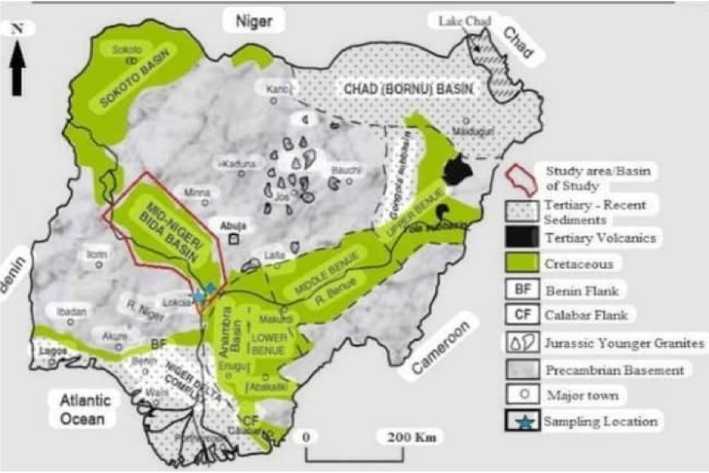
Figure 2.1; Geological Map of Nigeria showing the location of the Bida Basin

2.3 Regional Stratigraphic Setting of the Bida Basin
The Bida Basin has a well-developed Late Cretaceous stratigraphic sequence consisting of continental to marginal marine deposits. Its stratigraphy reflects a complex sedimentation history linked to tectonic activities and fluctuating climatic and depositional regimes.
The main formations, arranged from the oldest to the youngest, include:
- Lokoja Formation (Santonian–Campanian): Coarse conglomerates and sandstones deposited in braided river systems.
- Patti Formation (Campanian–Maastrichtian): Interbedded sandstones, shales, and siltstones, deposited in fluvial-deltaic settings.
- Agbaja Formation (Maastrichtian): Ironstones and shales, deposited in swampy, lowenergy environments.
- Enagi Formation (Maastrichtian): Reddish fine-grained sandstones and claystones, typical of meandering rivers and floodplains.
- Batati Formation (Maastrichtian): Lateritized fine sandstones and clays, representing floodplain and transitional depositional settings.
In the northern Bida Basin (Gbugbu area), the Enagi and Batati Formations dominate, and their exposures provide valuable lithological and stratigraphic information for this study.
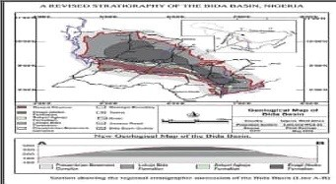
FIGURE 2.2 showing the lithostratigraphic unit
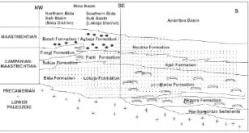
Figure 2.3: Showing stratigraphic setting
2.4 Overview of Sedimentary Rocks and Classification
Sedimentary rocks are formed by the accumulation and lithification of sediments derived from the weathering of pre-existing rocks. They are broadly classified into:
- Clastic Sedimentary Rocks – Formed from fragments of other rocks (e.g.,sandstone, shale, conglomerate).
- Chemical Sedimentary Rocks – Formed from mineral precipitation from solution (e.g., limestone, chert).
- Organic Sedimentary Rocks – Composed of biological material (e.g., coal, oil shale).
The sandstones of the Gbugbu area fall under the clastic category, with grain sizes, sorting, and composition varying due to depositional energy and provenance.
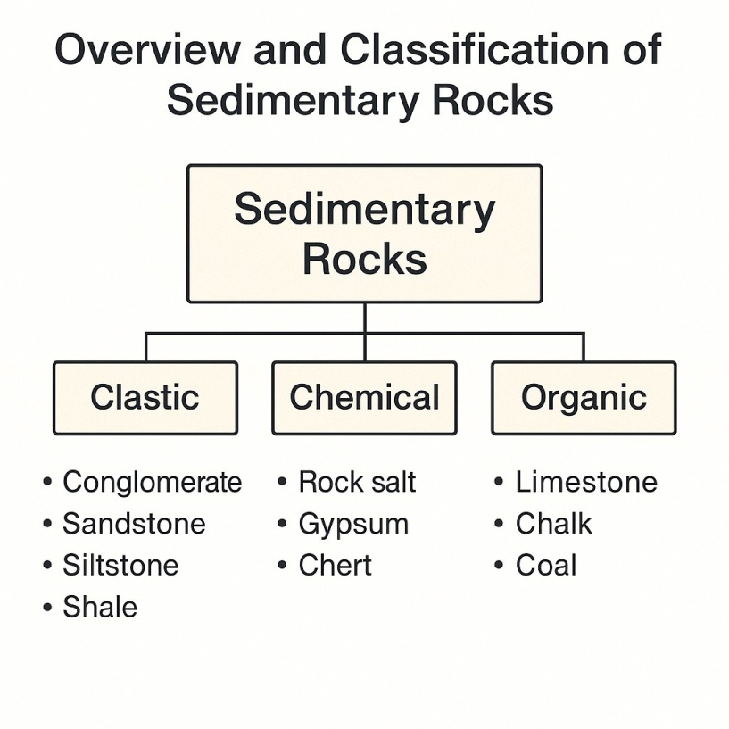
Figure 2.4 classifications of the rock
2.5 Sedimentary Rock Textures
The texture of sedimentary rocks refers to features such as grain size, shape, sorting, roundness, and packing, all of which help interpret depositional processes.
- Grain Size: Ranges from clay (<0.002 mm) to gravel (>2 mm).
- Sorting: Degree of grain size uniformity—well-sorted rocks suggest constant energy; poorly sorted ones indicate variable conditions.
- Roundness: Degree of grain edge smoothing. Rounded grains suggest longer transport.
- Packing: Tight grain packing indicates compaction; affects porosity.
- Cement: Common cements include silica, calcite, and iron oxides.
In the Gbugbu sandstones, the grains are subrounded to subangular, moderately sorted, with iron oxide and silica cements, reflecting moderate transport and fluvial deposition.
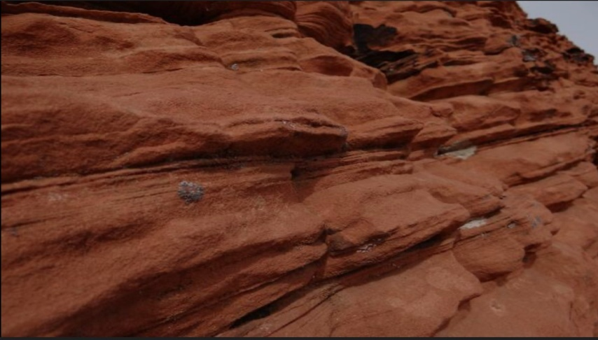
Figure 2.5: showing sedimentary rock
2.6 Deposition and Depositional Environment
Deposition is the process by which sediments settle out of transporting media. The depositional environment is the physical, chemical, and biological setting in which sediments accumulate.
Major depositional environments include:
- Fluvial: Dominated by channel deposits and overbank silts.
- Deltaic: Coarsening upward sequences, interfingering of sands and shales.
- Lacustrine: Fine-grained, organic-rich sediments in low-energy lakes.
- Floodplains: Alternating muds and sands with evidence of subaerial exposure.
The Enagi and Batati Formations were deposited mainly in fluvial and floodplain environ\ments, characterized by seasonal flooding, shifting channels, and overbank deposits. Structures such as ripple marks and cross-bedding observed in the field support this interpretation.

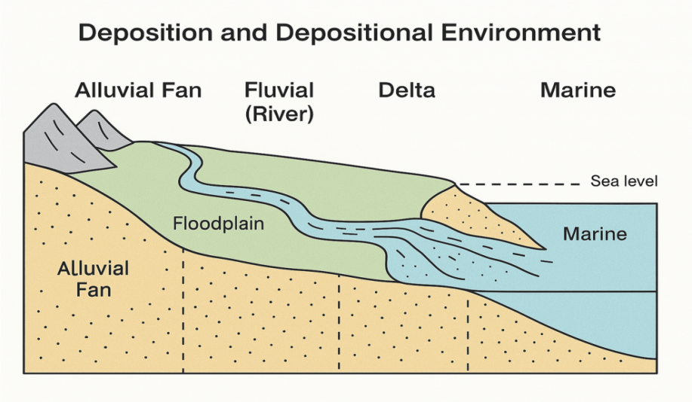
Figure 2.6: showing sedimentary deposition
2.7 Sedimentary Structures
Sedimentary structures are physical features formed during or soon after sediment deposition. They provide insights into transport mechanisms and paleoenvironmental conditions.

Common structures include:
- Cross-Bedding: Indicative of unidirectional current flow, as seen in river systems.
- Ripple Marks: Small wave-like structures formed by current or wave action.
- Mud Cracks: Indicate periodic drying of sediments, typical of floodplains.
- Graded Bedding: Vertical change from coarse to fine particles, typical of waning energy.
- Lamination: Thin, parallel layers in fine sediments—formed in low-energy settings.
These structures were observed in the Gbugbu outcrops and support deposition in a fluvialdominated setting with variable energy conditions.
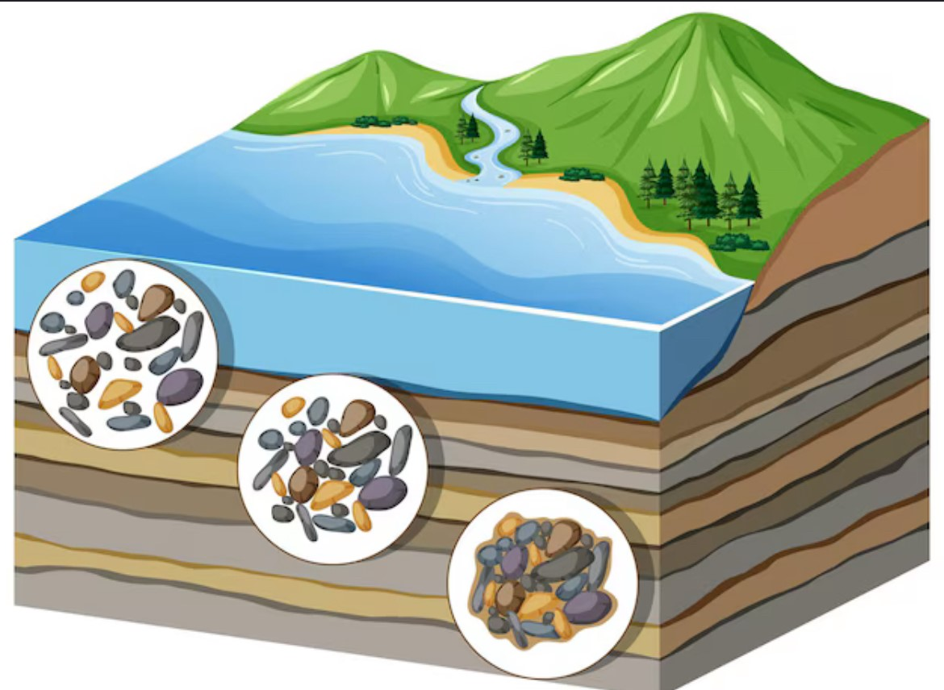
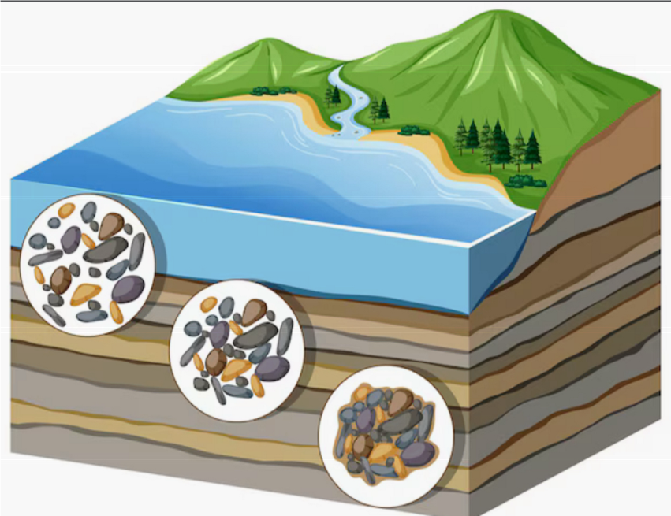
Figure 2.7: showing sedimentary structures
2.8 Study of the Rocks
Detailed field observation and petrographic analysis of rocks from the Gbugbu area revealed:
- Lithology: Dominantly sandstones with some interbedded claystones and siltstones.
- Color: Reddish-brown to yellowish-brown, due to iron oxide staining.
- Texture: Moderately sorted, subangular to subrounded quartz grains.
- Cement: Silica and iron oxide dominate the cementation.
- Structures: Ripple marks, cross-bedding, lamination, and ferruginous nodules.
Under the microscope, the sandstones classify as subarkosic arenites, composed mostly of monocrystalline quartz, feldspar, and muscovite, with minor rock fragments. These features reflect deposition in a continental fluvial environment, sourced from nearby basement rocks.

CHAPTER THREE
3.1 Materials and Methods
This study involves both field work and laboratory analysis.
3.2 Sample Collection and Field Study
Field study entailed carrying out a geological mapping of the rock types in the study area.
Gbugbu, Northern Bida Basin. The mapping exercise was basically aimed at identifying the rocks and establishing stratigraphic succession of the rocks on the basis of their field relationships. It also involved collection of spot rock samples for laboratory studies. Field observations including grain texture, colour, grains orientation, mineralogical composition, measurements of coordinates and elevation with GPS, taking photographs of important sedimentary structures and logging of exposed vertical sections were done.Five (5) samples of sandstones were collected from the road cut exposures with the aid of geological hammer. The samples were properly kept in the sample bags and labelled accurately with masking tape and permanent marker for easy identification. They were labelled as follows: GB1, GB2, GB3, GB4 and GB5 respectively. The samples were then taken to the laboratory for further analysi .
3.3 Laboratory Analysis
The thin section petrography analysis was aimed at determining the mineralogy of the sandstones. The experiment was performed in the Sedimentological Laboratory, Geology Department, Kwara State University, Malete.

3.3.1 Petrographic Analysis
Petrographic analysis was conducted using thin section microscopy to study the sandstone’s mineralogy and texture. All the sandstones sample from the field are poorly consolidated, fragile, and friable. Due to friable nature of these sandstone, firing impregnation and cool moulding. Impregnation was employed before mounting on slide for microscopic view. Three (3) samples GB1, GB3 and GB5 were selected for thin section petrography. The samples were dried over an acetone bath, impregnated with polyester resin mix, cut and polished using minor modification of standard hard rock thin sectioning equipment and techniques. The materials used are hardener and resin, in which their mixture is ratio 1:3 giving thin araldite. The moulding container acetone had to be lubricated with vaseline or engine oil to allow the mould to remove easily. A small quantity of the prepared araldite was poured at the bottom of the container after which the loose sample was poured and packed with a glass rod to prevent space from being created between the grains. The prepared araldite was applied to it and the sample number was written on the sample before it solidified.After impregnation, the thin section slides were prepared by grinding one side perfectly flat with carborundum powder on a glass plate. Slides to be used are heated after which Canada balsam is placed on it. Further grinding is done until a thickness of 0.03m was reached and this is checked under a microscope with cross polar to see the polarization color attribute of some known mineral such as quartz (grey or white of the first order). When the correct thickness is reached, the thin sections were thoroughly washed and all remaining resin scraped away from around the chip. The slides were later covered with cover slips which was pressed down to remove any air bobbles present. Excess cement was removed with methylated spirit. The thin sections were observed under the polarizing microscope to determine the mineral composition of the rock sample.

CHAPTER FOUR
4.1 Lithological Description and Depositional Environments

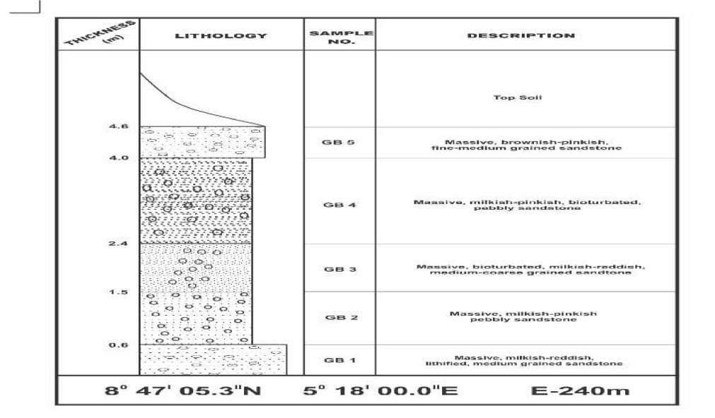
Table 4.1 Lithological section of Bida sandstone Formation exposed at Gbugbu

Location: Gbugbu, Northern Bida Basin, Kwara State, Nigeria
Coordinates: 8° 47′ 05.3″N, 5° 18′ 00.0″E Elevation: 240 m
The lithological section from Gbugbu in the Northern Bida Basin reveals a sedimentary succession indicative of a fluvially dominated depositional system. The outcrop displays a vertical profile of massive to laminated sandstone units, with varying grain sizes, pebble content, and ferruginous coloration. These features reflect the dynamic interplay of channel migration, sediment supply, and diagenetic processes characteristic of the Upper Cretaceous fluvial systems in the Bida Basin. The sandstone facies are moderately indurated, pinkish to reddish in color, and exhibit textural variation and bedding structures, which provide clues to depositional energy and paleoenvironments (Obaje, 2009; Nwajide, 2013).
Interval-Based Environmental Interpretation GD1 (0 – 1.3 m)
Description: Massive, reddish reddish, pebbly sandstone Interpretation:
This unit represents a high-energy fluvial channel lag deposit, with coarse detrital input and minimal fine matrix. The abundance of pebbles suggests deposition near the channel thalweg, possibly during flash flood events.
Environment: Braided River Channel Lag (High Energy)
GD2 (1.3 – 3.4 m)
Description: Massive, pinkish reddish, pebbly sandstone Interpretation:
A continuation of high-energy fluvial conditions, this layer may represent reactivation surfaces or channel bar accretion. The consistent pebble presence indicate strong hydraulic sorting. Environment: Mid-channel or Bar Surface Deposits.
GD3 (3.4 – 5.6 m)
Description: Massive, laminated, reddish pinkish, medium-grained sandstone Interpretation:
This interval shows a drop in energy, with visible lamination indicating fluctuating flow conditions.
The finer grain size reflects waning flow in a meandering river or overbank setting.
Environment: Point Bar or Levee Deposit (Moderate Energy)
GD4 (5.6 – 7.4 m)
Description: Massive, reddish pinkish, pebbly sandstone Interpretation:
Suggests a return to high-energy flow, possibly from a migrating or reactivated channel. Pebbly texture and lack of laminations support rapid deposition. Environment: Channel Fill or Flash Flood Deposit
GD5 (7.4 – 8.6 m)
Description: Massive, brownish pinkish, medium to coarse-grained sandstone Interpretation:
This upper unit may represent the upper bar surface or distal floodplain channel edge. The coloration and compaction suggest some degree of weathering and iron oxide cementation
Environment: Channel Margin to Floodplain Transition

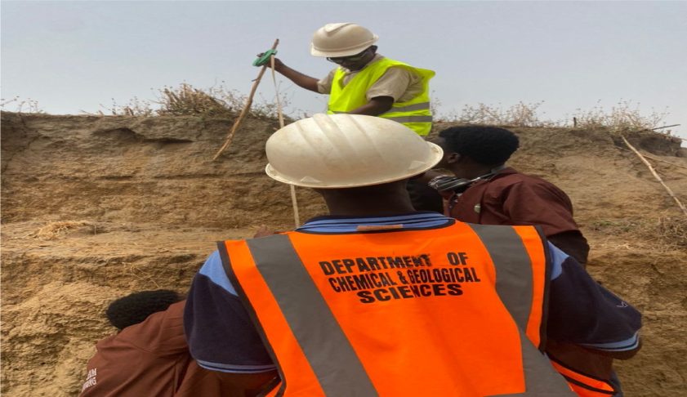
Figure 4.1 showing field work
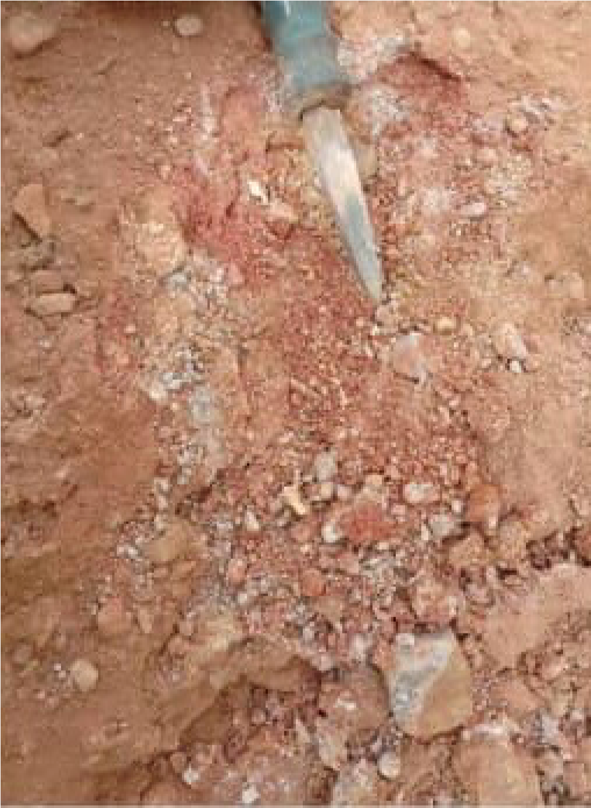
Figure 4.2 showing fields work

4.2 Thin Section Petrography Interpretation
This section presents the petrographic analysis of sandstone samples collected from outcrops in Gbugbu, Northern Bida Basin. Thin sections of selected samples were examined under a polarizing microscope to determine quartz types, textural characteristics, and compositional maturity. The maturity levels give insight into provenance, transport history, and depositional energy.

Summary of Thin Section Analysis
Sample No. | Quartz (Grain Type) | Angular/ Boundary | No. of Counts | Ratio of Polyx to Monox | Textural Maturity | Composi-  tional  Maturity
GB1 | Polycrys talline | Angul59Superma-bma-/45 r to  subangu-ture (lar / ~91% Rounded Qtz) to sub-rounded | 59  45 | 59;45 | Super mature | Super mature(=91%qtz)
GB3 | Monocrys talline & Polycrys- talline | Angul5445Superma-bma-/27 r to subangu-ture (lar/~95% Rounded Qtz) to subrounded | 54  27 | 54;27 | Super mature | Super mature(=95%qtz)
GB5 | Monocrys talline & Polycrys- talline | Angul51Superma-/bma- 32 r to subangu-ture (lar / ~94% Qtz) Rounded to sub-rounded | 51  32 | 51;32 | Super mature | Super mature(=94%qtz)

Table 4.2 showing the Maturity of the soil
Interpretation
- Quartz Grain Type: The presence of both monocrystalline and polycrystalline quartz suggests a mixed provenance – likely from metamorphic and igneous sources.
- Grain Boundaries and Roundness: The dominance of angular to subangular grains with some rounding indicates moderate transport distance, typical of fluvial environments.
- Textural Maturity: The sediments are sub mature texturally, indicating limited abrasion and sorting, consistent with deposition in a high-energy fluvial system.
- Compositional Maturity: High quartz content (≥91%) and low feldspar or lithic fragments indicate super mature composition, implying prolonged weathering and transport from stable continental interiors.
4.2.1 Provenance Interpretation
Provenance interpretation involves determining the source area or origin of the sediments based on mineralogical and textural characteristics observed in thin sections. The petrographic analysis of sandstone samples from Gbugbu reveals significant clues about their source rocks and depositional history.
The samples contain both monocrystalline and polycrystalline quartz grains, with polycrystalline quartz occurring in notable amounts (e.g., GB1: 59%, GB5: 51%). This high proportion of polycrystalline quartz is indicative of contributions from metamorphic and igneous terranes, as such quartz types commonly form in high-grade metamorphic rocks or as recrystallized quartz in plutonic rocks (Blatt et al., 1980).
The angular to subangular grain boundaries suggest a relatively short transport distance from the source, or rapid deposition, possibly in a fluvial setting. However, the super mature compositional character – dominated by quartz with minimal feldspars and lithic fragments – points toward intense chemical weathering and mechanical breakdown prior to deposition, likely within a cratonic or stable continental setting (Dickinson and Suczek, 1979).
The high quartz content (≥91%), together with the absence of unstable minerals, implies recycling from older quartz-rich sedimentary rocks or direct derivation from continental interiors. These features are characteristic of recycled or cratonic provenance environments, such as older sedimentary covers or exposed basement complexes.
4.2.2 Textural and Compositional Maturity Interpretation
Textural maturity refers to the degree of roundness, sorting, and matrix content in sedimentary rocks, while compositional maturity relates to the mineralogical stability of grains present in the rock. Both maturity types offer insight into sediment history, transport distance, and depositional environment.
Textural Maturity
The thin section analysis of the Gbugbu sandstone samples shows:
- Quartz grains that are angular to subangular, occasionally subrounded.
- Evidence of clay-supported matrices in some samples.
- Poor to moderate sorting of grains.
These features are typical of texturally submature sediments. Angular to subangular grain shapes imply limited abrasion during transport, suggesting short transportation distance from the source or rapid deposition in a high-energy fluvial system. Poor sorting supports the interpretation of sediments being deposited relatively quickly, possibly within braided river channels or proximal delta environments.
Compositional Maturity
Compositional maturity is assessed based on the abundance of stable versus unstable minerals.
In the Gbugbu samples:
- Quartz content exceeds 90% in all samples (e.g., GB1: ~91%, GB3: ~95%, GB5: ~94%).
- Feldspars and lithic fragments are nearly absent.
- Both monocrystalline and polycrystalline quartz are dominant.
Such high quartz content and absence of unstable minerals suggest a supermature composition. This indicates a sediment source that underwent intense chemical weathering, recycling, or derivation from a cratonic interior or recycled sedimentary terrain.
Dickinson and Suczek (1979) noted that compositional maturity increases with sediment recycling and prolonged transport under humid conditions. Thus, despite their textural immaturity, the Gbugbu sandstones exhibit very high compositional maturity.
4.2.3 Depositional Environment Interpretation
The depositional environment of a sedimentary rock unit can be interpreted using a combination of lithologic characteristics, grain textures, structures, and mineral composition. The sandstone samples from Gbugbu, Northern Bida Basin, provide strong evidence pointing to a continental fluvio-deltaic depositional system.
Lithological and Textural Indicators
The lithologic log and field description reveal:
- Massive, medium- to coarse-grained sandstones
- Presence of pebbly, clay-supported units
- Varying degrees of lamination and sedimentary structures
- Pinkish to reddish coloration, indicative of subaerial oxidation
These features are typical of deposition in fluvial (river) and deltaic environments, where alternating high and low energy conditions result in the deposition of coarse sands, pebbles, and finer sediments.
Petrographic Indicators
From the thin section analysis:
- Dominance of quartz grains (>90%), suggesting high compositional maturity
- Grains are angular to subrounded, with poor sorting – indicative of short transport or high-energy fluvial transport
- Clay matrix presence in some samples aligns with floodplain or lower delta plain deposition
These observations support deposition in a system where energy fluctuates, such as:
- Braided or meandering river channels (high energy)
- Floodplains or lower delta plains (lower energy, finer sediments)
Environmental Interpretation by Lithofacies (from your log)
- GB1 (Basal Layer): Massive, pebbly sandstone indicates deposition in braided river channels under high-energy conditions.
- GB2 & GB3: Pebbly, laminated sandstones suggest periodic flooding and sediment input in proximal delta fronts or point bars.
- GB4 & GB5: Finer-grained sandstones with clayey support suggest distal floodplain or lower delta plain settings, with calmer depositional conditions and clay accumulation.
Overall Interpretation
The combination of lithological, textural, and compositional evidence points to deposition within a fluvio-deltaic system, comprising:
- Braided to meandering river systems, responsible for coarse-grained channel deposits.
- Floodplains and delta plains, responsible for clay-rich, fine-grained deposits.

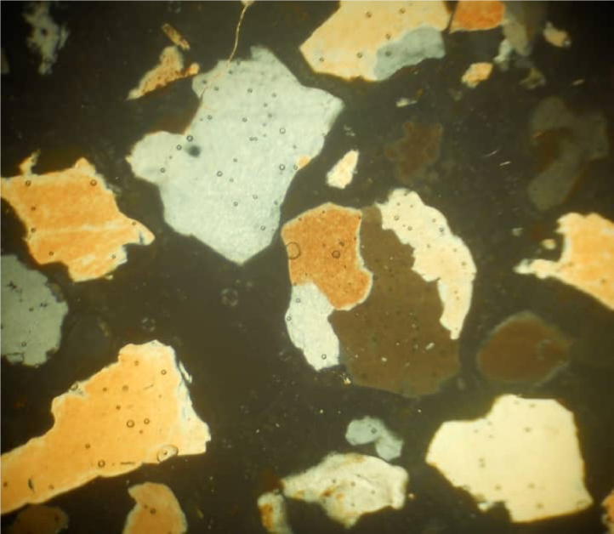
Figure 4.4: Photomicrography of GB 1 views under plane polarized light Microscope

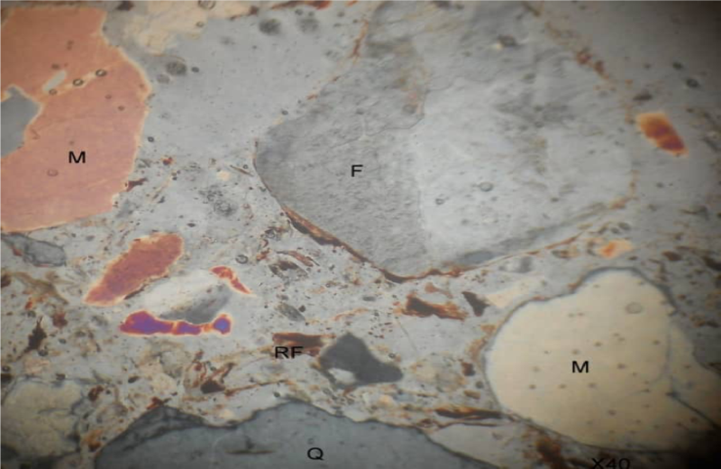
Figure 4.5: Photomicrography of GB 1 views under plane polarized light Microscope

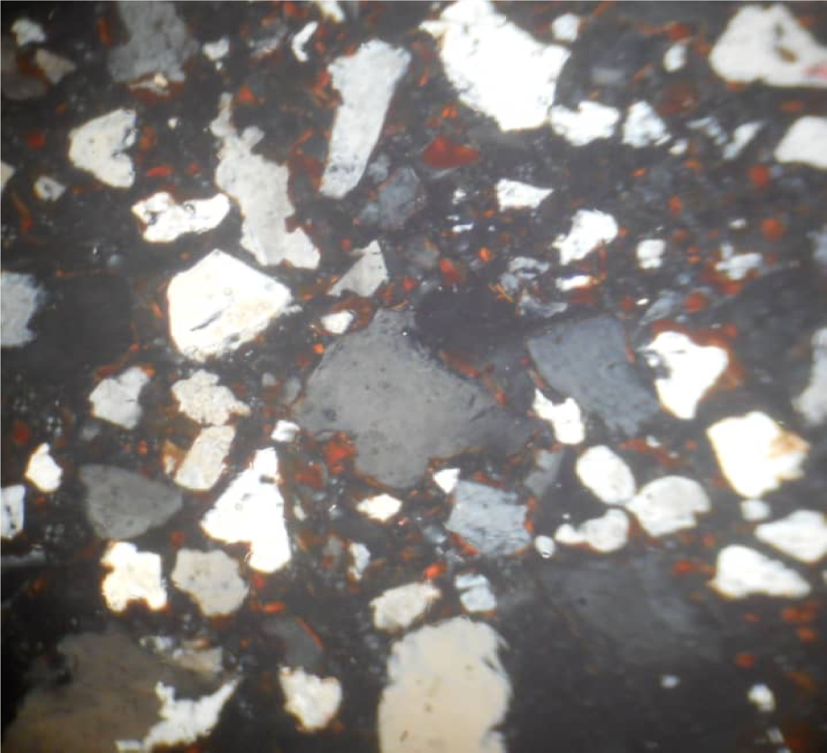
Figure 4.6: Photomicrography of GB 2 views under plane polarized Microscope

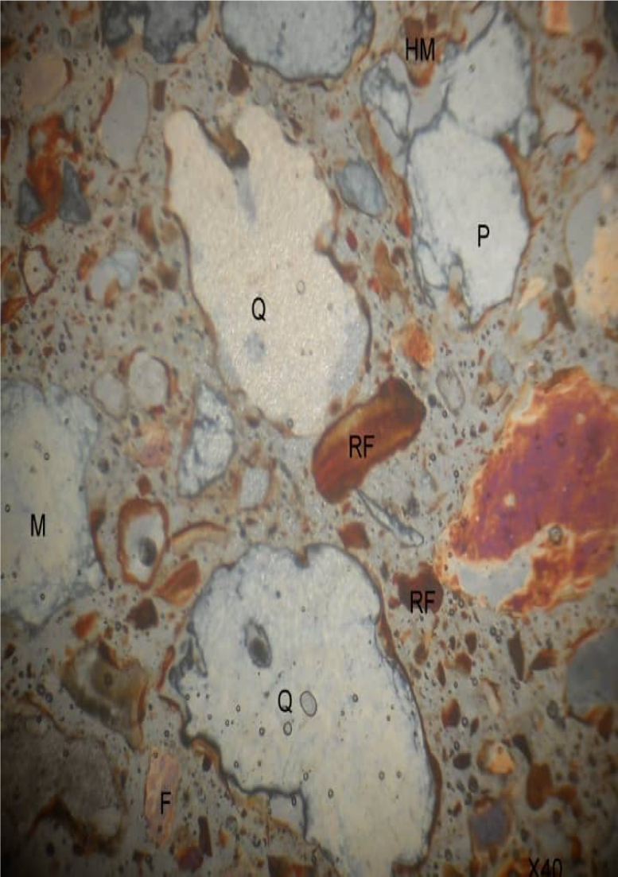
Figure 4.7: Photomicrography of GB 2 views under cross Polarize light Microscope

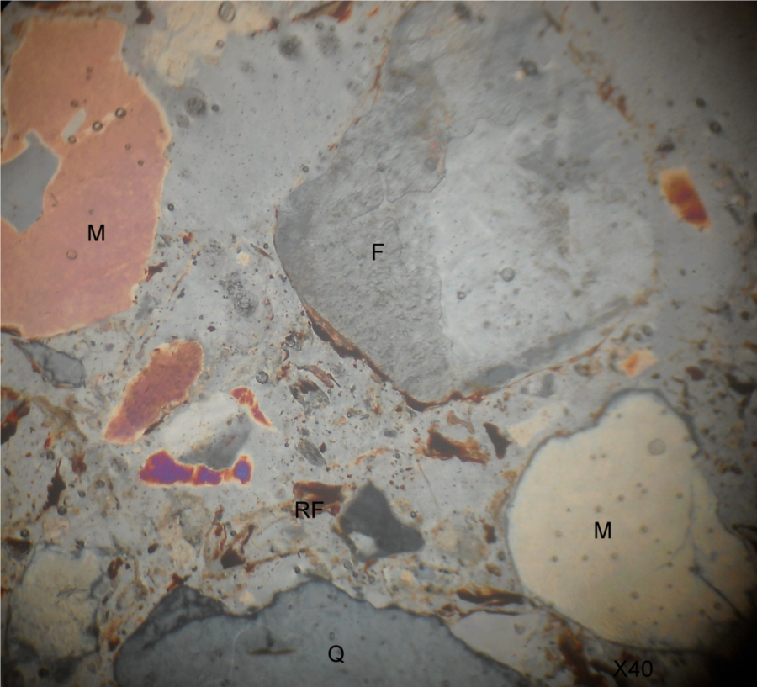
Figure 4.8: Photomicrograhy GB 5 under plane polarized Light Microscope
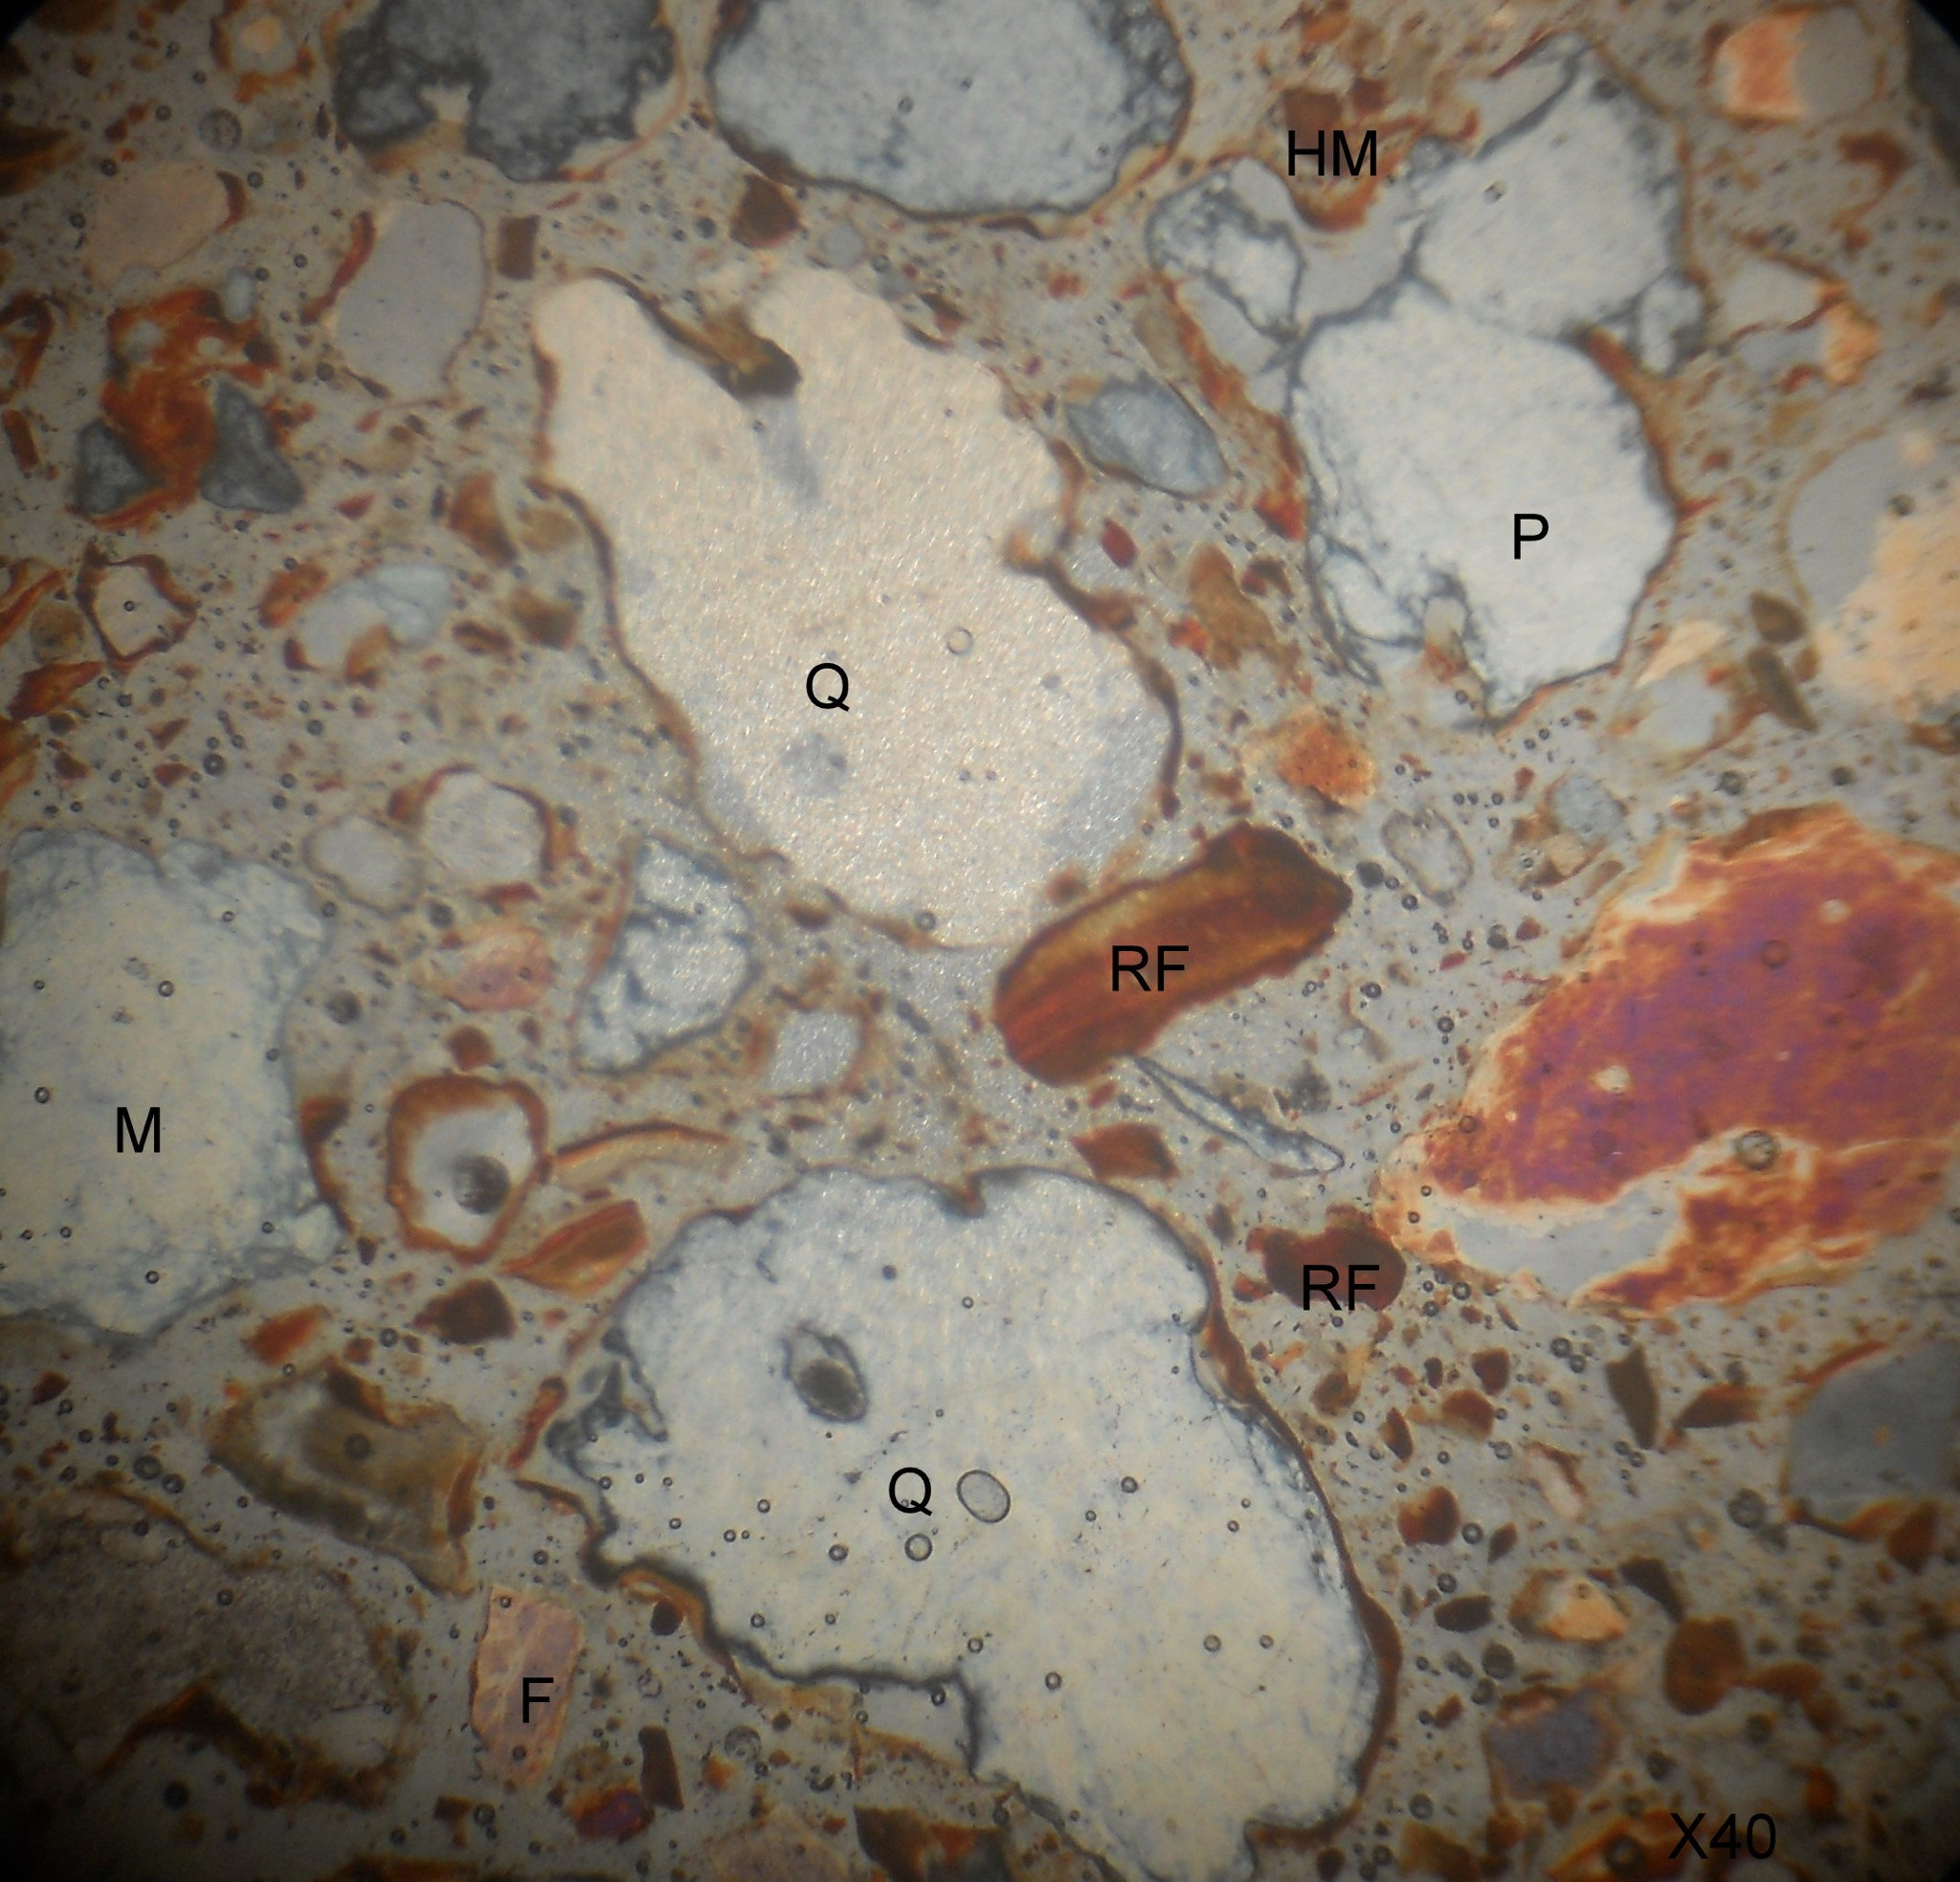
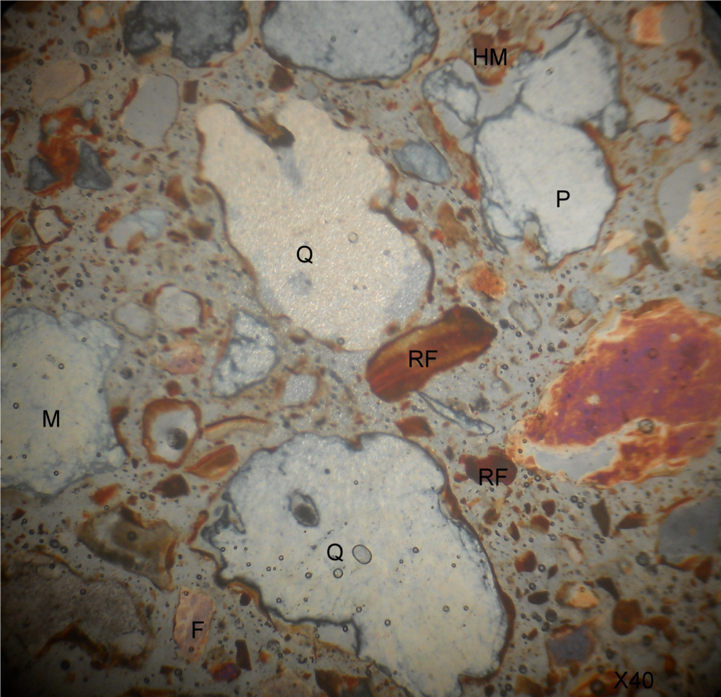
Figure 4.9: Photomicrography of GB 5 views under Plane Polarize Light Microscope

4.2.4 Importance of Petroleum Exploration
Petroleum exploration is a critical process in the search for economically recoverable hydrocarbon resources. It involves geological, geophysical, and geochemical investigations aimed at identifying subsurface rock units capable of generating, storing, and trapping hydrocarbons. The significance of petroleum exploration becomes especially relevant in sedimentary basins such as the Bida Basin, where sandstone units like those found in Gbugbu have shown promising lithological characteristics.
- Economic Relevance
Petroleum remains a major energy source globally and a backbone of the Nigerian economy. The discovery of new petroleum reserves contributes significantly to national income, energy security, foreign exchange earnings, and employment. Exploring inland frontier basins like the Bida Basin offers Nigeria an opportunity to diversify its hydrocarbon sources beyond the Niger Delta.
- Exploration Potential of the Bida Basin
Recent studies and drilling activities have revealed that parts of the Northern Bida Basin, including the Gbugbu area, possess key geological features conducive to hydrocarbon accumulation:
    - Thick sequences of sandstone, which can act as excellent reservoir rocks due to their porosity and permeability.
    - Presence of shales and siltstones, which may function as seal rocks or source rocks if rich in organic matter.
    - Structural traps such as faults and folds, as well as stratigraphic traps, which can localize and preserve hydrocarbon deposits.
Petrographic studies from this project confirm that the Gbugbu sandstones are compositionally mature, quartz-rich, and well-sorted – characteristics favorable for reservoir quality.
- Academic and Scientific Value
Petroleum exploration in the Bida Basin provides opportunities for academic advancement and geoscientific research. Understanding the sedimentology, stratigraphy, and reservoir quality of inland basins like Gbugbu aids in the training of geoscientists and improves the predictive models for hydrocarbon prospectivity.
- Strategic Importance
As offshore reserves become more capital-intensive to exploit, inland basins like the Bida Basin offer a strategic advantage due to:
    - Easier access and logistics for drilling.
    - Reduced exploration costs.
    - Potential to supply regional refineries and industries.

CHAPTER FIVE
CONCLUSION AND RECOMMENDATIONS
5.1 Conclusion
This study focused on the lithological and petrographic analysis of sandstones in Gbugbu, located within the Northern Bida Basin. Lithological logging revealed that the sandstone units are composed of moderately sorted, medium- to coarse-grained quartz-rich sandstones, with occasional clay intercalations and pebbly layers. Thin section analysis confirmed high quartz content (above 90%), with grains ranging from angular to subrounded, embedded in a minor clay matrix.
From these findings:
    - The sandstones are compositionally supermature and texturally submature, suggesting a stable cratonic source with relatively short transport distance.
    - The depositional environment is interpreted as fluvio-deltaic, marked by alternating high-energy channel deposits and lower-energy floodplain deposits.
    - The lithological and textural characteristics make these sandstones potential reservoir rocks in petroleum systems, particularly in the context of ongoing exploration in Nigeria’s inland sedimentary basins.
5.2 Contribution to Knowledge
This study contributes to geological understanding in the following ways:
    - It provides new lithological and petrographic data on the Gbugbu sandstone, an underdocumented unit within the Bida Basin.
    - It offers insight into the provenance, maturity, and depositional environment of the sediments, aligning with and reinforcing existing models of sedimentation in the northern Bida Basin.
    - It demonstrates the potential petroleum reservoir quality of Gbugbu sandstones, encouraging further hydrocarbon exploration in this inland frontier basin.
    - It adds to academic resources and geoscientific documentation related to sedimentary petrology and basin analysis in Nigeria.
5.3 Recommendations
Based on the results of this study, the following recommendations are made:
    - Further geochemical and palynological studies should be conducted to evaluate the source rock potential and age of the sedimentary sequence.
    - Core drilling and porosity-permeability tests should be performed to quantitatively assess the reservoir quality of the Gbugbu sandstones.
    - Geophysical surveys (e.g., seismic and gravity data) should be expanded in the area to identify potential traps and basin structures.
    - Detailed mapping and stratigraphic correlation should be carried out across other parts of the Northern Bida Basin to improve regional models of sedimentation and petroleum potential.
    - Government and exploration companies should consider the Bida Basin as a viable exploration target, given the evidence of suitable reservoir characteristics and basin architecture.

REFERENCES
Adeleye, D. R. (1971). Stratigraphy of the Bida Basin in northwestern Nigeria. African Geology, Ibadan University Press, 295–306.
Nwajide, C. S. (2013). Geology of Nigeria’s Sedimentary Basins. CSS Press, Lagos.
Obaje, N. G. (2009). Geology and Mineral Resources of Nigeria. Springer.
Pettijohn, F. J., Potter, P. E., & Siever, R. (1972). Sand and Sandstone. Springer.
Dickinson, W. R., & Suczek, C. A. (1979). Plate Tectonics and Sandstone Compositions. AAPG Bulletin, 63(12), 2164–2182.
Ojo, S. B., & Akande, S. O. (2002). Petroleum Potential of the Bida Basin, Nigeria: Hydrocarbon Source Rock Evaluation. AAPG Bulletin, 86(1), 1–15.
Abubakar, M. B. (2006). Biostratigraphy and Organic Geochemistry of the Bida Basin, Nigeria. Ph.D. Thesis, University of London.
Ojo, J. S. (1995). Hydrocarbon Potentials of the Bida Basin. Nigerian Association of Petroleum Explorationists (NAPE) Bulletin, 10(2), 17–23.
Adeigbe, O. C., & Adekoya, J. A. (2012). Petrographic analysis and depositional environment of Bida Basin sandstones. Journal of Geology and Mining Research, 4(5), 120–129.
Adepoju, A. A., Ibrahim, K. O., & Lawal, A. O. (2018). Petrographic and geochemical correlation of sandstones in the Bida and Sokoto Basins, Nigeria. Nigerian Journal of Basic and Applied Sciences, 26(1), 35–42.
Agyingi, C. M. (1991). Lithofacies and depositional environments of the Campano-Maastrichtian Patti Formation, southern Bida Basin, Nigeria. Journal of African Earth Sciences, 12(3), 433–443. Akande, S. O., Ojo, O. J., Erdtmann, B. D., & Hetenyi, M. (2011). Petrography and geochemistry of sandstones and shales of the southern Bida Basin, Nigeria: Implications for provenance and tectonic setting. Journal of Mining and Geology, 47(1), 59–74.
Ameloko, A. A., & Okosun, E. A. (2010). Petrographic and chemical characteristics of the Enagi Formation, Bida Basin, Nigeria. Nigerian Journal of Earth Sciences, 2(1), 50–59.
Dada, S. S., Sanni, M. A., & Kolawole, F. (2014). Petrography and geochemistry of sandstones from parts of Bida Basin, Nigeria: Implications for provenance and tectonic setting. Earth Science Research, 3(1), 71–85.
Ehinola, O. A., Ladipo, K. O., & Akande, S. O. (2009). Reservoir quality assessment of Bida Basin sandstones, Nigeria. Petroleum and Coal, 51(4), 266–278.
Fatoye, F. B., & Gideon, Y. B. (2013). Geology and mineral resources of the Bida Basin. Research Journal in Engineering and Applied Sciences, 2(1), 66–73.
Kogbe, C. A. (1976). The Cretaceous and Paleogene sediments of southern Nigeria. In C. A.
Kogbe (Ed.), Geology of Nigeria (pp. 325–334). Lagos: Elizabethan Publishing Company.
Ladipo, K. O. (1988). Paleogeography and depositional environments of the Cretaceous sequences in the Bida Basin, Nigeria. Journal of African Earth Sciences, 7(4), 865–871.
Nwajide, C. S. (2013). Geology of Nigeria’s Sedimentary Basins. Lagos: CSS Press.
Obaje, N. G. (2009). Geology and Mineral Resources of Nigeria. Berlin: Springer.
Oboh-Ikuenobe, F. E., Obi, C. M., & Jaramillo, C. A. (2005). Palynofacies and sequence stratigraphic interpretations of the Patti Formation in the southern Bida Basin, Nigeria. Journal of African Earth Sciences, 43(1), 79–93.
Ola-Buraimo, A. O., & Oyeyemi, K. D. (2013). Lithofacies and textural characteristics of sandstones in the Bida Basin: Evidence of braided fluvial system. International Journal of Physical Sciences, 8(28), 1478–1491.
Udoh, A. E., & Akpan, E. B. (2016). Heavy mineral studies and provenance determination in sandstones from the Bida Basin, Nigeria. Journal of Applied Geology and Geophysics, 4(3), 12– 22.

