INTEGRATED PETROGRAPHIC AND LITHOLOGICAL CHARACTERIZATION OF SANDSTONES FROM GBUGBU, NORTHERN BIDA BASIN, KWARA STATE, NORTH CENTRAL, NIGERIA

BY

OLUJIDE OPEYEMI AKOREDE
ND/23/MPE/PT/0003

A PROJECT SUBMITTED TO THE DEPARTMENT OF MINERALS AND PETROLEUM RESOURCES ENGINEERING TECHNOLOGY, INSTITUTE OF TECHNOLOGY, KWARA STATE POLYTECHNIC, ILORIN, KWARA STATE.

IN PARTIAL FULFILLMENT OF THE REQUIREMENTS FOR THE AWARD OF NATIONAL DIPLOMA (ND) IN MINERALS AND PETROLEUM RESOURCES ENGINEERING TECHNOLOGY

JULY, 2025

DECLARATION
I, OLUJIDE OPEYEMI AKOREDE, hereby declare that this project titled “INTEGRATED PETROGRAPHIC AND LITHOLOGICAL CHARACTERIZATION OF SANDSTONES FROM GBUGBU, NORTHERN BIDA BASIN, KWARA STATE, NORTH CENTRAL, NIGERIA” was written by me and is a record of my original work carried out under the supervision of Engr. Raji Jamiudeen Kayode in the Department of Minerals and Petroleum Resources Engineering, Kwara State Polytechnic, Ilorin. This work has not been presented in part or whole for the award of any certificate or diploma at any other institution.

OLUJIDE OPEYEMI AKOREDE Date: _____________________

CERTIFICATION
This is to certify that this project titled “Integrated Petrographic and Lithological Characterization of Sandstones from Gbugbu, Northern Bida Basin, Kwara State, North Central, Nigeria.” was carried out by '"OLUJIDE OPEYEMI AKOREDE" of the Department of Minerals and Petroleum Resources Engineering, Kwara State Polytechnic, Ilorin, under my supervision.

______________________________ __________________
Engr. Raji Jamiudeen Kayode. Date
(Supervisor)

__________________ ___________________
Dr. Olatunji Adebisi, Date
HOD
Department of Mineral and
Petroleum Resources Engin

____________________ ___________________
Director, Institute of Technology Date

____________________ __________________
External Examiner Date

DEDICATION
This work is first and foremost dedicated to Almighty God, the source of my strength, wisdom, and guidance throughout this journey. I also dedicate this project to my beloved parents, whose endless love, prayers, and sacrifices laid the foundation for my success.

ACKNOWLEDGEMENT
I wish to express my profound gratitude to Almighty God for granting me the strength, wisdom, and perseverance to complete this research work.
My sincere appreciation goes to my supervisor, Engr. Raji Jamiudeen Kayode, for his guidance, constructive feedback, and patience throughout this project.
My project wouldn’t have been possible without the support of my parents, Mr and Mrs Olujide. Their kind financial, spiritual and moral support strengthened me till the success of this research work. I pray when it is time for you to eat the fruit of your labour, May almighty God bless you with long life and good health. I also want to extend my appreciation to my siblings, Thank you all for your moral supports.
I also thank all the lecturers and staff of the Department of Minerals and Petroleum Resources Engineering, Kwara State Polytechnic, Ilorin, for their academic support.
Special thanks to my family, friends, and colleagues who stood by me through the course of this project. May God bless you all.

OLUJIDE OPEYEMI AKOREDE
ND/23/MPE/PT/0003

TABLE OF CONTENTS
Cover page i
Declaration ii
Certification iii
Dedication iv
Acknowledgement v
Table of Contents vi
List of Tables viii
List of Figures ix
List of Plates x
Abstract xi
CHAPTER ONE: INTRODUCTION
1.1 Background of Study 1
1.2 Statement of Problem 2
1.3 Aims and Objectives 2
1.4 Scope and Limitation 3
1.5 Justification and Significance 3
1.6 Location, Accessibility and Physiography 4
CHAPTER TWO: LITERATURE REVIEW
2.1 Review of Previous Works 6
2.2 Geological Setting of Bida Basin 8
2.3 Regional Stratigraphic Settings of Bida Basin 12
2.4 Overview of Sedimentary Rocks and Classification 15
2.5 Sedimentary Rocks Textures 15
2.6 Deposition and Depositional Environments 16
2.7 Sedimentary Structures 17
2.8 Study of Sedimentary Rocks 18
CHAPTER THREE: METHODS OF STUDY
3.1 Materials and Methods 20
3.2 Sample Collection and Field Study 20
3.3 Laboratory Analysis 20
3.3.1 Petrographic Analysis 20
CHAPTER FOUR: RESULTS AND DISCUSSIONS
4.1 Lithological Description and Depositional Environments 22
4.2 Thin Section Petrographic Interpretation 26
4.2.1 Provenance Interpretation 26
4.2.2 Texture and Compositional Maturity 27
4.2.3 Depositional Environment Interpretation 30
4.2.4 Implications for Petroleum Exploration 31
CHAPTER FIVE: SUMMARY, CONCLUSION AND RECOMMENDATIONS
5.1 Conclusion 39
5.2 Contribution to Knowledge
5.3 Recommendations 39
References 40
LIST OF TABLES
Table 2.2: Summary of Evolution 11
Table 2.3: Stratigraphic Correlation Table (Simplified) 13
Table 4.1: Result of Thin Section Petrographic Analysis of Sandstone from Gbugbu 25
LIST OF FIGURES
Figure 1.6: Geology Map of Nigeria Showing the Location and Accessibility
Areas of Bida Basin 5
Figure 2.2: Geological Map of Nigeria Showing the Bida Basin 11
Figure 2.4: Diagram of Sedimentary Rock 15
Figure 2.6: Diagram of Depositional Environments 17
Figure 4.1: Lithological section of Bida sandstone Formation exposed at Gbugbu 22
LIST OF PLATES
Plate 2.5A: Sedimentary Rock Textures 16
Plate 2.5B.: Sedimentary Rock Textures 16
Plate 4.1A: Environment Lithology of Gbugbu 24
Plate 4.1B: Environment Lithology of Gbugbu 24
Plate 4.2A: Photomicrography of GB 1 views under Plane Polarized Light Microscope 34
Plate 4.2B: Photomicrography of GB 3 views under Plane Polarize Light Microscope 34
Plate 4.2C: Photomicrography of GB 5 views under Plane Polarized Light Microscope 35
Plate 4.2D: Photomicrography of GB 1 views under Cross Polarize Light Microscope 35
Plate 4.2E: Photomicrography of GB 3 views under Cross Polarized Light Microscope 36
Plate 4.2F: Photomicrography of GB 5 views under Cross Polarize Light Microscope 36
ABSTRACT
This study presents an integrated sedimentological and petrographic analysis of quartz-rich Gbugbu sand deposits aimed at understanding their provenance, depositional environment, maturity levels, and implications for petroleum exploration. The lithological section is dominated by sandstone units with varying grain sizes, sorting, and sedimentary structures such as cross-bedding and ripple marks. These features indicate deposition in a fluvial to shallow marine environment under variable energy conditions. The results of thin section petrographic analysis reveal high textural and compositional maturity, characterized by dominant well-rounded monocrystalline quartz and angular to sub-angular polycrystalline quartz, indicating a mixed sediment supply from both recycled sedimentary sources and proximal metamorphic terrains. The compositional supermaturity of the sands reflects prolonged reworking in high-energy coastal to shallow marine environments, typical of passive continental margin settings. The research demonstrates that these sedimentary characteristics are favorable for hydrocarbon exploration, with supermature quartz sands providing excellent reservoir properties, including high porosity and permeability, and resistance to diagenetic cementation. Furthermore, the presence of associated fine-grained sediments suggests the likelihood of effective seals and source rocks. Overall, the study contributes to the understanding of sediment provenance and depositional processes, providing essential insights for predicting reservoir quality and guiding petroleum exploration in similar geological settings.

CHAPTER ONE
INTRODUCTION
1.1 BACKGROUND OF THE STUDY
Sedimentary rocks are crucial archives of Earth’s surface history, recording environmental changes, tectonic processes, and biological evolution over geologic time. Among these, sandstone stands out due to its abundance, durability, and capacity to preserve sedimentary structures, textures, and fossil content. The study of sandstones provides valuable insight into past depositional environments, provenance, diagenetic history, and the tectonic setting of sedimentary basins.
The Bida Basin, also referred to as the Mid-Niger Basin, is a Cretaceous intracratonic basin situated in North Central Nigeria. It is one of the inland basins that evolved during the break-up of Gondwana and the opening of the South Atlantic. The sedimentary infill of the basin reflects a complex interplay of tectonics, climate, sea-level changes, and sediment supply. Sandstones exposed at gbugbu in the northern part of the basin provide a unique opportunity to investigate these processes at a local scale.
Previous regional studies have broadly described the Bida Basin as consisting of non-marine and shallow marine sediments deposited in fluvial, deltaic, and estuarine settings. However, specific sedimentological investigations at the local scale—particularly around Gbugbu—are limited. Detailed facies analysis, sedimentary logging, and interpretation of depositional environments are needed to better understand the paleogeographic evolution of this part of the basin.
This study therefore focuses on the sedimentological characteristics and depositional environment of sandstone units exposed in the Gbugbu area. By examining the lithofacies, sedimentary structures, grain size distribution, and field relationships, this research aims to reconstruct the depositional setting and infer the paleoenvironment during the time of deposition.
The Bida Basin is bounded to the northwest by the Basement Complex of Nigeria and to the southeast by the Anambra Basin. It forms part of the larger West African rift system and is considered to be genetically linked to the Benue Trough. Stratigraphically, the basin is subdivided into two sub-basins—the Northern Bida Basin and the Southern Bida Basin—separated by a northeast-southwest trending structural high.
The basin fill consists of thick sequences of sandstones, siltstones, shales, and laterites, with the sandstone units being dominant in many outcrop areas. These sandstones are generally coarse- to fine-grained, and often show evidence of cross-bedding, ripple marks, mud drapes, and other sedimentary structures that can be used to infer depositional settings.
In the Gbugbu area, the sandstone exposures occur as isolated outcrops, road cuts, and stream channels. They are typically massive or bedded and occasionally show ferruginization and weathering effects. These characteristics provide important clues about depositional energy, transport mechanisms, and post-depositional changes.
1.2 STATEMENT OF THE PROBLEM
Despite the geological relevance of the sandstone outcrops around Gbugbu, there is limited detailed sedimentological work on their composition, stratigraphy, and depositional setting. Most existing studies are either broad regional syntheses or focus on other parts of the Bida Basin. Consequently, key questions remain unanswered: What depositional processes governed the accumulation of the sandstones? What sedimentary structures are preserved, and what do they reveal about the paleoenvironment? How do these local deposits correlate with other units in the basin?
This study addresses these gaps by conducting a comprehensive sedimentological analysis of the sandstone outcrops in Gbugbu. The findings will contribute to a better understanding of the depositional history of the Northern Bida Basin and provide a reference point for further academic and resource-related research.
1.3 AIM AND OBJECTIVES OF THE STUDY
This study focuses on investigating the sedimentary characteristics and interpreting the depositional environment of the sandstone units exposed in Gbugbu, Northern Bida Basin, North Central Nigeria.

Objectives
- To conduct detailed field mapping and sedimentary logging of the sandstone outcrops in Gbugbu.
- To describe and interpret the lithofacies and sedimentary structures present in the study area.
- To analyse grain size distribution and texture for environmental reconstruction.
- To classify the facies based on observed features and infer depositional environments.
- To determine the provenance, maturity and their implications on petroleum exploration.
1.4 SCOPE AND LIMITATIONS OF THE STUDY
This research is confined to the sandstone exposures within the Gbugbu area in Kwara State. The study includes fieldwork involving stratigraphic logging, sedimentary description, facies analysis, and collection of hand specimens for petrographic observation. Laboratory analysis may be limited to simple petrographic and textural studies depending on sample availability and equipment access.
Some limitations may arise due to weathering, limited exposure, anthropogenic disturbances, and accessibility to certain outcrop locations. However, every effort will be made to document representative sections and gather sufficient data for meaningful interpretation.
1.5 JUSTIFICATION AND SIGNIFICANCE OF THE STUDY
This study holds significance for several reasons:
Academic Contribution: It enhances the understanding of sedimentary processes and depositional environments in an understudied part of the Bida Basin.
Resource Implications: Knowledge of depositional environments aids in predicting the occurrence of reservoir rocks for groundwater and hydrocarbons.
Stratigraphic Correlation: The findings can be used to correlate local stratigraphy with broader regional frameworks, improving the geological map of the basin.
Environmental and Engineering Relevance: Understanding sedimentary facies and rock properties is essential for geotechnical studies, especially in infrastructural planning and erosion control.
In addition, the study can serve as a reference for future research and support teaching and learning in sedimentology, stratigraphy, and petroleum geology.
1.6 LOCATION, ACCESSIBILITY, AND PHYSIOGRAPHY OF THE STUDY AREA
Gbugbu is a town located in Edu Local Government Area, in the northern part of Kwara State, North-Central Nigeria. It lies within the Northern Bida Basin, which forms part of Nigeria's extensive inland sedimentary basins.
- Latitude: Approximately 9° 03' N to 9° 10' N
- Longitude: Approximately 5° 10' E to 5° 15' E
- Topographic Map Sheet: Falls within Topo Sheet 183 (Jebba NE) of the Nigerian Geological Survey Agency (NGSA).
The area is situated within the transition zone between the Middle Belt and the far north of Nigeria, making it geologically strategic due to its position near the southern margin of the Bida Basin.
Gbugbu is relatively accessible from major towns in Kwara and Niger States:
- By Road: It is about 25 km northwest of Lafiagi and roughly 65 km north of Ilorin, the state capital.
- Major Access Routes:
  - From Ilorin: Travel north via Shaare–Lafiagi Road, then divert northeast toward Gbugbu.
  - From Minna (Niger State): Via Bida–Lafiagi–Gbugbu axis.
- Road Condition: Most routes to Gbugbu are tarred but become lateritic or unpaved as you approach the outskirts and field locations. During the rainy season, some roads may become less passable due to erosion or flooding.
- Access to Outcrops: Sandstone outcrops are often exposed along stream cuts, road cuts, farmlands, and erosion gullies, especially in the dry season when vegetation is reduced.
Gbugbu lies within the sedimentary terrain of the northern Bida Basin, characterized by relatively flat to gently undulating landscapes. The physiographic features of the area are largely influenced by the underlying Cretaceous sedimentary rocks, especially sandstone and shale.
- Elevation: Ranges between 150 to 250 meters above sea level.
- Landforms:
  - Low sandstone ridges trending NW–SE.
  - Broad interfluves and gentle valleys carved by seasonal streams.
  - Occasional inselbergs or basement rock intrusions in surrounding areas.
- Drainage: The area is drained by several seasonal streams and tributaries flowing into the River Niger. Most streams are ephemeral and active only during the wet season.
- Vegetation: The area is covered by Guinea Savannah vegetation — a mix of grasses, shrubs, and scattered trees.
- Soils: Primarily sandy to lateritic soils derived from sandstone weathering.
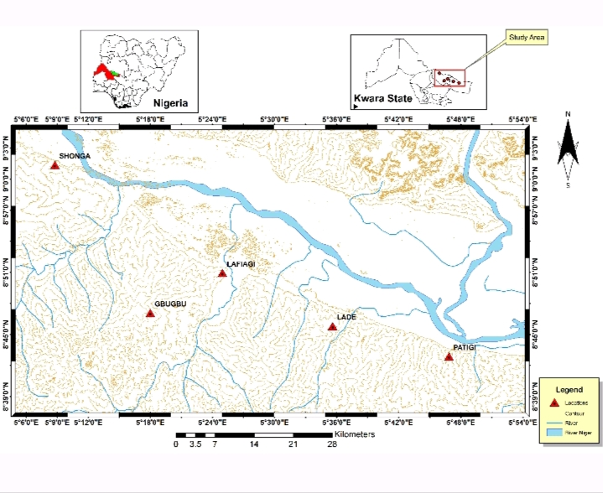

Figure 1.6: Geology Map of Nigeria Showing the Location and Accessibility of the Study Area

CHAPTER TWO
LITERATURE REVIEW
2.1 REVIEW OF PREVIOUS WORKS IN BIDA BASIN
Numerous geological studies have focused on the sedimentology, stratigraphy, and depositional environments of the Bida Basin, particularly concerning sandstone formations. The sandstone units around Gbugbu in the northern Bida Basin have received increasing attention due to their implications for paleoenvironments, provenance, and hydrocarbon potential.
Obaje (2009) discussed the general stratigraphy of the Bida Basin, identifying the Maastrichtian-aged Lokoja and Patti Formations as major fluvial-deltaic to shallow marine sandstones. He emphasised the dominance of medium to coarse-grained, poorly to moderately sorted sandstone indicative of braided fluvial depositional settings.
Adeleye (1971) first mapped and described the Bida Basin lithostratigraphy, noting the occurrence of cross-bedded, ferruginized sandstones that reflect high-energy depositional environments such as braided rivers and deltas. His work laid the foundation for subsequent sedimentological and petrographic studies.
Nwajide (2013) highlighted the sedimentary facies and structural framework of the Bida Basin, linking the sandstone units to syntectonic deposition in a foreland basin setting. He attributed the high variability in sandstone texture and composition to shifting fluvial regimes during basin evolution.
Udensi and Osazuwa (2004) used aeromagnetic data to define the subsurface architecture of the Bida Basin, correlating tectonic lineaments with depositional patterns. Their findings suggest that tectonics played a major role in controlling sediment influx and channel migration, especially in the northern sector around Gbugbu.
Akande et al. (2005) carried out petrographic analysis of the Lokoja Formation sandstones and concluded they were texturally immature, derived from nearby basement sources. The presence of feldspar and lithic fragments also suggests rapid deposition in proximal fluvial systems.
Akinyemi and Lar (2015) studied the geochemical signatures of Bida Basin sandstones and inferred a passive margin setting with moderate weathering. Their elemental ratios supported deposition under oxidising conditions, likely within braided river systems.
Ola-Buraimo and Boboye (2011) analysed the palynoflora of the Patti and Lokoja Formations, interpreting the depositional environment as alternating freshwater swamp, fluvial, and marginal marine systems. These environments fluctuated due to regional transgressive-regressive cycles during the Late Cretaceous.
Mamuda et al. (2020) integrated sedimentological logging and facies analysis along the Gbugbu area and identified a succession of conglomerates, pebbly sandstones, and planar-laminated sandstones. Their interpretation supports a high-energy braided stream to an alluvial fan environment.
Adekoya et al. (2012) focused on the provenance and tectonic setting of sandstones in the northern Bida Basin, concluding they were derived from a continental block provenance with moderate recycling. The presence of heavy minerals like zircon and tourmaline also suggests multiple cycles of reworking.
Tanko et al. (2018) conducted a grain-size statistical analysis of sandstone samples around Gbugbu and observed a bimodal grain size distribution typical of fluvial systems. Skewness and kurtosis values also reflected changing energy conditions within channel and overbank settings.
Muhammad et al. (2021) used remote sensing and field mapping to delineate sedimentary structures such as trough cross-bedding, ripple marks, and mud drapes. These features supported interpretations of alternating high- and low-energy depositional phases in a channelised environment.
Ogunbiyi and Odoma (2019) evaluated the reservoir quality of sandstone in the Gbugbu axis through porosity and permeability measurements, concluding that primary intergranular porosity is dominant, with secondary porosity developed through dissolution of feldspars and matrix.
Ibrahim et al. (2023) used facies models to reconstruct the paleoenvironment of the Gbugbu sandstones and reported fining-upward sequences, indicating meandering river channels and overbank floodplain
Adegoke and Ojo (2017) investigated the influence of diagenesis on sandstone reservoir quality in the Bida Basin. Their study found early cementation by quartz and calcite, reducing porosity but preserving some primary textures in7dicative of rapid burial.
Ojo and Akintola (2022) provided a recent synthesis of the depositional systems in the northern Bida Basin, identifying a progression from proximal braided rivers to more distal floodplain and delta front environments based on vertical facies transitions.
2.2 GEOLOGICAL AND TECTONIC SETTINGS OF BIDA BASIN
The Bida Basin, also referred to as the Nupe Basin, is an elongate, NW–SE trending, intracratonic sedimentary basin situated in central Nigeria. It forms part of the Cretaceous inland basins of Nigeria, which include the Benue Trough, Sokoto Basin, Anambra Basin, and Chad Basin. The Bida Basin is interpreted as a sag-type basin that developed due to tectonic forces associated with the opening of the South Atlantic and the separation of Africa from South America during the Late Jurassic to Early Cretaceous.

Geological Setting of the Bida Basin

Location and Extent
- The basin extends from Lokoja in the south to Kontagora in the north, trending NW–SE.
- It is bounded by:
  - The Nigerian Basement Complex to the northeast and west.
  - The Anambra Basin to the southeast (linked via the Niger Valley).
  - The Sokoto Basin to the northwest via a possible subsurface connection.

Lithostratigraphy
The basin is filled with non-marine and marginal marine Cretaceous sediments, reaching thicknesses of up to 3,500 meters. The major stratigraphic units include:
- Lokoja/Bida Sandstone Formation – Coarse fluvial clastics
- Patti/Enagi Formation – Fine-grained sandstones, siltstones, and shales
- Agbaja/Batati Formation – Limestones, ironstones, and marine clastics
These units represent a regressive-transgressive sedimentary cycle typical of rift and post-rift basins.

Tectonic Setting and Origin

Tectonic Context
The Bida Basin is interpreted as a sag basin (or a failed rift arm of a triple junction) associated with the Benue Trough and Anambra Basin. Its evolution is genetically linked to:
- Pan-African Orogeny (~600 Ma) – Provided the basement framework.
- Mesozoic Rifting (~130–100 Ma) – Initiated intracratonic extension during the opening of the South Atlantic Ocean.
- Benue Rift System Activity – The triple-junction system (Benue–Niger–Bida arms) led to the subsidence and sedimentation of the Bida Basin.

Evolutionary Stages

Stage 1: Pre-Rift Phase (Precambrian to Early Mesozoic)
- The basin area was part of the stable Nigerian Basement Complex composed of granite, migmatites, gneisses, and schists.
- No significant sediment accumulation occurred during this phase.

Stage 2: Rift Initiation and Early Sedimentation (Early–Middle Cretaceous)
- Continental rifting due to plate separation between South America and Africa created localized zones of crustal thinning and faulting.
- The initial sediments were coarse-grained conglomerates and arkosic sandstones (e.g., Lokoja and Bida Sandstones), deposited in alluvial and braided river systems.

Stage 3: Post-Rift Thermal Subsidence (Late Cretaceous)
- After active rifting ceased, the basin experienced thermal subsidence, allowing finer sediments to accumulate.
- Enagi and Patti Formations (fine-grained fluvio-deltaic and floodplain deposits) developed in response to widespread subsidence and rising sea levels.
- Marine incursions toward the end of the Cretaceous led to the deposition of shallow marine ironstones and limestones (Agbaja/Batati Formations).

Stage 4: Tectonic Quiescence and Erosion (Post-Cretaceous – Tertiary)
- The basin became tectonically stable.
- No major deposition occurred after the Maastrichtian.
- Uplift and erosion during the Tertiary exposed sedimentary sequences and created the present-day topography.

Structural Framework
The Bida Basin lacks the intense faulting seen in the Benue Trough but shows evidence of:
- Gentle folding and flexural warping due to underlying basement uplift and differential subsidence.
- Northwest–Southeast trending lineaments that control sediment thickness and facies distribution.
- Syn-sedimentary structures, such as cross-bedding and growth faults, suggesting localized tectonic activity during deposition.

Geodynamic Interpretation
The Bida Basin is often interpreted as:
- A failed arm of a triple rift junction, with the Benue Trough as the main active rift and the Bida and Anambra basins as the failed arms.
- A thermally subsiding basin following rifting, allowing for gradual infilling by fluvial and shallow marine deposits.
- A foreland basin in some models, responding to compression from the South American plate and basement reactivation.

Table 2.2: Summary of Evolution
Stage | Timeframe | Event/Process | Sediments
Pre-rift | Pre-Cretaceous | Stable basement | No sediments
Rift Phase | Early–Mid Cretaceous | Crustal thinning and subsidence | Coarse clastics (Lokoja/Bida Fm)
Post-Rift | Late Cretaceous | Thermal subsidence and marine transgression | Enagi/Patti + Agbaja/Batati
Post-Sedimentary | Tertiary to Present | Uplift, erosion, and exposure | Modern landforms, river incisions

Geological Importance
- The basin is a potential reservoir for hydrocarbons and groundwater.
- Rich in iron ore deposits (Agbaja area).
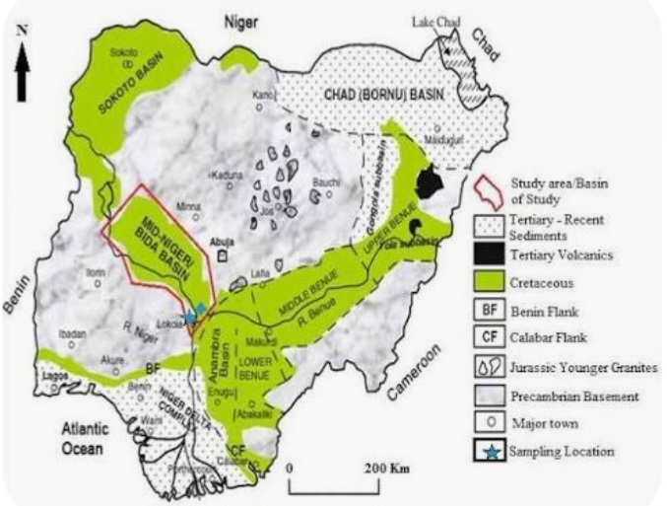
- Offers insight into rift basin dynamics, sedimentology, and Cretaceous paleoenvironments in West Africa.

Figure 2.2: Geological Map of Nigeria Showing the Bida Basin
Note: The Bida Basin is located in the central part of Nigeria, as indicated in the map above.

2.3 STRATIGRAPHIC SETTINGS OF THE BIDA BASIN

Stratigraphy of the Southern Bida Basin

Lokoja Formation (Basal Unit)
- Age: Maastrichtian (Late Cretaceous)
- Lithology: Coarse-grained, pebbly to conglomeratic sandstones; arkosic; poorly sorted
- Depositional Environment: Alluvial fan to braided fluvial systems
- Remarks: Represents initial clastic influx from uplifted basement terrain.

Patti Formation
- Age: Maastrichtian
- Lithology: Interbedded sandstones, siltstones, and shales with occasional coal seams
- Depositional Environment: Fluvial–deltaic to shallow marine
- Fossils: Contains plant impressions and occasional marine fauna (ostracods, foraminifera)
- Remarks: Indicates a transition from continental to marginal marine deposition during a transgression.

Agbaja Formation
- Age: Maastrichtian
- Lithology: Ironstone beds (oolitic and pisolitic ironstones), ferruginized shales, and siltstones
- Depositional Environment: Marine shelf or lagoonal
- Economic Importance: Major iron ore deposits in Agbaja and AjGBnoko
- Remarks: Often considered a condensed section; formed under reducing conditions.

Stratigraphy of the Northern Bida Basin
The Northern Bida Basin, which includes Mokwa, Lafiagi, Tsaragi, and Gbugbu, shows more dominantly fluvial signatures.

Bida Sandstone (equivalent to Lokoja Fm)
- Age: Maastrichtian
- Lithology: Coarse to medium-grained sandstone, quartzitic, sometimes conglomeratic
- Depositional Environment: Braided river or fluvial-dominated alluvial fans
- Remarks: Represents proximal sedimentation near basin margins.

Sakpe Ironstone Formation
- Age: Campanian
- Lithology: Ferruginized sandstone, oolitic ironstone, with interbedded shale and siltstone.
- Depositional Environment: This unit represents a shallow marine to deltaic environment influenced by iron-rich sediment influx.
- Significance: The Sakpe Formation marks the base of the sedimentary fill in parts of the Northern Bida Basin. It is a key stratigraphic marker due to its distinctive oolitic and ferruginous facies.

Enagi Formation
- Age: Maastrichtian
- Lithology: Heterogeneous sequence of fine-grained sandstones, siltstones, and mudstones; occasional carbonaceous beds
- Depositional Environment: Meandering river, floodplain, and tidal flat environments
- Structures: Ripple laminations, cross-bedding, bioturbation
- Remarks: Suggests fluctuating energy levels and occasional marine influence.

Batati Formation
- Age: Late Maastrichtian
- Lithology: Limestones, marl, and ferruginous shale
- Depositional Environment: Shallow marine to lagoonal
- Remarks: Marks the highest transgressive phase in the northern sector.

Table 2.3: Stratigraphic Correlation Table (Simplified)
Formation | Lithology | Depositional Environment | Location | Equivalent
Batati Fm | Limestone, marl, ferruginous shale | Shallow marine | Northern Basin | Agbaja Fm
Enagi Fm | Siltstone, mudstone, sandstone | Fluvial–tidal | Northern Basin | Patti Fm
Bida Sandstone | Conglomerate, coarse sandstone | Braided fluvial | Northern Basin | Lokoja Fm
Agbaja Fm | Oolitic ironstone, shale | Shallow marine/lagoonal | Southern Basin | Batati Fm
Patti Fm | Shale, siltstone, coal beds | Deltaic, marginal marine | Southern Basin | Enagi Fm
Lokoja Fm | Conglomerate, coarse sandstones | Alluvial/fluvial | Southern Basin | Bida Ss.

Geological Evolution Summary
- Tectonics: Both basins were affected by rift-related subsidence during the Late Cretaceous.
- Sedimentation: Initiated with coarse alluvial fans (Lokoja/Bida), followed by finer floodplain/deltaic sediments (Patti/Enagi), and culminated in shallow marine transgression (Agbaja/Batati).
Provenance: From nearby Precambrian basement rocks (schists, gneisses, granites) exposed in the surrounding Nigerian Basement Complex.
2.4 OVERVIEW OF SEDIMENTARY ROCKS AND CLASSIFICATION
Sedimentary rocks are formed by the accumulation and lithification of sediments. They are classified based on their origin into three main categories: clastic (e.g., sandstone, shale), chemical (e.g., limestone), and organic (e.g., coal). Clastic sedimentary rocks, particularly sandstones, are prevalent in the Bida Basin and are characterised by their grain size, composition, and sedimentary structures.

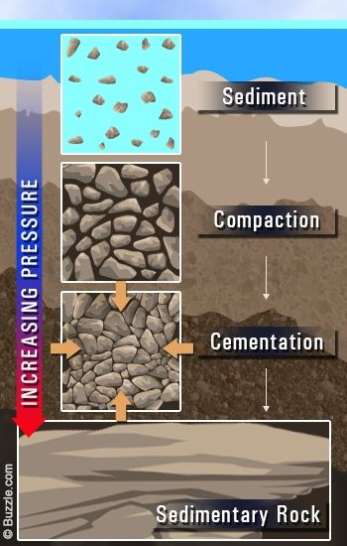

Figure 2.4: Diagram of Sedimentary Rock
2.5 SEDIMENTARY ROCK TEXTURES
The texture of sedimentary rocks refers to the size, shape, and arrangement of the grains within the rock. Key textural parameters include:
Grain Size: Determines the classification of the rock (e.g., sandstone, siltstone).
Sorting: Indicates the uniformity of grain sizes; well-sorted rocks have grains of similar size.
Roundness: Describes the shape of the grains; rounded grains suggest longer transport distances.
Matrix and Cement: The finer materials and minerals that bind the grains together.
These textural characteristics provide insights into the depositional environment and transport history of the sediments.

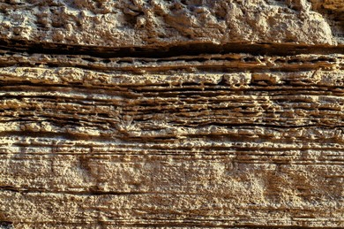

Plate 2.5A: Sedimentary Rock Textures

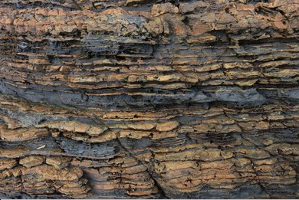

Plate 2.5B.: Sedimentary Rock Textures
2.6 DEPOSITION AND DEPOSITIONAL ENVIRONMENTS
The sandstones exposed at Gbugbu, within the Northern Bida Basin of Kwara State, Nigeria, reflect a complex interplay of sedimentary processes and depositional environments influenced by regional tectonics, fluvial dynamics, and climatic conditions during the Late Cretaceous period. Based on integrated petrographic observations, sedimentary structures, textural analysis, and lithological characteristics, the sandstones in this area were deposited in predominantly continental environments, specifically fluvial (river-dominated) and deltaic settings, with some influence from shallow lacustrine (lake) or estuarine systems in localized contexts.

1. Fluvial Depositional Environment
The dominance of medium to coarse-grained, moderately to poorly sorted sandstones, with sub-angular to sub-rounded quartz grains and common sedimentary structures such as cross-bedding, ripple marks, and parallel laminations, strongly indicate deposition in braided or meandering river systems.
- Example: The presence of large-scale planar cross-bedding and trough cross-stratification in some outcrops suggests deposition from migrating river channels with strong current activity. This is consistent with high-energy river environments, where sediments are constantly reworked and transported.

2. Deltaic Depositional Environment
Petrographic analysis reveals sub-mature sandstones with feldspar and lithic fragments, suggesting relatively short transport distances and rapid deposition. The occurrence of interbedded sandstones and siltstones, coupled with mud drapes, points to deposition within deltaic distributary channels and delta-front environments.
- Example: Alternations of fine-grained and coarse-grained layers, often with fining-upward sequences, are typical of deltaic channels that experience fluctuating energy levels due to distributary shifting and flood events.

3. Lacustrine Influence
Localized clay-rich interbeds and occasional massive, structureless silty units may suggest temporary standing water bodies such as lakes or floodplain ponds. These environments generally promote the deposition of finer sediments under low-energy conditions.
- Example: The presence of finely laminated, organic-rich shale layers with minor bioturbation suggests low-energy lacustrine deposition associated with overbank flooding or delta plain ponds.

4. Estuarine/Marginal Marine Influence (Possibly Minor)
Although the Northern Bida Basin is dominantly continental, some facies may show characteristics of tidal influence, such as bidirectional ripple marks or flaser bedding, implying a minor estuarine or marginal marine incursion during transgressive phases.
- Example: Minor occurrences of heterolithic bedding patterns may point to mixed tidal-fluvial conditions, possibly in a tidally influenced estuary or distributary mouth bar setting.

Summary of Depositional Environment Indicators
Feature | Interpretation
Cross-bedding | Fluvial channel migration
Ripple marks | Shallow water currents, fluvial or tidal
Poor sorting and angular grains | Proximal fluvial source
Interbedded sandstone and shale | Deltaic or floodplain deposition
Fining-upward sequences | Channel fill or delta distributary deposits
Laminated shale with organic matter | Lacustrine or floodplain pond
Sub-angular quartz, feldspar | Immature sediments, short transport

Conclusion
The depositional history of the Gbugbu sandstones indicates a complex continental sedimentary regime, dominated by fluvial and deltaic systems, with possible lacustrine and minor estuarine influences. These environments reflect the tectono-sedimentary evolution of the Northern Bida Basin, governed by active sediment supply, basin subsidence, and climatic fluctuations during the Late Cretaceous. The integrated lithological and petrographic characteristics of these sandstones are essential for interpreting the paleogeography, reservoir potential, and stratigraphic framework of the basin.

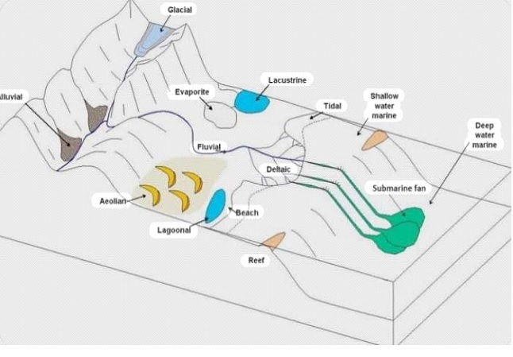

Figure 2.6: Diagram of Depositional Environments

2.7 SEDIMENTARY STRUCTURES
Sedimentary structures observed in the sandstones of Gbugbu provide critical insight into the depositional processes, paleo-flow directions, and sedimentary environments that prevailed during their formation. These structures are primarily physical in origin and reflect high- to low-energy depositional regimes associated with fluvial and deltaic systems.

1. Cross-Bedding
Cross-bedding is the most prominent and diagnostic sedimentary structure in the Gbugbu sandstones. It occurs as both planar and trough cross-stratification, indicating deposition by migrating ripples and dunes under the influence of unidirectional flow.
- Interpretation: Indicative of fluvial channel environments with moderate to high energy.
- Example from Gbugbu: Large-scale trough cross-bedding in coarse-grained sandstones, up to 30–50 cm thick, suggests deposition in braided river systems or deltaic distributary channels.

2. Ripple Marks
Both symmetrical (wave ripples) and asymmetrical (current ripples) ripple marks are present in finer-grained sandstone layers.
- Interpretation:
  - Asymmetrical ripples: Indicate unidirectional current flow typical of rivers or channels.
  - Symmetrical ripples: Suggest shallow water oscillatory wave action, possibly in a delta front or shallow lacustrine setting.
- Example from Gbugbu: Ripple marks preserved on bedding planes of fine-grained, micaceous sandstone beds.

3. Parallel Lamination (Planar Bedding)
Thin, horizontal laminations within fine to medium-grained sandstones suggest uniform sediment deposition under lower flow regimes.
- Interpretation: Indicative of upper flow regime plane beds or rapid settling from suspension in a relatively quiet water body.
- Example from Gbugbu: Horizontally bedded units in overbank deposits or floodplain settings.

4. Graded Bedding
Some sandstones show normal grading—a fining-upward sequence from coarse to fine grain sizes.
- Interpretation: Typical of waning flow conditions, possibly representing channel fills or flood deposits.
- Example from Gbugbu: A 40-cm thick sandstone bed with a sharp base grading into finer siltstone, indicating deposition from a decelerating turbidity current or flood event.

5. Mud Drapes
Mudstone layers or drapes interbedded with sandy units occur in places.
- Interpretation: Indicative of fluctuating energy conditions, often associated with tidal influence or periodic flooding.
- Example from Gbugbu: Thin mud drapes between ripple-marked sandstone layers suggest short pauses in sedimentation.

6. Load Casts and Flame Structures (Minor)
These are soft-sediment deformation structures observed at a few outcrops where overlying sandstones have deformed underlying muddy layers.
- Interpretation: Result of rapid sediment loading and water escape structures, possibly during rapid deposition or seismic disturbance.
- Example from Gbugbu: Isolated bulbous protrusions (load casts) seen in sand-mud interfaces.

7. Bioturbation (Rare)
Traces of bioturbation, such as burrows or root traces, are rarely seen but indicate some post-depositional biological activity.
- Interpretation: Suggests subaerial exposure or colonization in a delta plain or floodplain environment.
- Example from Gbugbu: Possible rootlets in silty interbeds near vegetated floodplain areas.

Summary Table of Sedimentary Structures
Sedimentary Structure | Interpretation | Example from Gbugbu
Cross-bedding (planar & trough) | High-energy fluvial/deltaic channels | Trough cross-beds in coarse sandstone
Ripple marks (asymmetrical & symmetrical) | Current or wave action | Rippled bedding planes in fine sandstone
Parallel lamination | Calm or uniform flow | Horizontally bedded overbank deposits
Graded bedding | Waning energy flows | Fining-upward sequences in channel fills
Mud drapes | Fluctuating energy, possible tidal influence | Thin mud layers between rippled sand beds
Load casts/flame structures | Rapid deposition on soft substrate | Bulbous features at sand-mud contacts
Bioturbation/root traces | Biological disturbance or soil formation | Rare root marks in fine-grained beds

Conclusion
The sedimentary structures present in the Gbugbu sandstones confirm deposition under dynamic conditions dominated by fluvial and deltaic influences. Cross-bedding and ripple marks dominate, suggesting varying current strengths, while graded bedding and mud drapes support periodic energy fluctuations. These structures collectively offer a detailed reconstruction of the sedimentary processes and paleoenvironments within the Northern Bida Basin during the Late Cretaceous.
2.8 STUDY OF SEDIMENTARY ROCKS
The study of sedimentary rocks is essential for understanding the Earth's history, surface processes, and the distribution of natural resources like groundwater, fossil fuels, and minerals. Sedimentary rocks are primarily formed by the deposition, compaction, and cementation of sediments derived from pre-existing rocks, biological activity, or chemical precipitation. These rocks preserve important clues about past environments, climates, and biological evolution (Boggs, 2012).
a. Field Study
Field observation is the first step in studying sedimentary rocks. It involves identifying rock types, measuring bedding thickness, describing textures and sedimentary structures, and mapping lithological boundaries. Characteristics such as grain size, color, mineral composition, and fossil content provide important environmental and stratigraphic information (Nichols, 2009).
b. Petrographic Analysis
Thin section petrography is used to examine the mineralogy, grain shape, sorting, cementation, and texture under a polarizing microscope. This helps in classifying the rock (e.g., quartz arenite, arkose) and interpreting the provenance and diagenetic history (Tucker, 2001).
c. Sedimentological Logging
Sedimentological logs record vertical changes in lithology, grain size, sedimentary structures (like cross-bedding, ripple marks, graded bedding), and fossil content. These logs help reconstruct the depositional history and environment of the rock sequence (Reading, 1996).
d. Geochemical and Paleontological Studies
Geochemical analysis reveals the chemical composition and source rock characteristics, while fossil identification provides age dating and paleoenvironmental interpretation (Blatt et al., 1980). Biostratigraphy, using fossil assemblages, is key in correlating sedimentary layers across regions.

e. Interpretation of Depositional Environments
By combining field and laboratory data, sedimentary environments such as fluvial, deltaic, shallow marine, or deep marine can be interpreted. Factors such as energy conditions, transport mechanisms, and biological activity are also considered (Nichols, 2009).
CHAPTER THREE
METHODS OF STUDY
3.1 MATERIALS AND METHODS
This study involves both field work and laboratory analysis.
3.2 SAMPLE COLLECTION AND FIELD STUDY
Field study entailed carrying out a geological mapping of the rock types in the study area Gbugbu, Northern Bida Basin. The mapping exercise was aimed at identifying the rocks and establishing the stratigraphic succession of the rocks based on their field relationships. It also involved the collection of spot rock samples for laboratory studies. Field observations including grain texture, colour, orientation, mineralogical composition, measurements of coordinates and elevation with GPS, taking photographs of important sedimentary structures and logging of exposed vertical sections were done.
Five (5) samples of sandstones were collected from the road cut exposures with the aid of geoloa gical hammer. The samples were properly kept in the sample bags and labelled accurately with masking tape and permaa nent marker for easy identification. They were labelled as follows: GB1, GB2, GB3, GB4 and GB5 respectively. The samples were then taken to the laboratory for further analysis.
3.3 LABORATORY ANALYSIS
The thin thin-sectionography analysis was aimed at determining the mineralogy of the sandstones. The experiment was performed in the Sedimentological Laboratory, Geology Department, Kwara State University, Malete.
3.3.1 PETROGRAPHIC ANALYSIS
Petrographic analysis was conducted using thin thin-sectionoscopy to study the sandstone’s mineralogy and texture. All the sandssandstone samples the field are poorly consolidated, fragile, and friable. Due to friabthe le nature of these sandssandstonesing impregnation and cool moulding. Impregnation was employed before mounting on slidea for microscopic view. Three (3) samples GB1, GB3 and GB5 were selected for thin section petrography. The samples were dried over an acetone bath, impregnated with polyester resin mix, cut and polished using
minor modif modification standard hard rock thin sectioning equipment and techniques. The materials used are hardener and resin, in which their mixture is ratio 1:3 giving thin a araldite. The moulding container acetone had to be lubricated with vaseline or engine oil to allow the mould to remove easily. A small quantity of the prepared araldite was poured at the bottom of the container after which the loose sample was poured and packed with a glass rod to prevent space from being created between the grains. The prepared araldite was applied to it and the sample number was written on the sample before it solidified.
After impregnation, the thin thin-sectiones were prepared by grinding one side perfectly flat with carborundum powder on a glass plate. Slides to be used are heated after which Canada balsam is placed on it. Fthemther grinding is done until a thickness of 0.03m was rished and this is checked under a microscope with crosscross-polarisedr to see the polarpolarisationrcolouribute of some known mineral such as quartz (grey or white of the first order). When the correct thickness is reached, the thin sections were thoroughly washed and all remaining resin scraped away from around the chip. The slides were later covered with cover slips which was pweresed down to remove any air bobblbubblesent. Excess cement was removed with methylated spirit. The thin sections were observed under the polarpolarisingoscope to determine the mineral composition of the rock samples.

CHAPTER FOUR
RESULTS AND DISCUSSIONS
4.1 LITHOLOGICAL DESCRIPTION AND DEPOSITIONAL ENVIRONMENTS
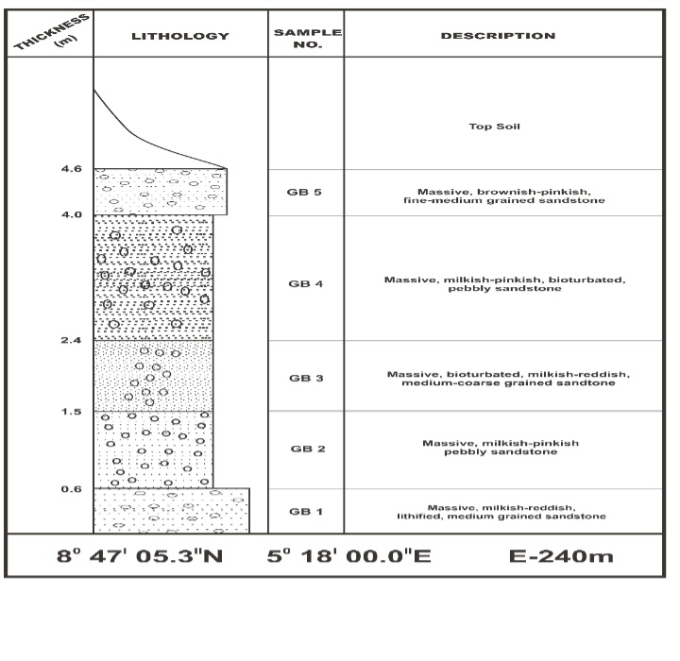

Figure 4.1: Lithological section of Bida sandstone Formation exposed at Gbugbu
The outcrop section studied at Gbugbu in the northern Bida Basin provides valuable insight into the lithological characteristics and depositional settings of the sandstone units. The total measured thickness of the section is approximately 4.6 meters and comprises massive, well-indurated sandstones with varying textural features. The lithologic profile and facies association suggest a dominantly fluvial depositional environment.
Below is a detailed lithological description:
GB 1 (0.0 – 0.6m): Description: Massive, milky-reddish, lithified, medium-grained sandstone.Interpretation: The degree of lithification and absence of primary structures suggest deposition in a low-energy fluvial setting, possibly part of a channel lag or lower point bar deposit.
GB 2 (0.6 – 2.4m): Description: Massive, milky-pinkish, pebbly sandstone.Interpretation: The presence of pebbles suggests a higher energy fluvial system such as a braided river channel. The massiveness indicates limited reworking.
GB 3 (2.4 – 3.4m): Description: Massive, bioturbated, milky-reddish, medium- to coarse-grained sandstone.Interpretation: Bioturbation points to subaqueous conditions with biological activity, possibly on a mid-channel bar or floodplain with alternating flow conditions.
GB 4 (3.4–4.0m): Description: Massive, milky-pinkish, bioturbated, pebbly sandstone. Interpretation: Similar to GB 2 but with more evidence of post-depositional reworking. This unit likely represents a transition between channel and overbank facies.
GB 5 (4.0 – 4.6m): Description: Massive, brownish-pinkish, fine-fine-to-medium-grainedstone.Interpretation: Finer grains and brownish tint indicate subaerial exposure or more oxidioxidisingitions typical of overbank or levee deposits. Coordinates: 8° 47′ 05.3″N, 5° 18′ 00.0″EElevation: 240 meters above sea level Overall Interpretation: The lithological and textural variations across the vertical profile of the Gbugbu section indicate a predominantly fluvial environment, ranging from high-energy braided channels (pebbly sandstones) to lower energy floodplain or point bar envirenvironmentsioturbated sandstones). The presence of bioturbation and lithification suggests alternating wet and dry periods and possible subaerial exposure.

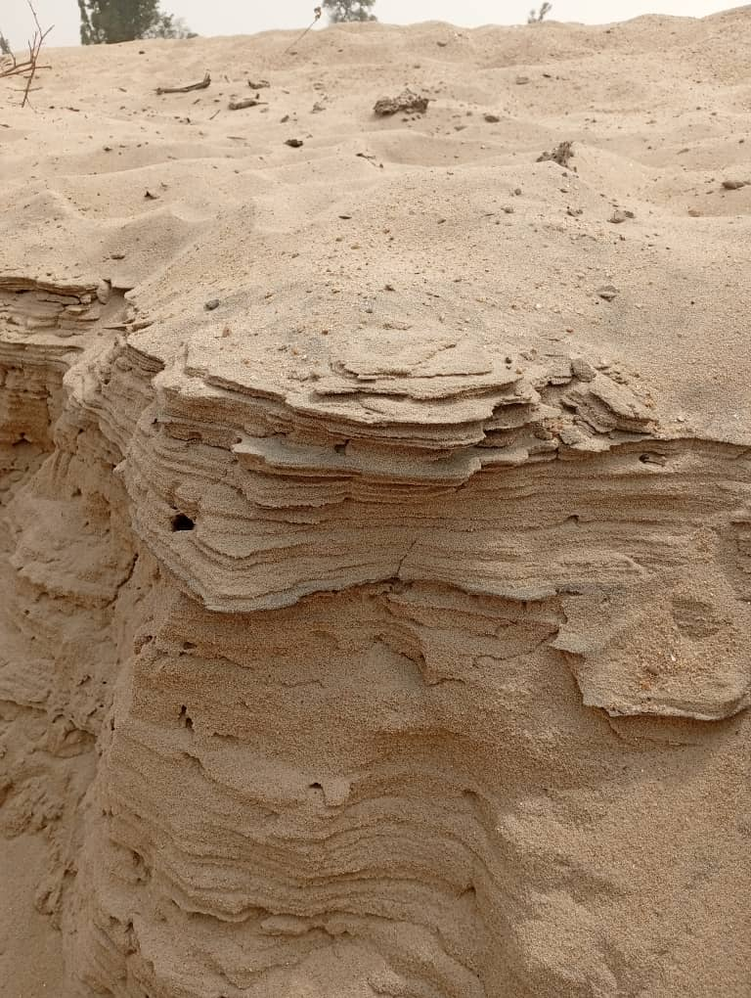

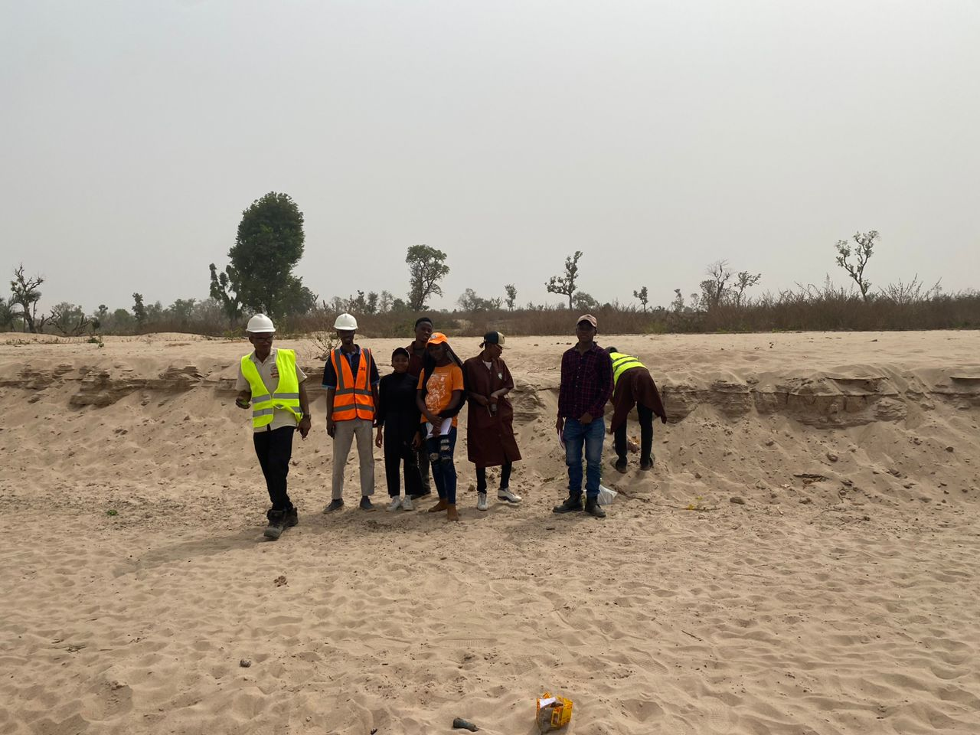
Plate 4.1A: Environment Lithology of Gbugbu

Plate 4.1B: Environment Lithology of Gbugbu
4.2 THIN SECTION PETROGRAPHIC ANALYSIS AND QUARTZ CHARACTERISTICS
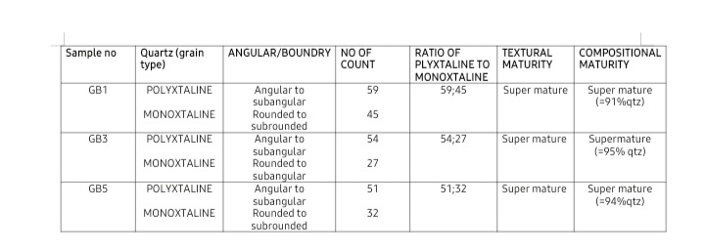
Table 4.1: Result of Thin Section Petrographic Analysis of Sandstone from Gbugbu

Table 4.1 above presents the petrographic analysis of quartz grains in sandstone samples (GB1, GB3, and GB5) collected from a study area. The samples were classified based on their quartz grain types—polycrystalline quartz (polyxtaline) and monocrystalline quartz (monoxtaline)—as well as their angularity, grain boundary characteristics, and grain count. These attributes were then used to assess both textural and compositional maturity of the sandstone units.
Quartz, being the most stable and resistant mineral in clastic sedimentary rocks, is crucial in evaluating compositional maturity. Each sample contains both polycrystalline and monocrystalline quartz. Polycrystalline quartz grains are those composed of multiple sub-grains and often indicate a metamorphic source, while monocrystalline quartz is typically derived from plutonic or volcanic sources (Tucker, 2001).
The ratios of polycrystalline to monocrystalline quartz for the samples are:
GB1: 59:45
GB3: 54:27
GB5: 51:32
This shows a dominance of polycrystalline quartz in all samples, suggesting a significant metamorphic contribution to the provenance (Pettijohn et al., 1987). The higher quantity of polycrystalline quartz, particularly in sample GB3 (54:27), may indicate recycling or multiple depositional cycles.
Grain angularity is a key parameter for determining textural maturity. In the table:
Polycrystalline quartz grains are consistently described as angular to subangular.
Monocrystalline quartz grains range from rounded to subrounded.
This mixture of angular and rounded grains suggests a moderately mature texture. The rounding of monocrystalline grains indicates prolonged transport or reworking, while the angular nature of polycrystalline grains could imply shorter transport distance or less mechanical weathering (Boggs, 2006).
Textural maturity refers to the roundness, sorting, and matrix content of sediment grains. All three samples were assessed to have super mature textures. This is consistent with:
The dominance of quartz (over 90%)
The presence of subrounded to rounded grains
Low matrix content (implied)
According to Folk (1980), super mature sandstones are characterized by very well-sorted and well-rounded grains with minimal matrix, and this classification fits the field observations from these samples.
Compositional maturity is typically evaluated based on the relative abundance of stable minerals like quartz and the absence of unstable minerals such as feldspars and lithics. In the table, all samples are labeled as super mature, with quartz content ranging from 91% to 95%. This high quartz concentration reflects extensive weathering and transport, which removes less stable components (Pettijohn et al., 1987). The quartz-rich nature of the samples implies a tectonically stable cratonic or passive margin setting.
4.2.1 PROVENANCE INTERPRETATAION
Provenance analysis involves the interpretation of sediment source areas, their nature, and the geological processes that transported and deposited the sediments. The quartz grain types, angularity, and maturity levels from the samples (GB1, GB3, and GB5) provide key insights into the origin and tectonic setting of the source rocks for the sandstone in the study area.
The predominance of polycrystalline quartz over monocrystalline quartz in all three samples (ratios of 59:45, 54:27, and 51:32) indicates a metamorphic source terrain. Polycrystalline quartz grains are commonly associated with high-grade metamorphic rocks such as gneisses and schists (Pettijohn et al., 1987; Basu et al., 1975). Their angular to subangular boundaries suggest that these grains did not travel far from their source before deposition, or that they were derived from the recycling of older sedimentary rocks originally sourced from metamorphic regions (Garzanti et al., 2007).
In contrast, monocrystalline quartz, typically derived from plutonic (igneous) or volcanic sources, shows more rounded to subrounded textures. The presence of well-rounded monocrystalline grains indicates longer transport distances or multiple cycles of sedimentation, likely implying a recycled or cratonic origin (Tucker, 2001). The mixture of grain types and shapes suggests a mixed provenance, with both first-cycle metamorphic input and recycled sedimentary sources contributing to the sandstone's formation.
4.2.2 TEXTURAL AND COMPOSITIONAL MATURITY
The super mature nature of the sandstones, both texturally and compositionally, supports the idea of a tectonically stable source area, such as a craton or passive continental margin (Folk, 1980). The high quartz content (91%–95%) and well-rounded textures are typical of sandstones that have undergone long-term weathering, transport, and reworking, allowing unstable minerals like feldspars and lithics to be removed (Pettijohn et al., 1987).
Such conditions are usually found in regions with low tectonic uplift and high chemical weathering, which is consistent with a cratonic interior setting or recycled orogen. This setting is typical of older continental blocks with minimal sediment input from active tectonic belts.
Given the high percentage of quartz, dominance of polycrystalline grains, and maturity, the study area sediments are most likely derived from a recycled orogen setting, possibly adjacent to a continental craton. This aligns with the Northern Bida Basin's geologic context, which is part of the broader West African craton known for its Precambrian basement rocks and paleoenvironmental stability (Ojo, 2012).
Understanding the textural and compositional maturity of sandstones is crucial for interpreting their depositional history, transport mechanisms, and source rock characteristics. The table provided offers insight into these aspects based on the analysis of quartz grain types, angularity, and overall quartz content.
Textural maturity refers to the degree of physical reworking that sediments have undergone, and is evaluated based on:
- Grain shape (roundness)
- Sorting
- Grain size
- Matrix content
- In the given samples:
- Polycrystalline quartz grains are mostly angular to subangular
- Monocrystalline quartz grains range from rounded to subrounded
This mixture reflects a moderately high degree of textural maturity. The rounded monocrystalline grains suggest that sediments experienced prolonged transportation, possibly through fluvial or aeolian processes, which promoted abrasion and rounding of grains (Tucker, 2001). Meanwhile, the angular to subangular polycrystalline grains imply less reworking or shorter transport distances from the source, possibly due to higher grain toughness or recent exposure (Boggs, 2006).
Despite the angularity of the polycrystalline quartz, all three samples are classified as super mature texturally. This may be attributed to:
- Excellent sorting (noted but not shown in the table)
- Dominance of quartz
- Minimal presence of matrix or unstable minerals
Such characteristics typically reflect deposition in high-energy environments like beaches, deserts, or well-established fluvial systems, where prolonged transport removes fine particles and unstable grains (Folk, 1980).
Compositional maturity describes the mineralogical composition of sedimentary rocks, especially the abundance of stable minerals (mainly quartz) versus unstable minerals (feldspars, lithics, heavy minerals).
In this case:
Sample GB1 has 91% quartz
Sample GB3 has 95% quartz
Sample GB5 has 94% quartz
All are classified as super mature compositionally, indicating:
Extensive chemical weathering
Removal of unstable minerals
Long-distance sediment transport and/or multiple recycling events (Pettijohn et al., 1987)
High quartz content is typically associated with stable tectonic settings, such as cratonic interiors or passive continental margins, where there is enough time and energy to remove unstable components. The near-total dominance of quartz implies that the sandstone has gone through multiple depositional cycles, supporting a recycled orogenic provenance (Dickinson, 1985).
The combination of super mature texture and super mature composition reflects a sandstone that is both physically and chemically evolved. Such maturity suggests:
- Long transport distances
- Reworking of older sediments
- Stable depositional conditions
The presence of rounded quartz grains and high quartz content aligns with deposition in a well-drained, high-energy fluvial or shallow marine system, likely influenced by prolonged weathering in a tropical to semi-arid climate (Garzanti et al., 2007).

4.2.3 DEPOSITIONAL ENVIRONMENTS INTERPRETATION
The depositional environment of sandstone can be interpreted by analyzing grain size, texture, roundness, sorting, maturity, and mineral composition. The petrographic data from samples GB1, GB3, and GB5 reflect a high degree of both textural and compositional maturity, which provides strong clues about the energy conditions, climatic setting, and sediment transport mechanisms in the study area.
All three sandstone samples exhibit super mature composition, with quartz content ranging from 91% to 95%. Such high quartz percentages are characteristic of clean, well-washed sandstones, often deposited in high-energy, stable environments where chemical weathering and hydraulic sorting can operate effectively (Folk, 1980; Pettijohn et al., 1987). The absence of feldspars, lithic fragments, or heavy minerals indicates intense weathering and prolonged sediment recycling before final deposition.
This level of compositional maturity is commonly associated with environments like:
- Beach and barrier island systems
- Shallow marine shelves
- Aeolian deserts
- Mature braided or meandering river systems
- Textural Evidence
- Texturally, the sandstones contain:
- Rounded to subrounded monocrystalline quartz
- Angular to subangular polycrystalline quartz
- This mix suggests a two-phase transport history:
- Longer transport or reworking of monocrystalline quartz, indicating extended sediment movement (likely by water or wind) or multiple cycles of deposition.
- Shorter transport for polycrystalline grains, likely due to their higher resistance to rounding and shorter exposure during sediment transfer.
The presence of rounded grains, minimal matrix, and likely good sorting (inferred from maturity level) point to high-energy conditions, capable of selective winnowing and grain abrasion.
Likely Depositional Setting
Based on these features, the most plausible depositional environments are:
Shallow Marine (Beach/Barrier Shoreface): These systems promote high energy from wave action, which explains the good sorting and grain rounding. The dominance of quartz and lack of unstable minerals are consistent with sediment recycling and reworking in the nearshore setting (Boggs, 2006).
Fluvial (Braided River or Meandering River): Mature river systems can also transport sediment over long distances, promoting both compositional and textural maturity. However, fluvial settings tend to preserve more feldspar and lithics unless the river flows through stable cratonic areas, as might be the case here.
Desert (Aeolian Dune Systems): Aeolian processes produce extremely well-rounded, well-sorted quartz grains with very high maturity. While possible, the presence of angular polycrystalline grains may limit this interpretation unless those grains were introduced from nearby hard rock exposures or escarpments.
Considering the Bida Basin's geologic setting, which includes fluvio-deltaic to shallow marine sedimentation during the Late Cretaceous (Ojo, 2012), the sandstones were likely deposited in a fluvial-to-marine transitional environment, where river channels, estuaries, and beach systems worked together to rework sediments.
4.2.4 IMPLICATIONS OF PETROLEUM EXPLORATION
Understanding the petrographic, compositional, and depositional characteristics of sandstone reservoirs has significant implications for petroleum exploration. The sandstone samples analyzed (GB1, GB3, and GB5) provide key insights into the reservoir potential, hydrocarbon migration pathways, and overall petroleum system of the northern Bida Basin. The implications are discussed under the following subheadings:
1. Reservoir Quality and Porosity Potential
The high textural and compositional maturity of the sandstone samples—characterized by:
- Dominance of quartz (>90%)
- Rounded to subrounded grains
- Minimal matrix or cement
...suggests the potential for excellent reservoir quality.
These properties are indicative of:
- Good primary porosity, due to well-sorted, rounded grains creating well-connected pore spaces.
- High permeability, which favors fluid flow and hydrocarbon accumulation.
According to Boggs (2006), super mature sandstones often exhibit high porosity retention, especially if post-depositional compaction and cementation are minimal. This means the sandstones in the study area may serve as effective hydrocarbon reservoirs.
2. Depositional Setting and Reservoir Continuity
The interpreted depositional environments (fluvial to shallow marine systems) support:
- Lateral continuity of sandstone bodies (e.g., shoreface or channel fills)
- Vertical stacking of sand-rich sequences
- Reservoir heterogeneity control, especially where facies change across fluvial and marine transitions
This improves the chances of extensive and laterally connected reservoir units, important for large-scale hydrocarbon entrapment and development.
3. Source Rock and Maturity Correlation
While the current petrographic study focuses on sandstone reservoirs, the presence of interbedded shales and claystones (as commonly reported in the Bida Formation—see Ojo, 2012) may act as:
- Source rocks, if organic-rich
- Seals or cap rocks, controlling hydrocarbon entrapment
Previous basin studies suggest that the Bida Basin may contain organic-rich shales with adequate burial history to reach thermal maturity, especially in deeper parts of the basin (Obaje et al., 2004).
If these shales have generated hydrocarbons, the mature, porous sandstone units could serve as effective hydrocarbon traps—supporting a viable petroleum system.
4. Tectonic Setting and Exploration Risk
The maturity of the sandstones, along with their recycled orogenic provenance, indicates a tectonically stable setting—likely a passive margin or cratonic basin. Such settings typically show:
- Low exploration risk
- Predictable sedimentary architecture
- Minimal tectonic disruption to reservoir continuity
- This enhances exploration confidence and reduces the geological risk of dry wells.
5. Implications for Drilling and Production
The clean nature of the sandstone, indicated by low matrix content and high quartz purity, implies:
- Good response to drilling
- Minimal formation damage
- Reduced risk of clay swelling or plugging
In petroleum production, these features allow for more efficient hydrocarbon extraction, especially when combined with favorable pressure regimes and structural traps.

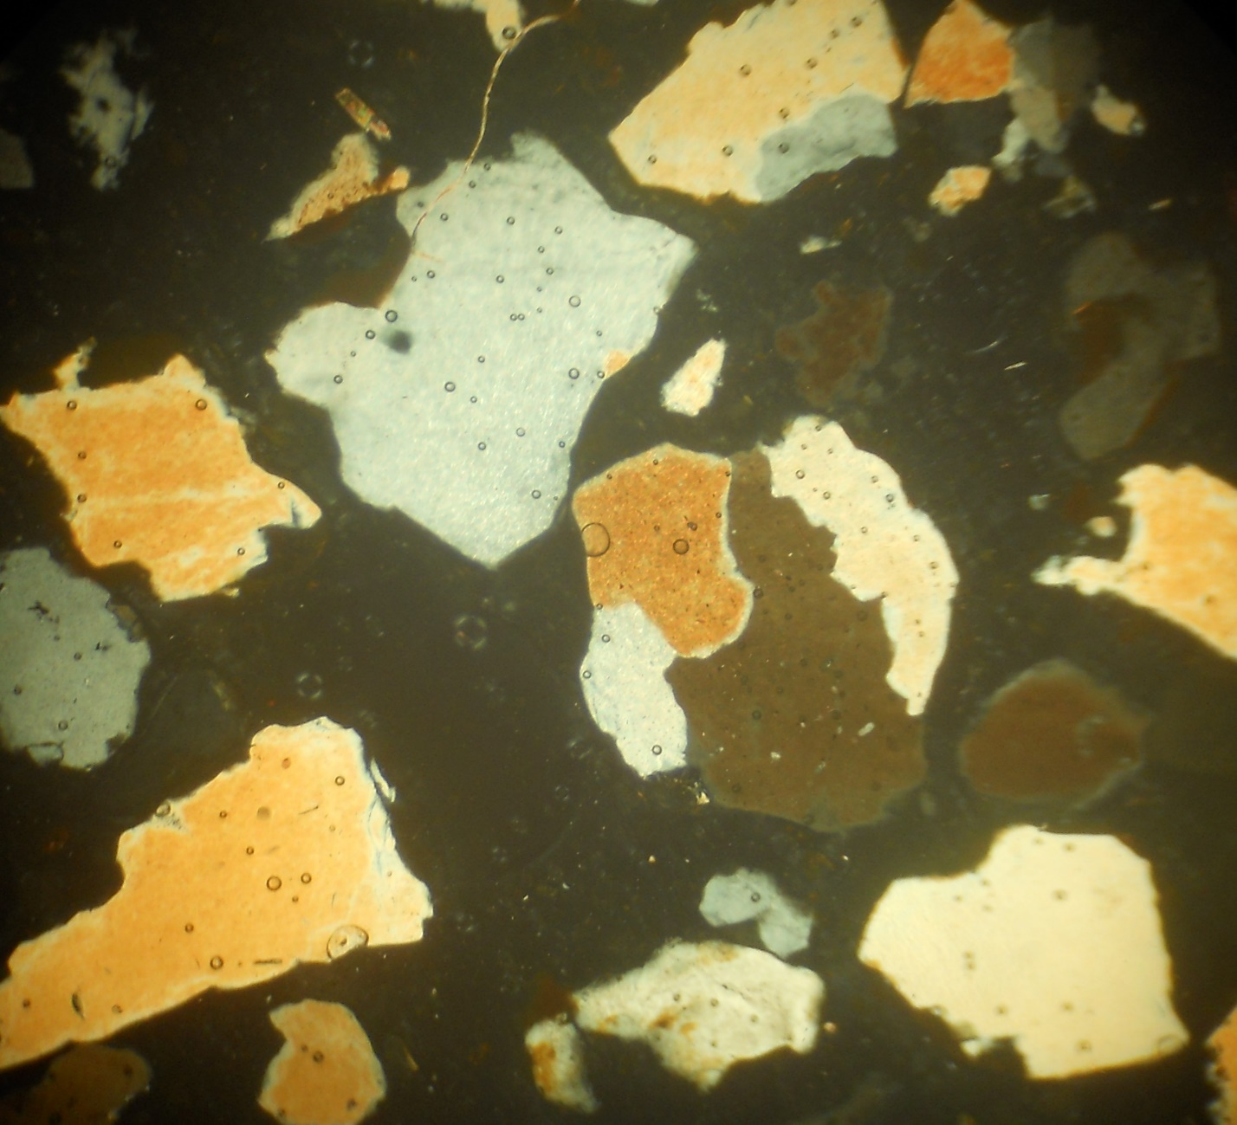

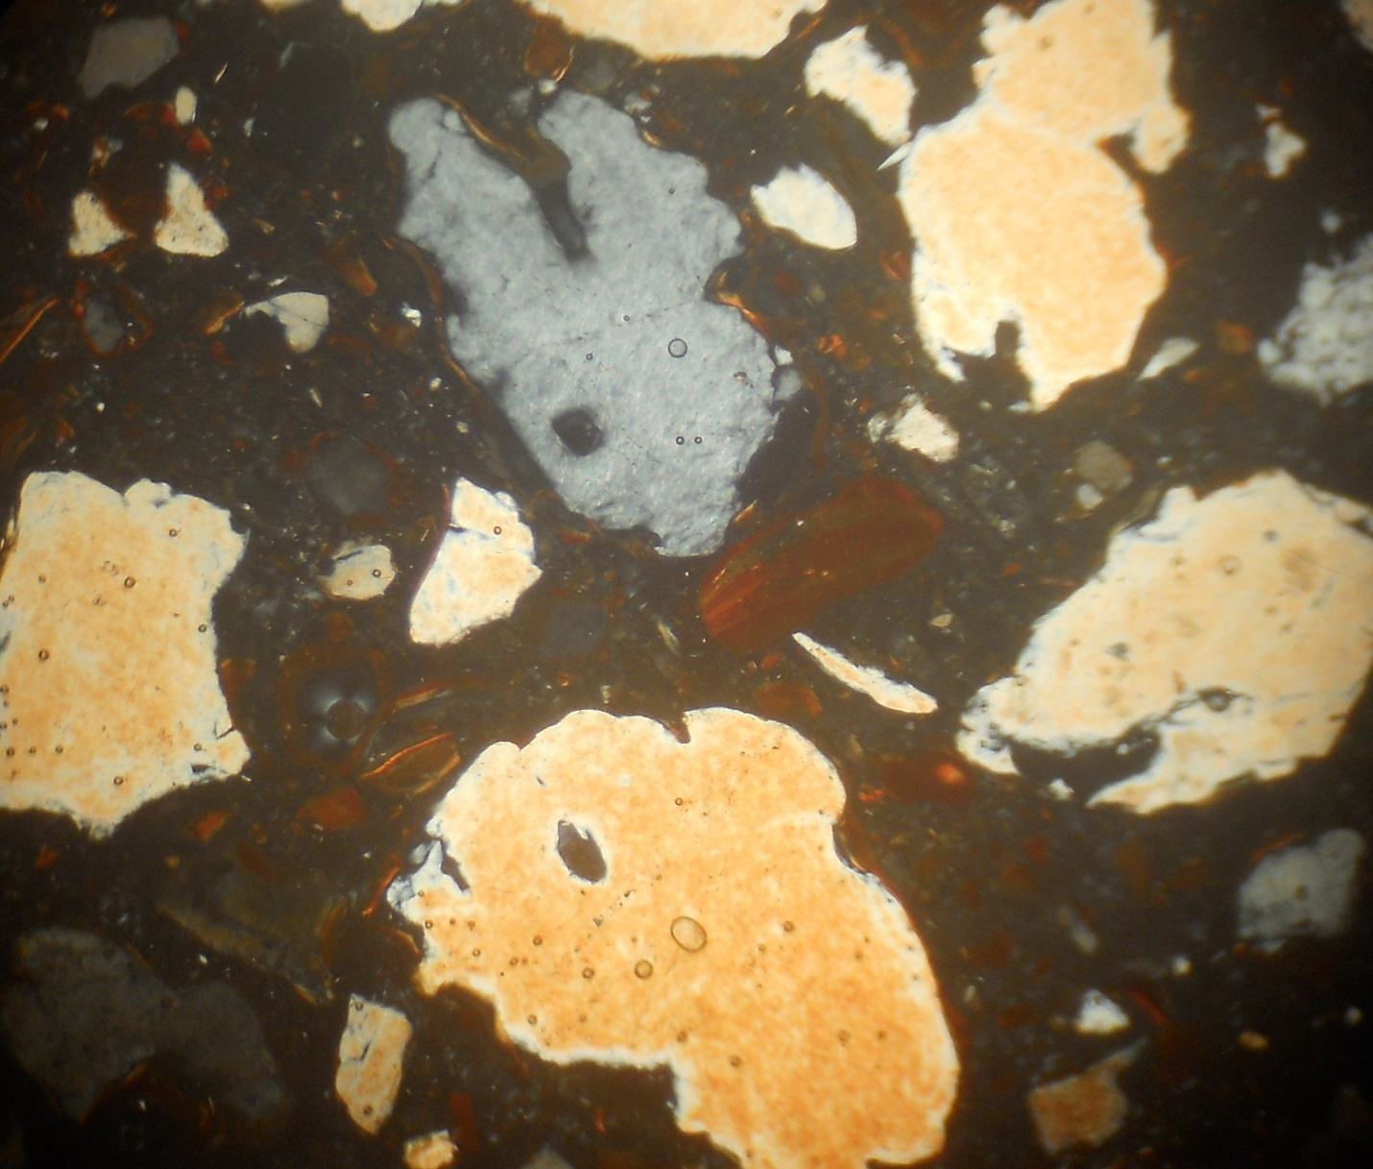
Plate 4.2A: Photomicrography of GB 1 views under Plane Polarized Light Microscope

Plate 4.2B: Photomicrography of GB 1 views under Plane Polarize Light Microscope


Plate 4.2C: Photomicrography of GB 5 views under Plane Polarized Light Microscope

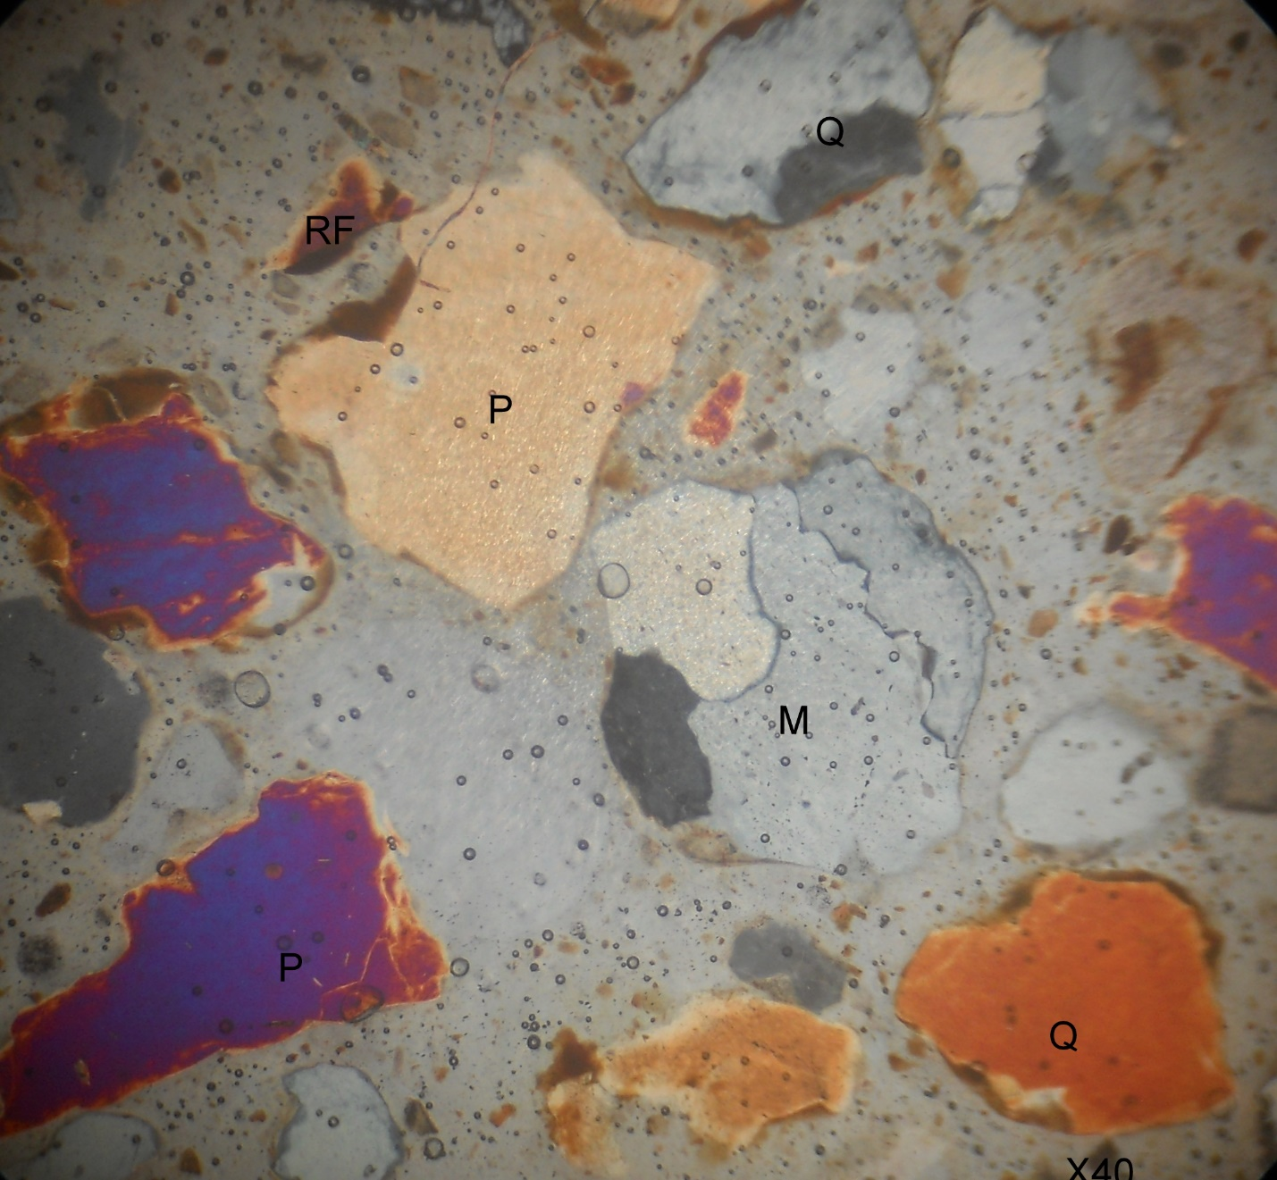

Plate 4.2D: Photomicrography of GB5 views under Cross Polarize Light Microscope
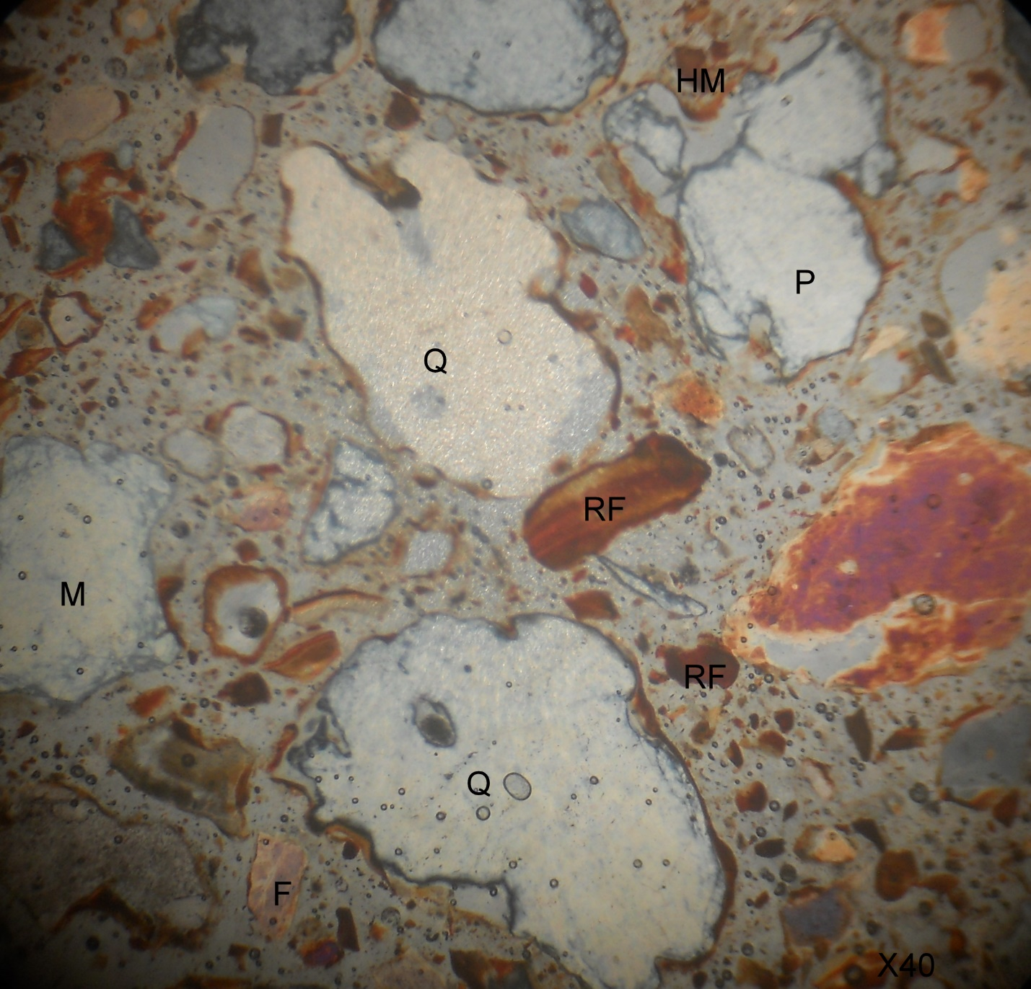

Plate 4.2E: Photomicrography of GB 3 views under Cross Polarize Light Microscope
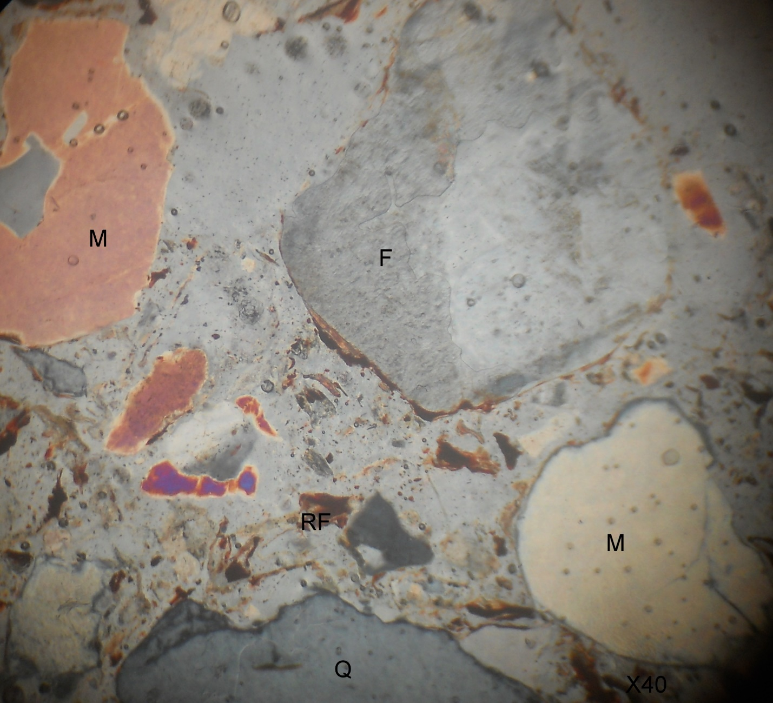

Plate 4.2F: Photomicrography of GB 3 views under Cross Polarized Light Microscope
CHAPTER FIVE
CONCLUSION, CONTRIBUTION TO KNOWLEDGE AND RECOMMENDATIONS
5.1 CONCLUSION
The sedimentary sequence at Gbugbu reflects deposition in a continental fluvial environment with episodic shifts in energy conditions. The occurrence of pebbly sandstones, cross-bedding, and fining-upward cycles supports the interpretation of deposition by braided and meandering river systems, likely influenced by seasonal flooding and climate variability during the Late Cretaceous.
The petrographic and sedimentological data support the presence of arkosic to subarkosic sandstone, pointing to derivation from nearby basement uplifts and possibly reworked older sedimentary units. The stratigraphic and facies characteristics observed are consistent with models developed for the Lokoja and Enagi Formations in the southern Bida Basin.
These results contribute valuable site-specific data that enhance the broader understanding of the Bida Basin's fluvial depositional systems and may guide future hydrocarbon or groundwater exploration efforts in the region.
This research provides new sedimentological, stratigraphic, and environmental data that significantly improve the understanding of the Gbugbu area and the broader Northern Bida Basin. It refines depositional models, introduces measurable grain size statistics, identifies key sedimentary features, and links surface geology with potential subsurface applications. These contributions create a foundation for future academic, hydrogeological, and resource-based investigations in the basin.
5.2 CONTRIBUTION TO KNOWLEDGE
The geological study of the Gbugbu sandstone outcrops within the Northern Bida Basin significantly advances the current understanding of sedimentary processes, depositional environments, and stratigraphy in Nigeria’s inland basins. The following contributions summarize the novel findings and their broader implications:

- Demonstrates the complex interplay of fluvial and deltaic processes, refining depositional models for the Bida Basin.
- Introduces new data relevant for hydrogeological and petroleum exploration within the Bida Basin.
- Serves as a reference location for regional stratigraphic and sedimentological studies in North-Central Nigeria.

5.3 RECOMMENDATIONS
Based on the findings of this research, the following recommendations are made:
- Further subsurface studies such as core drilling and geophysical surveys should be conducted to complement surface data and fully characterize the sandstone reservoirs.
- Detailed paleocurrent analysis should be carried out to reconstruct sediment transport directions and basin paleogeography more precisely.
- Geochemical and heavy mineral analyses are recommended for a more refined interpretation of provenance and diagenesis.
- Future research should explore the economic potential of these sandstones for hydrocarbon reservoirs, aquifers, or as industrial materials.
- The study area should be incorporated into regional sedimentological mapping to integrate Gbugbu exposures with adjacent formations for basin-wide depositional modeling.

REFERENCE
Adeleye, D. R. (1976). Sedimentology of the Bida Basin. Journal of Mining and Geology, 13, 1–18.
Adeleye, D. R. (1976). Sedimentology of the Bida Basin. Journal of Mining and Geology, 13, 1–18.
Akande, S. O., Ojo, O. J., Erdtmann, B. D., & Hetenyi, M. (2005). Paleoenvironments, source rock potential, and thermal maturity of the upper Cretaceous sediments in the Bida Basin. Journal of African Earth Sciences, 41, 394–406.
Allen, J. R. L. (1984). Sedimentary Structures: Their Character and Physical Basis. Elsevier.
Basu, A., Young, S. W., Suttner, L. J., James, W. C., & Mack, G. H. (1975). Re-evaluation of the use of undulatory extinction and polycrystallinity in detrital quartz for provenance interpretation. Journal of Sedimentary Petrology, 45(4), 873–882.
Boggs, S. (2006). Principles of Sedimentology and Stratigraphy. 4th ed., Pearson Prentice Hall.
Boggs, S. (2006). Principles of Sedimentology and Stratigraphy. 4th ed., Pearson Prentice Hall.
Boggs, S. (2006). Principles of Sedimentology and Stratigraphy. 4th ed., Pearson Prentice Hall.
Dickinson, W. R. (1985). Interpreting provenance relations from detrital modes of sandstones. In: Zuffa, G. G. (Ed.), Provenance of Arenites. D. Reidel Publishing Company, Dordrecht, pp. 333–361.
Dickinson, W. R. (1985). Interpreting provenance relations from detrital modes of sandstones. In: Zuffa, G. G. (Ed.), Provenance of Arenites, D. Reidel, pp. 333–361.
Dickinson, W. R., et al. (1983). Provenance of North American Phanerozoic sandstones in relation to tectonic setting. Geological Society of America Bulletin, 94, 222–235.
Folk, R. L. (1974). Petrology of Sedimentary Rocks. Hemphill Publishing.
Folk, R. L. (1980). Petrology of Sedimentary Rocks. Hemphill Publishing Co., Austin, Texas.
Folk, R. L. (1980). Petrology of Sedimentary Rocks. Hemphill Publishing Co., Austin.
Folk, R. L. (1980). Petrology of Sedimentary Rocks. Hemphill Publishing Co., Austin.
Folk, R. L. (1980). Petrology of Sedimentary Rocks. Hemphill Publishing Co., Austin.
Garzanti, E., Andò, S., & Vezzoli, G. (2007). Grain-size dependence of sediment composition and environmental bias in provenance studies. Earth and Planetary Science Letters, 277(3-4), 422–432.
Garzanti, E., Andò, S., & Vezzoli, G. (2007). Grain-size dependence of sediment composition and environmental bias in provenance studies. Earth and Planetary Science Letters, 277(3–4), 422–432.
Miall, A. D. (1996). The Geology of Fluvial Deposits. Springer-Verlag.
Miall, A. D. (1996). The Geology of Fluvial Deposits: Sedimentary Facies, Basin Analysis, and Petroleum Geology. Springer.
Miall, A. D. (2010). Fluvial Depositional Systems. Springer.
Nichols, G. (2009). Sedimentology and Stratigraphy. Wiley-Blackwell.
Obaje, N. G. (2009). Geology and Mineral Resources of Nigeria. Springer.
Ojo, O. J. (2012). Depositional environments and petrographic characteristics of Bida Formation around Gbugbu-Pategi, Northern Bida Basin, Nigeria. Earth Science Research, 1(2), 111–123.
Ojo, O. J. (2012). Depositional environments and petrographic characteristics of Bida Formation around Gbugbu-Pategi, Northern Bida Basin, Nigeria. Journal of Mining and Geology, 48(1), 1–12.
Ojo, O. J. (2012). Depositional environments and petrographic characteristics of Bida Formation around Gbugbu-Pategi, Northern Bida Basin, Nigeria. Journal of Mining and Geology, 48(1), 1–12.
Ojo, O. J. (2012). Depositional environments and petrographic characteristics of Bida Formation around Gbugbu-Pategi, Northern Bida Basin, Nigeria. Journal of Mining and Geology, 48(1), 1–12.
Pettijohn, F. J. (1975). Sedimentary Rocks (3rd ed.). Harper & Row.
Pettijohn, F. J., Potter, P. E., & Siever, R. (1987). Sand and Sandstone. 2nd ed., Springer-Verlag.
Pettijohn, F. J., Potter, P. E., & Siever, R. (1987). Sand and Sandstone. Springer-Verlag.
Pettijohn, F. J., Potter, P. E., & Siever, R. (1987). Sand and Sandstone. Springer-Verlag.
Pettijohn, F. J., Potter, P. E., & Siever, R. (1987). Sand and Sandstone. Springer-Verlag.
Reineck, H. E., & Singh, I. B. (1980). Depositional Sedimentary Environments. Springer.
Tucker, M. E. (2001). Sedimentary Petrology. 3rd ed., Blackwell Science.
Tucker, M. E. (2001). Sedimentary Petrology: An Introduction to the Origin of Sedimentary Rocks. 3rd ed., Blackwell Science.
Tucker, M. E. (2001). Sedimentary Petrology: An Introduction to the Origin of Sedimentary Rocks. 3rd ed., Blackwell Science.

