A TECHNICAL REPORT ON PROPOSED INDOOR GAME CENTER

BY:

ASHIRU MUSLIUDEEN BABATUNDE

HND/21/ARC/FT/141

TO:

THE DEPARTMENT OF ARCHITECTURAL TECHNOLOGY INSTITUTEOFENVIROMENTALSTUDIES,(IES)KWARASTATE POLYTECHNIC ILORIN.

IN PARTIAL FULFILLMENT OF THE REQUIREMENT FOR THE AWARD OF HIGHER NATIONAL DIPLOMA (HND) IN ARCHITECTURES TECHNOLOGY.

JULY, 2025.

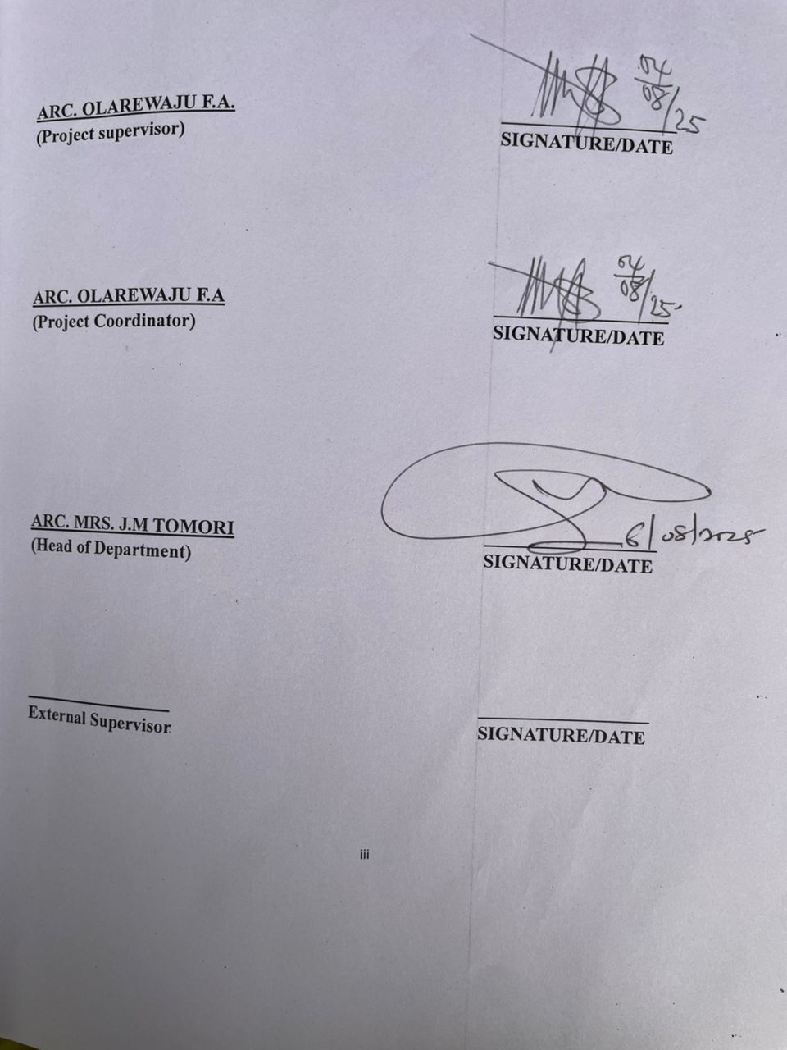

DECLARATION

“I declare that this project/dissertation area project of my personal research work. It has not been presented for the award of any HND in any polytechnic. The ideas, observation, comments, suggestion herein represent my own conviction except quotation, which have been acknowledged in accordance with conventional academic traditional.”

ASHIRU MUSLIUDEEN BABATUNDE HND/21/ARC/FT/141

SIGNATURE/DATE

DEDICATION

This project is dedicated to Almighty Allah who preserved me to reach this level in my education career.

ACKNOWLEDGEMENT

I Acknowledgement the almighty god the controller of the universe, the omnipotent, omni- science and the All-knowing God who has been my filler of strength, wisdom and a great provider of all through my academic to you be all the glory and praises.\
My appreciation also goes to my project supervisor ARC.ADEYEMI for his patience, guidance useful contribution and suggestion at the various stages of this project. May Almighty god continue to bless and uphold you.
My Appreciation also goes to my parent MR/MRS ASHIRU also to my family and friends for their immense contribution and support towards this project.

TABLE OF CONTENTS

TITLEPAGE i
CERTIFICATION ii
DECLARATION iii
DEDICATION iv
ACKNOWLEDGEMENT v
TABLEOFCONTENTS vi
CHAPTERONE
INTRODUCTION 1
BACKGROUNDOFSTUDY/HISTORICALBACKGROUND 2
DEFINATION 3
JUSTIFICATIONOFSTUDY 4
AIMANDOBJECTIVE 4
SCOPEOFTHESTUDY 5
DESIGNSCOPE 5
LIMITATIONOFSTUDY 6
RESEARCHMETHODOLOGY 6
CONTRIBUTIONTOTHEBODYOFKNOWLEDGEMENT 8
CHAPTERTWO
LITERATUREREVIEW 9
REVIEWOFRELEVANTLITERATURE 9
CASESTUDIES 10
CASESTUDYONE 11
CASESTUDYTWO 14
CASESTUDYTHREE 18
CHAPTERTHREE
HISTORY/INTRODUCTIONOFSTUDYAREA 23
SITELOCATION/DESCRIPTION 23
SITELOCATIONCRITERIA 23
SITEANALYSIS/INVENTORY 23
GEOGRAPHICAL/CLIMATICDATA 24
CHAPTERFOUR
DESIGNCRITERIA/DESIGNCONSIDERATION 27
BRIEFANALYSIS 27
SCOPEANALYSIS 27
APPAISALOFPROPOSEDSCHEME 28
SPATIALALLOCATION,SCHEDULEOFACCOMODATION 28
FUNCTIONALRELATIONSHIPDIAGRAM 29
CHAPTERFIVE
CONSTRUCTIONANDBUILDINGMATERIALS 34
SERVICES,CIRCULATION,VENTILATION,LIGHTENING,PLUMBINGAND
ELECTRICALINSTALLATIONETC. 34
CONCLUSION 38
RECOMMENDATIONS 38
REFERENCES 38
APPENDIX 40

CHAPTER ONE

  - INTRODUCTION

Indoor sports hall is universally used spaces designed to accommodate a variety sports some of these can take in a suitable game’s hall, and consequently it will be to settle on upon the range of game and levels before deciding the floor required area (peter Ackroyd 1995). The indoor game hall can be as a solitary ‘stand- alone’ structure with smallest bolster space or as a segment inside a larger structure. This sport building began to spring up during the end of the twentieth century. Earlier examples being basic games outbuilding on school places that gave fundamental climate projection to open spaces playing ground, others were a section of larger public sport building that were built in the 1970’^{s}.
Different development project and sport programmer in the 1980’^{s} saw the advancement of standard reduced and designs that were economical (sports halldesign and layout February 2018). Indoor sport hall activity can be competitive sport or for exercise purpose. Most sporting hall are designed in such a way that both national and international sport competition as well as country and club competition can take place in them. In this part the data given about every sport activity will by and large be limited to the required general sizes at the different perceived levels. Some of the sport buildings are large structure bounded by both dry and wet sport. It is feasible to have a dry or wet or sport complex. (Geraint john 1995). Such that variety of games can be hosted in a multipurpose indoor sporting hall each of this
game have individual count with the appropriate colour making. However, the utilization of lines minimizes the different sporting activities.
Many indoor games, including board games, or card games, were educational in nature nineteenth century board games, card games and jigsaw puzzles often depicted contemporary events as well as educational themes in her 1991 book on games.

HISTORICAL BACKGROUNDOFANINDOORGAME

When people think of the Olympics, they usually thank of thing like track and field, or other outdoor sports that have become synonymous with the games. But indoor sports are not to be overlooked when going over the history of the Olympics, as indoor sports have built a nice history of their own during the world’s biggest sporting event. You might now even find a (888 sport coupon code) for these kinds of sports event as well.
Of course, prominent indoor sports such as basketball and swimming have had a constant presence in the Olympics over the last half century and beyond as the current day Olympics would be unrecognizable without them.
There are of course, plenty of other indoor sports featured in the Olympics games as well sports like weightlifting, indoors cycling, wrestling and gymnastics are all featured indoors, and make it possible for spectators to enjoy all of the Olympics action they desire in an indoor setting. Sports like wrestling and weightlifting have been around for the entirely of the history of the Olympics, with their simplistic nature

and lack of modern equipment making them ideal for the games that were held in a less technologically advanced time period.
Overall, the history of indoor sports in the Olympics has become an illustrious one. At the same time, though, it is a history that still needs to be written, given how young most of the sports are relative to the age of the Olympics.
Badminton also took an interesting path to get into the Olympics once and for all. The sport was made a demonstration in1972, and was not picked up for the next Olympics games. Badminton was made a demonstration sport in 1988, and was then made a true Olympics sport for the 1992 games. Just like the Olympics themselves, badminton is a great reminder that perseverance is often the key to success.
Other indoor sports did not need to be a demonstration sport before gaming access to being a full-on Olympics sport. Handball is one of those sports, which became an Olympics sports straight away in 1972. Table tennis is also in the club of indoor sports that earned immediate entry into the Olympics becoming an official part of the games in 1988, which it has been ever since.

DEFINITION

Indoor games are a variety of structured games or competitive physical exercise typically carried out either at home, in a well-sheltered building, or in a specially constructed sport venue such as a gym, a natatorium, an arena or a roofed stadium.

JUSTIFICATION FOR THE PROJECT

It has come to notice that higher institutions of learning in Nigeria today have so much contribution to sport development across the league of the country. This institution gets their student involve in various sporting and game activities so as to equate the balance between busy and free time and to possibly compete for inter institutional games and sport competitions.
Also, after successful completion of this project it will offers adequate and efficient movement participants in the indoor games in tern of provision of adequate space, easy navigation between the various sport facilities.

AIM AND OBJECTIVES AIM
The main aim of this project is to design a modern physical structure that will accommodate the users of their maximum satisfaction.

OBJECTIVES

    - Providing suitable space which is capable of accommodating the require facilities needed in any standard indoor sport hall.
    - The provision of aesthetical balance design that will attract greater patronage.

    - Provision of adequate spectators seating for athletic event.

SCOPE OF THE PROJECT

    - Security Post
    - Generator House

    - Parking Lots
    - Training Ground

    - Main Building
    - Mosque

DESIGNSCOPE
    - Entrance
    - Reception

    - Ticket room

    - Coach office
    - Clinic offices

    - Male change room
    - Female change room

    - Offices
    - Male toilet

    - Female toilet

    - Basketball and Tennis Courthall

LIMITATION OF PROJECT

The major limitation against this project is that it will consume more time andit will be combined with other academic work. This might delay the speedy execution of the project.

RESEARC HMETHODOLOGY

Indoor sports game centres –Research on their use, users and non-users and its impact on policy, provision management.

Mike Fiizjohn and Malcolm Tungatt INTRODUCTION
- Over the past six decades and especially from the 1960s to the late 1990s,no national sporting topic received so much attention through reviews, reports and publications as the planning, development, management of and research into community indoor sports centers. In the 1960s, several were initiated by the Central Council of Physical Recreation (CCPR) and the National Playing Fields Association (NPFA) from 1965 of was the sports council, assisted from 1966 by the regional sports’ councils (and their successor bodies) that led the charge through the 1970s, 80s and 90s ably led from 1972 by the Late Mike Collins, Head of Research and our former boss whose role was massively influential. Academia too was quickto latch on to this emerging social phenomenon, producing copious research papers

and books. Indeed, sports centers spawned a small industry in research reviews and strategic planning over the period.
- Our intention here is to cover one small but highly significant, part of allthis endeavour – research studies of use and users of sports centers and in the later years, studies of people not using sports centers and how this feedback into policy provision and management. Our views are both personal and partial (and we would welcome feedback, additional contributions and alternative perspectives from others) personal because we are inevitably influenced by work undertaken by ourselves and partial because, despite huge searches, copies of many once seminal works appear to have vanished from the face of the earth.

1965–1972: The search for a standard of provision or Build and Hope

WHEN THE FIRST COMMUNITY SPORTS GAME CENTRES WERE EMERGINGINTHE1960sTOWNANDCOUNTRYPLANNINGWASITSELF
EVOLVING RAPIDLY. The historic roots of the profession in architecture, landscape design, civil and municipal engineering and surveying, whose practitioners had overseen post-war reconstruction and the development of the New Towns were being augmented by a wave of young planners, for whom it was their first discipline. Other disciplines too such as sociology and economics, where increasingly being through to bear on the subject, often from academia ‘standards’ of (space) provision where starting to give way to carefully researched methodologies which better reflected the human activities for which they were designed. This keeble(2),writing in 1964 was

able to devote a chapter to open space standards, including provision for outdoor sport (but not of course anything an indoor provision), but was also able elsewhere to suggest that “in preparing the town plan it is useful to know the catchment areas of influence of various public services” (through again, of course, he did not have indoor sports game centers in mind).
ORAL INTERVIEW: Oral interview was also conducted with people involved with the indoor sport complex such as the secretary to the sport director.
INTERNET: Research was made through internet from different website about indoor sport hall and indoor games.

CHAPTERTWO

2.1LITERATUREREVIEW
Tariq S. et. Al (2011); had evaluate organizational structure administrative framework and facilities of sports in district jail of Lucknow U.P, India. The sample ofthe present studywas drawn randomly from the jail administrators.
Mass Soumeh B. et. Al (2010); had reviewed the current literature on sports facilities worldwide to identify the gap address issues on the development of sport facilities development in Malasiya.
Yasmeen I. (2010); had identified them and endeavours to provide a better insight in the athletic potential of women. The biological female athlete was manifested in physiological and characteristics.
Sophie I. et. Al (2010); had been conducted with a view to compare the infrastructure between government and private college of purvanchal. This study was carried out 34 private colleges of purvanchal and data was from respective principal physical education teachers from self made questionnaires.
Dobbins et. Al (2009); had conducted a study on the topic “school based physical activity programs for promoting physical activity programs for promoting physical activity and fitness in children and adolescents aged given that there are no harmful effects and that there is some evidence of positive effects of lifestyle behaviours in schools is recommended at this time”.
Vivek S. (2012); was studied to equate the perception of society of physical education facilities in rural and urban district schools of U.P for the purpose of the study two rural and urban were selected.

Naylor et. Al (2008); had done study on the topic “An active school model to promote physical activity in elementary schools, action schools! BC “ The positive effect of the AS! BC Modelon boys’ PA is important in light of the current global strand of decreased PA”.
Leoni et. Al (2008); were conducted a study on the topic “Survey on sports practice and physical activities of primary school children in the area of Bologna Local health limit in relation with some individual and environment variables”. The prevalence of overweight is 24.4% of obesity 9.7% with a better distribution of BMI values in the metropolitan area where there is the highest occurrence of positive condition and behaviours; available of sports facilities, the highest prevalence of sports practice, and he lowest prevalence of completely sedentary children.
Bailey et. Al (2006); had proved that PES can have positive and profound effect in some respect, such an effect is unique, owing to the distinctive in which PES take place.
Saryhara et. Al (2004); had conducted a study on the topic “Survey of programme facilities and personnel services in Physical Education Colleges and University, Departments of Gujarat State”. The University of Department of Physical Education (66.66%) Government Aided Colleges (80%) Self Financed Colleges (72.33%) had the facilities of multipurpose hall. No indoor volleyball and basketball, facilities in any department of colleges, existed the University Department of Physical Education (91.67%) Government Aided Colleges (100%) and Self Financed Colleges (90.90%) had 400m Athletic track with necessary equipment. The University Department (25%) Government Aided Colleges (40%), Self Financed Colleges (9.10%) bad swimming pools facilities.

CASE STUDY ONE

Case study one was done at Lekan Salami indoor sport hall Adamasingba Area Ibadan Oyo state. The building was constructed with the name focus of having a building where physical activities can be carried out and indoor games can be played and most especially for the benefit of physical health.

HISTORY

Adamasingba Complex was built on 130,000 square meter of land, formerly occupied by Ibadan Race Course. It was open on 28 May, 1988. Development plan for the complex began in 1976 during the administration of DAVID JEMIBEWON. The race course space had gone unused and had been occupied by illegal structures and activities, to reclaim the land, the military government of Jemibe won decided to build a recreational and sports complex. While the initial design was for a sports and recreational complex, provision of additional facilities for shops was later added. At inception, the complex included a football field, tennis courts, squash court and indoor sports hall. Since it was opened, the facilities have been poorly maintained.
The stadium was named LEKAN SALAMI STADIUM in 1998 in honour of Chief Lekan Salami by the Oyo State Military Governor Hammed Usman.

MERIT OF CASE STUD YONE

    - It is early accessible

    - It is well ventilated

DEMERITOFCASESTUDYONE

- Lack of enough parking space

- Lack of modern facilities

- Poor training area
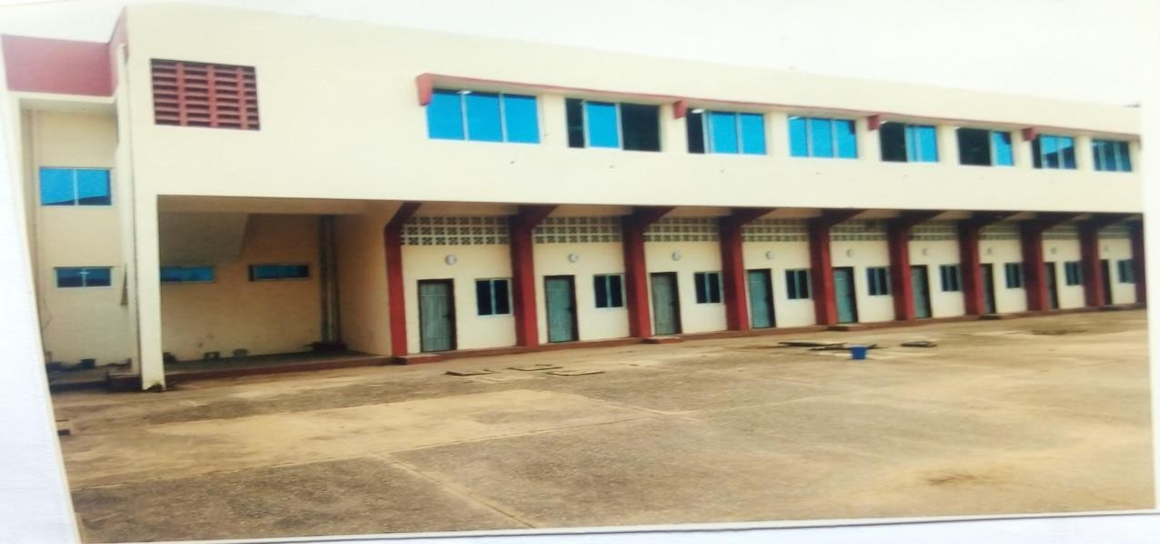
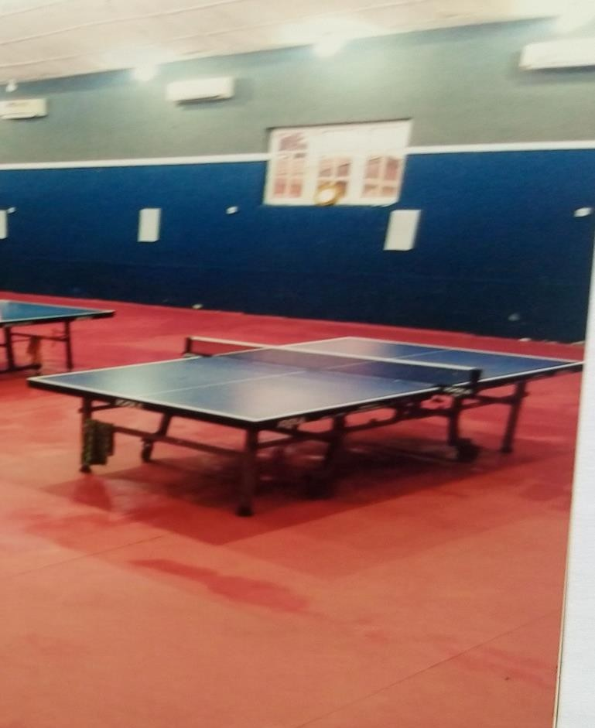

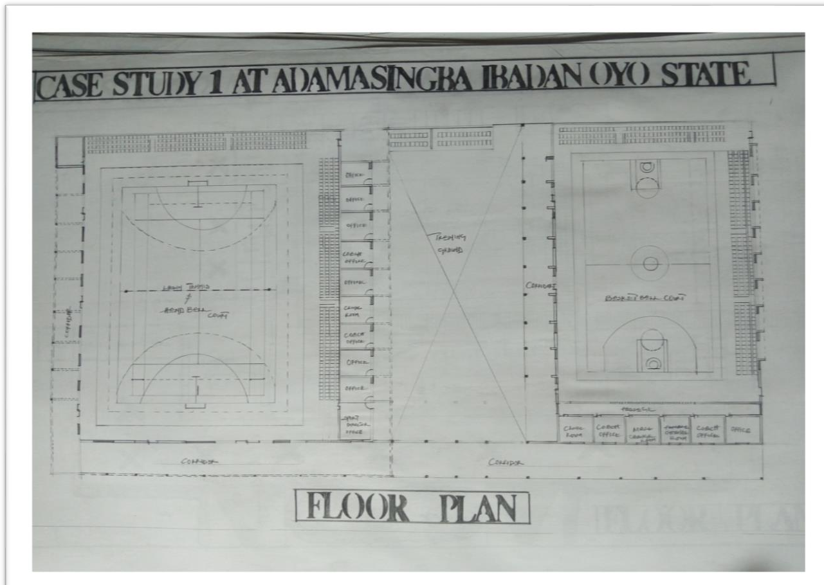

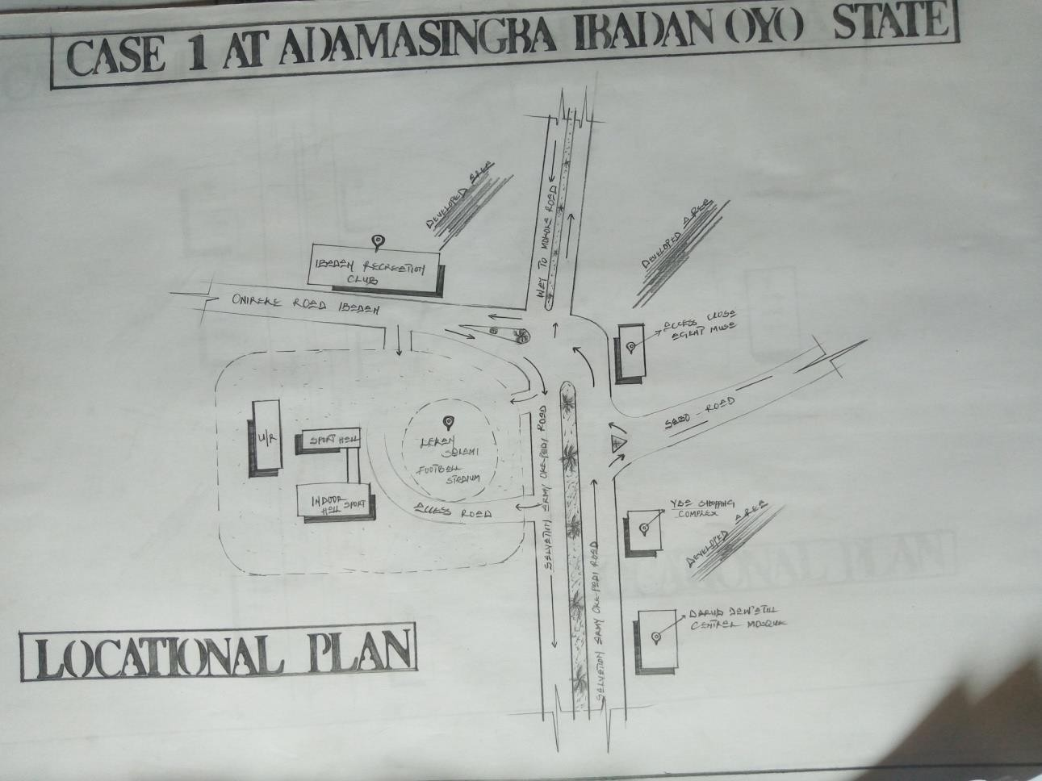

CASE STUDY TWO
Case study two was done at Kwara State stadium indoor sport hall, located at Ibrahim Taiwo road Ilorin East Kwara State.

HISTORY
The indoor section was constructed in order to improve indoor games and also for the purpose of been capable to host competition on 24th August 2017, Kwara State awarded the renovation of the indoor sport hall.
Kwara State Stadium indoor sport hall is a multi-use indoor game hall in Ilorin, Kwara, Nigeria. It is currently used mostly for tennis courts, basketball courts and indoor sport hall. After renovation work that started in 2010, it is located on Stadium road, Off Ibrahim Taiwo Road.

Merit Of Case Study Two
- It is easily accessible

- The sport hall are well ventilated

- It is well and scaped

Demerit of Case Study Two
- Poor maintenance of the facilities
- Poor floor finishes

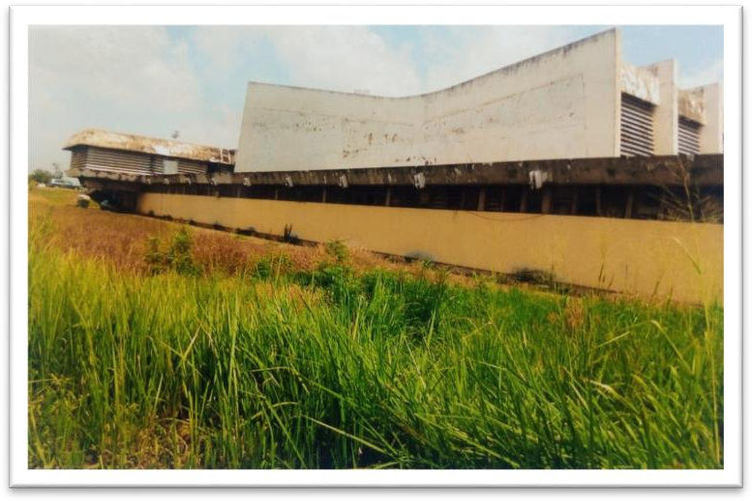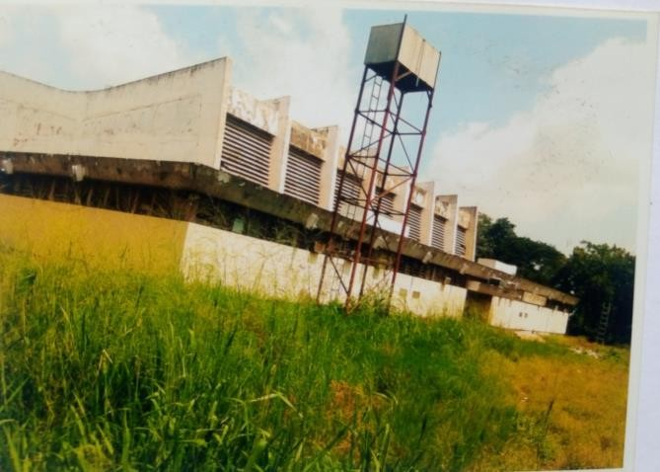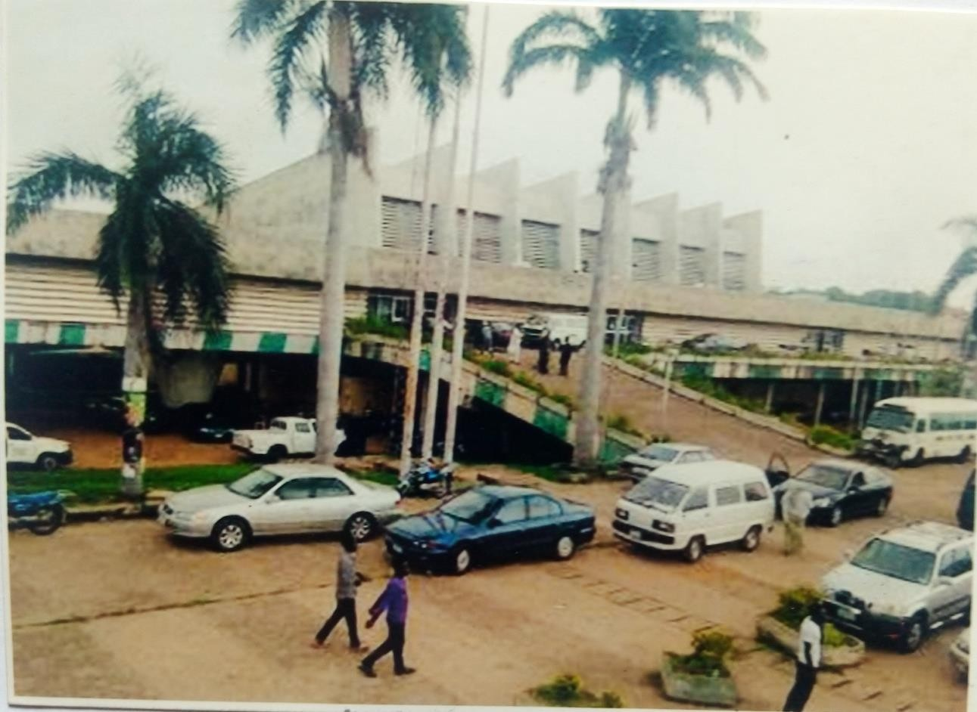

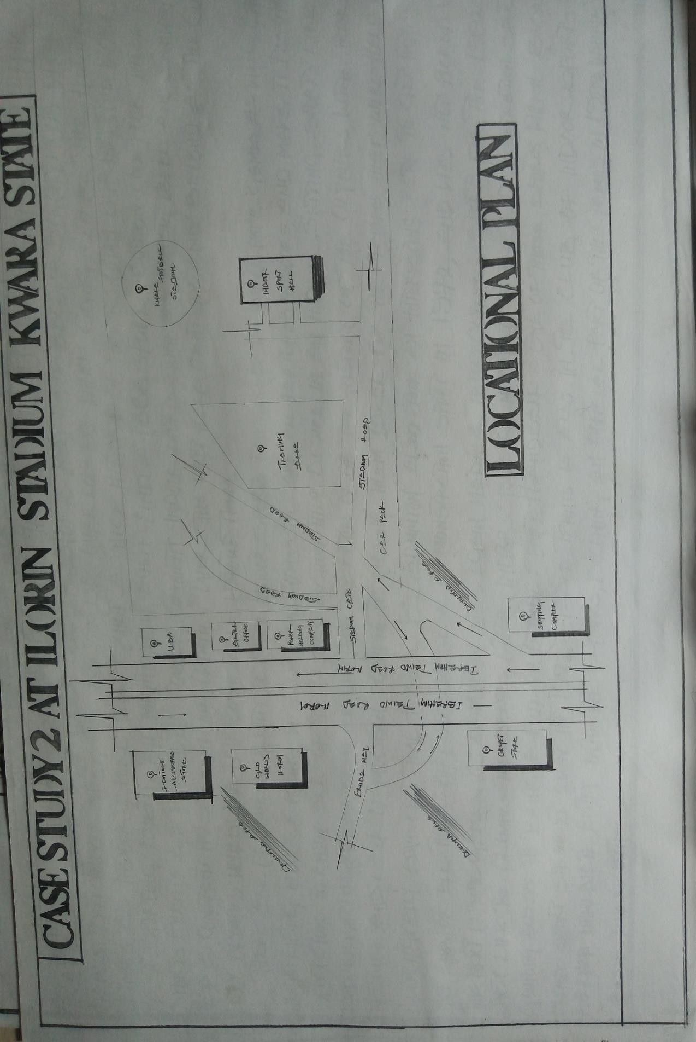

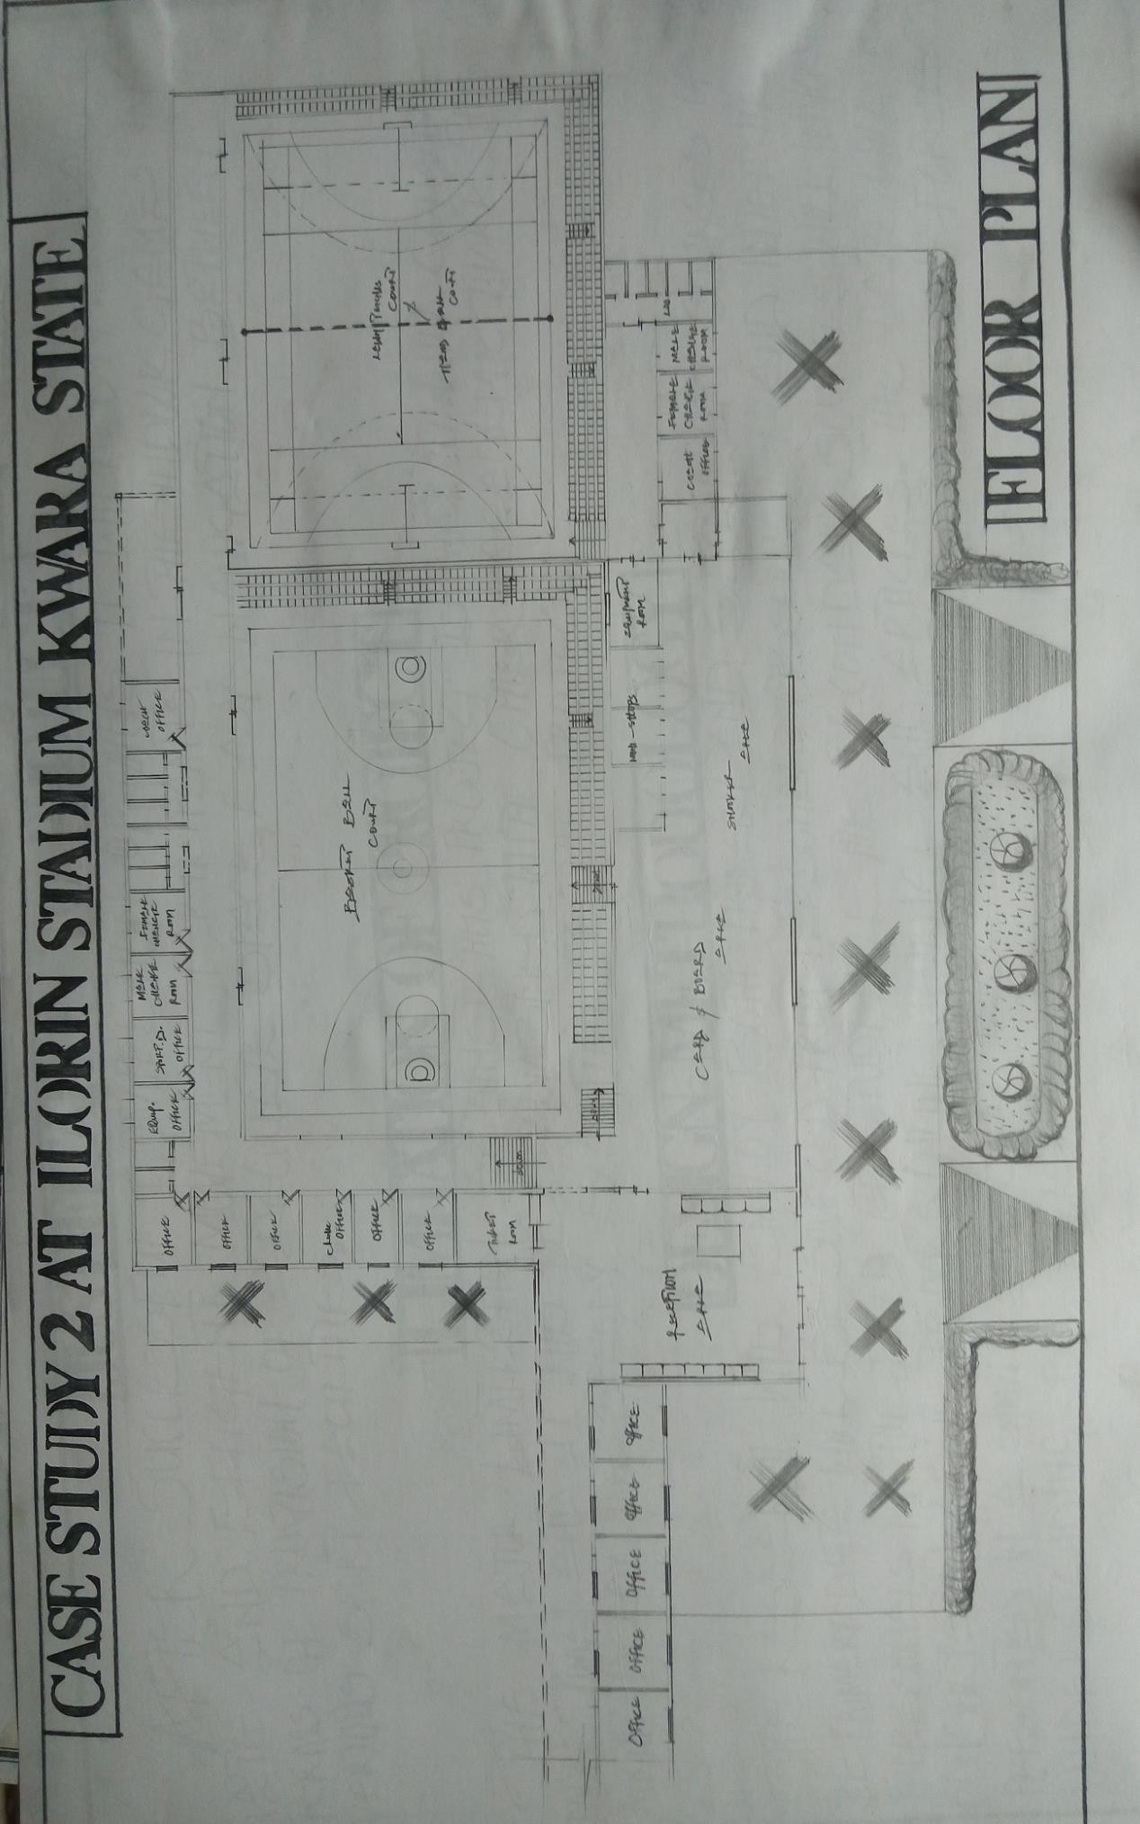

CASESTUDYTHREE

Case study three was done at Mobolaji Johnson indoor sport hall Yaba Lagos. It was constructed to foster the physical fitness of people and to also enable local and national competition.

HISTORY

The MOBOLAJI JOHNSON ARENA is a multi-purpose stadium indoor sport hall in Lagos. It is currently used for tennis courts, basketball courts and indoor sport hall and is the oldest in Nigeria located on the Southeastern Corner of Lagos Island near Tafawa Balewa Square, the original indoor sport hall was built in 1930 and six years later named after King George V. Between 1963 and 1973, it became known as the Lagos City Stadium Indoor Sport Hall.
In 2019, it was renamed by the Lagos State Government fromOnikan Stadium Indoor Sport Hall to MOBOLAJI JOHNSON INDOOR SPORT HALL.

Merit Of Case Study Three
- It is structurally balanced
- It is well ventilated
- It is early accessible

Demerit Of Case Study Three
- Poor land scaping
- Lack of modern facilities
- Lack of modern first aid equipment

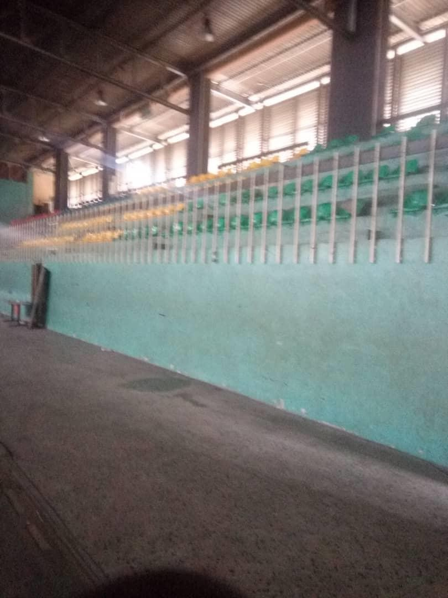

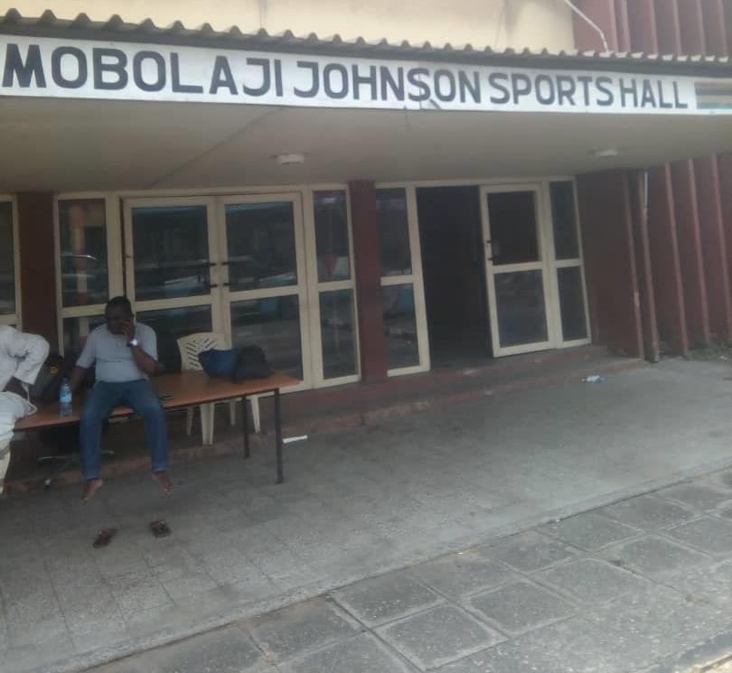
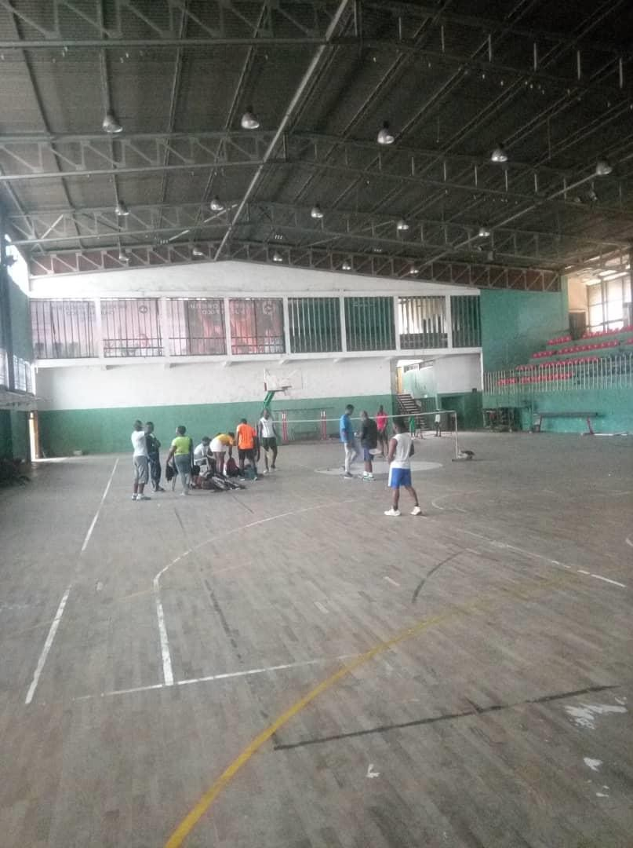

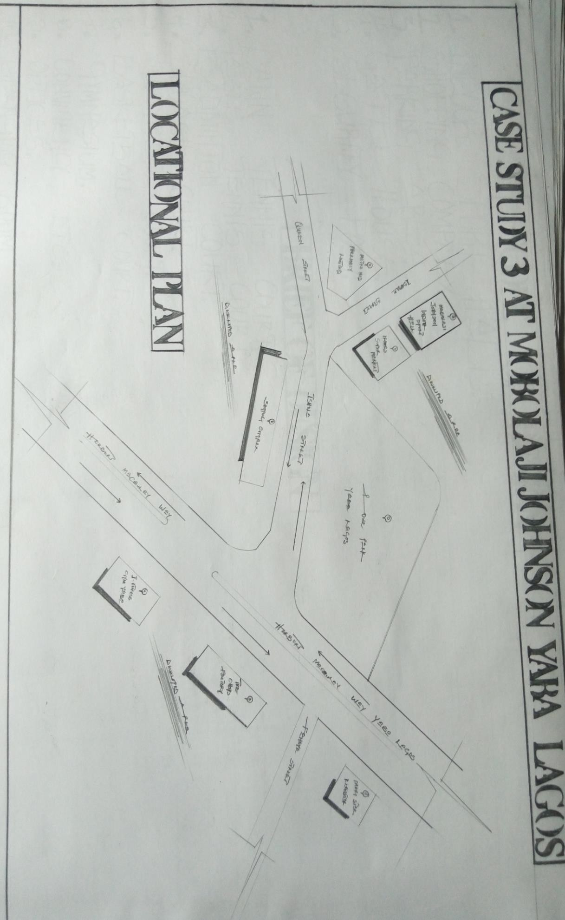

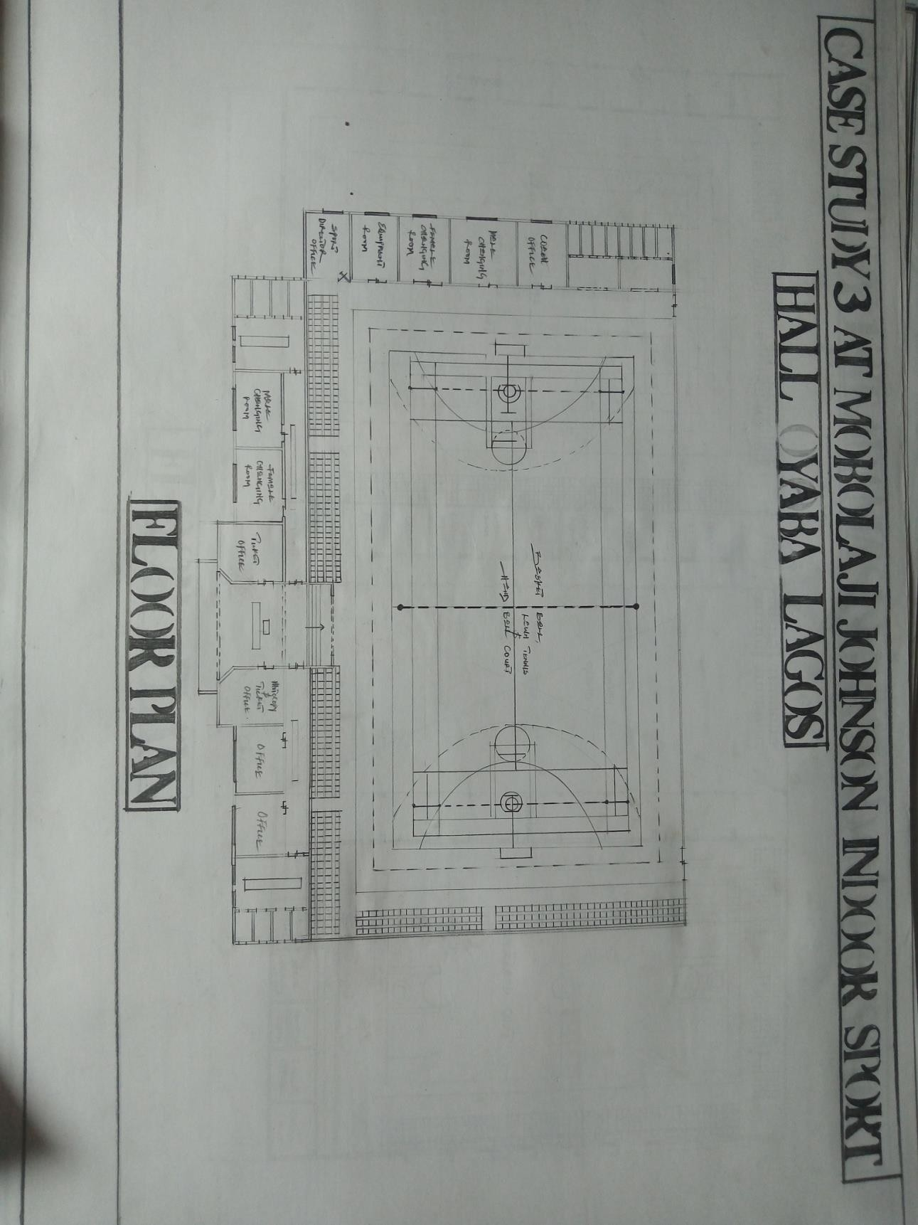

DEDUCTIONINCASESTUDIES

Deduction from case studies relevant design ideas as regard to the purpose project were gained and some deficiency in the construction method used as finished were also noticed. All the ideas gathered will be applied in my proposed design scope.
It was noticed that all demerit observed on the existing project will be seriously worked upon and demerits as guidelines to achieve a reasonable design.

CHAPTER THREE

  - HISTORY/INTRODUCTION OF STUDENT AREA PROJECT TOWN OFFA, KWARA STATE
OFFA is a town in Kwara State of Nigeria, with a population of about 166,122 inhabitants. The Town is noted for its wearing and dyeing trade, using vegetable dyes made from locally grown indigo and other plants.
OFFA is well known for cultivation of sweet potatoes and ‘maize’ which also formed part of the favorite staple foods of the indigenes in the town. Cattle, goats and sheep are also raised in the environment.

SITE DESCRIPTION

The site is located at ‘OLORUNKUSE AREA OFFA’ Beside Nawaraudeen Secondary School, Offa, Igbonna Road.

SITE SELECTION CRITERIA

The choice of the site is inevitable in situating a particular project in an area. This preamble aspect of a project has to be vividly put into consideration before the execution or commencement of any project.

SITE ANALYSIS

The site is carefully chosen to be the best location of the area and to receive the best atmospheric condition to give comfort.

The following observations are to be considered on the site

- The shape of the site relatively

- The soil nature

- The climatic and normal flowing on the site

CLIMATIC CONDITION OF OFFA, KWARA STATE OFFA CLIMATE SUMMARY
PRECIPITATION

A wet day is one with at least 6.04 inches of liquid or liquid equivalent precipitation. The chance of wet days in Offa varies very significantly throughout the year.
The water season lasts 6.3 months from April 14 to October 23, with a greater than 42% chance of a given day being a wet day. The month with the wet days in Offa is September, with an average of 24.5 days with at least 0.04 inches of precipitation.
The drier season lasts 5.7 months, from October 23 to April 14. The month with the fewest wet day in Offa is December, with an average of 0.6 days with at least 0.04 inches of precipitation.
Among wet days, we distinguish between those that experience rain alone, snow alone or a mixture of the two the month with the most days of rain alone in Offa is September, with an average of 24.5 days. Based on this categorization, the most common from of precipitation throughout the year is rain alone, with a peak probability of 83% on September 11.

DAILYCHANCEOFPRECIPITATIONINOFFA
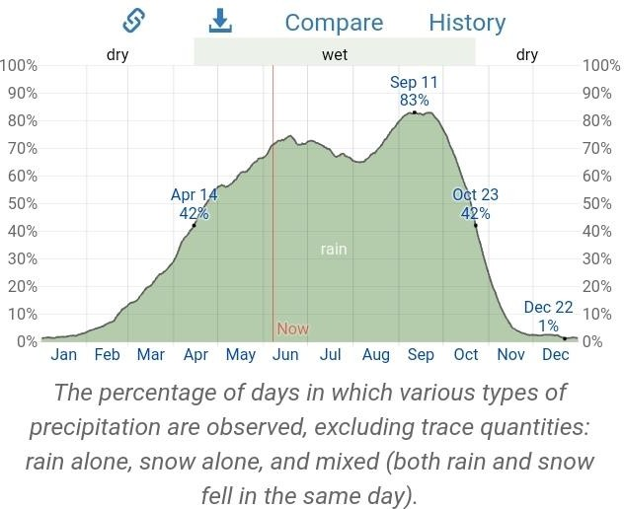

RAINFALL

To show variation within the months and not just the monthly totals, we show the rainfall accumulated over a sliding 31-day period centered around each day of the year. Offa experience extreme seasonal variation in monthly rainfall.
The rain period of the year lasts for 8.8 months from February 21 to November 15, with a sliding 31-day rainfall of at least 0.5 inches. The month with the most rain in Offa is September, with an average rainfall of 7.7 inches.
The rain less period of the year last for 3.2 months, from November15 to February 21
the months with the least rain in Offa is December, with an average rainfall of 0.1 inches.

AVERAGEMONTHLYRAINFALLINOFFA
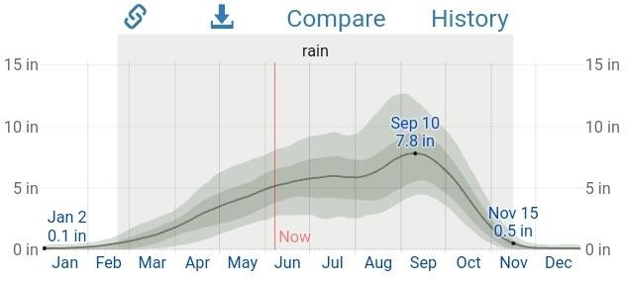

The average rainfall (solid line) accumulated over the course of a sliding 31-dayperiod centered on the day in question, with 25th to 75th and 10th to 90th percentile bands. The thin dotted line is the corresponding average snowfall

CHAPTER FOUR

  - DESIGN CRITERIA/DESIGN CONSIDERATION

Various factors are to be put into consideration when designing an indoor game. These factors are.
- The nature of the site

- The nature and function of the project

- The size and scope of the project

These factors will be explained soundly forelanty

- The nature of the site: This factor should be well considered because it entails topography and soil condition of the site. The type of foundation used in building.
Consideration depends on soil condition of the site.

- The natural and function of the project: The proposed indoor games is a civic building that serves as center of amusement for people confined to a building
- The size of the project: since the proposed indoor game Centre is a civic building and is designed to serve as a Centre for refreshment, reforming of mind and body to students.
Adequate land is used in actualizing the project.

SITE DEVELOPMENT/ZONING

Zoning refers to the placement of different and their space. On the site base on the functional requirement and their relationship with other functional space all with respect to the natural factors that are acting on the site.

PROJECTSCOPE

- Reception

- Ticket office

- Changing room(away team)

- Changing room(home team)

- Sport director office

- Assistance sport direct or office

- Conveniences for male and female

- Coach offices and contingencies

- Control room

- Equipment stores

- Shops

- Corridors & passages

- Courtyard

- Circulations

- Gymarea

- Main sports courts

- Table tennis, snooker and card & board game court

DESIGN SCOPE

(i.) Gate House/Security Post (ii.) Clinic
(iii.) Restaurant

(iv.) Shoppin complex
(v.) Car parking
(vi.) Public toilet (vii.) Generator house
(viii.) Proposed indoor game center

FUNCTIONALANALYSIS

It is the grouping of allowed space according to their function and relationship with one another. The grouping small be according shall be according to the allocate space and their function.

TYPES OF INDOOR GAMES

There are numerous types of indoor games. There is board game. In which we see game like cheese, scrabble, Ludo game etc. There are also games that require movement like volleyball, basketball, table tennis, badminton, lawn tennis and card games. Swimming is also an indoor game that can be done indoor.

FUNCTIONS OF INDOOR GAME

The functions of indoor games are to create an environment for pleasure and amusement so as to renew or create a relaxed body and soul when confined within an environment. These increase our knowledge, development of new skills and participation of activities in our social life.

SPACE DERIVATIVE ANALYSIS

CALCULATION OF ALL FURNITURE OR EQUIPMENT EXPECTED TO BE ALLOCATED IN THE DRESSING ROOM
- LIST OF ALL FURNITURE OR EQUIPMENT EXPECTED
  - Table
  - Chair
  - Wardrobe
  - Practicing Board
- GIVINGAREAOFEACHOFTHEFURNITUREOREQUIPMENT
  - Coverage of Table=1.2mX5.0m=6.0m²
  - Coverage of Chair=0.6mX0.6m=0.36m²
Note: The Total Number of Chair to be allotted in the dressing room=36
:-To get the area of all chair =Area of Single chair X Total Number of Chairs
=0.36 X 0.36
= 12.96m²
- COVERAGE OF WARDROBE
- Wardrobe(A)=5.5mX0.6m=3.3m²
- Wardrobe(B)=5.5mX0.6m=3.3m²
:-Total Area of all wardrobe=6.6m²
- COVERAGEOFPRACTICINGBOARD=3.0mX0.6m=1.8m²
:-𝜀=27.66m²

LIST OF THE AREA

S/N | FURNITURE | AREAS
1. | FURNITURE | 6.0m²
2. | TABLE | 12.96m²
3. | CAHARI | 6.6m²
4. | PARTICULARBOARD | 1.8m²
 | TOTAL | 27.36m²
PROVIDE FOR CIRCULATION

Assume 70% of TotalArea = 0.70X27.36m²=19.15m²sum up the area of the circulation 𝜀 = A + B = 27.36m² X 19.15m²
=46,512m²

SPACESCHEDULE

S/N | LOCATION | LXB(M) | LXB=M²
1. | Reception | 15mX11m | 165m²
2. | Ticket Room | 5.5mX3.0m | 16.5m²
3. | Circulation Area | 5.5mX 10.0m | 55m²
4. | Sport Hall | 36.5mX 23.0m | 839.5m²
5. | Gym Room | 11.5mX7.8m | 89.7m²
6. | Control Room | 7.8mX8.0m | 62.4m²
7. | Sport Coordinator | 7.8mX 10.0m | 70m²
8. | Commentator Office | 8.0mX5.0m | 40m²
9. | Exit | 2.7mX8.0m | 21.6m²
10. | Equipment Room | 19.0mX6.0m | 114m²
11. | Shop | 4.2mX3.6m | 15.12m²
12. | Changing Room | 6.0mX4.5m | 27m²
13. | Coach Office | 3.0mX7.0m | 21m²
14. | Court Yard | 12.0mX 7.2m | 180m²
15. | Circulation Area | 7.0mX4.2m | 50.4m²
16. | Equipment Room | 5.0mX4.3m | 21.0m²
17. | Table Tennis Courts | 1.0mX 23.5m | 235m²
18. | Snooker Court | 10.0mX 23.5m | 235m²
19. | Corridor | 25.0mX2.1m | 52.5m²
20. | Changing Room | 4.5mX3.6m | 16.2m²
21. | Coach Office | 4.5mX3.0m | 13.5m²
22. | Conveniences | 1.5mX1.8m | 2.7m²
23. | Changing Room | 7.0mX6.6m | 46.5m²
 |  | TOTAL | 2,389.22m²

CHAPTER FIVE CONSTRUCTION AND BUILDING MATERIALS CONSTRUCTION METHODOLOGY AND DESIGN
In the construction of building for the proposed indoor game center, the use of construction method will be employed. Design of the building will be construction before the block work. This will allow accurate construction of all the facilities provided will be handled by expertise and practicing architect for accuracy.

CHOICE OF MATERIALS

The construction technique and materials to be used in the proposed indoor sport hall are influenced by the following factors:
    - Durability and suitability of materials
    - Cost of material
    - Maintenance cost
    - Climate condition
    - Users

      - ROOFING: Roof is very sensitive and important element both in the purpose it serves and by it exposed to all the variable weather and such is objective to a lot of war and hard conditions. Roof should preferably be spacing galvanized aluminum roofing sheet is adopted in all indoor sport hall for project.
      - CEILING: The ceiling material should be attractive easy to clean. It should be of moderate cost limit finished like celotex is recommended.

      - WALL: Load bearing man sonly wall is used and finished with 25mm thick wall rendered and painted according to colour specification of the installation toilet wall are treated differently with ceramic title to minimum height of 2.1mm.
      - FLOOR: Some of these things should be put into consideration before choosing type of floor finishes. Such factors are:
        - Durability

        - Hygiene and fire resistance

        - Resistance to wear
        - Resistance to moisture

        - Economic factors i.e. the construction and maintenance cost should be reasonable
In above factors, the following recommendation were made 150mm thick over site concrete should be used for the entire floor and finished with plastic tile wall for the toilets.
      - DOOR: A door is a moving part of a building and is usually subjected to constant use and often abuse thoroughly its life therefore is must be carefully designed and made from good materials. The door of the office and changing room should be made of panel door while the doors to the flush door.
      - WINDOW: Window is a very important part of building. All windows in this project are casement types based on standard dimension
      - SERVICE: The handling of service in a building is very important in a building project service like electricity is tapped form PHCN pole in and
around the site for the use of the school. Tap water is dug in the site and pited to the indoor sport hall for adequate and regular provision of water and also plumbing and introduced in the toilet-soil drainage is done for water product which will be channeled with PVC pipe through main hole to the inspection chamber to the septic tank for final disposal to soak away tank.
Service like Air Condition (AC) is introduced to create a conductive atmospheric condition for human comfort.
      - VENTILATION: This is among the primary factors that determine human comfort for users and to activities this adequate ventilation in an indoor sport hall. Opening is located strategic and adjacent position to each other.
      - LIGHTENING: Adequate natural lightening is expected within the units ofthe building in the day and visual performance depends on total perceptions of space, quality as well as total amount of light. Interior of the building are lightened naturally with the interior part of the building.
      - PLUMBING: Plumbing is the system of pipe and system etc. that supply and store water for use for a building. The water will be supplied to the building through the borehole supply.
      - ELECTRICAL INSTALLATION: The Power Holding Company of Nigeria (PHCN) should be notified of the estimated total electrical supply that is required for the indoor sport hall during the planning stage of power supply into indoor sport hall and coordinate to the location of the services switchboard for two project, all cables will be constructed underground to reduce the disappointment owing to failure of PHCN and independent power supply will

be created on the site consistency to duel generator set. It will be an alternative use with one another as backup.
      - WASTE DISPOSAL: Waste disposal is the method of collection both liquid and solid waste in building as regard the project (Indoor Game Center) there will be tank for solid waste. Human excreta as well as discharge from toilet. Water closet pan and seat must be provided for uses to help them clean their hand after excretion.
      - ACOUSTIC: It is the study and the behaviour of sound in relation to the proposed buildings in design the control of intensive noise of great importance. This is achieved by the uses of acoustic material i.e. ceiling etc. The use of doors and window seal.
      - FIRE PROTECTION: Fire protection can be nerved into two ways fire prevention and fire control device, prevention of fire from its occurrence and better through detective which would be installed in the proposed building.

EXTERNALWORKS:
-Pedestratrian Circulation: The pedestrian has to be given an attention within the site. This is due to the fact that people are expected at the place at different time accessed area pared properly in such a way that people can have direct access to the structure when approaching the building strubs and edges flowers are planted to given a safe demarcation.
      - VEHICLECIRCULATION: There is provision for vehicle movement within the site also enough parking space are provided to ensure accessibility to the users.

      - LANDSCAPING ELEMENT: By definition landscaping simply means to enhance natural beauty required by the traditional architecture. The landscape element used to beautify the environment, some known of the soft landscape element used are the variety of grass covers flower and trees.

SUMMARY AND RECOMMENDATION
The major consideration in this design of the proposed indoor game center. Centered to provide adequate functional spaces that will meet the modern and comfortable indoor game center for the environment which will reflect with a well architectural planned and designed structure that will enhance the aesthetic value of the environment.

CONCLUSION
In conclusion, the deduction and experience learnt and gained from the essential research which was carried out has extremely exposed the research on issue related to hall and what is obtainable in indoor games centers throughout world.
Finally, these projects enlighten my knowledge positively and contribute to the advancement of educational development in Nigeria.

REFERENCES
Anita Lawrence (1989) Acoustics and built environment Elsevier Publishers Ltd. Barry R. (1982) The Construction of Building third edition, A John Uniley and Son’s Ltd Publication.
Denctira(1983) Architecture Site Planning, MacMillian Press Ltd.

Freezer Reckeir (1979) Draught Manship Architectural Building Graphics Granada Publisher
Neuter E. (1980) Architectural Data (Third National English Granada). Architecture details(2017)MicrosoftEncarta2017.Microsoft Corporation.
Google©2022“Newark Hotel”JackleJ.A and Sculle K.A (2004); lots of parking: land use in automobile culture, University of Virginia Press.
M.Facebook.comc2022“OgereHistory”happening in Ogun.
Mc Donald S.S. (2007) “Parking Facility” National Institute of Building McQuadeW.(1960)“Where are the parked trucks?”architectural forum.
Neufert E & P (2000) Architectural data Parking lot 2020 wikipedia encyclopedia www.wikipedia.com/parkinglothml Quora © 2022 “What are the sizes of lorries and parking lots ”online question by J.M. Clark. The; -Wikipedia c 2022 (en.m.wikipedia.org/wiki/hotel Wikitionary2020; online dictionary platform where most meaning and definitions of term and vocabulary used here are gotten from) (http://wikitionary.org)

