SECURE INTERACTIVE CHAT APPLICATION SYSTEM

BY

SULAIMAN OLAITAN YUSUF
ND/23/COM/PT/0130

A PROJECT REPORT SUBMITTED TO THE

DEPARTMENT OF COMPUTER SCIENCE
INSTITUTE OF INFORMATION AND COMMUNICATION TECHNOLOGY, KWARA STATE POLYTECHNIC ILORIN

IN PARTIAL FULFILLMENT OF THE REQUIREMENT FOR THE AWARD OF NATIONAL DIPLOMA (ND) IN COMPUTER SCIENCE

2025
CERTIFICATION
This is to certify that this project was carried out by Sulaiman Olaitan Yusufwith Matriculation Number ND/23/COM/PT/0130in the department of Computer Science, Institute of Information and Communication Technology, Kwara State Polytechnic, Ilorin.

------------------------------------- ----------------------
MR. ISIAKA, O.S. Date
(Project Supervisor)

--------------------------------- ----------------------
MR. OYEDEPO, F.S. Date
(Head of Department)

----------------------------------- ---------------------
External Supervisor Date

DEDICATION
This project is dedicated to Almighty Allah for His guidance over my life.

ACKNOWLEDGEMENT

TABLE OF CONTENT
TITLE PAGE i
CERTIFICATION ii
DEDICATION iii
ACKNOWLEDGMENT iv
TABLE OF CONTENTS v
ABSTRACT vii
CHAPTER ONE: GENERAL INTRODUCTION
1.1 INTRODUCTION 1
1.2 STATEMENT OF THE PROBLEM 2
1.3 AIM AND OBJECTIVES 2
1.4 SIGNIFICANCE OF THE STUDY 2
1.5 SCOPE AND LIMITATION 2
1.6 ORGANIZATION OF REPORT 3
CHAPTER TWO: LITERATURE REVIEW
2.1 REVIEW OF RELATED PAST WORK 4
2.2 INSTANT MESSENGER: THE FUTURE OF COMMUNICATION 5
2.3 ABBREVIATION: A SHORTHAND REVOLUTION 6
2.3.1 BROADCASTING 7
2.3.2 INTERACTION 7
2.4 IM: THE MESSAGE, THE MESSENGER, AND A NEW LIMINALITY 7
2.5 AWAY MESSAGES AND GREETINGS/CLOSINGS 8
CHAPTER THREE: METHODOLOGY AND ANALYSIS OF THE EXISTING SYSTEM
3.1 RESEARCH METHODOLOGY 9
3.2 ANALYSIS OF EXISTING SYSTEM 10
3.3 PROBLEM OF THE EXISTING SYSTEM 10
3.4 DESCRIPTION OF THE PROPOSED SYSTEM 10
3.5 ADVANTAGE OF THE PROPOSED SYSTEM 11
CHAPTER FOUR: DESIGN IMPLEMENTATION AND DOCUMENTATION
4.1 DESIGN OF THE SYSTEM 12
4.1.1 OUTPUT DESIGN 12
4.1.2 INPUT DESIGN 13
4.1.3 FILE DESIGN/DATABASE DESIGN 15
4.1.4 PROCEDURE DESIGN 15
4.2 IMPLEMENTATION OF THE SYSTEM 16
4.2.1 CHOICE OF PROGRAMMING LANGUAGE 16
4.2.2 HARDWARE SUPPORT 16
4.2.3 SOFTWARE SUPPORT 17
4.2.4 IMPLEMENTATION TECHNIQUE USED 17
4.3 DOCUMENTATION OF THE SYSTEM 17
4.3.1 PROGRAM DOCUMENTATION 18
4.3.2 OPERATING THE SYSTEM 18
4.3.3 MAINTAINING THE SYSTEM 18
CHAPTER FIVE: SUMMARY, CONCLUSION AND RECOMMENDATION
5.1 SUMMARY 19
5.2 CONCLUSION 19
5.3 RECOMMENDATION 19
REFERENCES 20
FLOWCHARTS 21
SOURCE CODE LISTING 30

ABSTRACT
This project will develop an application with a central database, and all other devices will be wirelessly connected to the database, allowing the connected system to send and receive messages. It will be designed in such a way that any amendments will be considered if the need arises. This project involved researching and implementing PC Chatting Software. It investigated systems utilized by other academic institutions, what users on such networks do with their network connections, and the feelings of both users and administrators towards acceptable use of an academic network connection. As a result, the programming language to be utilized for constructing this software is Visual Basic 6.0, and the back end will be a Microsoft Access database.

CHAPTER ONE
GENERAL INTRODUCTION
1.1 INTRODUCTION
Computers have come a long way since their forefathers. They have progressed from a simple home computer to today's market of computer devices that allow you to check your email, watch videos or movies, and even have one-on-one conversations. As a result of today's computer device market, you can have a variety of applications, such as GPS or even the latest video game, as well as various chat applications. Three factors influence the development of PC chatting applications. These include the maturation of computer network infrastructures, advanced computer hardware, and rising demand for computer applications/services.
Language is an essential component of human culture. Communication consists of many aspects, but humans are unique in that we have an organized spoken language, which allows us to communicate on a deeper, more personal level. We are becoming increasingly reliant on technology as we progress further into the electronic age. In the realm of language, this technology has taken us from face-to-face communication and letter writing to inventions such as the telephone, cell phone, online chat rooms, and, finally, Instant Messaging, one of the newest and fastest growing forms of communication. Given how quickly IM has spread, we must ask how it compares to the other modes of communication that we have at our disposal.
According to the results of an online survey, Instant Messenger comes in second place, right behind face-to-face communication, as the mode of interaction most commonly used: 35% of respondents said they used face-to-face communication the most, while 33% said they used Instant Messenger the most. Furthermore, 63% of respondents said they used Instant Messenger five or more times per day. What is the significance of this novel mode of communication in which two people can converse without even opening their mouths?
Although instant messaging has been celebrated as a symbol of communicative limitlessness, people have discovered it to be far more complex. After all, users are constrained by the medium's nature and the expectations of their peers — IM appears to have its own etiquette and set of regulatory patterns. Finally, instant messaging expands the boundaries of interpersonal communication or simply reconfigures existing boundaries that have always shaped the human experience. Investigation into the new phenomenon of Instant Messenger is a relevant topic in the study of language because it addresses all of the same issues that are relevant to spoken language. Instant Messenger could be considered a new communicative tool because it combines two previously disparate elements of language: it is written communication with no time delay.
1.2 STATEMENT OF THE PROBLEM
The primary issue confronting PC Chatting Software is the design of an interactive interface (environment) for users, as well as a lack of usability goals such as efficiency, effectiveness, good utility, difficult to learn, and so on.
1.3 AIM AND OBJECTIVES
The aim of this project is to create an application that will address the shortcomings of modern communication by replacing it with a system capable of exchanging instant messaging between users. The objectives are as follows:
i. Develop an interactive and user-friendly chat application that improves interpersonal relationships and understanding.
ii. Develop an application that simplifies the complex concept of sockets for a user-friendly environment.
1.4 SIGNIFICANCE OF THE STUDY
A PC chat application allows people to get the most out of their communication while spending the least amount of money. It also improves mutual understanding among people because, in terms of technological advancement, instant messaging has provided an easier, faster, and more convenient mode of communication among people.
1.5 SCOPE AND LIMITATION
The scope of this project is limited to some features that will allow users to effectively use the PC chat application's function. User registration, user authentication, messaging with a friend on a list, displaying online and offline users, and archiving messages are among the features available. It is also designed for one-on-one chat rather than conference chatting because the number of chat histories that can be stored is limited due to disk space and research time.
1.6 ORGANIZATION OF REPORT
This report is divided into five chapters, which are listed below. The first chapter provides a general introduction and overview of the entire research. It also discusses the problem statement, the aim and objectives of the proposed system, the significance of the study, the scope and limitations of the project, and the report's organization. The second chapter deals with the literature review, which includes a review of related topics to the project as well as a discussion of related aspects of the project topic related to computer technology. The third chapter deals with system analysis, which includes the data collection method used, a description of the existing system and its problems, and a description of the proposed system and the potential benefits it will provide to solve problems encountered in the existing manual system.The fourth chapter focuses on the proposed system's design, implementation, and description. It also describes the output design, the input design, the database design, and the procedure design. The techniques used in implementation, the programming language used in developing the new system, and the system requirements for running the system. It also discusses program documentation as well as user documentation. Finally, chapter five provides a brief summary of the work completed, experience gained, and problems encountered during the project, as well as a conclusion and recommendations. Following the references are the following appendices: algorithm, system flowchart, program flowchart, and program source listing.

CHAPTER TWO
LITERATURE REVIEW
2.1 REVIEW OF RELATED PAST WORKS
Christian, Arne& Anja (2003) investigated Internet chat systems. Although chat as an application does not generate a lot of traffic, chat systems are known to be habit-forming. This implies that catering to such users can be a promising way to attract them, particularly in low bandwidth environments like wireless networks. Unfortunately, there is no standard protocol foundation for chat systems. Rather, there are a plethora of protocol variants whose specifications, with a few exceptions such as IRC and ICQ, are either unavailable or poorly defined. Furthermore, chat systems are frequently layered on top of other application protocols such as HTTP. As a result, there is no simple way to identify chat traffic.
Nikita et al. (2014) concluded that Bluetooth allows for low-cost, low-power communication. In a mobile communication, wireless communication can also be accomplished with the help of Bluetooth technology. Short-range two-way communication has been established without network assistance. Bluetooth is built into Android, a popular Smartphone platform, as a means of mobile communication. Nowadays, Android is the most recent technology in Smartphones, offering open sourcing and powerful application APIs. Thus, we create a chatting application based on Android Bluetooth that establishes a Bluetooth connection between smart phones and then exchanges messages between them.
According to Nik et al. (2015), if messages are encrypted end to end, leaving only identifiers for anonymous inboxes in the unencrypted header, metadata can be easily hidden from service operators. An adversary cannot link single messages to conversations if each message is sent through a new channel. However, such schemes introduce adoption and usability issues; they are vulnerable to spam, flooding, and denial-of-service attacks, or they necessitate costly operations such as zero-knowledge authentication, posing adoption barriers. Worse, in these schemes, hiding metadata from a global adversary necessitates serious usability issues such as long delays. Decentralized schemes, on the other hand, either have synchronicity issues or serious scalability issues.
Chigozie, Williams& Osegi (2014) presented a hybrid social network for forming social communities within a university community. The semantic ontology was used for an offline/online social network site (SNS) using a Mobile Ad Hoc Network. It includes all of the essential features of a social networking site, such as profile creation, friend invite/search, group formation, chatting/messaging, blogging, and voting. During the implementation phase, three core frameworks were considered: the peer2me framework, the SMSN semantic mobile social network framework, and the Peoplepods framework. The results show that matching performance for prosumers with similar interests is exceptional, with relevance close to unity. The social network was able to meet the needs of university students by providing convenient directions to popular locations on campus.
2.2 INSTANT MESSANGER: THE FUTURE OF COMMUNICATION
Nowadays, a communication process is an important component for most organizations because it provides a lot of benefit to them. Communication between members of an organization, for example, is critical for archiving an organization's mission and vision. The Instant Chat Monitoring Tool Server is the better solution for all of the organization's fast and effective communication solutions.
Previously, there was no specific monitoring tool to monitor all Chat communication. The majority of monitoring tools now focus on monitoring the physical network environment. There is no need for video conferencing or any complicated configuration settings to create the best communication just in the local environment, we are supposed to use the Chat system to minimize the cost and time. The specific goal of this project is to develop the best solution for controlling and monitoring the chat process in order to create a fast and effective communication method.
Communication is constantly changing, and people must understand this change in order to apply it to their lives and relationships. There is a strong emphasis in Capitalist society on rushing, getting things done (right now), and never slowing down. As a result, utilizing technology has become easier, i.e. more time-efficient. You can make plans with a friend in two seconds over Instant Messenger, and you can use those cool self-checkout lines at the grocery store.The cost of modern conveniences like these, however, is the loss of personal contact with others. Nowadays, thanks to technological marvels, it is increasingly possible to filter all human interaction through a computer; one almost never has to interact with another person. We may be able to gain a better understanding of how human communication is changing in general by studying the changes in language caused by PC chat.
The pages that follow examine some of the fundamental aspects of instant messaging communication. Although instant messaging has been heralded as a symbol of communicative limitlessness, researchers discovered it to be far more complicated. After all, users are constrained by the medium's nature and the expectations of their peers—IM appears to have its own etiquette and set of regulatory patterns. Finally, we must ask whether instant messaging expands the boundaries of interpersonal communication or simply reconfigures existing boundaries that have always shaped the human experience.
Investigation into the new phenomenon of Instant Messenger is a relevant topic in the study of language because it addresses all of the same issues that are relevant to spoken language. Instant Messenger could be considered a new communicative tool because it combines two previously disparate elements of language: it is written communication with no time delay. People can compare instant messaging to Roman Jakobson's communication functions - the ideas of referential, emotive, conative, phatic, metalingual, and poetic functions examined in his "Closing Statements: Linguistics and Poetics" (Jakobson, 1960) - and discover that, while it appears to be very different from face-to-face, spoken conversations, each of these communicative functions can be found in typed dialogue."Any verbal behavior is goal-directed, but the aims are different, and the conformity of the means used to the effect aimed at is a problem that increasingly preoccupies inquirers into the various kinds of verbal communication," Jakobson (1960) maintains. Even though it is unspoken, instant messaging is a form of verbal communication.
2.3 ABBREVIATION: A SHORTHAND REVOLUTION
Although PC chat is arguably one of the best modes of communication, it does have a few drawbacks, one of which is the potential degradation of today's Standard English. One of the primary reasons instant messaging is such a popular mode of communication is its speed. People do not have to leave their room, or even their chair, in order to have a question answered. Instead, they can quickly look up another person's profile or away message and receive an instant response after sending a message.
2.3.1 BROADCASTING
Broadcasting is essentially old-fashioned public relations. You decide what to say and then write it up in a press release. You then compose a Tweet in which you encourage the reader to follow an attached link to the web page where your press release is located. Although you may choose to monitor the reaction to a broadcast tweet, feedback does not always guide your future actions. As a broadcaster, your primary goal is to get your content out there and hope that someone takes positive action as a result. The person who sends out your messaging is almost always anonymous, and the brand is focused on the company as a whole, rather than the individual team member doing the work.
2.3.2 INTERACTION
Interaction is a business-like approach to social media. It's simple customer service. Someone makes a comment about you, your organization, or your company, and you react in kind. Once you've addressed the issue, the relationship is over. When considering an interactive social media strategy, consider a bot. When someone utters a sentence, your bot analyzes it and responds. Interactors are more likely to categorize transaction types in order to identify trending topics and issues. This information could be used to guide a discussion about process improvement, pricing, or communication style. However, it does not delve deeply enough to comprehend your customer's motivations and deeper needs. Individual company team members may or may not be associated with the social media brand as part of the interaction strategy. Many team members are frequently involved in the transaction, but the customer rarely recalls who they are.
2.4 IM: THE MESSAGE, THE MESSENGER, AND A NEW LIMINALITY
Near the end of 1972, the first e-mail messages were sent via telegram-style pathways, but the eventual unfolding of hardware and software based on the principle of redundant connectivity resulted in an unexpected development. College students at various universities discovered that e-mail-like messages could be "posted" on individual pieces of online real estate, and the "bulletin board" craze was quickly on the rise (Diamond & Bates, 1995). Bulletin boards are similar to websites, but there are two major differences.
At the time, technology only allowed a user to connect his or her computer to one other "host" computer at a time. So, if the user wanted to visit the "Science Fiction Lovers" bulletin board first and then the "Rock 'n' Roll" bulletin board, he or she would have to connect and disconnect from each board separately. Another feature that distinguished bulletin boards from many modern websites was their complete reliance on the user community. Virtual bulletin boards were similar to their physical counterparts in that they were both devoid of content without contributions from the outside world.
Near the end of the 1980s, companies such as America Online (AOL), Prodigy, and CompuServe developed software that functioned as a "very sophisticated bulletin board," allowing people to explore various regions of "online" space without having to disconnect and reconnect at each move. According to Internet historian Jeff Tyson, AOL was the most influential in the development of what came to be known as the "online community." Perhaps most appealing to users was AOL's update of bulletin board technology, which now allowed users to interact in real time. Independent programmers created ICQ in 1996, the first technology that allowed one-on-one chat-room interaction. AOL quickly followed suit, and the Instant Message craze was on.
2.5 AWAY MESSAGES AND GREETINGS/CLOSINGS
Away messages, a feature of instant messaging that allows users to post a brief message of their choice that other people on their buddy list can view, are drastically changing the way college students communicate. "Away messages were originally designed to enable AIM [AOL Instant Messenger] users who were still logged on to their computers but not physically sitting at their machines to alert possible interlocutors not to expect immediate replies to instant messages" (Baron, 2003), but away messages have become a means of communication that allow people to find out information about other users without actually initiating conversation and speaking with them. This idea could imply that the amount of communication between students is decreasing because they do not need to speak to someone to find out what they are doing, or it could be interpreted as aiding in the increase of communication.
CHAPTER THREE
METHODOLOGY AND ANALYSIS OF THE EXISTING SYSTEM
3.1 RESEARCH METHODOLOGY
Many people accept the client-server model as the standard model for developing network applications. There are two concepts in this model: client and server. A server, as the name implies, is a process (or a computer on which the process is running) that provides services to other entities known as clients. A client, on the other hand, is a process (which is running) on the same or another computer that requests the server's services.
A chat application is made up of two applications: a server application and a client application. The server application is run on the server computer, while the client application is run on the client computer (or the machine with server). A client can send data to anyone who is connected to the server using this chat application. The Java application programming interface (API) includes classes for creating sockets, which allow programs to communicate over a network. Sockets are the endpoints of logical connections that can be used to send and receive data between two hosts. Because Java treats socket communications similarly to input and output operations, programs can read from and write to sockets just as easily as they can read from and write to files.
A server socket must be created and attached to a port, which is where the server listens for connections, in order to establish a server connection. The port recognizes the socket's Transmission Control Protocol service. For example, the email server typically runs on port 25, and the web server typically runs on port 80.
Server Execution: A thread is created on the server to handle multiple client requests. It also includes a list that stores the Client's name and IP address. The list is then broadcast to all users who are currently in the chatroom, and when a client logs out, the server deletes that client from the list, updates the list, and then broadcasts the list to all available clients.
Client Execution: A client must first register itself by sending a username to the server and then start the thread so that the system can obtain a list of all available clients. Any two registered clients can then communicate with one another.
3.2 ANALYSIS OF EXISTING SYSTEM
There is currently no system in place, and staff communication is primarily oral. Despite the fact that, since the introduction of social networking sites, most youth have been increasingly using instant messaging for socialization purposes. Oral communication is the primary form of socialization for Kwara State Polytechnic students. They form social groups among themselves in order to interact with one another, even though they are from different departments.
3.3 PROBLEMS OF EXISTING SYSTEM
Sending messages between employees in an organization is mostly done over the phone or the internet, with some face-to-face discussions thrown in for good measure. Sending a message through this medium costs money, and because it sometimes requires direct contact between two employees, the message to be sent may be lost or forgotten. There are also some issues that may be related to the current system, which are as follows:
- It costs money to recharge a phone or connect to the internet.
- It is difficult to make friends from the same organization when connected to the internet or by sending a phone message.
- It is difficult to hold an educational discussion among employees of the same organization because communication on the internet is a vast environment in which to communicate.
3.4 DESCRIPTION OF THE PROPOSED SYSTEM
The proposed system is based on a local area network, which allows employees within the same organization to easily communicate with one another at no cost. So sending messages between employees over the local area network has the following advantages, and the advantages are as follows: the local area social network does not require any financial investment. The proposed system is designed with PHP on a local area network that allows staff to send messages in a user-friendly environment, while My SQL is used as the database for storing our records, and SQL is used in querying our database.

3.5 ADVANTAGES OF THE PROPOSED SYSTEM
The proposed system is based on a local area network, which allows employees to communicate with one another without incurring any financial costs. The proposed system has several advantages over the existing system:
- It facilitates communication among employees within the same organization.
- It facilitates communication among employees in different departments within the same organization.
- It enables employees to easily discuss organizational issues.
- There is no cost to communicating via a local area network.
- Social interaction between employees in the same organization broadens, allowing employees to get to know each other very well, reducing conflict among employees.

CHAPTER FOUR:
DESIGN AND IMPLEMENTATION OF THE SYSTEM
4.1 DESIGN OF THE SYSTEM
This is the process of designing the input, output, and processing steps to meet the user's needs as identified in the system analysis. It begins with logical design, which results in a specification of the system's major features. Data, input, output, processing, storage, and other control requirements are among them.
4.1.1 OUTPUT DESIGN
The output design shows all registered users who have registered with the application, making record management simple. This design also allows users to view a recent blog display, which allows staff to post their blogs and comment on specific blogs.
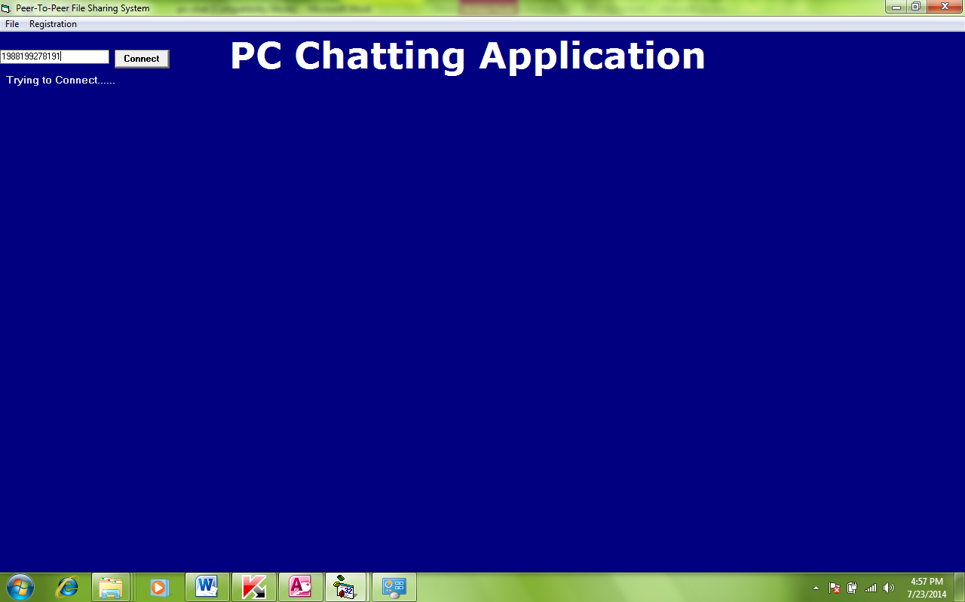

Figure 4.1: The Welcome Menu

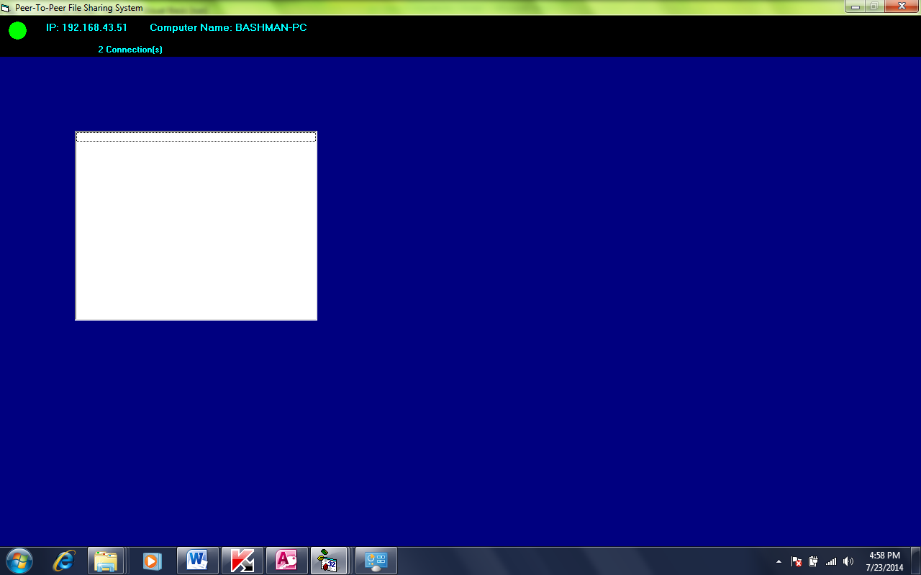

Figure 4.2:Sever Side
4.1.2 INPUT DESIGN
The input details enter client information that is to be entered on the chat page; it refers to the format or design of the input format on the screen. Inputs are the necessary information required for processing in order to produce the expected output, and they are supplied via the keyboard.
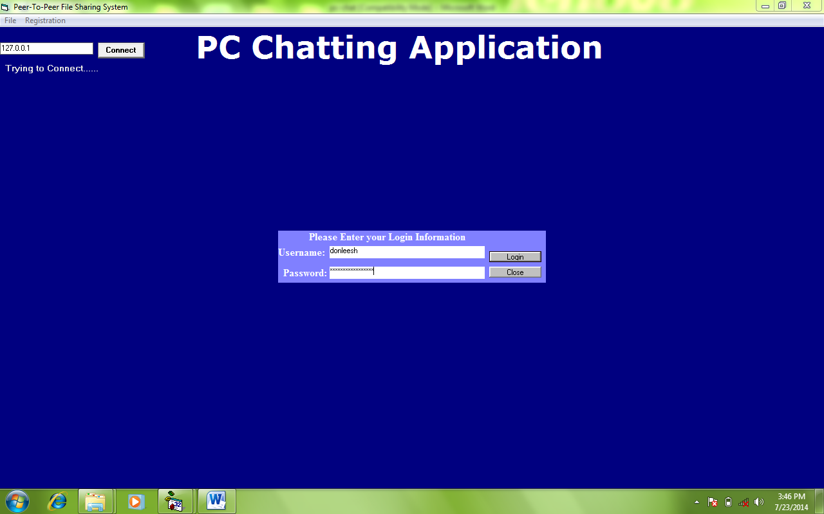

Figure 4.3: Login Menu

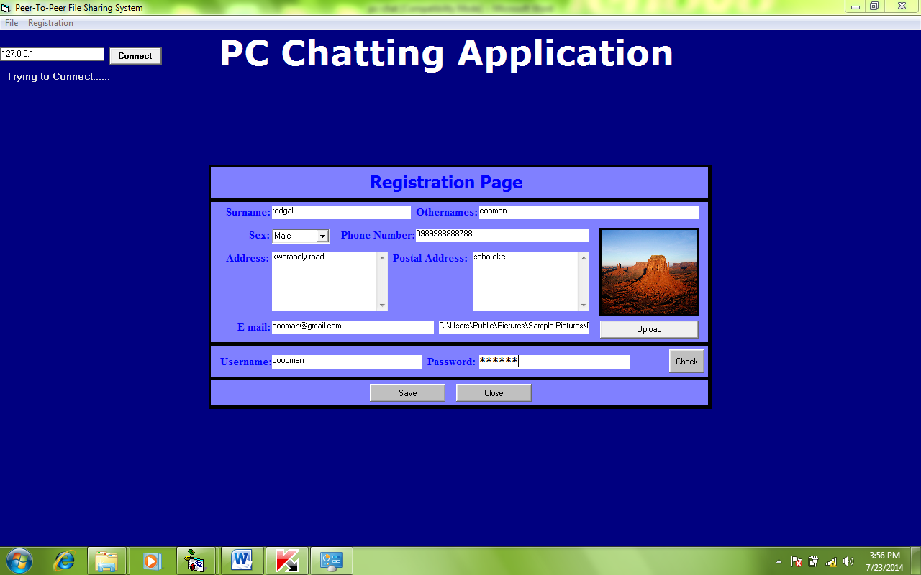
Figure 4.4: Registraion Menu
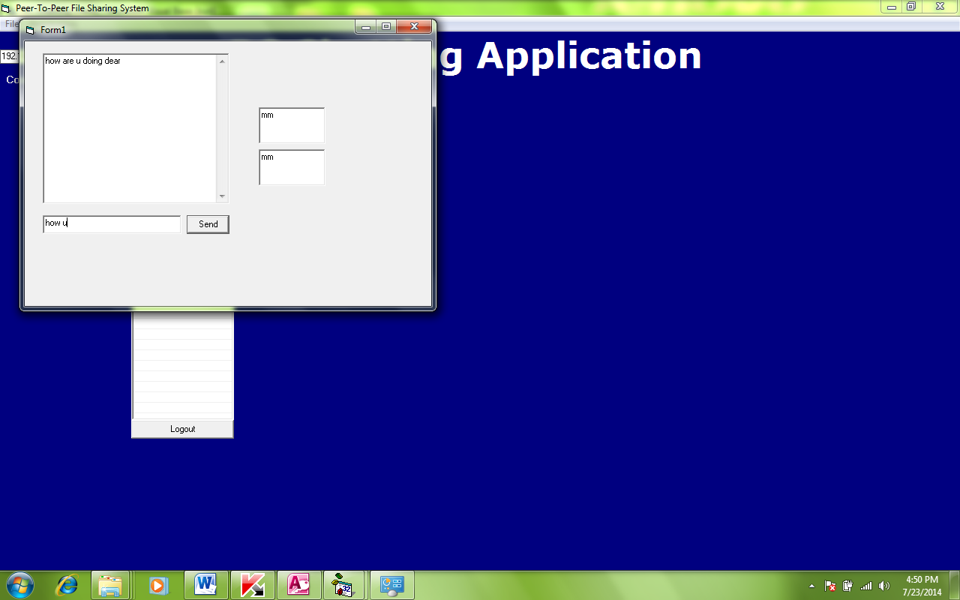

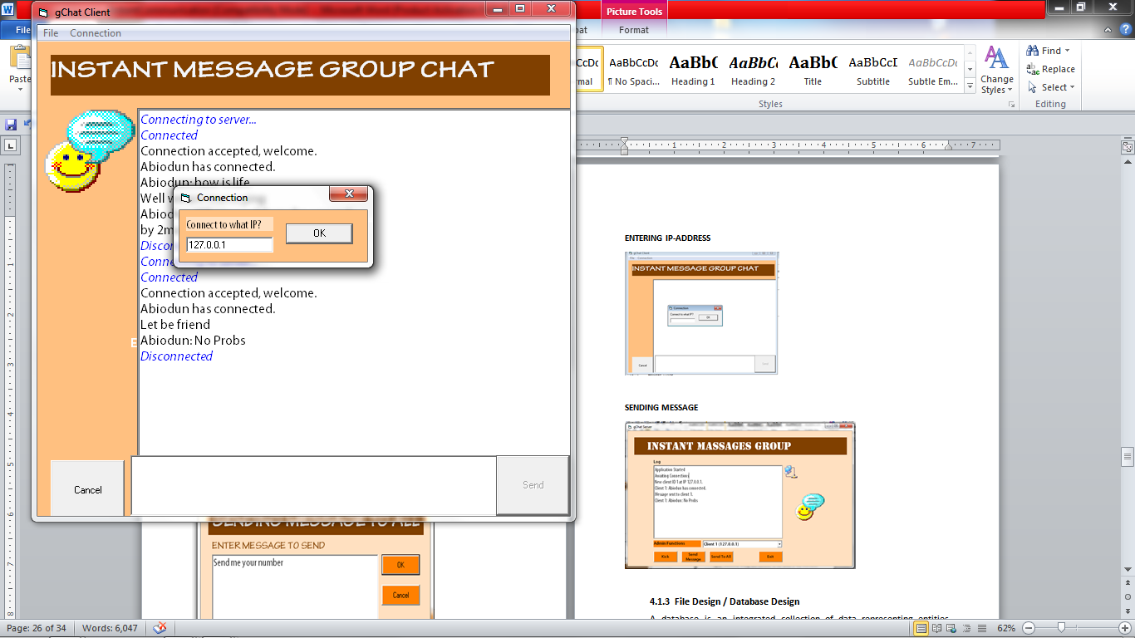
Figure 4.5: Sending Message Form

Figure 4.6: Entering IP-Address

4.1.3 FILE DESIGN / DATABASE DESIGN
A database is an integrated collection of data that represents entities important to the operation of an individual or organization; it is organized to reflect the logical relationship between data elements. A data base is at the heart of any information management system. This section provides detailed information on all data used in the design of this project; it provides analysis on the type, length, and so on. Two distinct data base structures were used in the design, as shown below:
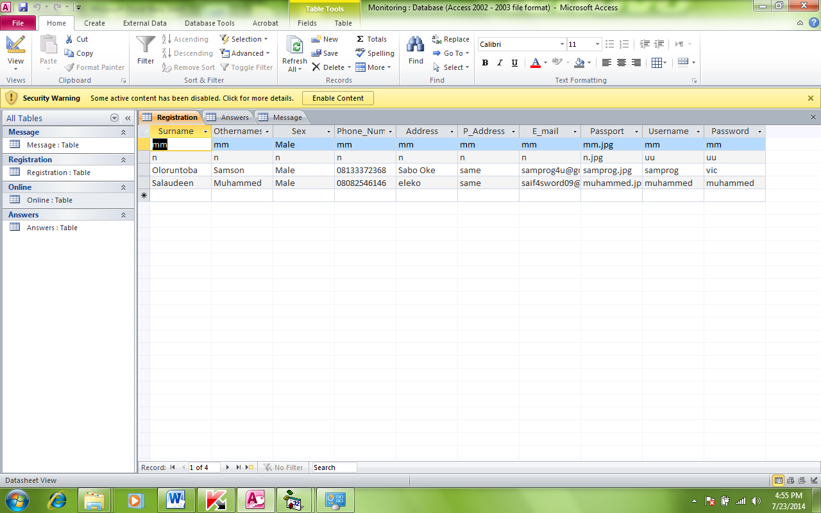

Figure 4.7: User Registration Table
4.1.4 PROCEDURE DESIGN
The procedure design refers to the overall structure of the program, i.e. how each section functions individually and collectively as a whole to make the program work/operate as specified. The system has four submenus, each of which has a different form and is controlled by modules. The system allows users to register as members in order to log in to the system. Users can also view their profiles and edit their information if necessary.

4.2 IMPLEMENTATIONOF THE SYSTEM
The capability and power of the computer on which the application system is installed determine the design system. However, the selection of application support (Hardware and Software) is heavily influenced by the following factors:
- How easily the user is able to interfere with the computer
- Cost and benefits
- Changes are supported by management.
As a result, selecting the appropriate hardware and software will improve system performance. The provision of internet access is a critical requirement on which the program's operation is based. As a result, any system that must run this program must be connected and ready to go.
4.2.1 CHOICE OF PROGRAMMING LANGUAGE
The system was created using Visual Basic 6.0 for interface design and Microsoft Access for database provision, with Dbase as the database management system. Various programming languages were examined during the analysis of the programming language to be used, but Visual Basic and Microsoft Access were chosen because they are server side programming languages. Because of the following reasons, it was decided to use Visual Basic.
- Visual Basic is simple to learn and use when designing.
- It is simple to manipulate in order to create a user-friendly environment.
- It is simple to manipulate in Microsoft Access for database reference.
4.2.2 HARDWARE SUPPORT
The following hardware is required for the system to function properly:
i. A voltage stabilizer with a minimum voltage of 240 volts.
ii. A 2.0GHz processor.
iii. RAM at 2.0GHz.
v. A modem (Modulator Demodulator).
v. A UPS
vi. A backup generator.
vii. An air conducting unit with a split design.
viii. Anti-spark devices to keep the system safe from sparks and lightning.
ix. The computer system.
4.2.3 SOFTWARE SUPPORT
The following are the software requirements:
- A network operating system such as Microsoft's Windows NT or Novell Netware.
- DBMS e.g. Access.
- Microsoft Access as the database query language.
- VB.server.
4.2.4 IMPLEMENTATION TECHNIQUES USED IN DETAILS
These are the processes and steps that are taken to put the system into use. Before the system can be fully employed into the system, some training may have been done by the user of the application if he or she is a computer illiterate. Because the user may be a computer illiterate, the system may also have been used. Because an expert's work cannot be eliminated from the system, the computerized system will have to collaborate with the expert in the field.
4.3 DOCUMENTATIONOF THE SYSTEM
After the program has been thoroughly tested with input from which the output is already known, the software is installed in the computer system for use. The installation procedure is outlined below. Following the completion of the program's installation. The next step is to find the package and install it so that it can be used. To find the package for expiration purposes, the following steps must be taken.

4.3.1 PROGRAM DOCUMENTATION
Working with software requires proper and adequate documentation, which is part of the quality of a good program. You click the start button, then locate all programs and click on PC-Chat on the home screen, enter your password and username, and the chat page will appear, listing all available friends in green for online friends and red for offline friends. As a result, you can select any menu from the list provided in order to perform any operation you desire.
4.3.2 OPERATING THE SYSTEM
The following algorithm must be followed in order for the system to function:
- Turn on the system.
- Let it boot and load all startup data and variables.
- Select the Start menu.
- Select the "PC-Chat" package and wait for the application to load.
The user can navigate and carry out the operation of the menu item by selecting one from the list of menus that appears on the application's main page.
4.3.3 MAINTAINING THE SYSTEM
The system's built-in safeguards prevent illegal or unintentional data file modification. Provisions for safely storing completed transactions, balances, and statements and restoring this information if necessary, and the software's ability to accurately recover from an accidental or improper shutdown.The system's features are well-suited to the needs of the social network. Integration refers to how well the system's various components communicate with one another, allowing data sharing and reducing the need for multiple data entries (the need to input the same data into different parts of the system).

CHAPTER FIVE
SUMMARY, CONCLUSION AND RECOMMENDATION
5.1 SUMMARY
Millions of people have joined social networking sites, where members create and maintain personal profiles that are linked to those of other members. The resulting network of "friends" or "contacts" who share similar interests, business goals, or academic courses has replaced older concepts of community for many people, particularly youth.
5.2 CONCLUSION
According to this study, PC Chat Messaging has changed the way people communicate. It enables immediate interaction as well as constant accessibility for interpersonal contact. Due to the solitary nature of PC-Chat, users can perform multiple tasks while carrying on multiple conversations, which is impossible with face-to-face conversations and much more difficult when on the phone. The presentational aspect of PC-Chat allows users to create an identity for themselves and express their personalities.Away messages, for example, allow users to constantly know where other people are and what they are doing, as well as learn personal information about a user without actually engaging in conversation with them. Another effect of away messages is that they have changed the way people enter into conversation by allowing people to avoid traditional linguistic conventions such as greetings. While it is clear that PC-Chat has caused changes in language and communication, we have discovered that these changes have both positive and negative aspects.
5.3 RECOMMENDATION
Chat application has always been an application that allows people to share ideas among themselves and it helps organizations achieve their optimum if not abused and if used properly for the required purpose. As a result, it is recommended that people use chat applications to improve and elevate their communications and relationships with one another.

REFERENCES
Baron N.S. et al (2003). Use of away messages in instantmessaging by american college student. Forthcoming in Rich Ling and Per Pedersen, eds. Front Stage – Back Stage: Mobile Communication and the Renegotiation of the Social Sphere. Springer-Verlag
Bauman R.(2001). Verbal art as performance in linguistic anthropology: A reader. AleessandroDuranti, ed. Oxford: Blackwell.
Bloch M. (1975). Introduction. political language and oratory in traditional society. Academic Press. New York
Boneva, B, Quinn (2006). Teenage communication in the instant messaging era. Springer press: New York.
Brown P. & Stephen C.L. (1978). Politeness: some universals in language use. Cambridge University Press:New York
Chigozie O., Williams P. & Osegi N.E. (2014); “Hybrid Social Networking Application for a University Community”
Christian D., Arne W. & Anja F. (2003). An analysis of Internet chat systems. IMC’03, October 27–29, Miami Beach, Florida, USA Copyright 2003ACM 1-58133-773-7/03/0010.
Flanagin, A.J. (2005). IM online: instant messaging use among college students. Communication research Reports. 22, 175-187.
KindredJ. & Roper S.L. (2004). Student use of IM to maintain personal relationships. Qualitative Research Report in communication. 5, 48-54
Krant R., Patterson M., Lundmark & Scherlis W.(1998). “Internet Paradox: A Social Technology that Reduces Social Involvement and Psychological Wellbeing”.America Psychologist.
Nik U. et al (2015). SoK: secure messaging. IEEE Symposium on Security and Privacy.
Nikita M. et al (2014). Design of chatting application based on android Bluetooth. International Journal of Computer Science and Mobile Computing, 3(3), 712-717.
Savicki V.& Kelly M.(2000). Computer mediated communication and group composition. Cyber psychology and behavior,3, 817-826.
Strom D. (2009). IM generation is changing the way business talk. The New York times.
Whittaker S. &BradnerE.(2000). Interaction and outeraction: instant messaging in action. Paper presented at the conference on computer supported cooperative work.
SYSTEM FLOWCHATFOR SERVER
START
LISTEN TO PORT

LISTEN TO IP ADDRESS

END

LISTEN TO PORT
RETURN
LISTEN TO PORT
OPEN PORT
START

LISTEN TO IP
STOP
LISTEN
START

SYSYTEM FLOWCHAT FOR CLIENT
END
CHAT
REGISTER
MAIN MENU
CONNECT TO SERVER
START

CONNECT TO SERVER
RETURN
CONNECT TO SERVER
OPEN CONNECTION
START

MAIN MENU

START
SELECT OPERATION
IS OPERATIONREGISTERATION?
IS OPERATION CHAT
RETURN
REGISTRATION
CHAT
Y
Y
N
N

REGISTER
START
OPEN DATABASE
INPUT DATA
IS ANY FIELD EMPTY?

CLOSE DATA BASE
RETURN
DISPLAY ALL FIELD ARE REQUIRED
Y
N
SAVE TO DATABASE

CHAT MENUE
START

OPEN DATA BASE
ENTER USERNAME AND PASSWORD
IS USERNAME AND PASSWORD CORRECT?
LOAD CHAT MENU

CLOSE DATA BASE
RETURN
DISPLAY INVALIDE USERNAME / PASSWORD
N
Y

CHAT
START
DISPLAY FREIND
IS ANY FRIEND ONLINE?
CONNECT TO FRIENDS
CHAT WITH FRIENDS
RETURN
N
Y

SOURCE CODE
'Dim LvAsListItem
Private Sub cmdconnect_Click()
Dim ip As String
WClient.Close
WClient.RemoteHost = txtIp.Text '"10.0.0.1"
WClient.RemotePort = 1007
Timer1.Enabled = True
End Sub

Private Sub Form_Load()
'connection
WClient.RemoteHost = "127.0.0.1"
WClient.RemotePort = 1007
WClient.Connect
End Sub
Private Sub mnuchat_Click()
frmLogin.ShowvbModal
End Sub

Private Sub mnuexit_Click()
End
End Sub
Private Sub mnureg_Click()
frmRegistration.ShowvbModal
End Sub
Private Sub Timer1_Timer()
lbltry2.Caption = "Trying to Connect......"
If WClient.State<>sckConnected Then
cmdconnect.Enabled = True
txtIp.Locked = False
WClient.Close
WClient.Connect
ElseIfWClient.State = sckConnected Then
lbltry2.Caption = "Connected to Server"
Timer1.Enabled = False
cmdconnect.Enabled = False
txtIp.Locked = True
Exit Sub
End If
End Sub

Private Sub WClient_DataArrival(ByValbytesTotal As Long)
WClient.GetDatasItem, vbString
Prog = Split(sItem, "==+==")
Select Case Prog(0)
Case "REGISTER"
MsgBoxProg(1)
frmRegistration.lblmsg.Visible = False
Case "ACCEPTED"
MsgBoxProg(1)
Unload frmLogin
frmOnline.ShowvbModal
'frmchat.ShowvbModal
Case "DACCEPTED"
MsgBoxProg(1)
Exit Sub

Case "LOGGEDOUT"
Unload frmOnline
MsgBoxProg(1)
Exit Sub
Case "CHATERR"
MsgBoxProg(1)
Exit Sub
Case "LOGGEDOUT2"
MsgBoxProg(1)
Exit Sub
Case "DATA"
'frmsavedmsg
Unload frmlogin4recieve
frmsavedmsg.Show
'MsgBoxProg(1)
'MsgBoxProg(2)
'MsgBoxProg(3)
'MsgBoxProg(4)
Set Lv = frmsavedmsg.lstitem.ListItems.Add(, , Prog(1))
Lv.SubItems(1) = Prog(2)
Lv.SubItems(2) = Prog(3)
Lv.SubItems(3) = Prog(4)

Case "CHATSUC"
frmchat.responseText
Case "CHATSUC2"
frmchat.responseText2
End Select
End Sub
Private StrArList(1000)
Dim LvAsListItem
Private Sub cmdLogout_Click()
frmMain.WClient.SendData "OUT" & "==+==" &Trim(txtusername.Text)
'user2 = Trim(txtusername.Text)
'user2pass = Trim(txtpassword.Text)
End Sub
Private Sub Form_Load()
Me.Left = Me.Left + 1
Me.Top = Me.Top + 100
txtusername.Text = user2
'frmMain.WClient.SendData "LOAD" & "==+==" & user
'On Error GoTo err
Network
sql = "Select * from Online"
rec.Opensql, con, adOpenDynamic, adLockOptimistic
LstView.ListItems.Clear
rec.MoveFirst
With rec
While Not .EOF
Set Lv = LstView.ListItems.Add(, , !UserName)
'Lv.SubItems(1) = !Password
.MoveNext
Wend
End With
Exit Sub
Err:
MsgBox "There was a problem loading drafts", vbCritical, "Error"
End Sub

Private Sub LstView_Click()
i = LstView.SelectedItem
'frmchat.txtMessages.Text = i'StrArList(i)
frmchat.ShowvbModal
End Sub
Private Sub LstView_DblClick()
'frmchat.Show
End Sub
Private Sub tmrOnline_Timer()
Me.Left = Me.Left + 1
Me.Top = Me.Top + 100
txtusername.Text = user2
'frmMain.WClient.SendData "LOAD" & "==+==" & user
'On Error GoTo err
Network
sql = "Select * from Online"
rec.Opensql, con, adOpenDynamic, adLockOptimistic
LstView.ListItems.Clear
rec.MoveFirst
With rec
While Not .EOF
Set Lv = LstView.ListItems.Add(, , !UserName)
'Lv.SubItems(1) = !Password
.MoveNext
Wend
End With
Exit Sub
Err:
MsgBox "There was a problem loading drafts", vbCritical, "Error"
End Sub
Dim id As Integer
Dim c As String
Private Sub cmdcancel_Click()
Unload Me
End Sub
Private Sub cmdcheck_Click()
cmdcheck.Visible = False
If txtUsername.Text = Empty Then
MsgBox "Username Is Required", vbCritical, "Registration"
txtUsername.SetFocus
Exit Sub
End If
frmMain.WClient.SendData "CHECK" & "==+==" &Trim(txtUsername.Text)
End Sub
Private Sub cmdclear_Click()
'cmbDepartment.Text = "Select"
End Sub

Private Sub Command3_Click()
End Sub
Private Sub cmdsave_Click()
For Each Control In Me
If TypeOf Control Is TextBox Then
If Control.Text = Empty Then
MsgBox "One of the Field(s) is Empty", vbCritical, "Registration"
Exit Sub
End If
End If
Next
For Each Control In Me
If TypeOf Control Is ComboBox Then
If Control.Text = Empty Then
MsgBox "One Field(s) is Empty", vbCritical, "Registration"
Exit Sub
End If
End If
Next
frmMain.WClient.SendData "REGISTER" & "==+==" &Trim(txtsname.Text) & "==+==" & Trim(txtoname.Text) & "==+==" & Trim(cmbsex.Text) & _
"==+==" &Trim(txtpno.Text) & "==+==" & Trim(txtadd.Text) & "==+==" & Trim(txtadd2.Text) & "==+==" & Trim(txtemail.Text) & _
"==+==" &Trim(txtupload.Text) & "==+==" & Trim(txtUsername.Text) & "==+==" & Trim(txtPassword.Text)
For Each Control In Me
If TypeOf Control Is TextBox Then
Control.Text = Empty
End If
Next
imgPass.Picture = LoadPicture()
cmbsex.Text = "Select"
End Sub

Private Sub cmdupload_Click()
cdl.Filter = "All Files(*.jpg)|*.jpg"
cdl.ShowOpen
imgPass.Picture = LoadPicture(cdl.FileName)
txtupload.Text = cdl.FileName
End Sub

Private Sub Form_Load()
Randomize Timer
id = Int((9999 - 1111 + 1) * Rnd) - 1111
c = "STF"
'txtStaffId.Text = c & id
cmbsex.AddItem "Male"
cmbsex.AddItem "Female"
End Sub

