
ESTABLISHIG THE ADVANTAGE OF RICE AS AN ALTERNATIVE IN THE PRODUCTION OF BREAD AND SNACKS

BY
JAMIU, ZAINAB ARIKE
ND/23/HMT/FT/0053

BEING A RESEARCH PROJECT SUBMITTED TO DEPARTMENT OF HOSPITALITY MANAGEMENT AND TECHNOLOGY, INSTITUTE OF APPLIED SCIENCES (I.A.S) , KWARA STATE POLYTECHNIC,ILORIN

IN PARTIAL FULFILLMENT OF THE REQUIREMENT FOR THE AWARD OF NATIONAL DIPLOMA (ND) IN HOSPITALITY MANAGEMENT AND TECHNOLOGY

SEPT, 2025

CERTIFICATION
This is to certify that this project was carried out JAMIU, ZAINAB ARIKE (ND/23/HMT/PT/0053)has been accepted and approved as part of the partial requirement for the award of National Diploma (ND) in the Department of Hospitality Management Technology, Institute of Applied Sciences, Kwara State Polytechnic ,Ilorin.

……………………………...... ………………………..
MRS. HASSAN DATE (Project Supervisor)

……………………………. …………………………. MRS. ADEBAYO S.M DATE
(Project Coordinator)

…………………………….. ………………………….
MRS. AREMU O.O DATE
(Head of Department)

DEDICATION
This project is dedicated to Almighty Allah who gave me the strength, ability, power and wisdom to complete this course successfully also to my caring, affectionate parents who eagerly show their patience and maximum support both financially and morally throughout the period of this project work, and my studies. I pray you all enjoy the fruit of your labour, Amen
ACKNOWLEDGEMENT
First and foremost, I extend my deepest gratitude to Almighty Allah, the giver of life for spearing my life to this point. His unconditional love, protection and blessings have been my strength. I am immensely thankful for his guidance and protection throughout my research period..
I express my sincere gratitude to my project supervisor MRS. OWOLABI R.M, and my H.O.D MRS. AREMU.O.O for their insightful comments, probing questions and valuable suggestions that helped identify and rectify potential errors throughout my research. Their dedication, support and guidance from the beginning to the end of this project were valuable.
I extend my heartfelt gratitude to my entire lecturers under the guidance of the Head of Department, Mrs. Aremu.o.o,my project coordinator Mrs Adebayo Serifat Mrs. Zakariyah Mujidat, Mrs. Abdulkareem Balikis, Mr. Jimada Abdulkadir, Mrs. Z.a.b Haruna, Mrs. Christiana Ayedun,.Mrs. Amuda Asiyat. Mrs. Yahaya Zainab, Mrs. Hassan Kudirat, Mrs. Hammed Balikis and the entire staff of the Department of Hospitality Management at Kwara State Polytechnic, Ilorin, from their unwavering academic support from the beginning of my program to this point in time
I wish to express my deepest and most heartfelt gratitude to my parents, for their unwavering support, both morally and financially, from the beginning of my education to the point in time .Your valuable support has been a corner stone of my success, and I deeply appreciate it. May Almighty God continue to bless you in all your endeavor and grant you the health and strength to reap the fruit of your labor, amen I also extend my sincere thanks to my supervisor for her timely advice and support, ensuring this write up meets the desire standard.
Finally, I am grateful for my able friends and family for their support and advice from the inception of the program and throughout the completion of this project work.

 | TABLEOFCONTENT
Tittle page |  | i
Certification |  | ii
Dedication |  | iii
Acknowledgement |  | iv
Table of content  CHAPTERONE |  | v
1.0 Introduction |  | 1
1.1 Background Of The Study |  | 1
1.2 Statement of The Problem |  | 4
1.3 Objective of the Study |  | 5
1.4 Research Questions |  | 5
1.5 Research Hypotheses |  | 6
1.6 Scope of the study |  | 6
1.7 Limitation of the study  1.8 Definition of key terms |  | 6
CHAPTERTWO
literature Review 9
Theoretical Framework 15
Empirical Framework 16
CHAPTERTHREE
Research methodology 17
Research Design 24
source of data 25
Population of the Study 26
Sampling Techniques and Sample Size 26
Research Instrument 27
Method of Data Analysis 27
model specification 27
The flow -chart 28
CHAPTERFOUR
Introduction 29
Data Presentation, Analysis and Interpretation 29
Discussion of findings 37
CHAPTERFIVE
Summary of findings 38
Conclusion 39
Recommendations 40
References 41

CHAPTER ONE
INTRODUCTION
BACKGROUND OF THE STUDY
The word , Flour is a fine powder obtained by grinding in our day to day activities, flour is used in the production of snacks, bread and all sort of convenient food. Unfortunately, people think that wheat is the only cereal used in the production of flour. Rice is defined by Webster dictionary (oryzasativa) as annual cereal grass widely cultivated for it seed usually for human food. It’s is one of the words most important food crops, where it is eaten every day and sometimes twice a day, is undoubtedly next in order of importance of wheat as food crop (selomulyo and Zhou, 2023)
The production of bread and snacks has traditionally relied on wheat flour as primary ingredients, however with the growing demand for gluten- free and sustainable food options, alternative ingredients like rice have gained significant attention . Rice is a versatile and nutritious crop that can be used to produced a variety products, including bread and snacks. The study aims to establish the advantages of using rice as an alternative ingredient in the production of bread and snacks , exploring its potential Benefits, applications and implications. Torley et al. (2023) pointed out that individuals starch gelatinization characteristics differs in their response to partial or complete substitution.
The impacts of various ingredients on sensory and nutritional quality of bread have been widely studied Barcenad and Rosell, 2024). The rice grain has approximately the same botanical structure as wheat grain introducing local cereal .
The rice as partial research work. The mixture of wheat and rice flour is known as that of wheat and even more nutrition’s m composite flour after the production, the end product might not be like wheat flour but as good as bread is one of the most widely consumed food products in the world . It has relatively low cost and give some of the nutrients missing in the majority of carbohydrates foods (Nwalor et al, 2024) , rice production originated in china, and India. It is believed that rice was brought to west Asia countries such as Srilanka and India. It is believed that rice was brought to west Asia and Greece in 300N.c by Alexander the greats armies, in 800 A.D people in west Africa traded with people from India and Indonesia were introduced to rice. It is hard to say exactly how rice was brought over to North America . One story says that a damaged ship was forced to clock in the Caroline’s. in return for repairs , the captain of the ship gave the colonizers a bag of rice. In addition, it is believed that famers from Africa brought rice from their land. In 1700, 300 tons of America Rice was shipped to England . After the civil war came to an end , rice was produced all over south America .In the United States, rice is mainly grown in California, Mississippi, Texas, Arkansas, Missouri and Louisiana .
The United state has adopted new technology and machinery to produced rice. on average it takes about 7 man hour’s per acre to cultivate rice, while in Asia it can take 300 man hours to cultivate and care for a rice field. An average American consumed around 25 pounds of rice a year. In part of Asia a person can consume between 200 and 400 pounds of rice a year .
There are different varieties of rice grown. They differ in shape, size and color of grains, the west Africa types of rice are brown and yellow before the introduction of oryzasaeiva 67 years ago, rice derived from the indigenous west Africa cultivated species oryza. Glaberima was grown and it is still grown on unprepared plan in mAli , sierra leon and Nigeria. Commercially, the two types of recognize are the white and generally the white type are preferred and bring much higher price in most markets. The use of rice in bread and snacks production offers several potential benefits; suitable for individual with gluten intolerance or carload diseases.
- high nutritional value, including essential vitamins, minerals and antioxidants
- ⁠sustainable and environmentally friendly production practice
- ⁠potentials cost savings compared to traditionally wheat based ingredients
1.2. Statement of the problem
The problem facing the integration of rice flour in the production of snacks is due to the following
1 Ignorance seems form the facts that some people are not knowledgeable due to poor orientation, people have been so used to wheat flour and introduction to another flour gotten from cereal as tuber crops, will be a great surprise because they always think that flour used for snacks can only be gotten from wheat and no others crop. Thereby purchasing of the rice flour will be minimized, because people will not know the proper way to use it, the proportion to use, how to acquire a good output , in other words, ignorance make them think no other flour can be good as that of wheat flour.
2. Time constraint make people fell if we use our local products, processing will have to be considered, using our locally produced rice, stone will have to be removed first, then wash thoroughly to remove the remaining stones , it will then be dried in the sun, after which will be taken to grinding machine that will grind it into fine flour, and this will take a lot of time. Those that are impatient may not have the time for this processing . They will prefer the ready make flour(wheat flour) that can be easily bought in the market
1.3. Aims and objective of the study
The objective of this study is to investigate the advantages of using rice as an alternative ingredient in the production of bread and snacks with a focus on its potentials benefits, application and implications.
1. To produced variety of snacks and bread using composite flour (rice flour)
2. ⁠To creates awareness on the uses of rice for production of snacks and bread in home and hotels
3. ⁠To examine the various cookery method in rice product
1.4 Research question
1. What are the nutritional benefits of using rice as an alternative ingredient in bread and snacks production?
2. ⁠How does the nutritional content of rice based bread and snacks compared to traditional wheat based products
3. ⁠Can rice based bread and snacks provide improved texture and sensory characteristics compared to traditional products?
4. ⁠What are the effect of rice flour on the bread texture taste , and overall acceptability of snacks
5. ⁠What are the potential cost savings and sustainability benefit of using rice as an alternative ingredients in bread and snacks production
1.5 Scope of the study
The study will examine the nutritional texture and sensory characteristics of rice - based bread and snacks
The study will investigate the potential cost savings and sustainability benefits of using rice as an alternative ingredient.
The study will explore the market potential and co Sumer acceptance of rice based bread and snacks
1.6. Significance of the study
The research work is intended to improve self reliance on our locally produced products and minimize if possible The use of imported flour eg. Wheat barley oat etc. the proper incorporation of ingredients to produce quality and acceptable snacks that will increase sale while the cost of production automatically will reduce.
1.7. Limitation of the study
This work will be limited to the use of rice and wheat flour due to result of the following factor:
- the study will not conducts a comprehensive life cycle assessment of rice based bread and snacks
- ⁠the study will investigate the use of rice in other food products beyond bread and snacks e.g, noodles and crepes
- ⁠time constraint : due to lack of time, only few of local product will be used. Rice
- ⁠lack of funds : due to the fact that there is lack of funds the project will be limited to some product like cash crops and others
1.8 definitions of key terms
Rice: a type of cereal grain used as a stable food in many parts of the world , particularly in Asia and Africa
Alternative ingredients: a substitute or replacement for a traditional ingredient in food production, in this case, wheat flour.
Bread: a baked food made from flour, water yeast, and other ingredients, often consumed as a stable or snack:
Snacks: small portion of food eaten between meals, often convenient and easy to consume
Rice flour: a type of flour made from rice grains, often used in baking and cooking.
Gluten free: a term used to describe food product that do not contain gluten, a protein found in the wheat, barley and rye
Nutritional benefit : the health benefit derived from consuming a particular food or ingredient , such as improved nutrient intake or reduced risk of disease .
Textural characteristics: the physical properties of a good product, such as texture, Chinese or softness
Sensory characteristics: the attribute of a food product that are perceived by the senses, such as taste, smell and appearance
Sustainability benefits: the environmental and social benefits of using a particular ingredient or production method, such as reduced greenhouse gas emissions or improved livelihood for farmers.

CHAPTER TWO
2.1 LITERATURE REVENUE
Rice offers several advantages as a substitute in bread and snacks production including nutritional benefits unique properties and cost effectiveness.
It provides a good source of energy and can be sources of various nutrients particularly when combined with other ingredients. Rice flour also has unique properties like being gluten free which make it suitable for specific diets and products like gluten free bread. Furthermore rice is a versatile and readily available crop, making it a potentially economical for food production brown derby (sugs, 2018). The same molecular motions and interactions are responsible for theology.
The use of rice as an alternative ingredient in bread and snacks production has gained significant attention in recent years several studies have explored the advantages of rice based products including their nutritional benefits textural and sensory characteristics and sustainability benefits (zhultz,2023).
Beyond many health claims and ability to mask any taste of deficiency that may have resulted from ingredient, interactions, inclusion of rice into bread and meat pies formulation is reported to offer functional benefits, improve water binding capacity of dough, provide increased volume and improve shelf life of bake products. Rice is a good source of carbohydrates, Fiber, and essential nutrients like manganese, magnesium, and selenium rice based products can provide a range of health benefits, including improved digestion, reduced risk of chronic diseases and enhanced nutrient in take the Substitution of a type of rice by another had typically been Studied in food products
With the objective of a finding levels of replacement that will improve the product characteristics In an earlier study.
Torley et al.(2022)pointed out that individual starch gelatinization characteristics differs in their response to partial or complete substitution of various foods the quality and stability effects of rice in 100% wheat flour bread have been reported in literature (aunyi et al ;2018 ): specifically, increased addition of food in bread and meat pies formulation was said to have resulted in to a higher water absorption shorter development and stability time in the dough packing (2019)
ADVANTAGES OF RICE AS AN ALTERNATIVE IN BREAD AND SNACKS PRODUCTION
* Gluten-free: Rice is naturally gluten free making it an excellent option for individuals with gluten intolerance or celiac disease.
* ⁠increased nutrition: Rice contains essential nutrients like carbohydrates Fiber and minerals, which can enhance the nutritional value of bread and snacks.
* ⁠improved texture: Rice flour can add texture and structure to bread and. Snacks providing a unique sensory experience.
* ⁠Sustainability: rice is a sustainable crop that can be produced with reduced environmental impact compared to wheat
* ⁠Cost effective: rice can be a cost effective option compared to wheat potentially reducing production costs.
* Versatility: rice can be use in various forms such as rice flour, rice bran, or rice protein, offering flexibility in bread and snacks production.
* ⁠Hypo allergenic: rice is considered a hypo allergenic ingredient, reducing the risk of allergic reactions in consumers.
* ⁠Nutrient denser: rice is a nutrient dense food that can provide a range of health benefits when consumed as part of a balanced diet.
By ⁠using rice as an alternative ingredient in bread and snacks production manufacturers can create products that cater to diverse consumer needs and preferences including those with dietary restrictions or preferences.

RICE UTILISATION AS AN ALTERNATIVE IN BREAD AND SNACKS PRODUCTION.
Rice can be utilized as an alternative ingredient in bread and snacks production in various ways:
RICE FLOUR
Replacement for wheat flour: Rice flour can be used as a partial or complete replacement for wheat flour in bread and snacks recipes.
Gluten-free options: Rice flour is gluten free, making it an excellent option for individual with gluten intolerance or celiac disease.
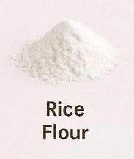

RICE BASED INGREDIENTS
1. Rice bran: Rice bran can be used as a nutrition ingredient in bread and snacks production adding Fiber vitamins and minerals.
2. Rice protein: Rice protein can be used as a plant based protein source in bread and snacks recipes.
BENEFITS
1. Increased nutrition: Rice based products can provide essential nutrients like carbohydrates Fiber and minerals.
2.Improved texture: Rice flour can add texture and structure to bread and snacks.
3.Sustainability:Rice can be sustainable crops that can be produced with reduced environmental impact.
ANTIBACTERIAL ACTIVITIES OF RICE
Rice has been found to exhibit antibacterial properties which can be can be attributed to various compounds present in the grains some studies have reported that rice extract and fractures have anti microbial activity against certain bacteria including.
COMPOUND RESPONSIBLE FOR ANTIBACTERIAL ACTIVITY
Phenol compounds: Rice contains phenol compounds such as ferric acid which have been shown to exhibit antibacterial activity.
Flavonoids; Flavonoids such as tracing and a pigeon’s has been found in rice and have demonstrated antibacterial properties.
Anthocyanins: Anthocyanin’s responsible for the red, purple, or black color of some rice varieties have also been reported to have antibacterial activity
POTENTIAL APPLICATIONS
Food preservation: The antibacterial properties of rice could be used to develop natural food preservatives, reducing the need for synthetic additives.
Health benefits: consuming rice with antibacterial properties may help support gut health and prevent certain diseases.
Pharmaceutical applications: Rice derived compounds with antibacterial activity could be used to develop new anti microbial agents.
2.2 THEORETICAL FRAMEWORK
Theory of viscosity:
For Newtonian fluids, viscosity is defined as the constant of proportionality between the tangential stress component and the velocity gradients(yung vi, 2021). Stated that the adverse effects of consuming sugar are increasing body weight tooth harming and other health problems in the case of non Newtonian fluids, a complex relationship exists between the advantages of rice as an alternative in the production of bread and snacks if another material in the form of small particles, either solids, liquids or gases are dispersed randomly throughout the fluid. The effect of suspended particles concentration by volume on the fluid viscosity change was studied and expressed quantitatively by Einstein in 2019.
THERAPEUTIC THE-DRIES: Rice: this theories contain Bawa get AL (2016) Noted that the production of most baking is been hampered by many factors among which are: Research into the rice as an alternative in baking , rice as the best in making bread. It is therefore imperative that we explore the production technique of this important in a bid to increase production of the bread and meat pie using rice. Bread and snacks said to have huge potential for Local industries and exports owing to their wide range of uses.
2.3 EMPIRICAL REVENUE
Razavi et al.(2017) worked on modeling Of the time, dependent rheological properties of f pistachio Butter.lalioni,(2027) studied the kinetics of irreversible structural relaxation and theological behavior of metallic glasses under quasi static loading. He derived a model that describes which within a common framework in number of research were conducted in establishing the advantage of rice as an alternative In production of bread and snacks. Also ,coussot et al,(2018) studied the peculiar properties of some baking. They took, cognizance of the inter particle links and micro structures in conducting the Effects of rice in Baking bread and others. Abu-dayil (2019). Also said that texture of chiffon bake is moist, soft, lights and high in volume buttery rich , but it has to be a mixture of honey in respect of the material etc. worked on modeling the time dependent rheological behavior of making foods. he used the structural kinetic model (s k m) to characterize the thxotropic behavior of three different kinds of food products His model was for structural delay of materials structure. The model expired the adaption of the structural kinetic analysis in the present study. The other kinetics accounts for principal participants in the structural configuration that determines observed theology in the present study the skim shall be derived for honey theology: it shall be applied to the experimental rheological data of the study. The ingredients shall be also used as a good trader of adulteration and limitation in honey.
The world rice production capacity in 2010 was 1,500,000 tons while the demand in the same year was 2,000,000 tons with wonder therefore, that Rice attracts the illicit affections of fraudsters who adulterate or fake the product for quick money and to meet up with huge gap between the demands and the supply of the product for this reason there is a strong imperative to constantly screen for qualify what is sold in the market as honey for public consumption and to industry for commercial purposes.

CHAPTER THREE
3.1. Research methodology
Introduction
This chapter describes the methodology that was used in carrying out the study. this includes; research Design, population, sample and sampling techniques, research instruments, procedures for data collection and data analysis.
3.2 MATERIALS AND METHODS
The collection, preparation and demographic location of Rice samples analyzed in this study are presented in this chapter. The experimental methods for the utilization of these samples and of their adulterated versions are also discussed. Validity checks were made on the inferences derived from the rheological analyses using the results of established confirmatory tests and by attempting correlations of the rheological data with accepted characteristics of Rice while making bread and Snacks.
Preparation of Rice Flour for Bread Making
Step 1: Rice Selection
- Choose suitable rice varieties for bread making, considering factors like amylose content and starch properties.
Step 2: Cleaning and Washing
- Clean and wash the rice to remove impurities and excess starch.
Step 3: Soaking and Drying
- Soak the rice in water to soften the grains.
- Dry the soaked rice to reduce moisture content.
Step 4: Milling
- Mill the dried rice into flour using a suitable milling process (e.g., wet or dry milling).
Step 5: Sifting and Packaging
- Sift the rice flour to remove large particles and achieve a uniform texture.
- Package the rice flour for storage or use in bread making.
Considerations
1. Rice Variety: Different rice varieties can affect the quality and characteristics of the flour.
2. Milling Method: The milling process can impact the particle size and starch damage of the flour.
3. Moisture Content: Controlling moisture content is crucial for storage and bread making.
Applications in Bread Making
1. Gluten-Free Bread: Rice flour can be used as a primary ingredient in gluten-free bread recipes.
Blended Flours: Rice flour can be blended with other flours to create unique bread products.
By carefully preparing rice flour, bakers can create high-quality bread products that cater to diverse consumer needs and preferences
Types of Rice Used for Bread and Snack Making
1. Long-Grain Rice
- High amylase content
- Suitable for bread making due to its structure and texture
2. Medium-Grain Rice
- Balanced amylose and amyl pectin content
often used for snack products due to its sticky texture
glutinous rice
5. Waxy Rice
L Almost pure amyl pectin
6. Aromatic Rice (e.g., Jasmine, Basmati
Can be used for creating sticky or chewy textures in snacks
Unique flavor and aroma
Factors to Consider
Can be used for specialty bread and snack products
1. Amylose Content: Affects the texture and structure of the final product.
2. Starch Properties: Influences the cooking and baking performance of rice flour.
3. Flavor and Aroma: Impacts the overall taste and smell of the final product. products with unique characteristics and textures.
By selecting the right type of rice, manufacturers can create a variety of bread and snack
Basic Steps in Rice Flour Preparation Step
1: Rice Cleaning
- Remove impurities, stones, and broken grains from the rice.
Step 2: Soaking (Optional)
- Soak the rice in water to soften the grains and reduce processing time.
Step 3: Drying
- Dry the soaked rice or raw rice to reduce moisture content.
Step 4: Milling
- Mill the dried rice into flour using a suitable milling process.
Step 5: Sifting
- Sift the rice flour to remove large particles and achieve a uniform texture.
Step 6: Packaging and Storage
Considerations
1. Moisture Content: Control moisture levels to ensure stability and quality.
2. Milling Method: Choose a suitable milling process to achieve the desired particle si and texture.
3. Storage Conditions: Store rice flour in a cool, dry place to maintain quality.
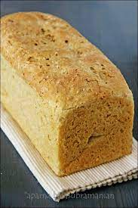
By following these basic steps, you can prepare high-quality rice flour for use in bread snack making.

Basic Formulation for Snacks and Bread Making
Chin Chin (Fried Dough Snack
1. Ingredients:
- 2 cups rice flour
- 1/2 cup wheat flour (optional)
- 1/4 teaspoon salt
- 1/4 teaspoon sugar
- 1/2 teaspoon baking powder
- 1/2 cup water
Ingredients
bread Making (Rice Flour Bread)
2 cups rice flour
- 1/4 teaspoon salt
- 1/2 cup starch (e.g., tapioca or potato)
- 1/4 teaspoon sugar
- 1 teaspoon yeast
- 1 cup warm water
- Optional:
xanthan gum or guar gum for texture
Instructions*:
- Mix dry ingredients
- Add warm water and yeast
- Knead dough and let it rise
- Bake in a preheated oven
Variations and Additions
1. Flavorings: Add herbs, spices, or seasonings to enhance flavor.
2. Texture Modifiers: Use xanthan gum or guar gum to improve texture.
3. Additional Ingredients: Add Nus, seeds, or dried fruits for added texture and flavor.
These basic formulations can be adjusted and modified to create a variety of snacks and bread products using rice flour
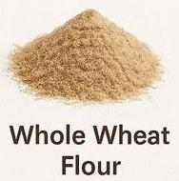
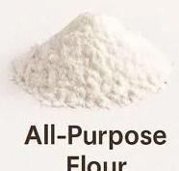
Ingredients for Rice-Based Bread and Snacks

Bread Production
1. Rice Flour: Primary ingredient can be used alone or blended with other flours.
2. Starches: Tapioca, potato, or corn starch to improve texture and structure.
3. Yeast: Active dry yeast or instant yeast for fermentation.
. Salt: Enhances flavor and texture.
5. Sugar: Feeds yeast and adds flavor.
6. Water: Hydrates ingredients and facilitates dough development.
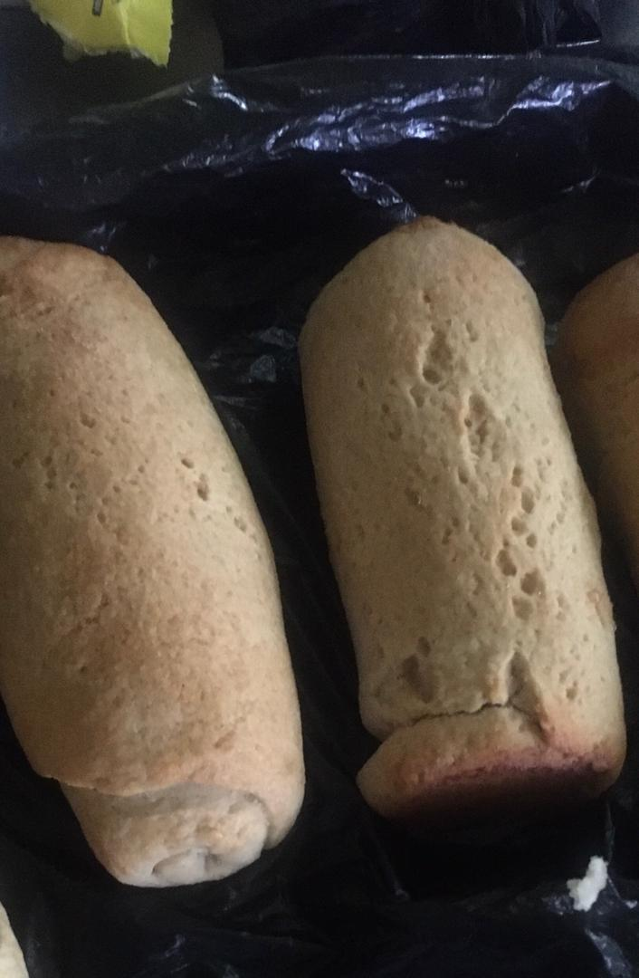
7. Optional Ingredients:

Rice And Wheat Based Bread (50/50)
- Xanthan gum or guar gum for texture modification.
- Eggs or egg replacers for added moisture and structure.
Snack Production (e.g., Chin Chin)
1. Rice Flour: Primary ingredient.
2. Water: Hydrates ingredients and facilitates dough development.
3. Salt: Enhances flavor.
4. Sugar: Adds flavor.
5. Vegetable Oil: For frying.
6. Optional Ingredients:
- Spices or seasonings for added flavor.
- Nuts or seeds for added texture.
1. Bread*: Rice flour (70-100%), starch (0-30%), yeast (1-2%), salt (1-2%), sugar (1-24
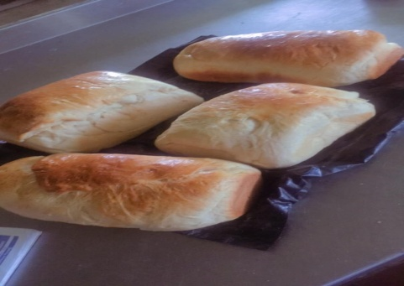
2. «Snacks (Chin Chin)*: Rice four (100%), water (50-70%), salt (1-2%), sugar (1-28)

Wheat based bread
3.3. RESEARCH DESIGN
Baking has undergone many change in recent years, for a baker to undergo the following changes of fundamental restructuring (economics) accompanying growth, in size and complexity of business depends on the way chefs executive can effectively manage the material. To cope with these changes, modern management techniques are used in contemporary banking organizations.
This part of the research shall try to examine the expected and resultant problems of the utilization of rice as an advantages.
This project has thoroughly examined the establishment this advantages of rice as an alternative in the production of bread and snacks. It has been able to distinguish rice and wheat flour and have identified features.
3.4 SOURCES DATA The researchers uses both the primary and secondary data in the study. This is due to the fact that sources of data front the baker through questionnaire been given to the staff and others.
3.5 PRODUCTION AND SAMPLE
This research works generally focuses on the hospitality industry and is basically constrained to the baking sector. The researcher shall examine the advantages of rice as an alternative in the production of bread and snacks. In doing this we shall be making of as many baking and as possible as example since the effect spread all over the who hospitality sector.

3.6 SAMPLE SIZE AND SAMPLE TECHNIQUES
Sample size determination is the act of choosing the number of observations or replicates to include in a statistical sample. it is an important feature of any empirical study in which the goals is to makes inferences about a population from a sample.
A sample size of 6 staff was obtained through the scientific random sampling where the population is divided into sub groups according to their communications courses and respondents randomly selected from each group permissions where sought From instructor.
Sampling techniques
Non profitability sampling is defined as a sampling technique in which the researcher select based on the subject judgment of the research rather than random selection. It is a less stringent method. this sampling method depends heavily on the expertise of the researcher. it is carried out by observation and researcher use it widely for qualitative research. it is also a sampling method in which not all members of the population have a equal chance of participating in the study, unlike probability sampling
Quota sampling
Quota sampling is a type of non profitability sampling in which researchers creates a sample involving individuals that represent a population. Researcher choose these individuals according to specific tracts or qualities.
3.7. Research instruments
The researchers made use of both sourch,a questionnaire while administered, field observations, interviews, internet was also established likewise material relevant to study were fully, appreciated and visited.
There are two main sources of data , these are primary and secondary data. The primary source rental the collection of data that are organically used for the study, example of such data are, data collection through conduct of interviews questionnaires and observations Secondary sources in other hands are recognized as second handed data which can be a source from the newspapers, internet and other secondary mediums
3.8 METHODS OF DATA ANALYSIS
To make the analysis of data collection simple frequently counts was used, the statical computation was done manually, furthermore, table as part of the description statistical techniques Was used mostly to best the researcher question and each respondents were scared according to the basis or frequency distribution and dimple percentage were completed from distribution.
3.9 MODEL SPECIFICATION
The researcher ensure the questionnaire context use presented with accuracy to make the valid and reliable for the respondents to answer the stipulated question in them. Researcher also conducted to make sure the questionnaire given to respondents was answered appropriately. To further validate the instrument used for the filed to study such as baker, instructor, others (educated) those who have in time past research on the same issue information in finding out that rice could be used in bread and snacks making..
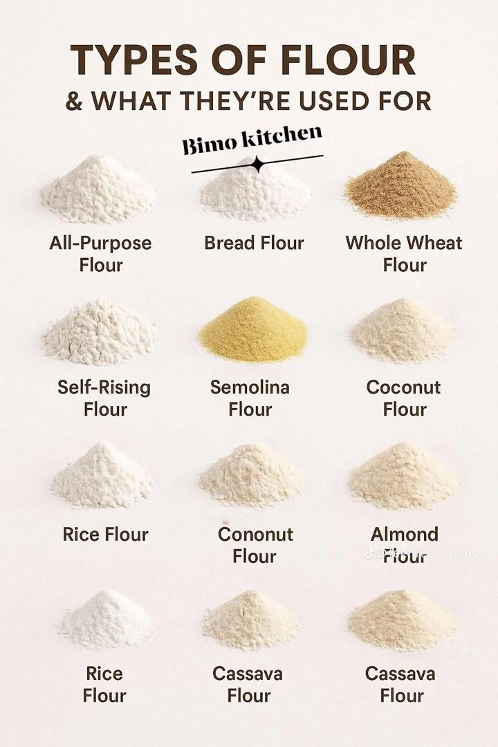

CHAPTER FOUR
DATA PRESENTATION, ANALYSIS AND INTERPRETATION
4.1 Data presentation
4.2 Introduction
The chapter focuses on the presentation and analysis of results obtained from the responses of the respondent on the questionnaire administered to them; it should be noted however that the response obtained from the respondent will be used to draw up the conclusion for the chapter.
4.3 Data Analysis Interpretation
This study intends to collate the sector of each of the practical response or items contained in the questionnaire. The overall scores will be statistically analyzed, employing the use of simple percentage, and tabulation of data so collected.
4.4 Data Presentation, Analysis and Interpretation
When the respondent receive the questionnaire their Gender category follow the frequency patterns. Below:

DATA DEMOGRAPHIC ANALYSIS
Table1: Gender Distribution of Respondents
Response | No of Respondents | Percentage%
Male | 22 | 44%
Female | 28 | 56%
Total | 50 | 100
Source: Field worksurvey2025
The table above shows the gender distribution of the respondents. it clearly shows that the male respondents are 44% while female are the highest responders with 56%. This shows that the female respondents shows interest in the questions than the men.
TABLE2: Age distribution of the respondent
Response | No of Respondents | Percentage%
18-30 | 30 | 60%
30-42 | 15 | 30%
Others | 5 | 10%
Total | 50 | 100%
Source: Field worksurvey2025
The above table shows the age distribution of the respondents where 18-30 caries 60%, and 30-42 have 30%, others have 10%. This implies that most respondents falls in the range of 18-30years.
QUALIFICATION OF RESPONDENTS
Qualification | No of respondents | Percentages%
Undergraduate | 20 | 40%
HND/Bsc | 20 | 40%
Others | 10 | 20%
TOTAL | 50 | 100%
Source: Field work survey 2025
Table 4 shows the educational level of the respondents, where 40% fall under the range of undergraduates, 40% of the respondents are HND/BSC holders and 20% have other certificate levels.
Table5: MARITAL STATUS
Response | No of Respondents | Percentages%
Single | 25 | 50%
Married | 15 | 30%
Engaged | 10 | 20%
Others | - | -%
TOTAL | 50 | 100%

Source: Field work survey2025
From the table above, its shows that the respondent’s marital status, with 50% single respondents, 30% respondents were married, while 20% of the respondents are engaged. No respondent for 0%.
Table6:Question1
Are there much nutritional benefit of using rice as alternative ingredient in bread and snacks production?
Response | No of Respondents | Percentage%
Strongly agree | 20 | 40%
Agree | 10 | 20%
Neutral | 5 | 10%
Disagree | 10 | 20%
Strongly disagree | 5 | 10%
Total | 50 | 100%

Source: Field survey 2025
The table above shows that the respondents are highly interested in the nutritional benefit of using rice as an alternative ingredient in bread and snacks production. The survey shows that 40% strongly agree with the statement, 20% of the respondent agree that using rice to enhance the taste of bread,10% are neutral, while 20% disagree and 10% strongly disagree with the statement.

Table7:Question3
Can nutritional content of rice based bread and snacks compare favorably with traditional wheat based bread?
Response | No of Respondents | Percentage%
Strongly agree | 25 | 50%
Agree | 15 | 30%
Neutral | 10 | 20%
Disagree | 0 | 0%
Strongly disagree | 0 | 0%
Total | 50 | 100%
Source: field survey 2025
From the above table, 50% of the respondent, strongly agree with the statement, 30% agree, 20% are neutral, 0% disagree with the statement and 0% of them strongly disagree with the statement that nutritional content of rice based bread and snacks can compare favorably with traditional wheat based bread?

Table8:Question4
Does rice-based bread and snacks provides improved texture and sensory characteristics?
 | Response | No of Respondents | Percentage%
 | Strongly agree | 30 | 60%
 | Agree | 15 | 30%
 | Neutral | 0 | 0%
 | Disagree | 5 | 10%
 | Strongly disagree | 0 | 0%
 | Total | 50 | 100%
Source: field survey2025
From the survey, with the above table, the Rice based bread and snacks provides improved texture and sensory characteristics, which in particular is important for bread to stay fresh and moist because 60% of the respondent strongly agree, 30% also agree to the question while 0% are neutral to the question and 10% disagree while 0% strongly disagree with the above statement.
Table 8 Question5:
Is there sustainability benefit of using rice as alternative ingredients in bread and snacks production?
Response | No of Respondents | Percentage%
Strongly agree | 10 | 20%
Agree | 25 | 50%
Neutral | 0 | 0%
Disagree | 5 | 10%
Strongly disagree | 10 | 20%
Total | 50 | 100%

Source: field survey2025
From the table, respondent’s responses to the statement sustainability benefit of using rice as an alternative ingredients in bread and snacks production, where 20% of them strongly agree and 50% agree and 0% Fall under neutral ground and 10% disagree while 20% strongly disagree.
With this analysis the sustainability benefit of using rice as alternative ingredient in bread and snacks production 70% respondents agree.
Table9:Question6
Is there any effect of rice flour on the texture, taste, and overall acceptability of bread and snacks?
Response | No of Respondents | Percentage%
Yes | 15 | 25%
No | 35 | 75%
Neutral | 0 | 0%
Total | 50 | 100%
Source: field survey2025
From the table, respondent’s responses to the statement Is there any effects of rice flour on the texture, taste, and overall acceptability of bread and snacks, where 25% of them agree and 75% disagree and 0% fall under neutral ground.
With this analysis there is no any effects of rice flour on the texture, taste, and overall acceptability of bread and snacks 75% respondents agree.
Table10:Question7
Are there various cookery methods used for rice production in making bread and snacks?
Response | No of respondence | Percentage%
Strongly agree | 30 | 60%
Agree | 20 | 40%
Neutral | 0 | 0%
Disagree | 0 | 0%
Strongly disagree | 0 | 0%
Total | 50 | 100%
Source: filed survey2025
The Table above shows the respondent answer to the above question which stated that there are various cookery methods in using rice in making bread and snacks.

The survey established that 60% of them strongly agree to the question, 40% agree totally and 0% is neutral, while 0% disagrees.
From the above table analysis, its shows that there are various cookery methods in rice in making bread and snacks, because all the 50% respondents agree to the statement.
4.2 DISCUSSION AND FINDINGS
In this research, work, all the questionnaire items were presented and analyzed, this opened way for evidence based information in finding out that rice could be used in bread and snacks making.
The summary included that: more females with 54% were interested more than men . Also that the age bracket is 18 to 30 years old with 60% were more interested. Education qualification did not show any difference in interest . For marital status , the singles showed that they have interest in finding the alternative to wheat in bread making . For the interest in nutritional value , those that agree with the textural comparison, the number was quite high at 100% while for sustainability survey the number that agreed to it’s been sustainable equal those that disagree importantly for textural acceptance ,taste and overall acceptance 75% of the responders agreed which showed the acceptability and concluded that various methods of cookery method will suit
CHAPTER FIVE
5.1 CONCLUSIONS
From the findings in this research work, it can be concluded that rice can be a viable alternative in the production of bread and snacks, offering several advantages. Its use can provide a gluten-free option, improve texture, and enhance nutritional content. Rice-based products can cater to diverse consumer needs, including those with gluten intolerance or preferences for unique flavors and textures.
Advantages of Rice in Bread and Snack Production
1. Gluten-Free Option: Rice flour is naturally gluten-free, making it suitable for gluten-free products.
2. Texture and Structure: Rice flour can improve texture and structure in bread and snacks, especially when combined with other ingredients.
3. Nutritional Content: Rice is a good source of carbohydrates, fiber, and minerals, contributing to the nutritional value of bread and snacks.
4. Flavor and Aroma: Rice can add unique flavors and aromas to bread and snacks, enhancing their overall taste experience.
5.2 RECOMMENDATIONS
1. Further Research: Conduct further research on optimal rice varieties, processing as well as Formulations for bread and snack production.
2. Product Development: Develop a range of rice-based bread and snack products to cater to diverse consumer preferences and needs.
3. Market Testing: Conduct market testing to assess consumer acceptance and Preferences for rice-based bread and snacks.
4. Industry Collaboration: Collaborate with industry stakeholders to promote the use of rice in bread and snack production and to develop commercial products. By establishing the advantages of rice as an alternative in bread and snack production, manufacturers can create innovative, nutritious, and gluten-free products that meet evolving consumer demands.

2
Abu-dayil (2019). & Smith, J. (2018). Trace Minerals in Rice Zand Their Blood Sugar Management: A Comparative Study on Rice and Other Grains. Journal of Nutrition Science, 5, €32.
Brown, A., & Green, E. (2020). Innovations in Bread Snack Production Using Rice. Journal of Culinary Science, 12(3), 45- 58.
Rosell, 2024& Lee, S. (2021). Bread Snacks with a Twist:
Kochhar, S. L. (2024). Rice Harvesting Techniques and Their Impact on Yield and Quality. International Journal of Agronomy, 23(1), 45-58
Incorporating 15(1), 10-16. Rice for Flavor and Texture. Snack Foods International.
Nwalor et al, (2023). Crop Rotation in Rice Cultivation:
Enhancing Production and Soil Health. Agricultural Science
Review, 12(4), 321-335
Nwalor et al, 2024. Creating Innovative Snacking Experiences
With Rice-Infused Treats. Food Innovation Journal,
7(2), 75-82.
Selomulyo and Zhou, 2023), Tropical Crop A.VI. Publishing company. Borilius. Rice in Yuyaw, Checking Province, China. Joural of Archaeological Research, 25(2), 147-162.
smith, R. J., & Dilday, R. H. (2025). Rice production technology in the United States. In Advances in research on rice in the United States (pp. 45-61). American Society of Agronomy.
solhelm, P. (1996). Excavations at Non ok: Unearthing Ancient Rice in Southern Thailand. Asian Archaeology, 8(3), 211-228.
Torley et al 2023). The Rice Economies: Technology and Development in Asian Societies. Berkeley: University of California Press. yung vi, 2021L., & Wang, C. (2024). Carbohydrate Sources and Blood Sugar Management: A Comparative Study on Rice and Other
Grains Journal of Nutrition Science, 5, e32.

