ENHANCED DRYING OF TOMATOS AND CAYENNE PEPPER USING A PARBOLIC SOLAR REFLECTOR

BY

IREWOLEDE BLESSING AJOKE
ND/23/SLT/PT/0187

A RESEARCH PROJECT SUBMMITED TO DEPARTMENT OF SCIENCES LABORATRY TECHNOLOGY, INSTITUTE OF APPLIED SCIANCES ( I A S ) KWARA STATE POLYTECHNIC, ILORIN, NIGERIA

IN PARTIAL FULFILMENT OF THE REQUIREMENT FOR THE AWARD OF NATIONAL DIPLOMA (ND) SCIENCE LABORATRY TECHNOLOGY
(PHYSICS/ ELECTRONIC UNIT)
Supervised By: DR. OLAORE K.O

JULY, 2025

CERTIFICATION
This to certify the project work was successful carried carry out by IREWOLEDE BLESSING AJOKE ND/23/SLT/FT/0187 of the department of sciences laboratory technology and has been prepared in accordance with the regulation governing the preparation and presentation of kwara polytechnic, Ilorin.

DATE
DR.OLAORE K.O
(Project supervisor)

Head of unit (physical/eletronic) DATE

DR.USMAN A . DATE
(Head of department)

DEDICATION

This project work is dedicated to Almighty God, the most beneficent, the merciful, who is worthy of praise, that gave ME strength, power, wisdom to understand the course and showered us His mercy on us throughout this project.
I also dedicate this project to our beloved parents for their tireless effort in supporting and encouraging us throughout the program.
Also this project is dedicated to all the lectures and staffs of the department of science laboratory technology, Kwara State Polytechnic, Ilorin.

ACKNOWLEDGEMENT

I give thanks to Almighty God for He is good and His mercies endure forever. Our special appreciation goes to our parents, siblings, guardians and friends. Our special appreciation also goes to our project supervisor in person of DR. K.O. OLAORE who have been there for us before and during our project work, thanks for being our father during this journey. I sincerely appreciate you sir, Our prayer for you is that God should grant you more understanding and success in all your endeavor, and for your children, May God’s favor locate them wherever they go in life. I as well celebrate and give kudos to all our a mazing and brilliant lecturers as well as the technologist of the department of science laboratory technology (Physics/Electronics Unit). God bless you all (AMEN).

ABSTRACT

Sun drying is the most common practice in drying agricultural products in Nigeria. The aim of this project is to carry out the performance evaluation of a stand-lone parabolic solar reflector for drying tomatoes and cayenne pepper which was carried out on the 15th and 17th of April, 2023 for both tomatoes and cayenne pepper respectively in Physics and Electronics unit (Science Laboratory Technology), Kwara state polytechnic , Ilorin. The global radiation obtained for drying of tomatoes was 958.8W/m², the fluid temperature was 96.7˚C, the ambient temperature was 55.7˚C, absorber temperature was 98.4˚C and the global radiation obtained for drying cayenne pepper was 822.3W/m², the ambient temperature was 90.3˚C, the absorber temperature was 93.4˚C. Therefore, from the experiment, conclusively, the parabolic solar reflector performed better than the open sun drying.

TABLE OF CONTENTS

Tile page i
Certification ii
Dedication iii
Acknowledgements iv
Table of Contents v
CHAPTER ONE
  - Introduction 1
  - Background Of The Study 1
  - Statement Of The Problem 4
  - Justification 4
  - Aim 5
  - Objectives 5
CHAPTER TWO
  - Literature Review 6
  - Classification Of Solar Dryers 15
    - Passive Or Direct Solar Dryers 16
    - Active Solar Dryers 17
    - Hybrid Solar Dryers 18
  - Advantages Of Solar Dryers 19
  - Food Drying Technology 21
  - Solar Energy And Drying 22
  - Open Sun Drying 22
CHAPTER THREE
  - Materials And Method 24
  - Samples 24
  - Study Area 24
  - Solar Drying 24

3.4 | Material Selection | 24
3.4.1 | Material For Body Of The Dish | 24
3.4.2 | Material For The Reflecting Surface | 25
3.4.3 | Material For The Drying Pan | 25
3.5 | Chemical Composition Of Specimens | 25
3.6 | Experimental Equipments | 26
3.6.1 | Experimental Set Up | 29
3.7 | Method | 30
3.8 | Nomenclature | 33
3:9 | Mathematical Expression | 34
3.9.1 | Determination Of Aperture Area | 34
3.9.2 | Determination Of Receiver Area | 34
3.9.3 | Determination Of Focal Length | 34
3.9.4 | Determination Of Rim Angle | 35
3.9.5 | Determination Of The Surface Area Of The Paraboloid | 35
3.9.6 | Determination Of Length Of Circumference | 36
CHAPTER FOUR
  - Result And Discussion 38
  - General Observation 38
CHAPTER FIVE
  - Conclusion 41
  - Recommendations 41
References 42
Appendix I 45
Appendix Ii 47

CHAPTER ONE

  - INTRODUCTION

  - BACKGROUND OF THE STUDY

Drying is a simple process of moisture removed from a product in order to reach a desired moisture content and is an energy intensive operation. The prime objective of drying apart from extended storage life can also be quality enhancement, ease of handling, further processing and is probably the oldest method of food preservation practiced by humankind. Solar drying is the most common method of preservation, especially in many African countries. It is an alternative which offers several advantages over the traditional direct sun drying. The traditional method of drying requires a lot of handling and leads to considerable loss due to contamination by insects, sand and gravel. It is an ancient practice, which exhibits slow drying rate, dirt or fungal contamination in product, birds and rodents attack and deterioration of quality, especially colour or flavour degradation ( Hassan, 2003). The quantity of energy received by the earth from the sun is extraordinarily large but it is also quite diffused. The use of solar cookers are often limited due to the fact that the sun is not available 24 hours a day. As a result, solar cookers are often either not functional or fully effective on cloudy days or when there is no sunshine. In fact, solar energy is clean, safe and it also guarantees use without negative impact on the environment and society. However, the era of cheap fuel (coal, wood, petroleum and so on) is becoming smaller, invariably pointing to the need of exploiting and harnessing renewable resources as paramount. Due to high demand for energy, people are beginning to see the energy crises in a very different light. In the present era, the parabolic dish reflector is used to focus sunlight for making fire and also

to dry agricultural products faster (Ashokraj & Sekar, 2016). Using parabolic solar reflector to dry limit losses due to contamination, save time and achieve better quality results. Historically, solar energy has always been present in daily activities such as cooking, drying food and clothes and heating water.
There is a high demand for inexpensive dried products with quality in food processing industries in order to produce better and cheaper dried products, energy must be used in a most productive (Jangeer, 2006). The renewable energy resources has a vital role in the life of farmers in improvising the technology in farming which will increase their productivity. Lack of adequate infrastructure for food processing and it's storage leads to average wastage of food of adequate infrastructure for food processing and it's storage leads to average wastage of food of 10% to 40% (Adhikari, 2006). Drying process dehydrates the food products which enhances the shelf life by resisting the growth of bacteria. Parabolic solar reflector utilizes solar energy to heat up the air and to dry any food substances loaded on it which is beneficial in reducing wastage of agricultural products and helps in the preservation of agricultural products (Abdullahi et al, 2013). In the present days, the demand for tomatoes and cayenne pepper are increasing steadily with the increase in population and likeness towards them. At current time, spoilage of fresh tomatoes and cayenne pepper is significantly massive in rural areas where they are grown. Post harvest loses should be minimized to improve the distribution of food to needy people. Widespread use of solar energy for domestic, agricultural and agro-industries activities has been practiced almost since the development of civilization, the increasing threat of shortage of the commercial sources of energy coupled with serious environmental pollution problems has brought about

interest in the scientific exploration of renewable sources of energy. It is estimated that the small fraction of solar radiation falling on earth is equal to the world energy demand for one year.
Some of the conventional method of food preservation methods include bottling, canning, freezing, sugaring, salting (curing), drying, smoking, refrigerating and pickling. Among these methods, drying is most common practical method to preserve food at a very low cost and means of renewable energy ( Prakash & Gary, 2001). Most of the natural food drying methods can hardly provide products with desired specifications because of inadequate hygienic conditions. Although drying of food under direct sunlight is economical, dried products lack quality due to contamination caused by dust, insects, birds and rain (Rajeshwari & Ramalingam, 2010), therefore, drying using renewable energy resources have become widespread. Moreover, direct sunlight drying is not only time consuming but also leads to loss of vitamins, nutrients and unpleasant color change due to its exposure to direct ultraviolet rays. In these conditions some problems such as crack of structure, bleaching, hard texture, loss of flavor and nutritional properties, low rehydration capacity which makes tomatoes and cayenne pepper to worsen in its quality could occur, thereby damaging the quality of the produce (Cernisev, 2010). These problems pertaining to direct sunlight drying is eliminated through dehydrating using parabolic solar reflector. In addition, parabolic solar reflector generate a higher temperature, minimum relative humidity, lesser moisture content of the product and lower damage of drying. Solar drying removes 20% more moisture than direct sun drying to produce better quality of dried products (Madhlopa, et al, 2002).

STATEMENT OF THE PROBLEM

Drying is a vital method used by human beings to preserve food for survival, and it is responsible for a large amount of energy consumption in many countries. Nigeria being Africa's second largest tomato producer, approximately, 200,000 farmers, grows more than
2.3 million metric tons of both tomatoes and cayenne pepper every year (Oberoi et al, 2005).

This is not enough to meet annually in the country's demand and the supply is further affected by 40-50% of the harvest that never reaches the market. Those that make it are subject to market vitality prices often plummet during harvest glut. Using parabolic solar reflector to dry tomatoes and cayenne pepper is a method of preserving excess production of agricultural products after harvest. However, this method has proved it's limits, because the operation is done with drying time, it takes approximately 3 hours to decrease the moisture content (8-10%) depending on the weather conditions which can damage the quality of tomato and cayenne pepper product especially since the quality is closely linked to the climate conditions. On the other hand, using temperature to dry produce lead to loss of volatile compounds, nutrients and color ( Adeodu et al, 2018).

JUSTIFICATION

Parabolic solar reflector is used to dry because of its very high temperature. It performs better than the direct sun drying as it control the drying operation properly, the length of the drying time, whether uncertainties, high labor costs, large area requirement and insect infestation, mixing with dust and other foreign materials.

AIM

The aim of this project is to design, construct, evaluate performance and analyze the thermal efficiency of a stand - alone parabolic dish collector to dry tomatoes and cayenne pepper.

OBJECTIVES

The specific objectives of this project are:

- To design and construct a parabolic solar reflector using locally available materials which is used to generate heat for drying.
- To determine the thermal efficiency of the parabolic solar reflector's performance measuring the following parameters:
  - Ambient temperature (Tam)

  - Temperature fluid (Tf)

  - Absorber temperature (Ta)

  - Solar radiation (SR)

  - Weight of the tomato at every 10 minute interval

  - Dryage ( mass of water loss at each minute interval)

CHAPTER TWO

  - LITERATURE REVIEW

Varghese et al, 2021, They designed and constructed a parabolic solar cooker having a diameter of 1.8m, height of 0.28m, radius of 0.9m, area of 0.26m, an aperture area of 0.167m, rim angle of 63.76•, concentrator ratio of 0.081, a focal length of 0.047m and receiver area of 2.061m to dry peanuts. They stated that peanut is a widely available edible seed in India, obtained from a legume crop (Arachis hypogaea) which is used either directly in food or for extracting cooking oil. From their analysis it was found that the parabolic dish collector generates a maximum temperature of 79°C at 12.30 PM and dries 1.5 kilograms of peanut in 5 hours of a day. They concluded that hot air from the parabolic dish concentrator reduces moisture content of peanut by 21% more than obtained from open solar drying.
Abd El Raman et Al, 2019, they constructed a simple parabolic solar reflector to serve as an alternative renewable source of energy to dry tomatoes. In their work they use both the constructed parabolic solar reflector and direct sunlight to dry tomatoes. They analyzed the study of time influence on moisture content losses ,weight of tomatoes, various parameters such as temperature and solar radiation on tomato and compared direct sun drying with the solar drying. Their tomatoes sample were sliced into two and arranged on a flat pan placed on the rim and left to dry naturally. Their result shows that : the weight of the tomatoes was decreased by increasing drying time. The weight of tomatoes was lower compared to the direct sun drying method. In their result, they observed that the losses of dried tomatoes were higher with the parabolic solar reflector than the direct sun drying method. They concluded in their work that the parabolic solar reflector appears to be an effective and faster

method of drying tomatoes because the drying time is less compared to the direct sun drying, They observed that this is due to the solar drying effect focused under the drying material. They also concluded that this is due to the solar drying effect of the parabolic solar reflector where the temperature keeps on increasing with decrease in relative humidity.
Aidan, 2014 designed and constructed a suitable solar parabolic dish collector cooker under Yola climatic conditions using the international standard procedures for the evaluation of solar parabolic cookers. In the experiment he conducted, his result showed that the optical efficiency of the collector has been found to be about 17.86%, the overall heat loss coefficient of 8.896 WK-1m-2 and the adjusted cooking power that measures its performance has been found to be 96.53 W. His work showed that the parabolic solar dish collector cooker can be used by families for cooking in Yola to minimize the purchase of other cooking fuels for at least cooking the afternoon meals.
Arunet et al 2014, reported in their work that the solar drying system utilizes solar energy to heat up air and to dry any food substance loaded, which is beneficial in reducing wastage of agricultural products and helps in preservation of agricultural products. They defined a solar cooker as a device which uses the energy of sunlight to heat food or drink or to sterilize it. They explained further that the vast variety of the solar cookers presently in use are cheap, low tech devices, because they use no fuel and cost nothing to operate, they reduce air pollution and slow deforestation and desertification. Furthermore, they observed that solar cooking is a form of outdoor cooking and is often used in situations where minimal fuel consumption is important or the danger of accidental fires is high. They explained that Solar energy represents nonpolluting, inexhaustible renewable source of energy that can be

utilized economically to supply man's needs for all the time. They carried out their performance evaluation of the system and their equipment was tested for cooking and drying of food materials
Abdelhamid et al, 2013. In their work attempted to assess the efficiency and profitability of the greenhouse (used in agriculture) to dry agricultural products. They aimed at studying and analyzing the drying of red pepper known as “Baklouti” by three different solar processes. They analyzed three drying processes which enables human to profit from a free energy coming from the sun. They reported that two experimental devices were used. They stated that drying kinetics were set up in a natural convection solar drier, under greenhouse and in open sun, respectively. Their result showed that drying times (including nights) are about 73 hours in the dryer, 79 hours in the greenhouse and 118 hours in open sun. Six thin-layer drying models (Newton, Henderson and Pabis, Modified Henderson and Pabis, Wang and Singh, Logarithmic and Twoterm) were fitted to their experimental data to select a suitable drying equation. In their result they observed that the Logarithmic was found to best describe the drying behavior of pepper for open sun, greenhouse and solar drier drying. Their experimental results also showed that the solar tunnel greenhouse dryer must be improved to become competitive to the solar air dryer.
Kamaldeen and Okedokun,2021 reported that a parabolic solar dryer was developed by the Nigerian Stored Products Research Institute and it was used to dry bell pepper. They stated in their work that the drying rate, color changes and drying kinetics using some empirical modeling equations were determined. They also used the Open sun drying method as a control. In their work, they observed that the drying rate (2.11 kg/day) of the parabolic solar

dryer was significantly higher than that of the direct sun drying (1.92 kg/day). They observed that bell peppers dried under parabolic dryer retained their color better than those peppers under sun drying. They observed that Page model is the most suitable model to describe the drying kinetics of the bell pepper under solar drying. Their result shows that the drying constant k (0.607) of the parabolic dryer is significantly higher than that of the sun drying (0.321) indicating higher mass transfer in the parabolic solar dryer.
Barret, 2008, They carried out a comprehensive study to appraise tomato value chain in order to promote the development of tomato production and processing industry in Nigeria. They stated in their work that currently in Nigeria, about 1.8 million tons of tomatos were produced per year, but over 50% of these were lost due to poor storage system, poor transportation and lack of processing enterprises. They stated that this makes it important to develop strategies for the development of tomato value chain. The method they employed in their work include semi-structured informal interviews with key value chain actors such as producers, intermediate traders and input suppliers. They revealed in their study that there are good varieties of tomatoes in Nigeria, but only few are sustaining processing with regard to quantity and quality. Their research also revealed that Nigeria is still not a major exporter of either food or processed tomato product despite the high production of tomatoes. This was due to inadequate supply of good quality seeds, inadequate storage facilities, poor disease, pest management and poor processing facilities. In their work, they observed that the development of tomatoes for industrial use is currently gaining momentum in the area of production of tomato juice, paste, ketchup, puree and powder. They analyzed strategies to overcome the challenges which include: Policy shift to encourage Small and Medium

Enterprises (SMEs) as well as industries along the value chain; improve input supplies; organization of farmers into corporative so as to initiate innovative funding mechanisms for them; establishment of clusters for processor improvement in marketing strategies including guaranteed price for fresh tomato products, adjustments in tariff regime to favor local manufacturers including outright ban on transportation of processed tomato products; increased investments in research and development (R & D) to produce improved seed varieties and develop technologies for storage and processing adoption of Good Agricultural Practice (GAP) by farmers and a strong National Commodity Association or Network.
Gwania et al, Confirmed in their work that the sustainability of our ecosystem is under threat due to the frequent use of fossil fuel for cooking purpose in the rural communities. They further explained that efforts are being made to replace our existing cooking fuel with renewable energy source. The aim of their research was to design, fabricate and test a solar parabolic dish concentrator for application in remote areas. The solar concentrator was designed and fabricated with low cost available material and skills that can be operate and easily repaired by the users and can be track manually to follow the movement of the sun. The performance test they carried out reveals that the concentrator can attain a very high temperature of 180oc for frying oil on a clear sunny day and boiling water of 100oc. Their study also reveals that the concentrator can be used for cooking and drying purpose.
Aliyu et al, 2021, in their work reported that despite being able to supply beyond energy required for global use, the sun is still being greatly under-utilized possibly due to the availability of alternative sources of energies which are finite, costly, and far more hazardous. The aim of their research work is to seek better ways of utilizing the luminous

flux (luminous energy emitted per second) or power from solar radiation, which is renewable, pollution free and which is freely available to mankind to generate heat or power required for cooking and for related needs of a cooker. They reported in their work that a solar cooker, which is a family size type was designed (with the design specification temperature of 180°C) which was constructed and tested between the periods of 9.00 am and
4.00 pm during sun shine days. Their result showed that the maximum temperature attained was 140°C. They revealed that the parabolic solar cooker constructed has four panel booster reflectors (with rectangular plane mirrors on each booster reflector) each of which is detachable and a mechanical device is provided to constantly tilt the reflectors in the azimuthally direction so as to track the sun. These reflectors reflect the sun rays which falls incident on it to a focal point which give solar energy of high intensity. A known size pot was positioned with aid of a potholder on the focal point. They further explained that the use of the parabolic cooker will help tremendously in the conservation of fossil fuel energy. However, they observed that on the sunny and cloudless days, the cooker can work effectively for various cooking purposes at almost the same rate as the conventional stoves. They stated that the efficiency of the cooker was determined and recorded. They further states that the cooker could be more efficient if the entire reflector surfaces of the cooker can be able to radiate heat energy from all its surfaces to the focal point. Their review shows that the cooker could be used for cooking on sunny days and in areas where electricity availability is questionable in terms of supply.
Craig, 2015 stated in his work that the reduction in the availability and the ever-increasing prices of fossil fuels, as well as the expensive and insufficient electricity supply, are some of

the reasons explaining why the public awareness of the use of alternative cooking methods has increased in recent years. He further explained that In most rural areas of Africa, the use of wood is even more preferred for cooking than either fossil fuel or electricity, and this has led to deforestation in many areas. However, he observed that the time spent on wood collection by women, who often walk kilometers under scorching hot, sunny conditions, can be utilized better in more productive activities. Most of those lacking access to convenient cooking methods live in places with good solar resources and where solar cookers would thrive if developed. This study presented in this report considered a prototype solar cooking system that is relatively cheap and that can be modified to meet these challenges faced in African communities. He designed a parabolic solar cooker, which uses a parabolic dish as concentrator. The concentrator he used was a television satellite dish of 2 m in diameter, in which the reflecting area was covered with reflective aluminum strips. The dish concentrates radiation from the sun onto a conical cavity receiver placed at its focal point. He made use of specially modified automotive pump that was used to circulate the heat transfer fluid throughout the system, while a cooking head in the form of a flat spiral copper tube put onto the storage tank was used as the cooking section. His experiment was carried out under winter conditions in South Africa and each cooking test was done according to international standard procedure for testing solar cooker performance. His result shows that a utilization efficiency of 47 % was obtained, the energy efficiency was 0.05 %, while the average characteristic boiling time was around 13.32 min/kg. He concluded that solar cooker can be used indoors, thus eliminating the need for its user to stay in the sun and that the cooking section of the system can be modified to be used for other high temperature-based

development activities in African communities, such as, among other things, industrial baking.
Tiris et al. (1994) revealed that there were two methods to avoid spoilage and wastage of food stuffs especially tomatoes. They stated the first has been the cold storage method where the food stuffs will be stored in a highly refrigerated room thereby enhancing the small-scale farmers to meet the sudden and high demands in the market without any significant wastage whereas, this method is an expensive one and small-scale farmers cannot afford it while the second method is the product drying which is the most appropriate solution for reducing spoilage, gaining prolonged shelf-life and enhancing the market value of the products, thereby allowing poor small-scale farmers to achieve profit. In their work, they constructed a parabolic solar reflector which showed a good performance in drying cayenne pepper for a shorter period of time compared to the direct sun drying. They observed that one of the main reasons for the slow drying time might be due to the cracking of the reflective material (aluminum foil) which sample are placed on before placing on the drying equipment. They concluded that further investigation should be conducted to replace aluminum foil with a reflective material that is strong and durable to improve the efficiency of the reflector. Vishal et Al, 2017, They investigated the use of solar energy in both direct sun drying and parabolic solar drying for drying crops, fruits, vegetables etc. They affirmed that solar energy drying is one of the techniques which overcome the traditional method of drying. They carried out an experimental investigation using tomato flake to compare the drying rates of both traditional sun drying and parabolic solar drying, their result shows that better conditions at high temperature and low relative humidity were found to be good in parabolic

solar drying as the hot air from the parabolic dish concentrator reduces moisture content of tomato by 21% more than the direct sun drying.
Azeez et Al, 2010, they conducted an experiment on a parabolic solar cooker and discovered that this cooker can achieve an average power scale of 175W and efficiency of 26.6%. They stated that drying under direct sun using solar radiation for food preservation has been practiced since ancient times. Their research further explained that drying involve heat and mass transfer phenomenon in which heat energy supplied to the product surface is utilized in two ways (1) to increase the product surface temperature in the form of sensible heat (2) to vaporize the moisture content present in product through the provision of latent heat of vaporization. They stated that direct sun drying is the most common and oldest traditional method to preserve agricultural products, grains, fruits, vegetables etc. Their result shows that with the increasing population, economic growth and environmental concerns, the use of solar energy in drying is becoming a good alternative for sustainable development which will greatly decrease mortality, deforestation and soil erosion.
Olajide et al. (2003) they estimated food loses due to spoilage and mishandling in the lesser and underdeveloped countries to fall between 25% and 40%. They observed that increasing the temperature or velocity of the drying air, the drying time decreased, while the relative humidity decreased. On the other hand, increasing the drying air temperature decreased the equilibrium moisture content and the total drying time. They reported that it was difficult to control the quality specifications of final products. Drying processes carried out in a closed system, where drying parameters were better controlled than natural drying; enable to obtain more hygienic and acceptable products.

CLASSIFICATION OF SOLAR DRYERS

During the last decades, various types of solar dryers have been developed to reduce post- harvest losses and to improve product quality. However, only few types are used on scales beyond demonstration projects or have been commercialized (Müller et al., 2012). Solar dryers are devices that use solar energy to dry substances, especially food. Solar dryers use the heat from sun to remove the moisture content of food substances. There are two general types of solar dryers: Direct and Indirect solar dryer. Solar dryers for agricultural products can be classified based on their size, design of the system, and mode of solar energy utilization. Herein, the passive, active, and hybrid solar dryers focusing on the method of air movement (natural or forced convection) and mode of heat transfer (direct or in- direct) are presented.

Passive or Direct Solar Dryers

The direct passive solar dryers (natural convection) such as cabinet and greenhouse dryers have a simple and cheap construction. A drying chamber usually consists of an insulated box with inlet and outlet holes and a transparent glass/polyethylene/polycarbonate sheet (Kumar et al.,2016). The solar-heated air is circulated through the agricultural materials either by buoyancy forces or as a result of air pressure, or a combination of both. The humid air escapes through an outlet on top or is ventilated through the chimney of the dryer. During drying, the solar radiation is partially reflected to the atmosphere while the rest is transmitted into the cabinet and absorbed by the materials. Tomar et al. (2017) suggested that an adequate moisture removal is required to prevent degradation of the materials by

condensation in the drying chamber. The cabinet dryer is suitable for small-scale drying of fruits and vegetables, while the greenhouse dryer is used for large-scale drying of multiple agricultural products. The average drying efficiency of the passive dryer ranges from 20 to 40%, depending on the type of materials, airflow rate, and location. Although a passive dryer can protect agricultural products from rain and foreign materials, it has some drawbacks. For example, Hii et al. (2006) reports that passive drying causes overheating and low product quality.

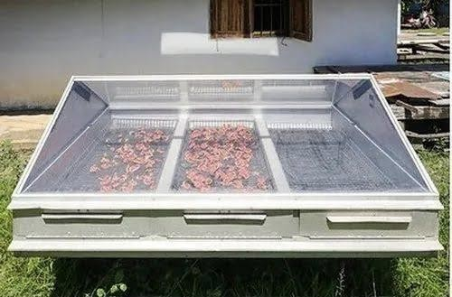
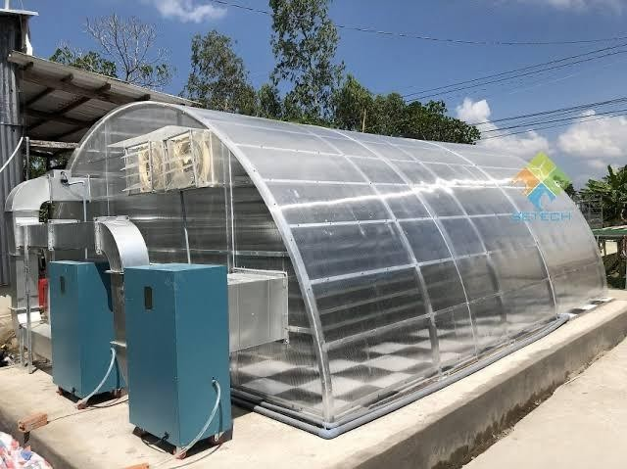

Active Solar Dryers

Active dryers have a ventilation system to circulate heated air inside the drying chamber or from the solar collector to the drying chamber. Fans or blowers are run by electricity, which

can be harnessed from a photovoltaic (PV) module or grid. In particular, in the passive mode of the greenhouse dryer, a ventilator or chimney is built for the natural circulation of heated air, and in the active dryer, an exhaust fan is provided for air movement. An active dryer has been re- ported to be more suitable for crops with a higher moisture content such as papaya, kiwi, cabbage, and cauliflower than the passive dryer (Chua and Chou, 2003). The active dryer requires more investment than a passive dryer and is more difficult to operate and maintain. To achieve high drying efficiency and product quality, the optimal temperature and air mass flow rate must be controlled. The indirect passive dryer (forced convection) contains a drying unit with a separate solar collector and three main components: solar collector, drying unit, and air duct for circulation. The air is heated while flowing through a low-pressure drop solar collector and then passes through air ducts into the drying chamber and over the drying trays. The moist air is discharged through air vents or a chimney at the top of the chamber. The average drying efficiency is 13–25%, which is lower than the direct solar dryer (Kumar et al., 2016). However, Tomar et al. (2017) reported that unlike the direct passive dryer, this method overcomes the problem of

cracking and helps to preserve vitamins and color as agricultural products are not directly exposed to solar radiation.

Hybrid Solar Dryers

In a hybrid dryer, agricultural materials are dried under direct solar radiation and/or back-up energy or stored heat in the absence of sun- light. The air is pre-heated by another auxiliary source of energy such as a solar PV module, electricity, and liquefied petroleum gas (LPG),
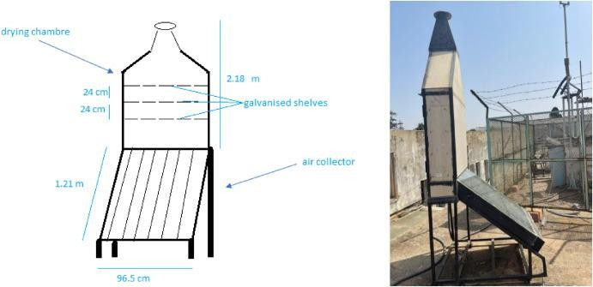
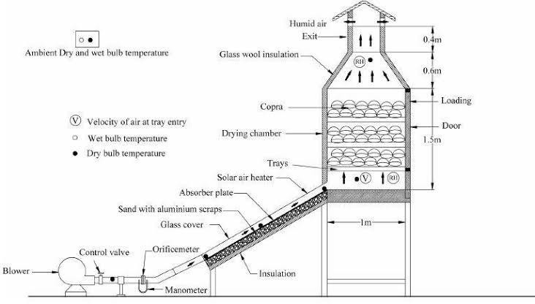

diesel, or biomass. This dryer can be used in both single and mixed modes (direct and indirect types of drying). Bala and Woods (1994) report that hybrid drying could reduce microbial infestation in products. Queiroz et al. (2004) show that the heat pump dryer can be 40% more energy efficient relative to the electric resistant dryer. Ferreira et al. (2007) present a study for banana and determine that the drying time obtained in hybrid drying is lower compared to open-air or artificial drying. In addition, better color, aroma, and texture were observed in hybrid dried banana compared to open-air sun drying. Eltawil et al. (2018)

developed a hybrid, portable tunnel dryer to dry peppermint by enhancing its performance using a solar PV system and flat plate solar collector. They determined that the quality of the hybrid-dried peppermint was higher than that of open sun-dried peppermint. The dryer efficiency was 31% with a net carbon dioxide (CO2) mitigation of 32 tons over its life span.

ADVANTAGES OF SOLAR DRYERS

This technology has several socio-economic advantages. One of the main problems facing developing countries today is food security. The solar dryer, using this renewable energy, can improve food security, allowing for better preservation of food after drying compared to

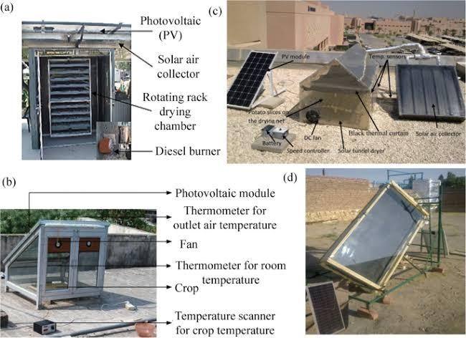
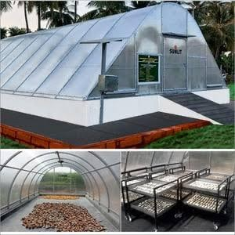

food that has not been dried. The solar dryer reduces the drying time and facilitates the drying of food compared to the sun drying method.

The solar dryer saves fuel and electricity when replacing dryer variants that require an external energy source in the form of electricity or fossil fuel. In addition, solar dryers reduce drying times compared to solar drying. While dryers powered by fossil fuels or electricity may have some advantages (smoother airflow and higher temperatures), the financial barriers associated with these technologies may be too high for marginal farmers. For example, electricity may not be available or may be too expensive, and drying with fossil fuels may involve high initial and operating costs.Fruit, vegetables and meat dried in a solar dryer are of better quality and more hygienic than sun-dried fruit, vegetables and meat. As mentioned, due to the closed system design, contamination of food is avoided or minimized. In addition, the food is not vulnerable to rain and dust, unlike the open sun- drying system.
In rural areas where farmers grow fruit and vegetables without adequate drying facilities, they have to sell the food on the market soon after harvest. When food production is high, farmers need to sell the food at a low price to prevent it from losing value through decomposition. Therefore, the solar food dryer may be able to avoid the financial losses that farmers face in these situations. Dried food can be stored for longer and retain its quality for longer. In addition, dried fruits and vegetables can be sold as differentiated products, which can increase their market value. For example, dried meat can be processed into a variety of different products. The food will be drier and less bulky. Therefore, in addition to a longer storage time, the food is also easier to transport after drying with the help of the integrated racks in the solar dryer.

FOOD DRYING TECHNOLOGY

Food spoilage refers to irreversible changes where food becomes inedible, or its quality is dangerous. Food harm can be prevented or reduced by implementing food preservation techniques, one of which is drying. Drying is a process of removing water to prevent the growth of microorganism, which can cause the decay process. The principle of drying is to remove water from food by dehydration. Food drying techniques have long been applied in conventional ways, such as drying in the sun or through blowing wind. These methods are still use today because they are considered more economical and efficient by utilizing natural energy with unlimited energy. However, this method’s drawback is the instability of power from nature, which affect drying rate. The development of drying technology in the last few decades has been very rapid, including the pretreatment process, techniques, equipment and the quality of the final principles produced. All these methods have different principles and mechanism have their respective advantages and disadvantages.

SOLAR ENERGY AND DRYING

Solar energy is quite simply the energy produced through a thermonuclear process directly by the sun. The process creates heat and electromagnetic radiation. The heat remains in the sun and the electromagnetic radiation in the form of visible light, infra-red light and ultra- violet radiation stream out into space in all directions. Small fraction of the total radiation produced reach the earth. The radiation that reaches the earth is the indirect source of nearly every type of energy used today (Geothermal energy, Nuclear energy and Exceptions).

Two essential components are required to store and convert to usable form of solar energy. One is “collector” and other is “storage unit”. The function of the collector is simply collects the radiation that falls on it and covert a fraction of it to required forms of energy. The function of the storage unit is required to store the excess solar produced during striking high intensity of solar radiation.
Drying principle: When hot air is circulated over the moist product moisture will remove from the product till the hot air is fully saturated i.e. means absolute humidity has been reached. But moisture will removal is depending on the temperature. The higher the temperature the larger is the removal of moisture. If the air is warmed and the moisture contains remains the same, but the relative humidity falls so the air removes more moisture from the product. For getting better result drying rate must be high.

OPEN SUN DRYING

Drying under open sun using the solar radiations for food preservation is practiced since ancient times. Drying involves a heat and mass transfer phenomenon in which heat energy supplied to the product surface is utilized in two ways (i) to increase the product surface temperature in the form of sensible heat and (ii) to vaporize the moisture present in product through the provision of the latent heat of vaporization. It is the oldest and most common traditional method to preserve agricultural products, grain, fruits, vegetable, fish etc. In which products are spread on ground directly exposed to solar radiations. The solar radiations falling on the surface is partly reflected and partly absorbed. The absorbed

radiations surrounding air heat up the surface. A part of this heat is utilized to evaporate the moisture from the surface atmosphere and through the conduction to the ground.

CHAPTER THREE

  - MATERIALS AND METHOD

  - SAMPLES

Tomato and cayenne pepper samples were obtained from Ipata Market, located in Ilorin, Kwara State in the republic of Nigeria.

STUDY AREA

This study was carried out in Physic and Electronics unit laboratory (Science and Technology Department) Kwara State Polytechnic Ilorin. The thermal efficiency a nd processing of drying was also experimented there. It was carried out on the 15th and 17th of April 2023, for both cayenne pepper and tomato respectively.

SOLAR DRYING

Solar drying is a more advanced version of conventional sun drying; the product i s kept in a transparent container exposed to the sun. The critical difference between solar drying and sun drying is that solar drying requires a solar collector, and the hydrating product is not exposed to the direct sunlight (Fargali et al, 2008).

MATERIAL SELECTION

    - MATERIAL FOR BODY OF THE DISH

Steel was selected over aluminium because of its strength, cost, durability, and energy effectiveness in use of material. It is easy to clean. Its smooth contour shape minimizes the sloping error of the reflective mirror material. Energy consumed to produce steel is estimated to be16500 kJ/kg compared to that of aluminium which is 141,000 kJ/kg

MATERIAL FOR THE REFLECTING SURFACE

A light glass mirror of high surface quality and good spectacular reflectance was selected. Glass mirror was selected over polished aluminium surface because its reflectivity of 95% is better than that of aluminium (85%). A glass mirror of 3 mm thickness was selected to reduce the overall weight of the parabolic solar cooker.

MATERIAL FOR THE DRYING PAN

From our findings, we discovered that aluminium is not only cheap and easily available, but also has a very good specific heat per cubic centimetre. Material of aluminium was chosen for the drying pan. Aluminium is cheap and easily available, because this reflector is targeted for use in the rural community.

CHEMICAL COMPOSITION OF SPECIMENS TOMATO
Tomato (Solanum lycopersium) is one of the most widely consumed fresh vegetables in both the industrialized and non-industrialized world. Tomatoes are considered as part of healthy diet regime as they are low in fats and are without any harmful cholesterol. Nutrient like vitamin A, ascorbic acid and potassium are present in significant concentrations in tomatoes. Non nutrient phytochemicals like carotenoids (lycopene, phytoene, and B-carlene) and polyphenols (flavonoids, flavanones, and flavones) are also present in significant amount in tomato (solanum lycopersium). Phytochemicals are fortified with ripening and cooking of tomatoes. Carotene is present in high concentration in opened tomatoes and cooking fortifies the lycopene content in tomatoes. Lutein is also present in high concentration in ripe tomatoes.

CAYENNE PEPPER

Cayenne pepper is widely grown in central and South American and in Nigeria. It was cultivated 7,000 years ago and in Peru 4,000 years ago. Native Americans have use the crop as a food and medicine for stomach ache, cramping pains, gas and disorder of the circulatory system for 9,000 years. It contains up to 1.5% capsaicinoids (pungent principles) including 0.11% capsaicin, 6,7 dihydrocapsaicin, nordihydrocapsaicin, homodydrocapsaicin and homocapsaicin; fixed oils; carotenoid pigment including capsanthin, capsorubin, alpha -and beta - carotene, steroids glycosides.

EXPERIMENTAL EQUIPMENTS
- Digital Thermocouple: Also known as thermoelectrical thermometer or thermistor sensor coupled with data loggers are now used to sense and record temperatures and record
them in a digital format. It is a temperature-measuring device consisting of two wires of different materials joined at each end.

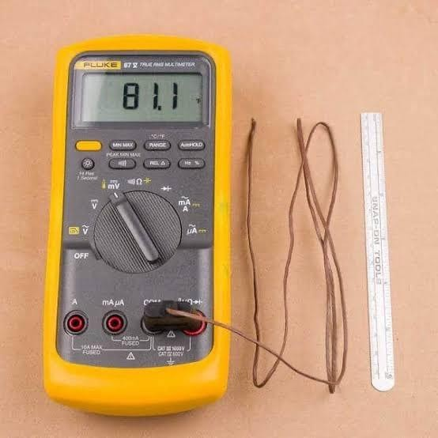

  - Pyranometer: is a type if actinometer used for measuring solar irradiance on a planar surface and it is designed to measure the solar radiation flux density ( W/m2) from the hemisphere above within a wavelength range of 0.3m to 3m.It is an instrument used to convert the global solar radiation it receives into an electrical signal that can be measured.
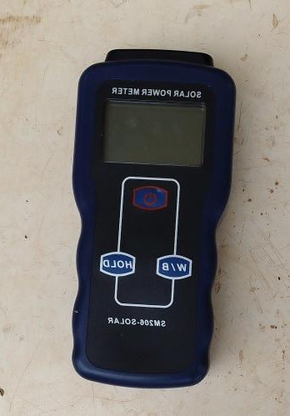

- Digital Weighing Balance: It is a device used to measure weight or mass. They are also known as mass scales, mass balances and weight balances. It is the most accurate and precise analog front-end (AFE) instrument that uses force sensor to measure the weight of an object with the value not more than 5kg or 500g.
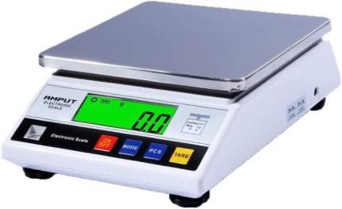

- Parabolic Dish: Is a reflective surface used to project energy such as light, sound or radio waves. It is used to generate heat for cooking or drying.
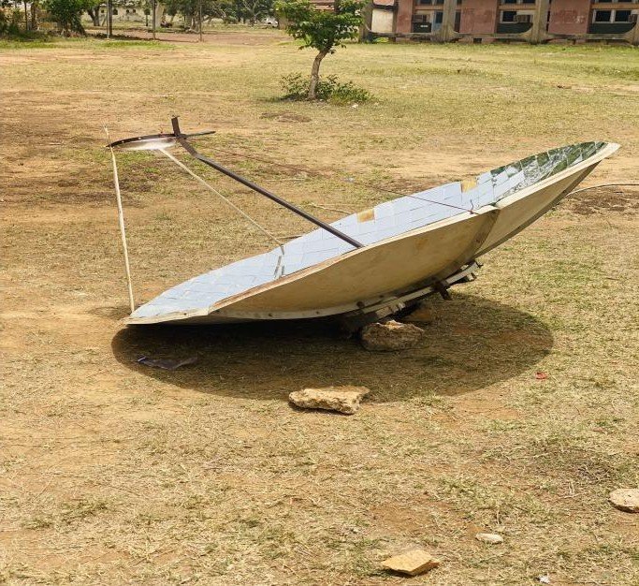

- Knife: It is a tool or weapon with a cutting edge or blade, usually attached to a handle or hilt. It is ordinarily made of wood, bone and stone. It is used for cutting.

- Drying pan: It is a flat bottom pan used for frying, grilling as well as drying.

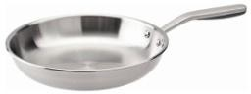

- Tray: It is a plastic material which the product is been kept in order to give it accurate arranging and easily weighing of the product.

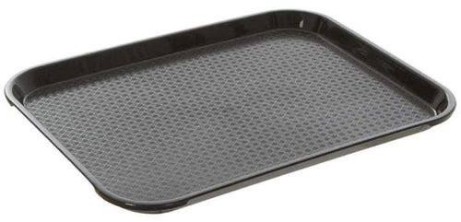

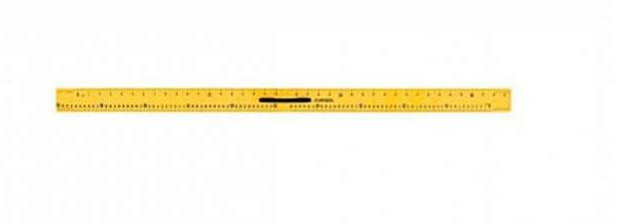
- Meter rule: It is a wooden nature (type) rule used in measuring the length, breadth and other measurement during an experiment.

EXPERIMENTAL SET UP

A satellite dish of diameter 1.8m and height of 0.27m, radius of 0.9m, area of 0.26m, aperture area of 0.016m, concentrator ratio of 0.081 and focal length of 0.047m was used for the construction of the parabolic solar reflector. A reflective mirror was cut using a glass cutter into small square pieces sizes 4cm x 4cm, these reflective mirrors was used to cover the surface of the satellite dish by using a glue to stick the small square size mirrors to the interior surface of the satellite dish which form the parabolic concentrator. The parabolic

dish concentrator was set to move freely in any direction for tracking purpose by rotating dish manually. As the rays of the sun falls on the surface of the dish, the focus of the reflected rays was calculated and the point of reflection was located using a plane white sheet of paper. During the construction process the drying pan is placed on a handle directed to the east.
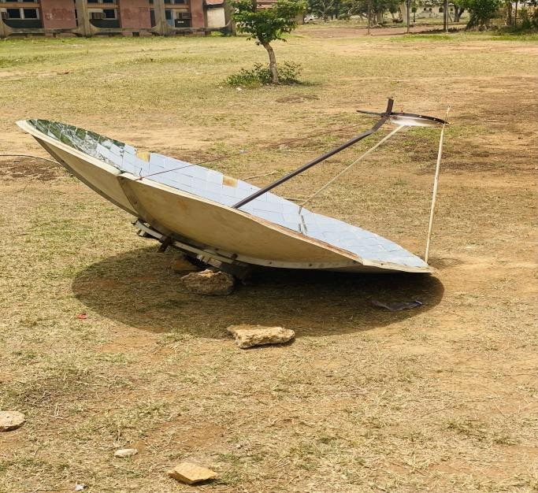

METHOD

The experiment was conducted on the 15th and 17th April 2023 in Kwara State Polytechnic, Ilorin. The experimental set up was placed at a free space at the back of the laboratory; the parabolic dish was set in a way that it can be moved freely in any direction depending on the focal point of the solar radiation. A retort stand was placed in a particular direction where the focal point was found during the time of the day. The distance from the focal point to the retort stand is recorded and also the height of the retort stand from the ground is also

measured using a meter rule. The drying specimens were tomato and cayenne pepper purchased from the market and brought to the laboratory.
The specimens were washed with clean tap water to remove dirt and decaying tomatoes and cayenne pepper , each samples ware sliced vertically using the knife into pieces and placed on the trays with the flesh of the tomatoes and cayenne pepper laying on the tray. The specimens were weighed and the values obtained are 249g and 107g for tomatoes and cayenne pepper respectively. The experiment for the drying of tomatoes started at 11:40 am and ends at 02:00pm on the 15th of April and that of the cayenne pepper started at 11:45 am and dried considerably at 1:25pm during the overhead sun on the 17th of April. The thermocouple was used for the temperature measurement which are the ambient temperature, absorber temperature, and fluid temperature while the pyranometer was used to measure the solar radiation and weighing balance was used to measure the moisture content loss of both the tomatoes and cayenne pepper at every ten minutes interval.
Tomatoes of 249g were reduced to 140g and cayenne pepper of 107g was reduced to 34g at 3 hours and 20 minutes and 1 hour, 40 minutes respectively. In the course of data collection, conditions of cloud cover during drying may have contributed to variations in solar radiation.

SAMPLE
WASHING OF
SAMPLES
SLICING OF THE
SAMPLE
SPREADING OF THE
SAMPLE ON THE DRYING PAN
TAKING READINGS
PARKING AND
STORAGE OF THE SAMPLE

Table 1.1 MEASUREMENTS AND PARAMETERS

MEASUREMENT | PARAMETERS
Diameter | 1.8m
Height | 0.27m
Radius | 0.9m
Area | 0.26m
Aperture | 0.016m
Concentrator | 0.081m
Focal length | 0.047m
Glass | 0.4m
Length | 1.45m

NOMENCLATURE

S surface area of parabolic F focal length
D diameter

R radius of parabolic H height of parabolic L length of parabolic A area of parabolic
Q heat of food require

3:9 MATHEMATICAL EXPRESSION

    - DETERMINATION OF APERTURE AREA

Aperture Area ()

= π(ra)²

=3.142(0.9×0.256)²

=3.142×0.053

=0.167m²

DETERMINATION OF RECEIVER AREA

Receiver Area()

π(rr²) =3.142(0.9×0.9)²

=3.142(0.81)

=3.142×0.6561

=2.061m

DETERMINATION OF FOCAL LENGTH

Focal Length (F)

F = (𝑟𝑎)² = (0.9×0.256)²
4ℎ 4×0.28

= (0.2304)²
4×0.28

= 0.0531
1.12

=0.047m

DETERMINATION OF RIM ANGLE

Rim Angle(Q)

𝑡𝑎𝑛

(𝑄)
= 1
d/8h
_2h
d

= 1
1.8/8×0.28
_2×0.28
1.8

1
=
1.8

2.24

= 1
_0.56
1.8

– 0.311

0.804

= 1
0.493
=2.029
Q =tanˉˡ 2.029
Q =63.76°

DETERMINATION OF THE SURFACE AREA OF THE PARABOLOID

The surface area of the paraboloid(As)

8(𝑓)^{⅔} × [(d/4f) + ³ ⁄ ²1] − 1

=8 × 3.142 × (0.047)⅔× [(1.8/4×0.047) +1]³⁄² - 1

=8×3.142×(0.047) ²³̸ × [(1.8/4×0.047) +1] - 1

=8×3.142×2.209×10ˉ³ ×[(1.8/0.188) +1]³⁄² - 1

=0.0555/3×[9.57+1]³⁄²-1]

=0.0185×[10.57]³⁄² -1]

=0.0185×[10.57]^1.5 – 1]

=0.0185×[34.36 – 1]

=0.0185×33.36

=0.62m².

By using indices

=0.0555÷3 × (9.57+1)³⁄² - 1

=0.0185 × [10.57]³⁄² - 1

x^1/a = a√x [10.57]³⁄² = 2√10.57³
= 2√1180.9
= 68.73
= 0.0185 × [68.73-1]
= 5.60-1
s = 5.5m²

DETERMINATION OF LENGTH OF CIRCUMFERENCE

Length of circumference

π× D×a
=3.142×1.8×0.265

=1.499m²

DETERMINATION OF CONCENTRATION RATIO

𝑨𝒂
𝑨𝒓
= 0.167
2.061

=0.081

CHAPTER FOUR

RESULT AND DISCUSSION

GENERAL OBSERVATION

The drying of the tomatoes and cayenne pepper using the parabolic solar reflector had an initial high drying rate, as the drying process continued. The drying rate declined in a drastic manner.

CHAPTER FIVE

CONCLUSION

A parabolic solar cooker was designed and constructed using locally available materials. The design parameters were aperture area, receiver area, focal length, rim angle, the surface area of the parabola and concentrator ratio. The constructed parabolic solar cooker showed a good performance in drying tomato and cayenne pepper for a short period of time compared to the open sun drying.

RECOMMENDATIONS

Based on the finding of this work, the following recommendations were made;

    - The parabolic solar reflector should be adopted as a method of drying agricultural product in most part of the rural area in Nigeria.
    - Base on the poor and erratic electricity supply in the nation. The parabolic solar reflector should be deployed for the purpose of drying agricultural products to prevent spoilages and massive waste of agricultural product after harvesting which is the common phenomenon in the nation agricultural sector

REFERENCES

A. A. Abd El-Rahmam, Abdel Mohsen, H., and H. E. Hassan. 2019. Drying of tomato fruits using solar energy. Agricultural Engineering International: CIGR Journal, 21(2): 204–215

Abdullahi,Y., Momoh, M., Garba, M. M., and M. Musa, M., “Design and Construction of an Adjustable and Collapsible Natural Convection Solar Food Dryer,” International Journal of Computational Engineering Research, vol. 3, no. 6, pp. 1–8, 2013.

Abdelhamid Fadhel , Sami Kooli , Abdelhamid Farhat and Ali Belghith, The Thermal Process Laboratory, The Research and Technology Center of Energy, Hammam-lif BP, Tunisia 2 Department of Physics, Faculty of Sciences Mathematics, Physics and Natural of Tunis, Belvèdère, Tunisia.

Adeodu O. Adefemi, Daniyan A. Ilesanmi: Development and optimization of Drying parameters for Low-cost Hybrid solar dryer. ISSN: 8, 23-35 (2018).
Aidan, J. Department of Physics, Modibbo Adama University of Technology, Yola, Nigeria. Aliyu Samuel Jacob, *, Nnodim Chiebuka Timothy, Kazeem Razak Adebayo, Adedayo
Aaron Banji: 2021: Department of Mechanical Engineering, Landmark University, Omu-Aran, Nigeria 2Department of Electrical and Information Engineering, Landmark University, Omu-Aran, Nigeria.

Arunet, S., Ayyappan, S. and Sreenarayanan, V.V 2014. Experimental Studies on Drying Characteristics of Tomato in a Solar Tunnel Greenhouse Dryer. International Journal of Recent Technology and Engineering (IJRTE). ISSN: 2277-3878, 3(4): 32–37.

Ashokraj, S. & Sekar, M. (2016). Design and analysis of receiver for a parabolic solar dish collector, Department of Mechanical Engineering. Government College of Technology, Coimbatore, Tamil Nadu, India.

Azeez, L., Adebisi, S. A., Oyedeji, A. O., Adetoro, R. O. & Tijani, K. O. Bioactive compounds’ contents, drying kinetics and mathematical modelling of tomato slices influenced by drying temperatures and time. J. Saudi Soc. 10, 120–126 (2019).

Bala, B.K., Woods, J.L., 1994. Simulation of the indirect natural convection solar drying of rough rice. Sol. Energy 53, 259–266.

Barrett DM, Anthon GE. Color quality of tomato products. Color quality of fresh and processed foods; 2008131–9.

Cernisev, S. 2010. Effects of conventional and multistage drying processing on non- enzymatic browning in tomato. Journal of Food Engineering, 96(1): 114–18.

Chua, K.J., Chou, S.K., 2003. Low-cost drying methods for developing countries. Trends Food Sci. Technol. 14, 519–528.

Eltawil, M.A., Azam, M.M., Alghannam, A.O., 2018. Energy analysis of hybrid solar tunnel dryer with PV system and solar collector for drying mint (Mentha Viridis). J. Clean. Prod.181, 352364.

Ferreira, A.G., Charbel, A., Silva, J.G., 2007. Experimental study of hybrid dryer. Therm.
Eng. 6 (2), 3–7.

Gwania*, M., Abubakarb, G.A., Abbasc, M., Na Allahd, M., Danyaroe J., a,b,c,e Department of Physics, Kebbi State University of science and Technology Aliero,
P.M.B 1144, Kebbi State Nigeria: National Mathematical Center, Abuja.Nigeria, Email: gwanimohammed@gmail.com.

Hassan H. E., Heba Abdel Mohsen, Abd El-Rahmam,A. A. (1. Researcher, Agric. Eng. Res. Institute, Agric. Res. Center, Egypt; 2. Prof. of Agric. Eng. Res. Institute, Agric. Res. Center, Egypt; 3. Prof. of National Institute of Laser Enhanced Sciences (NILES), Cairo University, Egypt)

Hii, C.L., Rahman, R.A., Jinap, S., Che, Man YB., 2006. Quality of cocoa beans dried using a direct solar dryer at different loadings. J. Sci. Food Agric. 86 (8), 1237–1243.

Jahangeer, K. A. 2006 and Hawlader, M. N. A. Solar heat pump drying and water heating in the tropics. Solar Energy, 80(5): 492–499. S. Adhikari, Postharvest Management of Fruit and Vegetables in the Asia-Pacific Region. 2006.

Jobin Varghese1, Rupesh S2, Jithu Augustine1, Adithya Nair1, Prajith1 - Adishankara Institute of Engineeirng and Technology, Kalady. 2PES College of Engi neering, Mandy :jobinvargheset@gmail.com.

Kamaldeen O. S 1, * and Okedokun O. W 21 Nigerian Stored Products Research Institute (NSPRI), Kano Station, Nigeria. 2 Federal College of Agricultural Produce Technology, Kano, Nigeria. GSC Advanced Engineering and Technology, 2022, 04(02), 025–031.

Kumar, M., Sansaniwal, S., Khatak, P., 2016. Progress in solar dryers for drying various commodities. Renew. Sustain. Energy Rev. 55, 346–360.

Madhlopa, A., Jones, S.A and Kalenga Saka, J.D “A solar air heater with co mposite absorber systems for food dehydration,” Renewable Energy, vol. 27, no. 1, pp. 27–37, 2002.

Müller, J., Mühlbauer, W., 2012. Solar drying. In: Tsotsas, E., Mujumdar, A.S. (Eds.), Modern Drying Technology, Energy Savings. Wiley-VCH Verlag & Co. KGaA, Weinheim, pp. 199–243.

Olajide, J. O., O. J. Oyelade and A. T. Y. Tundeand, 2003. Design of a cabinet tray dryer for small and medium scale food processors. In Nigerian drying symposium series 1., University of Port – Harcourt, Nigeria.

Omotoyosi Onalapo Craig - Thesis presented in fulfilment of the requirements for the degree of Master of Engineering (Mechanical) in the Faculty of Engineering at Stellenbosch University. December 2015 .

Prakash, G. and Garg, H.P., Solar Energy: Fundamentals and Applications. Tata McGraw- Hill Publishing Company, 2000.

Queiroz, R., Gabas, A.L., Telis1, V.R.N., 2004. Drying kinetics of tomato by using electric resistance and heat pump dryers. Dry. Technol. 22 (7), 1603–1620.

Rajeshwary, N. and Ramalingam, A. 2012, “low cost material used to construct effective box type solar dryer’’, archive of applied science reaches ,2012,4(3);1476-1482.

Tiris C., Özbalta, N., Tiris M. and Dinçer, I.,1994. Experimental testing of a new solar dryer. International Journal of Energy Research, 18(4): 483–490.

Tomar, V., Tiwari, G.N., Norton, B., 2017. Solar dryers for tropical food preservation: thermophysics of crops, systems and components. Sol. Energy 154, 2–13.

APPENDIX II

 