DESIGN AND IMPLEMENTATION OF
LECTURER’S BEHAVIOR EVALUATION SYSTEM
INTEGRATED WITH BUNIFUL FRAMEWORK

BY
JIMOH ABDULMAJEED OLATUNJI ND/23/COM/PT/0357

A PROJECT SUBMITTED TO

THE DEPARTMENT OF COMPUTER SCIENCE, INSTITUTE OF INFORMATION AND COMMUNICATION TECHNOLOGY KWARA STATE POLYTECHNIC, ILORIN

IN PARTIAL FULFILLMENT OF THE REQUIREMENTS FOR THE AWARD OF NATIONAL DIPLOMA (ND) IN
COMPUTER SCIENCE

JULY, 2025.

CERTIFICATION
This is to certify that this project work was carried out by JIMOH ABDULMAJEED OLATUNJI with Matriculation Number ND/23/COM/PT/0357 The project has been read and approved as part of the requirement for the award of National Diploma (ND) in Computer Science Department, Institute of information and communication technology, Kwara state polytechnic, Ilorin.

MRS. ADEMOLA R. DATE
PROJECT SUPERVISOR

MR. OYEDEPO F. S. DATE
HEAD OF DEPARTMENT

EXTERNAL SUPERVISOR DATE

DEDICATION
This project specially dedication to Almighty God for His love, protection, guidance and supports for me especially in my academic career. Also, to my beloved parents for their care and full support during my course, may Almighty God bless them abundantly (AMEN).

ACKNOWLEDEGEMNTS

All glory, adoration and glorification are due to almighty Allah (S.W.T) the most gracious, the most beneficent the most merciful, the creator of all creatures, for seeing me through my studies and this project in this great institution KWARA STATE POLYTECHNIC ILORIN, may his abundant blessings continue to be upon his prophet (S.W.T)
I appreciate the utmost effort of my Supervisor, MRS ADEMOLA.R. Whose patience, support and encouragement have been the driving force behind the success of this research work. She gave useful corrections, comments, recommendations, advice and always ensures that excellent research is done.my sincere gratitude goes to Head of department and other members of staff of the department of computer science, kwara state polytechnic, ilorin. For their constant cooperation constructive criticism and encouragement throughout the programmed.
Special gratitude to my parents, who exhibited immeasurable financial, patience, support and prayers. And has made it possible for me to complete my OND program in this intuition KWARA STATE POLYTECHNIC, ILORIN. Special thanks also go to my lovely siblings.

ABSTRACT
Evaluation is aimed at improving the ongoing teaching and learning process. Ongoing lecturer evaluation activities have several problems such as lecturer evaluation process is still done manually. To solve these problems, it needs a change within the system that is from the manual lecturer evaluation system into web-based lecturer evaluation information system. Thus, all processes in lecturer evaluation activities can be done by online, either in the input process of questionnaires or in presenting a report. Lecturer evaluation activities which conducted by online can assist in making decision to get the best lecturer's recommendation. System development method which use are use case diagram, activity diagram, sequence diagram, and class diagram and then is use PHP and MySQL as a programming language

TABLE OF CONTENTS
Title page i

Certification ii
Dedication iii
Acknowledgements iv
Abstract v
Table of Contents vi
CHAPTER ONE
  - Introduction 1
  - Aim and Objectives of the Study 3
  - Statement of the Problem 4
  - Significance of the Study 4
  - Scope and Limitation 4
  - Organization of the Report 5
CHAPTER TWO
  - Review of past work on the Project 6
  - Review of General Text 9
  - Other concept Related to the Topic 15
CHAPTER THREE
  - Research Methodology 28
  - Description of Existing System 28
  - Problem of Present System 29
  - Description of the Proposed System 29
  - Advantages of the proposed System 30

CHAPTER FOUR

4.1 | Design | of the System | 32
 | 4.1.1 | Output Design | 32
 | 4.1.2 | Input Design | 33
 | 4.1.3 | Database Design | 35
 | 4.1.4 | Procedure Design | 36
4.2 Implementation of Techniques Used in Details 37
 | 4.2.1 | Programming Language Used with Reasons | 37
 | 4.2.2 | Hardware Support | 37
 | 4.2.3 | Software Support | 38
4.3 | System | Documentation | 38
 | 4.3.1 | Program Documentation | 38
 | 4.3.2 | Operating the System | 38
 | 4.3.3 | Maintenance of the System | 39
CHAPTER FIVE
  - Summary 40
  - Conclusion 40
  - Recommendations 41
Reference 42
Appendix 1 Flowchart 44
Appendix 2 Source Code 51

Chapter One

General Introduction

  - Introduction

Performance management, particularly performance appraisal aspect of it with regards to academics in institutions of higher education has not received enough attention from policy makers and administrators of tertiary institutions in the past. Hence, its contribution to enhance institutional performance and quality appear to have been neglected. Consequently, universities adopted a laissez-faire approach to performance appraisal, thus, academic staff members were not closely monitored in terms of in-class effectiveness. The evaluation criteria used in evaluating the lecturers in Nigerian tertiary institutions today have failed to enhance the quality of performance and credibility of graduates of tertiary institutions because such evaluation methods tend to give low priority to teaching as noted by Oranu (2021) that describes the quality of teaching in Nigeria as apparently poor, and attributed this to the fact that teaching performance and other in-class behaviors are never recognized criteria when considering university lecturers for promotion or reward. Emphasis is rather placed on research publications (Ofoegbu, 2021).
According to Adomi (2023), students are the direct consumers of services rendered by universities; hence their views on all aspects of their higher education experiences are essential to the effective monitoring of quality in universities (Hill, Lomas & MacGregor, 2023).
As the most significant resource in schools, lecturers are critical to raise education standards. Improving the efficiency and equity of schooling depends, in large measure, on ensuring that lecturers are highly skilled, well resourced, and motivated to perform at their best.

Raising teaching performance is perhaps the policy direction most likely to lead to substantial gains in student learning (OECD, 2021).
University lecture, as a form of learning process, involves planning, implementation, and regular evaluation. In terms of evaluation, it mostly focuses on the scope of learning outcome. On the other hand, the scope of lecture evaluation assessed by students still requires supports for implementation (Suherman, 2023). Lecturers are obliged not only to evaluate learning outcome but also to accommodate students’ evaluation on lecturers’ performance during the learning process. It means that lecturers are responsible for both students’ achievement and their own performance in teaching. The statements show that course subject evaluation actually applies to students and lecturers (Jabbarifar, 2022).
Lecturers are capable of improving the teaching process through deep observation on the data of students’ perception on the teaching performance, and understanding of students’ learning style. It enables them to find students’ perception about their methods, approaches, and teaching strategies. In order to do so, they need to populate data from their students each semester (Marmah, 2020). They state that evaluation provides beneficial report concerning strength, weakness, and potential in learning process. In details, Arikunto (2023) explicate that by having evaluation, teaching staff will find out the material appropriateness for their students. Teaching performance will improve if lecturers – or in this sense is lecturers – receive regular, particular, and conceptual reports. In the level of higher education, the response from student evaluation can be the data sources to improve lecturers’ performances (Nuriyah, 2023).
In turn, the effective monitoring and evaluation of teaching is central to the continuous improvement of the effectiveness of teaching in a school. It is essential to know the strengths of lecturers and those aspects of their practice which could be further developed. From this perspective, the institution of lecturer evaluation is a vital step in the drive to improve the

effectiveness of teaching and learning and raise educational standards. Meaningful lecturer evaluation involves an accurate appraisal of the effectiveness of teaching, its strengths and areas for development, followed by feedback, coaching, support and opportunities for professional development. It is also essential to celebrate, recognize and reward the work of lecturers. TALIS results reveal that the great majority of lecturer’s report that the appraisal and feedback they receive is beneficial, fair and helpful for their development as lecturers (OECD, 2023).
Evaluation of lecturer’s achievement is a crucial and pervasive issue of concern in every classroom. Traditional evaluation activities were used to certify or promote lecturers. Currently, evaluation is recognized, as a comprehensive process not just something that occurs only at the end of some learning episode, it is an integral part of the teaching learning process.

Statement of the Problem

Education is concerned with the integral formation of lecturers. Hence, it should be directed toward their physical emotion, social, moral, intellectual and spiritual development. Most of the school’s evaluation system are being done manually whereby paper will be given to the class coordinator in order to be taken the attendance of each lecturer’s that comes to class. And this method is outdated and most of the time student’s find it difficult to rate the lecturer’s low because of the fear. But this system will give student’s free access to the system and rate the performance and behavior of the lecturer’s in the class.

Aim and Objectives of the Study

The main aim of this project is to provide an information tracking system along with evaluation system for evaluating lecturers. The design system holds the following features over the previous manual systems.

- To develop a system that will Enhanced easy retrieval and access to records.

- To design a highly secured users information.

- To develop a system that gives accuracy of result processing

- Accurate report for decision making by the school management.

Significance of Study
This study aimed to investigate the students’ perceptions of lecturers’ performance at the end of the semester in order to gauge the overall teaching quality of the lecturers assigned to teach them throughout the semester. Specifically, the study aims to answer the following research questions: 1. What are the students’ perceptions towards the teaching performance of lecturers? 2. Is there any significant difference in the teaching performance of male and female lecturers?

scope of the study
The scope of this research is to analyze the ongoing lecturer evaluation system, design and develop an information system capable of reducing the error rate in input data evaluation, data processing evaluation, calculating the evaluation value and presenting the result of evaluation output obtained by each lecturer. With the new information system is expected to facilitate the activity in evaluating the performance of lecturers.

Organization of the Report

This project is segmented into five distinct chapters. Chapter one describes the introduction, aim and objectives, significance of the study, scope of the study as well as the organization of the report and definition of key terms.
The second chapter talks about the literature review, historical background, and review of related projects.

The third chapter deals with the methodology, analysis of the existing system, problems of the existing system, description and the advantages of the proposed system.
The second to the last chapter deals with the design of the system which entails the output, Input, database and procedure design of the system, the implementation comprises of the hardware and software support while the documentation comprises of how to use the system and the system maintenance.
The last chapter deals with the summary experienced gained, conclusion and recommendations.

Chapter Two

Literature Review

  - Review of Related work

Lecturer evaluation is a periodic exercise of measuring lecturers’ performance by students Aduwa (2023). It is a systematic collection and analysis of information from which certain decisions relating to effectiveness, efficiency and/or competence of a lecturer in realizing set professional goals are made. In addition, Cross,( 2012) mentioned that “lecturers’ anxiety about students’ evaluations seems alleviated if lecturers are convinced that the evaluation results are meant to help them assess their own teaching and identify areas to improve”
Among the early studies of teaching evaluation in Nigeria is the work of Watkins and Akande (2023). They reported an investigation which tested the applicability of two American instruments (the Students' Evaluation of Educational Quality and the Endeavor Instruments) designed to assess tertiary students' evaluations of teaching effectiveness with 158 Nigerian undergraduates. This research finding indicated that teaching effectiveness can be measured in a Nigerian setting, that evaluation instruments developed at American universities may well be reliable in Nigeria.
Blair and Inniss (2022), conducted a pilot study to determine whether an online student evaluation questionnaire (SEQ) offered a pragmatic alternative to the hard copy version and whether the students in this developing nation (Trinidad and Tobago) were ready for the change to the online modality. The pilot study was analyzed against three success indicators: 1) that the average student response rate should be maintained. 2) That the turn-around-time should be improved. 3) That student satisfaction should be increased. However, specific limitations

were also acknowledged as this pilot study was specific to one case, and therefore, not easily generalizable. Furthermore, the research also suggested that results from the pilot study expressed positive student perception of online SEQ as they were likely to use online SEQs just as they would with their hard copy equivalents, and that future students were more likely to favour the online format.
A study by Pearson (2021) investigated motivators and barriers to student and faculty engagement with an online SET process. This was done by conducting semi-structured interviews with selected students, who self-identified as either “completers” or “non- completers” of SET, and 12 faculty members. Results from the study showed students motivation to complete SET were backed by students’ perception that results would be used and/or considered by instructors. On the other hand, students’ barriers to complete SET were backed by timing and number of surveys presented to the students. Results also showed that faculty members were motivated to engage with SET when the response rates were high and when senior administrators acknowledged survey results. This investigation of motivators and barriers to engagement with online SET was subjected to certain limitations. First, this study drew from a small number of students and faculty members within a single institution. Second, all participants were self-selected and not randomly picked, thus may have had a particular interest in the topic.
Abedin et al. (2023) attempted to investigate lecturers’ and students’ perceptions of Student Feedback Online (SuFO) in four aspects: 1) Lecturers’ and students’ perceptions on students’ evaluation. 2) The significance of SuFO evaluation to lecturers and students. 3) The differences between lecturers’ and students’ perceptions on the SuFO evaluation process. 4) Students’ response to their evaluation. The study was conducted using questionnaire given out to 97 lecturers and 330 second-semester students selected from various programmes in UiTM

Negeri Sembilan, Malaysia. Findings expressed that there were no significant differences

between students’ and lecturers’ perceptions on course evaluation process.

Rogers (2024) presented a model of the innovation-decision process. The model comprises five stages, among which is the implementation stage. Implementation occurs when an individual (or other decision-making unit) puts an innovation to use. Until the implementation stage, the innovation-decision process has been a strictly mental exercise of thinking and deciding. However, implementation involves overt behavior, as the new idea is actually put into practice. It is one thing for an individual to decide to adopt a new idea, yet quite a different thing to put the innovation to use, as problems with exactly how to use the innovation arise in the implementation stage. Implementation usually follows the decision stage, unless it is delayed by some logistical problem, such as temporary unavailability of the innovation. The crucial variable determining the rate of adoption of innovations is their perceived attributes, which consist of five types: 1) Relative advantage, 2) Compatibility, 3) Complexity, 4) Trial ability, and 5) Observability.
Ajjan and Hartshorne (2022) investigated faculty decisions to adopt Web 2.0 technologies. Through theoretical analysis and empirical tests, they found that while some faculty members feel that Web 2.0 technologies could improve students’ learning, interaction with faculty and their peers, writing abilities, and satisfaction with the course, few instructors chose to use them in the classroom. Additional results indicated that faculty members’ attitudes and perceived behavioral control are strong indicators of their intention to use Web 2.0. A number of implications were drawn highlighting how the use of Web 2.0 could be useful in the classroom.
Tantaphalin (2010) studied the causal factors affecting the decision process to adopt

blended learning by Faculty of Education instructors in Thailand. Drawing on Roger’s

innovation decision process theory, he found that the factors affecting knowledge in the decision phase were the characteristics of the instructors. The factors affecting the persuasion, decision, and adoption phases were the characteristics of blended learning.
Tomsic, Hendel and Matross (2023) draw somewhat contradictory conclusions. They looked at the demographic data from respondents to a survey of student satisfaction, administered in three successive years. Distributed survey packets included a web address and unique access code allowing students to complete the survey online if they so choose. Few students actually opted to respond online, overwhelmingly choosing to respond to the paper form. Evaluation of respondent characteristics found students from technological disciplines were more likely to respond to the online version, leading to the conclusion that online respondents might be different as a group. However, the study results point out that those choosing the online survey nearly doubled between the first and second years of the survey. The researchers conclude that while selection of the online format may indeed be an indication of a subject's comfort level with technology, the comfort level of the student population as a whole is broadening over time as computers and the Internet become more frequently used tools in higher education and American society at large.

Review of General Texts Evaluation Process and Procedures
Evaluation is the process of gathering data, which provides evidence of a lecturer’s performance. This data is synthesized and analyzed in light of county adopted performance criteria to determine the effectiveness of a lecturer’s performance for that cycle. The data is also used as a basis for refining performance during the evaluation cycle and as a guide for the development of a professional growth plan at the end of the cycle.

Two types of data may be gathered during the formative data gathering process – formal and informal. Formal data constitutes data that have been gathered, documented and shared with the evaluated. Only this formal data may be used for summative evaluation purposes. Informal drop-in observations (without documentation), self-evaluation, input from peers and others cannot be used. Lecturers are encouraged to use these and similar kinds of data as a basis for analyzing and improving their instruction, but this data must be documented and shared with the evaluator if it is to be used in the summative evaluation process.

The Formative Evaluation Process

  - Orientation The evaluation orientation is to be conducted at the building level by a building administrator for all lecturers who are scheduled to be evaluated.
  - Observation Formal and informal observations may be used to gather data and provide feedback to the lecturer. Only formal (documented) observation data may be used for the summative evaluation. Documented data must be shared with the lecturer within five working days after the observation.

Frequency

Informal observation may be conducted at any time and at the discretion of the evaluator. The required minimum formal observations include:
  - Two observations required during Year 3

  - One observation per year during Year 1 and Year 2 for probationary lecturers

  - One observation during Year 2 for continuing contract lecturers

  - No observations are required during Year 1 for continuing contract Lecturers

Observers

During the three-year cycle, the lecturer must be observed by at least two observers.

Length of Observation

Each formal observation must be at least 30 minutes in length. Preferably the observer should arrive prior to class starting and stay for the entire lesson or class period.

Pre-observation Planning Conference

- For the first formal observation during Year 3 of the cycle, the lecturer and observer must agree at least five days in advance on the date, time, and place of the observation. The lecturer must also complete the pre observation planning document and provide it to the observer no later than three days prior to the scheduled observation.
- Either the observer or lecturer may request a pre-observation conference. If the lecturer wishes a conference, he/she may indicate that request on the pre-observation form.
- Subsequent formal observations during Year 3 and any other time may be announced or unannounced at the discretion of the principal. If they are announced, a pre- observation planning document and/or conference may be requested by the principal, and the defined time period cited above will apply.

Post-observation Report and Conference

- All formal observations, announced or unannounced, will be followed by a post- observation report and conference. The report will be completed and the conference held no later than five work days after the observation, unless both parties agree.
- The observation report will be signed by the observer and the lecturer. The lecturer’s signature does not necessarily indicate agreement but signifies that the data has been shared.

The Summative Evaluation Process

Summative evaluation is the process of using performance data to judge the quality of teaching in accordance with the established criteria.
  - As part of the final formal post-observation conference during Year 3, the evaluator will review with the evaluate all formal evaluative data gathered to date, as well as any work samples or other formative data submitted by the lecturer.
  - After the final post-observation conference, the evaluator will analyze all data and complete the appropriate summative evaluation report. A copy of the report will be provided to the lecturer prior to a summative evaluation/professional growth planning conference.
  - A summative evaluation/professional growth planning conference will be held with the lecturer to review the summative evaluation report and to establish professional growth goals and plans. The professional growth plan will be cooperatively developed between the lecturer and administrator based upon a careful analysis and discussion of data generated during the cycle, including any informal data or work samples the lecturer wishes to share.
  - Lecturers are encouraged in particular to use the summative evaluation report as a basis for self-evaluation prior to the summative evaluation conference. This introspective review of the lecturer’s performance will assist in the establishment of meaningful and productive professional growth goals.

The Professional Growth Plan

The purpose of evaluation is to improve instruction. This goal is achieved through a systematic process of professional development reflected in a professional growth plan.

  - Based upon data gathered during the evaluation cycle, a professional growth plan will be mutually discussed and developed by the evaluator and lecturer. The evaluator will approve all professional growth plans.
  - The professional growth plan will then be monitored by the evaluator and new plans established as goals are accomplished.
  - The professional growth plan must be formally monitored and discussed at least once as part of a post-observation conference. d. Lecturers will be given appropriate assistance in implementing professional growth plans.

Special Evaluation

The evaluation process described in the previous section is designed for lecturers who are functioning in accordance with the established performance criteria. When formal data indicates that a lecturer is not meeting county performance expectations described by the criteria, the lecturer may be placed under special evaluation.
- When formal (documented) data indicates that a lecturer’s performance is not meeting established performance expectations, the principal shall submit a written recommendation to the Human Resources Department that the lecturer be placed on special evaluation.
- The Human Resources Department shall approve in writing the placement of a lecturer on special evaluation.
- The Human Resources Department will inform the lecturer in writing that he/she is being placed on special evaluation.
- The principal shall meet with the lecturer and explain the reason(s) for placement on special evaluation. During that conference, or at another conference in the immediate

future, the principal shall specify a plan of action which includes, but is not limited to, the following:
  - specific objective(s) to be accomplished

  - assistance to be provided

  - time limit for accomplishing objective(s), if appropriate

  - consequences of not meeting the objective(s), if appropriate.

- The principal will monitor the level of performance of the lecturer and will modify the original plan of action accordingly.
- A summative evaluation form will be completed at the end of the evaluation period.

Due Process

Due process is an integral part of the evaluation system. Due process requirements are met when:
- All parties had representation in the design, development, pilot testing, and revision of the system and its instruments.
- Every lecturer is provided an opportunity for familiarization with the system and its use.
- Knowledge of performance expectations and the procedure for performance evaluation is provided for staff through an orientation and through the distribution of a lecturer performance evaluation handbook.
- Lecturers are provided rebuttal opportunity for any summative report that is to be included in that lecturer’s personnel file. First, the lecturer must inform the principal that he or she does not agree with the report and specify why. If the matter cannot be resolved, then the lecturer can either provide an addendum that will be attached to the report or discuss their objection with the Director of Personnel. In any event, if the

matter is not resolved, and the lecturer chooses to submit one, a statement describing the objections will be attached to the report and placed in the lecturer’s personnel file.
- All reports of substandard performance must be in writing and must enumerate shortcomings in a specific manner.
- Each lecturer is provided access to the file of his/her evaluation documents located at the school site or division office. The procedure regarding employee records shall apply.

Other Concept Related To The Topic Evaluation
Evaluation is a systematic determination of a subject's merit, worth and significance, using criteria governed by a set of standards. It can assist an organization, program, design, project or any other intervention or initiative to assess any aim, realizable concept/proposal, or any alternative, to help in decision-making; or to ascertain the degree of achievement or value in regard to the aim and objectives and results of any such action that has been completed. The primary purpose of evaluation, in addition to gaining insight into prior or existing initiatives, is to enable reflection and assist in the identification of future change.
Evaluation is often used to characterize and appraise subjects of interest in a wide range of human enterprises, including the arts, criminal justice, foundations, non-profit organizations, government, health care, and other human services. It is long term and done at the end of a period of time.

Definition

Evaluation is the structured interpretation and giving of meaning to predicted or actual impacts of proposals or results. It looks at original objectives, and at what is either predicted or

what was accomplished and how it was accomplished. So evaluation can be formative, that is taking place during the development of a concept or proposal, project or organization, with the intention of improving the value or effectiveness of the proposal, project, or organization. It can also be summative, drawing lessons from a completed action or project or an organization at a later point in time or circumstance
Evaluation is inherently a theoretically informed approach (whether explicitly or not), and consequently any particular definition of evaluation would have been tailored to its context – the theory, needs, purpose, and methodology of the evaluation process itself. Having said this, evaluation has been defined as:
    - A systematic, rigorous, and meticulous application of scientific methods to assess the design, implementation, improvement, or outcomes of a program. It is a resource- intensive process, frequently requiring resources, such as, evaluate expertise, labor, time, and a sizable budget[4]
    - "The critical assessment, in as objective a manner as possible, of the degree to which a service or its component parts fulfills stated goals" (St Leger and Wordsworth-Bell). The focus of this definition is on attaining objective knowledge, and scientifically or quantitatively measuring predetermined and external concepts.
    - "A study designed to assist some audience to assess an object's merit and worth" (Stufflebeam). In this definition the focus is on facts as well as value laden judgments of the programs outcomes and worth.

Purpose of Evaluation

The main purpose of a program evaluation can be to "determine the quality of a program by formulating a judgment" Marthe (2009)

An alternative view is that "projects, evaluators, and other stakeholders (including funders) will all have potentially different ideas about how best to evaluate a project since each may have a different definition of 'merit'. The core of the problem is thus about defining what is of value." From this perspective, evaluation "is a contested term", as "evaluators" use the term evaluation to describe an assessment, or investigation of a program whilst others simply understand evaluation as being synonymous with applied research.
There are two function considering to the evaluation purpose Formative Evaluations provide the information on the improving a product or a process Summative Evaluations provide information of short-term effectiveness or long-term impact to deciding the adoption of a product or process.
Not all evaluations serve the same purpose some evaluations serve a monitoring function rather than focusing solely on measurable program outcomes or evaluation findings and a full list of types of evaluations would be difficult to compile. This is because evaluation is not part of a unified theoretical framework, drawing on a number of disciplines, which include management and organizational theory, policy analysis, education, sociology, social anthropology, and social change.

Performance Evaluation Systems

A performance evaluation system is a systematic way to examine how well an employee is performing in his or her job. If you notice, the word systematic implies the performance evaluation process should be a planned system that allows feedback to be given in a formal—as opposed to informal—sense. Performance evaluations can also be called performance appraisals, performance assessments, or employee appraisals.

There are four reasons why a systematic performance evaluation system should be implemented. First, the evaluation process should encourage positive performance and behavior. Second, it is a way to satisfy employee curiosity as to how well they are performing in their job. It can also be used as a tool to develop employees. Lastly, it can provide a basis for pay raises, promotions, and legal disciplinary actions.

Designing A Performance Appraisal System

There are a number of things to consider before designing or revising an existing performance appraisal system. Some researchers suggest that the performance appraisal system is perhaps one of the most important parts of the organization, J. Lawrie, “Prepare for a Performance Appraisal,” Personnel Journal 69 (April 1990): 132–36. while others suggest that performance appraisal systems are ultimately flawed, Marjorie Derven, “The Paradox of Performance Appraisals,” Personnel Journal 69 (February 1990): 107–11. making them worthless. For the purpose of this chapter, let’s assume we can create a performance appraisal system that will provide value to the organization and the employee. When designing this process, we should recognize that any process has its limitations, but if we plan it correctly, we can minimize some of these.
The first step in the process is to determine how often performance appraisals should be given. Please keep in mind that managers should constantly be giving feedback to employees, and this process is a more formal way of doing so. Some organizations choose to give performance evaluations once per year, while others give them twice per year, or more. The advantage to giving an evaluation twice per year, of course, is more feedback and opportunity for employee development. The downside is the time it takes for the manager to write the evaluation and discuss it with the employee. If done well, it could take several hours for just one employee. Depending on your organization’s structure, you may choose one or the

other. For example, if most of your managers have five or ten people to manage (this is called span of control), it might be worthwhile to give performance evaluations more than once per year, since the time cost isn’t high. If most of your managers have twenty or more employees, it may not be feasible to perform this process more than once per year.

Performance Appraisal System Errors

Before we begin to develop our performance review process, it is important to note some of the errors that can occur during this process. First, halo effects can occur when the source or the rater feels one aspect of the performance is high and therefore rates all areas high. A mistake in rating can also occur when we compare one employee to another, as opposed to the job description’s standards. Sometimes halo effects will occur because the rater is uncomfortable rating someone low on a performance assessment item. Of course, when this occurs, it makes the performance evaluation less valuable for employee development. Proper training on how to manage a performance appraisal interview is a good way to avoid this.
Validity issues are the extent to which the tool measures the relevant aspects of performance. The aspects of performance should be based on the key skills and responsibilities of the job, and these should be reviewed often to make sure they are still applicable to the job analysis and description.
Reliability refers to how consistent the same measuring tool works throughout the organization (or job title). When we look at reliability in performance appraisals, we ask ourselves if two raters were to rate an employee, how close would the ratings be? If the ratings would be far apart from one another, the method may have reliability issues. To prevent this kind of issue, we can make sure that performance standards are written in a way that will make them measurable. For example, instead of “increase sales” as a performance standard, we may

want to say, “increase sales by 10 percent from last year.” This performance standard is easily

measured and allows us to ensure the accuracy of our performance methods.

Acceptability refers to how well members of the organization, manager and employees, accept the performance evaluation tool as a valid measure of performance. For example, let’s assume the current measurement tools of Blewett Gravel, Inc. are in place and show validity for each job function. However, managers don’t think the tool is useful because they take too much time. As a result, they spend minimal time on the evaluation. This could mean the current process is flawed because of acceptability error.

Academic Analytics
Academic analytics combines selected institutional data, statistical analysis, and predictive modeling to create intelligence upon which students, instructors, or administrators can change academic behavior. The University System of Georgia undertook an early experiment, using analytic techniques to develop an algorithm that could predict student completion and withdrawal rates in an online environment.
Their results helped to confirm that it was possible, in this instance, to predict with up to 74% accuracy, the likelihood that a student would successfully complete an online course. Both high school GPA and the SAT quantitative measure were demonstrated to be related to retention in online courses, and with additional information on locus of motivation (internal or external), and financial aid, the researchers were able to correctly classify student dropout (60%) and student completion (76%) (Morris, Wu, Finnegan 2005). By some definitions, this experiment would be an early example of academic analytics, though currently, more emphasis is being placed on “actionable intelligence,” information that can be delivered early enough to make a difference in academic performance.

More recently, John Campbell and Kimberly Arnold have begun to move beyond the research and pilot phases of an exciting analytics project (Campbell, 2007; Iten, Arnold, &Pistilli, 2008; Arnold 2010). Building on decades of research shows that early and frequent assessment is not only a best practice but also a method for changing the studying habits of underperforming students in introductory courses, and the team developed an early academic alert system. Signals, the new academic warning system is integrated into the Blackboard CMS and draws from 20 discrete data points. Students log in and are presented with a simple panel of red, yellow, and green lights, indicating intuitively whether or not the student seems to be doing well. The Signals algorithm examines academic performance data, such as quiz and test grades and evidence of student effort. For instance, depending upon the course structure, the program might factor in time spent reading online course material or performing practice assignments to gauge effort and motivation.
The ability to splice together these different types of data, weigh their predictive relevance accordingly, and present the information back to the student in a quick and simple manner that makes this a valuable tool, particularly for early career students who may have trouble acclimating to a challenging academic workload. In Fall 2009, over 11,000 students were enrolled in these vast gateway courses. Many of them were in the STEM disciplines where there are many standardized exams and many quantifiable measures of student progress (Tally, 2009).
As analytic efforts like Purdue’s unfold, and should these enterprise-scale implementations succeed to the same degree as their pilots, new opportunities for course redesign might arise. We have known that frequent and early assessment has an impact, but when we can express that impact in terms of student retention, a very recognizable value, it may be easier to encourage colleagues to redesign courses and integrate more formative assessment and supplemental instruction.

While instructors have always been able to create more quizzes and follow-up study aids, they are generally hesitant to spend significant time creating teaching materials when there is little evidence that they will be used. Students need rapid feedback, and struggling students, in particular, need to be directed to salient content to help them redress their misconceptions and complete courses more successfully.

Data Mining In Higher Education
While there are many data mining techniques, most of the work that has been done in higher education falls into the categories of clustering, classification, visualization, and association analysis (Castro, Vellido, Nebot, &Mugica, 2007). This work remains largely exploratory, pointing to the potential of these forms of analyses more than their current application. As such, two examples stand in here for a growing number of experiments.
Researchers at the University of Florida aggregated all students’ activities in a graduate course with 67 students as expressed in the Moodle CMS data logs to see if this activity was predictive of a student’s sense of community (Black, Dawson, &Priem, 2008). All students took the validated Classroom Community Scale (CSS) at the end of the course, and these scores were paired with each student’s cumulative user log (the sum of all their “clicks” within the system). Although there were several significant limitations to the study, the researchers concluded that the total number of log entries or user events was a valid predictor of a sense of community within the course. Such information, should it prove valid through additional studies, might eventually help instructors unobtrusively construct a more accurate representation of, and tailored content for, their online students. Overall, the experiment suggests that it may be possible to measure some affective attributes among students with simple data logs. This development could augment data from student surveys or reduce the need to administer so many questionnaires at a time when survey fatigue has become a concern.

When instructors assign an online discussion, they tend to assess the forum based on the number and length of individual posts, or use a rubric to quickly assign a few points to each thread. These assessments become increasingly difficult as class sizes or the number of sections increases. And after scrutinizing every post, it is difficult to have a sense of how well the entire discussion has developed.
Researchers, however, have begun to experiment with new automated modeling tools that create network maps of online discussions. Each map can be played as an animation or be viewed at a glance as a static image.
Additionally, this kind of analysis could alter the assessment of individual students, automatically representing the answers to such question as: “When did the student make postings?” “Did the student respond to postings of other students?” “How immediate were those responses?” and “Did other students respond to this student?” (Black, Dawson & Priem, 2008).
Open source CMSs present some of the best chances to analyze individual courses with data mining techniques. Researchers at Cordoba University in Spain, for instance, have developed some experimental data mining tools that are integrated directly into Moodle (Romero, Ventura, & Garcia, 2008). These tools, themselves built in an open source framework, KEEL, allow course designers to perform a series of analyses on a course or collection of courses. The tools primarily use classification tasks that involve decision trees, rule induction, neural networks, and statistical inference. While this tool is as yet unproven, classification data mining techniques have already been used to:
- select student groups with similar characteristics and reactions to learning strategies;
- detect student misuse and lurking;

- identify students who, in multiple choice tests, are hint-driven or failure-driven in order to find common misconceptions;
- locate students who exhibit low motivation and find alternate means of reaching them; and,
- predict probable student outcomes.

One of the goals of this team’s work is to make the data mining tools easy enough to be used by individual instructors so they can analyze their own courses. A secondary goal would be to make the tools sufficiently transparent so that students could analyze their own usage data.
Although not specifically for data mining per se, the Visual Understanding Environment (VUE), developed by Tufts University (http://vue.tufts.edu), already provides SoTL researchers with an intriguing set of visualization tools. VUE is essentially a concept mapping application, but it has the capability to import datasets and rss feeds and represent the data as a web of nodes and links, ostensibly a network diagram. (It also has a set of analysis tools and integrates with other applications like Zotero (a reference manager) and SEASR (a Mellon Foundation digital humanities tool). VUE is freely available and easy to use, and it could eventually help SoTL researchers explore formal and informal learning in social networks. (Before this can happen easily, though, academic technologists will still need to create an easy way to flow data out of a CMS, and, of course, researchers will need to seek proper IRB approval to work with it. When performed covertly, data mining, as Helen Nissenbaum reminds us, can rightly provoke a sense of “privacy under assault” (Nissenbaum., 2010).

Research and Evolution of Data Mining
In addition to industry driven demand for standards and interoperability, professional and academic activities have also made considerable contributions to the evolution and rigor

of the methods and models; an article published in a 2008 issue of the International Journal of Information Technology and Decision Making summarizes the results of a literature survey which traces and analyzes this evolution.[Peng, et al. 2008]
The premier professional body in the field is the Association for Computing Machinery's Special Interest Group on Knowledge discovery and Data Mining (SIGKDD). Since 1989, they have hosted an annual international conference and published its proceedings and, since 1999 have published a biannual academic journal titled "SIGKDD Explorations".

Data Mining Process

Pre-processing

Before data mining algorithms can be used, a target data set must be assembled. As data mining can only uncover patterns already present in the data, the target dataset must be large enough to contain these patterns while remaining concise enough to be mined in an acceptable timeframe. A common source for data is a data mart or data warehouse. Pre-process is essential to analyses the multivariate datasets before clustering or data mining.
The target set is then cleaned. Cleaning removes the observations with noise and missing data.
The clean data are reduced into feature vectors, one vector per observation. A feature vector is a summarized version of the raw data observation. For example, a black and white image of a face which is 100px by 100px would contain 10,000 bits of raw data. This might be turned into a feature vector by locating the eyes and mouth in the image. Doing so would reduce the data for each vector from 10,000 bits to three codes for the locations, dramatically reducing the size of the dataset to be mined, and hence reducing the processing effort. The feature(s) selected will depend on what the objective(s) is/are; obviously, selecting the "right" feature(s) is fundamental to successful data mining.

The feature vectors are divided into two sets, the "training set" and the "test set". The training set is used to "train" the data mining algorithm(s), while the test set is used to verify the accuracy of any patterns found.

Mining the data

Data mining commonly involves four classes of tasks: [Fayyad et al. 1996]

- Clustering – is the task of discovering groups and structures in the data that are in some way or another "similar", without using known structures in the data.
- Classification – is the task of generalizing known structure to apply to new data. For example, an email program might attempt to classify an email as legitimate or spam. Common algorithms include decision tree learning, nearest neighbor, naive Bayesian classification, neural networks and support vector machines.
- Regression – Attempts to find a function which models the data with the least error.

- Association rule learning – Searches for relationships between variables. For example a supermarket might gather data on customer purchasing habits. Using association rule learning, the supermarket can determine which products are frequently bought together and use this information for marketing purposes. This is sometimes referred to as market basket analysis.

Results Validation
The final step of knowledge discovery from data is to verify the patterns produced by the data mining algorithm which occurs in the wider data set. Not all patterns found by the data mining algorithms are necessarily valid. It is common for the data mining algorithms to find patterns in the training set which are not present in the general data set, this is called overfitting. To overcome this, the evaluation uses a test set of data which the data mining algorithm was not trained on. The learnt patterns are applied to this test set and the resulting output is compared to the desired output. For example, a data mining algorithm trying to distinguish

spam from legitimate emails would be trained on a training set of sample emails. Once trained, the learnt patterns would be applied to the test set of emails which it had not been trained on, the accuracy of these patterns can then be measured from how many emails they correctly classify. A number of statistical methods may be used to evaluate the algorithm such as ROC curves.
If the learnt patterns do not meet the desired standards, then it is necessary to re-evaluate and change the preprocessing and data mining. If the learnt patterns do meet the desired standards, then the final step is to interpret the learnt patterns and turn them into knowledge.

Chapter Three

Methodology and Analysis of the Existing System
  - Research Methodology
The following methods will be used to achieve the above objectives; using the waterfall Method listed below:
    - Requirement Assessment: A thorough assessment of the existing evaluation system was carried out and the requirements of the new system clearly defined.
    - Work flow design: After stating the system requirements, a system work flow was designed which detailed the logic used to build the new system. The technology platform that was used to develop the system was installed and properly configured on System for development.
    - iii. Coding: At this stage, the design work flow was converted to code and debugged.

The system was developed using VB.Net, Bunifu Framework and Microsoft SQL Server 2015 was used as the Database.
    - Testing and Deployment: This project is tested only on the local computer system executable file, which was installed on the personal computer system.

Analysis of The Existing System

Data mining is a closely related field in which a large body of information is analyzed to identify particular facts. (Microsoft Encarta, 2009) For example, mining the academic records from a students’ database could identify performance patterns to help guide the institution in improving the standard of the students more effectively. Data mining is a system of searching through large amounts of data. It is a relatively new concept which is directly related to computer science. Despite this, it can be used with a number of older computer techniques such as statistics.

Data mining, a branch of computer science, is the process of extracting patterns from large data sets by combining methods from statistics and artificial intelligence with database management. Data mining is seen as an increasingly important tool by modern institutions to transform data into intelligence giving an informational advantage. It is currently used in a wide range of profiling practices, such as marketing, surveillance, fraud detection, and scientific discovery. (Clifton, 2010.)
Introducing data mining in academics will involve extracting facts about Students and staff of a tertiary institution from pool of students’ and Staffs record collected in a database. The work is based on identifying Lecturers’ performance which will be extracted from students’ academic records.

Problems of Existing Procedures
Data are manually collection and analysis is based on paper based.

- Loss of data such as document and file due to movement of documents across concerned offices and department.
- Correction and manipulation of document are rather tedious and error prone due to its paper work nature that entails use of more paper as regards the changes made.
- There is insufficient documentation of the existing system. Documents are easy to lost or damage without back-up. It makes it hard and difficult to make reference to the existing documents.

Description of The Proposed System

Data mining is a logical process that is used to search through large amounts of information in order to find important data. The goal of this technique is to find patterns that were previously unknown. Once you have found these patterns, you can use them to solve a number of problems.

The goal of anyone who uses data mining should be to predict certain behaviors or patterns. Once you are able to predict the behavior of something you are analyzing, you will be able to make strategic decisions that can allow you to achieve certain goals. There are certain stages to data mining that you will want to become familiar with, and these are exploration, pattern identification, and deployment.
Exploration is the first stage, and as the name implies, you will want to explore and prepare data. You may need to clean the data you have, or it may need to be transformed into another form. In addition to this, you may also need to create records. If you have a large number of variables to consider, you may need to reduce them to a range that is easy to deal with. Based on the problem that you are trying to solve, you may need to either come up with a number of predictions, or you may need to use a wider selection of tools in order to analyze the data. An example of tools you could use are graphs and statistics. The goal of the exploration stage is to find important variables and determine their nature.

Advantages of The Proposed System
- Once information has been obtained, it can be used in a way which will allow the institution to predict the behavior of the Lecturers through their performance evaluation.
- The use of data mining with visual tools for performance evaluation will allow the polytechnic to target the type of strategy required to promote or stabilize Lecturers performance over certain period of time.
- The volume of paper work generated by some normal clerical system or office system is relatively high. On line processing system where a terminal made available at every department in an organization reduced volume of point out required for management report as information may be displayed directly on the terminal screen on demand.

- As the terminal message is checked for accuracy and validity before being transmitted to the computer by data validation program, the quality of information in a system will increase as input error are reduced. Consequently, the resultant information will be reliable.

Chapter Four

Design, Implementation and Documentation of the System

  - Design of The System
System design describes the output deign, input design, procedure design and database design. Output design gives the description of the program outputs. Input design dives detail of the input medium and interface, database design gives detail specification of the database structure while procedure design describes the modules that make up the program.

Output Design
Output design is the detail description of the output interface of the program and the medium of the output presentation. The output medium for this program is presented with data report on the computer screen and the report is also printable on hardcopy for future documentation. The output designs (interfaces) of the program are as follows:
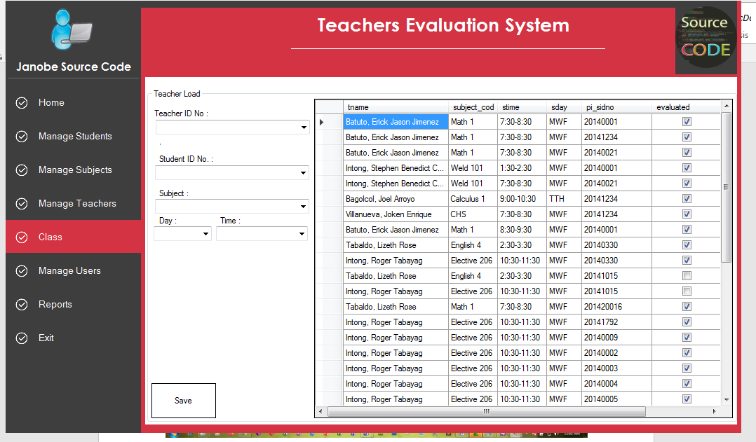

Figure 4.1: Teacher Evaluation performance

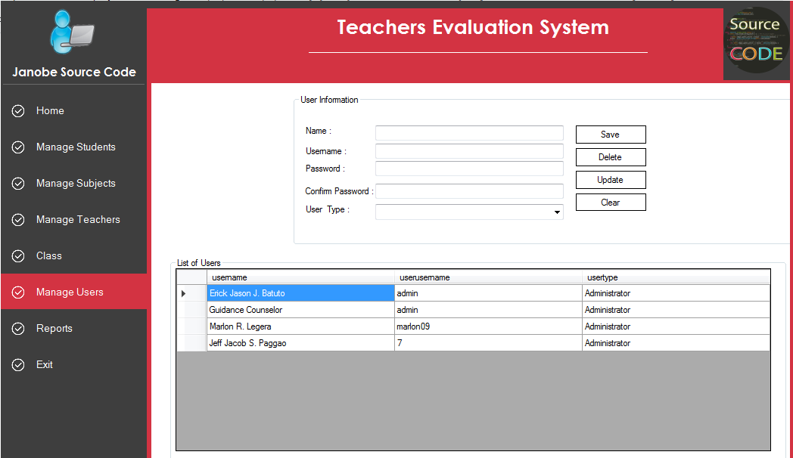

Figure 4.2: Student Management
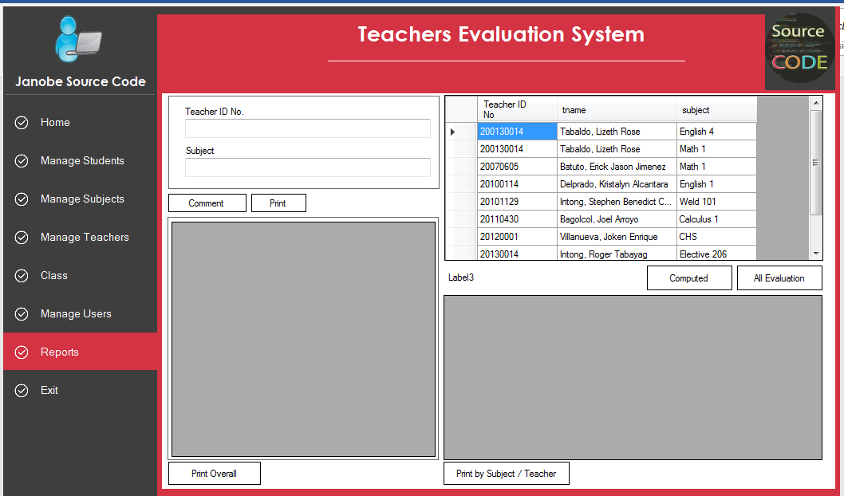

Figure 4.3: Evaluation Report

Figure 4.3: Spline Line chart analysis of student’s grade by course mode classification

Input Design

The input design describes the input interface for data entry into the program. Data entry interfaces needs to be considered in developing a new system to ensure users’ friendliness. Data entry is done through the keyboard and in some cases selection from the dropdown combos and list boxes are done using mouse selection. The interface descriptions are as shown below:

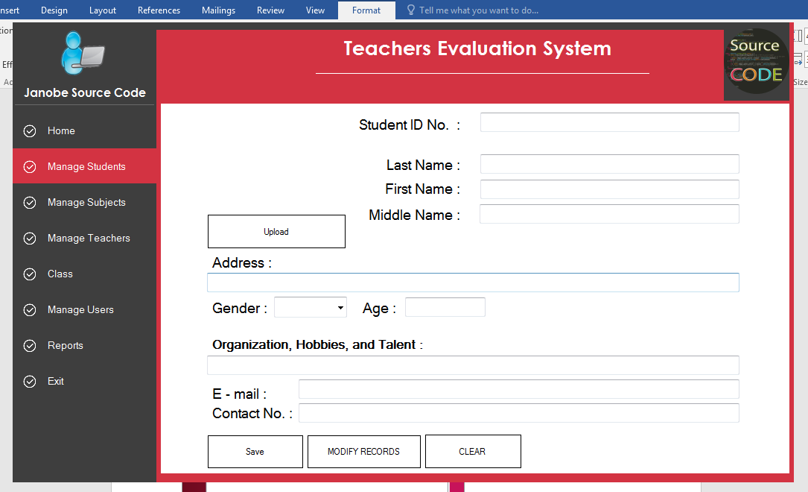

Figure 4. 4: Students detail entry form. This menu allows student to fill the entry details
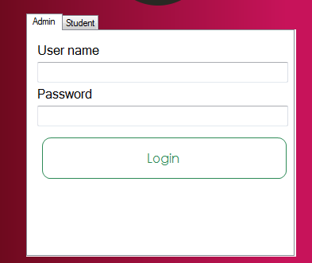
Figure 4.5: Entry form for Administartor to logiin to the system

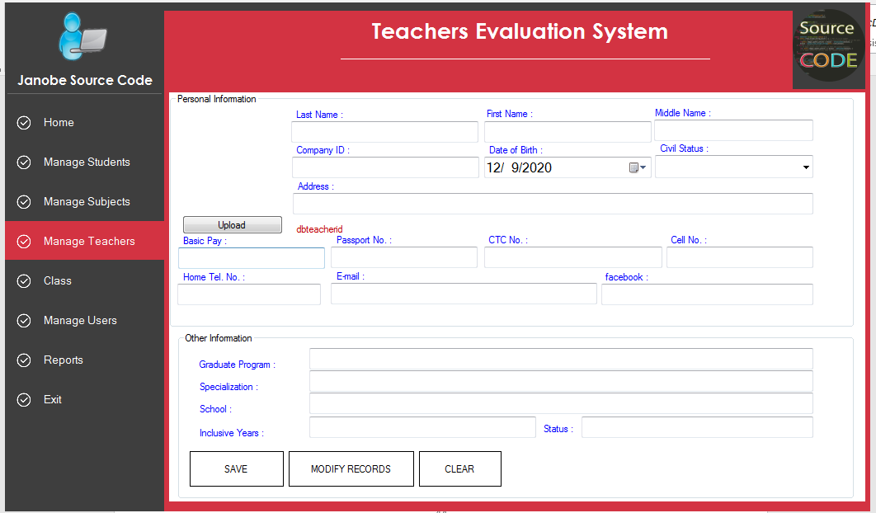

Figure 4.6: Lecturer management Page

Database Design

Database description gives detail description of the database field description used in keeping the records entered into the application and the information generated. Microsoft Access is used to develop and manage the database file for the application. The database is named MyDb.Mdb and it contains three (3) tables namely Stud, StudGP and GPTable. The tables presentation and the detail description of the data fields used are as follows:

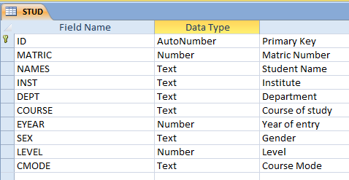

Figure 4.6: Database design for students table

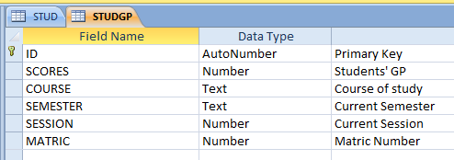
DATA MINING
ON ACADEMICS
LOGIN
ENTER
STUDENTS’
DATA
MODIFY
STUDENTS’
DATA
ENTER G. P.
PERFORMANCE
EVALUATION
REPORT
EXIT

Figure 4.7: Students GP extraction table

Procedure Design

The procedure design of the program gives description of modules that make up the project. The program is made up of Seven (7) modules. Each module performs specific function, with all functional modules working together as a whole to make a system. The description of the program is given as follows:

PROCEDURE DESIGN

Function Of Modules
      - LOGIN MODULE: the module serves as authentication of user that will operate the application by requesting for a valid username and password.

      - ENTER STUDENT DATA: the module handles data entry for students in the institute.
      - MODIFY STUDENT DATA: the module retrieve stored students data for modification in case there is any mistake or need for update.
      - ENTER G. P.: the module handles entry of student GP at the end of the semester.

      - PERFORMANCE EVALUATION: The performance evaluation module do the main work of the data mining by extracting necessary data from the database to draw the graphical patterns for students performance evaluation.
      - STUDENTS REPORT: the students report module allow the application to provide report of students data entered.
      - EXIT: the exit module is use to close/terminate the application by closing all handles to the open windows.

Implementation Of The System
System implementation entails the requirements of the system that will run the new application considering the hardware and software needed for effective performance of the program.

Hardware Requirements
The hardware required for this program is a necessity to be given a higher priority. Not software can run without the intervention of the other components of the system. The hardware required to run the proposed system to make it achieve it set goals and objectives are as follows:
- Pentium III with at least 500 MHZ processor speed
- VDU with high resolution color display colour display monitor

- Hard disk space of about 1.2GB space or more
- CD-ROM drive

- Standard keyboard
- Mouse
- Printer

Software Requirement

The software needed for the proposed system are as follows;

- Windows operating system
- Microsoft Visual Studio 2010

- Microsoft Office 2010

Documentation Of The System

    - Program Documentation
The program is installed by clicking on ‘My Computer’ from the start menu, then locates ‘Set Up’ file on the insertion of the flash drive or the CD-ROM. Double click on ‘Set Up’ to initiate the installation and then follow the required instructions given on the screen. On the application directory you can change the path of whatever location you want, but it is strongly recommended that you choose the default directory by clicking ‘NEXT’. Once the installation ends, one can start using the software.

Operating The System
Once the program has been fully installed, it will be added to the program list of window menu. The program can be run or executed by clicking the start button on the window taskbar, move the mouse pointer to ‘All programs’ and click to pop out the sub-menu. Locate ‘ACADEMIC DATAMINING’ and then click to activate (or run) the program. Here a welcome screen (called the ‘splash screen’) will be displayed which will last for 3 seconds (i.e. 3000 millisecond). Followed by the login screen, where the user will supply correct username and password to proceed.

Thereafter, the main menu will be displayed where one can choose to carry-out any of the following menu options:

      - ENTRY OF STUDENTS DATA

      - MODIFICATION OF EXISTING RECORD

      - ENTER STUDENTS G. P.

      - PERFORMANCE EVALUATION OF LECTURER

      - VIEW REPORT OF STUDENT DATA ENTERED
      - EXIT THE APPLICATION

Maintenance Of The System
The last stage in the system life cycle is the maintenance, which can be described as the periodically evaluation and modification of the system. This is done from time-to-time to see whether a system is meeting the goals and providing the services which it’s designed for.
This software can easily be maintained by adding more modules to it or removing existing module that is found to be irrelevant to the user’s need. Also the database allows for data resilience and portability. Maintenance at program refers to the correction, addition, or deletion of part of the program with ease program that has structure and features of maintainability which is referred to as a good ‘structured program’.
Generally, to be able to do any modification to each module in the program, one needs to open the program in Visual Studio 2010 IDE. In the design environment of the application, double click on each module of to take you to its respective coding environment where necessary amendments could be made and the changes will be implemented immediately. This allows the maintenance of the program to be very easy.

Chapter Five

Summary, Conclusion and Recommendations
  - Summary
Performance monitoring involves assessments which serve a vital role in providing information that is geared to help students, teachers, administrators, and policy makers to take decisions (Council, 2001) The changing factors in contemporary education has led to the quest to effectively and efficiently monitor student performance in educational institutions, which is now moving away from the traditional measurement and evaluation techniques to the use of data mining techniques which employs various intrusive data penetration and investigation methods to isolate vital implicit or hidden information.
Assessment as a dynamic process produces data that reasonable conclusions are derived by stakeholders for decision making that expectedly impact on students’ learning outcomes. The data mining methodology while extracting useful, valid patterns from higher education database environment contribute to proactively ensuring students maximize their academic output. This project has developed a methodology by the derivation of performance prediction indicators to deploying a simple student performance assessment and monitoring system within a teaching and learning environment by mainly focusing on performance monitoring of students’ examination scores in order to predict their final achievement status upon graduation. Based on various data mining techniques and the application of machine learning processes, rules are derived that enable the classification of students in their predicted classes. The deployment of the computer-based solution, integrates measuring, ‘recycling’ and reporting procedures in the new system to optimize prediction accuracy.

Conclusion
The result of this project indicates that Data Mining Tools capabilities provided effective monitoring tools for student academic performance with overall 94% success rating and fine tuning derived variables improves rules quality producing improved performance.
The various reporting tools that this system offers serve mainly to compare changes over time in performances as may be affected by the different rules that are available plus other well-chosen variables exposes systematic structures required to improve performance monitoring. Computer-based implementation with dynamic reporting capabilities and efficiency is perceived as better solution and recommended for very large student databases in Oracle or MS SQL Server database environment

Recommendations
The encouraging results obtained on application of knowledge discovery, begs for a comprehensive strategic implementation, an integration of the results of other research efforts in areas such as Instructor assessment and performance, curriculum, course relevance, student attitude, demographics, etc and its impact on the student learning process must be determined and integrated into any prototype. Learning process must be determined and integrated into any prototype performance, course relevance, student attitude, demographics, etc and its impact on the student learning process must be evaluated and integrated into any future performance monitoring prototype. Data Mining Tools has a potential in performance monitoring of High school and other levels education offering historical perspectives of students’ performances. The results may both complement and supplement tertiary education performance monitoring and assessment implementations.

References
Alex, Wen-Ching, Tridivesh (2010). PMML in Action: Unleashing the Power of Open Standards for Data Mining and Predictive Analytics. CreateSpace, 2010
Arnold, K. E. (2010). Signals: Applying academic analytics. Educause Quarterly, 33.
Black E. W., Dawson, K., & Priem, J. (2008). Data for free: Using LMS activity logs to measure community in online courses. Internet and Higher Education.
Campbell J. P. (2007). Utilizing student data within the course management system to determine undergraduate student academic success: An exploratory study. Unpublished doctoral dissertation, Purdue University.
Campbell J. P., DeBlois P. B., & Oblinger D. G. (2007). Academic analytics: A new tool for a new era. Educause Review.
Castro F., Vellido A., Nebot A., & Mugica F. (2007). Applying data mining techniques to e- learning problems. Studies in Computational Intelligence.
Cook C. E., Wright M. and O’Neal C. (2007). Action research for instructional improvement: Using data to enhance student learning at your institution. To Improve the Academy.
Clifton Christopher (2010). "Encyclopedia Britannica: Definition of Data Mining".
http://www.britannica.com/EBchecked/topic/1056150/data-mining.

Council N. (2001). “Knowing What Student Knows. The Science and Design of Educational Assessment”. National Academic Press. Washington, D.C. 2001
Ellen and Bret (2006). Concepts in Enterprise Resource Planning, Second Edition. Thomson Course Technology, Boston, MA.
Emmanuel N. Ogor, 1991, “Leaving Early: Undergraduate Non-completion in Higher
Education”. Philadelphia: Palmer Press. 1991

Fayyad U., Gregory P., and Padhraic S., (1996). "From Data Mining to Knowledge Discovery in Databases". http://www.kdnuggets.com/gpspubs/aimag-kdd-overview-1996- Fayyad.pdf.
Frawley W. J., Piatetsky-Shapiro, G and Matheus, C. J., (1991), “Knowledge Discovery databases: An overview In”: Piattetsky-Shapiro and Frawley, W. J. (eds) Knowledge Discovery in Databases, AAAI/MIT.
Kantardzic Mehmed (2003). Data Mining: Concepts, Models, Methods, and Algorithms. John Wiley & Sons.
Luan J. (2001), “Data Mining and Knowledge Management” Presentation at AIR Conference, Long Beach, CA.
Miller H. and Han J., (eds.), 2001, Geographic Data Mining and Knowledge Discovery,

(London: Taylor & Francis).

Morris L. V., Wu S., & Finnegan, C. (2005). Predicting retention in online general education courses. The American Journal of Distance Education, 19(1), 23-36.
Nolan J. (1998). “A Prototype Application of Fuzzy Logic and Expert Systems in Education Assessment”. AAAI/IAAI Proceedings.
Nissenbaum, H. (2010). Privacy in context: Technology, policy, and the integrity of social life.

Stanford, CA: Stanford Law Books.

Peng Y., Kou G., Shi Y., Chen Z. (2008). "A Descriptive Framework for the Field of Data Mining and Knowledge Discovery". International Journal of Information Technology and Decision Making, Volume 7, Issue 4 7.
Rubenking N. (2001), “Hidden Messages” PC Magazine, May 22, 2001.

Tally, S. (2009, September 1). Signals tells students how they’re doing even before the test.

Purdue University University News Service.

Flowcharts
START
DISPLAY LOGIN FORM
ENTER USERNAME AND
PASSWORD
YES
IS ENTRY
CORRECT
?
NO
INCORRECT
USERNAME OR PASSWORD ENTRY
RETRY
?
NO
YES
STOP
DATA ENTRY
SYSTEM FLOWCHART

MAIN MENU

MODIFY

PERFORMANCE EVALUATION

REPORT

PASSWORD FLOWCHART
START
DISPLAY LOGIN FORM
ENTER USERNAME AND
PASSWORD
YES
IS ENTRY
CORRECT
?
NO
INCORRECT
USERNAME OR PASSWORD
RETRY?
YES
NO
STOP

MAIN MENU

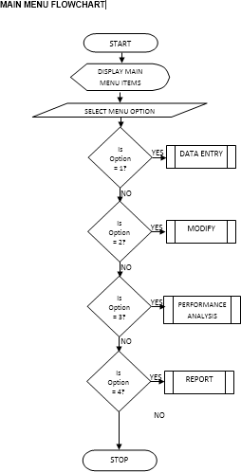

DATA ENTRY FLOWCHART
START
INPUT DATA
SAVE RECORD
Yes
ANY
MORE
No
RETURN
CLOSE DATABASE
OPEN DATABASE

MODIFY
START
OPEN DATABASE
INPUT RECORD ID
NO
IS
YES
DISPLAY RECORD
UPDATE DATABASE
Yes
EDIT
MORE?
No
MODIFY RECORD
CLOSE DATABASE

RETURN

PERFORMANCE ANALYSIS

START
READ RECORD
NO
EOF?
YES

DISPLAY PATTERNS
OPEN DATABASE
ANALYSE DATA EXTRACTED INTO GRAPH PATTERNS
CLOSE DATABASE

RETURN

REPORT

START
ENTER RECORD ID
EOF?
YES
NO
READ RECORD
NO RECORD
FOUN
?

YES
DISPLAY RECORD
RETURN
CLOSE DATABASE
OPEN DATABASE

Appendix 2: Program Source Code
‘SPLASH
Option Explicit

Private Sub Timer1_Timer()
If ProgressBar1.Value < 100 Then ProgressBar1.Value = ProgressBar1.Value + 1
Else
frmLogin.Show Unload Me
End If End Sub ‘LOGIN
Private Sub cmdCancel_Click() Unload Me
End Sub

Private Sub cmdOK_Click() 'check for correct password
If txtPassword.Text = "password" And txtUserName.Text = "user" Then FRMMAIN.Show
Unload Me Else
MsgBox "Invalid Username/Password, try again!", , "Login" txtUserName.SetFocus
End If End Sub
‘MAIN PROGRAM
Option Explicit
Public CON As ADODB.Connection Public RS As ADODB.Recordset Public CTRL As Control

Public Sub OPENRS(STRQ As String)
If RS.State = adStateOpen Then RS.Close
RS.Open STRQ, CON, adOpenDynamic, adLockBatchOptimistic End Sub
Option Explicit
Private STUDMAT, SQL As String Private ISNEW As Boolean

Private Sub CMBCOUR_Change()
OPENRS "SELECT MATRIC FROM STUD WHERE COURSE = '" & CMBCOUR.Text & "'"
If Not RS.EOF Then CMBMAT.Clear While Not RS.EOF
CMBMAT.AddItem RS!MATRIC
RS.MoveNext Wend
End If End Sub

Private Sub CMBCOUR_Click() CMBCOUR_Change
End Sub

Private Sub CMBMAT_Change()

OPENRS "SELECT * FROM STUD WHERE MATRIC = '" & CMBMAT.Text & "'" TXTNAM.Text = RS!NAMES
TXTINS.Text = RS!INST TXTDEP.Text = RS!DEPT TXTCOU.Text = RS!COURSE
CMBLEV.Text = RS!Level Command3.Enabled = True
End Sub

Private Sub CMBMAT_Click() CMBMAT_Change
End Sub

Private Sub CMDMIN_Click() Me.WindowState = vbMinimized End Sub

Private Sub Command1_Click() Picture2.Visible = False
End Sub
Private Sub CMBDEPT_Change() CMBCOURSE.Text = CMBDEPT.Text
End Sub

Private Sub CMBDEPT_Click() CMBCOURSE.Text = CMBDEPT.Text
End Sub

Private Sub CMBDEPT_Scroll() CMBCOURSE.Text = CMBDEPT.Text
End Sub

Private Sub CMBINST_Change() CMBINST_Click
End Sub

Private Sub CMBINST_Click() With CMBDEPT
Select Case CMBINST.ListIndex
Case 0:
'.AddItem "INSTITUTE OF BASIC AND APPLIED SCIENCES"
.Clear

.AddItem "Statistics"
.AddItem "Science Laboratory Technology"
.AddItem "Hospitality Management" Case 1:
'.AddItem "INSTITUTE OF FINANCE & MANAGEMENT STUDIES"
.Clear

.AddItem "Accountancy"
.AddItem "Banking & Finance"
.AddItem "Business Administration"
.AddItem "Marketing"
.AddItem "Public Administration"
.AddItem "Purchasing & Supply" Case 2:
'.AddItem "INSTITUTE OF ENVIRONMENTAL STUDIES"

.Clear
.AddItem "Architectural Technology"
.AddItem "Building Technology"
.AddItem "Estate Management"
.AddItem "Quantity Surveying"
.AddItem "Urban & Regional Planning"
.AddItem "Surveying and Geo-informatics" Case 3:
'.AddItem "INSTITUTE OF INFORMATION & COMMUNICATON TECHNOLOGY"
.Clear
.AddItem "Computer Science"
.AddItem "Office Technology & Management" Case 4:
'.AddItem "INSTITUTE OF TECHNOLOGY"
.Clear
.AddItem "Agricultural Engineering Technology"
.AddItem "Civil Engineering Technology"
.AddItem "Electrical/Electronics Engineering Technology"
.AddItem "Mechanical Engineering Technology"
.AddItem "Mining Engineering Technology"
.AddItem "Metallurgical Engineering Technology" End Select
End With End Sub

Private Sub CMBINST_Scroll() CMBINST_Click
End Sub

Private Sub CMDCLEAR_Click() cLEARtEXT
TXTMAT.SetFocus End Sub

Private Sub cLEARtEXT() For Each CTRL In Me
If TypeOf CTRL Is TextBox Then CTRL.Text = ""
If TypeOf CTRL Is ComboBox Then CTRL.ListIndex = -1 Next
End Sub
Private Sub CMDCLOSE_Click() Picture1.Visible = False
End Sub

Private Sub CMDMAX_Click() End
End Sub

