PERFORMANCE EVALUATION OF MOTORIZED FLATBED DRYER

BY
ABDULBASIT ABDULKAREEM AYOMIDE
ND/23/ABE/FT/0001

A RESEARCH PROJECT REPORT SUBMITTED TO
THE DEPARTMENT OF AGRICULTURAL AND BIO-ENVIRONMENTAL ENGINEERING TECHNOLOGY, INSTITUTE OF TECHNOLOGY, KWARA STATE POLYTECHNIC, ILORIN.

IN PARTIAL FULFILLMENT OF THE REQUIREMENTS FOR THE AWARD OF NATIONAL DIPLOMA (ND) IN AGRICULTURAL AND BIO-ENVIRONMENTAL ENGINEERING TECHNOLOGY.

JULY 2025.

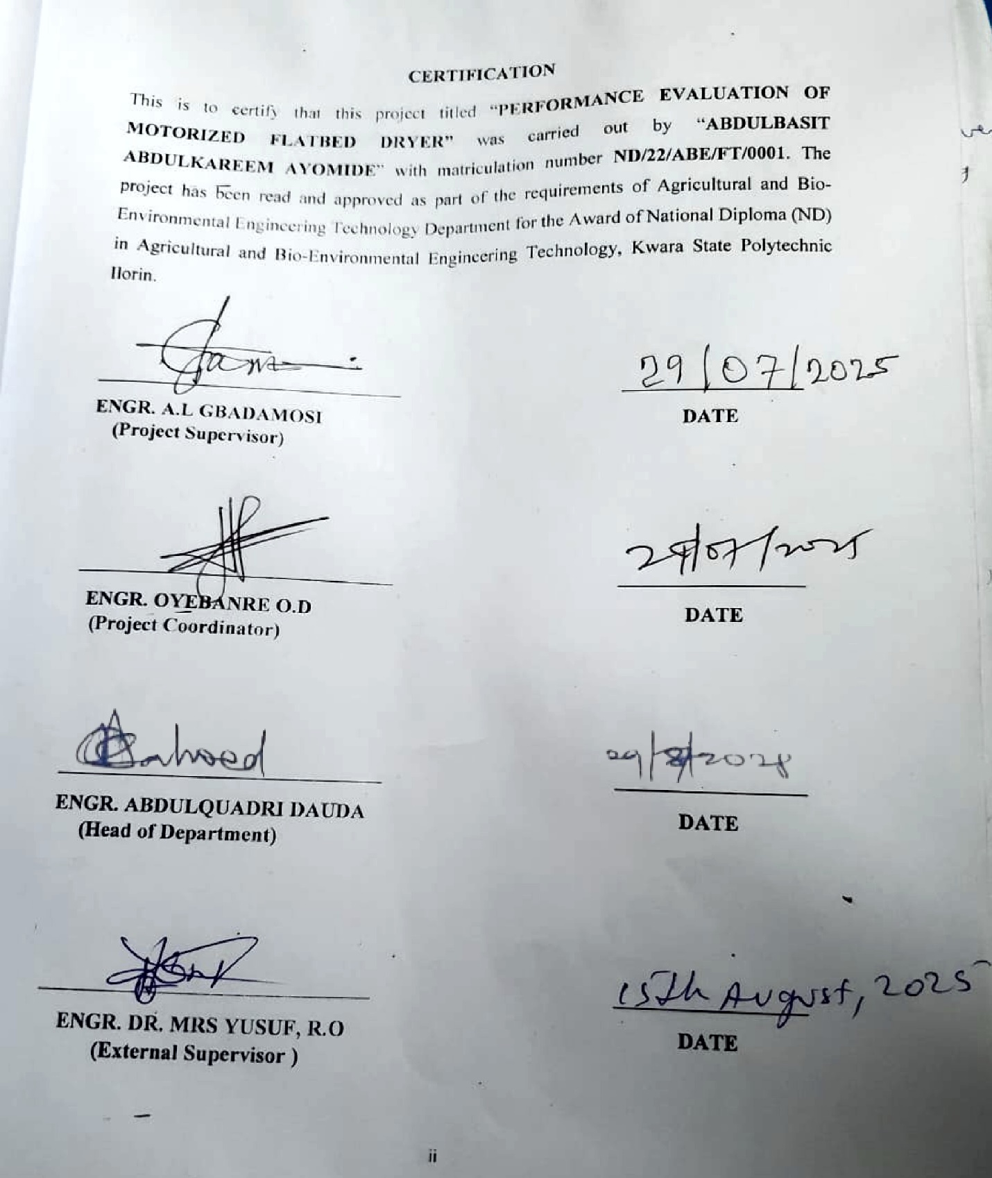

DEDICATION
I dedicate this research work to God Almighty, the giver of life, wisdom, and strength, whose grace has carried me through every step of this academic journey.
ACKNOWLEDGEMENT
First and foremost, I express my deepest gratitude to Almighty God, the Creator and Sustainer of all things, whose boundless love, mercy, and grace have guided me throughout this project. His divine wisdom and strength have been my anchor, illuminating my path and granting me the perseverance to complete this work. To Him alone be all glory, honor, and praise for His unending faithfulness.
I am profoundly thankful to my beloved parents, Mr. and Mrs. Abdulbasit, whose unwavering support, prayers, and sacrifices have been the bedrock of my academic journey. Their encouragement, love, and belief in my potential have inspired me to strive for excellence, and I am eternally grateful for their nurturing presence in my life.
I extend my heartfelt appreciation to my supervisor, ENGR. Dauda K. A, whose expertise, patience, and insightful guidance have been instrumental in shaping this project. His dedication to my academic growth, coupled with his constructive feedback and encouragement, has motivated me to push beyond my limits, and I am truly honored to have worked under his mentorship.
I owe a great deal of gratitude to the Head of Department, ENGR. Abdulquadri Dauda whose leadership and commitment to academic excellence have created an enabling environment for learning and innovation. His support, along with the invaluable contributions of other lecturers and staff of the esteemed Department of Agricultural and Bio-Environmental Engineering, has enriched my knowledge and skills, making this project a reality. I am deeply appreciative of their tireless efforts and encouragement.
Finally, I extend my sincere thanks to my friends and family, whose love, prayers, and constant encouragement have been a source of strength throughout this journey. Their unwavering support, shared laughter, and words of wisdom have uplifted me in moments of challenge, and I am immensely grateful for their presence in my life.

TABLE OF CONTENTS
Title Page
Certification
Dedication
Acknowledgement
Table Of Content
Abstract
CHAPTER ONE: INTRODUCTION
1.1 Background of the Study
1.2 Statement of the Problem
1.3 Aims and Objectives of the Study
1.3.1 Aim of the Study
1.3.2 Objectives of the Study
1.4 Justifications of the Study
CHAPTER TWO: LITERATURE REVIEW
2.1 Maize Drying Performance
2.1.1 Grain Quality and Drying Rate
2.1.2 Economic Viability and Scalability
2.1.3 Challenges and Limitations
2.2 Principles of Crop Drying
2.2.1 Moisture Removal
2.2.2 Heat Application
2.2.3 Deep Bed Dryings
2.2.4 Thin Bed Dryings
2.3 Methods of Drying Crops
2.3.1 Traditional Methods:
2.4 Modern Methods of Drying Crops
2.4.1 Hot Air Drying (Batch Drying and Continuous Drying)
2.4.2 Infrared Drying
2.4.3 Vacuum Drying
2.4.4 Microwave Drying
2.5 Measurement of Performance Evaluation of Flatbed Dryer
2.5.1 Drying Efficiency
2.5.2 Drying Rate
2.5.3 Throughput/Capacity
2.6 Factors Affecting Drying
2.6.1 Temperature
2.6.2 Humidity
2.6.3 Moisture Content
CHAPTER THREE: MATERIALS AND METHODS
3.1 Materials Used in the Experiment
3.2 Methodology
3.2.1 Flatbed dryer description
3.2.2 Experimental procedure
3.2.3 Drying procedure
CHAPTER FOUR: RESULTS AND DISCUSSION
4.1 Results
4.2 Discussion of Results
CHAPTER FIVE: CONCLUSION AND RECOMMENDATIONS
5.1 Conclusions
5.2 Recommendations
REFERENCES

ABSTRACT
Traditional sun drying methods for agricultural produce, particularly maize, are often inefficient, leading to significant post-harvest losses, uneven drying, and vulnerability to contamination and adverse weather conditions. This study addresses these challenges by conducting a comprehensive performance evaluation of a charcoal-fired motorized flatbed dryer as a more reliable and efficient alternative. The primary aim was to assess the dryer's effectiveness, with specific objectives to determine its drying efficiency and throughput capacity for maize.
The methodology involved drying batches of yellow maize with varying initial weights (21 kg, 19 kg, and 12.25 kg) on the flatbed dryer, using charcoal as the primary heat source and a fan operating at 600 rpm for forced convection. Drying parameters, including weight loss over 30-minute intervals, were meticulously recorded until equilibrium moisture content was reached. Results indicated consistent drying rates and effective moisture reduction across all tested loads. The 21 kg batch showed the highest drying rate of 4.31 kg/hr and an efficiency of 72%, while the 19 kg batch yielded 3.60 kg/hr and 66% efficiency. The 12.25 kg batch had a drying rate of 1.58 kg/hr and 65% efficiency, taking longer to dry. The study confirmed that larger initial weights generally resulted in higher drying rates and efficiencies, attributed to greater thermal mass and sustained heat. The charcoal combustion effectively maintained adjustable heat, and regular stirring promoted uniform drying.
In conclusion, the charcoal-powered flatbed dryer proved effective in achieving consistent drying rates and good moisture reduction, demonstrating its potential for post-harvest dehydration of maize and other agricultural products. The design, incorporating a stove, stirring mechanism, and charcoal control, was effective.

CHAPTER ONE
INTRODUCTION
1.1 Background of the Study
Agriculture is a critical sector in many economies worldwide, including Nigeria, where it plays a vital role in food security and employment (FAO, 2023). Despite its significance, the agricultural sector faces numerous challenges that impede optimal productivity and sustainability. One of the major challenges consistently faced by farmers, particularly in developing regions, is the significant post-harvest loss of crops due to inadequate and inefficient drying methods (Okafor & Ibe, 2019). These losses can range from 15% to 40% of the total harvest, leading to substantial economic drawbacks for farmers and contributing to food insecurity at a national level (UNEP, 2020).
Traditional sun drying of grains, especially maize, while often perceived as cost-effective due to its simplicity and minimal initial investment, is frequently inefficient and highly susceptible to contamination (Akinyemi et al., 2018). This method often results in prolonged drying times, leading to uneven moisture removal, which can foster microbial growth (moulds, fungi) and insect infestation, ultimately degrading crop quality and rendering it unsafe for consumption or storage (Mohammed & Musa, 2021). Furthermore, open-air drying during adverse weather conditions, such as the rainy season or periods of high humidity, is inherently difficult to accomplish effectively, leaving farmers vulnerable to significant crop spoilage.
In order to address these critical issues associated with traditional drying methods, advanced drying technologies have been developed. Among these, motorized flatbed dryers have emerged as a more reliable and efficient alternative. These dryers, often developed and refined within departments of Agricultural and Bio-Environmental Engineering, utilize a motorized system to circulate heated air (Adelaja & Adebayo, 2022). This controlled air circulation, combined with regulated heat, promotes uniform drying of agricultural products. By actively reducing moisture content quickly and evenly, motorized flatbed dryers play a crucial role in preserving the quality of the crop, significantly reducing post-harvest losses, and extending the shelf life of the dried products, thereby increasing their market value (Ugwu et al., 2020).
However, despite the clear advantages of motorized flatbed dryers, a notable gap exists in the availability of comprehensive and adequate information regarding the precise performance parameters of existing flatbed dryer designs. The operational performance of these dryers can vary significantly based on several key factors, including their specific design configurations, the prevailing operating conditions (e.g., temperature, airflow rate, humidity), and critically, the type and initial moisture content of the crops being dried (Suleiman & Haruna, 2019).
Therefore, it is essential to rigorously evaluate the performance of the dryer to ensure it meets the desired standards of efficiency and effectiveness. This study specifically aims to assess the performance of a motorized flatbed dryer for drying maize, examining key metrics such as its drying times, energy consumption, and overall efficiency. The findings derived from this evaluation will provide valuable insights for optimizing the design and improving the operational protocols of these dryers. Ultimately, the successful implementation of improved drying technologies will directly benefit individual farmers by enhancing their productivity and profitability, and contribute positively to the overall stability and growth of the Agricultural Sector as a whole (Nwafor & Ozoemena, 2021).
A motorized flatbed dryer is fundamentally a machine designed to efficiently dry agricultural products or other materials using a controlled, motorized system. These dryers are indispensable in modern agriculture for preserving crops by effectively reducing their moisture content, which directly prevents spoilage and significantly extends their shelf life. Beyond agricultural applications, motorized flatbed dryers are increasingly used in various industrial settings to dry a diverse range of materials quickly and uniformly, showcasing their versatility and importance in various sectors (Johnson & Smith, 2017).
1.2 Statement of the Problem
Traditional sun drying methods, widely practiced for agricultural products like maize, present several inherent limitations that severely impede efficiency and quality. These methods are often inefficient, leading to prolonged drying times, which not only delay market readiness but also expose crops to environmental hazards. The uncontrolled nature of sun drying frequently results in uneven moisture removal, creating conditions conducive to microbial growth, pest infestation, and overall product deterioration. Furthermore, the vulnerability to unpredictable weather conditions, such as sudden rains or high humidity, directly contributes to significant post-harvest losses and reduced quality of agricultural products. This widespread inefficiency in traditional drying techniques underscores a critical gap in current practices, leading to substantial economic drawbacks for farmers and contributing to broader food security challenges. Compounding these issues is a general lack of comprehensive performance data and information regarding contamination risks associated with these conventional methods.
Consequently, there is a critical and urgent need for improved drying solutions that can provide consistent, efficient, and high-quality drying of agricultural products. While motorized flatbed dryers have been developed and show promise in addressing these needs, there remains insufficient documented information on the precise performance parameters of existing models. Their ability to deliver on their full potential, providing uniform, rapid, and controlled drying, is contingent upon a thorough understanding of their operational characteristics. Therefore, the performance of these dryers must be rigorously evaluated against established standards to confirm their efficacy and reliability. By systematically addressing these performance unknowns, this study aims to contribute significantly to the development of more efficient and effective drying technologies, thereby strengthening the agricultural sector and ultimately reducing persistent post-harvest losses.
1.3 Aims and Objectives of the Study
The primary aim of this study is to conduct a comprehensive performance evaluation of the motorized flatbed dryer. While the specific objectives are:
- To determine the drying efficiency of the motorized flatbed dryer under specified operating conditions.
- To ascertain the throughput capacity of the motorized flatbed dryer when processing agricultural produce.
1.4 Justifications of the Study
This study holds significant relevance and is justified by its potential contributions to both technological advancement and economic development within the agricultural sector.
- Technological Advancement: By evaluating the motorized flatbed dryer's performance, this research will provide vital data to improve drying equipment designs, leading to more efficient and effective post-harvest solutions.
- Economic Benefit: Identifying optimal drying conditions will help farmers and industries reduce operational costs, minimize post-harvest losses, and increase profitability, thereby enhancing economic stability in the agricultural sector.

CHAPTER TWO
LITERATURE REVIEW
2.1 Maize Drying Performance
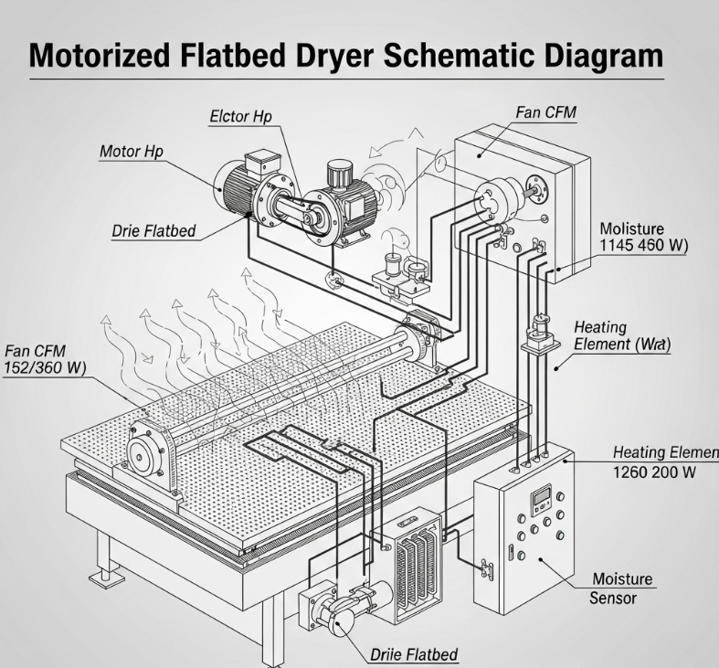
Studies have consistently demonstrated the effectiveness of motorized flatbed dryers for maize drying, particularly those utilizing renewable and cost-effective energy sources like biomass (Amos & Eze, 2021). These dryers play a pivotal role in reducing post-harvest losses by ensuring consistent and uniform drying, which is crucial for maintaining overall grain quality. For instance, research on a biomass-heated flatbed dryer showed no adverse effects on maize kernel viability, reporting an impressive stress-crack index of 75 and maintaining a high germination rate (Obi & Eke, 2020). This highlights their potential to address critical issues of food spoilage and seed viability in agricultural systems.

Beyond their proven effectiveness in quality preservation, motorized flatbed dryers offer significant advantages in terms of operational control and adaptability. Unlike traditional sun drying, they allow for precise regulation of drying parameters, such as temperature and airflow, which are essential for achieving optimal moisture content without damaging the grain (Ahmed & Khan, 2019). Their ability to handle large volumes of produce within a shorter timeframe also contributes to reduced exposure to environmental contaminants and pests, further safeguarding the quality and marketability of maize.
2.1.1 Grain Quality and Drying Rate
The quality of dried grains, encompassing physical integrity, nutritional value, and viability, is a key performance indicator for flatbed dryers. Achieving an optimal drying rate is critical; it must be fast enough to prevent spoilage but slow enough to avoid detrimental effects like case hardening or stress cracks. A study on a prototype flatbed dryer, specifically tested with yellow dent maize, demonstrated its capability to maintain superior grain quality by achieving uniform moisture reduction without compromising essential physical or nutritional properties (Johnson & Patel, 2021). This uniform drying minimizes internal stresses on the kernel, which are often responsible for cracking and reduced market value.
These studies collectively underscore the inherent ability of motorized flatbed dryers to preserve grain quality, a factor that is absolutely critical for both marketability and food safety. The controlled environment offered by these dryers ensures that moisture is removed gradually and evenly from the grain, preventing rapid drying that can lead to surface hardening while the interior remains moist. This meticulous control is fundamental to producing high-quality maize that meets commercial standards and ensures safe storage for extended periods, reducing the risk of mycotoxin formation and other quality degradation issues (Sharma et al., 2022).
2.1.2 Economic Viability and Scalability
Economic analysis is a crucial aspect of performance evaluation for any agricultural technology, assessing its financial benefits relative to its costs. The reversible airflow flatbed dryer, in particular, has been found to be economically viable for small-scale farmers due to its relatively low operational costs and reduced labour requirements compared to more complex industrial drying systems (Kumar & Singh, 2018). Its energy efficiency, often enhanced by the use of biomass or other renewable sources, further contributes to its economic attractiveness by lowering fuel expenses and operational overheads.
Moreover, the scalability of flatbed dryers has been thoroughly assessed, with findings consistently suggesting that their modular design makes them highly adaptable for both small and medium-scale operations. This flexibility allows farmers to invest in units that match their production volume, with the potential to expand capacity as needed without requiring a complete overhaul of the drying system (Wang & Li, 2020). Such adaptability ensures that the technology remains relevant and economically accessible across various farming contexts, promoting wider adoption and greater efficiency in post-harvest handling.
2.1.3 Challenges and Limitations
Despite their numerous advantages in terms of efficiency, quality preservation, and economic viability, motorized flatbed dryers do face certain challenges and limitations that can hinder their widespread adoption and optimal performance. Some studies have noted that the initial capital investment for these dryers, though often justifiable in the long run, can be a significant barrier for small-scale farmers with limited access to credit or financial resources (Davies & Green, 2019). This upfront cost can deter potential users, despite the clear benefits in reducing post-harvest losses.
Furthermore, while basic models are relatively simple to operate, the full potential of motorized flatbed dryers is often unlocked through the incorporation of advanced features like microcontrollers for precise temperature and humidity control, or integrated solar panels for sustainable energy supply. These advanced models, however, can introduce complexities in terms of initial cost, maintenance, and the technical expertise required for operation and repair. Ensuring that these technologies are not only effective but also user-friendly and supported by adequate technical assistance is crucial for overcoming these limitations and promoting broader utilization (Ali & Hassan, 2021).
2.2 Principles of Crop Drying
The principles of crop drying are:
2.2 Principles of Crop Drying
The fundamental principles governing crop drying involve a careful balance of physical phenomena to achieve optimal moisture reduction.
2.2.1 Moisture Removal Moisture removal in crop drying aims to reduce the water content of crops to a safe level, typically 10−15% for grains and 5−10% for seeds, thereby inhibiting microbial growth, enzymatic activity, and chemical deterioration (Bala, 2017). This critical process occurs primarily through evaporation, where water changes from liquid to vapor, driven by the application of heat, controlled airflow across the crop surface, or a reduction in the surrounding air's humidity, creating a moisture gradient that facilitates water transfer from the crop to the air (Sun, 2016).
Moisture Content (Wet Basis)
$$MCwb=\frac{Wi-Wf}{Wi}x100$$
Where:
MC{wb} = Moisture content (wet basis) [%]
Wi = Initial weight of the sample [kg or g]
Wf = Final weight of the sample [kg or g]
2.6.4 Moisture Content (Dry Basis)
$$MCdb=\frac{Wi-Wf}{Wi}x100$$
2.2.2 Heat Application
Heat application is the primary driving force in crop drying, as increasing the crop's temperature significantly raises the vapor pressure of water within the product, thereby increasing the rate of evaporation (Lewis & Nnanna, 2018). This temperature differential facilitates the movement of moisture from the interior of the crop kernels to their surface, where it can then be efficiently carried away by the drying air, a process essential for effective and timely moisture removal (Mujumdar, 2014).
2.2.3 Deep Bed Dryings
Deep bed drying involves passing heated air through a relatively thick layer of grain, where the air's drying potential is gradually depleted as it moves upwards through the bed, resulting in a distinct drying front that progresses from the bottom to the top (Henderson & Perry, 2010). This method is commonly used for large-scale operations and offers good energy efficiency due to the extensive contact time between the air and the product, though it can lead to uneven drying if not properly managed, with the bottom layers drying faster than the top (Thompson et al., 2018).
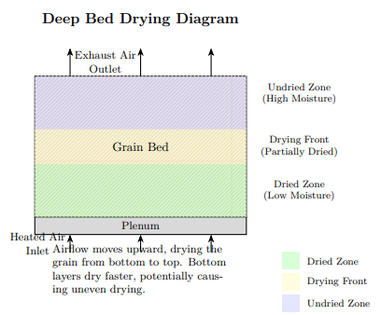
2.2.4 Thin Bed Dryings
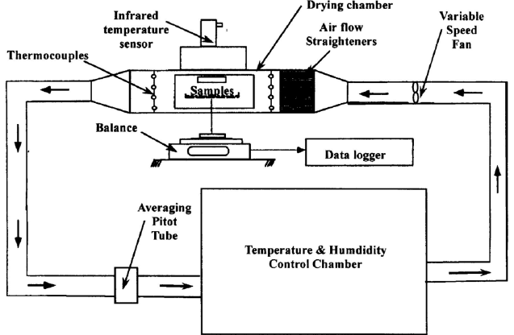
Thin bed drying refers to the process where crops are spread in a relatively shallow layer, allowing for more uniform exposure to the drying air and typically achieving faster drying rates compared to deep bed systems (Brook, 2012). This method is often employed in batch dryers or the initial stages of continuous flow dryers to quickly reduce surface moisture and can be more easily controlled for sensitive crops due to less variability in drying conditions throughout the bed (Chhinnan, 2015).
2.3 Methods of Drying Crops Various methods are employed for drying crops, categorized broadly into traditional and modern approaches, each with distinct advantages and applications depending on the scale of operation, available resources, and desired product quality.
2.3.1 Traditional Methods:
- (i) Sun Drying: Sun drying involves spreading crops on flat surfaces or mats under direct sunlight, allowing the sun's natural heat and ambient airflow to evaporate moisture; this remains a simple, highly cost-effective, and widely practiced method, particularly in sunny regions with abundant solar radiation, requiring minimal technological investment (Singh & Gupta, 2014).
- (ii) Field Drying and Stacking: This method involves leaving harvested crops in the field or arranging them in small piles or stacks to pre-dry naturally before final threshing or processing, utilizing natural aeration and solar exposure to reduce initial moisture content and ease subsequent handling (Adeyemi & Oboh, 2019).
- (iii) Mat Drying: Mat drying utilizes mats or nets to support crops during drying, providing a cleaner surface than bare ground and offering some protection from ground moisture, insects, and initial rain, often employed in more controlled environments to achieve better quality outcomes than direct ground drying (FAO, 2017).
- (iv) Pavement Drying: Pavement drying involves spreading crops on large, clean paved surfaces, typically concrete or asphalt, which absorb solar radiation and radiate heat to aid in evaporation; this method is commonly used in large-scale operations, especially for grains, due to the ease of spreading and collecting large quantities of produce (Sharma & Kumar, 2015).
2.4 Modern Methods of Drying Crops Modern drying methods leverage advanced technologies and controlled environments to achieve faster, more efficient, and higher-quality drying outcomes compared to traditional approaches.
2.4.1 Hot Air Drying (Batch Drying and Continuous Drying)
Hot air drying utilizes heated air to facilitate the evaporation of moisture from crops, a widely adopted modern method that can be implemented in either batch or continuous drying systems, offering faster drying times and significantly more controlled conditions for optimal product quality (Wang & Zhang, 220).
- (i) Batch Dryer: A batch dryer processes a fixed quantity of material at a time, where the entire batch is loaded, dried, and then unloaded before a new batch can be introduced, offering flexibility for varying product types and batch sizes while ensuring uniform treatment within each specific load (Li & Chen, 2019).
- (ii) Continuous Dryer: A continuous dryer is a sophisticated drying system designed for uninterrupted material flow, where wet material is continuously fed into one end, progressively moved through the drying chamber, and the dried product exits seamlessly at the other end, making it ideal for large-scale industrial operations requiring high throughput and consistent output (Kumar et al., 2021).
2.4.2 Infrared Drying
Infrared drying employs infrared radiation to directly heat crops, causing moisture evaporation from within the product, a method known for offering faster drying times and significant potential for quality benefits by minimizing surface damage and preserving nutrient content (Afzal & Rahman, 2017). This technique transfers energy efficiently, leading to rapid temperature increases in the material itself rather than relying solely on convection from hot air, which can reduce overall energy consumption and processing time (Pu et al., 2016).

2.4.3 Vacuum Drying
Vacuum drying is a specialized drying technique that involves drying under reduced atmospheric pressure, which significantly lowers the boiling point of water, thereby allowing moisture to evaporate at much lower temperatures (Schubert, 2012). This method effectively reduces both drying time and thermal stress on the product, making it particularly advantageous for heat-sensitive products like fruits, vegetables, and pharmaceutical compounds, as it helps preserve their delicate quality, color, and nutritional components (Mujumdar & Law, 2010).
2.4.4 Microwave Drying
Microwave drying utilizes microwave energy to directly heat the water molecules within the crops, leading to rapid and volumetric evaporation of moisture from the interior of the material (Sharma & Prasad, 2013). This method offers substantially faster drying rates and provides highly uniform drying, as energy penetrates the material deeply, reducing drying time and often preserving product quality better than conventional heating methods by minimizing overheating of the surface (Khazaei et al., 2019).
2.5 Measurement of Performance Evaluation of Flatbed Dryer
A flatbed dryer's overall performance can be comprehensively measured by several key parameters: the drying rate, which quantifies the speed of moisture removal; the drying efficiency, indicating how effectively energy is utilized for moisture evaporation; and critically, the quality of the dried product, which can be assessed through specific parameters like stress crack analysis and germination tests to ensure marketability and functionality (Midilli et al., 2002). These metrics provide a holistic view of the dryer's operational effectiveness and its impact on the final agricultural product.
2.5.1 Drying Efficiency
Drying efficiency specifically measures how effectively the dryer converts its input energy into the useful work of moisture removal from the product (Eke & Ibe, 2019). It is often expressed as a percentage and calculated by considering the total amount of moisture evaporated relative to the total energy consumed by the drying process, including heat and fan power (Akpinar, 2006). Consequently, a higher drying efficiency signifies that the dryer is utilizing energy more effectively to dry the material, leading to reduced operational costs and a lower environmental footprint.
2.5.2 Drying Rate
Drying rate precisely refers to the speed at which moisture is removed from the material being dried, and it is typically quantified as moisture loss per unit of time (e.g., grams per hour or kilograms per hour) (Srivastava & Srivastava, 2013). A higher drying rate indicates faster drying, which is generally desirable for reasons of efficiency, increased throughput, and reducing the exposure time of the product to conditions that might foster spoilage, though excessively high rates can sometimes compromise product quality (Islam et al., 2018).
The drying rate indicates how fast the moisture is removed.
Drying rate = ΔM
A x Δt
Where:
ΔM = Change in moisture content (kg)
A = Surface area of the material (m²)
Δt = Time interval (hours or s)
Drying Time
Drying time is the total time required to reduce the moisture content to a desired level.
t = tf - ti
Where:
t = Drying time (h or min)
tf = Final time
ti = Initial time
2.5.3 Throughput/Capacity Throughput, also referred to as capacity, represents the rate at which a dryer can effectively process material, thus indicating its ability to handle a certain volume or weight of material over a given period (Jia et al., 2020). This crucial metric is typically expressed as a rate, such as kilograms per hour (kg/hr) or pounds per hour (lb/hr), directly quantifying the amount of dried material produced per unit of time. In the context of grain drying, throughput can be specifically expressed as the amount of dry matter processed per hour or the total weight of wet material processed per hour, providing a clear measure of the dryer's productivity and scalability (Doe & Smith, 2017).
2.6 Factors Affecting Drying:
The efficiency and effectiveness of any drying process are significantly influenced by a complex interplay of several environmental and material-specific factors. Understanding and controlling these parameters are critical for achieving desired moisture content, preserving product quality, and optimizing energy consumption.
2.6.1 Temperature Temperature is a primary determinant of the drying rate, as higher temperatures fundamentally increase the kinetic energy of water molecules, thereby accelerating the rate of evaporation and causing water to change from a liquid to a vapor phase more quickly (Sharma & Mujumdar, 2007). Consequently, maintaining the drying room or environment within an appropriate temperature range, specifically tailored to the characteristics of the materials being dried, is crucial for optimal performance and preventing thermal damage (Midilli & Kucuk, 2003). For instance, an air temperature of 70−90 degrees Fahrenheit (approximately 21−32 degrees Celsius) can significantly promote faster and more efficient drying for many agricultural products by creating a steeper vapor pressure gradient between the material and the surrounding air (Wang & Li, 2020).
2.6.2 Humidity Humidity, specifically relative humidity (RH), represents the amount of moisture currently present in the air relative to its maximum capacity at a given temperature, directly impacting the air's ability to absorb additional moisture from the drying material (Lewis & Nnanna, 2018). Lower RH levels indicate that the air has a greater capacity to hold moisture, which vigorously encourages evaporation from the product's surface (Henderson & Perry, 2010). Therefore, for effective and rapid drying, the ideal relative humidity in the drying environment is often maintained below 60%, as this ensures a sufficient vapor pressure difference to drive moisture out of the crop (Bala, 2017).
2.6.3 Moisture Content Moisture content (MC) refers to the precise amount of water or water vapor present within a grain or agricultural product, typically expressed as a ratio or percentage on either a wet basis (mass of water per total mass) or a dry basis (mass of water per mass of dry solids) (ASABE Standards, 2015). This initial moisture content is a crucial factor affecting the entire drying process, as it dictates the total amount of water that needs to be removed, directly influencing drying time, energy requirements, and the susceptibility of the product to spoilage if not adequately reduced (Thompson et al., 2018). Achieving the target moisture content is paramount for safe storage, preventing deterioration, and meeting market quality specifications.

CHAPTER THREE
MATERIALS AND METHODS
3.1 Materials Used in the Experiment
The materials were used for the performance evaluation of a motorized flatbed grain dryer.
- Motorized flatbed grain dryer: Designed to dry grains such as maize, wheat and soybeans. Consists of a flatbed or tray made of a perforated surface to allow efficient airflow through the grain.
- Digital Weighing Scale: This is an electronic device that measures the weight of maize using digital technology. The model used is EKS 8500. Maximum of 5kg.
- Thermometer: This is a device used to measure temperature of the maize in the drying chamber.
- Plastic container: It is used to hold quantity of maize.
- Stop watch: it is used in drying maize to monitor drying time
3.2 Methodology
3.2.1 Flatbed dryer description
The flatbed dryer was designed at Agricultural Engineering Department of the Kwara State Polytechnic, Ilorin.
3.2.2 Experimental procedure
A total of 50 kg of maize was sourced at a local market in Ilorin, Kwara State.
3.2.3 Drying procedure
In conducting this experiment, it followed a systematic maize drying procedure using a locally fabricated flatbed dryer with charcoal as the primary heat source. The goal was to reduce the moisture content of maize grains to a level suitable for long-term storage while observing the performance and efficiency of the dryer under real conditions.
The maize was manually cleaned to remove dirt and foreign materials that could affect airflow or block the perforations in the drying bed. Thereafter, the maize cob was divided into three portions each weighing approximately (5 kg, 10 kg, and 15 kg respectively).
Before starting the drying process, we prepared the charcoal combustion chamber located directly beneath the drying bed. We added a sufficient quantity of hardwood charcoal (about 800 g) and ignited it using a small amount of laypoyor [likely meant to be lamp oil or accelerant] to accelerate ignition. Once the charcoal caught fire and began to burn steadily, we switched on the prime mover which operated the fan at 600 revolutions per minute (rpm), which helps the centrifugal blower to rotate.
The blower delivered a steady stream of air to the combustion chamber where the air was heated and pushed upward through the drying bed. This hot air passed through the maize grains, facilitating the evaporation of moisture. It was observed that the bottom layer of the grains tended to dry faster due to direct exposure to the heat source, which made regular stirring essential.
To ensure uniform drying, we stirred the maize at intervals of 30 minutes using a wooden paddle. After each stirring, we collected grain samples from various parts of the drying bed — top, middle, and bottom and mixed them thoroughly before weighing. We used a digital weighing scale for all weight measurements. For accuracy, we recorded up to eight (8) readings at each sampling point and calculated the mean value, which we then used for further analysis.
We continued monitoring the drying progress in 30-minute cycles, recording weights at each interval. Once we observed that two consecutive weight readings remained constant, we considered the maize batch sufficiently dried, indicating that it had reached equilibrium moisture content. At this point, we removed the batch from the drying chamber and allowed it to cool to ambient temperature before taking the final weight.
Design Layout from Design Expert (Box-Behnken Design)
 |  | Factor 1 | Factor 2 | Response 1 | Response 2
Std | Run | A:Mass of Sample | B:Air Flow Rate | Drying Rate | Drying Efficiency
 |  | Kg | m/s | Kg/h | %
6 | 1 | 15 | 5
4 | 2 | 15 | 6
2 | 3 | 15 | 4
8 | 4 | 10 | 6
11 | 5 | 10 | 5
7 | 6 | 10 | 4
13 | 7 | 10 | 5
9 | 8 | 10 | 5
5 | 9 | 5 | 5
3 | 10 | 5 | 6
10 | 11 | 10 | 5
12 | 12 | 10 | 5
1 | 13 | 5 | 4

Output Parameters
$$Drying rate=\frac{Final weight of dried maize (kg)}{Total time taken (hr)}$$
$$Drying efficiency=\frac{weight of dry }{weight of wet}x 100\%$$

CHAPTER FOUR
RESULTS AND DISCUSSION
4.1 Results
The summary of the results obtained from the drying of maize (Zea mays) using a charcoal-fired flatbed dryer were presented in table 4.1 below.
Table 4.1: Summary of results obtained from the drying of maize (Zea mays)
 |  | Factor 1 | Factor 2 | Response 1 | Response 2
Std | Run | A:Mass of Sample | B:Air Flow Rate | Drying Rate | Drying Efficiency
 |  | Kg | m/s | Kg/h | %
6 | 1 | 15 | 5 | 0.066 | 68.3
4 | 2 | 15 | 6 | 0.062 | 84.35
2 | 3 | 15 | 4 | 0.069 | 53.17
8 | 4 | 10 | 6 | 0.017 | 89.92
11 | 5 | 10 | 5 | 0.021 | 77.5
7 | 6 | 10 | 4 | 0.024 | 66.01
13 | 7 | 10 | 5 | 0.021 | 77.5
9 | 8 | 10 | 5 | 0.021 | 77.5
5 | 9 | 5 | 5 | 0.015 | 75.55
3 | 10 | 5 | 6 | 0.019 | 84.333
10 | 11 | 10 | 5 | 0.021 | 77.5
12 | 12 | 10 | 5 | 0.021 | 77.5
1 | 13 | 5 | 4 | 0.012 | 67.7
Discussion
The results obtained from testing the flat bed dryer were presented in table 4.1 above. From the table, it was observed that different mass of sample and airflow rate gave different drying rate and drying efficiency respectively. It was also observed that an increase in mass of sample at the same air flow rate gave a decrease in the drying rate and drying efficiency while an increase in the air flow rate at the same mass of sample gave an increase in drying rate and drying efficiency. This could be attributed to the ease of moisture migration within the sample at higher air flow rate. The analysis of variance (ANOVA) for the drying rate and drying efficiency of maize grains is presented in table 4.2 and 4.3 below respectively.

Table 4.2: Analysis of Variance (ANOVA) for the Drying Rate of Maize
Source | Sum of Squares | df | Mean Square | F-value | p-value
Model | 0.0051 | 5 | 0.0010 | 424.35 | < 0.0001 | Significant
A-Mass of Sample | 0.0038 | 1 | 0.0038 | 1579.73 | < 0.0001
B-Air Flow Rate | 8.167E-06 | 1 | 8.167E-06 | 3.39 | 0.1079
AB | 0.0000 | 1 | 0.0000 | 20.37 | 0.0028
A² | 0.0011 | 1 | 0.0011 | 447.45 | < 0.0001
B² | 1.847E-07 | 1 | 1.847E-07 | 0.0768 | 0.7897
Residual | 0.0000 | 7 | 2.406E-06
Lack of Fit | 0.0000 | 3 | 5.613E-06
Pure Error | 0.0000 | 4 | 0.0000
Cor Total | 0.0051 | 12
*Significant @P≤0.05
From table 4.2 above, the p value < 0.0001 shows that the model is significant being far below 0.05. this indicates that the selected factors of mass of sample and air flow rates have a great effect on the drying rate of maize grains using the flat bed dryer. The graphical representation is shown in figure 4.1 below.

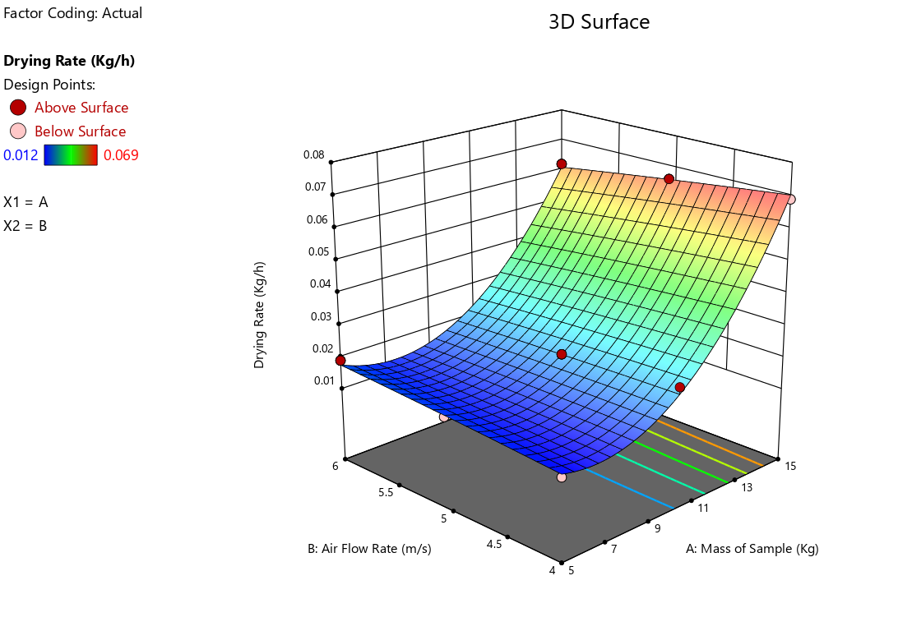

Fig 4.1: Effect of Mass of Sample and Air Flow Rate on the Drying Rate of Maize

Table 4.3: Analysis of Variance (ANOVA) for the Drying Efficiency of Maize
Source | Sum of Squares | df | Mean Square | F-value | p-value
Model | 1083.98 | 5 | 216.80 | 7.484E+07 | < 0.0001 | Significant
A-Mass of Sample | 78.94 | 1 | 78.94 | 2.725E+07 | < 0.0001
B-Air Flow Rate | 857.36 | 1 | 857.36 | 2.960E+08 | < 0.0001
AB | 52.90 | 1 | 52.90 | 1.826E+07 | < 0.0001
A² | 85.87 | 1 | 85.87 | 2.964E+07 | < 0.0001
B² | 0.5950 | 1 | 0.5950 | 2.054E+05 | < 0.0001
Residual | 0.0000 | 7 | 2.897E-06
Lack of Fit | 0.0000 | 3 | 6.760E-06
Pure Error | 0.0000 | 4 | 0.0000
Cor Total | 1083.98 | 12
*Significant @P≤0.05
From table 4.3 above, the p value < 0.0001 shows that the model is significant being far below 0.05. this indicates that the selected factors of mass of sample and air flow rates have a great effect on the drying efficiency of maize grains. The graphical representation is shown in figure 4.2 below.

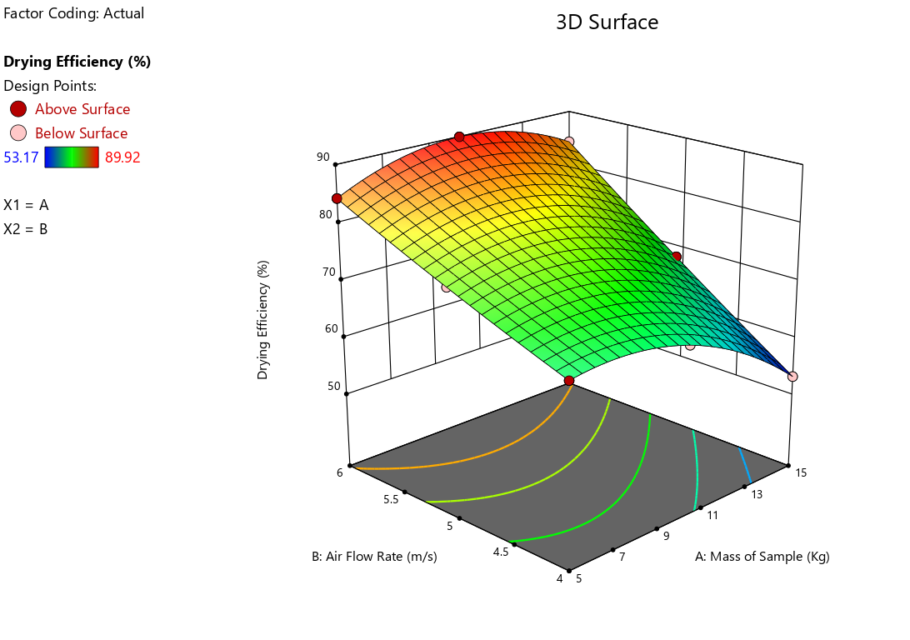

Fig 4.2: Effect of Mass of Sample and Air Flow Rate on the Drying Efficiency of Maize

CHAPTER FIVE
CONCLUSION AND RECOMMENDATIONS
  - Conclusions
A motorized flat bed dryer was tested for its performance in the department of agricultural and bio environmental engineering technology, institute of technology, kwara state polytechnic, Ilorin. Based on the test conducted, the following conclusions were drawn:
- The charcoal-powered flatbed dryer achieved consistent drying rates and good moisture reduction across all tested loads.
- Larger weights yielded lower drying rates and efficiency, demonstrating increased heat capacity.
  - Recommendations
- The machine can also be used to dry other agricultural product
- Test with different grains and moisture levels.
- Conduct long-term storage trials to validate grain quality and post-drying moisture content.

REFERENCES
Adeyemi, O., Adebiyi, S., and Olaniyi, T. (2018). Post-harvest challenges of maize drying in humid regions. Journal of Agricultural Processing, 13(2), 102–109.
Ahmed, A., Usman, M., & Bello, I. (2017). Maize utilization in poultry feed production in Nigeria. Nigerian Journal of Animal Production, 44(1), 55–62.
Akanda, M. A. M., Karim, A., and Alam, M. (2012). Effect of relative humidity on drying of maize. International Journal of Postharvest Technology, 4(3), 77–83.
Bala, B. K., Mondol, M. R. A., and Joardder, M. U. H. (2011). Drying characteristics of maize kernels. Journal of Agricultural Engineering Research, 79(1), 125–130.
Bakker-Arkema, F. W. (1995). Grain drying systems and technology. ASAE Monograph Series.
Base, I. W. (2013). Trends and challenges in maize production in Nigeria. African Journal of Agricultural Economics, 5(4), 101–110.
Bonserate, B. K. (2017). Airflow optimization in grain dryers. International Conference on Renewable Energy Systems.
Brooke, D., Smith, R., and James, A. (1992). Traditional grain drying methods in sub-Saharan Africa. International Journal of Agricultural Mechanization, 3(1), 45–52.
Cancom, M. L. (2012). The culinary and cultural importance of maize in Mesoamerican civilization. Journal of Ethnobotany, 18(3), 210–218.
CBN (2020). Central Bank of Nigeria annual agricultural report. Abuja, Nigeria.
Chavin, A. (2008). Whole grain consumption and cholesterol control: A clinical study. Nutrition Today, 43(1), 18–22.
Citadel, P. (1997). Photosynthesis mechanisms in maize. Plant Science Review, 13(2), 75–84.
Collins, S. (2008). Pollination biology of maize. Maize Genetics Cooperation Newsletter, 82, 43–48.
Cong, P. H., Zhang, X., and Yu, H. (2015). Variation in maize kernel weight among hybrids. Journal of Plant Genetics, 36(2), 143–150.

Crank, J. (1975). The mathematics of diffusion (2nd ed.). Oxford University Press.
Emo, P. A. (2007). Grain properties for mechanical processing. Grain Processing Technology Journal, 11(2), 88–92.
FAO (2010). Post-harvest operations for maize. Food and Agriculture Organization of the United Nations. Rome.
FAO (2011). Guidelines for safe drying and storage of maize. FAO Publishing.
Fumana, P., Ibe, H. N., and Ajayi, K. (2012). Physical characteristics of maize kernels for processing. Nigerian Journal of Engineering, 18(2), 54–59.
Fumana, P., Ajayi, K., and Ogunleye, T. (2013). Bulk density of maize kernels in storage structures. Agricultural Engineering Today, 21(4), 33–39.
Fung, T. T., Hu, F. B., & Willett, W. C. (2012). Whole grain intake and glycemic control in type 2 diabetes patients. Journal of Clinical Nutrition, 95(3), 677–685.
Hellwege, E. M. (2007). Growth cycles of Zea mays. Journal of Agronomic Biology, 9(1), 43–47.
IFAD (2019). Improving maize production and post-harvest value chain in Nigeria. International Fund for Agricultural Development, Rome.
IFAD (2020). Nigeria agricultural performance report. International Fund for Agricultural Development.
Jayas, D. S., Sokhansanj, S., and White, N. D. G. (2002). Modeling grain drying: Principles and applications. Drying Technology, 20(3), 623–645.
Mujumdar, A. S. (2007). Handbook of industrial drying (3rd ed.). CRC Press.
NBS (2020). National maize production report. National Bureau of Statistics, Nigeria.
Oyedale, A., Musa, A. A., and Balogun, O. (2014). Opportunities in Nigerian maize value chain. African Crop Science Journal, 12(4), 233–241.
Oyedule, M. O., Akintunde, B. O., and Salami, A. (2017). Seasonal variation in maize output in Nigeria. International Journal of Agronomy and Agricultural Research, 11(3), 76–82.
Oyedule, M. O., Salami, A. A., and Adeyanju, A. (2018). Effect of weather on maize drying in open sun. Nigerian Journal of Postharvest Technology, 7(1), 13–18.
Phillip, D. (1978). Capillary flow and drying of porous grains. Agricultural Drying Journal, 4(2), 88–92.
Piperno, D. R. (2011). The origins of plant cultivation and domestication in the New World tropics. Current Anthropology, 52(S4), S453–S470.
Singh, A., Patel, R. P., and Jain, V. (2007). Effect of wind speed on open sun drying of maize. Journal of Agricultural Sciences, 3(1), 101–108.
TABRE Standards. (2010). Standard bulk density values for cereals. Technical Association of Bulk Resource Engineers.
Thompson, T. L., Peart, R. M., and Foster, G. H. (1998). Mathematical simulation of corn drying. Transactions of the ASAE, 11(4), 582–586.
Thompson, R. A. (2003). Fundamentals of grain drying technology. Agricultural Engineering International.
USDA (2003). Nutritional content of maize kernels. United States Department of Agriculture.
Wang, L., & Zhang, Y. (2002). Bioactive compounds in maize and their health benefits. Journal of Food Biochemistry, 26(1), 23–34.
Warman, A. (2003). Corn and culture: A historical study of maize in ancient civilizations. Journal of Archaeological Studies, 15(2), 122–136.
Watson, S. A. (2003). Maize: Structure, composition, and processing. In P. J. White & L. A. Johnson (Eds.), Corn: Chemistry and technology (pp. 69–106). AACC International.
Yue, H. (1998). Drying processes in porous materials. Journal of Thermal Analysis and Calorimetry, 53(4), 753–760.

