DESIGN AND IMPLEMENTATION OF IOT BASED SMART SECURITY AND HOME AUTOMATION SYSTEM

BY
SULAIMAN MUIZ ABIOLA

ND/23/COM/PT/009

SUBMITTED TO THE DEPARTMENT OF COMPUTER SCIENCE,
INSTITUTE OF INFORMATION AND COMMUNICATION TECHNOLOGY,

KWARA STATE POLYTECHNIC, ILORIN
IN PARTIAL FULFILLMENT OF THE REQUIREMENTS FOR THE AWARD OF NATIONAL DIPLOMA (ND) IN
COMPUTER SCIENCE8

JULY, 2025.

CERTIFICATION
This is to certify that this project was carried out by ISIAKA RIDWAN OPEYEMI ND/23/COM/PT/0099, as part of the requirements for the award of the National Diploma (ND) in Computer Science.

…………………………………. ….………………………
Mr. Isiaka, O. S . Date
Project Supervisor

…………………………………. ….………………………
Mr. Oyedepo, F. S. Date
Head of Department

…………………………………. ….………………………
External Examiner Date

DEDICATION
We dedicate this project work to the Almighty God who inspired us and directed our ways during our academic stay in the polytechnic.

ACKNOWLEDGEMENTS
All praise is due to the Almighty God, the Lord of the universe. We praise Him and thank Him for giving us the strength and knowledge to complete our ND programand also for my continued existence on earth.
I appreciate the utmost effort of my supervisor, MR ISIAKA O.S .whose patience, support, and encouragement have been the driving force behind the success of this research work. He gave useful corrections, constructive criticisms, comments, recommendations, and advice and always ensures that excellent research is done. My sincere gratitude goes to the Head of the Department,Mr. Oyedepo, F. S.,and other members of staff of the Department of Computer Science, Kwara State Polytechnic, Ilorin, for their constant cooperation, constructive criticisms, and encouragement throughout the program.

TABLE OF CONTENTS
Title page i
Certification ii
Dedication iii
Acknowledgments iv
Table of Contents v
Abstract vi
CHAPTER ONE: GENERAL INTRODUCTION
1.1 Background to the Study 1
1.2 Statement of the Problem 2
1.3 Aim and Objectives 3
1.4 Significance of the Study 3
1.5 Scope of the Study 3
1.6 Organization of the Report 3
CHAPTER TWO: LITERATURE REVIEW
2.1 Review of Pastworks 5
2.2 Review Of General Text 9
CHAPTER THREE: RESEARCH METHODOLOGY AND
ANALYSIS OF THE SYSTEM
  - Research Methodology 13
  - Analysis of the Existing System 14
  - Problem of the Existing System 15
  - Description of the Proposed System 15
  - Advantages of the Propose System 16

CHAPTER FOUR: DESIGN, IMPLEMENTATION AND
DOCUMENTATION OF THE SYSTEM
  - Design of the System 17
    - Output Design 17
    - Input Design 19
    - Database Design 20
    - Procedure Design 22
  - Implementation of the System 22
    - Choice of programming language 22
    - Hardware support 23
    - Software Support 23
    - Implementation Techniques used in Details 23
  - Program Documentation 24
    - Operating the System 24
    - Maintaining of the System 24
CHAPTER FIVE: SUMMARY CONCLUSION AND
RECOMMENDATION
5.1 Summary 25
5.2 Conclusion 25
5.4 Recommendations 25
References 27

ABSTARCT
Fires are a significant concern in Nigeria, causing significant damage to property, the environment, and human life. According to the Federal Fire Service, there were over 8,000 fire incidents reported in Nigeria in 2020, resulting in 328 deaths and over N5 billion in property damage. Early detection of fires is critical to minimizing the loss of life and property damage caused by fires. However, traditional fire detection systems can be expensive and may not be practical in all situations.A fire attack is usually silent and people will know about fire only when it has spread across a large area. Property damaged by floods can often be dried out and restored. Structural damage from an earthquake might be repaired. Stolen property always has a chance of being recovered. Damage from fire, however, is usually permanent and irreparable. Historical buildings or contents, once reduced to ash, can never be restored. Fire is more cunning and less discriminating than a thief. It can travel (spread) through very small openings and concealed spaces to reach other parts of a building, deprive occupants of a life-supporting environment, and cause partial to the destruction of property.Many fire detection systems currently available on the market are expensive, require specialized equipment, and may not be practical in all situations. Additionally, some fire detection systems may not be able to detect fires in their early stages, leading to significant damage and loss of life. Therefore, there is a need for a cost-effective and efficient fire detection system that can detect fires in their early stages.The research methodology used in the development of the SMS-based fire detection system using smoke and temperature sensors in Nigeria involves both qualitative and quantitative methods. The qualitative method includes a thorough literature review of existing fire detection systems, particularly SMS-based systems, and the challenges facing fire detection in Nigeria. The quantitative method involves the design, development, and testing of the proposed system, which includes the integration of the sensors, microcontroller board, and GSM module. The testing phase involves the use of real-time fire scenarios to evaluate the accuracy and efficiency of the system in detecting fires and sending SMS alerts.

CHAPTER ONE
GENERAL INTRODUCTION
  - BACKGROUND OF THE STUDY
Nowadays, automation plays a crucial role in all work places and living homes. Automation is a technique of controlling a process by electronic devices with reducing human involvement. The large diffusion of smart devices with embedded sensors and wireless interfaces have enabled the rapid advancement of Internet of Things (IoT). The IoT plays a remarkable role in improving the quality of life and growing the world’s economy. It facilitates global connectivity over the world-wide physical objects (e.g., sensors, RFID, smartphones, vehicles, appliances) to serve people in a collaborative manner automatically and intelligently. The vision for the IoT states that various “things” are going to be connected and will be controlled across the Internet. Application domains of IoT cover smart home, smart healthcare, smart grid, smart transportation, smart city, industrial automation and surveillance. Among various IoT applications, the design of Home Automation System has drawn great attentions from both academic and industrial because it is more related to people’s lives (Devendra K. & Rajesh K. M., 2019).A Home Automation can be defined in many ways. One definition is a home with an automated system that comprises sensors and device controllers to provide a comfortable, intelligence and secure system to improve the quality of life and control home appliances easily, in particular for elderly and disabled people. Home automation may include centralized control of lighting, HVAC (heating, ventilation and air conditioning), appliances, and other systems, to provide improved convenience, comfort, energy efficiency and security. The concept of home automation has been around for a long time and products have been on the market for decades, though no one solution has broken through to the mainstream yet. Home automation for the elderly and disabled can provide increased quality of life for persons who might otherwise require caregivers or institutional care. It can also provide a remote interface to home appliances or the automation systemitself, via telephone line, wireless transmission or the internet, to provide control and monitoring via a smart phone or web browser.Home automation must have compliance with all the household standards and ease of use. This paper will describe the approach which we are implementing to control various home appliances with Android smart phone (Dhakad K. &Dhake T., 2016).
  - STATEMENT OF THE PROBLEM
During the information stage main problem statements for current systems are as below:
a) A common property of successful inventions is the abilities to make life easier. For example Washing Machine, making washing less burdensome.
b) Tragedies happen such as thefts especially late at night when the users are not at home. This is because home does not provide any secure system.
  - AIM AND OBJECTIVES OF THE STUDY
The aim of this research work is centred on the research topic itself, which is to develop a android-based application for Home Automation System using IoTwhich will be developed using ionic framework and the objectives are as follows:
- To help handicapped and old aged people to control home appliances and alert them in critical situations.
- To build a smart home device which can be used to control the home appliances via internet.
- To integrated a home automation system with almost all the home appliances and can be used to control them remotely from any part of the world.
- To do work effectively and timely manner

  - SIGNIFICANCE OF THE STUDY
The IOT based Home Automation will enable the user to use a Home Automation System based on Internet of Things (IOT).The modern homes are automated through the internet and the home appliances are controlled.This is a typical IOT based Home Automation system, for controlling all your home appliances. The smart home market is taking off as IOT device prices come down and the general public comes to understand the benefits of these products. And from smart homes, the next logical step is smart cities, which would take the IOT to the next level. And yet, smart homes are just one small part of our daily lives that the Internet of Things will transform in the coming years.

  - SCOPE AND LIMITATIONS OF THE STUDY
The project focus mainly on the development of a Home Automation System using IOT. This project does not go beyond this.
  - ORGANISATION OF THE REPORT
This is the overall organizational structure of the work as presented in this project write-up.
Chapter one of this project deals with the general introduction to the work in the project. It also entails the statement of the problem, aim and objectives of the project, the significance of the study, the scope and limitation of the study and organization of the report.
Chapter two deals with the review related journals and books, historical background ofthe study, as well as computerization current state of the art.
Chapter three covers the methods used for data collection, description of the current procedure, problems of existing system, description of the proposed system and the basic advantages of the proposed web based application.
Chapter four entails design, implementation and documentation of the system. The design involves the system design, output design form, input design form, database structure and the procedure of the system. The implementation involves the implementation techniques used in details, choice of programming language used and the hardware and software support. The documentation of the system involves the operation of the system and the maintenance of the system.
Chapter five deals with the summary, experience gained, conclusion, recommendations and references.

CHAPTER TWO
LITERATURE REVIEW
2.1 Review of Related Works
Biradar, Dhage, Jamadar, Kasar and Javed(2020),present a journal article titled “Smart Home Automation System” -Smart home automation system is a web based application that allows user to monitor home appliances using mobile devices. This system established for the entire home user after gaining access from administrator. This system includes remote control and monitoring domestic appliances, security and energy management. Once all the appliances in home are automated and connected it important to consider issue of security authentication and access control.
Saurabh, Harjeet and Sangeeta(2023), presents a journal titled “Internet Of Things (IoT) Based Home Automation System”,This paper purposes the study of Internet of Things (IoT) based home automation system. Internet of things (IoT) based home automation system can be controlled over mobile devices. This system can perform varied functions to be performed at home. This allows accessibility over internet from any corner in the world. The main focus of this project is to minimize the usage of electricity and reduce human efforts.The Home Automation system (HAS) incorporates various aspects of technologies such as wireless networking, communication over cloud.The data to be analyzed is stored onto the cloud. The user can access multiple appliances over the internet as per their convenience. This is a low cost system. This system can control multiple devices.
Vinay and Kusuma(2021), present a journal article titled “Home Automation Using Internet of Things” Withadvancement of Automation technology, lifeis getting simpler and easier in all aspects. In today’s world Automatic systems are being preferred over manual system. With the rapid increase in the number of users of internet over the past decade has made Internet a part and parcel of life, and IoT isthe latest and emerging internet technology. Internet of things is a growing network of everyday object-from industrial machine to consumer goods that can share information and complete tasks while you are busy with other activities. Wireless Home Automation system(WHAS) using IoT is a system that uses computers or mobile devices to control basic home functions and features automatically through internet from anywhere around the world, an automated home is sometimes called a smart home. It is meant to save the electric power and human energy. The home automation system differs from other system by allowing the user to operate the system from anywhere around the world through internet connection. Inthispaperwepresent aHome Automation system(HAS) using Intel Galileo that employsthe integration of cloud networking, wireless communication, to provide the user with remote control of variouslights, fans, and appliances within their home and storing the data in the cloud. The systemwillautomatically changeonthebasisofsensors’ data. Thissystem is designed to be low cost and expandable allowing a variety of devicesto be controlled.
Ravi, Lakshmi and Vishal (2019), present a journal article titled “IoT Based Smart Security and Home Automation System”Internet of Things (IoT) conceptualizes the idea of remotely connecting and monitoring real world objects (things) through the Internet. When it comes to our house, this concept can be aptly incorporated to make it smarter, safer and automated. This IoT project focuses on building a smart wireless home security system which sends alerts to the owner by using Internet in case of any trespass and raises an alarm optionally. Besides, the same can also be utilized for home automation by making use of the same set of sensors. The leverage obtained by preferring this system over the similar kinds of existing systems is that the alerts and the status sent by the Wi-Fi connected microcontroller managed system can be received by the user on his phone from any distance irrespective of whether his mobile phone is connected to the internet. The microcontroller used in the current prototype is the TI-CC3200 Launchpad board which comes with an embedded micro-controller and an onboard Wi-Fi shield making use of which all the electrical appliances inside the home can be controlled and managed.
Akrit and Ujwal (2016), present a journal titled “Wireless Home Automation System” Home automation structures have gotten commonness of late, paralleling advances in the possibility of the Internet of Things. The current endeavour exhibits the utilization of an unobtrusive home computerization system, inside the structure of assistive advancement. The system utilization relies upon the Arduino microcontroller along with Bluetooth correspondences capacity, and it is proposed for use by the elderly and people with insufficiencies. The structure is anything but difficult to use, with an instinctual interface executed on an Android based propelled cell phone. Showings exhibit that the structure empowers control of home devices, lights, warming, cooling systems and security devices by the arranged customers, i.e., the elderly and crippled.
Dhakad, Dhake, Undegaonkar, Zope and Vinay (2022), present a journal article titled “Smart Home Automation using IoT” Smart Building not only refers to reduce human efforts but also energy efficiency and time saving. In this ASP.NET is used in which appliances are connected to sensors and sensors give status of appliances to the web. Here electric appliances are operated by the website. The main objective of home automation and security is to help handicapped and aged people that will enable them to control home appliances and alert them in critical situations.
Lalit, Samir and Nihar (2020), presents a journal titled “Arduino based home automation using Internet of things (IoT)”,This paper presents a low cost flexible and reliable home automation system with additional security using Arduino microcontroller, with IP connectivity through local WiFi for accessing and controlling devices by authorized user remotely using Smart phone application. The proposed system is server independent and uses Internet of things to control human desired appliances starting from industrial machine to consumer goods. The user can also use different devices for controlling by the help of web-browser, smart phone or IR remote module. To demonstrate the effectiveness and feasibility of this system, in this paper we present a home automation system using Arduino UNO microcontroller and esp8266-01 as a connectivity module. It helps the user to control various appliances such as light, fan, TV and can take decision based on the feedback of sensors remotely. We have tested our system through conducted experiment on various environmental conditions.
Mahind,Gujar, Patel, Nikam and Patil (2019), present a journal article titled “Home Automation using IoT” A home automation is a technique which reduces the human efforts by using electronic devices. This system controls the home appliances through android application based on raspberry-pi. A home automation system have a two main components; First one is android app which control by locally as well as remotely and second is Raspberry Pi that has interface to sensors and appliances of an home automation system. It also saves the energy consumed by home appliances.
Ritvik and Antara (2019) present a journal article titled “IoT based Home Automation System with Pattern Recognition”Automation has numerous applications. This paper proposes a home automations system which can be effectively used to control and monitor home appliances using the internet. Due to its various advantages, home automation is gaining more and more popularity day by day because of its ability to ensure security and make life much easier. In the system, arduino will be interfaced with multiple sensors that can measure temperature & humidity, light, motion, and so on. The data collected by the various sensors is stored and a pattern analysis is done on the stored data which tells the user at which time the appliances are usually on or off so that they can be automatically controlled without any human intervention by observing the regular usage pattern. The user can also turn on/off any appliance remotely using the internet.
Marco (2021), present a journal titled “Introduction to the Internet of Things” The IoT can be viewed as a global infrastructure for the information society, enabling advanced services by interconnecting (physical and virtual) things based on existing and evolving interoperable information and communication technologies. Things are objects of the physical world (physical things) or of the information world (virtual world) which are capable of being identified and integrated into communication networks. Things have associated information, which can be static and dynamic.Physical things exist in the physical world and are capable of being sensed, actuated and connected. Examples of physical things include the surrounding environment, industrial robots, goods and electrical equipment. Virtual things exist in the information world and are capable of being stored, processed and accessed. Examples of virtual things include multimedia content and application software.
2.2 REVIEW OF GENERAL TEXT
The demand for automated systems has widely increased due to advancement of Automation Technology. The rapid increase in the number of users of internet has made Internet a part of life, and Internet of things (IoT) is the latest and emerging internet technology. Internet of things (IoT) is basically the interconnection via the internet of computing devices embedded in everyday objects, enabling them to send and receive data. It is a communication between multiple devices with no or less human intervention. Internet of things (IoT) can minimize human efforts. Internet of Things (IoT) analyzes the data retrieved from the sensors and performs appropriate activities thereby saving human time. The assurance to people about their home activities and securities led to the advancement of Home Automation System. The system will continuously update the system information as well as the user (Saurabh S., Harjeet M. &Sangeeta M., 2017).

2.3 OVERVIEW OF HOME AUTOMATION USING IOT
Home automation is the control of any or all Electrical gadgets in our home, regardless of whether we are there or away. Home automation is standout amongst of the most energizing improvements in innovation for the home that has gone along in decades. There are several items accessible today that permit us control over the gadgets automatically, either by remote control or even by voice charge.
IOT means Internet of Things, which connects the devices and things to the internet. The devices is nothing but smart-phones, TV, sensors etc. At the edge of the IOT are the appliances and equipment we use every day. These devices and thing are connected across an infrastructure using ZigBee, Raspberry-pi, Arduino, WiFie.t.c to provide bidirectional communications link with relatively long range, low power and a sufficient data rate to aggregate information from many connected devices. Home automation or Smart Homes can be described as introduction of technology within the home environment to provide convenience, comfort, security and energy efficiency to its occupants. Adding intelligence to home environment can provide increased quality of life. Now a day by giving the introduction of the Internet of Things (IOT), the research and implementation of home automation system are getting more popular. A smart home can be built on wide area by using variety of technology platforms or protocols. Each technology consists, its own language. Each language is used to connect the various devices and give instructions to perform a function. This system consist the automation of the home, housework or household activity. The smart home system is used for outlying area is nothing but extension of building automation and it involves the control and automation of turn on bulbs, heating, ventilation, air conditioning (HVAC), appliance.

2.4 CONCEPT OF INTERNET OF THINGS (IOT)
The Internet of things (IoT) describes the network of physical objects “things” that are embedded with sensors, software, and other technologies for the purpose of connecting and exchanging data with other devices and systems over the Internet.The main concept of a network of smart devices was discussed as early as 1982, with a modified Coca-Cola vending machine at Carnegie Mellon University becoming the first Internet connected appliance, able to report its inventory and whether newly loaded drinks were cold or not.(Mark W., 1991) paper on ubiquitous computing, "The Computer of the 21st Century", as well as academic venues such as UbiCompand PerCom produced the contemporary vision of the IOT. (Reza R., 1994) described the concept in IEEE Spectrum as "moving small packets of data to a large set of nodes, so as to integrate and automate everything from home appliances to entire factories". Between 1993 and 1997, several companies proposed solutions like Microsoft's at Work or Novell's NEST. The field gained momentum when Bill Joy envisioned device-to-device communication as a part of his "Six Webs" framework, presented at the World Economic Forum at Davos in 1999.
The term "Internet of things" was coined by Kevin Ashton of Procter & Gamble, later MIT's Auto-ID Center, in 1999, though he prefers the phrase "Internet for things". At that point, he viewed radio-frequency identification (RFID) as essential to the Internet of things, which would allow computers to manage all individual things. Defining the Internet of things as "simply the point in time when more 'things or objects' were connected to the Internet than people", Cisco Systems estimated that the IOT was "born" between 2008 and 2009, with the things or people ratio growing from 0.08 in 2003 to 1.84 in 2010.

2.4.1 ADVANTAGES OF INTERNET OF THINGS (IOT)
- The internet of things helps people live and work smarter, as well as gain complete control over their lives. In addition to offering smart devices to automate homes, IOT is essential to business.
- IOT provides businesses with a real-time look into how their systems really work, delivering insights into everything from the performance of machines to supply chain and logistics operations.
- IOT enables companies to automate processes and reduce labor costs. It also cuts down on waste and improves service delivery, making it less expensive to manufacture and deliver goods, as well as offering transparency into customer transactions.

2.4.2 BENEFIT OF IOT TO ORGANIZATION
The internet of things offers several benefits to organizations. Some benefits are industry-specific, and some are applicable across multiple industries. Some of the common benefits of IOT enable businesses to:
- Monitor their overall business processes;
- Improve the customer experience (CX);
- Save time and money;
- Enhance employee productivity;
- Integrate and adapt business models;
- Make better business decisions; and
- Generate more revenue.
2.4.3 APPLICATIONS OF INTERNET OF THINGS (IOT)
In his 1999 presentation to Procter & Gamble, Kevin Ashton, the co-founder of the Auto-ID Center at the Massachusetts Institute of Technology, explained the potential of IoT. Today computers and, therefore, the internet are almost wholly dependent on human beings for information. Nearly all of the roughly 50 petabytes (a petabyte is 1,024 terabytes) of data available on the internet were first captured and created by human beings by typing, pressing a record button, taking a digital picture or scanning a bar code. The problem is, people have limited time, attention and accuracy all of which means they are not very good at capturing data about things in the real world. If we had computers that knew everything there was to know about things using data they gathered without any help from us we would be able to track and count everything and greatly reduce waste, loss and cost. We would know when things needed replacing, repairing or recalling and whether they were fresh or past their best. Practical application of IoT technology can be seen in numerous industries.

AUTONOMOUS VEHICLES
An autonomous vehicle, sometimes referred to as self-driving cars or driverless cars, is a vehicle that uses a combination of sensors, camera, radar and artificial intelligence (AI) to travel between destinations without a human operator. In order to qualify as being completely autonomous, a vehicle must be able to navigate without needing human intervention to a predetermined destination via roads that have not been adapted for its use.

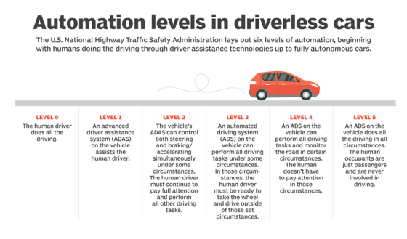
Fig 2.1 Driverless Car using Internet of Things (IOT)
AI technologies power self-driving car systems. Developers of autonomous vehicles use vast amounts of data from image recognition systems along with neural networks and machine learning. The intersection of these various fields results in being able to build systems that can drive autonomously. Neural networks identify patterns in the data, obtained through sensors and various other hardware, which is passed on to the machine learning algorithms. One prominent example is Google’s self-driving car which uses a mix of sensors and then combines all of the data generated by those systems in order to identify objects around the vehicle.
Smart Homes
Smart Home technology, also known as home automation is a classic example of the IoT in practice. Home automation provides home owners with comfort, security, convenience and improves energy efficiency by affording them the ability to control other smart devices, usually via a smart home app on their smartphone or a different networked device. Smart home systems and devices operate together and share consumer usage data among themselves in order to automate actions based on the owner’s preferences.

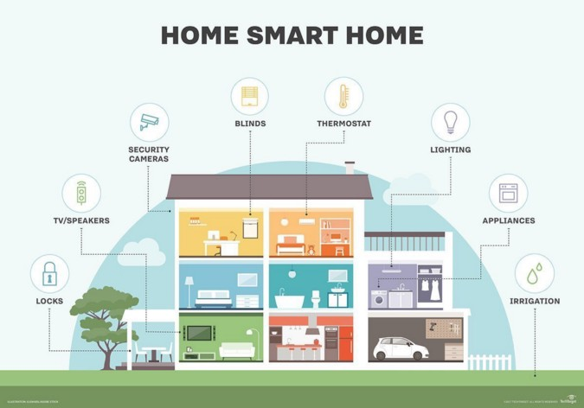
Fig 2.Smart Home Automation using Internet of Things (IOT)
Today, almost every appliance associated with domestic life has a smart home option. A few examples:
- Smart TVs connect to the internet to access content through applications, such as on-demand video and music. Some smart TVs also include voice or gesture recognition.
- Using smart locks and garage-door openers, users can grant or deny access to visitors. Smart locks can also detect when residents are near and unlock the doors for them.
- Pet care can be automated with connected feeders. Houseplants and lawns can be watered by way of connected timers.

CHAPTER THREE
RESEARCH METHODOLOGY AND ANALYSIS OF THE EXISTING SYSTEM
3.1 RESEARCH METHODOLOGY
Method of data collection refers to the practices and techniques in research used to gather, process, and manipulate information that can then be used to test ideas and theories about social life. Types of methodologies include interview, textbooks and internet research. The main type of method employed in this system is observation on the ways in which message is been sent and not known may be it delivered or not. The method is achieved through the following steps:
- An effective Home Automation using internet of things (IoT) is proposed.
- The system was implemented with IoT techniques.
- An application that will help homes, offices, industries e.t.cfrom other barriers was developed.
- A user-friendly application for Home Automation was created.
- The application is designed in C# package which involves the use of PHP server-side scripting language, MYSQL for database management and HTML (with other embedded functionalities) for the page design and layout settings. Hence, the program testing simply involves running it directly from a Mozilla Firefox web browser on local host server provided by Apache 2.0 inWampServer 2.0 application.
3.2 ANALYSIS OF THE EXISTING SYSTEM
The existing system of the home automation system present in the market are in general appliance specific and the same cannot be used interchangeably. Most of the existing system make use of Bluetooth to control the home appliances and this cannot be managed from a distant location. Thus functions such as being able to turn on an air-conditioner while returning home cannot be done with such systems. In contrast, this work gives a cost effective and simple solution for wireless home automation and home security systems. The difficulty faced by current home security or surveillance systems in providing information pertaining to the situation to users while being away from home is tried to overcome in this project. Some further modifications which can be done to increase the fidelity and user friendliness of the current system have been achieved in this system.

3.3 PROBLEMS OF THE EXISTING SYSTEM
During the information stage, the main problem encountered for the current systemsare as follows:
- Tragedies happen such as thefts especiallylate at night when the users are not at home. This is because home does notprovide any secure system.
- The systems are also regularly being installed incrementally without a central control point. And that can lead to home automation problems.
- Most of the existing system make use of Bluetooth to control the home appliances this cannot be managed from a distant location.

3.4 ANALYSIS OF THE PROPOSED SYSTEM
The introduction of home automation is failed to improve the lifestyles of users for several reasons. Firstly, these system is costly that’s why the economic benefits of home automation system is difficult. Secondly, the costs of implementing smart home technology must be depends on their installation and hardware cost. In this system we will make use of a common gadget which helps to create a home as a smart home. We are implementing a scheduling mechanism in this system.There is a need for home automation system is to be cost effective, flexible and easy to install with many network infrastructures and home appliances. The proposed home automation system has the capabilities to control most of the home appliances.
3.5 ADVANTAGES OF PROPOSED SYSTEM
The advantages of the proposed system include;
- Minimizing the cost of installing one application on different system, it provides far better security when compared to the existing system.
- Another major advantage of implementing the new system is that you do not need to be going around from city to city with your computer because the application home appliance can be control through the internet.
- The proposed system is very fast than the existing system.
- Save money and increase convenience of the user.
- Allow the user to control their appliances when they are out of town

CHAPTER FOUR
DESIGN, IMPLEMENTATION AND DOCUMENTATION OF THE SYSTEM
4.1 Design of the System
This system was developed using visual C# programming language. It starts with logical design, which produces a specification of major features of the system. These include the data, input, output, processing storage and other control requirement.

4.1.1 Output Design

Figure 4.1: Splash Screen Page Screenshot: On loading the application, this is the first page that will appear to the user.

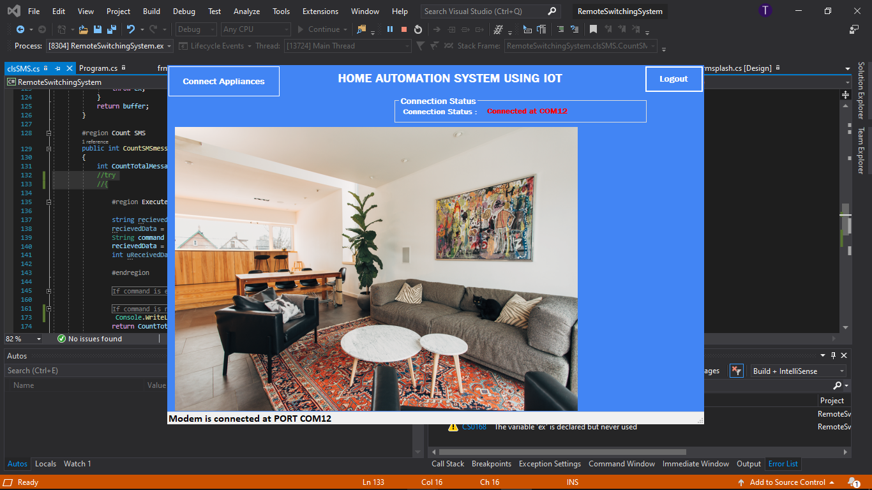
Figure 4.2:Home Page Screenshot: This is the module that shows the home settings.
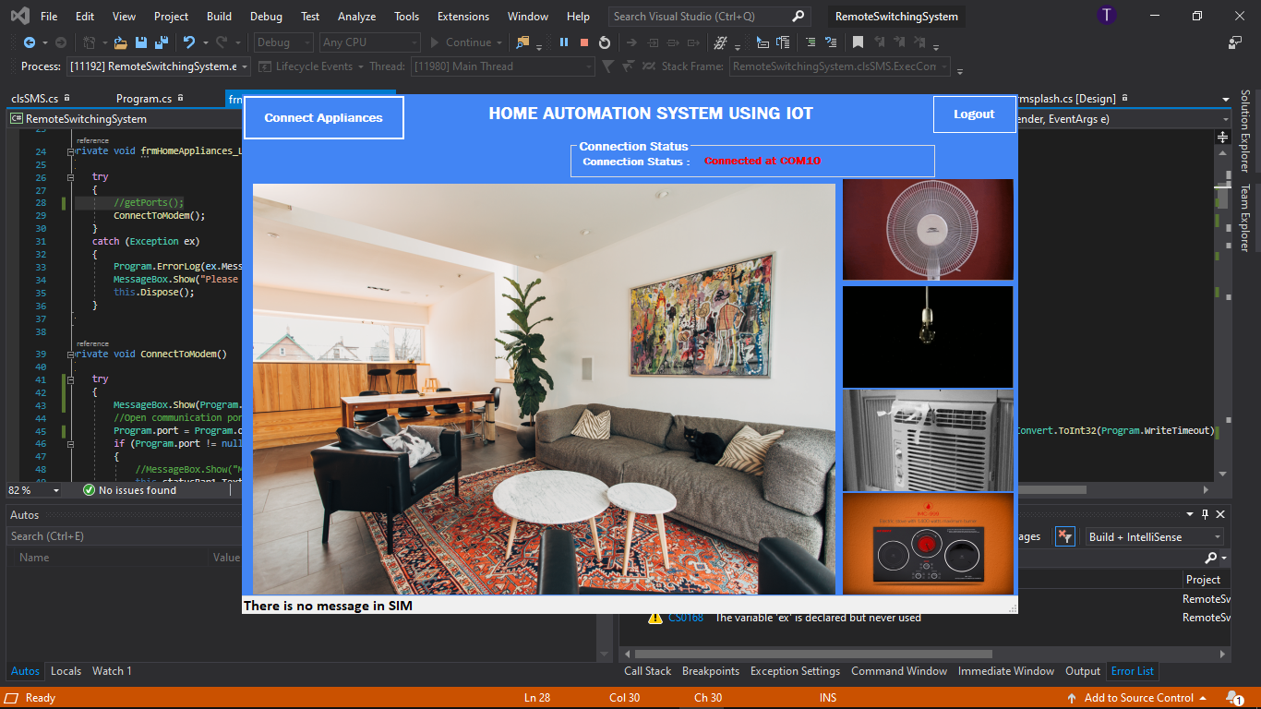
Figure 4.3:Appliances Screenshot: This is the module that shows all the home appliances.

4.1.2 Input Design
Design is a way of mapping and arranging parts into a whole, which satisfies the objective involved. The input design refers to the type of all data used to feed information into the database via the program and the format and input used for the system. Below are the snapshots of the input designs.
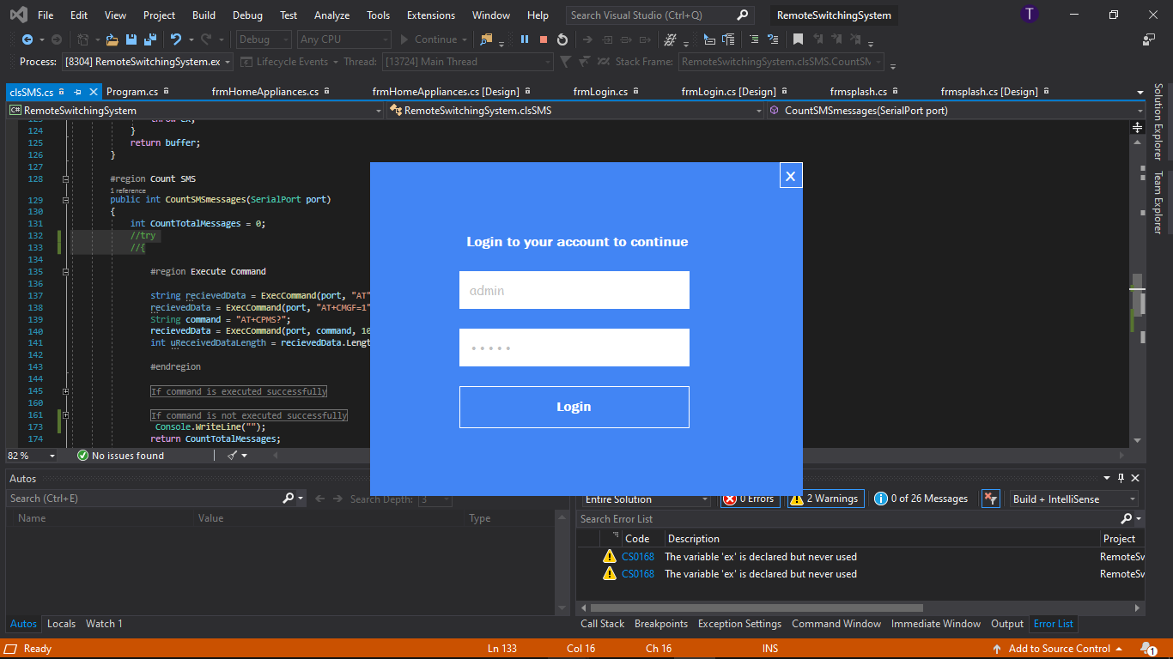
Figure 4.4: Sign In Page Screenshot: this gives access to the user after supplying username and password.
4.1.3 Database Design
A database is an integrated collection of data representing entities important to the functioning of an individual or organization; organize to reflect logical relationship among data elements. At the Centre of any information management is a database. In the design, two distinct data base structure were used as shown below:
This section gives detail information on all data that is use in the designing of this project; it gives analysis on the type, length etc.
This is just and encoded data definifion list here that describe that virus data definition, so during the scanning if the system found any file that matches the specified data the its going to flag the such file.
4.1.4 Procedure Design
The procedure design refers to the construct of the whole program i.e. how each section functions individually and collectively as a whole to make up the whole execution of the program work/operate according to specification.
The system contains four submenus, each submenu having difference form and they are control by modules.
The system allow user to register as a member to be able to log on into the system, the user also is allowing to view is profile, so also to edit its information if necessary.

4.2 System Implementation
Implementation is the stage of the project when the theoretical design is turned into a working system. At this stage the main workload, the greatest upheaval and the major impact on existing practices shift to the user department. Thus, it can be considered to be the most crucial stage in achieving a successful new system and in giving the user confidence that the new system will work and be effective.
The designed system depends on the capabilities and power of the computer on which the application system is installed. However, selecting a choice of application support (Hardware and Software) depends much on;
- How readily the user is to interfere with the computer
- Cost and benefits
- Managements support for changes
Hence, choosing the appropriate hardware and software will enhance the performance of the system.
4.2.1 Choice of Programming Language
The programming language to be used in the development of this application is the Microsoft Visual C#. C# is a third-generation event-driven programming language from Microsoft. Microsoft intended C# to be relatively easy to learn and use. C# was derived from C and C++ programming languages and enables the rapid application development (RAD) of graphical user interface (GUI) applications, access to databases using Data Access Objects, Remote Data Objects, or ActiveX Data Objects, and creation of ActiveX controls and objects. The database management system to be used in keeping the record of the virus definition is MYSQL. MYSQL is a database management system (DBMS) from that combines the relational Jet Database Engine with a graphical user interface and software-development tools.
MYSQL stores data in its own format based on the Jet Database Engine. It can also import or link directly to data stored in other applications and databases. Software developers, data architects and power users can use MYSQL to develop application software.

4.2.2 Hardware Support

The software was developed on a PC with the following hardware specifications which will function effectively on any computer system with the under listed minimum requirement. The hardware requires for the effective running of the software are as follows:

1. Intel Pentium 4 processor with a clock speed of at least 512 GHz.

2. Random Access Memory (RAM) of 1GB.

3. Computer system

4.2.3 Software Support
The software requirement for this project includes:
- A Computer System/Laptop running Windows Operating System (Windows XP, Windows 7, Windows 8/8.1 or Windows 10)
- Microsoft Visual studio 2012 IDE.
4.2.4 Changeover Technique
System changeover entails the diversion from the existing system to the new system. In this project, the changeover plan is direct method approach was used because it will allow the user operate the new system discarding the old system until the new system is operating in accordance with the defined user requirements and has proved that it’s reliable and efficient. The following steps are taking for the changeover plan;
- The system has been proved to the satisfaction of the system analyst and the other activities has been completed.
- User manager are satisfied with the result of the system tests, staff training and references manual.
- The operation manager is satisfied with the performance of the new system.
- The changeover may be achieved in a number of ways. The most common methods are direct changeover, parallel running, pilot running, and staged changeover.
- The changeover plan entails the diversion from an old system to a new one, at this stage, the parallel changeover will be used in project work which involve processing current data by both the old and new system to cross check result, both the old and new system are kept alive until the new system has been proved for at least one system circle.

4.3 System Documentation
After the program has been well tested with input that the output has already been known, the next is to install the software in to the computer system for use.
The process of installing is being stated below
- Insert the CD into the system through the CD-ROM after the computer is switch on
- Locate the CD drive directory in my computer and click it to open
- After open, locate setup.exe, and then click to install the program by following the necessary step in installing the program.
- Ensure full installing of the software for effective operation of the system.
After the program has been fully install. The next thing is to locate the package install to put it into operation, to locate the package for expiration purpose the following step are to be taking.
- Click on start menu from task bar. Then select all program
- From the display sub option, select by locating the software installed named Opulence Trojan detection to load the software.
4.3.1 Maintaining the System
Built-in safeguard of the system helps home to automate their appliances and to improve their securities.

CHAPTER FIVE
SUMMARY CONCLUSION AND RECOMMENDATION
5.1 SUMMARY
In this thesis, we have designedIOT based home automation system which will bring more convenience and comfort to people lives. The android based homeautomationsystem communicates with the system via an internet. Any android supported device can be used to install the home automation application. Using android application user can control and monitor the smart home environment. These home automation systems are mandatory because sometimes human can forgot to switch off the appliances when there is no need to use and in this situation, the home automation system is used to reduce the wastage of electricity.
5.2 CONCLUSION
As a final conclusion, we presented a design implementation of a Home Automation System using Internet of Things (IOT) for energy efficient housing that was optimized for low-cost,flexibility of system configuration, and interoperabilitywith other technologies.All described system components were tested in a prototype implementation of the Home Automation System. The experimental tests showed that the proposed architecture and components were well chosen both in terms of achieving the low cost of the overall solution and satisfactory system performance.Beside the basic system core described in this system, we plan to extend the basic system functionality by providing additional modules and services, such as smart entry control subsystem,human behaviour patterns learning and monitoring, remote access system control, configuring and controlling system configuration over smartphone or tablet etc.
5.3 RECOMMENDATION
Home automation has vast scope. Using this system as framework, the system can be expanded to include various other options which could include home security feature like capturing the photo of a person moving around the house and storing it onto the cloud. This will reduce the data storage than using the CCTV camera which will record all the time and stores it. The system can be expanded for energy monitoring, or weather stations. This kind of a system with respective changes can be implemented in the hospitals for disable people or in industries where human invasion is impossible or dangerous, and it can also be implemented for environmental monitoring.

References
Akrit K. and Ujwal D. (2016) “Wireless Home Automation System” International Research Journal of Engineering and Technology (IRJET) Volume: 02 Issue: 03 | Jan-2016
Biradar A. S., Dhage S. B., Jamadar V. V., Kasar H. S. and Javed S.(2016) “Smart Home Automation System” International Journal of Advanced Research in Computer Engineering & Technology (IJARCET) Volume 5, Issue 4, April 2016
DeepaliJavale, Mohd. Mohsin, ShreerangNandanwar “Home Automation and Security System Using Android ADK” in International Journal of Electronics Communication and Computer Technology (IJECCT) Volume 3 Issue 2 (March 2013).
Dhakad K., Dhake T., Undegaonkar P., Zope V. and Vinay L.(2016),present a journal article titled “Smart Home Automation using IoT”Jaypee University of Information Technology Waknaghat, Solan-173234, Himachal Pradesh
E. Yavuz, B. Hasan, I. Serkan and K. Duygu.“Safe and Secure PIC Based Remote Control Application for Intelligent Home”. International Journal of Computer Science and Network Security, Vol. 7, No. 5, May 2007
Home Automation Using Internet of Things International Research Journal of Engineering and Technology (IRJET) e-ISSN: 2395-0056 Volume: 02 Issue: 03 | Jan-2015 Vinaysagar K N1, Kusuma S M21 Student IV SEM, M.Tech, Digital Communication. Engg, MSRIT, Bangalore, India
Lalit M. S., Samir K. B. and Nihar M.(2018) “Arduino based home automation using Internet of things (IoT)” International Journal of Advanced Research in Computer and Communication Engineering Vol. 5, Issue 2, February 2016
Lalit Mohan Satapathy, Samir Kumar Bastia NiharMohanty, Arduino based home automation using Internet of things (IoT),International Journal of Pure and Applied Mathematics, Volume 118 No. 17 2018.
Mahind N. L.,Gujar G. V., Patel H. S., Nikam P.S. and N Patil P. D.(2018), present a journal “Home Automation using IoT” International Journal of Pure and Applied Mathematics Volume 118 No. 17 2018, 769-778 ISSN: 1311-8080 (printed version); ISSN: 1314-3395 (on-line version) url: http://www.ijpam.eu Special Issue
Mandurano, Justin, and Nicholas Haber. House Away: A home management system, IEEE Long Island Systems, Applications and Technology Conference (LISAT), Farmingdale, NY, (2012), 1-4.
Marco Z. (2014) “Introduction to the Internet of Things”December 2017 with 9,775 Reads DOI: 10.21742/ijsh.2017.11.09.01
Md. RaihaanKamarudin, Md. Aiman F. Md. Yusof. “Low cost Smart Home Automation “ 2013 IJENS Vol:13 No.:03.
Muhammad IzharRamli, MohdHelmyWahab, Nabihah, “towards smart home: control electrical devices online” ,Nornabihah Ahmad International Conference on Science and TechnologyApplication in Industry and Education (2006)
R. Piyare, and S.R. Lee, Smart home-control and monitoring system using smart phone, The 1st International Conference on Convergence and its Application, 84, (2013) 83-86.
Ravi K. K., Lakshmi B. and Vishal J. (2016) “IoT Based Smart Security and Home Automation System” [Singh* et al., 6(11): November, 2016] IC™ Value: 3.00
Ritvik I. and Antara S.(2019) “IoT based Home Automation System with Pattern Recognition” International Journal of Computer Trends and Technology (IJCTT) – Volume 56 Number 1- February 2018
SafiyyaRusli, MehrdadDianati“ Mobile access to smart home network” 2012.
Saurabh S., Harjeet M. and Sangeeta M. (2017) “Internet Of Things (IoT) Based Home Automation System” International Journal of Innovative Technology and Exploring Engineering (IJITEE) ISSN: 2278-3075, Volume-8 Issue-12, October 2017
Singh, S., Matharu, H., & Mishra, S., Dr. (n.d.). INTERNET OF THINGS (IOT) BASED HOME AUTOMATION SYSTEM. INTERNATIONAL JOURNAL OF ENGINEERINGSCIENCES & RESEARCH TECHNOLOGY, 6(11), 239-244
Sirsath N. S, Dhole P. S, Mohire N. P, Naik S. C &Ratnaparkhi N.S Department of Computer Engineering, 44, Vidyanagari, Parvati, Pune-411009, India University of Pune, “Home Automation using Cloud Network and Mobile Devices”.
Vinay K. N. and Kusuma S. M. (2015) “Home Automation Using Internet of Things” International Journal of Recent Technology and Engineering (IJRTE) ISSN: 2277-3878, Volume-8 Issue-2, July 2015

