SOLAR SUDDEN IONOSPHERIC DISTURBANCE

BY

ABDULRAHMAN OLAMILEKAN HABEEB
ND/23/SLT/PT/0118

SUBMITTED TO
DEPARTMENT OD SCIENCE AND LABORATORY TECHNOLOGY, INSTITUTE OF APPLIED SCIENCE, KWARA STATE POLYTECHNIC.

IN PARTIAL FULFILLMENT OF THE REQUIREMENT FOR THE AWARD OF NATIONAL DIPLOMA IN SCIENCE AND LABORATORY TECHNOLOGY

AUGUST, 2025

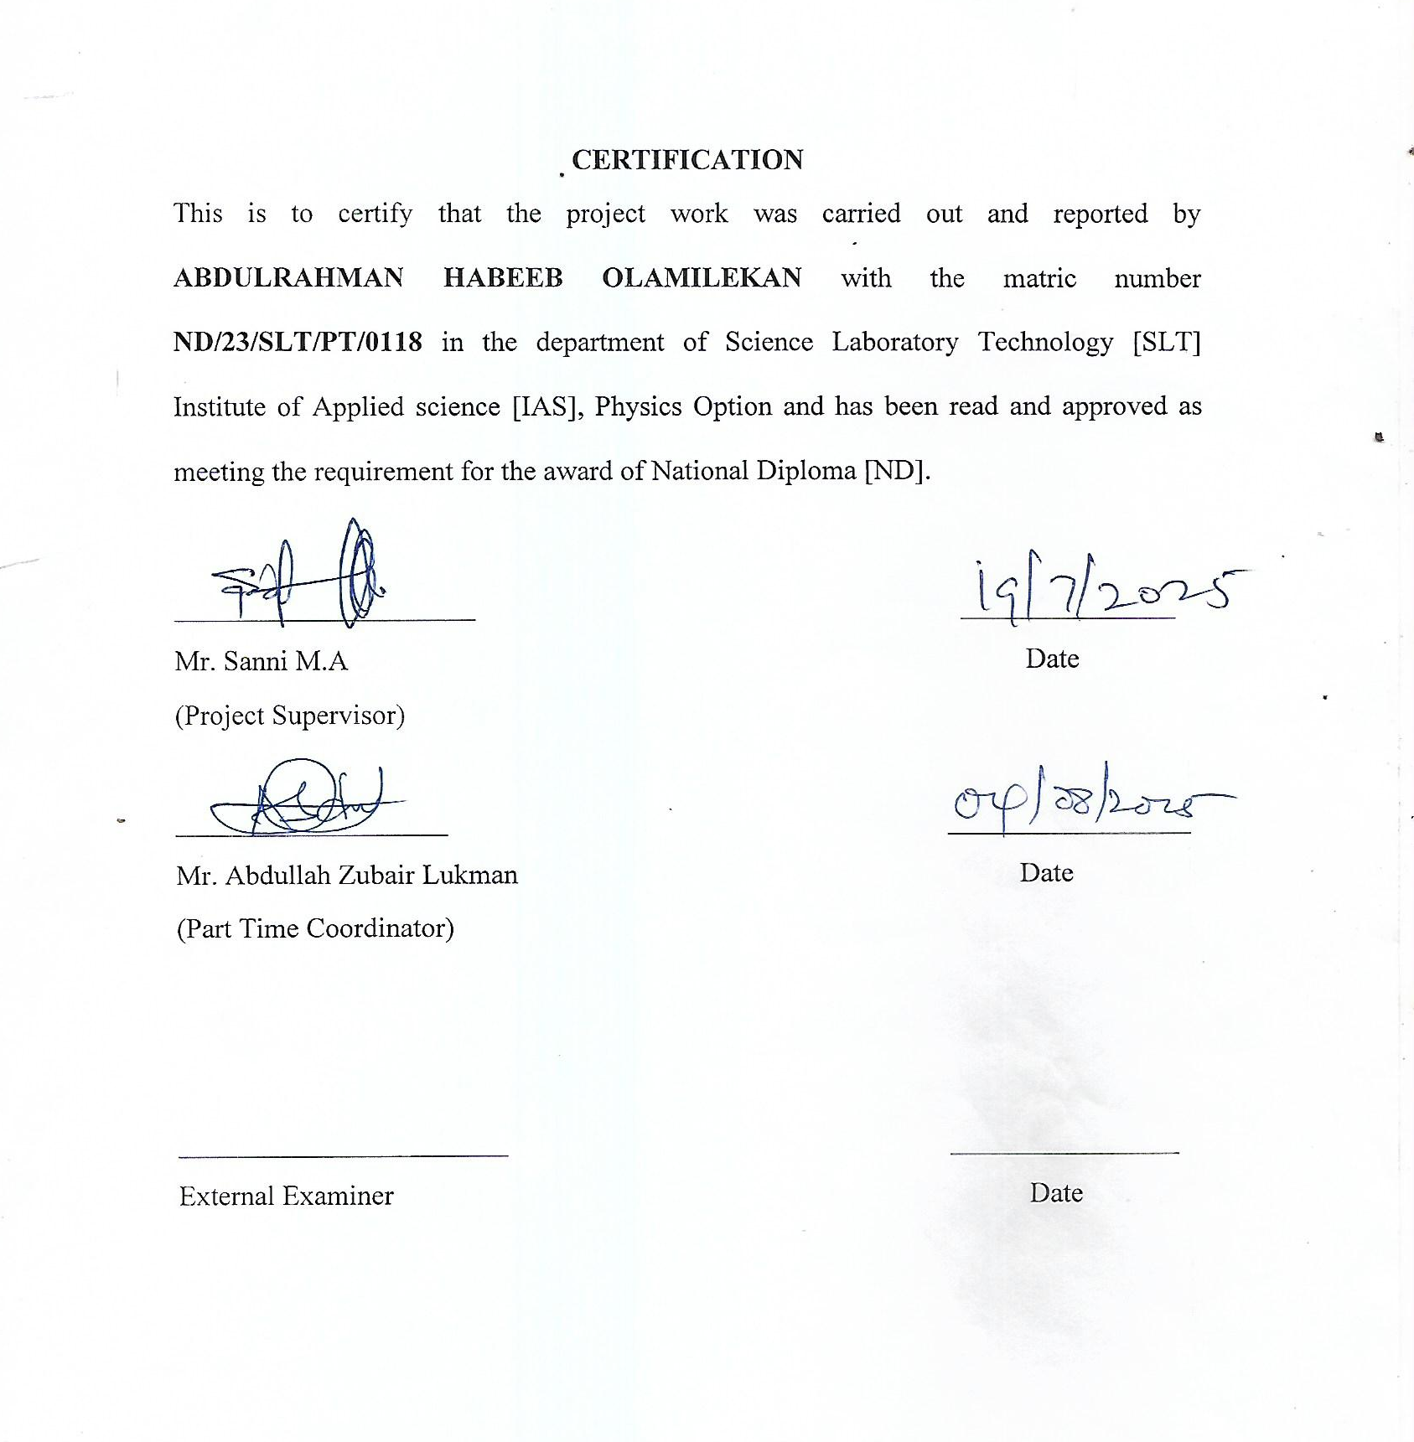
CHAPTER ONE

1.0 INTRODUCTION
Solar Ionospheric Disturbance is an abnormally high ionization/plasma density in the D region of the ionosphere caused by a solar flare. A Solar Ionospheric Disturbance (SID) is the result of a solar flare and is characterized by an unusual increase in ionization plasma in the D region of the ionosphere. SID's cause a spike in absorption of radio waves primarily in the upper MF and lower HF bands, resulting in disruption to telecommunication systems. John Howard Dellinger discovered and described an effect called sudden ionospheric disturbance in 1935. Hans Mögel also described the same phenomena in 1930 and since then it has become wellknown as the Dellinger effect. These fadeouts exhibit sharp and sudden onset and recovery that takes anywhere from a few minutes to several hours.When a solar flare happens, a burst of intense ultraviolet and x-ray radiation reaches the Earth’s dayside after about 8 minutes. This form of high energy radiation is absorbed by particles in the atmosphere, which in turn excites them and causes electrons to be freed through a process known as photo-ionization. The lower ionospheric regions (D region and E region) temporarily raise the density of all the Shaded regions. The Solar Ionospheric Disturbance refers to the abnormal excess of ionization/plasma density in the D region of the ionosphere due to a solar flare. SID occurs as a spike in the absorption of radio-waves. The ionospheric disturbance enhances VLF radio propagation. Scientists on the ground can use this enhancement to detect solar flares; by monitoring the signal strength of a distant VLF transmitter, sudden ionospheric disturbances (SIDs) are recorded and indicate when solar flares have taken place. Short wave radio waves (in the HF range) are absorbed by the increased particles in the low altitude ionosphere causing a complete blackout of radio communications. This is called a short-wave fading. These fadeouts last for a few minutes to a few hours and are most severe in the equatorial regions where the Sun is most directly overhead.
The ionospheric disturbance enhances long wave (VLF) radio propagation. SIDs are observed and recorded by monitoring the signal strength of a distant VLF transmitter. SIDs are classified in a number of ways including; Short Wave Fadeouts (SWF), Sudden Cosmic Noise Absorption (SCNA), Sudden Enhancement of Atmospherics (SEA/SDA), Sudden Phase
Anomalies (SFA), Sudden Enhancements of Signal (SES), Sudden Field Anomalies (SFA) and Sudden Frequency. Solar flares are powerful outbursts of radiation from the Sun that have a big effect on the ionosphere. A flare is a burst of X-rays and extreme ultraviolet (EUV) radiation that reaches Earth in a matter of minutes. Sudden Ionospheric Disturbances (SIDs) are caused by these high-energy radiations, which raise the electron density in the lower ionosphere, especially the D-layer, quickly and abnormally. SIDs primarily manifest as signal amplitude enhancements or phase shifts in Very Low Frequency (VLF) transmissions. These events can disrupt radio communications, affect GPS accuracy, and influence power grid operations. Monitoring and understanding the characteristics of SIDs, especially in the D and E layers, is vital for improving space weather forecasting and protecting ground-based and satellite communication systems.
1.2 The Sun
At first, there was nothing, well not exactly. Billions of years ago, there was no sun, no earth, no solar system. There was just a huge cloud of dust and gas in the galaxy. About 5 billion years ago, there were enough hydrogen atoms in the cloud for gravity to pull them together. As the cloud shrank, it become denser. The atoms were soon moving so fast that this cloud began to glow. When the cloud was hot enough, electrons and protons of the hydrogen atoms flew apart when two protons collided, they would fuse, or stick to one another, until atoms of helium formed. This process is called fusion. Energy is produced in the form of light and heat through fusion as well. This energy made the called to enlarge, while the gravity was pulling to hold the atoms together. Finally, the forces balanced and the sun was formed. With the sun at the center, our solar system formed. Over millions of years, the leftover gas and dust formed the nine planets, and a variety of moons asteroids, comets, and meteors.
The maximum temperature is 27 million degrees Fahrenheit. The gas in the core is roughly 100 times denser than that of most metals. Rats find it difficult to escape because of how tight the core is. Gamma rays continue to clash with additional atoms after being emitted by fusion. As a result, it takes the gamma rays over 30,000 years to reach the surface of the sun. Accordingly, the light we experience on Earth was produced thousands of years ago.
The Sun is by far the largest object in the solar system. It contains more than 99.8% of the total mass of the solar system (Jupiter contains most of the rest). It is often said that the sun is an "ordinary" star. That's true in the sense that there are many others similar to it. But there are many smaller stars than larger ones; the sun is in the top 10% by mass. The median size in our galaxy is probably less than half the mass of the sun.
Numerous legends personify the Sun; the Romans called it sol, while the Greeks called it
Helios. Currently, the Sun's mass is composed of roughly 70% hydrogen and 27% helium, with less than 2% coming from other "metals." As the sun's core transforms hydrogen into helium, this gradually changes over time. Differential rotation is a feature of the sun's outer layers; the surface spins once every 25.4 days at the equator and up to 36 days near the poles. Because the sun is not a solid body like the Earth, it exhibits this peculiar behavior. The gas planets exhibit comparable effects. The differential rotation extends considerably down into the interior of the sun but the core of the sun rotates as a solid body. Conditions at the sun's core ( approximately in the inner 25% of it's radius) are extreme. The temperature is 15.6 million kelvin and the pressure is 250 billion atmosphere. At the center of the core the sun's density is more than 150 times that of water
1.3 Internal Structure Of the earth
The structure of the sun is described by the diagram below which contains the inner core, radiative core, convectional shell, photosphere, chromosphere and coronal which later followed by their description
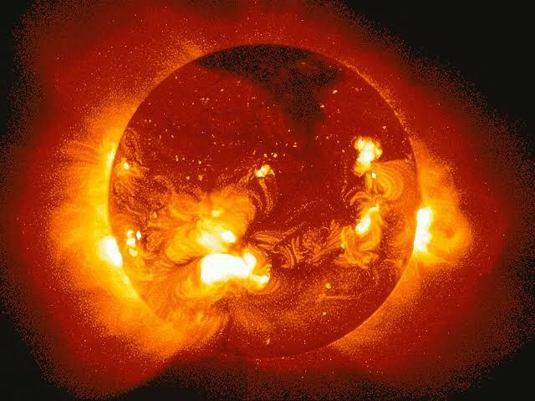
Figure 1. The structure of the sun (NASA)
The surface of the sun, called the photosphere, is at a temperature of about 5800 k. Sunspot are
"cool" regions, only 3800 K (they look dark only by comparison with the surrounding regions). Sunspot can be very large, as much as 50,000 km in diameter.sunspot caused by complicated and not very well understood interactions with the sun magnetic field. A small region known as the chromosphere lies above the photosphere. The highly rarefied region above the chromosphere, called the corona, extend millions of kilometers into space but is visible only during a total solar eclipse (left). Temperatures in the corona are over 1,000,000 K. It just happens that the moon and the sun appear the same size in the sky as viewed from the earth. And the moon orbits the Earth in approximately the same plane as the Earth orbit around the sun sometimes the moon comes directly between the Earth and the sun. This is called solar eclipse ; if the alignment is slightly imperfect then the moon covers only part of the sun's disk and the event is called partial eclipse.
A total eclipse of the sun occurs when it precisely aligns, blocking the entire solar disk. While partial eclipses can be seen throughout a large portion of the planet, the path of totality—the area from which a total eclipse can be seen—is extremely limited, measuring only a few kilometers (although it is typically thousands of kilometers long). A solar eclipse occurs once or twice a year. A partial eclipse is likely to occur multiple times every ten years if you remain at home.
However, it is quite unlikely that the path of totality will pass through your residence because it is so narrow. In order to witness a total solar eclipse, individuals frequently travel halfway across the world.

Dark in the middle of the day. The stars come out. The animals and birds think it's time to sleep. And you can see the solar Corona. It is well worth a major journey.
The sun's magnetic field is very strong (by terrestrial standards) and very complicated. It's magnetosphere (also known as the heliosphere) extends well beyond Pluto. In addition to heat and light, the sun also emits a low density stream of charged particles (mostly electrons and protons) known as the solar wind which propagates throughout the solar system at about 450km/sec. The solar wind and the much higher energy particles ejected by solar flares can have dramatic effects on the earth ranging from power line surges to radio interference to the beautiful aurora borealis.
Recent data from the spacecraft Ulysses show that during the minimum of the solar cycle the solar wind emanating from the polar regions flows at nearly double the rate 750kilometers per second, than it does at lower latitudes. The composition of the solar wind also appears to differ in the polar regions. During the solar maximum, however, the solar wind moves at an intermediate speed. Further study of the solar wind will be done by the recently launched wind, ACE and SOHO spacecraft from the dynamically stable vantage point directly between the earth and the sun about 1.6 million km from earth. The solar wind has large effects on the tails of comets and even has measurable effects on the trajectories of spacecraft
There was a period of very low sunspot activity in the latter half of the 17th century called the mounder minimum. It coincides with an abnormally cold period the sun's output is not entirely constant. The sun is about 4.5 billion years old. Since it birth it has used up about half of the hydrogen in its core. It will continue to radiate "peacefully" for another 5 billion years or so (although its luminosity will approximately double in that time). But eventually it will run out of hydrogen fuel. It will then be forced into radical changes which, though common place by stellar standards, will result in the total destruction of the earth (and probably the creation of a planetary nebula).
1.4 The sun's energy
A massive cloud of gas and dust was drawn together by gravity to form the sun, which is thought to be around 5 billion years old. From this cloud, the earth and other planets also formed. As Helmholtz had suggested, the gravitational pull heated the early sun and released energy. Atoms and molecules move due to heat; the higher the temperature, the faster they move and the more forcefully they collide. Nuclei started to adhere to one another when the temperature at the center of the newly formed sun rose to a point where collisions between them could overcome their electric repulsion. Protons were combined to form helium, with some of them changing into neutrons (plus positons, positive electrons, which combine with electrons and are destroyed) this released nuclear energy and kept up the high temperature of the sun's core, and the heat also kept the gas pressure high, keeping the sun puffed up and stopping gravity from pulling it together any more. That, in greatly simplified terms, is the "nuclear fusion " process which still takes place inside the sun. Different nuclear reactions may predominate at different stages of the sun's existence, Including the proton reaction and the carbon_ nitrogen cycle which involves heavier nuclei, but whose final product is still the combination of protons to form helium.

A branch of physics, the study of "contolled fusion" reactions which combine small nuclei into bigger ones _ power from to heat boilers, whose steam could turn turbines and produce electricity. Unfortunately, no earthly laboratory can match one feature of the solar powerhouse _ the great mass of the sun, whose weight keeps the hot plasma compressed and confines the " nuclear furnace" to the sun's core.
Instead, physicists use strong magnetic fields to confine the Plasma, and for fuel they use heavy forms of hydrogen, which " burn" more easily. Still, magnetic traps can be rather unstable, and any plasma hot enough and dense enough to undergo nuclear fusion tends to slip out of them after a short time. Even with ingenious tricks, the confinement in most cases lasts only a small fraction of a second. The sun today still consists mostly of hydrogen. The fuel supply which has seen it through its first 5 billion years should be good for about as long in the future
1.5 Effects of sun on ionosphere
Change on the sun Itself also affect the ionosphere, one major change occur as a result of sunspots that appears on the surface of the sun. If the sun is viewed by projecting it's image onto a screen, then a number of dark areas may be seen from time to time. These spots may last from where the surface of the sun is cooler than the surrounding areas. The temperature of the spots is only about 3000C, this is quite cool when compared to the rest of the surface which is around 6000C! However, it is very much hotter under the surface where temperature is in excess of a million degrees.
There is an area known as a plague around the sunspot, this is slightly brighter than the surrounding areas and is a large radiator of ultraviolet radiation and x - rays. The amount of radiation emanating from the plague means that, there is an overall increase in the level of radiation from the sun. Rise in sunspot number means increase in the level of radiation, which also means greater level of ionization in the ionosphere.

1.2 Aim of the Study
The aim of this research is to investigate the effects of solar flares on the lower ionosphere by analyzing sudden ionospheric disturbances (SIDs), with specific focus on the D and E layers, using Very Low Frequency (VLF) signal monitoring.

CHAPTER TWO

2.0 LITERATURE REVIEW
2.1 History of Ionosphere
The ionosphere has been characterized as having multiple layers in the past. The E layer, as Appleton called it, was the first to be discovered. Although the reason for his decision is unclear, one theory is that he used the letter E to stand for the electric field of the reflected radio waves. The D and F layers have been called after the E layer, which is below it in alphabetical order, and above it, respectively. Because a second ledge occasionally appears in the profile behind the primary F2 peak, the F area is typically further separated into F1 and F2 layers.
The ionosphere is so named because it is region in the atmosphere where ions exist. In the most area of the atmosphere molecules are in a combined state and remain electrically neutral. In the ionosphere however, solar radiation (mainly ultraviolet light) is so intense that when it strikes gas molecules, they split, ionize and an electron is set free.
Although ion gave their name to the region, free electron starts to increase at an altitude of about 30km, but the electron density is not 60km. We often think of the ionosphere as having a number of distinct layers, this is convenient for many explanations, but it is not entirely accurate as the ionosphere contains ionized molecules (and free electrons) instead, the layers are best thought as peaks of ionization level.

2.2 Formation of the ionosphere
The majority of the lower atmosphere's molecules are in a mixed state and maintain their electrical neutrality. But in the area that stretches from roughly 50 km to more than 600 km above sea level, solar radiation, or the main ultraviolet light, is so strong that when it hits a gas molecule, it splits (i.e., it becomes ionized) and releases electrons. A free electron and a positive ion a molecule that has lost an electron—are produced as a result. The ionosphere's daylight hemisphere is where the majority of electron generation takes place because this process depends on solar energy. Neutral particles are often lighter and have more free electron motion when they mix with charged ions. Adeniyi (2008).
At the outer space of the earth environment, power density (solar constant) reaches a value of 1370w/m, this intense level of radiation is spread over a broad spectrum ranging from radio frequencies through infrared (IR) and visible light to X _rays. Solar radiation at the ultraviolet (UV) and shorter wavelength is considered to be "ionized " since photons of energy at these frequencies are capable of dislodged an electron from natural gas atom or molecule during a collision. The conceptual drawing below is simplified explanation of this process:
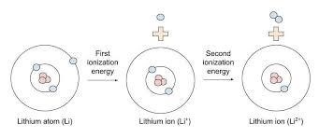
Figure 2.1: Conceptual image of the formation of the ionosphere
Incoming solar radiation is incident on a gas (or molecule). In the process, part of this radiation is absorbed by atom and free electron and a positively charged ion are produced. (Cosmic rays and solar wind particles also play a role in this process but their effect in minor compared with that due to the sun's electromagnetic radiation.) At the highest levels of earth's outer atmosphere, solar radiation is very strong but there are few atoms to interact with, so ionization is small. As the altitude decreases, more gas atoms are present so the ionization process increases. At the same time, however, an opposing process called recombination begins to take place in which a free electron is "captured" by a postive ion if it moves close enough to it. As the gas density increases at lower altitudes, the recombination process accelerates since the gas molecules and ions are closer together. The point of balance between these two processes determines the degree of " ionization" present at given time
At still lower altitudes, the number of gas atoms (and molecules) increases further and there is more opportunity for absorption of energy from a photon of UV Solar radiation. However, the intensity of this radiation is smaller at these lower altitudes because some of it was absorbed at the higher levels. A point is reached, therefore, where lower radiation greater gas density and greater recombination rates balance out and the ionization rate begins to decrease with decreasing altitude.
This leads to the formation of ionization peaks or layers (also called " heaviside" layers after the scientist who first proposed their their existence). Because the composition of the atmosphere changes with height, the ion production rate also changes and this leads to the formation of several distinct ionization peaks, the "D" "E" "F1", and " F2 " layers which is described below.

2.3 Layers of ionosphere
The ionosphere is divided into four layers namely: D layer, E layer, F1 and F2 layers:

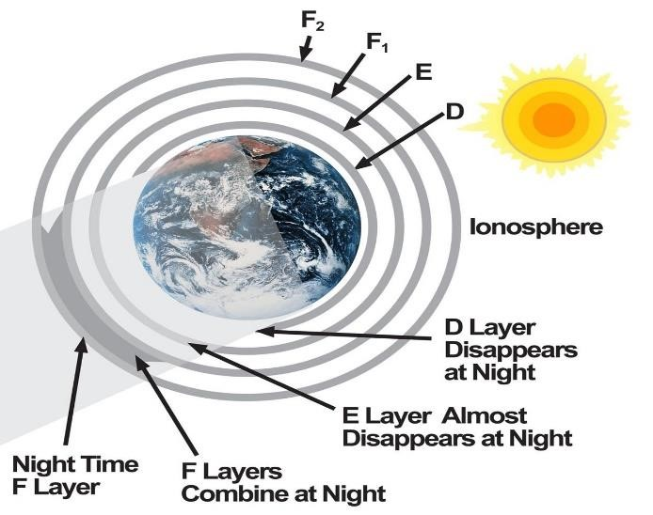
Fig 2.2: Layers of the ionosphere (Kelley, 2006)
The D layer which is lowest one occurs between 50 and 80km. It is present during the day when radiation is beaming in from the sun. The density of the air i.e (neutral molecules) in this height range is still high. This enhances fast recombination of ions and electrons with the result that electron density remains very low in this region. After sunset, when solar radiation is no longer present, electron density decreases quickly and the D- layer effectively disappear.
The E layer is the next above the D layer, it lies at the altitude range between 100 -125 km, UT lies above the earth because electron and ions recombine relatively quickly here also, electron density drop quickly after sunset but a small amount of residual ionization persist at night. There usually occur, the presence of some ionizing particles with electron density higher than that of the E layer itself, these particles are called sporadic E and are very common in low
latitude.

The F layer occurs during the day time, during certain periods often splits into two. The lower one is referred to as F1 and the upper one is called F2 layer as shown in the diagram Figure 2.2 below. At night, the two merges back into single F layer, typically F1 layer lies within the height range of 140 km to 210 km, while F2 layer is found above.
Dark in the middle of the day. The stars come out. The animals and birds think it's time to sleep. And you can see the solar Corona. It is well worth a major journey. The sun's magnetic field is very strong (by terrestrial standards) and very complicated. It magnetosphere (also known as the heliosphere) extends well beyond Pluto. In addition to heat and light, the sun also emits a low density stream of charged particles (mostly electrons and protons) known as the solar wind which propagates throughout the solar system at about 450km/sec. The solar wind and the much higher energy particles ejected by solar flares can have dramatic effects on the earth ranging from power line surges to radio interference to the beautiful aurora borealis.
Recent data from the spacecraft Ulysses show that during the minimum of the solar cycle the solar wind emanating from the polar regions flows at nearly double the rate 750 km per second, than it does at lower latitudes. The composition of the solar wind also appears to differ in the polar regions. During the solar maximum, however, the solar wind moves at an intermediate speed. Further study of the solar wind will be done by the recently launched wind, ACE and SOHO spacecraft from the dynamically stable vantage point directly between the earth and the sun about 1.6 million km from earth. The solar wind has large effects on the tails of comets and even has measurable effects on the trajectories of spacecraft

There was a period of very low sunspot activity in the latter half of the 17th century called the mounder minimum. It coincides with an abnormally cold period the sun's output is not entirely constant. The sun is about 4.5 billion years old. Since it birth it has used up about half of the hydrogen in its core. It will continue to radiate "peacefully" for another 5 billion years or so (although its luminosity will approximately double in that time). But eventually it will run out of hydrogen fuel. It will then be forced into radical changes which, though common place by stellar standards, will result in the total destruction of the earth (and probably the creation of a planetary nebula). Solar sudden ionospheric distubances are abrupt and temporary changes in the earths ionosphere primarily, triggered by intense solar flares emitting x-ray and rapidiy increase ionization in the lower ionospherere, particulaly in the d-region, thereby affecting radio wave propagation and satellite communication systems, one of the foundational studies on this subject was conducted by mitra 1974, who extensively explanied how x-ray and euv radiation from solar flares cause sudden increases in electron density in the ionosphere, leadind to enhanced absorption of vlf and lf radio signals. earlier, (deshpande and mitra 1972) had shown that the ionospheric response to solar flares depends significantly on both the flares intensity and the solar zenith angle.
Thomason, rodger, and clivered 2005 conducted detailed research on how solar flares induce measurable changes in the amplitude and phase of vlf radio signals, demonstrating a clear relationship between x-ray flux and ionospheric perturbations. building on this, mc rae theory to model the d-regions response to solar flare radiation, producing detailed electron density profiles that helped explain signal disruptions during SID events.

To improve the global monitoring of SIDs, scherrer et al., 2008 developed a low-cost vlf receiver system for real –time observation of disturbances, allowing researehers and education institution worldwide to contribute to SID detection. clivered et al., 2009 used such long-term vlf data to examine the seasonal and solar cycle variation in SID occurrence, finding that these disturbances are more frequent during solar maxima and day time hours. The real world impact of SIDs on navigation technology was explored by kintner, Ledvina, and de Paula (2007), Who highlighted that severe solar flare events could degrade GPS signal accuracy, particularly in equatorial and polar regions where ionopheric disturbances are strongest.
Grubor, Sulic, and Zigman (2005) also investigated Sid effects using VLF data, classifying solar flares based on their influence on the lower ionosphere electron density profile and confirming strong correlation with goes satellite measurements. Regional perspectives have also been addressed, notably by Chakraborti et al. (2010), who analyze VLF signal behavior over India during the 2009 solar eclipse and emphasized how local sunrise and sunset terminators influence SID observations.
More recently, Zhang et al. (2018) introduced the application of deep learning models for predicting Sid events using real time solar x - ray data. Making a significant advancement in forecasting capabilities. Their research represents the growing trend of integrating machine learning with space weather monitoring to enhance early warning systems for ionospheric disturbances

Charbeth Lopez_Urias (2023). Studied the analysis of ionospheric disturbances during x_class solar flares, the methodology used gnss data and wavelet analysis to investigate ionospheric disturbances and the result shows that disruptions in the ionosphere triggered solar flares, emphasizing the influence of solar activity on the ionosphere.
A.A. dimitriev (2008). Studied the geomagnetic signature of solar sudden ionospheric disturbances, explored geomagnetic signature of SID during extreme solar radiation events and highlighted in impact of SID’s in geometric field.
Jan Lastrovicka (2014). Studied the ionospheric disturbances under low solar activity and investigated ionospheric disturbances during periods of low solar activity, the result provided insights into the complex relationships between solar activity and ionospheric disturbances. Jing Liu (2020) Studied investigation of ionospheric disturbances during geometic storms adopted methodology, analyzing Tec variations during geomagnetic storms on the ionosphere.
Attila komjathy (2017). Studied analyzing ionopheric disturbances using GNSS data adopted the methodology using gnss data to investigate ionopheric disturbances, the result obtained showed the effectiveness of gnss data in monitoring ionopheric disturbances.
2.4 The D Layer
The D region is the lowest region of the Ionospher, between 50 and 80 km as earlier mentioned. D region ionization is produced mainly by solar radiation of wave length 102 to122 nm ( e.g Layman radiation). The primary positive ions formed in this region are and. Negative ions formation, due to electron attachment is also possible in this region. The free electron density in general is the lowest of all in this region and it varies widely depending on the time of the day. It is greatest shortly after noon and is extremely small at night. There are also large seasonal changes - free electron densities are highest in summer and lowest in winter. This behavior is basically expected due to the diurnal and seasonal variations in the amount of solar radiation impinging on the D region caused by rotation of the earth on its axis about the sun. The D region is the chief absorber of higher frequency radio waves because it has relatively high atmospheric density, which results in high electron-neutral collision rates that cause energy to be lost from radio waves which propagate as oscillation within the electron medium. The amount of absorption decreases as the radio wave frequency increases and the D Layer can cause absorption of radio signals at frequencies up to the low VHF band; however, there is no measurable effect on GPS signals. The temperature of D layer is about 190 k and the ionization properties usually about 1000 electron/cm³ and the ion present are O+, N2+, NO+.
Photo-chemical Reaction in the D layer
Photo ionization
. O+ hv —> O+ e- hv=13.5 eV
. N2+ hv —> N2+ e- hv=15.6 eV
. O2+ hv—> O2+ e- hv= 12.1 eV

Molecular Ionization
. O+ + O2 —> O2+O
. O+ + N2 —> NO+ N
. N2+ + O —> NO+ + N
Recombination
. NO+ + e- —> N+ O
However, very low ionization 1000 e-/m³ compared to 100,000 e-/ m³ in E layer and 1,000,000 e-/ m³ in the F layer
2.5 Observing the Ionosphere
The most important feature of radio communication is it's ability to reflect radio waves. However, only those waves within a certain frequency range will be reflected. The range of frequencies reflected depends on a number of factors. Various methods have been used to investigate the Ionosphere, and the most widely used instrument for this purpose is the ionosonde. An ionosonde is high frequency radar which sends very short pulses of radio energy vertically into the Ionosphere
If the radio frequency is not too high, the pulses are reflected back towards the ground. The ionosonde records the time delay between transmission and reception of the pulses over a range of different frequencies. Echoes appear first from the lower E region and subsequently, with greater time delay, from F1 and F2 regions. At night echoes are returned only from the F region since the E region is not present.
2.6 Variation Of Ionosphere
The Ionosphere is not a stable medium that allows the use of the same frequency throughout the year, even over 24 hours. The Ionosphere varies with a solar circle, the seasons and during any given day. The following are the variations of Ionosphere:
- Regular variations which occur in cycles and therefore can be predicted in advance with reasonable accuracy and
- Irregular variations which occur as a result of abnormal behavior of the sun such as the event we are monitoring and therefore cannot be predicted in advance. Both regular and irregular variations have important effects on the radio waves propagation.
Regular variations can be divided into four classes:
Daily variations in Ionosphere are as result of 24 hours rotation of the earth about it axis. The D Layer reflects very low frequency communication (VLF).
Seasonal variations are as result of the earth revolving round the sun, the relative position of the sun moves from one hemisphere to the other, with changes in seasons. Seasonal variation of D,E and F1 layers correspond to the highest angle of the sun, thus the ionization density of these layers is greatest In the summer.
Eleven years sunspot cycle is one of the most notable phenomenon on the surface of the sun is the appearance and disappearance of dark, irregular shaped areas known as a sunspots. The exact nature of the sunspots is not known but scientists believes they are caused by violent eruption fields. The sunspots are responsible for variation in ionization level of Ionosphere. 27- days sun spot cycle: the number of sunspots in existence at any time is continually subject to change as some disappear and new one emerges. As the sun rotates on its own axis, these sunspots are visible in 27- days intervals, the approximate period require for the sun to make one complete variation in the ionization density of the layers on a day-day basis.
Irregular variation in Ionospheric condition also have an important effect on radio waves propagation because this variations are irregular and unpredictable, they can drastically affect communication capabilities without any warning. The more common irregular variation is sporadic E, sudden Ionospheric disturbance and Ionospheric storm.
2.6 Waves propagation in Ionosphere
Electromagnetic waves, which can be classified as x-ray, gamma, infrared, radio, and ultraviolet waves, are waves that do not require a material medium to propagate. All electromagnetic waves move through vacuum. The theory of frequency and wavelength for each form of electromagnetic wave is summarized here.
Waves | Frequency (Hz) | Wavelength (m)
Radio | 10⁴ -10¹² | 10⁴ -10-¹²
Infrared | 104 – 1012 | 10-⁴
Ultraviolet | 1012 – 1016 | 10-⁸
X-rays | 1016 - 1020 | 10⁻⁸ -10-¹²
Gamma rays | 1020 – 1024 | 1012 – 10-16
(Source: Haliday et al)
2.7 Radio wave and signal propagation in Ionosphere.
The signal from the transmitter may reach receiving sites in two ways first by wave that follow the curvature of the earth to some extent known as ground waves; secondly the wave formed by the return of skyward travelling waves by the Ionosphere referred to as sky waves.
Ground waves: The so called ground waves follow the curvature of the earth because the speed of the waves is slowed slightly by the dielectric constant of the ground. This has the effect of tilting the wave front downward and allows the signal to be detected far beyond the normal visible horizon. Unlike higher frequencies, the strength of the ground waves signal is not reduced significantly by absorption.
As a result there is dead zone on the low frequencies (LF), except for every low power transmission and ground waves signal can be detected at over 2000 km from the transmitter.
Sky waves: because most amateur sized aerials are small compared to the wavelength considerable amounts of the radiated power are launched at higher angles and rapidly leave any influence on the ground. These waves travel upward until they reach the Ionosphere at around 50-100km altitude. Vertical incidence signal will penetrate deeply into the ionized regions but will suffer a great deal of attenuation, but at lower angle, the wave will be refracted towards the ground.
This will make the communication possible throughout much of the day almost anywhere in the world via sky wave. The figure below represents ground waves and sky waves in the Ionosphere.

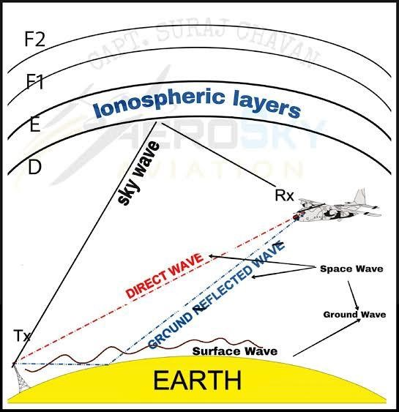
Figure 2.5: wave generated in the ionosphere.

CHAPTER THREE

3.1 Sudden ionospheric disturbance
A natural event known as a sudden ionospheric disturbance occurs when an explosion of extraterrestrial high energy photons momentarily disrupts the earth's ionosphere. SIDs can be produced by x-rays, powerful gamma ray bursts, or other luminous X-ray sources, but the sun is the most frequent source. The ionosphere momentarily expands during a sid, and variations in the measured power of far-off low frequency radio signals allow for the earth can notice the changes.
The E-layer, located just above the D-layer, also experiences increased ionization but to a slightly lesser degree. This layer reflects medium-frequency (MF) and high-frequency (HF) signals, and flare-induced changes can result in signal fading or abnormal propagation paths.
SID investigations focus on monitoring variations in VLF signal strength and phase delay using ground-based receivers. These measurements can detect the onset, duration, and intensity of disturbances, providing valuable insights into solar flare impacts. Through such studies, researchers aim to improve space weather forecasting and mitigate the adverse effects of solar activity on Earth-based technologies.
Specific events affecting particular aspects of radio propagation in SIDs are as shown.

3.1.1 Short wave fadeout (SWF)
This is most pronounced at frequencies around one megahertz. Short wave radio waves are absorbed by the increase particles in the low altitude ionosphere. Large flares can cause complete "blackout" of large distance short wave radio communications. Short wave fadeout last for a few minutes to a few hours and are the most severe in the equatorial regions where the sun is most directly overhead.
3.1.2 Sudden enhancement of atmosphere (SEA)
This is low frequency (10 – 500 KHZ) phenomenon. Atmosphere refer to electrical impulses of natural origin, mainly originating in lighting discharges, which cause crashing or grinding noise in a wireless receiver.
3.1.3 Sudden Cosmic noise absorption (SCNA)
High frequency signals of extraterrestrial origin (Cosmic noise) are attenuated by flare induced effects (principally by absorption in the D layer). Studying characteristics of SCNA's is useful is deducing ionospheric processes.
3.1.4 Sudden phase anomaly (SPA):
In addition to changes in the amplitude, changes in phase of low frequency radio wave are also observed. The cause is similar to that responsible for sea, (i.e. a lowering of the reflection level for low frequency signals by the enhancement of the electron concentration in the D layer). A lowering of the reflection height will change the phase of the received signals

3.1.5 Sudden frequency deviation (SFD)
This effect is observed on high frequency (- 20 MHZ) radio signals. As the refractive index in the E and F layer change due to increased ionization in these layers, the phase path also changes, and this result in a change of frequency proportional to the rate of change of the ionization. Hence the more impulsive the event, the more pronounced the SFD.

3.2 Causes of sudden ionopheric disturbance
Solar flare is one of the major causes of sid, whichever the sun erupts with a flare, it is usually in the form of X ray and EUV wave travel at the speed of light taking only 8 minutes to reach us here on earth. The second mechanism is through the impact of matter from the sun. Plasma or matter in a state where electrons wander around freely among the nucleic of atoms, it can also be ejected from the sun during a flare. This bundle of matter is called coronal mass ejection (CME).
CMEs from the sun at speed over two million kilometer per hour. Thus it would take a CME 72 hours or so to reach us. When energy from solar flare reaches the earth, the Ionosphere becomes sudden more ionized, thus changing the density and location of layers. Hence the term sudden ionospheric disturbance to describe the changes we are monitoring.

The diagram of solar flares and CME's are illustrated below:
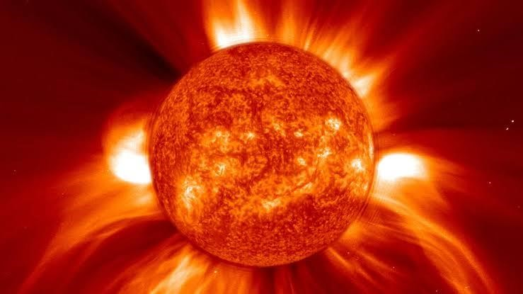

Solar flare images from NASA/JAXA SOHO CME: Ejection image from NASA/ESA SOHO
3.4 Observing SID with VLF Antenna
To observe an SID with VLF antenna, a loop antenna is required, a receiver and hardware, this is done because rather than observing the ionosphere itself, we are really observing the effects that a sudden disturbance has upon it seeing how the strength of a distant, low frequency signal changes with time, if the ionosphere is disturbed in some way (as by a solar flare), the propagation of the signal is affected, resulting in a change in signal strength, one can then correlate the SID events times with other indicators of solar flare of Cosmic activities like gamma ray bursts alerts or announcement.
3.5 Very low frequency and it's transmitters
Several nations use VFL waves to communicate, and VLF band is located in the frequency range between 2 KHz and 30 KHz. This band has unique characteristics of having a portion fall within audio frequency range of our ears. The VLF signals bounce off our ionosphere from many kilometer away and can picked up almost anywhere.
Very low frequency transmitter lists, here is a lists of VLF transmitters suitable for SID monitoring unless otherwise stated, they transmitters almost 24/7. These stations are used either as a communication means with submarines or for time signal.
1 | JXN | (1) | 16.4KHZ | Norvik, Norway  Locator:JP66wx | N 66°58'  27.67"  (+66.974353°) | E 013°52'  25.02"  (+013.873617°)
2 | VTX |  | 17.0KHZ | South  Vijayanarayanam,  India  Locator :MJ88vj | N 08°23'  13.25"  (+08.387015°) | E 077°45'  9.94"  (+077.752762°)
3 | SAQ | (2) | 17.2KHZ | Grimeton,  Sweden Locator:  JO67ec | N 57°06'  47.42"  (+57.113171°) | E 012°23'  50.20"  (+012.397277°)
4 | RDL | (3) | 18.1KHZ | Locator: --------- | - --°--'--.--"  (---.------°) | - ---°--'--.--"  (----.------°)
5 | VTX3 |  | 18.2KHZ | South  Vijayanarayanam, Indian  Locator: MJ88VJ | N 08°23'  13.25"  (+08.387015°) | E 007°45'  9.94  (+077.752°)
6 | NTS |  | 18.6KHZ | Woodside,  Victoria,  Australia | S 38° 28'  52.65"  (- 38.481290°) | E 146°56'  7.15"  (+146.935321°)
Locator

SQF311m

1 | VTX4 |  | 19.2KHZ | South  Vijayanarayanam,  India  Locator:MJ88vj | N 08° 23'  13.25"  (+08.387015°) | E 077° 45'  9.94"  (+077.752762°)
8 | GBZ | (4) | 19.2KHZ | Anthorn, UK  Locator: 1O84iv | N 54° 54'  41.91"  (+54.911643°) | W 003° 16'  42.44"  (-  003.278456°)
9 | NWC |  | 19.80KHZ | Harold E . Holt,  North West  Cape Exmouth, Australia Locator: | S 21° 48'  58.78"  (-21.816328°) | E 114° 09'  56.11"  (+114.165586°)

 |  |  | OG78be
ICV |  | 20.27KHZ | Isola di  Tavolara,  Italy  Locator:  JN40uw | N 40 55'  23.26"  (+40.923127  ) | E 009 43'  51.64"  (+009. 731011  )
FTA | (5) | 20.9KHZ | Sainte_ assist,  France Locator:  JN18gn | N 48 32'  40.68"  (+48.544632  ) | E 002 34'  45.94"  (+002.579429  )
NPM |  | 21.4KHZ | Pearl  Harbour,  Lualuahei, HI  Locator:  BL01wk | N 21 25'  12 .60"  (+21.420166  ) | W 158 09'  4.10"  (-158.151140)
HWU | (6) | 18.3KHZ  21.75KHZ  22.6KHZ | Rosnay, France Locator:  JN06or | N 46 42'  47.26"  (+46.713129  ) | E 001 14'  42.89"  (+001.245248  )
GQD | (7) | 22.10KHZ | Skelton,  UK  Locator:  1084nr | N 54 43'  54.48"  (+54.731799 | W 002 54'  58.92"  (_
 |  |  |  | ) | 002. 883033)
NDT |  | 22.20KHZ | Ebino, Japan Locator: PM52jb | N 32 04'  34.94"  (+32.076372) | E 130 49'  43.05"  (+130.828625)
DH

DH038 | (8) | 23.40KHZ | Rhauderfehn,  Germany Locator:  JO33tb | N 53 04'  44.04"  (53.078900) | E 007 36' 54. 00" (+007.  615000)
NAA |  | 24.00KHZ | Cutler, ME Locator :  FN64ip | N 44 38'  41.77"  (+44.644936  ) | W 067 16'  53. 90"  (_  067.281639)
NLK |  | 24.80KHZ | Oso wash,Jim creek, WA Locator:  CN98ae | N 48 12'  12 .55"  (+48.203487) | W 121 55'  0.58"  (_  121.916827)
NML | (9) | 25.20KHZ | LA moure,  ND  Locator:  EN06ti | N 46 21'  57.56"  (+46.365990  ) | W 098 20'  8.30"  (_  098.335638)

3.3 Instrumentation and Materials
Loop antenna (single-turn or multi-turn), material: shielded copper wire wound in a square or circular frame (about 1 m × 1 m), frequency range: 3 kHz – 30 kHz (VLF band). About 50 wire turns were needed for this antenna. Although wood or PVC pipe can be used to construct the antenna, we use wooden sticks for our purposes since they provide a more sturdy stand than the most common PVC type, which is unable to stand securely. The antenna is composed of three wooden sticks: Arm Horizontal (top): Have a "cross lap" cut in the center to connect with the Vertical Arm, and "bridle" cuts on both ends to hold the wires.

Vertical Arm (middle): has a “bridle” cut ( to be on the top), and “end lap” cut ( to be on the bottom) and a “cross-lap” cut in the middle to be joined with the Horizontal Arm. The “end lap” at the bottom is for sliding the wire loop into/out of the antenna as needed.
3.4 Methodology Adopted
These days, utilizing a PC is the most practical and straightforward method of receiving VLF signals. The least expensive option is a PC with a soundcard already installed; however, to complement this, a Data Q was utilized in its place. PC-based VLF reception is a straightforward technique that makes use of contemporary computer technology to enable anyone to receive VLF signals. In order to gather data in the form of a table, a data Q is also linked to the receiver, and a wire loop antenna a coil of insulated wire is connected to the antenna and receiver. Graph software is then used to construct spectrograms from the datum.
3.5: The Antenna
A SID antenna is called a “wire-loop antenna” and is nothing more than a frame that holds up
”wraps” or loops of wire. There is no “standard size” or even shape of antenna for a SID monitor. The antenna can either be a small or a large antenna, for our purpose we are dealing with small antenna. A small antenna is usually (<1meter wide) with lots of wraps of wire, though not as sensitive as large antenna which is (2 r more meters wide) with fewer wraps of wire. Unlike a large antenna, small antenna is easy to build, easy to carried about and can also be mount outside because of wind, rain and space requirements, as earlier mentioned small antenna are easy to build but required more loops or wire to pick up the signals.

3.6: Sitting the Antenna and it operation
Since the signal we are attempting to pick up is very small, the antenna need to be located in an area relatively free of electric interference, the antenna can either be indoor or outdoor, but should be away from generators and other large electric equipment, and not under power lines, not in a large metal frame buildings and not near microwave ovens, e.t.c
Unlike the TV antenna, our antenna need not to be high and should not placed where it get struck by lightning and the monitor need yi placed where it can be secured from been tampered with, an access to the power supply is very important as the has to be taken 24/7.
Operation of the antenna
As previously said, a loop antenna is a form of antenna that can detect VLF signals. In essence, a lop antenna is an LC (capacitor and inductor) circuit that resonates at a specific frequency. An inductor stores electrical energy by concentrating charges. The wire loop creates the inductance. The wiring metal surface running parallel along the loop creates the capacitance; wire resistance is tiny but constantly present in a wire and rises with wire length. As the electromagnetic field from a VLF station passes by the loop a very small (= 0.1 mV) electrical current is induced in the wire. The chances of picking up this tiny signal increases by increasing the number of turns or enlarging the size of the antenna.
As the number of turns increases, the distributed capacitance can also increases, the resistance of the wire increases too, causing the amplitude of the signal to drop.

3.7 Maintenance and Safety
What would happen should be antenna be struck by lightning? Would anyone get hurt? Absolutely no! Unfortunately should the antenna be struck by lightning, the SID detector will be damaged beyond repair, also the antenna should be placed where it is likely to get struck with lightning. The antenna should be placed in a location where it will not be disturbed. If the antenna were blown around or off a roof would anyone get hurt or would property get damaged? Take extra steps to secure the antenna. The cable should have some strain relief to prevent the coax from being pulled or tugged. If the signal suddenly drops out, the antenna should be checked to make sure it has not been moved or tuned. The VLF stations periodically shut off the signal for maintenance.

CHAPTER FOUR
4.0 Result
VLF signals were recorded continuously over a defined period (e.g., 3 days) during daytime hours when

the D and E layers are active. This is the display of graph for when the station is shut down for maintenance purpose, there happens to be that the instrument use for the maintenance shows loss of ionization where as there is disturbance or ionization, when the station undergoes maintenance. The voltage intensity is constant i.e 0V.

The graph shown below is for a typical quiet day, while we were carrying the research there was fluctuations in the increase of voltage supplied and with this herewith we have a graph that shows the fluctuating movement of the increased voltage as it rises and fall, then fall to rise.

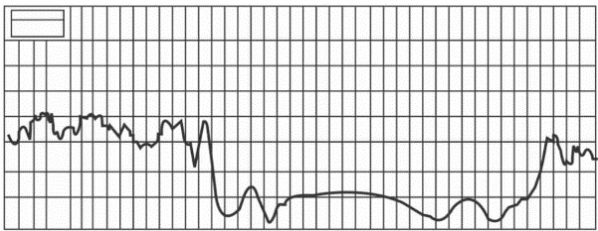

Graph of signal level against time for September 03, 2015
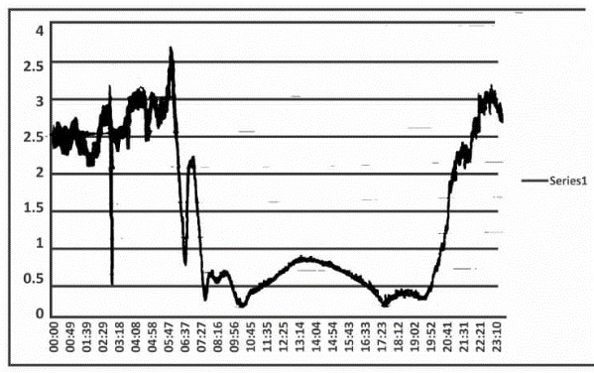

4.2 Analysis of the data
Eexamining the magnitude and duration of signal perturbations using graphs generated from SID Monitor. During the night the receiver was not able to capture SID events from solar flares that is present in E- layer, from the graph between 6am – 8am local time, the strength of the SID begin to drop but there were no record for the time of the day 7am, there is transition between D and E layer, due to the effect of the sun on the ionosphere.

Graph of signal level against time for September 07, 2021
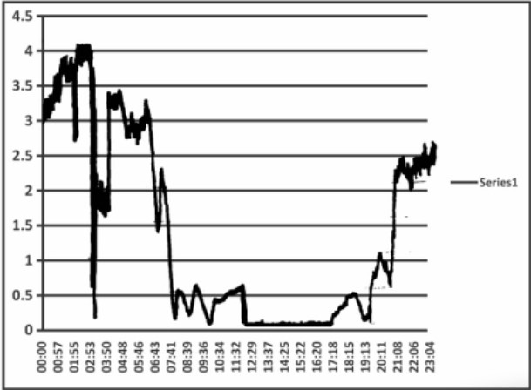

During the night the receiver was not able to capture SID events from solar flares that is present in E- layer, from the graph between 7:40am – 5:20pm local time, the strength of the SID begin drop and there were no record for the time of the day between those interval, the transition between D and E layer, occurs due to the effect of the sun on the ionosphere.

CHAPTER FIVE: CONCLUSION
Understanding the specific impacts of solar flares on the D and E layers of the ionosphere remains a critical gap in ionospheric research. By investigating the nature and intensity of Sudden Ionospheric Disturbances (SIDs) using VLF signal perturbations, in this study it was recorded that around between 7am (3 September, 2021) to 5pm (7 September, 2021) for the days used in this research comes a drop of intensity of solar flares in the low ionosphere which addresses the need for detailed characterization of lower ionospheric responses to solar flare activity. The findings shows that sunrise and sunset drastically change the signal strength of VLF radio waves because of the dramatic variation in the ionizing power of the ionosphere as this can be shown from the graph of the signal level against time and are expected to contribute to improved space weather prediction models and enhance the reliability of radio communication and navigation systems during solar events.

REFERENCES
Adeniyi J.O, inaugural lecture subduing the earth ionosphere inclusive university press university of Ilorin Nigeria 2008
Alen Amelia, G3NYK, Steve Nicholas, GOKYA RSGB propagation studies committee. Pg 32 @(www.)2009
B.A. Ezekiel, ph.D. and R.M. Obodo, M.Sc. Volume 8. Number 1. (Spring) The Effects of
Solar Radiations on Telecommunications, Department of Physics and Astronomy, University of Nigeria, Nsukka 2007
Halliday, Resnick, Walker fundamental of physics sixth edition Sanat printers kindli, Haryana ISBN81-256-6823-x 2006 5. 1996. Ian Poole, G3YWX Nov., QST @ ARPL
J.K Hargreaves The uppper atmosphere and solar terrestrial relation department of environmental sciences university of Lancaster ,van nostrino Reinhold company isbn 0-442-30215-1 190
Lionel John D. Fix Mosby Astronomy journey to cosmic frontier year book Inc united state of America page 375-376ISBN0.08016-7449-21995.
Louder. (2011) List of VLF www.sidstation.loudet.org/stations-listen.xhtmlsid.monitorstation
McRae, W. M., & Thomson, N. R. (2004). Solar flare induced ionospheric D-region enhancements from VLF phase and amplitude observations. Journal of Atmospheric and Solar-Terrestrial Physics, 66(1), 77–87. https://doi.org/10.1016/j.jastp.2003.09.009
Mead way Staines TWI82PW United Kingdom. J.K Hargreaves The uppper atmosphere and
solar terrestrial relation department of environmental sciences university of Lancaster ,van nostrino Reinhold company isbn 0-442-30215-1 1901

Mitra, A. P. (1974). Ionospheric Effects of Solar Flares. Springer.
Rawer, K. (1993). Wave Propagation in the Ionosphere. Springer-Verlag.
Stations @ SID user antenna Manual developed by Ray Mitchell, Deborah Scherrer, and
Shannon Lee@ SID@sun.Stanford.edu. 2007
Sun’s energy @http://www-istp.gsfc.nasa.gov/stargaze/Sun7enrg.htm
The sun@ http://slat system.nasa.gov/planets/profile.com? Object-Sun & Display-overview
Long The Sun “World Book Multimedia Encyclopedia. Chicago: World Book Iine. 199
Thomson, N. R., & Clilverd, M. A. (2001). Solar flare induced ionospheric D-region enhancements from VLF amplitude observations. Journal of Atmospheric and SolarTerrestrial Physics, 63(16), 1729–1737. https://doi.org/10.1016/S13646826(01)00042-6.

