THE ROLE OF MASS MEDIA IN FIGHT AGAINST RELIGIONS CRISES IN NIGERIA

BY
OLOYIN RODIYAH AJOKE

ND/23/MAC/PT/0250

BEING A RESEACH PROJECT SUBMITTED TO THE DEPARTMENT OF MASS COMMUNICATION, INSTITUTE OF INFORMATION AND COMMUNICATION TECHNOLOGY, KWARA STATE POLYTECHNIC, ILORIN.

IN PARTIAL FULFILLMENT OF THE REQUIREMENTS FOR THE AWARD OF NATIONAL DIPLOMA (ND) IN MASS COMMUNICATION

JULY, 2025

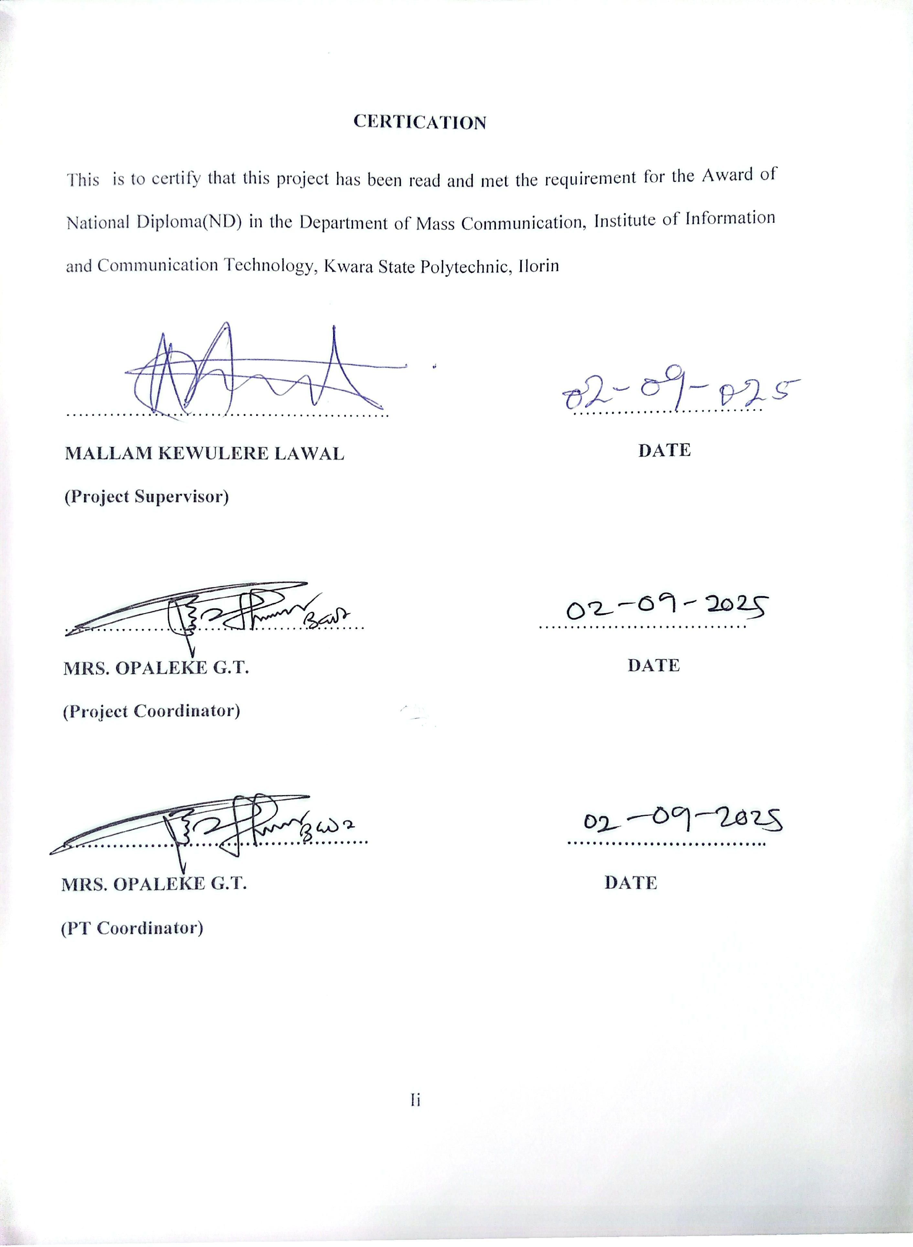CERTIFICATION
This is to certify that this research work has been read and approved by DEPARTMENT OF MASS COMMUNICATION, KWARA STATE POLYTECHNIC, ILORIN as having satisfied part of the requirement for the award of National Diploma (ND) in Mass Communication.

________________________ __________________
MALLAM LAWAL KEWULÈRE. DATE
(Project supervisor)

________________________ __________________
MR. OLUFADI B. A DATE
(Project coordinator)

________________________ __________________
MR. OLOHUNGBEBE F.T. DATE
(Head of Department)
DEDICATION
I dedicate this project to God Almighty, the source of Wisdom knowledge, and understanding.
This project is a testament to your faithfulness and your goodness. May it be a reflection of your glory and a tribute to your greatness
ACKNOWLEDGMENTS
All praises, adoration and glorification are due to Almighty God the most gracious, the most beneficent, the most merciful
Thanks to our parents that make this ND programme a successful one through their prayers and encouragement, may Almighty God bless them abundantly.
We give glory to Almighty God, who has given us the knowledge, wisdom and understanding, and has made it possible for us to complete our ND programme in this Institution, Kwara State Polytechnic, Ilorin.
We express our sincere gratitude to our supervisor MALLAM LAWAL KEWULERE for his understanding despite his busy and tight official schedule he found this research work worthy of supervision.
I appreciate the effort of my amiable MRS. OPALEKE G.T for their great support towards this programme.
We appreciate the effort of our amiable project coordinator MRS. OPALEKE G.T and other lecturers in the Department of Mass Communication for their great support towards this programme.

TABLE OF CONTENT
CHAPTER ONE: INTRODUCTION
1.1 Background to the study 1-2
1.2 Statement of the problem 2
1.3 Justification 3
1.4 Research objectives 3
1.5 Research Questions 3
1.6 Significant of study 3
1.7 Scope of the study 4
1.8 Limitation of the study 4
1.9 Definition of Terms 4
CHAPTER TWO: REVIEW OF LITERATURE
2.1 Introduction 5
2.2 Theoretical framework 5-7
2.3 Conceptual framework 7-14
2.4 Empirical Review 15-16
2.5 Appraisal of the review 16
CHAPTER THREE: RESEARCH METHODOLOGY
3.1 Introduction 17
3.2 Research Design 17
3.3 Target population 17
3.4 Research sample size 18
3.5 Data collection method 18-19
3.6 Instrument Reliability 19-20
3.7 The validity of the Instrument 20
3.8 Data Analysis 20
CHAPTER FOUR: DATA PRESENTATION ANALYSIS AND INTERPRETATIONS
4.1 Introduction 21-23
4.2 Causes of religious crisis in Nigeria 23-29
4.3 Discussion of Findings. 29
CHAPTER FIVE: SUMMARY, CONCLUSION AND RECOMMENDATION
5.1 Summary 30
5.2 Conclusion 30
5.3 Recommendation 31

CHAPTER ONE
1.1 Background to the Study
Almost in all societies of the world, religion has become a key index that catapults the socio-economic, cultural and political structures either for good or for bad. Like any multi-cultural society, Nigeria has a number of religious movements and practices viz: Islam, Christianity and indigenous religion. Before the intrusion of the colonial masters into the hitherto peaceful Nigeria, our ancestors were staunch adherents of the African Traditional Religion (ATR). The ATR was a system of belief and worship that was totally devoid of acrimony, hate and conflicts. It was in consonance with the above stated that Fagan (1994) averred that a stable society is that which prizes highly the value of religion.For administrative convenience, Fredrick Lugard conceived a merger of northern and southern protectorates. In 1914, an entity called Nigeria emerged, bringing about 250 ethnic groupings together into one political and administrative entity. Today ironically, the merger became a bane of peace, progress and stability of the Nigerian nation.
Although Nigeria has witnessed some pockets of religious conflicts over the years, it assumed an alarming proportion when Nigeria assumed democratic ideals in 1999. As a multi-ethnic and religious entity, Christians and Moslems (the two major religions in Nigeria) have over the years tried to outwit each other in terms of belief, adherence, structure and growth viz-a-viz the Nigerian nation. Consequently, a dimension of fanaticism was introduced into the religious practice. Unfortunately, the so-called religion has become a source of strife, anarchy and bloodletting in Nigeria in recent time. Today, there is a sharp deviation from the core values of religion, occasioned by the alarming nature of religious crisis in Nigeria, leading to destruction of lives and properties. Rather than entrench peace, unity and stability, religion has somewhat threatened the whole essence of Nigeria's nationhood. Religious dichotomy in Nigeria has been much pronounced in the largely Moslem dominated north. In 1985, there was

Moslem Christian conflict in Gombe and Bauchi States; Religious riot in Kaduna. Kaduna State between the Christians and Moslems and in 2020, Bauchi riots disrupted the National Sports Festival holding in Bauchi State then. It was the realism of these religious conflicts in Nigeria that prompted former military dictator. Gen. Babangida to describe one of such religious riots as "civilian equivalent of coup" in a national broadcast. The quest to entrench Islamic faith led to the enforcement of Sharia legal code in Zamfara. Bauchi, Sokoto and Kaduna States. This singular factor further worsened the already strained relationship between the two dominant faiths in Nigeria.
1.2 Statement of the Problem
The fact that religious differences produce hatred and intolerance is never in doubt. Over the years, religious crises have been a reoccurring decimal and every effort to promote unity, peace and progress in a multi-ethnic and religious society like Nigeria has defied all known solutions. One important function of the Press in any society is that of correlation, where media coverage ought to be streamlined for uniting divided ends, but this sectas to not have been the case in Nigeria. Besides there are allegations from various quarters that the media (especially the print) have been sensational and biased the repertage of religious crises in the country.
Various religious crises in the past were actually reported by the news media particularly the print media. Be that as it may, the growth of the Nigerian media, as well as their coverage of religious crises may not have yielded desired ends after all over the years, particularly between 2020 and 2011 when religious crisis attained its peak in Nigeria. There seems to be this theory that connects religious crises with media coverage, but the link remains undefined in past studies. The pattern of media coverage and the extent to which the news media (newspapers in particular) have helped in curtailing religious crises in Nigeria are problematic arcas in socio-communication research, which prompted this study in the first instance. Therefore, the researcher sets out to find the roles of the mass media in the fight against religious crisis a case study of Ilorin west Local Government Area of Kwara State Nigeria.

1.3 Justification
The study of this nature is justified due to the fact that the study will contribuic and reduce crisis among religious in Nigeria through social media.
1.4 Research Objectives
The general objective or main objective of this study is to investigate the roles of the mass media in the fight against religious crisis a case study of Ilorin west Local Government Area of Kwara State. Nigeria. The specific objectives are:
i) To determine the causes of religious crisis in Nigeria
ii) To identify the benefits of media reportage to the society
iii) To examine the media challenges of crisis reportage
1.5 Research Questions
The following are some of the questions which this study intends to answer:
i) What are the causes of religious crisis in Nigeria?
ii) What are the benefits of media reportage to the society?
iii) What are the challenges facing media reportage on religious crisis in Nigeria?
1.6 Significance of the Study
This research will set the tone for the media to embrace national integration and religious tolerance as the core functions of the modern day Nigerian media. Through this investigation. Therefore, both the print and broadcast media in Nigeria will understand their shortcomings and subsequently drive a synergy aimed at curtailing religious crises in Nigeria. The result of this research will entrench professionalism in the coverage of religious-related conflicts in the future. Also, this research will significantly bring to the fore the media/religious crises theory, by defining the extent to which media reports could fuck or exacerbate religious crises in Nigeria. Therefore, the study will strive to unbundle the theory for other scholars to replicate or possibly refute. More importantly this research will contribute significantly to literature that will be useful to communication teachers, social workers, scholars and researchers in various fields of learning, particularly those embarking on similar studies in the future.
1.7 Scope of the Study
This research will cover newspapers coverage of religious crises and the consequential effects of such crisis in the socio-economic and political fortunes of Nigeria. It involves a critical and evaluative analysis of religious crises in Nigeria as well as newspapers coverage of same, particularly as it concerns direction of reports, balance use of pictorial illustrations, space allotment and prominence of coverage within the study period.
1.8 Limitation of the Study
The inappropriate and careless storage of newspapers, magazines and journals in libraries in Nigeria is a major undoing of this research work. The ability of the rescarcher to assemble all the publications is not only arduous but tasking. These were setbacks the researcher encountered in the course of this research.
1.9 Definition of Terms
The following terms were used in the course of this study:
Crisis: Francis (2006) defines crisis as the pursuit of incompatible interest and goals by different groups. In this research, it is a crisis of belief system and faith of Christian and Islamic religion, as well as Christian and traditional religious differences.
Media: Newspaper organizations in Nigeria that engage in daily publication of ace, in the context of this research, Daily Trust, The Guardian, The Sun and The Nation newspapers were chosen because they are national in their publication, daily and privately owned.
Media Coverage: Newspaper report of events published daily.
Religious Crises: A biind and fixated mental and psychological negative attitude towards religious beliefs and practices that are contrary to ones cherished beliefs and practices (Ekwunife 1992).

CHAPTER TWO
REVIEW OF LITERATURE
2.1 INTRODUCTION
Our focus in this chapter is to critically examine relevant literatures that would assist in explaining the research problem and furthermore recognize the efforts of scholars who had previously contributed immensely to similar research. The chapter intends to deepen the understanding of the study and close the perceived gaps.
Precisely, the chapter will be considered in three sub-headings:
- Theoretical Framework
- Conceptual Framework
- Empirical Review
- Appraisal of the Review
2.2 THEORITICAL FRAMEWORK
2.2.1 Social Responsibility Theory
This study will be looked at from the social responsibility theory of the press which clearly states the responsibility the media owes any society within which it operates the origin of the theory is traced to the Hutchins Commission on freedom of the press, set up in the United States of America in 1947 to reconsider the idea of press freedom as propounded by the Libertarian Theorists. The social responsibility theory can be summarily defined as the free flow of information with a sense of responsibility. This imple that the media is free to report all sorts of information as far as it is for public good but the media must ensure that the information given out is done with utmo responsibility.
Domick (2000, P.401) stated that the press has the right to criticize government and other institutions, but has the responsibility to preserve the peace, unity and democracy of any society by properly informing and educating the people and by responding to society's needs and interests. The theory equally explains in a deep way the assigned consutational

watch dogging role of the media. This role empowers the media to monitor the activities of those in government like the Executive, Legislature and Judiciary to ensure goed governance and welfare of the society. Moreover, the theory with regard to the research topic posits that the broadcast media (the press) must take active part in governance to ensure peace, progress development and national integration. The media must ensure that the democratic principles of a nation and rule of law are upheld without deviance by individuals or group(s) irrespective of social status, tribe or religion. According to Mocmeka (2020. P.26) the social responsibility theory postulates and shows the evaluative role the broadcast media should play in this crusading programme and messages against ethno-religious crisis in Nigeria.
2.2.2 Self-Determination Theory
The self-determination theory covers the spectrum of motivation, distinguishing between external and internal stimuli. Following the basic tenets of the Self-determination theory there are few fundamental psychological needs inherent to human beings. Such is the need for autonomy, competence and relatedness, and individuals often engage in behaviours that facilitate the fulfilment of elementary needs based on diverse motivations.
2.2.3 Cognitive Evaluation Theory
Cognitive Evaluation Theory (CET), another branch of Self-determination theory, posits internal and external events influence intrinsic and extrinsic motivation (Deci & Ryan, 1990). A dichotomy was often posed concerning intrinsic and extrinsic motivation. The former supports the exercise of the behaviour's inherent satisfaction derived from engaging in it or the supreme value one appraises to such behaviour. Extrinsic motivation guides the behaviour with the expectation of external rewards, and incentives are always reducible to innate needs. In the context of disease prevention, extrinsic motivation may be due to one's drive to feel competent while dealing with the environment, and people may also be motivated to comply with the norm in order to meet their need for social support and social networking or to avoid guilt, dangerous consequences and community

judgement. Extrinsically motivated persons often exert behaviour because they were coerced or directed to do so. When externally regulated, one's behaviour is compulsory and not self-determined insofar, it is subjected to external requirements and norms. Contrary, introjection is another type of regulation, and it indicates that external requirements are internalized, meaning the behaviour is partially intentional. When a behaviour is introjected, internalization of external pressure is applied to the person through sanctions and self-discipline. On the other hand, identification driven behaviour is regarded as self-determined as the individual considers the outcomes extremely valuable. On the other end of the spectrum, integrated regulation means that required behavioural outcome is entirely correspondent to individual's sense of self. making the behaviour fully autonomous, and thus the fundamental need for autonomy is fulfilled.
2.3 CONCEPTUAL FRAMEWORK
2.2.1 RELIGION
Religion is a cultural phenomenon, and it has played a dominant role in the socio political organization of man throughout history. Nigeria is a country that is culturally diverse and has a number of religious groups which includes; Christianity, Islam and Traditional religion. In a diverse environment such as Nigeria, religion has become very significant, as Christians and Muslims who mainly dominate the environment are strong about their beliefs and therefore passionately act and exercise such belief system care freely. Okebukola (2012), affirms that religion is, without doubt, a potent force to achieve political stability in the land, considering the role it can play in bringing about development in the light of corruption that pervades society. This is probably because according to Anyanwu (2010), religion is human interaction with the supernatural in order to cope with life crises. However, the process of using religion in coping with life issues has become detrimental to the world at large. Religious crises has led to loss of lives and properties population displacement, instability in government underdevelopment, and distortion in national unity, fear and lack of trust. Furthermore,

the causes of religious crises can also be identified as lack of recognition: which exists when a religion do not have regard for the other, which breeds hatred and blackmail and a lack of understanding (Omotosho, 2012). Religion is often depicted as a contributing factor in many conflicts and a tool to mobilize people during conflicts (Tjaart 2012) especially with political conflict (Okoric, Loto. & Omojola, 2018). Nigeria has experienced religious crises and it is most times between Christians and Muslims (the two major religions in Nigeria). Disagreements between these two dominant religions crupts because the religions désire to have dominant recognition of their beliefs, structure and culture in Nigeria. This has been the basis for religious crises in Nigeria since 2020. Some of these crises includes; the Kano revolt in 1980, the Bulunktu Bisarre in 1982 the Kastina crises in 2020, the Zamfara conflict, Kaduna revolt, Bauchi crises and Sokoto 2020. Recent examples are the Jos crises and the current conflict by Boko Haram against Christians and Muslims which officially started in 2002.
2.3.2 RELIGIOUS CRISIS IN NIGERIA
Between 2011 and 2024, numerous religious conflicts, resulting in the death of tens of thousands of persons destruction of Churches and Mosques and property worth millions of dollars, have been documented in Nigeria (Gofwen, 2022, Minchakpu. 2006. Nwaomah. 2010: ). The most recent of these conflicts are the post-clections conflicts and with possible group terrorist attacks that have been traced to the Boko Haram, an Islamic links with other terrorist groups outside Nigeria. These conflicts and attacks have largely occurred in northern Nigeria and they have been attributed to many causes. Though these conflicts are religious in nature, other factors which are non- religion have also been identified as contributory or even fundamental to the crisis. The myriad of causes-remote and immediatecould be summed into (i) religious, (ii) socio-political, and (iii) economic. Religion is a poignant issue in Nigeria, possibly because of the fundamental quest for dominance between the Northern and Southern parts that for contingent historical reasons are dominated by Islam and Christianity, respectively. There is also the incessant protest of marginalization by the Northern minorities who profess Christianity in contrast to the
Hausa/Fulanis who are largely Muslims and hold political dominance. The Boko Haram crises, though seen by some as a reaction to the failure of political leadership nonetheless, has deep religious overtone (Nwaomah, 2010). Acknowledging the significance of religion in the Nigerian conflicts, Ndukwe, according to Boer (2022b) stresses that one cannot talk about the political situation in Nigeria without relating it to religion. Every political programme or event always has a religious overtone. Passion for religion also affects the economic climate of Nigeria. However, while to analyst the significance of religion in Nigerian politics is unquestionable, the political leaders prefer to deny the religious connotations of these crises. For instance, reacting to the riots of 2021, Kukah (1993) observes that President Ibrahim B. Babangida denied the religious basis of the riots arguing that the trails of destructions of lives and property in Kaduna. Zaria, Katsina and Funtua and other places in Kaduna State were politically motivated. Further, Babaginda as cited in Kukah (1993) note was quoted to have said the riots were carefully planned and masterminded by
evil men who saw the incident in Kafanchan as an opportunity to subvert the Federal Military Government and the Nigerian nation. Similarly, Binta Faruk Jalingo, a Muslim women leader argued "I want the common man to know that their leaders want to use them for their selfish interests in the cover of religion. A lot of these leaders are only using religion to make money and to enrich themselves...." (cited in Boer, 2022a:72). Further, in the 2000 Kaduna riots that followed the introduction of the Sharia law in the Northern States of Adamawa. Bauchi, Borno. Jigawa, Kaduna. Kano, Katsina, Kebbi, Sokoto and Zamfara authorities insisted that the Kaduna crisis was beyond religion. It is not religion. It is politics (Awowede, 2000 citing Boer 2022a:92). But Kenny argues that religion in the politics of 1970 onwards was basically a tool which the politicians used for secular interests (citing Muslim Christian Relations in Nigeria 2019). This might be because of the regional dominance of the two major religions in Nigeria Islamic North and Christian South and the gullibility of the masses when greedy
political leaders appeal to threat on their religion as an easy excuse to protect political status. Gofwen (2022) identifies four reasons that inflame the religious bigotry prevalent in Nigeria. These are:
(i) The differing political philosophy of the major religions in Nigeria,
Islam and Christianity.
(ii) The mutual suspicions and fear of domination between the two religions. (iii) Mutual ignorance of the beliefs and teachings of each other's religion and sometimes even of one's own faith.
(iv) Provocative acts of pronouncements which hurt the religious sensibilities of people of other faiths, whether they are intended or inadvertent" (p.74).
These circumstances could lead to misinterpretation of national events and issues. For example, when President Shehu Shagari openly received Pope John Paul 11 in 1982 Muslims such as Kukah (1993)sees such fraternization' as a reason to question the "Muslimness" of President Shagari, claiming that Islam was losing out to Christianity and the President was losing grip of asserting himself as a Muslim leader. On the background of mutual ignorance and misinterpretation, adherents of either religious group have tended to assert themselves or even to react violently when they felt their religion was threatened or its heritage was being ridiculed. Thus, violent conflicts in which lives were lost and property was destroyed were caused by acts like the misquotation/interpretation of the Quran or the Bible, the construction of a church or mosque, religious assemblies, inciting statements and/or publications and even the protest against alleged prosecutions of religious fellow members in other countries.
2.3.3 THE EFFECTS OF RELIGIOUS CONFLICTS/CRISES
The resultant effects of religious conflicts in Nigeria are enormous. It pervades all the sectors of the economy. Generally, conflicts breed insecurity, discrimination, mutual distrust and slow economic and educational development. This is the case in Nigeria where in addition to the gratuitous killings and maiming of thousands of persons properties worth billions of naira have been destroyed. Certainly, these huge losses have
deprived the nation of needed manpower and services for the growth of its wobbling economy. Religious conflicts in Nigeria have also left its effect on investment options in the crises ridden areas. The political instability, arising from the insecurity and uncertainty that pervades the region, does not inspire the confidence of foreign investors and thereby deprives the nation of the economic gains. In some instances, the enterprising Southerners who had established thriving businesses in the troubled areas in the North have relocated to other and safer places. Further, religious conflicts in Nigeria have left in its trail a broken society: communities that hitherto co-existed peacefully now treat cach other with mistrust and latent or open aggression. Consequently, settlement patterns begin to follow the boundaries of religion in these areas so that adherents can be swiftly mobilized in the event of future riots. The disrupted social harmony is sometimes felt in places far from the crisis scene and thus account for the reprisal riots in other parts of Nigeria.
2.3.4 MASS MEDIA
Mass media is a channel, medium, utility, device, or instrument used in the mass communication process. The mass media also includes, printed media, electronic media and Cyber media. Printed media such as newspapers, magazines, books, pamphlets, billboards and other technical tools that bring out the message by touching the senses of sight. Electronic media such as radio and recorded programs use the senses of hearing and television programs, motion picture and video recording covering both senses which is hearing and vision (Ray M. 2019). Meanwhile the online media (online media. cybermedia) is the internet-based mass media. Mass media is happen to be the suggestions for cultural development, not just culture in the sense of art and symbol but also in the sense of the development of settings, fashion, lifestyle and norms (Pate. U. & Abubakar, A. 2013). The Mass Media definitions have therefore been going through dynamic changes on a daily basis. As digital technology develops, mass media, advertising and marketing communications are experiencing new dimensions. Mass
media has been described in different ways depending on the context from which the subject is being perceived. Ruben (1984) cited Ray M. (2019) defined mass media as the communication of behavior-related information. Bozzi, H. (2013), in his own view, sees it as the sharing of ideas and feelings in a mood of mutuality. Other definitions place emphasis on the importance of signs and symbols, as well as the transmission of cultural information, ideas, attitudes, or emotions from one person or a group to another. This branch of mass media involves in some ways the aspects of theater, music, dance, folklore, and other complementary traditional communication media. These definitions tend to capture the general idea of the sociological impact of the media on one hand, and the variances in individual perspectives of the media approach on the other hand. From whatever angle we look at it, these definitions may fit well into specific aspects of human development, from philosophy to psychology, from sociology to education, etc. Media in todays world has been described as a combination of content, comprising the scientific and artistic ensemble of music, film, TV, radio, publishing, advertising, and electronic games (Bazley, T. (2016).
Thus, the mass media is any medium used to transmit mass information. The categorical classifications of what could be termed as mass media forms comprise the eight industries of the mass media industries; books, newspapers, magazines, and recordings, radio, movies, television, and the Internet. Mass media has attained rapid and remarkable expansion resulting in proliferated dynamism over its content, platforms, and devices following technological innovations over a long period of years. These developments have provided some dimensions of influence over various industries and social institutions. One major clement of the media is the nature of its audience, which refers to its relatively large audience. Mass media is any medium which is intended for a large audience (Smith., 2003). It either takes broadcast or print media form. The broadcast form of media is also referred to as electronic media and is peculiar to radio and television technology. Print media, on the other hand, operates in the form of newspapers, magazines, journals and other print media.
2.3.5 MASS MEDIA ALONE VERSUS MASS MEDIA PLUS
There is a tension in the literature and in the field of communication about the effectiveness of mass media alone versus the effectiveness of mass media in combination with other programmatic interventions funders want to know the cost-effectiveness of cach of the program components so that, in the future, they can fund only the most effective components. Methodologically, these are challenging questions to answer because it is difficult to parse out the effects of each program component when several components are implemented simultaneously and each interacts with and depends on the other to generate the overall effect. To try to better understand the effects of distinct program components, randomized controlled trials have been undertaken, but the results effects of have been underwhelming. Perhaps evaluations of the constrained communications campaigns through RCTs inadvertently also constrain exposure and the larger social processes at work during a comprehensive intervention (Hornik, 2002). Program components work very differently in isolation than they do in synergy and it is not evident that a mass media campaign that was effective when implemented simultaneously with the training of service providers and development of interpersonal counseling services would be effective alone (and vice versa). In an intervention with multiple program components, individuals have more opportunities to be exposed repeatedly to parallel messages from various sources. In addition, the program can work through multiple pathways including individual, social, and institutional. The literature suggests that comprehensive interventions that simultaneously address individual beliefs social norms, and environmental constraints are most likely to be successful at changing behavior (Wakefield. Loken, & Hornik, 2010). And yet, the question about the effectiveness of mass media alone is tempting due to considerations of cost-effectiveness and scale. Mass media can reach more people more frequently than many other intervention components and is relatively more cost-effective to bring to scale. Changing policy, training health professionals, delivering interpersonal counseling, and developing or revitalizing services are slow and expensive processes that are difficult to scale.
In response to this tension teams of interventionists and scientists at Development Media International (DMI) and the London School of Hygiene and Tropical Medicine are
tackling the question "Can mass media interventions reduce child mortality?" through a five year clusterrandomized controlled trial of a high intensity radio and television campaign addressing multiple life-saving behaviors in Burkina Faso (Head et al., 2015). Using the Lives Saved Tool (LIST), they predict that DMI's Saturation approach (broadcasting messages 6-12 times per day on market-leading radio stations and at least three times per day on market-leading TV stations) could reduce under 5 mortality by between 16% and 23% during the third and subsequent years of a campaign. They add that. if these predictions are correct, mass media campaigns, at $1-10 per disability- adjusted life year (DALY) averted would be among the most cost-effective of all currently available health interventions (the most cost-effective being childhood immunizations at $1-8 per DALY averted)
2.3.6 MEDIA AND RELIGION
The media have come to play an ever more prominent role in social and cultural life since the emergence of the so-called "mass media" in the late nineteenth century. Before that time, even though the media through which social and cultural knowledge were shared (oral transmission, ritual performance, writing, visual representation, and printing) were vital they were more tacit and transparent to the processes they enabled. Today, in a range of social and cultural contexts, the media are foregrounded, even determinative. The mass media emerged as the result of interacting technological and social developments. Mechanized printing, which developed with the industrial revolution and found its way into mass-market communication in Britain in the 1870s, brought about major changes in production, in reception, and in the political economy of media. Mass production allowed media to be financially supported by advertising instead of direct sales of newspapers or magazines. The resultant economic logic saw readers as audiences and sought to maximize their numbers. This coincided with the increasing concentration of populations in urban settings, removed from the social and cultural supports of the village and town. These audiences began to be thought of as "mass" audiences, and the content of media began to reflect more generalized class tastes. A debate has raged ever since over how the resulting relationship between the mass audience and the mass media is to be seen. To some observers, the media ideologically dominate the audience. To
others, the media act as a kind of cultural canvas on which is inscribed the more or less common themes, ideas, and discourses of the culture.
2.4 Empirical Review
Adelabu (2017), study mass media and ethno-religious crisis in Nigeria, the study revealed that. The peace and unity of any given nation determine the economic and political development of such a nation. The situation in Nigeria with regard to ethno- religious crises is alarming. The colonial government boycotted the due course of legitimisation at its formation and this poses serious consequences for its stability and unity at the present time. It is against this backdrop that the need for effective coverage of ethno-religious crisis is inalienable to the mass media. This study will look into the roles of the media and the fight against ethno-religious crisis in Nigeria also find out if the activities of the media have helped to reduce or eliminate ethno-religious crisis in the country. The theory adopted in this study was the social responsibility and with regards to the topic, the theory posits that the media (press) must take active part in governance to ensure peace, progress development and national integration.
In the work of Pauline (2021) The Influence of Media Coverage of Religious Crises in Nigeria: A Case Study of the Mohammed Cartoon Riots. He postulate that, enormous the world over. To say that media reports of religious crises cause serious religious tension around the world is an under-statement. The case of Nigeria is not different. That religion in Nigeria has not only become sensitive in nature, but that it has resulted to violent crises leading to huge destruction of lives and properties is not in doubt. This is seen in the series of religious crises that engulf the country in the past three decades. This paper explores the role of media in covering religious conflict in the country. The paper focuses on the Mohammed Cartoon Riots in Nigeria. (http://www.bbc.co.uk/news). It also explores people’s opinion on media reports of religious conflict in Nigeria. The question is what role the media coverage of religious crises, plays in calming or igniting religious tension in Nigeria. What are people's attitudes on hearing reports of religious restiveness over the media? How has the media helped in curbing religious tension in the country? To achieve this, the author makes use of materials published from different media houses like the radio, television, national dailies, and publication from other authors who have
written on similar issues. The outcome of the findings will be disseminated to the public for the benefit of the media institutions, (both government and privately owned media houses), journalists, the government and individuals.
2.5 Appraisal of the Review
The knowledge gap hypothesis explains that knowledge like other forms of wealth is often differentially distributed throughout a social system. Research gap are those areas in the literature review where there are loopholes which need to be filled. Some of the crises were not correctly reported as to how they started and who the starters of these crises were. (Kukah, 1993). Others still are religious publications that are provocative or bias or both, from both sides. There are also cases of Christians being denied accesses to electronic media in the northern part of Nigeria the comment of the former Ambassador Jolly Tanko Yusuf: Christians have been denied accesses to electronic media in 16 northern states, while Islam monopolizes 24 hours for its broadcast in the same area. Agents compound themisery by using the media to heap insults on Christians. Every hour the Muslims broadcast provocative statements on chritianity means nothing. they proclaimthat people go to church on Sundays only to dance and to listen to songs authorities merely wink (Yusuf, 2020) Although the Muslims were reluctant in using the electronic media at the initial stage for fear of western influence they later saw the need for mediating the religion. Sheik Abubakar Gumi was one of the first Nigerian Muslim to recognize the potency of mass media, the print media has been manipulated by both sides. One is bound to accept the fact that both Christians and Muslims have produced sensitive materials over the years. The hot debate on OIC and plans for Nigeria to join the Islamic Economic Group tagged the D-8 in the newspapers. (Danmole. 2020)

CHAPTER THREE
RESEARCH METHODOLOGY
3.1 Introduction
This chapter describes how the research was carried out based on subject matters "The roles of the mass media in the fight against religious crisis in Nigeria". It focuses on methods and techniques used to conduct the study. It looks at the research design, the population, sample and sampling techniques, data collection procedure, the procedure for analyzing the data collected and limitations to the data collection. For the research design the researcher adopted the case study. The population was made up of social media from most Local Government Area of Kwara State as well as Human resources specialists from a few selected companies, while the simple random sampling was used to get the sample population. The data was collected through questionnaires, interviews and documentary search. The chapter also seeks to justify the reasons why the researcher chose each particular technique.
3.2 Research Design
According to Kumer (2021), research design can be regarded as an arrangement of conditions for collection and analysis of data in a manner that aims to combine relevance with the research purpose. It is the conceptual structure within which research is conducted. The research designs used in this study was both qualitative and quantitative. The study aimed at collecting information from respondents within Ilorin on their attitudes and opinions as to the roles of the mass media in the fight against religious crisis in Nigeria. They returned the filled questionnaires the same day. This process took three months.
3.3 Target Population
According to Ogula (2014. p.14) target, population refers to an entire group of persons or element that have at least one thing in common; it also refers to the larger group from which the sample is taken. The greater the diversity and differences that exist in the population, the larger the researcher's sample should be. Ilorin has a population of 13.643 according to the management between the ages 17-33 who were targeted for this research.
3.4 Research Sample Size
Gatara (2020.p.6) defines sampling as the procedure a researcher uses to gather people, places or things to study. It is a process of selecting a number of individuals or objects from a population such that the selected group contains elements representatives of the characteristics found in the entire group.
Both quantitative and qualitative methods were used in the collection of data. In quantitative, the Data was collected using open and closed ended questionnaires. Based on the Krejcie and Morgan table, the student population of Ilorin was 13.657 thus a base line survey was conducted from interviewing 120 residents from Ilorin west Ilorin cutting across from Form 1 - Form 4 (Krejcic and Morgan, 1970). The Krejcic and Morgan's sample size calculation was based on p 0.05 where the probability of committing type I error is less than 5 % or p<0.05.
s = X² NP (1-P) + d² (N-1) + X²P(1-P)
Where.
s required sample size
X² the table value of chi-square for 1 degree of freedom at the desired confidence level (0.05 3.841).
N the population size
Р the population proportion (assumed to be 0.50 since this would provide
the maximum sample size.
d - the degree of accuracy expressed as proportion (0.05)
3.5 Data Collection Method
The data collection tools used in this research was questionnaire, interviews as well as documentary search. The study made use of both primary and secondary sources of data information from Kam wire industry published records and Human resources and the sampled Kam wire industry social media and management. The primary sources of data included information that was gathered from the questionnaires and interviews that were administered to the respondents. The advantage of using primary data is that, they are more reliable since they come from the original sources and are collected especially for
the purpose of the study. The secondary sources of data included annual reports, brochures and manuals.
3.5.1 The Questionnaire
The researcher aimed to quantify the chosen population's knowledge, attitude and awareness of religion crisis in the workplace, thus the questionnaire method of data collection was used. The researcher used both open ended questions and closed ended questions. The main advantage of open ended questions is that they give room for the respondent to express their views freely. While closed ended questions enabled the researcher to steer and control the responses of the respondents so that the researcher got exact answers to the given questions. The questionnaire was employed as a data collection tool as it enabled the researcher to get diverse views from respondents so that she could get a conclusive result from the study and thus be able to make objective conclusions and recommendations.
However the main challenge of the questionnaire was that some respondents gave glib answers and also answers they thought the researcher wanted to get, thus some of their responses had no substance and were biased.
3.5.2 Documentary search
This tool consists of existing documents that were not collected by the researcher but were utilized by him. The sources included books, magazines, newspapers, records, journal articles, conference papers, reports and websites. Through these documents the researcher managed to ascertain a multiplicity of benefits of religion crisis on social media, as well as theories of measuring impact of religion crisis which enabled the researcher to establish a theoretical framework to carry out the study. The documentary research also availed to the researcher statistics as well as trends of non-monetary incentives.
3.6 Instrument Reliability
The main instruments used were the questionnaires that were administered to the identified target groups. The questionnaire sought to gather information from the identified groups on but not limited to the parameters identified for this survey.
Before embarking on the actual field data collection, a pre-test was carried out in
one of the target companies in order to test and modify the reliability of the tools. This was done to assess its reliability (i.e. consistency and clarity, in terms of yielding the desired data) and the exercise's planned logistics. A pilot study was undertaken on at purpose of least (10) indigene to test the reliability and validity of the questionnaire. The a pilot test was to test the reliability and validity of the questionnaire and enable the researcher to amend the questionnaire as appropriate so as to capture data accurately.
According to Cooper and Schindler (2020), pilot test is conducted to detect weaknesses in design and instrumentation and to provide proxy data for selection of a probability sample. Pilot study is an activity that assists the researcher in determining if there are flaws limitations, or other weaknesses within the interview design and allows him or her to make the necessary revisions prior to the implementation of the study (Kvale. 2019).
3.7 The Validity of the Instrument
According to Rousson et al (2021,) validity is the degree by which the sample of test items represents the content the test is designed to measure. To ensure that valid data is collected, the researcher pilot tested the instrument before the actual field study Adjustments to the research instrument will then be made as necessary.
Reliability refers to the consistency of measurement and is frequently assessed using the test-retest reliability method (Rousson et al. 2021). The pilot study will allow pre testing of the research instrument that will ensure its reliability. Reliability of the questionnaires was evaluated through Cronbach's Alpha which measures the internal consistency. Pretesting of research instruments, member checking (confirming with the respondents the veracity of the fields obtained), recording of interviews (to ensure that all the information is captured) and conferring with the supervisor further ensured the reliability and validity of the results obtained.
3.8 Data Analysis
The data was sorted, coded and recorded in MS-Excel computer package and transferred to SPSS version 21.0 for further analysis. The study generated a substantial body of data rigorously collected and compared on students' access, the roles of the mass media in the fight against religious crisis in Nigeria.
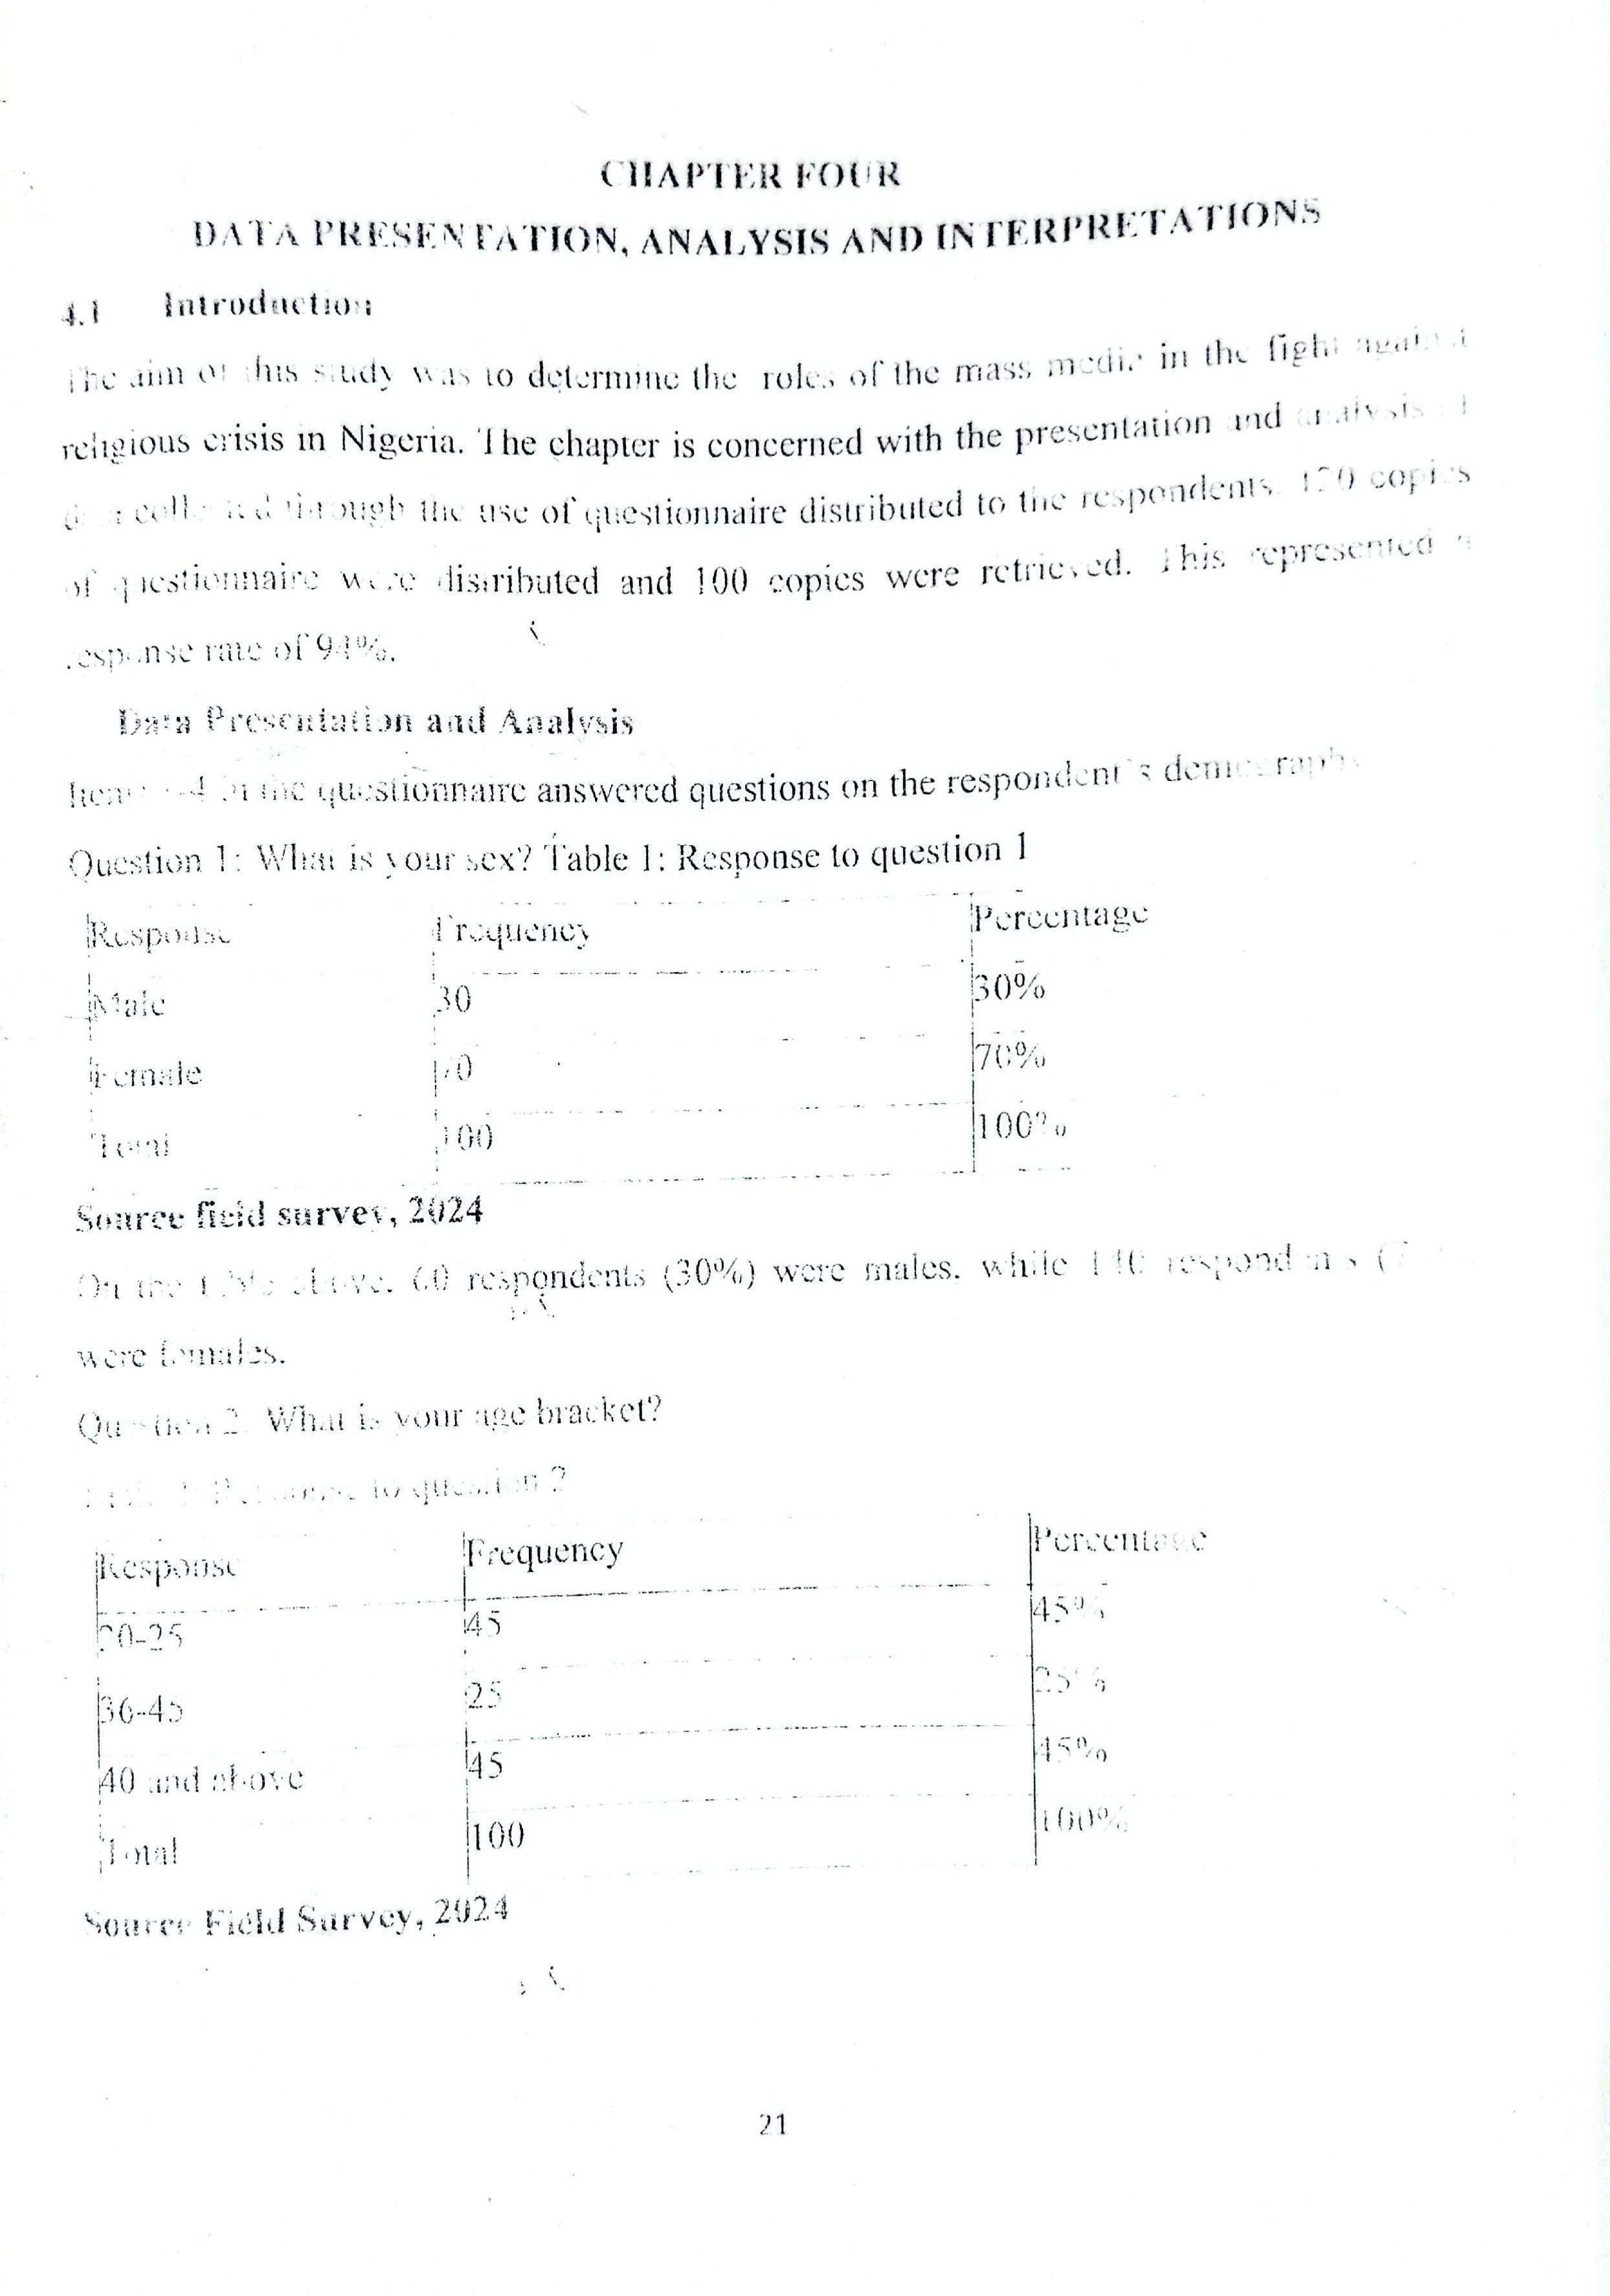
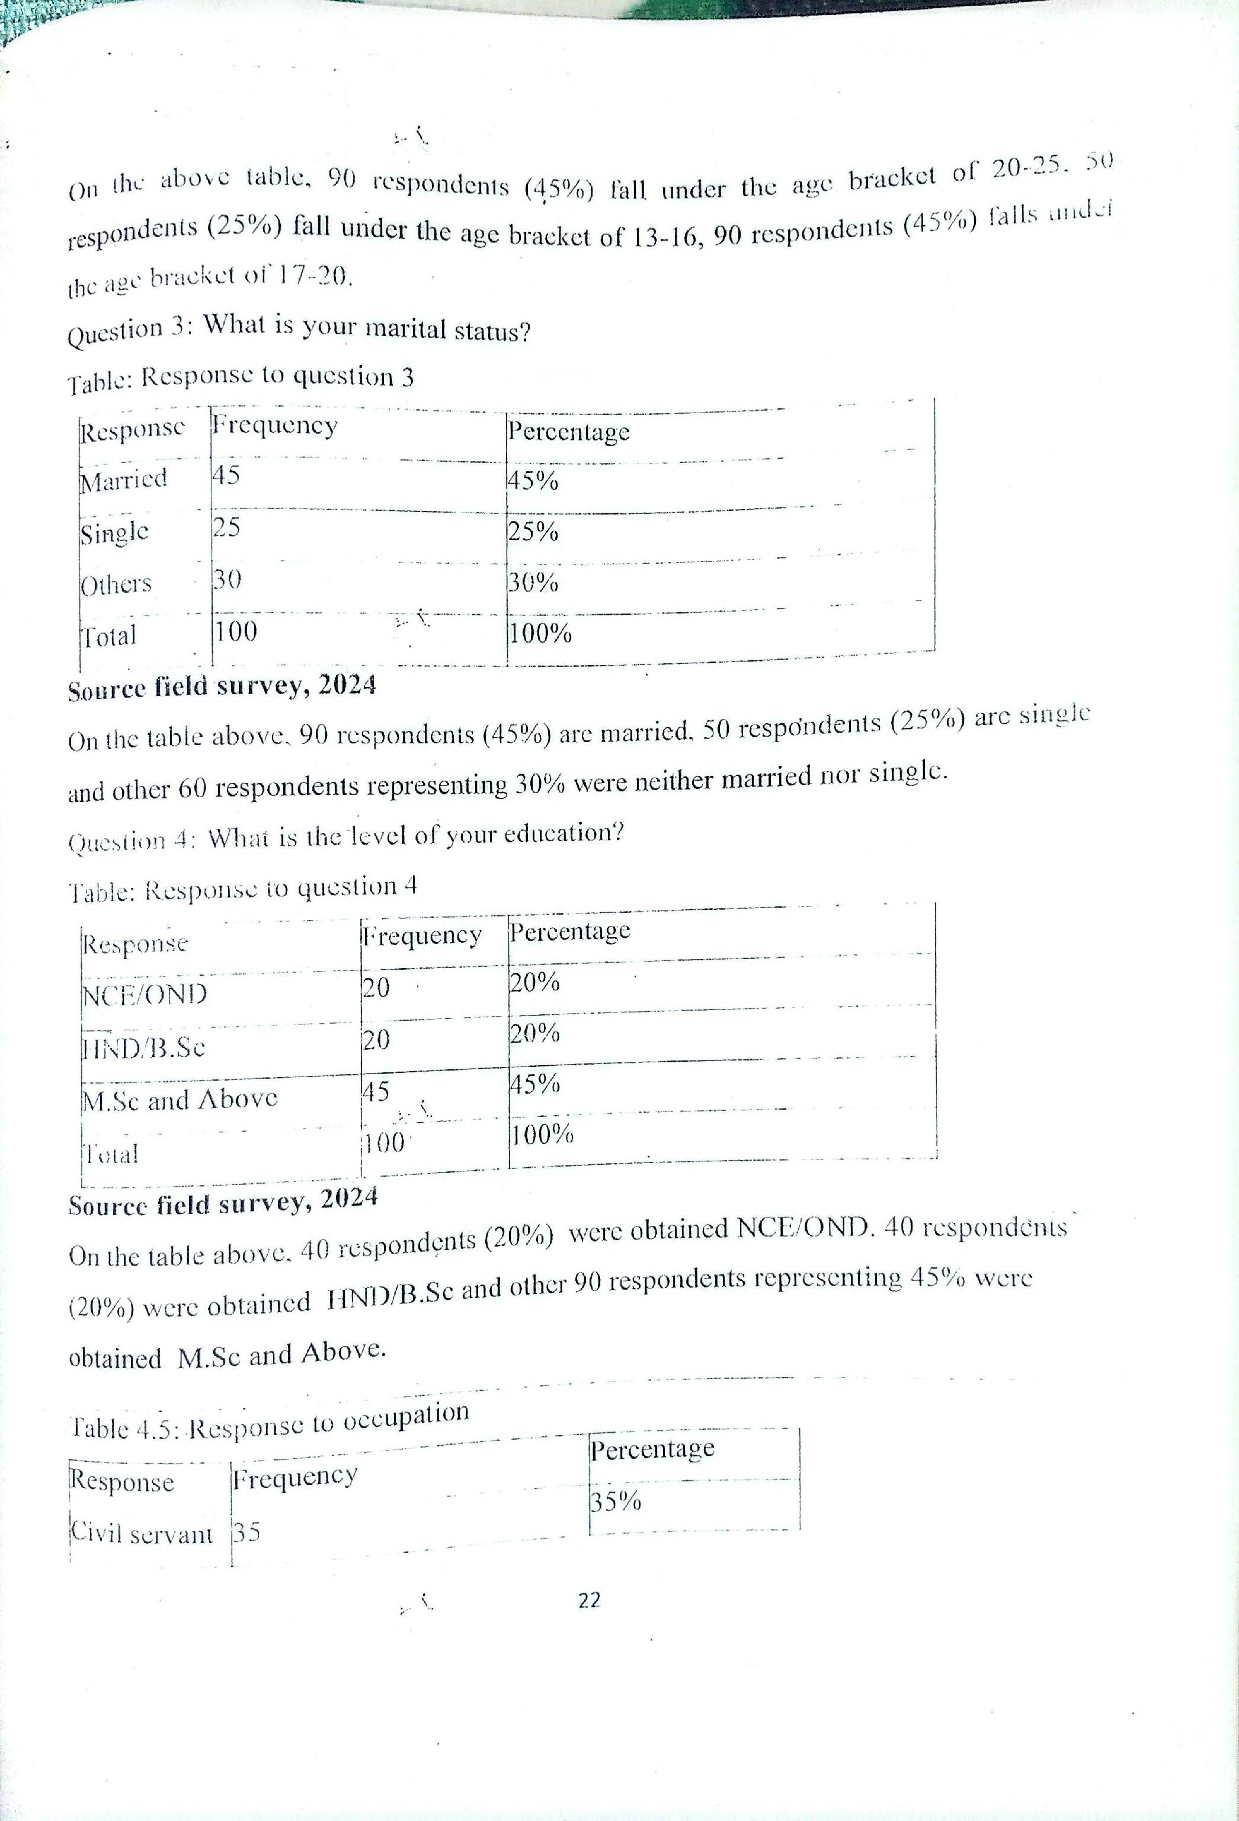
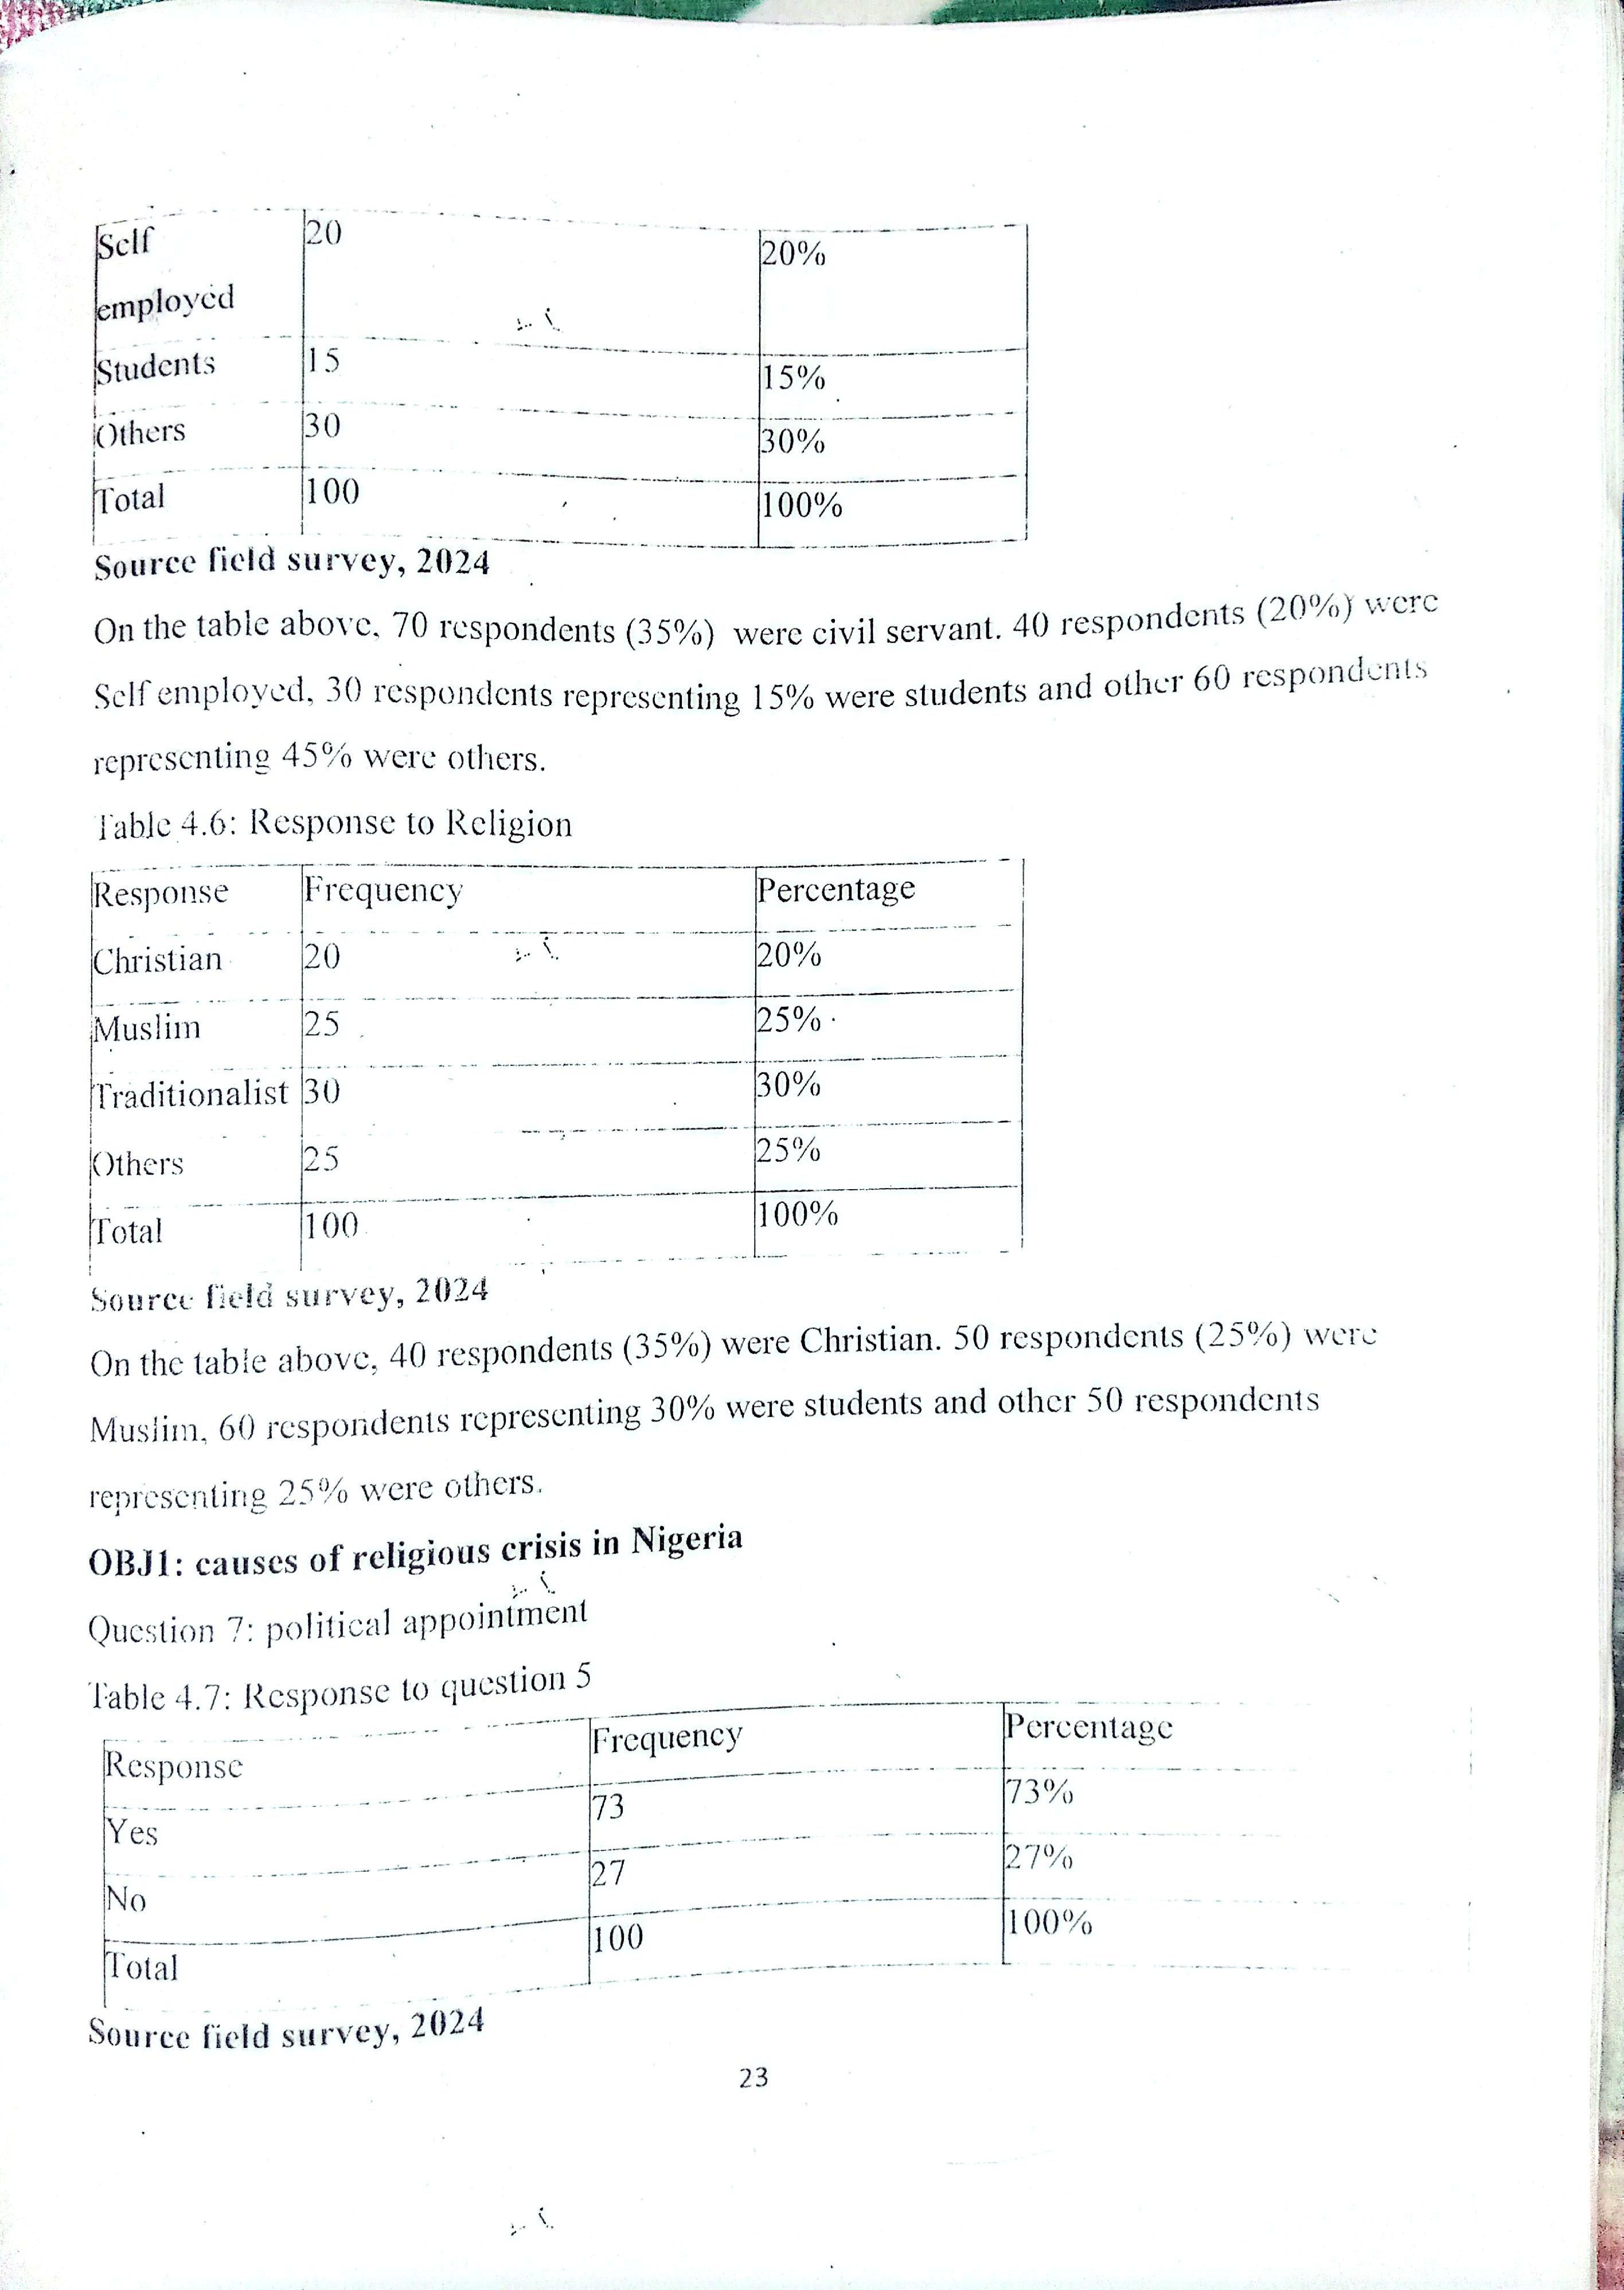
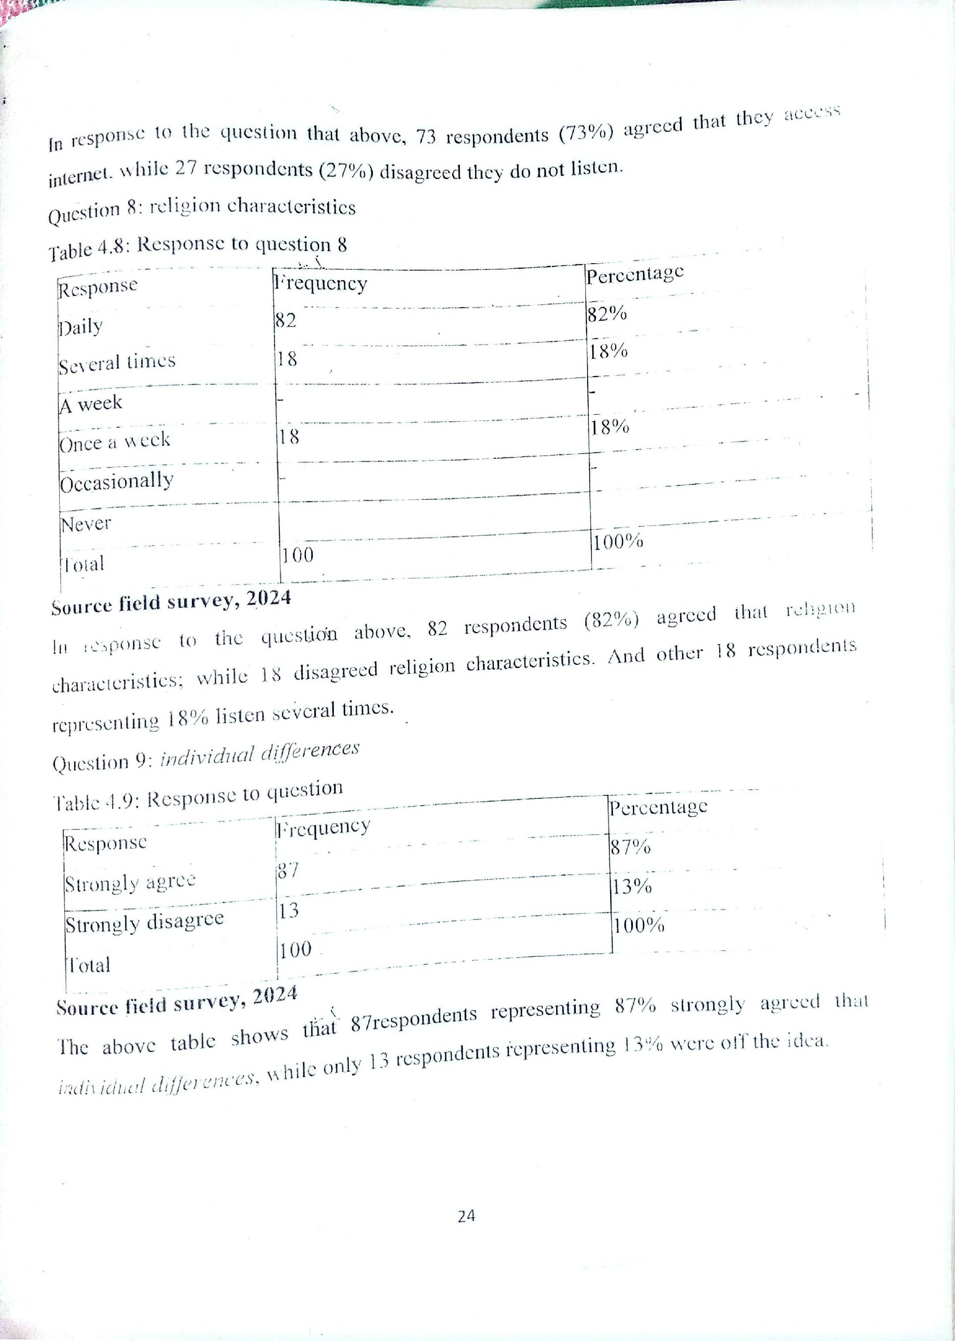
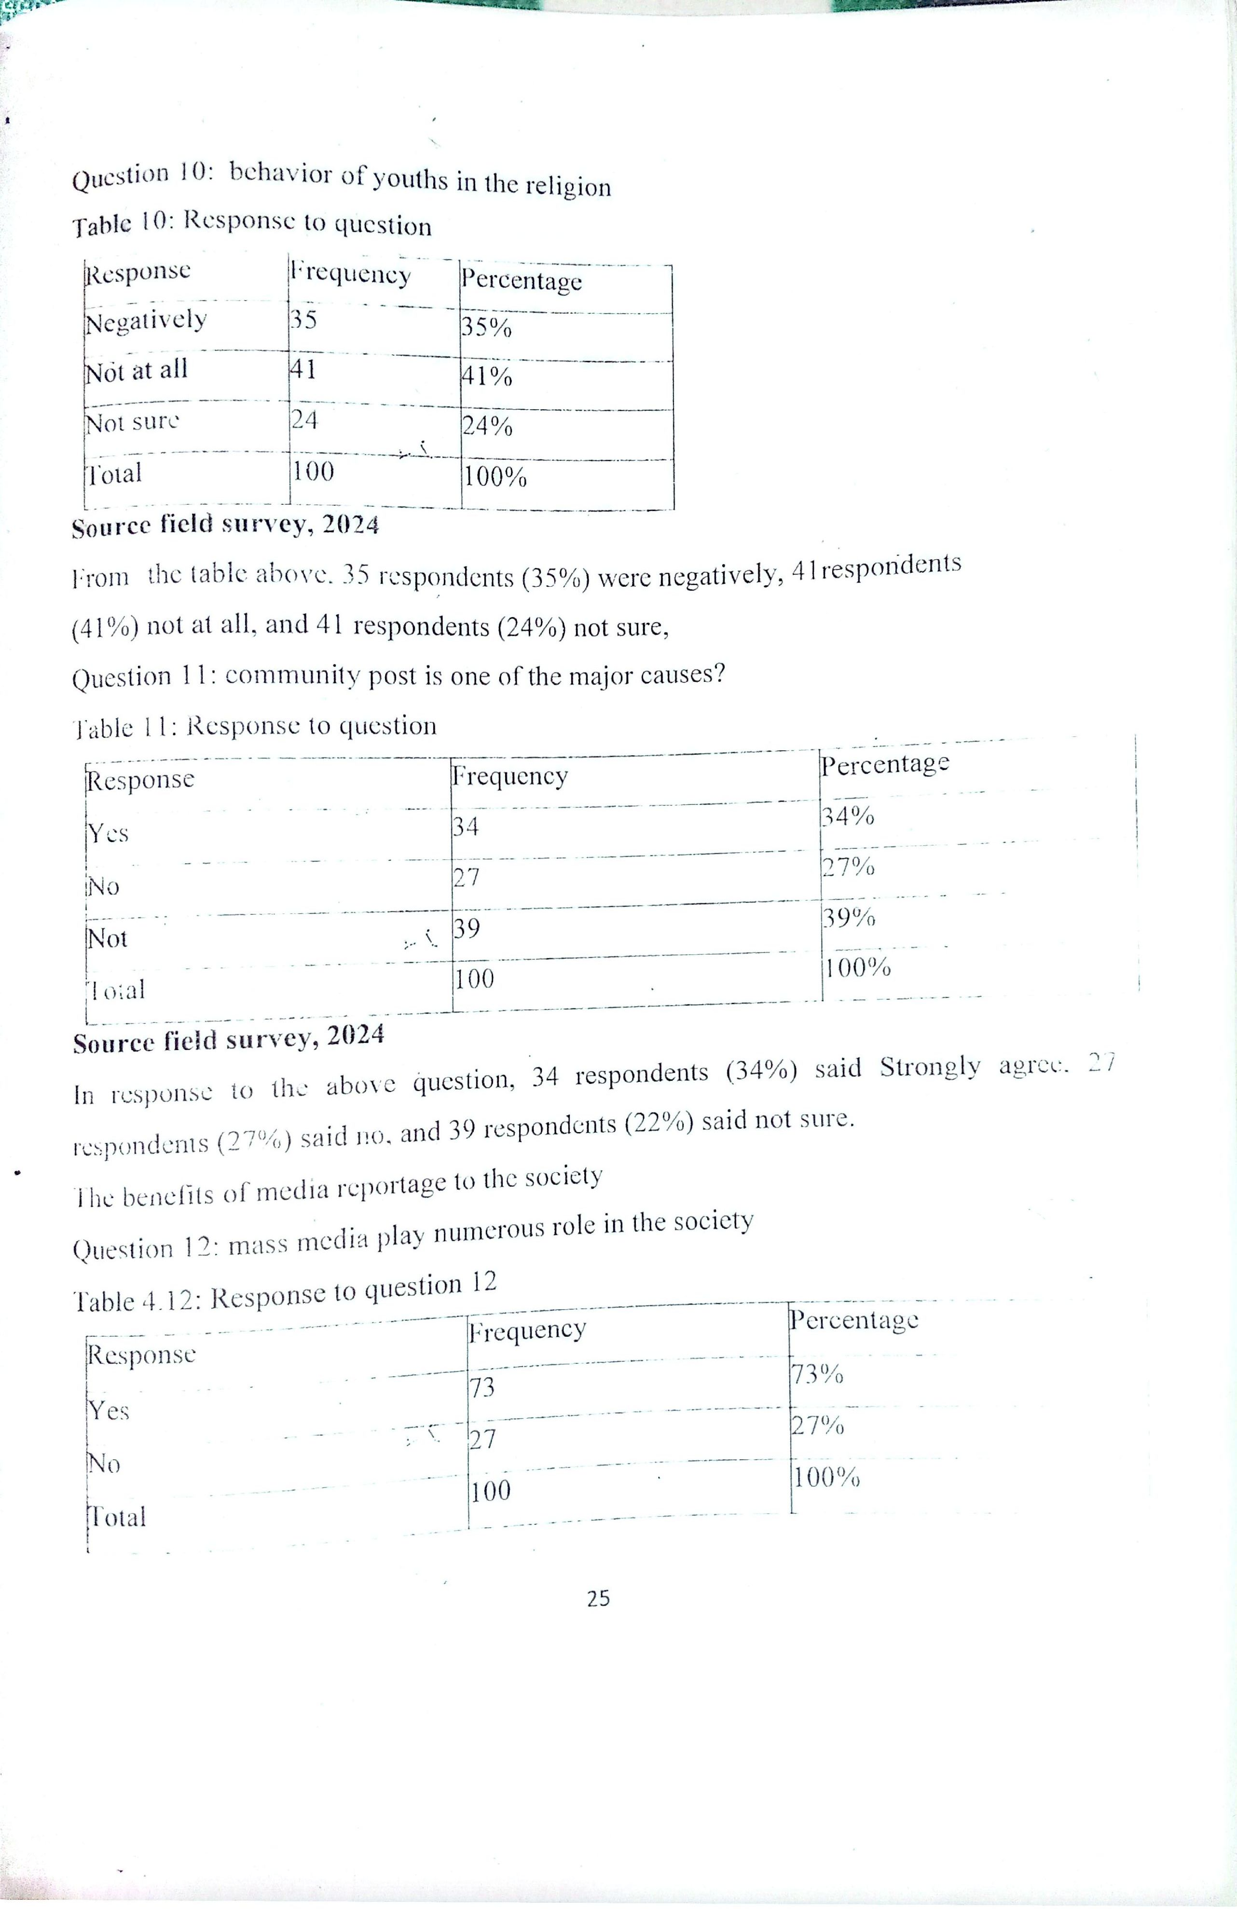
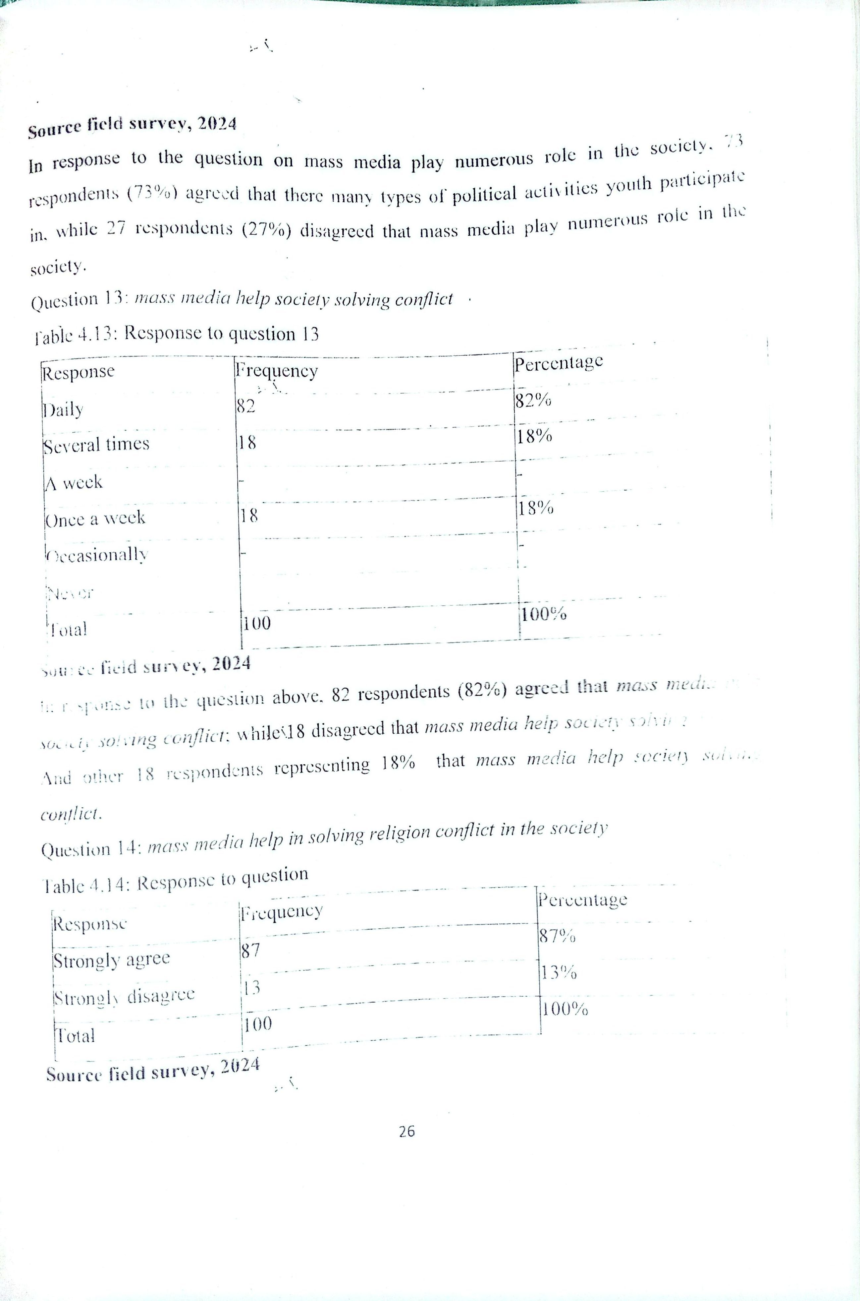
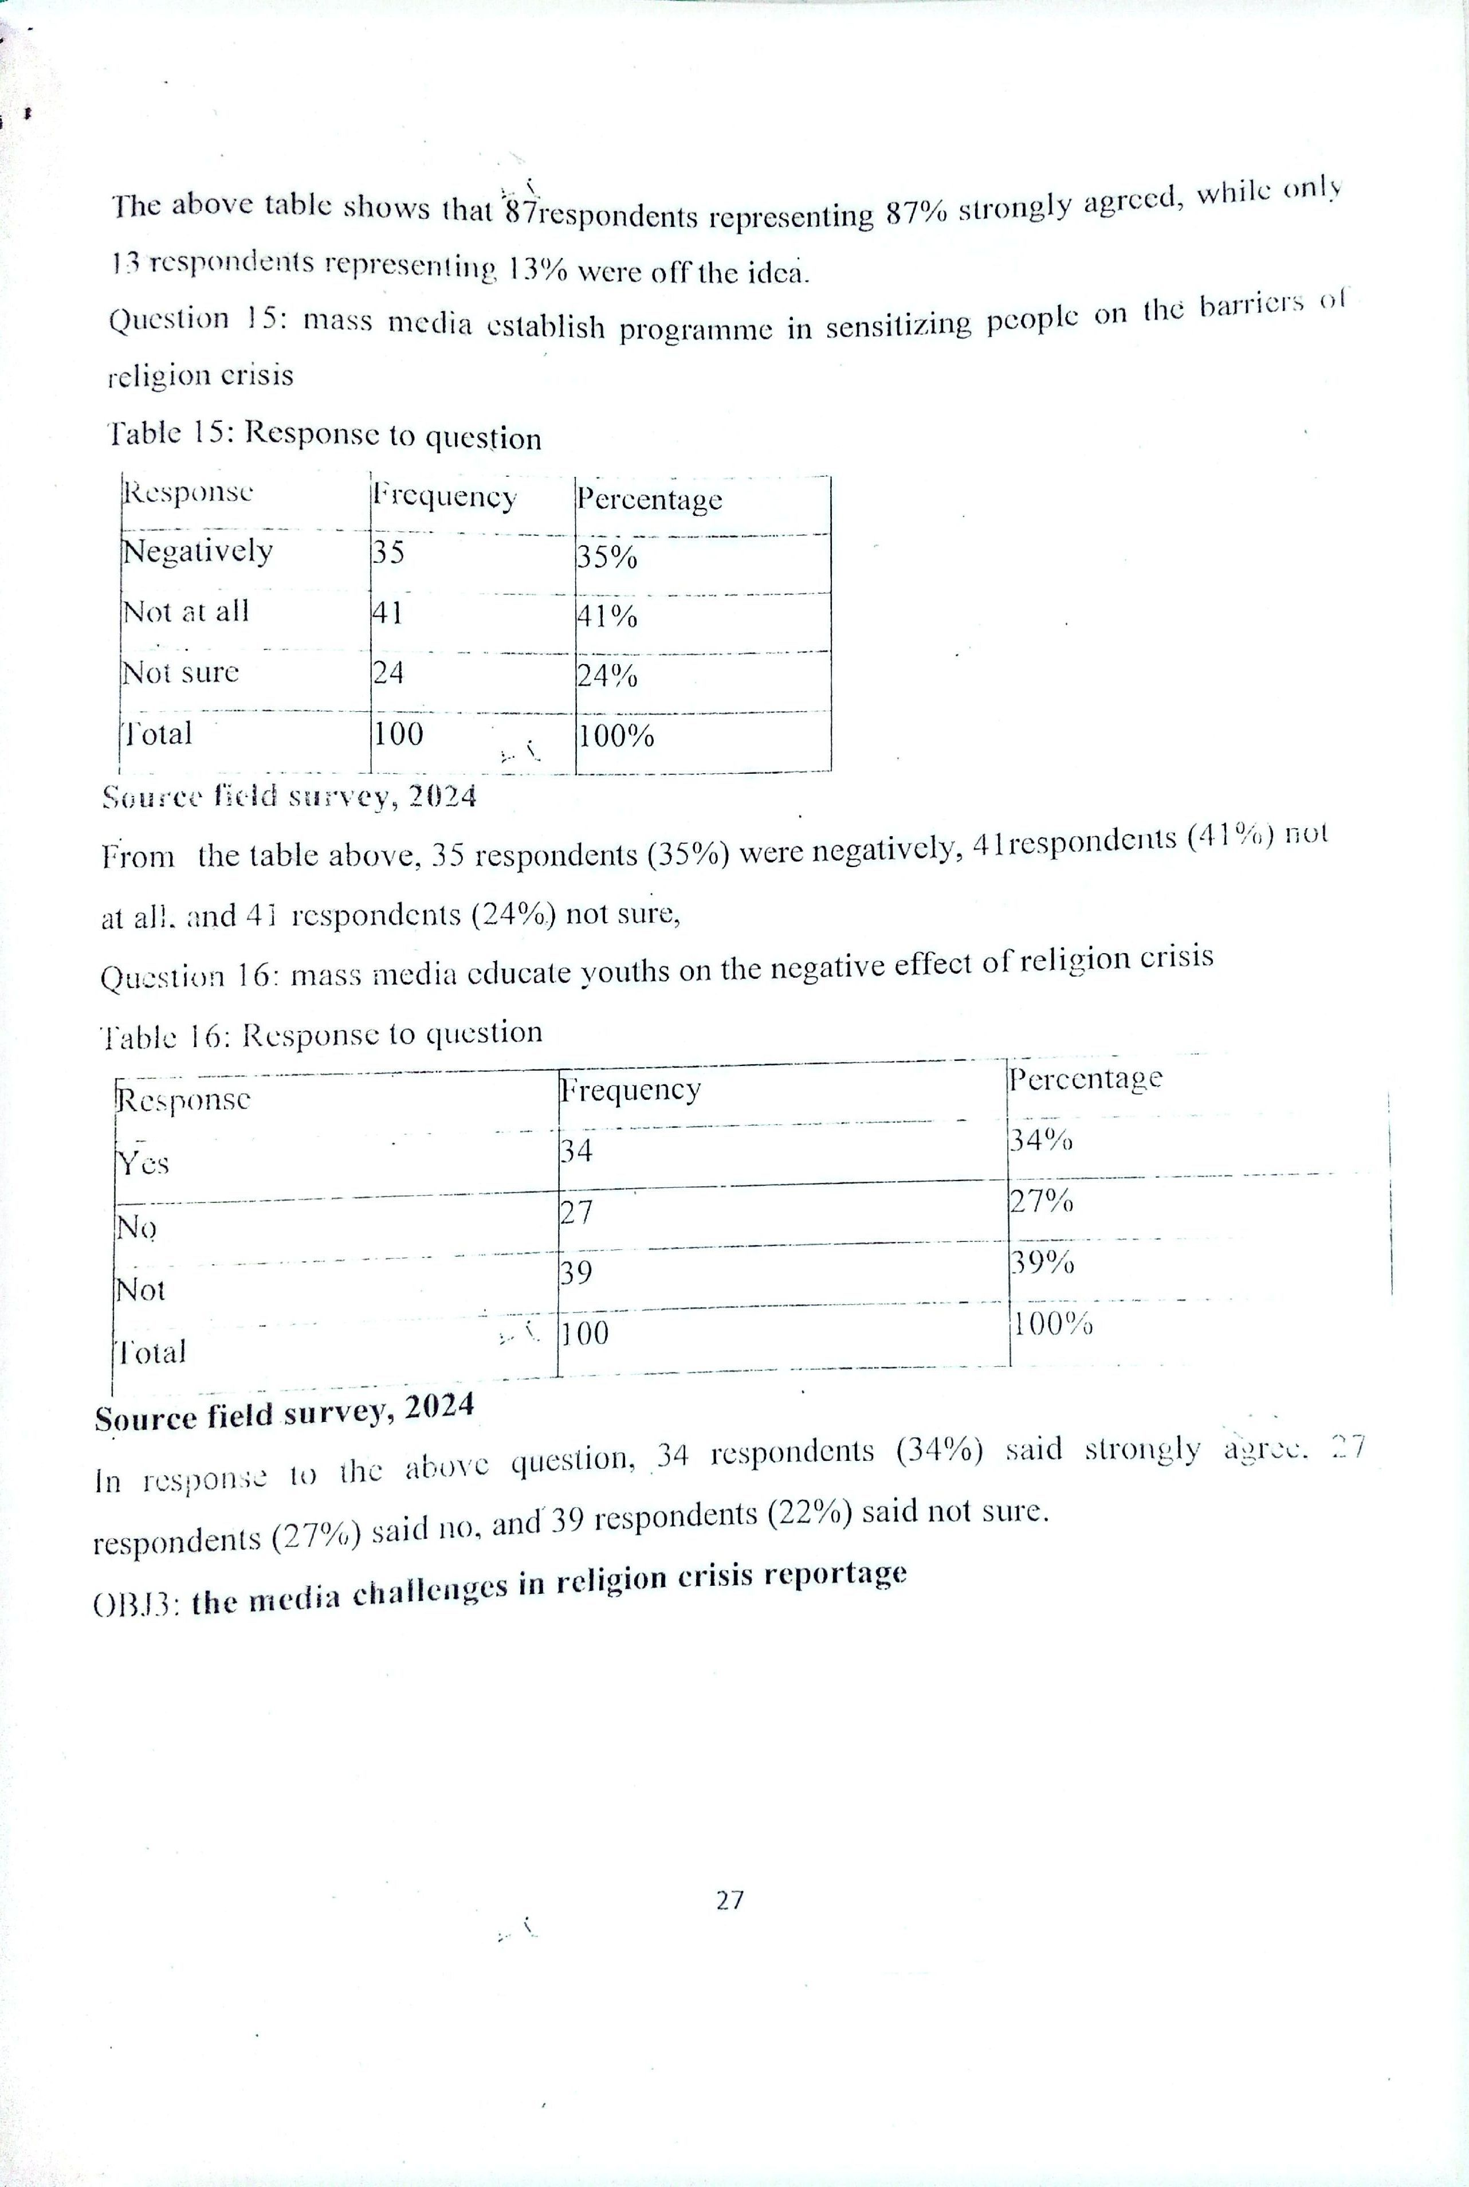
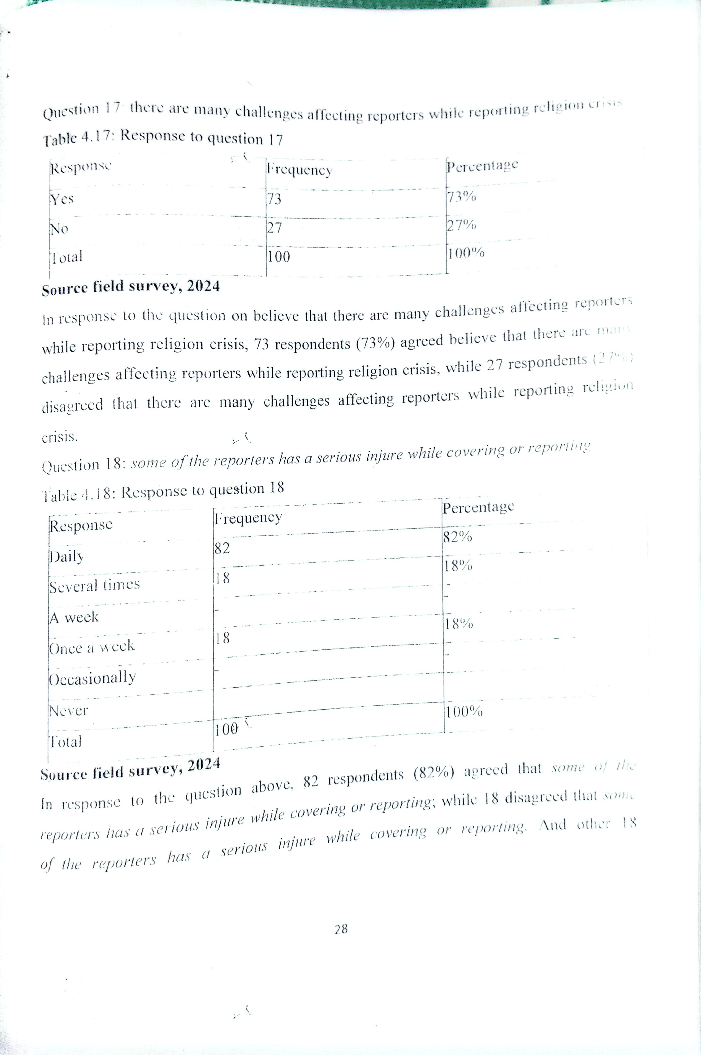
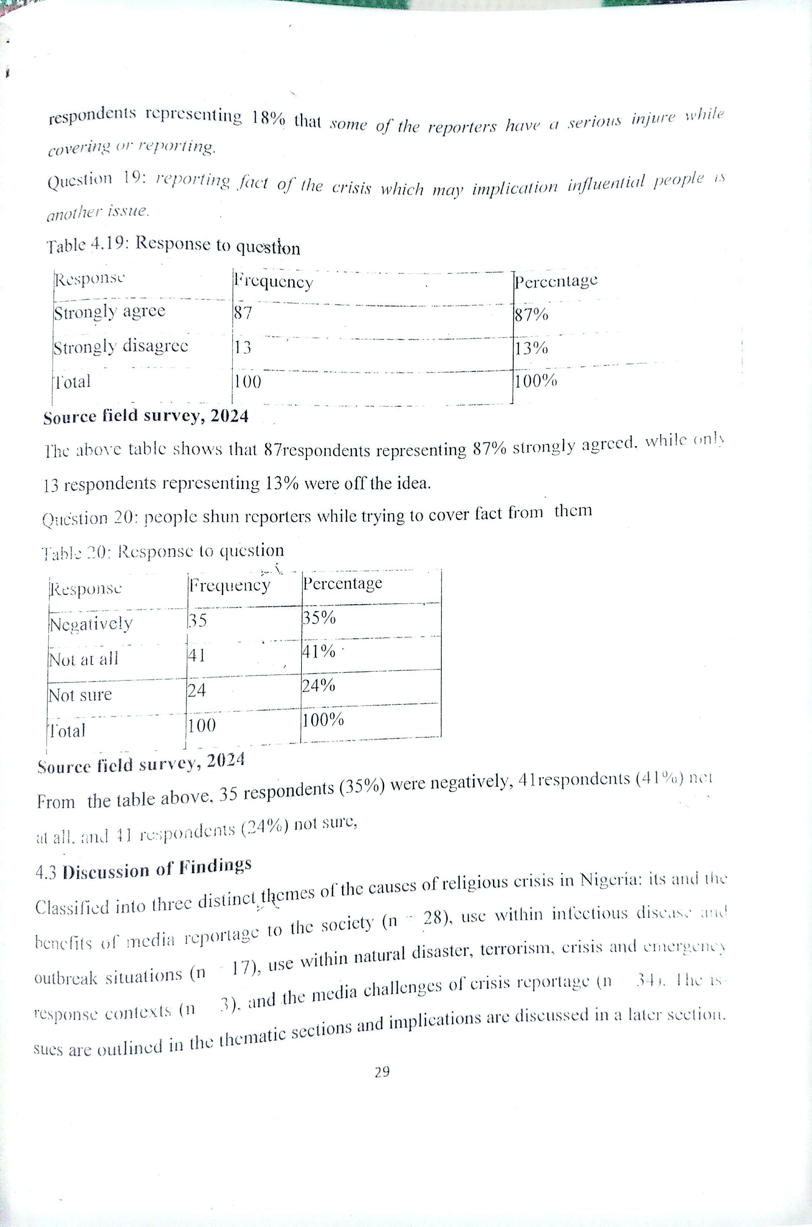
CHAPTER FIVE
SUMMARY, CONCLUSION AND RECOMMENDATION
5.1 SUMMARY
In this study, our focus was to examine the roles of the mass media in the fight against religious crisis using residents of Ilorin west LGA as a case study. The study specifically was aimed at highlighting the causes of religious crisis in Nigeria identify the benefits of media reportage to the society
To examine the media challenges of crisis reportage understand the prevalence of religious crisis in Nigeria The study adopted the survey research design and randomly enrolled participants in the study. A total of 77 responses were validated from the enrolled participants where all respondent are drawn from residents of Ilorin west local government area
5.2 CONCLUSION
Based on the finding of this study, the following conclusions were made:
1. Through making some religious groups feel superior,
2. Delineating different religious groups
3. Delineating different religious groups
4. Bribery and corruption
5. Been biase in the report of the crisis
6. Inability to get the real fact about the story

5.3 RECOMMENDATION
Based on the responses obtained, the researcher proffers the following recommendations.
- Culture of forgiveness must transcend words but reflected in social relationships and even influence government policies which may require putting in place social and physical structures that symbolize such forgiveness and unity of decision to emphasize forgiveness rather than retaliation
- The government should endeavor to provide security to its citizens at periods of crises
- Sermons at Christian services and other gatherings and kutbas at mosques and other Muslims gatherings should be devoid of incitement against other religious adherents
REFERENCES
Aderibigbe. 1. S. (2019). Muslim-Christian Relations in Nigeria: History of Tolerance and Peaceful Coexistence. In Momoh, C. S. et al (eds.) Nigerian Studies in Religious Tolerance, Vol. 111. Lagos, Nigeria: John West, . 135-152.
Anstey, M. (2020). Negotiating Conflict: Insights and Skills for Negotiators, and Peacemakers. Cape Town: Juta.
Barker. Larry L. (2021). Groups in Process: An Introduction to Small Group Communication. New York: Prentice Hall.
Boer, J. H. (2019). Christianity and Islam under Colonialism in Nigeria. Jos, Nigeria: ICS Boer, J. H. (2022a), Nigeria's Decades of Blood: 1980-2002: Studies in Christian- Muslim Relation, Vol. 2. Jos, Nigeria: Stream Christian Publishers.
Boer, J. H. (2022b). Christian: Why This Muslim Violence: Studies in Christian-Muslim Relation,. Vol. 3. Jos, Nigeria: MoreBooks
Crampton, E. P. T. and Gaiya, Musa A. B. (2022). Christianity in Northern Nigeria. Kaduna, Nigeria: Baraka Press.
Ajayi, J. F.A; (2022). Chritian Missions In Nigeria; The Making Of New Elites London: Oxford University Press.
Anene, J.C.; And Brown, G.; (2021). Slavery And Slave Trade In Africa In The 19th And 20th Centuries. Ibadan: Ibadan University Press.
Bereau For African Afairs, 2021). http://www.state.gov/r/pa/ei/bgn/2836.htm accessed June, 2021.
Best, Shedrack; (2002). "Achieving Lasting Peace on The Plateau: The Way Forward” A Paper Presented At The Peace Summit on 10th September.

Bidmos M.A., (1993), Inter-Religious Dialogue: The Nigerian Experience. Nigeria: University of Lagos.
Boer. Jan. (2022), Christians: Why This Muslim Violence? Bernvile: Essence Publishing. Vol. 3.
Clarke. G: (2021). Faith Matters:Development and the Complex World of Faith Base Organisation, Center for Development Studies, University of Wales, Swansca
Danmole. 11.0:(2020). Media Use Of Muslims In South Western Nigeria: Parallel and Comparism. London: A paper presented At SOAS, quoted by Hackett, Rosalind I.J.(2021) Managing Or Manipulating Religion in The Nigerian Media.
Enwerem, I.M, (2020), Dangerous Awakening: The Polarization of Religion in Nigeria. Ibadan: IFRA
Imo.O.Cyril; (2020), Religion And The Unity Of The Nigerian Nation. Sweden: Repricentralen. J
uensgesmeyer, Mark. (2001), Terror In The Mind OF God: The Global Rise Of Religious Violece. Califonia: Califonia Universty Press.
Lere. P.M.;(2006), "The Impact Of Religious Crises On The Nigerian Child". The Journal of The National Council For Exceptional Children. Vol.9 No. 1
Mbiti, J.S.:(2020). African Religions And Philosophy. London: Heinemann.
Nyombi, R. (2019), African Traditional Religion. http://algen.com att.html, access. March 2008
Yusuf, Jolly Tanko (2020), That We May Be One.: The Biography of Ambassador Joll Yusuf Tanko Grand Rapids MI: William B. Erdman
APPENDIX
Dear Respondent
We are final year students of the Department of Mass Communication in Kwara State Polytechnic. Ilorin, carrying out research on the topic: THE ROLES OF THE MASS MEDIA IN THE FIGHT AGAINST RELIGIOUS CRISIS IN NIGERIA. The outcome of the research will be useful to the general public. The information gathered will be for academic purposes. I solicit your Co-operation by filling the questionnaire. This will be treated confidentially. Thank in anticipation for your cooperation.
Thanks
QUESTIONNAIRE
Please tick () the appropriate box that correspond to your response. The information supplied shall be treated with strict confidentiality.
SECTION A
PERSONAL INFORMATION
1. Sex: Male ( ) Female ( )
2. Educational Qualification: Msc. ( ) HND/Bsc. ( ) ND/NCE ( ) O level ( )
3. Working Experience: 5-10 years ( ) 10-15years ( ) 15 years and above ( )
SECTION B
OBJ 1: causes of religious crisis in Nigeria
1. Political appointment (a) Yes ( ) (b) No ( )
2. Religion characteristics (a) Yes ( ) (b) No ( )
3. Individual differences (a) Yes ( ) (b) No ( )
4. Behavior of youths in the religion (a) Yes ( ) (b) No ( )
5. Community post is one of the major causes? (a) Yes ( ) (b) No ( )
SECTION C
OPTIONS
SA Strongly Agree
A Agree
U Undecided
D-Disagree
SD Strongly Disagree
S/N | STATEMENT | SA | A | D | SD
 | The benefits of media reportage to the society
1. | Mass media play numerous role in the society
2. | Mass media help society solving conflict
3. | Mass media help in solving religion conflict in the society
4. | mass media establish programme in sensitizing people on the barriers of religion crisis
5. | Mass media educate youths on the negative effect of religion crisis
 | the media challenges in religion crisis reportage
6. | There are many challenges affecting reporters while reporting religion crisis
7. | Some of the reporters has a serious injure while covering or reporting
8. | Reporting fact of the crisis which may implication influential people is another issue.
9. | People shun reporters while trying to cover fact from them

