DEVELOPMENT OF CUSTOMER CLUSTERING SYSTEM USING MACHINE LEARNING

BY

OLADEBO OPEYEMI GBOTEMI
ND/23/COM/PT/0321

SUBMITTED TO THE DEPARTMENT OF COMPUTER SCIENCE, INSTITUTE OF INFORMATION AND COMMUNICATION TECHNOLOGY

KWARA STATE POLYTECHNIC, ILORIN.
IN PARTIAL FULFILLMENT OF THE REQUIREMENTS FOR THE AWARD OF NATIONAL DIPLOMA (ND) IN
COMPUTER SCIENCE

JULY, 2025.

CERTIFICATION
This is to certify that this project was carried out by Oladebo Opeyemi Gbotemi with matriculation number ND/23/COM/PT/0321 in the Department of Computer Science, Institute of Information Communication Technology, Kwara State Polytechnic, Ilorin, Kwara State.

…………………………………. ….………………………
MR. BOLAJI-ADETORO, D. F. Date
Project Supervisor

…………………………………. ….………………………
MR. OYEDEPO, F. S. Date
Head of Department

…………………………………. ….………………………
External Examiner Date

DEDICATION
I dedicate this project work to Almighty God who inspired me and directed my ways during my academic stay in the polytechnic.

ACKNOWLEDGEMENT
All praise is due to Almighty God the Lord of universe. I praise him and thank him for giving me the strength and knowledge to complete my HND program and also for our continued existence on the earth.
I appreciate the utmost effort of my supervisor, Mr. Bolaji-Adetoro, D. F. whose patience, support and encouragement have been the driving force behind the success of this research work. He gave useful corrections, constructive criticisms, comments, recommendations, advice and always ensures that an excellent research is done. My sincere gratitude goes to Head of Department and other members of staff of the Department of Computer Science, Kwara State Polytechnic, Ilorin, for their constant cooperation, constructive criticisms and encouragements throughout the programme.
Special gratitude to my parents, who exhibited immeasurable financial, patience, support, prayers and understanding during the period in which I was busy tirelessly on my studies, special thanks go to my lovely siblings
My sincere appreciation goes to my friends and classmates.

TABLE OF CONTENTS
Title page i
Certification ii
Dedication iii
Acknowledgements iv
Table of contents v
Abstract vi
CHAPTER ONE: GENERAL INTRODUCTION
1.1 Background to the Study 1
1.2 Statement of the Problem 3
1.3 Aim and Objectives 3
1.4 Significance of the Study 3
1.5 Scope of the Study 4
1.6 Organization of the Report 5
CHAPTER TWO: LITERATURE REVIEW
2.1 Review of Related Works 5
2.2 Review of General Study 9
2.2.1 Customer Classification 9
2.2.2 Big Data 9
2.2.3 Data repository 10
2.2.4 Clustering data 10
2.2.5 K-means 10
CHAPTER THREE: RESEARCH METHODOLOGY AND ANALYSIS OF THE SYSTEM
  - Research Methodology 11
  - Analysis of the Existing System 12
  - Problem of the Existing System 13
  - Analysis of the Proposed System 13
  - Advantage of the Propose System 14
CHAPTER FOUR: DESIGN, IMPLEMENTATION AND DOCUMENTATION OF THE SYSTEM
  - Design of the System 15
    - Output Design 15
    - Input Design 16
    - Database Design 20
    - Procedure Design 20
  - Implementation of the System 20
    - Choice of programming language 20
    - Hardware support 21
    - Software Support 21
  - System Documentation 21
    - Operating the System 22
    - Maintaining of the System 22
CHAPTER FIVE: SUMMARY CONCLUSION AND RECOMMENDATION
5.1 Summary 23
5.2 Conclusion 23
5.4 Recommendations 23
References 25

ABSTRACT
Customer Segmentation means grouping the customers based on marketing groups which shares the similarity among customers. To be more exact, it means segmenting customers sharing the common characteristics, which is the best way of marketing. Customer segmentation is gathering information about each customer and analyzing it to identify the different patterns for creating the segments. Some of the best methods for gathering information are face-to-face interviews, Telephonic interviews, through surveys or through research using information which is published related to market categories. The emergence of many business competitors has engendered severe rivalries among competing businesses in gaining new customers and retaining old ones. Due to the preceding, the need for exceptional customer services becomes pertinent, notwithstanding the size of the business. Furthermore, the ability of any business to understand each of its customers’ needs will earn it greater leverage in providing targeted customer services and developing customised marketing programs for the customers. This understanding can be possible through systematic customer segmentation. Each segment comprises customers who share similar market characteristics. The ideas of Big Data and Machine Learning have fuelled a terrific adoption of an automated approach to customer segmentation in preference to traditional market analyses that are often inefficient especially when the number of customers is too large. K-Means is an unsupervised learning algorithm and used for clustering tasks which works really well with complex dataset. It is an iterative algorithm that partitions the dataset into “k” pre-defined non-overlapping subgroups (clusters) where each data point belongs to only one group.

CHAPTER ONE
INTRODUCTION
  - BACKGROUND TO THE STUDY
Customer Segmentation means grouping the customers based on marketing groups which shares the similarity among customers. To be more exact, it means segmenting customers sharing the common characteristics, which is the best way of marketing. Customer segmentation is gathering information about each customer and analyzing it to identify the different patterns for creating the segments. Some of the best methods for gathering information are face-to-face interviews, Telephonic interviews, through surveys or through research using information which is published related to market categories. The basic information which includes billing information, shipping information, products purchased, promo codes, payment method etc. (Monil, 2020).
Over the years, the increase in competition amongst businesses and the availability of large historical data repositories have prompted the widespread applications of data mining techniques in uncovering valuable and strategic information buried in organisations’ databases. Data mining is the process of extracting meaningful information from a dataset and presenting it in a human understandable format for the purpose of decision support. The data mining techniques intersect areas such as statistics, artificial intelligence, machine learning and database systems. The applications of data mining include but not limited to bioinformatics, weather forecasting, fraud detection, financial analysis and customer segmentation(Banduni, 2019)..
The importance of customer segmentation include, inter alia, the ability of a business to customized market programs that will be suitable for each of its customer segments; business decision support in terms of risky situation such as credit relationship with its customers; identification of products associated with each segments and how to manage the forces of demand and supply; unravelling some latent dependencies and associations amongst customers, amongst products, or between customers and products which the business may not be aware of; ability to predict customer defection, and which customers are most likely to defect; and raising further market research questions as well as providing directions to finding the solutions (Chinedu, et al. 2015).
The thrust of this research is to identify customer segments in a retail business using a data mining approach. Customer segmentation is the subdivision of a business customer base into groups called customer segments such that each customer segment consists of customers who share similar market characteristics. This segmentation is based on factors that can directly or indirectly influence market or business such as products preferences or expectations, locations, behaviours and so on

  - STATEMENT OF THE PROBLEM
The emergence of many business competitors has engendered severe rivalries among competing businesses in gaining new customers and retaining old ones. Due to the preceding, the need for exceptional customer services becomes pertinent, notwithstanding the size of the business. Furthermore, the ability of any business to understand each of its customers’ needs will earn it greater leverage in providing targeted customer services and developing customised marketing programs for the customers. This understanding can be possible through systematic customer segmentation. Each segment comprises customers who share similar market characteristics. The ideas of Big Data and Machine Learning have fuelled a terrific adoption of an automated approach to customer segmentation in preference to traditional market analyses that are often inefficient especially when the number of customers is too large.
1.3 AIM AND OBJECTIVES
The aim of this project work is to implement a web application that will divide consumers into subgroups or segments and the objectives are as follows:
- Design a web based application that will help create customer segmentation
- Design a friendly application for easy access
- Develop the system using k-means clustering algorithm.

  - SIGNIFICANCE OF THE STUDY
The importance of customer segmentation include, inter alia, the ability of a business to customize market programs that will be suitable for each of its customer segments; business decision support in terms of risky situation such as credit relationship with its customers; identification of products associated with each segments and how to manage the forces of demand and supply; unraveling some latent dependencies and associations amongst customers, amongst products, or between customers and products which the business may not be aware of; ability to predict customer defection, and which customers are most likely to defect; and raising further market research questions as well as providing directions to finding the solutions.

  - SCOPE OF THE STUDY
This project focus mainly on the design and implementation of a computer based application that will cater for customer segment using K-Means algorithm. This project does not go beyond this.
1.6 ORGANIZATION OF THE STUDY
For easy study and proper understanding of this project write-up, It is planned and organized into five chapters. The description of what each chapter contains is explained below:
Chapter One: This contains an Introduction to the whole write-up, the problem of the study, aims and objectives of the study, the significant of the study, the scope and limitation of the study, and organization of the report.
Chapter Two: It focuses on the literature review of the study, organization of the board of director, computerization of the current state of the art.
Chapter Three: It presents data collection method employed, analysis of data and existing system, advantages of the proposed system, design and implementation, programming language used with reasons, hardware and software support.
Chapter Four: It deals with the system design implementation and documentation, design of the system, output design, input design, file system, procedural design, and documentation of the new system.
Chapter Five: This centres the summary, experienced gained, recommendation and conclusion.

CHAPTER TWO
LITERATURE REVIEW
2.1 REVIEW OF RELATED WORK
Vijilesh, et al. (2021) wrote an article on “Customer Segmentation Using Machine Learning” In carrying out successful E-Commerce, the most important things are innovation and understanding what customer wants. Now-a-days the ease of using ecommerce encourages the customers to buy using ecommerce. It runs on the basis of innovation having the ability to enthral the customers with the products, but with such a large raft of products leave the customers confused of what to buy and what not to. According to business, a company may create three segments like High (Group who buys often, spends more and visited the platform recently), Medium (Group which spends less than high group and is not that much frequent to visit the platform) and Low (Group which is on the verge of churning out). This is where Machine Learning provides a crucial solution, several algorithms are applied for revealing the hidden patterns in data for better decision making. In this paper we proposed a Customer segmentation concept in which the customer bases of an establishment is divided into segments based on the customers’ characteristics and attributes. This idea can be used by the B2C companies to outperform the competition by developing uniquely appealing products and services and make it reach to potential customers. This approach is implemented using “k-means”, an unsupervised clustering machine learning algorithm.
Aman, et al. (2019) presented a journal titled “Customer Segmentation Using Machine Learning”. The emergence of many competitors and entrepreneurs has caused a lot of tension among competing businesses to find new buyers and keep the old ones. As a result of the predecessor, the need for exceptional customer service becomes appropriate regardless of the size of the business. Furthermore, the ability of any business to understand the needs of each of its customers will provide greater customer support in providing targeted customer services and developing customized customer service plans. This understanding is possible through structured customer service. Each segment has customers who share the same market features. Big data ideas and machine learning have promoted greater acceptance of automated customer segmentation approaches in favor of traditional market analytics that often do not work when the customer base is very large. In this paper, the k-means clustering algorithm is used for this purpose. The Sklearn liabrary was developed for the k-Means algorithm (found in the Appendix) and the program is trained using a 100-pattern two-factor dataset derived from the retail trade. Characteristics of average number of customer purchases and average number of monthly customers.
Monil, et al., (2020) “Customer Segmentation using Machine Learning” In recent years, every e-commerce enterprise focuses on Customer Relationship Management (CRM) to provide the better services to the customer as compared to their competitors. Building a better relationship with customer help the enterprises in increasing profit and customers retention and satisfaction. It is necessary for enterprises to identify the potential customers in the market by mining the customer data to gain profitable insight. One of the efficient way to identify the different customer characteristics is by applying clustering analysis. In this paper, different clustering approach has been presented in order to segment the customer and apply the different marketing strategies accordingly. The possibility of hybrid combination of clustering algorithm can outperform individual model has also been discussed.
Chinedu, Simeon & Constance (2015) wrote an article on “Application of K-Means Algorithm for Efficient Customer Segmentation: A Strategy for Targeted Customer Services” The emergence of many business competitors has engendered severe rivalries among competing businesses in gaining new customers and retaining old ones. Due to the preceding, the need for exceptional customer services becomes pertinent, notwithstanding the size of the business. Furthermore, the ability of any business to understand each of its customers’ needs will earn it greater leverage in providing targeted customer services and developing customised marketing programs for the customers. This understanding can be possible through systematic customer segmentation. Each segment comprises customers who share similar market characteristics. The ideas of Big data and machine learning have fuelled a terrific adoption of an automated approach to customer segmentation in preference to traditional market analyses that are often inefficient especially when the number of customers is too large. In this research project, the k-Means clustering algorithm is applied for this purpose. A MATLAB program of the k-Means algorithm was developed (available in the appendix) and the program is trained using a z-score normalized two-feature dataset of 100 training patterns acquired from a retail business. The features are the average amount of goods purchased by customer per month and the average number of customer visits per month. From the dataset, four customer clusters or segments were identified with 95% accuracy, and they were labeled: High-Buyers-Regular-Visitors (HBRV), High-Buyers-Irregular-Visitors (HBIV), Low-Buyers-Regular-Visitors (LBRV) and Low-Buyers-Irregular-Visitors (LBIV).
Wei, Huiting & Ruzhen (2015) wrote an article on “Customer segmentation model based on two-step optimization in big data era” With the advent of the era of big datasets, real-time data is becoming increasingly important in assisting the decision making process for commercial banks. In this paper, we develop a two-step optimization model (FSGA-FCEN) based on genetic algorithm (GA) and cluster ensemble (CE) for customer segmentation. Firstly, the key attributes are selected using GA. Then FCEN algorithm is used to segment customers into small groups. Taking 3544 customers in a commercial bank as samples, empirical results show that, compared with K-means, FCM and MAJ models, two-step model is an efficient and practical tool for customer segmentation.
Kishana, IACSIT & Velu (2014) wrote an article on “Customer Segmentation Using Clustering and Data Mining Techniques” Clustering technique is a critically important step in data mining process. It is a multivariate procedure quite suitable for segmentation applications in the market forecasting and planning research. This research paper is a comprehensive report of k-means clustering technique and SPSS Tool to develop a real time and online system for a particular super market to predict sales in various annual seasonal cycles. The model developed was an intelligent tool which received inputs directly from sales data records and automatically updated segmentation statistics at the end of day’s business. The model was successfully implemented and tested over a period of three months. A total of n = 2138, customer, were tested for observations which were then divided into k = 4 similar groups. The classification was based on nearest mean. An ANOVA analysis was also carried out to test the stability of the clusters. The actual day to day sales statistics were compared with predicted statistics by the model. Results were quite encouraging and had shown high accuracy.
Jayant, Sudhanshu & Sujata, (2015) wrote an article on “An Approach to Customer Classification usingk-means” A customer segment is a group of customers who share similar attributes or who have similar needs. Knowledge about customer segments allows businesses to target their products for customers of specific groups or segments. K-Means clustering is a method to divide raw data into different clusters where members of one cluster have more similar attributes among themselves than the members of other clusters. This paper describes customer segmentation in detail and explains clustering algorithms. More specifically, the paper describes k-means clustering technique and explains its use in customer segmentation by explaining segmentation of television company customers on the basis of various variables.
Andrew (2017) wrote an article on “Customer Segmentation based on Behavioural Data in E-marketplace” In the past years, research in the fields of big data analysis, machine learning and data mining techniques is getting more frequent. This thesis describes a customer segmentation approach in a second hand vintage clothing E-marketplace Plick. These customer groups are based on user interactions with items in the marketplace such as views and "likes". A major goal of this thesis was to construct a personal feed for each user where the items are derived from the user groups. The customer segmentation method discussed in this paper is based on the clustering algorithm K-means using cosine similarity as the similarity measure. The input matrix used by the K-means algorithm is a User-Brand ratings matrix where each brand is given a rating by each user. A visualization tool was also constructed in order to get a better picture of the data and the resulting clusters. In order to visualize the highly dimensional User-Brand matrix, Principal Component Analysis is used as a dimensionality reduction algorithm.
Jansen, (2017) wrote an article on “Customer Segmentation and Customer Profiling for a Mobile Telecommunications Company Based on Usage Behavior” Vodafone, an International mobile telecommunications company, has accumulated vast amounts of data on consumer mobile phone behavior in a data warehouse. The magnitude of this data is so huge that manual analysis of data is not feasible. However, this data holds valuable information that can be applied for operational and strategical purposes. Therefore, in order to extract such information from this data, automatic analysis is essential, by means of advanced data mining techniques. These data mining techniques search and analyze the data in order to find implicit and useful information, without direct knowledge of human experts. This research will address the question how to perform customer segmentation and customer profiling with data mining techniques. In our context, ’customer segmentation’ is a term used to describe the process of dividing customers into homogeneous groups on the basis of shared or common attributes (habits, tastes, etc). ’Customer profiling’ is describing customers by their attributes, such as age, gender, income and lifestyles. Having these two components, managers can decide which marketing actions to take for each segment. In this research, the customer segmentation is based on usage call behavior, i.e. the behavior of a customer measured in the amounts of incoming or outgoing communication of whichever form. This thesis describes the process of selecting and preparing the accurate data from the data warehouse, in order to perform customer segmentation and to profile the customer. A number of advanced and state-of-the-art clustering algorithms are modified and applied for creating customer segments.
Konstantinos and Antonios (2017) “Data Mining Techniques in CRM” Customers are the most important asset of an organization. There cannot be any business prospects without satisfied customers who remain loyal and develop their relationship with the organization. That is why an organization should plan and employ a clear strategy for treating customers. CRM (Customer Relationship Management) is the strategy for building, managing, and strengthening loyal and long-lasting customer relationships. CRM should be a customer-centric approach based on customer insight. Its scope should be the ‘‘personalized’’ handling of customers as distinct entities through the identification and understanding of their differentiated needs, preferences, and behaviors.

2.2 REVIEW OF GENERAL STUDY
2.2.1 Customer Classification
Over the years, the commercial world has become more competitive, as organizations such as these have to meet the needs and desires of their customers, attract new customers, and thus improve their businesses. The task of identifying and meeting the needs and requirements of every customer in the business is very difficult. This is because customers can vary according to their needs, wants, demographics, size, taste and taste, features etc. As it is, it is a bad practice to treat all customers equally in business. This challenge has adopted the concept of customer segmentation or market segmentation, where consumers are divided into subgroups or segments, where members of each subcategory exhibit similar market behaviors or characteristics. Accordingly, customer segmentation is the process of dividing the market into indigenous groups.

2.2.2 Big Data
Recently, Big Data research has gained momentum. Defines big data - a term that describes a large number of formal and informal data, which cannot be analyzed using traditional methods and algorithms. Companies include billions of data about their customers, suppliers, and operations, and millions of internally connected sensors are sent to the real world on devices such as mobile phones and cars, sensing, manufacturing and communications data. Ability to improve forecasting, save money, increase efficiency and improve various areas such as traffic control, weather forecasting, disaster prevention, finance, fraud control, business transactions, national security, education and healthcare. Big data is mainly seen in three Vs: volume, variability, and speed. Other 2Vs are available - authenticity and price, thus making it 5V.
2.2.3 Data repository
Data collection is the process of collecting and measuring information against targeted changes in an established system, which enables one to answer relevant questions and evaluate the results. Data collection is part of research in all fields of study including physical and social sciences, humanities and business. The purpose of all data collection is to obtain quality evidence that leads the analysis to construct concrete and misleading answers to the questions presented. We collected data from the UCI machine learning repository.
2.2.4 Clustering data
Clustering is the process of grouping information into a dataset based on some commonalities. There are several algorithms, which can be applied to datasets based on the provided condition. However, no universal clustering algorithm exists, hence it becomes important to choose the appropriate clustering techniques. In this paper, we have implemented three clustering algorithms using the Python scalar library.
2.2.5 K-means
K-means that an algorithm is one of the most popular classification algorithms. This clustering algorithm relies on centro, where each data point is placed in one of the overlapping ones, which is pre-sorted in the K-algorithm. Clusters are created that correspond to hidden patterns in the data that provide the necessary information to help decide execution. process. There are many ways to make assembling K-means, we will use the elbow method.

CHAPTER THREE
RESEARCH METHODOLOGY AND ANALYSIS OF THE NEW SYSTEM
3.1 RESEARCH METHODOLOGY
I used machine learning Clustering algorithm K-Means for this customer segmentation.
There are three major sections to be adopted:
- Data Pre-processing.
- RFM score calculation.
- Cluster Creation.
Data Pre-processing:
The dataset which is an excel file is loaded using Pandas. We dropped all the duplicate entries in CustomerID and Country column. Count of customers for each country is calculated and sorted the count in descending order to see from which country the maximum number of customers purchases.
RFM Score Calculation
Our dataset is limited to sales record, we can use a RFM based model for finding segments where R is Recency (how recently a purchase happened), F is Frequency (how frequent transactions are made), M is Monetary value(Value of all transactions). Recency, Frequency and Monetary score for each customer is calculated. The latest date is assigned as a placeholder to calculate recent purchases. All the transactions are grouped using CustomerID and then aggregate lambda operations are performed. As a result of this operation numbers will be obtained which depicts the recency., frequency and how much a specific customer spent till date. All these are stored in a new dataframe RFMscores. To note, the distribution for recency is right skewed.
Clustering
K-Means is an unsupervised learning algorithm and used for clustering tasks which works really well with complex dataset. It is an iterative algorithm that partitions the dataset into “k” pre-defined non-overlapping subgroups (clusters) where each data point belongs to only one group.
The algorithm works as follows:
Step-1 : Specifying the number of clusters – k value.
Step-2 : Centroids are initialized by shuffling the dataset and then randomly selecting k data points for the centroids without replacement.
Step-3: Repeat the iteration until there is no change to the centroids. i.e, assignment of data points to the clusters does not change.
Recency, Frequency and Monetary are brought to the same scale and the data is normalized before clustering process. It is important to determine the optimum number of clusters i.e, “k value”. For this we used Elbow method. It involves running the algorithm multiple times over a loop with an increasing number of cluster choice and then plotting a score as a function of the number of clusters. When “k” increases, the centroids are closer to cluster centroids. The improvement will decline at some point rapidly creating an elbow-like shape in graph and that is the whole reason this method is called as elbow. We take the count of cluster, k-value at the point where this elbow is bending. When we executed this metric, the result was not obvious and the bend is not clear as there was rapid decline at three values – 3, 5 and 7.
3.2 ANALYSIS OF THE EXISTING SYSTEM
The existing system of customer segmentation is done manually where every customer’s records are written on a paper. This method is prone to lots of errors and also biasness take place within the shop where workers give out names of customers that are not worth giving prizes for best buyer. Also, records are not save because it could be lost or get damaged.
  - PROBLEMS OF THE EXISTING SYSTEM
- It's inefficient and time-consuming - Much manual effort is needed to create, fine-tune and deliver offers, resulting in months-long waits to launch campaigns.
- It's not agile - Brands can't quickly respond to changing trends or other customer insights.
- It's not scalable - Rarely can brands handle more than 30 distinct cohorts because the manpower and time to do more is not cost-effective.
3.4 ANALYSIS OF THE PROPOSED SYSTEM
The proposed system collect data collected from an online retail outfit. Our model has partitioned customers into mutually exclusive groups, three clusters in our case. This will be useful for applying further data mining strategies and the derived insights are helpful in decision making for the business wings. Customer segmentation involves categorizing various customers which are involved with the company. A simple segmentation may be into frequent buyers and rare buyers and giving special offers/ features to frequent buyers in order to gain more revenue.
Predictive models utilize available statistics for prediction of data. They are generally made up of multiple factors that are likely to affect future behavior or results. In marketing specifically, a customer’s age, gender and purchase history are very likely factors to affect the odds of a future object being bought by the customer. The basic steps involved in a predictive model may include:
1. Collection of data using various predictors, ranging from simple regression to complex neural network systems.
2. Predicting possible output based on current conditions and observed statistics for it.
3. Ranking the odds of occurrence of possible outcomes based on likelihood (confidence value).
4. Present 1 or more outcomes depending on relative occurrence chance.

3.5 ADVANTAGES OF THE NEW SYSTEM OVER THE EXISTING SYSTEM
Consumers today are demanding more of their favorite brands - from offers tailored to their personal preferences to ways they can engage at the store, online and in social media. And those brands that do this well are rewarded with long-term customer loyalty and increased revenue, the following are some of the advantages of the new system.
- Develop consumer insights
- Product development
- Improve marketing results
- Win higher quality leads
- Drive higher ROI
- Better marketing and higher quality leads adds up to better ROI.
- Identify niche markets
- Discover if the audience is big enough
- Improve customer retention
- Brand loyalty and referrals
- Differentiate your brand

CHAPTER FOUR
DESIGN IMPLEMENTATION AND DOCUMENTATION OF THE SYSTEM
4.1 Design of the System
System design and specification is very important in every software development. At this stage, the developer puts every factor into consideration while making this design. In the course of the design, the system has to be designed in a way that there will be a close relationship between the inputs and outputs. Also, the design format must be made in a way that it will be acceptable to the end users.
4.1.1 Output Design
Figure 4.1: Add Customer Page Interface
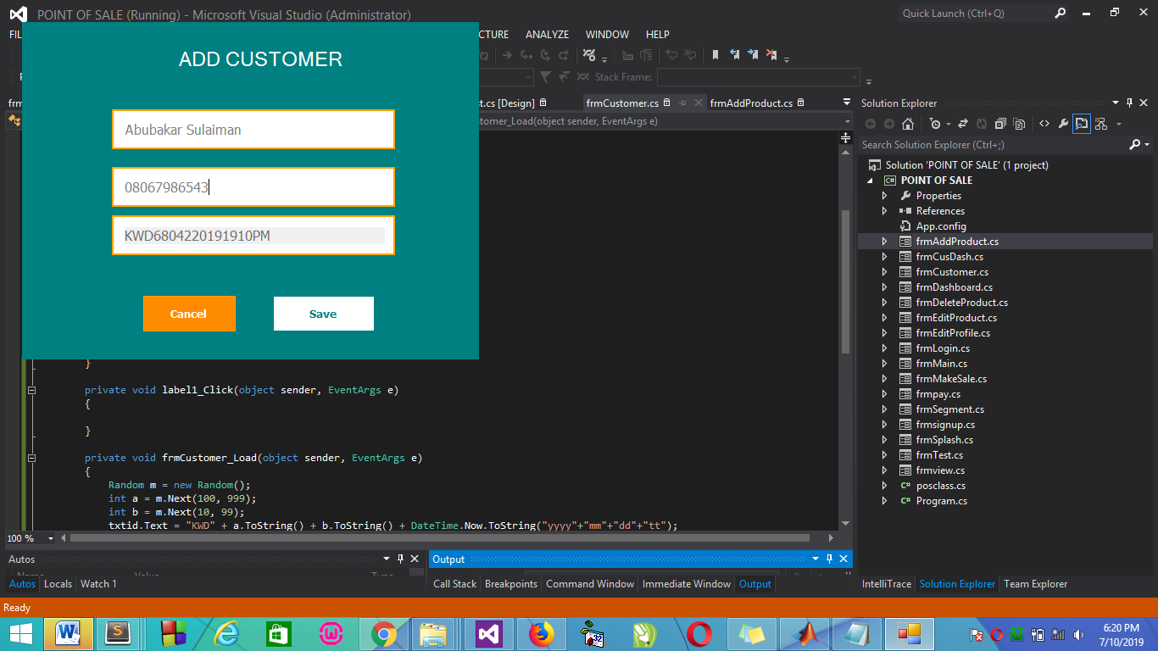
Show information about the customer and allow user to add details to the database with customer ID generated.

Figure 4.2: Make Sales Page Interface

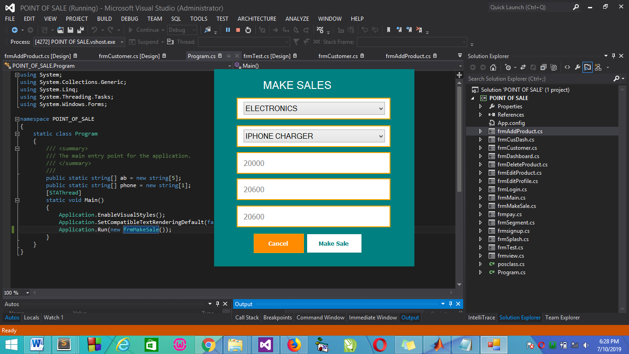
This is where sales is being made for new and existing customer.
4.1.2 Input Design
It is also necessary to denote that data inputted in the computer for processing determines what the output will be. The inputs are use in collecting information the student through the keyboard. Inputs are necessary information needed for processing so as to produce the expected outputs; which are supplied through the keyboard.
Figure 4.3: Input Interface for Admin login.
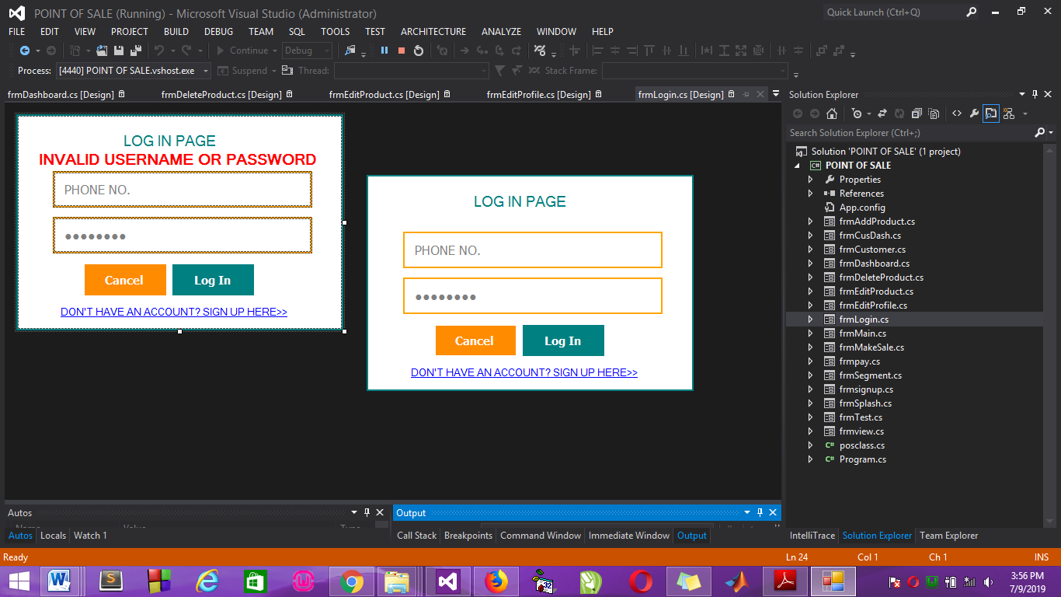
The login environment for users
Figure 4.4: Product Edit Page
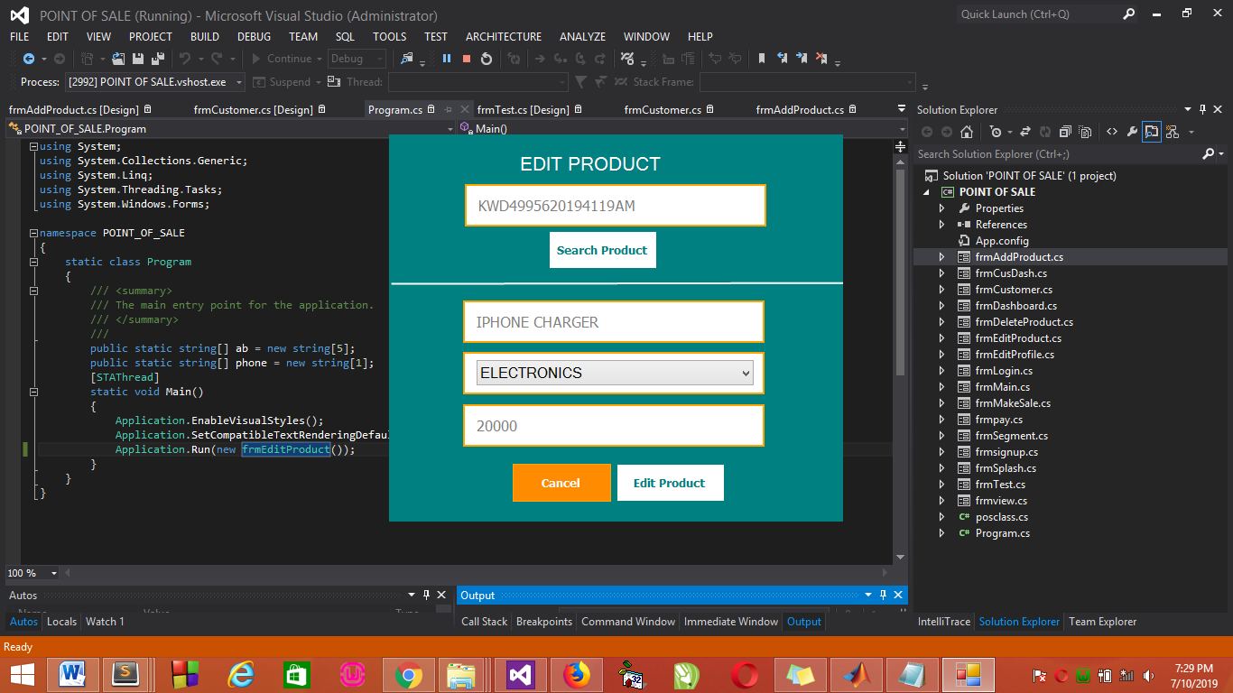
This is where product details are edited.
Table: 4.1 Data for High Customer Buyer
Name | Customer ID | Phone No | Total Amount of Good Purchase per month
Oladosu Zainab | KWD680422019191PM | 08067986543 | 113,453
Okuade Femi | KWD780340191910PM | 09081393831 | 322,765
Bello Abeeb | KWD260340191917PM | 08109951411 | 454,290
JejelayeNaimat | KWD464340131916PM | 09082712134 | 653,327
Abubakar Sulaiman | KWD564340351912PM | 08031528450 | 681,432
Abdulquadri Ahmed | KWD432140351912PM | 07063942846 | 865,765
Table: 4.2 Data for Low Customer Buyer
Name | Customer ID | Phone No | Total Amount of Good Purchase per month
Ajayi Rukayat | KWD679856442222PM | 08163452398 | 2,265
Okuade Timileyin | KWD675433889997PM | 09030108901 | 3,635
Okunade Adebola | KWD568723908798PM | 08132989890 | 4,902
Razak Fatima | KWD653421890097PM | 07033243334 | 6,723
Ajao Suliyat | KWD564878753633PM | 08148600309 | 7,653
Abdulwahab Azima | KWD321000897652PM | 08145326766 | 8,162
Table 4.3: Result
Iteration | Cluster Centre + High | Cluster Centre + Low | Cluster Centre * High | Cluster Centre * Low | Cluster Centre O High | Cluster Centre O Low | Cluster Centre X High | Cluster Centre O Low
0 | -0.0892 | 1.3654 | 0.6541 | -1.0856 | -0.2131 | -0.3669 | -0.2131 | 0.3669
1 | 0.5656 | 1.0971 | 0.8733 | -0.9508 | -0.6728 | -0.6306 | -0.6728 | -0.6306
2 | 0.5798 | 1.0456 | 0.9976 | -0.9639 | -0.5466 | -0.8295 | 0-5466 | -0.295
3 | 0.5502 | 1.0346 | 1.0376 | -0.9348 | -0.5600 | -0.9284 | -0.5466 | -0.9284
4 | 0.5502 | 1.0346 | 1.0376 | -0.9348 | -0.5641 | -0.9557 | -0.5641 | -0.9557
5 | 0.5502 | 1.0346 | 1.0376 | -0.9348 | -0.5901 | -0.9894 | -0.5901 | -0.9894
4.1.3 Database Design
A database table is used for storing information about the files. The database used for this application is mysql database. The files and their respective modes of access as well as information they hold are given below;
Table 4.4: Users Data Table
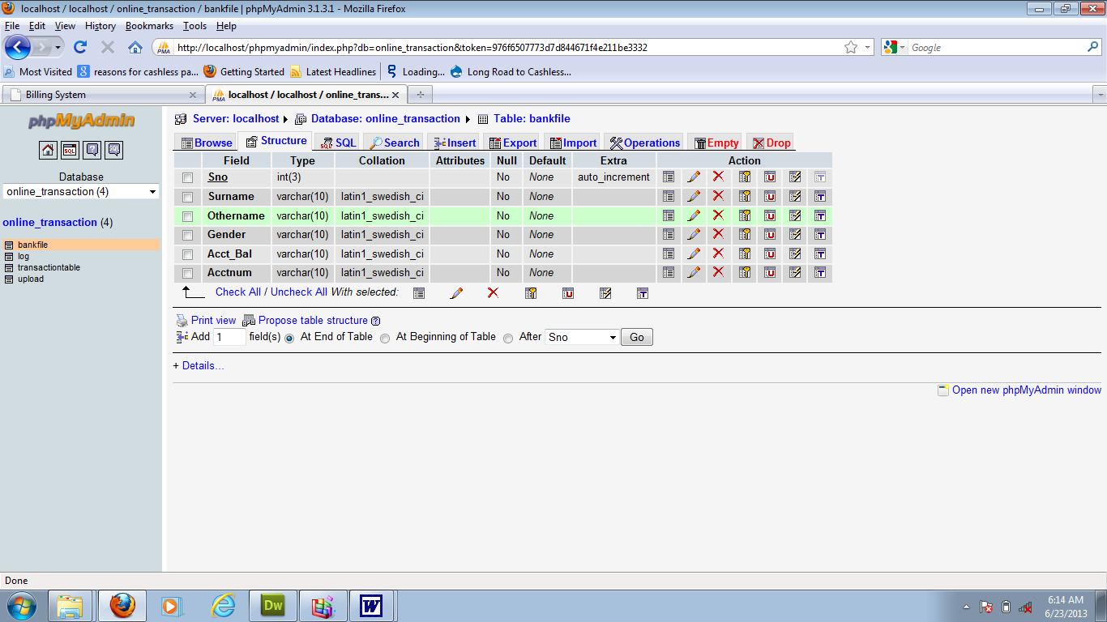

This is users data table where data are stored and retrieved
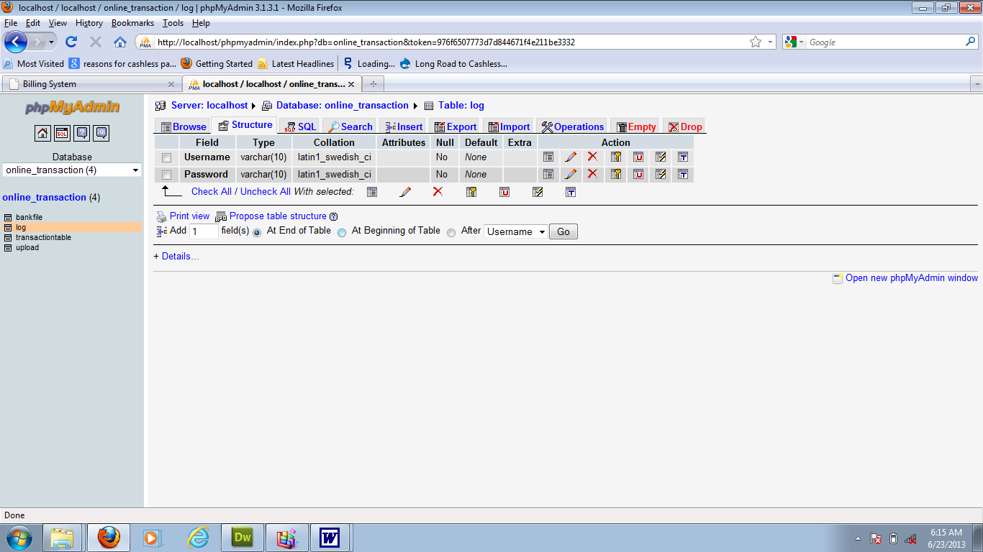
Table 4.5: Product Details Data table

This is where Products data are stored and retrieved
Table 4.6: Customer Data Table
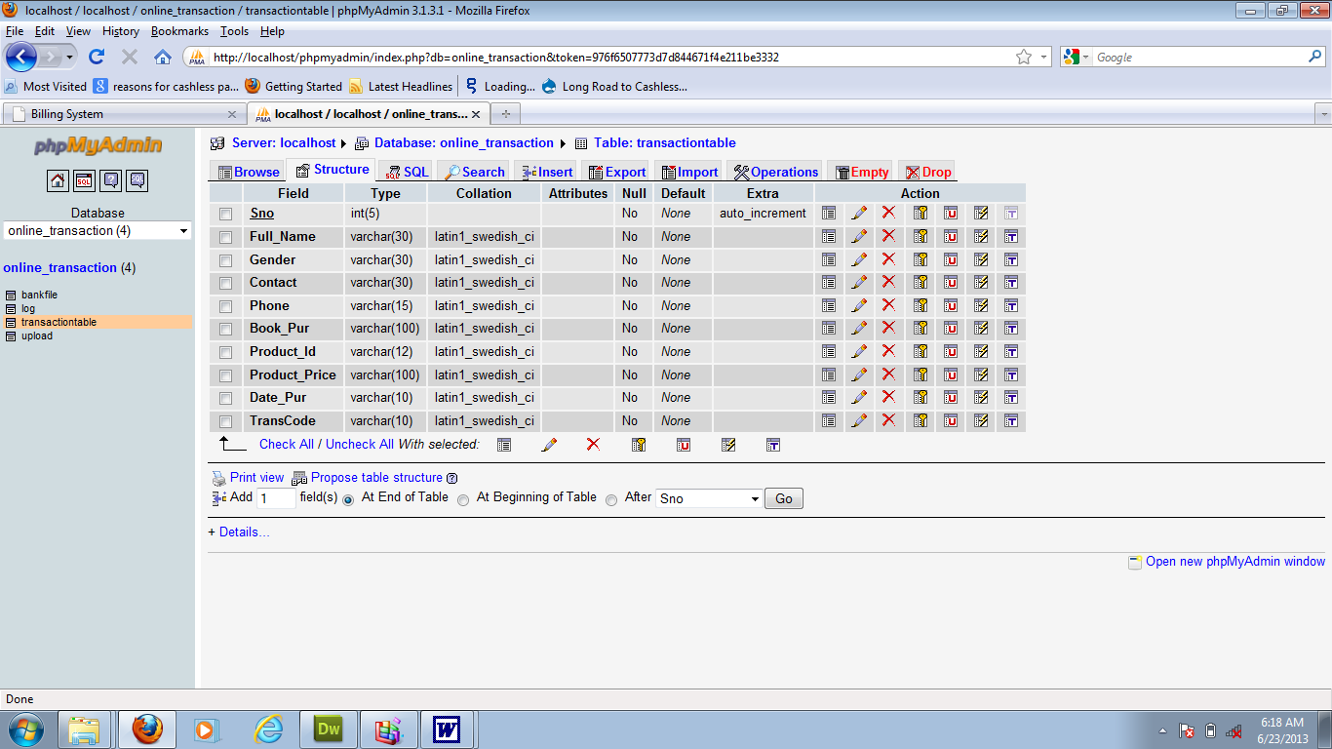
This is where customers selected symptoms are stored and retrieved
4.1.4 Procedure Design
Procedures are steps which verify the whole process i.e which are everything put together to produce the desired output. This involves the organization of the source document and end with the output result.
Documents are sent to various departments to be filled by the employees and later returned to the personnel department which are analyzed to determine which record goes into the computer.
After selecting the necessary data, this serves as input to the computer system.
4.2 Implementation of the System
It is always good to develop new ideas, to implement them on a computer and eventually to relish the satisfaction of achieving a successful result. The implementation process involves converting the system design into a complete and tested EDP that is fully operational and that can be used by the system users to meet their business needs. During implementation phase, the hardware and the software must be implemented.
Implementation of a system can be explained in six steps:-
1. Review design specification
2. Code, test and document programs
3. Train users
4. Perform system test
5. Convert to new system
6. Evaluate and maintain the new system
4.2.1 Choice of Programming Language
The application is designed using C# as the programming language and MYSQL for database management. Hence, the database testing simply involves running it directly from a Mozilla Firefox web browser on local host server provided by Apache 2.0 in WampServer 2.0 application.
In preparation for the installation of the new system, the method of changeover is given serious consideration to determine the success of the new system. Suitable changeover technique for this system is pilot changeover. The pilot changeover operates by applying the new system bit-by-bit until it covers the whole of the operations. The result obtained from using the pilot method on a small portion of the operations would be used in determining the suitability of the need system for the rest of the operations. This method is similar to testing small sample of a distribution if the test yields a good result then the whole system because fully operational and the manual/existing system is eliminated.
4.2.2 Hardware Support
The computer configuration required to run the software is;
Computer/memory processor PC with a 48dx, MHZ or Pentium, Intel or higher processor required.
Memory: 2GB of RAM
Cache memory: 512KB
Hard disk Minimum size 500GB
Recommended 200GB
Virtual Memory 32Bits
Cache memory 512KB
4.2.3 Software
I. Microsoft Visual Studio
ii. MY SQL Database Management Software
iii. Operating system window 07 professional
v. Graphic software paint shop and choosing these two formats GIF (Graphic Image Format)
vi. Scanner software, Mira scans
vii. Web browser software MOZILLA

4.3 System Documentation
4.3.1 Operating the System
Step 1: Boot your computer and click on start button on task bar
Step 2: Click on document
Step 3: Locate Visual Studio and click it
Step 4: Locate your application and click it
Step 5: Choose user and enter the password
Step 6: Click on Options
6.1 Click on Main (to Select Function)
4.3 Click on Sales (to Make Sales)
4.4 Click on Report (to view Sales Report)
4.5 Click on Help (to view the help page)
4.5 Click on About (to view the about page)
Step 5: Logout

4.3.2 Maintaining the System
The use of the term maintenance for software is different from other references to maintenance. Unlike the tires on your car, software does not “wear out”. If this is the case, then why does software maintenance account for such a high percentage of the Total Cost of Ownership for software?
The software maintenance definition refers to changes for defect correction, performance improvements, or adaptations to a changed environment (enhancements). According to this definition, if we build software that is defect-free, performs well, and contains user-controlled parameters to adjust processing rules in response to changing requirements then most maintenance would not be necessary.
Why does this happen? There are many reasons but the most common reasons are time constraints and lack of experience. Adding validation logic takes time. So, people make assumptions about the quality of in-bound data. Assumptions are also made about the volume of transactions and the impact on performance and the stability of the automated business processes. Finally, it is common for new software to be developed by younger developers who don’t understand the maintenance impacts of their designs.
The reality is that business requirements change and most of these assumptions are flawed. Transaction volumes increase, changing business processes require new transactions or new validation criteria, and software users will use the software incorrectly. The cost of software maintenance and the total cost of ownership can dramatically be reduced if developers build software that adjusted to changes in transaction volumes; validated all inbound data and provide user-configurable options for decision logic and data validation.

CHAPTER FIVE
SUMMARY, CONCLUSION AND RECOMMENDATION
5.1 Summary
In summary, customer segmentation system has help in the prediction of highest buyer and lowest buyer at the end of every month which have a positive effect on the business. When dealing with large magnitude of data, organizations need to make use of more efficient clustering algorithms for customer segmentation. These clustering model need to possess the capability to process this enormous data effectively. Each of the above discussed clustering algorithms come with their own set of merits and demerits. With different technique pointed above, it came to light that hybrid approach of combining the algorithm can be useful depending upon different situation and the requirement and apply the strategy accordingly.

5.2 Conclusion
The paper briefly explains customer segmentation and k-means clustering could be used in order to determine high buyer customer and low buyer customer. The simulation results show the distribution of twelve customers of Shoprite supermarket into four clusters. However, the paper considers a data set of 12 customers which can also be the case in real life scenarios as the number of customers might be huge and k-means will provide the intended results when the dataset is large. As explained in “Adapting k-means for clustering in big data”, k-means algorithm would prove to be effective while handling big data as it is while handling small datasets. This is due to the reason that large size of datasets will not affects the clustering quality but clustering time efficiency. Also, in practical situations the dataset would contain attributes that could be numerical as well as categorical and k-means would perform effectively only if the data is purely numerical or purely categorical. It would not perform well when the dataset is a combination of numerical and categorical attributes.

5.3 Recommendation
Our future work will mainly focus on overcoming these drawbacks by working on an approach that would modify the standard k-means clustering and in turn allow the segmentation of large number of customers with minimal error and a better time efficiency. The future will also focus on considering priorities of different variables when performing k-means clustering and hence cluster the customers depending on their score for each variable and the priority of each variable.

REFERENCES
Andrew Aziz (2017) “Customer Segmentation based on Behavioural Data in E-marketplace”, ISSN NO 2320-5407. International Journal of Advanced Research (2017), Volume 1, Issue 7, 343-348. Journal homepage: http://www.journalijar.com
Chinedu, P. E., Simeon, O. & Constance, k. (2015). Application of K-Means Algorithm for Efficient Customer Segmentation: A Strategy for Targeted Customer Services. International Journal of Advanced Research in Artificial Intelligence (IJARAI)Vol. 4, No.10, 201.
Jansen, S.M.H. (2007). Customer Segmentation and Customer Profiling for a Mobile Telecommunications Company Based on Usage Behavior. A heuristic for estimating the parameters in a mixture of normal distributions. IEEE Trans. Comput., vol.C-24 (1975), pp. 835-838.
Jayant, T., Sudhanshu, T. & Sujata, K. (2015). An Approach to Customer Classification using k-means. International Journal of Innovative Research in Computer and Communication Engineering(An ISO 3297: 2007 Certified Organization) Vol. 3, Issue 11, November 2015. ISSN(Online): 2320-9801. ISSN (Print): 2320-9798.
Jenny C. (2014). “Retail Customer Segmentation using SAS” Calgary SAS Users Group meetinghttp://support.sas.com/documentation/http://www.youtube.com/watch?v=NSed-m3Z8Ikhttp://support.sas.com/events/sasglobalforum/previous/online.htmlhttp://support.sas.com/resources/papers/
Kishana, R. K. & Velu, C. M. (2013).“Customer Segmentation Using Clustering and Data Mining Techniques” International Journal of Computer Theory and Engineering, Vol. 5, No. 6, December 2013.
Konstantinos, T. & Antonios, C. (2009).“Data Mining Techniques in CRM”.Library of Congress Cataloguing-in-Publication Data Record on fileA catalogue record for this book is available from the British Library.ISBN: 978-0-470-74397-3 Typeset in 11/13.5pt NewCaledonia by Laserwords Private Limited, Chennai, India. Printed and bound in Great Britain by Antony Rowe Ltd, Chippenham, Wiltshire.
Moe, W. W. & Fader, P. S. (2014) Modeling hedonic portfolio products: a joint segmentation analysis, Journal of Marketing Research, 38(3), 376–385.
Moriarty, R. T. & Reibstein, D. J. (2011) Benefit segmentation in industrial markets, Journal of Business Research, 14(6), 463–486.
Nelson & Ramesh (2007) “Clustering and k-Means Algorithm”, International Journal of Engineering Research and Reviews ISSN 2348-697X (Online) Vol. 4, Issue 1, pp: (82-91), Month: January - March 2016, Available from: www.researchpublish.com.
Nynne L. (2007). “Market Segmentation - A framework for determining the right target customers”. Target marketing for marketing managers Routledge, London(IJARAI) International Journal of Advanced Research in Artificial Intelligence, Vol. 4, No.10, 201.
PRABHA (2012) “An Improved Clustering Algorithm for Customer Segmentation”, International Journal of Computer Science and Information Technologies, Vol. 3 (6), 2012, 5315-5321. www.ijcsit.com Lancet.2015;385:1136–1145.
puwanenthiren (2012).” Customer Segmentation”, Regulatory watch: the target product profile as a tool for regulatory communication: advantageous but underused. Nat Rev Drug Discov. 2012. International Journal of Computer Science and Information Technologies, Vol. 3 (6), 2012,5315-5321. www.ijcsit.com.
Sulekha (2011), ”Product Segmentation” . Information Engineering and Electronic Business, 2, 14-22 Published Online March 2011 in MECS (http://www.mecs-press.org/) DOI: 0.5815/ijieeb.2016.02.02.
Vaishali & Rupa, (2011) “Large Customer arrangement”, Regulatory watch: the target product profile as a tool for regulatory communication: advantageous but underused. Nat Rev Drug Discov. 2011. International Journal of Computer Science and Information Technologies, Vol. 3 (6), 2012,5315-5321. www.ijcsit.com

Appendix 1: SYSTEM FLOWCHART
Customer
Product
Logout
Customer Segmentation
Main Menu
Login
Welcome Page

Start

Stop

Appendix 2: SPLASH SCREEN

Start
Display Splash Screen Details
Stop
Open Database

Close Database

Appendix 3: LOGIN
Start

Open Database

Enter Username and Password

All field are required to proceed
Is any field empty?
Yes

No
Invalid Username and Password
No Username and Password Correct?
No

Yes
Main Menu

Close Database

Return

Appendix 4: MAIN MENU
Start

Open Database

Select option
Yes
Is it option
Customer?
No
No
No
Make Sales
Is it option
Customer Segmentation?
Sales Report
Return
Close Database
Is it option
Product?
No
Customer

No
Yes

No
Yes

Logout
Yes
Is it option Logout?

End Select

Appendix 5: ADD CUSTOMER
Close Database

Open Database

All field are required to proceed
Return
Save Database
Display Customer Details
Is any field empty?
Enter Customer Details
Start

Y

N

Appendix 6: EDIT CUSTOMER
Open Database
Invalid Customer
Enter Customer ID to Search
Is Customer ID correct?
Is any field empty?
ID to search
Start

Y

N
N

Display Customer Record
Y

Edit Record

Update Database

Close Database

Return

Appendix 7: DELETE CUSTOMER

Delete Customer
Close Database

Open Database

Return
Start

Appendix 8: MAKE SALES
Close Database

Open Database

Return
Start
Make Sales

Appendix 9: SALES REPORT
Start

Open Database

Display Sales Report

Close Database

Stop

Appendix 10: PRODUCT
Display Product
Close Database

Open Database

Return
Start

Appendix 11: CUSTOMER SEGMENTATION

Close Database

Open Database

Return
Start
Display Customer Segmentation

Appendix 12: Source Code
using System;
using System.Collections.Generic;
using System.ComponentModel;
using System.Data;
using System.Data.OleDb;
using System.Data.Common;
using System.Drawing;
using System.Linq;
using System.Text;
using System.Windows.Forms;
using Emgu.CV;
using Emgu.CV.Structure;
using Emgu.CV.CvEnum;
using Microsoft.VisualBasic;

namespace FacialRecognition
{
public partial class frmface : Form
{
private Capture grab;
private HaarCascade face;
private List<Image<Gray, byte>> trainingImgs;
private List<string> trainingNames;
private Image<Bgr, byte> current;
private string filePath;
private double scale;
private double epsilon;
private int minNeighbors;
private string name;

public frmface()
{
InitializeComponent();
}

private void Form1_Load(object sender, EventArgs e)
{

txtCascadeFile.Text = Application.StartupPath + "\\haarcascade_frontalface_default.xml";
face = new HaarCascade(txtCascadeFile.Text);
btnTrain.Enabled = false;
trainingImgs = new List<Image<Gray, byte>>();
trainingNames = new List<string>();
Application.Idle += new EventHandler(FrameGrabber);
current = null;
filePath = string.Empty;
btnDetect.Enabled = false;
chkboxDetectFaces.Enabled = false;
scale = Double.Parse(txtScale.Text);
epsilon = Double.Parse(txtEpsilon.Text);
minNeighbors = Int32.Parse(txtMinNeighbors.Text);
}

private void btnGrabber_Click(object sender, EventArgs e)
{
if (btnGrabber.Text == "View Webcam")
{
grab = new Capture();
grab.QueryFrame();
//btnTrain.Enabled = true;
btnGrabber.Text = "Stop Webcam";
btnLoad.Enabled = false;
btnDetect.Enabled = false;
btnTrain.Enabled = true;
chkboxDetectFaces.Enabled = true;
}
else if (btnGrabber.Text == "Stop Webcam")
{
btnGrabber.Text = "View Webcam";
//btnTrain.Enabled = false;
grab.Dispose();
btnLoad.Enabled = true;
btnTrain.Enabled = false;
chkboxDetectFaces.Enabled = false;
}

picWebCam.Image = current.ToBitmap();
}

private void lstTraining_DoubleClick(object sender, EventArgs e)
{
if (lstTraining.SelectedIndex == -1) return;
DialogResult result = MessageBox.Show("Are you sure you wish to delete this entry?", "Delete?", MessageBoxButtons.YesNo);
if (result == DialogResult.Yes)
{
int index = lstTraining.SelectedIndex;
trainingImgs.RemoveAt(index);
trainingNames.RemoveAt(index);
if (trainingImgs.Count > 0) lstTraining.SelectedIndex = trainingImgs.Count - 1;

lstTraining.Items.RemoveAt(index);

}
//else do nothing
}

private void btnDetect_Click(object sender, EventArgs e)
{
current = new Image<Bgr, byte>(filePath).Resize(300, 250, INTER.CV_INTER_CUBIC);
Image<Gray, byte> grayScale = current.Convert<Gray, byte>();

if (btnGrabber.Text == "Stop Webcam")
{
Program.kip.imgpic.Image = picTraining.Image;
btnGrabber.PerformClick();
this.Close();
}
this.Close();
}

