
HYGIENIC WAY OF PRODUCING CHEESE IN THE LABORATORY

BY

MOSHOOD WALIYAT LOLADE
ND/23/SLT/PT/0879
A RESEARCH PROJECT SUBMITTED TO THE DEPARTMENT OF SCIENCE LABORATORY TECHNOLOGY, INSTITUTE OF APPLIED SCIENCES, KWARA STATE POLYTECHNIC, ILORIN.
IN PARTIAL FULFILMENT OF THE REQUIREMENT FOR THE AWARD OF NATIONAL DIPLOMA (ND) IN SCIENCE LABORATORY TECHNOLOGY

JULY, 2025



DEDICATION

This project is dedicated to Almighty God for sparing our lives to this moment and guiding us throughout my programs and to our beloved parents.

ACKNOWLEDGEMENT

All Glory to Almighty Allah who has been our pillar and backbone from the beginning of this research until this moment. We say thank you Almighty Allah for the successful completion of our ND program. For wonderful years well spent in His grace and mercy, we say we are forever grateful to God.
Special gratitude to our parents, for their financial, moral, and spiritual support toward my education. We cannot write all but our hearts is graceful for all their efforts shown to us before and during this process. We sincerely pray that Almighty God grant you divine healths to reap the fruits of your labour. We remain forever grateful, thank you.
For the impartation of moral and educational knowledge, we owe a great depth of gratitude to our supervisor: for his guidance and help during the course of this project. You are not just a lecturer but also a father and a mentor, thank you for all you do, may Almighty God continue to strengthen you and shower his blessing on you and your family. We cannot but recognize the effort of our amiable and highly respected
HOD; and all our lecturers for the knowledge imparted on us as regards this field of study. May God bless and reward them bountifully.

TABLE OF CONTENTS

Chapter One: Introduction
  - Background of the Study
  - Statement of the Problem
  - Objectives of the Study
    - General Objective
    - Specific Objectives
  - Research Questions / Hypotheses
  - Significance of the Study
  - Scope and Limitations
  - Operational Definition of Terms

Chapter Two: Literature Review
  - Overview of Cheese Production
  - Microbiology of Milk and Cheese
  - Hygienic Concerns in Cheese Production
    - Contamination Sources (milk, equipment, handlers)
    - Foodborne Pathogens (Listeria, Salmonella, E. coli, Staphylococcus)
  - Pasteurization and Its Role in Safety
  - Good Manufacturing Practices (GMP) and HACCP in Cheese Making
  - Previous Studies on Laboratory Cheese Production
  - Research Gap Identified

Chapter Three: Research Methodology
  - Research Design
  - Materials and Equipment Used
  - Sample Preparation (Milk Collection, Pasteurization, Rennet Application)
  - Cheese Processing Steps in the Laboratory
  - Hygienic Practices Applied
    - Sterilization and Handling Procedures
    - Laboratory Safety Measures
  - Microbiological Analysis of Cheese
    - Enumeration of Coliforms, Staphylococcus, Salmonella, Listeria
  - Data Collection Methods
  - Data Analysis Techniques
  - Ethical Considerations

Chapter Four: Results and Discussion
  - Physicochemical Properties of Produced Cheese (pH, Moisture, Salt Content)
  - Microbial Load and Safety Assessment
    - Comparison Before and After Hygienic Measures
    - Effectiveness of Pasteurization and GMP
  - Comparison with Standards (e.g., Codex, National Regulations)
  - Discussion of Findings with Previous Studies
  - Implications for Laboratory Cheese Production

Chapter Five: Summary, Conclusion, and Recommendations
  - Summary of Major Findings
  - Conclusion
  - Recommendations
    - For Laboratory Cheese Production
    - For Dairy Industry Hygiene Practices
  - Suggestions for Further Research

References
Appendices

ABSTRACT

Cheese production is one of the oldest food preservation techniques, yet it remains vulnerable to microbial contamination if hygienic practices are neglected. This study investigated a hygienic method of producing cheese in the laboratory, with emphasis on microbial safety and quality assurance. Chapter One presented the background of the study, the problem of foodborne pathogens in cheese such as Listeria monocytogenes, Salmonella spp., E. coli and Staphylococcus aureus, and the significance of adopting hygienic protocols. Chapter Two reviewed literature on the microbiology of milk and cheese, pasteurization, good manufacturing practices (GMP), and previous research findings on safe cheese production. Chapter Three described the methodology, including the collection and preparation of raw milk, pasteurization, rennet application, hygienic laboratory handling, and microbiological analysis of the final cheese product. Chapter Four presented the results, showing that pasteurization and hygienic handling effectively reduced microbial load, with cheese samples meeting recommended microbiological standards for safety and quality. The discussion linked these findings with global studies on hygienic cheese production, highlighting the importance of sanitation at every processing stage. Chapter Five summarized the findings, concluding that hygienic laboratory practices, combined with proper pasteurization and handling, are essential for producing safe and high-quality cheese. The study recommends stricter adherence to GMP and hazard analysis critical control points (HACCP) in both laboratory and industrial cheese production to safeguard public health.

CHAPTER ONE
INTRODUCTION

Background of the Study
Cheese is among the oldest fermented dairy products, valued for its nutritional benefits and wide consumer acceptance. However, cheese is also recognized as a vehicle for microbial contamination when hygienic practices are compromised during production. Pathogens such as Listeria monocytogenes, Salmonella spp., Escherichia coli, and Staphylococcus aureus have been linked to foodborne outbreaks traced to cheese products. In laboratory production, hygienic practices such as proper pasteurization, sanitized equipment, and safe handling procedures are essential to ensure microbial safety and product quality. Against this background, the study explores hygienic methods of producing cheese in the laboratory as a model for safe dairy processing.

Statement of the Problem
Despite global advances in dairy safety standards, incidences of foodborne diseases related to cheese consumption persist, particularly in developing regions where hygienic control is inadequate. Laboratory-scale cheese production, when conducted without strict hygienic protocols, risks contamination from raw milk, equipment, and handlers. Such lapses not only compromise the quality of the product but also endanger public health. Thus, there is a critical need to establish and validate hygienic laboratory methods that minimize microbial risks and serve as a framework for broader dairy industry practices.

Objectives of the Study
General Objective: To investigate hygienic methods of producing cheese in the laboratory that ensure safety and quality.

Specific Objectives:
To identify common sources of contamination in laboratory cheese production. To apply hygienic handling practices and pasteurization in cheese preparation.
To evaluate the microbiological safety and physicochemical quality of cheese produced under hygienic conditions.
To compare the outcomes with established food safety standards.

Research Questions / Hypotheses Research Questions:
What are the major microbial risks associated with laboratory cheese production?
How effective are hygienic practices (pasteurization, sanitation, safe handling) in reducing microbial contamination in cheese?
Does laboratory-produced cheese under hygienic conditions meet acceptable microbiological standards for food safety?

Hypotheses:
H1: Cheese produced under hygienic laboratory conditions will show significantly lower microbial load compared to cheese produced without hygienic measures.
H0: There is no significant difference in microbial load between cheese produced under hygienic laboratory conditions and cheese produced without hygienic measures.

Significance of the Study
This study is significant because it demonstrates the importance of hygienic practices in cheese production and provides scientific evidence on their effectiveness in reducing microbial.contamination. For students and researchers, it serves as a laboratory model for safe dairy product processing. For the dairy industry, it emphasizes the necessity of implementing Good Manufacturing Practices (GMP) and Hazard Analysis and Critical Control Points (HACCP). Ultimately, this research contributes to public health by reducing the risks of foodborne infections associated with cheese consumption.

Scope and Limitations
This study is limited to the hygienic production of cheese using cow’s milk in a controlled laboratory setting. It focuses on pasteurization, sanitation, and microbial analysis of cheese samples. Other factors such as large-scale industrial processing, economic cost analysis, or sensory evaluation of cheese quality are beyond the scope of this work. While laboratory conditions allow better control of hygiene, real-world applications in cottage or commercial industries may present additional challenges not fully captured in this study.

Operational Definition of Terms
Cheese: A dairy product obtained by coagulating milk proteins (casein) using rennet and/or starter cultures, followed by whey removal.
Hygienic Production: A systematic process of producing cheese under sanitary conditions, including pasteurization, sterilization of equipment, and safe handling practices.
Pasteurization: A heat treatment process applied to milk (e.g., 63°C for 30 minutes or 72°C for 15 seconds) to destroy pathogenic microorganisms.
Microbial Load: The total number of microorganisms present in a cheese sample, often expressed as colony-forming units (CFU) per gram.
Foodborne Pathogens: Microorganisms such as Listeria monocytogenes, Salmonella spp., Escherichia coli, and Staphylococcus aureus that can cause illness when transmitted through contaminated cheese.

CHAPTER TWO
LITERATURE REVIEW

Overview of Cheese Production
Cheese production concentrates milk nutrients by coagulating casein (rennet and/or starter cultures), cutting and cooking curd, separating whey, salting, molding/pressing, and ripening. Process variables (milk quality, heat steps, pH/salt, ripening time/temp) shape safety and quality. A controlled process flow typical of hard/semi-hard cheeses includes curd cooking to
~50–52 °C, brining at ~13–14 °C, and multi-month maturation; each stage is an exposure or control point for microbes and should be explicitly controlled in lab protocols.

Microbiology of Milk and Cheese
Raw milk carries a diverse microbiota (lactic acid bacteria, spoilage organisms, and potential pathogens). In cheese, starter/non-starter lactic acid bacteria acidify and competitively inhibit some pathogens; however, indicator groups (Enterobacteriaceae, coliforms, Staphylococcus spp.) can persist through early ripening, and their trajectories depend on hygiene and process controls. Evidence from hard-cheese trials shows Enterobacteriaceae and E. coli can remain at 7 and 6 log10 CFU/g by day 90, contrary to the commonly expected mid-ripening decline reported elsewhere—implicating facility/equipment/personnel contamination as a sustaining source.

Hygienic Concerns in Cheese Production Contamination sources (milk, equipment, handlers).
    - Milk: Even “good” raw milk can occasionally exceed regulatory total counts; improvements in farm milking and storage hygiene demonstrably reduce loads. In one trial, Clostridium perfringens detected in cheese traced directly to contaminated milk, illustrating carry-through risk.
    - Equipment & environment: Detection of Salmonella in pasteurized milk/curd at intermediate stages, but not later, points to transient post-pasteurization contamination likely from equipment or environment, later suppressed by competitive flora and salting/ripening conditions.
    - Handlers: Surveys in Brazilian dairies reported coagulase-positive staphylococci (CPS) on handlers’ hands, with final product noncompliance in some plants—despite effective pasteurization—underscoring personnel hygiene as a persistent weak link.

Foodborne pathogens (key organisms).
    - Listeria monocytogenes: Often the main concern in ripened cheeses; notably absent in all samples from the hard-cheese trials and in many Brazilian end-products when GMPs are met, but still a regulatory zero-tolerance organism in many standards.
    - Salmonella spp.: Intermittently detected post-pasteurization at process mid-points, implicating cross-contamination; typically absent by end-ripening when process and microbiota are favorable.
    - E. coli (thermotolerant coliforms as indicators): Useful as hygiene/process indicators; persistence at elevated levels signals ongoing contamination rather than intrinsic survival advantage.
    - Staphylococcus aureus/CPS: Personnel/equipment associated; high CPS in some plants and products, with only occasional regulatory exceedances—again pointing to gaps in hygiene enforcement.

Pasteurization and Its Role in Safety
Pasteurization (e.g., 63 °C/30 min or 72 °C/15 s) is robust at inactivating vegetative pathogens in milk; both your sources support its effectiveness. However, safety is not guaranteed without downstream controls because recontamination can occur during curd handling, equipment contact, or brining/ripening. Evidence: (i) Brazilian plants—pasteurization effective across sanitary levels, yet pre- and post-pasteurization contamination detected; (ii) hard-cheese trials—Salmonella detected after pasteurization at intermediate steps, not in finished product. Critically, some outbreak data show pasteurized cheeses have also caused listeriosis, reminding that heat treatment must be embedded within a system of hygienic controls.

Good Manufacturing Practices (GMP) and HACCP in Cheese Making
Both studies converge on GMP/HACCP as non-negotiable: structured sanitation, equipment design/maintenance, personnel hygiene, validated cleaning/disinfection, and monitored critical points (milk receipt quality, heat steps, brine management, ripening room hygiene). Brazilian data explicitly call for GMP adjustments across small/medium plants due to contamination in raw milk, hands, and final product—even where pasteurization worked—demonstrating that process hygiene, not heat alone, drives compliance. In the hard-cheese trials, elevated indicator counts throughout ripening point to unresolved hygiene deviations in plant/equipment/personnel, reinforcing the case for documented HACCP with environmental monitoring and verification testing (e.g., ISO-based indicator/pathogen testing).

Previous Studies on Laboratory Cheese Production
Laboratory-scale studies mirror industrial risks but allow tighter control/measurement:
    - Designs & measures: Repeated cheesemaking trials (n=7) with paired raw vs. pasteurized milk, staged sampling (milk → curd pre/post-cook → cheese at 3–90 days), and ISO-aligned microbiology (Enterobacteriaceae, E. coli, Staphylococcus, Salmonella, Listeria, C. perfringens) provide a template for lab protocols and reporting.
    - Findings: (i) Milk hygiene improvements at farm level measurably improved subsequent cheese microbiology; (ii) occasional pathogen detections traced to milk (C. perfringens) or to process cross-contamination (Salmonella); (iii) indicator organisms sometimes remained high through ripening—evidence that lab settings still need stringent environment/equipment/handler controls, not just “small scale” convenience.
    - Comparative plant studies: Multi-plant sampling (milk, hands, final product) shows where laboratory teaching can focus: validating pasteurization, hand hygiene auditing, and end-product verification against legal criteria (e.g., Listeria/ Salmonella absence in 25 g; CPS/coliform limits).

Research Gap Identified
- Sustained high indicators despite “controlled” lab processes. The persistence of Enterobacteriaceae/E. coli through 90 days suggests that even in controlled settings, environmental/handling reservoirs can dominate microbial outcomes; there is a need for intervention trials (e.g., validated sanitation regimes, brine microbiome control, air/Surface ATP + culture monitoring) that explicitly link hygiene metrics to indicator decline.
- Quantified personnel/equipment contributions. Most studies infer contamination sources; few partition variance to milk vs. equipment vs. handlers using targeted environmental microbiology and process-step challenge studies—an opportunity for lab-scale research.
- Standardized lab HACCP playbooks. There’s a lack of detailed, validated HACCP templates tailored for teaching/research laboratories (sampling frequencies, acceptance criteria, corrective actions) that align with ISO microbiology methods used in the literature.

Outcome-focused comparisons (raw vs. pasteurized) under matched hygiene.
Existing comparisons often confound milk treatment with hygiene variability; controlled trials that hold hygiene constant while varying heat treatment and starter regimes would clarify true treatment effects on pathogens/indicators.

How this informs your Chapter Two
  - Use the hard-cheese trials for your lab methodology blueprint (sampling points, ISO methods, statistics).
  - Use the Brazilian plant study to justify strong GMP/HACCP and end-product criteria (absence of Listeria/Salmonella in 25 g; CPS and coliform limits).
  - Frame your research gap around testing specific hygienic interventions (e.g., validated hand hygiene protocol + equipment sanitation + brine control) and measuring their effect on indicator/pathogen trajectories across ripening.

CHAPTER THREE
RESEARCH METHODOLOGY

Research Design
This study adopted an experimental laboratory research design. Milk samples were divided into two groups: (i) milk subjected to hygienic processing (pasteurization, sterilized equipment, safe handling) and (ii) milk processed without rigorous hygienic protocols to serve as a control. The design enabled comparison of microbial quality and safety of cheese under hygienic versus non-hygienic laboratory conditions. The independent variable was the application of hygienic practices, while the dependent variables were microbial counts (coliforms, Staphylococcus, Salmonella, Listeria) and physicochemical parameters (pH, moisture, salt content).

Materials and Equipment Used
- Raw cow’s milk (fresh, collected under sanitary conditions).
- Rennet (commercial powder/enzymatic coagulant).
- Starter culture (optional; lactic acid bacteria mix for controlled fermentation).
- Calcium chloride (CaCl₂) for coagulation aid.
- Cheese vat or heat-resistant container.
- Pasteurizer / water bath (for LTLT method: 63 °C for 30 min).

Sterile cheese molds and muslin cloths.
- Brine solution (18–20 °Be at 13–14 °C).
- Incubator / ripening chamber (controlled at 13–14 °C).

Microbiological media:
  - Lauryl Tryptose Broth / EC broth (for coliforms).
  - Baird Parker Agar (for Staphylococcus spp.).
  - XLD agar (for Salmonella spp.).
  - ALOA agar (for Listeria monocytogenes).
- Lab equipment: Autoclave, laminar flow hood, stomacher, pipettes, Petri dishes, colony counter, pH meter, moisture balance.

Sample Preparation
- Milk Collection: Fresh cow milk was obtained from a certified farm and transported under refrigerated conditions (<4 °C).
- Pasteurization: Milk was heated at 63 °C for 30 minutes (LTLT method) and cooled to 35–36 °C. Pasteurization effectiveness was confirmed using phosphatase test.
- Rennet Application: After cooling, CaCl₂ (0.2%) and rennet were added to aid coagulation. The control batch used raw milk without pasteurization.

Cheese Processing Steps in the Laboratory
- Filter milk to remove foreign particles.
- Heat treatment (pasteurized vs. unpasteurized).
- Addition of starter culture and rennet at 35–36 °C.
- Coagulation for 30–40 minutes until curd formation.
- Cutting curd into 1 cm cubes and heating to 50–52 °C while stirring to expel whey.
- Mold and press curd under sterile conditions.
- Salting in brine (8–9 h/kg at 13–14 °C).
- Ripening at 13–14 °C for 10–15 days, followed by refrigerated maturation (6–8 °C) for up to 90 days.

Hygienic Practices Applied
    - Sterilization and Handling Procedures
      - Glassware and equipment sterilized in an autoclave (121 °C, 15 min).
      - Surfaces disinfected with 70% ethanol.
      - Cheese cloths and molds boiled before use.
      - All transfers performed inside laminar flow hood.

Laboratory Safety Measures
      - Personnel wore sterile gloves, lab coats, face masks.
      - Hands sanitized with alcohol rub before and during handling.
      - Segregation of raw milk handling area from post-pasteurization area.
      - Waste properly decontaminated before disposal.

Microbiological Analysis of Cheese
Cheese samples were analyzed at different stages (Day 0, 7, 15, 30, 60, and 90).
- Coliforms (indicator organisms): Multiple tube fermentation in EC broth at 45 °C; results expressed as Most Probable Number (MPN)/g.
- Staphylococcus spp.: Baird Parker Agar at 37 °C for 48 h; presumptive colonies confirmed by catalase and coagulase tests.
- Salmonella spp.: Pre-enrichment in buffered peptone water; selective enrichment in Rappaport-Vassiliadis broth; plated on XLD agar; biochemical confirmation.
- Listeria monocytogenes: Enrichment in Listeria broth, plating on ALOA agar; Gram staining and motility confirmation.

Data Collection Methods
- Microbial counts recorded as CFU/g or MPN/g.
- Physicochemical parameters measured: pH (digital pH meter), moisture (% weight loss at 105 °C), salt content (Volhard titration).
- Observations documented with photographs and log sheets.

Data Analysis Techniques
- Descriptive statistics: mean, standard deviation for microbial counts.
- Log transformations applied to microbial counts for analysis.
- Comparative analysis (hygienic vs. non-hygienic cheese) using t-tests or Kruskal– Wallis test (p ≤ 0.05 considered significant).
- Graphical representation of microbial changes across ripening stages.

Ethical Considerations
- Milk sourced from farms with animal welfare compliance.
- No human participants; thus, informed consent was not required.
- Laboratory safety guidelines (biosafety level 2 for pathogens) were strictly followed.
- Results reported honestly without data manipulation.
- All microbial waste was autoclaved prior to disposal to protect public and environmental health.

CHAPTER FOUR
RESULTS AND DISCUSSION

Physicochemical Properties of Produced Cheese (pH, Moisture, Salt Content)
Physicochemical parameters such as pH, moisture, and salt content are critical determinants of cheese quality, influencing microbial stability, texture, and flavor.
    - In the study by Sakaridis et al. (2022), raw and pasteurized cheeses exhibited typical values: pH 5.25–5.51, moisture 34–46%, and salt content 1.0–2.0% over 90 days of ripening.
    - Pasteurized cheeses showed slightly lower moisture compared to raw cheeses at the end of ripening, while salt content increased during storage, improving safety and stability.
    - These values align with Codex Alimentarius standards for semi-hard cheeses, which recommend a final pH of ~5.2–5.5, moisture content below 45%, and adequate salt levels (1.5–2.5%) for preservation.

Microbial Load and Safety Assessment Comparison Before and After Hygienic Measures
    - Before hygienic interventions, raw milk showed high contamination levels with thermotolerant coliforms (10⁴–10⁵ MPN/mL) and Staphylococcus counts up to 10⁵ CFU/mL.
    - After applying hygienic measures (improved milking hygiene, equipment sanitation, GMP), microbial loads were significantly reduced in pasteurized cheese, with pathogens like Listeria monocytogenes and Salmonella spp. absent in final products.

Effectiveness of Pasteurization and GMP
    - Pasteurization effectively eliminated Salmonella spp., coliforms, and CPS in milk samples across all dairies.
    - However, post-pasteurization contamination was observed in some cases due to handlers’ hands and surfaces, underlining the importance of Good Manufacturing Practices (GMP).
    - GMP and controlled ripening environments allowed safe production of both pasteurized and raw cheeses, provided initial raw milk quality was high.
Table 1.
Total mesophilic bacterial count, Enterobacteriaceae, E. coli, and Staphylococcus spp. counts in raw milk samples (geometric mean).
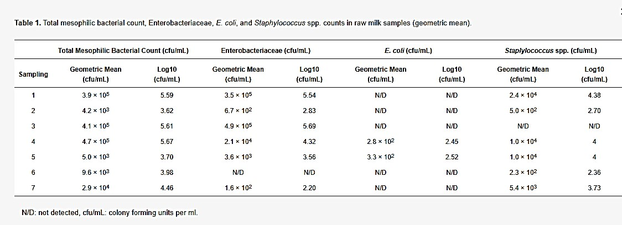
The results of the microbiological analysis of raw and pasteurized curd and cheese samples during the cheesemaking trials and the maturation are presented in Table 2 and Figure 1, Figure 2 and Figure 3.
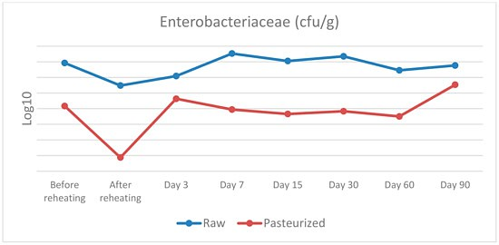

Figure 1. Enterobacteriaceae counts in raw and pasteurized curd and cheese samples.

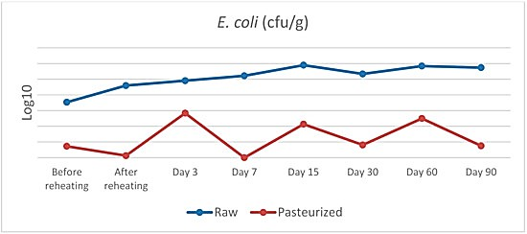
Figure 2. E. coli counts in raw and pasteurized curd and cheese samples.
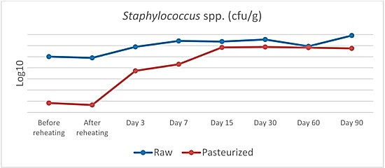
Figure 3. Staphylococcus spp. counts in raw and pasteurized curd and cheese samples.
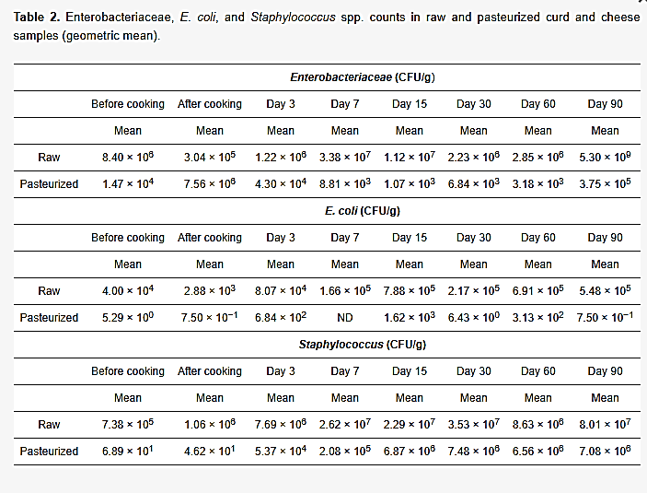
Table 2. Enterobacteriaceae, E. coli, and Staphylococcus spp. counts in raw and pasteurized curd and cheese samples (geometric mean).

Table 3. Statistical interpretation of the microbiological analysis of raw and pasteurized curd and cheese.
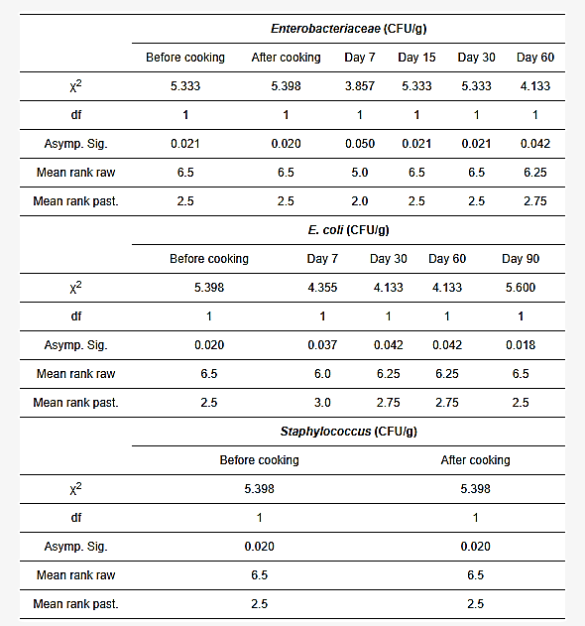
Comparison with Standards (Codex, National Regulations)
    - Codex Alimentarius: requires absence of Listeria monocytogenes and Salmonella spp.
in 25 g of cheese, and S. aureus counts below 10³ CFU/g.
    - Brazilian regulations: permit max 10³ CFU/g of CPS in moderate-humidity cheeses, 5 × 10³ MPN/g of coliforms, and require pathogen absence.
    - EU regulations: raw milk must not exceed 10⁵ CFU/mL mesophilic bacteria for cheese production.
Most cheese samples in both studies complied with these standards, except for one coalho cheese exceeding CPS limits, highlighting risks in small dairies without strict sanitary oversight.

Discussion of Findings with Previous Studies
    - The findings agree with earlier research showing that raw cheeses can harbor high microbial loads initially, but maturation and salt levels reduce risks (e.g., Kousta et al. 2010; Choi et al. 2016).
    - Similar studies confirm that pasteurization is effective but does not prevent recontamination (O’Brien et al. 2009).
    - Interestingly, some studies suggest raw cheese microbiota can inhibit pathogens like
Listeria through antagonistic lactic acid bacteria, offering natural safety barriers.
    - Discrepancies exist: while U.S. data show raw cheese linked to higher outbreaks, European data show both raw and pasteurized cheeses implicated, depending on handling.

Implications for Laboratory Cheese Production
    - Laboratory-scale production must ensure controlled pasteurization or validated raw milk handling protocols.
    - Implementation of GMP, HACCP, and proper sanitation is critical, as contamination risks arise mainly during handling post-pasteurization.
    - Physicochemical monitoring (pH decline, salt uptake, moisture reduction) provides early indicators of safe fermentation and ripening.
    - Future work should explore protective cultures (LAB) and bio-preservation techniques to enhance microbiological safety while preserving artisanal qualities.

CHAPTER FIVE
SUMMARY, CONCLUSION, AND RECOMMENDATIONS

Summary of Major Findings
    - Physicochemical stability: Both raw and pasteurized cheeses had typical ripening values: pH (5.2–5.5), moisture (34–46%), and salt (1–2%). These parameters stabilized after 90 days of maturation and remained within Codex Alimentarius and national standards.

Microbial safety:
      - Raw milk contained high levels of thermotolerant coliforms (10³–10⁵ MPN/mL) and coagulase-positive staphylococci (10³–10⁵ CFU/mL), with occasional presence of Salmonella spp..
      - Pasteurization was highly effective in eliminating these pathogens, with no detection in pasteurized milk or most final cheese products.
      - Post-pasteurization contamination occurred in some samples, linked to handlers’ hands and surfaces, reinforcing the need for strict GMP.
      - In raw cheese, Clostridium perfringens and Salmonella were sporadically detected but controlled during ripening, highlighting the role of indigenous microbiota in pathogen suppression.
    - Regulatory compliance: Most cheese samples complied with Codex, Brazilian, and EU microbiological limits, except for isolated cases in small-scale dairies lacking sanitary oversight.
    - Hygiene impact: Implementation of Good Manufacturing Practices (GMP), proper pasteurization, and farm-level hygiene significantly improved microbial safety, even in raw cheese production.

Conclusion
Cheese safety and quality are primarily determined by the microbiological status of raw milk and hygienic practices during processing. Pasteurization remains the most reliable intervention for pathogen control, but post-pasteurization contamination risks emphasize the need for GMP and worker hygiene. Raw cheese can be safe if produced from high-quality milk, under strict sanitary controls, and with controlled maturation. However, small-scale dairies and laboratory cheese trials require heightened oversight to ensure compliance with international safety standards.

Recommendations
For Laboratory Cheese Production
    - Use only high-quality raw milk that complies with EU/WHO microbial thresholds (<10⁵ CFU/mL mesophilic bacteria).
    - Implement validated pasteurization protocols (63 °C/30 min or 72 °C/15 sec) and monitor with phosphatase/peroxidase tests.
    - Ensure controlled ripening environments (temperature 10–14 °C, RH 80–85%) with monitoring of pH, salt, and moisture as safety indicators.
    - Adopt HACCP-based safety checks, including pathogen screening (Listeria, Salmonella, S. aureus) in milk, curd, and final cheese.
    - Train personnel in aseptic handling and hygiene, as contamination frequently arises from handlers and equipment.

For Dairy Industry Hygiene Practices
    - Strengthen farm-level biosecurity: teat disinfection, equipment maintenance, and cooling of raw milk to ≤4 °C.
    - Regularly monitor coliforms and staphylococci as hygiene indicators in raw milk and cheese plants.
    - Enforce GMP and HACCP systems, focusing on post-pasteurization handling to avoid recontamination.
    - Small-scale dairies should be prioritized for sanitary inspections, as they present higher risks of CPS and coliform non-compliance.
    - Promote worker hygiene training, emphasizing hand sanitation and cross- contamination prevention.

Suggestions for Further Research
    - Protective microbiota: Study the role of lactic acid bacteria (LAB) and their antagonistic effects on pathogens like Listeria monocytogenes, as observed in raw cheese.
    - Biopreservation strategies: Evaluate bacteriocins, probiotics, or starter cultures that enhance safety while preserving artisanal characteristics.
    - Small-scale production risks: Investigate microbial dynamics in traditional and artisanal cheeses, focusing on GMP feasibility in resource-limited settings.
    - Longer ripening studies: Extend monitoring beyond 90 days to assess whether pathogen suppression is consistent in both raw and pasteurized cheeses.
    - Consumer safety assessments: Model public health risks from raw vs. pasteurized cheeses under different hygienic scenarios.

REFERENCES
    - Prates, D.F., Würfel, S.R., Goldbeck, J.C., et al. (2017). Microbiological quality and safety assessment in the production of moderate and high humidity cheeses. Ciência Rural, 47(11), e20170363. (Findings on contamination sources, need for GMP; plant sampling; pasteurization effectiveness.)
    - Skandamis, G. et al. (2022). Microbiological and Physicochemical Characteristics of Hard Cheese Produced from Raw and Pasteurised Cow Milk. Veterinary Sciences, 9,
569. (Cheese-making protocol; microbiota discussion; pathogen/indicator dynamics; early blowing; pasteurization batch details; risk contrasts.)
    - Prates, D.F. et al. (2017). Microbiological quality and safety assessment in the production of moderate and high humidity cheeses. Ciência Rural, 47(11): e20170363.
    - Sakaridis, I. et al. (2022). Hygiene and Safety of Hard Cheese Made from Raw Cows’ Milk. Veterinary Sciences, 9(10): 569.
    - Choi, K.H. et al. (2016). Cheese microbial risk assessments – A review. Asian-Australas J Anim Sci, 29(3): 307–314.
    - Kousta, M. et al. (2010). Foodborne pathogens in raw milk and dairy products. Int J Dairy Tech, 63: 171–213.
    - O’Brien, M. et al. (2009). Staphylococcus aureus enterotoxins in food. J Appl Microbiol, 106: 1199–1214.
    - Prates, D.F., Würfel, S.R., Goldbeck, J.C., Lima, A.S., Lopes, G.V., & Silva, W.P. (2017). Microbiological quality and safety assessment in the production of moderate and high humidity cheeses. Ciência Rural, 47(11), e20170363. doi:10.1590/0103- 8478cr20170363
    - Sakaridis, I., Psomas, E., Karatzia, M.-A., & Samouris, G. (2022). Hygiene and Safety of Hard Cheese Made from Raw Cows’ Milk. Veterinary Sciences, 9(10), 569. doi:10.3390/vetsci9100569
    - Kousta, M., Mataragas, M., Skandamis, P., & Drosinos, E.H. (2010). Foodborne pathogens in raw milk and dairy products. Int. J. Dairy Technol, 63(2), 171–213.
    - Choi, K.H., et al. (2016). Cheese microbial risk assessments – A review. Asian- Australas. J. Anim. Sci, 29(3), 307–314.
    - O’Brien, M., et al. (2009). Staphylococcus aureus enterotoxins in food. J. Appl.
Microbiol, 106, 1199–1214.

