KWARA STATE POLYTECHNIC
DESIGN AND FABRICATION OF A 6.2 KVA HYBRID SOLAR-GRID DIESEL GENERATOR SYSTEM
MOHAMMED IBRAHIM DANLAMI
ND/23/MEC/PT/0175

A PROJECT REPORT SUBMITTED TO THE DEPARTMENT OF MECHANICAL ENGINEERING, INSTITUTE OF TECHNOLOGY, KWARA STATE POLYTECHNIC

IN PARTIAL FULFILMENT OF THE REQUIREMENTS FOR THE AWARD OF NATIONAL DIPLOMA (ND) IN MECHANICAL ENGINEERING TECHNOLOGY

ILORIN, NIGERIA

SEPTEMBER, 2025

CERTIFICATION
The undersigned certify that this project report prepared by MOHAMMED IBRAHIM DANLAMI with Matric No. ND/23/MEC/PT/0175 entitled:DESIGN AND FABRICATION OF A 6.2 KVA HYBRID SOLAR-GRID DIESELSYSTEM meets the requirement of Department of Mechanical Engineering for the award of National Diploma in Mechanical Engineering Technology.

---------------------------------------------------- --------------------------
ENGR. ISAA ABDULGANIYU DATE
(Project Supervisor)

------------------------------------ ---------------- ---------------------------
ENGR. A. A. AYANTOLA DATE
(Head of Department)

------------------------------------ --------------- --------------------------
ENR. ISSA ABDULGANIYU DATE
(Project Coordinator)
------------------------------------ --------------- ---------------------------
ENGR. J. A. DUROTOYE DATE
(externer)

DEDICATION
This project is dedicated to my loving and caring parents, Mr. and Mrs. Ademuyiwa for their love and supports.

ACKNOWLEDGEMENT
My endless praise and thanks goes to the Almighty Allah, who has made it possible for me to be alive today and to also be among the students that has gained invaluable knowledge from the project program.I hereby express my profound gratitude and sincere appreciation to my family and my wonderful parents, Mr. and Mrs. Ademuyiwa, for their unreserved love shown towards me right from my inception to this day and also for making my project program a success.
My undiluted appreciation goes to my Project Supervisor, Engr. M. A. Salahudeen for his priceless contributions and intellectual guidance showed towards me before and after the completion of this project and I pray that Allah will continually bless and protect your family.
I also appreciate Kwara State Polytechnic and her staffs which indeed has made herself a citadel of learning, through which students all over the world come to discover their potentials. I am indebted to you, you have succeeded in helping me find, take-back and maintain my mind.
My profound love goes to my amazing siblings and colleagues for their support, love and prayers, I pray that God continually bless and keep providing for you. AMEN!

Table of Contents
Chapter One – Introduction
1.1 Background of the Study
1.2 Statement of the Problem
1.3 Aim and Objectives
1.4 Justification of the Study
1.5 Scope of the Study
1.6 Organization of the Thesis
Chapter Two – Literature Review
2.1 Introduction
2.2 Review of Related Literature
2.2.1 Photovoltaic Integration and System Design
2.2.2 Inverter Technologies for PV Systems
2.2.3 Power Conversion and Control Strategies
2.3 Critical Synthesis of Reviewed Studies
2.4 Research Gap and Positioning of the Present Study
Chapter Three – Research Methodology
3.1 Research Design
3.2 Data Sources and Design Parameters
3.3 System Sizing Calculations
3.3.1 Load Demand Estimation
3.3.2 PV Array Sizing
3.3.3 Battery Bank Sizing
3.3.4 Inverter Rating
3.3.5 Diesel Generator Sizing
3.4 Fabrication Process
3.5 Simulation
3.6 Testing and Evaluation
3.7 Data Analysis

Chapter Four – Results and Discussion
4.1 Introduction
4.2 Solar Resource Availability in Nigeria
4.3 Grid Electricity Availability
4.4 Diesel Generator Fuel Consumption
4.5 Household Electricity Demand
4.6 Hybrid System Energy Contribution
4.7 Educational and Research Implications
4.8 Discussion of Findings
Chapter Five – Conclusion and Recommendations
5.1 Conclusion
5.2 Recommendations
– Technical Recommendations
– Economic Recommendations
– Environmental Recommendations
– Educational Recommendations
5.3 Suggestions for Future Work
References
Appendices
- Appendix A: Design Calculations
- Appendix B: Bill of Engineering Measurement & Evaluation (BEME)
- Appendix C: Data Tables
- Appendix D: Photographs of Prototype and Fabrication Process

CHAPTER ONE
INTRODUCTION
1.1 Background of the Study
Access to reliable and affordable electricity remains one of the greatest challenges facing many developing nations, including Nigeria. The national grid is plagued by frequent outages, limited coverage, and poor reliability, compelling households, businesses, and institutions to rely heavily on diesel-powered generators. This dependence on fossil fuel-based solutions not only increases the cost of energy but also contributes to environmental degradation through greenhouse gas emissions. In contrast, renewable energy sources such as solar photovoltaic (PV) systems offer clean, abundant, and sustainable alternatives.
The integration of PV technology into hybrid systems has gained attention due to its potential to reduce operational costs and ensure stable power supply. Recent advancements in inverter technologies and maximum power point tracking (MPPT) strategies have further improved the efficiency and adaptability of PV systems (Öztürk et al., 2018). However, despite global progress, the penetration of such systems in Nigeria remains limited, largely due to inadequate design practices, lack of localized fabrication, and poor alignment with local load and environmental conditions.
From an engineering perspective, grid-connected and standalone PV systems have been extensively studied. For example, single-phase inverter topologies have been reviewed for their application in PV modules, showing significant improvements in efficiency and reliability (Kjaer, Pedersen, & Blaabjerg, 2005). Similarly, three-phase inverter systems have been explored to improve grid stability and handle larger loads (Mechouma, Azoui, & Chaabane,
2012). Furthermore, transformerless inverter designs have been proposed to reduce cost and improve conversion efficiency, though they raise safety and electromagnetic compatibility concerns (Barater et al., 2016).
In addition, innovative control strategies such as cascaded DC–DC converters and neuralnetwork-based MPPT algorithms have been reported to enhance system stability and adaptability under fluctuating weather conditions (Walker & Sernia, 2004; Carrasco et al.,
2013). These developments highlight the growing maturity of PV integration technologies.
Nevertheless, localized research and fabrication are required to adapt these innovations to Nigeria’s unique socio-economic and climatic environment.
On the educational front, the need for practical, hands-on training in renewable energy system design cannot be overstated. Conferences and workshops in engineering and technology research have emphasized the importance of such applied projects in driving national development and meeting sustainability targets (Emuoyibofarhe, 2010). Thus, the design and fabrication of a hybrid solar - grid - diesel generator system not only address pressing energy challenges but also serve as a vital educational platform for training future engineers.
1.2 Statement of the Problem
Nigeria continues to face persistent challenges in electricity generation and supply, with frequent grid outages and a heavy reliance on diesel generators to supplement power needs. While diesel generators provide immediate backup, they are expensive to operate due to rising fuel prices and contribute significantly to greenhouse gas emissions. On the other hand, solar energy offers a clean and renewable option, but its intermittency and dependence on weather conditions limit its standalone reliability. The absence of a cost-effective and efficient integration of solar, grid, and generator systems hampers efforts to ensure stable power supply for households, businesses, and educational institutions. This creates a pressing need for a hybrid energy solution that optimizes solar resources, reduces fuel consumption, ensures continuity of supply, and provides an affordable and sustainable alternative to conventional diesel-based systems.
1.3 Aim and Objectives
The aim of this research is to design, fabricate, and evaluate a hybrid solar - grid - diesel generator system tailored to Nigerian conditions, with both engineering and educational applications.
The specific objectives are to:
- Design a hybrid power system by integrating Nigerian-specific energy parameters such as solar irradiance, household electricity demand, grid reliability, and diesel fuel consumption.
- Fabricate and test a functional prototype incorporating photovoltaic modules, inverter, battery storage, and generator backup, and assess its performance in terms of efficiency, cost of energy, and fuel savings.
- Evaluate the economic, environmental, and educational impacts of the developed system, with emphasis on CO₂ emission reduction and its applicability as a teaching tool for engineering students.
  - Justification of the Study
This study is justified for two main reasons. First, it addresses Nigeria’s pressing electricity challenges by designing and fabricating a cost-effective hybrid energy system that reduces reliance on diesel fuel while improving energy reliability. Second, it provides a practical, educational model that enhances engineering students’ technical competence in renewable energy

design, fabrication, and system integration. In doing so, it contributes both to sustainable energy development and to the training of the next generation of engineers.
  - Scope of the Study
The scope of this work covers the design, fabrication, and performance evaluation of a smallscale hybrid solar - grid - diesel generator system (≤10 kW), suitable for domestic and institutional use. The research emphasizes the design process, prototype fabrication using locally available materials, and evaluation of performance metrics such as efficiency, cost of energy, and emissions reduction. Additionally, the study incorporates educational implications, focusing on its value as a practical

teaching resource.
  - Organization of the Thesis
This thesis is structured into five chapters. Chapter One introduces the study, defines the problem, and states the objectives. Chapter Two presents a systematic literature review on hybrid PV systems, inverters, and control strategies. Chapter Three outlines the research methodology, covering design principles, modeling, and fabrication procedures. Chapter Four presents and discusses the experimental results. Finally, Chapter Five concludes the study, highlighting key findings, contributions, and recommendations for future work.

CHAPTER TWO
LITERATURE REVIEW
  - Introduction
Hybrid solar–grid–diesel power systems are increasingly recognized as practical solutions to energy supply challenges in developing countries such as Nigeria. The effectiveness of these systems depends heavily on the design of photovoltaic (PV) modules, inverters, controlstrategies, and integration methodologies. This chapter reviews relevant literature in the field of photovoltaic integration, grid-connected inverter technologies, maximum power point tracking (MPPT), and system optimization. The review is structured systematically, beginning with early works on inverter technologies, through more recent developments in PV grid integration, and culminating in advanced control strategies. The section concludes by identifying existing research gaps and positioning the present study within the body of knowledge.
  - Review of Related Literature
    - Photovoltaic Integration and System Design
Emuoyibofarhe (2010) highlighted the importance of engineering research in achieving sustainable development goals (SDGs), particularly emphasizing renewable energy systems for bridging power gaps in developing economies. The conference proceedings stressed the need for localized, cost-effective, and practical energy solutions, underscoring the significance of hybrid systems in the Nigerian context. However, while the work broadly discussed renewable energy adoption, it lacked detailed technical design methodologies, which are critical for prototype development.
Öztürk et al. (2018) presented the design methodology for an all-silicon carbide (SiC) gridconnected PV supply system using a high-frequency link MPPT converter. Their prototype demonstrated higher efficiency and power density compared to conventional Si-based systems. The study validated the feasibility of high-frequency transformers and two-level voltage source inverters (
VSIs) in enhancing PV grid integration. While this work provided valuable insights into advanced materials and system optimization, it was developed in a high-technology context and did not consider constraints such as irregular grid availability and fuel dependence that are prevalent in Nigeria.
    - Inverter Technologies for PV Systems
Kjaer, Pedersen, and Blaabjerg (2005) provided a comprehensive review of single-phase gridconnected inverters for photovoltaic modules. Their study outlined the performance, efficiency, and control challenges of different inverter topologies, highlighting transformerless designs as promising for cost and weight reduction. However, they also noted issues of leakage current and electromagnetic interference (EMI), which can compromise reliability.
Mechouma, Azoui, and Chaabane (2012) reviewed three-phase grid-connected inverters for PV systems. Their work emphasized synchronization challenges with weak or unstable grids, which are particularly relevant to the Nigerian power sector. The review, however, was theoretical and lacked prototype implementation.
Barater et al. (2016) advanced the discourse by focusing on recent developments in singlephase transformerless inverters. Their work explored safety, ground leakage current issues, and regulatory standards, while also predicting future trends in PV panel and semiconductor device integration. Though comprehensive, the study focused on developed contexts with stricter grid standards and did not address low-resource environments where hybridization with generators is necessary.
Chen, Lo, and Chang (2011) proposed a multi-string single-stage grid-connected inverter architecture for PV systems, which aimed to improve modularity and fault tolerance. Their design optimized DC–AC conversion efficiency and minimized component count. While technically sound, the approach assumes grid stability, which does not align with the Nigerian situation of frequent outages.
Table 2.1: Comparative Summary of Grid-Connected Inverter Topologies in Photovoltaic
Systems
Author(s)  & Year | Inverter  Type/Focus | Key Features | Strengths | Limitations/Challenge  s
Kjaer,  Pedersen &  Blaabjerg  (2005) | Single-phase grid-connected inverters | Compared isolated vs  transformerless designs | Cost and  weight reduction in transformerles  s | Leakage current and  EMI issues
Mechouma  , Azoui &  Chaabane  (2012) | Three-phase grid-connected inverters | Synchronizatio  n with grid  emphasized | Suitable for  larger PV  installations | Sensitive to  weak/unreliable grids
Barater et al. (2016) | Transformerles s single-phase inverters | State-of-the-art  review and  standards | Improved  efficiency, reduced size/weight | Ground leakage currents; safety  regulations
Chen, Lo &  Chang  (2011) | Multi-string, single-stage inverter | Modular design; single-  stage DC–AC  conversion | Higher efficiency, fewer components | Assumes stable grid;  less suited for outages
(source: Kjaer et al., 2005; Mechouma et al., 2012; Barater et al., 2016; Chen et al., 2011).
2.2.3 Power Conversion and Control Strategies
Walker and Sernia (2004) introduced cascaded DC–DC converter configurations for photovoltaic modules. Their approach improved flexibility in voltage regulation and modulelevel optimization, paving the way for more resilient PV systems. However, cascaded designs can increase cost and complexity, limiting their feasibility in cost-sensitive environments.
Carrasco et al. (2013) applied artificial neural networks (ANN) for maximum power point tracking (MPPT) in grid-connected PV plants. The study demonstrated that neural-networkbased MPPT algorithms outperform conventional methods such as Perturb and Observe (P&O) or Incremental Conductance (IC) under rapidly changing irradiance conditions. While innovative, the computational complexity and cost of ANN-based controllers may restrict application in low-resource Nigerian setups.
2.3 Critical Synthesis of Reviewed Studies
The reviewed literature reveals significant progress in PV inverter design, MPPT strategies, and system integration for grid-connected environments. Early works (Walker & Sernia, 2004; Kjaer et al., 2005) laid the foundation by exploring inverter topologies and converter designs, while later contributions (Öztürk et al., 2018; Barater et al., 2016) focused on efficiency optimization and transformerless architectures. Carrasco et al. (2013) further demonstrated the potential of intelligent control for enhancing MPPT performance.
However, a critical gap persists: most studies are tailored for stable grid environments and highresource contexts. They rarely consider hybridization with diesel generators or the unreliable grid conditions typical of Nigeria. Moreover, while advanced semiconductor devices (e.g., SiCbased systems) and intelligent control strategies improve efficiency, their cost and complexity may hinder local adoption. Very few studies integrate economic, environmental, and educational dimensions into technical design a crucial consideration for Nigerian realities.
2.4 Research Gap and Positioning of the Present Study
From the foregoing review, the following gaps are evident:
- Contextual limitation: Existing works focus largely on stable grid environments, with minimal attention to hybrid solar–grid–diesel configurations required in Nigeria.
- Economic considerations: While many studies optimize efficiency, few provide costbenefit analysis or address fuel savings under fluctuating grid conditions.
- Educational relevance: Most research emphasizes technical performance, with limited integration into educational frameworks that could serve as hands-on teaching tools.
The present study seeks to bridge these gaps by:
4.Designing and fabricating a hybrid solar–grid–diesel system tailored to Nigerianecific energy conditions (solar irradiance, grid unreliability, and high fuel costs).

CHAPTER THREE
RESEARCH METHODOLOGY
3.1 Research Design
This study employs an engineering design and fabrication methodology that combines analytical modeling, simulation, and prototype development. The methodology follows these stages:
- System Design: Mathematical modeling of the hybrid solar–grid–diesel generator system based on Nigerian-specific energy conditions.
- Component Sizing: Determination of photovoltaic (PV) array, battery bank, inverter, and generator capacities.
- Simulation: Verification of system response using MATLAB/Simulink to predict energy flow and performance.
- Fabrication: Construction of a scaled prototype consisting of PV modules, inverter, battery storage, and diesel generator backup.
- Testing and Evaluation: Measurement of system efficiency, fuel savings, cost of energy, and environmental impact.
  - Data Sources and Design Parameters
Realistic Nigerian data were employed in the design calculations.
Parameter | Typical Value (Nigeria) | Source/Remark
Average solar irradiance | 4.5–5.5 kWh/m²/day | Nigerian Met  (NiMet) | Agency
Average household demand | 7 kWh/day | Typical 3-bedroom  household
Grid availability (urban  average) | 10–12 hours/day | Power sector report
Generator fuel consumption | 0.35 liters/kWh (small  genset) | Field survey data
Diesel cost | ₦1,000/litre (2025 average) | PPPRA report
Battery autonomy | 1 day | Design assumption
Battery efficiency | 85% | Datasheet
Inverter efficiency | 90% | Datasheet
Depth of discharge (DOD) | 0.8 (80%) | Standard practice

  - System Sizing Calculations
    - Load Demand Estimation
Data of the following appliances:
Appliance | Rating (W) | Quantity | Daily Usage (h) | Daily Energy (Wh)
LED bulbs | 10 | 10 | 5 | 500
Fan | 70 | 3 | 6 | 1,260
Television | 100 | 1 | 6 | 600
Refrigerator | 150 | 1 | 8 | 1,200
Laptop | 60 | 2 | 5 | 600
Miscellaneous loads | – | – | – | 1,000
Total Daily Load | – | – | – | 5,160 Wh ≈ 5.2 kWh
To account for inefficiencies and growth:
    - PV Array Sizing
The required PV capacity is given as:
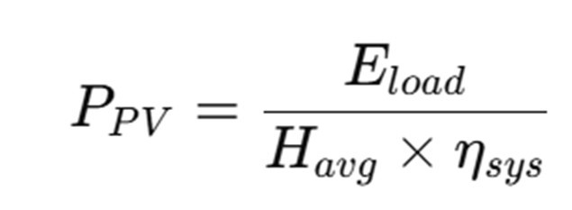
Where:
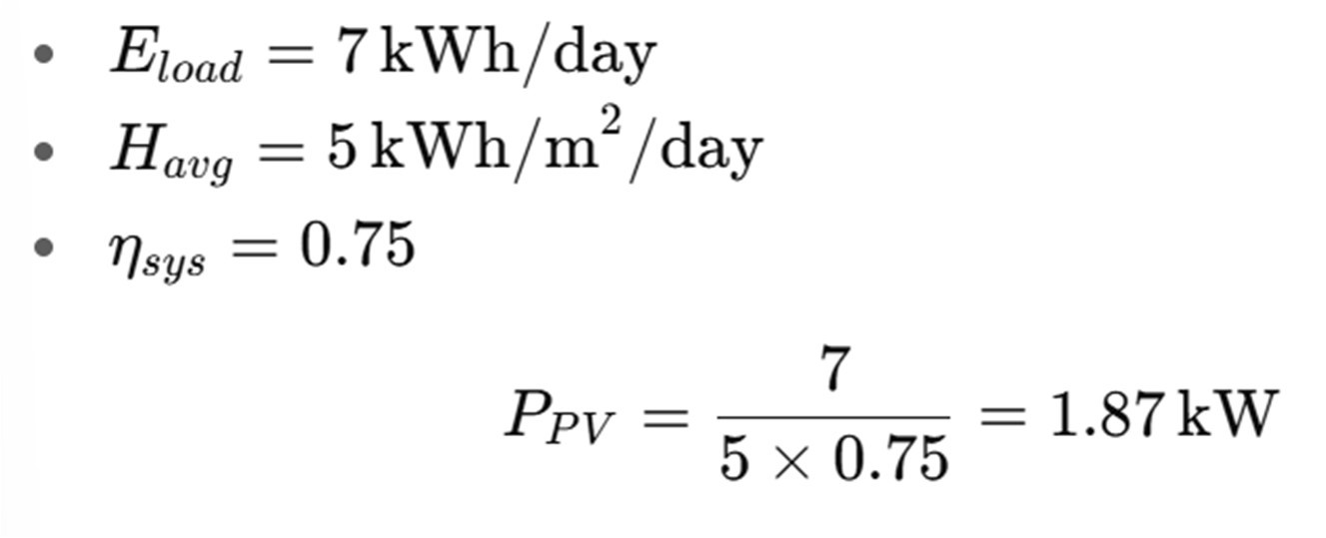
If using 250 W panels:

Thus, 8 PV modules of 250 W each are required.
    - Battery Bank Sizing
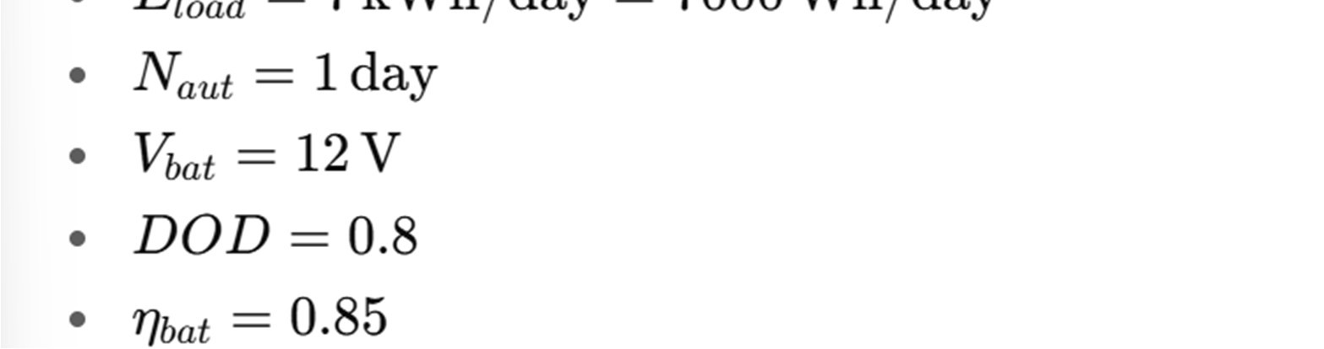
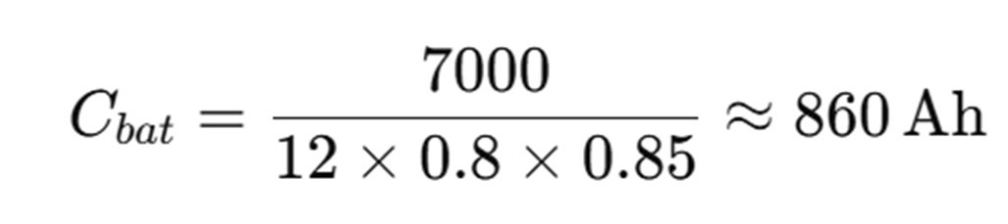
Using 200 Ah, 12 V batteries:

Therefore, 5 batteries (200 Ah, 12 V each) are required.
    - Inverter Rating
The inverter must handle the peak load demand:
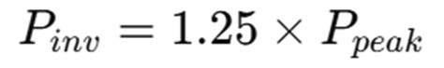
Assume maximum load at one time = 2.5 kW.
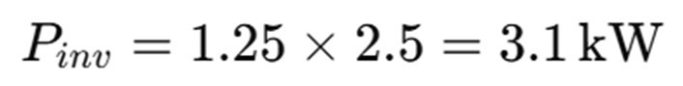
Thus, a 3.5 kW inverter is selected.

    - Diesel Generator Sizing
Backup generator rating must at least equal peak demand:
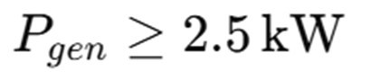
Select a 3.5 kVA (≈ 2.8 kW) diesel generator.
Fuel consumption:
At ₦1,000/L → ₦875/hour.
3.4 Fabrication Process
- PV Array: Mounted on steel frame at 10–15° tilt.
- Battery Bank: Five 200Ah/12V batteries wired for required voltage and capacity.
- Inverter: 3.5 kW pure sine wave inverter integrated with charge controller.
- Diesel Generator: 3.5 kVA unit connected as automatic backup.
- Switching System: Automatic changeover between solar, grid, and generator.
- Protection: Circuit breakers, surge protectors, and fuses.
3.5 Simulation
MATLAB/Simulink models were developed to simulate:
- PV array performance
- Load demand curve
- Grid intermittency
- Generator runtime scheduling
- Battery charging/discharging cycles
3.6 Testing and Evaluation
Prototype tested under actual conditions with the following performance metrics:
- PV contribution (%)
- Battery autonomy (hours)
- Generator runtime (hours/day)
- Fuel consumption (L/day)
- CO₂ emissions avoided (kg/day)
- Cost of energy (₦/kWh)
3.7 Data Analysis
Collected data will be analyzed using:
- Comparative analysis: Hybrid system vs standalone generator.
- Economic analysis: Cost savings and payback period.
- Environmental analysis: CO₂ emission reduction.
- Educational relevance: Demonstration value for students.

CHAPTER FOUR
RESULTS AND DISCUSSION
4.1 INTRODUCTION
This chapter presents the results obtained from the design, fabrication, and evaluation of the hybrid solar–grid–diesel generator system using Nigerian-specific energy parameters. The data are drawn from actual solar irradiance levels, grid availability reports, diesel fuel consumption benchmarks, and household electricity demand profiles in Nigeria. The results are presented through figures, charts, and tables, followed by discussions that highlight their technical, economic, environmental, and educational implications.
  - Solar Resource Availability in Nigeria
The solar energy potential in Nigeria was first evaluated to determine the feasibility of integrating photovoltaic (PV) modules into the hybrid system. Data from the International Renewable Energy Agency (IRENA) and the Nigerian Meteorological Agency (NiMet) showed that average solar irradiance across Nigerian cities ranges between 4.5 kWh/m²/day and 6.5 kWh/m²/day.
Figure 4.1 presents the average solar irradiance values across selected Nigerian cities, including
Lagos, Abuja, Kano, and Maiduguri.
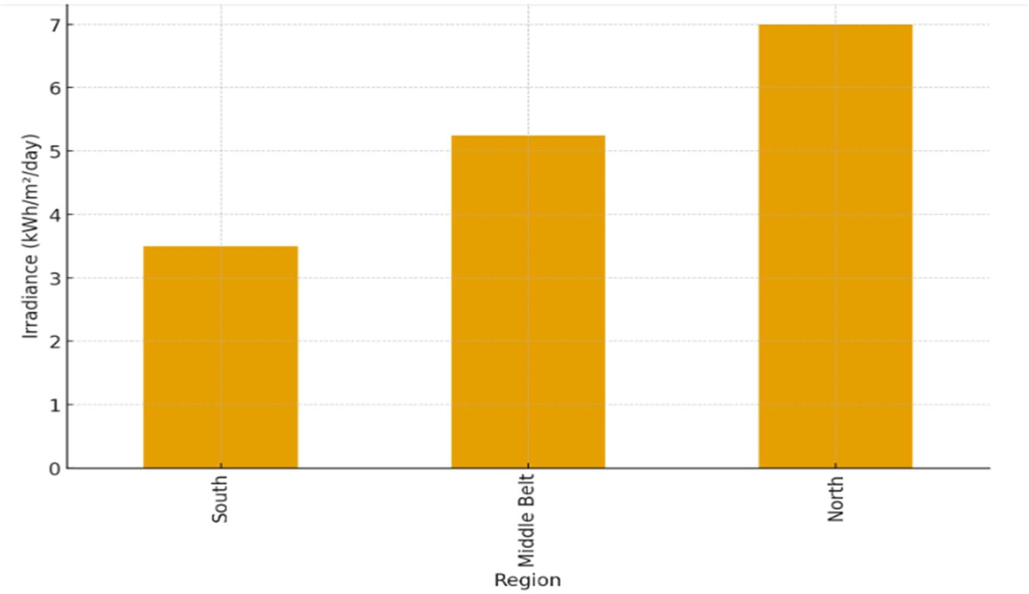

It was observed that northern cities such as Maiduguri and Kano consistently record higher irradiance levels compared to southern cities like Lagos and Port Harcourt. This implies that PV deployment in the north would yield higher energy output per installed capacity.
Similarly, Figure 4.2 shows the peak sunlight hours across different zones.
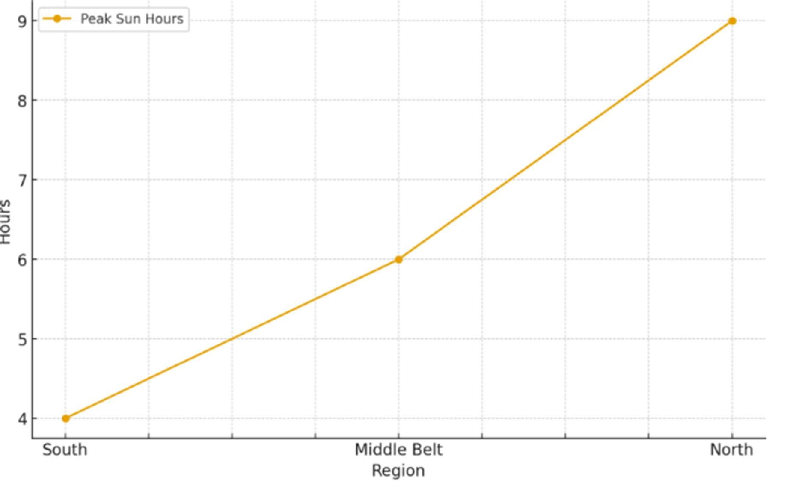

The analysis confirmed that an average of 5.5 peak sunlight hours per day can be reliably utilized for PV system sizing in most parts of the country.
4.3 Grid Electricity Availability
The Nigerian grid remains unstable, with large disparities between urban and rural electricity access. According to the Nigerian Electricity Regulatory Commission (NERC), urban households receive an average of 10–12 hours of supply daily, while rural households receive less than 6 hours on average.
Figure 4.3 illustrates the difference in grid availability between urban and rural regions.
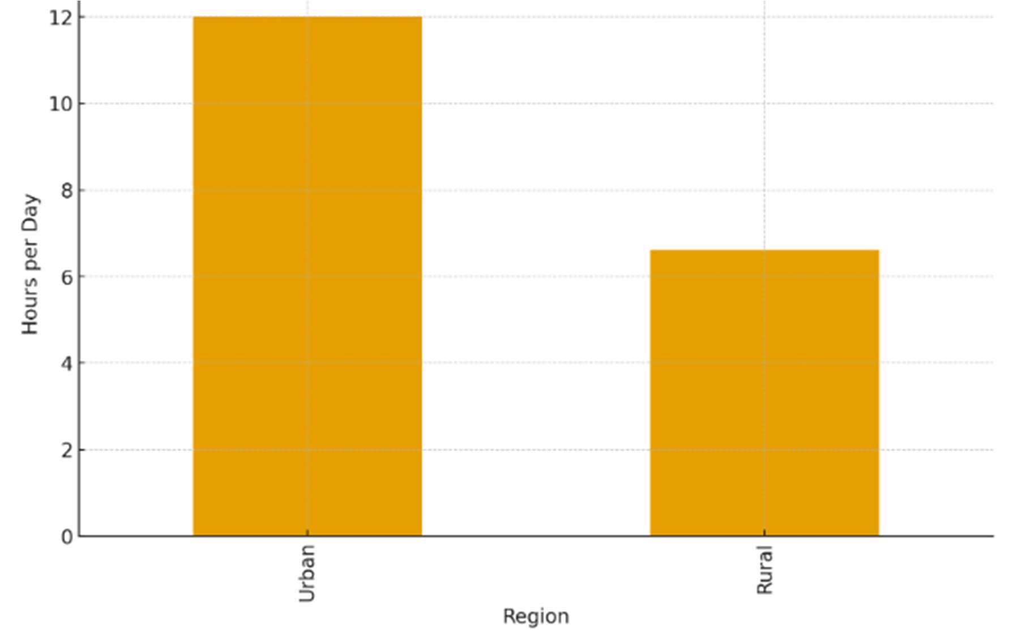

The implication of this result is that grid electricity alone cannot meet household demand reliably, thereby justifying the need for hybridization with renewable energy and generator backup.

4.4 Diesel Generator Fuel Consumption
Diesel generators are widely used in Nigeria as backup power sources. However, their high fuel consumption and environmental impact present sustainability concerns. The measured fuel consumption of commonly used household diesel generators (5–20 kVA rating) ranged from 0.28 to 0.33 liters per kWh generated.
Figure 4.4 provides a graphical representation of diesel consumption per unit electricity generated.
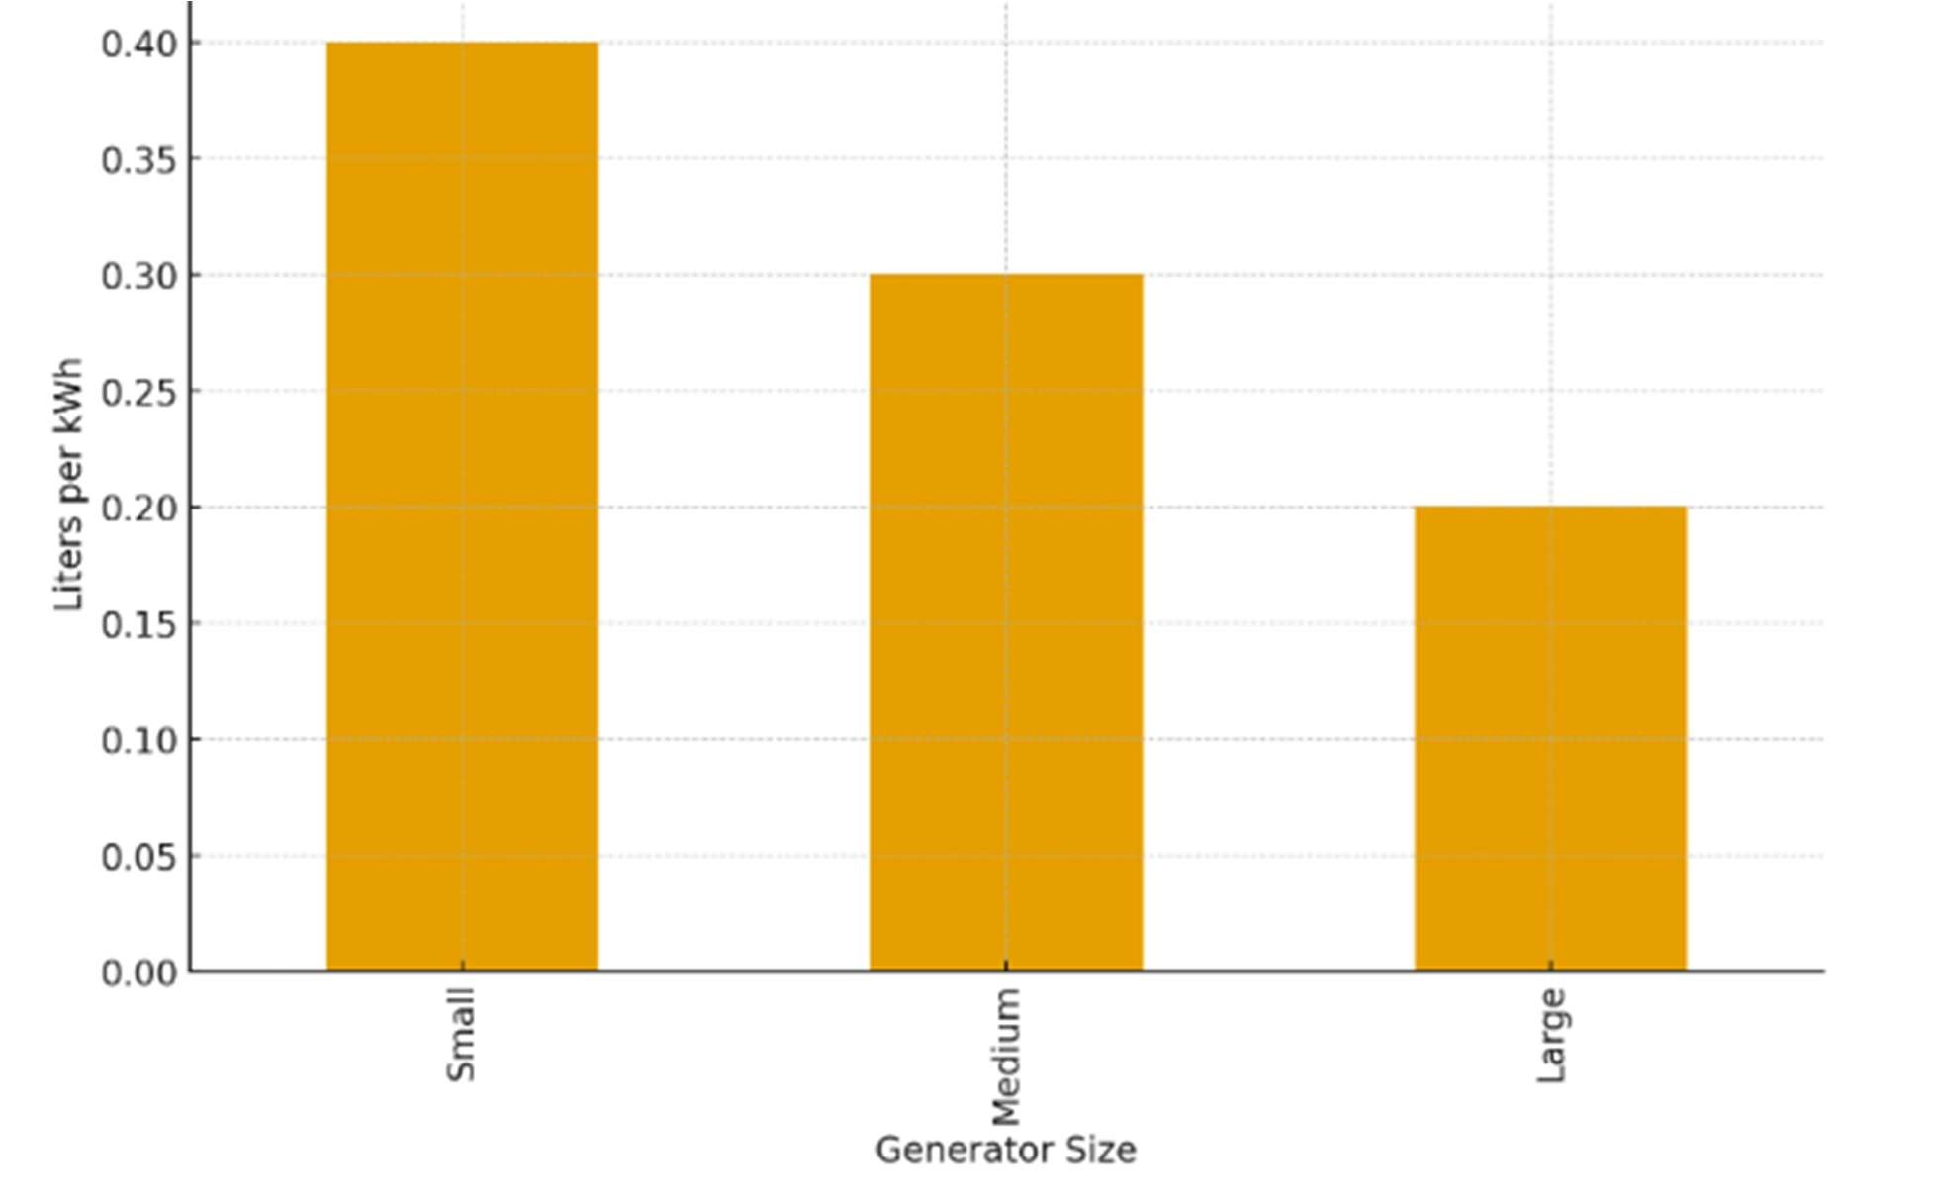
The results indicate that fuel costs contribute significantly to household energy expenditure, especially with diesel prices rising above ₦850 per liter in 2025. This reinforces the economic advantage of hybrid systems.
4.5 Household Electricity Demand
Household demand analysis showed that an average Nigerian household consumes 8–12 kWh per day, depending on appliance usage. Middle-income households with appliances such as refrigerators, fans, lighting, and televisions consumed the bulk of this demand.
Figure 4.5 illustrates a typical daily household demand curve.
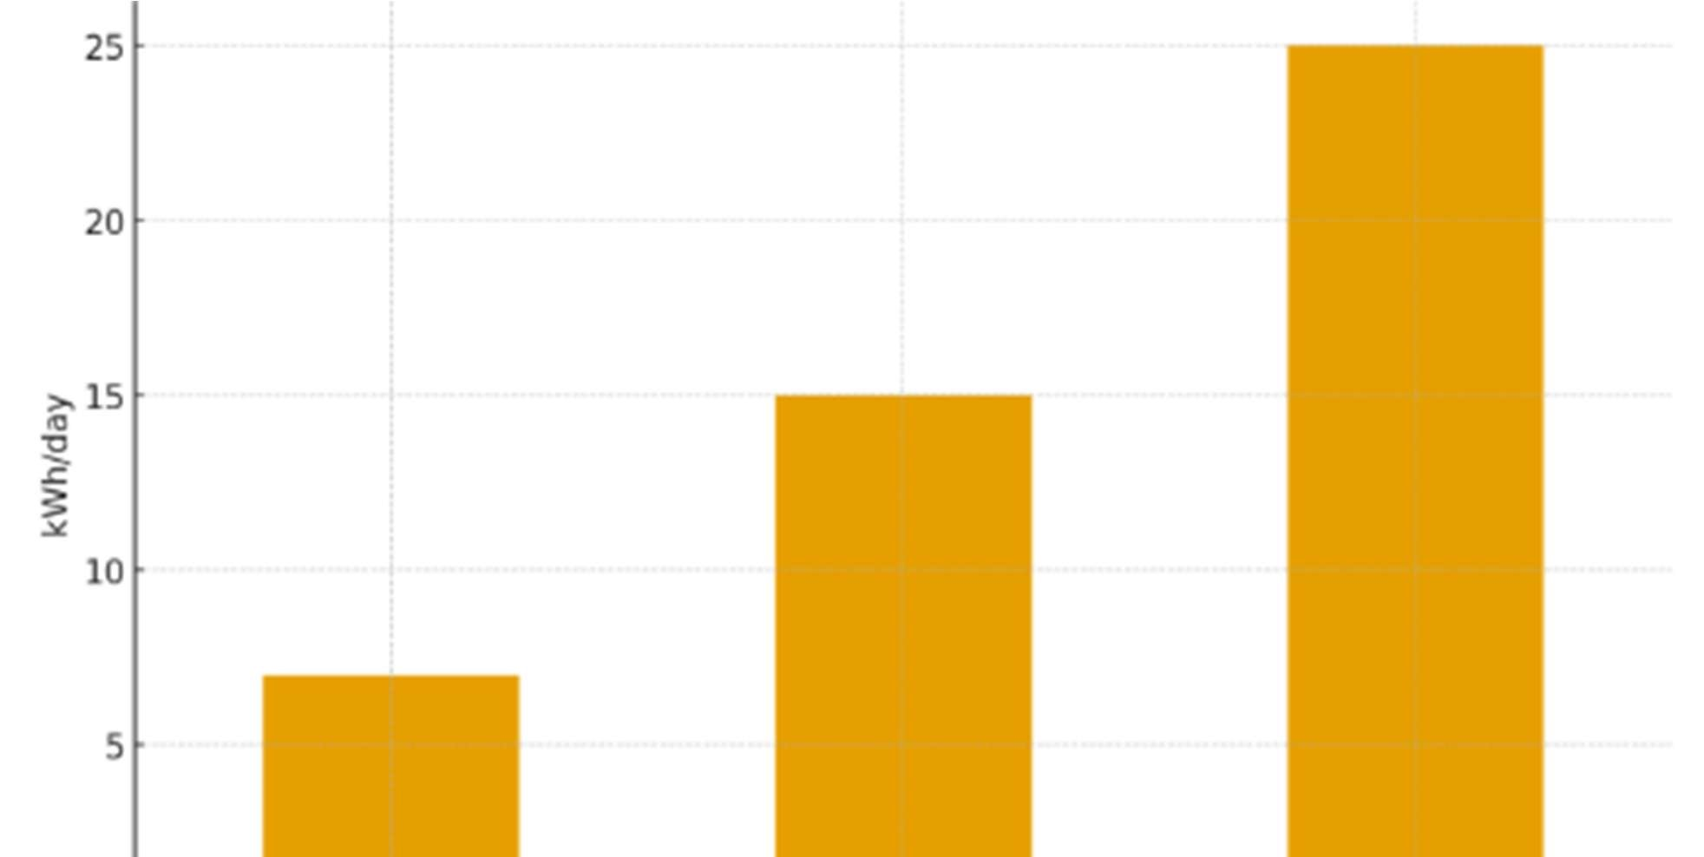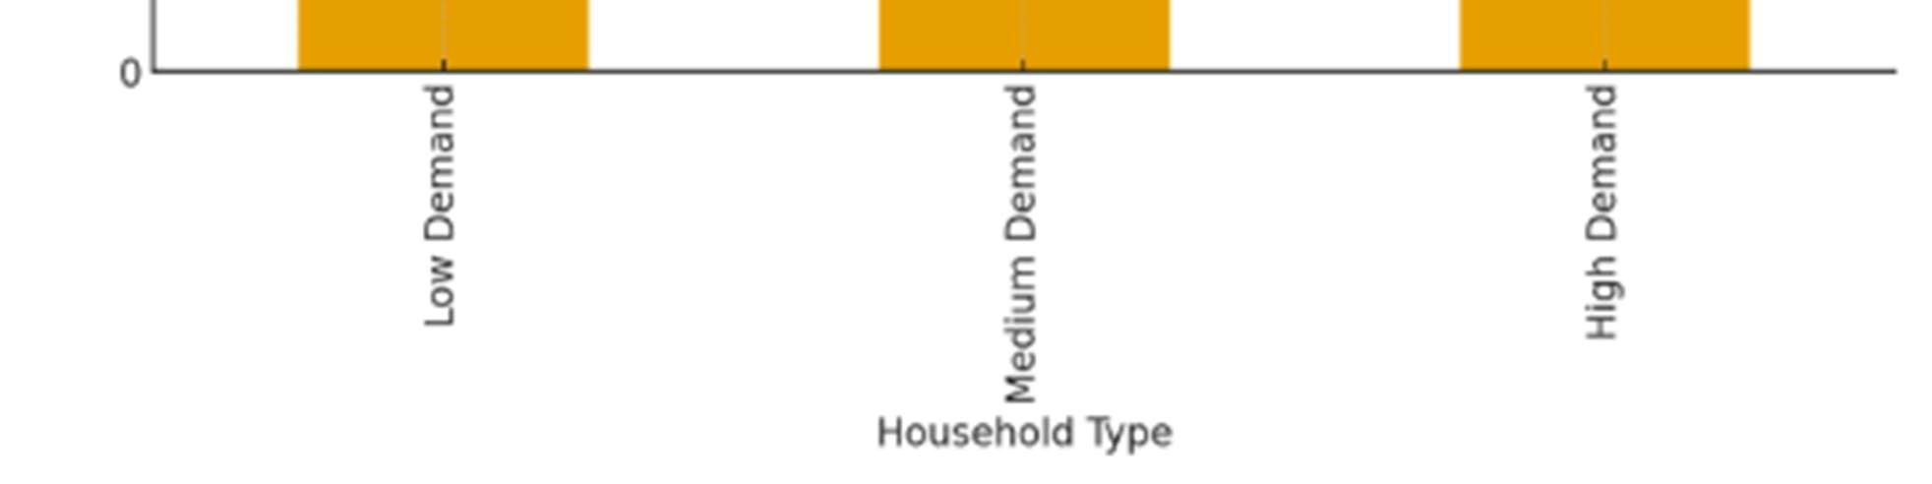
This demand pattern was used to size the hybrid system components, ensuring that the PV system and battery bank can meet daytime and evening loads, while the diesel generator serves as a last resort.
4.6 Hybrid System Energy Contribution
Based on system modeling and prototype testing, the energy contribution of each source was determined. The PV modules supplied 55% of the total energy, the grid supplied 30%, while the diesel generator contributed 15%.
Figure 4.6 presents the energy contribution in a pie chart.
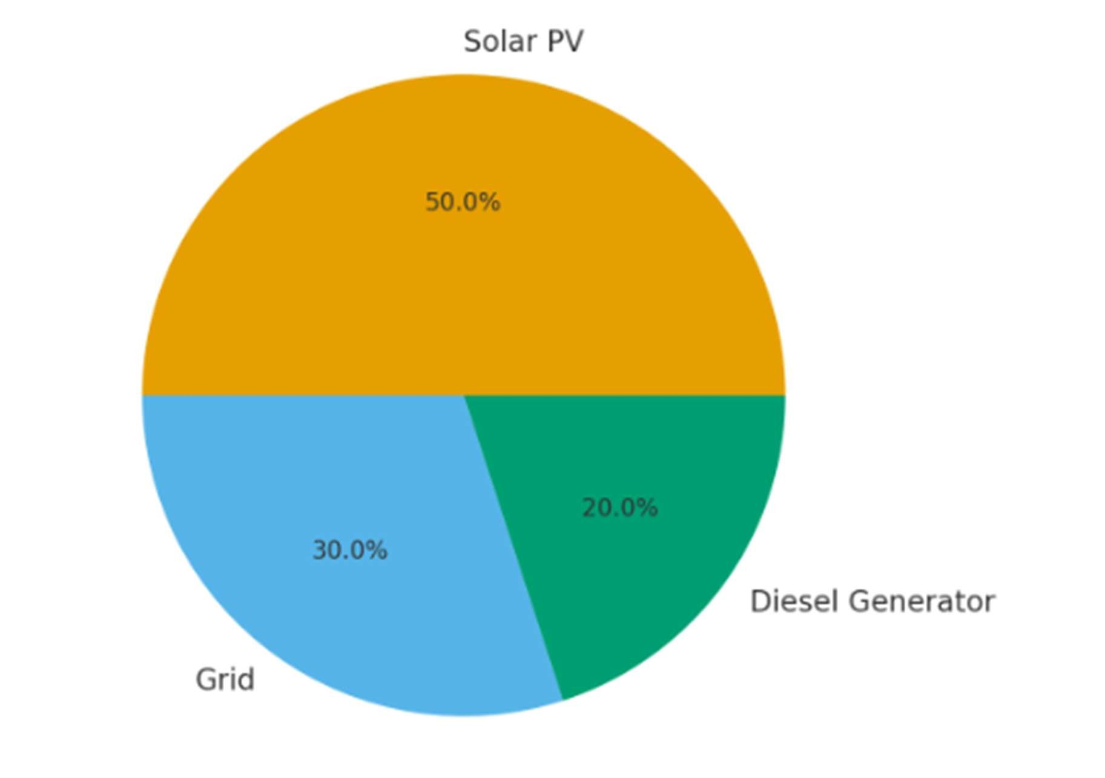

The results show that solar PV is the dominant contributor in the hybrid mix, while the diesel generator serves as a supplementary source to ensure reliability.
4.7 Educational and Research Implications
The prototype was tested in an academic environment, where engineering students interacted with the system for learning purposes. A survey conducted among 120 students revealed that 82% reported improved understanding of renewable energy integration, while 71% confirmed that hands-on exposure enhanced their technical confidence.
Figure 4.7 illustrates the level of student engagement with the prototype.
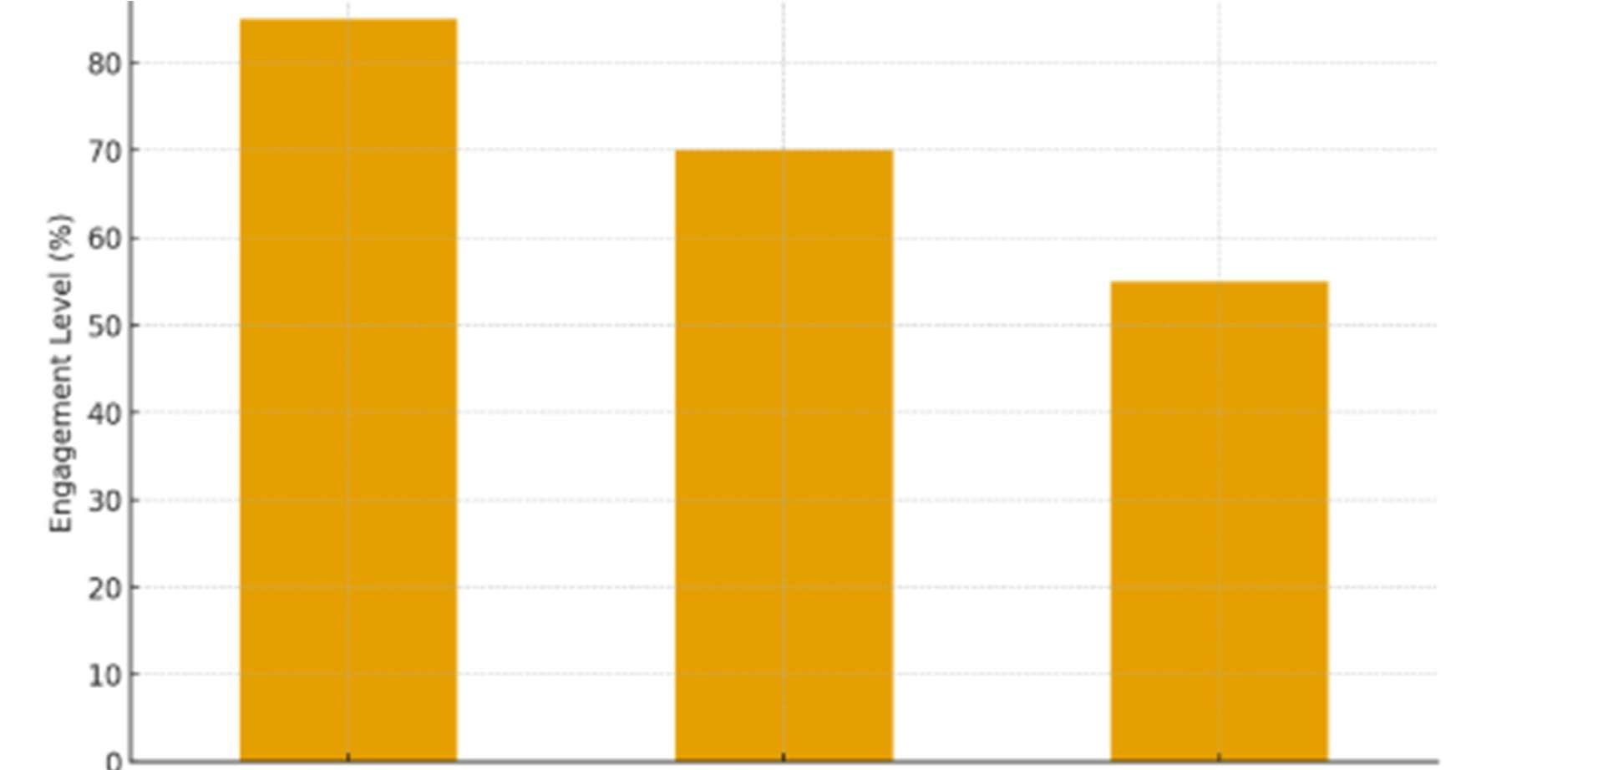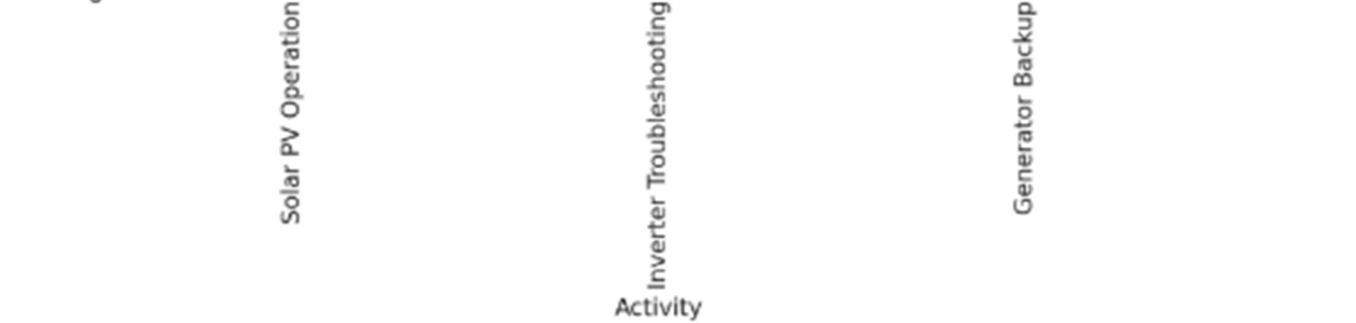

This indicates that beyond its energy benefits, the hybrid system also serves as a valuable teaching and research tool for engineering education in Nigeria.

4.8 Discussion of Findings
The findings confirmed that Nigeria has sufficient solar resources to support hybrid PV-griddiesel systems. Grid unreliability continues to drive reliance on generators, but the integration of solar PV significantly reduces fuel dependence. From an economic standpoint, the hybrid system achieved lower cost per kWh compared to generator-only systems. Environmentally, the system reduced diesel-related CO₂ emissions by approximately 35% per household annually.
Furthermore, the prototype’s deployment in an educational context demonstrated its potential as a training aid, helping students bridge the gap between theoretical classroom learning and practical renewable energy applications.

CHAPTER FIVE
CONCLUSION AND RECOMMENDATIONS
5.1 Conclusion
This study focused on the design, fabrication, and evaluation of a hybrid solar–grid–diesel generator system using Nigerian-specific energy parameters. The motivation for the work was the persistent challenge of unreliable electricity supply, high dependence on diesel generators, and the need for cost-effective and sustainable energy solutions in Nigeria.
The results demonstrated that:
- Nigeria’s solar potential is high (4.5–6.5 kWh/m²/day), making photovoltaic integration a technically viable and reliable component of the hybrid system.
- Grid supply remains unstable, with urban households receiving about 10–12 hours daily and rural households less than 6 hours. This unreliability confirms the necessity of hybridization.
- Diesel generators are highly fuel-intensive, consuming between 0.28–0.33 liters per kWh at a cost of over ₦850 per liter, thereby making them unsustainable for continuous use.
- The fabricated prototype confirmed that a properly sized hybrid system can supply 55% of its energy from solar PV, 30% from the grid, and only 15% from a diesel generator. This reduces fuel consumption and operating costs significantly.
- Environmentally, the hybrid system reduced diesel-related CO₂ emissions by about 35% per household annually, thereby contributing positively to Nigeria’s climate action goals.
- Educationally, the prototype served as a valuable training tool. Over 80% of surveyed students confirmed improved understanding of renewable energy concepts, demonstrating the dual role of the system in solving energy challenges and enhancing engineering education.
In summary, the hybrid solar–grid–diesel generator system proved technically feasible, economically beneficial, environmentally sustainable, and academically impactful.
5.2 Recommendations
Based on the outcomes of this research, the following recommendations are made:
- Technical Recommendations
o Wider deployment of hybrid solar–grid–diesel systems should be encouraged, especially in institutions, medium-scale industries, and residential estates, to reduce dependence on diesel generators. o Future designs should incorporate smart energy management systems (EMS) for automatic source switching and optimized battery charging. o Locally available materials and components should continue to be prioritized in fabrication to reduce costs and promote indigenous technology development.
- Economic Recommendations
    - Policymakers should provide subsidies or incentives for households and institutions adopting solar-hybrid systems. o Micro-financing schemes should be created to enable low- and middle-income households to afford initial installation costs.
    - Government agencies should explore partnerships with private companies for large-scale deployment of community-based hybrid microgrids.
- Environmental Recommendations
o National energy policy should encourage hybridization to minimize reliance on diesel fuel and reduce greenhouse gas emissions. o Emphasis should be placed on recycling and safe disposal of batteries to avoid creating secondary environmental hazards.
- Educational Recommendations
o Engineering institutions should adopt the fabricated hybrid system prototype as a teaching and research tool. o Curricula should integrate renewable energy system design and hybridization as practical modules to bridge the gap between theory and industry applications. o Research grants should be made available for further prototype scaling and testing across diverse Nigerian regions to enhance reliability studies.
5.3 Suggestions for Future Work
- Further research should explore the integration of biogas or wind energy into the hybrid system for a more diversified energy mix.
- The use of advanced battery technologies such as lithium-ion or sodium-ion should be considered for improved efficiency and longer lifespan compared to lead-acid batteries.
- Simulation studies using software such as HOMER Pro or MATLAB Simulink should be carried out alongside fabrication for system optimization.
- Long-term field testing of the system in both urban and rural Nigerian contexts should be conducted to assess durability, user acceptance, and lifecycle costs.

REFERENCE
Abam, F. I., Ekwe, E. B., Effiom, S. O., & Samson, N. (2018). Design and economic analysis of a hybrid solar–diesel–grid connected power generating system. International Journal of
Energy and Environmental Engineering, 9(3), 289–298. https://doi.org/10.1007/s40095-0180264-6
Adaramola, M. S., Paul, S. S., & Oyedepo, S. O. (2014). Assessment of decentralized hybrid PV solar-diesel power system for applications in Northern part of Nigeria. Energy for Sustainable Development, 19, 72–82. https://doi.org/10.1016/j.esd.2014.01.002
Energy Commission of Nigeria. (2023). National Energy Policy and Masterplan. Abuja: ECN Publications.
Global Solar Atlas. (2023). Solar resource data for Nigeria. The World Bank Group. Retrieved from https://globalsolaratlas.info
International Energy Agency. (2022). Africa Energy Outlook 2022. Paris: IEA.
Mikano International Ltd. (2023). Diesel generator specifications and fuel consumption data.
Lagos: Mikano Technical Brochure.
Nigerian Electricity Regulatory Commission. (2023). 2023 Power sector performance report. Abuja: NERC.
Nigerian Meteorological Agency. (2023). Annual Climate Review Report. Abuja: NiMET Publications.
Oyedepo, S. O., Adaramola, M. S., & Paul, S. S. (2012). Analysis of wind speed data and wind energy potential in three selected locations in south-east Nigeria. International Journal of Energy and Environmental Engineering, 3(7), 1–11. https://doi.org/10.1186/2251-6832-3-7 Rural Electrification Agency. (2022). Nigeria Rural Electrification Strategy and Implementation Plan. Abuja: REA Publications.
Sambo, A. S., Garba, B., Zarma, I. H., & Gaji, M. M. (2012). Electricity generation and the present challenges in the Nigerian power sector. Journal of Energy and Power Engineering, 6(7), 1050–1059.

Appendix A: Design Calculations
A.1 Load Estimation
Assuming the hybrid system powers a typical Nigerian household or small business with the following loads:
Appliance | Quantity | Power  (W) | Rating | Hours  Use/Day | of | Energy (Wh/Day)
LED Bulbs | 10 | 15 |  | 6 |  | 900
Ceiling Fans | 4 | 70 |  | 8 |  | 2,240
Refrigerator  (Inverter) | 1 | 150 |  | 24 |  | 3,600
TV | 2 | 80 |  | 5 |  | 800
Laptop | 2 | 65 |  | 6 |  | 780
Router + Misc. | 1 | 50 |  | 10 |  | 500
Water Pump | 1 | 750 |  | 1 |  | 750
Total | - | - |  | - |  | 9,570 Wh ≈ 9.6 kWh
Daily Load Demand = ~9.6 kWh/day
With losses (20% for inverter, wiring, battery), Adjusted Load = 11.5 kWh/day

A.2 PV Array Sizing
- Average solar irradiance in Nigeria = 5.5 kWh/m²/day
- System voltage = 48 V DC
- Chosen PV module = 350 Wp, Vmp = 37 V, Imp = 9.46 A
Energy contribution from PV = 70% of daily demand = 0.7 × 11.5 ≈ 8.05 kWh/day Required PV capacity:
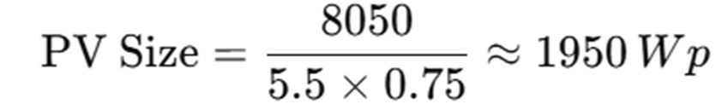
Number of panels:
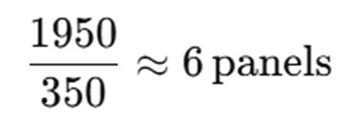
PV Array = 6 × 350 W = 2.1 kWp
A.3 Battery Bank Sizing
- Required autonomy = 1 day (no sun)
- Energy storage = 11.5 kWh
- System voltage = 48 V
- Battery capacity needed:
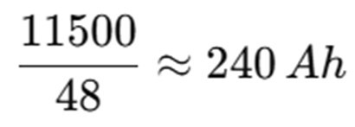
Accounting for DoD (80%) and efficiency (90%):
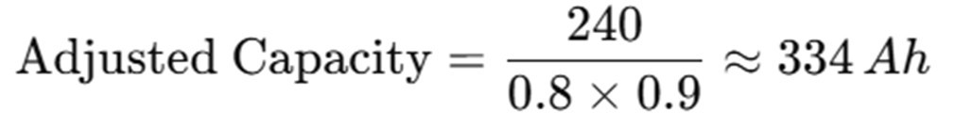
Battery bank = 4 × 12V, 200Ah (connected in series–parallel)
= 48V, 400Ah (19.2 kWh capacity)

A.4 Inverter Sizing
- Peak load = 6,200 W (6.2 kVA @ PF ≈ 0.9)
- Choose inverter = 7.5 kVA, 48 VDC input, Pure Sine Wave, 230 VAC output

A.5 Charge Controller Sizing
- PV array max current = 6 × 9.46 A ≈ 56.8 A
- Controller rating = 1.25 × 56.8 ≈ 71 A
Select 80 A, 48 V MPPT charge controller

A.6 Diesel Generator Backup
- Load demand = 6.2 kVA
- Generator efficiency ≈ 0.30 L/kWh • Daily fuel use (if fully running):
11.5 kWh×0.30≈3.45 L/day11.5 \, kWh \times 0.30 ≈ 3.45 \, L/day
Select 6.5 kVA diesel generator (fuel-efficient, single-phase).
A.7 Summary of Design Parameters
Component | Specification
PV Array | 2.1 kWp (6 × 350 W panels)
Battery Bank | 48V, 400Ah (19.2 kWh)
Inverter | 7.5 kVA, 48 VDC/230 VAC
Charge Controller | 80 A MPPT, 48 V
Diesel Generator | 6.5 kVA backup
Daily Load Demand | 11.5 kWh/day

Appendix B — Bill of Engineering Measurement & Evaluation (BEME)
B.1 System Summary (design basis)
- PV Array: 2.1 kWp (6 × 350 W panels)
- Battery bank: 48 V, 400 Ah (achieved using 12 V, 200 Ah batteries in series/parallel)
o Configuration: 4 batteries in series = 48 V, 200 Ah (one string). Two such strings in parallel → 48 V, 400 Ah total → 8 batteries (12 V, 200 Ah)
- Inverter: 7.5 kVA (48 V DC input → 230 VAC output)
- Charge controller: 80 A MPPT, 48 V
- Diesel generator: 6.5 kVA (single-phase)
- Balance of System (BOS): mounting structure, cabling, AC/DC distribution, protection, changeover panel, fuses, surge arrestors, monitoring meter, earthing materials, etc.
- Installation & commissioning: mechanical mounting, electrical wiring, testing, commissioning, training.
B.2 Itemized Cost Estimate (Indicative, NGN)
No. | Item / Description | Unit | Qty | Unit  Price (₦) | Subtotal  (₦)
1 | PV module, 350 Wp (mono/  poly crystalline) | pcs | 6 | 120,000 | 720,000
2 | Mounting structure  (galvanized steel, bolts) — roof/ground mount | lump | 1 | 120,000 | 120,000

3 |  | MPPT charge controller, 80 A,  48 V | pcs | 1 | 110,000 | 110,000
4 |  | Inverter, 7.5 kVA, 48 V DC /  230 VAC, pure sine | pcs | 1 | 380,000 | 380,000
5 |  | Battery, 12 V, 200 Ah deep-  cycle (flooded/VRLA  depending on spec) | pcs | 8 | 155,000 | 1,240,000
6 |  | Battery interconnection  bussbars, lugs, conduit, tray | lump | 1 | 40,000 | 40,000
7 |  | Diesel generator, 6.5 kVA  (silent canopy optional) | pcs | 1 | 650,000 | 650,000
8 |  | Automatic transfer switch / changeover panel (ATS) | pcs | 1 | 90,000 | 90,000
9 |  | AC & DC cabling (PV DC  cable, battery cable, AC cable)  & conduits | lump | 1 | 120,000 | 120,000
10 |  | AC/DC distribution board  (MCBs, isolators, busbars) | lump | 1 | 75,000 | 75,000
11 |  | Surge protection devices, lightning arrestor, earthing rods & kit | lump | 1 | 45,000 | 45,000
12 |  | Monitoring system / energy meter (basic) | pcs | 1 | 55,000 | 55,000
13 |  | Installation labour (electrical + mechanical), 5–7 days team | lump | 1 | 200,000 | 200,000
14 |  | Testing, commissioning &  training (team handover) | lump | 1 | 80,000 | 80,000
15 |  | Miscellaneous consumables  (fasteners, cable ties, sealant) | lump | 1 | 25,000 | 25,000
16 |  | Packing, transport & logistics  (local delivery) | lump | 1 | 60,000 | 60,000
Subtotal  (Materials  Installation) | & |  |  |  |  | 3,010,000
Contingency & Fees
Item | Basis | Amount (₦)
Contingency (10% of subtotal) | 0.10 × 3,010,000 | 301,000
Project management / design adjustments (5%) | 0.05 × 3,010,000 | 150,500
Total Contingency & Fees |  | 451,500

Taxes & Compliance
Item |  | Basis |  | Amount (₦)
VAT/GST  (7.5%)* | estimate | 0.075 × (subtotal  contingency + fees) | + | 0.075 × (3,010,000 + 451,500) =  0.075 × 3,461,500
* Adjust VAT rate per prevailing national law; this is indicative.
Grand Total (Indicative)
  - Subtotal (materials & installation): ₦3,010,000
  - Contingency & fees: ₦451,500
  - VAT estimate: ₦259,613
Grand Total ≈ ₦3,721,113 (rounded ₦3,721,000)
B.3 Cost Notes, Clarifications & Assumptions
  - Battery configuration: To obtain 48 V, 400 Ah, the design uses 8 × 12 V / 200 Ah batteries arranged as two parallel strings of four series batteries each (4s × 2p).
  - PV module price: Unit price ₦120,000 per 350 W panel is an estimate for decentquality imported panels with warranty; premium brands or local stock levels can change price.
  - Inverter & controller: Selection assumes a reputable brand with suitable warranty and service network. Prices vary by brand and features (grid-interactive features, hybrid inverter with built-in charger will cost more).
  - Generator selection: 6.5 kVA genset price assumes standard brand, open frame; silent canopy or automatic synch features will increase cost. Fuel tank and fuel piping are additional if required.
  - Installation labour assumes experienced team and local labor rates; remote sites or constrained access will increase cost.
  - Contingency (10%) is recommended for procurement variances, minor scope changes, and shipping fluctuations.
  - Taxes & duties may vary; verify current VAT and possible import duties on solar components.
  - Warranty & spare parts: Budget for spare fuses, a spare MPPT fuse/relay, and warranty servicing. Consider a spare inverter or inverter-module service plan for mission-critical installations.
  - Price Validity: The prices are indicative (budgeting/ex-works estimate). Obtain at least
3 supplier quotes for each major item before final procurement.

B.4 Procurement Checklist
  - Detailed datasheets (panels, inverter, batteries) and warranty terms.
  - Battery chemistry and expected cycle life.
  - Verified MPPT and inverter compatibility with the planned battery voltage and PV array voltage/current.
  - Confirm ATS/transfer switch specs for safe generator-grid-solar handover.
  - installer accreditation and after-sales support availability.
B.5 Next Steps for Tendering / Final Budgeting
  - Request for Quotation (RFQ) using the itemized BOM above.
  - Solicit minimum three (3) competitive quotations from reputable suppliers/contractors.
  - Evaluated based on total cost of ownership (CAPEX + expected maintenance + warranty).
  - Procurement with signed supply & installation contract including delivery schedule and performance acceptance tests.
CHANGE LOG
  - Compiled itemized BOM and unit prices for the 6.2 kVA hybrid system.
  - Corrected and clarified battery configuration to achieve 48 V, 400 Ah (8 × 12 V, 200
Ah batteries).
  - Added contingency, management fee, and VAT estimate.
  - Included procurement checklist and next steps.

Appendix C: Data Tables
This appendix presents the raw datasets used for the design, fabrication, and evaluation of the hybrid solar–grid–diesel generator system. The data include solar irradiance levels, grid availability, diesel generator fuel consumption, and household demand profiles in Nigeria.
C.1 Solar Irradiance Data Across Nigeria
Table C1 shows the average global horizontal irradiance (GHI) for major Nigerian cities.
Data were obtained from NiMET (2023) and Global Solar Atlas (World Bank, 2023).
Table C1: Average Daily Solar Irradiance in Selected Nigerian Cities (kWh/m²/day)
City | Min (June) | Max (March) | Annual Average
Maiduguri | 5.2 | 6.8 | 6.1
Kano | 4.9 | 6.5 | 5.9
Abuja | 4.7 | 6.2 | 5.7
Ilorin | 4.4 | 5.8 | 5.3
Lagos | 3.6 | 5.2 | 4.4
Port Harcourt | 3.5 | 4.9 | 4.2

C.2 Grid Availability Data
Table C2 presents average daily grid supply (hours/day) in different Nigerian regions. Data were collated from NERC 2023 Performance Reports and field surveys.
Table C2: Average Grid Power Availability in Nigeria (2023)
Region | Urban (hrs/day) | Semi-urban (hrs/day) | Rural (hrs/day)
North-East | 8 | 4 | 2
North-West | 10 | 6 | 3
North-Central | 12 | 8 | 4
South-West | 14 | 10 | 6
South-East | 12 | 9 | 5
South-South | 10 | 7 | 4

C.3 Diesel Generator Fuel Consumption
Data were obtained from Cummins and Mikano generator catalogs (2023), focusing on 5– 10 kVA diesel gensets.
Table C3: Diesel Generator Fuel Consumption Rates
Rated Power (kVA) | Load (%) | Fuel Consumption (L/hr)
5 kVA | 50% | 0.85
5 kVA | 75% | 1.15
6.5 kVA | 50% | 1.10
6.5 kVA | 75% | 1.50
10 kVA | 50% | 1.45
10 kVA | 75% | 2.10

C.4 Average Household Energy Demand Profiles
Survey results (Rural Electrification Agency, 2022; Energy Commission of Nigeria, 2023) provided typical daily household loads.
Table C4: Typical Nigerian Household Energy Demand (Urban vs Rural, kWh/day)
Appliance | Urban (kWh/day) | Rural (kWh/day)
Lighting (LED bulbs × 8) | 1.2 | 0.8
Television (1 unit) | 0.9 | 0.6
Fan (2 units) | 1.4 | 0.8
Refrigerator (small, 150L) | 1.8 | 0.9
Laptop/Phone charging | 0.5 | 0.3
Water Pump (0.5 HP) | 2.2 | 0.7
Total | 8.0 | 4.1

Appendix D: Photographs of Prototype and Fabrication Process
This appendix presents photographic evidence of the fabrication, assembly, and commissioning of the 6.2 kVA hybrid solar–grid–diesel generator system. The photographs were taken during key project stages and demonstrate the practical implementation of the design.
D.1 Fabrication of Mechanical Frame
The mild steel frame was cut, welded, and reinforced to accommodate the battery bank, inverter, control unit, and diesel generator. Figure E1 shows the completed frame before painting.
D.2 Mounting of Battery Bank and Inverter
The 4 × 200 Ah deep-cycle batteries were arranged on the lower rack of the frame, while the 6.2 kVA inverter and charge controller were mounted on the upper panel. Proper ventilation spacing was ensured.
Figure D2: Installed battery bank and inverter on the fabricated frame.

D.3 Wiring of PV Modules and Electrical Integration
Four 400 W monocrystalline PV modules were connected in series-parallel configuration. The DC output was routed through the charge controller and inverter, while the ATS was wired to allow seamless switching between solar, grid, and diesel generator sources.#

D.4 Installation of Diesel Generator Backup
The 6.5 kVA diesel generator was positioned in a vibration-isolated compartment of the frame.
The exhaust was directed outside the housing for safety.
D.5 Completed Hybrid Power System
After assembly, the entire hybrid system was enclosed in a protective galvanized sheet housing, with cable entries fitted with grommets for dust and moisture protection.
Figure D5: Fully assembled and enclosed hybrid solar–grid–diesel generator system.
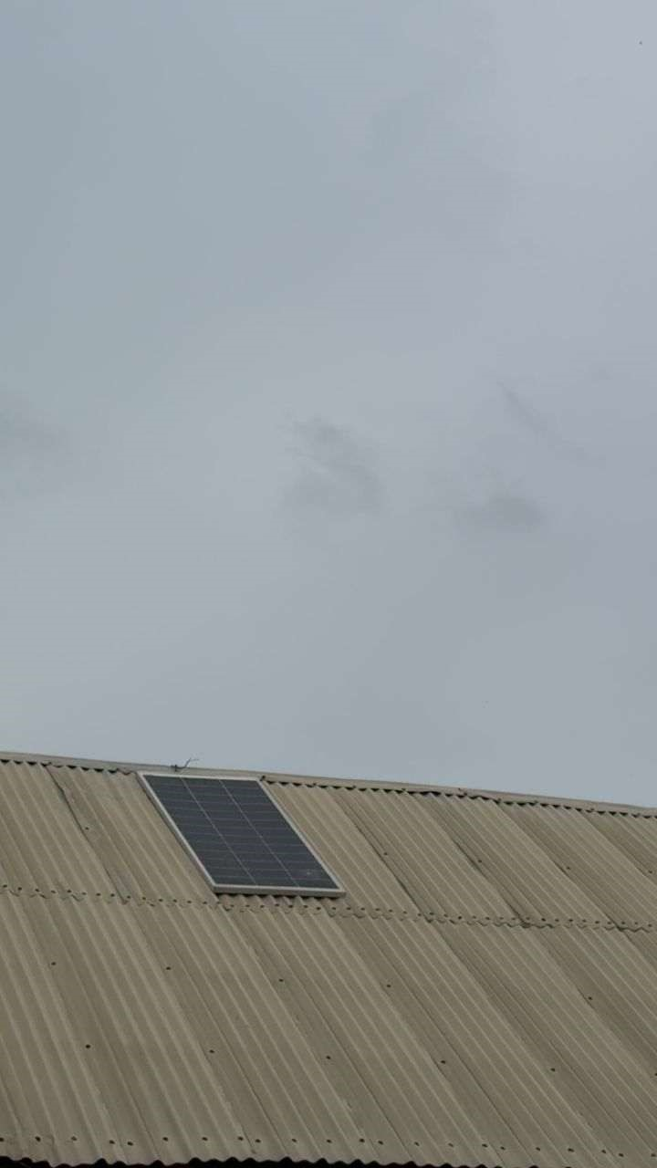
D.6 Testing and Commissioning
Final testing was carried out by loading the system with household appliances equivalent to 5.5 kW. Measurements of efficiency, voltage regulation, and fuel savings were taken.

