BARCODE AUTHENTICATION FOR SECURING BUSINESS-TO-CONSUMER E-COMMERCE APPLICATION
(A CASE STUDY OF ASAMADIYAH’S PHARMACY, ILORIN)

BY

SULYMAN JAMIU YUSUF
ND/23/COM/PT/0180

A PROJECT SUBMITTED TO:
DEPARTMENT OF COMPUTER SCIENCE INSTITUTE OF INFORMATION AND COMMUNICATION TECHNOLOGY (IICT), KWARA STATE POLYTECHNIC, ILORIN.

IN PARTIAL FULFILLMENT OF THE REQUIREMENTS FOR THE AWARD OF NATIONAL DIPLOMA (ND) IN COMPUTER SCIENCE

2025

CERTIFICATION
This is to certify that this project was carried out by Sulyman Jamiu Yusuf with Matriculation Number ND/23/COM/PT/0180 in the department of Computer Science, Institute of Information and Communication Technology, Kwara State Polytechnic, Ilorin.

__________________ __________________
MR. ISIAKA, O.S. DATE
Project Supervisor

__________________ __________________
MR. OYEDEPO, F.S. DATE
Head of Department

__________________ __________________
External Supervisor DATE

DEDICATION
This research work is dedicated to Almighty ALLAH for His mercy and protection on me throughout this program.

ACKNOWLEDGMENT
My sincere appreciation goes to Almighty ALLAH for the gift of life, knowledge, wisdom, strength and peace of mind He bestowed on me. I shall forever glorify His name.
My special thanks also go to my families for their support, both morally and financially, before and during my program, I shall forever be grateful, May you live long to enough to reap the fruit of your labour. Amin.
I will be indebted if I fail to acknowledged my supervisor Mr. Isiaka O. S for taking his time to scrutinize and make proper corrections and guidance where applicable for the overall success of this research work

TABLE OF CONTENTS
TITLE PAGE i
CERTIFICATION ii
DEDICATION iii
ACKNOWLEDGMENT iv
TABLE OF CONTENTS v-vi
ABSTRACT vii
CHAPTER ONE (GENERAL INTRODUCTION)
1.1 INTRODUCTION 1
1.2 STATEMENT OF THE PROBLEM 2
1.3 AIM AND OBJECTIVES OF THE STUDY 2
1.4 SIGNIFICANCE OF THE STUDY 2
1.5 SCOPE OF THE STUDY 3
1.6 ORGANIZATION OF THE REPORT 3
CHAPTER TWO (LITERATURE REVIEW)
2.1 REVIEW OF RELATED PAST WORKS 4
2.2 E-COMMERCE TECHNOLOGIES 6
2.2.1 CHARACTERISTICS OF E-COMMERCE TECHNOLOGIES 6
2.3 CONCEPT OF BARCODE 7
2.3.1 TYPES OF 2D BARCODES 7
CHAPTER THREE (METHODOLOGY AND ANALYSIS OF THE SYSTEM)
3.1 RESEARCH METHODOLOGY 9
3.2 ANALYSIS OF THE EXISTING SYSTEM 10
3.3 PROBLEM OF THE EXISTING SYSTEM 10
3.4 DESCRIPTION OF THE PROPOSED SYSTEM 11
3.5 ADVANTAGES OF THE PROPOSED SYSTEM 11
CHAPTER FOUR (IMPLEMENTATION AND DOCUMENTATION OF THE SYSTEM)
4.1 DESIGN OF THE SYSTEM 12
4.1.1 OUTPUT DESIGN 12
4.1.2 INPUT DESIGN 14
4.1.3 DATABASE DESIGN 15
4.1.4 PROCEDURE DESIGN 16
4.2 SYSTEM IMPLEMENTATION 16
4.2.1 CHOICE OF PROGRAMMING LANGUAGE 17
4.2.2 HARDWARE SUPPORT 17
4.2.3 SOFTWARE SUPPORT 17
4.2.4 IMPLEMENTATION TECHNIQUE 17
4.3 PROGRAM DOCUMENTATION 17
4.3.1 DOCUMENTATION OF THE SYSTEM 17
4.3.2 OPERATING SYSTEM 18
4.3.3 MAINTENING THE SYSTEM 18
CHAPTER FIVE (SUMMARY, CONCLUSION AND RECOMMENDATION)
5.1 SUMMARY 19
5.2 CONCLUSION 19
5.3 RECOMMENDATION 20
REFERENCES 21
FLOWCHARTS 22
PROGRAM SOURCE CODE 33

ABSTRACT
E-commerce (electronic commerce) is the buying and selling of goods and services, as well as the transmission of payments or data, over an electronic network, most notably the internet. These business transactions are either B-to-B (business-to-business), B-to-C (business-to-consumer), C-to-C (consumer-to-consumer), or C-to-B (consumer-to-business) (consumer-to-business). It is the exchange of goods or services across computer networks such as the Internet or online social networks. Business is conducted here using computers, telephones, fax machines, barcode readers, credit cards, automated teller machines (ATM), or other electronic appliances rather than exchanging paper-based documents or physically travelling to a shopping mall. Procurement, order entry, transaction processing, online payment, authentication, inventory control, order fulfillment, shipment, and customer support are all part of it. E-commerce Security is a subset of the Information Security framework that focuses on the components that affect e-commerce, such as data security and other broad areas of the Information Security framework. E-commerce security is the safeguarding of e-commerce assets against illegal access, use, modification, or destruction. Integrity, Non-repudiation, Authenticity, Confidentiality, Privacy, and Availability are the dimensions of e-commerce security. Ecommerce provides significant opportunities for the banking business, but it also introduces new dangers and vulnerabilities, such as security threats and hacking. As a result, it is a necessary managerial and technical necessity for any efficient and effective internet payment transaction activity. Because of the ongoing technological and business change, which necessitates a coordinated match of algorithm and technical solutions, the barcode will be used in the transaction.

CHAPTER ONE
GENERAL INTRODUCTION
1.1 INTRODUCTION
Consumer attitudes toward the website's information quality, trust, privacy concerns, reputation, security concerns, and the company's reputation all have a significant impact on Internet users' trust in the website. Privacy and security are two major issues for both e-commerce customers and sites. The control over one's personal data is referred to as privacy, whereas security refers to unauthorized users attempting to access data. As a result, information security is a critical management and technical requirement for any efficient and effective payment transaction activities conducted over the internet. E-commerce security is the protection of e-commerce assets from unauthorized access, destruction, alteration, or use, and the dimensions to be studied are integrity, privacy, non-repudiation, authenticity, confidentiality, and availability (Gupta and Dubey, 2016).
Today, electronic technologies face significant challenges in terms of privacy, security, and trust. Ecommerce security refers to the components that affect e-commerce, such as computer security, data security, integrity, availability, and other broader realms of the Information Security framework. According to Forrester, Business to Consumer (B-to-C) Internet commerce is growing at a steady rate (about 19 percent per year), and it is a familiar mode of shopping for many consumers. Many academics have argued that trust is essential for successful commerce because consumers are hesitant to make purchases unless they trust the seller (Kim, Ferrin, and Rao, 2008). The establishment of trusted transaction processes, where e-sellers create an environment in which a prospective consumer can be relaxed and confident about any prospective transactions, may be the key to success in Internet business. Given the growing popularity of B-to-C Internet commerce, there is an urgent need to examine an online consumer's decision-making process holistically in order to gain a better understanding of the complex and dynamic phenomenon of trust in online exchanges.
Web e-commerce applications that handle payments, such as electronic transactions using credit cards or debit cards, online banking, PayPal, or other tokens, have more compliance issues and are more likely to be targeted than other websites because they suffer greater consequences if data is lost or altered. Mule, Trojan horse, and worm attacks against client systems pose the greatest threat to e-commerce privacy and security because they can circumvent the majority of the authorization and authentication mechanisms used in an ecommerce transaction. Trust has always been an important factor in influencing consumer behavior toward merchants, and it has been demonstrated to be especially important in uncertain environments such as Internet-based EC environments. While a number of factors, such as branding and store reputation, may influence trust, one factor that is missing is face-to-face communication and the lack of touch and feel that is present in physical interactions. As a result, it has been argued that an increase in perceptions of security and privacy in E-Commerce transactions would positively influence trust.
1.2 STATEMENT OF THE PROBLEM
The use of e-commerce systems has recently increased at an astounding rate. On the Internet, a wide range of products (tangible and intangible) are sold, with payments primarily made with debit or credit cards. Furthermore, there is growing concern about the security of payment systems used to process online transactions. Payment card information confidentiality is important because disclosure of this information to malicious adversaries could allow them to perform fraudulent transactions at the expense of the customer. The complications associated with sales analysis and management in almost every manufacturing company in Nigeria are factors worthy of influencing the need for a functional application system that best handles sales records processing and also provides appropriate means of record analysis, data and information management, and presentation of sales reports on a desired media whenever the need arises.
1.3 AIM AND OBJECTIVES OF THE STUDY
The aim of this project is to create barcode authentication for securing business-to-consumer ecommerce applications. The objectives are as follows:
- Develop a computer-based application that tracks a company's sales transactions at the point of sale.
- Compare performance evaluation, which can check and analyze the amount of sales with the product placed on the shelf at a given point in time on a regular basis.
1.4 SIGNIFICANCE OF THE STUDY
The importance of having a computerized system for using barcodes in products or finished goods in any business organization cannot be overstated, especially now that these are a problem in determining the quality of daily transactions. If used properly, this work will aid in the development of any business organization. The purchasing department will understand when to buy and when not to buy goods. This work will also allow the supermarket to determine whether it is making a profit or losing money, which will determine whether the organization is growing or not. The company's problems include the large number of customers they deal with, the intensity of their work rate, and a lack of trust from their various sales representatives. Customers become bored and tired of the entire operation as they wait in line for a sales representative to attend to their request. The proper implementation of the computer application for the analysis and management of their sales record will make the entire system more appreciable to the Company's management as well as the customers.
1.5 SCOPE OF THE STUDY
Web e-commerce applications that handle payments, such as electronic transactions using credit cards or debit cards, online banking, PayPal, or other tokens, have more compliance issues and are more likely to be targeted than other websites because the consequences of data loss or alteration are more severe. When launched against client systems, mule, Trojan horse, and worms pose the greatest threat to e-commerce privacy and security because they can circumvent the majority of the authorization and authentication mechanisms used in an e-commerce transaction. Trust has always been an important factor in influencing consumer behavior toward merchants, and it has been demonstrated to be especially important in uncertain environments such as Internet-based Electronic Commerce.
1.6 ORGANIZATION OF THE REPORT
The first chapter of this project is devoted to a general overview of the project's work. It also includes the problem statement, the study's aim and objectives, the significance of the study, the scope and limitations of the study, and the report's organization. The second chapter is a review of the literature. It addresses current issues in software quality control. It also examines a review of previous projects related to the project's topic of study. The third chapter discusses the research methodology, analysis of the existing system, itemized problems of the existing system (procedure), description of the proposed system, and basic advantages of the proposed system. The fourth chapter contains the system's design, implementation, and documentation. The system design, output design form, input design form, database structure, and system procedure are all part of the design. The implementation includes the details of the implementation techniques used, the programming language used, and the hardware and software support. The documentation of the system includes the operation and maintenance of the system. Chapter five deals with the summary, conclusion, and recommendation.
CHAPTER TWO
LITERATURE REVIEW
2.1 REVIEW OF RELATED PAST WORK
According to Gupta & Dubey (2016), consumer disposition to the information quality of the website, trust, privacy concerns, reputation, security concerns, and the company's reputation all have a strong effect on Internet consumers' trust in the website. Privacy and security are two major issues for both e-commerce consumers and sites. Privacy is the control over one's personal data, whereas security is the attempted access to data by unauthorized users. As a result, information security is a critical management and technical requirement for any efficient and effective payment transaction activities over the internet.
According to Culnan (2000), privacy concerns are a major reason why people do not go online and provide false information. Indeed, few consumers believe they have much control over how businesses use or sell personal information revealed online. The combination of current business practices, consumer fears, and media pressure has resulted in privacy becoming a significant issue for electronic commerce. Some people regard privacy as a fundamental right, while others regard it as a tradable commodity. Aside from "privacy," other terms to be addressed in e-commerce include digital persona, notice, identification, choice, authentication, pseudonymity, anonymity, and trust.
Security in E-commerce, according to Patro, Padhy & Panigrahi (2016), is a component of the Information Security framework that is specifically applied to the components that affect e-commerce, which include Computer Security and Data Security. E-commerce necessitates high-security components that impact the end user through their daily payment interactions with businesses. To enable secure and successful e-commerce, a dependable infrastructure and framework were required. E-commerce (electronic commerce), also known as EC, is the buying and selling of goods and services, as well as the transmission of funds or data, via an electronic network, most notably the internet. These business transactions can be B to B (business-to-business), B to C (business-to-consumer), C to C (consumer-to-consumer), or C to B (consumer-to-business) (consumer-to-business). It is the exchange of goods or services via computer networks such as the Internet or online social networks.
Khandare (2015) discussed how, in the twenty-first century, any entity that conducts business or maintains customer data will do so online. The 'e' in eBusiness is already obsolete. There are already well-established practices and standards in place for user authentication, data encryption, and credit card transactions. Security of online electronic transactions is a major issue in today's society that must be addressed. Various methods are proposed for the security of online transactions, but they may fail in one or more ways; the secure electronic transaction SET protocol is also proposed. The operation of SET is dependent on software that implements a series of protocols and is installed in the workstations or servers of four different types of people and organizations.
According to Masalkar, Singh & Shinde (2015), in markets or malls, a 1d barcode system is used, as well as a queue line system, which takes time. The majority of mobile phones on the market do not have a barcode detection system; only phones like the iPhone do. The market's money transaction system is also slow, and credit cards and other methods of payment are used. Mobile payment is a vital component of mobile commerce. To assist mobile users in conducting secure and reliable payment transactions using mobile devices, a user-friendly mobile payment solution is critical.
According to Julius (2010), proper inventory management necessitates the use of some sort of system. It makes no difference whether the system consists of writing inventory levels on the back of an envelope or employing the most sophisticated radio frequency identification system. As the old adage goes, "there are many ways to skin a cat," and the various types of inventory control systems all have advantages and disadvantages. Choosing the best one comes down to determining which system is most valuable to the company.
According to John (2011), many small business owners, particularly those with few products, manually track inventory using a spreadsheet. Spreadsheets are set up to calculate when products need to be reordered. At the start of each week, the owner manually counts the products and materials on hand and enters the values into the spreadsheet, as well as the expected usage based on existing orders. Using the appropriate spreadsheet formulas, the owner can determine whether he has enough materials for the week or if purchases should be made. Manual systems enable the small business owner to manage inventory with little investment in systems or training. Maintaining data integrity is a significant disadvantage of manual inventory management because a single data entry or formula error can result in major inaccuracies in the data output.
According to Chandersekaran (2011), barcodes are a series of parallel vertical lines, or bars, used to assign a unique identification code to an item. The primary application of a barcode identification system is to track inventory automatically. A barcode combines several sequences to create a unique set of numbers or characters that identifies the item. (Encarta, 2009) Because it improves the accuracy and efficiency of inventory management, all major retailers use barcode technology as part of their overall inventory control system. When a barcode is read at the point of sale, inventory sales data is immediately read and sent to a larger system that keeps usage statistics. Barcodes are used to manage inventory at the warehouse level because they allow inventory to be moved around the warehouse.
According to Denton (2011), this technology is relatively new and works by having a tag that emits information that can be collected by a reader from a distance. RFID uses two types of technology to manage inventory movement: active and passive technology. Active RFID technology employs fixed tag readers distributed throughout a warehouse so that whenever an item with an RFID tag passes the reader, the movement of the item is recorded in the inventory management software. Active systems perform best in environments that require real-time inventory tracking or have inventory security issues. Passive RFID technology necessitates the use of handheld readers to track inventory movement. RFID technology has a reading range of up to 40 feet using passive technology and 300 feet using active technology, which greatly improves the accuracy of moving inventory around a warehouse.
2.2 E-COMMERCE TECHNOLOGIES
E-commerce requires a number of technologies to function. The internet is the most obvious example. Aside from that network system, many other sophisticated software and hardware components are required to provide the necessary support structure: database software, network switches and hubs, encryption hardware and software, multimedia support, and the World Wide Web. Methods for connecting all of the software and hardware elements to support electronic commerce are changing and evolving on a daily basis. All elements that support electronic commerce are changing at a rapid pace. Any company that does e-commerce and wants to compete in the future must adapt to new internet technologies as they become available. The anticipated e-commerce overload necessitates businesses finding faster and more efficient ways to deal with the ever-increasing rush of online shoppers as well as the increasing traffic between businesses (Sengupta, Mazumdar and Barik, 2005).
2.2.1 CHARACTERISTICS OF E-COMMERCE TECHNOLOGIES
E-commerce technologies have the following characteristics (Burns 2002):
- Ease of automated processing: With minimal effort and cost, a payer can now easily automate the generation and processing of multiple payments. Previously, the reliance on banks to handle the majority of payments, as well as the lack of a low-cost, ubiquitous communications technology, made automation of payment processes expensive and difficult to implement.
- Payment immediacy: Payment immediacy occurs as a result of automation and the ability of intermediary systems and providers to process payments in real-time. There is a time delay in manual, paper-based systems due to the need for human intervention in the process.
- Openness and accessibility: The availability of low-cost computing and communications technology, as well as appropriate software, allows small businesses and individuals to access or provide a variety of payment services that were previously only available to large organizations through dedicated networks or bank transactional processing units.
- Loss of collateral information: The new technology eliminates or modifies collateral information associated with transactions. This information has traditionally been included in the transaction and relied on by the parties involved to validate individual payments.
2.3 CONCEPT OF BARCODE
Barcodes are horizontal strips of vertical bars that are printed and used to identify specific items. "Scanning devices read barcodes by moving a beam across the symbol." Digital barcodes, according to McCathie (2004), are an excellent way to store information in a portable format. Barcodes are machine-readable data that can be stored, transferred, and processed. As they are printed and processed by machines, barcodes have the potential to improve the productivity and reliability of nearly all applications. They are processed faster and with greater accuracy than human data entry.
Barcodes have numerous applications, including product identification, inventory marking, payment, shipping container marking, and many others. Barcodes not only provide a simple and low-cost way to present a variety of commercial data, but they also improve mobile user experience by reducing manual inputs (Gao, Prakash, and Jagatesan, 2007). Barcode identification provides a simple and inexpensive way of encoding text information that is easily read using electronic readers because barcodes can be easily stored, transferred, processed, and validated in digital form. As a result, using barcodes provides a quick and accurate tool for entering data without the use of a keyboard. Because earlier forms of linear barcodes could not encode letters, 2-D barcodes were developed to meet the needs of encoding alphanumeric data such as letters, numbers, and punctuation marks.
2.3.1 TYPES OF 2D BARCODES
1. QRCode
2. Data Matrix
3. PDF 417
There are two types of 2D barcodes: stacked 2D barcodes like PDF417 and matrix 2D barcodes like Data Matrix and QR Code. The purpose of the barcode technology that has been further developed with the creation of 2D barcodes is to increase the data capacity of 1D barcodes. With the integration of cameras, mobile phones can function as scanners, barcode readers, portable data storage devices, and network connectivity devices. When combined with such camera phones, 2D-barcodes serve as a tag to connect the digital and physical worlds (Kato and Tan, 2007).




Figure 2.1. Types of Barcode
Source: https://www.google.com/url?sa=i&source=images&cd=&ved=2ahUKEwiTuIn-qJHjAhXM8eAKHUAbCpkQjRx6BAgBEAU

Table 2.1: 2D-Barcoes Comparison
 | QR Code | PDF 147 | Data Matrix | Maxi Code
Developer | DENSO (Japan) | Symbol Technologies (USA) | RVSI Acuity CiMatrix (USA) | UPS (USA)
Numeric | 7, 089 | 2,710 | 3116 | 138
Alphanumeric | 4,296 1 | 8,50 2 | 355 | 93
Binary | 2, 953 | 1,018 | 1,556
Kanji | 1,817 | 554 | 778
Major features | Large capacity | Large capacity | Small printout size | High speed scan
Major features | Small printout size | Large capacity | Small printout size | High speed scan
Major features | High speed scan | Large capacity | Small printout size | High speed scan
Standards | Ascan IM | AIM | AIM | AIM
Standards | International | International | International | International
Standards | ISO | ISO | ISO | ISO
Standards | JIS | ISO | ISO | ISO
Source: 2D Barcode Based Mobile Payment System With Biometric Security, ISSN (Online):2349–9745 ; ISSN (Print):2393-8161

CHAPTER THREE
METHODOLOGY AND ANALYSIS OF THE SYSTEM
3.1 RESEARCH METHODOLOGY
Only certified sellers and buyers will be able to participate in the system, ensuring security because only legitimate users will be able to participate in the online electronic transactions sellers and buyers will be certified by the certifying authority. When a user, whether a seller or a buyer, wishes to become certified and thus participate in transactions, the certifying authority will certify the user. The usernames and passwords that the buyer enters must be secure, and no one else should be able to read the sensitive information; thus, I will employ multiple encryption schemes to ensure information security. The Proposed System's Modules The proposed system has three modules, which are as follows:
- Entities Participating in Online Electronic Transactions Certification
- Encryption of Sensitive Data Using an Encryption Scheme
- Verifying the authenticity of an application and sensitive data sent over an insecure channel.
- A defense mechanism was used to address a vulnerability in a web application.
This system made use of top-down implementation techniques, which entail breaking down or decomposing the programming problem into smaller manageable modules. If necessary, the modules can be broken down into smaller units to obtain smaller module units. This implementation technique supports modular programming, which makes programs easier to write and debug, making maintenance easier.
A research work typically obtains information from unpublished or raw sources, as well as published or processed sources such as publications on previous related research, journals, and so on. This method of gathering information is referred to as a Primary Data Source and a Secondary Data Source, respectively. It is self-evident that no effort can be called research if it does not employ any of the aforementioned data collection techniques. This research relied on secondary sources of data to complete the project. Data for this study were gathered from a review of previous and related academic thesis, projects, seminars, online journals, and web blogs.
Because this application can be used in malls to purchase items, the proposed system will have a broader scope in the future. New customers will register with the system via admin, and their information will be saved in the database. So, after successfully logging in, customers can use a code number to check out a specific product if they want to perform any transaction. The proposed system was created with HTML, CSS, and JavaScript for the interface and code environment, and PHP and MYSQL for database management.
3.2 ANALYSIS OF THE EXISTING SYSTEM
Although the internet has made online shopping possible for many businesses and individuals, e-commerce has been around for a long time. For decades, banks have used electronic funds transfers (EFTs), which are electronic transmissions of account exchange information over private communications networks (Schneider and Perry 2001). For many years, businesses have engaged in a type of e-commerce known as electronic data interchange (EDI). EDI occurs when one company sends computer-readable data in a standard format to another company. Businesses realized in the 1960s that many of the documents they exchanged related to the shipping of goods – such as invoices, purchase orders, and bills of lading – contained the same set of information for almost every transaction. They also realized that they were wasting time and money entering these data into their computers, printing paper forms, and then re-entering the data on the other side of the transaction.
Although each transaction's purchase order, invoice, and bill of lading contained much of the same information, each paper form had its own distinct format for presenting that information. Businesses were able to reduce errors, avoid printing and mailing costs, and eliminate the need to re-enter data by developing a set of standard formats for transmitting that information electronically. Trading partners are companies that exchange electronic documents with one another. The information contained in the standard formats used in EDI is the same information that businesses have always included in their standard paper invoices, purchase orders, and shipping documents. The use of electronic data transmission to implement or improve any business process is referred to as e-commerce. Some people define "internet commerce" as e-commerce that uses the internet or the web as its data transmission medium. Electronic business, according to IBM, is "the transformation of key business processes through the use of Internet technologies."
3.3 PROBLEM OF THE EXISTING SYSTEM
  - Unauthorized access - It denotes unauthorized access to data, systems, or applications for nefarious purposes. Consumers are concerned about the loss of their financial information, and e-commerce sites are concerned about the financial losses associated with any resulting negative publicity and break-ins.
  - Theft and Fraud - Fraud occurs when stolen data is used or manipulated. Theft of software entails illegal copying from a company's servers or theft of hardware, specifically laptop computers.
  - Denial of Service- This can happen as a result of spamming or viruses.
3.4 DESCRIPTION OF THE PROPOSED SYSTEM
The proposed system includes features to improve the company's sales analysis and management. The barcode number in the other will be used by the system to verify the goods and provide accurate information about the specific item. The system will be built with a web application tool and a MYSQL database to create improved and rich data applications that will allow the organization to handle product sales more effectively.
Sales representatives can formally access the application from any computer to sell products to their customers or obtain information about any specific type. The computer-based application aims to close the communication gap that currently exists between customers and the company. It also intends to use the application as a broad medium to bring the company closer to the world's core market exits. The system will also allow the customer to be notified once the goods have been purchased. This new system is intended to eliminate inefficiency, inefficiency, and time-consuming sales record preparation. Before designing a new system, it is obvious that existing systems have flaws or problems that, when resolved, will increase the profitability of the business as well as the efficiency and effectiveness of the sales system.
3.5 ADVANTAGES OF THE PROPOSED SYSTEM
- The application provides businesses with timely, relevant information to help them make sound business decisions.
- All reports are designed to meet the needs of the company and are presented in an accurate, detailed, and easy-to-understand format.
- Sales analysis applications improve both the organization's efficiency and compatibility.
- The company can gain more control over routine activities, eliminate unnecessary tasks, and experience business process separation.
- Sales Analysis Software provides new comfort and speed to the company's sales management by producing results that are faster, more efficient, and less expensive.
CHAPTER FOUR
IMPLEMENTATION AND DOCUMENTATION OF THE SYSTEM
4.1 DESIGN OF THE SYSTEM
In general, all efforts are directed toward developing a system program that eliminates all of the drawbacks of the current manual method. This new approach is straightforward, efficient, and guaranteed. The proposed is intended to meet the organization's goal and objectives. The system's design aims to address the various issues raised by the manual method of credit card request and pin generation.
4.1.1 OUTPUT DESIGN
The barcode is recognized when the live camera focuses on it, and the search field is populated as soon as the value is available. This would, of course, initiate a filtered search on the Equipment entity to locate the item with this barcode. You can expand the app further by going to the "add new equipment" form when the search result returns zero items and entering the new barcode value. It refers to the report that is expected to be generated from database files. The reports that are generated are lists of views, index pages, and so on. The output designs are shown in the screenshots below.
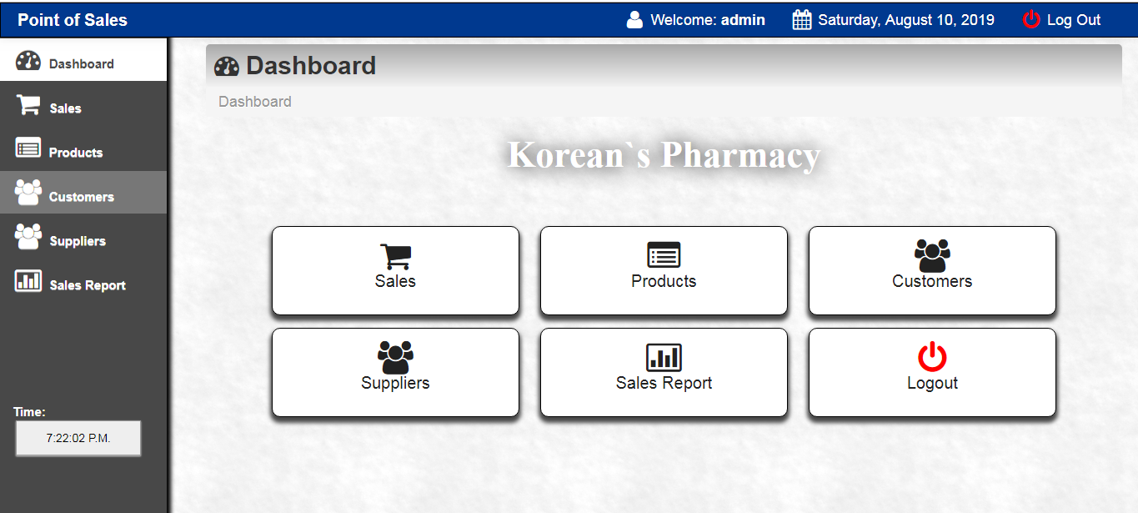

Figure 4.1: The main dashboard page, from which administrators can navigate to the desired module and perform operations.
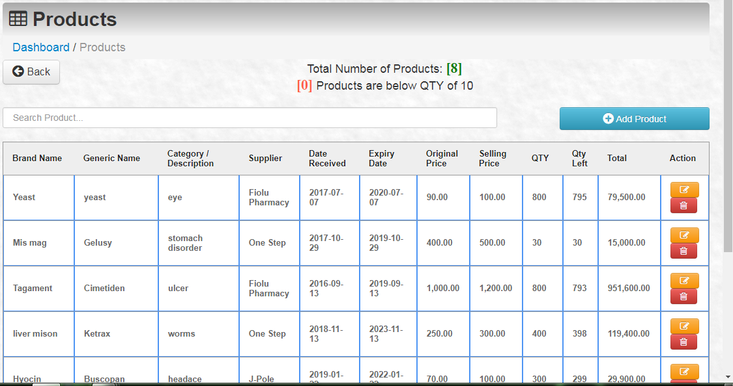

Figure 4.2: The product page, from which we will obtain a list of all newly added products, their prices, and the remaining quantity in stock.

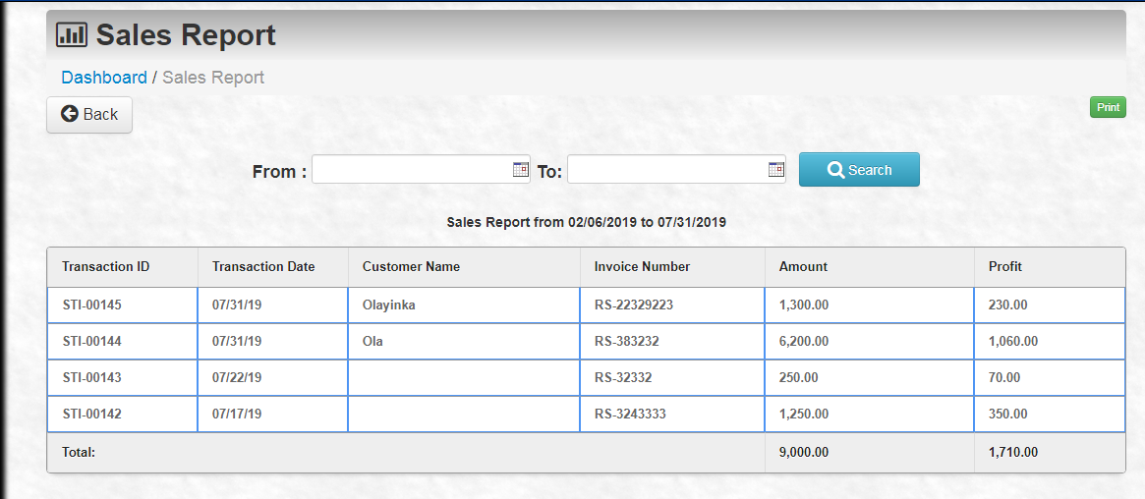

Figure 4.3: The report page, where we will get a list of all transactions performed on the system based on the specified dates.

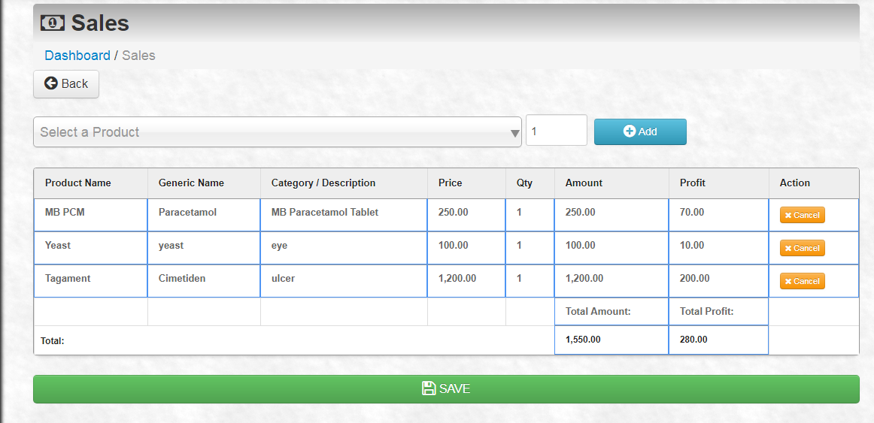
Figure 4.4: The sale page is where the main transaction takes place, i.e. where goods are sold and records are saved.
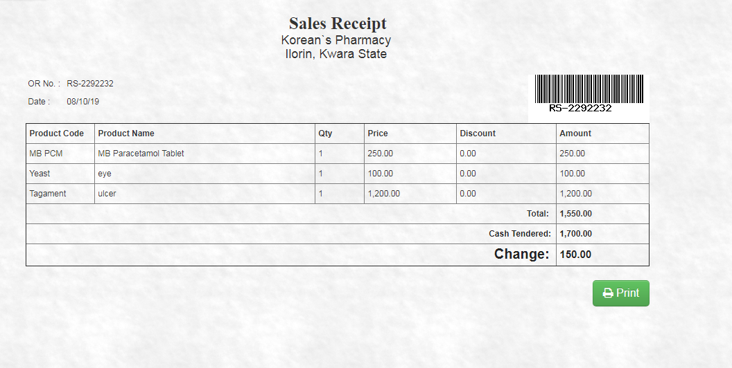
Figure 4.5: The sale report page, where the receipt for the transaction will be printed.
4.1.2 INPUT DESIGN
Design is a method of mapping and arranging parts into a whole that achieves the desired result. The input design refers to the type of all data used to feed information into the database through the program, as well as the format and input used for the system. The snapshots of the input designs are shown below. Insert Media contains the barcode control. There is a critical step in a successful application once it is added. The scanner receives a live image from the camera stream, and it is critical to size the barcode control to the optimal value for your target devices.
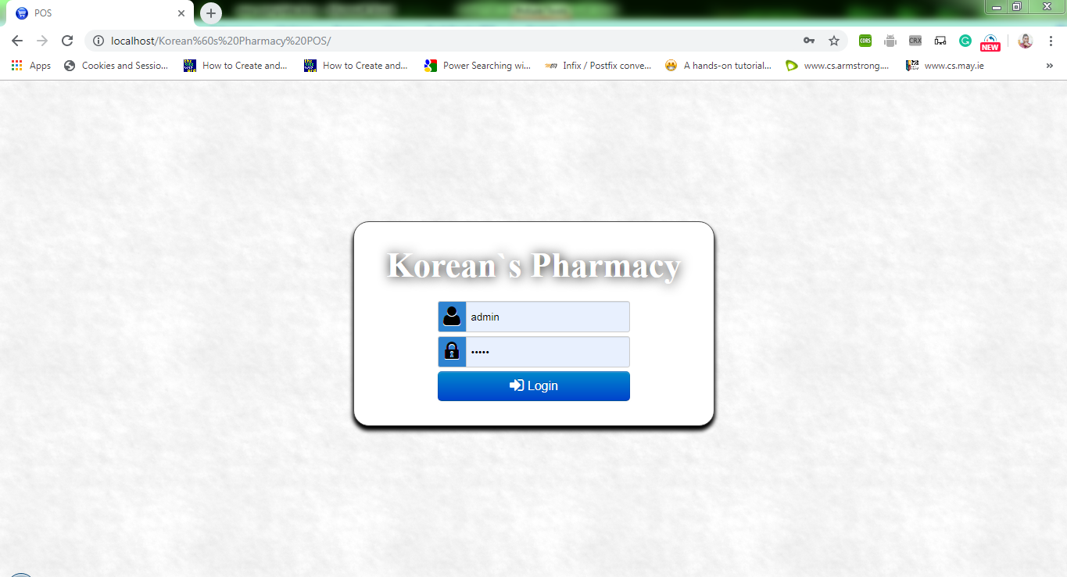
Figure 4.6: Login page: This is the page where an administrator or application user logs in to gain access to the system.
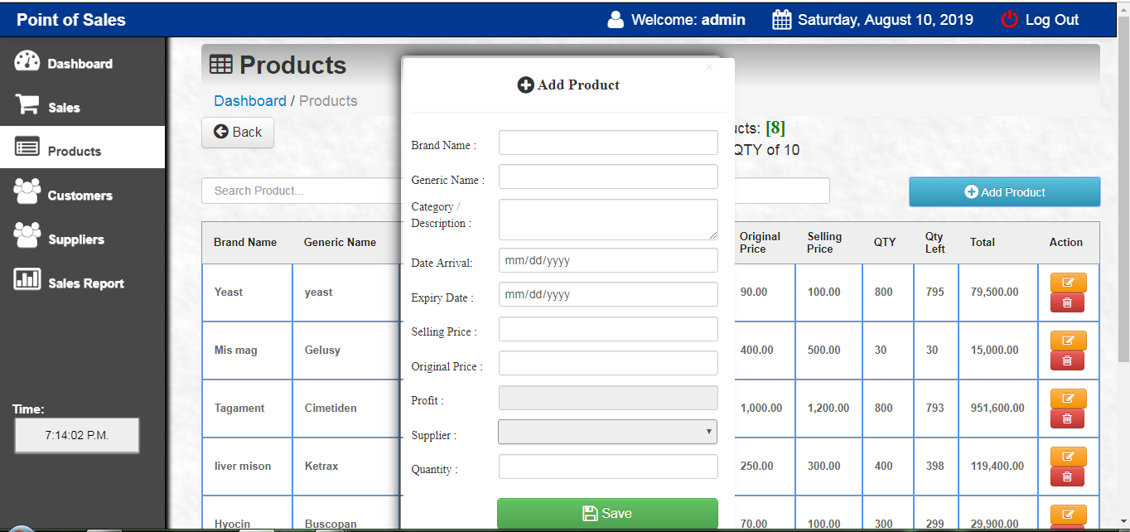
Figure 4.7: Add new product page: This is a page where administrators can add new products to the system by providing the system with all of the necessary information.
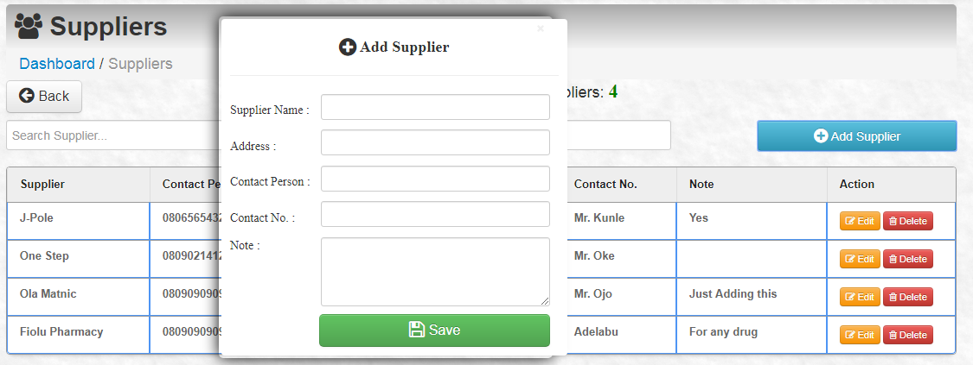
Figure 4.8: Add Supplier page: This is where you can add the suppliers who supply goods to your store.

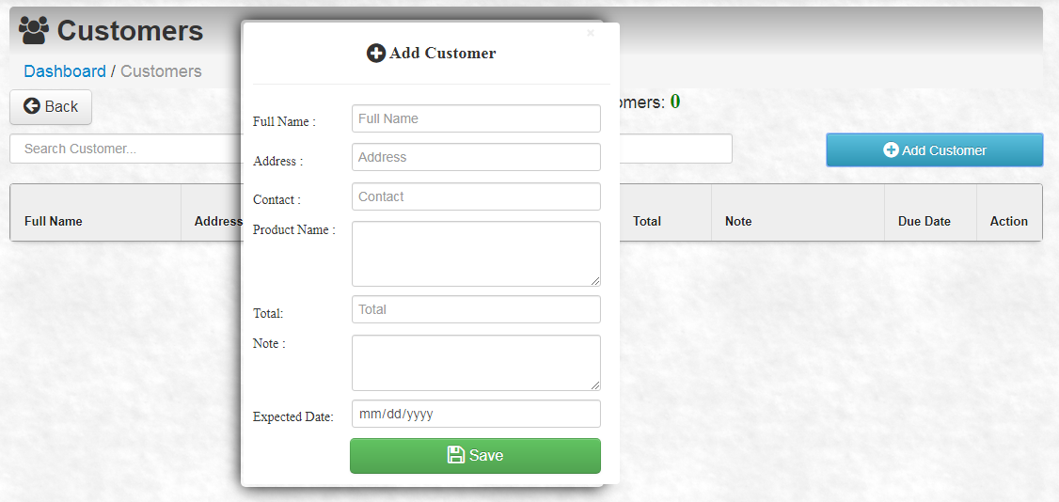
Figure 4.9: Add customer page: This is where you add the customers who buy goods from the store on a regular basis.

4.1.3 DATABASE DESIGN
This is the element that connects the input and output interfaces. Their content is processed to generate the required outputs. This is referring to the tables that will be used in the proposed system. The proposed system's database design is as follows:
Table 4.1: Product table: a structure for a product table that includes the field name and field type.
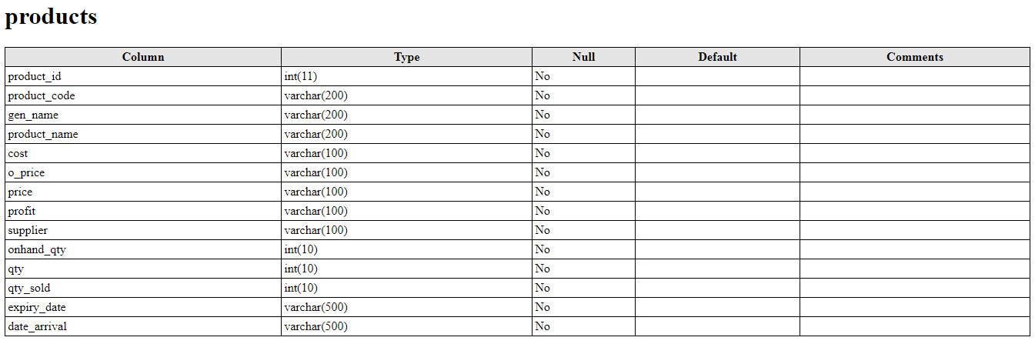
Table 4.2: Sales table: A sales table structure that includes the field name and field type.
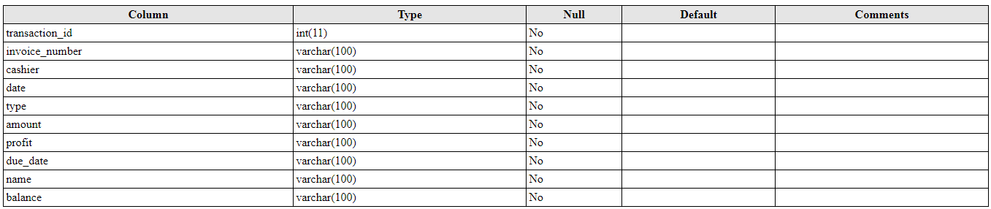
Table 4.3: Customer table: Structure of a customer table that includes the field name and field type.
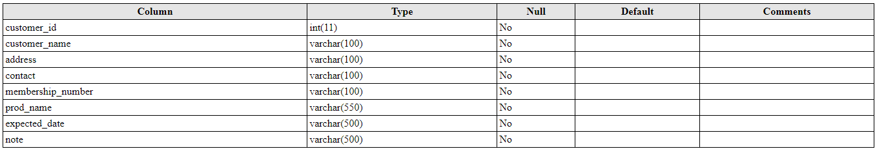
Table 4.4: Supplier table: Structure of a supplier table that includes the field name and field type.
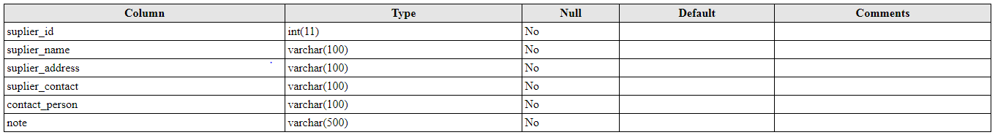
4.1.4 PROCEDURE DESIGN
This refers to the method of using the proposed system in a step-by-step manner. The proposed system includes an Admin Login, an add new product page, a product listing page, a sale page, a customer adding and listing page, and a report.
4.2 SYSTEM IMPLEMENTATION
System implementation entails the requirements of the system that will run the new application, taking into account the hardware and software required for the program's effective performance. A system's implementation can be broken down into six steps: -
    - Examine the design specifications
    - Develop, test, and document programs
    - Educate users
    - Run a system test
    - Switch to a new system
    - Assess and maintain the new system
4.2.1 CHOICE OF PROGRAMMING LANGUAGE
The application is designed in Barillo Software for barcode generation, HTML for web development, which includes the use of PHP server-side scripting language, MYSQL for database management, and (with other embedded functionalities) for page design and layout settings. As a result, testing the program is as simple as running it directly from a Mozilla Firefox web browser on a local host server provided by Apache 2.0 in the Wamp Server 2.0 application.
4.2.2 HARDWARE SUPPORT
- A minimum of a Pentium II- Intel 533 MHz processor.
- 1 GB RAM, 3.5 GB HDD, and a 3.5" FDD.
- 14-inch VGA monitor
- Microsoft Windows 2000 Enhanced Keyboard
- Mouse and mouse pad
- Scanner for barcodes.
4.2.3 SOFTWARE SUPPORT
- Interface Design Language, Windows Notepad for assisting with interface design using Hypertext Mark-up Language (HTML).
- MY SQL Database Management Software.
- PHP programming (Hypertext Pre-processor).
- Windows 8.1 operating system.
4.2.4 IMPLEMENTATION TECHNIQUE
In preparation for the installation of the new system, the method of changeover is carefully considered in order to ensure the success of the new system. Pilot changeover is a suitable changeover technique for this system. The pilot changeover applies the new system bit by bit until it covers the entire operation. The results of using the pilot method on a small portion of the operations would be used to determine the suitability of the need system for the remaining operations. This method is similar to testing a small sample of a distribution; if the test yields a positive result, the entire system becomes fully operational, and the manual/existing system is removed.
4.3 PROGRAM DOCUMENTATION
4.3.1 DOCUMENTATION OF THE SYSTEM
The following is a detailed description of the proposed system. It is significant because it aids in the design and implementation of a system that allows customers to shop by accessing the company's website via the internet from any location. It also aids in the design and implementation of a website that is more interactive and contains more information about the company's activities. Furthermore, it designs and implements a system that will create a virtual community without the need for offices and staff stationed all over the world.
4.3.2 OPERATING THE SYSTEM
The steps to use the proposed system are as follows
Installed the Application
- You are prompted to enter your username and password, which confirms that you are an administrator with permission to view this page.
- If the username and password entered are correct for an administrator, you will be directed to the home page.
- There are two types of usernames and passwords: administrator and user.
- As an administrator, you are directed to a page that contains all of the system's features.
4.3.3 MAINTENANING THE SYSTEM
The modification of the system is related to system maintenance. It refers to the ease with which changes can be made to the system under certain conditions. It also refers to the addition, deletion, or modification of a portion or the entire program. Programs with structure and a feature of maintainability are considered to be good. In terms of system maintenance, all network system components should be maintained and managed as the operation progresses. The purpose of system maintenance is to ensure that the system continues to perform as expected, and it includes:
- Hardware Maintenance: This includes all activities performed on computer and network hardware in order to anticipate the onset of incipient hardware faults. Professionals in hardware technology, engineering, or information technology
- Software Maintenance: All activities performed in updating and modifying programs to meet future challenges in software development are included in this category.
- Adaptive Maintenance: This entails making changes and modifications to programs to accommodate the operating environment.
- Corrective Maintenance: This is the process of detecting bugs in programs and other faults and then removing the functionality and operation.
CHAPTER FIVE
SUMMARY, CONCLUSION AND RECOMMENDATION
5.1 SUMMARY
Barcode authentication is intended to improve customer service when they are shopping by eliminating the need for them to pay with cash on hand. It has also improved the business's manual method of paying for their products. Because the application is designed for Malls and E-Shopping as a whole, rather than being tailored for individual use, the use of the application raises the issue of fake currency. Furthermore, only customers who have a debit or credit card that is authorized on the application are able to place orders with the goods manufacturers. All transactions are recorded in the system to allow for the tracking of goods. The findings of this study show that there is little awareness and sensitization to the availability (conceptual or otherwise) of online products. Furthermore, the use of these available applications (as discussed in the section on closely related works) is minimal. This feature prevents unauthorized users from ordering available drugs and also controls the account.
5.2 CONCLUSION
The application provides businesses with timely, relevant information to help them make sound business decisions. All reports are designed to meet the needs of the company and are presented in an accurate, detailed, and easy-to-understand format. Sales analysis applications improve both the organization's efficiency and compatibility. The developed product is simple to use, stress-free, and requires little special training for the cashier at the payment unit. This project report examines and capitalizes on existing developments and various types of barcode scanner technologies used for product identification, billing, and so on. The system's architecture has also been learned so that it can be used in shopping systems for intelligent and easy shopping in malls to save consumers' time, energy, and money. Current trends indicate that barcode scanners will grow rapidly over the next decade. There are a few issues that can be addressed to make the proposed system more robust. To promote consumer confidence, this issue must be resolved specifically with regard to billing. Furthermore, a more sophisticated microcontroller, larger display system, GPS to track the product, internet facility inside the scanner to browse offers, deals, and payment facility within the trolley via scanner can be used to make the trolley more advanced and provide a better consumer experience.
5.3 RECOMMENDATION
The main goal in the early stages of the project was to define the project problem statement, aim, and scope. It was determined that the best solution to TFM's information management problems would be a new technological system. The next step was to determine which technologies would be best suited to the project and thoroughly research each option. Following this evaluation, it was determined that a bar-coding system would be the best option. The Radio Frequency Identification (RFID) system was then used to determine the bar-coding system's technical requirements. Choosing the best barcode type, barcode reader type, and connection type to communicate information between the barcode reader and enterprise resource planning (ERP) system was involved. After the RFID method was completed, it was determined that a Code 128 type barcode would be the best option. It was also determined that a laser type barcode reader with a data input interface was required. The feasibility study was presented in the form of a feasibility matrix, which demonstrated that the proposed system would be a viable solution. This research will be expanded upon in the project's final report. The final step was to decide how the system should be implemented and to create clear instructions and procedures for employees to follow once the system was up and running. By following these operating procedures, TFM can ensure that all information required by the ERP system is accurate and up to date. It is strongly recommended that TFM carefully consider all suggested changes and that the company continue with the implementation of this project because it will result in a significant reduction in frustration and communication errors.
REFERENCES
Borisov, N., Goldberg, I. and Wagner, D. (2001). Intercepting Mobile Communications: The Insecurity of 802.1. Proceedings of the Seventh Annual International Conference on Mobile Computing and Networking: 180-189.
Chandersekaran, A. C. (2011). Education and Training Transformed by Internet-enabled Electronic Commerce. Business America, Vol. 119, No. 1, January, US Department of Commerce, Washington D.C, USA.
Culnan, M. J. (2000). Information Privacy Concerns, Procedural Fairness and Impersonal Trust: An Empirical Investigation. Organization Science Journal of Public Policy and Marketing, 19 (1): 120-426
Denton, M. (2011). Preliminary Estimates of the Multiplier Effects of Electronic Commerce on the EU Economy and Employment, FAIR Working Paper No. 47, March.
Gao, J. Z. Prakash, L. and Jagatesan, R. (2007). Understanding 2DBarCode Technology and Applications in M-Commerce - Design and Implementation of A 2D Barcode Processing Solution. in Computer Software and Applications Conference, pp. 49-56.
Gupta, P. and Dubey A. (2016). E-Commerce- Study of Privacy, Trust and Security from Consumer’s Perspective. International Journal of Computer Science and Mobile Computing, Vol.5 Issue.6, pg. 224-232, New Delhi, India
John, K. (2011), “Manual Inventory Management System”, Financial Times, 28 April, p. 18, Liverpool, England.
Julius, M. (2011). Inventory Control System, Financial Times, 28 April, p. 18, Massachusetts, USA.
Kato, H. and Keng T. (2007). Pervasive 2D Barcodes for Camera Phone Applications, stated in IEEE conference, Sloan Management Review, 42 (1), pp. 39–48.
Khandare N. B. (2015). Transaction Security for Internet E-commerce Application. International Journal of Advanced Research in Computer Science and Software Engineering, Volume 5, Issue 2, Mumbai, India.
Kim, D. J., Ferrin, D. L. and Rao, H. R. (2008). A Trust-Based Consumer Decision Model in Electronic Commerce: The Role of Trust, Risk, and Their Antecedents. Decision Support Systems, 44(2), 544. Research Collection Lee Kong China School of Business.
Masalkar, P.A., Singh, U. and Shinde S. (2015). 2D Barcode Based Mobile Payment System With Biometric Security. International Journal of Modern Trends in Engineering and Research (IJMTER) Volume 02, Issue 04, ISSN:2349 – 9745 ; ISSN:2393-8161.
McCathie B. T. (2004). Protective measures in ecommerce to deal with security threats arising out of social issues a framework, iaeme -issn 0976 – 6375, volume 4, issue 1, 39,
457-461
Patro S. P., Padhy, N. and Panigrahi, R. (2016). Security Issues over E-Commerce and their Solutions. International Journal of Advanced Research in Computer and Communication Engineering ISO 3297:2007 Vol. 5, Issue 12, Gunupur, India.
Schneider G. P., & Perry J T (2001) Electronic commerce. Course Technology, Cambridge, MA.
Sengupta, A., Mazumdar, C. and Barik M. S. (2005). e-Commerce security – A life cycle approach. Vol. 30, Parts 2 & 3, pp. 119–140. India.

PROGRAM FLOWCHART
START
Sales
Products
Customer
Supplier
Report
Login
Main Menu
Logout
Stop

LOGIN FLOWCHART
Yes
START
Is username and password correct?

Enter username and password
Main menu
Stop
No
Yes
Try Again?
No

MAIN MENU FLOWCHART
Start
Choose operation
Is option sales?
Is option
Products?
Is option
Customers?
Is option
suppliers?
Is option
Report?
Stop
No
Yes
Yes
Yes
Yes
Yes
Sales
Customers
Products
Suppliers
Report

SUPPLIER FLOWCHART
Perform Transaction
Add to List
Start
Save to Database
Close Database
Open Database
Enter Product ID
Return
Any more process?

Yes

PRODUCT FLOWCHART
Return
Start
Open Database
Fetch all records
Display Products
Do you want to add new product?
Yes
No
Add Products

Close Database
Close Database

Return

ADD NEW PRODUCT FLOWCHART
Return
Yes
Start
Any
More
Process?
Save record
Enter product information

Open database

No

Close database

CUSTOMERS FLOWCHART
Start

Open Database

Fetch the data

Display records

Do you want to add new customer?

Add Customer

Close Database

Return

Yes

No

ADD CUSTOMER FLOWCHART
Return
Yes
Start
Any
More
Process?
Save record
Enter customer details
Open database

Close database

SUPPLIER FLOWCHART
Start

Open Database

Fetch the data

Display Records

Do you want to add new supplier?

Add supplier

Close Database

Return

ADD SUPPLIER FLOWCHART
Return
Yes
Start
Any
More
Process?
Save record
Enter supplier details
Open database

Close database

REPORT FLOWCHART
Start

Display Records
Close database
Enter dates
Fetch the data
Return
Open database

SOURCE CODE

<?php
//Start session
session_start();
//Unset the variables stored in session
unset($_SESSION['SESS_MEMBER_ID']);
unset($_SESSION['SESS_FIRST_NAME']);
unset($_SESSION['SESS_LAST_NAME']);
?>
<html>
<head>
<title>
POS
</title>
<link rel="shortcut icon" href="main/images/pos.jpg">
<link href="main/css/bootstrap.css" rel="stylesheet">
<link rel="stylesheet" type="text/css" href="main/css/DT_bootstrap.css">
<link rel="stylesheet" href="main/css/font-awesome.min.css">
<style type="text/css">
body {
padding-top: 60px;
padding-bottom: 40px;
}
.sidebar-nav {
padding: 9px 0;
}
</style>
<link href="main/css/bootstrap-responsive.css" rel="stylesheet">
<link href="style.css" media="screen" rel="stylesheet" type="text/css" />
</head>
<body>
<div class="container-fluid">
<div class="row-fluid">
<div class="span4">
</div>
</div>
<div id="login">
<?php
if( isset($_SESSION['ERRMSG_ARR']) && is_array($_SESSION['ERRMSG_ARR']) && count($_SESSION['ERRMSG_ARR']) >0 ) {
foreach($_SESSION['ERRMSG_ARR'] as $msg) {
echo '<div style="color: red; text-align: center;">',$msg,'</div><br>';
}
unset($_SESSION['ERRMSG_ARR']);
}
?>
<form action="login.php" method="post">

<font style=" font:bold 44px 'Aleo'; text-shadow:1px 1px 15px #000; color:#fff;"><center>Korean`s Pharmacy</center></font>
<br>

<div class="input-prepend">
<span style="height:30px; width:25px;" class="add-on"><i class="icon-user icon-2x"></i></span><input style="height:40px;" type="text" name="username" Placeholder="Username" required/><br>
</div>
<div class="input-prepend">
<span style="height:30px; width:25px;" class="add-on"><i class="icon-lock icon-2x"></i></span><input type="password" style="height:40px;" name="password" Placeholder="Password" required/><br>
</div>
<div class="qwe">
<button class="btn btn-large btn-primary btn-block pull-right" href="dashboard.html" type="submit"><i class="icon-signin icon-large"></i> Login</button>
</div>
</form>
</div>
</div>
</div>
</div>
</body>
</html>
// textes
$langues = array(
'en' => array(
'langue' => 'English',
'autreLangue' => 'Version Fran&ccedil;aise',
'autreLangueLien' => 'fr',
'titreHtml' => 'WAMPSERVER Homepage',
'titreConf' => 'Server Configuration',
'versa' => 'Apache Version :',
'versp' => 'PHP Version :',
'versm' => 'MySQL Version :',
'phpExt' => 'Loaded Extensions : ',
'titrePage' => 'Tools',
'txtProjet' => 'Your Projects',
'txtNoProjet' => 'No projects yet.<br />To create a new one, just create a directory in \'www\'.',
'txtAlias' => 'Your Aliases',
'txtNoAlias' => 'No Alias yet.<br />To create a new one, use the WAMPSERVER menu.',
'faq' => 'http://www.en.wampserver.com/faq.php'
),
'fr' => array(
'langue' => 'Fran?s',
'autreLangue' => 'English Version',
'autreLangueLien' => 'en',
'titreHtml' => 'Accueil WAMPSERVER',
'titreConf' => 'Configuration Serveur',
'versa' => 'Version de Apache:',
'versp' => 'Version de PHP:',
'versm' => 'Version de MySQL:',
'phpExt' => 'Extensions Charg&eacute;es: ',
'titrePage' => 'Outils',
'txtProjet' => 'Vos Projets',
'txtNoProjet' => 'Aucun projet.<br /> Pour en ajouter un nouveau, cr&eacute;ez simplement un r&eacute;pertoire dans \'www\'.',
'txtAlias' => 'Vos Alias',
'txtNoAlias' => 'Aucun alias.<br /> Pour en ajouter un nouveau, utilisez le menu de WAMPSERVER.',
'faq' => 'http://www.wampserver.com/faq.php'
)
);
// images
//affichage du phpinfo
if (isset($_GET['phpinfo']))
{
phpinfo();
exit();
}
//affichage des images
if (isset($_GET['img']))
{
switch ($_GET['img'])
{
case 'pngFolder' :
header("Content-type: image/png");
echo base64_decode($pngFolder);
exit();
case 'pngFolderGo' :
header("Content-type: image/png");
echo base64_decode($pngFolderGo);
exit();
case 'gifLogo' :
header("Content-type: image/gif");
echo base64_decode($gifLogo);
exit();
case 'pngPlugin' :
header("Content-type: image/png");
echo base64_decode($pngPlugin);
exit();
case 'pngWrench' :
header("Content-type: image/png");
echo base64_decode($pngWrench);
exit();
case 'favicon' :
header("Content-type: image/x-icon");
echo base64_decode($favicon);
exit();
}
}

// D?nition de la langue et des textes

if (isset ($_GET['lang']))
{
$langue = $_GET['lang'];
}
elseif (isset ($_SERVER['HTTP_ACCEPT_LANGUAGE']) AND preg_match("/^fr/", $_SERVER['HTTP_ACCEPT_LANGUAGE']))
{
$langue = 'fr';
}
else
{
$langue = 'en';
}

//initialisation
$aliasContents = '';
// recuperation des alias
if (is_dir($aliasDir))
{
$handle=opendir($aliasDir);
while ($file = readdir($handle))
{
if (is_file($aliasDir.$file) && strstr($file, '.conf'))
{
$msg = '';
$aliasContents .= '<li><a
href="'.str_replace('.conf','',$file).'/">'.str_replace('.conf','',$file).'</a></li>';
}
}
closedir($handle);
}
if (!isset($aliasContents))
$aliasContents = $langues[$langue]['txtNoAlias'];

// recuperation des projets
$handle=opendir(".");
$projectContents = '';
while ($file = readdir($handle))
{
if (is_dir($file) && !in_array($file,$projectsListIgnore))
{
$projectContents .= '<li><a href="'.$file.'">'.$file.'</a></li>';
}
}
closedir($handle);
if (!isset($projectContents))
$projectContents = $langues[$langue]['txtNoProjet'];
//initialisation
$phpExtContents = '';

// recuperation des extensions PHP
$loaded_extensions = get_loaded_extensions();
foreach ($loaded_extensions as $extension)
$phpExtContents .= "<li>${extension}</li>";

$pageContents = <<< EOPAGE
<?xml version="1.0" encoding="iso-8859-1"?>
<!DOCTYPE html PUBLIC "-//W3C//DTD XHTML 1.1//EN"
"http://www.w3.org/TR/xhtml11/DTD/xhtml11.dtd">

<html lang="en" xml:lang="en">
<head>
<title>{$langues[$langue]['titreHtml']}</title>
<meta http-equiv="Content-Type" content="txt/html; charset=utf-8" />

<style type="text/css">
* {
margin: 0;
padding: 0;
}

html {
background: #ddd;
}
body {
margin: 1em 10%;
padding: 1em 3em;
font: 80%/1.4 tahoma, arial, helvetica, lucida sans, sans-serif;
border: 1px solid #999;
background: #eee;
position: relative;
}
#head {
margin-bottom: 1.8em;
margin-top: 1.8em;
padding-bottom: 0em;
border-bottom: 1px solid #999;
letter-spacing: -500em;
text-indent: -500em;
height: 125px;
background: url(index.php?img=gifLogo) 0 0 no-repeat;
}
.utility {
position: absolute;
right: 4em;
top: 145px;
font-size: 0.85em;
}
.utility li {
display: inline;
}

h2 {
margin: 0.8em 0 0 0;
}

ul {
list-style: none;
margin: 0;
padding: 0;
}
#head ul li, dl ul li, #foot li {
list-style: none;
display: inline;
margin: 0;
padding: 0 0.2em;
}
ul.aliases, ul.projects, ul.tools {
list-style: none;
line-height: 24px;
}
ul.aliases a, ul.projects a, ul.tools a {
padding-left: 22px;
background: url(index.php?img=pngFolder) 0 100% no-repeat;
}
ul.tools a {
background: url(index.php?img=pngWrench) 0 100% no-repeat;
}
ul.aliases a {
background: url(index.php?img=pngFolderGo) 0 100% no-repeat;
}
dl {
margin: 0;
padding: 0;
}
dt {
font-weight: bold;
text-align: right;
width: 11em;
clear: both;
}
dd {
margin: -1.35em 0 0 12em;
padding-bottom: 0.4em;
overflow: auto;
}
dd ul li {
float: left;
display: block;
width: 16.5%;
margin: 0;
padding: 0 0 0 20px;
background: url(index.php?img=pngPlugin) 2px 50% no-repeat;
line-height: 1.6;
}
a {
color: #024378;
font-weight: bold;
text-decoration: none;
}
a:hover {
color: #04569A;
text-decoration: underline;
}
#foot {
text-align: center;
margin-top: 1.8em;
border-top: 1px solid #999;
padding-top: 1em;
font-size: 0.85em;
}
</style>

<link rel="shortcut icon" href="index.php?img=favicon" type="image/ico" />
</head>

<body>
<div id="head">
<h1><abbr title="Windows">W</abbr><abbr title="Apache">A</abbr><abbr title="MySQL">M</abbr><abbr title="PHP">P</abbr></h1>
<ul>
<li>PHP 5</li>
<li>Apache 2</li>
<li>MySQL 5</li>
</ul>
</div>

<ul class="utility">
<li>Version ${wampserverVersion}</li>
<li><a href="?lang={$langues[$langue]['autreLangueLien']}">{$langues[$langue]['autreLangue']}</a></li>
</ul>

<h2> {$langues[$langue]['titreConf']} </h2>

<dl class="content">
<dt>{$langues[$langue]['versa']}</dt>
<dd>${apacheVersion} &nbsp;</dd>
<dt>{$langues[$langue]['versp']}</dt>
<dd>${phpVersion} &nbsp;</dd>
<dt>{$langues[$langue]['phpExt']}</dt>
<dd>
<ul>
${phpExtContents}
</ul>
</dd>
<dt>{$langues[$langue]['versm']}</dt>
<dd>${mysqlVersion} &nbsp;</dd>
</dl>
<h2>{$langues[$langue]['titrePage']}</h2>
<ul class="tools">
<li><a href="?phpinfo=1">phpinfo()</a></li>
<li><a href="phpmyadmin/">phpmyadmin</a></li>
</ul>
<h2>{$langues[$langue]['txtProjet']}</h2>
<ul class="projects">
$projectContents
</ul>
<h2>{$langues[$langue]['txtAlias']}</h2>
<ul class="aliases">
${aliasContents}
</ul>
<ul id="foot">
<li><a href="http://www.wampserver.com">WampServer</a></li> -
<li><a href="http://www.wampserver.com/en/donations.php">Donate</a></li> -
<li><a href="http://www.alterway.fr">Alter Way</a></li>
</ul>
</body>
</html>
EOPAGE;

echo $pageContents;
?>
td a{
color:darkblue;
}

td a:hover{
color:red;

}

@font-face
{
font-family: myFirstFont;
src: url(MTCORSVA.woff);
}
#header{
font-family:myFirstFont;
font-weight: bold;
font-size: 25px;
}
#loginform {
margin: 150px auto;
width: 280px;
}
#loginform span {
width: 100px;
display: inline-block;
}
#ac span {
width: 95px;
display: inline-block;
font-size: 14px;
margin-bottom: 12px;
padding-right: 10px;
}
select {
border: 1px solid #999;
background: #EEEEEE;
padding: 5px 10px;
box-shadow:0 1px 2px #ddd;
-moz-box-shadow:0 1px 2px #ddd;
-webkit-box-shadow:0 1px 2px #ddd;
}

.qwe{
width:246px;
margin:auto;
}

input {
border: 1px solid #999;
background: #EEEEEE;
padding: 10px;
box-shadow:0 1px 2px #ddd;
-moz-box-shadow:0 1px 2px #ddd;
-webkit-box-shadow:0 1px 2px #ddd;
}
#btn {
width:100px;
background: green;
border: 1px solid #999;
border-radius:10px;
cursor: pointer;
font-size: 13px;
font-weight: bold;
}
#maintable {
margin: 50px auto;
width: 900px;
}

button a, a:hover{
color:#fff;
text-decoration:none;
}

#filter {
width: 70%;
float:left;
}
#addd {
border: 1px solid #999;
background: #EEEEEE;
padding: 5px 10px;
box-shadow:0 1px 2px #ddd;
-moz-box-shadow:0 1px 2px #ddd;
-webkit-box-shadow:0 1px 2px #ddd;
width: 25%;
display: inline-block;
float:right;
text-align: center;
text-decoration: none;
color: #000000;
}
#cccc {
border: 1px solid #999;
background: #EEEEEE;
padding: 5px 10px;
box-shadow:0 1px 2px #ddd;
-moz-box-shadow:0 1px 2px #ddd;
-webkit-box-shadow:0 1px 2px #ddd;
width: 25%;
display: inline-block;
float:left;
text-align: center;
text-decoration: none;
color: #000000;
}
.clearfix {
clear: both;
}
#resultTable {
border-collapse: separate;
background-color: #FFFFFF;
border-spacing: 0;
max-width: 100%;
}
#resultTable {
color: #666666;
text-shadow: 0 1px 0 #FFFFFF;
width: 100%;
border: 1px solid #999999;
box-shadow: 0 5px 5px -5px rgba(0, 0, 0, 0.3);
margin-top: 13px;
}
#resultTable thead tr th {
background: none repeat scroll 0 0 #EEEEEE;
color: #222222;
padding: 10px 14px;
text-align: left;
border-top: 0 none;
font-size: 13px;
}

#resultTable tbody tr td{
font: bold 13px 'Arial';

text-align: left;
padding: 10px 14px;
border-top: 1px solid #999999;
}

#resultTable td{
padding:7px; border:#4e95f4 1px solid;
}
#resultTable tr{
background: #fff;
}
#resultTable tr:hover {
background-color: #ffff99;
}

#mainmain {
margin: 50px auto;
text-align: center;
width: 980px;
}
#mainmain a {
text-decoration: none;
padding-top:15px;
padding-bottom:5px;
padding-left:15px;
padding-right:15px;
border-radius:10px;
margin:10px;
box-shadow:0 5px 5px 2px #484848;
-moz-box-shadow:0 5px 5px 2px #484848;
-webkit-box-shadow:0 5px 5px 2px #484848;
border:1px solid #000;
background: #fff;
color: #222222;
font-size:20px;
display: inline-block;
width: 265px;
height: 85px;
text-align: center;
margin-bottom: 5px;
}
<link href="../style.css" media="screen" rel="stylesheet" type="text/css" />
<table class="table table-bordered" id="resultTable" data-responsive="table" style="text-align: left;">
<thead>
<tr>
<th width="25%"> Name </th>
<th width="3%"> Qty </th>
<th width="8%"> Cost </th>
</tr>
</thead>
<tbody>

<?php
include('../connect.php');
$id=$_GET['iv'];
$result = $db->prepare("SELECT * FROM purchases_item WHERE invoice= :userid");
$result->bindParam(':userid', $id);
$result->execute();
for($i=0; $row = $result->fetch(); $i++){
?>
<tr class="record">
<td><?php
$rrrrrrr=$row['name'];
$resultss = $db->prepare("SELECT * FROM products WHERE product_code= :asas");
$resultss->bindParam(':asas', $rrrrrrr);
$resultss->execute();
for($i=0; $rowss = $resultss->fetch(); $i++){
echo $rowss['product_name'];
}
?></td>
<td><?php echo $row['qty']; ?></td>
<td>
<?php
$dfdf=$row['cost'];
echo formatMoney($dfdf, true);
?>
</td>
</tr>
<?php
}
?>
<tr>
<td colspan="2"><strong style="font-size: 12px; color: #222222;">Total:</strong></td>
<td><strong style="font-size: 12px; color: #222222;">
<?php
function formatMoney($number, $fractional=false) {
if ($fractional) {
$number = sprintf('%.2f', $number);
}
while (true) {
$replaced = preg_replace('/(-?\d+)(\d\d\d)/', '$1,$2', $number);
if ($replaced != $number) {
$number = $replaced;
} else {
break;
}
}
return $number;
}
$sdsd=$_GET['iv'];
$resultas = $db->prepare("SELECT sum(cost) FROM purchases_item WHERE invoice= :a");
$resultas->bindParam(':a', $sdsd);
$resultas->execute();
for($i=0; $rowas = $resultas->fetch(); $i++){
$fgfg=$rowas['sum(cost)'];
echo formatMoney($fgfg, true);
}
?>
</strong></td>
</tr>

</tbody>
</table>

