DESIGN AND IMPLEMENTATION OF DIGITAL SIGNATURE

BY

SABITU, Samad Daniel
ND/23/COM/PT/0344

A PROJECT SUBMITTED TO THE
DEPARTMENT OF COMPUTER SCIENCE,
INSTITUTE OF INFORMATION AND COMMUNICATION TECHNOLOGY, KWARA STATE POLYTECHNIC, ILORIN
IN PARTIAL FULFILMENT OF THE REQUIREMENTS AWARD OF NATIONAL DIPLOMA (ND) IN COMPUTER SCIENCE.

JUNE,2025

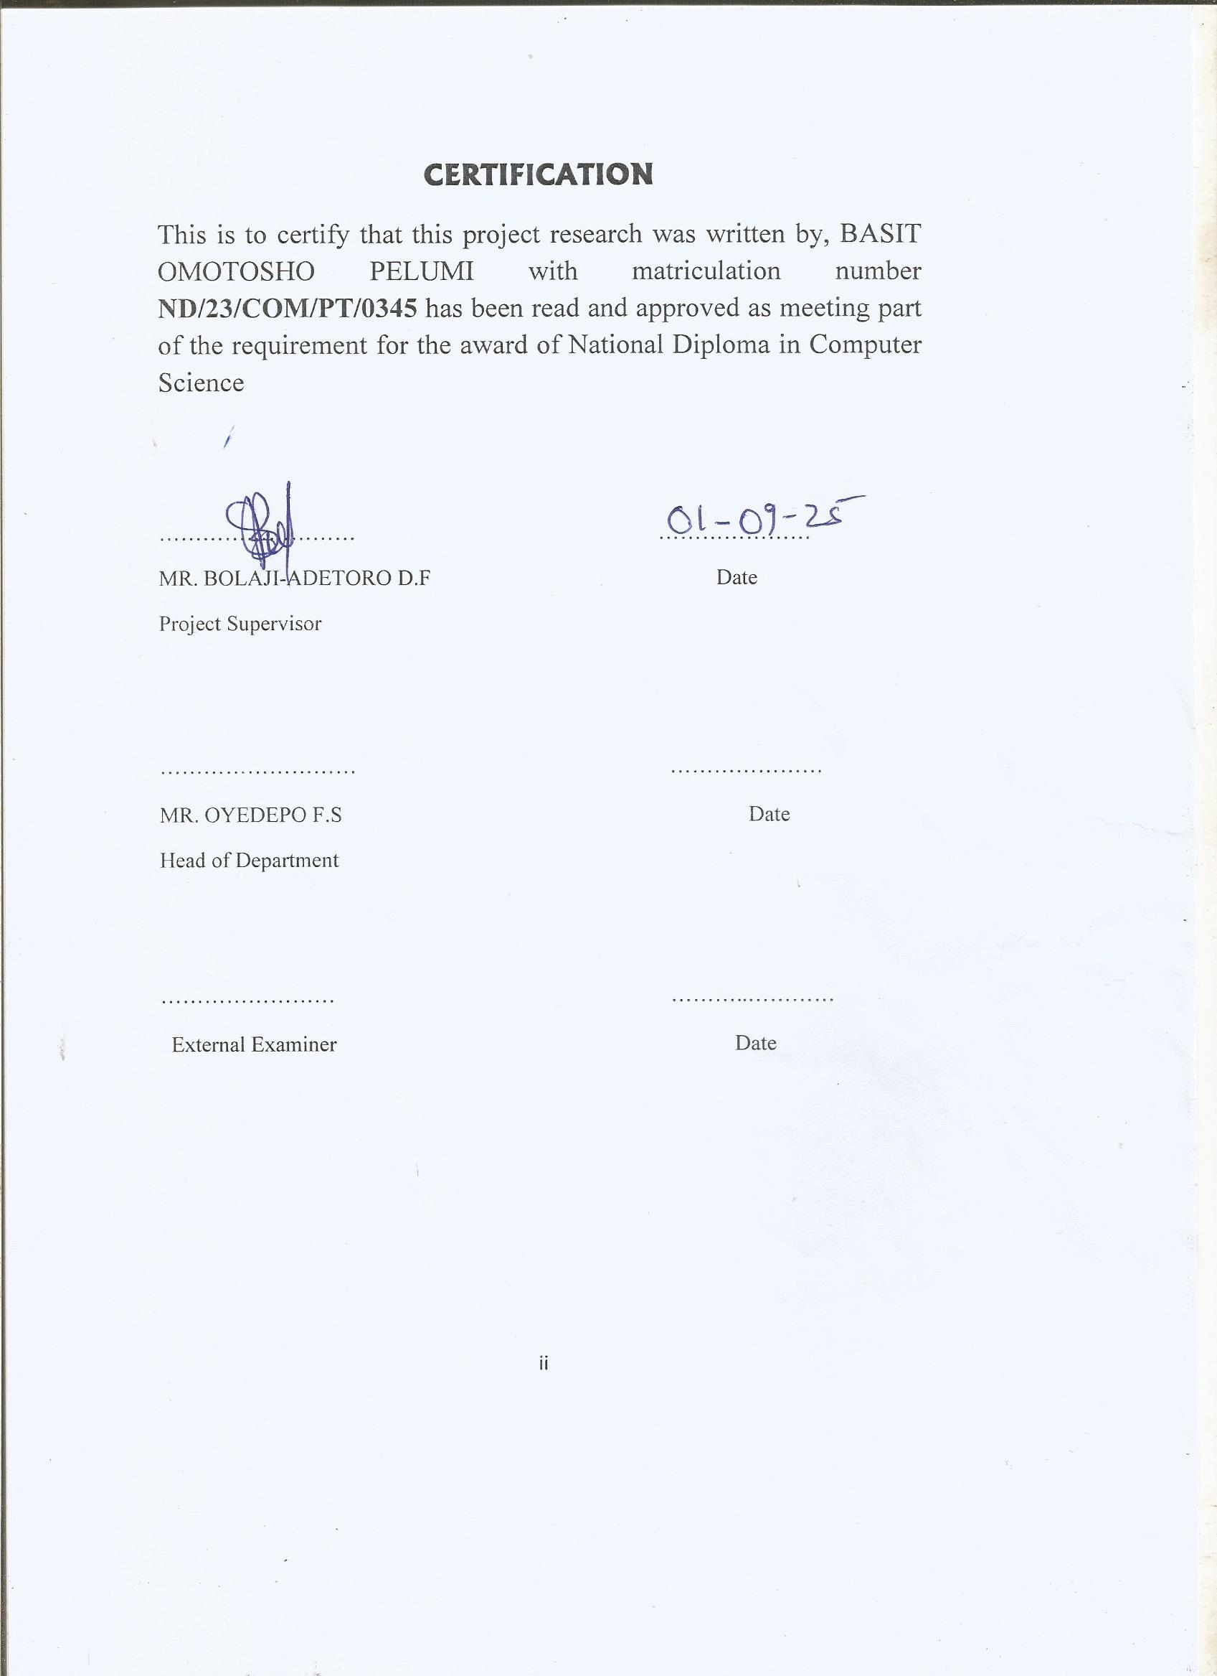
DEDICATION
This project is dedicated to the Almighty God.

ACKNOWLEDGEMENT

The completion of this programme has been both intellectually demanding and deeply rewarding. I first give thanks to Almighty God, whose grace, protection, and guidance have sustained me from inception to conclusion.
My sincere gratitude goes to Mr F. S. Oyedepo, Head of the Department of Computer Science, for his consistent support and encouragement. His leadership and commitment to student success were a constant source of motivation.
I am especially indebted to my project supervisor, Mr D. F. Bolaji-Adetoro, whose expert guidance, constructive feedback, and scholarly insight were pivotal to the direction and quality of this research.
I also thank the lecturers of the Department of Computer Science for their dedication to academic excellence and for the knowledge and discipline they imparted, which have enriched my professional growth.
To my lovely parent Mr & Mrs Sabitu and also to my family, friends, and colleagues, I am grateful for your prayers, encouragement, and unwavering support during challenging times. Your confidence in me was invaluable.
Finally, I acknowledge all who contributed in any way to the success of this project. Your assistance and goodwill are deeply appreciated.

TABLE OF CONTENTS
Title Page…………………………………………………………………………………..i
Certification Page…………………………………………………………………………ii
Dedication………………………………………………………………………………...iii
Acknowledgement………………………………………………………………………..iv
Table of contents…………………………………………………………………………..v
List of figures………………………………………………………………………..........vi
List of tables……………………………………………………………………………..vii
Abstract…………………………………………………………………………............viii
CHAPTER ONE: GENERAL INTRODUCTION
  - Introduction…………………………………………………………………………1
  - Statement of the Problem…...………………………………………………………3
  - Aim and objectives……………………………………………………...…………..4
  - Significance of the study……………………………………………………...…….4
  - Scope of the study……………………………………………………………...…...4
  - Organization of report………………………………………………………...…….4
CHAPTER TWO: LITERATURE REVIEW
2.1 Review of related past work……………………………………………………...…7
2.2 Review of general literature texts………………………………………………….10
2.2.1 Examination Malpractice in Nigeria……………………………………………….10
2.2.2 Effects of examination Malpractice in Nigeria…………………………………….11
2.2.3 Fight against examination Malpractice in Nigeria………………………………...12
2.2.4 Effects of effective invigilation on examination malpractice in Nigeria………….13
2.3 Closed-Circuit television Surveillance…………………………………………….13
CHAPTER THREE: ANALYSIS OF THE SYSTEM
3.1 Research methodology……………………………………………………………14
3.1.1Installing the system……………………………………………………………...14
3.1.2 Classification of CCTV cameras……………...…………………………………..15
3.1.3 How the smart video surveillance will be used to curb examination malpractice.....................................................................………………………………………17
3.2 Analysis of the existing system …………………………………………………..18
3.3 Problem of the existing system…………………………………………………...18
3.4 Description of the proposed system……………………………………………....19
3.5 Advantages of proposed system………………………………………………….20
CHAPTER FOUR: DESIGN AND IMPLEMENTATION OF THE SYSTEM
4.1 Design of the System……………………………………………………………...21
4.1.1 Output Design…………………………………………………………………......21
4.1.2 Input Design………………………………………………………………….........22
4.1.3 Database Design…………………………………………………………………...25
4.1.4 Procedure Design………………………………………………………………….25
4.2 System Implementation……………………………………………………….......26
4.2.1 Hardware Support………………………………………………………………....26
4.2.2 Software Support………………………………………………………………….26
4.2.3 Implementationof the techniques used in details………………………………....26
4.3 System Documentation …………………………………………………………...26
4.3.1 Documentation of the program …………………………………………………...27
4.3.2 Operating the System……………………………………………………………...27
4.3.3 Maintaining the System…………………………………………………………...27
CHAPTER FIVE: SUMMARY, CONCLUSION AND RECOMMENDATION
5.1 Summary………….………………………………………………………………….30
5.2 Conclusion…………………………………………………………………………...30
5.3Recommendation for future Work…………………………………………………...30
References

CHAPTER ONE
GENERAL INTRODUCTION
  - INTRODUCTION
In this modern age of increasing interconnectivity, information security has come to occupy a pivotal position in recent research works. Traditional methods of authentication have been text-based password schemes. However, the major drawback with them, has been the fact that their strength varies inversely with user convenience. Users generally tend to select passwords that are easier to recall and shorter in length. This, gives rise to password cracking attempts. A graphical password is a confirmation framework that works by having the client selected pictures, in a particular order. Graphical passwords authentication system has inherent advantages over conventional textual password schemes.User authentication for network or internet based environment posed a challenging task for system and network administrator. This statement is true and is still very much applicable till these days as it is a well-known fact that authentication is being widely incorporated as part of access control for most systems. Authentication has been the catalyst for business organization in information protection and security. Implementation of access control policies, standard procedures involves the identification of appropriate authentication mechanism whereby the criticality of the information being protected are being used as justification for having a more refined authentication mechanism as compared to a more simple approach.(Adams, 2010)
Without the appropriate authentication mechanism in place, attacker could easily gain access to systems or applications by utilizing personal information, gained through various means, including but not limited to social engineering. Conventional textual passwords are the most common mechanism used in authentication. This method requires a user to enter their username and password, either in alphabet or numeric, or more commonly, a mixture of both forms as authentication tokens to gain access to systems or applications. Two recent surveys have shown that users choose short, simple passwords that are easily guessable, for example, “password”, personal names of family members, names of pets, and dictionary words (Sasseet et al, 2001; Brown et al,. 2004). Ironically, these practices are one of many loopholes that can be compromised easily. Therefore, it is essential that the application of this mechanism involves having appropriate complexity rules, such that the probability of password being cracked is less likely. Without the appropriate complexity, passwords can be easily cracked through dictionary attack. With the complexity in place, especially when using a non-dictionary word, users tend to type such passwords 40 percent slower than the time used for typing of dictionary words (Thomas et al.,2005). The slower rate of typing essentially would render the user more vulnerable to shoulder surfing. Shoulder Surfing is basically a form of social engineering whereby an attacker would look over his/her victim’s shoulder to establish the password that are being entered.
To counteract the easy to guess problem and to make a balancing act on user friendliness and authentication complexity, the usage of graphical passwords in the authentication process is presented to offset against insecure password and make the graphical password system more memorable to the users by using Intuitive approach method.A graphical password is a confirmation framework that works by having the client selected pictures, in a particular order. Graphical passwords authentication system has inherent advantages over conventional textual password schemes. In this system there are 3 authentication levels after registering the basic information, User login’s and after implementing id password system ask to authenticate in 3 different levels.(James, 2012)
  - STATEMENT OF THE PROBLEM
Several security weakness noticed in the existing alphanumeric password authentication system, has often been criticized for reasonable concerns due to the fact that, difficulty in remembering passwords that are so long makes the users to create short, simple and insecure password. Text-based password is the most popular method of authenticating users in computer system, but these suffer from security and usability problems which has almost become the norm. A recent research on graphical password (Persuasive Cued Click point, PCCP) improves security issues but it is also vulnerable to attacks, it (images) can be attacked by scammers, hackers before it gets to the database.
  - AIM AND OBJECTIVES OF THE STUDY
The aimof this project is to develop a graphical password authentication system using intuitive approach that will allow user selected pictures, in a particular order for authentication. This aim has the below objectives.
- To develop an application that will authenticate user through image arrangement.
- To develop a graphical password system that is resistance to shoulder surfing.
- To review various graphical authenticating scheme.
- To develop a system where the implementation will be carried out using Sublime Text IDE and PHP Programming language.
  - SIGNIFICANCE OF THE STUDY
The importance of this study compared to the existing one is that the outcome would be a web based authentication system, with graphical password as the access control mechanism. The outcome is code named ‘IGPS’ (Intuitive Graphical Password System) and will be known as such throughout this study. The implementation of the system on web platform is to ensure that the system is platform independent, which can be adapted for most, if not all type of systems. Also, as current trend shows, there is an urgent need to have a more secure authentication mechanism for web based environment, where most current systems are typically being emphasized on and where commercial growth are apparent at this moment. Essentially, this project would also emphasize on providing a secure environment to its user, without compromising on the user-friendliness of the system.
  - SCOPE OF THE STUDY
The project scope includes an authentication system that can connect to the other kind of system such as accounting system, administration system or payroll system, point of sales etc.
  - ORGANIZATION OF THE REPORT
Chapter one of this project deals with the general introduction to the work in the project. It also covers the statement of the problem, aim and objectives of the study, the significance of the study, the scope and limitation of the study, organization of the report.
Chapter two presents a review of literature. It discusses topical issues on software quality control. It also looks into review of past projects related to the project topic of study.Chapter three covers the research methodology, analysis of the existing system, problems of existing system (procedure) itemized, the description of the proposed system and the basic advantages of the proposed system.
Chapter four contains the design, implementation and documentation of the system. The design involves the system design, output design form, input design form, database structure and the procedure of the system. The implementation involves the implementation techniques used in details, choice of programming language used and the hardware and software support. The documentation of the system involves the operation of the system and the maintenance of the system. Chapter five deals with the summary of findings, conclusion, recommendation and references.

CHAPTER TWO
LITERATURE REVIEW
2.1 REVIEW OF RELATED WORK
Wazir Z. (2011) in his paper titled "A Graphical Password Based System for Small Mobile Devices" proposed a new hybrid graphical password based system, which is a combination of recognition and recall based techniques that offers many advantages over the existing systems and may be more convenient for the user. proposed system is an approach towards more reliable, secure, user-friendly, and robust authentication. It have also reduced the shoulder surfing problem to some extent. This scheme is proposed for smart mobile devices (like smart phones i.e. ipod, iphone, PDAs etc) which are more handy and convenient to use than traditional desktop computer systems.
Haichang G. et. al (2016) in their journal titled"A New Graphical Password Scheme Resistant to Shoulder-Surfing" propose and evaluated a new shoulder-surfing resistant scheme which has a desirable usability for PDAs. The main contribution is that it overcomes a drawback of recall-based systems by erasing the drawing trace and introduces the drawing method to a variant of Story to resist shoulder-surfing. Usability testing of the CDS scheme showed that users were able to enter their passwords accurately and to remember them over time.
Nikhil A.P and Deepak G.R (2013) in their paper titled "A Secure Authentication Using Graphical Password Authentication System GPAS" the work have introduced a framework of the proposed Graphical Password Authentication System (GPAS), which is immune to the common attacks suffered by other authentication schemes. In this proposed system we have used a new technique for authentication. It is a variation to the login/password scheme using graphical password used in an graphical manner. They have introduced a framework of our proposed Graphical Password Authentication System (GPAS), which is immune to the common attacks suffered by other authentication schemes.
Walanjkar, D. D (2014) in this paper titled "User Authentication Using Graphical Password Scheme: A More Secure Approach Using Mobile Interface"observed that the main motivation for graphical passwords is the hypothesis that people are better at remembering images than artificial words. Visual objects seem to offer a much larger set of usable passwords schemes, graphical password employs graphical presentations such as icons, human faces or custom images to create a password. The paper covers the graphical password used in authentication system; there are chances of attacks on graphical password also so to overcome this new technique introduced random question generation; after user gives right answers to question which are provided to him/her then only user can enter into the system. A proposed method is introduced random question generation to provide more secure approach to authenticate a user.
Mohammed A.K (2016) in this paper "A More Secure Position Based Graphical Password Authentication" proposed a new pass-point graphical password authentication by using a simple virtual environment. In this system, user interacts with the virtual environment and user can generate sequence of interactions according to his /her choice which will gather by a background process. This process decides whether the user is authenticated user or a not, depending on which the system allows or denies accessing the resources. The proposed system solves all the issues related to the past algorithms by utilizing the recalling and recognition ability of human, keeping in mind the disadvantages of these algorithms. Hence this proposed system is user friendly, safe, secure and easy to use that can be applied to all fields. The system proposed by us has a drawback of shoulder surfing attack.
Reshma, G.S (2019) in his research paper "Research and Development of User Authentication using Graphical Passwords: A Prospective Methodology" presented a detailed survey of user authentication techniques using a graphical password. It contains basically two type approaches. They are recognition-based and recall-based approaches. This survey discusses the different techniques about Graphical password authentication and their advantages and limitations. The survey provides a roadmap for the development of new graphical authentication scheme
Bhusari, V. (2013) in his paper "Graphical Authentication Based Techniques"observed the password techniques used in market are very insecure. The textual passwords which we normally use suffer with both security and usability problems. Therefore in this extended abstract, we have discussed different graphical password authentication systemssuch as Cued Click Points (CCP), a cued-recall graphical password technique and other techniques which uses sound signature for password authentication.Various techniques for password authentication have been discussed in details Due to the use of graphical based techniques a brute force attack are avoided and is the most important advantage of graphical based password. In the CCP technique the users are required to remember only one point in one image and the next image is displayed only when the user clicks on the click point of previous image correctly.
Susan W. et al. (2013) in their paper titled "Authentication Using Graphical Passwords: Effects of Tolerance and Image Choice" expanded our human factors testing by studying two issues: the effect of tolerance, or margin of error, in clicking on the password points and the effect of the image used in the password system. it have developed one such system, called PassPoints, and evaluated it with human users. The results of the evaluation were promising with respect to memorability of the graphical password.
Towseef A.et al. (2017) in their journal paper titiled "Graphical Password Authentication" aimed at to achieving the goal in which the usability as well as the security of the system is maintained in such a way that they don’t need to compromise on either of these constraints In this research paper, we conduct a comprehensive survey of the existing graphical password techniques and provide a possible theory of our own. Graphical password schemes have been proposed as a possible alternative to text-based schemes, by the fact that humans can remember pictures better than text; Pictures are generally easier to be remembered or recognized than text.
Muhammad A. and Yugang L. (2017) in their paper titled "Graphical Password Authentication using Images Sequence"allowed user to upload images from his/her personal gallery/directory for password selection and images uploaded by one user will not be visible to other user. Graphical password is used as an alternative to textual/traditional alphanumeric password The existing graphical authentication techniques based on images selection are not good enough because in these techniques images are predefined by the system. The system tested this method in a Web-based application.

2.2 GRAPHICAL PASSWORD SCHEME BY GREG BLONDER
The first graphical password scheme was introduced by Greg, B. (2006). In his scheme, a user is offered with one preset image, which is displayed on screen. The user is then required to select one or more fixed positions, which is recognized as “tap regions” on the displayed image, in a particular order to access the system.
Weakness: A problem with this scheme was that the number of predefined click regions was relatively small so the password had to be quite long to be secure. Also, the use of pre-defined click objects or regions required simple, artificial images, for example cartoon-like images, instead of complex, real-world scenes, also, this scheme was not resistant to shoulder surfing because as the users clicking on the image may make the users’ actions easier to capture and the attacker can gain the access to the system with the same password. The attacker can get the password with the simplest way by standing behind the user when the user selects the “tap region” on the image. Example of such image is as shown in Figure 2.1. The major flaw of this scheme is that:
_ The users are not allowed to click randomly on the background.
_ Only pre-processed pictures can be used.

Figure 2.1: Graphical password scheme suggested by Blonder 2006
source: https://www.google.com/search?q=graphical+image&sxsrf=
2.3 DRAW - A – SECRET (DAS)
Draw – A – Secret (DAS) was suggested by Jermyn et al. (1999). DAS requires a user to draw a secret design on a grid as a way to input a password. The coordinates of the grids occupied by the picture are stored in the order of the drawing. During authentication, the user is asked to re-draw the picture. If the drawing touches the same grids in the same sequence, then the user is authenticated.
Weaknesses: Goldberg, K. in 2002 had a survey which showed that most of the users forgot their stroke order. On the other hand, he showed that the user can remember text password easier than DAS Password. The other weakness is that, the users tend to choose frail graphical passwords that are vulnerable to the graphical dictionary attack. Use of DAS scheme was not resistant to shoulder surfing because when users redraw the picture on the grid, the users’ actions can be captured by attackers simply by standing behind the user during authentication process.

Figure 2.2: Draw – a – Secret scheme
source: http://ieeexplore.ieee.org/document/8094280/
2.4 GRID SELECTION
To improve the security of Draw-A-Secret technique, Thorpe and van Oorschot (2004b) proposed a “Grid Selection” technique. The selection grid is an initially large, fine grained grid from which the user selects a drawing grid, a rectangular region to zoom in on, in which they may enter their password. This would significantly increase the DAS password space.
Weaknesses: This method just significantly increases the DAS password space but the lacks of DAS doesn’t solve yet But this technique is also not resistant to shoulder surfing because as the users re-draw the picture on the grid may make the users’ actions easier to capture and the attacker can gain the access to the system with the same password. The attacker can still obtain the password by standing behind the user during authentication process.

Figure 2.3: Grid selection scheme
source:https://www.researchgate.net/figure/Grid-selection-user-selects-a-drawing-grid-Source-Thorpe-and-Van-Oorschot-28_fig6_221046286
2.5 GRAPHICAL PASSWORD SCHEME BY SYUKRI
Syukriet al. (1998) proposed a system where authentication is conducted by having the user drawing their signature on the screen using a mouse. Their technique includes two stages which are registration and verification. During the registration stage: the user will first be asked to draw their signature on the screen with a mouse, and then the system will extract the signature area and either enlarge or scale-down the signature, and rotates if needed, also known as normalizing. The information will later be saved into the database. The verification stage first takes the user input, and does the normalization again, and then extracts the parameters of the signature. After that, the system conducts verification using geometric average means and a dynamic update of the database. According to the paper, the rate of successful verification was satisfying. The biggest advantage of this approach is that there is no need to memorize one’s signature and the signatures are hard to fake.
Weakness: Not everybody is familiar with using a mouse as a writing device; the signature can therefore be hard to draw. One possible solution to this problem would be to use a pen-like input device. Also, adding of new hardware to the current system can be expensive. We believe such a technique is more useful for small devices such as a PDA, which may already have a stylus. Furthermore, this technique was not resistant to shoulder surfing because the attacker can easily used a video capture device to capture users’ actions and the attacker can gain the access to the system with the same password.

Figure 2.4: Syukriet al. scheme
source: http://www.ai.mit.edu/projects/su/su.html
2.6 STORY GRAPHICAL PASSWORD
Story scheme was suggested by Davis et al. (2004), in which the user’s password is a sequence of images selected by the user through storytelling. The user is then asked to select those images as selected during registration to be authenticated.
Weakness: User tends to forget the images as in cases when the number of images chosen in much, also, Story was not resistant to shoulder surfing because as the user is clicking on the image, the users’ actions can be easily captured by the attacker by standing behind the user. Later, the attacker can gain the gain access to the system with the same password. A sample login screen is as shown in Figure 2.6

Figure 2.5: Story scheme
source:https://www.fca.org.uk/news/news-stories/card-security-product-holders-compensation-scheme-now-closed
2.7 PICTURE PASSWORD
“Picture password” was suggested by Jansen et al. (2003). In creation of a picture password, a user is required to select a predefined theme, such as ‘seashore’, ‘kitten’ and so on, which consists of thumbnail photos. The user are then required to selects a sequence of thumbnail photos as a password. Sample of login screen is as shown in Figure 2.6. To gain entry to the system, the user would need to know and identify the thumbnail photos which the users have selected earlier, in the same order as in the registration stage. A numerical value is assigned for each thumbnail photo. Thus, the sequence of selection during registration will actually generate a numerical password to be stored in the database. In one to one mapping, an eight entry image sequence, the number of possible password strings would be only 308. The concept of “akin” was introduced, which serves as a shift or alternate key in a traditional keyboard for each thumbnail photo in the theme. For example, instead of picking only one thumbnail photo, a user could select one or two thumbnail photos as one single action. The corresponding alphabet size is then expanded for example from 30 (i.e., singly selected keys) to 930 (i.e., 30 singly selected keys plus 30 x 30 composite keys) if the theme is consists of 30 thumbnail photos. Such expansion drastically enlarge the full password space, and makes brute force highly unlikely to break through. However, the difficulty in remembering a Picture Password will also increase drastically at the same time. This scheme was further enhance through the use of the “Zooming” technique, which magnifies the area of the screen close to the point of cursor in order to facilitate the handling of small objects on display. While “Zooming” does make small thumbnail photos easier to choose, it however also introduces greater complexity in creating and handling themes. “Picture password” has been unsuccessful in repelling shoulder surfing due to the ease of capturing users’ action when clicking on the password image. This is because the attacker can easily monitor the action by standing behind the user during authentication process.

Figure 2.6: Picture password scheme
source:https://www.researchgate.net/figure/Picture-Password-Scheme-2003_fig4_220485956
2.8 IMAGE-BASED AUTHENTICATION
Takada and Koike (2003) introduced image-based authentication for use in mobile phones through use of user-defined images. In the password registration phase, a user can choose his or her images as pass-images. He or She is then required to recognize and identify them among decoy images in the authentication phase as shown in Figure 2.7. The user would need to go through several rounds of verification to ensure the password is secure enough. For each round, the user has to select a pass image or choose nothing, if no correct pass-image is being displayed. The authentication process will deem to be successful if all verifications are successful.
Weakness: As shown in the studies by Davis et al. (2004), users’ choices of picture passwords are often predictable. Allowing users to use their own pictures would make the password even more predictable, especially if the attacker is familiar with the user. Moreover, the password image can be easily observed by an attacker standing behind the user when the users are in the midst of clicking on the password images.

Figure 2.7: Image-based authentication scheme
Source:https://www.researchgate.net/publication/Image_Based_Authentication_System
2.9 CHALLENGE RESPONSE AUTHENTICATION BY SOBRADO
AND BIRGET
The challenge response authentication was introduced by Sobrado and Birget. The principle of this scheme is, if entity B wants to gain access to a system, entity B will need to know of a secret that are only known between the system and B. The shared secret would even establish the way a password mechanism would be constructed for a particular access. Sobrado and Birget presented three techniques for their scheme. For the first technique, the user is presented with a screen that shows a large amount of graphical objects, which are generated and distributed randomly each time they are displayed. With that, the user is to identify the objects that form the password. In this technique, the shared secret between system and the user are the triangle, in which the user must identify to forms the convex hull of the invisible triangle that forms the password.

Figure 2.8: Sobrado and Birget’s first method-triangle scheme
source:https://www.researchgate.net/publication/Image_Based_Registration_System
The second technique requires the user to click at the diagonal intersection point of a set of four points (As shown in Figure 2.11).

Figure 2.9 Sobrado and Birget’s second method-intersection scheme
Source: https://ieeexplore.ieee.org/document/8919108/
And the third example is move a frame to align one object on a mobile frame with others that are fixed on the screen.

Figure 2.10 Sobrado and Birget’s third method-movable frame scheme
Source: https://link.springer.com/chapter/10.1007/11538356_78
These three technique objectives are to prevent shoulder surfing from happening (Sobrado and Birget 2002). However, these three techniques can authenticate a user in an insecure location because the users never have to click directly on their password images. The third technique has the advantage that it discloses the least information. There are two disadvantages for this scheme though. If the number of graphical objects is large, the user will need to spend a much longer time in searching for objects that form the password. Objects are also more difficult to locate because of the random distribution of objects, which changes every time the user attempt to login. Thus, the scheme employed here does not need to use as much pictures, and each picture employed are much larger. This will allow the user to search for the picture passwords at a much faster pace. If the randomly distributed objects that make up a given password are clustered in a corner of the screen, the convex hull of the triangle will be very small , which makes it easier to guess the password. Thus, the scheme employed here does not use such method.

2.10 CHALLENGE RESPONSE AUTHENTICATION BY MAN (2003) AND HONG (2004)
Man et al. (2003) suggested another shoulder surfing resistant solution. In creation of a password, a user has to choose a number of pass-objects, and has to remember the textual characters that are related to each variant of their pass-objects. During login, the pass-objects, which are randomly generated, are displayed on the screen with about 400 to 500 decoy objects. The user has to input a string of textual characters, in accordance to the order of the pass-objects. The advantage of this scheme is that, even if the process of login is filmed by a video camera, the attacker will not be able to derive the password, as the password is time variant and is different for each login.
Weakness: Findings showed that user gets confused with the images chosen and the decoy images during login. However, if attackers are able to observe the password entries for a few times, attacker might be able to guess that time was used as the actual password. Thus, the employed scheme does not implement this strategy

Figure 2.11 Shoulder surfing solution of Man et al.
Source:http://citeseerx.ist.psu.edu/viewdoc/download?doi=10.1.1.679.2797&rep=rep1&type=pdf

Hong et al. (2004) improves the scheme of Man, Hong and Mathews (2003), which allows users to choose their own words to associate with each pass-object variant. For example, “three” can be used to be associated with a pass-object variant which exhibits a shape similar to the shape of “3”. This option would facilitate the task of password recall.
Weakness This process would significantly extend the time for password registration. For instance, if each pass-object has five variances and there are eight pass-objects, a user has to make 5 × 8 = 40 associations before a password can be created successfully. Moreover, these 40 associations must be remembered by the user. If any of the association is forgotten, the user might not be able to login successfully. Apparently this scheme will substantially increases the difficulty in remembering of a password, and this may discourage users to adopt this password scheme.
2.11 VISKEY PASSWORD
Viskey is commercial authentication software by SFR IT Engineering (2005). visKey was designed for operating system of pocket PC such as PDA and Handheld Palm. In this scheme, pictures or visual door called Viskey, which are stored in common format such as JPEG, GIF, PNG or BMP, can be chosen by a user as the graphical password background during the password initialization phase. The graphical password consists of one to nine predefined spots, as shown in Figure 2-15. To enter a password correctly, a user has to touch the same sequence of spots as in the registration stage. It is not necessary to, and usually not possible to touch the exact points, as visKey will accept all input within a certain tolerance area around the exact points. The size of this area can be predefined by users. The input precision needs to be set carefully, as it will directly influence the security and usability of the graphical password. If the tolerance area is too big, the password will be relatively easy to crack since there are fewer possible password combinations. If the tolerance area is too small, users might have difficulty to enter a password correctly. For a reasonable setting of parameters, a four spot visKey can offer theoretically at almost 1 billion (approximately 30 bits) possibilities to define a password, comparable to password space of a five alphanumeric characters (945 = 7.3 x 109) textual password. This amount of password space, however, is not large enough to resist off-line attacks by a fast computer. Therefore, in order to defend against brute-force attacks, more spots are recommended. VisKey was not resistant to shoulder surfing because as the users clicking on the image may make the users’ actions easier to capture and the attacker can gain the access to the system with the same password. The attacker can get the password with the simplest way by standing behind the user when the user identifies the spots on the picture during authentication process.

Figure 2.12: visKey login screens
Source: http://paper.ijcsns.org/07_book/201011/20101122.pdf

2.12 PASSFACES
PassFaces is a commercial graphical passwords system by Real User Corporation (2001). PassFaces can be thought of as a kind of reverse biometrics. Studies on PassFaces indicate that human have the natural ability to recognise faces long after we have been exposed to them. In short, faces are much easier to “remember” than passwords or Pins. With that in mind, PassFaces Corporation decides to use faces as replacement for passwords, where users are assigned PassFaces much like they are assigned passwords. A number of faces will be required to form a PassFaces Code. There are five screens in PassFaces from which each user will need to choose one correct face (from a 3 by 3 face grid). In the end, a password containing five characters will be chosen from five 3 x 3 grids, which provides 95 combinations (Real User Corporation 2001). According to a user study, password using PassFaces is easy to remember than alphanumeric passwords (Brostoff and Sasse 2000). However, according to another research, this authentication system was vulnerable to shoulder surfing if a mouse is used in entering of PassFaces passwords. Tariet al.(2006) The study noted that, if keyboard are used in entering of PassFaces password, the difficulty to shoulder surf someone private information will increase tremendously. This is because the shoulder surfer will need to observe the screen pictures and the keyboard at the same time. Another problem with PassFaces is that some of the displayed faces might not be welcome by certain users. In other words, if a user was to choose his/her password, it is likely that he/she will choose faces that he/she likes. An empirical study’s result shows that the user’s choice is highly affected by race, gender of the user and the attractiveness of the faces. (Davis et al.,2004)

Figure 2.13: PassFaces login window
Source:https://www.semanticscholar.org/paper/Image-Based-Registration-and-Authentication-System-Akula-Devisetty/c3f08f67e50b880ecdb24d4f4a5c9578ea4d378c

2.13 ENCRYPTED CUED RECALL GRAPHICAL PASSWORD SYSTEM (ECRGPS)
In this research, a graphical password system that uses the challenge response authentication method is presented. A system is created in such a way where it will provide a test or a challenge to the user when the user want to login. The user would need to provide the correct textual character to each click points which was chosen at the registration process. A correct response to the system would enable him to log on successfully.
The presented graphical password system is based on Man et al.’s (2003) original idea that overcomes its limitation where users are required to remember the predefined textual character associated with the pass-object. The proposed graphical password system allows users to choose their own words to associate with each click point.
This presented graphical password scheme is also based on Hong et al.’s (2004) idea that overcome its limitation where users are required to remember the pass-objects and their variances. For instance, each pass-object has five variances and there are eight pass-objects, a user has to make 5 × 8 = 40 associations before a password can be created successfully. The proposed graphical password system uses click points instead of pass-objects, such that the users would only need to remember three click points and their associated textual character ECRGPS can be carried out in three processes. There was registration process, authentication process and reset process. These three processes were explained in detail below.

(i) Registration process: In the registration process, the user is required to fill in their detail such asUsername, name, identification number, email address, and so on. The user will be directed to a page where they chose their click points and associate each click points with a textual character. To create a password, a user has to select three click points and create words to associate with each click point. The user would need to remember the textual characters that are associated with each of their click point. After finishing the selection process, the system would display a review page automatically. The user will need to confirm on the selection of click points and their associated textual character. This confirmation is done by clicking on the “Confirm” button, which will save the user’s information into the database. If the user want to change the click points and their associated character, the user could do it in the review page before the user’s information is save into the database.
(ii) Authentication process: In the authentication process, the user is requested for the username. The user is given three chances to enter the username correctly. At third failed log in attempt, user will be force to leave the log in page. If the username is correct then the user is directed to the click point login interface where the user will be required to select the three click points as chosen during registration, the user has to input a string of textual characters for each click points selected. The proposed graphical password system will use the cued recall method to help increase the user memorability.
(iii) Reset process: In the reset process, the user is required to enter their username to the system; if the username is found in the database then the user is directed to the second page. In the second page, the user’s detail is displayed. The user can change their personal information in the second page. Then the user is directed to a page to change their click points and the click point’s associated textual characters. The user can choose a new selection of his 3 click points and their associated textual character. After the selection, the system will direct the user to the review page where user can confirm the selection or make change to the selection before the user’ data is saved into the database with a click on the
Confirm button.

CHAPTER THREE
METHODOLOGY AND ANALYSIS OF THE SYSTEM
3.1 RESEARCH METHODOLOGY

The proposed system will be implemented using Visual Basic.net (VB.net). The implementation has three main classes: which are:
- LoginInfo: Contains username, graphical password, and related methods.
- Graphical Password: Contains graphical password information and related methods.
- SelReg: Contains fields about selected regions (POIs).

In the proposed system, a user freely chooses a picture, POIs and corresponding words. The order and number of POIs can be enforced for stronger authentication. Together, these parameters allow for a very large password space. I believe that proposed approach is promising and unique for at least two reasons:
- It combines graphical and text-based passwords trying to achieve the best of both worlds.
- It provides multi-factor authentication (graphical, text, POI-order, POI-number) in a friendly intuitive system.

3.2 ANALYSIS OF DATA AND THE EXISTING SYSTEM
Storing of information without hiding, password, encrypt or with plain text enhances unauthorized access or hackers to view information without the consent of the organization. Therefore, folder hiding is proposed in this project to prevent unauthorized viewer of organization information. The choice of data encryption comes next in the minds of those that want reduction of unauthorized access on confidential files or data. Security provided by the computer systems come with a present super user account and password. The super user may have a password to control network functionality, another to conduct or access nightly backups, create accounts and so on.

3.3 PROBLEM OF THE EXISTING SYSTEM
The existing system has the following setbacks;
- Password strength varies inversely with user convenience.
- No clear understanding of emoticon/emoji to determine mood and emotion
- Time taken to type or read text.
3.4 DESCRIPTION OF THE PROPOSED SYSTEM
In this modern age of increasing interconnectivity, information security has come to occupy a pivotal position in recent research works. Traditional methods of authentication have been text-based password schemes. However, the major drawback with them, has been the fact that their strength varies inversely with user convenience. Users generally tend to select passwords that are easier to recall and shorter in length. This, gives rise to password cracking attempts. A graphical password is a confirmation framework that works by having the client selected pictures, in a particular order. Graphical passwords authentication system has inherent advantages over conventional textual password schemes. In this system there are 3 authentication levels after registering the basic information, User login’s and after implementing id password system ask to authenticate in 3 different levels.

3.5 ADVANTAGES OF THE PROPOSED SYSTEM
There are many advantages that can be derived from this application among these benefits are listed below:
- Easy to remember and hard to guess for others.
- Here the security of the system is very high.
- Time taken to use images arrangement is faster than text.

CHAPTER FOUR

DESIGN AND IMPLEMENTATION OF THE SYSTEM

4.1 DESIGN OF THE SYSTEM
This is the process of designing the input, output and the processing steps to meet the user’s requirement identified in the system analysis. It starts with logical design, which produces a specification of major features of the system. These include the data, input, output, processing storage and other control requirements.
4.1.1 OUTPUT DESIGN
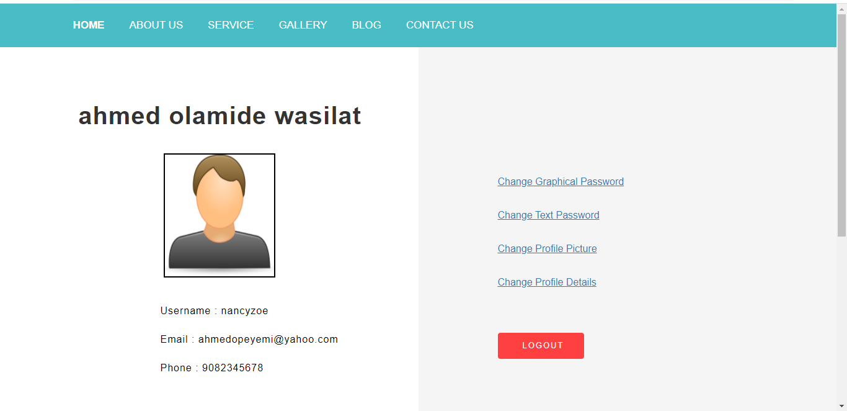
Figure 4.1: User profile: user profile is a visual display of personal data associated with a specific user, or a customized desktop environment. A profile refers therefore to the explicit digital representation of a person's identity. A user profile can also be considered as the computer representation of a user model.
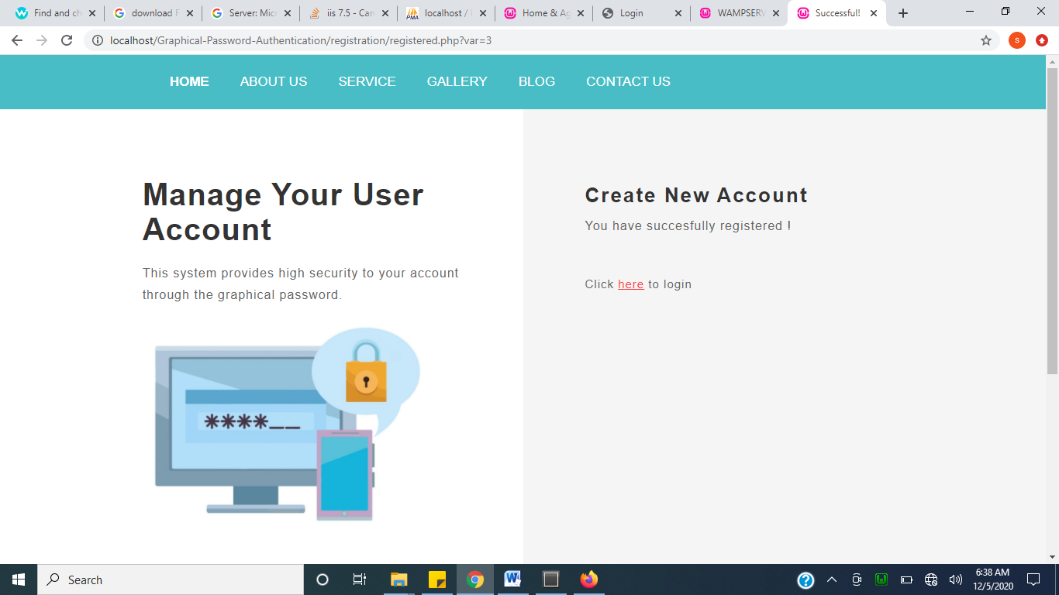
Figure 4.2: Success page: A Success Page is the page shown to form users after they've completed your form. This page is useful for displaying a "thank you" or confirmation message.
4.1.2 INPUT DESIGN
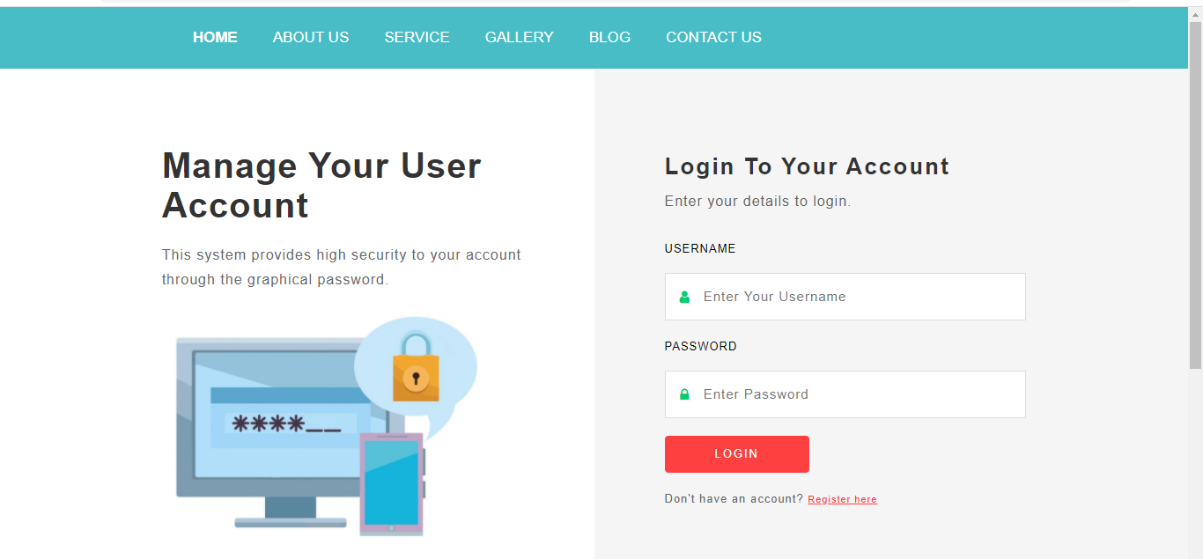
Figure 4.4: Login page: A login page is a web page or an entry page to a websitethat requires user identification and authentication, regularly performed by entering a username and password combination. Loginsmay provide access to an entire site or part of a website.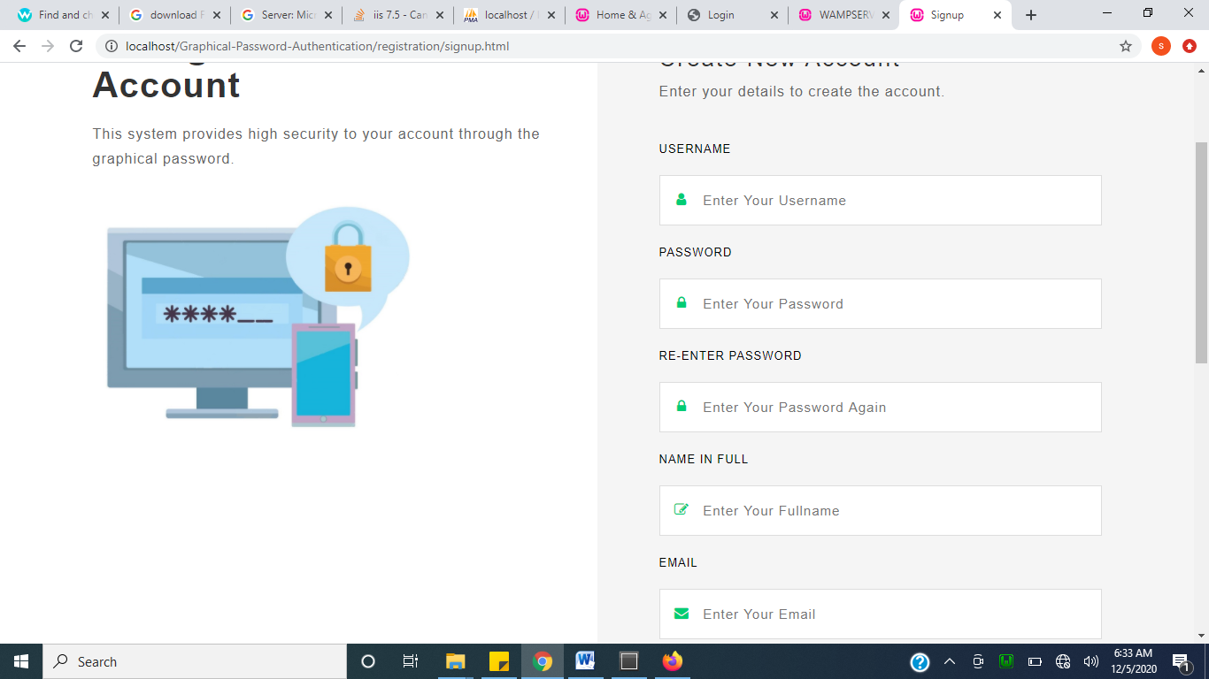
Figure 4.5: Registration: A registration form is a list of fields that a user will input data into and submit to a company or individual. There are many reasons why you would want a person to fill out a registration form. Companies use registration forms to sign up customers for subscriptions, services, or other programs or plans.
4.1.3 DATABASE DESIGN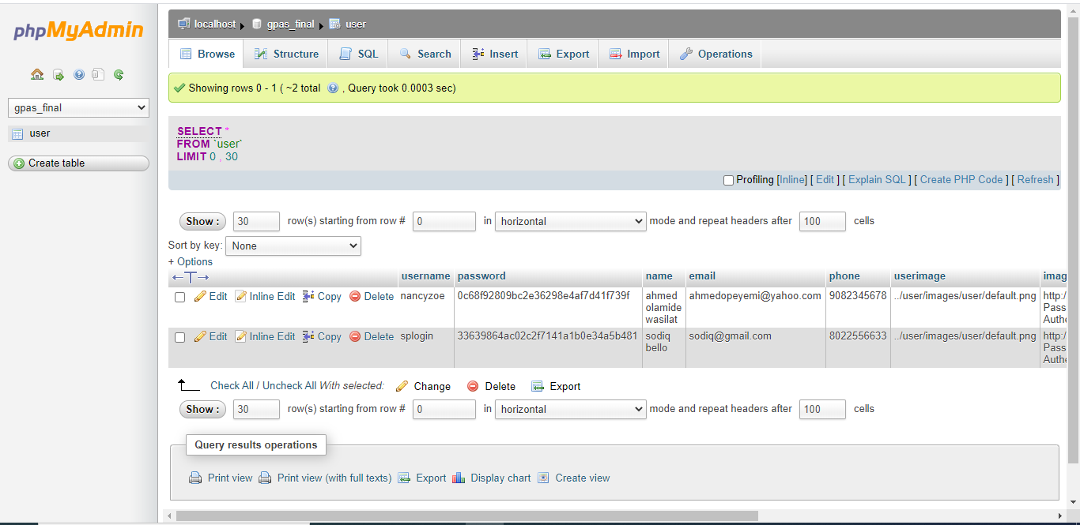
Figure 4.7: Database: This handles all table which includes user details table,
4.1.4 PROCEDURE DESIGN
This refers to the ways in which the proposed system will be used and the steps are as follows:
- Click start on the computer desktop
- Select all programs
- Select any browser e.gMorzilla Firefox , internet Explorer , Google Chrome e.t.c
- Type the url (Uniform Resource Locator) of the system into the address bar (http://localhost/graphical_password /index.php)

4.2 SYSTEM IMPLEMENTATION
The design system depends on the capabilities and power of the computer on which the application system is installed. However, selecting a choice of application support (Hardware and Software) depends much on:
- How readily the user is to interfere with the computer
- Cost and benefits
- Managements support for changes
Hence, choosing the appropriate hardware and software will enhance the performance of the system.
A most important requirement on which the running of the program basically depends on is the provision of internet facility. So any system that must run this program must be internet ready.

4.2.1 CHOICE OF PROGRAMMING LANGUAGE
The programming language used in the proposed system is php. PHP meaning (PHP Hypertext Preprocessor) is a server-side programming language. It is an open source server-side scripting language that has taken web-based development to a new level of sophistication. The PHP scripting engine is well optimized for the response times needed on web applications, it can even be part of the web server itself improving the throughput even more.
If it were only a matter of improving the speed of the scripts, then PHP will be one of many solutions. But there is more to the PHP equation than that. There is the simplicity and robustness of the language and the scripting engine. There is the connectivity to an ever increasing number of database servers, the shorter development cycles and the ease (encouraged by the syntaxes and constructs) of creating modular and reusable components.
4.2.2 HARDWARE SUPPORT
The hardware that is required in the successful completion of this project includes monitor, CPU, keyboard, mouse, printer and an uninterrupted power supply (UPS) and an internet access.
- An appropriate hard disk storage of at least 120 GB (for the dynamically expandable database)
- A minimum of 1.0 GHz processor
- Random access memory (RAM) of at least 1 GB
- An effective display unit (VGA monitor)
- A suitable printer
- Standard input devices such as keyboard, mouse, etc.
- CD-ROM drive or DVD-ROM drive (since the installation would be made through this medium)
- An uninterrupted power supply (UPS) unit (to prevent abrupt interruption due to power failure)
- A network modem (for internet connection).
4.2.3 SOFTWARE SUPPORT
The software required are basically any web browser (internet explorer, Firefox and the likes), WampServer and a network service, be it wired or wireless.
- A network operating system windows NT from Microsoft, Novell Netware.
- A DBM either PhpMyAdmin
- MySQL as the query language to query the database.
- Wambserver

4.2.4 IMPLEMENTATION TECHNIQUES
The system will be implemented using the parallel approach. This approach is considered because it ensures that the new system is tested along side with the old system to ensure the effectiveness and efficiency of the system.

4.3 SYSTEM DOCUMENTATION
It has to do with the installation and usage of the new system.
After the program has been well tested with input that the output has already been known, the next is to install the software in to the computer system for use.
The process of installing are been stated below
- Insert the CD into the system through the CD-ROM after the computer is switch on
- Locate the CD drive directory in my computer and click it to open
- After open, locate setup.exe, and then click to install the program by following the necessary step in installing the program.
- Ensure full installing of the software for effective operation of the system.
After the program has been fully install. The next thing is to locate the package install to put it into operation, to locate the package for expiration purpose the following step are to be taking
v. Click on start menu from task bar. Then select all program
From the display sub option, select by locating the software installed named http://localhost/grapical_password/index.php/ personality check to load the software.
4.3.1 PROGRAM DOCUMENTATION
- HOME
- BLOG
- ABOUT US
- SAVICES
- GALLARY
- LOGOUT

4.3.2 OPERATING THE SYSTEM
- Click on the start button
- Click on control panel
- Click add/remove program
After the configuration, the folder called graphical_password will be created in the local disk.
4.3.3 MAINTAINING OF THE SYSTEM
- Keeping the system free from virus so as not to corrupt the program installed on the system.
- Having an updated anti-virus.

CHAPTER FIVE
SUMMARY, CONCLUSION AND RECOMMENDATION
5.1 SUMMARY
In this work, a system that can serve as a front end to high end system like data warehousing system, banking system, and any other network information system has been implemented. Intuitive Graphical Password Systems authentication scheme which is implemented is a promising, usable and memorable user authentication mechanism by taking the advantage of users’ natural ability of recognizing images. IGPS has advantages over Pass points in terms of usability and security. This is due to arrangement of an image which makes it easier to remember arrangement on the image with PHP User- Defined functions for security purpose.

5.2 CONCLUSION
Intuitive Graphical Password System (IGPS) serves as a graphical user authentication scheme based on the ability of human brain at recognizing images better than texts. It is interesting to note that IGPS offers a usable and secure authentication that is simple to learn, create and use. The implemented system uses arrangement on a given image and each click point is associated with a textual character, but the image size and the possible arrangement can be increased in other to increase password space and work load for an attacker, though our goal is to make graphical password authentication scheme simple to use while still maintaining its security. So, increasing the image number or sizes will affect usability and we would have arrived at the same result as in some past graphical password scheme like passFaces and déjà vu.

5.3 RECOMMENDATIONS
Usability studies have been performed on Intuitive Graphical Password System to measure its effectiveness and performances. A favorable result has been obtained both for usability and security, so it is therefore strongly advised that IGPS should be adopted in the banking, marketing, transportation companies to improve security against intruders who might want to gain access to unauthorized systems or applications.
Further research can also be tailored towards improving the project by making the system’s user interface provide a more professional feel to the user.This project could also be improved upon by making the IGPS a much harder to guess for an attacker while still maintaining users friendliness.

REFERENCES
Adams, K. (2010). VIP: A visual approach to user authentication, Proceedings of the WorkingConference on Advanced Visual Interfaces (AVI 2002), ACM Press, New York.
Brown, K., et al. (2004). Graphical passwords based on robust discretization [Online], Available: http://eprint.iacr.org/.
Bhusari, V. (2013). Graphical passwords.United States Patent 5559961, Lucent Technologies, Inc., Murray Hill, NJ.
Brostoff, S. & Sasse, M. A. (2000). Are Passfaces more usable than passwords?A field trial investigation. Proceedings of Human Computer Interaction 2000, Sunderland, UK.
Davis, D., Monrose, F. & Reiter, M. K. (2004). On user choice in graphical password schemes, [Online], Available:http://www.usenix.org/events/sec04/tech/full_papers /davis/davis_html/index.html.
Dhamija, R. (2000). Hash visualization in user authentication [Online], Available: http://people.ischool.berkeley.edu/~rachna/papers/hash_visualization.pdf.
Dhamija, R. & Perrig, A. (2000), Déjà Vu: A user study using images for authentication,[Online],Available:http://www.usenix.org/publications/library/proceedings/sec2000/full_ppers/dhamija/dhamija_html/index.html.
Haichang ,G. et al. (2016). ‘A password scheme strongly resistant to spy ware’, Proceedings of International conference on security andmanagement, Las Vergas, NV.
James, L. (2012). The Unified Software Development Process, Addison-Wesley, United States.
Mohammed, A.K. (2016), ‘Hash visualization: A new technique to improve realworld security’, International Workshop on Cryptographic Techniques and Ecommerce.
Muhammad, A. & Yugang, L. (2017).Towards Secure Design Choices for Implementing Graphical Passwords [Online], Available: http://www.acsac.org/2017/papers/48.pdf.
Nikhil A.P & Deepak G.R (2013) ‘The design and analysis of graphical passwords’, Proceedings of the 8th USENIX SecuritySymposium.
Reshma, G.S (2019). Graphical Passwords. The Rutgers Scholar [Online],Available:http://rutgersscholar.rutgers.edu/volume04/sobrbirg/sobrbirg.htm.
Sasse, E., et al. (2001), ‘Transforming the ‘weakest link’ – a human/computer interaction approach to usable and effective security’, BTTechnical Journal.
Susan W. et al. (2013). ‘A User Identification System Using Signature Written with Mouse’, Proceedings of the Third Australasian Conference on Information Security and Privacy (ACISP), Springer-Verlag, Lecture Notes in Computer Science.
Thomas, R. C., Karahasanovic, A. and Kennedy, G. E. (2005), An Investigation into Keystroke Latency Metrics as an Indicator of Programming Performance [Online], Available: http://crpit.com/confpapers/CRPITV42Thomas.pdf.
Towseef A.et al. (2017). ‘Graphical dictionaries and the memorable space of graphical passwords’, Proceedings of the 13th USENIX SecuritySymposium, San Deigo, USA.
Weinshall, D. and Kirkpatrick, S. (2004), Passwords You'll Never Forget, But can't Recall [Online], Available: http://www.cs.huji.ac.il/~kirk/Imprint_CHI04_final.pdf.’
Wazir, Z (2011), Authentication using Graphical Passwords: Basic Results [Online], Available: http://clam.rutgers.edu/~birget/grPssw/susan3.pdf.
Walanjkar, D. D (2014) Authentication using Graphical Passwords: Effect of Tolerance and Image Choice [Online], Available:
Wiedenbeck, S., Waters, J., Birget, J., Brodskiy, A. and Memon, N. (2005c), ‘PassPoints: Design and longitudinal evaluation of a graphical password system’, International Journal of Human-Computer Studies.
Wiedenbeck, S., Water, J., Birget, J. C. and Sobrado, L. (2006), ‘Design and evaluation of a shoulder-surfing resistant graphical password scheme’, Proceedings of the Working Conference on Advanced Visual Interfaces (AVI 2006), pp. 23-26, Venezia, Italy.

