
KWARA STATE POLYTECHNIC, ILORIN.
MOBILE STATION.

BY:
ABDULMUHMIN KAOSARA BOSE
(ND/23/SLT/PT/906)

BEING A PROJECT SUBMITTED TO THE DEPARTMENT OF
SCIENCE LABORATORY TECHNOLOGY, INSTITUTE OF APPLIED SCIENCES,
KWARA STATE POLYTECHNIC, ILORIN.

IN PARTIAL FULFILLMENT OF THE REQUIREMENTS
FOR THE AWARD OF ORDINARY NATIONAL DIPLOMA (OND) IN SCIENCE LABORATORY TECHNOLOGY (SLT).

JULY, 2025

CERTIFICATION.
This is to certify that this project is the original work carried out and reported by ABDULMUHMIN KAOSARA BOSE (ND/23/SLT/PT/906) to the Department of Science Laboratory Technology (SLT), Institute of Applied Sciences (IAS) Kwara State Polytechnic Ilorin and it has been approved in partial fulfillment of the requirements of the award of National
Diploma (ND) in Science Laboratory Technology (PHYSICS ELECTRONICS UNIT).

---------------------------- -------------------------------
DR. AGUNBIADE G. DATE
(Seminar Supervisor)

---------------------------- -------------------------------
MR. LUKMAN I. A. DATE
(SLT PT Coordinator)

---------------------------- -------------------------------
DR. ABDULKAREEM USMAN DATE
(Head of Department)

------------------------------. -------------------------------
EXTERNAL EXAMINER. DATE

DEDICATION
To Almighty GOD who is kind and merciful to me.
To my father Mr. ABDULMUHMIN and my mother Mrs. ABDULMUHMIN by
whose encouragement, sacrifices, support and prayers I attained this level of success.

ACKNOWLEDGEMENT
I acknowledge the most-high God who has always been kind and merciful to me. I thank the Lord Almighty for the gift of life, sound health, and journey mercies and for providing all the needed resources throughout my period of studies. My profound gratitude goes to my beloved Supervisor, Dr. G. Agunbiade for his scholarly guidance and mentoring during the entire period of this work. I acknowledge and I appreciate the efforts of Dr. B. B. Ibrahim for his contributions as the Head of Department. I appreciate, greatly, the current H.O.U. Dr. O. K. Olaore who worked tirelessly to ensure that the needful is done. God bless you Sir.
Other members of academic and non-academic staff of Physics Department, Kwara State Polytechnic Ilorin are highly appreciated. You are all unique and wonderful.
I am also indebted to my sibling. Your encouragement and voice of wisdom to me most especially when I share my challenges with you, are highly appreciated. I specially appreciate my beloved parents for their support and encouragement in the course of my education.
I love you all.

TABLE OF CONTENTS.
Contents
CERTIFICATION PAGE ........................................................................... Error! Bookmark not defined.
DEDICATION iv
ACKNOWLEDGEMENT iv
TABLE OF CONTENTS v
LIST OF ACRONYMS ix
ABSTRACT xv
CHAPTER ONE: INTRODUCTION/LITERATURE REVIEW 1
OBJECTIVES: 1
INTRODUCTION 1
MOBILE STATION FUNCTIONS 2
TYPES OF MOBILE STATION 4
VEHICLE-MOUNTED MOBILE STATIONS 4
TRANSPORTABLE MOBILE STATIONS 4
HAND-HELD MOBILE STATIONS 5
MOBILE STATION CLASSES 5
ERICSSON MOBILE PHONES 6
OTHER MOBILE PHONES 9
SUBSCRIBER IDENTITY MODULE (SIM) 9
TYPES OF SIM CARD 9
ID-1 SIM 9
PLUG-IN SIM 10
SECURITY FEATURES 10
SIM INFORMATION STORAGE REQUIREMENTS 10
MANDATORY STORAGE 11
SUBSCRIBER DATA STORED IN THE MOBILE EQUIPMENT 12
PIN MANAGEMENT 12
BLOCKING/UNBLOCKING OF SIM 12
MOBILE STATION FEATURES 12
TYPES OF MS FEATURES 13
BASIC MOBILE STATION FEATURES 13
MANDATORY 13
SUPPLEMENTARY MOBILE STATION FEATURES 17
ADDITIONAL MOBILE STATION FEATURES 17
FIXED CELLULAR APPLICATION (FCA) 18
INTRODUCTION 18
SYSTEM ASPECTS 19
FIXED CELLULAR TERMINALS (FCT) 20
RESIDENTIAL 21
BASIC 21
OFFICE 21
CHAPTER TWO: MATERIALS AND METHODS 25
MEASUREMENTS MADE BY THE MOBILE STATION 25
IDLE MODE 25
ACTIVE MODE 26
POWER SAVING FUNCTIONS 27
DISCONTINUOUS TRANSMISSION (DTX) 27
DISCONTINUOUS RECEPTION (DRX) 27
PROCESS OF CALL SET-UP 28
MSISDN AND IMSI 29
HOW DOES MOBILE STATION WORKS? 30
CHAPTER TREE: DISCUSSION OF RESULT 32
APPLICATIONS OF UMTS 32
LAPD FORMATS 35
LAPD CONCENTRATION 37
GSM SERVICES 38
BEARER SERVICES 38
TELESERVICES 39
SUPPLEMENTARY 39
CHAPTER FOUR: SUMMARY, CONCLUSION AND RECOMMENDATION 40
REFERENCE: 43

LIST OF ACRONYMS
ADC
American Digital Cellular
AMPS
advanced mobile phone service AoC
advice of charge
AUC
authentication center bps
bits per second
BSC
base station controller
BSS
base station system BTS
base transceiver station CGI
cell global identity
CUG
closed user group
DCS
digital cellular system
DTMF
dual-tone multifrequency EIR equipment identity register
GIWU
GSM interworking unit
GMSC
gateway mobile services switching center
GMSK
Gaussian minimum shift keying
GSM
global system for mobile communication HLR
home location register Hz
hertz ISDN
integrated services digital network k
kilo
kbps
kilobits per second
LA
location area
LAI location-area identity
LPC
linear predictive coding
MHz
megahertz MSC
mobile services switching center
MSN
mobile service node
MXE
message center NMT
Nordic Mobile Telephone
OMC
operations and maintenance center OSS
operation and support system PCS
personal communications services PDC
personal digital cellular
PLMN
public land mobile network SS
switching system TACS
total access communication system
TDMA
time division multiple access
VLR
visitor location register
A3 Authentication algorithm
A5 Ciphering algorithm
A8 Ciphering key computation
A Interface between MSC and BSC
Abis Interface between BSC and BTS
ACK Acknowledgement protocol
ADM Adaptive delta modulation
ADPCM Adaptive differential pulse-code modulation
ADSL Asymmetric Digital Subscriber Line. A technique for dramatically increasing the data rates available on copper wiring.
AMPS Analog Mobile Phone System. The US analogue cellular standard.
ARFCN Absolute Radio Frequency Channel Number
ARQ Automatic repeat request
ATM Asynchronous Transfer Mode
AuC: Authentication Centre. The part of the GSM system responsible for authenticating the mobiles and providing ciphering keys.
BCCH Broadcast Control Channel. A GSM logical control channel providing information to the mobile as to the channel configuration in the cell.
BER Bit error rate
BP Burst Period. The duration of a single burst, when one mobile transmits within the GSM framing structure.
BS Base station. The part of the radio system which transmits the signal to the mobile.
BSC Base Station Controller. The part of the GSM system responsible for controlling the base stations.
BSS Base Station Sub-system. The combination of the BTS and BSC.
BSSMAP BSS Management Part. The protocol used for BSS management on the Abis interface.
BT Bandwidth-Time product. A means of measuring the amount of filtering applied to the pulse during the modulation process.
BTS Base Transceiver Station. Another name for BS.
CAI Common air interface – as in CT2 standard.
CDMA Code Division Multiple Access. The use of different codes to allow users to access the same spectrum at the same time.
CC Call Control. The protocol layer within GSM responsible for overall control of the call.
CELP Code-excited linear prediction, vocoder.
CEPT European Committee for Post and Telecommunications. The European body Responsible for radio spectrum management.
COST Co-operation in Science and Technology programme (Europe).
COST 231 COST committee dealing with future mobile system.
CT-0 The original analogue VHF/LF cordless phone technology as used in UK, France and elsewhere.
CT-1 Cordless Telephone Generation One – 900MHz analogue FM cordless Technology standardized by CEPT.
CT-2 Cordless Telephone Generation 2. An early UK digital cordless standard. CT-3 Early Swedish (Ericsson) digital cordless standard.
CTM Cordless terminal mobility – an application concept and an ETSI project. DCS Digital cellular system (eg DCS1800).
DECT Digital European Cordless Telephone. The European cordless telephone standard.
Downlink Transmission path from radio fixed part to portable part.
Duplex Simultaneous two-way conversation.
DTAP Direct Transfer Application Part. The protocol used on the Abis interface to Distinguish between messages for mobiles and for BTSs.
DTX Discontinuous transmission
EDGE Enhanced Data rates for GSM Evolution. Method of increasing data rates in GSM by using 8PSK modulation
8PSK Eight Phase Shift Keying. Modulation techniques encoding 3 bits to each symbol.
EIR Equipment Identity Register. Part of the GSM system responsible for keeping details of the mobile units and their status.
ETR ETSI technical report.
ETS ETSI technical standard.
ETSI European Telecommunications Standards Institute.
FACCH Fast Associated Control Channel. A logical channel used for sending emergency information to the mobile by suppressing traffic information.
FCCH Frequency Control Channel. A logical control channel within GSM used to allow the mobile to lock onto the transmitted signal.
FDMA Frequency Division Multiple Access. The division of the radio frequency into narrow slots, each one being given to a different user.
FEC Forward error correction.
FH Frequency Hopping. Changing rapidly from frequency to frequency to avoid problematic propagation effects.
FPLMTS Future Public Land Mobile Telecommunications Service. The US name for third generation radio systems.
FSK Frequency-shift keying.
FT Fixed termination.
GAP Generic access profile of DECT.
GFSK Gaussian-filtered FSK modulation.
GIP GSM interworking profile of DECT.
G-MSC Gateway Mobile Switching Centre. The part of the GSM system providing the link into the PSTN.
GMSK Gaussian Minimum Shift Keying. The modulation technique used in GSM, a form of phase modulation.
GoS Grade of service.
GPRS General Packet Radio Service.
GSM Global System for Mobile telecommunications. also Groupe Speciale Mobile
Handoff Procedure whereby communications between a mobile handset and a base station is automatically routed via an alternative base station when necessary to maintain or improve communications.
Handover Another term for handoff.
HLR Home Location Register. The part of the GSM system responsible for holding records about mobiles and for keeping track of the parent MSC area.
HSCSD High Speed Circuit Switched Data. 2.5 G enhancement to GSM giving higher data rates
IAP ISDN access profile for DECT.
ISI Inter-Symbol Interference. A radio propagation effect whereby echoes of received signals cause previous symbols transmitted to interference with current symbols.
IMEI International Mobile Equipment Identity. The GSM number given to each mobile. IMSI International Mobile Subscriber Identity. The phone numbering system used within GSM.
IMT2000 International Mobile Telecommunications system for the year 2000.
IN Intelligent Network.
IP Internet Protocol, a layer 3 network protocol IS54 US digital AMPS standard.
IS95 US CDMA digital cellular standard.
ISDN Integrated Services Digital Network. A protocol for sending digital information over copper landlines.
ITU International Telecommunications Union. The international body responsible for spectrum management.
IWP Inter-working profile.
IWU Inter-working unit.
LA Location Area
LAC Location Area Code
LAI Location Area Identity
LAPD Link Access Protocol on interface D. Part of the ISDN protocol stack also used in GSM.
LEO Low Earth Orbiting satellite system. A proposed communications system based on up to 66 satellites.
LLME Lower layer management entity (DECT).
LNA low noise amplifier.
LOS Line-Of-Sight
LPC Linear Predictive Coding.
MAC Medium Access Control. The means whereby mobiles access radio channels which are not permanently reserved for their own particular use.
MAP Mobile Application Part. Part of the SS7 protocol dealing with mobile services. MM Mobility Management. The protocol layer within GSM responsible for keeping track of mobiles and performing security functions. MoU Memorandum of Understanding MS Mobile Station.
MSC Mobile Switching Centre. The part of the GSM system responsible for switching calls. MSISDN Mobile Subscriber Integrated Services Digital Number. The numbering system used to contact GSM mobiles from other networks.
MSK Minimum shift keying modulation.
MTP Message Transfer Part. Part of the SS7 protocol stack.
NADC North American Digital Cellular
NCC National Colour Code
NMT Nordic Mobile Telephone system. The Nordic analog cellular standard.
O&M Operations and maintenance
OAM Operations, administration and maintenance.
OMC Operations and Maintenance Centre. The part of the GSM system responsible for monitoring network function.
PABX private automatic branch exchange.
PAGCH Paging and Access Grant Channel. A GSM logical control channel providing paging information and allowing mobiles to make access attempts.
PBX Private Branch Exchange (today has same meaning as PABX).
PCM Pulse Code Modulation. A simple form of speech coding.
PCN Personal communications network.
PCS1900 Personal Communications System at 1900 MHz. A variant of GSM working at 1900MHz designed for the US.
PDC Personal Digital Cellular. The Japanese cellular standard.
PHL Physical layer – lowest protocol layer.
PHS Personal Handiphone System. The Japanese cordless telephone standard.
PLMN Public Land Mobile Network.
PMR Private (or Professional) Mobile Radio. A radio system owned by the users ` typically large companies.
POTS Plain old telephone service.
PSK Phase shift keying modulation.
PSTN Public Switched Telephone Network.
PT Portable termination.
QPSK Quadrature Phase Shift Keying. A form of modulation whereby orthogonal carriers are used to gain the maximum information from the channel.
Quantization: A process of representing samples of an analogue waveform by the nearest whole number of predefined voltage steps.
RACH Random Access Channel. A GSM logical control channel used for making uplink access attempts.
RAP Radio access profile for DECT. RAN Radio Access Network RFP Radio fixed part.
RIL Radio Interface Layer. The protocol within GSM responsible for maintenance of the radio interface.
RLAN Radio local area network.
RLL Radio local loop.
RPE-LTP Regular pulse excitation – long term predictor – speech coder user in GSM.
RR Radio Resource. The protocol layer within GSM responsible for providing a service over the air interface.
RSSI: Received signal strength indication.
SACCH Slow Associated Control Channel. A logical channel used alongside a traffic channel to send signalling information to and from the mobile.
SCCH Synchronisation Control Channel. A GSM logical control channel providing synchronisation to the mobile.
SCCP Signalling Control and Connection Part. Part of the SS7 protocol stack.
SID Silence Descriptor
SIM Subscriber Identity Module. A small card within GSM mobiles which contains the subscriber identity.
Simplex One-way communication.
SMS Short Message Service. A feature within GSM whereby messages of up to 160 characters can be transmitted to mobiles.
SMS-SC SMS Service Centre. The part of the GSM system which handles short messages. SRES Signed Results Produced by authentication algorithm.
TA Timing Advance
TACS Total Access Communications System. The UK (and other European countries) analogue cellular standard.
TBR Technical basis for regulation – ETSI standards.
TCH Traffic Channel. The channel used in GSM to send subscriber information.
TCAP Transaction Capability Application Part. Part of the SS7 protocol stack.
TDD time division duplex.
TDM Time division multiplex.
TDMA Time Division Multiple Access. A system where users access all the frequency but only for a limited time.
TETRA TErrestrial Trunk RAdio
TMN Telecommunications Management Network. The concept of managing the network from a single point using a networked operations and maintenance system.
TMSI Temporary Mobile Subscriber Identity. A GSM number given to the mobile during an encrypted call to prevent eavesdroppers being able to located the mobile.
TRAU Transcoder Rate Adapter Unit
TRX Transmit/Receiver module. The GSM term for a single carrier card within a BTS. UMTS Universal Mobile Telecommunications Service. One name for the third generation mobile radio system.
Uplink Communications path from portable part to fixed part.
UPT Universal Personal Telecommunications. The fixed network equivalent of third generation systems.
VAD Voice Activity Detection
VLR Visitors Location Register. The part of the GSM system responsible for keeping track of a mobile’s position to the nearest location area.
VSAT Very Small Aperture Terminal. A satellite communication system based on dishes around 1m across.
WAP Wireless Application Protocol
WLL Wireless Local Loop. The use of radio to replace copper wiring as a means of connecting the home to the PSTN.
WPABX Wireless PABX.

ABSTRACT.
A mobile station (MS) comprises all user equipment and software needed for communication with a mobile network. Mobile Station (MS) = Mobile Equipment(ME) + Subscriber Identity Module (SIM). Now, these mobile stations are connected to tower and that tower connected with BTS through TRX. TRX is a transceiver which comprises transmitter and receiver.
Each Generation is defined as a set of telephone network standards, which detail the technological implementation of a particular mobile phone system. The number generation of cellular communications networks is 1G, 2G, 3G, 4G, and 5G. The five generations of mobile networks are 1G, 2G, 3G, 4G, and 5G, where G stands for 'Generation' and the numerals 1, 2, 3, 4, and 5 signify the generation number. Since the early 1980s, a new generation of mobile networks" has emerged every ten years or so.
The handover mechanism guarantees that whenever the mobile is moving from one base station area/cell to another, radio connection is handed over to the target base station without interruption. Intra and inter MSC handover, Inter-MSC and intra-MSC handover from WCDMA to GSM were discussed. Handover scenarios in 2G, 3G, 4G, and 5G were addressed. Interfrequency handover, hard handover, soft and softer handover were treated with the aid of diagrams to illustrate them, Uplink and Downlink power control in soft handover were explained. Handover procedure and parameters in the handover algorithm were not left out.
Useful Glossary of Terms were added to this work.
Measurements made by the mobile station, power saving functions and process of call set-up were addressed. How mobile station works and applications of UMTS, LAPD formats and GSM services were major focus in this work.

CHAPTER ONE: INTRODUCTION/LITERATURE REVIEW.
This is designed to provide the student with an overview of the mobile station. It addresses mobile station components, their functions, features, and required specifications.

OBJECTIVES:
Upon completion of this work, one will be able to:
- Describe the functions of a mobile station
- Describe the reason for separated subscription and telephony equipment
- Describe the different mobile station classes
- Describe the objectives of the Subscriber Identity Module
- Describe the mobile station features
- Identify the mobile stations provided by Ericsson for GSM systems

INTRODUCTION.
A mobile station (MS) comprises all user equipment and software needed for communication with a mobile network. Mobile Station Diagram. The term refers to the global system connected to the mobile network, i.e. a mobile phone or mobile computer connected using a mobile broadband adapter. A mobile station (MS) comprises all user equipment and software needed for communication with a mobile network. Mobile Station (MS) = Mobile Equipment(ME) + Subscriber Identity Module (SIM). Now, these mobile stations are connected to tower and that tower connected with BTS through TRX. TRX is a transceiver which comprises transmitter and receiver.
The MS is the equipment used to access the network. The MS consists of two independent parts:
- Subscriber Identity Module (SIM) card
- Mobile Equipment (ME)
A SIM card is an electronic smart card which stores information about the subscription. The ME is the actual telephone terminal.

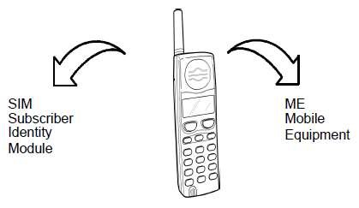
Figure 1 Mobile station.

MOBILE STATION FUNCTIONS
TRANSMISSION AND RECEIPT.
As described previously, the transmission and receipt process in an MS includes the steps shown in Figure 2.

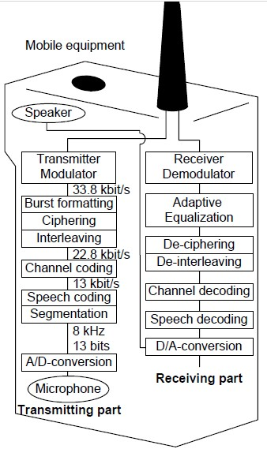
Figure 2 Transmission and receipt in an MS.

TYPES OF MOBILE STATION.

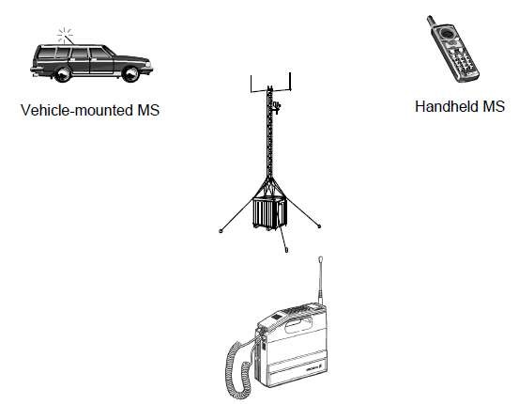
Figure 3 Types of mobile station.

VEHICLE-MOUNTED MOBILE STATIONS
Vehicle-mounted MSs are physically mounted to the dashboard of a vehicle. The antenna unit is separately mounted on the outside of the vehicle. These MSs are more powerful than handheld
or transportable, therefore offering a greater range and signal quality.

TRANSPORTABLE MOBILE STATIONS
In a transportable MS the antenna is not attached to the hand-set. These MSs support all power levels required in the system and can either be vehicle-mounted or hand-carried. They usually consist of a portable plug-in unit and a vehicle-mounted adapter.

HAND-HELD MOBILE STATIONS
The hand-held MS is hand-carried, with the antenna attached to the hand-set. Hand-held MSs are portable and are usually pocket-sized. Hand-held MSs can also be vehicle-mounted by plugging the MS into an interface inside the vehicle. The vehicle provides battery charging facilities and has an externally mounted antenna connection.

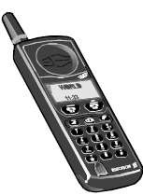
Figure 4 Ericsson hand-held mobile equipment.

MOBILE STATION CLASSES.
Different types of MSs have different output power capabilities and therefore different ranges. and-held phones generally have a lower output power and consequently a shorter range than a vehicle-mounted phone. The output power varies according to the distance from the BTS.
The further away from the source, the weaker the signal will be. According to GSM specifications, MSs are categorized into five classes according to MS output power. These classes are listed in the following table:
Table 1 MS Power Classes.
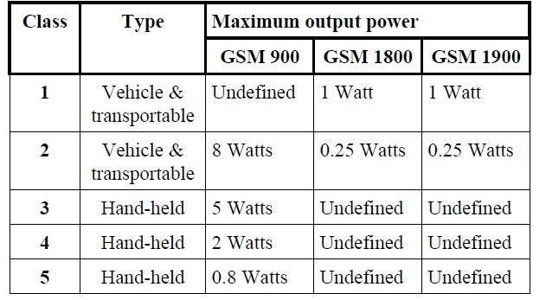

The location of the MS also affects the received power of the transmitted signal. An MS located at the top of a high building has a greater range than one that is located at or below ground level.

ERICSSON MOBILE PHONES.
Ericsson offers a wide range of mobile phones for major cellular standards. For GSM alone, Ericsson has over twenty models.

Table 2 Ericsson’s range of GSM phones
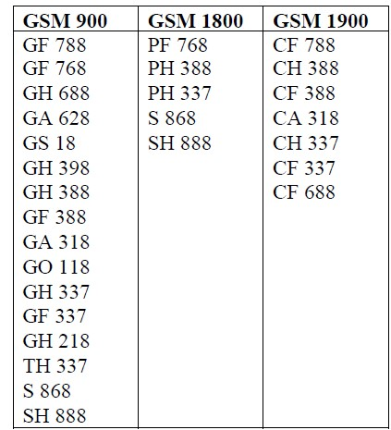

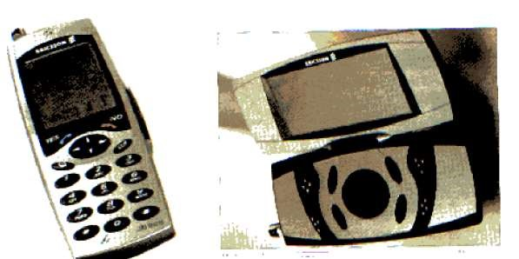
Figure 6 James Bond’s mobile phone, designed by Ericsson.
In the film “Tomorrow Never Dies”, James Bond used various Ericsson phones, including a specially developed concept phone: JB 988

EXAMPLE OF ERICSSON’S GSM PHONES

GF 788
The GF 788 is Ericsson’s smallest and one of its most sophisticated mobile phones. The phone is palm-sized and flips open when in use. Its dimensions are 105x49x24 mm and it weighs only 135 g. The battery provides 180 minutes of talktime and 60 hours of standby time. It has a range of system menus which can be customized for personal use. It has an internal phone book, clock, alarm and has data/fax capability

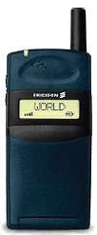
Figure 7 Ericsson’s GF 788

OTHER MOBILE PHONES

SUBSCRIBER IDENTITY MODULE (SIM)
A key feature of the GSM standard is the Subscriber Identity Module (SIM) card. A SIM card contains information about the subscriber and must be plugged into the ME to enable the subscriber to use the network. With the exception of emergency calls, MSs can only be operated if a valid SIM is present.
The SIM stores three types of subscriber related information:
- Fixed data stored before the subscription is sold: e.g. IMSI, authentication key and security algorithms
- Temporary network data: e.g. the location area of the subscriber and forbidden PLMNs •  Service data: e.g. language preference, advice of charge GSM phase 1 SIMs contain all necessary network control information, while phase 2 SIMs include a large number of extra features such as a language identifier and a preferred language option.

TYPES OF SIM CARD
Two physical types of SIMs are specified. These are the” ID-1SIM” and the” Plug-in SIM”. The logical and electrical interfaces are identical for both types of SIM.

ID-1 SIM
The format and layout of the ID-1 SIM comply with ISO standards for Integrated Circuit (IC) cards (i.e. credit card size).

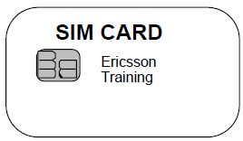
Figure 8 ID-1 SIM card

PLUG-IN SIM
The plug-in SIM is smaller than the ID-1 SIM. It is intended for semi-permanent installation in the ME.

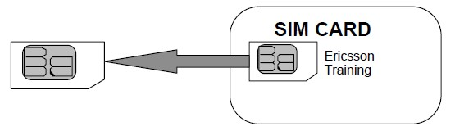
Figure 9 Plug-in SIM card.

SECURITY FEATURES
GSM defines a number of security features to be supported by SIMs. These are:
- Authentication algorithm, A3
- Subscriber authentication key, Ki
- Ciphering key generation algorithm, A8
- Ciphering key, Kc
- Control of access to data stored and functions performed in SIM.

SIM INFORMATION STORAGE REQUIREMENTS.
A SIM contains information for GSM network operations. This information can be related to the mobile subscriber, GSM services or PLMN.
The data storage requirements of a SIM are divided into two categories: mandatory and optional.

MANDATORY STORAGE
A SIM must provide storage capability for the following:
- Administrative information: describes the SIM’s mode of operation, e.g. normal or type approval
- IC card identification: unique information identifying the SIM and the card issuer •  SIM service table: indicates which optional services are provided by the SIM (e.g. last numbers dialed, call length indication, PLMN selection, etc.)
- International Mobile Subscriber Identity (IMSI): an identity number used by the network to identify the subscription
- Location information: comprising LAI, current value of periodic location updating timer and location update status
- Ciphering key (Kc) and ciphering key sequence number
- List of carrier frequencies to be used for cell selection
- Forbidden PLMNs
- Language preference: subscriber's preferred languages
The location information, Kc and the Kc sequence number may be updated at each call termination.
In addition, the SIM must be able to manage and provide storage in accordance with the security requirements:
- Personal Identification Number (PIN)
- PIN enabled / disabled indicator
- PIN error counter
- PIN Unlock Key (PUK)
- PUK error counter
- Subscriber authentication key (Ki)

SUBSCRIBER DATA STORED IN THE MOBILE EQUIPMENT.
All subscriber related information transferred to the ME during operation must be deleted after the removal of the SIM or deactivation of the MS. Examples of such information are the PIN and the PUK codes.

PIN MANAGEMENT
A SIM is required to have a PIN function even if it is deactivated by a user. The PIN consists of 4 to 8 digits. An initial PIN is loaded by the network operator at subscription time. Afterwards the PIN, including the length, can be changed by the user. In addition, the user can decide whether to use the PIN function or not by activating an appropriate SIM-ME function called the PIN disabling function. The PIN is disabled until the user changes the status of the function.
This PIN disabling function can be blocked at subscription time by a person authorized to do so.
If an incorrect PIN is entered, the user is informed. After three consecutive incorrect entries the SIM is blocked, even if between attempts the SIM has been removed or the MS has been switched
off.

BLOCKING/UNBLOCKING OF SIM
When a SIM is blocked GSM network operations are forbidden. To unblock the SIM, the user must enter the PIN Unblocking Key, PUK.
The PUK is an 8-digit numerical code. If the PUK is entered incorrectly the user is informed. The user can make 10 attempts to enter the PUK before the system blocks entry, in which case the subscriber must contact their network operator.

MOBILE STATION FEATURES
An MS feature is defined as a piece of equipment or a function which relates directly to the operation of the MS.

TYPES OF MS FEATURES
MS features are defined as mandatory or optional. Mandatory features must be implemented as long as they pertain to the MS type. The choice of implementing optional features is left up to the manufacturers. Manufacturers are responsible for ensuring that the MS features neither conflict with the air interface nor interfere with the network, any other MS, or the MS itself. Standardization of a minimum set of features is desirable to make a simple and uniform set of MS features independent of the MS manufacturer and type. This minimum set includes all the mandatory features.
THERE ARE THREE CATEGORIES OF MS FEATURES:
- Basic: Basic MS features are directly related to the operation of basic telecommunication services. Each feature is classed as being mandatory or optional.
- Supplementary: A supplementary MS feature is directly related to the operation of the supplementary service (e.g. display of calling line number). All supplementary MS features are optional.
- Additional: Additional features are neither basic nor supplementary. All additional MS features are optional.

BASIC MOBILE STATION FEATURES.

MANDATORY.
Display of called number: This feature enables the caller to check that the selected number is correct before call set-up.
Dual Tone Multi Frequency function (DTMF): The MS must be able to send DTMF tones.

Indication of call progress signals: Indications are given such as tones, recorded messages or a visual display based on signaling information returned from the PLMN. On data calls, this information may be signaled to the Data Terminating Equipment (DTE).

Country/PLMN indication: The country/PLMN indicator shows in which GSM/PLMN the MS is currently registered. This indicator is necessary so that the user knows when roaming is taking place and that the choice of PLMN is correct. Both the country and PLMN are indicated. When more than one GSM/PLMN is available in a given area this information is indicated.
Country/PLMN selection: If more than one GSM/PLMN is available, the user must have the
ability to select their preferred choice.
Service indicator: The user is informed that there is adequate signal strength (as far as can be judged from the received signal) to allow a call to be made and that the MS has successfully registered on the selected PLMN. This can be combined with the Country/PLMN Selection. Subscription identity management: The IMSI is part of the SIM card and is physically secured and standardized in the GSM system. If the user can remove the SIM, its removal detaches the MS from the network causing a call in progress to be terminated, and preventing the initiation of further calls (except emergency calls).

International Mobile Station Equipment Identity (IMEI):
Each MS must have a unique identity and must transmit this if requested by the PLMN. The IMEI is incorporated into a module which is built into the MS and is physically secured. The implementation of each individual module is to be carried out by the manufacturer.

Support of A5/1 and A5/2: Provisions are made for support of up to seven algorithms as well as the support of ‘no encryption’. It is mandatory for A5/1 and A5/2 and non-encrypted mode to be implemented, but other algorithms are optional.
Short message indication and acknowledgment: This feature allows delivery of short messages to a MS from a service center. Such messages are submitted to the service center by a telecommunications network user who can also request information on the message status from the service center. The service center then transmits the message to the active MS user.

The MS must therefore provide an indication to the user that a message has been received from the service center and must also send an acknowledgment signal to the PLMN, to show that this indication has been activated. The PLMN then returns this acknowledgment to the service center.

Short message overflow indication: An MS user using the short message service will be informed when an incoming message cannot be received due to insufficient memory.
Emergency call capabilities: It must be possible to make an emergency call even without a valid SIM.

OPTIONAL
On/Off switch: The MS can be equipped with the means of switching its power supply on and off. Switch-off is generally “soft”, so that the MS completes housekeeping functions, such as deregistration, before actually switching off. Keypad: A physical means of entering numbers, generally in accordance with the layout below:

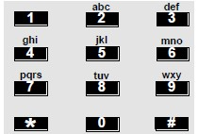
Figure 10 Keypad.

DTE/DCE interface: This is a standard connector for attaching Data Terminating Equipment
(DTE)/Data Communication Equipment (DCE) to an MS and is used with data services.
ISDN ’S’ terminal interface: A standard connector for attaching equipment to ISDN.
International access function (‘+’ key): This enables a direct, standard method of gaining international access. For this purpose, the MS may have a key whose primary or secondary function is marked “+”. This has the effect of generating the International Access Code (IAC) in the network. This is useful because the IAC varies from country to country and may be unknown by a subscriber who is roaming internationally (e.g. the IAC in Sweden is 009, while it is 00 in Ireland).
Short Message Service Cell Broadcast (SMSCB) screening:
This feature enables the user of the MS to receive only those broadcast messages that are of interest to the user and in this way save on consumption of battery power. This may be useful in the future to ignore advertisements sent as short messages.

SUPPLEMENTARY MOBILE STATION FEATURES.
Charge indication: This feature enables the display of charging information provided by the PLMN on a per call basis.
Control of Supplementary Services: It is mandatory that Supplementary Services can be controlled from the MS.

ADDITIONAL MOBILE STATION FEATURES
Abbreviated dialing: The feature stores a full directory number or part of a directory number in the MS with the abbreviated address. After retrieval, the directory number may appear on the display. An incomplete directory number must be supplemented by means of the keypad function or a second stored number. The full directory number is then transmitted on the radio path.
Fixed number dialing: Using this feature in conjunction with an electronic lock makes it possible to place a bar on calling any numbers other than those pre-programmed into the MS. There are two sub-categories to this service:
- All calls are made to only one predetermined number.
- Calls can be made to several predetermined numbers. The required number is selected by means of an abbreviated address code.

Sub-addresses may be added to the predetermined number. In both cases, the actual directory number is transmitted on the radio path.

Barring of outgoing calls: This feature allows outgoing calls to be blocked with the exception of emergency calls. The barring condition may be activated/deactivated by using a key word. The barring may be selective, that is, applied to individual services, individual call types (e.g. long distance, international calls) or supplementary services. No network signaling is involved. DTMF control digits separator: This enables subscribers to enter DTMF digits with a telephone number. When the called party answers, the ME automatically sends the DTMF digits to the network after a delay of three seconds. This may be useful for accessing a voice mailbox, when the subscriber knows the actions which they wish to perform. For example, the sequence 087 5551234#31 may dial the mailbox (087 5551234) access menu 3 and delete message 1.
Call charge units meter: The MS may incorporate a call charge units indicator. This call charge indicator gives information about the actual call charge units consumed during the last conversation or information about accumulated call charge units for each PLMN.
Selection of directory number in short messages: The short message (point-to-point mobileterminated or mobile-originated, or cell broadcast) can be used to convey a directory number which the receiver wishes to call. This can be indicated by enclosing the directory number in a pair of inverted commas (“ “).
If the displayed message contains these characters enclosing a directory number, then a call can be set up. The message can contain more than one directory number, in which case the receiver selects the desired one. This service is useful for giving someone a telephone number via SMS.
Last numbers dialed (LND): The MS can store the last ‘N’ numbers dialed in the SIM and/or the
ME. ‘N’ can take the value up to 10 in the SIM but there is a greater number storage capacity in the ME.

FIXED CELLULAR APPLICATION (FCA)

INTRODUCTION
Over the last few years the potential market for building fixed telephony systems using cellular access technology has grown rapidly. Using wireless technologies instead of traditional copper wire offers many benefits to an operator, including:
- Cost: Investment in the local loop (the final connection from the local exchange to the subscriber’s premises) represents a large percentage of an operator’s costs. Maintenance of the access network is costly and time-consuming. However, Radio in the Local Loop (RLL) systems can be installed and maintained with less expense than wire-based systems.
- Time: Wireless systems can be rapidly deployed in far less time than is required to install the underground or over ground cables required for wire-based systems.
- Flexibility: Wireless systems are highly flexible and can be easily adapted to different situations. To meet the needs of the growing fixed-cellular telephony market, Ericsson provides Fixed Cellular Application (FCA). FCA provides a fixed telephony network using standard cellular systems. FCA is based on GSM and offers a range of functions that support service and price differentiation for the end user.

SYSTEM ASPECTS
FCA uses, as much as possible, existing technology and services to create new applications.
In a fixed cellular application, the demand for indoor coverage is crucial. To gain indoor coverage everywhere in a macro cell network would require a very high signal strength margin, resulting in a very expensive network. A possible solution for indoor signal gain is to use repeaters which are devices for boosting signals. This is suitable for situations where indoor coverage is required in a certain building and capacity demands are not too high.

Another solution is to use outdoor (or window-mounted) antennae for indoor terminals. The length of the antenna cable will, however, be limited to a maximum of a few meters. It must also be remembered that by applying these solutions, the subscribers will use the macro cell frequencies and thereby steal capacity from outdoor users.

A more advanced technique is to apply specific indoor micro or pico cells. The problem will then occur that frequencies used in these cells cannot be re-used in adjacent macro cells or in nearby buildings. Consequently, many channels are needed.
The mobility of fixed cellular subscribers is low. In some cases, it may even be a requirement that there will be no mobility at all in the network. By applying local or regional subscriptions, or using a parameter-setting to block handovers, the mobility in the network can be restricted.

FIXED CELLULAR TERMINALS (FCT)
The subscriber equipment is called a Fixed Cellular Terminal (FCT). There are two main types depending on end-user requirements:
- A terminal with the functionality of an ordinary MS, but built into housing more adapted to the fixed telephone environment.
- A terminal based on MS radio parts integrated to a line interface simulating a PSTN connection to which ordinary DTMF or dial pulse telephones can be attached (integrated adapters for fax and data can be added optionally).
All models of FCTs are applicable for Ericsson digital systems. The FCTs look the same regardless of whether they will be used within a GSM 900, GSM 1800 or GSM 1900-system. The only hardware difference is the frequency band used.

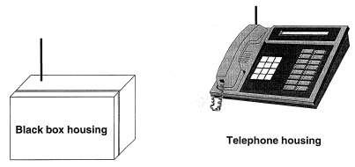
Figure 11 Fixed cellular terminals.

Ericsson has defined and developed three different FCT models:

•  FCT Residential

•  FCT Basic

•  FCT Office
RESIDENTIAL
A residential appears as a “black-box” without a display or a keypad and is wall-mounted. This terminal is able to handle voice, fax and data calls. However, fax and data communication require an external adaptor.

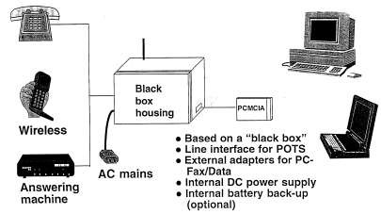
Figure 12 Residential model
BASIC
The basic terminal looks like a wireline telephone with display and keypad and can be either desk-top or wall-mounted. It can handle voice calls and Short Message Service (SMS).

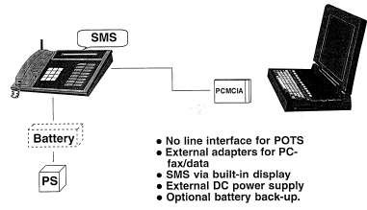
Figure 13 Basic model
OFFICE
The office terminal also looks like a wireline telephone with a display and a keypad and can be either desk-top or wall mounted. It is able to handle voice, fax and data calls and SMS. Fax and data capability have been integrated and can be offered from this terminal.

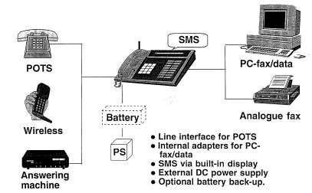

Figure 14 Office model

CHAPTER TWO: MATERIALS AND METHODS.

MEASUREMENTS MADE BY THE MOBILE STATION.
The measurements made by an MS are used in making decisions about signal strength and handovers. Measurements are taken in both idle and active mode.

IDLE MODE
Cell selection is made at “power on” of the mobile:

- The mobile scans all radio frequency channels in the GSM system and calculates average levels for each. The mobile tunes to the strongest carrier and determines if it is a BCCH carrier. If so, the mobile reads the BCCH information to find out if the cell is locked (e.g. chosen PLMN, barred cell, etc.). Otherwise the mobile tunes to the second strongest carrier, and so on until a valid BCCH carrier is found.
- The mobile may optionally include a BCCH carrier memory of valid BCCH carriers in the home PLMN. In this case it only needs to search these carriers. If this ends unsuccessfully, the mobile performs as in 1.
- If no valid BCCH carrier is found, but a BCCH carrier belonging to another GSM network operator is found, the mobile will display the message “Emergency calls only”. Every emergency call is permitted onto a GSM network, even if the subscriber has not subscribed to the network the MS chooses.
Alternatively, if no valid BCCH carrier is found, and no other network can be found, the MS will display the message “No network”. In this case no calls (including emergency calls) can be made.

Once it has tuned to a valid BCCH carrier, the mobile is informed which BCCH carriers it is to monitor for cell re–selection purposes. These are the BCCH carriers in neighboring cells. A list of the strongest carriers is updated regularly by the MS as a result of the measurements.

ACTIVE MODE
During a call, the mobile continuously reports (via SACCH) to the system how strong the received signal strength is from BTSs. Both signal strength and quality are measured on the MS’s
“own” BTS. These measurements are used by the BSC to make fast decisions about target cells when a handover is required.

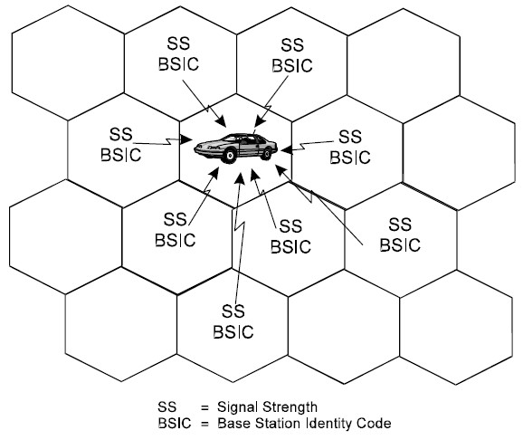
Figure 1 Monitoring BCCH carriers

Measurements on neighboring cells during a call takes place when the mobile is idle, i.e. when it is not transmitting or receiving.

POWER SAVING FUNCTIONS.

DISCONTINUOUS TRANSMISSION (DTX)
Discontinuous Transmission (DTX) is a method of saving battery power for the MS. An
MS with the DTX function detects the input "voice" and turns the transmitter ON only while "voice" is present. When there is no voice input, the transmitter is turned OFF.
When the MS detects that speech is absent during the conversation, it sends out a signal called
“Post” to report a transmission output state OFF for the TCH. Conversely, when the MS detects that speech is present again, it sends out a signal called “Pre” to report the transmission output state ON for the TCH.

The Post signal incorporates background noise information from the MS, which enables the BTS to generate background noise. This ensures that the other subscriber on the call hears something and does not think that the mobile subscriber has ended the call. The MS transmits the Post signal periodically during a speech pause, to enable the BTS to update the background noise.

DISCONTINUOUS RECEPTION (DRX)
Another method used to conserve power at the MS is Discontinuous Reception (DRX).
The paging channel, used by the BTS to signal an incoming call, is structured into sub channels. Each MS is assigned one of these sub-channels and needs to listen only to its own sub-channel. In the time between successive paging sub-channels, the mobile can go into “sleep mode”, when almost no power is used.

PROCESS OF CALL SET-UP.
The process of call set-up in telecommunications typically involves the following steps:

- Call Initiation: The call set-up process begins when a user initiates a call by dialing a phone number or selecting a contact on their device.
- Call Request: The user's device sends a call request to the telecommunication network. This request contains the necessary information, such as the destination phone number or contact
details.
- Call Routing: The telecommunication network receives the call request and performs call routing. Call routing involves determining the best path for the call to reach the destination. The network examines various factors like the destination number, network availability, quality of service, and routing policies to determine the optimal route.

- Signaling: Signaling protocols are used to exchange control information between network elements during call set-up. Common signaling protocols include Signaling System 7 (SS7) or Session Initiation Protocol (SIP). The signaling messages are sent between the calling party's device, network nodes, and the called party's device to establish and manage the call.

- Call Authentication and Authorization: The telecommunication network may perform authentication and authorization checks to ensure the caller is authorized to make the call and verify the called party's availability.

- Call Connection: Once the call request reaches the destination, the network establishes a connection between the calling party and the called party. This involves allocating the necessary network resources, such as voice channels, to support the call.

- Ringing and Call Progress: The called party's device receives the call request and initiates ringing to alert the user. During this phase, the calling party may hear ring back tones or other call progress tones indicating that the call is being set up.

- Call Acceptance: When the called party answers the call, signalling messages are exchanged between the devices and the network to confirm call acceptance. This includes establishing a fullduplex voice communication channel to enable two-way communication.

- Call Termination: At the end of the call, either party can terminate the call by hanging up. Signaling messages are exchanged to release the allocated network resources and terminate the call session.

MSISDN AND IMSI.
THE MOBILE STATION CANNOT TRANSMIT SIGNALS WITHOUT THE U-SIM AND PHONE NUMBER.
MSISDN: (Mobile Station Integrated Services Digital Network) is the phone number which identifies a device during calls or data sessions.
IMSI: International Mobile Subscriber Identity.
Both MSISDN and IMSI play a vital role in mobile identity. They are used for various purposes, such as billing, roaming, and subscriber identification. MSISDN establishes communication between devices, while IMSI is used to authenticate and authorize subscribers to access mobile networks. So the primary difference is that MSISDN is associated with a phone number. It’s a public identity, while IMSI is a private identity. The MSISDN is a gateway to the IMSI, and the link between the two is anything but secure – easily broken if a phone number is reassigned to a new SIM card. If the IMSI is the lock on the SIM, the MSISDN is the key we use to open it – and this key is almost as easy to copy as an email and password.
MSISDN establishes communication between devices, while IMSI is used to authenticate and authorize subscribers to access mobile networks. So the primary difference is that MSISDN is associated with a phone number. It's a public identity, while IMSI is a private identity.

HOW DOES MOBILE STATION WORKS?
The signals are sent to and received from antennas that are attached to radio transmitters and receivers, commonly referred to as mobile phone base stations. The base stations are linked to the rest of the mobile and fixed phone networks and pass the signal/call on into those networks.
A base station works as the main communication point for one or more wireless mobile devices. It is a fixed transceiver capable of sending and receiving wireless signals via the radio frequency (RF) base station antennas to transmit RF signals to other device.
Mobile communications follow the general principle of telephony: connecting two remote users through the network equipment of an operator responsible for managing the service. But unlike fixed phones, in the mobile network, it is not copper wires or fibre optics but radio transmissions that provide the final link. A user’s mobile telephone communicates through the air with an base station antenna, which in turn links to the central exchange of the operator – a computer. This routes the communication to the corresponding party on the fixed network or via other base
stations.
To communicate, a mobile user must be within range of base stations. This has a limited range, and covers only a small area around it called the “cell” (hence the alternative name of “cellular networks” often used for mobile networks). To cover maximum territory, and ensure that users are always able to call, operators deploy thousands of cells, each equipped with antennas, ensuring that their cells overlap and thus never lose the current location of the users.

CHAPTER TREE: DISCUSSION OF RESULT.

APPLICATIONS OF UMTS.
The success of the UMTS network influenced its use case in various capacities. It brought innovations such as sharing files like videos and music over the internet in real-time. It has a wide application in the Internet of Things (IoT) and revolutionized the mobile entertainment industry. Since UMTS is JAVA compatible, gaming was also introduced on a different scale on mobile devices. Some of the top applications of UMTS include:
- Streaming and downloading of videos and audio
With the use of UMTS-enhanced devices, videos could now be downloaded or streamed online using a mobile device. This was not possible with the GSM or GPRS system. The introduction of mobile television and online streaming platforms became prominent as the use of UMTS expanded. Some companies that blossomed from this innovation include:
  - YouTube: Platforms like YouTube boomed as it became easier for users to upload, download or stream video content over the internet with a data rate that was cheap, convenient and fast.
  - Social media (or Web 2.0) companies: Companies like Facebook and Twitter that were text-based incorporated video feeds in their programs where users could watch videos while browsing through the platform.
- Internet of Things (IoT)
There will soon be more IoT devices than humans, and UMTS is used to connect these devices to public or private clouds. The use of IoT cuts across several industries, including health, banking and finance, agriculture, manufacturing of home appliances, supply chain, etc. It is used to automate processes and transfer data packets over destinations, thereby saving time and money, improving communications between electronic devices, and providing a means of accessing information from anywhere, at any time, on any device.
In homes today, many appliances use UMTS to transfer data to make our lives easier. These are known as “smart appliances” and cut across regular home appliances like air conditioners, lighting, security, and environmental control.
Thermostats can sense the temperature of the room and regulate themselves. Smart sprinklers work by monitoring the moisture content of the soil and spraying water over lawns and gardens when the moisture content of the soil falls below a certain threshold. Smoke alarms measure the amount of smoke in the air and go off if it exceeds a certain degree.
In healthcare, wearables such as smartwatches serve as devices to check heart rate, blood pressure, and calories. IoTs are also deployed as diagnostic devices that help facilitate early diagnosis and disease prevention.
In business, one could use it to check inventory, automate orders, and carry out transactions. You could set some devices like vending machines to order a refill when they get to a particular stock level. For these functions to run efficiently, these devices need to connect to the cloud, and they can only do this with the help of a mobile network like UMTS.
- Mobile e-commerce
The rise of UMTS transformed several things, including the way people buy and sell. With widespread superior connectivity, people could create e-commerce stores online where they sell goods and services to their customers.
This also increased the number of customers they could gain at any time. Customers could send feedback on the products after use, and they could access short video clips that demonstrated the use of the products even before they purchased them. Customer-centric companies such as Amazon and customer-to-customer auction companies like eBay were among the first to leverage this. B2B e-commerce platforms like Ali Express and Alibaba also use UMTS to enhance buying and selling online.
- Fast internet and intranet
Unlike the 2G system, UMTS provided the internet with speed due to the broader bandwidth and its system of transmission. One could carry out online transactions with fewer glitches with the fast internet. Files were easier to download and share, you could analyze IoT devices in real-time, etc. The introduction of cellular carriers like high-speed packet access (HSPA), Evolved HSPA
(HSPA+), and advanced HSPA+ made the UMTS devices significantly faster than their GSM or GPRS counterparts.
- Mobile entertainment (gaming)
There has been an evolution in the gaming industry in recent years, specifically games on mobile phones. Due to the packet-switched carrier of UMTS, you can download games on mobile phones where you can play them. Online games also became prominent as UMTS enabled players from various world regions to connect on one platform to play games. This has increased the market value of various companies in the gaming niche as they now create games that can be played on mobile phones and are accessible anywhere in the world.
- Emails and multimedia messages
Emails became more commonly used as the speed of the internet increased. With the introduction of high-speed UMTS internet, messages could be sent and received in seconds. This revolutionized communication has even made it possible for individuals to work remotely, provided that attention is given to email security. Multimedia messages such as pictures, videos, and audio can also be sent through the internet using UMTS mobile network.
- Video conferences
Platforms such as Skype became popular with the UMTS network because of their video conferencing feature. Video calls could be made and received from anywhere in the world. Industries and news channels like CNN, BBC, and Aljazeera used video conferencing to communicate with their correspondents in different parts of the world. Businesses also use video conferencing to conduct virtual meetings remotely on platforms such as Zoom, Google Meet, and Microsoft Teams, all thanks to UMTS and other network innovations building on it.

LAPD FORMATS.
The A-bis Interface is responsible for transmitting traffic and signaling information between the BSC and the BTS. The transmission protocol used for sending signalling information on the A-bis interface is Link Access Protocol on the D-channel (LAPD).

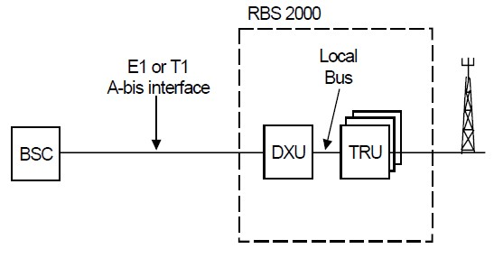

The A-bis interface facilitates the transfer of voice and signaling information between the BSC and RBS. There is signaling to both the DXU (MO CF) and the TRU (MO TRXC). Speech is coded by the TRA in the TRC or BSC/TRC. Signaling information is handled inside the BSC by the TRH. The physical layout of the traffic and signaling to each TRU on the A-bis Interface depends on the format chosen to facilitate the transfer of information. There are three possible formats that can be designated for information transfer on the A-bis Interface:

LAPD (Link Access Procedure on the D channel)

Channel= Time slot X number of TRU 2.25 X 12 = 27 channels.

1TRU supply 8 CALLS
LAPD normal =E1 10TRU
LAPD concentration =E1 13TRU
LAPD multiplexing=E1 12TRU

32 time slots one for signaling and the rest for data/traffic
E1 has 31 channel 30 for signaling and one for synchronization

LAPD un-concentration =E1 10TRU
31-1syncronisation =30
30/(3time slots/TRX) = 10TRX/PCM OR 10TRU.

LAPD concentration =E1 13TRU
31-1syncronisation =30
30/(2.25 time slots/TRX)= 13TRX/PCM OR 13TRU

LAPD multiplexing =E1 15TRU
31-1syncronisation =30
30/(2. time slots/TRX) = 15TRX/PCM OR 15TRU

Concentration = increase in strength
One-time slot carries one call
Each frequency in 8 time slots

Each Time Slot (TS), which is 64 kbit/s, on the PCM link towards the RBS is called a RBLT device. The device is a resource that the BSC can put information on. In this case it is either LAPD signaling or speech towards the RBS.

LAPD CONCENTRATION
LAPD Concentration is recommended for all cells, but in particular those with 3 TRUs or more.
(For cells with 1-2 TRUs per cell LAPD multiplexing provides the most efficient A-bis transmission). With LAPD concentration, each TRU needs 2,25 PCM time slots. It is hence possible to fit up to 13 TRUs on one 2 Mbit/s PCM line (E1), as compared to 10 TRUs without this feature.

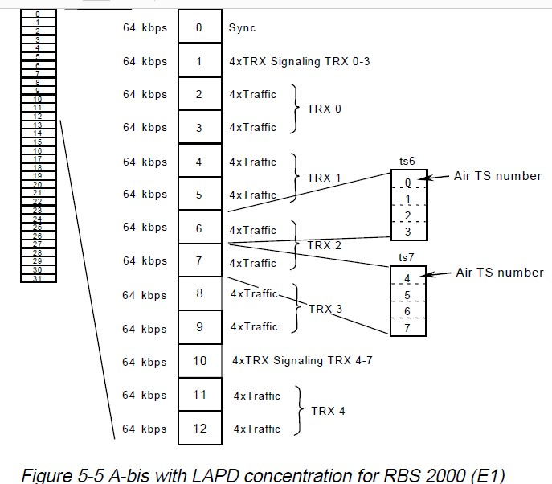

GSM SERVICES.
In GSM terminology, telecommunication services are divided into three broad categories:
List of GSM Service:

1. Bearer services
- Tele services
- Supplementary Services

BEARER SERVICES
Bearer services are also called as Data services. These are telecommunication services providing the capability of transmission of signals between access points [the user-network interfaces (UNIs) in ISDN]. For instance, synchronous dedicated packet data access is a bearer service.

TELESERVICES.
Teleservices are telecommunication services providing the complete capability, including terminal equipment functions, for communication between users according to protocols established by agreement between network operators. Supplementary Services. In addition to these services, supplementary services are defined that modify or supplement a basic telecommunication service. Telephony (also referred to as teleservices)

SUPPLEMENTARY.
Supplementary services include several forms of call forward (such as call forwarding when the mobile subscriber is unreachable by the network), caller identification, call waiting, multiparty conversations, charging information, and call barring of outgoing or incoming calls. These callbarring features can be used for example when roaming in another country, if the user wants to limit the communication fees.
Supplementary Services
- Call forwarding.
- Barring of Outgoing Calls.
- Barring of Incoming Calls.
- Advice of Charge (AoC). This GSM service estimates the call cost for display on the user's mobile phone. ...
- Call Hold.
- Call Waiting.
- Multiparty service.
- Calling Line Identification Presentation (CLIP)/ Restriction (CLIR).
•
WHAT ARE THE SERVICES PROVIDED BY LTE?
- LTE supports data transmissions such as mixed data, voice, video and messaging traffic. LTE-A uses multiple input, multiple output (MIMO) antenna technologies similar to that used in the IEEE 802.11n wireless local area network standard.
WHAT ARE THE SERVICES OFFERED BY 4G NETWORK?
- 4G network provides up to 100 Mbps speed to users, far higher than a 3G network. 4G enables users to stream high-definition audio and videos without interruption due to its high speed. It also facilitates wireless broadband that allows the users to access the internet without any need for fixed wired

CHAPTER FOUR: SUMMARY, CONCLUSION AND RECOMMENDATION.
The measurements made by an MS are used in making decisions about signal strength and handovers. Measurements are taken in both idle and active mode. Discontinuous Transmission (DTX) is a method of saving battery power for the MS. An MS with the DTX function detects the input "voice" and turns the transmitter ON only while "voice" is present. When there is no voice input, the transmitter is turned OFF. When the MS detects that speech is absent during the conversation, it sends out a signal called “Post” to report a transmission output state OFF for the TCH. Conversely, when the MS detects that speech is present again, it sends out a signal called
“Pre” to report the transmission output state ON for the TCH.

Another method used to conserve power at the MS is Discontinuous Reception (DRX).
The paging channel, used by the BTS to signal an incoming call, is structured into sub channels. Each MS is assigned one of these sub-channels and needs to listen only to its own sub-channel. In the time between successive paging sub-channels, the mobile can go into “sleep mode”, when almost no power is used. The process of call set-up in telecommunications typically involves were discussed.

The mobile station cannot transmit signals without the U-SIM and phone number, this have been explained. How does mobile station works were discussed? The signals are sent to and received from antennas that are attached to radio transmitters and receivers, commonly referred to as mobile phone base stations. The base stations are linked to the rest of the mobile and fixed phone networks and pass the signal/call on into those networks. A base station works as the main communication point for one or more wireless mobile devices. It is a fixed transceiver capable of sending and receiving wireless signals via the radio frequency (RF) base station antennas to transmit RF signals to other device.
The top 7 applications of UMTS were not left out. The success of the UMTS network influenced its use case in various capacities. It brought innovations such as sharing files like videos and music over the internet in real-time. It has a wide application in the Internet of Things (IoT) and revolutionized the mobile entertainment industry. Since UMTS is JAVA compatible, gaming was also introduced on a different scale on mobile devices. Some of the top applications of UMTS include
The LAPD FORMATS and confirmation and determination were discussed. The A-bis
Interface is responsible for transmitting traffic and signaling information between the BSC and the
BTS. The transmission protocol used for sending signalling information on the A-bis interface is Link Access Protocol on the D-channel (LAPD).
List of GSM Services were listed such as Bearer services, Tele services and Supplementary Services. The services provided by LTE discussed. LTE supports data transmissions such as mixed data, voice, video and messaging traffic. LTE-A uses multiple input, multiple output (MIMO) antenna technologies similar to that used in the IEEE 802.11n wireless local area network standard. The services offered by 4G network, 4G network provides up to 100 Mbps speed to users, far higher than a 3G network. 4G enables users to stream high-definition audio and videos without interruption due to its high speed. It also facilitates wireless

REFERENCE:

- GSM SYSTEM SURVEY STUDENT TEXT EN/LZT 123 3321 R2C
- https://www.academia.edu/24399074/GSM_SYSTEM_SURVEY?auto=do wnload&email_work_card=download-paper
- Air Interface Dimensioning, Dimensioning Guideline – RL20:
https://sharenet-ims.inside.nokiasiemensnetworks.com/Overview/D380538151
- Serna, L.; Chris, J; Novosad, T: LTE RPESS Training https://sharenet-ims.inside.nokiasiemensnetworks.com/Open/424371939
- 3GPP TS 36.214 Physical Layer – Measurements www.3gpp.org
- Guideline for Propagation Modelling with NetAct Planner, Ver. 1.0, 28.9.2007 https://sharenet-ims.inside.nokiasiemensnetworks.com/Open/407812263
- Jussi Reunanen: HSDPA dim material, Nokia, ver 29.6.2005:
https://sharenet-ims.inside.nokiasiemensnetworks.com/Open/407818402
- Holma, H; Toskala, A: HSDPA/HSUPA for UMTS, Wiley 2006
- Laiho, J; Wacker, A; Novosad, T: Radio Network Planning and Optimisation for UMTS, Second Edition, Wiley 2006
- Chris J: 3G Radio Network Planning Guidelines https://sharenet-
ims.inside.nokiasiemensnetworks.com/livelink/livelink?func=ll&objId=364981390&obj Action=Browse&viewType=1
- Novosad, T: Atoll for LTE, NSN Test Report https://sharenet-ims.inside.nokiasiemensnetworks.com/Download/397837410
- Djupsund, M Performance Indicator Definition Document, Guideline document for all Radio technology performance indicator definitions, Version 3.0.0 https://inside.nokiasiemensnetworks.com/global/Company/Organisation/COO/RA_index/
Multiradio_RD/System_architecture/Organization_structure/Performance-Capacity-
Management/Pages/Performance_and_Capacity_Management.aspx?redirected=true
- Khiem, L; Zanier, P; Arjoma, A; Novosad, T: LOS project, NSN, April 2009 deliverable: https://sharenet-ims.inside.nokiasiemensnetworks.com/Open/402659684
- 3GPPdoc. R4-080625, Reporting Range of RSRP, TSG-RAN Working Group 4 (Radio) meeting #46bis, Shenzhen, China, 31 March – 4 April, 2008.
- 3GPPdoc. R4-081419, RSRQ Reporting Range, TSG-RAN Working Group 4 (Radio) meeting #47bis , Munich, Germany, June 16 – 20, 2008.
- Makelainen, K: ,LTE workaround with NetAct Planner :
https://sharenet-ims.inside.nokiasiemensnetworks.com/Open/372999100
- Szervinsk. A; Sanchez, R: LTE Reuse 1 vs. Reuse 1/3: Planning Analysis, System Performance, CMO NAM, June 2008 :
https://sharenet-ims.inside.nokiasiemensnetworks.com/Overview/407814112
- Bajon, M., Wojciech B., Marcin, G.: Migration towards LTE (v0.4) 02.11.2009: https://sharenet-ims.inside.nokiasiemensnetworks.com/Open/409022864
- Peng Juan Ming, Su Yefei: TD LTE Planning Guidelines: https://sharenet-ims.inside.nokiasiemensnetworks.com/Overview/D419261006
- Lamminmaki, J.: SINR vs. RSRP and RSRQ for Field Measurements https://sharenet-ims.inside.nokiasiemensnetworks.com/Open/410878443
- Wan, Tao: Atoll WI: https://sharenet-ims.inside.nokiasiemensnetworks.com/Open/409512031
- Novosad, T.: LTE planning study for Sydney cluster with Atoll and Atoll ACP module. https://sharenet-ims.inside.nokiasiemensnetworks.com/Overview/D409093376
- Atoll Ordering Instructions, https://sharenet-ims.inside.nokiasiemensnetworks.com/Open/416797696
- Planet Evaluation by NSN: https://sharenet-ims.inside.nokiasiemensnetworks.com/Open/417095435
- Wan, Tao: Planet WI:
https://sharenet-
ims.inside.nokiasiemensnetworks.com/livelink/livelink?func=ll&objId=402670437&obj Action=Browse&viewType=1
- Wan, Tao: Comparison of Planet and Atoll for LTE: https://sharenet-ims.inside.nokiasiemensnetworks.com/Open/402670437
- LTE dimensioning tool by NE:
https://sharenet-ims.inside.nokiasiemensnetworks.com/Open/D380069775
- Serna, Lorena, Hathiranami, Navin: LTE Optimization Guidelines: https://sharenet-ims.inside.nokiasiemensnetworks.com/Overview/D415266561
- Golden eNB Parameter Configuration: https://bts.inside.nokiasiemensnetworks.com/labstorage/Current_Configuration/Inc22_Go lden_Configuration/
- NE Parameter Knowledge Database: http://10.151.18.141
- RL10 eNB Parameter Course : https://sharenetims.inside.nokiasiemensnetworks.com/livelink/livelink?func=ll&objId=419966762&obj Action=Browse
- Balazs, A: KPI Definitions for: RL20 https://sharenet-
ims.inside.nokiasiemensnetworks.com/livelink/livelink/overview/423964880

- Balazs, A: KPI Targets for RL20:
https://sharenet-ims.inside.nokiasiemensnetworks.com/Overview/D424009366

- Serna, L: e-UTRAN Field and Network KPI List (RL10) – https://sharenet-ims.inside.nokiasiemensnetworks.com/Overview/D411459148
- Novosad, T: LTE Performance Estimation Based on HSPA Field Measurements slideset: https://sharenet-ims.inside.nokiasiemensnetworks.com/Overview/D419155036
- Salo, Jari: eNodeB Databuild Templates (RL10): https://sharenet-ims.inside.nokiasiemensnetworks.com/Open/420186968
- Green, M: AT&T Trial Report: https://sharenet-ims.inside.nokiasiemensnetworks.com/Guest/Open/416124709
- Reference Signal Coverage Comparison in LTE and UMTS: https://sharenet-ims.inside.nokiasiemensnetworks.com/Overview/D421544601
- LTE Project Material Uploads – CoDe IMS: https://sharenet-ims.inside.nokiasiemensnetworks.com/Open/416686784
- LTE Delta Enabling by Network Engineering related to RL10 P7, RL20 P3 and RL15TD P3 (July 2010): https://sharenet-ims.inside.nokiasiemensnetworks.com/Open/420011455
- LTE Delta Enabling by Network Engineering related to RL20 P7 and RL15TD P7 (December 2010):
https://sharenet-ims.inside.nokiasiemensnetworks.com/Open/425105301
- Parameter Knowledge Database (PKDB): http://10.151.18.141.

