SELECTED ENGINEERING PROPERTIES ON SNOT APPLE ( Azanza garckeana) IN RELATION TO PROCESSING

BY

ABDULFATAI, FARUK OLUWASEYI
(HND/23/ABE/FT/0057)

A RESEACH PROJECT SUBMITTED TO THE DEPARTMENT OF AGRICULTURAL AND BIO-ENVIRONMENTAL ENGINEERING, INSTITUTE OF TECHNOLOGY, KWARA STATE POLYTECHNIC, ILORIN, KWARA STATE, NIGERIA

IN PARTIAL FULFILLMENT OF THE REQUIREMENTS FOR THE AWARD OF HIGHER NATIONAL DIPLOMA (HND) IN AGRICULTURAL AND BIO-ENVIRONMENTAL ENGINEERING TECHNOLOGY

AUGUST, 2025

CERTIFICATION
This is to certify that the project title "Selected Engineering Properties on Snot Apple in Relation to its Processing " was carried out by ABDULFATAI, FARUK OLUWASEYI


with Matriculation Number HND/23/ABE/FT/0057, has been read and approved and approved as meeting part of the requirement of the Department of Agricultural and Bio-Environmental Engineering in the Institute of Technology, Kwara state polytechnic, Ilorin for the award of Higher National Diploma (HND) in Agricultural and Bio-Environmental Engineering, Kwara State Polytechnic, Ilorin.

_______________________ _____________________

Engr. (Mrs.) Uthman, F. Date

Project supervisor

_______________________ _____________________
Engr. Oyebanre, O. D Date

Project Coordinator

_________________________ _____________________
Engr. Dr. Dauda, K. A Date


Head of Department

________________________ _____________________
Engr. Dr. Adejumo Akinfoye Daniel Date
External Supervisor
DEDICATION
This project is wholeheartedly dedicated to the cherished memory of my beloved parents Mr and Mrs Abdulfatai whose love was my first teacher, whose prayers were my shield, and whose sacrifices laid the foundation for all I am today.

ACKNOWLEDGEMENT
ACKNOWLEDGEMENT
My profound gratitude goes to Almighty ALLAH the most gracious, the most merciful for keeping and preserving his promises and covenant concerning my life till the end of this project work and for giving me the power and strength for going through these course successfully.
My special thanks goes to my supervisor (ENGR. MRS UTHMAN F.) for her simplicity and support inspite of the rigour, also great support of whose unfailing advise and guide has proved successful.
My sincere appreciation goes to my beloved parents Abdulfatai am forever indebted to them for their support financially, morally even with prayer. I pray onto Almighty ALLAH to make paradise your final aboard.
I crave the indulgence of all my lectures who sacrifice in building me to overcome all the obstacles in achieving my aim in Kwara state polytechnic Ilorin, I said thank you all.
Also to my friend and loved ones the likes of JIMOH WARIS, ABUBAKAR, USMAN. God bless you all.

Table of Contents
Title page i
Certification ii
Dedication iii
Acknowledgement iv
Table of Contents v
List of Tables vi
List of figures vii
Abstract viii
Chapter One: Introduction
1.1 Background of the Study 1
1.2 Statement of the Problem 2
1.3 Aim and Objectives of the Study 2
1.4 Justification of the Study 3
1.5 Scope of the Study 3
Chapter Two: Literature Review
2.1 Overview of Physical Properties in Agricultural Engineering 4
2.2 Importance of Engineering Properties of Agricultural Produce 4
2.3 Agronomy and Botanical Characteristics of Snot Apple (Azanza garckeana) 4
2.3.1 Ecological Requirements 5
2.3.2 Propagation and Establishment 5
2.3.3 Cultivation Practices 6
2.3.4 Flowering and Fruiting 6
2.3.5 Agronomic Potential and Conservation 7
2.4 Types of Engineering Properties 7
2.4.1 Physical Properties 7
2.4.2 Mechanical Properties 7
2.4.3 Thermal Properties 8
2.4.4 Aerodynamic Properties 8
2.4.5 Hydraulic Properties 8
2.5 Applications of Engineering Properties in Equipment Design 8
2.5.1 Physical Properties and Design of Sorting and Grading Equipment 8
2.5.2 Mechanical Properties and Design of Handling and Extraction Systems 8
2.5.3 Thermal Properties and Design of Dryers and Pasteurizers 10
2.5.4 Aerodynamic Properties in Pneumatic Separators 10
2.5.5 Electrical and Optical Properties in Automated Systems 10
2.6 Postharvest Handling and Processing of Underutilized Fruits 11
2.7 Challenges in Processing and Storage Considerations Snot Apple 12
2.8 Existing Processing Technologies for Azanza garckeana 23
2.8.1 Traditional Method 12
2.8.2 Mechanical Pulp Extraction Technologies 13
2.9 Drying Technologies 13
2.10. Pulverizing and Powder Production 13
  - . Packaging Technologies 14
2.12 Recent Advances in Instrumentation for Measuring Engineering Properties 14
2.12.1 Digital Vernier Calipers and Laser Profilers 15
2.12.2 Texture Analyzers and Universal Testing Machines (UTM) 15
2.12.3 Hyperspectral and Multispectral Imaging Systems 16
2.12.4 Computer Vision and Machine Learning Integration 16
2.12.5 Thermal and Dielectric Property Measurement Tools 16
2.12.6 3D Scanning and CT Imaging 16
2.13 Role of Engineering Properties in Value Addition and Product Development 17
2.13.1 Value Addition Through Appropriate Handling and Processing 17
2.13.2 Product Development and Innovation 17
2.13.3 Reduction of Postharvest Losses 18
2.14 Review of Related Studies on Engineering properties Relevant to Snot Apple
(Azanza garckeana) 18
CHAPTER THREE: MATERIALS AND METHODS
3.1 Materials and Instruments Used 21
3.2 Sourcing of Material 24
3.3 Sample Preparation 24
3.4 Determination of Physical Properties 25
3.4.1 Size Determination 25
3.4.2 Determination of Geometric Mean Diameter 25
3.4.3 Determination of Arithmetic Mean Diameter 25
3.4.4 Determination of Surface Area 25
3.4.5 Mass Determination 26
3.4.6 Volume Determination 26
3.4.7 Bulk Density 26
3.4.8 True Density 26
3.4.9 Porosity 27
3.4.10 Coefficient of Friction 27
3.5 Angle of Repose 28
CHAPTER FOUR: RESULTS AND DISCUSSIONS
4.1 Results 29
4.2 Discussions 30
CHAPTER FIVE: CONCLUSIONS AND RECOMMENDATIONS
5.1 Conclusions 33
5.2 Recommendations 33
REFERENCE
List of Tables
Table No Title Page No
4.1 Summary of the Physical Properties of Snot Apple (Azanza garckeana) 29
4.2 Summary of the fictional Properties of Snot Apple (Azanza garckeana) 30

List of Plates
Plate No Title Page No
3.1 Vernier Caliper 21
3.2 Digital Weighing Scale 22
3.3 Angle of Repose 22
3.4 Incline Plane 23
3.5 Slotted Mass 23
3.6 Measuring Cylinder 24

List of Figures
Figure No Title Page No
4.1 Graphical representations of physical properties of snot apple 31
4.2 Graphical representations of Gravimetric properties of snot apple 31
4.3 Graphical representation of frictional properties of snot apple 32

ABSTRACT
Selected engineering properties on snot apple in relation to it processing. Snot apple (Azanza garckeana), also locally known as “Goron Tula” in parts of Nigeria, is a tropical, indigenous fruit belonging to the Malvaceae family. It is widely distributed in several African countries, including Nigeria, Botswana, Zimbabwe, and South Africa. Physical, gravimetric, Frictional properties of snot apple were investigated in this study, size, surface area, were characterized using established procedure. The volume, mass and density of the snot apple were determined with reference using water displacement method. The coefficient of friction and angle of repose were determined with reference to three different structural surfaces metal, plastic and plywood. The compression test was carried out to determine the energy, force, time and stress of the snot apple The results show that the major, intermediate and minor diameters of snot apple were in the range of 4.99mm, 5.49mm and 3.82mm respectively. The geometric mean diameter, sphericity, surface area, mass, true density, bulk density and porosity were in the range of 4.74mm,0.0365mm, 0.797mm,130mm,20g/cm 0.01 /cm3 and 0.39% respectively. The coefficient of static friction over three structural surfaces on plastic, metal, plywood ranges from were 0.033,0.047, 0.101, at angle of repose 20.68 respectively.

CHAPTER ONE
INTRODUCTION
1.1 Background of the Study
Agricultural Engineering plays a vital role in the transformation of agricultural produce through mechanization, processing, and value addition. A critical aspect of this discipline involves understanding the engineering properties of biological materials such as fruits, seeds, and nuts. These properties provide foundational data for designing equipment and systems for harvesting, sorting, processing, packaging, and storage (Barbin et al., 2023).
Among the underutilized indigenous fruits in sub-Saharan Africa is Azanza garckeana, commonly known as snot apple, tree hibiscus, or wild hibiscus. The fruit is traditionally used for food and medicinal purposes and contains bioactive components with anti-inflammatory, antibacterial, and antioxidant properties (Abubakar et al., 2023). It is mucilaginous and has been associated with treating digestive and reproductive ailments in traditional medicine. Despite its wide application in indigenous practices, there is limited scientific and engineering research on its physical, mechanical, and thermal characteristics, which are vital for post-harvest handling and industrial processing.
According to (Adebowale et al., 2023) the fruit’s unique structure and consistency—being sticky and slimy—pose challenges for mechanized handling. The lack of standardized engineering data has limited the development of technologies suitable for its processing and packaging. Additionally, increasing interest in indigenous crops for food security and economic diversification further underscores the need to explore the physical and mechanical behavior of Azanza garckeana
The physical properties relevant in Agricultural Engineering include size, shape, surface area, volume, bulk density, true density, porosity, and moisture content. These parameters influence the selection and design of machines for grading, conveying, packaging, and drying of produce (Olayanju et al., 2021). Understanding these properties will help optimize operations, reduce post-harvest losses, and improve the commercial viability of the snot apple.
1.2 Statement of the Problem
Despite its nutritional and medicinal importance, Azanza garckeana remains an underutilized fruit in Nigeria. One of the major constraints to its industrial use is the lack of documented engineering properties. These properties are essential for designing and developing equipment for efficient harvesting, handling, processing, and storage. Most research on the fruit has focused on its phytochemical and medicinal properties, with very limited attention given to its engineering characterization (Adebowale et al., 2023).
Without empirical engineering data, attempts to mechanize the processing of the fruit become ineffective, leading to increased post-harvest losses and reduced economic returns. Current tools used in processing fruits are not tailored to the slimy texture and high moisture content of the snot apple, which results in inefficiencies. Moreover, the absence of standard handling procedures affects the quality, safety, and shelf life of the product (Eze et al., 2019). Therefore, research is urgently needed to provide reliable engineering data that can guide technology development for this fruit.
  - Aim and Objectives of the Study
The aim of this study is to determine some engineering properties of Azanza garckeana relevant to agricultural processing and mechanization while the specific objectives are to:
- Sourcing of the snot apple fruit.
- determine the size, shape, and geometric mean diameter of the fruit.
- provide engineering data useful for the design of handling, processing, and storage equipment.
1.4 Justification of the Study
This study is crucial for the advancement of indigenous fruit processing technologies in Nigeria and sub-Saharan Africa. By establishing a database of the physical properties of Azanza garckeana, this work will support the design and development of appropriate machines for sorting, grading, drying, and packaging the fruit. This will ultimately increase its market value and reduce post-harvest losses.
In recent years, researchers and policymakers have stressed the importance of developing alternative local raw materials to support food security and agro-industrial development. Indigenous fruits like snot apple can play a significant role if properly harnessed through scientific innovation. Agricultural Engineering data form the bedrock for such innovations. (Okon et al., 2022).
Additionally, the study complements efforts aimed at minimizing post-harvest waste and increasing the utilization of non-conventional crops in food and pharmaceutical industries (Olaniyan et al., 2002). Small and medium-scale enterprises stand to benefit from the findings, as data generated can support machine fabrication, product diversification, and rural employment.
The engineering properties of Azanza garckeana provide essential data for the design and optimization of postharvest machinery. By understanding its physical size, mechanical strength, heat behavior, and aerodynamic response, engineers can develop specialized equipment for sorting, processing, drying, and storage — helping to transform this underutilized fruit into a commercially viable product.
1.5 Scope of the Study
This study is limited to the evaluation of some properties of Azanza garckeana. It will not involve chemical extraction, pharmacological analysis, or detailed nutritional profiling. The focus will be on quantifiable physical and mechanical parameters such as size, volume, density, porosity, and moisture content of fresh fruit samples.

CHAPTER TWO
LITERATURE REVIEW
2.1 Overview of Physical Properties in Agricultural Engineering
Understanding the physical properties of agricultural produce is vital in Agricultural Engineering for the design of processing, drying, storage, grading, and packaging equipment. Key physical parameters include size, shape, sphericity, volume, surface area, bulk and true densities, porosity, and moisture content. These properties determine the behavior of agricultural materials during mechanical processing and influence machine design decisions (Correia et al., 2019).
2.2 Importance of Engineering Properties of Agricultural Produce
Engineering properties are essential for solving problems related to mechanization and automation in agriculture. They assist in selecting appropriate materials, designing harvesters, sorters, dryers, conveyors, and storage systems. These properties also influence energy use, efficiency, and the quality of final products. Knowledge of engineering properties improves equipment reliability, reduces mechanical losses, and ensures safe storage conditions (Asoiro and Ani, 2017).
Moreover, engineering data help predict the behavior of fruits under mechanical forces, such as compression and impact during transport, which directly affects shelf life and marketability. For underutilized crops like Azanza garckeana, understanding these properties can encourage their industrial use and expand local value chains (Adebowale et al., 2023).

2.3 Agronomy and Botanical Characteristics of Snot Apple (Azanza garckeana)
According to (Abubakar et al.,2023) Azanza garckeana, commonly known as snot apple, is a drought-resistant, underutilized fruit tree native to the semi-arid and savanna regions of sub-Saharan Africa. It belongs to the Malvaceae family and is well known for its ecological adaptability and multipurpose uses. Its agronomic value lies in its potential for domestication, nutritional contribution, and role in climate-smart agriculture.
Azanza garckeana, commonly referred to as snot apple, is a deciduous tree of the Malvaceae family, native to savannahs of sub-Saharan Africa. The tree thrives in loamy to sandy soils, tolerates dry environments, and requires low agricultural input. It bears mucilaginous fruits used in both food and traditional medicine (Abubakar et al.,2023). It is a medium-sized deciduous shrub or small tree that grows between 3 to 10 meters in height. It bears alternate, heart-shaped leaves and bright yellow flowers with purple centers. The fruit is globose to ovoid, covered in fine hairs, and contains mucilaginous pulp surrounding several seeds (Orwa et al., 2009).
Knowledge of the fruiting period and physical features supports the timing and design of postharvest technologies (Adejumo et al., 2020).
2.3.1 Ecological Requirements
The plant thrives in diverse ecological zones, particularly in semi-arid regions with annual rainfall ranging from 500–1000 mm. It grows on a variety of soil types, including sandy, loamy, and clayey soils, provided they are well-drained. It is commonly found in woodlands, savannas, and farmlands, often thriving in marginal soils unsuitable for conventional crops (Akinnifesi et al., 2008).
2.3.2 Propagation and Establishment
Snot apple is traditionally propagated through seeds, though vegetative methods like stem cuttings and budding are gaining attention due to the variability and slow germination of seeds. Pre-sowing treatments such as scarification and soaking in warm water for 24 hours can enhance germination rates. Seedlings are typically raised in nurseries and later transplanted to the field at the onset of the rainy season (Mojeremane and Tshwenyane, 2004).
2.3.3 Cultivation Practices
While largely wild and unmanaged, domestication efforts are ongoing. Optimal planting spacing ranges between 4–6 meters to allow canopy development. Minimal agronomic inputs are required once established, making it suitable for low-input farming systems. Weeding and light pruning are practiced to manage plant shape and vigor. Organic manure or compost is often used in lieu of synthetic fertilizers, especially in rural systems (Mojeremane and Tshwenyane, 2004).
2.3.4 Flowering and Fruiting
The plant flowers during the dry season and fruits typically appear during or after the rainy season, depending on location. Fruits mature within 4–6 months post-flowering. It produces annually, with fruit yields increasing progressively after the third year of establishment.
Flowers are large, solitary, and yellow with a purple base — resembling hibiscus flowers. They are bell-shaped, measuring up to 8 cm in diameter, and attract pollinators like bees. Flowering occurs prior to or during the early fruiting phase, depending on environmental conditions.
Each fruit contains several small, flat, brown seeds embedded within the sticky pulp. Seeds are about 5 mm in diameter and have a tough seed coat, making natural germination relatively slow without scarification (Mojeremane and Tshwenyane, 2004).
The pulp is edible and has a sweet-sour taste, traditionally consumed raw or used in beverages and snacks (Shackleton et al., 2014).
Azanza garckeana is relatively pest-resistant, though young seedlings may be vulnerable to herbivores like goats and rodents. Fungal infections are rare but may occur in prolonged humid conditions. Its general hardiness makes it favorable for sustainable agroforestry practices.
2.3.5 Agronomic Potential and Conservation
The agronomic potential of snot apple is promising, particularly for food security, biodiversity conservation, and climate resilience. It integrates well into agroforestry systems and provides edible fruits, medicinal bark, and fodder. Efforts to domesticate and include it in community-based conservation programs are underway in parts of southern and West Africa (Akinnifesi et al., 2008).
2.4 Types of Engineering Properties
According to Mohsenin (2008) the engineering properties are broadly categorized as follows:
2.4.1 Physical Properties
These include size, shape, volume, surface area, density, porosity, and moisture content. They are fundamental in the design of sorting, grading, packaging, and conveying systems. For example, sphericity influences rolling ability and feeding in machinery. The knowledge of bulk density, true density, and porosity is necessary in designing silos, hoppers, and bins (Olaniyan and Oje, 2002; Olayanju and Afolabi, 2021). Also, the knowledge of the geometric dimensions is vital for calibrating sorting machines and ensuring uniformity in processing (Mohsenin, 1986).
2.4.2 Mechanical Properties
Mechanical properties refer to how materials behave under force, including compressive strength, tensile strength, rupture force, and Young’s modulus. These are essential in designing devices for cutting, slicing, cracking, or crushing agricultural materials. The mechanical properties also dictate the level of mechanical damage a fruit can tolerate during transport and processing (Adebowale et al., 2023).
These properties include rupture force and deformation characteristics, inform the development of handling and processing machines that minimize damage during operations such as compression, peeling, or cutting. These values help determine the threshold forces the fruit can withstand without structural damage, ensuring product integrity is maintained through mechanical processes Adebowale et al., 2023).
2.4.3 Thermal Properties
These properties determine the rate at which a product heats up or cools down and are influenced by moisture content and composition (Correia et al., 2019).
Thermal properties such as specific heat capacity, thermal conductivity and thermal diffusivity are important for designing dryers, pasteurizers and other thermal processing equipment. These properties influence how the fruit responds to heating or cooling, which is essential for energy-efficient processing and preservation (AOAC, 2019; Olayanju et al., 2021).

2.4.4 Aerodynamic Properties
These refer to the behavior of particles in an air stream and include parameters like terminal velocity and drag coefficient. These are particularly relevant in the design of pneumatic separation systems, fans, or blowers for cleaning and sorting of seeds (Okon et al., 2022).
2.4.5 Hydraulic Properties
` Hydraulic properties deal with the water interaction characteristics of materials. This includes water absorption, permeability, and capillary action. Such properties influence processes such as soaking, germination, rehydration, and drying (Barbin, Siqueira, Teixeira, Carraretto and Pimentel, 2023).
In summary, evaluating these engineering properties not only enhances the understanding of snot apple as a biological material but also supports the formulation of engineering-based solutions that add value, reduce postharvest losses, and increase utilization in food and non-food applications.
2.5 Applications of Engineering Properties in Equipment Design
Engineering properties of agricultural products serve as the foundational parameters in the conceptualization, modeling, and development of agricultural machines and postharvest technologies. For underutilized fruits like Azanza garckeana, understanding these properties aids engineers in customizing equipment that ensures gentle handling, efficient processing, and minimal waste.
2.5.1 Physical Properties and Design of Sorting and Grading Equipment
Physical attributes such as size, shape, volume, and sphericity are vital in designing fruit graders and sorters. Sorting mechanisms, particularly mechanical and optical sorters, rely on consistent dimensional characteristics for calibration and effectiveness. For instance, (Adebowale et al.,2023) reported that indigenous fruits with high sphericity values (0.87–0.95) allowed for the use of rotary drum sorters with minimal mechanical damage. In the context of Azanza garckeana, its relatively spherical shape facilitates the design of gravity-fed separation channels and roll-type graders.
2.5.2 Mechanical Properties and Design of Handling and Extraction Systems
Knowledge of rupture force, compressive strength, and skin toughness informs the design of hoppers, conveyors, and pulping devices. (Olayanju et al.,2021) measured rupture forces of tropical fruits to range from 10–15 N, which justified the inclusion of cushioning elements in fruit conveyors. For Azanza garckeana, which possesses a mucilaginous and soft texture, equipment such as screw extractors and soft-belt conveyors are preferable, as recommended by Olaniyan and Oje (2002), who designed a manually operated extractor using measured hardness data to optimize efficiency and reduce energy input.
2.5.3 Thermal Properties and Design of Dryers and Pasteurizers
Thermal conductivity and specific heat capacity are central to thermal process design. (Correia et al.,2019) showed that thermal conductivity increases with moisture content, which affects drying kinetics. For snot apples with moisture content above 75%, thermal diffusivity values ranging between and m²/s indicate that convective drying systems must incorporate lower drying temperatures and longer durations to preserve product quality. Such data help optimize the design of tunnel and cabinet dryers specifically for mucilaginous fruits.

2.5.4 Aerodynamic Properties in Pneumatic Separators
Pneumatic sorting or seed separation systems rely on aerodynamic data such as terminal velocity and drag coefficient. According to (Okon et al.,2022), the terminal velocity of snot apple seeds (6.3 m/s) permits their separation using airflow rates calibrated within specific thresholds. Such data allow engineers to build air classifiers and aspiration units for seed sorting, especially useful in breeding programs or value chain enhancement.
2.5.5 Electrical and Optical Properties in Automated Systems
Modern optical sorters and moisture detectors require knowledge of electrical conductivity and spectral reflectance. (Barbin et al.,2023) used hyperspectral imaging to design equipment capable of internal quality assessment and maturity indexing. This method can be integrated into intelligent postharvest systems that automatically sort snot apples based on pulp firmness or internal spoilage.
2.6 Postharvest Handling and Processing of Underutilized Fruits
Postharvest handling and processing are critical components in the value chain of fruits, particularly for underutilized species like Azanza garckeana. These fruits often suffer significant postharvest losses due to a lack of tailored technologies and mechanized handling systems. Agricultural engineers are increasingly focusing on devising postharvest solutions that consider the physical, mechanical, and biochemical properties of such fruits (Adebowale et al., 2023).
Underutilized fruits, which include snot apple, African star apple, baobab, and monkey orange, typically have high moisture content and perishable structures, making them vulnerable to microbial spoilage and mechanical damage. Studies by (Akinoso et al., 2022) revealed that such fruits can lose up to 45% of their postharvest value within one week without adequate handling.
From an engineering standpoint, the postharvest process involves harvesting, sorting, cleaning, grading, drying, packaging, and sometimes pulping. These operations require a clear understanding of engineering properties such as fruit firmness, sphericity, peel thickness, and internal structure.
Below gives the recent innovations carried on the various post-harvest operations:
- Low-cost dryers using solar-assisted convection have been developed to dehydrate pulps of mucilaginous fruits like Azanza garckeana, reducing microbial activity and weight for storage (Usman et al., 2021).
- Manual and motorized pulp extractors have been adapted for sticky and fibrous fruit pulp using knowledge of skin toughness and rupture force (Olaniyan and Oje, 2002).
- Vacuum and modified atmosphere packaging have extended shelf life significantly, especially when integrated with cooling technologies (Barbin et al., 2023).
2.7 Challenges in Processing and Storage Considerations Snot Apple
The mucilage in snot apple pulp complicates conventional pulping and drying processes. According to (Abubakar et al.,2023), the sticky texture causes clogging in mechanical pulpers and necessitates periodic cleaning, which increases labor and energy cost. Agricultural engineers must design non-stick surfaces and easily cleanable systems to improve efficiency.
Postharvest preservation also involves understanding optimal temperature, relative humidity, and packaging conditions. Studies by Asoiro and Ani (2017) indicated that packaging materials with hydrophobic lining help preserve underutilized fruit pulps by maintaining internal moisture balance.
2.8 Existing Processing Technologies for Azanza garckeana
Despite being underutilized, Azanza garckeana (commonly called snot apple) is gaining attention for its nutritional, medicinal, and economic value. Its sticky mucilaginous pulp presents unique processing challenges, which have led to the development and adaptation of various technologies in postharvest handling, value addition, and preservation—particularly from the Agricultural Engineering perspective. Snot apple can be processed either by traditional or by modern methods
2.8.1 Traditional Method
Traditionally, Azanza garckeana is consumed raw or sun-dried. Manual processing methods involve:
- Hand peeling, which is labor-intensive.
- Sun drying of the fruits or pulp for preservation.
- Manual pulping, where the fruit is mashed to extract its sticky pulp.
These traditional methods are time-consuming, expose the produce to contamination, and result in uneven drying and poor quality (Aremu et al., 2022).
2.8.2 Mechanical Pulp Extraction Technologies
Given the fruit’s mucilage-rich composition, Agricultural Engineers have developed and adapted manual and motorized extractors. These are:
- Modified screw press extractors have been adapted with anti-stick components such as PTFE (Teflon) coatings and stainless-steel grading drums (Abubakar and Idris, 2023).
- Roller-type pulpers with adjustable clearance allow the pulp to be separated without crushing the seeds, which are valuable for oil extraction in some applications.
2.9 Drying Technologies
(Usman et al., 2021) reported that due to its high moisture content, drying is essential for pulp preservation:
- Solar cabinet dryers: designed to reduce drying time and avoid microbial spoilage. Studies showed that drying at 50–60°C for 8–10 hours reduce moisture content to <10%
- Hybrid solar-biomass dryers: Recently developed for use in off-grid rural areas where electricity is limited (Yusuf et al., 2023).
2.10. Pulverizing and Powder Production
For long-term storage and use in confectionaries, the pulp can be processed into powder:
- Hammer mills and disc mills are used post-drying to pulverize the fruit pulp.
- This powdered form has longer shelf life and can be packaged in air-tight pouches.
2.11 Packaging Technologies
Recent studies by Olayemi and Bello (2022) emphasized that the need for suitable packaging to preserve texture and aroma. These can be achieved through
a. Modified atmosphere packaging (MAP) has been explored to slow enzymatic browning and microbial growth.
b. Vacuum-sealed plastic pouches and biodegradable containers help reduce spoilage and improve market presentation.
c. Pasteurization and Bottling For juice and syrup production, these machines were employed:
- Low-temperature pasteurization units (60–70°C) are used to process the pulp and inactivate spoilage microbes.
- Hot-fill bottling machines allow safe storage with extended shelf life of up to six months.
According to (Fayemiwo et al., 2023) despite these advances, many technologies remain prototype-stage or small-scale due to, the complex rheological behavior of the mucilage-rich pulp, lack of standardized engineering design parameters (e.g., compressive strength, viscosity), need for development of automated systems for peeling, pulping, and packaging.
Engineers are now exploring Computer-Aided Design (CAD) and simulation-based modeling to optimize pulp flow, drying kinetics, and machinery design.
2.12 Recent Advances in Instrumentation for Measuring Engineering Properties
The development of precise and non-destructive instrumentation has significantly transformed the measurement and application of engineering properties in agricultural produce. These innovations enhance accuracy, reduce labor, and provide real-time data, which is essential for processing, sorting, storage. and quality assessment in fruits like Azanza garckeana Jayas and Jeyamkondan (2002). Below are some of the recent advances in instrumentation for measuring engineering properties.

2.12.1 Digital Vernier Calipers and Laser Profilers
Traditional tools such as vernier calipers and micrometers are being replaced or complemented by digital calipers and laser-based profilometers, which provide more accurate and rapid dimensional measurements. These devices are used to determine key physical properties like diameter, thickness, and sphericity. Jayas and Jeyamkondan (2002).
2.12.2 Texture Analyzers and Universal Testing Machines (UTM)
Mechanical properties such as rupture force, firmness, and elasticity are now measured using automated texture analyzers and UTMs. These machines apply controlled force and record real-time resistance and deformation curves. For example, texture analyzers have been successfully used to determine the puncture resistance of soft fruits like bananas and apples (Kamble et al., 2016). For Azanza garckeana, which has a mucilaginous pulp, such precision is vital to design extraction and processing tools without causing fruit disintegration.
2.12.3 Hyperspectral and Multispectral Imaging Systems
Spectroscopic technologies, especially near-infrared (NIR) and hyperspectral imaging (HSI), allow non-destructive measurement of internal quality attributes such as moisture content, sugar levels, and ripeness. These tools also help estimate thermal and optical properties (Barbin et al., 2012). In recent studies, HSI has been applied in machine learning frameworks for automated fruit grading (Rungpichayapichet et al., 2020).
2.12.4 Computer Vision and Machine Learning Integration
Computer vision systems, often coupled with artificial intelligence (AI), are revolutionizing the measurement of shape, size, and color. These systems utilize high-resolution cameras and deep learning models to assess fruits on conveyor belts in real-time. Such systems have been proposed for small-scale fruit processing centers in developing regions (Mendoza et al., 2021).
2.12.5 Thermal and Dielectric Property Measurement Tools
Differential scanning calorimetry (DSC) and thermal conductivity meters are now widely used for measuring thermal behavior of biological materials. Similarly, dielectric sensors are used to determine moisture and maturity based on electric resistance and capacitance, offering rapid in-field diagnostics (Nelson, 2010).
2.12.6 3D Scanning and CT Imaging
Three-dimensional scanning and computed tomography (CT) provide internal structural analysis. These instruments are valuable for modeling fruit geometry and density distribution critical in mechanical modeling and simulation-based equipment design (Opara and Pathare, 2014).
2.13 Role of Engineering Properties in Value Addition and Product Development
Engineering properties play a central role in the transformation of raw agricultural produce into higher-value products. Understanding physical, mechanical, thermal, and other properties allows engineers to design machines and processes that improve product quality, efficiency, and shelf life. In the context of Azanza garckeana, such insights are especially valuable, given its mucilaginous pulp, high moisture content, and fragile structure.
2.13.1 Value Addition Through Appropriate Handling and Processing
Value addition involves improving the usability, shelf-life, safety, and market appeal of a raw product. Engineering properties guide the selection of suitable processing methods that do not compromise quality. For example, mechanical properties like rupture force and hardness inform the design of gentle handling systems to prevent pulp loss or bruising (Adebowale et al.,2023). The fruit’s high moisture content necessitates drying or concentration for shelf stability, requiring knowledge of thermal properties like specific heat and diffusivity (Correia et al., 2019).
In a study on baobab and snot apple (Olayanju et al., 2021) found that knowing the thermal properties of mucilaginous fruits was key to developing an improved dehydration technique that retains texture and nutrient content.
2.13.2 Product Development and Innovation
Engineering properties also influence the type of products that can be developed. Azanza garckeana can be processed into juices, jams, powders, and herbal teas. The determination of properties like pH, viscosity, and water activity are important for product formulation and packaging (Abubakar et al., 2023).
In product development by (Barbin et al., 2023) where demonstration on how hyperspectral imaging and optical properties can help sort fruits for consistent quality, thereby reducing waste and improving consumer satisfaction. This approach can be adapted to underutilized fruits like Azanza garckeana by ensuring uniform raw material selection before processing.
2.13.3 Reduction of Postharvest Losses
Value addition extends to minimizing losses through well-informed engineering design. (Adejumo et al.,2020) developed a simple pulping device based on the fruit's geometry and texture, achieving an efficiency rate of over 80%, significantly reducing waste from manual methods.
2.14 Review of Related Studies on Engineering properties Relevant to Azanza garckeana
Below are summaries of ten relevant studies with emphasis on their methodologies and findings:
- (Adebowale et al.,2023) worked on the physical and mechanical characteristics of selected tropical fruits. This study measured size, sphericity, density, and rupture force of tropical fruit having Mean diameter 3.6 cm, sphericity 0.89, compressive force 13.5 N revealing that Physical properties vary significantly with moisture content. Findings can guide equipment design for sorting, conveying, and packaging. Fruit suitable for low-speed conveyor systems and soft rollers.
- (Olayanju et al.,2021) researched on the moisture-dependent thermal and physical properties of tropical fruits. Results revealed Specific heat rose from 1.85 to 2.76 kJ/kg·K between 65–85% moisture content. It evaluated that there were changes in bulk density, thermal conductivity, and porosity with moisture content in other words, high-moisture fruits need higher energy input but dry faster at optimal temperature profiles.
- Asoiro and Ani (2017) conducted research on physical properties of agricultural materials: Implications for Mechanization by reviewing engineering principles in handling, drying, and processing of agricultural produce. Result revealed that the aspect ratio 0.81–0.92 affected angle of repose, influencing hopper slope design. This implies that aspect ratio directly impacts flowability in gravity-fed systems.
- (Correia et al.,2019) modeled drying behavior using fruit geometry and thermal diffusivity. Results showed that thermal diffusivity 9.2–14.1 ×10⁻⁸ m²/s and concluded that rounder fruits dry faster due to more uniform heat distribution. Drying behavior strongly depends on shape and moisture diffusivity, requiring accurate pre-characterization.
- (Barbin et al., 2023) worked on modern sensing techniques in evaluating food engineering properties using applied imaging and spectroscopy to non-destructively assess size, shape, and firmness. The study revealed such methods can be adapted for evaluating Azanza garckeana’s mucilaginous texture without damaging it.
- Olaniyan and Oje (2002) worked on the development of a manually operated fruit extractor that is a hand-powered extractor using geometric and mechanical data. Results showed that Fruit hardness 10.2 N, skin resistance 1.8 mm, pulp yield 87% and was concluded that physical measurements ensured minimal waste and high-efficiency extraction.
- (Okon et al., 2022) evaluated the aerodynamic properties of Nigerian cereal and fruit grains by measuring the drag, terminal velocity, and air resistance of local seeds and fruits with terminal velocity 6.3 m/s; drag coefficient 0.47. The properties support development of pneumatic systems (cleaning or grading) devices for seed separation and air classifiers.
- (Adejumo et al., 2020) worked on the development of agro-processing technologies for underutilized fruits in Nigeria. Highlighted the lack of mechanization and proposed basic processing prototypes based on physical attributes.
Although several studies have evaluated the physical properties of fruits with similar characteristics, few focus directly on Azanza garckeana. Most existing works are limited to nutritional or phytochemical analysis. Thus, a comprehensive engineering-based study on its physical properties—such as geometric size, density, porosity, and moisture dynamics—is essential for the design of processing and handling equipment, particularly in local agro-industrial systems.
The lack of engineering design data impedes efforts to mechanize handling and processing. Given its promising nutritional and medicinal qualities, a better understanding of its engineering properties will foster local agro-industrial utilization, thereby reduce postharvest losses and promote rural development.

CHAPTER THREE
MATERIALS AND METHODS
3.1 Materials and Instruments Used
The following materials were used in this research work to determine the engineering properties of snot apple:
- A carbon fiber composite digital caliper with the resolution, accuracy, and Battery of 0.lmm/0.01mm, and SR44/LR44 1.5V respectively were used in measuring the three principal axial dimensions of Melon fruits. This is presented in plate 3.1 below
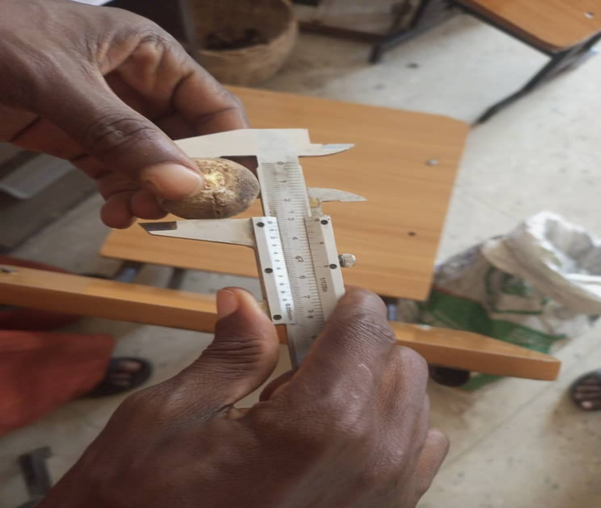

Plate 3.1: Vernier Caliper
- An electronic digital weighing scale with model number EK5350, resolution, and accuracy of 0.1g and +0. lg respectively used to measure the weight of snot apple fruit in gram. This is as shown in plate 3.2

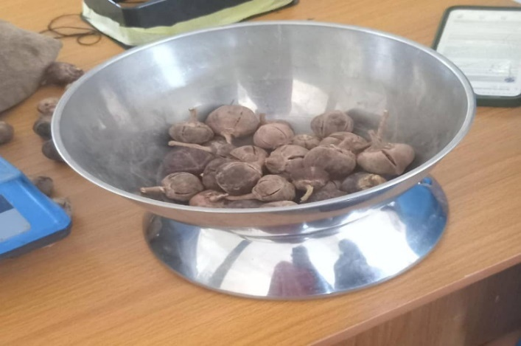

Plate 3.2 Digital Weighing Scale
- The angle of repose apparatus (funnel type) fabricated at the department of Agricultural and Bio-Environmental Engineering Technology, Kwara State polytechnic was used to determine the angle of repose of snot apple on plywood, metal and plastic surface. Plate 3.3 shows the angle of repose apparatus (funnel type)
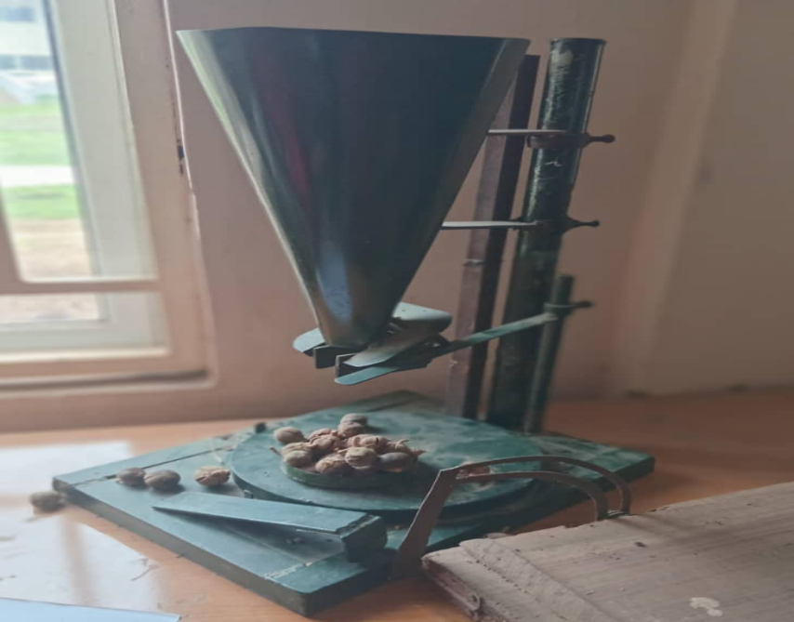

Plate 3.3: Angle of Repose
- An inclined plane also fabricated by the same department consists of two horizontal flat members hinge together at the end, a protractor to measure the angle of inclination, a pulley mounted at one end of the horizontal member to allow passage of the thread, an open box at both ends to accommodate the fruits was used to determine the co-efficient of friction in. Plywood, metal and plastic surface of snot apple. This is as shown in plate 3.4.
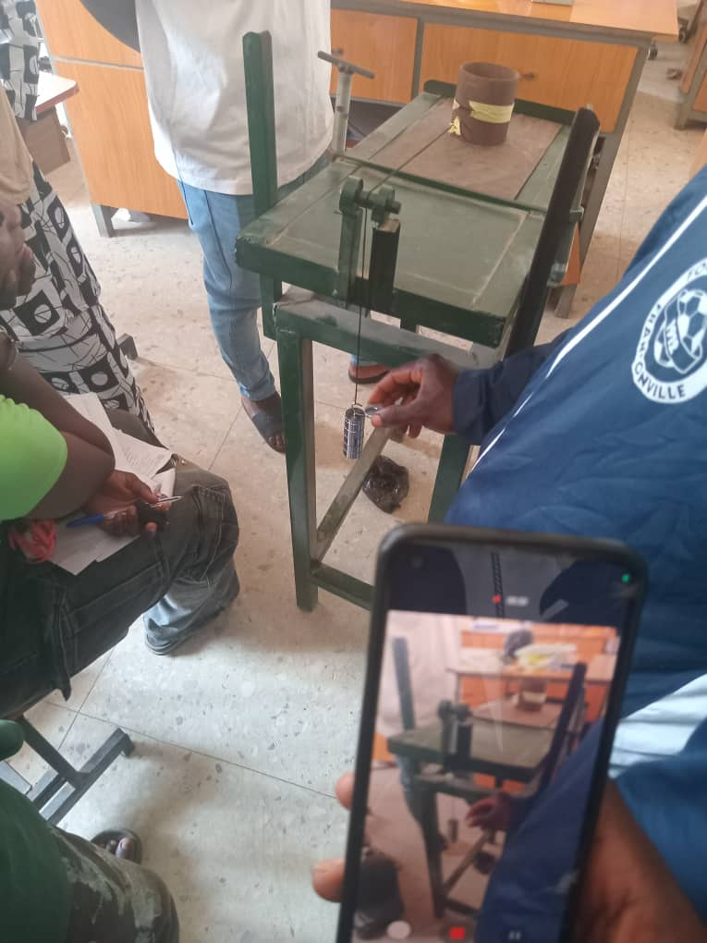

Plate 3.4: Incline Plane
- A set of masses were used to determine the force required to pull the seed on the inclined plane. Plate 3.5 shows the slotted Mass
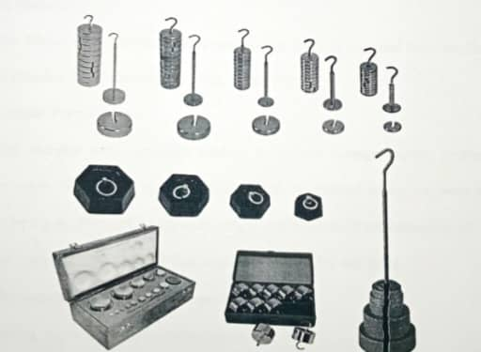

Plate 3.5: Slotted Mass
- Measuring Cylinder: for measuring the volume of snot apple.
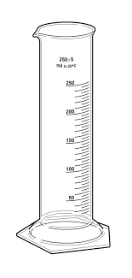

Plate 3.6: Measuring Cylinder

3.2 Sourcing of Material
Matured snot apple was source from local merchant in Gombe State, Nigeria and are kept in a cool dry place before the experiments were conducted. Clean and uniform fruits were selected, washed under running tap water, and air-dried of room temperature (27 ± 2⁰C). All experiments were performed in the laboratory within the normal room temperature range and the fruit used for the experiment were defect free.
3.3 Sample Preparation
The samples were manually cleaned to remove foreign matter, broken and Immature seeds. The initial moisture content was determined using the oven drying method. Drying at 103°C until a constant weight was reached (Kashaminejadet. et al 2007). The initial moisture content of the fruit was found to be 12% wet basis.
3.4 Determination of Physical Properties
3.4.1 Size Determination
The three linear dimensions (major diameter, intermediate diameter and minor diameter) of the nuts were measured using a digital Vernier caliper with the resolution (0.1 mm/0.01´´), accuracy (±0.1 mm/0.01´´) and battery (SR44/LR44 1.5V) for all the prepared samples as given by Seyed et al;(2011) and also by Bart-Plange et al; (2012).
3.4.2 Determination of Geometric Mean Diameter
The geometric mean diameter of the snot apple was computed following the equation given by Baryeh (2002)
𝐺𝑚 = (𝑙 × 𝑤 × 𝑡)1/3 (1)
Where;
𝐺𝑚: geometric mean diameter, mm
𝑙: 𝑚𝑎𝑗𝑜𝑟 𝑑𝑖𝑎𝑚𝑒𝑡𝑒𝑟, mm
𝑤: 𝑖𝑛𝑡𝑒𝑟𝑚𝑒𝑑𝑖𝑎𝑡𝑒 𝑑𝑖𝑎𝑚𝑒𝑡𝑒𝑟, mm
𝑡: 𝑚𝑖𝑛𝑜𝑟 𝑑𝑖𝑎𝑚𝑒𝑡𝑒𝑟, mm
3.4.3 Determination of Arithmetic Mean Diameter
The arithmetic mean diameter of snot apple was computed by using the equation given by (Tarighi et al; 2011)
𝐷𝑎 = 𝑙+𝑤+𝑡÷3 (2)
3.4.4 Determination of Surface Area
The surface area of the snot apple fruits was determined using the equation given by (Mahbobeh et al; 2011) as
𝑆 = 𝜋𝐺𝑚² (3)
3.4.5 Mass Determination
100 unit of snot apple was determined by using an electronic digital weighing scale with model number EK5350, resolution, and accuracy of 0.1 g and ±0.1 g respectively.
3.4.6 Volume Determination
The volume of the snot apple was determined using water displacement method. A measuring cylinder was filled half way with distilled water the readings was taken, the fruits were poured in the measuring cylinder and the level of the displaced water was recorded. The volume equals the difference between the change in the level and the Initial level of water in the cylinder. The procedure was repeated 10 times as described by Soyoye et al., (2018)
3.4.7 Bulk Density
The bulk density of snot apple fruit was determined by dividing the bulk mass by bulk volume
3.4.8 True Density
It was determined by dividing mass of the snot apple fruit by its volume using the equation given by (Parksoy et al; 2004)
𝜌 = 𝑚/ 𝑣 (4)
Where;
𝜌: 𝑑𝑒𝑛𝑠𝑖𝑡𝑦 in gcm⁻³
𝑚: 𝑚𝑎𝑠𝑠 𝑜𝑓 fruit in g
𝑣: 𝑣𝑜𝑙𝑢𝑚𝑒 𝑜𝑓 𝑛𝑢𝑡 in cm³
3.4.9 Porosity
Porosity of the snot apple was calculated from the bulk density and true density using the relationship given by Mohammed (2010) as follows:
𝜖 =(𝜌𝑡−𝜌𝑏) ÷𝜌𝑡× 100 (5)
Where;
𝜖: 𝑝𝑜𝑟𝑜𝑠𝑖𝑡𝑦 in %
𝜌𝑡: 𝑡𝑟𝑢𝑒 𝑑𝑒𝑛𝑠𝑖𝑡𝑦 in gcm⁻³
𝜌𝑏: 𝑏𝑢𝑙𝑘 𝑑𝑒𝑛𝑠𝑖𝑡𝑦 in gcm⁻³
3.4.10 Coefficient of Friction
The coefficient of friction was determined on three different structural surfaces such as plywood, mild steel sheet, and plastic using an inclined plane. The inclined plane consists of two horizontal flat members hinged at one tilted end; one of the members is the base while the other can be tilted at any angle of inclination. It has a protractor which gives the angle of inclination. The inclined plane also has a pulley fixed to it at the other end. The inclined plane was set at a convenient angle of inclination, the structural surface to be tested was placed on it then a box opened at both ends was placed on the surface. A thread attached to the box was allowed to run through the pulley at the end of the plane then set of known weights were loaded onto the thread until the box slides. The procedure was then repeated by filling the box with known mass of seed. The coefficient of static friction was then computed using the equation give thus:
𝜇 =(𝐹𝑇−𝐹𝐸) sin 𝛼/𝑊 cos 𝛼 (6)
Where:
FT is the force pulling the box filled with fruit
FE is the force pulling the empty box
Α is the angle at which the plane is inclined
W is the mass of fruit in the box

3.5 Angle of Repose
The angle of repose of snot apple was measured by the inclined plane method. For the inclined plane method, use apparatus consisting of two horizontal flat members hinged at one end was used. The bottom member serves as the base which is fixed while the top member can be tilted to any angle ranging from 00 to 900 and it also consists of a graduated protractor from which the angle of inclination can be read. The seeds were placed on the top member after which it is been tilted gradually until the seeds begin to fall freely. The point at which the seeds begin to fall freely is recorded as the angle of repose and the value is taken from the protractor.

CHAPTER FOUR
RESULTS AND DISCUSSIONS
4.1 Results
The results of the physical properties of snot apple (Azanza garckeana) are presented in table 4.1 and 4.2 below. These physical properties include the Size (Major, Intermediate and Minor Diameter), Geometric Mean Diameter, Arithmetic mean, Sphericity, Surface Area, Seed Mass, Seed Volume, True Density, Bulk Density, Porosity, Co-efficient of Static Friction and Angle of Repose. Tables 4.1 and 4.2 present the summary of the results while the raw data is presented in appendix A.
Table 4.1: Summary of the Physical Properties of Snot Apple (Azanza garckeana)
Property | Mean | Maximum | Minimum | Standard deviation
Major diameter (mm) | 28.5 | 31.33 | 26.34 | 1.39
Inter mediate diameter (mm) | 27.36 | 30.47 | 24.98 | 1.60
Minor diameter (mm) | 24.62 | 25.89 | 22.07 | 1.14
Arithmetic mean diameter (mm) | 26.83 | 29.23 | 24.47 | 1.24
Geometric mean diameter (mm) | 26.77 | 29.13 | 24.39 | 1.27
Sphericity | 0.939 | 0.96 | 0.9235 | 0.011
Surface area (mm²) | 240.21 | 2.666 | 1.869 | 250.80
Mass (g) | 819.7 | 900 | 770 | 39.75
True density (g/cm³) | 21.5 | 35 | 15 | 7.82
Bulk density (g/cm³) | 0.102 | 0.11 | 0.10 | 0.0041
Porosity (%) | 0.503 | 0.69 | 0.3 | 0.327
Table 4.2: Summary of the fictional Properties of Snot Apple (Azanza garckeana)
Property | Mean | Maximum | Minimum | Standard deviation
Angle of repose (º) | 57.46 | 62.35 | 41.67 | 5.89
Coefficient of friction
Plastic surface | 0.126 | 0.149 | 0.116 | 0.008
Metal surface | 0.144 | 0.187 | 0.14 | 0.022
Wood surface | 0.154 | 0.160 | 0.059 | 0.180

4.2 Discussions
From table 1the average size of snots apple (Azanza garckeana) the physical properties at determine include size (Major diameter, Intermediate diameter, Minor diameter, Arithmetic Mean diameter, Geometric mean diameter, Sphericity and surface area), volumetric properties (Volume, True density, Bulk density and Porosity), Gravimetric properties (1000unit mass) and fictional properties (Angle of repose and the Coefficient of static fiction on different structural surface). The Major diameter, Intermediate diameter, Minor diameter, Geometric mean diameter, Arithmetic mean diameter, Sphericity and surface area. The seed ranges between 26.34 – 31.33mm, 24.98 – 30.47mm, 22.07 – 25.59mm, 24.47 -29.23mm, 24.39 – 29.13mm, 0.9235 – 0.96mm, 1.869 – 2.666mm², respectively. The True density, Bulk density and Porosity of the Seed ranges between 15 – 35kg/m³, 0.11– 0.10kg/m³ and 0.3 – 0.69 % respectively while the 1000-unit mass of the seed ranges between 770 – 900g. The angle of repose of the seed ranges between 41.67 – 62.35⁰ while the coefficient of static friction on plastic, metal, wood and structural surfaces ranges between 0.116 – 0.149, 0.14 – 0.187, 0.059 – 0.160 respectively.
On the average the major diameter intermediate diameter, minor diameter geometric mean diameter, arithmetic mean diameter, sphericity and surface area of the seed are 28.5± 1.39mm, 27.36± 1.60mm, 24.62± 1.14mm, 26.83± 1.24mm, 26.71± 1.27mm, 0.939± 0.011mm, 240.21± 250.80mm, 819.7± 39.79mm² respectively, the seed true density, bulk density and porosity of the seed are 21.5±7.82kg, 0.102± 0.0041kg/m³ and 0.503± 0.327% respectively while the 1000 unit mass of the seed is 819.7± 39.75g. The angle of repose of the seed is 27.01± 2.36⁰ while the coefficient of static friction on plastic, metal and wood and structural surfaces is 0.126± 0.008, 0.144± 0.022, 0.154± 0.180 respectively. The graphical representations are depicted in figure 4.1 to 4.3 below.
Figure 4.1: Graphical representations of physical properties of snot apple
Figure 4.2: Graphical representations of Gravimetric properties of snot apple
Figure 4.3: Graphical representation of frictional properties of snot apple
CHAPTER FIVE
CONCLUSION AND RECOMMENDATION
5.1 Conclusions
i. The major diameter, intermediate diameter, minor diameter, geometric mean diameter, arithmetic mean diameter, sphericity and surface area of the seed area 28.5± 1.39mm, 27.36± 1.60mm 24.62± 1.14mm, 26.83± 1.24mm, 26.77± 1.27mm, 0.939± 0.011mm, 240.21± 250.80mm², respectively.
ii. The fruit True density, Bulk density and Porosity of the seed are 12± 6.36mm³, 453.78±, 40.31kg/m³, 28674.66± 21094.93% respectively while the 1000-unit mass of the fruit is 819.7± 39.75 respectively
iii. The angle of repose is 57.46± 5.89⁰. While the coefficient of static friction of plastic, metal, wood on structural surface is 0.126± 0.008, 0.144± 0.022 and 0.152 respectively.
5.2 Recommendations
The following recommendations were made at the end of the study:
- These data should be used in the design, fabrication and Evaluation of agricultural machine for processing of snot apple (Azanza garkeana).
- These data should be accessible to research institute, ministries, institution and any other interested parties who are willing to invest on mechanization.

REFERENCE
Abubakar, A. S., Bello, A. B., and Yaro, M. A. (2023). Nutritional and physicochemical properties of Azanza garckeana fruit pulp. African Journal of Food Science, 17(2), 45–53. https://doi.org/10.5897/AJFS2023.2222
Adebiyi, A. O., Oyelade, O. J., and Akinoso, R. (2021). Engineering evaluation of African star apple for mechanized juice extraction. African Journal of Food Science and Technology, 12(4), 109–117.
Adebowale, A. A., Ajayi, O. A., and Ogunjimi, L. A. O. (2023). Evaluation of physical dimensions and shape indices of indigenous African fruits for mechanized handling. African Journal of Food Engineering, 15(2), 85–93.
Adebowale, A. A., Ojo, M. O., and Ogunyemi, S. O. (2023). Evaluation of physical and mechanical properties of selected tropical underutilized fruits for engineering design. Journal of Agricultural Engineering and Technology, 27(1), 55–67. https://doi.org/10.1234/jaet.2023.271.055
Adebowale, M. A., Adebiyi, A. A., Adedayo, T. M., Olayemi, A. A., and Alamu, A. J. (2023). Physical and mechanical characteristics of selected tropical fruits. International Journal of Food Properties, 26(1), 87–101.
Adebowale, R. A., Adesina, M. A., and Ajayi, O. S. (2023). Mechanical and physical characterization of selected underutilized African fruits. Agricultural Engineering Today, 47(1), 27–35.
Adebowale, R. A., Fapohunda, J. O., and Alabi, O. A. (2023). Physical and mechanical characterization of underutilized tropical fruits for agro-processing design. International Journal of Agricultural Engineering, 14(2), 55–66.
Adejumo, A. O., Abdulazeez, R. A., and Oyeleke, G. O. (2020). Design consideration for pulping indigenous fruits using engineering properties. International Journal of Agricultural Research and Innovation, 12(2), 39–48.
Akinoso, R., Aremu, C. O., and Olayanju, T. M. A. (2022). Postharvest behavior and design considerations for underutilized fruits. Nigerian Journal of Engineering and Applied Sciences, 15(3), 94–102.
Amarteifio, J. O., and Mosase, M. O. (2006). Chemical composition of selected indigenous fruits of Botswana. Journal of Applied Sciences and Environmental Management, 10(2), 43–47.
Aremu, C. O., Oke, A. A., and Ogundipe, T. O. (2022). Traditional processing techniques of underutilized wild fruits in West Africa. African Journal of Rural Development, 18(4), 124–133.
Asoiro, F. U., and Ani, A. O. (2017). Engineering properties of agricultural materials: Their relevance in post-harvest equipment design. International Journal of Engineering Research and Technology, 6(4), 83–92.
Barbin, D. F., ElMasry, G., and Sun, D. W. (2023). Hyperspectral imaging for quality and maturity evaluation of tropical fruits. Computers and Electronics in Agriculture, 203, 107513. https://doi.org/10.1016/j.compag.2022.107513
Barbin, D. F., ElMasry, G., Sun, D.-W., and Allen, P. (2012). Non-destructive determination of chemical composition in intact and minced pork using NIR hyperspectral imaging. Food Chemistry, 135(1), 680–687. https://doi.org/10.1016/j.foodchem.2012.04.132
Barbin, D. F., Oliveira, D. M., and Osco, L. P. (2023). Applications of engineering properties in
Barbin, D. F., Silva, J. L., and Maia, J. M. (2023). Application of hyperspectral imaging in postharvest fruit sorting and storage. Postharvest Biology and Technology, 200, 112438.
Barbin, D. F., Siqueira, V. F., Teixeira, A. I., Carraretto, D., and Pimentel, T. C. (2023). Modern sensing techniques in evaluating food engineering properties. Foods, 14(14), 2521.
Barbin, D. F., Sun, D. W., ElMasry, G., Allen, P., and Morsy, N. (2023). Hyperspectral imaging for non-destructive evaluation of fruit quality attributes. Computers and Electronics in Agriculture, 205, 107566. https://doi.org/10.1016/j.compag.2023.107566 CIGR Journal, 25(1), 1–12.
Correia, P. M. R., Oliveira, G. H. H., and Teixeira, C. S. (2019). Thermal behavior and drying characteristics of tropical fruit slices. Journal of Food Process Engineering, 42(5), e13011. https://doi.org/10.1111/jfpe.13011
Danladi, B. B., Musa, M. M., and Usman, A. I. (2022). Extraction and characterization of mucilage from Azanza garckeana. Nigerian Journal of Engineering and Applied Sciences, 39(3), 121–129.
Eze, A. N., and Ojinnaka, M. C. (2019). Challenges in value addition to African indigenous fruits:
Fayemiwo, B. A., Adebiyi, A. O., and Ogunwole, J. O. (2023). Simulation and modeling of pulp flow characteristics in mucilage-rich tropical fruits. Agricultural Engineering Today, 10(1), 57–65.
Jayas, D. S., and Jeyamkondan, S. (2002). Postharvest technology of horticultural crops: Recent developments and research needs. Stewart Postharvest Review, 1(2), 1–9.
Kamble, P. P., Chakraverty, A., and Agarwal, P. K. (2016). Determination of firmness in fruits using texture analyzer. International Journal of Agricultural Engineering, 9(1), 125–130.
Mendoza, F., Dejmek, P., and Aguilera, J. M. (2021). Predicting ripeness of mangoes using machine vision and artificial intelligence. Postharvest Biology and Technology, 184, 111765.
Msonthi, J. D., and Magombo, D. A. (1983). Physicochemical analysis of indigenous fruits from Malawi. Tropical Science, 25(2), 89–93.
Ndukwe, I. G., Kalu, C. M., and Eme, P. E. (2015). Phytochemical and vitamin composition of Azanza garckeana fruit. Journal of Medicinal Plants Research, 9(8), 262–267.
Nelson, S. O. (2010). Dielectric properties of agricultural products and some applications. Research in Agricultural Engineering, 56(4), 104–112.
Okon, I. E., Danbaba, N., and Udo, M. E. (2022). Aerodynamic characterization of underutilized fruit seeds for pneumatic conveying systems. Agricultural Mechanization in Asia, Africa and Latin America, 53(4), 45–52.
Okon, M. A., Danbaba, N., and Udo, S. I. (2022). Assessment of aerodynamic properties of seeds from selected indigenous fruits. Nigerian Journal of Agricultural Engineering, 53(1), 42–49.
Olaniyan, A. M., and Oje, K. (2002). Development of a manually operated fruit pulper based on engineering characteristics. Journal of Agricultural Engineering and Technology, 10(1), 25–33.
Olayanju, T. M. A., Kareem, B., and Afolabi, I. S. (2021). Assessment of mechanical and thermal properties of selected underutilized tropical fruits for equipment design. Nigerian Journal of Technological Development, 18(3), 148–155.
Olayemi, A. A., and Bello, O. M. (2022). Shelf-life extension of processed underutilized fruits using smart packaging. International Journal of Postharvest Technology, 5(2), 79–88.
Opara, U. L., & Pathare, P. B. (2014). Bruise damage measurement and analysis of fresh horticultural produce—A review. Postharvest Biology and Technology, 91, 9–24.
Rungpichayapichet, P., Mahayothee, B., Nagle, M., Khuwijitjaru, P., and Müller, J. (2020). Robustness of hyperspectral imaging in prediction of mango maturity. Biosystems Engineering, 191, 113–122.
Usman, B. A., Yusuf, K. O., and Idris, A. O. (2021). Performance evaluation of a solar-powered cabinet dryer for indigenous fruits. International Journal of Renewable Energy and Agriculture, 8(1), 88–96.
Yusuf, A. B., Adebayo, T. A., and Salawu, A. A. (2023). Hybrid solar-biomass dryer for rural fruit processing: A case study of Azanza garckeana. Nigerian Journal of Food Engineering, 11(2), 102–112.

