

A PROJECT REPORT ON
COMPARATIVE ANALYSIS OF VITAMIN C IN FRESH FRUITS JUICE OF
PINEAPPLE (Anana comosus) AND ORANGE (Citrus sinensis)

PRESENTED BY SULAIMAN IBRAHIM BOJUA
ND/23/SLT/PT/0583 SUBMITTED TO:

THE DEPARTMENT OF SCIENCE LABORATORY TECHNOLOGY INSTITUTE OF APPLIED SCIENCE (IAS), KWARA STATE POLYTECHNIC, ILORIN
IN PARTIAL FULFILMENT OF THE REQUIREMENTS FOR AWARD OF NATIONAL DIPLOMA (ND) IN SCIENCE LABORATORY TECHNOLOGY

SUPERVISED BY: MISS ABDULKAREEM S.B MAY 2024

DECLARATION

I SULAIMAN IBRAHIM BOJUA, declare that the contents of this project represent my work and that the project or parts of the contents have not been previously submitted towards any academic qualification.

CERTIFICATION

This is to certify that this project has been examined and approved as meeting the requirement for the award of National Diploma (ND) in Science Laboratory Technology, Institute of Applied Sciences (IAS), Kwara State Polytechnic, Ilorin, Nigeria.

----------------------------------- ---------------------------- MISS ABDULKAREEM S.B DATE
(PROJECT SUPERVISOR)

------------------------------------- ---------------------------- MR LUQMAN DATE
(PART-TIME COORDNATOR)

---------------------------------------- ---------------------------- DR. ABDULKAREEM USMAN DATE
(Head Of Department)

DEDICATION

This report is dedicated to the Almighty ALLAH, the greatest and supreme, who is unchangeable and the custodian of total wisdom. As the Creator from whom all creatures originate, He knows all things that exist.
It is also dedicated to my parents, whose encouragement and support propelled me toward success. Furthermore, I dedicate this work to my siblings, sisters, and uncles, who offered patient guidance and support throughout my National Diploma (ND) program.

ACKNOWLEDGEMENT

Thanks to the Almighty God for his support, guidance and blessing to complete this project successfully. I would like to acknowledge the department of science laboratory technology for helping through and enhancing my knowledge throughout my stay at the Kwara State Polytechnic Ilorin, Kwara State, Nigeria.
My sincere gratitude and appreciation go to my project supervisor in person of MISS ABDULKAREEM S.B for his valuable words of advice, guidance, enlightenment and encouragements in making this project a successful one. I pray you will not lack all good things in life and may your children meet kindness everywhere they go in life.
Also, my appreciation goes to the Head of the department of science laboratory technology, for his love, caring and support geared towards me. May God Almighty be your Defense and your family.
I recognize and commend the tremendous efforts of all the teaching and non-teaching staff of my great department for unquantifiable support and assistance that we do enjoy from them at the time both morally and academically, may you be rewarded all by God Almighty.
Furthermore, I am very appreciative to my parents and guardians Mr and Mrs SULAIMAN, my backbone Abu Solia for their immeasurable and persistent support and love, morally, financially and for their word of advice.

Table of Contents

DECLARATION ii
CERTIFICATION iii
DEDICATION iv
ACKNOWLEDGEMENT v
Table of Contents vi
CHAPTER ONE 1
  - Background to Study on Vitamin C 1
  - STATEMENT OF PROBLEM 2
  - JUSTIFICATIONS 3
  - AIMS AND OBJECTIVES 4
    - AIMS 4
    - OBJECTIVES 4
  - SCOPE OF THE STUDY 5
CHAPTER TWO 6
  - OVERVIEW OF VITAMIN C 6
    - Biological Functions of Vitamin C 6
    - Chemical Nature and Stability 6
    - Dietary Sources of Vitamin C 7
    - Factors Affecting Vitamin C Stability in Juices 7
    - Importance of Vitamin C Preservation in Fruit Juices 8
  - Chemical Structure Of Vitamin C 8
    - Molecular Composition and Structure 9
    - Redox Behavior and Functional Groups 9
    - Solubility and Ionization 10
Fig. 2.1: Ascorbic Acid Oxidation Scheme 10
Fig. 2.2: Ascorbic Acid (Vitamin C) 11
  - Properties of Vitamin C 11
    - Oxidation-Reduction Potential 11
    - Solubility and pH Stability 12
    - Thermolability 12
    - Light Sensitivity and Oxygen Reactivity 13
    - Chelation and Enzyme Sensitivity 13
  - Functions of Vitamin C 14
    - Antioxidant Defense 15
    - Collagen Synthesis 15
    - Immune System Support 15
    - Iron Absorption Enhancement 16
    - Enzyme Cofactor Functions 16
    - Detoxification and Wound Healing 16
    - Potential Anticarcinogenic and Cardioprotective Roles 16
  - Method of Vitamin C Determination: Titration 17
    - Principle of the Method 17
    - Different Method of Vitamin C Determination 18
    - Advantages of Titration Method 19
    - Disadvantages of Titration Method 19
    - Limitations 20
  - Factors Affecting Vitamin C Content In Pineapple Juice 21
    - Temperature 22
    - pH Level 22
    - Oxygen Exposure 22
    - Light Exposure 23
    - Metal Ions 23
    - Storage Conditions and Duration 23
    - Enzymatic Activity 23
  - Factors Affecting Vitamin C Content In Orange Juice 24
    - Thermal Processing and Pasteurization 24
    - Storage Temperature and Duration 24
    - Light Exposure 25
    - Oxygen Availability and Packaging 25
    - pH of the Juice 25
    - Metal Ion Catalysis 26
    - Enzymatic Oxidation 26
    - Juice Concentration and Reconstitution 26
CHAPTER THREE 27
MATERIALS AND METHODS 27
  - Materials 27
    - Glassware 27
    - Equipment 27
    - Preparation of Solutions 28
    - Sample Preparation 28
    - Standard Iodine Preparation 28
    - 0.5% Starch Solution 29
    - Iodine Solution 29
  - Experimental Procedure 29
    - Titration 29
    - Calculations 30
    - Precautions 30
CHAPTER FOUR 32
RESULTS AND CONCLUSION 32
  - Results 32
  - Discussion 34
CHAPTER FIVE 36
  - CONCLUSION 36
Reference 37

CHAPTER ONE

Background to Study on Vitamin C
Vitamin C, or ascorbic acid, is a vital water-soluble antioxidant that plays an essential role in numerous metabolic functions, including collagen formation, immune defense, iron absorption, and the protection of biomolecules against oxidative damage (Padayatty et al., 2003). It is considered one of the most important micronutrients for human health. Unlike many animals, humans lack the enzyme L-gulonolactone oxidase required for the endogenous synthesis of vitamin C. As a result, they must obtain it through dietary intake, particularly from fruits and vegetables (Naidu, 2003).
Among the various dietary sources, fruit juices, especially those derived from citrus fruits like oranges and pineapples, are widely regarded for their high vitamin C content and are commonly consumed as part of a healthy diet. These juices are not only appreciated for their pleasant taste and refreshing qualities but also for their contribution to meeting the recommended daily intake of essential vitamins (Lee & Kader, 2000). However, the vitamin C content of these juices is often assumed rather than verified, especially in developing countries, where limited technological resources hinder proper nutrient analysis and quality control.
Vitamin C is inherently unstable and susceptible to degradation through oxidation. Several intrinsic and extrinsic factors such as temperature, light exposure, air (oxygen), storage duration, pH, and the method of juice extraction and preservation significantly influence its stability (Munyaka et al., 2010). These factors can cause progressive loss of ascorbic acid, which reduces the nutritional value of the juice over time. The degradation process is further accelerated in poorly regulated storage conditions, which are common in regions with inadequate refrigeration, erratic power supply, and limited food preservation knowledge.
In the context of Nigeria and other tropical countries, fruit juice production is often done at the small-scale or cottage-industry level, where producers rely on traditional methods without proper packaging, cold storage, or preservation protocols. Many juice vendors

operate under open-air conditions, exposing their products to sunlight and high ambient temperatures, two major contributors to vitamin C breakdown (Iqbal et al., 2006). Consumers, therefore, may be unknowingly drinking juices with minimal nutritional benefit, despite paying for products believed to be healthy.
Moreover, the shelf life of commercially and locally produced fruit juices is influenced by the type of fruit, method of juice extraction, use of preservatives, and storage conditions. For instance, pasteurization, a common method used to improve microbial safety and extend shelf life, can significantly affect the vitamin C content if not carefully controlled (Burdurlu et al., 2006). Natural enzymes present in fruits may also contribute to vitamin C degradation post-extraction.
Given these challenges, there is a pressing need to isolate and examine the factors affecting vitamin C retention in commonly consumed fruit juices such as pineapple and orange juice. Through controlled experimentation and simulated environmental conditions, this study aims to provide empirical data on the degradation of vitamin C under various factors. The research will not only offer scientific insight into the stability of vitamin C in fruit juices but also equip juice producers, vendors, and consumers with knowledge on best practices for juice preparation, storage, and consumption.
The findings from this study are particularly relevant to public health nutrition, food science, and the local juice production industry. They are expected to support initiatives aimed at reducing micronutrient deficiencies, improving dietary quality, and promoting better food safety standards.

STATEMENT OF PROBLEM
Vitamin C is widely recognized for its vital role in maintaining human health. Its deficiency has been linked to various ailments such as scurvy, poor wound healing, weakened immune function, and increased oxidative stress (Carr & Maggini, 2017). Although fruit juices, especially from citrus fruits like orange and pineapple, are assumed to be reliable sources of vitamin C, the actual concentration of this vitamin in juices at the point of consumption is often much lower than anticipated. This is primarily due to the vitamin's high sensitivity to environmental and processing factors.

In Nigeria and similar developing countries, a large portion of fruit juice production is carried out by small-scale, informal vendors who typically lack access to proper preservation and quality control technologies. Their production and storage practices often involve exposure to high temperatures, light, oxygen, and extended storage times, all of which accelerate the degradation of vitamin C. Despite the widespread consumption of these juices, there is limited awareness about how significantly their vitamin C content can decline under such conditions.
The problem is further compounded by the lack of regular quality assessments and public knowledge. Consumers often assume they are receiving full nutritional value from juices that, in reality, may be nutritionally depleted. The absence of standardized storage and processing guidelines contributes to nutrient loss, undermining public health benefits and defeating the primary purpose of juice consumption.
Therefore, the central problem addressed by this study is the lack of scientific data and public knowledge regarding the extent to which environmental and processing factors affect vitamin C content in pineapple and orange juices. This issue highlights the urgent need to identify, isolate, and analyze these factors to ensure the nutritional quality of fruit juices is maintained from production to consumption.

JUSTIFICATIONS
The consumption of fruit juices such as pineapple and orange is widespread, both in Nigeria and globally, due to their perceived health benefits and high vitamin C content. Vitamin C is an essential nutrient that supports numerous physiological functions, including antioxidant protection and immune system efficiency (Padayatty et al., 2003). However, ascorbic acid is chemically unstable and prone to degradation under various environmental and processing conditions, which often go unnoticed by both producers and consumers.
In developing countries, many small-scale juice producers and vendors operate without adequate knowledge or facilities to preserve the nutritional quality of their products. This results in significant nutrient losses, reducing the health benefits that consumers expect from these juices. The lack of empirical data on how factors such as temperature, light

exposure, pH, oxygen availability, and storage duration affect vitamin C content in locally produced juices limits the development of effective preservation strategies.
This study is therefore justified as it addresses a critical gap in knowledge by isolating and determining the factors that influence vitamin C degradation in pineapple and orange juices. The findings will provide evidence-based recommendations for juice producers, vendors, and consumers to improve handling and storage practices, thereby maximizing the retention of vitamin C. Furthermore, this research contributes to public health by promoting better nutritional outcomes through improved juice quality, ultimately helping to reduce micronutrient deficiencies associated with vitamin C.
The study’s results are expected to inform policies and guidelines for fruit juice production and preservation, especially at the cottage and small-scale levels. It will also serve as a valuable resource for further scientific investigations into food preservation and nutrition in similar tropical settings.

AIMS AND OBJECTIVES

AIMS
The primary aim of this study is to isolate and determine the factors affecting the vitamin C content in pineapple and orange juices, with the goal of understanding how various environmental and processing conditions influence vitamin C retention.

OBJECTIVES
- To quantify the initial vitamin C content in freshly prepared pineapple and orange juices.
- To investigate the effects of temperature variations on the stability of vitamin C in both juices.
- To examine the impact of light exposure on the degradation rate of vitamin C in pineapple and orange juices.
- To assess the influence of storage duration on the vitamin C content of the juices.
- To evaluate how pH levels affect the stability and retention of vitamin C in the fruit juices.

- To provide recommendations for best practices in the handling, processing, and storage of pineapple and orange juices to maximize vitamin C retention.

SCOPE OF THE STUDY
This study focuses on the isolation and determination of factors affecting vitamin C content in two commonly consumed fruit juices: pineapple and orange juice. The research investigates how different environmental and processing variables, specifically temperature, light exposure, storage duration, and pH, impact the retention and degradation of vitamin C in these juices.
The study is limited to simulated experimental conditions that mimic realistic scenarios commonly encountered during juice preparation, handling, and storage, particularly within tropical regions such as Nigeria. It does not cover other fruit juices or additional vitamins and nutrients.
Additionally, the study concentrates on laboratory analysis of vitamin C content using standard chemical methods, with data generated through simulated experiments rather than direct sampling from commercial juice producers. The findings aim to provide practical recommendations for small-scale producers and consumers to enhance the nutritional quality of pineapple and orange juices.

CHAPTER TWO

OVERVIEW OF VITAMIN C
Vitamin C, chemically known as ascorbic acid, is a vital micronutrient indispensable to human health and metabolism. It is a water-soluble vitamin that cannot be synthesized endogenously by humans due to the lack of the enzyme L-gulonolactone oxidase, which is essential in the biosynthetic pathway of ascorbic acid from glucose (Naidu, 2003).
Consequently, humans must rely on dietary intake from various sources to meet their physiological needs.

Biological Functions of Vitamin C
Vitamin C serves multiple biological functions that underscore its importance. Primarily, it acts as a potent antioxidant, protecting cells and tissues from oxidative damage induced by reactive oxygen species (ROS) and free radicals. This antioxidative capacity contributes to the prevention of chronic diseases including cardiovascular diseases, certain cancers, cataracts, and neurodegenerative disorders (Carr & Maggini, 2017).
Additionally, vitamin C is a critical cofactor in enzymatic reactions such as collagen synthesis, which is essential for maintaining the structural integrity of skin, blood vessels, bones, cartilage, and connective tissue (Padayatty et al., 2003). Deficiency in vitamin C impairs collagen formation, leading to clinical manifestations such as scurvy, characterized by bleeding gums, impaired wound healing, and joint pain (Naidu, 2003).
Moreover, vitamin C enhances the absorption of non-heme iron by reducing ferric iron (Fe³⁺) to the more absorbable ferrous form (Fe²⁺), thereby playing a pivotal role in preventing iron deficiency anemia (Hallberg, Brune, & Rossander, 1989). It also participates in the biosynthesis of neurotransmitters such as norepinephrine and the metabolism of cholesterol to bile acids.

Chemical Nature and Stability
Vitamin C is a six-carbon lactone with a molecular formula of C₆H₈O₆. Its chemical structure comprises an enediol group that facilitates its electron-donating ability, which accounts for its antioxidative function (Padayatty et al., 2003). The molecule exists primarily in two forms: ascorbic acid (the reduced form) and dehydroascorbic acid (the

oxidized form), both of which are biologically active as the latter can be enzymatically reduced back to the former in vivo (Naidu, 2003).
Despite its critical physiological roles, vitamin C is chemically unstable. It is highly susceptible to degradation through oxidation, especially in the presence of heat, light, oxygen, metal ions, and alkaline pH. The oxidative degradation of vitamin C follows a multi-step reaction leading to the formation of biologically inactive compounds such as diketogulonic acid (Davey et al., 2000). This instability poses significant challenges in the food industry, particularly in the processing, storage, and preservation of vitamin C- rich products like fruit juices.

Dietary Sources of Vitamin C
Fruits and vegetables are the primary dietary sources of vitamin C. Citrus fruits such as oranges, lemons, and limes are well-known for their high vitamin C content (Lee & Kader, 2000). Other rich sources include strawberries, kiwi fruit, guava, papaya, mango, pineapple, bell peppers, and leafy green vegetables (Naidu, 2003). The vitamin C content varies depending on the species, cultivar, maturity at harvest, and growing conditions.
Fruit juices, especially orange and pineapple juices, are popular vehicles for vitamin C intake because they are convenient and retain significant amounts of the vitamin if properly handled (Burdurlu, Koca, & Karadeniz, 2006). However, the vitamin content can vary widely depending on processing methods such as pasteurization, filtration, storage conditions, and packaging.

Factors Affecting Vitamin C Stability in Juices
Vitamin C degradation in fruit juices is influenced by both intrinsic and extrinsic factors. Intrinsic factors include juice pH, presence of enzymes such as ascorbate oxidase, and metal ions (e.g., copper and iron), which can catalyze oxidation reactions (Burdurlu et al., 2006). The acidic nature of most fruit juices tends to stabilize vitamin C, but variations in pH can alter its stability significantly (Munyaka, Makule, & Oey, 2010).
Extrinsic factors encompass temperature, light exposure, oxygen availability, and storage duration. High temperatures, as experienced during pasteurization or improper storage, accelerate the oxidation of vitamin C and lead to rapid degradation (Lee & Kader, 2000).

Similarly, exposure to light, particularly ultraviolet radiation, promotes the breakdown of ascorbic acid (Munyaka et al., 2010). Oxygen is a critical factor, as it facilitates the oxidation process, and juices stored in poorly sealed containers or exposed to air lose vitamin C more rapidly.
The storage period also plays a significant role; vitamin C content decreases progressively over time, with faster losses occurring under non-ideal storage conditions such as high temperature and light exposure. The combined effects of these factors can significantly reduce the nutritional quality of fruit juices before consumption (Burdurlu et al., 2006).

Importance of Vitamin C Preservation in Fruit Juices
Given the nutritional importance of vitamin C and its sensitivity to degradation, preserving its content during juice production and storage is essential. This has implications for consumer health, especially in regions where fruit juices are a significant source of micronutrients.
Small-scale juice producers and vendors in tropical countries often face challenges such as limited access to refrigeration and packaging technologies, increasing the risk of nutrient loss. Understanding the mechanisms and factors influencing vitamin C degradation can inform improved processing and storage techniques, such as optimizing pasteurization conditions, minimizing oxygen exposure, and using light-protective packaging.
Efforts to maintain vitamin C content in juices also contribute to reducing micronutrient deficiencies and improving overall dietary quality. This is particularly important for vulnerable populations, including children, pregnant women, and individuals with compromised immunity.

Chemical Structure Of Vitamin C
Vitamin C, scientifically known as ascorbic acid, is a vital water-soluble micronutrient with antioxidant properties and biochemical relevance in human health. It functions as a cofactor in enzymatic reactions, assists in collagen synthesis, enhances non-heme iron absorption, and combats oxidative stress by scavenging free radicals (Naidu, 2003).

Understanding its chemical structure is foundational to appreciating its physiological functionality and its vulnerability to degradation in food matrices such as fruit juices.

Molecular Composition and Structure
The molecular formula of ascorbic acid is C₆H₈O₆, and its molecular weight is approximately 176.12 g/mol. Structurally, vitamin C is a derivative of glucose and belongs to the class of compounds known as γ-lactones (Carr & Frei, 1999). It contains a five-membered lactone ring (furan ring) with adjacent hydroxyl groups at the 2- and 3- carbon positions. These hydroxyl groups form an enediol configuration, which imparts strong reducing properties to the molecule, enabling it to act as an electron donor in biological redox systems.
Vitamin C primarily exists in its L-ascorbic acid configuration, which is the only biologically active form in humans. The D-isomer is not physiologically significant (Padayatty et al., 2003). In aqueous solution, L-ascorbic acid can undergo reversible oxidation to form dehydroascorbic acid (DHA). However, with prolonged exposure to oxygen, heat, or metal ions, DHA undergoes irreversible hydrolysis to 2,3-diketogulonic acid, which has no vitamin activity (Davey et al., 2000).

Redox Behavior and Functional Groups
The antioxidant behavior of vitamin C is primarily due to its enediol moiety, which enables it to donate two electrons and two protons during oxidative reactions. The chemical reaction proceeds as follows:
L-ascorbic acid ⇌ dehydroascorbic acid → 2,3-diketogulonic acid

This redox capacity is crucial for maintaining cellular redox balance and protecting biomolecules such as lipids, proteins, and DNA from oxidative damage (Jacob & Sotoudeh, 2002). However, the same redox reactivity also makes the compound highly sensitive to environmental stressors such as heat, light, oxygen, and the presence of transition metal ions.

Solubility and Ionization
Ascorbic acid is highly soluble in water, with a solubility exceeding 300 g/L at room temperature. It exhibits weak acidity due to the presence of hydroxyl groups and has two dissociation constants (pKa values): approximately 4.1 and 11.6 (Lee & Kader, 2000).
This indicates that under the mildly acidic conditions typical of fruit juices (pH 3–4), the molecule remains largely protonated and more stable. However, pH also affects its degradation rate; oxidation accelerates at both high and low extremes of pH, especially under thermal influence.
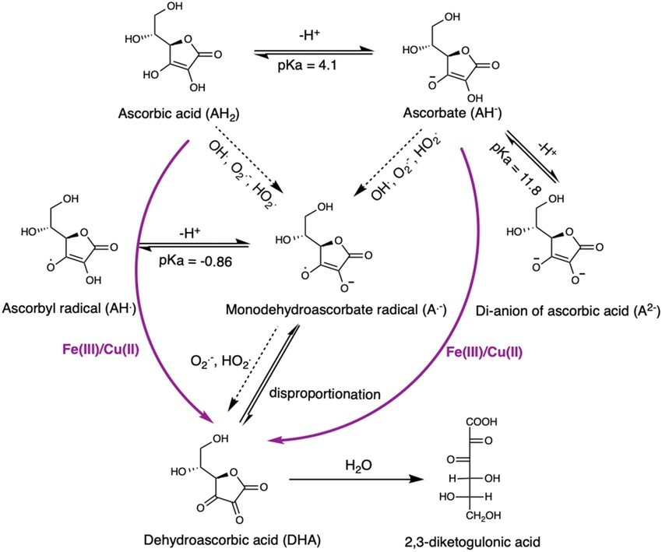

Fig. 2.1: Ascorbic Acid Oxidation Scheme.
    - Stability Implications for Fruit Juices

Due to its molecular structure, ascorbic acid is prone to degradation in fruit juices during processing and storage. High temperature, prolonged exposure to light, oxygen, and

catalytic metal ions such as Cu²⁺ and Fe²⁺ significantly reduce its stability (Davey et al., 2000). These degradation pathways result in the loss of nutritional value and reduction of antioxidant potential in juices like pineapple and orange, which are naturally rich in vitamin C.

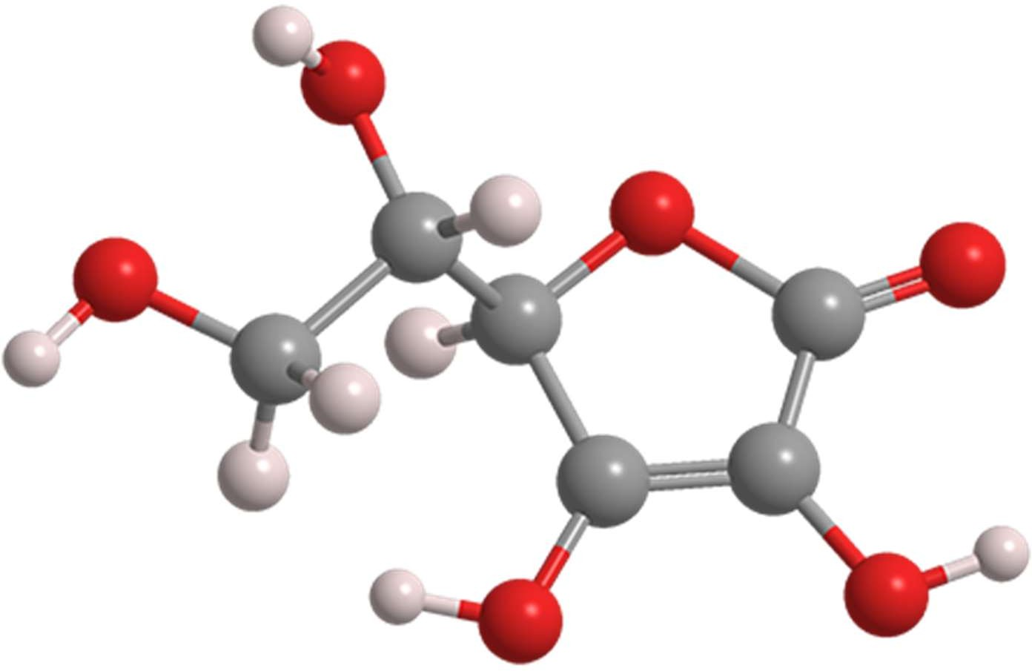

Fig. 2.2: Ascorbic Acid (Vitamin C)

Properties of Vitamin C
Vitamin C, or ascorbic acid, is an organic compound with the molecular formula C₆H₈O₆ and a molecular weight of approximately 176.12 g/mol. Structurally, it is a six-carbon lactone derived from glucose, and its chemical identity is based on the enediol structure present at the second and third carbon atoms of the furan ring (Padayatty et al., 2003).
This enediol moiety gives the molecule its strong reducing properties, allowing it to act as a potent antioxidant.

Oxidation-Reduction Potential
Vitamin C acts as a primary electron donor, readily undergoing oxidation to form dehydroascorbic acid (DHA). Both ascorbic acid and DHA are biologically active; however, further oxidation of DHA results in diketogulonic acid, which is biologically

inactive and irreversibly lost (Davey et al., 2000). This oxidation process is influenced by environmental conditions such as oxygen concentration, temperature, light, and the presence of metal ions like copper and iron, which can act as catalysts.
The reversible oxidation of ascorbic acid to dehydroascorbic acid and back again under controlled physiological conditions is one of the reasons why vitamin C is an effective antioxidant in vivo. It also participates in redox cycling with other antioxidants, such as vitamin E and glutathione, contributing to the body’s overall antioxidant defense network (Naidu, 2003).

Solubility and pH Stability
Ascorbic acid is highly soluble in water due to its polar structure. This hydrophilicity allows it to be easily transported through blood plasma and cellular fluids, enhancing its accessibility in biological systems (Lee & Kader, 2000). However, this same property contributes to its instability during food processing. Being water-soluble means it is more likely to leach out during washing, boiling, or juicing, especially if the fluid is exposed to heat or oxygen.
Vitamin C exhibits maximum stability in acidic environments. It is most stable at a pH below 3.0, but its rate of degradation increases significantly under neutral and alkaline conditions. This pH sensitivity has important implications in juice production and storage, as the natural acidity of citrus juices helps preserve vitamin C, while improper neutralization during processing can lead to rapid nutrient loss (Munyaka et al., 2010).

Thermolability
One of the key chemical limitations of vitamin C is its thermolability, its tendency to break down when exposed to heat. Thermal processing methods such as pasteurization, sterilization, and boiling lead to varying degrees of vitamin C degradation, depending on temperature, duration, and pH (Burdurlu et al., 2006). For example, in fruit juice processing, high-temperature short-time (HTST) pasteurization is preferred over low- temperature long-time (LTLT) techniques, as the former retains more vitamin C due to the shorter exposure period.

Thermal degradation involves the breakdown of the ascorbic acid ring structure, leading to the formation of furfural compounds and eventually to the loss of both nutritional and sensory qualities in juices. Therefore, managing thermal exposure is crucial to preserving vitamin C content during fruit juice production.

Light Sensitivity and Oxygen Reactivity
Vitamin C is highly photosensitive, especially in solution. Ultraviolet (UV) and visible light accelerate the oxidative degradation of ascorbic acid, particularly when combined with oxygen exposure (Davey et al., 2000). This is of great concern in fruit juice storage and packaging, where clear glass or plastic containers may permit light penetration and promote nutrient loss. Oxygen, especially in the presence of light and heat, catalyzes the conversion of ascorbic acid to dehydroascorbic acid and further to non-functional degradation products.
To mitigate these effects, oxygen-permeable packaging should be avoided, and juice should be stored in dark or opaque containers, preferably under refrigeration. Vacuum sealing and nitrogen flushing are also employed in commercial settings to prolong shelf life and nutrient stability.

Chelation and Enzyme Sensitivity
Ascorbic acid has metal-chelating properties, enabling it to bind with metal ions, which can have both stabilizing and destabilizing effects. In the presence of iron or copper ions, it may actually catalyze its own degradation via redox cycling reactions. Additionally, enzymes such as ascorbate oxidase, naturally present in fruits, can accelerate the degradation of ascorbic acid post-extraction if not inactivated by heat treatment.
Understanding and controlling these chemical interactions is essential in maintaining vitamin C content in fresh and processed fruit juices. The combination of temperature, light, oxygen, and enzymatic activity determines the stability and bioavailability of vitamin C in food systems.

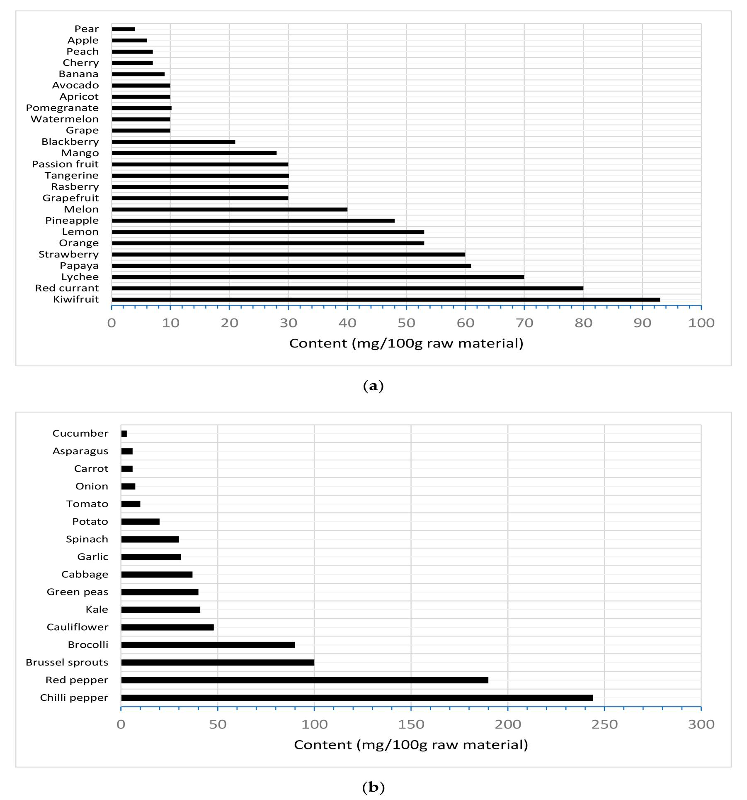

Fig. 2.3: Properties Of Vitamin C

Functions of Vitamin C
Vitamin C, or L-ascorbic acid, is one of the most essential water-soluble vitamins required for various physiological and biochemical functions in the human body. It acts as a cofactor, antioxidant, immune system enhancer, and enzyme modulator, among other roles. Unlike most animals, humans lack the enzyme L-gulonolactone oxidase, which is necessary for endogenous synthesis of vitamin C from glucose; therefore, it must be

obtained exogenously through diet (Padayatty et al., 2003). Fruits such as oranges and pineapples serve as rich dietary sources of this nutrient.

Antioxidant Defense
One of the most significant functions of vitamin C is its antioxidant activity. As a potent reducing agent, vitamin C donates electrons to neutralize reactive oxygen species (ROS) and free radicals, thereby protecting biomolecules, such as lipids, proteins, carbohydrates, and nucleic acids, from oxidative damage (Naidu, 2003). The redox cycle of vitamin C, wherein it is oxidized to dehydroascorbic acid (DHA) and subsequently regenerated, is central to its role in cellular antioxidant systems (Carr & Frei, 1999). It also helps regenerate other antioxidants, notably vitamin E (α-tocopherol), by reducing its oxidized form back to its active state (Jacob & Sotoudeh, 2002).

Collagen Synthesis
Vitamin C is an essential cofactor for prolyl and lysyl hydroxylase, the enzymes responsible for hydroxylating proline and lysine residues in procollagen chains (Lee & Kader, 2000). This post-translational modification is crucial for the structural integrity, stability, and function of collagen, a protein that forms the basis of connective tissues including skin, blood vessels, tendons, cartilage, and bone. Vitamin C deficiency impairs collagen synthesis, leading to scurvy, characterized by hemorrhages, gum disease, and poor wound healing.

Immune System Support
Vitamin C contributes significantly to immunological defense mechanisms. It promotes the production and function of leukocytes, enhances phagocytosis, and stimulates the production of interferons, all of which are crucial for combating microbial and viral infections (Wintergerst et al., 2006). Furthermore, vitamin C supports the epithelial barrier function, thereby reducing susceptibility to infections and speeding up recovery from illnesses such as the common cold and upper respiratory tract infections (Hemilä, 2017).

Iron Absorption Enhancement
Vitamin C enhances the absorption of non-heme iron, which is predominantly found in plant-based foods. It achieves this by reducing ferric iron (Fe³⁺) to the more soluble ferrous form (Fe²⁺) in the gastrointestinal tract, which can then be readily absorbed by intestinal cells (Cook & Monsen, 1977). This function is particularly important in preventing iron-deficiency anemia, especially in populations with limited access to animal protein sources.

Enzyme Cofactor Functions
Beyond collagen biosynthesis, vitamin C functions as a cofactor for several dioxygenase and monooxygenase enzymes, including:
      - Carnitine biosynthesis enzymes, which are essential for fatty acid transport into mitochondria for β-oxidation.
      - Neurotransmitter biosynthesis enzymes, such as dopamine β-hydroxylase, which converts dopamine to norepinephrine (Englard & Seifter, 1986).
      - These roles underscore its involvement in energy metabolism and neurotransmitter regulation, which are vital for both physical and cognitive functions.

Detoxification and Wound Healing
Vitamin C enhances detoxification in the liver by assisting cytochrome P450 enzymes, which play roles in drug metabolism and clearance of toxins. In wound healing, it contributes to tissue repair through collagen synthesis, immune modulation, and reduction of inflammation (Hunt, 2003). Its deficiency leads to fragile capillaries, delayed wound closure, and tissue degeneration.

Potential Anticarcinogenic and Cardioprotective Roles
Emerging studies suggest that vitamin C may play a role in cancer prevention and cardiovascular health, largely attributed to its antioxidant function and ability to protect endothelial cells from oxidative stress (Carr & Maggini, 2017). Some clinical trials have explored high-dose intravenous vitamin C in oncology, though these remain inconclusive and under investigation.

Vitamin C’s multifunctionality is unparalleled among vitamins. From its antioxidant defense and collagen synthesis to immune enhancement and iron metabolism, vitamin C remains essential for maintaining overall human health. These physiological functions underscore the importance of preserving vitamin C content during food processing and storage, particularly in juices derived from citrus fruits like oranges and pineapples.
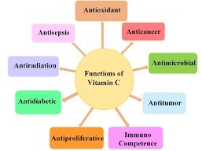

Fig. 2.4: Functions Of Vitamin C

Method of Vitamin C Determination: Titration
The quantitative determination of vitamin C (ascorbic acid) in fruit juices is crucial for assessing the nutritional quality and stability of these products. Among the various analytical techniques available, redox titration using 2,6-dichlorophenolindophenol (DCPIP) is one of the most commonly employed methods due to its simplicity, cost- effectiveness, and reasonable accuracy for routine analysis (Arya et al., 2000). This titrimetric method is particularly useful in laboratory settings and food industries for determining the ascorbic acid content in citrus-based juices like orange and pineapple.

Principle of the Method
The titration method is based on a redox reaction in which ascorbic acid reduces the blue dye DCPIP (2,6-dichlorophenolindophenol) to a colorless form. In this reaction, ascorbic acid is oxidized to dehydroascorbic acid, while DCPIP is reduced from its blue oxidized form to a colorless reduced state.

The reaction can be represented as follows:

C₆H₈O₆ (ascorbic acid) + DCPIP (blue) → C₆H₆O₆ (dehydroascorbic acid) + DCPIPH₂ (colorless)
The end-point of the titration is visually identified when a persistent pink coloration appears, indicating that all the ascorbic acid in the sample has been oxidized and excess DCPIP is present in the solution.

Different Method of Vitamin C Determination
Beyond titration, a variety of analytical methods are available for determining the concentration of vitamin C in fruit juices. These methods differ in their sensitivity, specificity, equipment requirements, and cost-effectiveness. The choice of method often depends on the objective of the analysis (e.g., research vs. industrial quality control), the matrix of the sample, and the required accuracy.

Spectrophotometry

UV–Visible spectrophotometry is a widely used method for vitamin C determination due to its simplicity and ability to analyze multiple samples rapidly. This method typically involves the reaction of ascorbic acid with a chromogenic reagent (such as 2,6- dichlorophenolindophenol or Folin–Ciocalteu reagent) that results in a color change, which is then measured at a specific wavelength using a spectrophotometer (Arya et al., 2000). The absorbance is directly related to vitamin C concentration.

High-Performance Liquid Chromatography (HPLC)

HPLC is considered the gold standard for ascorbic acid analysis due to its high precision, specificity, and ability to separate ascorbic acid from dehydroascorbic acid and other interfering substances. It typically uses a reverse-phase C18 column with UV detection at 245–265 nm (Nielsen, 2010). Sample preparation often includes filtration and derivatization, especially for DHA. Although HPLC is more expensive and time- consuming, it is indispensable in clinical, pharmacological, and food research.

Fluorometry

Fluorometric methods detect vitamin C based on its ability to quench or enhance fluorescence when interacting with specific fluorophores. These methods are highly sensitive and can detect trace amounts of ascorbic acid. However, the presence of fluorescent compounds in fruit juices can interfere with measurements, making this method less suitable for complex matrices without rigorous sample preparation (Robinson et al., 2006).

Titrimetry with Iodine

An alternative to DCPIP titration is iodimetric titration, in which iodine is used as the titrant. Ascorbic acid reduces iodine to iodide, and the endpoint is detected by the formation of a blue-black complex with starch. Although simple, this method is less specific and can be affected by other reducing agents in the sample (Verma & Bhatnagar, 2014).

Enzymatic Methods

These methods use specific enzymes such as ascorbate oxidase to selectively oxidize ascorbic acid, followed by a coupled colorimetric or fluorometric readout. They offer excellent specificity and are commonly employed in clinical diagnostic kits. However, they are more expensive and have a shorter shelf life for reagents.

Advantages of Titration Method
      - Simplicity: Requires minimal equipment and training.
      - Low cost: Reagents are inexpensive and readily available.
      - Rapid analysis: Can be completed in a few minutes.
      - Good reproducibility when performed under controlled conditions.
      - Visual Endpoint Detection

Disadvantages of Titration Method
      - Subjectivity of Endpoint Detection
      - Interference from Other Reducing Agents
      - Sensitivity to pH and Temperature
      - Limited Detection Range

      - Not Suitable for Differentiating Vitamin C Forms

Limitations
      - Subjective endpoint detection: May vary depending on observer.
      - Potential interference: Pigments, turbidity, or presence of other reducing agents in fruit juices may lead to inaccurate results.
      - Sensitivity: Less sensitive compared to chromatographic techniques like HPLC (High-Performance Liquid Chromatography) (Nielsen, 2010).
The titrimetric determination of vitamin C using DCPIP is a classical, reliable, and effective method for evaluating ascorbic acid concentration in fruit juices. While it may lack the high sensitivity of modern analytical tools, it remains a fundamental technique in food science laboratories for routine assessments of vitamin C content in beverages like orange and pineapple juice.

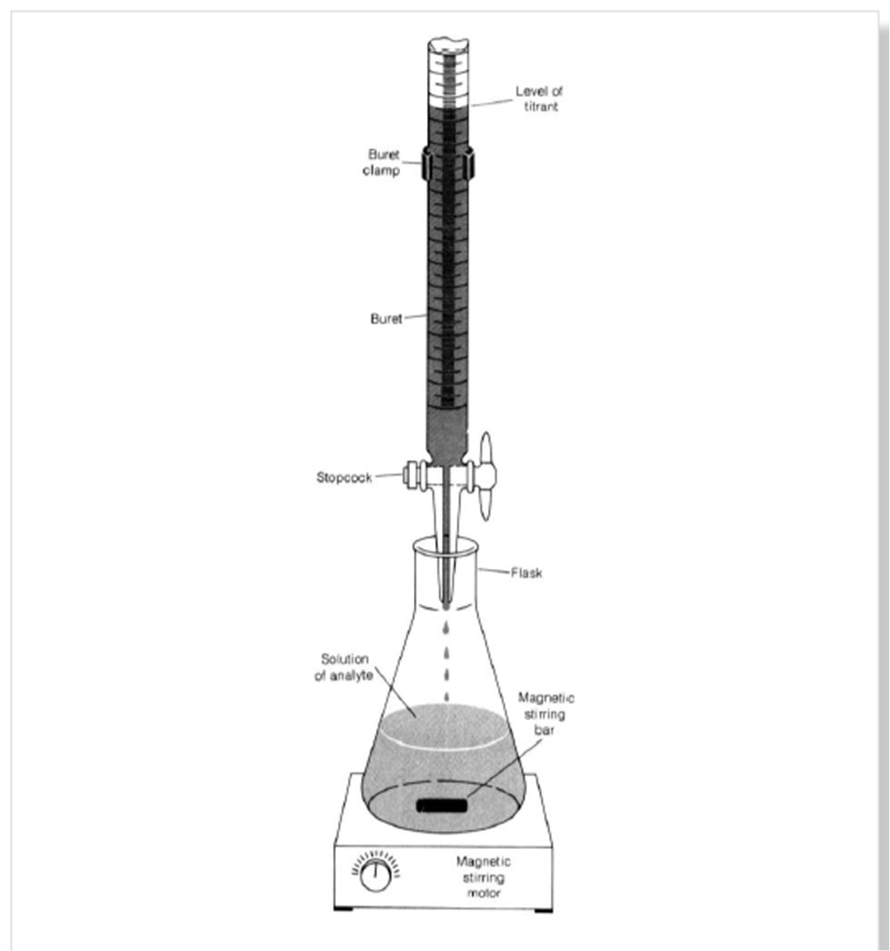

Fig. 2.5: Method Of Vitamin C Determination: Titration

Factors Affecting Vitamin C Content In Pineapple Juice
Pineapple (Ananas comosus) is a tropical fruit valued for its sweet flavor, high water content, and substantial nutritional value, particularly as a source of vitamin C. However, the ascorbic acid content in pineapple juice is highly unstable and prone to degradation under certain processing, environmental, and storage conditions. Understanding the various physicochemical and biological factors that influence vitamin C levels in pineapple juice is crucial for optimizing processing techniques and maintaining its

nutritional quality (Lee & Kader, 2000). These factors include temperature, pH, light exposure, oxygen availability, metal ions, and storage duration.

Temperature
Vitamin C is highly thermolabile, meaning it breaks down rapidly under elevated temperatures. Heating pineapple juice during pasteurization or cooking can lead to substantial losses of ascorbic acid due to its oxidative degradation (Davey et al., 2000). The extent of degradation increases with both temperature intensity and duration of heat exposure. According to Severini et al. (1997), a loss of up to 50–60% of vitamin C can occur during pasteurization at 90°C for just a few minutes. This degradation is catalyzed by oxygen and is irreversible, converting ascorbic acid into biologically inactive compounds such as 2,3-diketogulonic acid.

pH Level
Pineapple juice naturally has a pH range between 3.2 and 4.0, making it acidic. Ascorbic acid is generally more stable under acidic conditions, and thus this pH range provides a relatively protective environment against degradation (Rojas-Graü et al., 2007).
However, if pH is artificially altered, such as during fermentation or with improper pH control during processing, vitamin C becomes more vulnerable. In alkaline environments, the oxidation of ascorbic acid accelerates significantly due to increased deprotonation of the molecule, which makes it a better electron donor and thus more prone to oxidative damage (Yuan & Chen, 1998).

Oxygen Exposure
Vitamin C is highly susceptible to oxidation in the presence of oxygen. During the juicing, packaging, and storage of pineapple juice, exposure to atmospheric oxygen can initiate auto-oxidation of ascorbic acid. This reaction is further accelerated in the presence of oxygen-permeable packaging materials or when containers are not vacuum- sealed. Oxygen not only oxidizes ascorbic acid to dehydroascorbic acid but also promotes chain reactions that degrade it irreversibly (Klimczak et al., 2007). Hence, controlling oxygen levels during processing and packaging is critical to preserving vitamin C.

Light Exposure
Light, particularly ultraviolet (UV) and visible wavelengths, can catalyze photochemical degradation of vitamin C in pineapple juice. Transparent containers that allow light penetration accelerate this process, especially when the juice is stored near windows or under fluorescent lighting (Martinsen & Sundheim, 2000). Vitamin C loss due to photodegradation is often compounded by the presence of trace metals and flavonoids, which can act as photosensitizers and promote the formation of reactive oxygen species. This necessitates the use of opaque or UV-blocking packaging materials for juice preservation.

Metal Ions
The presence of transition metals, particularly iron (Fe²⁺/Fe³⁺) and copper (Cu²⁺), significantly enhances the rate of vitamin C oxidation in pineapple juice. These metal ions act as catalysts in redox reactions, facilitating the conversion of ascorbic acid to dehydroascorbic acid and beyond (Nielsen, 2010). Metal contamination may occur during juicing or from processing equipment, emphasizing the need for stainless steel machinery and the use of chelating agents such as EDTA (ethylenediaminetetraacetic acid) to mitigate this effect.

Storage Conditions and Duration
Storage temperature and duration play critical roles in vitamin C stability. Even under refrigeration (4–8°C), pineapple juice exhibits gradual degradation of ascorbic acid over time. According to Kefford et al. (1995), pineapple juice stored at room temperature for more than 48 hours can lose over 30% of its initial vitamin C content. Long-term storage, especially in suboptimal conditions (e.g., high temperature, light exposure, oxygen- permeable containers), leads to cumulative oxidative damage.

Enzymatic Activity
Enzymes such as ascorbate oxidase, present naturally in fruits or introduced by microbial contamination, can degrade ascorbic acid enzymatically. These enzymes become more active during storage or fermentation, further accelerating the breakdown of vitamin C (Arya et al., 2000). Enzymatic degradation is particularly relevant in unpasteurized or freshly squeezed juices that have not undergone enzyme inactivation.

The vitamin C content in pineapple juice is highly sensitive to various physicochemical and environmental factors. Heat, oxygen, light, metal ions, and improper storage conditions are primary contributors to ascorbic acid degradation. Therefore, to retain optimal nutritional value, pineapple juice must be processed and stored under carefully controlled conditions, including low temperatures, minimal oxygen exposure, dark storage, and use of inert materials. These strategies are essential for maximizing vitamin C stability and ensuring the health benefits of the final product.

Factors Affecting Vitamin C Content In Orange Juice
Orange juice, derived from Citrus sinensis, is widely recognized as one of the richest natural sources of vitamin C (ascorbic acid) in the human diet. However, despite its nutritional benefits, the vitamin C content in orange juice is inherently unstable and subject to rapid degradation under various physicochemical, environmental, and biochemical conditions. These changes can significantly diminish its nutritional value, particularly during juice processing, packaging, and storage (Lee & Kader, 2000).
Understanding the factors influencing the retention or loss of vitamin C in orange juice is essential for maintaining quality and ensuring accurate nutritional labeling.

Thermal Processing and Pasteurization
Heat treatment is routinely applied to orange juice during commercial processing to inactivate microbial contaminants and enzymes. However, vitamin C is highly heat- sensitive, and its concentration decreases with increased temperature and exposure time. Pasteurization at 90–95°C for 15–30 seconds may result in a 10–50% reduction in ascorbic acid, depending on the method used and the initial juice composition (Moshonas & Shaw, 1994). Extended heat exposure leads to irreversible degradation through oxidation, especially when oxygen is present.

Storage Temperature and Duration
The rate of vitamin C degradation in orange juice during storage is temperature- dependent. Refrigerated storage (4–8°C) slows the degradation process, while storage at room temperature or above (25–30°C) can accelerate the oxidative breakdown of ascorbic acid (Favell, 1998). For instance, orange juice stored at 30°C for three months may lose up to 80% of its original vitamin C content. Degradation follows first-order

kinetics, and long-term storage even at lower temperatures still results in gradual but cumulative vitamin C loss (Campos et al., 2009).

Light Exposure
Exposure to light, particularly ultraviolet (UV) and blue light, can initiate photochemical reactions that oxidize ascorbic acid into dehydroascorbic acid and other byproducts.
Transparent packaging materials (e.g., glass or clear plastic bottles) exacerbate this degradation when juices are stored under fluorescent lighting or sunlight (Martinsen & Sundheim, 2000). Light-sensitive degradation is more prominent when combined with high temperature or prolonged storage.

Oxygen Availability and Packaging
Vitamin C is easily oxidized in the presence of oxygen, especially when combined with light and heat. Oxygen permeation through packaging materials, headspace air in bottles, or inadequate sealing can greatly reduce ascorbic acid levels. Packaging materials such as polyethylene terephthalate (PET) and glass differ in their oxygen permeability. PET bottles allow more oxygen diffusion than laminated or vacuum-sealed containers, leading to faster degradation (Buettner & Schaich, 1996).
To preserve vitamin C, commercial manufacturers often use oxygen-barrier packaging, nitrogen flushing, or vacuum sealing. These methods reduce oxygen exposure and prolong shelf life by minimizing oxidative stress on the juice.

pH of the Juice
Orange juice has a natural pH range between 3.2 and 4.4, which provides a mildly acidic environment conducive to vitamin C stability. At this pH, ascorbic acid remains predominantly in its protonated form, reducing its reactivity and susceptibility to oxidation (Klimczak et al., 2007). However, pH shifts during fermentation or chemical contamination can enhance degradation. A more alkaline environment increases deprotonation of the hydroxyl groups, thus enhancing electron donation and oxidative degradation.

Metal Ion Catalysis
Transition metal ions, such as Fe²⁺, Fe³⁺, and Cu²⁺, significantly catalyze the oxidation of vitamin C. These metals may originate from equipment surfaces, metallic containers, or residues from agricultural sprays. The Fenton-type reaction, involving metal ions and hydrogen peroxide, accelerates the formation of reactive oxygen species, which directly oxidize ascorbic acid (Nielsen, 2010). Chelating agents such as EDTA are sometimes added during processing to bind metal ions and mitigate their catalytic effect.

Enzymatic Oxidation
In fresh-squeezed or unpasteurized orange juice, endogenous enzymes like ascorbate oxidase and polyphenol oxidase can contribute to enzymatic degradation of vitamin C. These enzymes are activated during cell disruption and remain active unless inactivated by pasteurization or acidification (Frank et al., 2004). The presence of microbes in poorly preserved juice may also produce enzymes that further degrade vitamin C during storage.

Juice Concentration and Reconstitution
Concentrated orange juice, when reconstituted, may show different vitamin C levels depending on the quality of the concentrate and the water used. Some loss of vitamin C occurs during evaporation in juice concentration processes due to thermal effects.
Furthermore, improper dilution ratios, recontamination, or exposure to light and air during reconstitution can reduce final ascorbic acid levels in the consumer product.
Vitamin C content in orange juice is highly sensitive to a combination of processing conditions, storage environment, and packaging technologies. To preserve ascorbic acid in orange juice, it is essential to minimize oxygen exposure, use UV-protective packaging, avoid prolonged heat treatment, and store under refrigerated, dark conditions. By addressing these factors, producers and consumers can retain the maximum nutritional and antioxidant benefits of orange juice.

CHAPTER THREE

MATERIALS AND METHODS

Materials
The following materials and equipment were used for this experiment:

Glassware:
      - 50 ml burette

      - 25 ml pipette

      - 250 ml Erlenmeyer flask

      - Beakers (100 ml and 250 ml)

      - Funnel

      - Volumetric flask (100 ml)

      - Dropper

Equipment:
      - Retort stand with burette clamp

      - Analytical balance (±0.01 g accuracy)

      - Stirring rod

      - White tile (for endpoint detection)

    - Reagents and Chemicals

      - Pineapple juice samples (freshly prepared)

      - Orange juice (freshly prepared and commercially available

      - Standard iodine solution

      - Starch indicator solution (0.05%)

      - Distilled water

      - Potassium iodide (KI)

Preparation of Solutions

Sample Preparation
Packaged commercial orange juice was purchased from local supermarket, while the fresh pineapple and orange fruit was purchased from local market at Oja-oba Market, Kwara State of Nigeria and brought to chemistry department of Kwara State Polytechnic, Ilorin.
The samples were prepared as follows:

For fresh fruit juice: Peel and cut 50g of sample (pineapple fruit) into small pieces and blended with a fruit blender together with 25ml of distilled water. After blending, strain the pulp through a cheesecloth. Washing it with 25ml of distilled water.
Cut 50g of the second sample (orange fruit) into two (2), Juice it into a beaker. The samples were numbered as follows:
Sample 1 is fresh pineapple fruit Sample 2 is the fresh orange fruit

Standard Iodine Preparation
The iodine solution was prepared from potassium iodide (KI), potassium iodate (KIO3), and sulfuric acid (H2SO4) and then standardized by using a standard ascorbic acid with starch solution as indicator. This method also determines the vitamin c concentration in a solution by a redox titration using iodine. As the iodine is added during the titration, the ascorbic acid is oxidized to dehydroascorbic acid, while the iodine is reduced to iodide ions as shown below:

IO3– + 8I– + 6H⁺ ⇌ 3I3– + 3H2O C6H8O6 + I3– ⟶ C6H6O6 + 3I– + 2H⁺

0.5% Starch Solution
Weigh 0.25g of soluble starch and add to 50mL of near boiling water in a 100mL conical flask. Stir to dissolve allowed the solution to cool to room temperature before use.
Note: This is especially important if the starch solution is to be used in a kinetics experiment where temperature is a fact.

Iodine Solution
The solution was prepared by weighing (0.05mol) 2.00 g potassium iodide (KI) into a 100mL beaker. Weigh 1.3g of iodine of iodine (I) and add it into the same beaker. Add a few Ml of distilled water and swirl for a few minutes until iodine is dissolved. Transfer iodine solution to a 1L volumetric flask, making sure to rinse all traces of solution into the volumetric flask using distilled water.

Experimental Procedure

Titration
- Rinse the burette with the standard iodine solution and fill it with the same solution, ensuring no air bubbles remain in the burette tip.
- Rinse the pipette and use it to transfer 25ml of filtered sample into a 250 ml Erlenmeyer flask, add 50ml of distilled water to make up 75mL.
- Add 10 ml of 0.1 M sulfuric acid to the Erlenmeyer flask to maintain the acidic conditions necessary for the titration.
- Add 3 drops of starch indicator solution to the flask. The solution will remain colorless at this stage.
- Titrate the sample with the standard iodine solution.

- Swirl the flask continuously during titration to ensure proper mixing.

- Near the endpoint, the solution will begin to turn blue due to the interaction between iodine and starch.
- Continue adding iodine dropwise until a stable blue-black color appears, indicating the endpoint of the titration.
- Record the final burette reading and calculate the volume of iodine solution used.

- Repeat the titration at least three times with further aliquotes sample to obtain concordant results.

Calculations
      - Calculate the average volume of iodine solution used for the titration

      - Calculate the moles of iodine reacting

      - Using the equation of the titration, determines the number of moles of ascorbic acid reacting
C6H8O6 + I2 ⟶ 2I⁻ + dehydroascorbic acid +2H⁺

      - Calculate the concentration of ascorbic acid in the solution and obtained from the fruit juice and concentration of ascorbic acid in the commercial juice.

Precautions
- All glassware were thoroughly washed to avoid sample contamination

- Proper care is advised due to the fact that iodine can stain cloth.

- The sample should be prepared immediately before the titration due to the fact that ascorbic acid is susceptible to oxidation by atmospheric oxygen
- Ensuring accurate measurement of reagents and samples to avoid error

- Avoidance of over titration by ensuring the identification of the endpoint through color changes.

CHAPTER FOUR

RESULTS AND CONCLUSION

Results
In a redox titration involving ascorbic acid titration and iodine, the stoichiometry is typically a 1:1 molar ratio.
C6H8O6 + I2 ⟶ 2I⁻ + dehydroascorbic acid +2H⁺ Molar mass of Ascorbic acid = 176.12g/mol
Moles of iodine = concentration of iodine solution x volume of iodine solution used. Moles of ascorbic acid = moles of iodine (since the reaction is 1:1)
Concentration of ascorbic acid (mol/L) = moles of ascorbic/ volume of solution in litre (L)
Mass (g) of ascorbic acid = moles of ascorbic acid ×molar mass of ascorbic acid. Concentration (mg/100mL) = mass of ascorbic acid in mg/volume of sample in mL×100

Table 1: Titration value table Pineapple
 | 1st titration(ml) | 2nd titration(ml) | 3rd titration(ml)
Final Reading | 10.80 | 8.20 | 8.20
Initial Reading | 0.00 | 0.00 | 0.00
Volume used | 10.80 | 8.20 | 8.20

Average titer = 2nd + 3rd /2

8.20+8.20/2 =8.20ml

Moles of iodine = 0.005molL×0.0082L

= 0.000041mol.

Concentration of ascorbic acid = 0.000041mol/0.1L

= 0.00041mol/L

Mass (g) of ascorbic acid = 0.000041 mol x 176.12g/mol

= 0.007221g

= 7.221mg

Concentration (mg/100mL) = 7.221mg /75mL x 100mL

= 9.628mg/100mL

Table 2: Titration value table Orange
 | 1st titration(mL) | 2nd titration(mL) | 3rd titration(mL)
Final Reading | 28.00 | 26.10 | 25.90
Initial Reading | 0.00 | 0.00 | 0.00
Volume used | 28.00 | 26.10 | 25.90

Average titre = 2nd + 3rd /2

26.10+25.90 =26.00ml

Moles of iodine = 0.005molL×0.0260L

=0.00013mol.

Concentration of ascorbic acid = 0.00013mol x 0.1L

= 0.00013mol/L

Mass (g) of ascorbic acid = 0.00013mol x 176.12g/mol

= 0.0228956g

= 22.896mg

Concentration (mg/100mL) = 22.896mg/75mL x 100mL

= 30.528mg/100Ml.

Discussion
Different methods can be used to determine the vitamin C content in juices. Iodometry titration was used in this research because it is less expensive, highly precise and accurate. Based on the result, the ascorbic acid in orange is higher than that of pineapple (30.528mg/100mL and 9.628mg/100mL respectively) which means that the concentration of ascorbic acid in pineapple is lesser than that of orange in correlation to those earlier reported by [C.C. Nweze, M.G. Abdulganiyu and O.G. Erhabor 2015].
Orange and pineapple fruits contain enough vitamin C which is an antioxidant vitamin essential for human health. Generally, vitamins are essential, but in small amounts, for the regulation of normal metabolism and as an antioxidant.
According to the World Health Organization (WHO) guidelines, the recommended daily intake of vitamin C is 65-90 mg for adults. The vitamin C content in fresh orange juice could provide about 60% of this requirement per 100 ml serving. Fresh pineapple juice can provide a significant percentage of your daily vitamin C needs. A 100 ml serving of fresh pineapple juice contains approximately 9.2 to 93.8 mg of vitamin C. A 2021 study from MDPI indicates that a 200 ml portion of pineapple juice can provide around 50% or

more of the daily recommended vitamin C intake. According to Healthline, one cup (250 g) of pineapple juice provides about 100% of the Daily Value (DV) for vitamin C.
According to Ejimofor et al., vitamin contents of fruits are influenced by a number of factors and prominent among them include varietal differences and pre-harvest environmental conditions.
Vitamin C is highly sensitive to oxygen, light intensity to which the plants are exposed just previous to harvest, Heat ( Higher temperatures can accelerate vitamin C degradation), processing as well as storage all plays a significant role in the determination of vitamin c content in both pineapple and orange juice(fresh) [ Seung K. Lee, Adel
A. Kader 2000].

CHAPTER FIVE

CONCLUSION
The titration results indicate that fresh orange juice contains the highest vitamin C concentration compared to fresh pineapple juice. To retain vitamin C content, consumers may store juices in the refrigerator and glass containers intended for food applications to minimize vitamin C degradation. Future studies could explore other methods, such as UV spectrophotometry or HPLC, to cross-check the accuracy of vitamin C measurements and examine the impact of long-term storage on vitamin C stability.

Reference
Arya, S. P., Mahajan, M., & Jain, P. (2000). Non-spectrophotometric methods for the determination of vitamin C. Analytica Chimica Acta, 417(1), 1–14.
Buettner, G. R., & Schaich, K. M. (1996). Vitamin C and oxidative stress. In J. A. Jacob & J. Suttie (Eds.), Vitamins in health and disease (pp. 411–435). Marcel Dekker.
Burdurlu, H. S., Koca, N., & Karadeniz, F. (2006). Degradation of vitamin C in citrus juice concentrates during storage. Journal of Food Engineering, 74(2), 211–216.
Campos, F. M., Ribeiro, S. M. R., Della Lucia, C. M., Pinheiro-Sant’Ana, H. M., & Stringheta, P. C. (2009). Optimization of methodology to analyze ascorbic and dehydroascorbic acid in vegetables. Química Nova, 32(1), 87–91.
Carr, A. C., & Frei, B. (1999). Toward a new recommended dietary allowance for vitamin C based on antioxidant and health effects in humans. The American Journal of Clinical Nutrition, 69(6), 1086–1107.
Carr, A. C., & Maggini, S. (2017). Vitamin C and immune function. Nutrients, 9(11), 1211. https://doi.org/10.3390/nu9111211
Cook, J. D., & Monsen, E. R. (1977). Vitamin C, the common cold, and iron absorption. The American Journal of Clinical Nutrition, 30(2), 235–241.
Davey, M. W., Montagu, M. V., Inzé, D., Sanmartin, M., Kanellis, A., Smirnoff, N., Benzie, I. J., Strain, J. J., Favell, D., & Fletcher, J. (2000). Plant L-ascorbic acid: Chemistry, function, metabolism, bioavailability, and effects of processing. Journal of the Science of Food and Agriculture, 80(7), 825–860.
Englard, S., & Seifter, S. (1986). The biochemical functions of ascorbic acid.
Annual Review of Nutrition, 6, 365–406.

Favell, D. J. (1998). A comparison of the vitamin C content of fresh and frozen vegetables. Food Chemistry, 62(1), 59–64.

Frank, J., Rimbach, G., & Minihane, A. M. (2004). Impact of food matrix and processing on bioavailability of vitamin C. Food & Nutrition Research, 48(4), 237–245.
Hallberg, L., Brune, M., & Rossander, L. (1989). The role of vitamin C in iron absorption. International Journal for Vitamin and Nutrition Research, 30(2), 103–108.
Hemilä, H. (2017). Vitamin C and infections. Nutrients, 9(4), 339. https://doi.org/10.3390/nu9040339
Hunt, C. (2003). Ascorbic acid: A factor in wound healing. Advances in Wound Care, 1(1), 10–12.
Iqbal, K., Khan, A., & Khattak, M. (2006). Biological significance of ascorbic acid (vitamin C) in human health: A review. Pakistan Journal of Nutrition, 3(5), 1–12.
Jacob, R. A., & Sotoudeh, G. (2002). Vitamin C function and status in chronic disease. Nutrition in Clinical Care, 5(2), 66–74.
Klimczak, I., Malecka, M., Szlachta, M., & Gliszczynska-Swiglo, A. (2007). Effect of storage on the content of polyphenols, vitamin C and the antioxidant activity of orange juices. Journal of Food Composition and Analysis, 20(3-4), 313–322.
Lee, S. K., & Kader, A. A. (2000). Preharvest and postharvest factors influencing vitamin C content of horticultural crops. Postharvest Biology and Technology, 20(3), 207– 220.
Martinsen, B. K., & Sundheim, G. (2000). Light-induced degradation of ascorbic acid in model solutions and orange juice. Food Chemistry, 71(4), 503–509.
Moshonas, M. G., & Shaw, P. E. (1994). Stability of vitamin C during storage of reconstituted frozen concentrated orange juices. Journal of Agricultural and Food Chemistry, 42(8), 1565–1567.
Munyaka, A. W., Makule, E. E., & Oey, I. (2010). Application of high-pressure thermal treatments in fruit and vegetable processing: A review. Trends in Food Science & Technology, 21(6), 327–336.

Naidu, K. A. (2003). Vitamin C in human health and disease is still a mystery? An overview. Nutrition Journal, 2, 7. https://doi.org/10.1186/1475-2891-2-7
Nielsen, S. S. (2010). Food analysis (4th ed.). Springer. https://doi.org/10.1007/978-1-4419-1478-1
Padayatty, S. J., Katz, A., Wang, Y., Eck, P., Kwon, O., Lee, J. H., Chen, S., Corpe, C., Dutta, A., Dutta, S. K., & Levine, M. (2003). Vitamin C as an antioxidant: Evaluation of its role in disease prevention. Journal of the American College of Nutrition, 22(1), 18– 35.
Robinson, D. S., Sadiku, S. A., & Russell, R. G. (2006). Essentials of food science (2nd ed.). Springer.
Rojas-Graü, M. A., Soliva-Fortuny, R., & Martín-Belloso, O. (2007). Effect of natural antimicrobials and packaging on quality and safety of fresh-cut fruit: A review. Trends in Food Science & Technology, 18(9), 541–556.
Verma, N., & Bhatnagar, R. (2014). Rapid method for the estimation of ascorbic acid content in fruit juices. International Journal of Food and Nutritional Sciences, 3(5), 150–153.
Wintergerst, E. S., Maggini, S., & Hornig, D. H. (2006). Immune-enhancing role of vitamin C and zinc and effect on clinical conditions. Annals of Nutrition and Metabolism, 50(2), 85–94.
Yuan, J. P., & Chen, F. (1998). Degradation of ascorbic acid in aqueous solution.
Journal of Agricultural and Food Chemistry, 46(10), 5078–5082.

