TEMPORAL VARIATIONS CHARACTERISTICS OF AEROSOL OPTICAL DEPTH IN ILORIN, KWARA STATE, NIGERIA

By

ARANSIOLA OLALEKAN DAMILARE
HND/23/SLT/FT/0350

BEING A PROJECT SUBMITTED TO THE DEPARTMENT OF SCIENCE LABORATORY TECHNOLOGY,

PHYSICS AND ELECTRONICS UNIT, INSTITUTE OF APPLIED SCIENCES,
KWARA STATE POLYTECHNIC, ILORIN

IN PARTIAL FULFILLMENT OF THE REQUIREMENTS FOR THE
AWARD OF THE HIGHER NATIONAL DIPLOMA (HND) IN SCIENCE
LABORATORY TECHNOLOGY (SLT)

JUNE, 2025

CERTIFICATION
This is to certify that this project was carried out by SHOBOLA, Azeezat Adejoke with matriculation number HND/23/SLT/FT/ 1046 submitted to the Department of Science
Laboratory Technology, Physics Unit, Institute of Applied Science (IAS), Kwara State
Polytechnic, Ilorin, in partial fulfillment for the requirements of the award of Higher
National Diploma (HND) in Science Laboratory Technology (SLT).

____________________________ ___________________

DR. USMAN ABDULKAREEM Date
(Project Supervisor)

_____________________________ ___________________ MR. SALAHU BASHIR Date
(HOU, Physics & Electronics Unit)

_____________________________ ___________________ DR. USMAN ABDULKAREEM Date
(Head of Department)

_____________________________ ___________________ Date
External Examiner

DEDICATION
This project research is dedicated to GOD Almighty and the giver of life, for seeing me through my Higher National Diploma. And to my beloved parents, siblings, friends and also to people who have contributed in one way or the other to enable me
accomplish this project work.

ACKNOWLEDGEMENTS
All praise to Almighty Allah the most beneficent, the most merciful for his favor and mercy upon my life.
My appreciation goes to my parent MR. and MRS. SHOBOLA for their love, prayers, advice and support throughout the course of my study, may Almighty Allah give you long life to reap the fruit of your labour.
I also pray you will never cry over me and anyone of us (Amen) I will like to extend my heartfelt gratitude to my supervisor (MR. ABDUL KAREEM USMAN) who through all odds inconvenience took out his precious and valuable time to supervise, edit and read despite his tight schedule may the Lord bless you abundantly.
And also to my H.O.U. MR. SALAHU BASHIR for his advice and
encouragement may Almighty Allah bless you sir.
My profound gratitude goes to my lovely siblings for all their support, love, care and prayers I pray Allah does not severe our bond.
Finally, my appreciation goes to my man and my loving family Alhaja Nihmotallahi and my grandma's for their care, prayers and support I love you so much, may Almighty Allah be with you all, like you people are amazing.

TABLE OF CONTENTS
Title Page i
Certification ii
Dedication iii Acknowledgement iv
Table of Contents v
Abstract vii

CHAPTER ONE: INTRODUCTION
1.1 Background of the Study 1
1.2 Problem Statement 4
1.3 Objectives of the Study 5
1.4 Significance of the Study 5

CHAPTER TWO: LITERATURE REVIEW
2.1 Introduction 7
2.2 Concept of Aerosols and Aerosol Optical Depth (AOD) 7
2.2.1 Sources and Types of Aerosols 8
2.2.2 Remote Sensing of Aerosols 8
2.2.3 Temporal and Seasonal Variations in AOD 9
2.3 Aerosol Robotic Network (AERONET) 9
2.4 Aerosol Optical Depth Measurement and Derivation 10
2.5 Health and Environmental Impacts of Aerosols 11
2.6 Research Gaps and Justification for the Study 12
2.7 Summary 12

CHAPTER THREE: METHODOLOGY
3.1 Introduction 14
3.2 Study Area 14
3.3 Data Description 14
3.3.1 AERONET 15
3.3.2 Sorting, Averaging, and plotting of AERONET 15
3.4 Summary 16

CHAPTER FOUR: RESULTS AND DISCUSSION
4.1 Introduction 17
4.2 Temporal variations of AERONET data for 2016 in Ilorin 17
4.3 Temporal Variations of AERONET Data for 2017 in Ilorin 19
4.4 Temporal Variations of AERONET Data for 2018 in Ilorin 21
4.5 Temporal Variations of AERONET Data for 2019 in Ilorin 23
4.6 Temporal Variations of AERONET Data for 2020 in Ilorin 25
4.7 Temporal Variations of AERONET Data for 2021 in Ilorin 27
4.8 Summary 29

CHAPTER FIVE: CONCLUSION, AND RECOMMENDATIONS
5.1 Conclusion 31
5.2 Recommendations 31
References 33 ABSTRACT
This study investigates the temporal variation characteristics of Aerosol Optical Depth (AOD) over Ilorin, Kwara State, Nigeria, using satellite-derived data from the Aerosol Robotic Network (AERONET) for the period 2016 to 2021. AOD at 340 nm was analyzed to understand the seasonal and inter-annual fluctuations in atmospheric aerosol concentrations. The results reveal that AOD values were highest during the dry Harmattan season (particularly in January and February) and lowest during the rainy season (June to September), highlighting the significant influence of Saharan dust transport and wet deposition processes. The year 2017 recorded a peak AOD of 1.62 in February, while 2018 and 2019 also showed similar seasonal trends with varying intensity. AOD values generally declined during the wet season due to rain-induced aerosol removal. The findings emphasize the seasonal dependence of aerosol loading in Ilorin, driven by natural dust intrusions and modulated by local meteorological conditions. This research contributes to the understanding of aerosol dynamics in midsized urban environments in West Africa and underscores the importance of continuous monitoring for climate modeling, air quality assessment, and public health planning. The study demonstrates the usefulness of AERONET and MODIS data in regional aerosol studies and provides valuable insights for policymakers and environmental researchers.

CHAPTER ONE

INTRODUCTION

1.1 Background of the Study
Aerosols are minute solid or liquid particles suspended in the Earth’s atmosphere, originating from both natural sources such as sea spray, desert dust, and volcanic eruptions, as well as anthropogenic activities including industrial emissions, vehicle exhaust, and biomass burning (Kaufman et al., 2012). These particles play a crucial role in the Earth's radiation budget by scattering and absorbing sunlight and by acting as cloud condensation nuclei, which influences cloud formation and precipitation patterns (IPCC, 2013).
A key parameter used to measure the concentration and optical effects of aerosols in the atmosphere is Aerosol Optical Depth (AOD), which represents the degree to which aerosols prevent the transmission of sunlight by absorption or scattering (Remer et al., 2015). AOD is dimensionless and typically derived from satellite remote sensing instruments like MODIS (Moderate Resolution Imaging Spectroradiometer) and groundbased networks like AERONET (Aerosol Robotic Network). The variation in AOD values over time offers significant insight into changes in atmospheric aerosol loadings, source strength, meteorological influences, and long-term environmental trends
(Kaskaoutis et al., 2010).
Changing concentrations and composition of atmospheric aerosol particles immensely influence the global climate system in a number of ways especially due to aerosol radiative and microphysical properties (Giorgi et al., 2012).
Growing possibilities for aerosol loading changes are mostly found in regions such as West Africa being the location of the world’s biggest natural reservoir for dust (The Sahara). In the sub-Sahel region of West Africa there is growing interest amongst climate scientists on account of the extraordinary aerosol production mechanisms encountered (Nwofor, 2019). The harmattan wind deposits Sahara aerosols during the dry period (Adeyewa and Balogun, 2013) and transports same to various parts of the globe (Kaufman et al., 2015).
The Sahara has encroached into previously forested areas in what seems to be the world’s most accelerated desertification process, and this has been accompanied by exceptional rise in dust aerosol loading (Anuforom et al., 2017), with severe consequence for the weather and climate system.
One of the most critical challenges facing atmospheric research in Africa has to do with understanding the intricate links between the highly variable rainfall patterns in the Sahel and sub-Sahel area and the increasing atmospheric aerosol loading trends being reported in many parts of the region (Marticorena and Cairo, 2016). Desertification in the sub-Sahara region is usually a combination of drought-driven aridity and increasing deforestation arising from farming, grazing and fuel wood collection occasioned by increasing population (Nwofor, 2019).
The potential impacts of aerosol loading scenario in parts of the Sahel and subSahel of West Africa and the association to desert encroachment have necessitated continuous monitoring of aerosol optical and particulate properties by the National
Aeronautics and Space Administration (NASA) and Aerosol Robotic Network
(AERONET) of ground-based sun photometers (Holben et al., 2010). The Ilorin AERONET site located in the sub-Sahel region of Nigeria, since inception about 10 years ago, is providing data on aerosol concentration as well as optical and size distribution characteristics which are invaluable for the validation of the Earth Observation System (EOS) datasets with respect to aerosol climatology and desert encroachment.
These data provides a reliable tool for assessing the relationships between aerosol loading and rainfall dynamics (Pinker et al., 2016).
In recent decades, the increasing rate of urbanization, industrialization, and population growth in many Nigerian cities, including Ilorin the capital of Kwara State has led to higher emissions of air pollutants and particulate matter into the atmosphere.
Additionally, the city is subject to seasonal changes in aerosol levels due to the annual Harmattan phenomenon, which brings Saharan dust over West Africa during the dry season (Adesina et al., 2020). These factors combine to create substantial temporal fluctuations in AOD levels, which can influence not only visibility and climate but also public health and agricultural productivity.
Despite the growing concerns about the environmental and health impacts of aerosols in Nigeria, there is a dearth of localized studies focusing specifically on the temporal characteristics of AOD in Ilorin. Much of the available research has centered around larger metropolitan cities or broad regional scales, thereby neglecting mid-sized urban areas that are also vulnerable to the effects of aerosol pollution (Ogunjobi et al., 2018). Monitoring and understanding AOD variations in Ilorin is essential for developing sustainable environmental policies, managing air quality, and adapting to the challenges posed by climate variability and urban expansion.
This study seeks to examine the temporal variation of aerosol optical depth over Ilorin using satellite data and climatological analysis. Through this, it aims to provide empirical evidence to support climate resilience, health protection, and sustainable development in the region.

1.2 Problem Statement
Despite the increasing concerns about air quality and its implications in Nigeria, there is limited localized research on the temporal dynamics of aerosol concentrations, particularly in Ilorin. Most existing studies are broad in scope or focus on other regions. As a result, there is insufficient data-driven insight into how AOD fluctuates over time within Ilorin, and what factors contribute to these variations.
The lack of such localized data creates challenges in air quality forecasting, climate modeling, and implementation of effective environmental health policies. This study, therefore, seeks to bridge the knowledge gap by investigating the temporal variation characteristics of AOD in Ilorin using data from AERONET.

1.3 Objectives of the Study
The main objective of this study is to analyze the temporal variation characteristics of aerosol optical depth in Ilorin, Kwara State, Nigeria.
The specific objectives are:
- To examine the monthly and seasonal variations of AOD over Ilorin.
- To identify the possible sources and meteorological influences contributing to
AOD changes.
- To compare the trends in AOD over (2016-2021).

1.4 Significance of the Study
Understanding the temporal variation of aerosol optical depth (AOD) is essential for addressing key environmental, climatic, and public health concerns. This study is particularly significant as it provides localized insights into aerosol behavior in Ilorin, a city that experiences both natural dust events and increasing anthropogenic emissions due to urbanization and industrial activities (Adesina et al., 2020).
From a climatological perspective, this research contributes to the body of knowledge needed to assess the impact of aerosols on regional climate systems. Aerosols play a dual role in the Earth’s energy balance by either cooling the atmosphere through scattering solar radiation or warming it through absorption (Kaufman et al., 2012). By examining the temporal characteristics of AOD, this study offers valuable data that can be incorporated into regional climate models to improve predictions of climate variability, particularly in the West African sub-region (IPCC, 2013).
The study is also significant for environmental monitoring and air quality management. High AOD levels are associated with poor air quality, which can lead to increased respiratory and cardiovascular illnesses (WHO, 2016). By identifying periods of high aerosol concentration and linking them to meteorological and environmental conditions, this research provides evidence-based guidance for public health advisories, especially during high-risk seasons like Harmattan (Ginoux et al., 2011).
Moreover, this study supports the application of remote sensing technologies in environmental assessment. Demonstrating its application in Ilorin could encourage similar studies in other under-researched Nigerian cities, thereby filling data gaps and promoting environmental literacy.
Finally, the study serves as a reference point for policymakers and urban planners in Kwara State. The findings can inform the development of policies aimed at reducing air pollution, regulating industrial emissions, and promoting sustainable urban development. It also highlights the need for investment in ground-based monitoring systems to complement satellite observations for more accurate and continuous data collection.

CHAPTER TWO

LITERATURE REVIEW

2.1 Introduction
The study of atmospheric aerosols and their impact on the Earth’s climate and environment is a crucial area of research in atmospheric science. Aerosols, which are small particles suspended in the atmosphere, influence the planet’s radiation balance, climate patterns, and human health. Understanding the temporal variations of aerosol properties, particularly Aerosol Optical Depth (AOD), is essential in regions like Ilorin,
Kwara State, where both natural and anthropogenic factors contribute to aerosol levels.
This chapter reviews existing literature on aerosols, the AERONET (Aerosol Robotic Network), and the measurement and derivation of AOD, with an emphasis on methods used to monitor and assess aerosol characteristics.

2.2 Concept of Aerosols and Aerosol Optical Depth (AOD)
Aerosols refer to a suspension of fine solid particles or liquid droplets in the atmosphere. They include natural particles such as sea salt, dust, volcanic ash, and biological materials, as well as anthropogenic particles like soot, sulfate, and organic carbon from combustion sources (Kaufman et al., 2012). Aerosols influence the atmosphere directly by scattering and absorbing sunlight, and indirectly by altering cloud properties and atmospheric dynamics (IPCC, 2013).
Aerosol Optical Depth (AOD) is a measure of the extinction of solar radiation due to aerosol scattering and absorption as it passes through the atmosphere. An AOD value of
0.1 indicates a relatively clear sky, whereas a value greater than 0.4 represents a hazy or polluted atmosphere (Remer et al., 2015). AOD is a dimensionless quantity often retrieved from satellite sensors like MODIS or from ground-based networks such as
AERONET.

2.2.1 Sources and Types of Aerosols
Aerosols are broadly categorized into natural and anthropogenic sources. Natural sources include desert dust, sea spray, volcanic emissions, and biogenic emissions from plants. In contrast, anthropogenic sources arise from fossil fuel combustion, biomass burning, industrial processes, and vehicular emissions (Ginoux et al., 2011).
In West Africa, particularly Nigeria, Saharan dust plays a dominant role in aerosol loading, especially during the dry season when the Harmattan wind transports dust southward (Prospero et al., 2012). Additionally, urban growth, open waste burning, and industrial emissions contribute significantly to AOD levels in Nigerian cities (Adesina et al., 2020).

2.2.2 Remote Sensing of Aerosols
Remote sensing has revolutionized aerosol monitoring by providing long-term, continuous, and large-scale observations. Satellite instruments like MODIS (Moderate Resolution Imaging Spectroradiometer) onboard NASA’s Terra and Aqua satellites provide AOD data with near-daily global coverage. MODIS AOD retrievals use algorithms such as Dark Target and Deep Blue to detect aerosols over land and ocean surfaces (Remer et al., 2015).
In addition, ground-based networks such as AERONET provide high-accuracy, sun photometer-based AOD measurements for calibration and validation of satellite data. The synergy between satellite and ground-based observations enhances the reliability of aerosol research, especially in regions with limited ground stations like Nigeria (Holben et al., 2018).

2.2.3 Temporal and Seasonal Variations in AOD
Temporal variations in AOD reflect the influence of both natural cycles and anthropogenic activity. In many parts of Nigeria, AOD peaks during the Harmattan season (December to February) due to the influx of dust-laden air from the Sahara (Ogunjobi et al., 2018). Conversely, lower AOD values are usually observed during the rainy season when rainfall scavenges particles from the atmosphere.
Several studies have examined seasonal AOD trends using MODIS data. For instance,
Kaskaoutis et al. (2010) observed higher aerosol loadings during the dry season in West Africa, with clear seasonal peaks and troughs. Similar findings were reported by Adesina et al. (2020), who highlighted inter-annual variability linked to meteorological conditions and land-use changes.

2.3 Aerosol Robotic Network (AERONET)
The AERONET is a global ground-based network of sun photometers designed to provide high-quality, real-time measurements of aerosol optical properties. It was developed by NASA and is widely used for aerosol monitoring and research.
AERONET’s primary objective is to obtain long-term, continuous observations of aerosol optical depth (AOD), as well as other properties such as aerosol size distribution, absorption, and scattering coefficients (Holben et al., 2018).
AERONET stations are equipped with instruments called sun photometers, which measure the amount of solar radiation that is scattered or absorbed by aerosols in the atmosphere. The data collected from AERONET stations can be used to validate satellitederived AOD and improve our understanding of regional aerosol characteristics (Remer et al., 2015). In Nigeria, AERONET data has been used to monitor aerosol behavior in cities like Lagos, Abuja, and Port Harcourt, but there is a lack of such data for cities like Ilorin, where aerosol studies are limited.

2.4 Aerosol Optical Depth Measurement and Derivation
Aerosol Optical Depth (AOD) is a key parameter used to quantify the aerosol
concentration in the atmosphere. It is defined as the integral of the extinction coefficient along the path of sunlight through the atmosphere, which includes both scattering and absorption by aerosol particles (Remer et al., 2015). AOD is a dimensionless quantity and is typically derived using ground-based, aircraft, or satellite remote sensing techniques.
- Ground-based Measurement: AERONET provides ground-based
measurements of AOD using sun photometers. These instruments measure the intensity of sunlight at various wavelengths and calculate AOD by comparing the observed radiation to theoretical models (Holben et al., 2018).
- Satellite Measurement: Satellites like MODIS (Moderate Resolution Imaging Spectroradiometer) measure AOD using algorithms that retrieve aerosol information from reflected sunlight. The MODIS Dark Target and Deep Blue algorithms are commonly used to retrieve AOD over land and ocean, respectively (Remer et al., 2015). The MODIS AOD data has global coverage, making it a valuable tool for assessing aerosol levels in regions with limited ground-based monitoring.
- Derivation of AOD: The retrieval of AOD from satellite data involves atmospheric correction and radiative transfer models to account for the influence of clouds, surface reflectance, and other factors. The AOD values are calculated by comparing the observed and modeled reflectance, with data typically provided at multiple wavelengths, which helps in characterizing aerosol size distribution and composition.
The availability of satellite AOD data, in combination with ground-based AERONET measurements, allows for more accurate aerosol monitoring over vast areas, which is essential for understanding the temporal variations of aerosols, especially in regions like
Ilorin.

2.5 Health and Environmental Impacts of Aerosols
Exposure to high aerosol concentrations poses serious health risks, particularly respiratory and cardiovascular diseases. Fine particles (PM2.5) can penetrate deep into the lungs and bloodstream, causing inflammation and exacerbating conditions such as asthma and bronchitis (WHO, 2016). In developing regions where healthcare access is limited, such exposure can result in elevated morbidity and mortality rates.
Environmentally, aerosols reduce visibility and solar radiation at the surface, which affects energy production from solar panels and alters ecosystem dynamics. In addition, aerosols play a role in cloud formation and precipitation patterns, influencing regional climate variability (Kaufman et al., 2012; IPCC, 2013).

2.6 Research Gaps and Justification for the Study
While numerous studies have explored aerosol trends at global and regional scales, there is a paucity of research focusing specifically on Ilorin and other mid-sized Nigerian cities. Most aerosol studies are concentrated in larger urban centers or conducted at broad spatial resolutions that overlook local dynamics (Adesina et al., 2020).
Given Ilorin's exposure to both Saharan dust and increasing anthropogenic emissions, a localized investigation into AOD trends is necessary. This study therefore addresses this gap by using remote sensing data to assess the temporal variation in AOD in Ilorin over a multi-year period.

2.7 Summary
Aerosols are a significant component of the Earth's atmosphere, impacting climate, air quality, and human health. AOD, as a measure of aerosol concentration, plays a vital role in aerosol studies. Ground-based networks like AERONET and satellite systems like MODIS provide crucial data for monitoring aerosol properties. In regions like Ilorin, where both natural dust from the Sahara and anthropogenic emissions influence aerosol levels, understanding the temporal variations in AOD is essential for addressing environmental and health concerns. Despite the advancements in aerosol monitoring, there remains a need for localized studies in Nigerian cities to better understand aerosol dynamics, with implications for public health, climate change, and air quality management.

CHAPTER THREE

METHODOLOGY
3.1 Introduction
This chapter discusses the study areas, AERONET data sorting and averaging.
3.2 Study Area

ILorin
The AERONET measurements is shown in Figure 3.1 Google map or map indicating Ilorin.
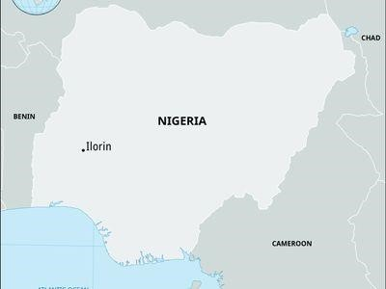
Figure 3.1 AERONET measurement city.

3.3 Data Description
The data used in this study is AERONET data for AOD. The data is well described in detail in this section.

3.3.1 AERONET
AERONET is a ground-based remote sensing network that provides accurate and continuous measurements of AOD. We analyze the monthly averages of AOD data for a period of 5 years (2016-2021) provided by AERONET. The instrument is situated in Ilorin (1998). The CIMEL Electronique 318A spectral radiometer measures sun and sky radiance at several wavelengths within the VNIR spectrum. AERONET provides continuous cloud-screened observations of spectral AOD, precipitable water, and inversion aerosol products in diverse aerosol regimes. Manufactured by NASA under the leadership of Dr. Brent Holben, it provides ground-truth calibration data for NASA and other international satellite missions. AERONET is situated at University of Ilorin, Kwara State Nigeria, Department of Physics rooftop (° N, ° E).
In this research, we use the data obtained from AERONET in Ilorin. AOD values at UV wavelength, 340 nm data were processed and filtered to ensure quality control. We investigated the temporal variations of AOD in Ilorin using AERONET.

3.3.2 Sorting, Averaging, and plotting of AERONET
The data were obtained from the official website
https://aeronet.gsfc.nasa.gov/cgi-bin/climo_menu_new_v3, they were checked properly for outliers and missing values. The AOD at 340 nm was computed into monthly averages which were finally used to create time series graphs and Pareto plots for 6 years (2016-
2021).

3.4 Summary
The study area discussed in the project is Ilorin. The study focused on AERONET, which provides AOD measurements using ground-based remote sensing networks in Ilorin. The data collected included AOD values at a specific wavelength (340 nm) over six years from 2016 to 2021.

CHAPTER FOUR
RESULTS AND DISCUSSION

4.1 Introduction
This study aims to observe the temporal variations characteristics of aerosol optical depth in Ilorin, Kwara State, Nigeria using AERONET. The AERONET data was reduced to the monthly averages from 2016 to 2021 for city under consideration.
4.2 Temporal variations of AERONET data for 2016 in Ilorin

Monthly mean temporal variations of AOD data
Figure 4.1 exhibits a monthly mean variation of AOD_340 nm over Ilorin city. The graph is depicted to establish the differences in temporal variations of AOD in 2016. As shown in Figure 4.1, the highest overall AOD monthly average was 1.68 (as presented in Table 4.1) and was recorded in the month of February. The AOD decreases from the month of March to June, pick up slightly in July to August and reduced to 0.34 in the month of September which represent the lowest AOD value for the year 2016.

0
0.2
0.4
0.6
0.8
1
1.2
1.4
1.6
1.8
JAN
FEB
MAR
APR
MAY
JUN
JUL
AUG
SEP
OCT
NOV
DEC
Figure 4.1 Monthly mean temporal variations of AOD data measured by AERONET in Ilorin for the year 2016.
Table 4.1. Monthly Mean and the Associated Standard Deviations (SD) of AOD at 340 nm, for the year 2016 of Measurements in Ilorin City.
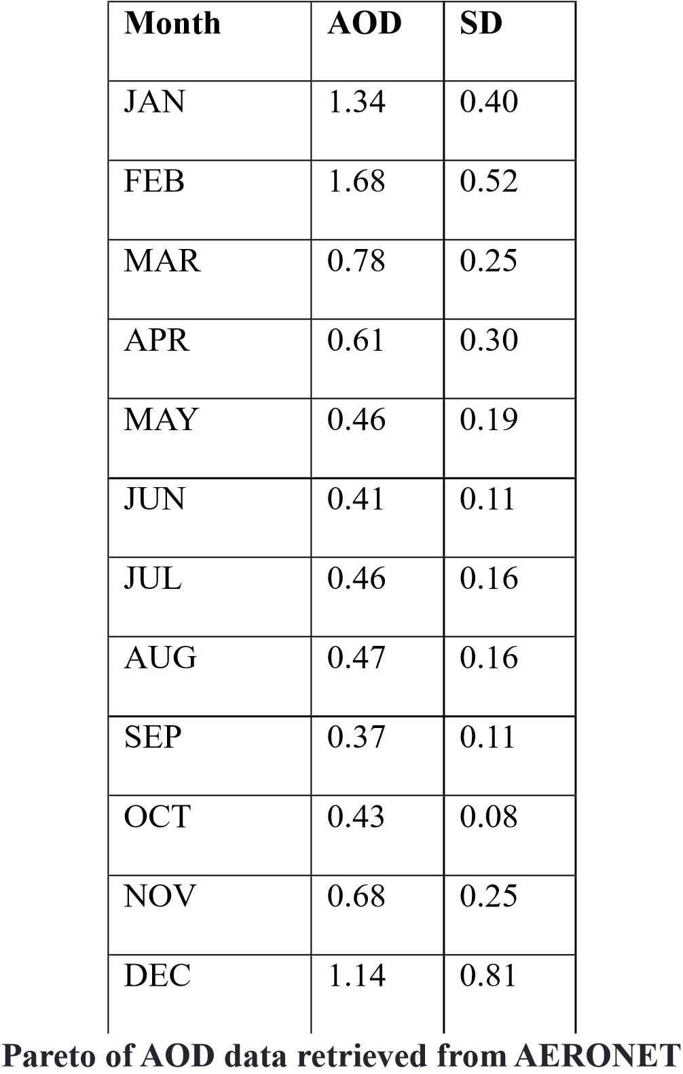

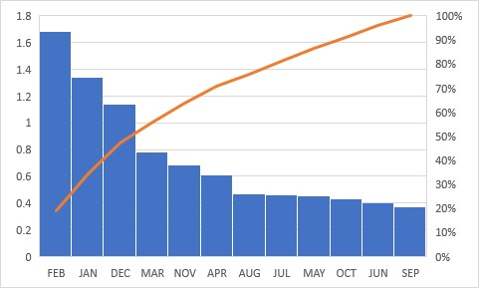
Figure 4.2: The Pareto graph for the monthly mean temporal variations of AOD data measured by AERONET in Ilorin for the year 2016.
4.3 Temporal Variations of AERONET Data for 2017 in Ilorin

Monthly mean temporal variations of AOD data
Figure 4.2 shows the monthly mean variation of AOD at 340 nm over Ilorin city for the year 2017. The pattern reflects the typical seasonal cycle influenced by both meteorological conditions and aerosol transport. The highest AOD monthly average was 1.62, recorded in February, which aligns with the peak of the Harmattan season. A sharp decline followed from March (0.73) through June (0.20), coinciding with the onset of the rainy season. AOD levels remained moderate during July (0.63) and August (0.39), and rose again to 0.93 in December, signaling the return of drier atmospheric conditions. This reflects the cyclic influence of dust loading and rainfall on aerosol concentration.
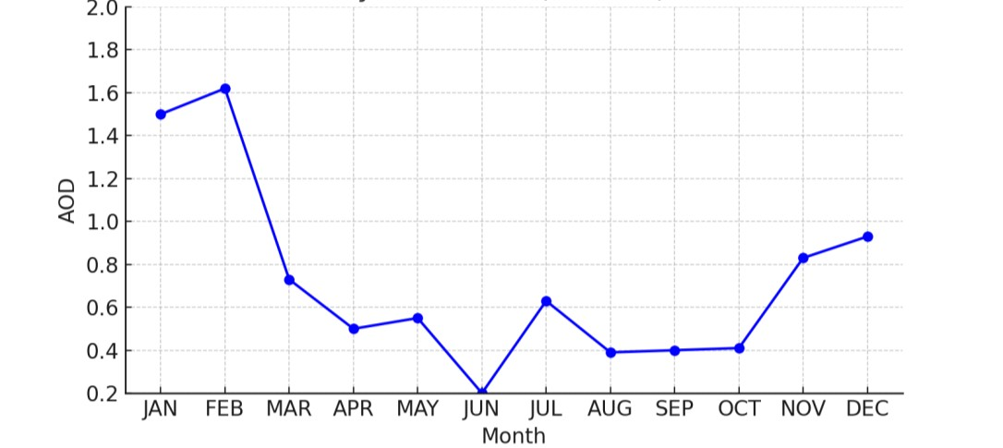
Figure 4.3: Monthly mean temporal variations of AOD data measured by AERONET in Ilorin for the year 2017.
Table 4.2. Monthly Mean and the Associated Standard Deviations (SD) of AOD at 340 nm, for the year 2017 of Measurements in Ilorin City
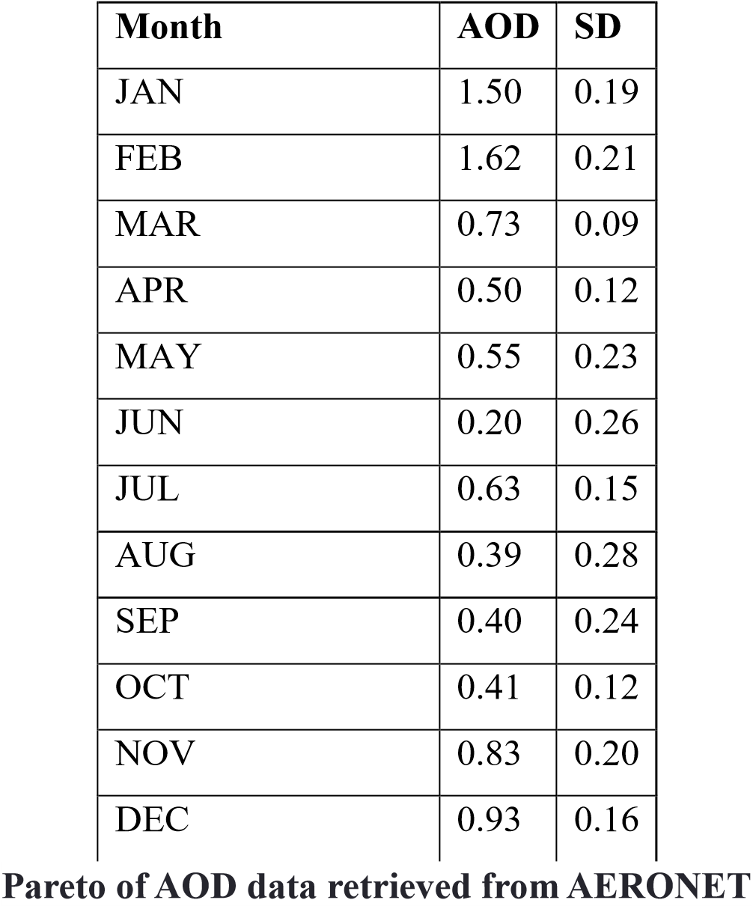
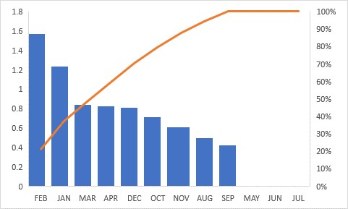
Figure 4.4: The Pareto graph for the monthly mean temporal variations of AOD data measured by AERONET in Ilorin for the year 2017.
4.4 Temporal Variations of AERONET Data for 2018 in Ilorin

Monthly mean temporal variations of AOD data
As illustrated in Figure 4.3, the monthly mean AOD at 340 nm for 2018 displayed noticeable seasonal variability. The highest AOD value of 1.67 was observed in February, while the lowest value was 0.26 in September, reflecting intense aerosol washout during the wet season. After February, AOD declined steadily through May (0.28) and June (0.33). A slight increase occurred in July (0.51) and August (0.35). Notably, AOD spiked to 1.37 in December, indicating the beginning of the Harmattan period and higher atmospheric dust content.

0
0.2
0.4
0.6
0.8
1
1.2
1.4
1.6
1.8
JAN
FEB
MAR
APR
MAY
JUN
JUL
AUG
SEP
OCT
NOV
DEC
Figure 4.5: Monthly mean temporal variations of AOD data measured by AERONET in Ilorin for the year 2018.
Table 4.3. Monthly Mean and the Associated Standard Deviations (SD) of AOD at 340 nm, for the year 2018 of Measurements in Ilorin City
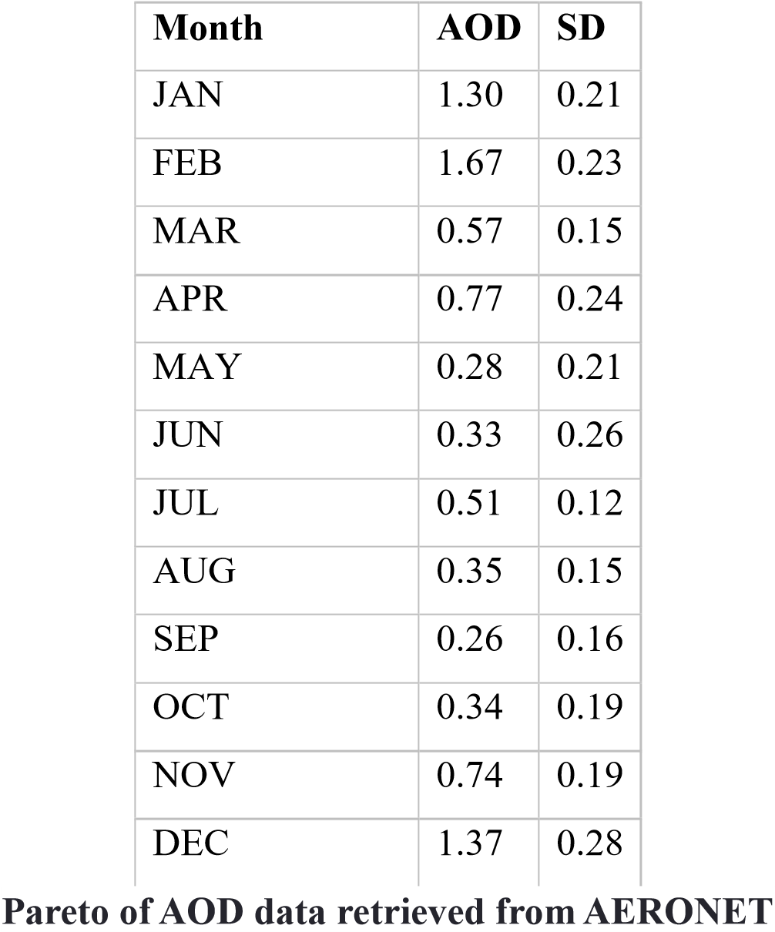
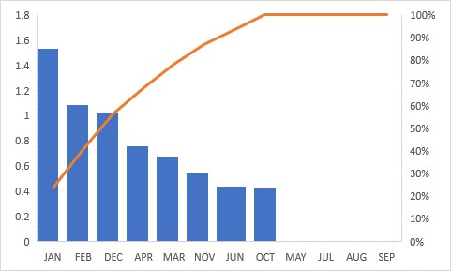
Figure 4.6: The Pareto graph for the monthly mean temporal variations of AOD data measured by AERONET in Ilorin for the year 2018.
4.5 Temporal Variations of AERONET Data for 2019 in Ilorin

Monthly mean temporal variations of AOD data
Figure 4.4 depicts the monthly AOD values at 340 nm for 2019, showing that February (1.72) had the highest AOD concentration for the year, consistent with the peak of the dry, dusty Harmattan season. The AOD gradually reduced through the wet season months, reaching a minimum of 0.37 in both June and September. Slight increases occurred during July (0.45) and August (0.41). AOD rose again to 1.23 in December, which signifies the return of Saharan dust influx during late-year Harmattan events.

0
0.2
0.4
0.6
0.8
1
1.2
1.4
1.6
1.8
JAN
FEB
MAR
APR
MAY
JUN
JUL
AUG
SEP
OCT
NOV
DEC
Figure 4.7: Monthly mean temporal variations of AOD data measured by AERONET in Ilorin for the year 2019.
Table 4.4. Monthly Mean and the Associated Standard Deviations (SD) of AOD at 340 nm, for the year 2019 of Measurements in Ilorin City
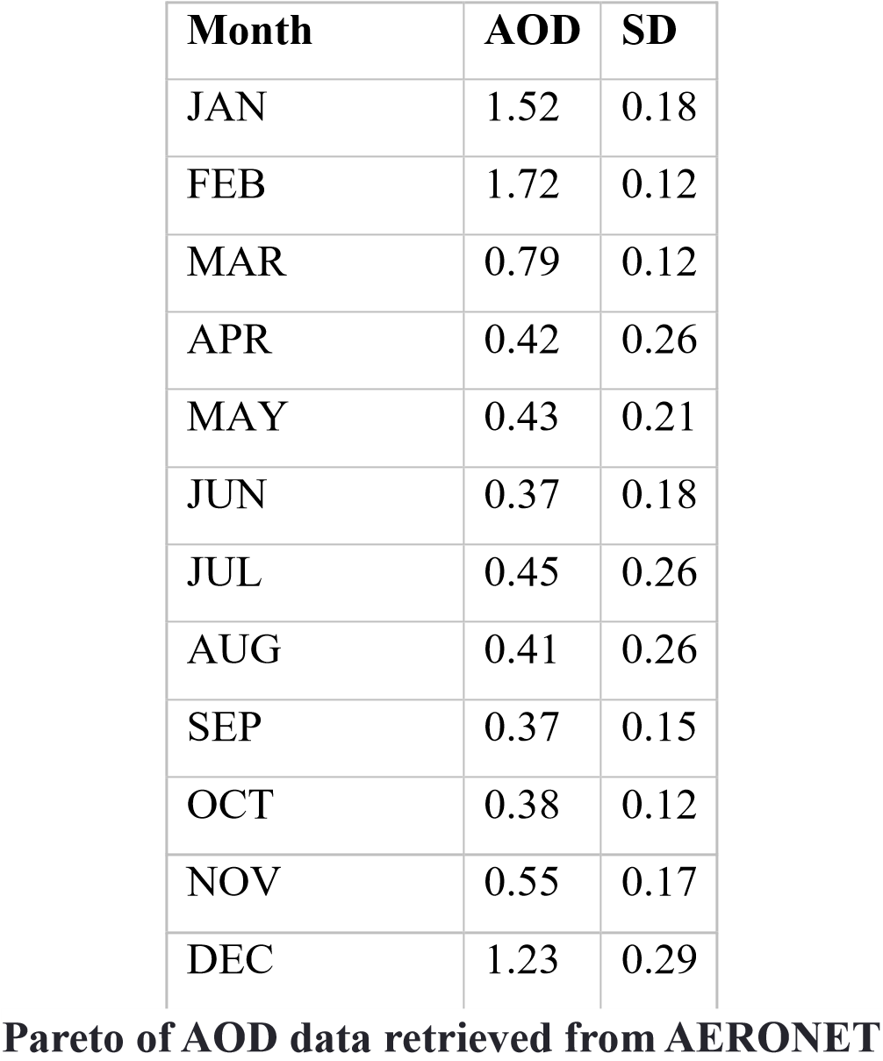
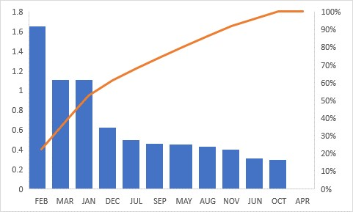
Figure 4.8: The Pareto graph for the monthly mean temporal variations of AOD data measured by AERONET in Ilorin for the year 2019.
4.6 Temporal Variations of AERONET Data for 2020 in Ilorin

Monthly mean temporal variations of AOD data
In Figure 4.5, the AOD trend for 2020 demonstrates seasonal fluctuation with a maximum AOD of 1.73 in February and a minimum of 0.25 in June. From March onward, AOD values declined through the wet months, with minor rises in August (0.53). A noticeable upsurge was recorded in November (0.74) and December (1.13). This trend affirms the impact of meteorological events on aerosol levels, with the rainy season reducing AOD through washout, while the dry Harmattan months elevated dust presence in the atmosphere.

0
0.2
0.4
0.6
0.8
1
1.2
1.4
1.6
1.8
JAN
FEB
MAR
APR
MAY
JUN
JUL
AUG
SEP
OCT
NOV
DEC
Figure 4.9: Monthly mean temporal variations of AOD data measured by AERONET in Ilorin for the year 2020.
Table 4.5. Monthly Mean and the Associated Standard Deviations (SD) of AOD at 340 nm, for the year 2020 of Measurements in Ilorin City
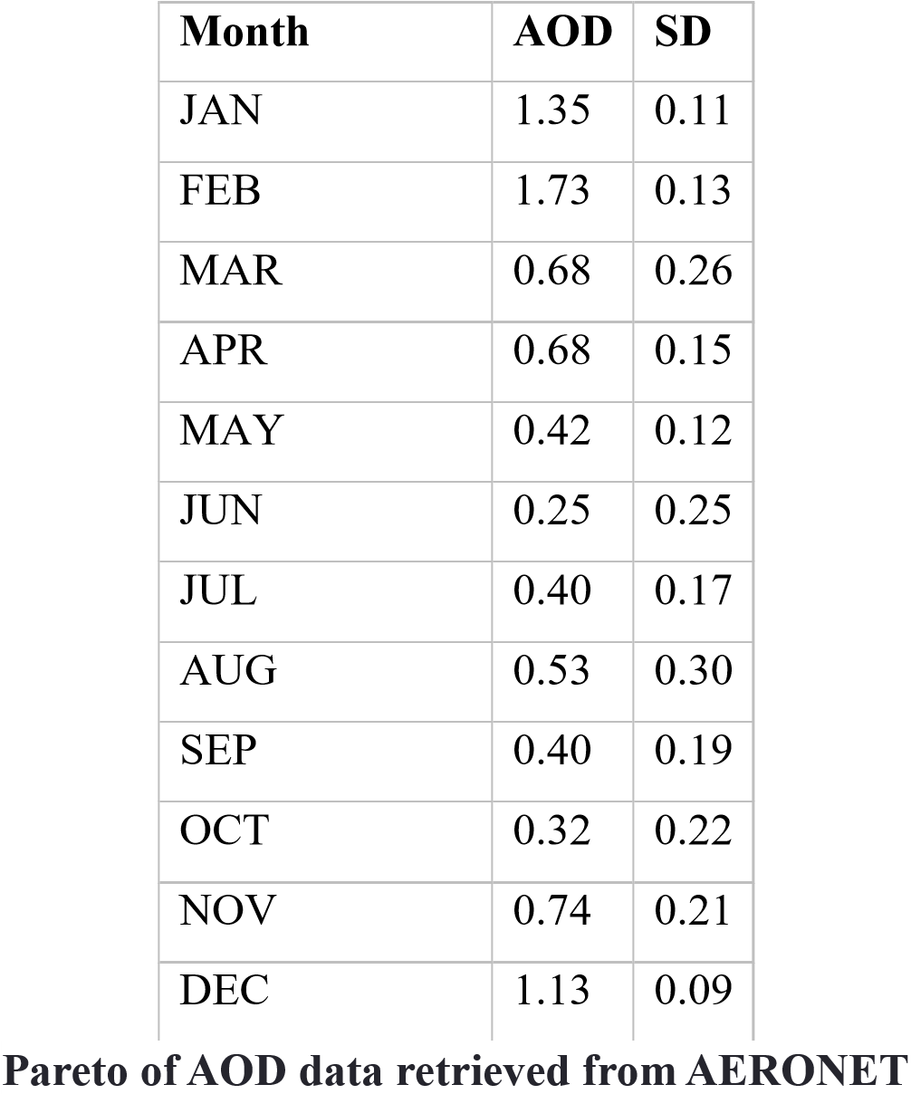
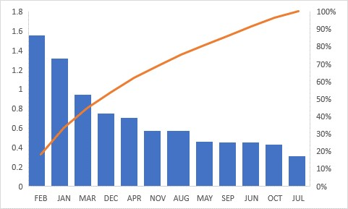
Figure 4.10: The Pareto graph for the monthly mean temporal variations of AOD data measured by AERONET in Ilorin for the year 2020.
4.7 Temporal Variations of AERONET Data for 2021 in Ilorin

Monthly mean temporal variations of AOD data
Figure 4.6 presents the monthly variation of AOD at 340 nm for 2021. The year experienced its highest AOD value in February (1.65) and the lowest in August (0.41). As in previous years, the Harmattan period (January to March) recorded elevated AOD levels, followed by a decline during the wet season, especially between April (0.58) and June (0.57). There was a notable spike in March (1.02), possibly due to a transient dust storm event. AOD began increasing again toward the end of the year, reaching 1.12 in
December, confirming the cyclical aerosol pattern in Ilorin.

0
0.2
0.4
0.6
0.8
1
1.2
1.4
1.6
1.8
JAN
FEB
MAR
APR
MAY
JUN
JUL
AUG
SEP
OCT
NOV
DEC
Figure 4.11: Monthly mean temporal variations of AOD data measured by AERONET in Ilorin for the year 2021.
Table 4.6. Monthly Mean and the Associated Standard Deviations (SD) of AOD at 340 nm, for the year 2022 of Measurements in Ilorin City
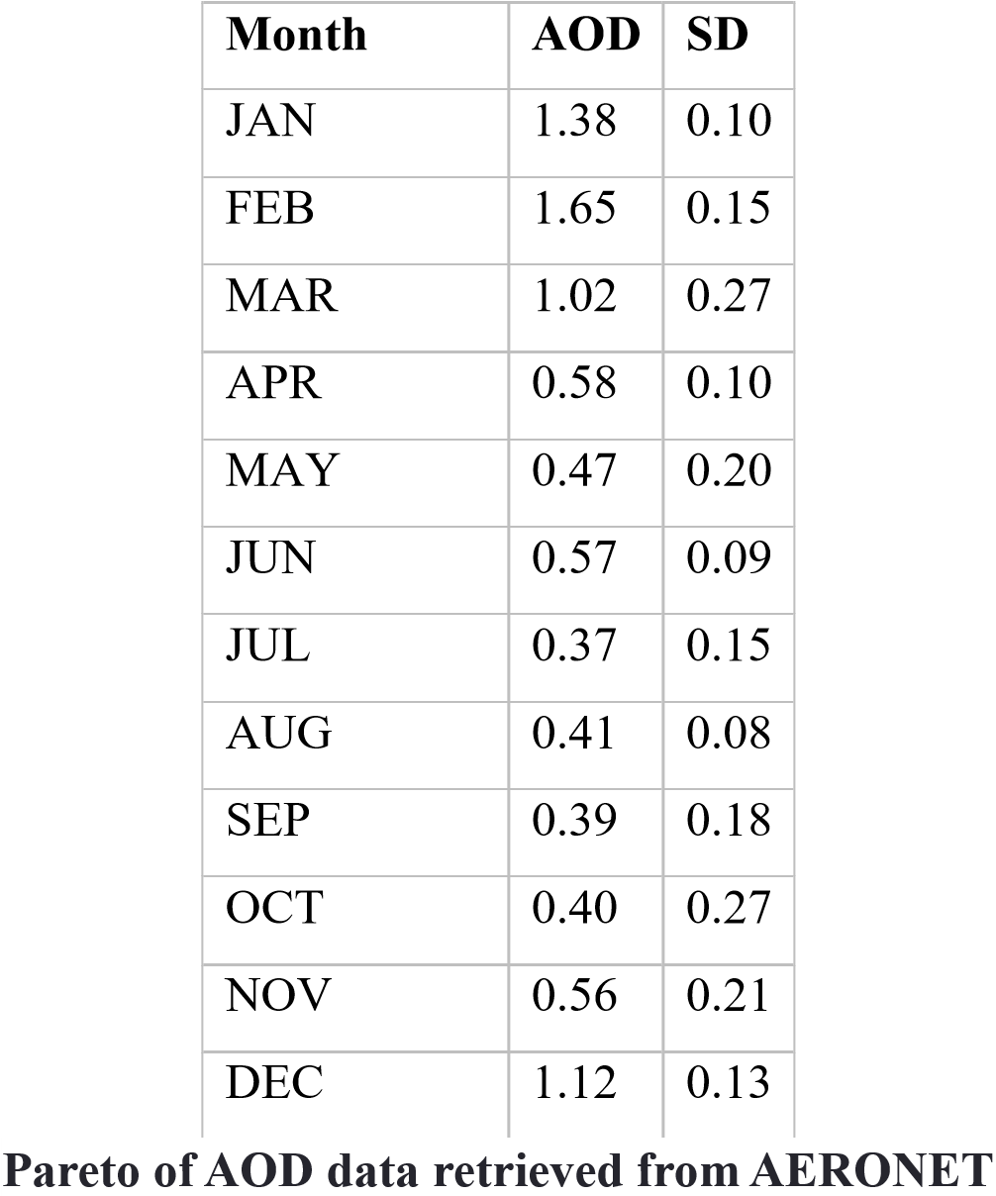

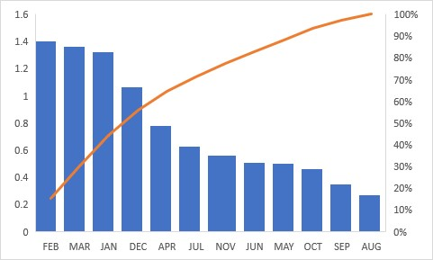
Figure 4.12: The Pareto graph for the monthly mean temporal variations of AOD data measured by AERONET in Ilorin for the year 2021.

4.8 Summary
This study examined the temporal variations in Aerosol Optical Depth (AOD) over Ilorin, Kwara State, Nigeria, using data obtained from the AERONET network between 2016 and 2021. AOD at a wavelength of 340 nm was used as an indicator of aerosol concentration in the atmosphere. Monthly and seasonal variations were analyzed to identify patterns related to meteorological conditions, particularly the dry and wet seasons.
The results indicated that:
- Peak AOD values occurred consistently in February across most of the years, corresponding to the Harmattan season when Saharan dust is prevalent in the region.
- Lowest AOD values were typically recorded between June and September, aligning with the rainy season, when wet deposition helps remove atmospheric particles.
- There was notable inter-annual variability, but the general pattern of high dryseason and low rainy-season AOD was consistent throughout the study period.
- The year 2021 recorded a relatively high AOD peak in March (1.02), possibly indicating a late dust event.
The study confirms the influence of both natural (dust transport) and anthropogenic
(urban emissions) factors in shaping aerosol levels in Ilorin.

CHAPTER FIVE

CONCLUSION, AND RECOMMENDATIONS

5.1 Conclusion
Aerosol Optical Depth (AOD) is a critical parameter for understanding atmospheric pollution, radiation balance, and public health risks. This study revealed clear seasonal and temporal trends in AOD over Ilorin between 2016 and 2021, with higher concentrations in the dry Harmattan months and lower values during the wet season.
The findings demonstrate that the Harmattan season remains the dominant period of aerosol loading in Ilorin due to the influx of Saharan dust. AOD values fluctuate significantly year by year, suggesting the influence of changing weather patterns, emission sources, and urban activity. Monitoring AOD trends is essential for managing air quality, understanding local climate impacts, and preparing health advisories.
The use of remote sensing data from AERONET and MODIS proves effective in
observing and interpreting atmospheric aerosol behavior in locations like Ilorin.

5.2 Recommendations
Based on the study’s findings, the following recommendations are proposed:
- Expansion of ground-based monitoring networks (e.g., more AERONET stations) in other parts of Nigeria to enable real-time and localized air quality assessment.
- Policy intervention should target periods of high aerosol concentration (especially
Harmattan) with public health advisories and pollution control strategies.
- Urban planning and industrial regulation should consider aerosol emissions, especially from vehicular traffic and waste burning, to reduce anthropogenic contributions to AOD.
- Further research should be conducted to assess the chemical composition of aerosols and their specific health and climatic impacts in Ilorin.
- Educational campaigns should raise awareness about the effects of air pollution and the importance of using cleaner technologies and energy sources.

REFERENCES
Adesina, A. J., Kumar, K. R., Sivakumar, V., & Griffith, D. (2020). Trend analysis of aerosol optical depth over selected cities in Nigeria. Atmospheric Pollution Research, 11(3), 439–450. https://doi.org/10.1016/j.apr.2019.12.005
Ginoux, P., Prospero, J. M., Gill, T. E., Hsu, N. C., & Zhao, M. (2001). Global-scale attribution of anthropogenic and natural dust sources. Reviews of Geophysics, 40(1), 1–31. https://doi.org/10.1029/2000RG000095
Holben, B. N., Eck, T. F., Slutsker, I., Tanre, D., Buis, J. P., Setzer, A., Vermote, E.,
Reagan, J. A., Kaufman, Y. J., Nakajima, T., Lavenu, F., Jankowiak, I., & Smirnov, A. (1998). AERONET—A federated instrument network and data archive for aerosol characterization. Remote Sensing of Environment, 66(1), 1–
16. https://doi.org/10.1016/S0034-4257(98)00031-5
IPCC. (2013). Climate Change 2013: The Physical Science Basis. Contribution of Working Group I to the Fifth Assessment Report of the Intergovernmental Panel
on Climate Change. Cambridge University Press.
https://www.ipcc.ch/report/ar5/wg1/
Kaskaoutis, D. G., Kambezidis, H. D., Hatzianastassiou, N., Kosmopoulos, P. G., & Retalis, A. (2010). Aerosol climatology over Athens, Greece based on MODIS
data. Atmospheric Environment, 44(19), 2546–2556.
https://doi.org/10.1016/j.atmosenv.2010.03.017
Kaufman, Y. J., Tanré, D., & Boucher, O. (2002). Aerosols, climate, and the hydrological cycle. Nature, 419(6903), 215–223. https://doi.org/10.1038/nature01089
Ogunjobi, K. O., Ajayi, V. O., & Fawole, O. G. (2008). Variability in aerosol optical properties and their relationship with meteorological parameters over Ilorin, Nigeria. Environmental Research Journal, 2(3), 102–109.
Prospero, J. M., Ginoux, P., Torres, O., Nicholson, S. E., & Gill, T. E. (2002). Environmental characterization of global sources of atmospheric soil dust identified with the NIMBUS 7 Total Ozone Mapping Spectrometer (TOMS) absorbing aerosol product. Reviews of Geophysics, 40(1), 2-1–2-31. https://doi.org/10.1029/2000RG000095
Remer, L. A., Kaufman, Y. J., Tanré, D., Mattoo, S., Chu, D. A., Martins, J. V., Li, R. R., Ichoku, C., Levy, R. C., Kleidman, R. G., Eck, T. F., Vermote, E., & Holben, B.
N. (2005). The MODIS aerosol algorithm, products, and validation. Journal of the Atmospheric Sciences, 62(4), 947–973. https://doi.org/10.1175/JAS3385.1
World Health Organization (WHO). (2016). Ambient air pollution: A global assessment of exposure and burden of disease. World Health Organization.
https://www.who.int/publications/i/item/9789241511353

