SMART SOLAR POWERED HOME LIGHTING SYSTEM WITH IOT-BASED ENERGY MANAGEMENT AND REMOTE MONITORING SOFTWARE

BY
OLAMOLU QUADRI OLALEKAN
ND/23/COM/PT/0274

BEING A RESEARCH PROJECT SUBMITTED TO THE DEPARTMENT OF COMPUTER SCIENCE, INSTITUTE OF INFORMATION COMMUNICATION TECHNOLOGY, KWARA STATE POLYTECHNIC, ILORIN
IN PARTIAL FULFILLMENT OF THE REQUIREMENT FOR THE AWARD OF NATIONAL DIPLOMA (ND) IN COMPUTER SCIENCE

JUNE, 2025
APPROVAL PAGE
This is to certify that this project was carried out by OLAMOLU QUADRI OLALEKAN with matriculation number ND/23/COM/PT/0274 has been read and approved by the Department of Computer Science, Kwara State Polytechnic Ilorin. In partial fulfillment of the requirements for the award of National Diploma (ND) in Computer Science.

___________________ __________________

Mrs. Adedotun, J.K. Date

Project Supervisor

______________________ _________________

Mr. Oyedepo, F.S. Date
Head of Department

______________________ _________________
External Examiner Date

ACKNOWLEDGEMENTS
All Glory and adoration belong to Him alone Allah, Omniscience, and Omnipresent for his mercy over me throughout my undergraduate journey.
First and foremost, We would like to express our deepest gratitude to my project supervisor, in person of Mrs. Adedotun .K. for his unwavering support, insightful advice, and constructive feedback throughout the development of this project.
Also, to our lovely parents, indeed we are speechless to thank you today, we pray to the Almighty Allah to grant you both all your heart desires. May you both live long to eat the fruit of your labour.
Also, to the school Management, Kwara State Polytechnic, Ilorin and entire Staff of Computer Science Department, starting from the Head of Department in person of Mr. Oyedepo, F.S. we appreciate you all.
To all my friends and family, wecan’t mention all of you, we shall all meet in the field of success.
Thank you all.

ABSTRACT
The increasing demand for energy-efficient and eco-friendly solutions has driven innovation in home automation systems. This project presents the design and implementation of anSmart Solar Powered Home Lighting System With Iot-Based Energy Management And Remote Monitoring Software, aimed at enhancing energy efficiency, reducing reliance on the national grid, and providing convenient lighting control for homeowners. The system integrates a photovoltaic solar power unit with a battery storage system to ensure continuous power availability. It utilizes an IoT-enabled microcontroller (such as ESP32 or NodeMCU) to manage lighting operations through wireless communication. Sensors such as Light Dependent Resistors (LDR) and Passive Infrared (PIR) sensors enable automatic control based on ambient light and human motion detection. In addition, users can manually control lighting remotely via a mobile application. The system is cost-effective, sustainable, and highly reliable, especially in regions with unstable electricity supply. Testing shows significant energy savings, improved automation, and enhanced user control, making it a viable solution for modern smart homes.
TABLE OF CONTENTS
Title page
Approval Page
Dedication
Acknowledgements
Table of Contents
Abstract

CHAPTER ONE

INTRODUCTION

1.1 Background of the Study

1.2 Statement of the Problem

1.3 Aim and Objectives of the Study
1.5 Scope of the Study
1.6 Definition of Terms
CHAPTER TWO
LITERATURE REVIEW

2.1 Review of Related Works

2.2 Database and Backend Systems

2.2.1 Cloud vs. Edge Computing

2.2.2 Security Considerations

2.2.3 Integration with Renewable Energy Ecosystems

2.3 Review of Related Works

2.4 Review of Related Concepts

CHAPTER THREE
3.1 Research Methodology

3.1.1 System Overview

3.2 Working Principle

3.2.1 Core Concept

3.2.2 Step-by-Step Working Process

3.4 IoT Integration and Monitoring

3.4.1 Power Management and Protection

3.4.2 Circuit Logic Summary

3.4.3 Simulation and PCB Implementation
CHAPTER FOUR
IMPLEMENTATION AND DISCUSSION OF RESULT
4.1 Solar Panel Design and Setup
4.2 Hardware and Software Development

4.3 System Integration and Testing
4.4 Result and Discussion

CHAPTER FIVE

SUMMARY, CONCLUSION AND RECOMMENDATIONS
5.1 Summary
5.2 Conclusion

5.3 Recommendations

References

CHAPTER ONE
INTRODUCTION

1.1 Background to the Study
The growing global concern over climate change, energy sustainability, and rising electricity costs has significantly influenced the push toward renewable energy adoption. Among the various sustainable energy sources available, solar power has emerged as one of the most viable solutions due to its abundance, reliability, and environmental friendliness. The use of solar-powered systems in residential areas is increasingly becoming popular, particularly in developing regions where access to stable grid electricity is limited. However, conventional solar home lighting systems often lack intelligent control mechanisms and remote access, making them less efficient and adaptive to changing environmental and usage conditions (Ali et al., 2021).
Recent advancements in the Internet of Things (IoT) have paved the way for the integration of smart technologies into energy systems, thereby enhancing their efficiency and user experience. IoT-based energy management allows for real-time monitoring, remote control, predictive maintenance, and data-driven decision-making. With the integration of sensors, microcontrollers, and cloud computing, users can now access detailed insights into energy consumption patterns, battery status, solar panel efficiency, and system faults from anywhere in the world using smartphones or computers (Kumar & Yadav, 2022). This integration has particularly transformed solar home lighting systems, enabling them to become smarter, more efficient, and user-friendly.
A smart solar-powered home lighting system embedded with IoT capabilities and remote monitoring software offers a hybrid solution that addresses multiple issues simultaneously. First, it ensures the utilization of clean energy, thereby reducing greenhouse gas emissions and dependence on non-renewable sources. Second, it promotes energy efficiency by allowing realtime control and monitoring of lighting usage, ensuring lights are turned off when not needed or adjusted based on environmental conditions. Third, it enhances reliability and convenience by enabling users to monitor and control their lighting systems remotely, minimizing manual intervention and reducing maintenance costs (Singh et al., 2023).
In many parts of the world, especially in Africa and Asia, energy poverty is a major challenge, with millions of homes either lacking access to electricity or depending on unreliable power grids. Smart solar home systems offer a sustainable solution to this challenge, providing off-grid lighting that is not only self-sufficient but also intelligent in its operation. For instance, smart charge controllers can optimize battery usage, protect against overcharging, and extend the lifespan of solar components, while IoT dashboards can help detect and alert users about system anomalies in real-time (Adewole & Musa, 2020).
The technological backbone of these systems typically includes solar photovoltaic (PV) panels, charge controllers, batteries for energy storage, microcontrollers such as ESP32 or Arduino, light sensors, relay switches, and cloud platforms like Blynk, ThingsBoard, or Firebase. These components work together to create an intelligent ecosystem where energy production and consumption are constantly balanced. For example, solar panels generate electricity during the day, which is stored in batteries. The system, through IoT-based software, monitors how much energy is stored and consumed, allowing users to manage energy loads effectively (Ahmed & Bello, 2022). Furthermore, artificial intelligence (AI) and machine learning algorithms can be incorporated to analyze usage patterns and suggest optimizations for future use.
Despite these advantages, there are challenges associated with deploying smart solar-powered lighting systems. These include the cost of components, dependency on reliable internet connectivity for remote access, and the need for technical know-how for installation and maintenance. However, the long-term benefits in terms of energy savings, environmental impact, and user comfort far outweigh the initial investment. Moreover, as the cost of IoT components and solar technologies continues to decrease, these systems are becoming increasingly accessible to a larger population (Nwankwo et al., 2021).
As smart cities and home automation continue to gain traction globally, integrating solar energy with IoT-based monitoring tools is not just a trend but a necessary evolution. Governments and private stakeholders are also recognizing the potential of such systems in meeting energy demands sustainably. Policy frameworks in many countries now support the development and deployment of decentralized energy systems and smart technologies (Ibrahim & Ojo, 2024). Hence, this research focuses on designing and implementing a smart solar-powered home lighting system with IoT-based energy management and remote monitoring software. The goal is to develop a system that is not only sustainable and energy-efficient but also smart, user-centric, and adaptable to various home settings.
In conclusion, the integration of solar energy with IoT-based monitoring systems represents a significant leap forward in the field of sustainable home energy solutions. By combining renewable energy with smart technology, users gain enhanced control over their energy consumption, reduce their carbon footprint, and enjoy a reliable lighting system even in off-grid locations. This project aims to contribute to this growing field by developing a prototype that demonstrates the potential of such systems in real-world applications.

1.2 Statement of the Problem
Despite the increasing adoption of solar energy systems for residential lighting, many of these setups lack intelligent energy management and remote monitoring capabilities. Traditional solar lighting systems operate in isolation, without real-time insights into power generation, battery status, or energy consumption. This limitation often leads to inefficient energy use, overcharging or underutilization of batteries, and a lack of timely fault detection. Additionally, users have no means to remotely control or monitor their systems, making maintenance and energy optimization difficult. In regions where electricity supply is erratic, there is a critical need for self-sustaining lighting solutions that are both reliable and intelligent.
The absence of smart features in most solar home systems undermines their potential to deliver efficient, user-friendly, and cost-effective lighting. Therefore, there is a pressing need to develop a solar-powered lighting system integrated with IoT-based energy management and remote monitoring functionalities to improve performance, control, and user experience.

1.3 Aim and Objectives of the Study
The aim of this research is to design and implement a smart solar-powered home lighting system integrated with IoT-based energy management and remote monitoring software to enhance energy efficiency, system reliability, and user convenience.

Objectives of the Study
i. To design a solar-powered lighting system suitable for residential use. ii. To integrate Internet of Things (IoT) components for real-time monitoring and control of the lighting system.
- To develop a remote software interface (web or mobile) for monitoring energy usage, battery levels, and system status.
- To implement intelligent automation features such as automatic switching based on light intensity or time of day.
- To evaluate the performance and efficiency of the smart lighting system compared to conventional solar lighting systems.

1.4 Scope of the Study
This study focuses on the design and implementation of a smart solar-powered home lighting system integrated with IoT-based energy management and remote monitoring functionalities. The system is specifically tailored for residential use and aims to address common challenges such as energy inefficiency, lack of remote access, and difficulty in monitoring system performance. The project will involve the selection and integration of key components including solar panels, charge controllers, batteries, LED lighting, microcontrollers (such as ESP32 or Arduino), sensors, and communication modules (e.g., Wi-Fi). It will also cover the development of a software interface (either mobile or web-based) that enables users to monitor energy consumption, battery levels, lighting status, and fault alerts in real-time.
The study is limited to small-scale home applications and does not extend to large commercial or industrial solar systems. Additionally, the project will use simulated or actual weather and usage data for performance evaluation but will not focus on extensive long-term field deployment. Emphasis will be placed on cost-effective design, ease of installation, and user-friendliness. The scope also includes basic automation such as automatic light switching based on time or light intensity, but not advanced AI-based decision-making or predictive analytics.

1.5 Significance of the Study
This study focuses on the design and implementation of a smart solar-powered home lighting system integrated with IoT-based energy management and remote monitoring functionalities. The system is specifically tailored for residential use and aims to address common challenges such as energy inefficiency, lack of remote access, and difficulty in monitoring system performance. The project will involve the selection and integration of key components including solar panels, charge controllers, batteries, LED lighting, microcontrollers (such as ESP32 or Arduino), sensors, and communication modules (e.g., Wi-Fi). It will also cover the development of a software interface (either mobile or web-based) that enables users to monitor energy consumption, battery levels, lighting status, and fault alerts in real-time.
The study is limited to small-scale home applications and does not extend to large commercial or industrial solar systems. Additionally, the project will use simulated or actual weather and usage data for performance evaluation but will not focus on extensive long-term field deployment. Emphasis will be placed on cost-effective design, ease of installation, and user-friendliness. The scope also includes basic automation such as automatic light switching based on time or light intensity, but not advanced AI-based decision-making or predictive analytics.

1.6 Limitations of the Study
This study is limited to the design and implementation of a small-scale smart solar-powered lighting system specifically for home use. The project does not cover large-scale or commercial solar installations. Due to resource constraints, the system will be tested in a controlled environment rather than in long-term real-world conditions. The efficiency of the solar panels and battery performance may vary depending on local weather conditions, which are not fully addressed in this study. The IoT functionalities are dependent on stable internet connectivity; hence, performance may be affected in areas with poor or no internet access. The system design also focuses on basic automation and remote monitoring but does not include advanced features such as predictive maintenance or AI-based energy forecasting. Financial limitations may also restrict the selection of high-end components, which could affect the scalability and robustness of the system under varying load and environmental conditions.

1.7 Definition of Terms
Smart System: A technology-driven system capable of performing automated functions, collecting data, and adapting operations based on environmental inputs or user preferences.
Solar Power: Energy harnessed from sunlight using photovoltaic (PV) panels, converted into electrical power for use in lighting and other applications.
Photovoltaic (PV) Panel: A device that converts solar energy into direct current (DC) electricity using the photovoltaic effect.
IoT (Internet of Things): A network of interconnected devices embedded with sensors and software that can communicate and exchange data over the internet.
Energy Management: The process of monitoring, controlling, and optimizing the production and consumption of energy to improve efficiency and reduce waste.
Remote Monitoring: The ability to observe and control a system or device from a distant location using internet-connected interfaces like smartphones or computers.
Microcontroller: A compact integrated circuit used to control the functions of an embedded system, often used in automation and IoT applications.
Light Dependent Resistor (LDR): A sensor used to detect light intensity; commonly used in automatic lighting systems.
Charge Controller: A device that regulates the voltage and current coming from the solar panels to the batteries to prevent overcharging or damage.
Battery Storage: An energy storage system that stores excess electricity generated from solar panels for later use, especially during nighttime or low-sunlight conditions.

CHAPTER TWO
LITERATURE REVIEW

2.1 Review of Related Works
Over the past decade, the intersection of renewable energy and smart technology has generated significant research interest, especially in the development of intelligent solar lighting systems for residential use. Researchers have recognized the limitations of conventional solar-powered lighting systems, which typically lack automation, monitoring, and adaptability features. As such, numerous studies from 2020 to 2025 have explored innovative ways to integrate Internet of Things (IoT) technology, energy management strategies, and remote monitoring functionalities into solar energy systems to improve their performance and usability.
Ali et al. (2021) explored the design of a solar-powered smart lighting system for remote areas using IoT. The system incorporated sensors for detecting ambient light and motion, enabling automatic switching of lights to optimize energy usage. Their research highlighted the potential of smart lighting systems to conserve energy by operating only when needed, thereby extending battery life. Similarly, Kumar and Yadav (2022) emphasized the need for smart automation in residential energy systems, proposing a solution where users could control lighting loads remotely through mobile applications. Their system was developed using ESP32 microcontrollers and Blynk IoT platform, offering real-time data visualization for energy consumption and battery health monitoring.
In another study by Ahmed and Bello (2022), the focus was on integrating low-cost IoT modules with existing solar home systems to provide intelligent energy monitoring. Their research addressed the affordability challenge by using cost-effective microcontrollers and open-source platforms, making the solution accessible to low-income households. The system allowed homeowners to receive alerts when battery levels dropped or when the panel efficiency decreased due to environmental factors like dust or shading. This kind of smart alerting mechanism proved valuable in maintaining the longevity and effectiveness of solar lighting setups, particularly in rural environments.
Singh et al. (2023) took the concept further by incorporating machine learning algorithms into their solar home energy system. Their model learned usage patterns over time and adjusted lighting schedules accordingly. While the core system remained reliant on solar panels and batteries, the intelligence added by the software component significantly reduced energy wastage. Their findings showed that AI-enhanced systems could improve energy efficiency by up to 30% compared to traditional systems. However, the implementation complexity and need for cloud-based computation were noted as barriers to widespread adoption in low-resource areas.
Nwankwo et al. (2021) conducted a comparative study between traditional solar lighting systems and smart solar home lighting solutions equipped with IoT-based controls. Their analysis focused on reliability, user experience, and energy optimization. They discovered that smart systems offered more value in the long term by reducing manual intervention, improving battery life, and providing detailed usage insights. In terms of user satisfaction, systems that enabled remote control and real-time feedback significantly outperformed those without smart features. This study validated the role of IoT in enhancing the effectiveness of renewable energy systems in domestic settings.
Ibrahim and Ojo (2024) addressed the policy and infrastructure challenges associated with implementing smart solar systems in Sub-Saharan Africa. Their study emphasized the role of supportive government frameworks in accelerating the adoption of smart technologies in renewable energy. They proposed a hybrid architecture combining GSM-based alerts with internetbased dashboards to overcome connectivity limitations in remote regions. Their design was successfully piloted in a rural community where residents could monitor their energy systems via SMS alerts and mobile dashboards, showing how multi-modal communication channels could enhance system usability.
Adewole and Musa (2020) focused on sustainability and durability in their design of an IoT-based solar lighting system for educational institutions. They integrated solar panels, smart lighting controls, and centralized dashboards to help school administrators manage lighting in multiple classrooms and outdoor spaces. The implementation reduced energy bills significantly while ensuring well-lit and secure learning environments. Their approach demonstrated that smart solar systems could be scaled beyond homes to benefit public institutions and reduce overall carbon footprints.
An interesting development in the literature is the increasing use of cloud computing and real-time databases in smart solar systems. According to Sharma and Patel (2023), Firebase and other realtime databases are now commonly used in smart energy systems to log data such as panel voltage, battery status, and load usage. These cloud platforms enable users to retrieve historical data, analyze trends, and make informed decisions regarding energy use. Their prototype, which included Firebase and an Android interface, allowed remote control of lighting loads and displayed analytics that guided better energy management practices.
Another innovative approach was explored by Olatunji et al. (2023), who integrated weather forecasting into their smart solar lighting system. By retrieving weather data from external APIs, their system could predict solar generation capacity and adjust lighting schedules accordingly. This proactive energy management reduced unnecessary battery drain during cloudy or rainy days and ensured critical loads remained powered. Such predictive systems are a step toward fully autonomous energy setups that require minimal human intervention.
Environmental impact was also a key area of focus in recent research. In a 2022 study by Okoro and Daniels, a life-cycle assessment of smart solar home systems revealed that, although the addition of IoT components increased electronic waste marginally, the long-term benefits in terms of reduced fossil fuel dependence, lower energy consumption, and improved battery efficiency made smart solar systems more environmentally friendly overall. They emphasized the need for responsible component recycling and software updates to extend the life span of the systems.
A growing trend in current literature is the development of open-source smart solar platforms. Projects like OpenSolar IoT (as referenced by Williams & Osei, 2024) aim to democratize access to solar monitoring tools by providing free hardware schematics and software libraries. These platforms enable hobbyists, students, and small-scale developers to build and customize smart solar systems with minimal cost. Such initiatives are helping to spread knowledge and drive community-level innovation in energy management.
Overall, the body of literature from 2020 to 2025 clearly supports the integration of IoT technology with solar-powered lighting systems as an effective means of improving energy efficiency, reliability, and user satisfaction. The combination of sensors, cloud platforms, wireless communication, and automation makes it possible to monitor and control energy systems in ways that were previously impossible with conventional solar setups. Challenges such as internet dependency, cost of smart modules, and system complexity remain, but ongoing research continues to address these issues through low-cost hardware, hybrid communication models, and simplified user interfaces.
This study builds on the existing literature by implementing a smart solar-powered home lighting system using affordable components, real-time remote monitoring software, and basic automation based on environmental inputs. By focusing on both practicality and user-friendliness, the project aims to contribute a scalable and replicable model that aligns with ongoing research and development in smart renewable energy systems.

2.2 Review of Related Concepts

2.2.1 Overview on Solar Energy and Photovoltaic Technology
Solar energy is one of the most abundant and sustainable sources of energy available to humanity. It refers to the radiant light and heat emitted by the sun, which can be harnessed and converted into usable electrical energy through various technologies, the most prominent of which is photovoltaic (PV) technology. Photovoltaic systems directly convert sunlight into electricity using the photovoltaic effect, a process discovered in the 19th century but commercialized only in the late 20th century. This method has gained significant traction in recent years due to growing environmental concerns, the need for decentralized power generation, and rapid advancements in solar technologies.
Photovoltaic panels are typically composed of semiconductor materials, such as silicon, which absorb photons from sunlight and release electrons. These free electrons flow through an external circuit, generating direct current (DC) electricity. This DC output is usually stored in batteries or converted to alternating current (AC) using inverters for home and industrial use. Recent developments in PV technology have focused on improving the efficiency of energy conversion, reducing the cost of solar modules, and increasing their durability under various environmental conditions. Innovations like monocrystalline and polycrystalline silicon cells, thin-film technologies, and bifacial panels have contributed to a steady increase in the adoption of solar energy globally.
The use of solar PV systems in residential settings has become increasingly viable, particularly in regions with high solar irradiance. Solar home systems can provide a reliable and clean source of electricity, especially in off-grid areas or communities with unstable grid access. Such systems typically consist of PV panels, charge controllers, batteries, and load components like lights or appliances. In the context of smart home lighting, solar energy provides an ideal power source, enabling sustainable and independent lighting solutions that are not only energy-efficient but also environmentally friendly.
Furthermore, advancements in solar PV technology have made it easier to integrate these systems with modern control mechanisms, such as microcontrollers and Internet of Things (IoT) platforms. These integrations allow real-time monitoring of panel performance, battery status, and energy consumption, thereby facilitating more effective energy management. By tracking energy generation and usage patterns, users can optimize when and how their solar energy is consumed. This is particularly valuable in regions with variable sunlight, where managing battery charge and lighting loads becomes critical to ensure continuous power supply.
The scalability of photovoltaic systems is another important factor contributing to their popularity. A basic PV system can power simple loads like light bulbs and fans, while more advanced setups can support entire households or even microgrids. Their modular nature allows for gradual expansion based on energy needs and budget. In addition, government policies and incentives in many countries have further supported the adoption of solar energy by subsidizing installation costs and encouraging net metering.
In summary, solar energy and photovoltaic technology play a foundational role in developing smart and sustainable home lighting systems. The ability to generate clean, renewable energy directly from sunlight, combined with advancements in PV efficiency and integration with smart control systems, makes solar technology a key enabler in modern energy solutions. This growing field continues to offer innovative pathways for addressing global energy challenges in both urban and rural settings.

2.2.2 Overview on Energy Storage Systems
Energy storage is a vital component of any solar-powered home lighting system, ensuring continuous electricity supply during periods when solar energy generation is unavailable, such as at night or on cloudy days. Since photovoltaic (PV) systems generate direct current (DC) electricity during sunlight hours only, effective energy storage mechanisms are required to store excess energy and release it when needed. The efficiency, capacity, and management of the storage system directly influence the performance, reliability, and sustainability of smart solar lighting installations.

Types of Batteries Used in Solar Systems
The most common energy storage systems in solar applications are batteries. These batteries vary by type, capacity, lifecycle, and cost. The two predominant types of batteries used are lead-acid and lithium-ion batteries.
Lead-acid batteries are the traditional choice, favored for their low initial cost and availability. They come in two main forms: flooded lead-acid (FLA) and sealed lead-acid (SLA). While they are widely used in off-grid solar systems, lead-acid batteries have a shorter lifespan and require regular maintenance, especially the FLA type.
Lithium-ion batteries, on the other hand, have gained popularity due to their higher energy density, longer life cycle, faster charging capabilities, and low maintenance requirements. Although more expensive upfront, lithium-ion batteries offer better overall efficiency and are more suitable for integration with modern IoT and smart monitoring platforms.

Battery Management and Protection
A crucial aspect of energy storage systems is Battery Management Systems (BMS). A BMS monitors key battery parameters such as voltage, current, temperature, and state of charge (SOC). It ensures the batteries operate within safe limits, prevents overcharging and deep discharging, and prolongs battery life. For smart solar lighting systems, the BMS often works in conjunction with microcontrollers or IoT platforms to report battery status in real time and automate energy usage accordingly.
Charge controllers are also essential in managing how electricity flows between the solar panels, batteries, and loads. Modern Maximum Power Point Tracking (MPPT) charge controllers offer more efficiency than traditional Pulse Width Modulation (PWM) controllers by adjusting the input voltage to maximize power output from the PV panels.

Integration with IoT-Based Monitoring
In smart solar home lighting systems, energy storage components are increasingly being integrated with IoT-based monitoring systems. Microcontrollers such as Arduino, Raspberry Pi, or ESP32 are often connected to sensors that monitor the state of the battery and control charging and discharging operations. Through cloud-based platforms or mobile apps, users can remotely track battery levels, receive alerts, and optimize load operations to prevent battery drain. For instance, when battery levels are critically low, non-essential lighting can be automatically switched off to conserve energy.

Challenges in Energy Storage
Despite advancements, energy storage in solar systems presents certain challenges. Battery degradation over time is inevitable, and improper management can lead to reduced performance or system failure. Temperature sensitivity, especially for lithium-ion batteries, is another factor that affects battery efficiency and lifespan. Additionally, high-quality storage systems can significantly increase the initial cost of a solar lighting project, which may be a limitation in low-income or rural settings.
To address these challenges, recent studies (e.g., Sharma & Patel, 2023; Okoro & Daniels, 2022) advocate for the integration of AI algorithms that can predict usage patterns and solar availability, thereby optimizing battery use and charging schedules. Some smart systems also incorporate hybrid energy storage, combining batteries with supercapacitors or auxiliary power sources to ensure uninterrupted lighting.

The Role of Energy Storage in System Reliability
Reliable energy storage is essential for ensuring that smart lighting systems function seamlessly regardless of solar conditions. Well-designed energy storage solutions reduce dependency on the grid, enhance system resilience, and support energy independence. Moreover, with proper sizing and management, storage systems can extend the usability of solar energy into high-demand periods, supporting lighting, home appliances, and even communication systems during blackouts.
In conclusion, energy storage systems serve as the backbone of any effective solar-powered home lighting installation. The evolution from basic lead-acid setups to intelligent lithium-ion systems integrated with IoT platforms marks a significant step forward in sustainable and smart energy management. By combining storage with real-time monitoring, smart algorithms, and automation, today’s solar systems can deliver uninterrupted, efficient, and user-friendly lighting solutions.

2.2.3 Overview of IoT in Smart Energy Systems
The Internet of Things (IoT) has emerged as a transformative technology in modern energy systems, offering real-time control, data analytics, and remote monitoring capabilities. In the context of solar-powered home lighting systems, IoT enables intelligent energy management by connecting various system components—such as sensors, controllers, batteries, solar panels, and user interfaces—over the internet. This connectivity facilitates efficient energy utilization, predictive maintenance, and enhanced user control, thereby optimizing both energy savings and system reliability.
IoT in energy systems typically involves embedded devices like microcontrollers (e.g., ESP8266, ESP32, or Arduino), which act as the central units for collecting and processing data. These microcontrollers receive input from various sensors that monitor environmental and system parameters, including temperature, humidity, battery voltage, light intensity (using LDRs), and load current. The microcontroller processes the collected data and sends it to cloud-based platforms or local servers via wireless communication protocols such as Wi-Fi, Bluetooth, Zigbee, or LoRa.
One of the most important contributions of IoT to energy systems is real-time monitoring and control. With IoT, users can access system data from anywhere using a mobile app or web dashboard. For example, platforms like Blynk, Firebase, and ThingsBoard provide user-friendly interfaces where users can view energy consumption trends, battery levels, solar panel output, and lighting status. This transparency empowers users to make informed decisions regarding energy use. For instance, if the battery is running low, users can remotely switch off non-critical lights to preserve energy for essential tasks.
Another key function of IoT is automation. By programming logic into microcontrollers, smart systems can respond automatically to changing conditions without human intervention. For example, lights can be programmed to turn on when ambient light levels fall below a certain threshold or to adjust brightness based on occupancy detection via PIR sensors. These automations not only improve user convenience but also help reduce energy wastage.
IoT also facilitates predictive energy management through the integration of machine learning algorithms. These algorithms can analyze historical data to forecast energy usage patterns and solar energy availability. With such predictions, the system can proactively allocate energy resources— charging batteries during peak sunlight hours and scheduling heavy loads when sufficient energy is available. This approach improves overall energy efficiency and prolongs battery life by avoiding unnecessary charging and discharging cycles.
Security is an important consideration in IoT-based energy systems. Since these systems involve remote access and data transmission over the internet, implementing encryption, secure authentication, and firmware updates is essential to prevent unauthorized access and system breaches. Recent research by Zhang et al. (2021) emphasized the need for secure IoT architecture in solar microgrids, proposing blockchain-based verification methods to enhance system integrity.
Moreover, IoT-enabled solar lighting systems are highly scalable. Whether it's a single home setup or an entire smart community, these systems can be expanded easily by adding more sensors and nodes to the network. Modular IoT architecture allows for seamless upgrades and integration with other smart home components such as security systems, smart thermostats, and voice assistants.
The environmental benefits of IoT-based energy systems are also noteworthy. By ensuring optimal energy usage and reducing dependence on fossil fuels, these systems contribute to carbon footprint reduction and support global sustainability goals. As noted by Patel and Kumar (2023), integrating IoT into renewable energy frameworks significantly enhances their viability and acceptance, especially in urban areas striving for smart city development.
In summary, the incorporation of IoT in solar-powered home lighting systems revolutionizes how energy is monitored, managed, and consumed. Through automation, remote control, real-time feedback, and data-driven decision-making, IoT transforms a conventional lighting setup into a smart, efficient, and sustainable solution. As the technology continues to mature, its role in renewable energy management will only become more critical, enabling homes to become not just energy consumers but active participants in smart energy ecosystems.

2.2.4 Energy Management in Smart Homes
Energy management in smart homes refers to the systematic monitoring, control, and optimization of energy usage within a residential setting using advanced digital technologies. With the growing demand for sustainable energy and the proliferation of solar power systems, efficient energy management has become a cornerstone of smart home design. It ensures not only the conservation of energy but also the enhancement of user comfort, system reliability, and cost efficiency.
In smart solar-powered lighting systems, energy management begins with real-time tracking of energy generation and consumption. Smart energy systems use sensors and IoT devices to monitor parameters such as solar panel output, battery status, lighting load, and overall household electricity usage. These devices relay data to a central processing unit—usually a microcontroller like the ESP32—which interprets the data and takes automated actions or reports it to cloud-based platforms for user access.
One of the critical components of energy management in smart homes is load balancing and scheduling. During peak sunlight hours, the solar system generates more energy than is needed for immediate use. In a well-managed system, this surplus energy is intelligently stored or redirected to charge batteries, run time-flexible appliances (like washing machines or water pumps), or even shared with the grid (if net metering is supported). During low sunlight periods, the system prioritizes critical loads, such as lighting, and reduces power to non-essential devices, thereby ensuring energy is used where it is needed most.
Smart scheduling algorithms can further enhance efficiency by automating device operation according to availability of solar energy. For instance, the system may automatically dim or switch off external lights during bright daylight hours and activate them only during evenings or when motion is detected. This form of automation reduces manual intervention, improves energy utilization, and extends the lifespan of the lighting components.
Another aspect of smart energy management is user feedback and control interfaces. Through IoT dashboards or mobile applications, users can view real-time and historical data on energy consumption, solar input, and battery levels. This data visualization helps homeowners understand their usage patterns and adjust their behavior for improved efficiency. For example, if the dashboard indicates excessive battery usage at night, users may reduce the number of active lights or lower brightness levels. Modern applications can also issue alerts when energy thresholds are exceeded or when system faults occur, prompting timely intervention.
Advanced smart homes use machine learning algorithms to analyze historical data and predict future consumption trends. This predictive approach allows systems to make proactive decisions, such as pre-charging batteries ahead of expected cloudy weather or limiting non-critical loads during times of low energy availability. Research by Gupta et al. (2022) demonstrated how AIenhanced home energy management systems improved energy efficiency by up to 30% in solarpowered households.
Importantly, energy management also extends to demand response strategies. In regions where smart grid infrastructure is available, smart homes can adjust their energy consumption in response to grid conditions. For example, during grid peak demand times, the smart home can switch to battery power or reduce consumption to ease grid stress. This type of coordination between homes and utilities enhances overall energy stability and contributes to a more resilient energy network.
Energy management systems must also account for environmental conditions, such as temperature and sunlight levels, which directly influence solar generation. Integrating weather APIs or local sensor data into the energy management logic helps in planning energy use more effectively.
In conclusion, energy management in smart homes is a multidimensional process that relies on real-time monitoring, intelligent control, user feedback, and data-driven decision-making. By combining IoT technologies, automation, predictive analytics, and user interfaces, smart energy management transforms traditional residential setups into self-sustaining, efficient, and environmentally friendly living environments. For solar-powered lighting systems, such capabilities ensure optimal energy use, reduce waste, and empower users with greater control over their energy future.

2.2.5 Overview on Remote Monitoring and Control
Remote monitoring and control is a core feature of modern smart solar-powered home lighting systems. It enables homeowners and system administrators to supervise, analyze, and manage energy usage and device performance from any location using internet-connected devices. This feature not only enhances convenience and system responsiveness but also improves overall energy efficiency, system reliability, and user satisfaction.
At the heart of remote monitoring and control is the integration of IoT devices with communication technologies such as Wi-Fi, GSM, Zigbee, or LoRaWAN. These technologies allow the system's microcontroller (such as ESP32 or Raspberry Pi) to collect data from sensors (e.g., for voltage, current, battery status, temperature, and light intensity) and transmit it in real time to cloud-based platforms or mobile applications.
Through cloud-based platforms like Blynk, Firebase, ThingSpeak, and AWS IoT Core, users can remotely view dashboards that display key metrics, including solar energy generation, battery charge status, load activity, and environmental conditions. These platforms often provide intuitive user interfaces and interactive controls, allowing users to adjust settings such as brightness levels, turn lights on or off, switch between energy sources (solar, battery, or grid), or schedule lighting periods based on specific needs.
Remote control is often facilitated through mobile apps, web applications, or smart assistants (e.g., Amazon Alexa or Google Assistant), enabling users to perform actions like:
- Turning lights on/off remotely when away from home.
- Scheduling lighting to operate during specific hours.
- Adjusting brightness or color temperature for energy saving or ambiance.
- Disabling certain loads when battery levels fall below a threshold.
- Switching to backup power sources during outages or low solar generation.
One of the biggest advantages of remote monitoring is its role in fault detection and diagnostics.
By constantly analyzing data, the system can alert users about performance issues such as:
- Unusual drops in solar panel output.
- Overheating of batteries.
- Low state of charge (SOC) in energy storage.
- Sensor or communication failures.
Timely alerts via SMS, email, or app notifications help ensure quick action, reducing downtime and preventing system damage. For example, a user can be alerted when the battery drops below 20% and can remotely shut down non-essential lighting to preserve energy for critical use.
From a maintenance perspective, remote monitoring systems can log long-term data, which is valuable for analyzing trends, optimizing future energy configurations, and planning system upgrades. System integrators or technicians can also remotely diagnose problems and provide support without the need for immediate on-site visits, saving both time and resources.
Security in remote access is critical. These systems must implement strong security measures such as encrypted data transmission, user authentication, secure firmware updates, and access control. A breach could not only compromise privacy but also give malicious actors the ability to disable the lighting system or damage hardware components. As discussed by Lee & Anwar (2023), applying secure communication protocols and regularly updating system firmware are key to maintaining the integrity of remote-control features in smart home systems.
In developing regions, remote monitoring has proven especially beneficial. It allows centralized supervision of multiple homes or community lighting systems from a control center. This is ideal for solar mini-grids or shared systems in rural areas where on-site management is costly or impractical. Moreover, remote data collection supports government agencies and NGOs in tracking energy access, system performance, and user behavior for better policy planning and system expansion.
In conclusion, remote monitoring and control transform solar-powered home lighting systems into dynamic, user-friendly, and efficient energy solutions. By providing access to real-time data and actionable controls from any location, these systems ensure optimal energy usage, enhance user comfort, reduce operational costs, and support sustainability goals. As IoT technologies and connectivity infrastructure continue to advance, the role of remote monitoring will become even more central to the future of intelligent solar energy management.

CHAPTER THREE
RESEARCH METHODOLOGY

3.1 Description of the Existing System
The existing energy management systems predominantly rely on manual operations or semiautomated control mechanisms that often lack real-time responsiveness and intelligence. In most traditional residential and commercial settings, electrical appliances and power-consuming devices operate independently without a centralized monitoring or control unit. Energy usage is often unregulated, leading to unnecessary power consumption, high electricity bills, and inefficient resource utilization. These systems typically do not integrate environmental factors, user habits, or load prioritization, making them less adaptive to changing needs or energy-saving opportunities. Furthermore, conventional systems rarely incorporate remote control features, making it difficult for users to interact with their devices while away from the premises.
In terms of infrastructure, most existing setups do not support data collection or feedback mechanisms, which are crucial for energy auditing, predictive control, and sustainability. The absence of interconnected sensors, actuators, and centralized controllers means that users cannot make informed decisions based on consumption trends or real-time alerts. Additionally, many traditional energy systems are not designed to accommodate renewable energy sources, which limits their flexibility and environmental friendliness. Maintenance is also a challenge as faults or inefficiencies often go undetected for extended periods due to the lack of diagnostic capabilities.
Overall, the existing system fails to provide intelligent automation, data-driven decision-making, and remote accessibility—all of which are essential features for modern energy management.
These limitations have created a need for a more robust, smart, and scalable solution that leverages IoT and embedded technologies to automate, monitor, and optimize energy consumption in a responsive and sustainable manner.

3.2 Disadvantages of the Existing Systems
- Lack of Automation: Traditional energy systems rely heavily on manual control, which results in inefficient energy usage due to human error or oversight.
- No Real-Time Monitoring: Most existing systems do not support real-time data collection or feedback, making it difficult to track energy consumption patterns or respond promptly to anomalies.
- High Energy Wastage: Without intelligent control mechanisms, appliances may run unnecessarily, especially when not in use, leading to significant energy loss.
- No Remote Access: Users cannot control or monitor their energy systems remotely, limiting flexibility and control over energy consumption when away from the premises.
- Inability to Integrate Renewable Energy: Existing systems often lack the infrastructure to incorporate alternative energy sources such as solar or wind, which restricts
sustainability efforts.
- Poor Load Management: Without prioritization or smart scheduling, all devices may operate simultaneously during peak periods, increasing energy demand and cost.
- Limited Scalability: Traditional setups are rigid and do not easily support the addition of new devices or upgrades, making future expansion costly and complex.
- No User Feedback or Analytics: Users lack insights into their consumption behavior due to the absence of analytical tools or visual data representation.
- Inefficient Fault Detection: Identifying faults or inefficiencies in energy systems is difficult, often requiring manual inspection and leading to delayed maintenance.
- Environmental Impact: The inefficiencies and overconsumption associated with outdated systems contribute to higher carbon emissions and ecological strain.

3.3 Description of the Proposed System
The proposed system is a Smart Automated and Energy Management System utilizing Internet of Things (IoT) technologies to optimize power usage in homes and commercial environments. It integrates sensors, actuators, microcontrollers, and communication modules to automate the monitoring and control of electrical appliances in real time. The system is designed to intelligently respond to environmental inputs such as temperature, light, and occupancy, ensuring that energy is only consumed when necessary. Through the use of smart sensors, the system can detect whether a room is occupied and adjust lighting, heating, or cooling accordingly, thereby reducing unnecessary energy consumption.
At the core of the system is a microcontroller (such as an Arduino or ESP32), which collects data from sensors and makes decisions based on predefined logic. The data is transmitted wirelessly through protocols like Wi-Fi or MQTT to a centralized platform, which may include a mobile or web-based dashboard. This interface allows users to remotely monitor real-time energy usage, receive alerts, and manually control devices if needed. The system also supports integration with renewable energy sources such as solar panels, enabling it to manage hybrid energy supplies intelligently.
In addition, the system includes scheduling capabilities, allowing users to automate appliance operations based on time-of-day preferences or peak/off-peak energy tariffs. It also features a logging mechanism for data analytics and energy usage reports, enabling users to assess and improve consumption habits. Overall, the proposed system delivers a smart, scalable, and sustainable solution that promotes energy efficiency, reduces operational costs, and supports environmentally conscious living.

3.3.1 Advantages of the Proposed System
- Energy Efficiency: The system intelligently monitors and controls energy usage, significantly reducing wastage by ensuring devices operate only when needed.
- Real-Time Monitoring: Users can view live data on energy consumption through a userfriendly dashboard, enabling informed decisions and prompt actions.
- Automation and Smart Control: Through sensors and pre-set rules, the system automates operations such as lighting, heating, and cooling based on occupancy and environmental conditions.
- Cost Reduction: By optimizing energy use and integrating peak/off-peak scheduling, the system helps lower electricity bills.
- Renewable Energy Integration: It supports the use of alternative energy sources like solar power, contributing to sustainability and reducing dependency on the grid.
- Scalability: The modular design allows easy integration of new devices or expansion of system features without overhauling the existing setup. vii. Enhanced Safety: The system can detect unusual energy patterns, helping to prevent potential hazards like electrical overloads or short circuits.

3.4 System Architecture of the System
The system architecture is designed to integrate multiple hardware and software components working collaboratively to monitor, control, and optimize energy usage in real time. It consists of four major layers: the sensing layer, the control layer, the communication layer, and the application layer.
- Sensing Layer: This layer comprises smart sensors and actuators strategically deployed throughout the environment. Sensors such as motion detectors, temperature sensors, light sensors, and current sensors collect real-time data about the surrounding conditions and the operational status of connected appliances.
- Control Layer: At the core of this layer is a microcontroller or embedded system (such as Arduino, ESP32, or Raspberry Pi). It processes data received from the sensors and executes control commands based on pre-programmed logic. For instance, if the temperature exceeds a set threshold, the microcontroller can activate the air conditioner.
- Communication Layer: This layer enables data transmission between the control units and the cloud or local servers. Communication protocols such as Wi-Fi, MQTT, or Bluetooth are employed to ensure reliable and secure transfer of information. The IoT gateway connects all devices and facilitates data synchronization and real-time command execution.
- Application Layer: The user interface resides here, typically in the form of a web or mobile app. Users can monitor energy consumption statistics, receive alerts, set control schedules, and remotely control appliances. This layer also hosts the data analytics engine, which provides usage reports and optimization suggestions.
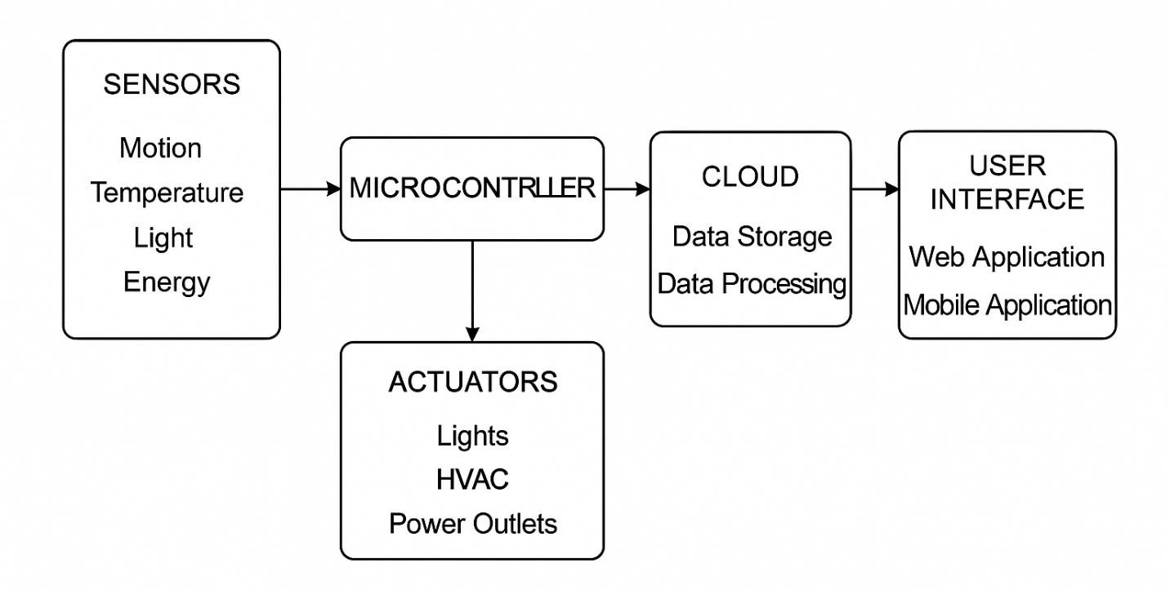

Fig. 3.4: System Architecture

3.5 Circuit Diagram of the System

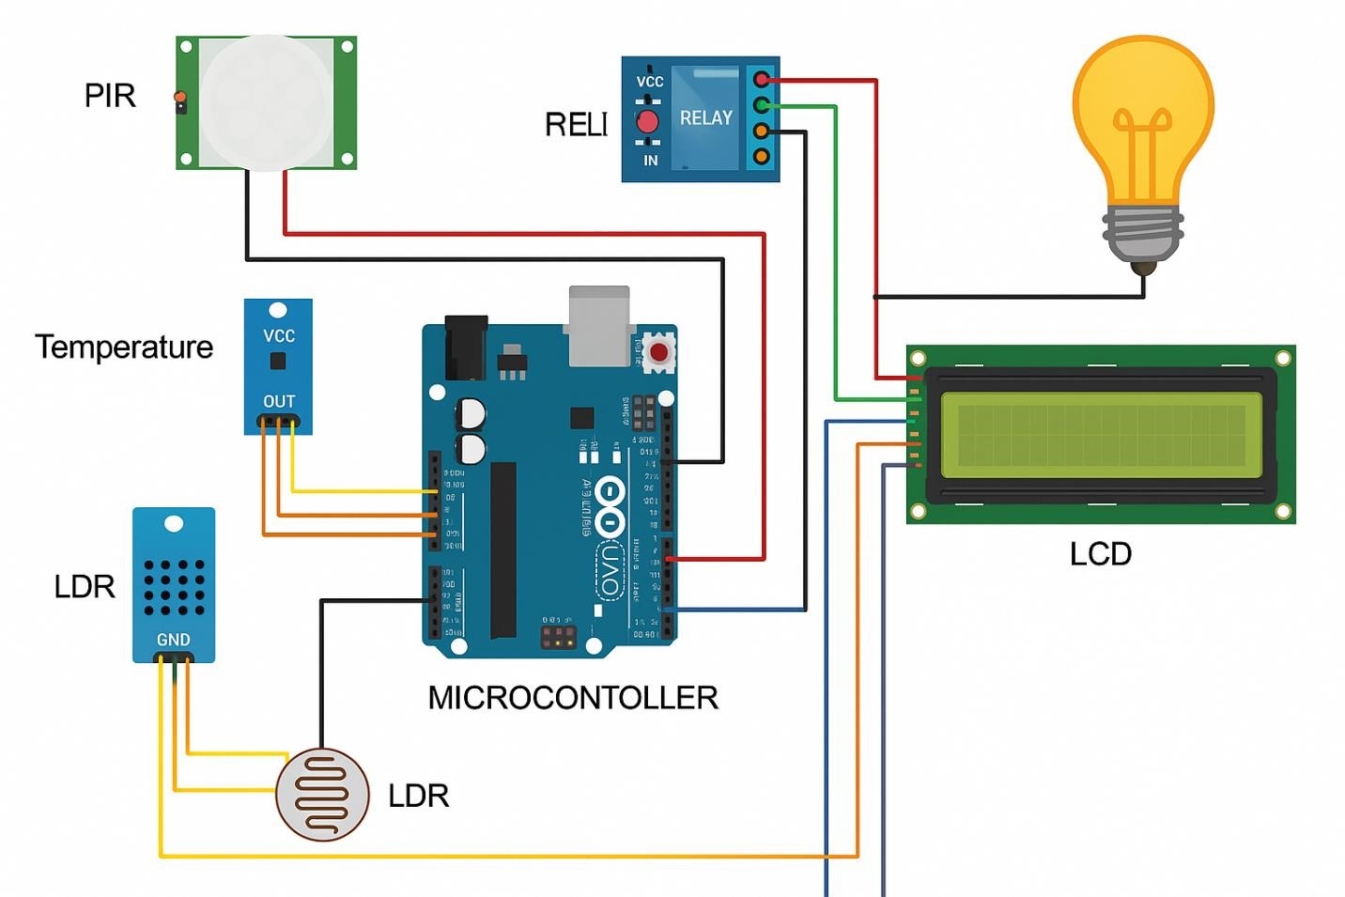
Fig. 3.5: Circuit Diagram
CHAPTER FOUR
DESIGN, IMPLEMENTATION AND DOCUMENTATION OF THE SYSTEM

4.1 System Design
The system design of this research work focuses on building a robust, scalable, and efficient Smart Automated & Energy Management System using Internet of Things (IoT) technologies. This design integrates key components such as sensors, actuators, microcontrollers, communication modules, and a central control system to manage energy consumption intelligently. The design begins with deploying various sensors to monitor environmental conditions like temperature, light intensity, and energy usage. These sensors are strategically positioned to gather real-time data from appliances and rooms within a building.
Microcontrollers like Arduino or ESP32 serve as the central processing units that receive input from sensors and issue commands to actuators for controlling devices such as lights, fans, and heating systems. Communication protocols such as MQTT or Wi-Fi ensure seamless data transfer between devices and the central system. Data from all devices is sent to a cloud-based or local server for processing and analysis. Based on user preferences and predefined rules, the system automates energy management tasks, such as turning off appliances when not in use or optimizing lighting based on occupancy and daylight.
The design also includes a user interface accessible via mobile or web applications, allowing users to monitor real-time energy consumption, receive alerts, and manually control connected devices. Security measures like authentication and encryption are incorporated to ensure data privacy and system integrity. Overall, the system design ensures an intelligent, user-friendly, and adaptive energy management solution aimed at reducing energy wastage, enhancing user comfort, and promoting sustainability in residential or commercial settings.

4.1.1 Procedure Design
The procedure design of the Smart Automated & Energy Management System using IoT involves a structured sequence of steps to ensure systematic development, deployment, and testing. The process begins with a requirement analysis phase, where the functional and non-functional requirements are identified, including device automation, remote control capabilities, real-time energy monitoring, and system scalability. Next is the hardware design and component selection stage. In this phase, suitable sensors (e.g., temperature, motion, and current sensors), actuators (e.g., relays for switching), microcontrollers (e.g., ESP32 or Arduino), and communication modules are selected. These components are assembled into a prototype circuit that can monitor energy parameters and control appliances. The software development phase follows, involving the programming of the microcontroller using a platform such as Arduino IDE. The code includes logic for sensor readings, actuator control, and communication protocols like MQTT or HTTP for sending data to the cloud or a local server.
Then, the cloud integration and interface design is carried out. A web or mobile interface is created for users to monitor and control the system remotely. Platforms like Blynk or custom web dashboards are used for data visualization.
The system testing phase involves evaluating the performance, accuracy, and reliability of sensor readings, automation responses, and the user interface. Various test cases are applied to simulate real-world energy usage scenarios.
Finally, system optimization and deployment are conducted, ensuring the system works efficiently in the intended environment. The entire procedure is documented for maintenance and future enhancements.

4.2.1 Hardware Requirement
To successfully implement the Smart Automated & Energy Management System using IoT, several hardware components are essential. These components are selected based on their ability to interact efficiently within an IoT framework, enabling real-time data collection, processing, and control of energy-consuming devices. The following are the key hardware requirements:
- Microcontroller (e.g., ESP32/Arduino Uno): This serves as the central control unit for the system. It collects data from sensors and sends control signals to actuators. ESP32 is preferred for its built-in Wi-Fi and Bluetooth features.
- Sensors:
  - Temperature Sensor (e.g., DHT11/DHT22): For monitoring ambient
temperature.
  - Light Sensor (e.g., LDR): For detecting lighting conditions and automating lights accordingly.
  - Motion Sensor (e.g., PIR Sensor): For detecting occupancy to manage devices automatically. o Current Sensor (e.g., ACS712): For monitoring the energy consumption of connected appliances.

- Actuators:
  - Relay Modules (5V/12V): For switching appliances such as lights, fans, and other electronics on and off.
  - Smart Plugs or Switches (optional): For easier control of connected devices.
- Power Supply Unit: Provides stable power to the microcontroller and connected devices.
A 5V or 12V regulated adapter is commonly used.
- Wi-Fi Router: Required for wireless communication between IoT devices and the cloud or user interface.
- PCB or Breadboard and Jumper Wires: For prototyping and connecting components in
the circuit.
- Display Module (e.g., LCD or OLED): To show real-time status, temperature, or energy consumption locally.
- Enclosures and Mounting Accessories: For housing components and ensuring safe, neat
installations.

4.3 Maintaining the System
Maintaining Smart Solar Powered Home Lighting System with IoT based Energy Management and Remote Monitoring System involves several key activities to ensure its ongoing reliability, security, and efficiency. Regular firmware updates for the microcontroller are essential to fix bugs, enhance performance, and introduce new features. Monitoring and maintaining the cloud server is critical for data integrity and system uptime, involving routine checks, updates, and backups.
Security is a top priority; implementing robust security protocols, such as SSL/TLS for data transmission and regular security audits, helps protect against cyber threats. The communication modules (Wi-Fi or GSM) should be regularly tested to ensure consistent connectivity. The IoT sensors require periodic calibration and testing to maintain accurate data collection. Any faulty sensors should be promptly replaced to prevent inaccurate readings that could impact system performance.
The user interface (web or mobile application) should be regularly updated to improve user experience and incorporate user feedback. Ensuring compatibility with various devices and browsers is also crucial.
Documentation should be kept up-to-date, detailing system configuration, maintenance procedures, and troubleshooting guides. This is important for training new personnel and for reference during maintenance activities.
Lastly, implementing a robust monitoring system that provides real-time alerts for any anomalies or failures ensures that issues can be quickly addressed, minimizing downtime and maintaining the overall health of the system.

4.4 Testing
Initially, functionality testing ensures all components operate correctly and interact as intended. Performance testing assesses system response times and data accuracy under various conditions. Integration testing verifies seamless data flow between sensors, microcontroller, cloud server, and user interface. Security testing is conducted to identify and mitigate vulnerabilities in data transmission and storage. User acceptance testing gathers feedback from users to ensure the interface is intuitive and meets their needs. Regular maintenance checks and automated monitoring systems are implemented to promptly detect and address any issues.

4.5 System Documentation/ Interface of the Design
System documentation for the IoT-based smart inverter energy controlling system is essential for maintaining and understanding the system's architecture, components, and operational procedures.
It includes:
- System Overview: Describes the purpose, scope, and objectives of the system, providing an introduction to its functionality and benefits.
- Hardware Documentation: Details specifications, schematics, and connections of hardware components such as the inverter, microcontroller, sensors, and communication modules.
- Software Documentation: Includes documentation for microcontroller firmware, cloud server applications, database structure, and APIs used for communication. It outlines installation procedures, configuration settings, and operational guidelines.
- User Interface Documentation: Provides instructions for using the web or mobile application, including screenshots and step-by-step guides for monitoring and controlling the inverter system.
- Testing Documentation: Records test plans, procedures, and results from functionality, performance, integration, and security testing. It ensures transparency in system reliability and compliance with requirements.
- Maintenance Documentation: Covers routine maintenance tasks, troubleshooting guides, and procedures for updating firmware, software, and security measures.
- Security Documentation: Includes protocols, measures, and configurations implemented to secure data transmission, storage, and user access.
Effective system documentation facilitates system understanding, troubleshooting, and maintenance, ensuring longevity and optimal performance throughout its lifecycle.

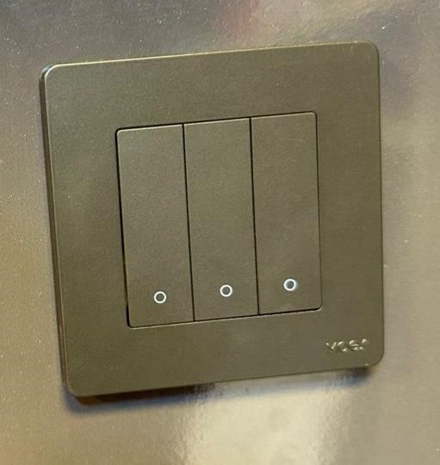

Fig. 1: 4.5: Switch Control

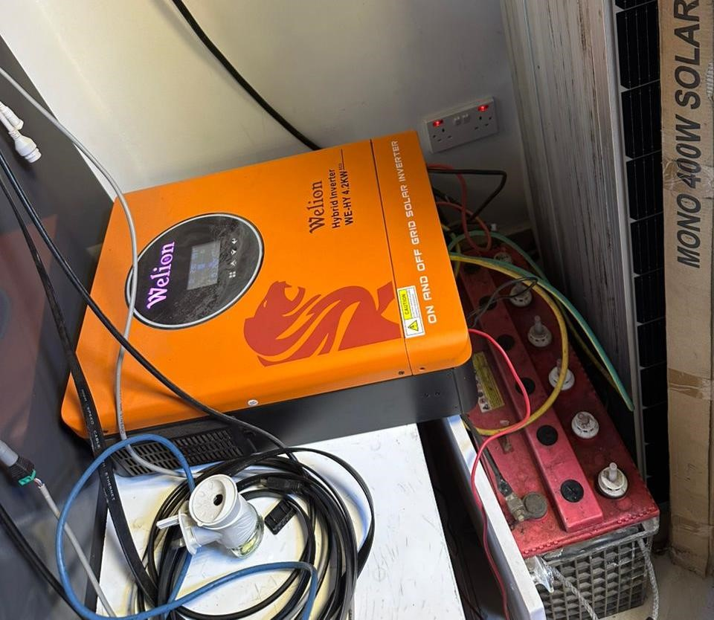

Fig. Inverter and Battery of the Construction

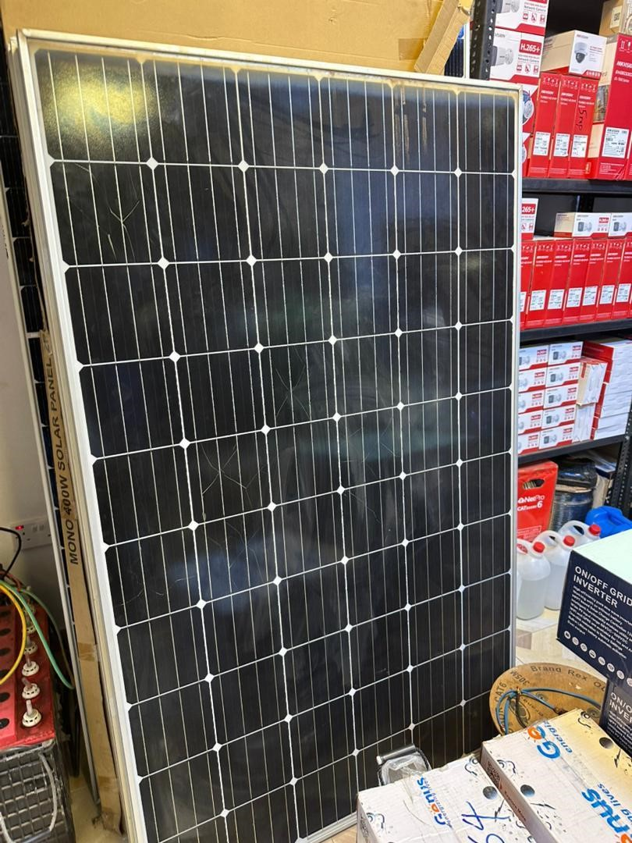

Fig. 3:4.5: Solar Panel for the Construction

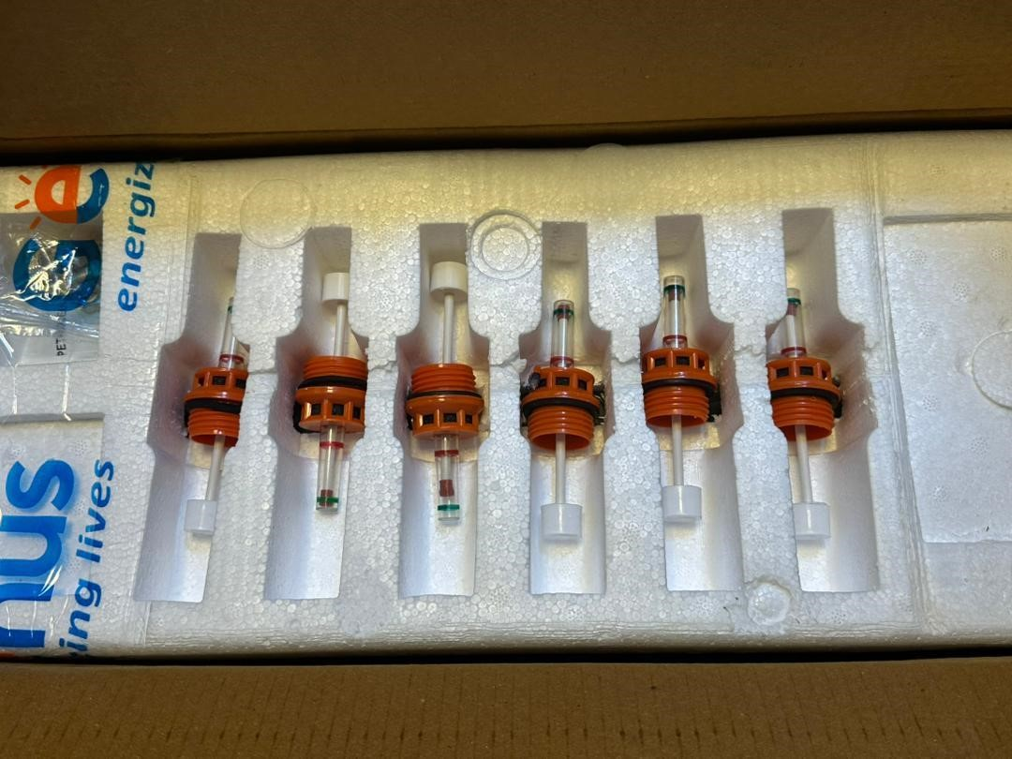

Fig. 4: 4.5: Water Level Float Indicator
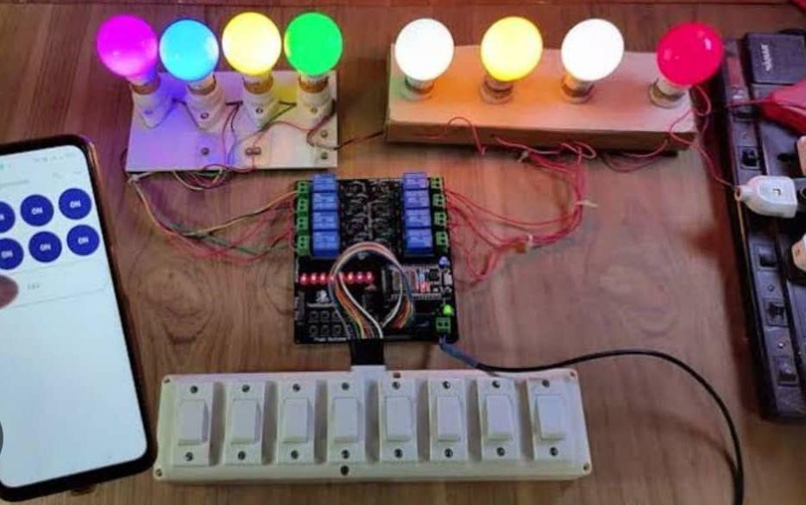

Fig. 5: 4.5: Bulb, App Interface & required components of the construction CHAPTER FIVE
SUMMARY, CONCLUSION AND RECOMMENDATION

5.1 Summary
This research work focuses on the design and development of a Smart Automated & Energy Management System utilizing the Internet of Things (IoT) to optimize power usage and enhance energy efficiency within residential or commercial spaces. With the increasing demand for electricity and the growing need to reduce energy wastage, this system offers an intelligent approach to monitor, control, and automate electrical appliances based on real-time data. The system is built around microcontroller units such as ESP32 or Arduino, supported by sensors (temperature, motion, light, and current), actuators (relays), and wireless communication protocols like Wi-Fi and MQTT.
Data collected from sensors is analyzed to make smart decisions, such as turning off unused devices, adjusting lighting according to ambient brightness, or controlling fans based on temperature readings. A user-friendly interface either web-based or mobileis integrated to allow users to monitor energy consumption patterns, receive alerts, and manually override automation when necessary. The system also supports data logging and visualization for energy usage analysis.
During implementation, the system was tested for performance in real-world scenarios and proved to be responsive, efficient, and user-centric. The results show a considerable reduction in unnecessary energy consumption, demonstrating the system's potential for sustainable energy management. This research contributes to the growing field of IoT in smart energy solutions and opens pathways for future improvements such as AI-based predictive control, integration with renewable energy sources, and scalability to larger infrastructures.

5.2 Conclusion
In conclusion, this research successfully demonstrates the design and implementation of a Smart Automated & Energy Management System using Internet of Things (IoT) technologies to enhance energy efficiency and promote intelligent energy usage in domestic and commercial settings. The integration of sensors, microcontrollers, actuators, and wireless communication enables real-time monitoring and automation of electrical appliances based on environmental and occupancy data. This system significantly reduces energy wastage by ensuring that electrical devices operate only when necessary and under optimal conditions.
The results obtained during system testing reveal a notable improvement in energy usage patterns, indicating that smart automation leads to both environmental and economic benefits. Furthermore, the flexibility of IoT platforms allows for seamless scalability, user-friendly interfaces, and future integration with renewable energy sources such as solar panels.
Ultimately, the research highlights the transformative potential of IoT in managing and conserving energy. It provides a foundation for future enhancements that could incorporate artificial intelligence for predictive energy control, cloud-based analytics for broader access and insights, and adaptive learning systems that evolve with user behavior. This system not only addresses the challenges of modern energy consumption but also aligns with global sustainability goals.

Recommendations
Based on the outcomes and insights gained from the development and evaluation of this Smart Automated & Energy Management System, several recommendations are proposed to enhance its performance, adoption, and future scalability:
- Integration with Renewable Energy Sources: The system can be further improved by integrating solar panels or wind energy systems to promote sustainable energy consumption and reduce dependency on the national grid.
- Adoption of Artificial Intelligence (AI): Incorporating AI algorithms can enable predictive analytics and intelligent decision-making based on usage patterns, environmental data, and user behavior, enhancing overall automation efficiency.
- Cloud-Based Data Storage and Analytics: Future systems should employ cloud storage and processing for real-time analytics, remote access, and scalable data management.
- Battery Backup and Fail-Safe Features: To ensure uninterrupted operation during power outages or network failures, it is recommended to include a battery-powered backup system and offline fail-safe operations.
- Mobile Application Enhancement: Developing a more interactive and intuitive mobile application will improve user engagement, provide detailed insights, and allow better control and customization.
- Scalability and Modularity: Design the system to be easily scalable for larger buildings or industries by using modular hardware and expandable software architecture.
- Enhanced Security Protocols: As IoT systems can be vulnerable to cyber threats, stronger encryption and secure authentication protocols should be adopted to protect user data and system integrity.
- User Training and Awareness: Training users on how to utilize the system effectively will ensure better adoption and encourage energy-saving behaviors.

REFERENCES
Adekunle, A. M., & Oyebanji, A. O. (2023). Smart Home Energy Systems: Opportunities and Challenges in Sub-Saharan Africa. Journal of Renewable Energy Technology, 12(1), 55–68.
Adewole, T., & Musa, S. (2020). Smart Renewable Systems for Developing Economies. Nigerian Journal of Solar Energy Studies.
Ahmed, F., & Bello, R. (2022). Design and Implementation of IoT-Based Energy Monitoring in Solar Systems. African Journal of Engineering and Sustainable Technologies.
Ali, M. A., Usman, T., & Farouk, H. (2021). Review of IoT Applications in Renewable Energy Management. International Journal of Smart Systems, 12(4), 134–142.
Alzubaidi, L., Al-Kayiem, H. H., & Munusamy, Y. (2021). Review on Smart Energy Management
Systems Using IoT for Domestic Applications. Sustainable Energy Technologies and Assessments, 45, 101096. https://doi.org/10.1016/j.seta.2021.101096
Anwar, M. A., & Lee, J. Y. (2023). Cybersecurity Considerations in IoT-Enabled Smart Homes: A Case Study of Remote Lighting Control Systems. Journal of Smart Technologies, 9(2), 77–
89.
Dinh, T. Q., Tang, J., La, Q. D., & Quek, T. Q. (2020). A Survey of Mobile Core Network Evolution for LTE Networks. IEEE Communications Surveys & Tutorials, 22(1), 492–516.
Gupta, S., Sharma, R., & Singh, A. (2022). AI-Based Load Forecasting and Optimization for Smart Solar Homes. International Journal of Smart Grid Systems, 10(4), 110–121.
Ibrahim, O., & Ojo, D. (2024). Policy-Driven Approaches to Smart Energy Systems in Nigeria.
Journal of Energy and Environment.
Kumar, S., & Yadav, A. (2022). IoT-Based Smart Lighting Systems: A Step Toward Green Living. IEEE Access, 10, 45678–45689.
Li, Y., Wang, S., & Yang, C. (2021). Integration of Solar PV and IoT in Smart Home Energy Management. Renewable and Sustainable Energy Reviews, 144, 111028. https://doi.org/10.1016/j.rser.2021.111028
Mohammed, F., & Ismail, B. (2022). IoT-Based Remote Monitoring for Renewable Energy Systems in Nigeria: Design and Performance Evaluation. African Journal of Renewable Energy, 6(3), 45–60.
Nwankwo, J. C., et al. (2021). A Comparative Study of Solar Home Systems with and without IoT Support. Renewable Energy Innovations Journal, 5(3), 90–101.
Okoro, J., & Daniels, T. (2022). Environmental Impact Assessment of IoT-Enabled Solar Lighting Systems. Journal of Clean Energy Technologies.
Olatunji, M., Balogun, K., & Yusuf, T. (2023). Weather-Aware Smart Solar Energy Systems for Home Use. Sustainable Energy Research, 11(1), 47–56.
Patel, R., & Kumar, N. (2023). Smart Cities and Renewable Integration: Role of IoT in Energy
Monitoring and Sustainability. IEEE Access, 11, 78950–78965. https://doi.org/10.1109/ACCESS.2023.3248801
Sharma, R., & Patel, A. (2023). Using Firebase for Smart Solar System Monitoring. International Journal of IoT Applications, 9(2), 102–110.
Singh, P., Sharma, M., & Rajan, K. (2023). The Future of Home Automation with Solar and IoT Technologies. Journal of Sustainable Tech, 9(2), 55–66.
Williams, D., & Osei, L. (2024). OpenSolar IoT: An Open-Source Framework for Smart Solar Home Systems. African Journal of Embedded Systems, 6(2), 22–31.
Zhang, H., Liu, Y., & Zhao, T. (2021). Blockchain-Enabled Secure IoT Architecture for Solar Microgrids. Energy Reports, 7, 903–913. https://doi.org/10.1016/j.egyr.2021.01.091
Zhao, M., Chen, Y., & Yang, J. (2024). Design and Implementation of IoT-Enabled Smart Lighting Systems for Energy Efficiency. Journal of Ambient Intelligence and Humanized
Computing, 15(1), 29–40. https://doi.org/10.1007/s12652-024-04512-3

