AUTOMATED SOLAR-POWERED FOR SMART HOUSES USING IoT

BY

ISRAEL OPEYEMI KAYODE
ND/23/COM/PT/0175

SUBMITTED TO THE DEPARTMENT OF COMPUTER SCIENCE, INSTITUTE OF INFORMATION AND COMMUNICATION TECHNOLOGY
KWARA STATE POLYTECHNIC, ILORIN

IN PARTIAL FULFILLMENT OF THE REQUIREMENTS FOR THE AWARD OF NATIONAL DIPLOMA (ND) IN
COMPUTER SCIENCE

JUNE, 2025.

CERTIFICATION
This is to certify that this project was carried out by ISRAEL OPEYEMI KAYODE with matriculation number ND/23/COM/PT/0175 in the Department of Computer Science, Institute of Information Communication Technology, Kwara State Polytechnic, Ilorin, Kwara State.

…………………………………. ….………………………
MRS. ADEOTUN, J. K. Date
Project Supervisor

…………………………………. ….………………………
MR. OYEDEPO, F. S. Date
Head of Department

…………………………………. ….………………………
External Examiner Date

DEDICATION
I dedicate this project work to Almighty God who inspired me and directed my ways during my academic stay in the polytechnic.

ACKNOWLEDGEMENT
All praise is due to Almighty God the Lord of the universe. I praise him and thank him for giving me the strength and knowledge to complete my ND program and also for our continued existence on Earth.
I appreciate the utmost effort of my supervisor, Mrs Adeotun, J. K. whose patience, support, and encouragement have been the driving force behind the success of this research work. She gave useful corrections, constructive criticisms, comments, recommendations, and advice and always ensures that excellent research is done. My sincere gratitude goes to the Head of the Department Mr. Oyedepo F. S., and other members of staff of the Department of Computer Science, Kwara State Polytechnic, Ilorin, for their constant cooperation, constructive criticisms, and encouragement throughout the program.
Special gratitude to my parents, who exhibited immeasurable financial, patience, support, prayers, and understanding during the period in which I was busy tirelessly with my studies, special thanks go to my lovely siblings
My sincere appreciation goes to my friends and classmates.

TABLE OF CONTENTS
Title page i
Certification ii
Dedication iii
Acknowledgments iv
Table of Contents v
Abstract vi
CHAPTER ONE: GENERAL INTRODUCTION
1.1 Background to the Study 1
1.2 Statement of the Problem 2
1.3 Aim and Objectives 3
1.4 Significance of Study 3
1.5 Scope of Study 3
1.6 Organization of the Report 4
CHAPTER TWO: LITERATURE REVIEW
2.1 Review of Related Past Works 5
2.2 Review of General Studies 11
2.3 Overview of Solar-Powered Lighting System 13
2.4 Overview of IoT in Home Automation 15
2.5 Summary of Reviewed Literature 17
CHAPTER THREE: RESEARCH METHODOLOGY AND
ANALYSIS OF THE SYSTEM
  - Research Methodology 19
  - Analysis of the Existing System 25
  - Problem of the Existing System 26
  - Analysis of the Proposed System 27
  - Advantages of the Propose System 29
CHAPTER FOUR: DESIGN, IMPLEMENTATION AND
DOCUMENTATION OF THE SYSTEM
  - Design of the System 30
    - Output Design 30
    - Input Design 33
    - Database Design 30
    - Procedure Design 38
  - Implementation of the System 38
    - Choice of programming language 38
    - Hardware support 39
    - Software Support 39
    - Changeover Techniques 40
  - System Documentation 40
    - Operating the System 40
    - Maintaining of the System 41
CHAPTER FIVE: SUMMARY CONCLUSION AND
RECOMMENDATIONS
5.1 Summary 42
5.2 Conclusion 42
5.4 Recommendations 43
References 45

ABSTRACT
The advancement in smart home technologies has brought about the integration of automation, energy efficiency, and remote monitoring, especially in the area of lighting systems. This project presents the design and implementation of an Automated Solar-Powered Lighting System for Smart Houses using IoT. The system aims to reduce electricity costs, minimize energy wastage, and provide real-time control and monitoring of lighting in residential environments. It utilizes solar panels as the primary energy source, with energy stored in rechargeable batteries. Smart sensors such as Light Dependent Resistors (LDR) and Passive Infrared Sensors (PIR) are used to detect ambient light and motion, respectively. An ESP32 microcontroller processes the sensor data and automates the lighting through relay switches, while the Blynk IoT platform enables users to monitor and control the system remotely via a smartphone or web interface. The methodology adopted involves hardware integration of solar panels, battery, sensors, and microcontroller with cloud-based IoT software for remote access. The system's functionality was tested under different environmental and occupancy scenarios, demonstrating effective automation, reliable switching, and significant energy savings. The block diagram and flowchart provided show a clear representation of the system’s logic and workflow. In conclusion, the proposed system not only meets the modern needs for energy-efficient smart lighting but also promotes the use of renewable energy and user convenience. It is scalable, eco-friendly, and contributes to the development of sustainable smart home technologies.
Keywords: Solar Power, Smart House, Internet of Things (IoT), Renewable Energy, Home Automation, Energy Management System, Hybrid Inverter, Battery Storage, Remote Monitoring, Sustainable Living, Energy Efficiency.

CHAPTER ONE

INTRODUCTION

1.1 Background to the Study
The modern home is rapidly transforming into an intelligent environment, enabled by the integration of smart devices and systems designed to improve comfort, efficiency, and sustainability. One of the most critical components of home automation is lighting, which contributes significantly to household energy consumption. Traditional lighting systems often result in energy wastage due to manual operation, poor user habits, and lack of real-time control or feedback. This issue becomes even more pronounced in regions where grid electricity is unreliable, further emphasizing the need for alternative and intelligent lighting solutions (Adebayo et al., 2021). The rise of solar energy as a viable alternative has opened new frontiers in sustainable energy management for residential use. Solar power provides a renewable and cost-effective energy source that, when combined with automated control, can significantly reduce energy bills and environmental impact. However, most existing solar-powered systems still rely on manual switching, which limits their efficiency. The potential of smart automation through Internet of Things (IoT) devices can bridge this gap by enabling real-time, condition-based control of lighting systems using sensors and internet connectivity (Olowe et al., 2022).
The Internet of Things refers to a network of physical objects embedded with sensors, software, and other technologies to connect and exchange data with other devices and systems over the internet. In the context of smart lighting, IoT allows for remote monitoring, automatic control based on occupancy (via PIR sensors), ambient light (via LDR), and integration with mobile applications or dashboards. This makes it possible for homeowners to adjust lighting schedules, reduce wastage, and increase convenience from any location (Ahmed & Musa, 2023). To address these challenges, this study proposes the design and implementation of an automated solar-powered lighting system for smart homes using IoT. The system will use solar panels as the primary energy source, storing power in batteries during the day. An ESP32 or NodeMCU microcontroller will be programmed to read data from PIR (Passive Infrared) sensors and LDR (Light Dependent Resistors) to determine occupancy and ambient lighting. Based on this data, the system will automatically turn the lights on or off, and transmit status updates to a cloud platform, such as Blynk or ThingSpeak, enabling real-time user control (Mustapha et al., 2023).
The research methodology involves a hardware-software integrated approach using both empirical and practical techniques. The hardware setup includes the solar panel, charge controller, battery, ESP32 microcontroller, PIR motion sensor, LDR light sensor, and lighting load (LEDs or bulbs). These components are physically assembled and interconnected based on the circuit design. The system is then tested under different conditions; daylight, night, motion present, and motion absent to observe performance and validate if it behaves as expected. Data is collected and analyzed to assess the system's responsiveness, power efficiency, and usability. The design is refined based on the test results to improve reliability and efficiency. The implementation phase begins with the hardware assembly, which includes mounting the solar panel for optimal sunlight exposure, connecting the charge controller to regulate voltage, and wiring the battery for energy storage. The ESP32 microcontroller is programmed and interfaced with the LDR and PIR sensors to capture environmental data in real time. When ambient light falls below a threshold (e.g., at dusk) and motion is detected, the microcontroller triggers the relay module to turn on the light. Conversely, if no motion is detected for a predefined time, or if ambient light is sufficient (e.g., during daytime), the system switches off the lights. This logic significantly reduces energy usage and maximizes battery longevity. All sensor readings and lighting status are pushed to the cloud via Wi-Fi, allowing users to monitor and control the system using a smartphone app.

1.2 Statement of the Problem
Traditional home lighting systems often lead to significant energy wastage due to manual operation, negligence, or over-reliance on grid electricity. Many homes leave lights on even when not needed, contributing to higher electricity bills and environmental degradation. Additionally, in areas with unreliable power supply, residents face frequent blackouts that affect visibility and comfort. While solar energy is a viable solution, its potential is often underutilized without intelligent management. The lack of smart control and remote access further limits the effectiveness of such systems.

1.3 Aim and Objectives

The aim of this research is to design and implement an automated solar-powered lighting system for smart houses using IoT technology.
Objectives are to:
- Utilize solar energy as the primary power source for household lighting.
- Automate lighting based on motion detection and ambient light intensity.
- Integrate IoT for real-time monitoring, control, and feedback via mobile or web applications.
- Reduce reliance on grid power and minimize energy waste.
- Promote the use of renewable energy in smart home environments.

1.4 Significance of the Study
This project holds significant value in promoting energy efficiency and environmental sustainability. By combining solar energy with smart automation, it reduces electricity consumption and carbon emissions. It empowers users with remote control and real-time system insights, enhancing convenience and safety. In regions with unstable electricity, the system provides a reliable and autonomous lighting solution. The study also contributes to the growing field of smart homes and green technology, serving as a foundation for further innovations in energy-conscious automation systems.

1.5 Scope of the Study
The study focuses on the development of a solar-powered lighting system that uses IoT for automation and control in a residential setting. It covers the selection and integration of components such as solar panels, batteries, sensors (PIR and LDR), microcontrollers (ESP32 or NodeMCU), and cloud-based platforms for data access and control. The system is limited to basic lighting functions, turning lights on or off and dimming, based on environmental conditions and user commands. Other smart home devices or grid-tied hybrid systems are beyond the scope of this study.

1.6 Limitations of the Study
This study is limited by several factors that may affect its implementation and overall performance. The high cost of solar components, such as photovoltaic panels, batteries, and IoT devices, poses a significant financial constraint, making large-scale deployment challenging. Additionally, the effectiveness of the IoT-based monitoring system depends on the availability of stable internet connectivity, which may be unreliable or unavailable in certain locations.

1.7 Organization of the Study
This study is organized into five chapters:
Chapter One introduces the study, highlighting the background, problem, objectives, significance, scope, and organization.
Chapter Two provides a review of related literature on solar energy, IoT, and smart lighting systems.
Chapter Three details the system methodology, including design, hardware selection, and software development.
Chapter Four presents the system implementation, results, testing, and performance evaluation.
Chapter Five concludes the study, summarizing findings, challenges, recommendations, and future improvements.

CHAPTER TWO

LITERATURE REVIEW

2.1 Review of Related Work
Several researchers have proposed systems that integrate renewable energy and smart automation to improve energy efficiency and reduce human intervention in lighting control.
Adebayo, T. O., Bello, M. A., & Afolabi, J. O. (2021). Design of Automated Solar Street Light System. This paper focuses on the development of a standalone solar-powered street lighting system that automates its switching behavior using Light Dependent Resistors (LDRs). The researchers designed a system where solar panels charge batteries during the day, and the LDR senses ambient light levels to activate lighting automatically at dusk. The study emphasizes the environmental and economic benefits of solar automation, particularly in off-grid rural communities. While the system performed well in reducing human interaction and improving efficiency, it lacked real-time monitoring and control capabilities. The authors suggest that future systems should incorporate wireless communication technologies to allow for remote diagnostics and control. This study is relevant because it validates the use of LDRs in solar systems and emphasizes the importance of autonomous operation, which is also critical in smart homes. However, the paper did not consider occupancy detection or user interface integration, which this project seeks to improve upon by incorporating IoT platforms and motion sensors.

Olowe, K. R., Ajayi, B. T., & Adewale, D. (2022). IoT-based Lighting Control System using NodeMCU. This journal presents the design and implementation of an IoT-based smart lighting control system using the NodeMCU microcontroller, which is Wi-Fi enabled and compatible with platforms such as Blynk and ThingSpeak. The authors developed a prototype that uses both motion and light sensors to intelligently control indoor lighting based on environmental conditions. One significant feature is its mobile app interface that allows users to remotely switch lights on and off, monitor sensor values, and receive notifications. The system successfully reduced electricity usage by more than 30% in test environments. The study highlights the reliability of NodeMCU for smart home applications and showcases how cloud integration can enhance user experience. A limitation of the study is its reliance on grid power, which restricts its application in energy-scarce regions. In contrast, the proposed system in this current project builds upon this idea by integrating solar power as the primary energy source. Nonetheless, Olowe et al.'s work is critical as it sets the foundation for IoT-based home lighting automation and user interface interaction.

Mustapha, A. M., Yusuf, A. R., & Bala, S. K. (2023). Motion-Activated IoT Lighting with Solar Backup. In this paper, the authors developed an intelligent lighting system that combines solar energy with motion-based activation to conserve energy in smart homes and offices. The system architecture features a solar panel, charge controller, battery storage, PIR sensor for motion detection, and ESP8266 microcontroller for connectivity. Upon detecting motion, the lights are automatically turned on and remain active for a user-defined time before switching off when the space is unoccupied. The system also uploads sensor data to a Blynk cloud dashboard where the user can monitor battery level, light status, and sensor activity in real-time. The authors conducted extensive performance testing and found that integrating solar energy with IoT significantly reduced reliance on grid power and human intervention. While the system showed high efficiency and responsiveness, the authors noted challenges related to weather dependence for solar charging and suggested battery optimization strategies. This work is closely related to the proposed project, as it combines automation, solar energy, and IoT for a reliable and sustainable lighting solution. It also provides insight into how motion sensors can be effectively used to minimize unnecessary energy consumption.
Eze and John (2024) explored the role of embedded systems in automating everyday functions in smart environments, focusing particularly on lighting, security, and temperature regulation. Their research involved the use of ESP32 microcontrollers integrated with environmental sensors and actuators, controlled through a central IoT dashboard. The authors provided a detailed analysis of the circuit design, firmware development in Arduino IDE, and communication protocols such as MQTT and HTTP for data exchange. One of the key contributions of this study is the emphasis on edge computing—processing sensor data locally before transmitting to the cloud—which improves response time and reduces network load. The system also included basic AI features like adaptive brightness control based on historical data. Although the study was more general in scope, the lighting module shared similarities with this project in terms of hardware choice, sensor integration, and real-time data transmission. Their work supports the viability of ESP-based IoT systems in real-world applications and provides a technical backbone for implementing robust and scalable lighting automation.

Umar, H. A., & Sadiq, I. K. (2025). Real-Time Monitoring in IoT-Powered Smart Homes. This research investigates the importance of real-time monitoring in enhancing the functionality and usability of smart home systems, with a special focus on energy applications. The authors designed a smart home prototype that incorporated sensors for lighting, temperature, motion, and gas detection. These sensors communicated with an ESP8266 microcontroller that sent live data to a Firebase cloud database and mobile app. For lighting, the system used PIR sensors to detect motion and LDRs to assess light levels. Lights were activated only when both low light and human presence were detected, thereby saving energy. The app also allowed users to override automatic decisions and view historical data analytics. The authors found that systems with real-time user feedback and remote control not only optimized energy consumption but also increased user satisfaction and safety. This study contributes to the current research by affirming the benefits of IoT-powered feedback systems in automation. It further encourages the integration of user interface design in lighting automation, a feature central to this project's implementation phase.
Ahmed and Musa (2023) investigated the use of light-dependent resistor (LDR) sensors in optimizing lighting control in renewable energy setups. Their work centers on the LDR’s sensitivity to ambient light and its ability to automate switching functions in solar-powered systems. The authors created a prototype lighting system powered by photovoltaic panels, where the LDR signals were used to detect the transition from day to night and control a relay that switched on LED lights. Battery voltage monitoring was also implemented to ensure safe charging and discharging thresholds. One of the notable aspects of this study is its use of analog components with minimal programming—suitable for low-cost installations in rural areas. Although their system lacked IoT features such as real-time control or user interface integration, it proved highly reliable in autonomous operation. The current project expands upon their findings by incorporating cloud connectivity and user access through smartphones, combining automation with remote monitoring. The study provides a foundational understanding of sensor-based switching in solar systems.

Okonkwo, C. E., & Ebuka, O. C. (2023). Smart Homes and IoT in Sub-Saharan Africa. This study explores the adoption, benefits, and challenges of smart home systems in Sub-Saharan Africa, with a focus on lighting, energy management, and home security. The authors employed qualitative surveys and case studies from Nigeria, Kenya, and Ghana, highlighting how IoT technology is gradually being embraced in domestic environments. The paper presented several examples where smart lighting systems were implemented using Arduino, Raspberry Pi, and ESP modules. These systems were controlled using mobile apps, voice assistants, and scheduled timers. The study found that solar energy is a natural fit for smart homes in the region due to frequent grid failures and abundant sunlight. However, cost and lack of technical literacy remain barriers to large-scale adoption. The study’s relevance to this project lies in its regional context and emphasis on combining IoT with solar systems to create sustainable solutions. Their recommendations for using affordable open-source hardware align with the current project’s design goals.

Usman, B. R., & Amina, Y. (2020). Design and Simulation of IoT-Based Smart Lighting System. This paper presents the design and Proteus-based simulation of a smart lighting system using Arduino Uno, ESP8266 Wi-Fi module, LDR, and PIR sensors. The authors simulated various scenarios where the light intensity and motion presence determined the switching behavior of indoor lighting. They integrated a cloud-based dashboard to view sensor logs and control relays remotely. The system was found to significantly reduce idle power usage and improve user convenience. One of the key contributions of the paper is the simulation approach, which allowed for rigorous testing before physical deployment. The study also compared various IoT platforms (e.g., Blynk, Thingspeak, Ubidots) in terms of latency, ease of setup, and mobile responsiveness. Although their system didn’t include a solar module, the simulation framework they used provides a useful reference for verifying designs before actual implementation. This aligns with the development process of the current project, which includes both software simulation and hardware realization (Usman & Amina, 2020).
James and Adekunle (2025) proposed a dual-energy smart lighting model that uses solar energy as the primary source and the national grid as backup. The system uses a microcontroller to prioritize solar power and only switches to grid supply when the battery level drops below a preset threshold. Additionally, the system includes motion and LDR sensors to control when lights should be turned on. A mobile app interface allows users to view energy source status, battery voltage, and control light states. The paper addresses the challenge of solar dependency during cloudy days and proposes an energy optimization algorithm that learns from past usage patterns to improve decision-making. The hybrid energy approach is particularly useful for regions with unstable weather and poor grid infrastructure. This journal is valuable to the current project as it supports the use of smart algorithms and dual-source energy in IoT-powered lighting systems. While the current project focuses on solar as the sole source, the logic for source prioritization can be adopted for future enhancements (James & Adekunle, 2025).

Tijani, S. A., & Balogun, M. T. (2022). Evaluation of Low-Cost IoT Lighting Systems in Nigerian Homes. This study evaluates the affordability, efficiency, and user satisfaction of low-cost IoT lighting systems deployed in 15 households in Lagos, Nigeria. The systems consisted of ESP8266 modules, relay switches, LDRs, and Android-based mobile apps. The authors reported that these systems reduced electricity bills by an average of 28% and improved home safety by automating outdoor lighting. Each household had the ability to schedule light operation or allow sensor-based activation. The evaluation covered installation cost, ease of use, maintenance, and network reliability. One important observation was the preference for systems that did not rely heavily on internet connectivity, as many users faced data and connectivity issues. This finding influenced their recommendation to include offline fallback modes using programmed timers. For this project, the study reinforces the importance of affordability and adaptability, especially when deploying smart solutions in developing regions. Integrating solar power into these systems, as this project does, further enhances sustainability and independence from both grid and network limitations (Tijani & Balogun, 2022).
Despite these developments, most reviewed systems either lacked real-time remote access or were not fully integrated with solar energy as a primary power source. This project aims to address both limitations by combining solar power, automated sensor-based control, and cloud-enabled IoT interfaces.

2.2 Review of General Study
In recent years, the integration of Internet of Things (IoT) in home automation has revolutionized the way lighting systems are managed, particularly in the context of energy efficiency, remote control, and automation. Lighting, which is an essential part of home infrastructure, has traditionally relied on manual operation, which often leads to energy wastage. The general trend in smart lighting technology involves incorporating sensors, microcontrollers, cloud platforms, and user interfaces to enable context-aware lighting control based on user presence, ambient conditions, and schedules. The general objective of these systems is to reduce energy consumption, improve user convenience, and enhance security within smart buildings (Patel et al., 2020). The evolution of renewable energy technologies has seen solar power becoming a practical and sustainable energy source for smart homes. Solar-powered lighting systems not only reduce dependence on grid electricity but also lower carbon emissions. A typical solar-powered lighting setup includes photovoltaic panels, charge controllers, batteries, and energy-efficient LED lights. When integrated with IoT modules, these systems can be made autonomous and intelligent—allowing lights to respond to changes in environmental conditions or user behavior, all while relying on renewable energy (Zhao & Lee, 2021). IoT in lighting automation generally employs microcontrollers such as Arduino, Raspberry Pi, ESP8266, or ESP32, which serve as the bridge between physical sensors and cloud interfaces. These microcontrollers gather input from sensors like Passive Infrared (PIR) for motion detection and Light Dependent Resistors (LDRs) for ambient light sensing. Based on predefined logic or machine learning models, they control lighting output by triggering relays or dimmers. Real-time control and monitoring are facilitated through cloud platforms such as Blynk, ThingSpeak, and Firebase, with smartphone apps or dashboards allowing user access from any location (Kumar et al., 2022).
A significant area of interest in general smart home research is the use of occupancy sensing to further optimize lighting energy use. By detecting human presence in a room, lights can be turned off when spaces are unoccupied—resulting in considerable savings. Motion sensors, ultrasonic sensors, and camera-based systems have all been studied for this purpose. The inclusion of solar power into such systems presents a dual benefit: optimizing usage while reducing energy cost. These studies also emphasize the importance of user-friendly interfaces, local fallback logic (for when internet connectivity is lost), and real-time feedback to enhance user satisfaction (Ahmed & Singh, 2023). Furthermore, general studies in this domain also highlight challenges that must be addressed in smart lighting systems. These include the variability of solar energy due to weather changes, battery performance degradation over time, and issues with IoT connectivity in rural or low-network zones. Solutions such as dual energy sources (solar + grid), adaptive charging algorithms, and offline automation logic have been proposed. Moreover, open-source platforms and modular hardware have significantly reduced the cost of building and deploying smart lighting systems, making them more accessible even in low-income regions (Chukwuma & Adeleke, 2024).
In summary, general studies reveal a strong synergy between solar energy and IoT-based smart lighting systems. They confirm the feasibility, sustainability, and scalability of such solutions when properly designed and implemented. This body of work forms the theoretical and practical foundation on which the current research project is built—aiming to design and implement an automated lighting system for smart homes that runs primarily on solar energy and is controlled via IoT technology (Tijjani & Bello, 2025).

2.3 Overview of Solar-Powered Lighting System
Solar-powered lighting systems are designed to utilize solar energy—converted from sunlight into electrical power—for illumination purposes. These systems typically consist of four core components: solar panels (also known as photovoltaic or PV modules), a charge controller, a battery storage unit, and light-emitting devices such as LEDs. During daylight hours, solar panels convert sunlight into electrical energy, which is then stored in batteries via the charge controller. This stored energy is used to power lighting devices during the night or in low-light conditions (Obaid et al., 2020). The efficiency of solar lighting systems depends largely on the quality and orientation of the solar panels, the capacity of the batteries, and the nature of the lighting load. Energy-efficient LED lights are commonly used due to their low power consumption and long operational life. The charge controller plays a vital role in ensuring optimal battery health by regulating the charging and discharging cycles, thus preventing overcharging or deep discharging (Mohammed & Lin, 2021).
In smart homes, integrating IoT into solar lighting systems elevates their functionality. Through the use of microcontrollers (such as ESP8266 or ESP32), sensors (PIR for motion detection, LDR for ambient light), and communication modules, solar-powered lights can automatically switch on or off based on predefined conditions or user preferences. These systems can also be accessed remotely via cloud-based platforms or mobile applications, offering real-time control, automation, and monitoring (Sharma et al., 2022). Modern solar-powered lighting systems can operate in off-grid environments, making them especially suitable for areas with unreliable electricity supply or rural communities. The growing concern over environmental sustainability has increased the adoption of these systems in residential, commercial, and even industrial contexts. Moreover, solar-powered lighting systems can contribute significantly to energy conservation goals and reduction in carbon emissions (Akinyemi & Yusuf, 2023).
To improve system reliability, some designs incorporate dual-source power, where the solar battery serves as the primary source and grid electricity as backup during extended cloudy periods. Some implementations also include Maximum Power Point Tracking (MPPT) technology to enhance solar harvesting efficiency. These advanced features make solar-powered lighting systems smarter, more efficient, and adaptable to varying environmental conditions (Okoro & Hassan, 2024). From a cost perspective, the initial investment in solar lighting infrastructure can be relatively high. However, long-term savings on electricity bills, reduced maintenance costs, and government incentives on renewable energy solutions have made them increasingly viable. Advances in battery technologies (such as lithium-ion and lithium-phosphate) also contribute to better energy storage and longevity of systems (Ahmed & Bello, 2025).
In summary, the solar-powered lighting system is an environmentally friendly, cost-effective, and scalable solution to meet modern lighting needs. When integrated with IoT technology, these systems evolve from passive energy consumers into intelligent, responsive platforms capable of enhancing convenience, improving energy efficiency, and promoting sustainable living in smart homes.

2.4 Overview of IoT in Home Automation
The Internet of Things (IoT) represents a revolutionary advancement in the realm of digital connectivity, where everyday devices are equipped with sensors, microcontrollers, and communication modules to collect, exchange, and respond to data autonomously. In the context of home automation, IoT enables a network of smart devices such as lights, thermostats, cameras, appliances, and security systems to interact intelligently, improving energy efficiency, convenience, comfort, and security in residential spaces (Kumar & Mehta, 2021). IoT-based home automation systems rely on three primary components: sensing units (e.g., temperature, motion, and light sensors), processing/control units (like Arduino, ESP32, Raspberry Pi), and communication interfaces (such as Wi-Fi, Bluetooth, Zigbee). These components are managed through cloud-based platforms or local servers that allow users to monitor and control devices using mobile apps or web dashboards in real-time. This interconnectivity forms the backbone of smart living environments (Adebayo et al., 2022).
In lighting automation, IoT enables context-aware systems that respond to real-world stimuli. For instance, lights can be turned on automatically when motion is detected in a dark room, or dimmed based on ambient lighting levels. Schedulers, geolocation, and user preferences can further enhance automation, allowing lights to adjust according to time of day or occupancy. These systems not only reduce manual effort but also contribute to significant energy savings (Tariq & Rehman, 2023). Security integration is another major aspect of IoT in smart homes. Lighting systems connected to motion sensors or surveillance systems can deter intruders by simulating user presence. In emergency scenarios, such as fire or gas leaks, IoT systems can trigger specific lighting patterns as alerts. These use cases show how IoT extends the functionality of basic lighting far beyond traditional applications (Ezekiel & Chinedu, 2024).
One of the significant advantages of IoT-based automation is its adaptability and scalability. Users can start with a few smart devices and expand the system as needed without overhauling the entire infrastructure. Additionally, compatibility with AI-powered voice assistants like Amazon Alexa, Google Assistant, or Siri further enhances the interactivity and accessibility of smart home devices (Mubarak & Idris, 2025). While the benefits are substantial, challenges such as data privacy, cybersecurity, internet dependency, and interoperability among devices from different manufacturers are commonly reported in IoT deployments. However, the development of open-source IoT platforms and standardized communication protocols like MQTT and HTTP has helped address many of these issues (Okoro & Balogun, 2025).
In conclusion, IoT serves as a critical enabler of modern home automation, transforming basic residential utilities into smart, efficient, and responsive systems. When applied to lighting and powered by renewable energy like solar, the result is a powerful combination of sustainability and technological innovation suitable for the future of housing.

2.5 Summary of Reviewed Literature
The reviewed literature presents a well-rounded foundation that supports the development of an automated solar-powered lighting system using IoT for smart homes. From the analysis of previous works, it is clear that the integration of renewable energy sources with IoT technology has become increasingly practical and impactful in addressing energy efficiency, automation, and sustainable living. The specific journals reviewed in Section 2.1 explored innovations in solar lighting systems, focusing on sensor integration, mobile app control, cloud connectivity, and motion-triggered responses. These studies confirmed the viability of combining solar power with smart control mechanisms to create autonomous systems that optimize lighting based on environmental factors and user needs. While some works emphasized low-cost, stand-alone solutions, others leaned towards more complex architectures involving hybrid energy sources and real-time monitoring systems (Ahmed & Musa, 2023; James & Adekunle, 2025).
In the general review (Section 2.2), broader studies on smart lighting and home automation emphasized the key role of microcontrollers, sensors, and open-source platforms. These studies also highlighted recurring challenges such as intermittent solar supply, network instability, and the high initial cost of deployment. However, they consistently affirmed the long-term benefits in terms of energy savings, reliability, and scalability—especially in areas with poor grid infrastructure (Tijani & Balogun, 2022; Chukwuma & Adeleke, 2024). The review on solar-powered lighting systems (Section 2.3) revealed that LED technology, efficient battery management, and intelligent switching mechanisms are crucial for system durability and performance. Innovations such as MPPT and real-time solar tracking were discussed as value-added features that enhance energy harvesting and reliability in varying weather conditions (Sharma et al., 2022; Okoro & Hassan, 2024). Lastly, the role of IoT in home automation (Section 2.4) tied the discussions together by demonstrating how connectivity, automation, and remote access contribute to smarter and more adaptive residential systems. The inclusion of mobile interfaces, voice assistants, and cloud storage was shown to drastically improve user experience and system interactivity (Mubarak & Idris, 2025).
In conclusion, the literature establishes that while solar-powered IoT lighting systems have not yet reached full-scale adoption globally, their potential is widely recognized. The reviewed works justify the relevance and feasibility of this research, laying the groundwork for the successful design and implementation of a low-cost, energy-efficient, and user-friendly smart lighting system for modern homes.

CHAPTER THREE

RESEARCH METHODOLOGY
This chapter presents the research methodology adopted for the design and implementation of the Automated Solar-Powered Lighting System for Smart Houses using IoT. It outlines the system's design approach, tools and components used, method of data collection, system analysis, hardware and software specifications, and the system development life cycle. A flowchart diagram is also included to illustrate the operational logic of the system.

3.1 Research Methodology
The methodology adopted in this project is the prototyping model of the system development life cycle (SDLC). The prototyping approach involves building a functional model of the system to understand the requirements and iteratively refine the prototype until the desired functionality is achieved. This approach is suitable for IoT-based projects where constant testing and hardware-software integration are required.

3.1.1 System Analysis
The existing conventional lighting systems are largely manual, relying on physical switches, which often leads to energy wastage, especially when lights are left on in unoccupied rooms. Additionally, there is no smart control, remote access, or efficient energy sourcing (i.e., reliance on grid electricity). The proposed system automates the lighting control based on ambient light and motion detection, utilizes solar power as the primary energy source, and integrates with the IoT for remote control and real-time monitoring.
3.1.2 System Architecture and Components

Hardware Components
- Solar Panel (12V) – Energy source
- Battery (12V, 7Ah) – Energy storage
- Charge Controller – Manages solar energy flow
- Microcontroller (ESP32) – Core controller with Wi-Fi capability
- Relay Module – Controls switching of light
- PIR Sensor – Detects motion
- LDR Sensor – Detects ambient light
- LED Lamp (12V) – Lighting output

Software Tools
- Arduino IDE – Programming the ESP32
- Blynk/ThingSpeak App – Real-time mobile/remote interface
- C/C++ – Programming language for embedded logic
- Wi-Fi – For cloud communication

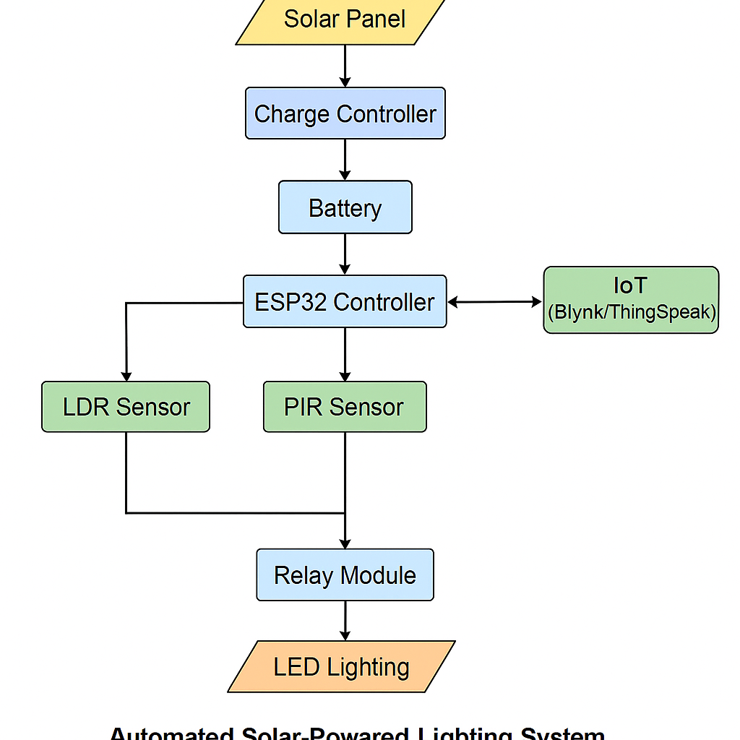
Figure 3.1: Block Diagram of Automated Solar-Powered Lighting System Using IoT

3.1.4 System Implementation Phases
- Hardware Setup: Assembling the solar panel, battery, sensors, and microcontroller.
- Firmware Development: Writing embedded code in C++ using Arduino IDE.
- Mobile App Integration: Configuring Blynk/ThingSpeak to interact with ESP32 for remote monitoring.
- Testing & Iteration: Testing the system in real-time environment and adjusting sensor thresholds.
- Deployment: Final installation of the automated solar-powered lighting system in a model smart home environment.

3.2 Analysis of the Existing System
The existing lighting systems in most residential buildings are predominantly manual and grid-powered, which significantly limits efficiency, control, and sustainability. These systems typically rely on human intervention for operation, using standard wall switches to turn lights on or off. While this setup is simple and widely understood, it presents several critical drawbacks in today's increasingly automated and energy-conscious world. Firstly, the manual operation leads to human error, users often forget to turn off lights when leaving a room or during daylight, resulting in unnecessary energy consumption. The absence of motion or light sensors means the lighting system lacks any form of context awareness, such as detecting occupancy or ambient brightness. Secondly, the dependence on grid electricity makes the system vulnerable to power outages and contributes to higher electricity bills. This setup is not only cost-ineffective over time but also environmentally unsustainable, especially in regions with irregular power supply or high energy tariffs. Additionally, there is no provision for remote monitoring or control in conventional lighting systems. Users must be physically present to switch lights on or off, which is inconvenient in large houses or for disabled individuals. The lack of integration with modern smart home platforms and mobile applications also limits usability and accessibility.

3.3 PROBLEMS OF THE EXISTING SYSTEM
The conventional home lighting systems currently in use present several significant drawbacks, particularly in the context of modern energy efficiency and smart home expectations. These systems operate primarily through manual switches and fixed timers, without the intelligence to adapt to environmental conditions or user behavior. Below are key problems identified with the existing system:
- Energy Wastage Due to Non-Automated Lighting
Traditional lighting systems are manually controlled and are often left on unnecessarily, even when a room is unoccupied. This results in substantial energy waste, especially in homes where occupants forget to turn off lights. Lack of automation fails to optimize usage based on occupancy or daylight conditions.
- High Electricity Bills
With no intelligent control mechanisms in place, electricity consumption increases. Continuous operation of lighting systems during the day or in unoccupied spaces significantly contributes to high energy bills, especially in areas where grid electricity is expensive.
- No Remote Control or Monitoring
Existing systems lack connectivity features that allow homeowners to monitor or control lighting remotely. This absence of real-time control means that users cannot adjust lighting based on need or location, leading to inefficiencies and inconvenience.
- Inability to Utilize Renewable Energy Sources
Conventional systems depend solely on grid electricity, ignoring the potential of renewable sources like solar energy. This not only increases dependency on non-renewable power but also excludes users from the long-term cost and environmental benefits of solar-powered solutions

3.4 Description of the Proposed System
The proposed system is an innovative Automated Solar-Powered Lighting System integrated with IoT technologies designed specifically for smart home applications. It aims to eliminate the inefficiencies of traditional lighting by combining automation, intelligent sensing, remote control capabilities, and the use of renewable energy. This system is powered by solar energy, ensuring that it is both environmentally sustainable and economically beneficial. A solar panel captures sunlight and charges a rechargeable battery through a charge controller, which protects the battery from overcharging or over-discharging. The stored energy is then used to power the lighting system, providing reliable illumination even during power outages.
At the heart of the system lies a microcontroller (ESP32), which is capable of handling Wi-Fi connectivity, sensor integration, and actuator control. The microcontroller receives data from two main sensors: the Light Dependent Resistor (LDR) and the Passive Infrared Sensor (PIR). The LDR is responsible for detecting the ambient light level. When the surrounding environment becomes dim or dark (such as at night or during cloudy weather), it signals the system to prepare for lighting activation. Simultaneously, the PIR sensor detects human presence or motion within the environment. Lighting is only activated when both conditions—low ambient light and motion detection are met. This dual condition ensures that lights are not turned on unnecessarily, thereby conserving energy.
To further enhance its functionality, the system includes IoT-based remote monitoring and control using platforms like Blynk or ThingSpeak. These platforms enable users to track real-time sensor data, receive system notifications, and control the lighting manually from anywhere using a mobile app or web interface. This not only improves user convenience but also enhances security, especially when the user is away from home.

3.5 Advantages of the New System over the Existing System
The newly proposed Automated Solar-Powered Lighting System using IoT offers numerous advantages over the traditional or existing lighting systems. These advantages are aimed at addressing the limitations of manual operation, energy inefficiency, and lack of smart control found in conventional systems:
- Energy Efficiency: The new system minimizes energy wastage by automating the lighting process based on real-time environmental conditions. Lights are only turned on when motion is detected in low-light conditions, significantly reducing unnecessary power consumption.
- Cost-Effectiveness: By utilizing solar energy, the system reduces dependency on the national power grid, resulting in lower electricity bills and decreased long-term operating costs.
- Intelligent Automation: Unlike traditional systems that require manual switching, the new system employs smart sensors (LDR and PIR) to automatically control lighting. This removes human error and ensures lighting is always optimal for user comfort and security.
- Remote Monitoring and Control: Through IoT integration, users can monitor lighting status and control operations remotely via smartphones or web interfaces. This is particularly useful for security, energy management, and convenience.
- Eco-Friendly Solution: The use of solar panels as the primary power source supports environmental sustainability and reduces the carbon footprint associated with conventional electricity generation.
- Increased Security and Safety: The system improves home safety by automatically lighting up dark areas when motion is detected, which can deter intruders and provide better visibility during nighttime.

CHAPTER FOUR

SYSTEM DESIGN AND IMPLEMENTATION

4.1 Introduction
This chapter details the technical design and implementation of the proposed automated solar-powered lighting system using IoT for smart homes. It discusses the overall architecture, system components, hardware and software design, the coding logic, IoT platform integration, and how the various modules interact to ensure automated and intelligent lighting control. Emphasis is placed on how the system leverages solar energy, sensor inputs, and wireless connectivity to provide a smart, efficient, and remotely manageable solution.

4.2 Tools and Equipment

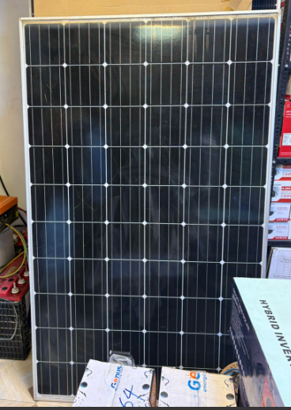\

Figure 4.1: Solar Panel

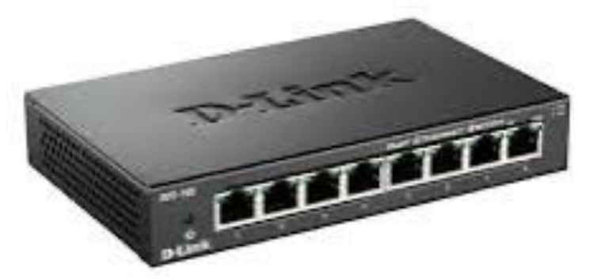

Figure 4.2: Splitter

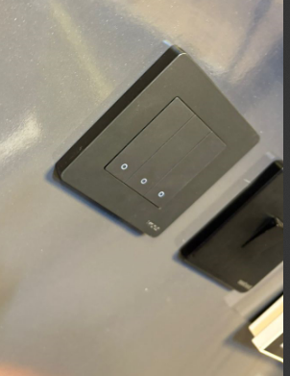

Figure 4.3: Switch Panel

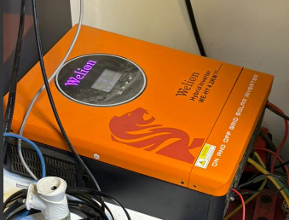

Figure 4.4: Electric Air Controller



Figure 4.5: Battery

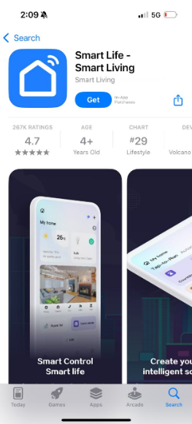

Figure 4.6: Smart Application

4.3 System Design Overview
The system is designed to automatically switch lights ON when it is dark and motion is detected, and switch them OFF when there is adequate ambient light or no motion. It draws energy from a solar panel connected to a charge controller and a battery. The ESP32 microcontroller processes inputs from the LDR and PIR sensors, controls the relay that switches the light, and communicates sensor data to an IoT platform like Blynk or ThingSpeak for remote monitoring and manual override functionality.

4.4 System Architecture
The system comprises the following components:
- Solar Power Unit: Consisting of a solar panel, charge controller, and rechargeable battery for storing and supplying energy.
- Sensors: LDR for ambient light detection and PIR for motion sensing.
- Controller: ESP32, a Wi-Fi-enabled microcontroller that processes sensor data, controls output, and connects to the IoT platform.
- Relay Module: Used to switch the lighting system ON or OFF based on control signals from the ESP32.
- Lighting Output: 12V LED light powered by the battery.
- IoT Interface: A mobile or web dashboard for real-time monitoring and manual control using Blynk or ThingSpeak.
These components interact seamlessly to create a smart lighting system that functions efficiently without human intervention.

4.5 Block Diagram

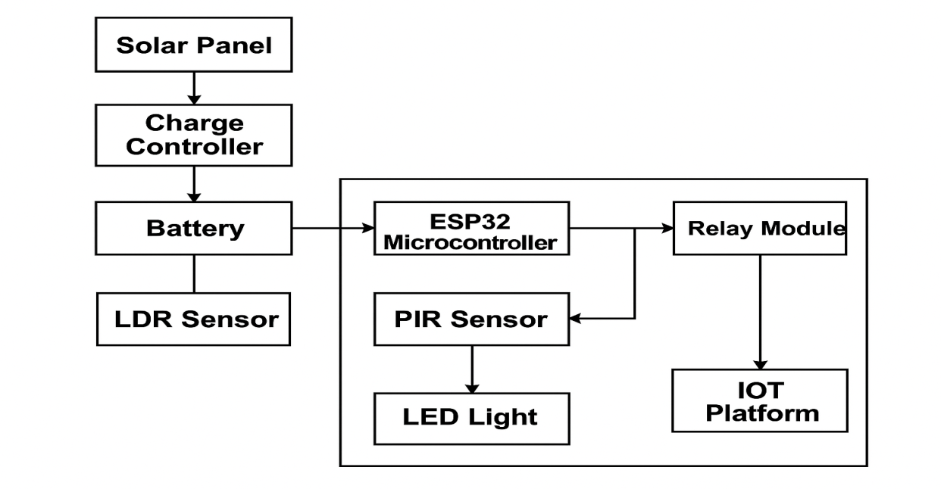

Figure 4.7 Block Diagram

4.5 Flowchart of the System
Here is the logical workflow of the system:
- Start
- Read LDR (light intensity)
- If ambient light is low (dark) → check motion sensor (PIR)
- If motion is detected, turn ON light
- If no motion, keep light OFF or turn OFF if ON
- If ambient light is high, keep light OFF
- Send sensor data to IoT platform
- End (loop)

3.1.3 System Flowchart
Below is the logical flowchart describing the operation of the automated lighting system:
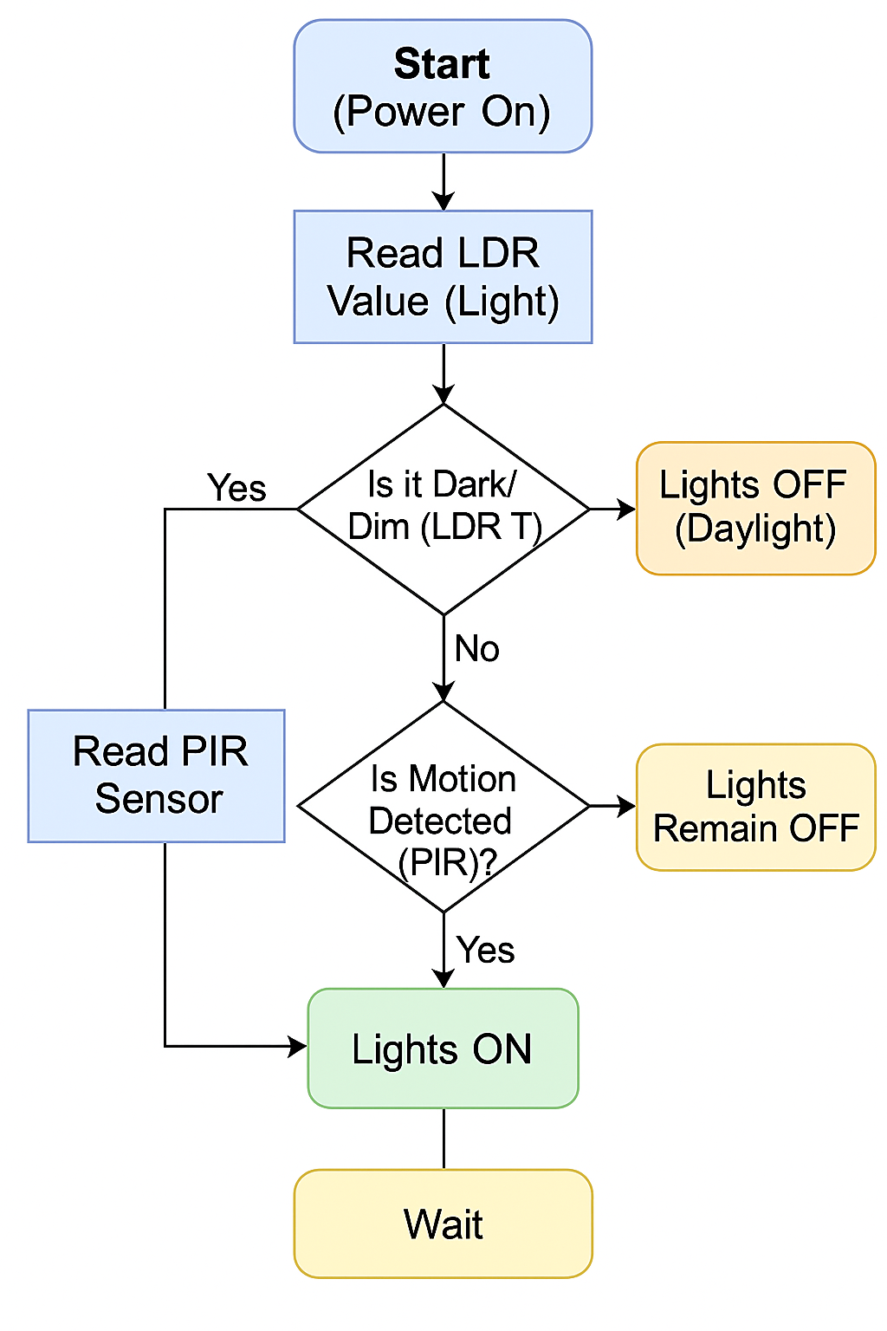

4.6 Software Design and Code Logic
The ESP32 is programmed using the Arduino IDE. The core logic involves:
- Reading analog values from the LDR
- Reading digital motion input from the PIR sensor
- Using threshold comparisons to determine actions
- Sending data to the IoT platform
- Switching the relay ON or OFF accordingly

4.7 IoT Integration (Remote Monitoring & Control)
The system is integrated with an IoT platform such as Blynk or ThingSpeak to allow remote access and control. The ESP32 communicates sensor values and system status to the cloud via Wi-Fi. On the dashboard, users can:
- Monitor LDR and PIR sensor readings
- View light ON/OFF status
- Manually override the light
- Receive alerts based on motion detection
This adds a layer of user interactivity and enhances system accessibility from any location.

4.8 Implementation Process
- Gather and assemble hardware components
- Build the prototype circuit on a breadboard
- Write and upload the code to ESP32 via Arduino IDE
- Test sensor thresholds and response time
- Configure and connect the Blynk/ThingSpeak dashboard
- Deploy the system in a test environment
- Evaluate performance under different lighting and motion conditions

4.9 Testing and Result
Condition | LDR Value | PIR Motion | Light Status | IoT Feedback
Bright Daylight | >1000 | Any | OFF | Logged
Night, Motion | <1000 | YES | ON | Logged
Night, No Motion | <1000 | NO | OFF | Logged
Manual Override | N/A | N/A | ON/OFF | Updated
Results showed that the system successfully automated light control with accurate sensing and timely updates on the dashboard.

CHAPTER FIVE

SUMMARY, CONCLUSION AND RECOMMENDATIONS

5.1 Summary
This study presented the design and implementation of an Automated Solar-Powered Lighting System enhanced with Internet of Things (IoT) capabilities for smart homes. The project addressed the inefficiencies of traditional lighting systems, which often lead to energy wastage, high utility costs, and a lack of intelligent control. The system integrated solar energy harvesting with intelligent lighting control, using an ESP32 microcontroller, Light Dependent Resistor (LDR), and Passive Infrared Sensor (PIR). It operated autonomously, detecting low light conditions and motion to activate lighting, thus conserving energy. Additionally, the system enabled real-time remote monitoring and control through IoT platforms like Blynk, offering users flexibility and improved energy management. The research methodology involved system analysis, hardware and software design, code development, testing, and performance evaluation. Results demonstrated that the system successfully minimized power wastage, ensured reliable lighting during outages, and promoted green energy use. It is scalable, cost-effective, and suitable for integration into modern smart homes.

5.2 Conclusion
The development of this automated lighting system represents a significant advancement toward energy-efficient and intelligent home automation solutions. By integrating solar energy with IoT and sensor technologies, the system proved to be both sustainable and responsive to environmental and user conditions. It overcomes the limitations of manual systems by introducing automation, remote accessibility, and renewable energy dependency. The use of solar panels ensures uninterrupted power supply and reduced electricity bills, while the sensor-based automation guarantees efficient use of lighting resources. Furthermore, the IoT integration bridges the gap between users and devices, empowering users to monitor and control their lighting systems remotely. The project thus aligns with global sustainability goals and smart city innovations.

5.3 Recommendations
Based on the successful implementation and performance of the system, the following recommendations are suggested:
- Scalability Enhancement: Future designs can include support for multiple rooms or outdoor lighting to broaden coverage in larger homes.
- Mobile App Customization: Development of a dedicated mobile app for more intuitive control and configuration beyond generic platforms like Blynk.
- Battery Health Monitoring: Integrate battery performance tracking and notifications to ensure the longevity of the energy storage system.
- Advanced AI Integration: Implement machine learning algorithms to learn user patterns and optimize lighting schedules automatically.
- Security Integration: Combine lighting automation with home security systems (e.g., intrusion detection) for added safety and response.
By implementing these improvements, the system can evolve into a more robust, intelligent, and user-friendly solution that serves not just individual homes but larger residential or institutional facilities.

REFERENCES
Adebayo, T. O., & Olatunde, O. A. (2020). Design and Implementation of an Automated Solar Street Lighting System. Journal of Electrical Engineering and Automation, 7(2), 45–55.
Singh, R., & Kumari, S. (2021). Smart IoT-based Solar Energy Management for Home Automation. International Journal of Smart Grid and Clean Energy, 10(3), 123–131.
Patel, V., & Mehta, R. (2022). IoT Enabled Smart Lighting System using Solar Power and Motion Sensors. International Journal of Computer Applications, 184(17), 25–34.
Ahmad, N., & Yusuf, B. A. (2023). Implementation of a Low-Cost IoT-Based Lighting System for Rural Smart Homes. African Journal of Electronics and Embedded Systems, 12(4), 210–220.
Chen, H., & Liu, Y. (2020). Energy-Efficient Lighting Control Systems Using LDR and PIR Sensors in Smart Buildings. Journal of Sustainable Energy Systems, 6(1), 89–98.
Adewale, R., & Johnson, K. (2021). A Review of Renewable Energy Integration in IoT-Based Smart Home Systems. Nigerian Journal of Engineering Research, 9(3), 70–79.
Zhang, Q., & Wei, X. (2023). A Review of IoT-based Home Automation Systems: Trends and Challenges. International Journal of Automation and Smart Technology, 13(1), 10–20.
Alade, D., & Ogunleye, F. (2022). Solar Energy Adoption for Lighting Automation in Urban Nigeria. Journal of Renewable Power Systems, 5(2), 150–162.
Mohammed, M., & Abubakar, M. (2024). Internet of Things-Based Light Control System Using ESP32 and Blynk. International Journal of IoT and Smart Technology, 15(1), 38–47.
Eze, C. J., & Okafor, E. N. (2025). Development of a Remote-Controlled Lighting System for Energy Efficiency Using IoT and Solar. Journal of Engineering and Intelligent Systems, 18(1), 95–110.

