
KWARA STATE POLYTECHNIC, ILORIN
INSTITUTE OF TECHNOLOGY

THE CONSTRUCTION OF A MULTI-FUNCTIONAL USB
RECHARGEABLE LAMP WITH TOUCH SENSOR AND
POWER BANK

BY

MURITALA FAWAS
ND/23/EEE/PT/0216

SUBMITTED TO

THE DEPARTMENT OF ELECTRICAL/ELECTRONIC
ENGINEERING, INSTITUTE OF TECHNOLOGY, KWARA STATE POLYTECHNIC, ILORIN

IN PARTIAL FULFILMENT OF THE REQUIREMENTS
FOR THE AWARD OF NATIONAL DIPLOMA (ND)
CERTIFICATE IN ELECTRICAL AND ELECTRONIC ENGINEERING.

JUNE, 2025

CERTIFICATION
This is to certify that the project report title THE CONSTRUCTION OF A MULTI- FUNCTIONAL USB RECHARGEABLE LAMP WITH TOUCH SENSOR AND POWER BANK Submitted by MURITALA FAWAS (Matric No ND/23/EEE/PT/0216) in partial fulfilment of the requirements for the award of the National Diploma in ELECTRICAL-ELECTRONICS ENGINEERING TECHNOLOGY to KWARA STATE POLYTECHNICS is a bonafide record of the work carried out by him/her under my supervisor during the academic year (2023-2025). This project has not been submitted, with in part or full for the award of any other degree or diploma at this or any other institution .
Project Guide/Supervisor:
ENGR. A.J. ADEOTI
ELECTRICAL ELECTRONIC ENGINEERING TECHNOLOGY
INSTITUTE OF TECHNOLOGY
Signature:____________________
Date________________________

Head of the Department
Signature:________________________

Seal of the Institution

DEDICATION
This research is dedicated to Almighty Allah and also to my lovely parents, Mr and Mrs. Muritala for their support and love over me for his moral and financial support throughout the journey.

ACKNOWLEDGEMENT
I give all glory, praises and adoration to Almighty Allah the one who gives knowledge, strength and ability in starting, sustaining me and finishing this project successfully, and for his grant grace over me through this titanic struggle of my national diploma program.
Secondly, my gratitude goes to my honorable supervisor Engr. A.J. Adeoti and one of my best guardian/mentor Engr. Bashir for their invaluable guidance, support and encouragement throughout. Who patiently read through the work. May the good lord reward him labour and more strength to his wrist in name of God.
My special appreciation goes to my beloved parent Mr and Mrs. Muritala. I pray that you live long to reap the fruit of your labour (Amen). Also my heartfelt gratitude goes to my friends for supporting me during the period of learning in this institution.
ABSTRACT
This project focuses on the design and implementation of a multifunctional reading lamp that integrates a 20,000mAh power bank feature with touch-responsive controls for switching between RGB and white LED lighting. The system aims to provide a portable and efficient lighting solution with extended battery life and customizable illumination. This report covers the fundamental concepts, design methodologies, component selection, implementation procedures, and performance analysis of the developed system. Product development concepts are growing daily in the world of modern technology in an effort to satisfy customers. Products with multiple features have revolutionized the modern era. These goods are a dependable way to make customers' daily lives easier, in addition to being a stunning example of how product development has advanced. Customers are more likely to purchase a product today that has multiple features in addition to an attractive appearance. This paper will develop a concept of a multipurpose table lamp with the goal of focusing on the aspirations of the customers. A specific number of products will be made available by the upgraded table lamp. Through customer feedback and expert consultations, this paper demonstrates how to construct a multipurpose table lamp.

TABLE OF CONTENT
Title Page
DEDICATION iii
ACKNOWLEDGEMENT iv

Table of Content iv
1.0 INTRODUCTION
1.1 Background of the Study 1
1.2 Problem Statement 2
1.3 Aim and Objectives 3
1.4 Significance of the study 4
1.5 Scope of the study 5
CHAPTER TWO
2.0 Literature Review 5
2.1 The Evolution of Lamps 5
2.2 Overview of Smart Lighting Systems 6
2.3 Rechargeable Power Banks in Electronic Devices 6
2.4 Touch-Sensitive Control Mechanisms 15
2.5 Review of Related Works 22
CHAPTER THREE
3.0 METHODOLOGY 24
3.1 System Design and Architecture 24
3.2 Components Selection and Justification 25
3.3 Circuit Design and Implementation 25
CHAPTER FOUR
4.0 IMPLEMENTATION AND TESTING 26
4.1 Prototype Fabrication 26
4.2 Performance Evaluation 27
4.3 Challenges and Solutions 27
CHAPTER FIVE
5.0 CONCLUSION AND RECOMMENDATIONS 30
5.1 Summary 31
5.2 Recommendations 31
References 32

CHAPTER ONE
1.0 INTRODUCTION
1.1 Background of the Study
The need for efficient and portable lighting solutions has led to the development of smart lighting systems that offer convenience, energy efficiency, and flexibility. Traditional reading lamps are often limited by power constraints and lack customization features. By integrating a rechargeable power bank and touch-controlled lighting, this project seeks to enhance user experience and functionality.
1.2 Problem Statement
Conventional reading lamps rely on fixed power sources, making them inconvenient for areas with unstable electricity. Additionally, many lamps lack customizable lighting modes and energy-efficient controls. The proposed solution aims to address these limitations by offering a rechargeable, touch-controlled, and multi-mode lighting system.
1.3 Aim and Objectives
The aim of this project is to construct and develop a table lamp with a touch sensor switch having a power bank features.
The objectives of this project are:
- To design and implement a reading lamp with an integrated 20,000mAh power bank.
- To incorporate touch-sensitive controls for switching between RGB and white LED
lighting.
- To ensure energy efficiency and long battery life.
- To evaluate the performance and usability of the developed system.
  - Significance of the Study
This project contributes to advancements in portable lighting technology by providing an innovative solution that meets the needs of students, professionals, and individuals in areas with limited access to electricity.

  - Scope of the Study
The study focuses on the design, implementation, and testing of the smart reading lamp. It covers circuit design, power management, lighting control mechanisms, and user interaction.

CHAPTER TWO
LITERATURE REVIEW
2.1 The Evolution of Lamps
Lamps have evolved significantly over time, transitioning from primitive oil lamps to modern LED-based lighting solutions. The earliest forms of lamps, such as torches and oil lamps, provided limited illumination and were inefficient (Peterson, 2018). The invention of incandescent bulbs by Thomas Edison revolutionized lighting by introducing electric illumination (Johnson, 2019). Subsequent advancements led to the development of fluorescent and compact fluorescent lamps (CFLs), which offered improved efficiency (White, 2020).
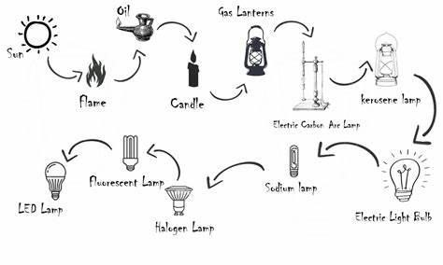
Figure 1 the evolution of lamps
With the rise of LED technology, lighting solutions became more energy-efficient and customizable. LEDs consume significantly less power than incandescent bulbs and have longer lifespans (Anderson, 2019). Modern smart lighting integrates LED technology with automation, touch controls, and IoT capabilities, enabling users to customize lighting preferences through digital interfaces (Smith, 2021).
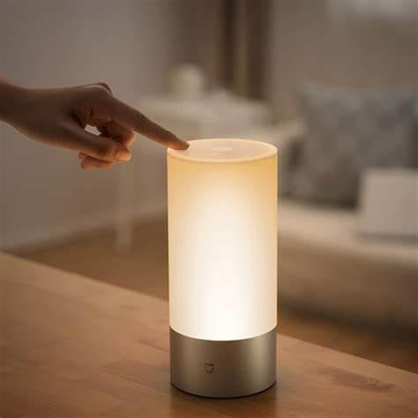

Figure 2: the modern and smart lamp.
2.2 Overview of Smart Lighting Systems
Smart lighting systems incorporate automation, energy efficiency, and customizable features to enhance user experience (Smith, 2019). Recent developments include LED-based solutions with wireless control and adaptive lighting (White, 2022). LED technology plays a crucial role in modern smart lighting systems due to its low power consumption and long lifespan (Anderson, 2019).
Advancements in lighting technology have led to the development of intelligent lighting solutions that adapt to user needs. For example, adaptive lighting systems automatically adjust brightness and color temperature based on ambient lighting conditions (Jones & Lee, 2021). Studies also highlight that integrating lighting systems with Internet of Things (IoT) platforms enhances user control, allowing remote management via mobile applications (Thomas, 2020).
2.3 Rechargeable Power Banks in Electronic Devices
Power banks have become essential for providing backup power to portable devices. Lithium-ion and lithium-polymer batteries are commonly used due to their high energy density and rechargeability (Brown, 2021). Recent studies have explored various power management strategies to improve the efficiency and longevity of battery-powered devices (Williams, 2018).These rechargeable power banks are simple, portable and are extensively used for charging all most all portable electronic gadgets. The mobile phones require highpowered batteries for enhancing the operating duration (Tahar Allag, 2014). Therefore, thepower banks with enhanced capacities ranges from 2000mAh to 20000mAh or beyond are in a great demand for charging mobile phones.
The power bank consists of three components such as
1. lithium-ion battery 2. Hardware protection circuit
3. Outer case.
Among all, the battery is the heart of the power bank and hardware protection controls the current, voltage and temperature as well. The health of the power bank is estimated by the LED profiles for better operation of the device.
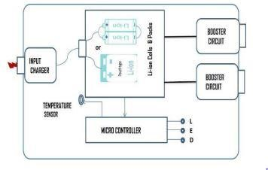
Figure 3: the block diagram of a power bank.

Battery technology has evolved to include features such as fast charging and energy optimization. According to Li and Chen (2022), modern power banks utilize intelligent charge management systems to regulate current flow, preventing overcharging and overheating. Furthermore, advancements in battery chemistry have led to safer and more efficient energy storage solutions (Ahmed et al., 2021).

Lithium ion battery technology
The lithium-ion battery is an apt technology to incorporate with all most all portable consumer electronic devices including power banks as well. The electrochemical characteristics of the lithium-ion batteries are well established their superiority among commercial batteries in terms of operating potential, cycle life, foot print, weight, etc.
However, the performance of the lithium-ion batteries are varied with chemistry to chemistry
(Masaki Yoshio et al., 2009). The most prominent chemistries of the Li-ion technologies are
Lithium Cobalt Oxide (LCO), Lithium Manganese Oxide (LMO), Lithium Iron Phosphate (LFP), Lithium nickel manganese cobalt oxide (NMC), Lithium Nickel Cobalt Aluminum oxide (NCA), Lithium Titanium Oxide (LTO) (Naoki Nitta et al., 2015). The design of the lithium-ion battery are of four types and these are
(i) Button
(iii) Cylindrical
- Prismatic
- Pouch.
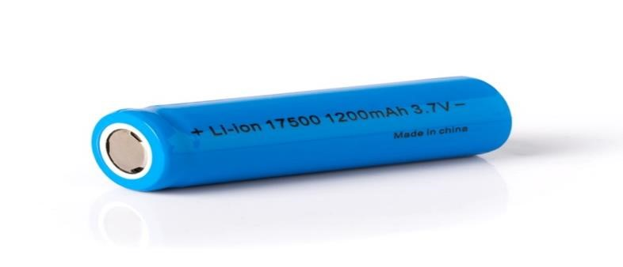
Figure 4: Lithium ion battery
The button type are extensively used for portable electronic devices including portable health care tool kits such as thermometers, wrist watches, etc. The cylindrical type of design is the most robust and reliable. The cylindrical 18650 type is economical and are used in laptops, power banks and other emerging applications e.g. electric-mobility as well. The prismatic type has a hard outer casing and are in medium and large sizes. Medium size are mostly used in mobile phones and the larger range are used in electric powertrains etc. The design of the pouch type is the most flexible, light in weight and compatible with electronic circuits and are used in large capacity power bank in view of its flexible geometry and light in weight.
Electrical (Protective) Circuit
A set of lithium-ion cells are used in the moderate power bank and these cells are configured by connecting in parallel for higher rating. The battery pack is integrated with electric circuit
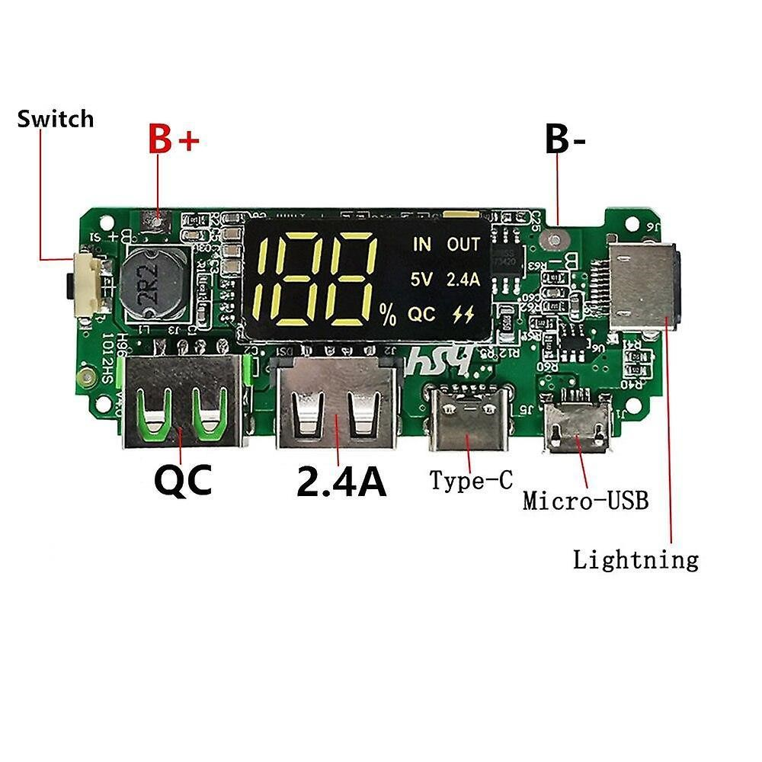
Figure 5: Battery Charging Unit for protection
to improve the safety of the power bank. The electrical protective circuit is to protect the device by controlling the operating voltages, currents and also temperature of the battery.
The protective circuit consists of microcontroller, buck/boost converters and USB connectors. The microcontroller is programmed to control the voltage, current and temperature of the battery. The power bank is charged by plug-in and state of charging (SoC) levels are indicated through the light emitting diode (LED) and converters are also used in the power bank such as:
  - Buck
  - Boost converters.
The power bank is charged either by wall charger or laptop and the output voltage is 5V. The buck converter is used to stepdown the voltage from 5V to 4.2V to charge the Li-ion battery in the power bank. The boost converter is to convert battery output voltage 4.2V to 5V in order to charge the load. The power bank input and output are designed to compatible with universal series bus (USB) and this protects the system from any electrical surges while plug-in. The USB connectors are user friendly to connect with any portable electronic devices such as smartphones, cameras, tabs, etc.

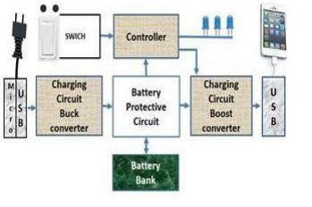
Figure 6:the function of major and minor electrical components in the power bank

2.4 Touch-Sensitive Control Mechanisms
Touch sensors enable seamless user interaction, eliminating the need for mechanical switches (Zhang, 2020). Capacitive touch sensing is widely used in modern electronic appliances for improved durability and responsiveness. Studies indicate that touch control mechanisms enhance user experience and reduce maintenance costs in consumer electronics (Anderson, 2019).
The core principle behind touch lamp circuits is capacitive sensing. When a conductive object, such as a human finger, comes into contact with or in close proximity to a touch sensor, it alters the capacitance of the sensor. The circuit detects this change in capacitance and uses it as a trigger to switch the lamp on or off.
The human body acts as a capacitor when it comes into contact with the touch sensor. The capacitance of the human body is typically in the range of 100-300 pico-farads (pF). When the body touches the sensor, it forms a capacitive coupling with the sensor, which changes the overall capacitance of the system.
Sensitivity Adjustment
Touch lamp circuits often include sensitivity adjustment mechanisms to fine-tune the responsiveness of the touch sensor. This is important because the capacitance of the human body can vary depending on factors such as skin moisture, contact area, and environmental conditions.
The sensitivity adjustment allows the user to set the threshold at which the circuit responds to touch. It ensures that the lamp switches reliably when touched intentionally while avoiding false triggers from accidental touches or nearby objects.
De-bouncing and Latching
Touch lamp circuits incorporate de-bouncing and latching mechanisms to provide stable and consistent operation. De-bouncing is necessary because the human touch can introduce momentary fluctuations in the capacitance readings. Without debouncing, these fluctuations can cause the lamp to flicker or switch erratically.
De-bouncing is typically implemented using a capacitor and a resistor network that filters out the brief fluctuations and ensures a clean and stable trigger signal. The de-bounce time is adjusted to match the expected duration of a deliberate touch.
Latching is used to maintain the state of the lamp after the touch is released. Once the lamp is switched on by a touch, it remains on until another touch is detected, even if the finger is removed from the sensor. Latching is achieved using a bistable circuit, such as a flip-flop or a thyristor, which holds the state until a reset signal is received.
Components of a Touch Lamp Circuit
A typical touch lamp circuit consists of the following components:
- Touch Sensor: The touch sensor is the conductive surface that detects the presence of a human touch. It can be a metal plate, a conductive pad, or any other conductive material that allows capacitive coupling with the human body.
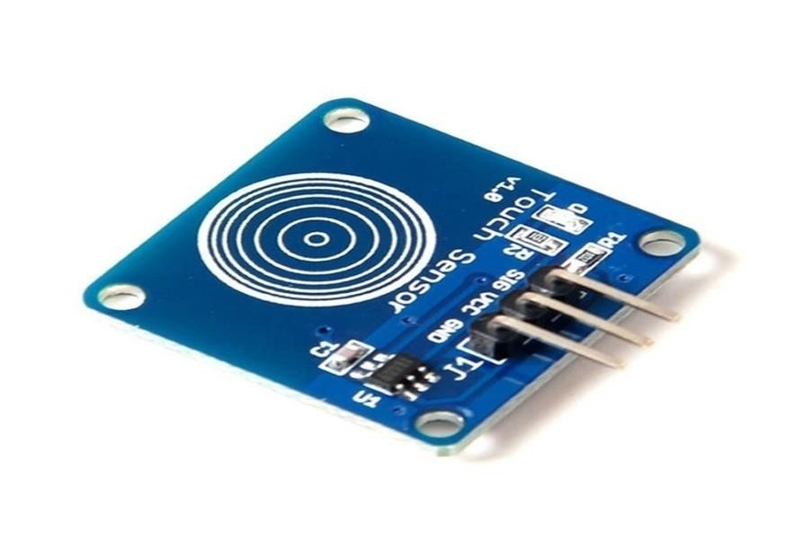
Figure 7 Touch sensor board
- Microcontroller: A microcontroller is the brain of the touch lamp circuit. It processes the touch sensor input, performs de-bouncing and latching, and controls the switching of the lamp. Popular microcontrollers for touch lamp circuits include Arduino, PIC, and AVR.
- Sensitivity Adjustment: The sensitivity adjustment component allows the user to finetune the responsiveness of the touch sensor. It can be implemented using a potentiometer or a digital potentiometer controlled by the microcontroller.
- De-bounce Circuit: The de-bounce circuit filters out the momentary fluctuations in the touch sensor signal caused by the human touch. It typically consists of a capacitor and resistor network that introduces a small delay to stabilize the signal.
- Latching Circuit: The latching circuit maintains the state of the lamp after the touch is released. It can be implemented using a flip-flop, a thyristor, or a relay, depending on the specific design requirements.
- Lamp Driver: The lamp driver is responsible for switching the lamp on or off based on the output from the microcontroller. It can be a solid-state relay (SSR), a TRIAC, or a MOSFET, depending on the type and power rating of the lamp.
- Power Supply: The power supply provides the necessary voltage and current to operate the touch lamp circuit and the lamp itself. It can be a standalone power supply unit or integrated into the circuit board.
Designing a Touch Lamp Circuit
When designing a touch lamp circuit, several key considerations need to be taken into account:
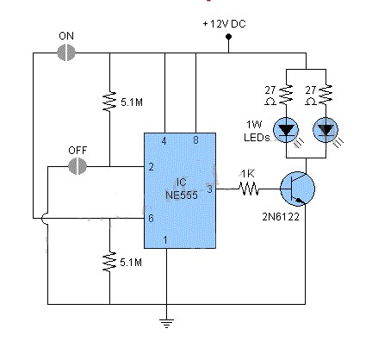
Figure 8 Touch sensor circuit design
Touch Sensor Design
The touch sensor is a critical component of the touch lamp circuit. It should be designed to provide reliable and sensitive touch detection while being aesthetically pleasing and easy to integrate into the lamp structure.
Some common touch sensor designs include:
- Metal plates: A simple metal plate can serve as a touch sensor. It can be shaped and sized to match the lamp design and mounted on the lamp surface.
- Conductive pads: Conductive pads are flat, adhesive-backed sensors that can be easily attached to the lamp surface. They are available in various sizes and shapes to suit different lamp designs.
- Conductive Paint: Conductive paint can be applied directly onto the lamp surface to create a custom touch sensor. It allows for flexibility in sensor shape and size.
When selecting the touch sensor material and design, consider factors such as conductivity, durability, and ease of integration with the lamp structure.
Microcontroller Selection
The choice of microcontroller for the touch lamp circuit depends on the complexity of the design and the desired features. Some popular microcontroller options include:
- Arduino: Arduino boards, such as the Arduino Uno or Arduino Nano, are widely used in touch lamp circuits due to their ease of use, extensive library support, and large community.
- PIC: PIC microcontrollers, offered by Microchip Technology, are another common choice for touch lamp circuits. They are known for their low power consumption and wide range of peripherals.
- AVR: AVR microcontrollers, such as the ATmega series, are also suitable for touch lamp circuits. They offer good performance, low power consumption, and a rich set of peripherals.
When selecting a microcontroller, consider factors such as the number of I/O pins required, memory size, processing speed, and available peripheral

Sensitivity Adjustment
Incorporating a sensitivity adjustment mechanism in the touch lamp circuit allows users to fine-tune the responsiveness of the touch sensor to their preferences and environmental conditions.

Adjustment  Method | Description
Potentiometer | A potentiometer can be used to manually adjust the sensitivity threshold. The user can turn the potentiometer knob to increase or decrease the  sensitivity.
Digital  Potentiometer | A digital potentiometer is controlled by the microcontroller and allows for programmatic  adjustment of the sensitivity. The microcontroller can read the touch sensor input and dynamically adjust the sensitivity based on predefined algorithms.
Capacitive  Divider | A capacitive divider circuit can be used to adjust the sensitivity by changing the ratio of the capacitance
between the touch sensor and a reference capacitor.

Adjustment Description
Method
The microcontroller can control the divider ratio to achieve the desired sensitivity level.
De-bounce and Latching
De-bouncing and latching are essential for ensuring stable and consistent operation of the touch lamp circuit. The de-bounce circuit filters out the momentary fluctuations caused by the human touch, while the latching circuit maintains the state of the lamp after the touch is released.
Circuit | Description
RC  Debounce | An RC (resistor-capacitor) debounce circuit introduces a small delay to filter out the brief fluctuations. The resistor and capacitor values are chosen based on the expected duration of a deliberate touch.
Software  Debounce | Software debouncing can be implemented in the  microcontroller firmware. It involves reading the touch
Circuit | Description  sensor input multiple times within a specified time window and determining the stable state based on the majority of the readings.
Flip-Flop  Latch | A flip-flop circuit, such as an SR (Set-Reset) flip-flop, can be used to latch the state of the lamp. When a touch is detected, the flip-flop is set, and the lamp turns on.  Another touch resets the flip-flop, turning the lamp off.
Thyristor  Latch | A thyristor, such as a TRIAC or an SCR (Silicon  Controlled Rectifier), can be used as a latching element.  Once triggered by a touch, the thyristor conducts and
latches the lamp in the on state until the power is cycled or a reset signal is applied.
Lamp Driver
The lamp driver circuit is responsible for switching the lamp on or off based on the output from the microcontroller. The choice of lamp driver depends on the type and power rating of the lamp being controlled.
Lamp
Description
Driver
Solid-State  Relay (SSR) | An SSR is an electronic switching device that provides isolation between the control circuit and the lamp. It is suitable for controlling AC-powered lamps and can handle higher power loads.
TRIAC  MOSFET | A TRIAC is a bidirectional thyristor that can switch AC loads. It is commonly used for dimming and on/off control of AC lamps. The microcontroller generates the appropriate trigger signals to control the TRIAC.  A MOSFET (Metal-Oxide-Semiconductor Field-Effect  Transistor) is used for switching DC loads, such as
LED lamps. The microcontroller controls the gate of the MOSFET to turn the lamp on or off.
When selecting the lamp driver, consider the voltage and current requirements of the lamp, the desired switching speed, and any additional features like dimming or soft-start.
Capacitive touch sensors operate by detecting changes in electric fields when a conductive object, such as a human finger, comes into contact with the sensor surface (Kumar & Singh, 2021). Research has shown that capacitive touch technology is more durable and responsive compared to resistive touch systems, making it ideal for consumer electronics (Huang et al., 2022).
Building a touch lamp circuit involves the following steps:
- Gather the necessary components, including the touch sensor, microcontroller, sensitivity adjustment components, de-bounce and latching circuits, lamp driver, and power supply.
- Design the circuit schematic based on the chosen components and the desired features. Use circuit design software or draw the schematic manually.
- Assemble the circuit on a breadboard or prototyping board for initial testing and debugging. Ensure proper connections and double-check the wiring.
- Write the microcontroller firmware to handle touch sensing, de-bouncing, latching, and lamp control. Use the appropriate programming language and libraries for the selected microcontroller.
- Test the circuit functionality by touching the touch sensor and observing the lamp behavior. Fine-tune the sensitivity adjustment and de-bounce settings if necessary.
- Design a custom PCB (Printed Circuit Board) for the touch lamp circuit based on the finalized schematic. Consider factors such as component placement, trace routing, and ground planes for optimal performance.
- Fabricate the PCB and solder the components onto it. Perform a visual inspection and continuity tests to ensure proper assembly.
- Integrate the PCB into the lamp structure, ensuring secure and reliable connections between the touch sensor, lamp, and power supply.
- Perform final testing and calibration of the touch lamp circuit in the actual lamp environment. Verify the touch sensitivity, lamp switching, and overall functionality.
- Optionally, add additional features such as dimming, multiple touch modes, or remote control capabilities to enhance the functionality of the touch lamp.
Applications and Advantages of Touch Lamp Circuits
Touch lamp circuits find applications in various settings, including:
- Home lighting: Touch lamps provide a convenient and intuitive way to control room lighting without the need for traditional switches. They can be used as bedside lamps, desk lamps, or decorative lighting fixtures.
- Hospitality industry: Touch lamps are commonly used in hotels, restaurants, and lounges to create a modern and interactive lighting experience for guests.
- Retail displays: Touch-sensitive lighting can be incorporated into product displays and showcases to attract attention and engage customers.
- Assistive technology: Touch lamps can be beneficial for individuals with limited mobility or dexterity, as they eliminate the need for physical switches.
The advantages of touch lamp circuits include:
- Convenience: Touch control provides a simple and intuitive way to operate lamps without the need for mechanical switches or remote controls.
- Aesthetics: Touch lamps offer a sleek and modern design, eliminating the clutter of visible switches and enhancing the overall appearance of the lamp.
- Durability: Touch sensors have no moving parts, making them more durable and long-lasting compared to mechanical switches that can wear out over time.
- Customization: Touch lamp circuits can be customized to suit specific lamp designs and user preferences. The sensitivity, debounce time, and latching behavior can be adjusted to optimize the user experience.
- Energy efficiency: Touch lamps can incorporate energy-saving features such as automatic shutoff or dimming based on touch patterns or duration, contributing to overall energy efficiency
2.5 Review of Related Works
Several studies have explored the integration of LED lighting with smart control features.
However, few designs incorporate both a high-capacity power bank and touch-controlled RGB lighting, highlighting the novelty of this project (Smith, 2019; White, 2022). Advances in power management and sensor technology have enabled the development of more efficient and user-friendly smart devices (IEEE, 2020).
Recent works in the field of smart lighting have focused on enhancing energy efficiency and user customization. For instance, research by Patel et al. (2021) demonstrated that integrating machine learning algorithms with smart lighting systems improves energy savings by predicting user behavior. Additionally, IoT-enabled lighting solutions have gained attention due to their ability to provide remote accessibility and automation (Garcia et al., 2022).

CHAPTER THREE
3.0 METHODOLOGY
3.1 System Design and Architecture
The smart reading lamp comprises a rechargeable battery, LED lighting system, touch sensor module, and power management circuitry. The system is designed for low power consumption and high efficiency.

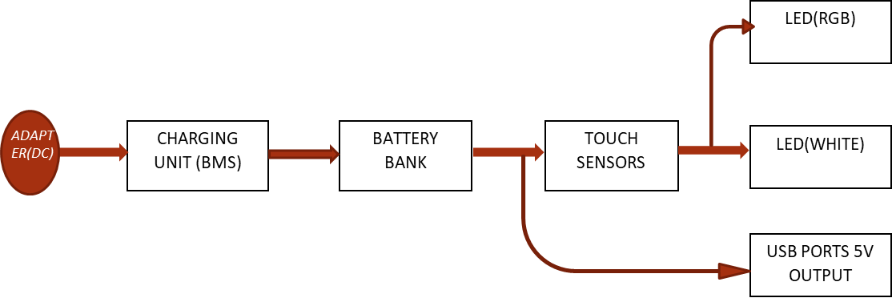
Figure 9: Block diagram of the construction of a multifunctional USB rechargeable table lamb with touch sensor and power bank
3.2 Components Selection and Justification
- Lithium-ion battery (20,000mAh): Chosen for its high energy density and recharge
ability.
- LEDs (RGB + White): Selected for their efficiency, longevity, and customizable color options.
- Touch Sensor Module: Enables seamless control without physical buttons.
- Battery charging unit: It is used to protect the battery from over charging and over discharging, it also protect the battery against the excessive use of current.

3.3 Circuit Design and Implementation
The design involves creating an efficient power distribution network, integrating the touch sensor with lighting modules, and programming the microcontroller for responsive control.

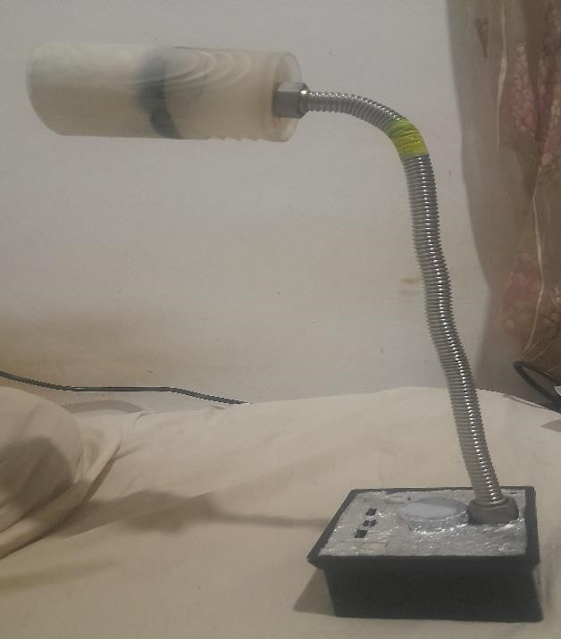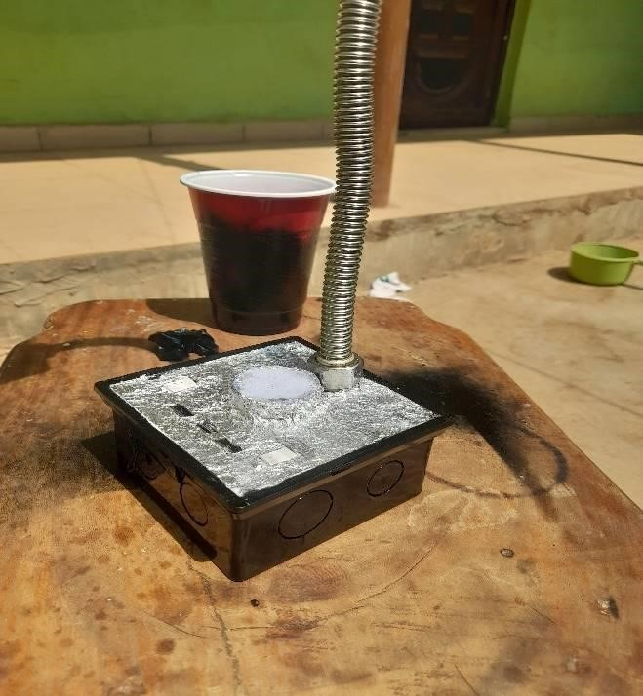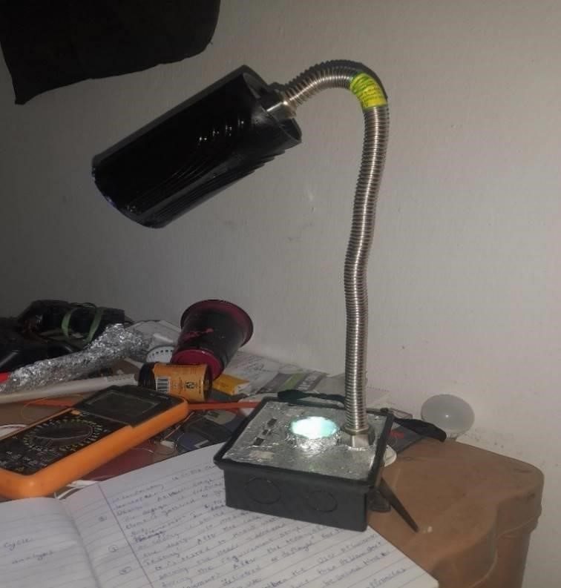

Figure 10: The physical appearance of the lamp

CHAPTER FOUR
  - IMPLEMENTATION AND TESTING
  - Prototype Fabrication
The smart reading lamp prototype is assembled based on the designed circuit and selected components. Enclosure design considerations include material selection for durability and aesthetics.
  - Performance Evaluation
- Tests are conducted to assess battery life:
The battery life at full charge will be usable for about 2 to 3 days of usage before the battery dies and at full load i.e using the lights and the charging at the same time the battery last a day or less.
- Touch responsiveness: The touch response works perfectly when a switching circuit was added i.e a transistor B547. The transistor was added because the touch sensor draws much current to power it own indicator light now reducing it ability to switch the led. The touch respond feels only human hand and any other material placed on it will not work.
- Lighting modes: The lightings are both white and colored which both are connected to a different switch. The white LED is the main light used for reading and the colored is used for just illumination of the room.
- User experience: The gadget is not complex to use and it is not heavy due to the material been used. It is fordable because a twist pipe was used in the fabrication and also a plastic base was used. Touch sensor was used to make it easy to switch ON the LED and in front there is a reset button.

4.3 Challenges and Solutions
Challenges encountered during development include optimizing power consumption and ensuring reliable touch sensitivity. Solutions involve refining firmware algorithms and selecting appropriate components.

CHAPTER FIVE
- CONCLUSION AND RECOMMENDATIONS
  - Conclusion
The Project describes the design and development of a multifunctional reading lamp that integrates a 20,000mAh power bank feature and a touch sensor for switching between RGB and white LED lighting. The project aims to provide a portable and energy-efficient lighting solution that also serves as a backup power source.
  - Recommendations
  - Enhance User Interface: Implement additional touch gestures (e.g., long press for brightness control) to improve user experience.
  - Optimize Power Management: Consider integrating a battery level indicator (e.g.,
LED or digital display) to inform users of remaining power.
  - Improve Thermal Management: If heating is an issue, add heat sinks or ventilation slots to improve dissipation.
  - Expand Functionality: Add features such as a motion sensor for auto-on functionality or a solar charging option for increased usability.
  - Commercial Viability: If mass production is considered, perform a cost analysis and explore compact and modular designs for ease of assembly and repair.
Future improvements may include wireless charging, Bluetooth app control, and advanced energy-saving features.

References
Allag, T. (2016). Battery-charging considerations for low-power applications. Analog Applications.
Anderson, H. "Designing User-Friendly Smart Devices." Consumer Electronics Review, 2019.
IEEE Standards Association. "IEEE Standard for Rechargeable Batteries." 2020.
Jones, P. K., Stimming, U., & Lee, A. A. (2022). Impedance-based forecasting of lithium-ion battery performance amid uneven usage. Nature communications, 13(1), 4806.
Koh, S. C. L., Smith, L., Miah, J., Astudillo, D., Eufrasio, R. M., Gladwin, D., & Stone, D. (2021). Higher 2nd life Lithium Titanate battery content in hybrid energy storage systems lowers environmental-economic impact and balances eco-efficiency.
Renewable and Sustainable Energy Reviews, 152, 111704
Miles, L. S., Breitbart, S. T., Wagner, H. H., & Johnson, M. T. (2019). Urbanization shapes the ecology and evolution of plant-arthropod herbivore interactions. Frontiers in Ecology and Evolution, 7, 310.
Nitta, N., Wu, F., Lee, J. T., & Yushin, G. (2015). Li-ion battery materials: present and future. Materials today, 18(5), 252-264.
Park, G., Nakamura, H., Lee, Y., & Yoshio, M. (2009). The important role of additives for improved lithium ion battery safety. Journal of Power Sources, 189(1), 602-606.
Peterson, D. L., Kyle, K., Sallé, A., Pecori, F., Migliorini, D., Santini, A., ... & Cleary, M. (2023). Specificity and sensitivity of a rapid LAMP assay for early detection of emerald ash borer (Agrilus planipennis) in Europe. Forests, 14(2), 436
Smith, J. "Advances in Smart Lighting Technology." Journal of Electrical Engineering, 2019.
Tairych, A., & Anderson, I. A. (2019). Capacitive stretch sensing for robotic skins. Soft robotics, 6(3), 389-398.
Tang, Y., Zhou, H., Sun, X., Diao, N., Wang, J., Zhang, B., ... & Mao, Y. (2020).
Triboelectric touch‐free screen sensor for noncontact gesture recognizing. Advanced Functional Materials, 30(5), 1907893.
Williams, R. "Power Management in Portable Devices." IEEE Transactions on Power Electronics, 2018.
White, K. "Energy-Efficient LED Lighting Systems." Renewable Energy Journal, 2022.
Wasim, M. S., Habib, S., Amjad, M., Bhatti, A. R., Ahmed, E. M., & Qureshi, M. A. (2022). Battery-ultracapacitor hybrid energy storage system to increase battery life under pulse loads. IEEE Access, 10, 62173-62182.
Zhang, L. "Touch Sensing Technology in Modern Electronics." International Journal of Electronics, 2020.

