BENEFICIATION OF SPODUMENIC ROCK FROM LADE , KWARA STATE , FOR RECOVERY OF LITHIUM AND SOME OTHER CRITICAL MINERALS
BY

SOLIU MONSURAT BISOLA
HND/23/MNE/FT/0003

SUBMITTED TO
THE DEPARTMENT OF MINERAL AND PETROLEUM RESOURCES ENGINEERING TECHNOLOGY, INSTITUTE OF TECHNOLOGY, KWARA STATE POLYTECHNIC, ILORIN

IN PARTIAL FULFILLMENT OF THE REQUIREMENT FOR THE AWARD OF HIGHER NATIONAL DIPLOMA (HND) IN MINING ENGINEERING TECHNOLOGY

JULY 2025

CERTIFICATION
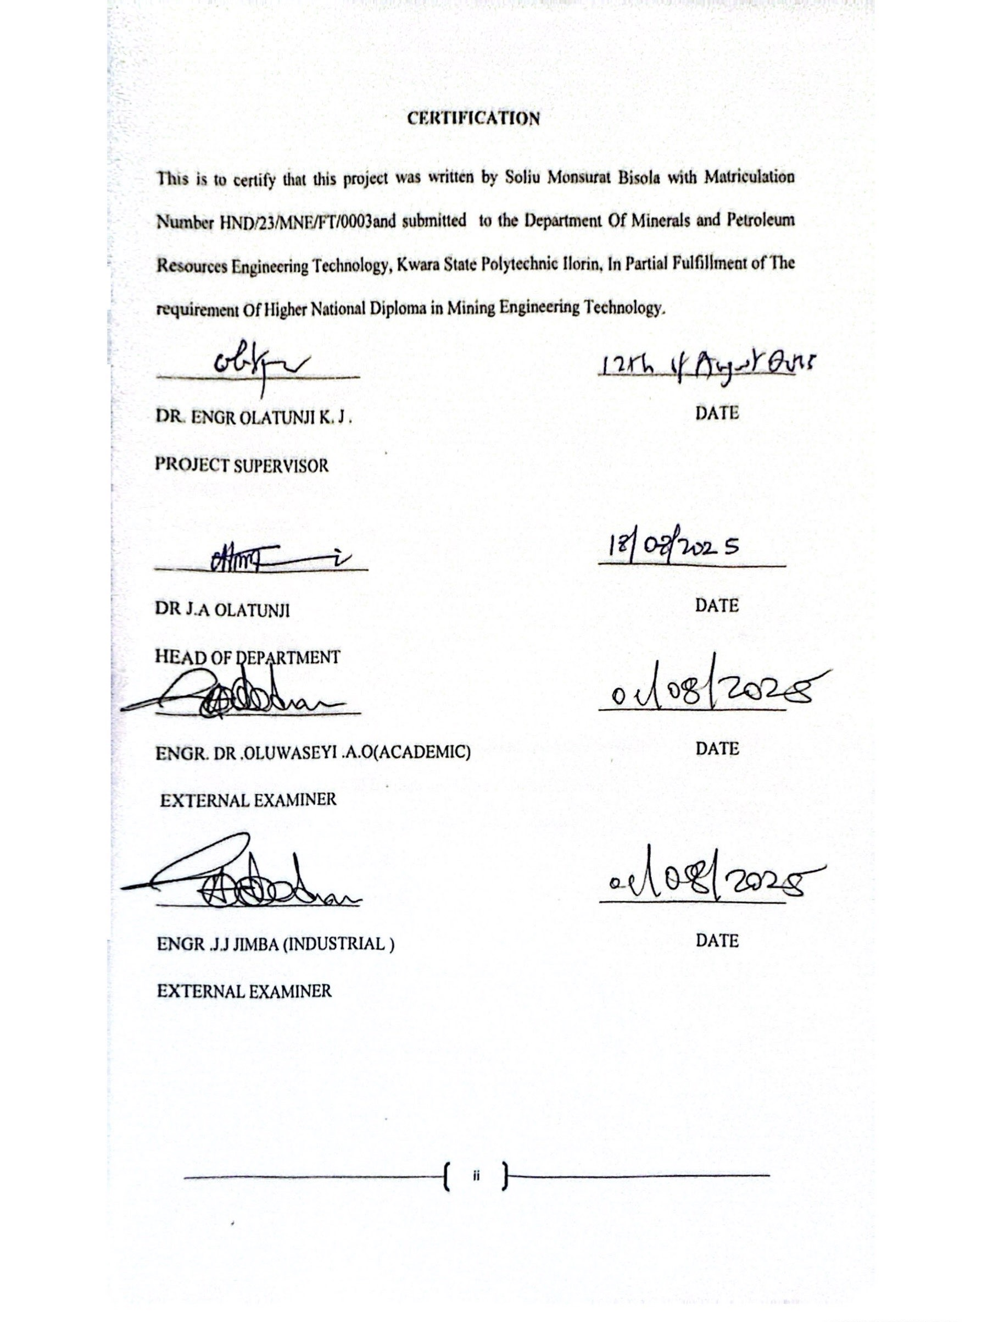

DEDICATION
I dedicate this project work to almighty Allah for his sufficient mercy over me throughout the course of the project

ACKNOWLEDGEMENT
All glory, honor and adoration be unto almighty Allah for his mercy and protection over my life and for the opportunity that he gave me for writing this project, may his name be glorified.
My gratitude goes to my loving parent Mr. and Mrs. Abdulwahab for their prayers, advice and support throughout my HND program.
Likewise, my appreciation goes to my project supervisor in person of Engr. Dr. Olatunji. K.J for the fatherly role he played throughout the course of this research work, may almighty Allah reward you abundantly.
My appreciation also goes to the Head Of Department Of Minerals And Petroleum Resources Engineering Technology in person of Engr Olatunji J.A and to all my departmental lecturers for the knowledge they have impacted in me throughout my higher national diploma, may almighty Allah reward you abundantly.
My appreciation goes to my friends in person of Abdulfatai sodeeq Olamilekan (biggy banty) for his support .
My appreciation won’t stop until it extends to my project partners bolaji , Monsurat and Appolus for the sincerely love we shared during this research work .
I remain disloyal if I drop my pen without appreciating my partner in success , my big brother , my man in person of Oluwanishola Tijani Aremu (Tj ciro) for his support, advice and encouragement throughout my program, may almighty Allah be with him and bless him beyond his imagination. I appreciate you all, I will live to always remember your good deeds.

ABSTRACT
This project investigates the beneficiation of spodumenic rock from the Lade area of Kwara State, Nigeria, with the aim of recovering lithium and other critical minerals. Froth flotation tests were conducted using sodium oleate-based collectors, calcium chloride as activator, and sodium silicate as depressant. While lithium was not detected in the ore, chemical analysis of the flotation products revealed significant concentrations of silicate minerals, primarily SiO₂, along with and trace Al₂O₃, Fe₂O₃, levels of other oxides. The beneficiation process improved the concentration of these oxides, indicating potential for industrial use in ceramics, glass, and metallurgy. Although lithium was absent, the study highlights the mineralogical value of the Lade deposit and provides a basis for further investigation into alternative economic uses of the ore .

TABLE OF CONTENTS
Title Page i
Certification ii
Dedication iii
Acknowledgements iv
Abstract v
Table of Contents
List of tables
List of figures
Chapter One – Introduction
1.1 Aims and Objectives 2
1.2 Statement of the Problem 2
1.3 Justification 2
1.4 Scope of the Study 3
Chapter Two – Literature Review
2.1 Physical and Chemical Properties of Lithium and Other Critical Minerals 4
2.2 Formation and Occurrence of Lithium and Other Critical Minerals 5
2.3 Industrial Applications of Lithium and Other Critical Minerals 6
2.4 Froth Flotation of the Spodumenic Ore 7-8
Chapter Three – Materials and Methods 9
3.1 Description of the Study Area 9-10
3.2 Sample Collection 10-12
3.3 Sample Preparation 13
3.4 Laboratory Procedures of Froth Flotation of the Ores 13-14

Chapter Four – Results and Discussion
4.1 Grades of the Ore 15-16
4.2 Result of the Froth Flotation Procedures 17-18
4.3 Change In The Concentration After Beneficiation 19-20
Chapter Five – Conclusion and Recommendations
5.1 Conclusion 21
5.2 Recommendations 21
References 22-23
List of figures
Fig 3.1: Map Of Kwara State Showing The Location 10
Fig 3.2 Spodumenic Rock 11
Fig 3.3 Geoligic Hammer 11
Fig 3.4 Jaw Crusher 12
Fig 3.5: Ball Mill 12
Fig 3.6: Sieved Mineral 13
Fig 3.7: Flotation Cell 14
List of tables
Table 4.1: Elemental And Oxides Of Crititcal Minerals In Crude 15
Table 4.2: Result Of Beneficiation 17
Table 4.3: Change In The Concentration After Beneficiation 1
CHAPTER ONE
INTRODUCTION
Lithium ore is one of the most sought-after minerals of the 21st century due to its versatile applications, especially in the fields of sustainable energy and advanced electronics. The global demand for lithium has surged in recent years with the rise of electric vehicles (EVs), portable electronics, and renewable energy storage systems. Lithium-ion batteries, which power these systems, are widely used due to their high energy density and rechargeability (Goodenough and Park, 2013).
One of the most important sources of lithium is spodumene, a lithium–aluminum inosilicate mineral with the chemical formula LiAl(SiO₃)₂. Spodumene is favored in lithium production because it often contains relatively high lithium content and allows for straightforward processing compared to other lithium sources such as lithium brines (Gruber et. al., 2011).
In addition to lithium, spodumene-rich rocks often contain other critical minerals that are of growing strategic interest. These include elements like silicon (used in electronics and solar photovoltaics), aluminum (valued for its strength-to-weight ratio and corrosion resistance), iron, potassium, and calcium (commonly used in fertilizers and construction). Some of these elements, though present as gangue minerals, represent untapped resources that may have industrial or commercial value (Gambogi, 2022; Cordell et. al., 2009).
The global shift toward cleaner energy technologies has greatly intensified the search for critical minerals, particularly lithium. While Nigeria is not yet recognized as a major lithium producer, several areas—including Lade in Kwara State—have shown geological signs of spodumenic pegmatites, prompting interest in their exploration and beneficiation.
1.1 Aim of The Study
The main aim of this project is to study the optimal beneficiation method of lithium and critical minerals’ ores from Lade Pategi Local Government Area of Kwara State, Nigeria.
1.2 Objectives Of The Topic
1. To characterize the mineralogical composition of spodumene ores and critical minerals.
2. To optimize froth flotation method technique
1.3 Statement of the problem
Lithium is a vital element in the global transition to green energy. Its primary sources include brine and hard rock deposits with hard rock sources like spodumene and lepidolite accounting for a significant share of global production . Effective Beneficiation is critical to separate lithium bearing minerals and of other critical minerals from gangue material,enhance ore grade and reduce processing costs. Despite advancements in, challenges such as fine particle liberation, reagent optimization, and energy consumption remain still persist .
1.4 Justification
Despite the abundance of spodumene deposits, traditional lithium extraction particles are often selective and disregard other potentially valuable components in the ore. This leads to low resource efficiency and environmental burdens due to increased waste generation. Lithium,a critical component in modern technology has seen a surge in demand due to its use In batteries for electric vehicles, smartphones, and energy storage system. This increased demand has spurred exploration and mining of lithium ores world wide . The distribution of benefits from this industry is uneven, with certain stakeholders benefiting more than others.

1.5 Scope of the Study
The study cover sampling of the ore, determining the grade of the sample and carrying out of froth flotation experiment on the samples from the study area to recover lithium and some other critical minerals.

CHAPTER TWO
LITERATURE REVIEW
2.1 Physical and Chemical Properties of Lithium and Other Critical Minerals
Lithium is a soft , silvery white alkali metal and the lightest known metallic element. It is highly reactive , especially with water , and has strong electrochemical properties that make it ideal for energy storage applications. It possesses the following properties: atomic number 3, atomic weight: 6.94, density: 0.534g/cm3, melting point: 180.5c, boiling point 1342c, common minerals are spodumene, lepidolite, solubility: forms water soluble salts like lithium carbonate (Li₂Co₃) and lithium hydroxide (LiOH). in spodmene, lithium exists as a tightly bound ion in the crystal lattice and requires thermal conversation before leaching can occur (Tadesse and Makuei, 2020).
Vanadium (V) is a transition metal used mainly in alloy steels and emerging battery technologies. It exhibits multiple oxidation states, mainly +3, +4, and +5 , which allow it to form a variety of oxides and soluble complexes , atomic number: 23, atomic weigh : 50.94, density: 6.11g/cm3, melting point: 191^{O}c , boiling point : 3407c , common minerals : vanadinite and titanomanetite , and mica hosted vanadium, solubility : varies with oxidation state commonly processed as vanadium pentoxide ( V₂O₅) . Vanadium may be found as minor element in clays or accessory minerals in pegmatites and can be recovered through acid or alkaline earth metal commonly found in sedimentary rocks and silicate minerals. It is a reactive metal and an essential component in various industrial applications. In spodumenic ores, calcium bearing minerals may act as a gangue and influence flotation behavior or acid consumption during leaching ( Gupta and Krishna Murthy, 2005). Pottasium is a soft, highly reactive alkali metal used mainly in fertilizers and chemical processing, it readily forms water soluble salts, In spodumene ores, potassium bearing minerals may be recovered as by product during flotation or roasting (Cordell et.al; 2009). Silicon is a mettaloid widely used in electronics and solar cells. It is a fundamental component of most rock forming minerals, silicon is not typically recovered as a standalone product from spodumene beneficiation but plays a structural role in the mineral matrix (Deer et.al; 2013).
Aluminum is a light weight, ductile metal with amphoteric chemical behavior, it is the most abundant metal in the earth’s crust. In spodumene, aluminum is a structural component and can be recovered through roasting and leaching processes, although it’s typically not the primary target (Tadesse and Makuei, 2020) .
2.2 Formation And Occurrence Of Lithium And Other Critical Minerals
Lithium is concentrated in the late stages of magma crystallization and becomes enriched in residual melt. These melts form granitic pegmatites, where lithium bearing minerals such as spodumene and lepidolite (kesler, 1994).
In sedimentary settings , lithium occurs in continental brine deposits, typically found in closed basin saline lakes or playas. Lithium accumulates through evaporation and weathering of volcanic rocks in arid environments (Gruber et.al; 2011).
The most economically significant hard rock lithium sources are pegmatite hosted deposits like those found in Australia (Greenbushes), Canada and parts of Africa. Brine sources, such as the lithium Triangle (Chile, Argentina, Bolivia) are dominant globally but are less associated with solid mineral beneficiation.
Vanadium occurs in a range of geological environments, often as a dispersed trace element in minerals such as titanomagnetite, clay minerals, phosphate rocks and shales. It is commonly found in mafic and ultra mafic igneous rocks, where it substitutes for iron or titanium in minerals like magnetite or ilmenite ( Moss et.al; 2013 ) .
Calcium is one of the most abundant elements in the earths crust and is primarily sourced from carbonate rocks and silicate minerals . It is formed through igneous and sedimentary processes, occurring in minerals such as calcite ( CaCo₃) dolomite Ca(Mg) (Co₃)₂, anorthite and apatite .
In sedimentary environments, calcium is abundant in limestones and dolostone, formed by chemical precipitation or biological activity in marine settings (Deer et.al; 2013).
2.3 Industrial Application Of Lithium And Other Critical Mineral
Lithium is a cornerstone of the modern energy transition and is most widely known for its uses in lithium ion batteries, over 70% of lithium demand is for rechargeable batteries used in electric vehicles (Evs) , portable electronics , and renewable energy storage system ( IEA, 2022). Glass and ceramics lithium compounds improve thermal shock resistance and strength of specialty glasses and ceramics .
Vanadium is a transition metal with key uses in metallurgy and energy storage .it is used in steel industry. Vanadium is used in small quantities (20.1%) to produce high strength low alloy (HSLA) steels for construction, pipelines and tools (Gambogi, 2022). It is used in vanadium redox flow batteries which are ideal for grid scale renewable energy storage due to their long cycle life and safety. Calcium has extensive applications in construction, metallurgy and chemicals , calcium carbonate (CaCo₃) is a major component of cement, lime and concrete, essential in infrastructure development. Calcium salts serve as dietary supplements and acidity regulators, calcium hydroxide (slaked lime ) is used for ph adjustment and softening water .
Potassium is crucial in agriculture, chemical production and industrial processes over 90% of global potassium consumption is in the form of potash, a key macro nutrient for plant growth (cordell et.al; 2009).
Potassium compounds lower the melting point and improve the durability of specialty glass .
Silicon is a foundational element in the electronics and solar industries, high purity silicon (99.9999%) is used in integrated circuits, computers and telecommunications. Silicon is the key material in photovoltaic cells used in solar energy generation, silicon is added to aluminum and steel to improve strength and corrosion resistance.
Aluminum used in aircraft, cvs, and lightweight vehicles components to reduce fuel consumption and emissions.Aluminum is used in doors , windows, roofing and cladding due to its durability and low maintenance.
2.4 Froth Flotation of the Spodumenic ore
Froth flotation is a process that uses air bubbles to separate lithium ore from other minerals. It’s a widely used method for Beneficiating lithium ore. Froth flotation is used because of the difference in the physiochemical properties of the mineral surfaces. The ore particles with strong surface hydrophobicity stick to the bubbles and float. Below are the steps in froth flotation
1. Grinding: breaking the ore into smaller pieces so that the useful minerals separates
2. Adjusting concentration: adjust the concentration of the ore slurry
3. Adding reagents: Add chemicals that help the ore particles attach to the air bubbles.
4. Flotation : The ore particles attach to the bubbles and float to the surface of the slurry
5. Separating : separate the foam that contains the ore from the tailings
6. Sorting : separate the valuable minerals from the gangue minerals (Tadesse and Makuei) 2020.

CHAPTER THREE
MATERIALS AND METHOD
3.1 Description of Study Area
Lithium ore samples was collected from deposit at Lade , Pategi Local Government Area of Kwara state . Lade is a rural community located in the Pategi Local Government Area of kwara state, Nigeria. The area is predominantly inhabited by the Nupe speaking people, who have traditionally England in farming as their primary occupation. In recent years, Lade has experienced a significant shift in its economic activities due to the discovery of lithium deposits in the region, this has led many residents to transit from farming to artisanal mining.
This transformation has turned Lade into a notable site for lithium extraction, attracting attention from various stake holders interested in the minerals potential. The climate of the area Lade; located in the Guinea Savannah zone of Nigeria, experiences a tropical Savanah climate characterized by two main seasons which are rainy season : April to October and dry season : November to March , average annual rainfall is around 1000 to 1500mm. The natural vegetation is that of the Guinea Savannah, featuring tall grasses and scattered trees, during the rainy season, the area becomes lush and green, while the dry season brings browner, sparser vegetation due to moisture loss .
However, recent Mining in Lade have started to impact the natural landscape and may lead to gradual vegetation degradation if not managed sustainably. Geographically it lies at approximately on 8.7589%N latitude and 5.616 longitude, with an elevation of about 83 meters (272 feet ) above sea level( Geonames,2024).
Fig 3.1 shows map of Kwara state showing the location of Lade

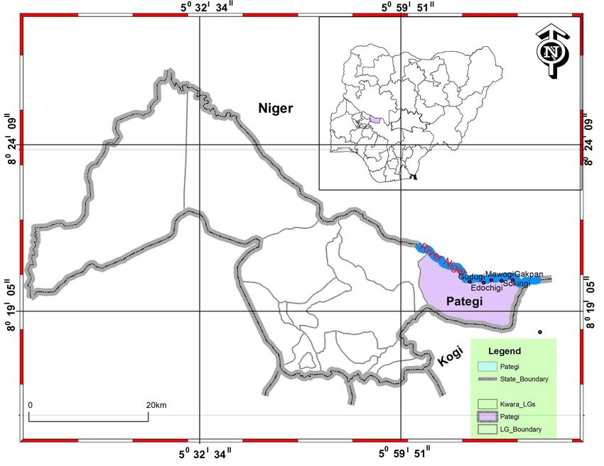
Fig. 3.1: map of Kwara state showing the location of Lade Pategi Local Government ( Abiodun olabode,. 2011).
3.2 Sample Collection
Fifty kilogram (50kg) of lithium ore was collected from Lade , Pategi Locak Government Area of Kwara State Nigeria. The sizes of grains of ore sample was reduced to about 50mm using a geologic hammer, it was further reduced to 5mm using a Denver laboratory jaw crusher and subsequently, the sample was further reduce to a fine particle by a ball mill.

Fig 3.2 shows the photograph of Spodumenic rock collected from site
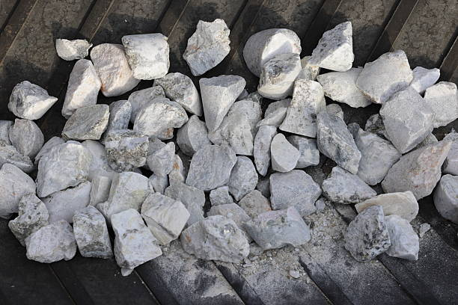
Fig. 3.2: Spodumenic rock
Fig 3.3 shows the equipment used to reduce the particle size
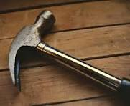
Fig 3.3: Geologic hammer
Fig 3.4: shows the equipment to ground the spodumenic rocks
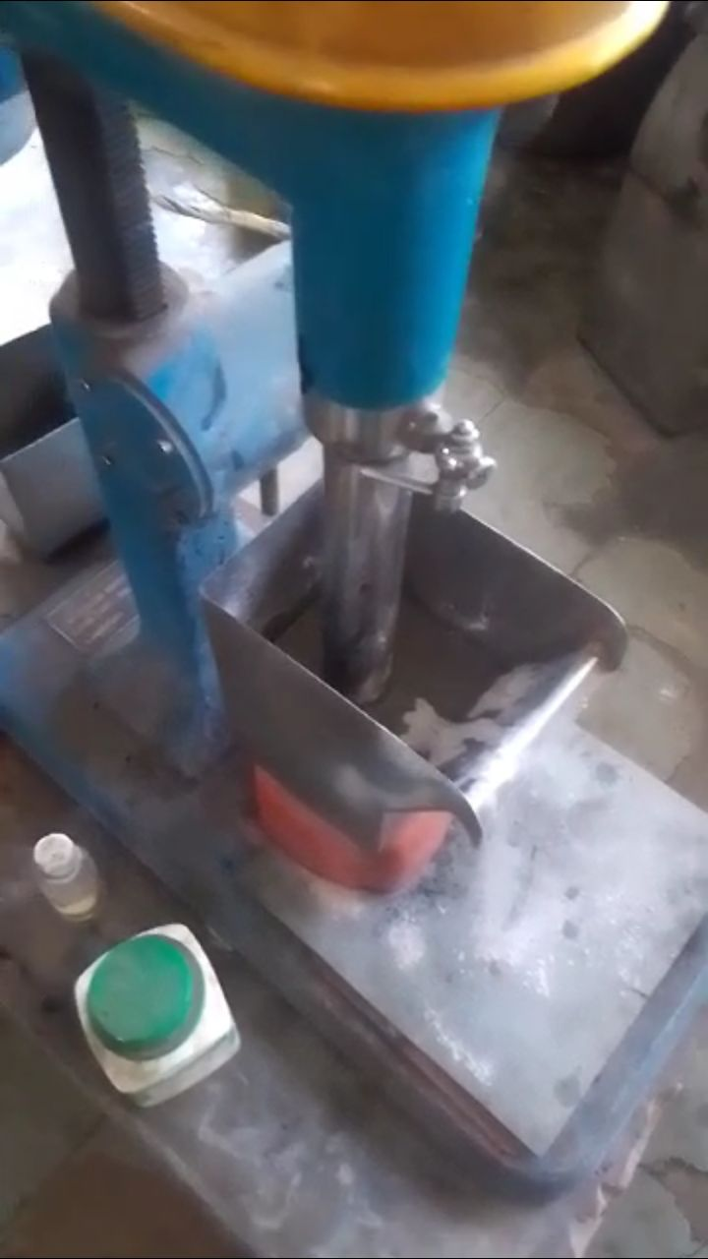
Fig 3.4: Jaw crusher
Fig: 3.5: shows the Ball mill
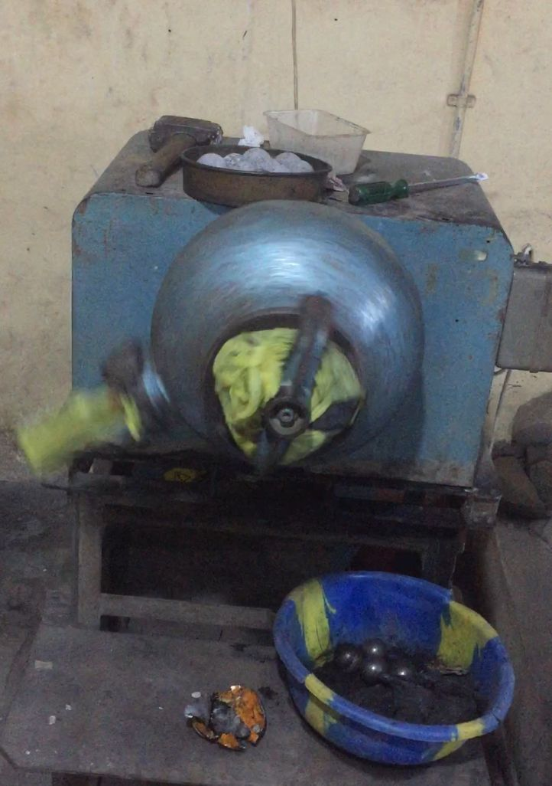
Fig 3.5: Ball mill
3.3 sample preparation
After the particle were milled by the ball mill machine , the particle were sieved so that the mineral can be easier separation from the critical mineral , the fraction were sieved using fitter paper size 125mm diameter , After the lithium sample was ready for laboratory procedure
Fig 3.6 shows the Sieved mineral

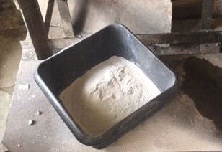
Fig 3.6: Sieved mineral
3.4 Laboratory Procedure of Froth Flotation of the ores
The laboratory procedure begins with the sieving analysis . The fraction sieve technique was employed to determine particle size distributions of the grounded ore. Mainly oleic acid and sodium oxate were used as collector and the slurry was agitated for another 2 minutes before being transferred into the flotation cell, where it agitated for another 2 minutes. Methyl Isobuty Carbinol (MIBC) was added as a fr other and the mixture was agitated for a total of 10 minutes in the sun and sampled randomly for chemical analysis. The entire process was repeated for each particle sizes of 180um, 125um, 90um as specified.
Fig 3.7 shows the flotation cell

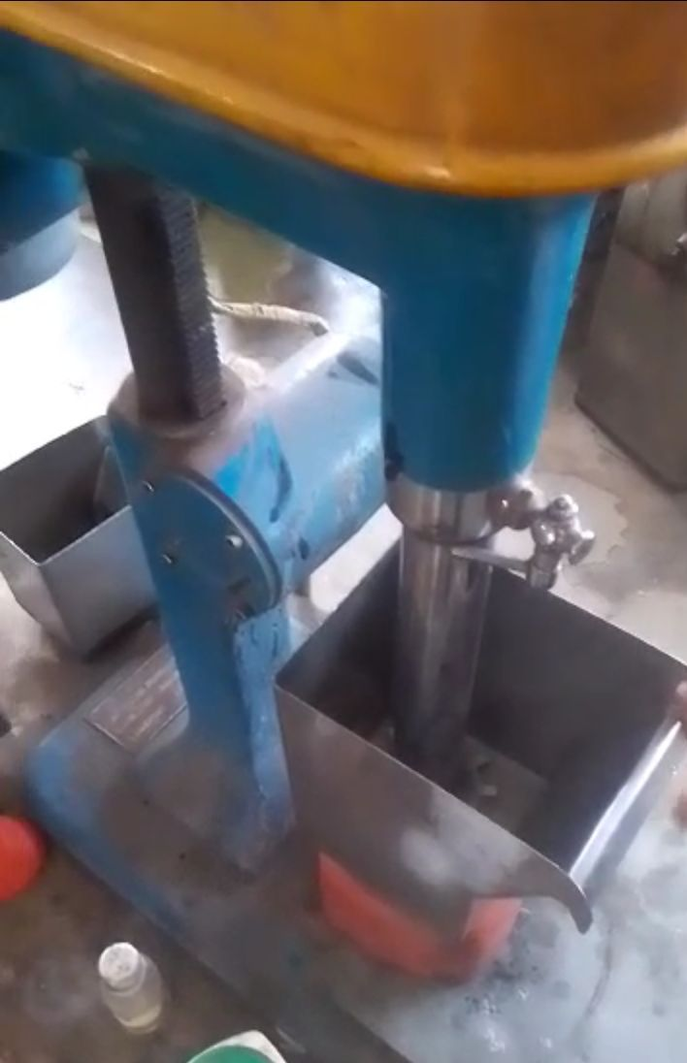
Fig 3.7: Flotation cell

CHAPTER FOUR
RESULTS AND DISCUSSION
4.1 Grade of the Ore
Table 4.1 shows the elemental and oxides of critical minerals in crude
Table 4.1: Elemental and oxides of critical minerals in crude
Mineral Oxide Formula XRF (%) Element AAS (%)
Silicon SiO₂ 74.385 Si 34.791
Aluminum Al₂O₃ 11.930 Al 6.314
Potassium K₂O 7.961 K 6.609
Manganese MnO 0.801 Mn 0.620
Chromium Cr₂O₃ 0.04 Cr 0.037
Chlorine Cl 1.053 Cl 1.053
Magnesium MgO 0.00 Mg 0.00
Calcium CaO 0.403 Ca 0.288
Titanium TiO₂ 0.027 Ti 0.016
Vanadium V₂O₅ 0.00 V 0.00
Iron (Ferrous) Fe₂O₃ 1.112 Fe 0.778
Phosphorus P₂O₅ 0.105 P 0.047
The table 4.1 shows the oxide and elemental composition of the spodumene ore. The chemical composition of the ore is a crucial determinant of its beneficiation potential and economic value . The table shows a wide range of elements, analyzed by both X-ray Flurescences(XRF) Atomic A
bsorption Spectometry AAS, each giving complementary insights into mineral content. Silica ( Sio₂) XRF result: 74.385%, AAS Result: 34.791% , the ore is pre-dominantly composed of silica, which likely comes from quartz and feldspar, common gangue minerals in spodumene rocks. High silica levels dilute lithium grades and thus require effective rejection during beneficiation ( Kesler et.al; 2012) . Comparisons of crude at spodumene ore from Lade, Pategi Local Government Area of Kwara state to others from two main localities which are at Gikil and Magalam, Tafa Balewa Area, Bauchi state, Nigeria. The spodumene there are predominantly siliceous and contain moderate amounts of aluminum silica ( Sio₂) content ranges from 63.3% to 72.7% with an average of 68.7% while aluminum ( Al₂O₃) varies from 10.9 % to 17.8% , averaging 14.6% . These variations reflect differences in mineralogical composition particularly in the level of sio₂, Al₂O₃ and TiO₂. Geochemical diagram using elemental ratios such as Rb, Vs, Ba, Sr, K/Rb vs .Rb , and k/ Rb indicate that the pegmatite from Gikil are highly evolved and display strong of affinity for rare metals. These rocks are variably enriched in tantalum (Ta) , and beryllium. The Gikil spodumene are notably mineralized in lithium oxide ( liO₂) with valu reaching up to 2.4% , although they exhibit lower concentrations of tantalum and beryllium ( Ogaba et.al; 2025).

4.2 Result of Froth Flotation Procedure
TABLE 4.2: Shows the result of beneficiated ores
TABLE 4.2: RESULT OF BENEFICIATION
MINERALS | Crude  XRF ( %) |  | Crude  AAS (%) |  | 0.25g of  XRF |  | 0.25g  AAS |  | 0.5g  XRF |  | 0.5g  AAS |  | 0.75g  XRF |  | 0.75g  AAS |  | 1.0g  XRF |  | 1.0g  AAS
MINERALS |  |  |  |  | CONC. | TAILING | CONC. | TAILING | CONC. | TAILING | CONC. | TAILING | CONC. | TAILING | CONC. | TAILING | CONC. | TAILING | CONC. | TAILING
silicone | Sio2 | 74.385 | si | 34.791 | 70.099 | 70.22 | 52.768 | 34.695 | 69.865 | 70.942 | 32.658 | 33.161 | 69.070 | 69.26 | 32.29 | 32.38 | 34.78 | 66.95 | 31.57 | 31.30
alumininum | Al2o3 | 11.930 | Al | 6.314 | 16.447 | 11.51 | 8.71 | 6.11 | 13.78 | 17.12 | 9.30 | 9.06 | 16.43 | 15.92 | 8.69 | 8.43 | 6.31 | 12.36 | 8.26 | 6.55
pottasium | K2o | 7.961 | k | 6.6.9 | 7.492 | 7.99 | 6.23 | 6.03 | 8.30 | 6.32 | 6.96 | 5.24 | 6.92 | 7.01 | 5.74 | 5.82 | 6.60 | 6.65 | 6.32 | 5.36
maganese | mno | 0.801 | mn | 0.620 | 0.882 | 0.65 | 0.68 | 0.50 | 0.78 | 0.51 | 0.61 | 0.59 | 0.65 | 0.60 | 0.50 | 0.47 | 0.62 | 0.07 | 0.56 | 0.40
crominum | Cr203 | 0.04 | cr | 0.037 | 0.078 | 0.04 | 0.05 | 0.08 | 0..8 | 0.06 | 0.06 | 0.03 | 0.06 | 0.00 | 0.03 | 0.03 | 0.04 | 0.07 | 0.05 | 0.03
chlorine | cl | 1.053 | Cl | 1.053 | 0.682 | 1.30 | 0.68 | 1.30 | 0.96 | 0.59 | 0.96 | 0.59 | 1.05 | 0.75 | 1.04 | 0.75 | 1.05 | 0.46 | 0.46 | 0.36
magnesium | mgo | 0.000 | Mg | 0.000 | 0.000 | 0.00 | 0.00 | 0.00 | 0.00 | 0.82 | 0.00 | 0.49 | 0.00 | 2.22 | 0.00 | 1.33 | 0.00 | 2.08 | 1.25 | 5.94
calcum | cao | 0.403 | Ca | 0.288 | 0.841 | 0.95 | 0.60 | 0.61 | 1.04 | 0.63 | 0.74 | 0.45 | 1.70 | 0.63 | 1.21 | 0.45 | 0.28 | 1.04 | 0.74 | 0.24
titanium | Tio2 | 0.027 | Ti | 0.016 | 0.000 | 0.06 | 0.00 | 0.03 | 0.01 | 0.02 | 0.01 | 0.01 | 0.09 | 0.00 | 0.05 | 0.00 | 0.01 | 0.04 | 0.02 | 0.02
Vanadium | V205 | 0.000 | v | 0.000 | 0.011 | 0.04 | 0.01 | 0.02 | 0.00 | 0.01 | 0.00 | 0.03 | 0.01 | 0.07 | 0.01 | 0.04 | 0.00 | 0.00 | 0.00 | 0.00
ferrous | Fe203 | 1.112 | Fe | 0.778 | 1.023 | 0.92 | 0.72 | 0.69 | 2.14 | 0.69 | 1.49 | 0.48 | 1.83 | 0.83 | 1.28 | 0.58 | 0.78 | 1.99 | 1.39 | 0.48
phosphorus | P203 | 0.105 | P | 0.047 | 0.042 | 0.42 | 0.12 | 0.18 | 0.00 | 0.13 | 0.00 | 0.05 | 0.10 | 0.00 | 0.04 | 0.00 | 0.42 | 0.00 | 0.00 | 0.69
sulphur | So3 | 0.076 | s | 0.031 | 0.098 | 0.00 | 0.04 | 0.03 | 0.17 | 0.49 | 0.08 | 0.19 | 0.00 | 0.57 | 0.00 | 0.23 | 0.03 | 0.84 | 0.34 | 0.15

Table 4.2 shows the result of the test carried out using finely ground ore at 90um particles size and 30% pulp density for each flotation run, 500g of ore was used, collector enhances spodumene hydrophobicity and reagent used oleic acid + sodium oleate in varied dosages: 0.25g, 0.5g, 0.75g, 1.0g. At 0.25g Table flotation yielded no lithium grade and recovery possibly, indicating insufficient collector for effective hydrophobization of spodumene particles increasing the dosage to 0.5g and 0.75g led to significant improvement in concentration grade of critical minerals. At 1.0g, some of the critical minerals remained high but grade slightly decreased at some level , suggesting that excessive collector may have increased the recovery of some gangue minerals thus diluting the concentrate.
The observed flotation behavior is consistent with previous studies, sodium oleate / oleic acid is widely used as an effective collector for spodumene flotation under alkaline conditions. It promotes strong absorption on the mineral surface, The optimum flotation performance in the test appears at 0.75g collector dosage, achieving high critical grade and recovery with minimal gangue carryover, similar results were reported by Meshram et.al (2020) and Ferreira et al (2019) where spodumene flotation recovery improved significantly with collector dosage up to an optimum point, after which excess dosage caused reduced selectively.
Table 4.3 below shows the result of changes in the concentration of the critical minerals and we explain the best minerals.

TABLE 4.3 : RESULT OF BENEFICIATION
MINERALS | Crude  XRF( %) |  | Crude  AAS ( %) |  | 0.25g of  XRF |  | 0.25g  AAS |  | 0.5g  XRF |  | 0.5g  AAS |  | 0.75g  XRF |  | 0.75g  AAS |  | 1.0g  XRF |  | 1.0g  AAS
MINERALS |  |  |  |  | CONC. | TAILING | CONC. | TAILING | CONC. | TAILING | CONC. | TAILING | CONC. | TAILING | CONC. | TAILING | CONC. | TAILING | CONC. | TAILING
silicone | Sio2 | 74.385 | si | 34.791 | 4.286 | 0.16 | 2.01 | -0.09 | 4.52 | 3.44 | 2.11 | 1.16 | 5.31 | 5.12 | 2.48 | 2.39 | 6.87 | 7.43 | 3.19 | 3.47
alumininum | Al2o3 | 11.930 | Al | 6.314 | -4.56 | 0.42 | 2.33 | 0.20 | -2.35 | -5.20 | -0.98 | -2.75 | -4.51 | -3.99 | -2.38 | -2.11 | -3.69 | -0.43 | -1.95 | -0.23
pottasium | K2o | 7.961 | k | 6.6.9 | 0.47 | -0.03 | 0.39 | -0.02 | -0.41 | 1.64 | 0.34 | -1.36 | 1.03 | 0.95 | 0.86 | 0.78 | 0.35 | 1.50 | 0.28 | 1.25
maganese | mno | 0.801 | mn | 0.620 | 0.15 | 0.15 | -0.06 | 0.12 | 0.01 | 0.29 | 0.01 | 0.23 | 0.15 | 0.19 | 0.12 | 0.15 | 0.73 | 0.28 | 0.05 | 0.21
crominum | Cr203 | 0.04 | cr | 0.037 | -0.03 | 0.001 | -0.2 | 0.001 | -0.04 | -0.01 | -0.02 | -0.01 | -0.03 | 0.05 | -0.02 | -0.01 | 0.02 | 0.05 | -0.01 | 0.01
chlorine | cl | 1.053 | Cl | 1.053 | 0.37 | -0.25 | 0.37 | -0.25 | 0.09 | 0.45 | 0.08 | 0.46 | 0.04 | 0.30 | 1.01 | 0.30 | 0.59 | 0.68 | 0.59 | 0.68
magnesium | mgo | 0.000 | Mg | 0.000 | 0.000 | 0.00 | 0.00 | 0.00 | 0.00 | 0.83 | 0.00 | 0.49 | 0.00 | -2.22 | 0.00 | -1.34 | -2.08 | 9.85 | -1.25 | -5.94
calcuim | cao | 0.403 | Ca | 0.288 | -0.44 | -0.54 | -0.31 | 0.39 | -0.64 | -0.23 | -0.45 | -0.16 | -1.30 | -0.23 | -0.93 | -0.16 | -0.68 | 0.05 | 0.45 | 0.04
titanium | Tio2 | 0.027 | Ti | 0.016 | 0.003 | 0.03 | 0.02 | -0.02 | 0.01 | 0.01 | 0.05 | 0.07 | -0.07 | 0.02 | -0.04 | 0.00 | -0.01 | -0.01 | -0.01 | -0.01
Vanadium | V205 | 0.000 | v | 0.000 | -0.01 | -0.04 | -0.01 | -0.02 | 0.00 | -0.01 | 0.00 | -0.03 | -0.09 | -0.07 | -0.05 | -0.01 | 0.00 | 0.00 | 0.00 | 0.06
ferrous | Fe203 | 1.112 | Fe | 0.778 | 0.09 | 0.19 | 0.06 | 0.08 | -1.02 | 0.43 | -0.72 | 0.39 | -0.72 | 0.27 | -0.52 | 0.19 | -0.88 | 0.42 | -0.62 | 0.29
phosphorus | P203 | 0.105 | P | 0.047 | 0.06 | -0.31 | 0.02 | -0.13 | 0.11 | -0.02 | 0.05 | -0.07 | 0.07 | 0.17 | 0.03 | 0.05 | 0.10 | -0.05 | 0.05 | -0.02
sulphur | So3 | 0.076 | s | 0.031 | -0.02 | 0.07 | 0.001 | -0.03 | -0.09 | -0.41 | -0.04 | -0.16 | 0.07 | 0.49 | 0.03 | -0.19 | -0.76 | -0.28 | -0.31 | -0.12

Table 4.3 above shows the change in the improvement of the result of the beneficiation which show that the element such as oxide of iron ( Fe₂O₃) , oxides of magnesium ( MgO), oxides of calcium ( CaO) and oxides of titanium ( TiO₂) decreased in the concentrate. The table shows a steady increase in SIO₂ content in the concentrate across different collector dosages. This means the silicate rich minerals in the ore were preferentially floated and concentrated. The increase in SiO₂ suggests that these light silicate rich phases were recovered effectively, possibly due to natural floatability or surface activation by reagents like calcium chloride and sodium oleate, silicon behavior can be a useful indicator of how well the flotation process is recovery light silicate minerals. In lithium pegmatites, for instance, concentrating SiO₂ often correlates with the recovery of lithium bearing silicates ( if present ) The fact that SiO₂, Al2O3, Na₂O, and K₂O improved at 1.0g dosage, while Fe₂O₃, CaO,MgO and TiO₂ decreased at 0.75g dosage confirms that the flotation process successfully floated light silicate phases (feldspar, mica, quartz) Depressed and rejected heavier or unwanted gangue (iron oxides, carbonates, amphiboles). Even though lithium was not found, the beneficiation process still effectively upgraded the acidic silicate fraction , which would be highly beneficial if any trace or hidden lithium carriers were present.

CHARPTER FIVE
5.0 CONCLUSION AND RECOMMENDATIONS
5.1 Conclusion
In the absence of lithium, silicon (Sio₂) is the best improved element in the flotation test. Its consistent enrichment in the concentrate demonstrates effective beneficiation of silica rich minerals, likely feldspar and micas. These results indicate successful separation of desired light silicates from unwanted gangue , highlight in the flotation system efficiency and selectivity even in lithium absent ores. Although lithium minerals was not detected, this study demonstrates that the flotation conditions applied effectively to concentrate silicate phases such as quartz, feldspar , and mica. These findings support the potential for resources recovery from pegmatites by repurposing flotation methods for industrial mineral extraction, and offer a foundation for future mineralogical and geochemical investigation.

5.2 Recommendations
Based on the results and observations of this study, the following recommendations are proposed :
1. Scale up and pilot testing : the flotation conditions identified should be tested in larger scale or pilot plant operations to validate their effectiveness and economic feasibility under industrial conditions.
2. Cleaner flotation stages: incorporate one or more cleaner flotation stages to further upgrade the concentrate quality, especially after the rougher flotation stage at 0.75g collector dosage
REFERENCES
Abiodun, O. D. (2011). Map of Kwara State. Adekunle Ajasin University, Akungba-Akoko
Cordell, D., Drangert, J. O., and White, S. (2009). The story of phosphorus: Global food security and food for thought. Global Environmental Change, 19(2), 292–305.
Deer, W. A., Howie, R. A., and Zussman, J. (2013). An Introduction to the Rock-Forming Minerals (3rd ed.). Mineralogical Society of Great Britain and Ireland.
Ferreira, C. A., Araújo, A. C., and Peres, A. E. C. (2019). Flotation of lithium ores: Processing of spodumene. Minerals Engineering, 138, 92–100.
Gambogi, J. (2022). Mineral Commodity Summaries 2022: Lithium, Vanadium. U.S. Geological Survey.

Goodenough, J. B., and Park, K.-S. (2013). The Li-ion rechargeable battery: A perspective. Journal of the American Chemical Society, 135(4), 1167–1176.
Gruber, P. W., Medina, P. A., Keoleian, G. A., Kesler, S. E., Everson, M. P., and Wallington, T. J. (2011). Global lithium availability: A constraint for electric vehicles? Journal of Industrial Ecology, 15(5), 760–775.
Gupta, A., and Krishnamurthy, N. (2005). Extractive Metallurgy of Rare Earths. CRC Press.
International Energy Agency (IEA). (2022). Global EV Outlook 2022 – Securing supplies for an electric future. https://www.iea.org
Kesler, S. E. (1994). Mineral Resources, Economics and the Environment. Macmillan College Publishing Company.
Kesler, S. E., Gruber, P. W., Medina, P. A., Keoleian, G. A., & Wallington, T. J. (2012). Global lithium resources: Relative importance of pegmatite, brine and other deposits. Journal of Mineral Economics, 85, 453–466.
Meshram, P., Pandey, B. D., and Mankhand, T. R. (2020). Recovery of lithium from primary and secondary resources and its application. Minerals Engineering, 147, 106158.
Moss, S. A., Evans, K. A., and Zhang, Y. (2013). Vanadium geochemistry in hydrothermal systems. Geochimica et Cosmochimica Acta, 110, 13–25.
Ogaba, S. O., Abubakar, M. B., and Yusuf, A. M. (2025). Geochemistry and mineral potential of pegmatite-hosted spodumene in Bauchi State, Nigeria. Nigerian Journal of Geological Sciences, 31(2), 44–56.
Tadesse, B., and Makuei, B. (2020). A review of spodumene flotation. Minerals Engineering, 155, 106488.

