A PROJECT REPORT
ON
PROPOSED HOUSING ESTATE

FOR
LANDMARK PROPERTIES, ETI OSE L.G.A, LEKKI.LAGOS STATE
BY

OLUWATOSIN EMMANUEL RICHARDS
HND/23/ARC/FT/081

BEING A PROJECT SUBMITTED TO THE
DEPARTMENT OF ARCHITECTURAL TECHNOLOGY
INSTITUTE OF ENVIRONMENTAL STUDIES
KWARA STATE POLYTECHNIC, ILORIN.

IN PARTIAL FULFILMENT OF THE REQUIRMENTS
FOR THE AWARD OF HIGHER NATIONAL DIPLOMA (HND)
OF ENVIRONMENTAL STUDIESS
KWARA STATE POLYTECHNIC, ILORIN.

JULY, 2025
DECLERATION
I declare that this project is a product of my personal research work. It has not been presented for the award of any degree in any polytechnic. The ideas, observation, comment, suggestion herein represent my own convictions, except quotation, which have been acknowledged in accordance with conventional academic traditions.

OLUWATOSIN EMMANUEL
RICHARDS
HND/23/ARC/FT/0081
……………………………..
SIGNATURE AND DATE

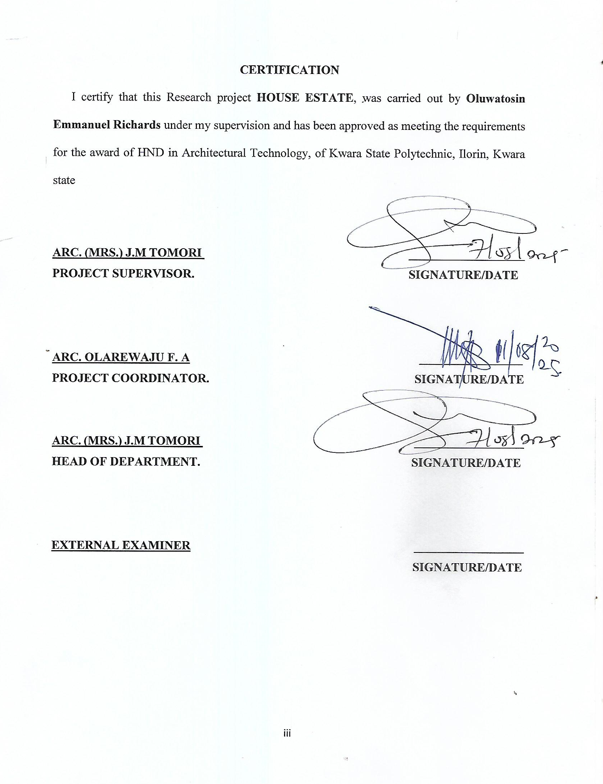

DEDICATION
This project is wholly dedicated to God ALMIGHTY the architect of the universe.to whom all Glory, Adoration, Honor and profound gratitude belong to, Glory be to God in the highest Hallelujah
Finally, my appreciation also to my entire family for their support through my academic pursuit.

ACKNOWLEDGMENT
My profound gratitude goes to the God Almighty who had been with me through the thick and tin of my academic program. Juggernaut of praise to his name
A million accolades goes to my inestimable HOD. Supervisor in person of ARC(Mrs).J.M.Tomori for her guide and support in the course of my research work. Also to my lecturers arc. Nmom chukwuma, Arc familua O.S, and Arc J.M. Tomori, Arc Olarewaju F.A, Arc. B .Y F abdulazeez for their support and assistance toward the success of the programmed. I say thanks you all.
I must but command and appreciate my loving and caring family and friends for their financial and spiritual support during my academic programmed, I pray may you love long in good health and sound mind (Amen).
Also to my Boss in person of ARC OWOLABI AKANO, C E O Ways studios his financial and moral support, encouragement throughout my academic pursuit.
Also to Ways Studio Admin Officer I person of Mrs. TOBI, May the lord reward you all as you had extended your gesture of kindness toward me.
Finally, my appreciation also to my entire family for their support through my academic pursuit.
I am also indebted to my loving sister Oluwatosin Blessing Okotie. Who had been my anchor and hostage during my programmed, I pray that the bond of love that hold us together will continually be strengthened. I also appreciate my sibling who had in one way or the other supported me through my academic pursuit. A big kudos to you all

TABLE OF CONTENTS
Title page……………………………………………………………………………...................i
Declaration………………………………………………………………………………………ii
Certification……………………………………………………………………………………..iii
Dedication……………………………………………………………………………………….iv Acknowledgment…………………………………………………………………………….…..v
Table of Content…………………………………………………………………………………vi
List of Table…………………………………………………………………………………….vii
List of Figure…………………………………………………………………………………...viii
List of Plates…………………………………………………………………………………….ix
List of Appendices………………………………………………………………………….……x
Abstract……………………………………………………………………...............................1
CHAPTER ONE
1.0 Introduction……………………………………………………………………………….4
1.1 Historical Background…………………………………………………….........................4
1.2 Statement Background of Housing Estate……………………………………………4 1.3 Aim and Objective………………………………………………………………………...4
1.3.1 Aim………………………………………………………………………………………...4
1.3.2 Objective…………………………………………………………………………………..4
1.4 Justification……………………………………………………………………………….. 4
1.5.1 Client Background…………………………………………………………………………4
1.5.2 Philosophy…………………………………………………………………………………5
1.5.3 Operational Structure and Goal……………………………………………………………5
1.6 Scope of Study…………………………………………………………………………….5
1.7 Limitation………………………………………………………………………………….6
1.8 Research Methodology……………………………………………………………………6
CHAPTER TWO
LITERATURE REVIEW
2.0 Introduction…………………………………………………………………………….....7
2.1 Housing Estate…………………………………………………………………………….7
2.2 Housing Estate (Type-Classification)……………………………………………………..8
2.3 Solution to Problems in Housing Estate…………………………………………………..8
2.4 Type of Structure Use……………………………………………………………………..9
2.4.1 Residential structures……………………………………………………………………...9
2.4.2 Community Structures…………………………………………………………………….9
2.4.3 Supportive Structures…………………………………………………………………...10
CHAPTER THREE
CASE STUDIES
3.0 Case Study………………………………………………………………………………..11
3.1 Case Study One…………………………………………………………………………11
3.1.1 Merits…………………………………………………………………………………….12
3.1.2 Demerits…………………………………………………………………...…………….12
3.2 Case Study Two……………………………………………………………………........16
3.2.1 Merits……………………………………………………………………………………16
3.2.2 Demerits…………………………………………………………………………………16
3.3 Case Study Three………………………………………………………………………...20
3.3.1 Merits……………………………………………………………………………………20
3.3.2 Demerits…………………………………………………………………………………20
3.4 Case Study Four…………………………………………………………………………29
3.4.1 Merits……………………………………………………………………………………29
3.4.2 Demerits…………………………………………………………………………………29
3.5 Case Study Five…………………………………………………...................................25
3.5.1 Merits……………………………………………………………………………………25
3.5.2 Demerits…………………………………………………………………………………25

CHAPTER FOUR
4.0 Introduction……………………………………………………………………………..32
4.1.1 Site Selection……………………………………………………………………………32
    - Site Location…………………………………………………………………………...33
    - Site Analysis……………………………………………………………………………34
    - Geographical Data………………………………………………………………….......35
    - Environment Conditions of the Site……………………………………………………35
    - Project Goals……………………………………………………………………………35
    - Functional /Spatial Criteria……………………………………………………………..36
    - Spaces, Size and Relationship…………………………………………………………..36
    - Equipment and Operation and Performance Requirements…………………………….36
4.2.5 Spatial Allocation /Schedule of Accommodation…………………................................37
4.2.6 Functional Relationship………………………………………………………………...37

CHAPTER FIVE
5.1 Design Ideas/ Concept………………………………………………………………….45
5.2 Well Supported With By Sketches and Graphics………………………………………45
5.3 Technological and Environment Criteria………………………………………………..48
5.3.1 Construction Methodology and Materials/Finishes……………………………………..48 5.3.2 Service Required………………………………………………………………………...48 5.3.2 Service Required………………………………………………………………………..49
5.3.3 Environmental Condition to Be Achieved……………………………………………..50 5.4 Legal Issues and Planning Regulation………………………………………………….50 5.5 Conclusion……………………………………………………………………………….51
Reference………………………………………………………………………………..52
Appendix………………………………………………………………………………..53

LIST OF TABLE

TABLE 4.1 Showing 4Bedroom fully detached ………………… …… ……………...37
TABLE 4.2 Showing 4units if 2bedroom apartment ……………………………….….38
TABLE 4.3 Showing 2bedroom bungalow…………….………………………………39
TABLE 4.4 Showing program of work………………………………………………...40

LIST OF FIGURES
Figure 3.1.2 Showing Location Plan Case study 1 …………………..………………….13 Figure 3.1.3 Showing Site Plan Case study 1 ………………………..………………….13 Figure 3.1.4 Showing Ground Floor Case study 1 …………………………………….14 Figure 3.1.5 Showing Upper Floor Plan Case study 1 ………………..……………….14 Figure 3.2.1 Showing Locational Plan Case study 2 …………………………………..15 Figure 3.2.2 Showing Site Plan Case study 2 …………………………………………15 Figure 3.3.1 Showing Locational Plan Case study 3…………………….……………..17 Figure 3.3.2 Showing Site Plan Case study 3 …………………………..……………...17 Figure 3.3.4 Showing Ground Floor Case study 3………………………………...…...19 Figure 3.3.5 Showing Upper Floor Case study 3………………………….....................19 Figure 3.4.1 Showing Locational Plan Case study 4……………………………...……22 Figure 3.4.2 Showing Site Plan Case study 4………………………………………......22 Figure 3.5.1 Showing Locational Plan Case study 5……………………………...……26 Figure 3.5.2 Showing Site Plan Case study 5…………………………………………..26 Figure 5.1 Showing Propose site location……………………………………………31 Figure 5.2 Showing Propose Site Location Google Map…………………………….31 Figure 5.3 Showing Propose Site Plan……………………………………………….39

LIST OF PLATE
Plate 3.1.1 Google Map of Case Study One…..............................................................15
Plate 3.1.1 Approach View of Case Study One……………………………………….15
Plate 3.1.2 Approach View of Case Study One………,………………………………18
Plate 3.2.1 Google Map Of Case Study Two ………………………………..………18 plate 3.2.2 Rear view of case study two…………………...........................................19 Plate 3.2.3 Approach view of case study…………………………………………… 19 Plate 3.3.1 Google Map of Case study Three ……………………………………... 20 Plate 3.3.2 Approach View Of Case study Three ………………………..………… 20 Plate 3.3.3 Approach View Of Case study Three………………………….……..….20 Plate 3.4.1 Google Map Of Case study Four…………………………………….…..23 Plate 3.4.1 Approach View Of Case study Four……………………………..……...24 Plate 3.4.2 Approach View Of Case study………………….…………………….…27 Plate 3.5.3 Google Map Of Case study Three…………………….…………………27

LIST OF APPENDICES
Appendix 1 Showing Propose Site Plan……………………………………….……..53 Appendix 2 Showing Ground Floor Plan……………………………………..………53 Appendix 3 Showing Upper Floor Plan………………………………………….…..54 Appendix 4 Showing Front View………………………………………….......…..…54 Appendix 5 Showing Right View……………………………………………...…..… 55 Appendix 6 Showing 3d View For 4bedroom Full/D Duplex……………..…….…....55 Appendix 7 Showing Ground floor………………………………………….…….…..56 Appendix 8 Showing Upper Floor Plan…………………………………………...… 56 Appendix 9 Showing Front View……………………………………………...…….. 57 Appendix 10 Showing Right View……………………………………………….….. 57 Appendix 11 Showing 3d View for 4units of 3bed Apartment …………….………... 58 Appendix 12 Showing Ground Floor Plan………………………………….……….… 58 Appendix 13 Showing Front View………………………………………………….… 59 Appendix 14 Showing Left View……………………………………………………. ..59 Appendix 15 Showing 3d, 2bedroom Bungalow…………………………………… ... 60 Appendix 16 Showing Spaces Analysis For 4units 2bedroom Apartment………….….60 Appendix 17 Showing Space Anaylsis, 2bedroom Bubgalow……………….………….61 Appendix 18 Showing Space Analysis For 4units Apartment …………………...…… 61 Appendix 19 Showing Details drawing…………………………………………...……. 62 Appendix 20 Showing Detail Drawing For 4units Apartment…………….……………62 Appendix 21 Showing Spaces Anaysis For 4bedroom Fully………………………….. 63 Appendix 11 Showing 3d View For 4units Of 3bed Apartment………...…………...63

ABSTRACT
Housing estate are multi- functional building that provides access to leaving, promotes citizens participation and offer lifelong learning opportunities. Housing estate have their roots in ancient civilizations where public spaces were used for leaving and artistic expression which the historical background highlights the evolution of housing estate design centers from ancient public spaces to modern multi-disciplinary institution. This work is focusing on leaving activities. Apart from the fact that this project can't be underestimated the design is also considering some structure as it is of a great significance to housing estate. Adequate Car parks are considered for spectators ranging from the V.I.P s to the popular ones, As a housing estate which will accommodate several people, there is a need for proper security measures which was duly approached through the introduction of security post where necessary, Other facilities like gate house, open parade ground, museum, through the buffer area etc., on the site. The research project is limited to housing estate, other factors that restrict over to the project that most of the respond are negative to true information concerning themselves of heavy and levy or counter action against them. The method of research in order to arrive at a functional and appealing design, different types of methods were adopted in carrying out the research work of this project are case studies, online research and oral overvie

CHAPTER ONE
- INTRODUCTION
Housing estate is a planned community or neighborhood with a collection of residential properties, often developed and managed by a single or co-operate entity. Its design and built with a specific layout and infrastructure. Housing estate foster a sense of community among residents. It’s developed and managed by private companies or individuals. Government subsidized housing for low-income families or individuals.it can provide a comfortable and convenient living environment for residents, with a range of amenities and service to enhance their quality of life.
Housing estate are designed with infrastructure, amenities, and services. Its typically consist of single-family homes, apartment, or condominiums, it’s occupied with parks, children playground, swimming pools, community centers, and security service. The concept of housing estates has evolved over time, influenced by social, settlements near industrial sites. Housing estate expanded beyond city centers, with suburban developments becoming popular. Its Eco-friendly housing estate with green buildings and community-focused designs.
  - HISTORICAL BACKGROUND OF HOUSING ESTATE
The historical background of housing estates dates back to ancient civilization, with various developments and influences shaping their evolution.
Romans villa: Wealthy romans built large estate with luxurious homes and amenities. Medieval manors: Lords and nobles resided in fortified manor houses with surrounding villages. 19th and 20TH centuries, Garden cities: Ebenezer Howard’s concept of garden cities emphasized green spaces and planned communities. Public housing: Government began building housing estate for low-income families and individual.

1.2 STATEMENT OF DESIGN PROBLEM
Design a sustainable and livable housing estate that balance the needs of resident, the environment, and the community, while addressing the challenges of urbanization, climate change, and social inequality. Creating visually appealing building and public space .limited funds can impact design choice and materials, compliance with local laws and regulations can influence design. Climate, topography, and natural resource can impact design
1.3 AIM AND OBJECTIVE
1.3.1 AIM
- To design an aesthetically appealing structure with a modernized concept that enhance livable and thriving community that meets the needs of its residents
1.3.2 OBJECTIVE
- To design a safe and secure living environment.
- To ensure functional space with easy accessibility that is well lightened and properly
- To provide and create a will lightened
- To ensure proper and befitting landscaping features.
1.4 JUSTIFICATION
- To design incorporating resident, commercial, and recreational spaces to foster a sense of community and reduce commuting distances.
1.5.1 CLIENTS BACKGROUND
A Company or individual developing, the estate for profit a government agency or housing authority developing the estate for social housing, provide affordable housing by meeting the housing needs of low income families or individuals, its Generating revenue through property sale or rentals, it also develop eco-friendly and socially responsible housing estate.
1.5.2 PHILOSOPHY
Human-centered design it prioritizing the needs and well-being of residents, balancing economic, social, and environment needs and also fostering a sense of community and social interaction, creating space that are accessible and usable by everyone
1.5.3 OPERATIONAL STRUCTURE AND GOAL
A multidisciplinary team consisting of architects, engineers, urban planners, and stakeholders, it developing a comprehensive design plan, including architectural design, engineering plans, and landscaping
1.6 SCOPE OF STUDY
4BEDROOM FULLY DETACHED DUPLEX
- ENTRANCE
- LIVINGROOM
- GUEST ROOM
- DINNING ROOM
- KITCHEN
- V/T
- FAMILY LOUNGE
- BEDROOMS
- CLOSET
4 UNITS OF 2BEDROOM APARTMENT
- ENTRANCE
- LIVINGROOM
- DINNIG ROOM
- BEDROOM
- KITCHEN
- TOIL/BATH
- STORE
2BEDROOM BUNGALOW
- ENTRANCE
- LIVINGROOM
- DINNIG
- BEDROOM
- KITCHEN
- STORE
- TOIL/BATH
1.7 LIMITATION
Design must balance competing demands, such as affordability, sustainability and aesthetics. Design should cater to diverse needs .including accessibility and universal design, design should incorporate innovative solution to address complex challenges
1.8 RESEARCH METHODOLOGY
- Literature review: Reviewing existing research on housing estate design, it allowing me to identify relevant theories, method and gaps in the existing research.
- Case Studies ;Analyzing successful and unsuccessful housing state design project
- Surveys and Questionnaires; Gathering data from residents, stakeholders and expects
- Interview and focus group; Conducting in depth discussion with residents stakeholders, and experts
CHAPTER TWO
2.0 LITERATURE REVIEW
This is the methods and process of consulting with some articles, journals, magazines by Alfred M.T (2018) Mc GraWhill Publication London 5th Edition, explores strategies for making more housing affordable, including innovative financing models and design solutions, that are found to the relevant to the propose project topic with a view to brooding the intellectual horizon of the researcher.
Andrea Palladio (2016) Mx Grall Publication uk, 6th Edition, The exercise enable me as the researcher to acquire adequate information on the tasks of planning and designing a project of this magnitude.
The research finding when well documented will serve as useful takeoff point to future effect of similar project
2.1 HOUSING ESTATE.
Housing estate design has undergone significant evolution, reflecting changing societal needs, technological concern advancement and environment
Tradition era been emphasized on characterized by ornate details, intricate craftsmanship and hierarchical arrangement of spaces. Modern movement emphasize simplicity, functionality and connection to nature, with pioneers like le Corbusier and frank Lloyd wright introducing open floor plans and innovative materials.
Contemporary era focuses on sustainability, technology integration and adaptable living spaces, incorporating living space, incorporating green practices, smart technologies and flexible design. Le Corbusier pioneered modernist architecture with emphasis on functionality and simplicity. Frank Lloyd Wright introduced organic architecture philosophy, integrating. Bjarke lngels knows for inventive and sustainable designs that merge architecture, urbanism and environment consciousness.
2.2 HOUSING ESATE (TYPE-CLASSIFICATION)
- Public housing estate; are residential areas developed and managed between government agencies or non-profit organization to provide affordable housing for low-income families or individual.
Government-subsidized public housing estates are often subsidized by the government, which helps to keep rents affordable for residents. Rental housing public housing estates typically offer rental housing options, public housing estate often face funding constraints, which can limits the quality and quantity of
Housing provided.it require regular maintenance and upkeep, which can be challenging to manage.
- Private housing estate; private housing states are residential areas developed and managed by private companies or individuals, offering a range of housing options to suit different needs and budgets.
Private housing can be expensive, making then inaccessible to low-income households.it as a significant environmental impact, particularly if they are not designed with sustainability I mind, it must comply with local regulations and laws, which can be complex and time-consuming
2.3 SOLUTION TO PROBLEMS IN HOUSING ESTATE
- Infrastructure and Maintenance; Regularly inspect and maintain buildings, roads and amenities to prevent deterioration.it also upgrade infrastructure, such as water and sewage system, to meet growing demands.it implement effective waste management systems, including recycling and waste collection
- Safety and Security; Install security cameras to deter crime and improve surveillance, hire security personal to patrol the estate and respond to incidents, implement access control measures, such as gated communities or electronic doors.
- Community Engagement; Organize community events, such as festivals and town hall meetings, to foster a sense of community. It create community spaces, such as parks and community centers, to promote social
- Environmental Sustainability; Implement green initiative, such as solar panels and rainwater harvesting ,to reduce the estate environmental impact.it promote energy efficiency by using energy-efficient appliances and lighting.it create green spaces, such as park and gardens, to promote biodiversity and mitigate the urban heat island effect.
- Affordability and Accessibility; Offer affordable housing option, such as subsidized housing or rent control, to make housing more accessible.it implement inclusive design principles, such as wheelchair-accessible buildings, to promote accessibility.it provide community facilities, such as childcare centers and community centers, to support resident’s needs.
2 .4 TYPE OF STRUCTURE USE
2.4.1 RESIDENTIAL STRUCTURES
- Single-family homes; Detached homes designed by one family
- Apartment; Multi-unit buildings that can range from low-rise to high-rise.
2.4.2 COMMUNITY STRUCTURES
- Parks and playground; outdoor spaces designed for recreation and leisure.
- Shopping centers; Retail spaces that provide convenient access to good and service
- Religious center; Provisions for churches and mosque
- 2.4.3 SUPPORTIVE STRUCTURES
- Parking facilities; Structure or areas designated for resident and visitors parking.
- Utility building; Building that has essential service, such as electricity and water
- Guardhouses and gates; Security features that control access to the estate.

CHAPTER THREE
3.0 CASE STUDY
To have a good understanding of a housing estate and its relevant function base, there is needed to appraise existing housing estate. From their deficiencies and merit will be able fashion out a design that will accommodate and strength the merits of existing design while taking care of their deficiencies. It is carried out in the following housing estate of Nigeria.
- Rose Gardens, Magboro ogun state
- Millennium housing estate ijaye ojokoro, Lagos state.
- Omole Phase 2 Housing Estate, Lagos State
Appraisal were also carried out on foreign housing estate based on information from publication which include
- The green estate, tema Ghana
- Fancourt estate south africa
3.1 CASE STUDY ONE
ROSE GARDENS, MAGBORO OGUN STATE
Rose Gardens Magboro is a residential project developed by 4point Real Estate investment limited, offering luxurious living spaces with modern amenities. Located in magboro, Ogun state. The estate features various housing options including.4 Bedroom Semi-Detached Duplex, 4 Bedroom Fully Detached Duplex +BQ ,3 Bedroom Fully Detached +BQ.it was launched in mid-2018 and has nations housing demand within suburban communities like simawa, mowa, asese and magboro. All within the Lagos and ogun state. Being the preferred location for development as the cost of land within these regions are more affordable and insufficient capacity to accommodate housing projects as opposed to metropolitan Lagos.
3.1.1 MERITS
1. Smart landscaped design and well-designed outdoor living space,
2. Availability of electricity
3. Modern access control system with CCTV and monitored alarms
4. Strictly controlled entrances with security patrol
5. 2-3 Parking spaces available per unit.
3.1.2 DEMERITS
1. No adequate ventilated
2. No introduction of buffer area
3 lack of social amenities like school, shopping center
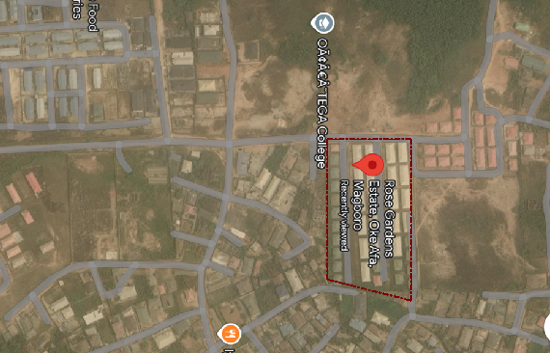
PLATE 3.1.1 GOOGLE MAP OF CASESTUDY ONE

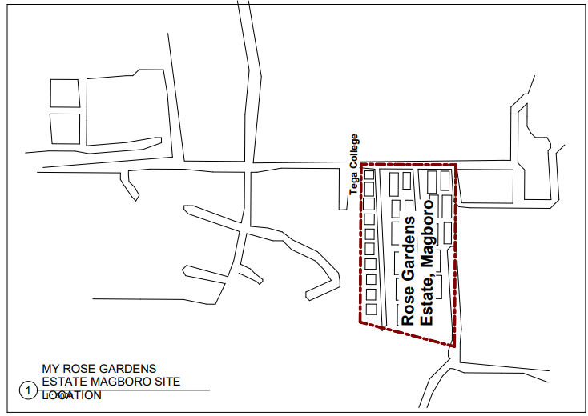 FIGURE 3.1.2 LOCATION PLAN OF CASESTUDY ONE
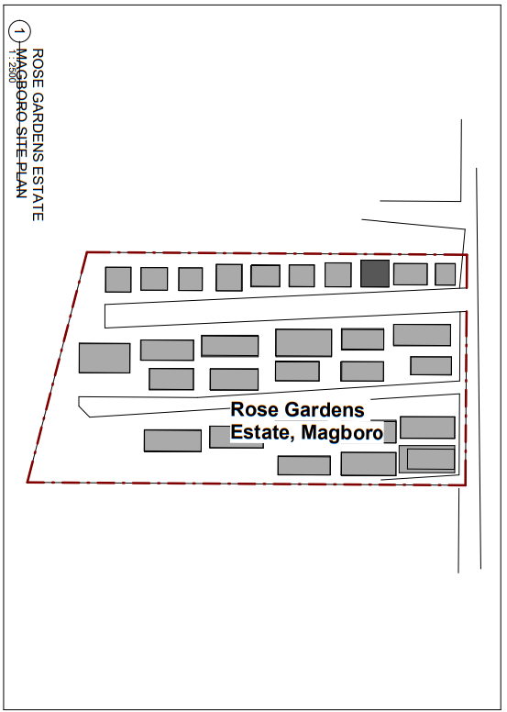
FIGURE 3.1.3 SITE PLAN OF CASESTUDY ONE
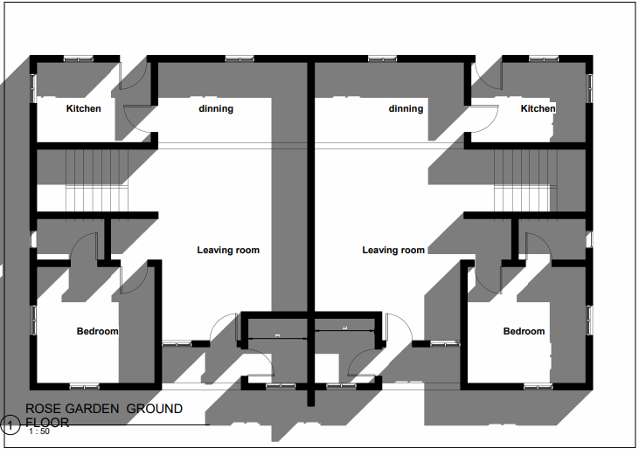
FIGURE 3.1.4 GROUND FLOOR OF CASESTUDY ONE
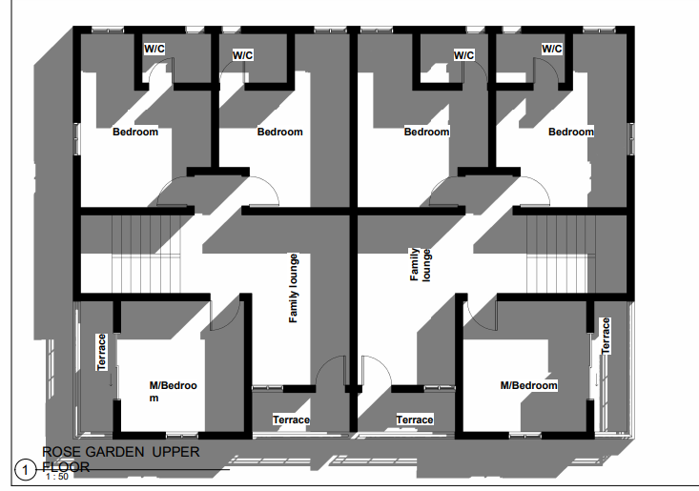
FIGURE 3.1.5 UPPER FLOOR PLAN OF CASESTUDY ONE
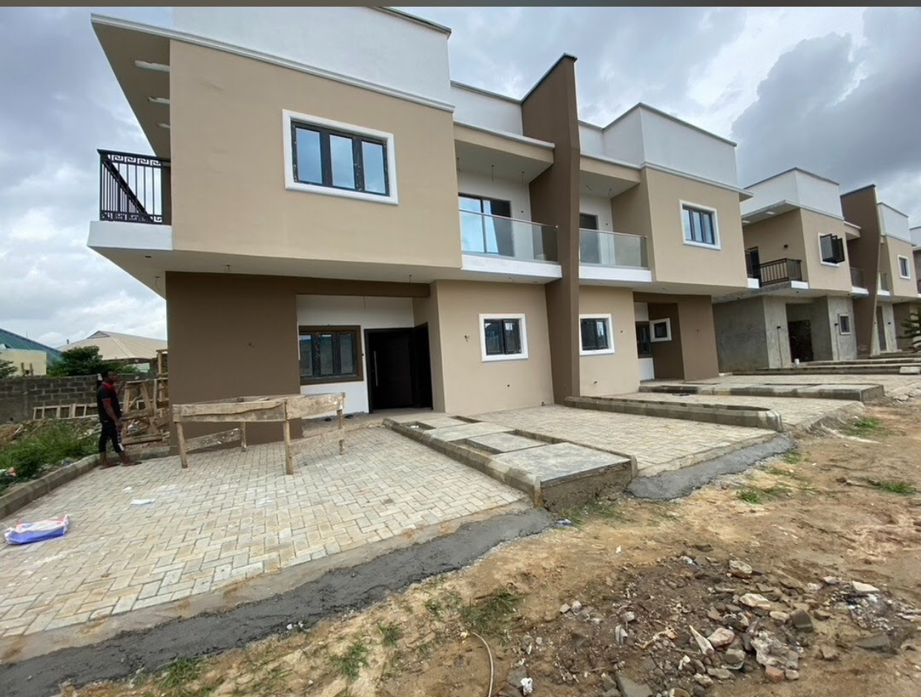
PLATE 3.1.1 APPROACH VIEW OF CASESTUDY ONE
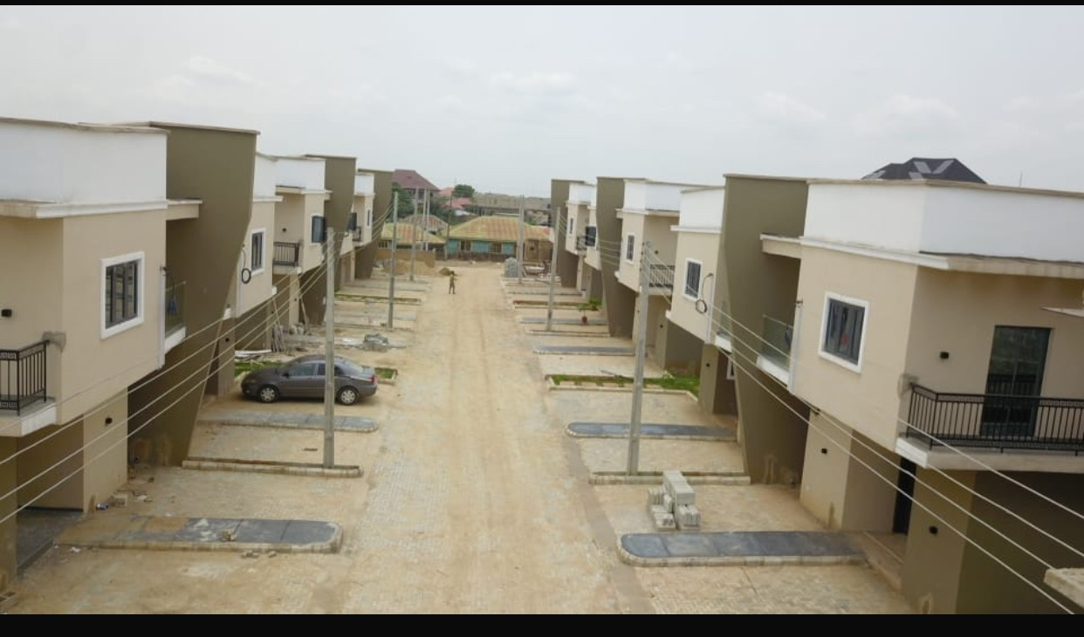
PLATE 3.1.2 APPROACH VIEW OF CASESTUDY ONE
3.2 CASE STUDY TWO
MILLENNIUM HOUSING ESTATE (IJAYE OJOKORO)
The Millennium Housing Estate has its roots in government initiative to provide affordable establishment isn’t specified, it’s part of a broader effort to address housing deficit. Nigeria’s housing development has been shaped by various national development plans, starting from the national development plan (1962-1968), which established state-owned Housing Corporation. The government launched several housing program, including the national housing programed and the federal mortgage bank of Nigeria (FMBN), to promote affordable housing.
    - MERITS
- Adequate convenience
- Sufficient parking area
- It’s well fenced
- Its high aesthetic value
3.2.2 DEMERITS
1. Inadequate green area
2. Poor road networking
3. Absent of religions buildings
4. No social amenities like school, shopping center

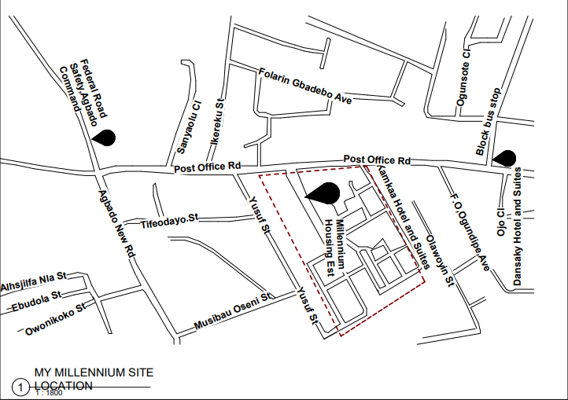 FIGURE 3.2.1 LOCATIONAL PLAN OF CASESTUDY TWO
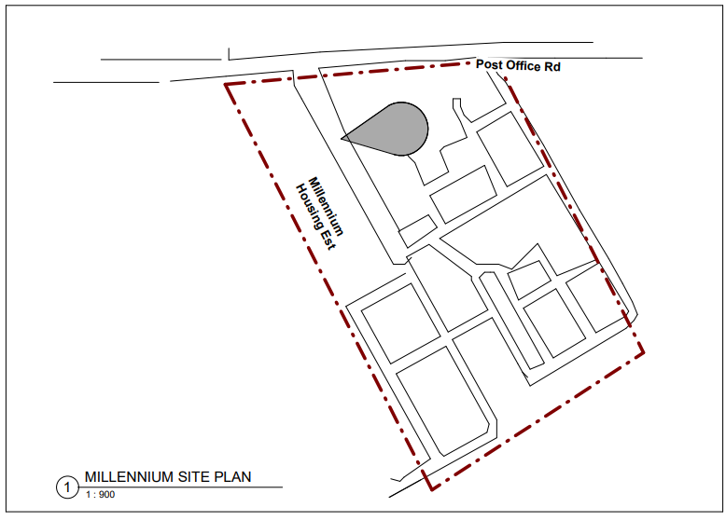
FIGURE 3.2.2 SITE PLAN OF CASESTUDY TWO
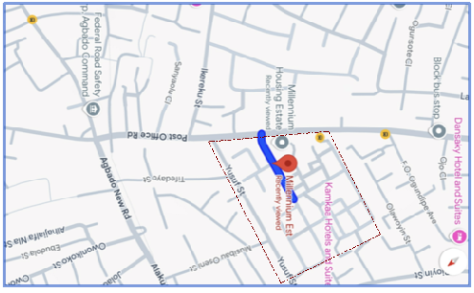 PLATE 3.2.1 GOOGLE MAP OF CASESTUDY TWO
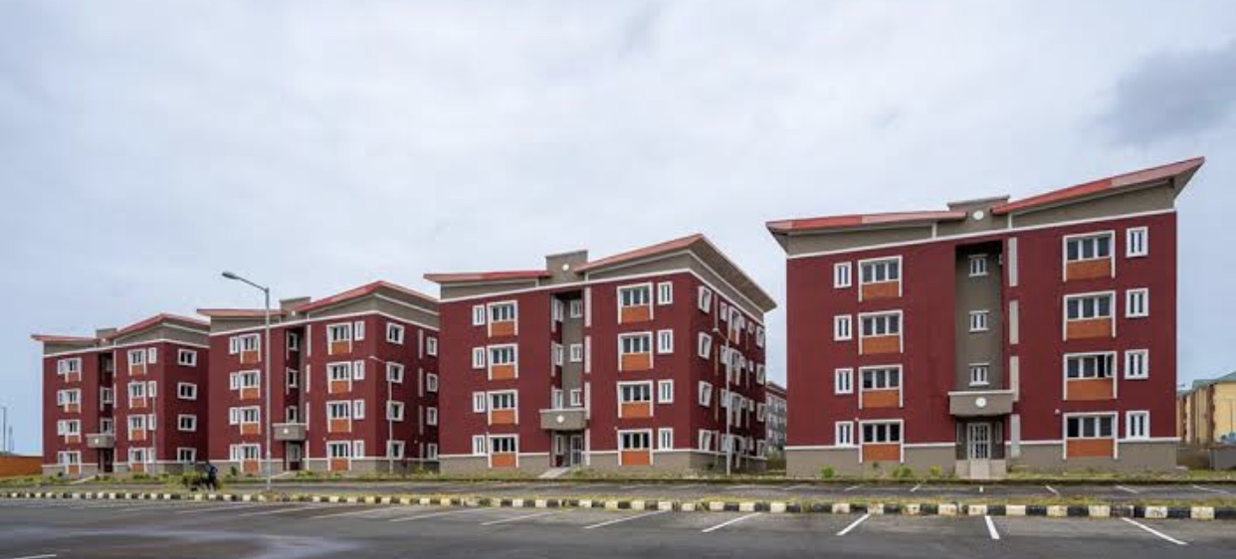
PLATE 3.2.2 REAR VIEW OF CASESTUDY TWO
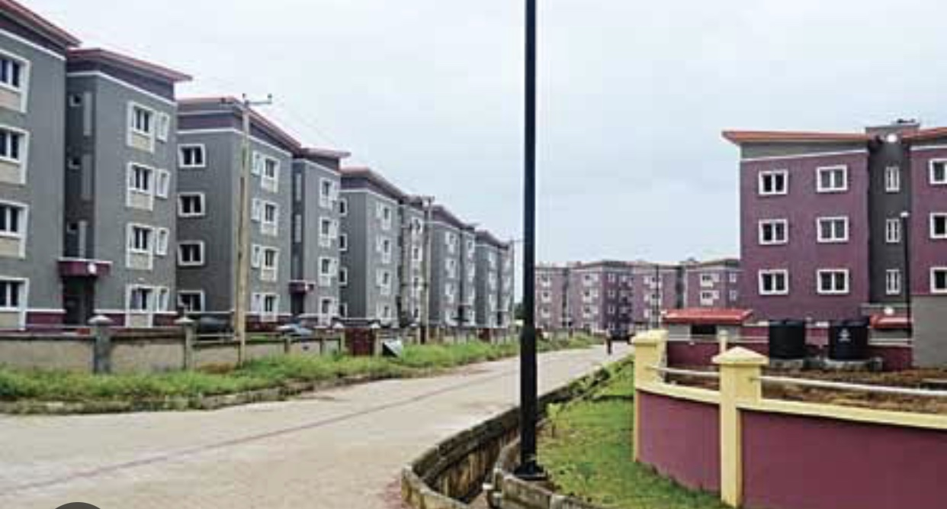
PLATE 3.2.3 APPROACH VIEW OF CASESTUDY TWO
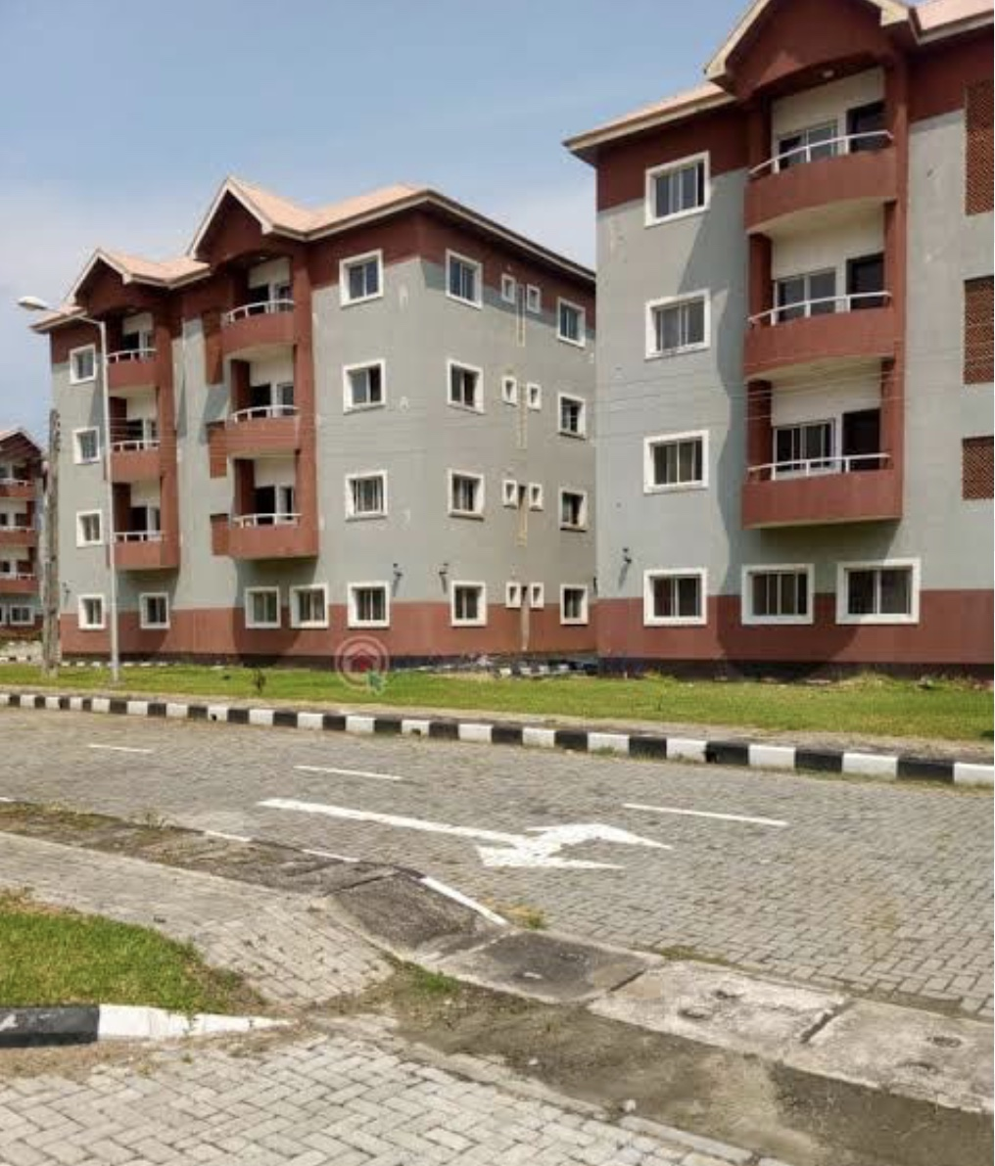
PLATE 3.2.4 APPROACH VIEW OF CASESTUDY TWO
3.3 CASESTUDY THREE
OMOLE PHASE 14 HOUSING ESTATE, LAGOS STATE
Omole is an extension of the larger omole estate, which was developed to meet the growing demand for quality residential and commercial spaces in ikeja, a major area in lagos.it located in a situated area near Lagos Ibadan expressway, making it easily accessible to other parts of Lagos and neighboring state. Omole phase 2 has experienced growth, with the Lagos state government investment in infrastructure development. omole phase two boasts modern infrastructure, including well-planned roads, security features, and amenities like school, shopping center, and healthcare facilities
    - MERITS
- The area provides a peaceful living environment, away from the bustle of city life.
- The estate has a secure environment, with features like gates access and security personal
- The estate boasts well-planned roads,
- Provision of social amenities like school, shopping centers, and healthcare.
3.3.2 DEMERITS
1. Lack of buffer zones
2. It lead to traffic congestion, especially during peak hours
3. The proximity to the expressway can also result in noise pollution, affecting residents.
4. No adequate parking spaces
5. The estate popularity can lead overcrowding, straining

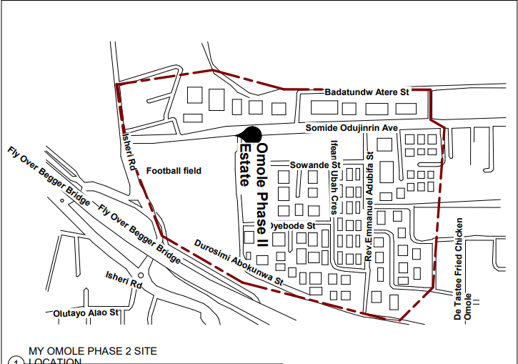
FIGURE 3.3.1 LOCATIONAL PLAN OF CASESTUDY THREE
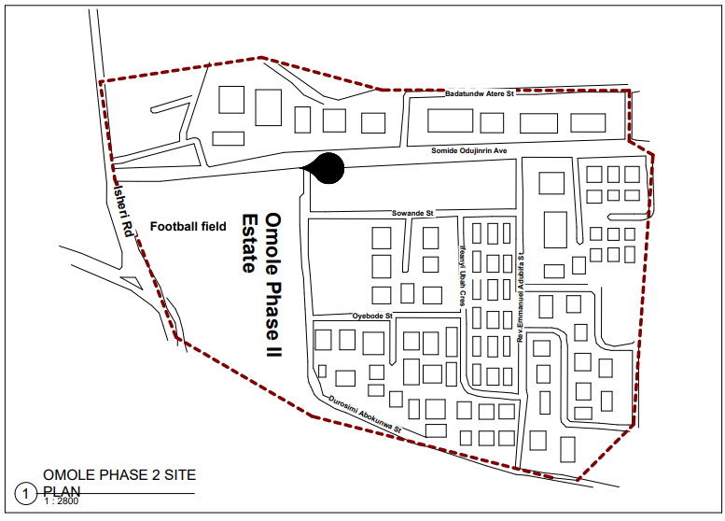
FIGURE 3.3.2 SITE PLAN OF CASESTUDY THREE
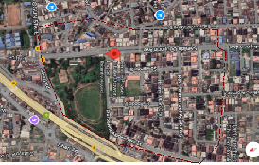
PLATE 3.3.1 GOOGLE MAP OF CASESTUDY THREE

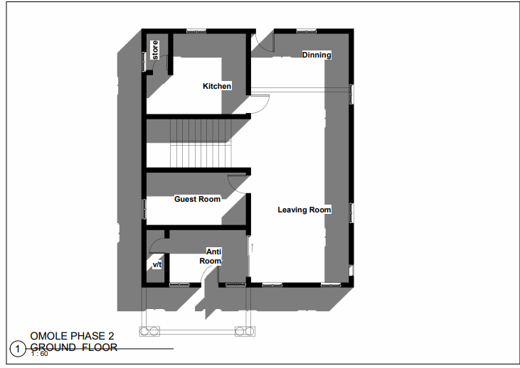
FIGURE 3.3.3 GROUND FLOOR OF CASESTUDY THREE
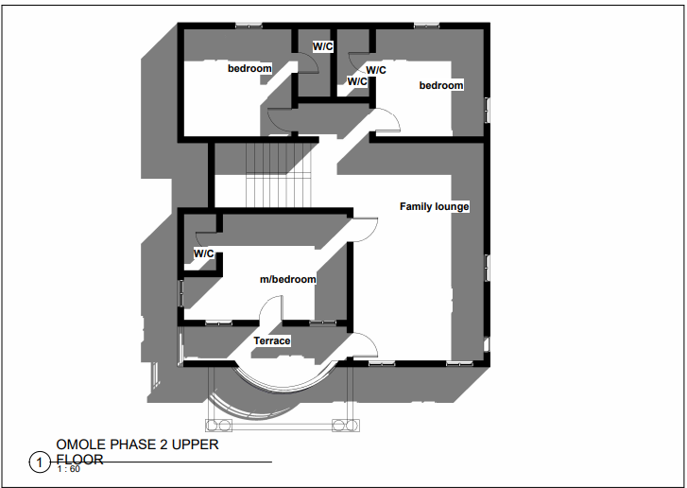
FIGURE 3.3.4 UPPER FLOOR OF CASESTUDY THREE
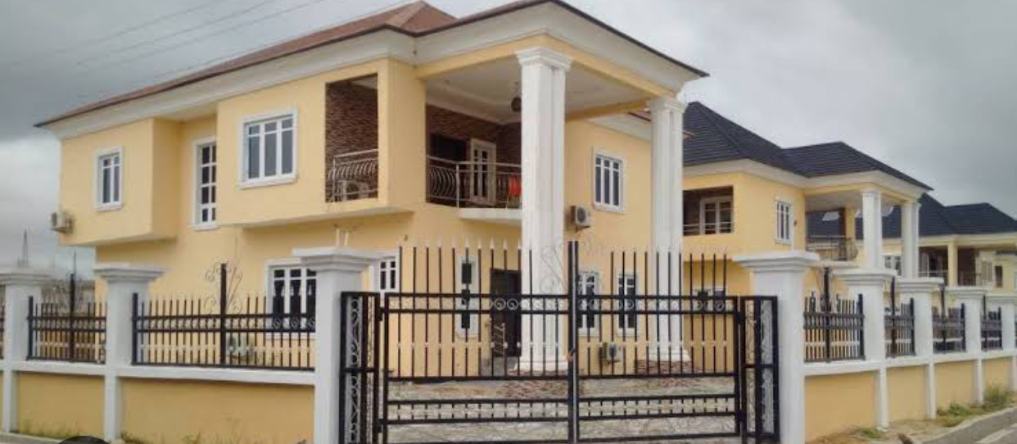
PLATE 3.3.2 APPROACH VIEW OF CASESTUDY THREE
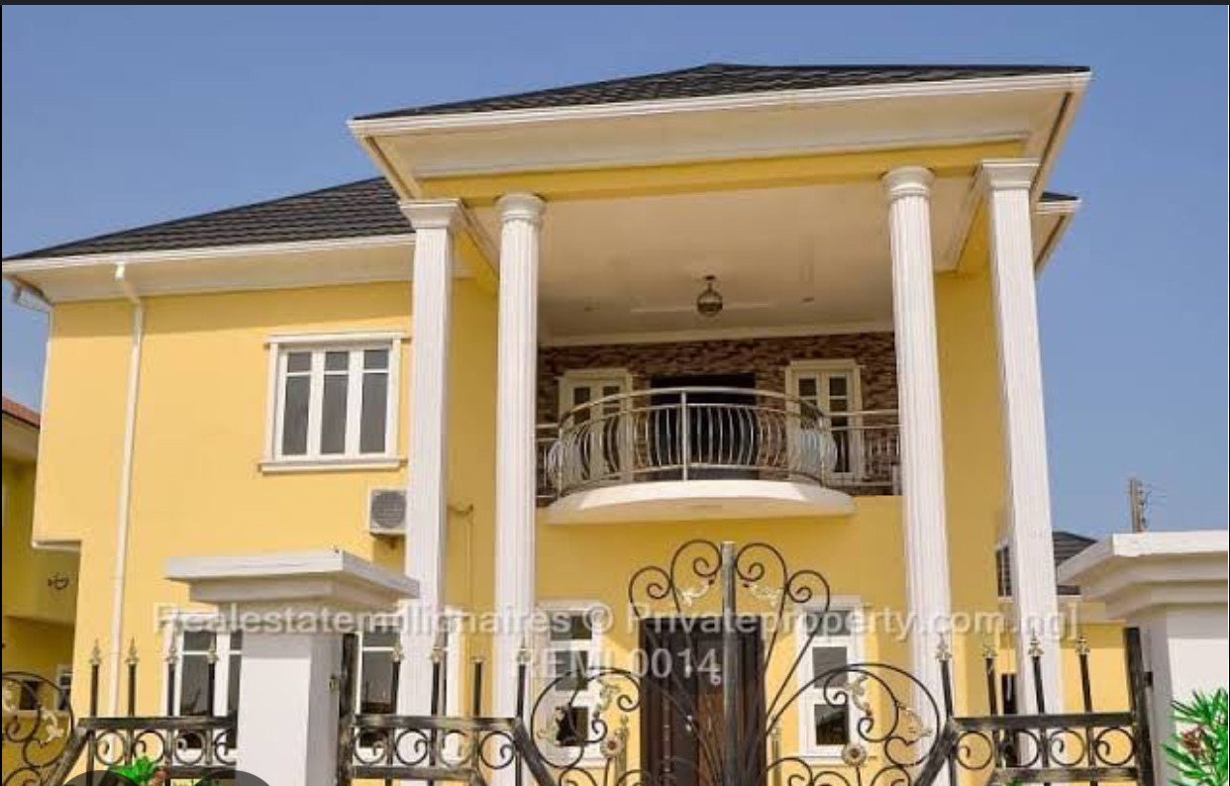
PLATE 3.3.3 APPROACH VIEW OF CASESTUDY THREE
3.4 THE GREENS ESTATE, TEMA GHANA
The Greens Estate in tema, Ghana is a gated community developed by shelter mart, offering luxurious urban homes dedicated to style and comfort. Located in tema community 25, the estate spans 7.2 acres featuring various types of semi-detached and detached houses. It is located at 30 kilometers from kotoka international airport, and approximately 1 kilometer from the gated community. The estate is designed to provide a secure and peaceful living environment, perfect for families and individuals seeking a tranquil atmosphere. The estate offer different types of homes, including 1-4 bedroom house. Its incorporate eco-friendly landscaping, enhancing the aesthetic appeal and environmental sustainability the community.
3.4.1 MERITS
1. incorporates eco-friendly landscaping and solar-powered system, promoting sustainability.
2. Resident can enjoy social amenities like gym, swimming pool, and multipurpose court
3. Good road networking system
4. Gated community with security personnel to ensures residents safety.
5. High-end amenities and modern architecture provide a luxurious living experience
3.4.2 DEMERITS
1. Luxury homes and amenities may require higher maintenance cost, adding to overall expense of living in the estate
2. Solar power can be a reliable source of energy, it may not be sufficient during periods of low sunlight or high energy demand
3. Despite the estate security features, there may still be concern about crime or safety,

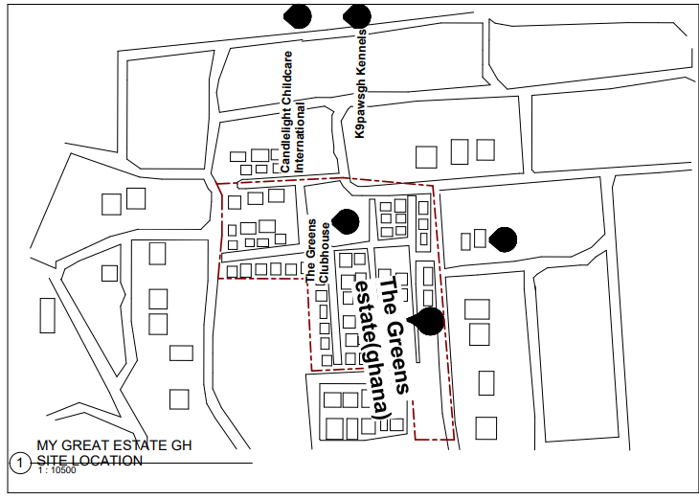
FIGURE 3.4.1 LOCATIONAL PLAN OF CASESTUDY FOUR
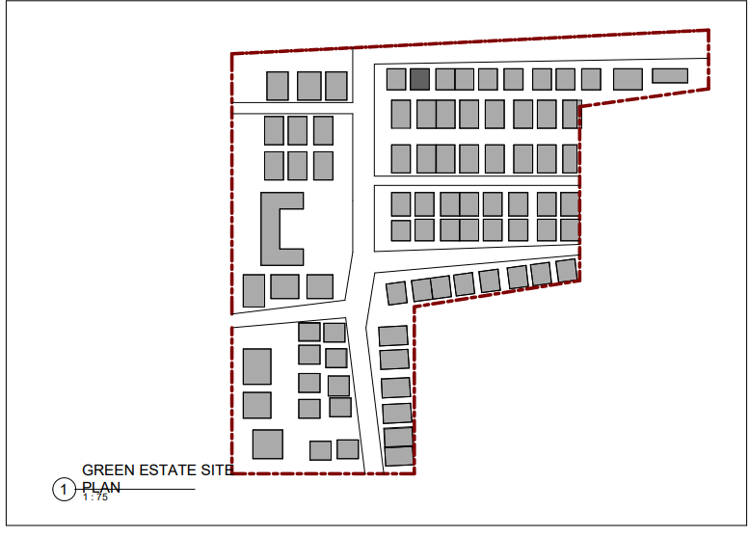
FIGURE 3.4.2 SITE PLAN OF CASESTUDY FOUR
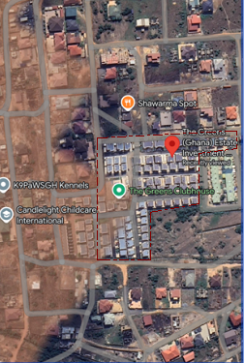
PLATE 3.4.1 GOOGLE MAP OF CASESTUDY FOUR

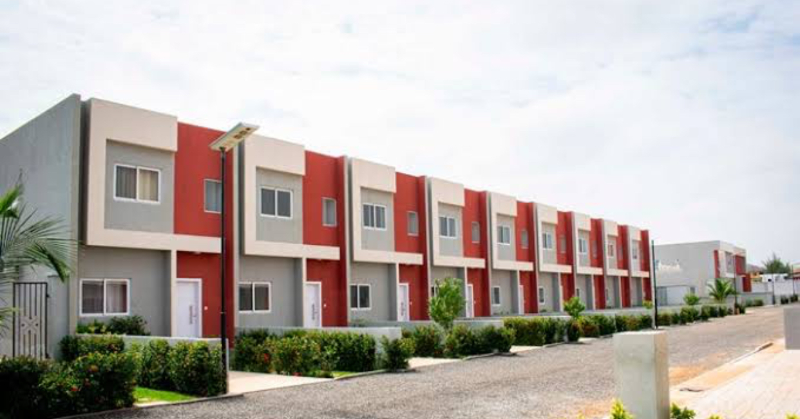
PLATE 3.4.1 APPROACH VIEW OF CASESTUDY FOUR 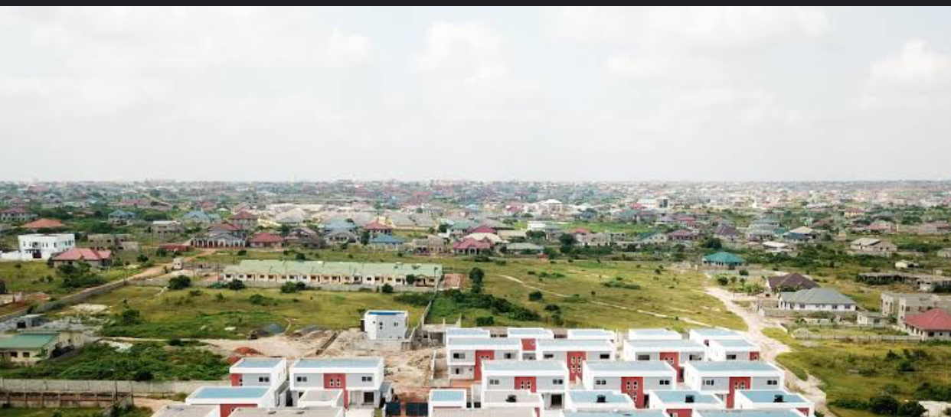
PLATE 3.4.2 APPROACH VIEW OF CASESTUDY FOUR
3.5 FANCOURT ESTATE, GEORGE, SOUTH AFRICA.
Fancourt estate is a luxury golf resort located in George, South Africa within the stunning garden route. This 613-hectare estate is nestled at the foot of the Outenique Mountains and offers breathtaking views.
The estate features two five-star hotels. The fancourt hotel with 115 luxurious rooms and suites, and the manor house boutique hotel. Room option including classic rooms, luxury rooms, one bedroom suites, and two bedroom
3.5.1 MERITS
1. it’s as a range of activities including tennis, squash, bowls, croquet, volleyball, and outdoor swimming.
2. A world-class spa inspired by the harmony of the four element. Air, water, fire, and earth.
3. A well-equipped gym for those who prefer finding wellness through exercise.
4. Well design conference venue for business events and weddings.
3.5.2 DEMERITS
1. Its located in George, which may be far from major cities like Cape Town or Johannesburg, making transportation and accessibility a challenge.
2. The area receive a significant rainfall during certain months, which could impact outdoor activates like golfing.
3. During peak season, the estate may be crowded, and noise level may increase due to the high volume of guests.
4. The estate is operations and large number of visitors may have an environment impact on the surrounding area.

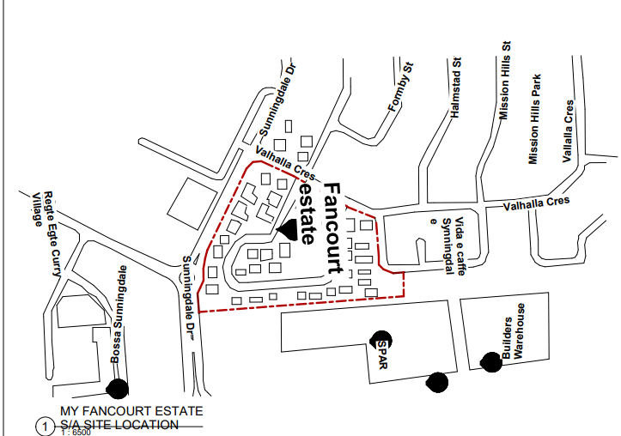
FIGURE 3.5.1 LOCATIONAL PLAN OF CASESTUDY FIVE
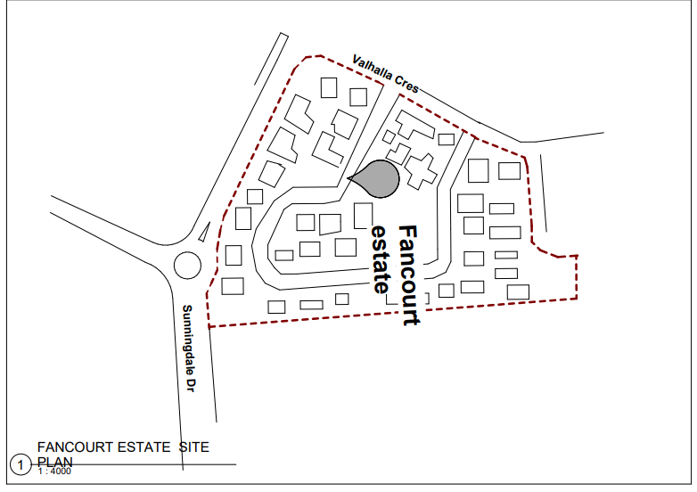
FIGURE 3.5.2 SITE PLAN OF CASESTUDY FIVE

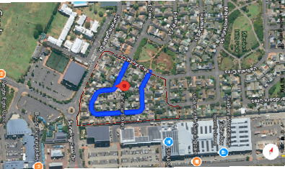
PLATE 3.5.3 GOOGLE MAP OF CASESTUDY THREE

CHAPTER FOUR
4.0 INTRODUCTION
Housing estate in lekki, Lagos state, reflects a blend of luxury, modernity, and Functionality, catering to the to the growing demand for high-end residential Properties in this affluent area. Lekki is known for its well-planned Infrastructure, serene environment, and proximity to key area of Lagos, Making it’s a desirable location for both individual and families.
4.1.1 SITE SELECTION
The site is a growing area in lekki with proximity to major road and amenities. abijo has seen significant development in recent years, with improved roads and amenities.
In term of infrastructure challenges abijo has seen development, some area may still face infrastructure challenges. abijo has a growing community, with various social and recreational activities
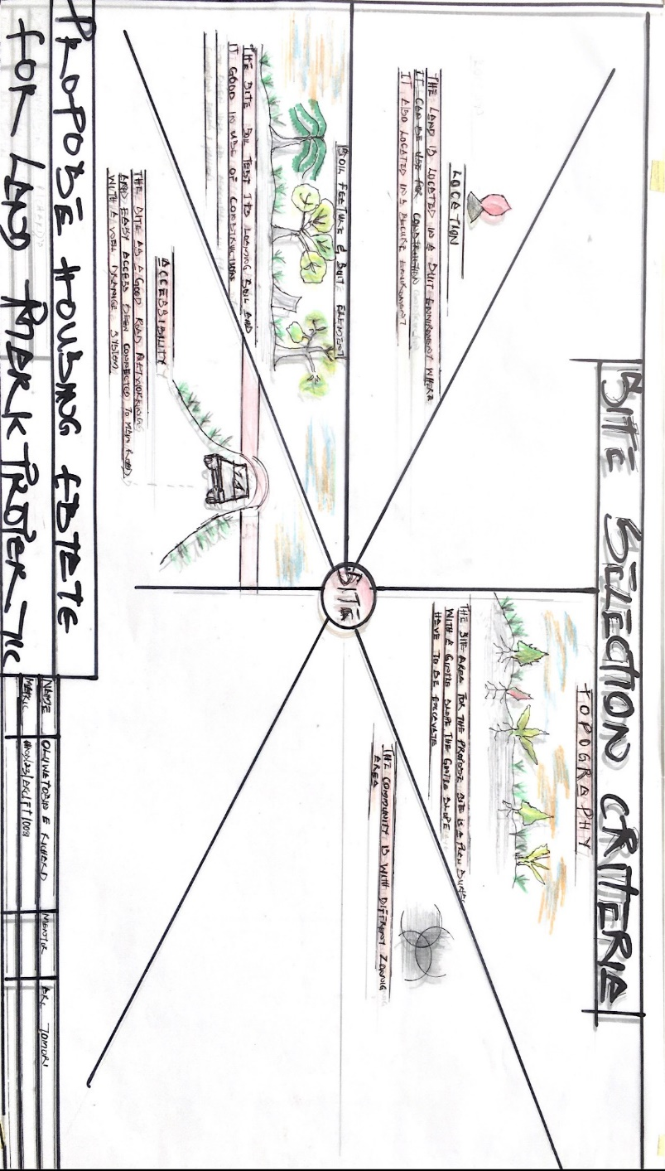
SITE SELECTION
4.1.2 SITE LOCATION
Abijo Is a locality in Eti-osa, Lagos city, Lagos sate, situated near the village of oko abe.
The site benefit from its proximity to this major highway, providing seamless access to key area of Lagos. The site located nearby known for its raid urban development and strategic location. The site enjoy easy access to eleko beach and atican beach, ideal for weekend gateways and elaxation. 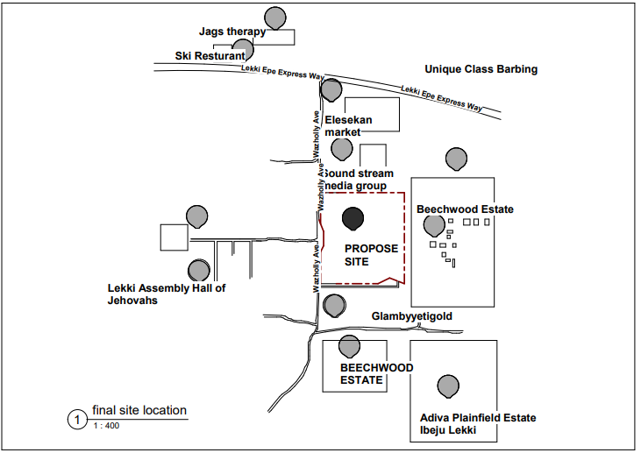
PROPOSE SITE LOCATION
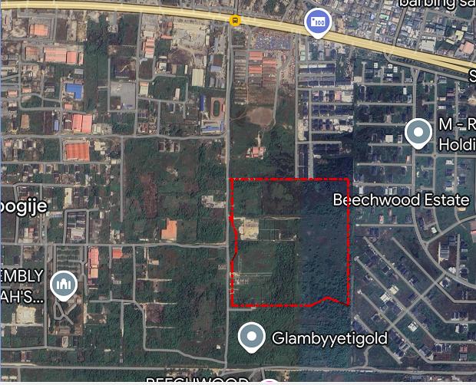
PROPOSE SITE GOOGLE MAP
4.1.6 SITE ANALYSIS
The analysis at the site has to do with the physical synthesis within the site. A site is analyzed by expressing how the features present on the site. Site and its display to suit the orientations of the building, sunrise and sunset coupled with the direction of prevailing winds.
On the site; there are tree(s) on the site. This covers an area some will be retained and some will be removed. The retained we served as a shed and wind breaker. Also the trees and shrubs will be retained to supplement younger ones to be planted to reduce the effect of sun and as noise filter
Topography; the site as stable land with a gentle slope toward the north region
Orientation; the effect of the four cardinal point are active.
Wind floor ; the site experience the effect of two trade wind, the south west trade wind and north east trade wind.
Relative humidity; due to the climate condition the relative humidity falls between 60-70
Solar radiation; the site experience solar radiation which comes from the easy and set at the west
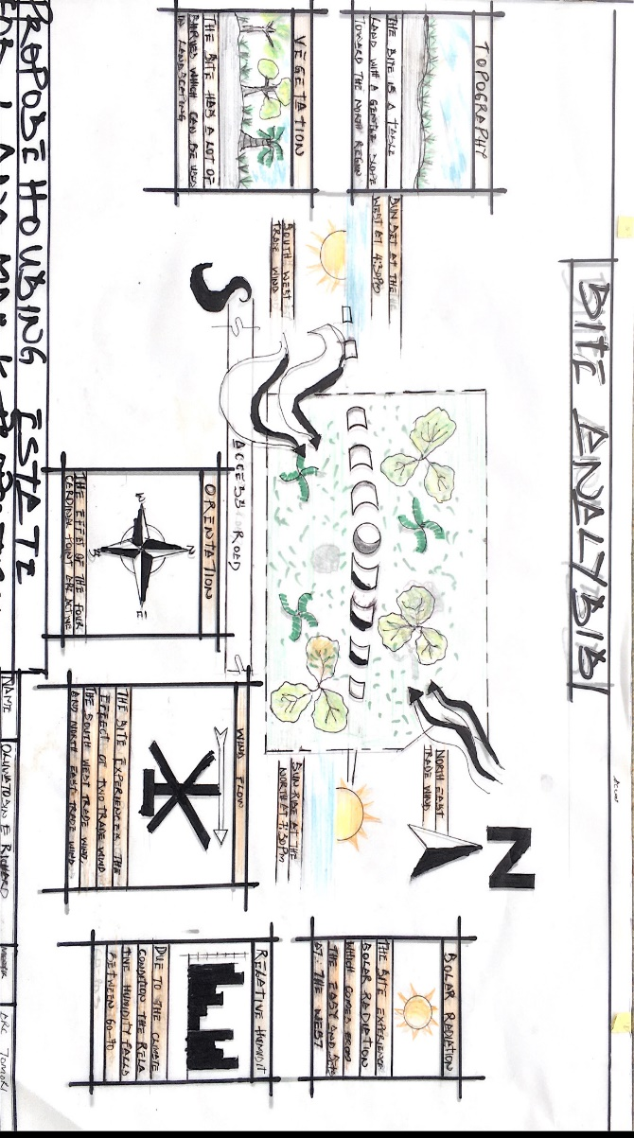

4.1.4 GEOGRAPHICAL DATA
The site is located in eti-osa, Lagos state, it as a latitude 6.47509 north, longitude 3.67187 east abijo is situated near the village of oko-abe and is approximately 30 kilometers from Victoria island, the commercial heart of lagos. The site benefits from its proximity to the lekki-Epe Expressway, providing seamless access to key area of Lagos, such as Victoria Island, ikoyi and epe.

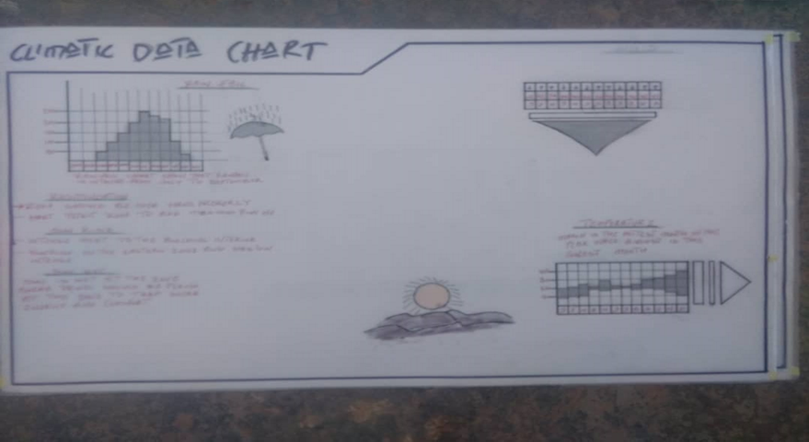

    - ANALYSIS OF THE IMMEDIATE ENVIRONMENT CONDITIONS OF THE SITE
The site has initiated clean-up operation in abijo area, highlighting the need for proper waste management. Urban area like abijo are prone to air pollution due to vehicle emissions and industrial activities. This can exacerbate respiratory issues and other health problems Access to clean water is essential and abijo water quality may be affected by various factor, including sewage leaks or industrial waste. abijo infrastructure is developing ,with some area featuring interlocking roads, drainage system and streetlight.
    - PROJECT GOAL
- Design for an eco-friendly and environmentally responsible housing estate that minimize its carbon footprint, also to provide residents with high quality of life by incorporating amenities,. Green space, and community facilities to design spaces that encourage social interaction belonging among residents.

- 4BEDROOM FULLYDETACHED DUPLEX
S/N | UNITS | (L)M | (B)M | AREA( SQ M) | NO
1 | ENTRANCE | 1.8 | 1.5 | 2.7 | 1
2 | TERRACE | 3 | 3 | 10 | 1
3 | LIVINGROOM | 10 | 4 | 40 | 1
4 | FAMILY LOUNG | 7.5 | 3 | 22.5 | 1
5 | MASTER ROOM | 5 | 4 | 20 | 1
6 | BEDROOMS | 4 | 3.6 | 12 | 2
7 | DINNING | 4 | 4 | 16 | 1
8 | KITCHEN | 4.5 | 4 | 16 | 1
9 | VISIT/ ROOM | 4.5 | 4 | 18 | 1
10 | BATH | 2.1 | 1.5 | 3.15 | 3
11 | V/TOIL | 2.1 | 1.2 | 2.52 | 1
12 | SIT/OUT | 4 | 2.4 | 10 | 1
13 | STAIR AREA | 4 | 2.4 | 10 | 1
14 | M/BATH | 3 | 1.5 | 4.5 | 1
TABLE 4.1 4BEDROOM FULLY DETACHED DUPLEX TABLE
- 4 UNITS OF 2BEDROOM APARTMENT
S/N | UNITS | (L)M | (B)M | AREA( SQ M) | NO
1 | ENTARNCE | 4.5 | 2 | 9 | 4
2 | TERRACE | 4.5 | 2 | 10 | 4
3 | LIVINGROOM | 4.5 | 5 | 20.5 | 4
4 | DINNING ROOM | 4.5 | 2.5 | 11.3 | 4
5 | BEDROOM | 4 | 4 | 16 | 8
6 | BATH | 2.1 | 1.5 | 3.15 | 8
7 | KITCHEN | 3 | 3 | 10 | 4
8 | STORE | 1.5 | 1.2 | 2 | 4
9 | SIT/OUT | 2.5 | 2 | 5 | 2
TABLE 4.2 4UNITS OF 2BEDROOM APARTMENT

2BEDROOM BUNGALOW
 | S/N | UNITS | (L)M | (B) M | AREA(SQ M) | NO
 | 1 | ENTARNCE | 1.6 | 2.5 | 4 | 1
 | 2 | LIVINGROOM | 4.5 | 5.5 | 25 | 1
 | 3 | BEDROOM | 4 | 4 | 16 | 2
 | 4 | KITCHEN | 3 | 3.6 | 10 | 1
 | 5 | DINING | 4 | 2.5 | 10 | 1
6 |  | S/OUT | 1.6 | 1.2 | 2 | 1
7 |  | BATHS | 2.1 | 1.5 | 3.5 | 4
TABLE 4.3 2BEDROOM BUNGALOW TABLE
PROGRAM DEVELOPMENT
S/N | CADER | BUILDING TYPOLOGY |  | NO, B | NO OF DWELLER |  | PERCENTAGE
1 | HIGH INCOME EARNER | 4BEDROOM FULLY DETACHED DUPLX |  | 27 BUILDINGS | 1
2 | MEDIUM INCOME EARNER | 4UNITS OF 2BEDROOM APART |  | 12 BUILDINGS | 4
3 | LOW INCOME EARNER | 2BEDROOM BUNGALOW |  | 24 BUILDINGS | 1
 |  |  | 63 BUILDINGS
TABLE 4.4 PROGRAM DEVELOPMENT
4.2.2 FUNCTIONAL /SPATIAL CRITERIAL
A well-designed housing estate in abijo should prioritize functionality, incorporating functionality incorporating features that enhance the quality of life for residents. Incorporate a mix of residential, commercial and recreational spaces to create a vibrant community. Balance density with green spaces living environment. Easy access to public transportation, major roads and amenities.
Provide a community center with amenities like gym, pool, and event spaces .incorporate parks, playgrounds, and green space to promote recreation and relaxation. Design a storm water management system that reduce flooding and erosion, creating space for community event, such festival, concert, and farmers market. Design building and space that can adapt to changing needs and uses.
    - APPRAISAL OF PROPOSED SCHEMES IN THE SPACES,SIZE AND RELATIONSHIP
Service refer to those domestic system which affect human health, safety, and comfort as well as building form and construction. Paramount among these are the water system, electricity and lighting, the efficient disposal of fluid waste and organic matter which is critical to the maintain of sanitary condition within the building and its surrounding, so also a fire safety mechanism security of the environment and acoustics of the building.
These are some people who feel that the imagination and reason cannot be intermingled, the beauty and utility are inconsolable, that a useful building should be designed foe utility and be required to be useful.
I believe and repeatedly demonstrate throughout this project that a useful building can also be beautiful, that beauty has therapeutic value, and that beauty worth payment for. This belief embracing the living concept as well as the smallest details and transcending functionalism, pose the challenge for any architect engaged real estate design to satisfy the highly demanding functional requirement and skill create a beautiful building.
The functional efficiency of this project depends largely on the closeness of one unit to another, the functional relationship of all the units within the project are taken care of.
    - EQUIPMENT AND OPERATION AND PERFORMANCE REQUIRMRNTS.
The choice of equipment and operation use
- Electricity system
- Water supply system
- Waste management system
- Security system
- Landscaping and maintenance equipment
- Regular maintenance
- Customer support

    - SPATIAL ALLOCATION /SCHEDULE OF ACCOMODATION
- DOOR
The main purpose of door is to provide access into or out of a building and between the various compartments within the building. In specifying types of doors, the numbers of people expecting to pass through are considered along with the control desirable. Glazed doors in aluminum frame are provided in the reception hall. Restaurant among others, kitchen are specified with doors that have high fire rating.
- WINDOWS
The purpose of a window is to admit day-light, provide natural ventilation exclude rain water and give a view outside.
The selection of size, shape, location, and numbers of windows openings in a room depends upon the size of the room, direction of the wall, direction of the wind, climate condition and the requirement of the exterior of the building.
- FLOORS
Floors are the structural part of a horizontal supporting elements as distinct firm the wearing surface. The solid ground floor which is otherwise called German floor in Nigeria. Its consist of concrete not less than 150mm thick laid on a hardcore of a least 250mm thick compacted in layer of 59-75mm.the damp proof membrane should be placed below. The over site concrete which compacted before cement and sand (1:3) screed is finally laid on it to a thickness of not less than 19mm.
    - FUNCTIONAL RELATIONSHIP
Residential units will be located near amenities like parks. Playground, community centers, and shopping areas to enhance convenience and quality of life. Amenities will be designed to be accessible to all residents. A well-designed road network should connect residential units to amenities, transportation hubs, and commercial areas, ensuring easy navigation and accessibility..
Essential utilities like water, electricity, and waste management services should be reliable and efficiently managed to support resident needs. Parking green spaces should be integrated into estate, providing residents with areas for recreation, relaxation and socialization. Playground and sport facilities should be designed for safety and accessibility, promoting physical activity and community engagement the estate will incorporate green building practices, such as energy-efficient design renewable energy, effective waste management systems should be implemented, including recycling and composting, to reduce waste and promote sustainability.

CHAPTER FIVE
5.3 TECHNOLOGICAL AND ENVIRONMRNT CRITERIAL
Integrated renewable energy sources, like solar or wind power, to reduce dependenceon
Traditional energy sources and minimize carbon footprint. Provide high-speed internet connectivity to support resident’s digital needs and enable remote works, education, and entertainment. Implement intelligent building system that can monitor and control energy usage, water consumption, and waste management, optimizing resource efficiency .incorporate smart home technologies, such as energy-efficient system, smart lighting and home automation, to enhance resident comfort and convenience. Use of sustainable building materials, such as locally sourced materials, recycled materials, and low-VOC (volatile organic compound) paints, to minimize environmental impact.
5.3.1 CONSTRUCTION METHODOLOGY AND MATERIALS/FINISHES DESIRED BY CLIENTS.
- WALLS
This generally defines the outside and inside space of a building structure. Its primary function is to enclose or divide space, offer privacy and specially to provide support to different kinds of loads (live, dead, wind).
Walls can be categorized into load-bearing and non-load bearing walls. Load bearing walls are walls which carry vertical imposed load from roofs and floors while non-load bearing walls are walls which carry only their self-weight and are mainly used as dividing walls, partition and dwarf walls.
For the construction of the walls, block of 450mm*225mm*225mm would be suitable, curtain walls are also used. These are fixed to the face of the structure so as to perform the function of windows and walls.
- ROOF
A roof is usually the uppermost part of the building which protects them from weather i.e rain and wind etc .for the uppermost part of the project, it consists of steel structural element aluminum roofing sheet.
- FLOORS
Floors are the structural part of a horizontal supporting elements as distinct firm the wearing surface. The solid ground floor which is otherwise called German floor in Nigeria. Its consist of concrete not less than 150mm thick laid on a hardcore of a least 250mm thick compacted in layer of 59-75mm.the damp proof membrane should be placed below. The over site concrete which compacted before cement and sand (1:3) screed is finally laid on it to a thickness of not less than 19mm.

- CEILING
Suspended ceiling of aluminum railing with paper pulp sheet are use in the project. This product has an advantage of smooth, flame resistance and good acoustic value.
5.3.2 SERVICE REQUIRED
- VENTILATION
In housing estate, mechanical equipment is required to carry out the thermal loads still remain after techniques of heat rejection, conservation and passive cooling and heating have been applied. However, with proper design and orientation of the housing estate as described earlier on this thesis, the size and energy demands of heating the cooling equipment can be very small.
In the proposed housing estate, air condition is use to heat, cool, clean and circulate air although, windows are also provided for adequate ventilation.
- LIGHTING
Lighting in an estate is a very fundamental for wing of objects and artifact. There are two methods of lighting the museum namely; natural and artificial lighting. Both of these could be damaging to the artifact depending on their intensity. Hence, the use of indirect light is encourage to reduce the risk of fading of colors of the artifact.
Natural lighting is more viable than artificial lighting. There are basically two method of natural lighting namely top and lateral lighting. The choice of lighting system depend on the design program of the housing estate.
Side (lateral) lighting has the advantage of accessibility, low cost of maintenance, low radiation dirt and dust accumulation.it also gives good ventilations, allows for outside viewing and multi-level exhibition.
Lateral lighting is more ideal in place like northern Nigeria because it reduces intensive solar radiation, maintenance cost, natural ventilations and accessibility.
Top lighting is a second method of natural lighting in housing estate.it has advantage of maximum use of wall surface for exhibition, amount of light coming in is regulated.
- PLUMBING AND ELETRICAL INSTILLATION.
The need for water is very important in the public center, however there will be digging of boreholes water, there will be a point where the borehole water will be channel to each apartment.
Paved area are laid to gradient or falls towards gullies or channels that collect surface water and discharge through drains to servers or soak away.
- ELETRICAL INSTILLATION
Electricity is supplied by ikeja electricity power Distributor Company, however in case of power failure, it would be augmented to have stand-by generator set as specified by the service engineer. The power transmission and wiring system shall be conduit step down a/c power transmitter shall be service and maintained by the maintenance section. The housing estate will receive five phase of electricity supply from the electricity grid at the rating of 600 volts and frequency of 200 hertz each. The size of the cable will depend on the service entrance equipment in the housing estate and the amp age supplied by the electricity power authority.
- ACOUSTIC
Sound is absorbed by a mechanism which converts the sound into other forms of energy and ultimately into heat. Most manufactured materials depend largely on their porosity for their absorptivity. Many materials such as mineral wool pads and blankets have multitude of small deeply penetrating inter-communicating pores, the sound waves can readily propagate into these interstices where a portion of sound energy is converted into heat by fractional and viscous resistance within the pores and by vibration of small fibers of the materials.
If the materials is sufficiently porous, and of appropriate thickness, as much as percent of the energy of an incident sound wave may be absorbed in this manner. When sound wave strikes a panel, the alternative pressure of these wave against the panel ay force it into vibration. The resulting flexural vibration use a certain amount of the incident sound energy by converting it into heat.
- FIRE PROTECTION
Fire in building are nearly man-made that is, resulting from errors or negligence. The principal aim of fire precaution are simply to safeguard life and property and are achieved by
- Reducing fire incidence
- Controlling fire propagation and spread
- Providing adequate means of escape occupant of building.
The architect role is in the prevention, detection and combat of fire through appropriate designs. Specification and choice of materials.
5.3.3 ENVIRONMENTAL CONDITION TO BE ACHIEVED
- Air Quality
To design the estate to minimize air pollution from vehicle emissions, industrials activates, and others source.to incorporate green spaces and parks to help purify the air improve air quality
- Water Quality
To design effective storm water management systems to prevent flooding and minimize water pollution.to incorporate water conservation measures, such as rainwater harvesting and greywater reuse, to reduce water consumption.
- Waste management
To design effective waste management systems, including recycling and composting facilities, to minimize waste sent to landfills.to encourage reduction and recycling practices among residents.
- Noise Pollution
To design the estate to reduce noise pollution from traffic, industrial activates, and others sources.to incorporate noise barriers, such as soundproofing materials and green walls, to minimize noise pollution
- Energy efficiency
To incorporate energy-efficient design principles, such as passive solar design and insulation, to reduce energy consumption.to consider incorporating renewable energy source, such as solar or wind power, to reduce dependence on traditional energy source.
5.3.4 PERFORMANCE STANDARDS.
- Sustainability
To design building and systems to minimize energy consumption and reduce greenhouse gas emissions. To implement water-saving measures, such as low-flow fixtures and rainwater harvesting, to reduce water consumption.to design waste management system that promote recycling, composting, and minimizing waste sent to landfills
- Safety and Security
To design the estate to prevent crime, including features like secure access point, CCTV surveillance, and adequate lighting.to ensure that emergency service, such as fire stations, hospitals, and police stations, are easily accessible
- Accessibility and inclusivity
To design building and public spaces to be accessible to people with disabilities, including features like ramps, elevators, and accessible walkways.to foster an inclusive community by providing amenities and services that cater to diverse needs and demographics.
- Community Engagement
To provide community facilities, such as community centers and parks, to foster social interaction and community engagement among resients.to encourage resident participate in decision-making processes and community development initiatives.
- Transportation and Mobility
To encourage sustainable transportation options, such as walking, cycling, and public transportation, by designing pedestrian-friendly and bike-friendly infrastructure.to design effective traffic managements system to minimize congestion and ensure safe traffic flow.
5.4 LEGAL ISSUES AND PLANNING REGULATION
- Land Ownership;
To ensure clear land ownership and title to avoid disputes and litigation.
- Zoning Regulations
Comply with zoning regulations, which dictate land use, density and building height.
- Density and Height Restrictions
Comply with density and height restriction to ensure that the development is in line with the surroundings
- Building Code and Standards
To comply with local building codes and standards to ensure structural integrity and safety.

5.5 CONCLUSION
The housing estate, abijo is an example of housing estate with adequate infrastructure facilities. Measuring are also taken to ensure that. Its meet its design aim, improving on the preservation and conservation of artifacts through appropriate reconditioning of the museum environment and by adequate cushioning the effects of the harsh climatic factors through passive and actives means. The design should prioritize maximizing useable space while maintaining privacy and comfort for residents, easy access for pedestrians, cyclists, and vehicle is crucial, public transportation option should be considered to reduce reliance on car.

REFRERNCES
Alfred M.T (2018); Architectural Hand Book, Mc GraWhill Publication London, 5th Edition, PP 30-37.
Andrea Palladio (2016) Architectural Hand Book, Mx Grall Publication uk, 6Th Editon.
Aantoni Gaudi (2019) Landscaping Design Hand Book, Gralilo Publication sp. 6th Edition
Barry R (1972); the construction of building, MPG Book Ltd. Cornwall, Great Britain. Vol 1-5
Barry R. (1979); the construction of building, the English language book society and crosylock wood staple, London, vols5, pp 69-76
Churdly R. (1987); Building site works, sub structure and plant, Longman group limited, UK 2ND Edition, pp 94-102
De-Chiara J. (1929); Tiwa Savers standard for building type. Me Grwa hill New York. Fourth Edition
Ernst and Peter Neufert (2018) Architect Data, A John Wiley & Sons, ltd. Singapore, 5Th Edition
Fullerton R.L (2022); Building Construction in warm climates, Macmillan publisher limited, London, 2nd Edition, pp 53-59
Neufert E. (2022); Architect Data Granada publishing limited, Newyork, 3rd Edition, pp 199-205

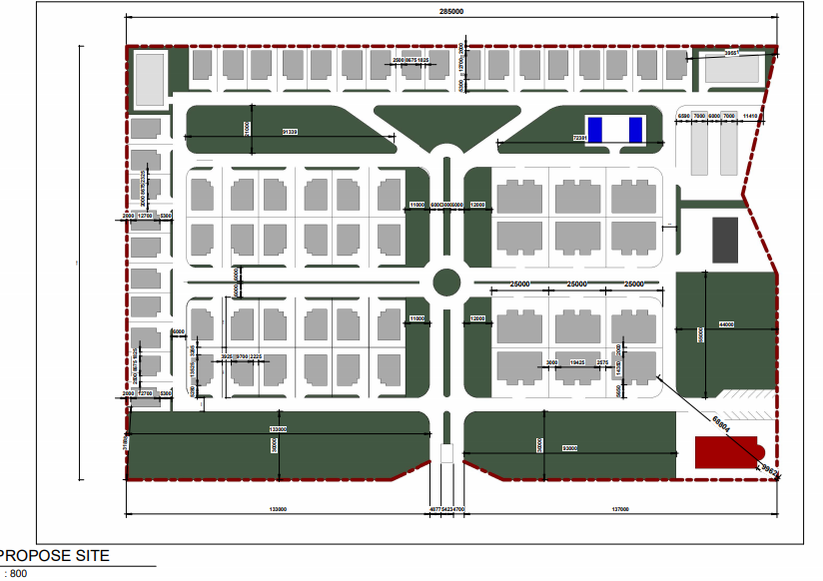APPENDIX 1 PROPOSE SITE PLAN

- 4BEDROO FULLY DETACHED DUPLEX
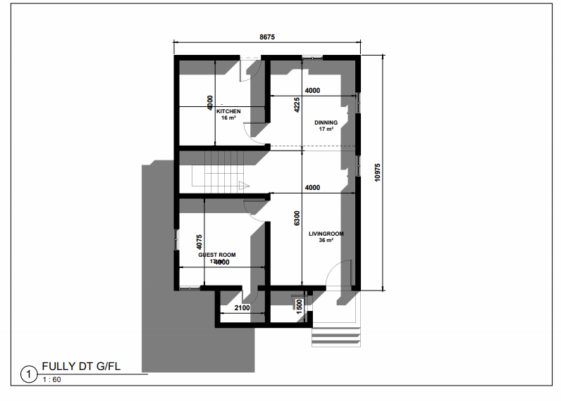
APPENDIX 2 GROUND FLOOR PLAN
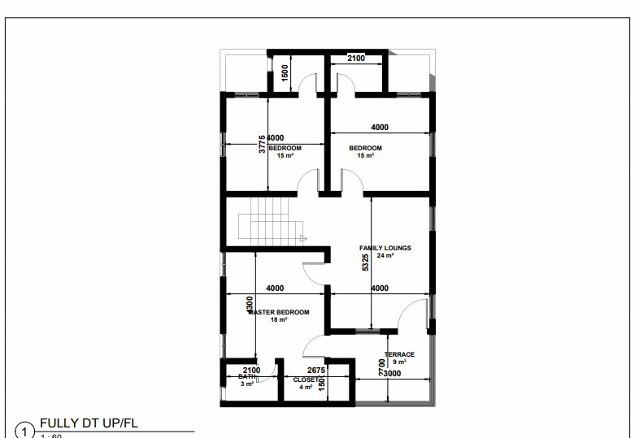
APPENDIX 3 UPPER FLOOR PLAN
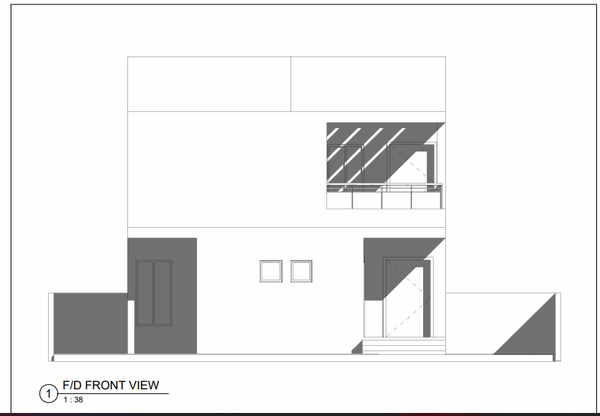 APPENDIX 4 FRONT VIEW
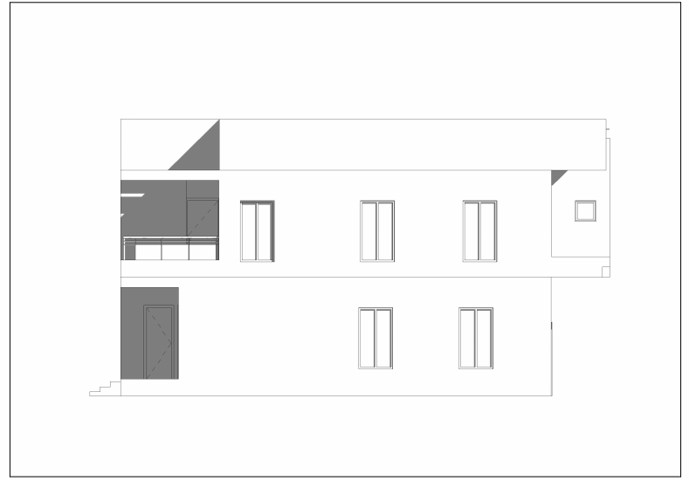
APPENDIX 5 RIGHT VIEW
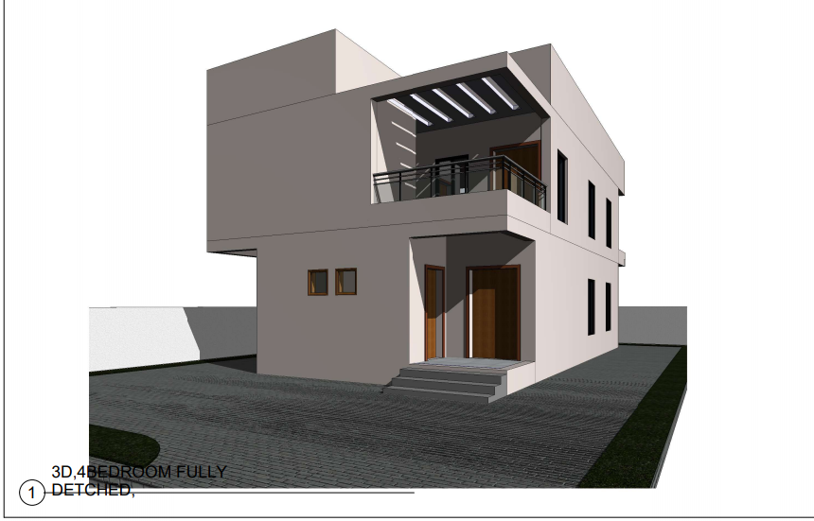
APPENDIX 6 3D VIEW FOR 4BEDROOM FULL/D

4UNITS OF 2BEDROOM APARTMENT
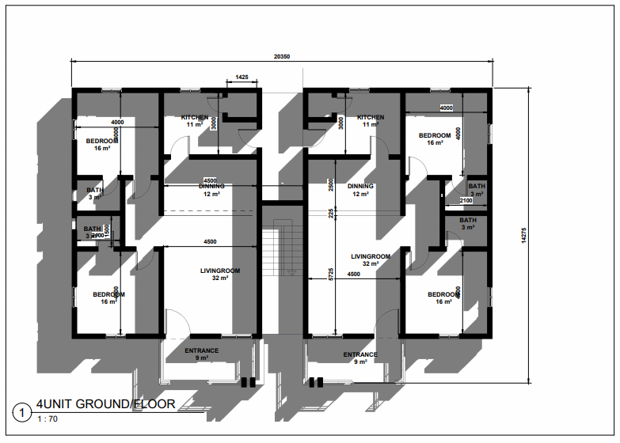
APPENDIX 7 GROUNDFLOOR
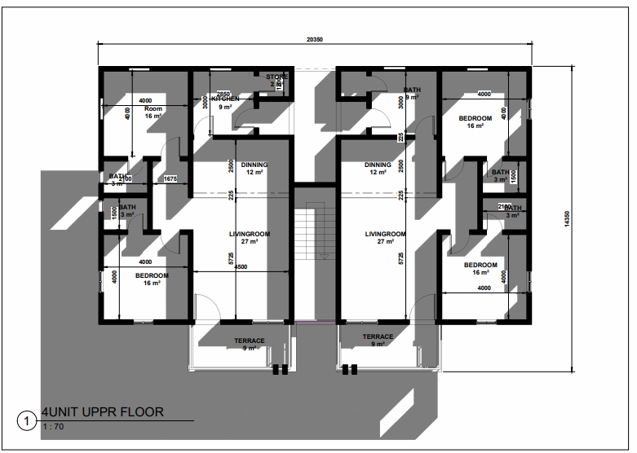 APPENDIX 8 UPPER FLOOR PLAN
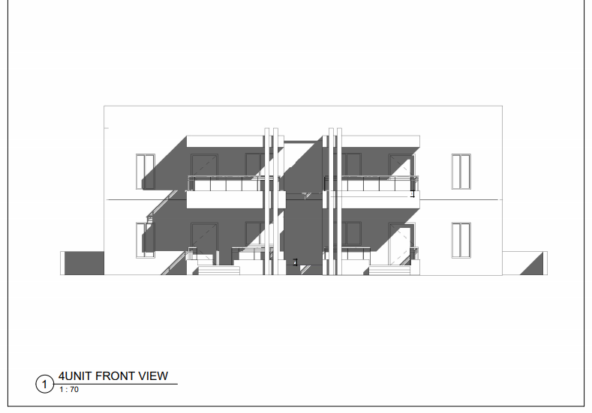
APPENDIX 9 FRONT VIEW
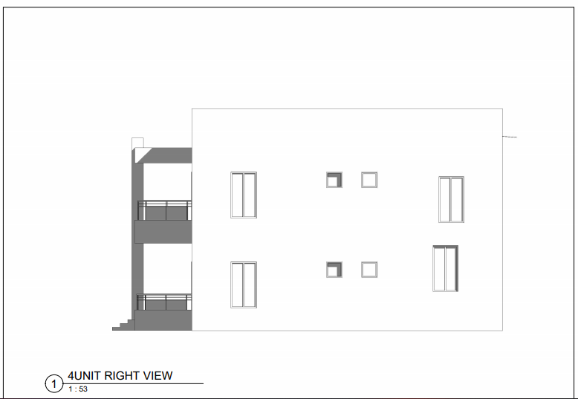
APPENDIX 10 RIGHT VIEW
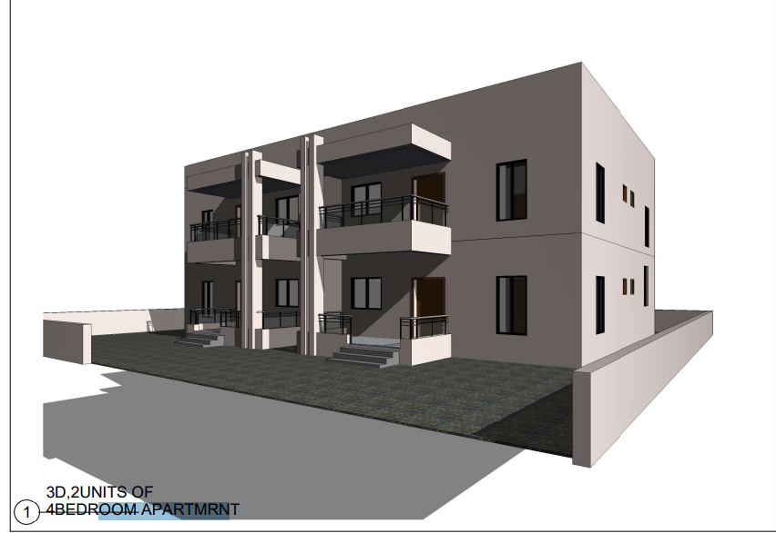
APPENDIX 11 3D VIEW FOR 4UNITS OF 3BED APARTMENT

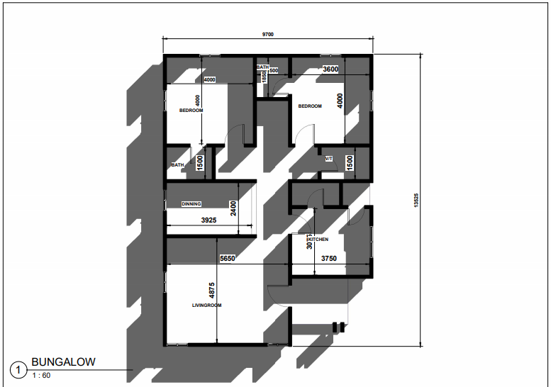
APPENDIX 12 GROUND FLOOR PLAN

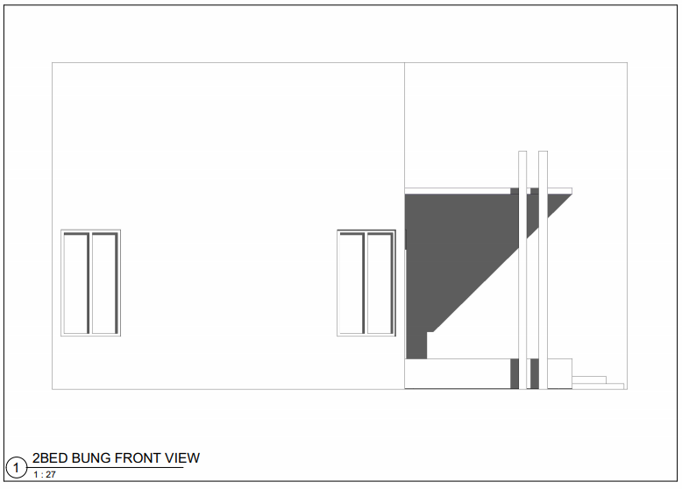
APPENDIX 13 FRONT VIEW
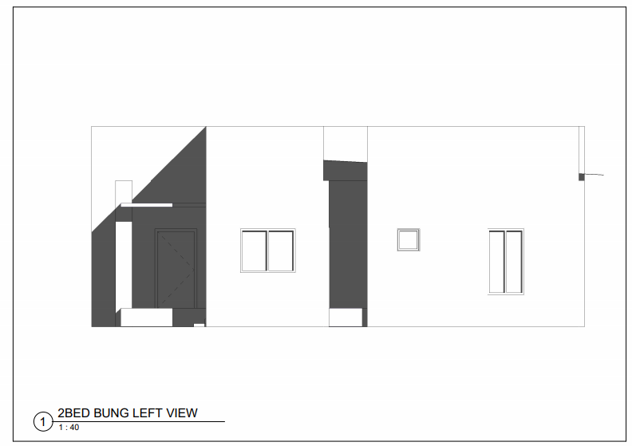 APPENDIX 14 LEFT VIEW
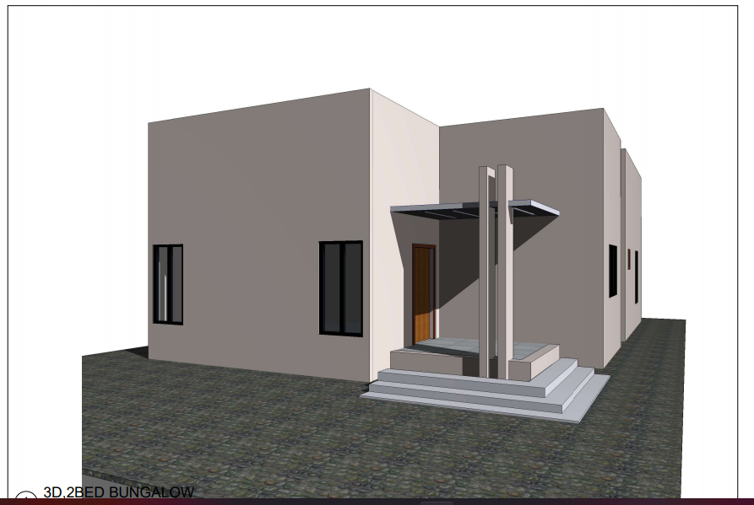

APPENDIX 15 3D, 2BEDROOM BUNGALOW
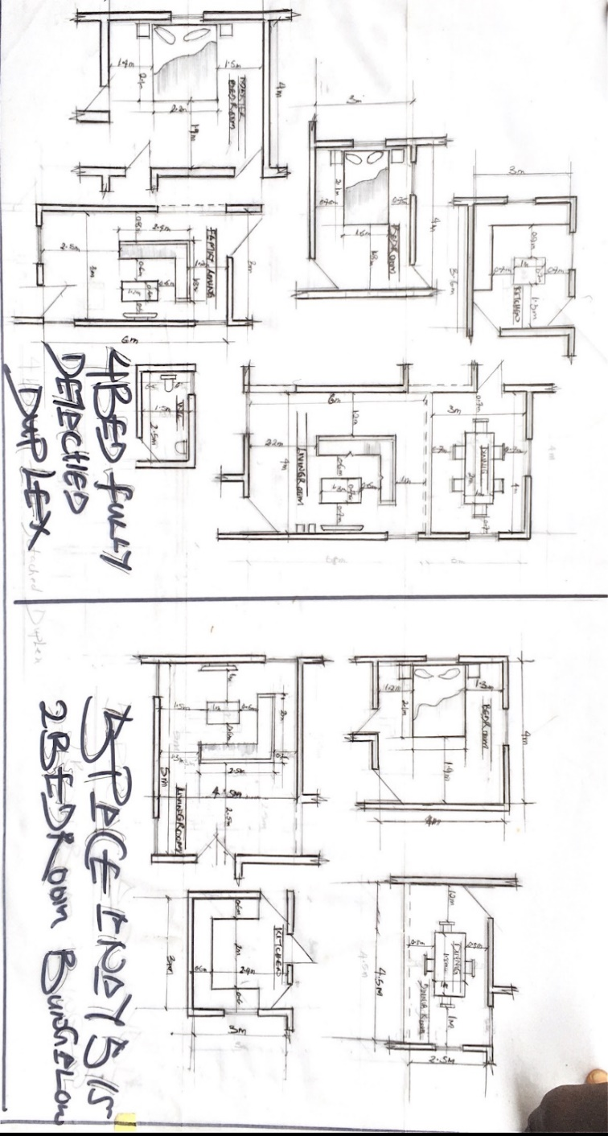
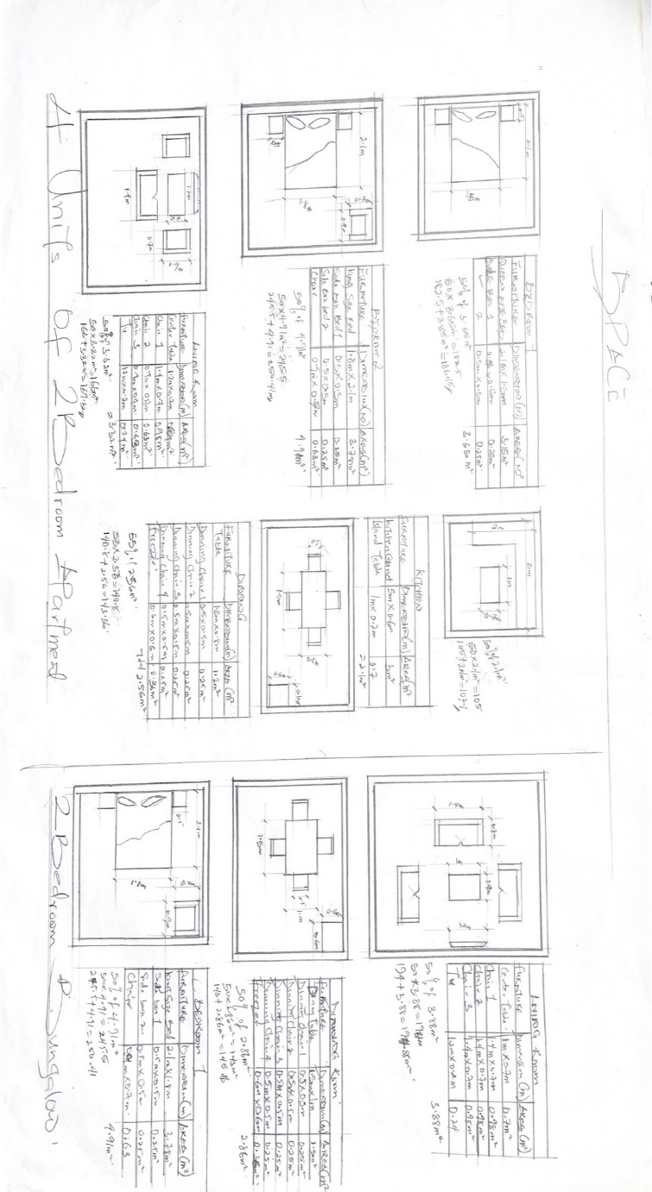APPENDIX 16 SPACES ANALYSIS FOR 4UNITS 2BEDROOM

APPENDIX 17 SPACE ANAYLSIS, 2BEDROOM BUBGALOW

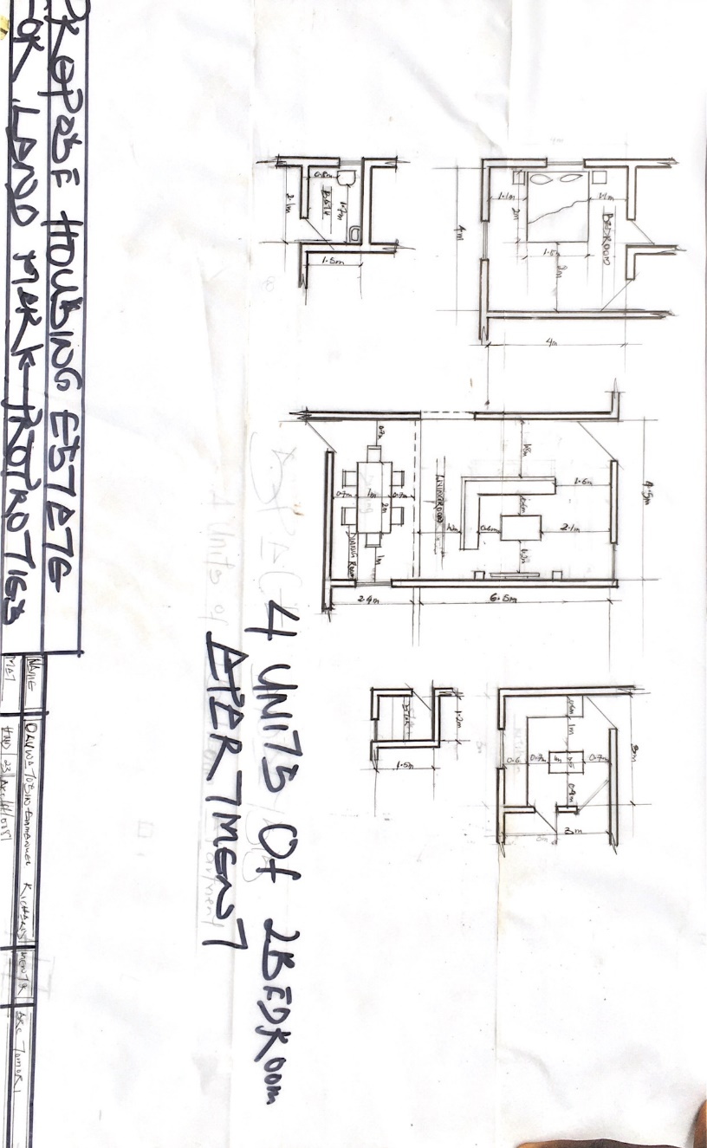

APPENDIX 18 SPACE ANALYSIS FOR 4UNITS APAERTMENT

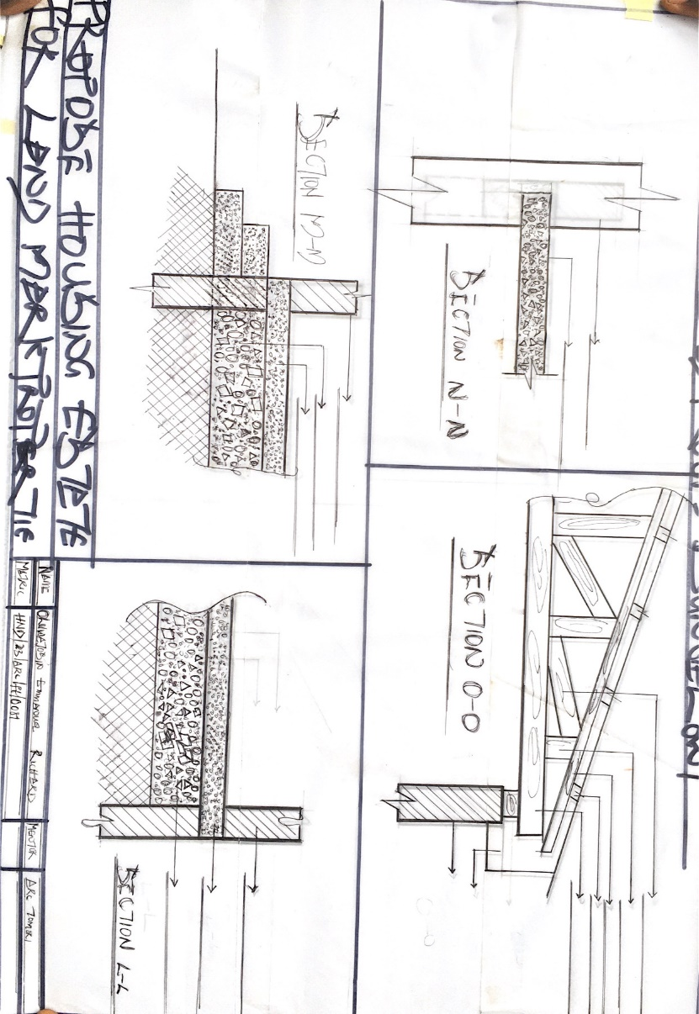
APPENDIX 19 DETAILDRAWING

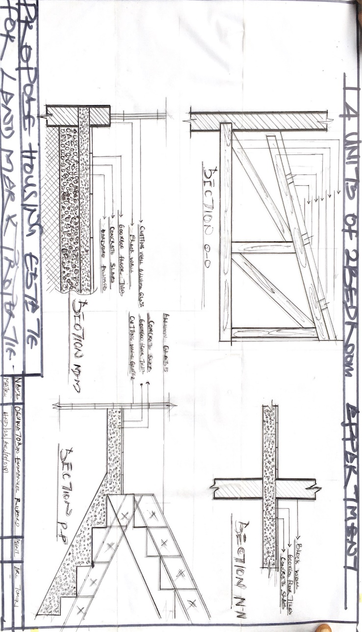

APPENDIX 20 DETAIL DRAWING FOR 4UNITS APARTMENT

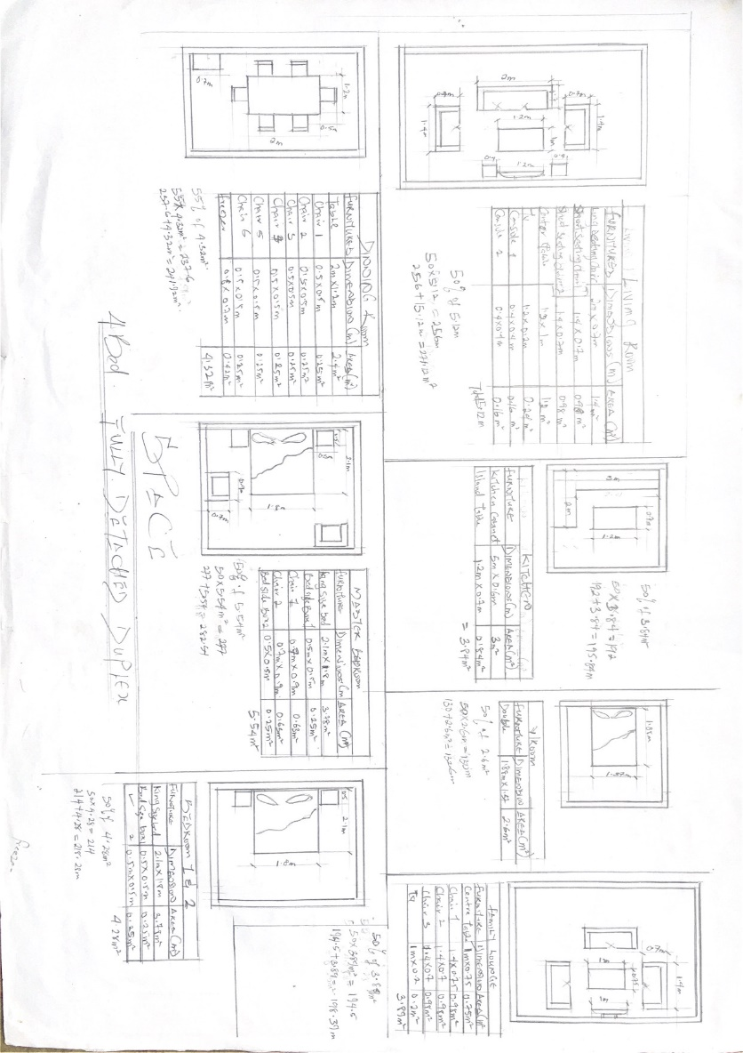

APPENDIX 21 SPACES ANAYSIS FOR 4BEDROOM FULLY DETACHED

