

A PROJECT REPORT
ON
PROPOSED EATERY
FOR
(MR ALIMI ASHIWAJU)
LOCATED AT: OFFA GARAGE AREA, ILORIN SOUTH L.G.A
BY
ABUBAKAR MUSTAPHA AGORO
ND/23/ARC/PT/0049
SUBMITED TO : DEPARTMENT OF ARCHITECTURAL TECNOLOGY,
INSTITUTE OF ENVIRONMENTAL STUDIES,
KWARA STATE POLYTECHNIC ILORIN.
IN PARTIAL FULFILMENTS OF THE REQUIREMENTS,
FOR AWARD OF NATIONAL DIPLOMA
(ND) IN ARCHITECTURAL TECHNOLOGY

SUPERVISOR: ARC. SHERO .MUHAMED

JULY, 2025

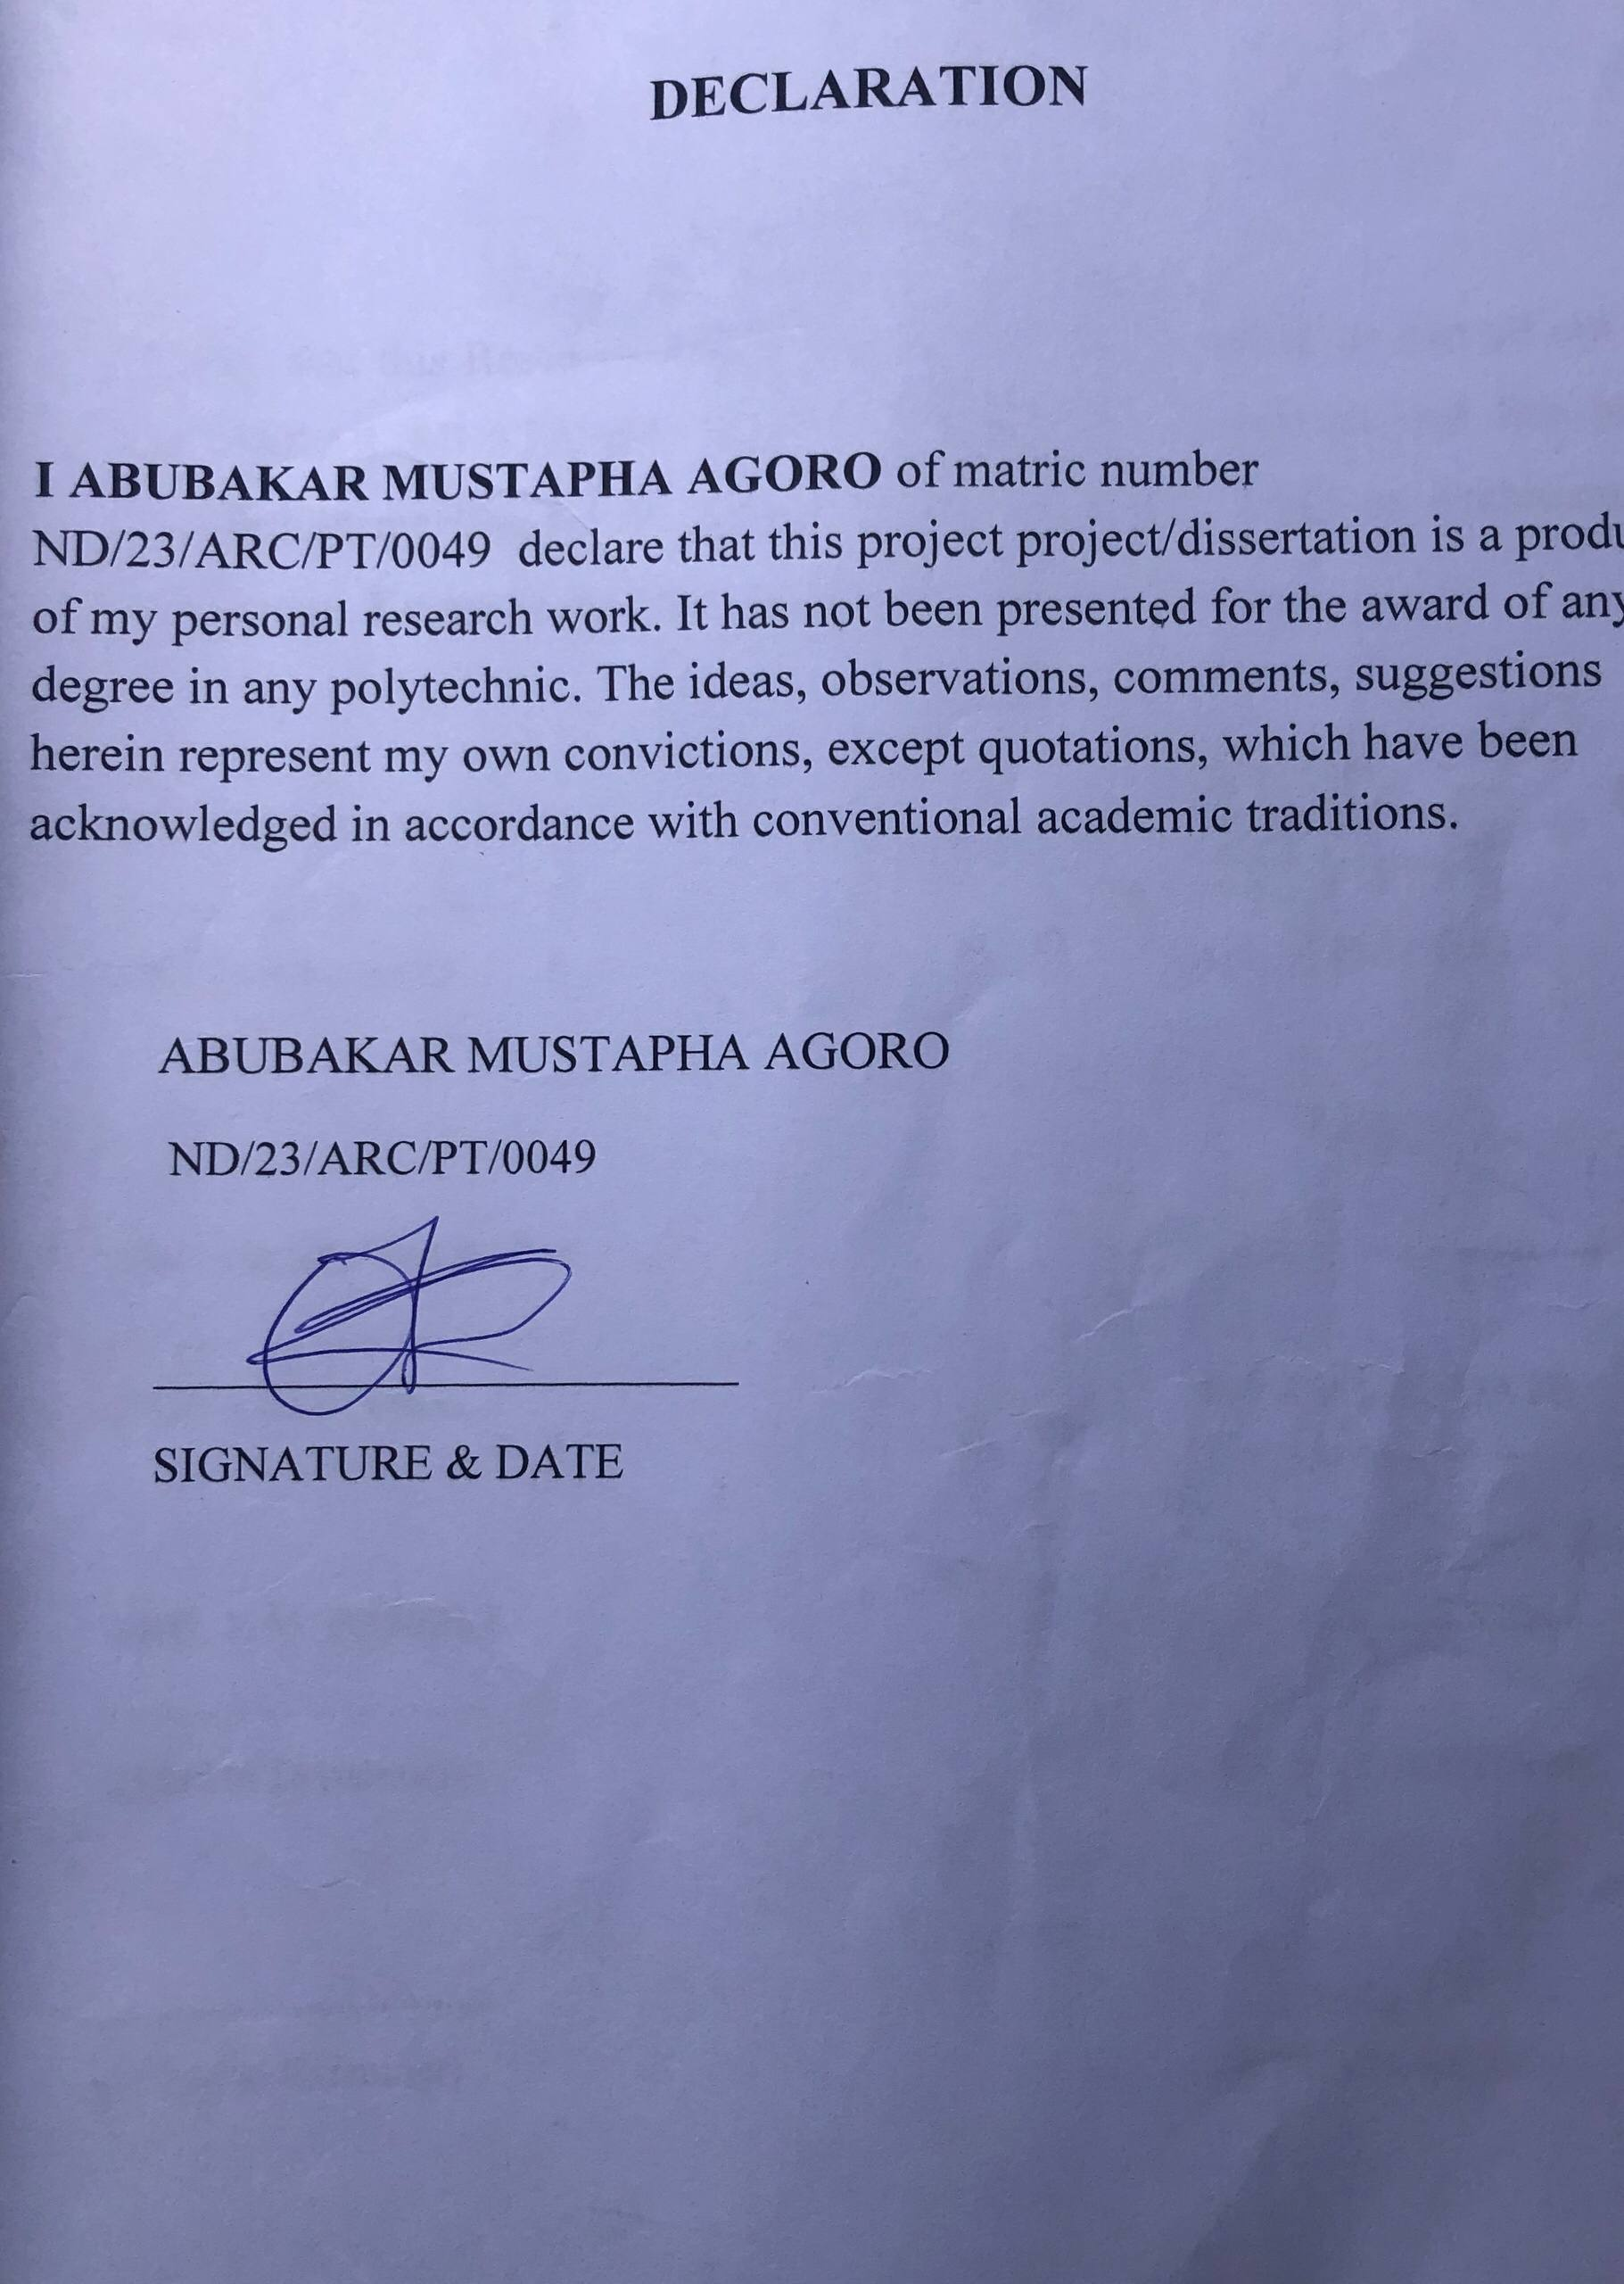

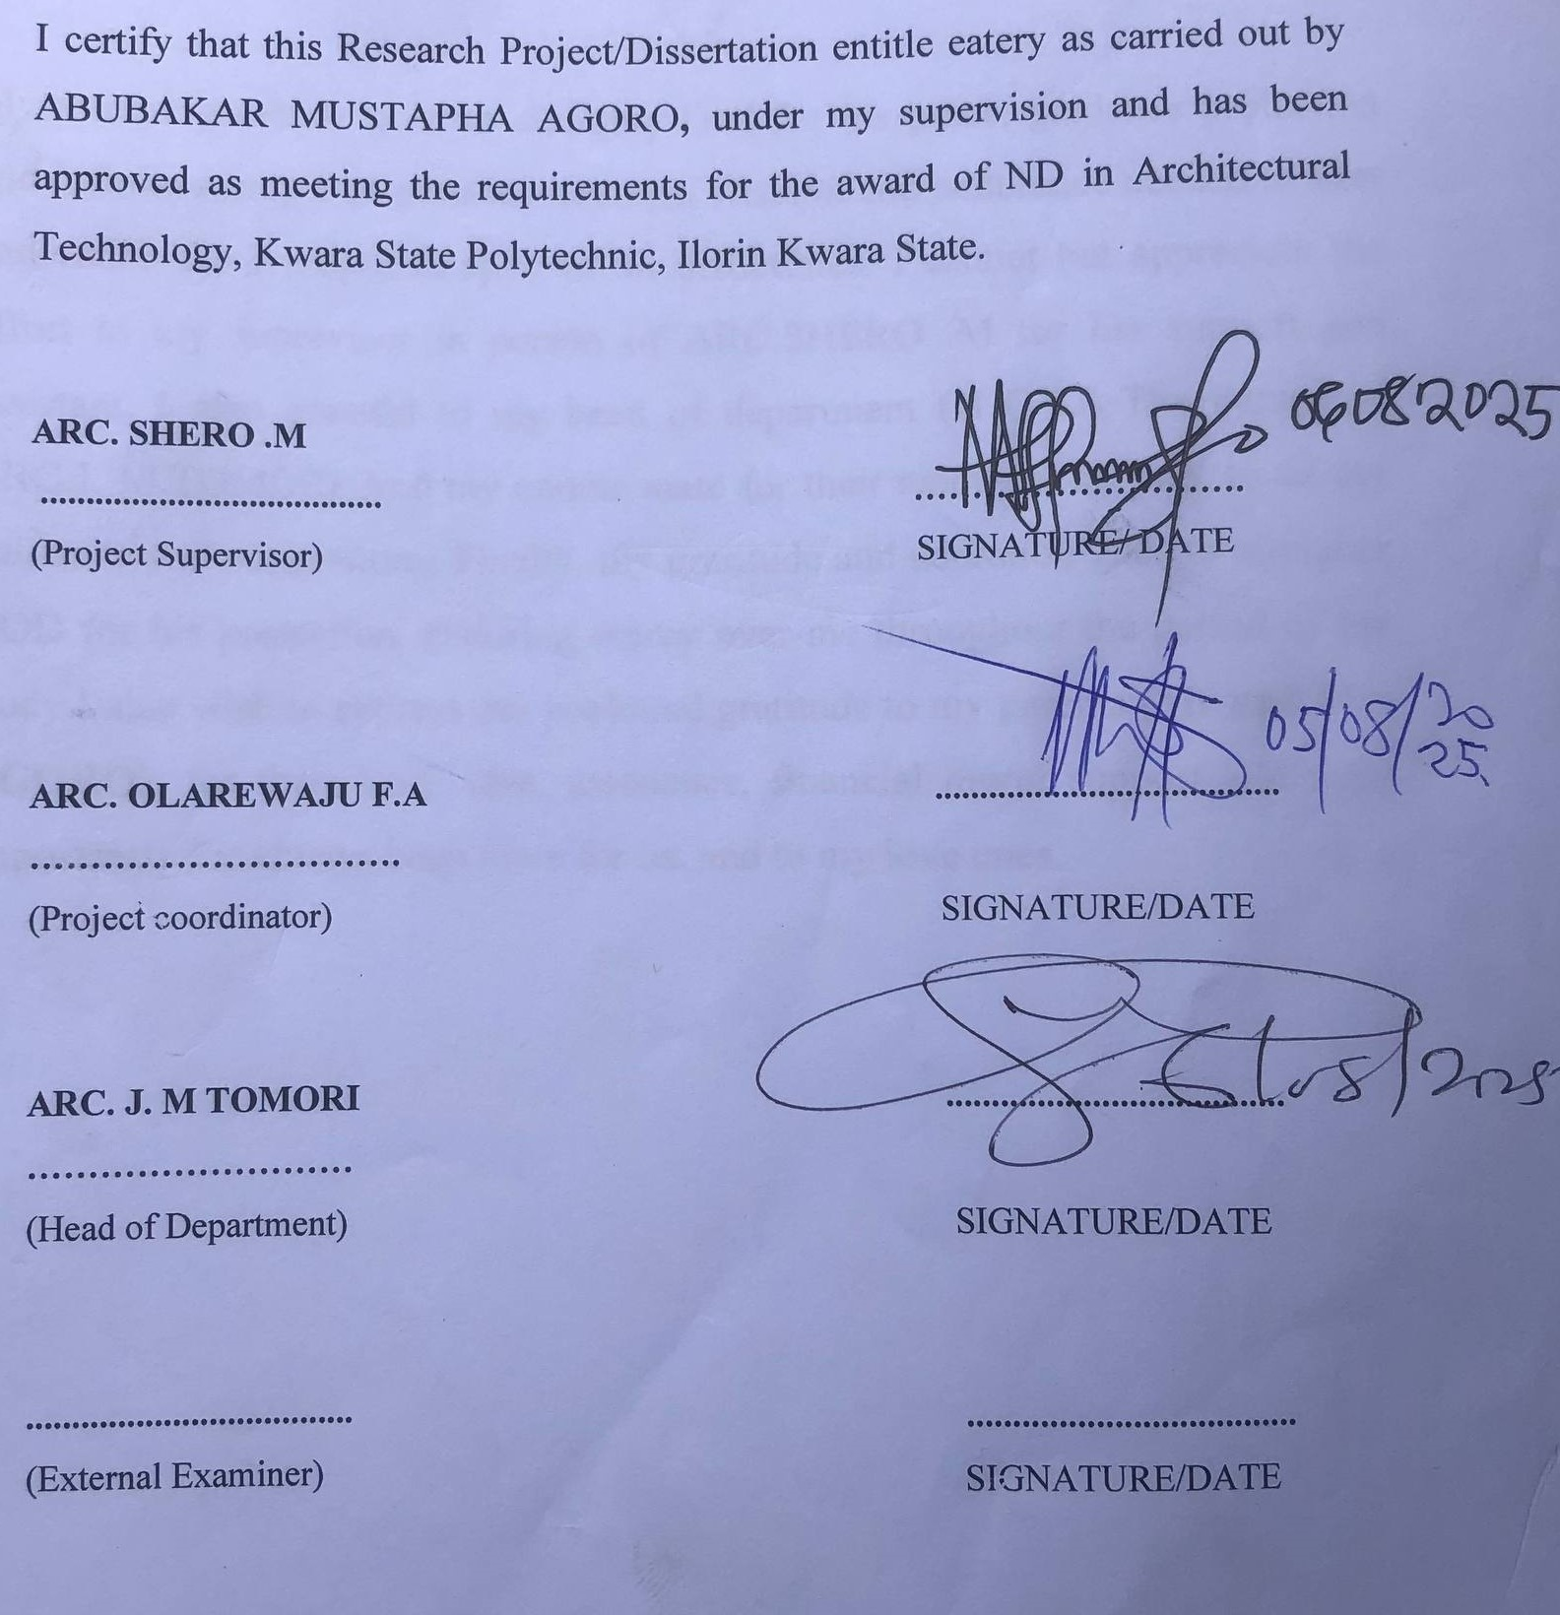

ACKNOWLEDGEMENT

My utmost gratitude goes to almighty God for his grace, guidance protection and infinite mercy that gave me courage, wisdom and endurance needed to start and finish the research in spite of all difficulties. I cannot but appreciate the effort to my supervisor in person of ARC.SHERO .M for her support and assistant. I also grateful to my head of department (H O D) The person of ARC.J. M.TOMORI And my course mate for their readiness to help, to all my guidance and suggestions. Finally, my gratitude and adoration goes to almighty GOD for his protection, enduring mercy over me throughout the period of my study.I also wish to express our profound gratitude to my parents (Mr and Mrs AGORO), for their love, care, assistance, financial moral support and most importantly for always been there for us, and to my love ones.

DEDICATION

This research is dedicated to almighty GOD whose guidance and protection has been more than enough for me since the beginning of this research to the end. I also to my parents MR AND MRS AGORO for been there for me at all time.

TABLE OF CONTENTS

TITTLE PAGE………………………………………………………………………... i
DECLARATION……………………………………………………………………...ii
CERTIFICATION………………………………………………………………….….iv
ACKNOWLEDGEMENT……………………………………………………………..v
TABLE OF CONTENT…………………………………………………………….... vi
LIST OF FIGURE………………………………………………………………….....vii
LIST OF PLATES……………………………………………………………………viii
LIST OF APPENDIX……………………………………………………………….... ix
ABSTRACT…………………………………………………………………………...x
CHAPTER ONE
1.0 INTRODUCTION…………………………………………………………………1
1.1 PROJECT DEFINITION……………………………………………………….….1
1.2 HISTORICAL BACK GROUND………………………………………………….2
1.3 JUSTIFICATION ………………………………………………………………….2
1.4 AIM…………………………………………………………………………………3
1.5 OBJECTIVES………………………………………………………………………3
1.6 CLIENT BACKGROUND, PHILOSOPHY………………………………………..3
1.7 SCOPE OF STUDY………………………………………………………………...3
1.8 LIMITATION OF DESIGN………………………………………………………..4
1.9 RESEARCH METHODOLOGY…………………………………………………..5
CHAPTER TWO
2.1 LITERATURE REVIEW…………………………………………………………...6
2.2 REVIEW OF ALL LITERATURE ON THE SUB-TOPIC………………………..8

CHAPTER THREE

3.1 CASE STUDY ONE…………………………………………………………………9
3.2 CASE STUDY TWO…………..……………………………………………………12
3.3 CASE STUDY THREE………………………………………………………….….15

CHAPTER FOUR

4.1 INTRODUCTION OF STUDY AREA………………………………………….…18
4.2 SITE LOCATION/DESCRIPTION………………………………………………...19
4.3 SITE ANALYSIS/INVENTORY…………………………………………………...19
4.4 GEOGRAPHICAL/CLIMATIC CONDITIONS……………………………….…..20
4.5 DESIGN CRITERIA…………………………………………………………….….20
4.6 BRIEF ANALYSIS………………………………………………….……………....20
4.7 SPATIAL PROGRAMMING (REAQUIREMENT AND ANALYSIS)……..……21
4.8 CONCEPTUAL DEVELOPMENT…………………………………………...……21
4.9 SITE CONCEPT………………………………………………………………...….22
4.10 BUILDING CONCEPT……………………………………………………...……23

CHAPTER FIVE
5.1 PROJECT APPRAISAL…………………………………………………………..24
5.2 CONSTRUCTION METHODOLOGY AND MATERIALS…………………….26
5.3 BUILDING SERVICE…………………………………………………………….28
5.4 CONCLUSION AND RECOMMENDATION…………………………………...32
5.5 REFERENCES…………………………………………………………………….33

LIST OF FIGURES

FIGURE 2.1: LOCATIONAL PLAN CASE STUDY ONE………………….9

FIGURE 2.2: FLOOR PLAN OF CASE STUDY ONE ……………………..9

FIGURE2. 3: LOCATIONAL PLAN OF CASE STUDY TWO……...……..12

FIGURE2. 4: FLOOR PLAN OKELERIN CASE STUDY TWO …………..13

FIGURE2. 5: LOCATIONAL PLAN OF CASE STUDY THREE.…..……..15

FIGURE2. 6: FLOOR PLAN OF CASE STUDYTHREE… …………….....15

FIGURE3.1. GEOGRAPHICAL/ CLIMATIC DATA ……………………...18

FIGURE3.3. AVERAGE MONTHLY RAINFALL IN ILORIN ……………24

FIGURE 4.1 BUILDING CONCEPT ………………………………………..27

LIST OF PLATE

PLATE 2.1 .FRONT VIEW OF CASE STUDY ONE…………………….….10

PLATE 2.2 .INTERNAL VIEWS OF CASE STUDY ONE …….……….…..10

PLATE 2.2 .INTERNAL VIEWS OF CASE STUDY TWO …….……….…..11

PLATE 2.3 .FRONT VIEW OF CASE STUDY TWO ……………………….13

PLATE 2.4 .PICTURES OF CASE STUDY THREE…….…………..…........16

PLATE 2.4 .PICTURES OF CASE STUDY THREE…….…….......................16

LIST OF APPENDIX

APPENDIX 5 .1; SHOWING LOCATIONAL MAP………..…………..……….32

APP ENDIX 5 .2; SHOWING LOCATIONAL PLAN………….……………......32

APPENDIX.5;3 SHOWINGINTERNAL PERSPECTIVE…………….………..33

APPENDIX 5. 4; SHOWING SITE ANALYSIS…………..…………….….…....33

APPENDIX 5. 5; SHOWING ROOF……...…………………………….….….….34

APPENDIX 5 .6; SHOWING FLOOR PLAN…….………………………….…...34

ABSTRACT
The eatery offers a delightful culinary experience with its diverse menu, warm ambiance, and exceptional service, making it a perfect spot for any occasion, whether it's a casual meal with friends, a family gathering, or a romantic dinner, as the eatery's chefs carefully craft each dish with fresh, locally sourced ingredients, blending traditional flavors with innovative techniques to create a truly unforgettable dining experience that is both delicious and visually stunning, with a menu that boasts a wide array of options to cater to different tastes and dietary needs, from hearty breakfast options to elegant dinner entrees, and with a commitment to using only the freshest ingredients, the eatery's dishes are not only flavorful but also healthy and sustainable, all served in a warm and inviting atmosphere that makes every guest feel valued and appreciated, with attentive, knowledgeable, and genuinely friendly service that ensures every guest has an exceptional dining experience, and with its community-focused approach, the eatery also serves as a hub for local events and activities, hosting live music nights, cooking classes, and other events that bring people together and foster connections, making it a beloved destination for foodies and families alike, and a place where memories are created and experiences are savored, and where every guest can enjoy a truly exceptional culinary experience that will leave them craving more and eager to return.

CHAPTER ONE

1.0 INTRODUCTION
The concept of an eatery is a fundamental aspect of human culture, providing a space for people to come together and share in the joy of food. An eatery can take many forms, from a small, family-owned bakery to a large, industrial-scale restaurant, and each one plays a significant role in shaping our culinary experiences and contributing to our communities. Whether it's a cozy café, a bustling diner, or a trendy food truck, eateries are an integral part of our daily lives, providing sustenance, comfort, and a sense of community. The importance of eateries extends beyond just providing food; they also serve as cultural institutions that preserve traditional cooking techniques and recipes, while innovating and adapting to changing consumer preferences. Eateries are often at the forefront of culinary trends, introducing new flavors, ingredients, and cooking methods that shape the way we think about food. Moreover, eateries provide a platform for entrepreneurs to showcase their creativity and skills, contributing to local economies and fostering community development. This project aims to explore the world of eateries, examining the key factors that contribute to their success, including product quality, customer service, and marketing strategies. By highlighting the importance of eateries in different cultures and communities, we hope to promote a greater appreciation for the role that these establishments play in shaping our culinary experiences and contributing to our communities. Through this project, we will also examine the challenges and opportunities faced by eateries, including the impact of technology, changing consumer preferences, and sustainability concerns. By providing a comprehensive and informative guide to the world of eateries, this project aims to support entrepreneurs, food enthusiasts, and anyone interested in the culinary industry. Whether you're looking to start a new eatery, improve an existing one, or simply learn more about the art of food preparation, this project will provide valuable insights and information to help you navigate the complex and ever-changing world of eateries.

1.1 HISTORICAL BACKGROUND
The historical background of eateries dates back to ancient times, with evidence of food establishments existing in civilizations such as ancient Egypt, Greece, and Rome. In these early societies, food vendors and taverns provided sustenance to travelers, workers, and locals, often serving traditional dishes and drinks. Throughout history, eateries have evolved to reflect changing societal needs, cultural influences, and economic conditions. In the Middle Ages, inns and taverns were common gathering places for food, drink, and socializing. The Industrial Revolution brought about the rise of urbanization and the development of new types of eateries, such as cafes and restaurants. In the 20th century, the rise of fast food chains and casual dining restaurants transformed the way people ate out, with a focus on convenience, affordability, and standardized menus. Today, eateries continue to evolve, with trends such as food trucks, pop-up restaurants, and experiential dining becoming increasingly popular. Eateries have played a significant role in shaping culinary traditions, fostering social connections, and contributing to local economies. From humble street food vendors to upscale restaurants, eateries have been an integral part of human culture, providing sustenance, comfort, and community to people around the world. By understanding the historical background of eateries, we can appreciate the rich cultural heritage and diversity of food traditions that exist today.

1.2 DEFINITION.
An eatery is a place where food and beverages are prepared and served to customers, encompassing a wide range of establishments such as restaurants, cafes, diners, food trucks, and bakeries. Eateries can vary in size, style, and cuisine, offering diverse dining experiences to suit different tastes and preferences. They may specialize in specific types of cuisine, such as Italian, Chinese, or Mexican, or offer a broad menu to cater to various palates. Eateries often provide a welcoming atmosphere, allowing customers to relax, socialize, and enjoy a meal. Whether formal or casual, eateries play a vital role in providing sustenance, community, and culinary experiences.
1.3 JUSTIFICATION
Designing a standard eatery is crucial in addressing the lack of quality food production in some parts of the community. By creating a well-planned and equipped eatery, we can provide nutritious and safe food options that cater to the community's needs. A standard eatery ensures proper food handling, storage, and preparation, reducing the risk of food borne illnesses. It also promotes transparency, accountability, and consistency in food quality. By setting high standards, we can elevate the dining experience, build trust, and foster a healthier community. This initiative can positively impact public health, local economy, and community well-being, making it a worthwhile investment.
1.4 AIM
The aim For this project is to design a well-designed eatery that can positively impact the local community by providing nutritious food options, promoting healthy eating habits, and fostering social connections. By incorporating fresh, locally-sourced ingredients, eateries can offer balanced meals that cater to diverse dietary needs.
1.5 OBJECTIVES
1. To Offer a variety of healthy and balanced meals that cater to diverse dietary needs and preferences.
2. To Implement proper food handling, storage, and preparation practices to minimize the risk of food borne illnesses.
3: To Create a welcoming atmosphere that encourages socialization, community building, and cultural exchange.
4. To Source ingredients from local farmers, suppliers, and producers to boost the local economy and promote sustainability.
5. To Educate customers about nutrition, healthy eating, and sustainable food practices through menu labeling, workshops, and events.
6. To Provide excellent customer service, comfortable ambiance, and consistent food quality to build customer loyalty and satisfaction.
7.To Contribute to the overall health and well-being of the community by providing nutritious food options and promoting healthy eating habits.

1.6 CLIENTS BACKGROUNG, PHYLOSHOPHY
Mr. Alimi, a distinguished former Senator and seasoned businessman, is a dynamic leader with a proven track record of driving growth and development. With experience in the oil and gas sector, particularly with NNPC, he possesses a deep understanding of Nigeria's energy landscape. As a prominent figure in Ilorin South, Mr. Alimi is committed to empowering his community through strategic initiatives and partnerships. His expertise in politics and international trade has earned him a reputation as a shrewd and innovative thinker. Mr. Alimi values integrity, professionalism, and results-driven approaches, and seeks to collaborate with like-minded individuals and organizations to promote sustainable development and economic growth. As my client, I am excited to work with him to leverage his expertise and network to achieve his goals and make a positive impact in Nigeria. His vision and leadership inspire confidence and motivation.

1.7 SCOPE OF THE DESIGN
- Entrance
- Dining
- Customer Serving Area
- Toilet
- Kitchen
- Manager Office
- Changing Room
- Store
- Bakery
- Exit
1.8 LIMITATION
Limitations in research refer to the constraints or weaknesses that may impact the validity, reliability, or general ability of the findings. These limitations can arise from various sources, including:

1.9 RESEARCH METHODOLOGY
Research methodology refers to the systematic and scientific approach used to conduct research, including the methods, techniques, and procedures employed to collect and analyze data. It provides a framework for investigating a research question or hypothesis and ensures the validity, reliability, and accuracy of the findings.
Types of Research Methodologies
1. Quantitative Research: Uses numerical data and statistical methods to investigate research questions or hypotheses.
2. Qualitative Research: Employs non-numerical data, such as text, images, or observations, to gain insights into research phenomena.
3. Mixed-Methods Research: Combines quantitative and qualitative approaches to provide a more comprehensive understanding of the research topic.
Research Methodology Steps
1. Literature Review: Conducting a thorough review of existing research on the topic to identify gaps and inform the research question.
2. Research Design: Selecting an appropriate research design, such as experimental, quasi-experimental, or descriptive, to investigate the research question.
3. Data Collection: Collecting data using various methods, such as surveys, interviews, observations, or experiments.
Importance of Research Methodology
1. Ensures Validity and Reliability: A well-designed research methodology ensures that the findings are valid, and reliable
2. Provides a Framework: Research methodology provides a systematic approach to conducting research, guiding the researcher through the entire process.
3. Enhances Credibility: A rigorous research methodology enhances the credibility of the research findings and contributes to the advancement of knowledge in the field.

CHAPTER TWO

2.0 LITERATURE REVIEW
2.1 HISTORICAL BACKGROUND OF EATERY
The design and development of eateries have been widely studied across architectural, urban, and environmental disciplines. An eatery is not merely a functional space for food preparation and consumption; it is a social, cultural, and economic space that reflects societal trends, architectural innovation, and environmental considerations. This chapter reviews relevant literature on eatery design, focusing on the evolution, space planning principles, structural considerations, environmental impact, and user experience. The literature review provides a theoretical foundation for the design of a modern eatery that meets both functional requirements and architectural excellence.
An eatery, as defined by Ching (2014), is a public or semi-public space designed to facilitate the preparation, sale, and consumption of food and drinks, often incorporating elements of leisure, social interaction, and aesthetics. Eateries include various establishments such as restaurants, cafés, fast-food outlets, canteens, and food courts, each with distinct spatial and structural requirements. According to Jones (2016), the architectural design of an eatery plays a significant role in influencing user comfort, circulation patterns, food hygiene, and overall operational efficiency.
Oldenburg (1999) introduced the concept of eateries as "third places" — spaces outside the home (first place) and workplace (second place) where people gather, interact, and build community ties. This highlights the eatery's role not just as a service-oriented space but as an essential component of urban and social life.
Efficient space planning is critical to the success of any eatery design. According to Neufert (2012), the functional zoning of an eatery must ensure clear separation between service areas (kitchen, storage, waste disposal) and customer areas (dining, lounge, restrooms) to enhance hygiene and user experience. Lawson (2001) emphasizes that the layout must consider accessibility, circulation, and flexibility to accommodate varying customer needs and operational efficiency.
Recent studies by Petrie et al. (2018) suggest that open-plan layouts, strategic furniture arrangement, and integration of natural light improve spatial comfort and customer satisfaction. Furthermore, the incorporation of outdoor seating areas has been found to enhance the spatial experience, particularly in tropical climates like Nigeria.
The structural design of eateries is influenced by factors such as building materials, climatic conditions, building codes, and functional requirements. According to Allen and Iano (2013), modern eateries utilize reinforced concrete, steel frames, glass facades, and eco-friendly materials to achieve structural stability, durability, and visual appeal.
Akande (2020), in a study of food outlets in Nigeria, emphasized the importance of selecting materials that are cost-effective, durable, and responsive to the local climate. In regions with high temperatures and rainfall, like Ogun State, structural features such as wide overhangs, effective drainage systems, and proper ventilation are critical design considerations.
The integration of sustainability into structural design is increasingly prioritized. Kwok and Grondzik (2018) advocate for energy-efficient building envelopes, rainwater harvesting systems, and the use of recycled materials to reduce the environmental footprint of eateries.
Environmental sustainability has become a core consideration in eatery design. According to Edwards (2010), eateries have significant environmental impacts, particularly in energy consumption, water use, and waste generation. Architectural interventions such as passive ventilation, natural lighting, solar shading, and waste recycling can significantly mitigate these impacts.
Umar and Oladapo (2019) highlighted that in tropical regions, incorporating natural ventilation and shading reduces the need for mechanical cooling, enhancing both energy efficiency and user comfort. Additionally, the use of renewable energy sources such as solar panels is increasingly integrated into eatery designs to promote sustainability.
The success of an eatery is closely tied to the user experience, which is significantly influenced by the architectural design. According to Bitner (1992), factors such as interior design, acoustics, lighting, and spatial organization play critical roles in shaping customer perception and behavior.
Contemporary research by Kaya and Erkip (2020) shows that the aesthetic appeal of eateries — including color schemes, materials, and furniture design — contributes to customer retention and brand identity. Furthermore, eateries that incorporate cultural elements and contextual design often create a sense of belonging and identity for users.

CHAPTER THREE

3.0 CASE STUDY

This can be defined as the gathering of information through various means was Case Study 2.2 This is a research or an exercise that is carried out on existing building which 1s Similar to the one researcher is writing on. The objective of a case study is to take a critical appraisal of existing related project with a view to identity the positive and negative aspect of such project. It is only with time that a project can be adjusted so that it can be successful. The information obtained from the appraisal will guide the designer of new and similar project, the project position aspect of it shall be incorporated in the View proposal while attempts will be made to solve the problem of negative aspect. it is only through this that a design can better enhance the quality and efficiency of building in the society, tor a comprehensive analysis their case studies have been conducted.

3.1 CASE STUDY
CASE STUDY ONE
NAME: MATHA’S
LOCATION: OPPOSITI-ORE PRIMARY SCHOOL, IBADAN OYO STATE
MERIT
1 It has a large and mass area of land
2. It is easily accessible through existing road
DEMERIT
1 The roof needs renovation
2. It has no toilets to use

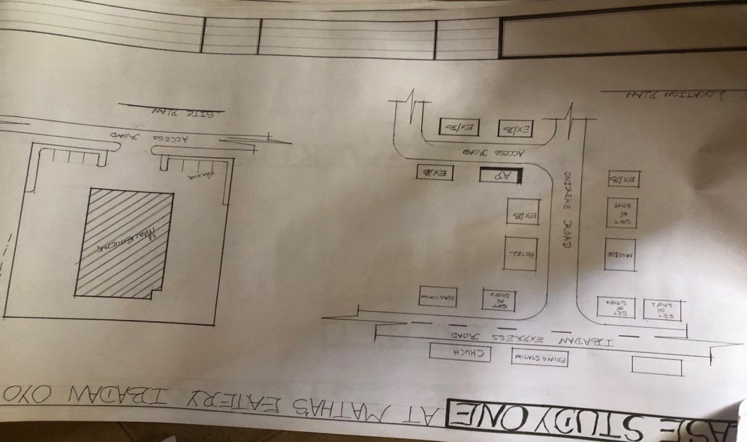
FIGURE3.1: LOCATIONAL PLAN OF CASE STUDY ONE
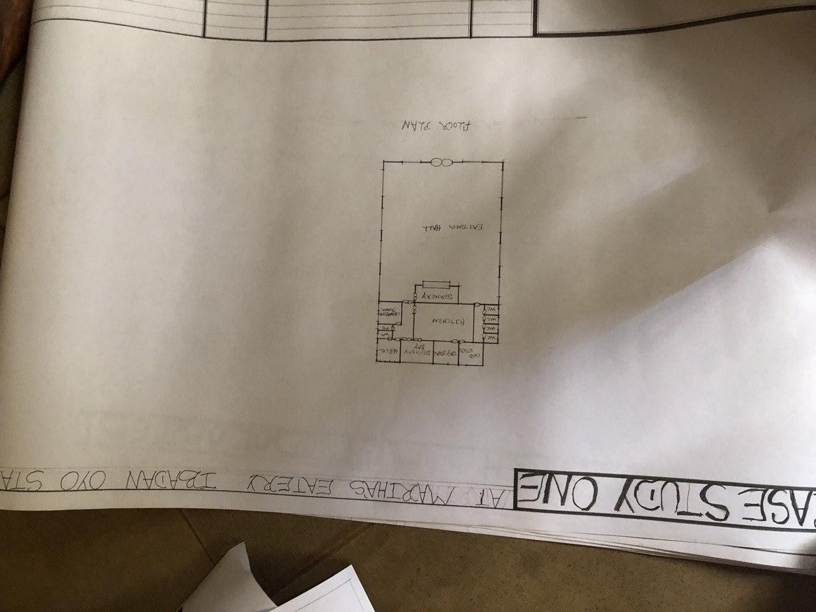

FIGURE3.2: FLOOR PLAN OF CASE STUDY 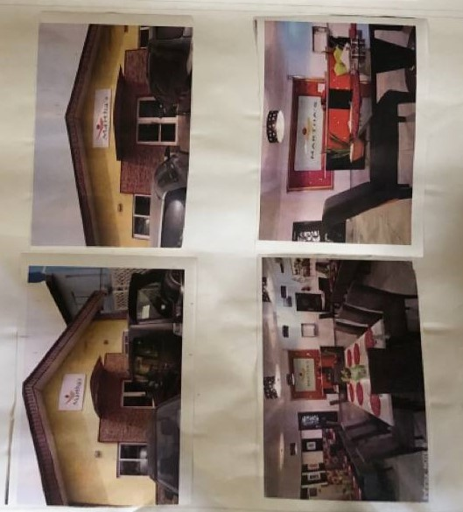
PLATE3.1: FRONT VIEW CASE STUDY ONE

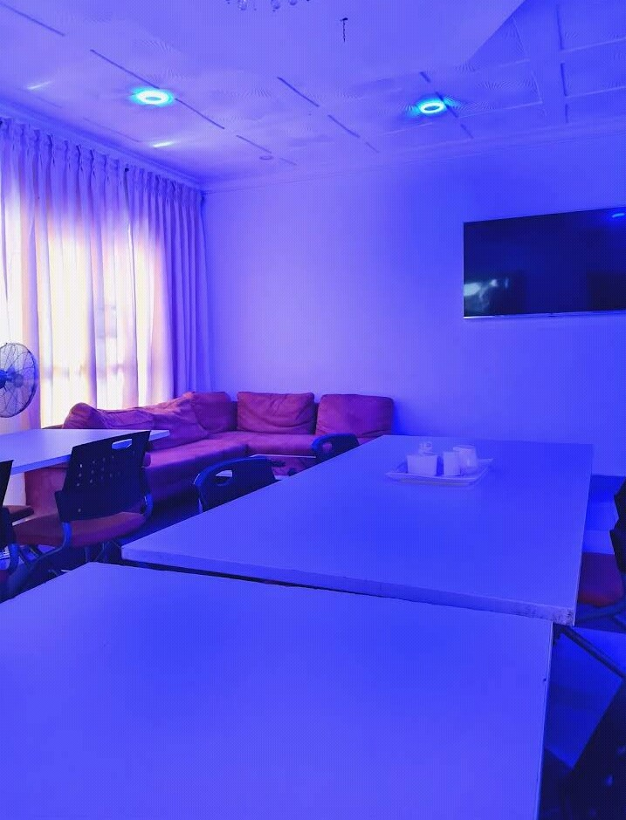
PLATE3.2: INTERNAL VIEW CASE STUDY ONE

CASE STUDY TWO
NAME: BITE MORE
LOCATION: OSHOGBO OSUN STATE
MERIT
1 It is well ventilated
2 The approach is well aesthetic
DEMERIT
1 It has no landscape
2 not enough space for further development

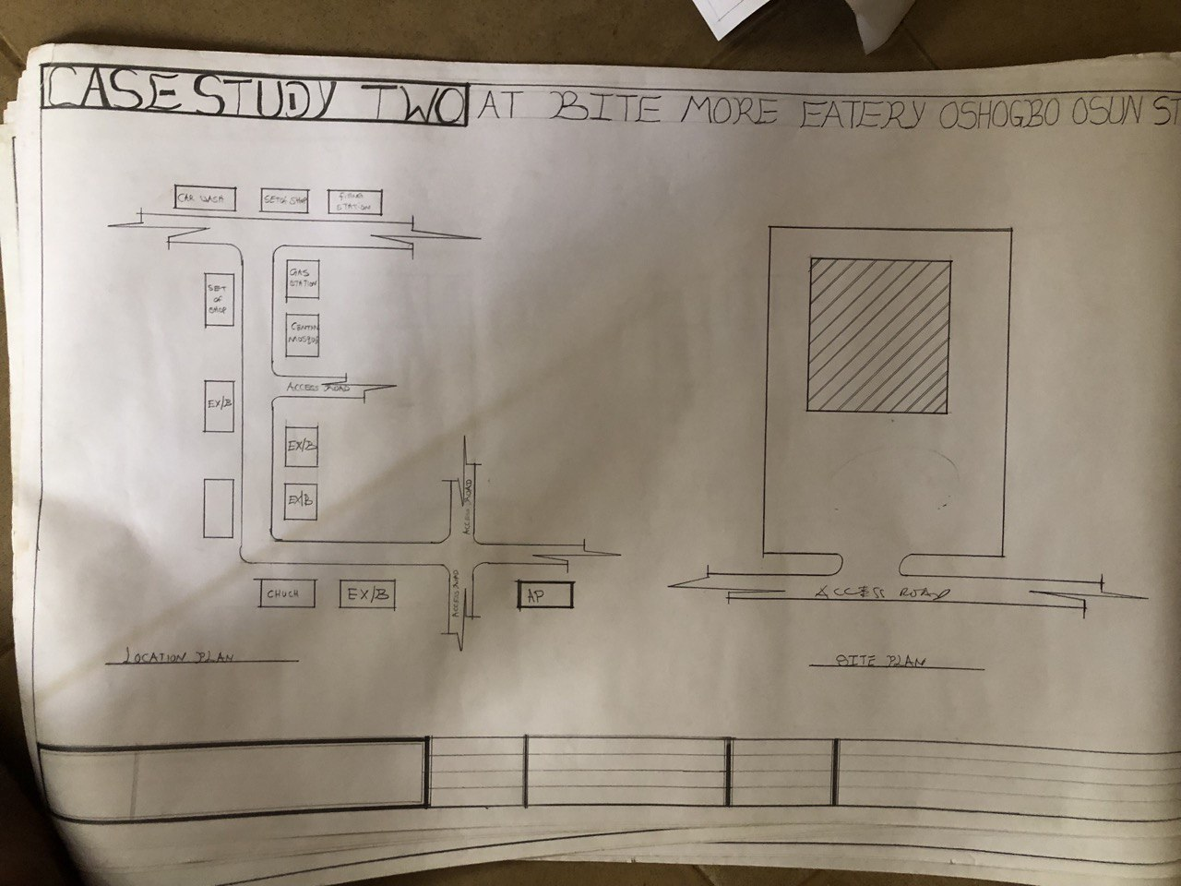
FIGURE3.3: LOCATIONAL PLAN F CASE STUDY TWO
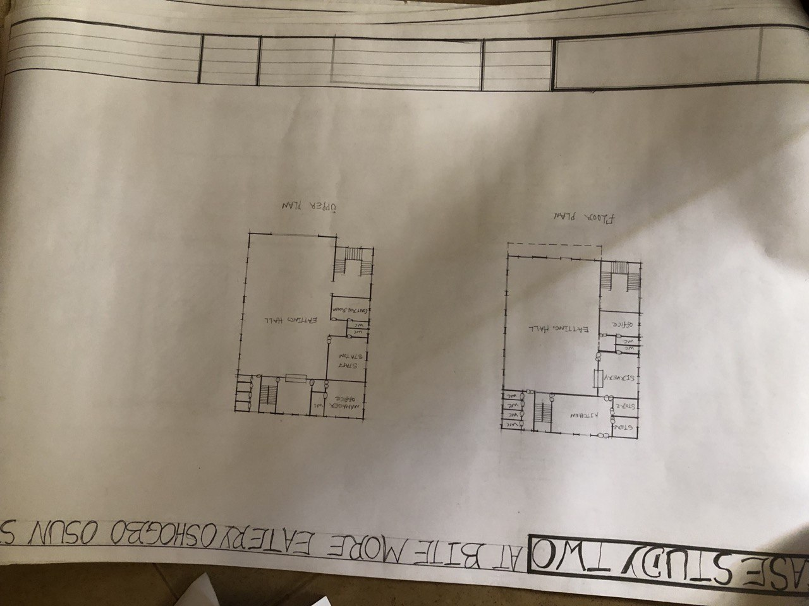

FIGURE3.4: FLOOR PLAN OF CASE STUDY TWO
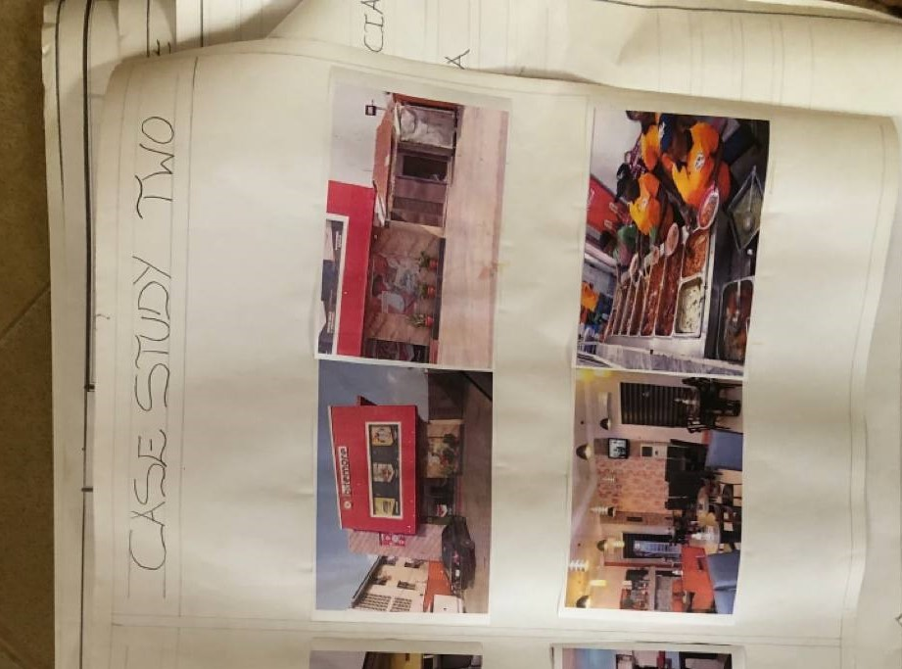
PLATE 3.3 .FRONT VIEW OF CASE STUDY TWO

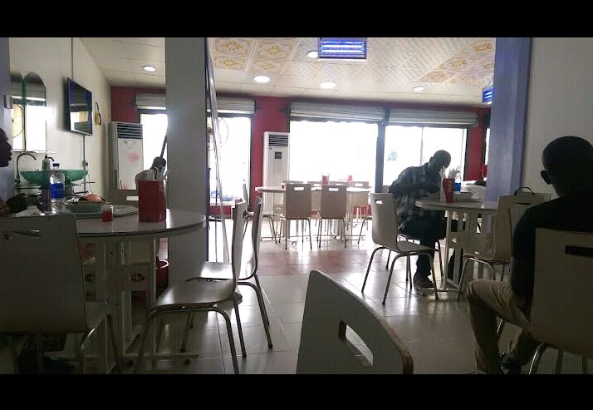

PLATE 3.4 INSIDE VIEW OF CASE STUDY TWO

STUDY THREE
NAME: AMALA SPOT
EATERY LOCATION: ADO EKITI, EKITI STATE
MERIT
1. It is easily accessible through existing road
DEMERIT
1. It is not well ventilated
2. The approach is aesthetically poor

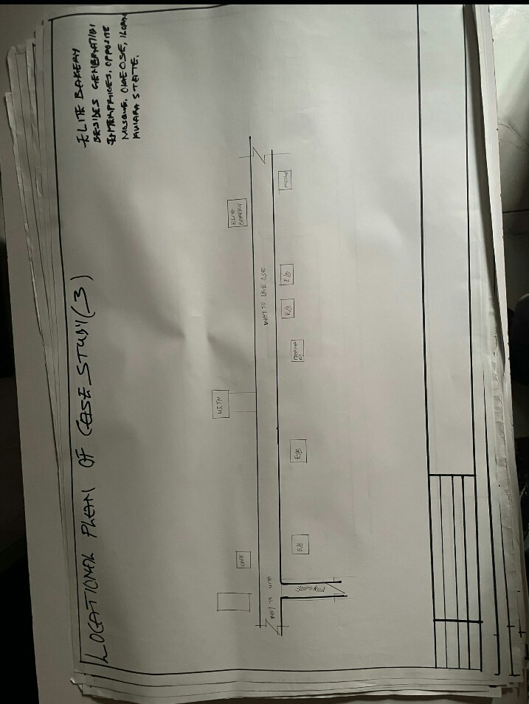
FIGURE3. 5: LOCATIONAL PLAN OF CASE STUDY THREE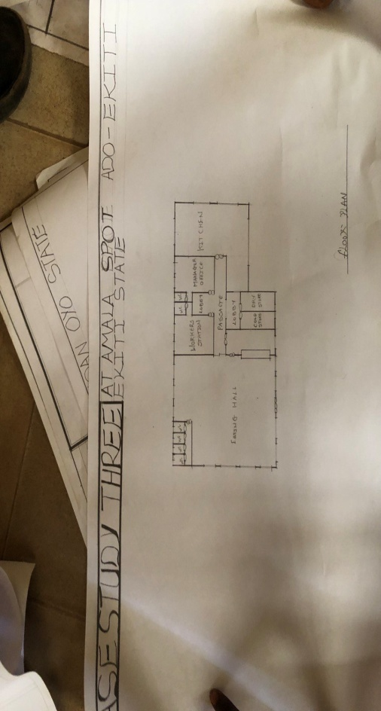
FIGURE3. 6: FLOOR PLAN OF CASE STUDY THREE
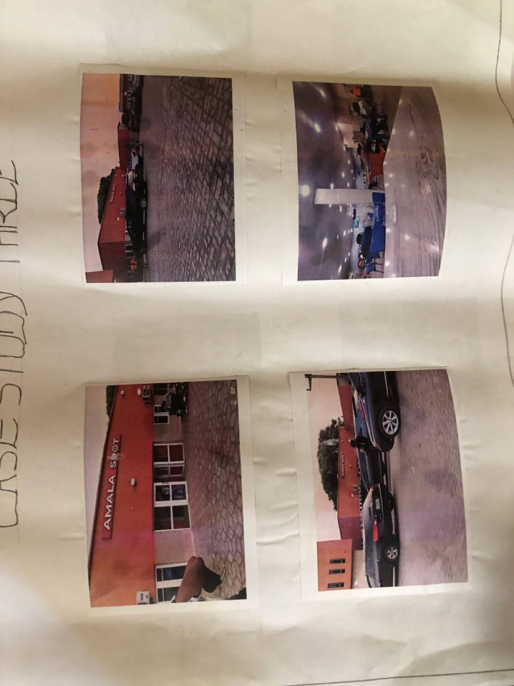

PLATES 3. 5: SHOWING FRONT VIEW OF CASE STUDY THREE
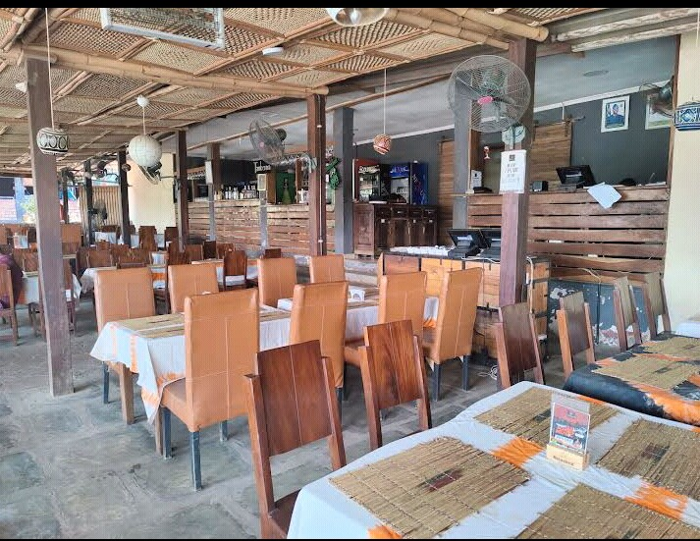
PLATES 3. 6: SHOWING INTERNAL VIEW OF CASE STUDY THREE
ONLINE CASE STUDY 1
NAME: 47 PLATE
EATERY LOCATION: HONG KUNG,CHINA
MERIT
1. It is easily accessible through existing road
DEMERIT
1. It is not well ventilated
2. The approach is aesthetically poor

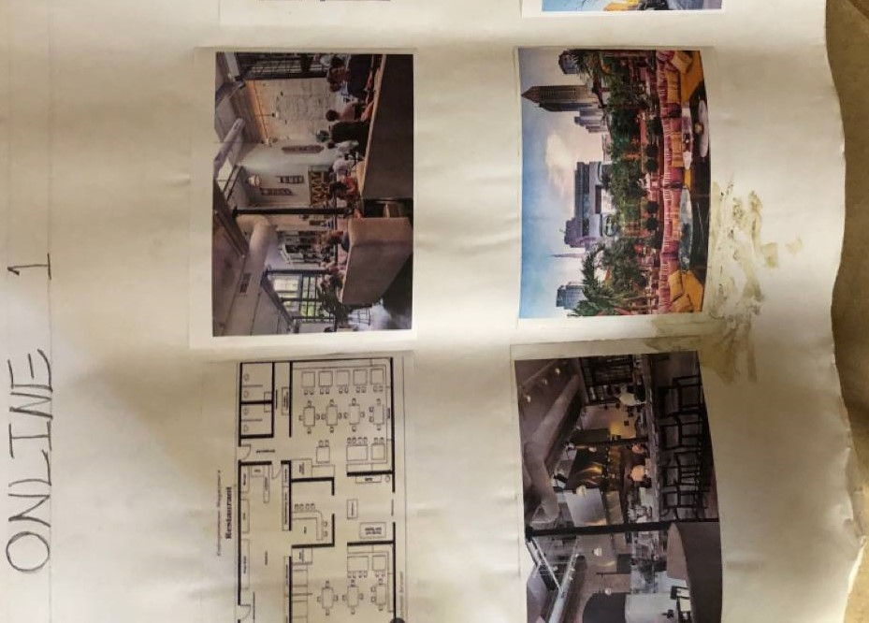
PLATES 3.7: SHOWING VIEW OF ONLINE CASE STUDY 1
ONLINE CASE STUDY 2
NAME: BITE MORE
LOCATION: Sydney city, australia
MERIT
1 It is well ventilated
2 The approach is well aesthetic
DEMERIT
1 It has no landscape
2 not enough space for further development
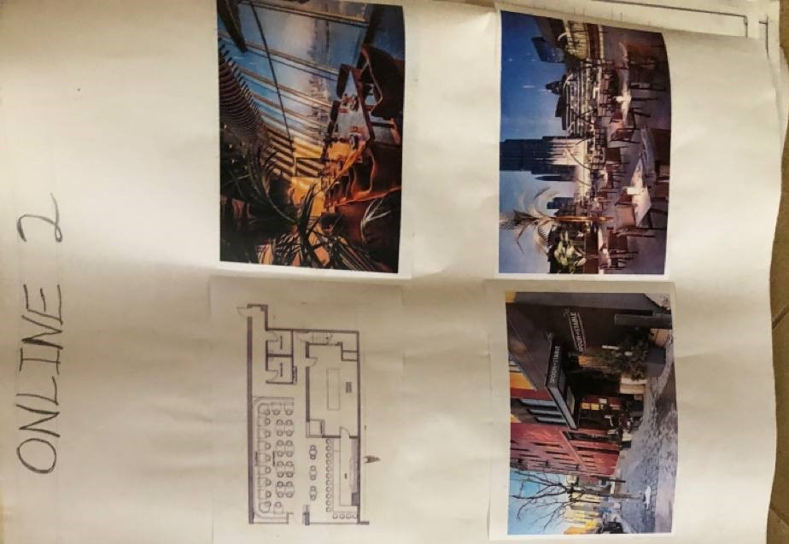
PLATES 3.8: INTERNAL VIEW ONLINE CASE STUDY 2
CHAPTER FOUR

4. LOCATIONAL OF PROJECT
Ilorin South, a Local Government Area in Kwara State, Nigeria, boasts a rich and diverse history that spans centuries, with its ancient roots tracing back to the Fulani people's founding of the Ilorin Emirate in the 18th century. The area's strategic location has made it a significant hub for commerce, agriculture, and culture, with its history reflecting the influences of various ethnic groups, including the Yoruba, Hausa, and Fulani people. Over time, Ilorin South has evolved into a thriving community, shaped by its cultural heritage and historical significance. The area's cultural landscape is characterized by vibrant traditional festivals and celebrations, which showcase its rich cultural diversity and heritage. Ilorin South is also home to several historical sites, including the Ilorin Emir's Palace and the Ojomu of Ilorin's Palace, which serve as testaments to its storied past. The area's economy has experienced significant growth, driven by its agricultural sector, with crops such as maize, cassava, and yams being major staples. Additionally, Ilorin South's markets, including the popular Oja-Kunu market, attract traders from across the region, further solidifying its position as a commercial hub. Despite its many strengths, Ilorin South faces several challenges, including inadequate infrastructure, poverty, and limited access to education and healthcare. However, the area also presents opportunities for development, particularly in the areas of agriculture, commerce, and tourism. With proper investment and planning, Ilorin South has the potential to become a thriving economic hub and a major contributor to the growth and development of Kwara State. By leveraging its rich history, cultural heritage, and economic potential, Ilorin South can unlock new opportunities for growth and development, ultimately improving the lives of its residents and solidifying its position as a significant player in the region's economy

4.1 BRIEF HISTORY OF KWARA STATE
Kwara State, located in the North-Central region of Nigeria, has a rich and diverse history that dates back to the ancient Nupe and Yoruba kingdoms, with the state being a significant hub for trade, commerce, and culture in the pre-colonial era, and its history reflecting the influences of various ethnic groups, including the Yoruba, Nupe, and Fulani people, who have all contributed to the state's unique cultural heritage and identity, with the state being part of the old Oyo Empire, and later becoming a province during the colonial era, before gaining statehood in 1967. Ilorin is the capital city of kwara state and it is believed to be the sixth of the first ten largest cities in Nigeria, Ilorin is located in the southern part of kwara state in latitude 8.26N and longitude 4E and 2E of Nigeria. It is about 300km away from Abuja (the federal capital city by road) it has a north-south rail line linking it to various part of the country apart from the numerous road networks. Ilorin is also provided with airstrip, which has facilities for standard international airport and a standard 5star hotel.
4.1.2 HISTORY OF PROJECT TOWN (ILORIN)
OFFA GARAGE are areas in Ilorin, but I couldn't find specific historical information on "offa garage in Ilorin South. However, I can provide some insights on Pakata, a neighborhood in Ilorin, which might be helpful. Pakata has a rich history, with its name possibly derived from a market or economic center. The area is known for its significant contributions to Ilorin's history, particularly in trade and commerce. Pakata Road, a major highway, connects the palace segment to other parts of the city and has historical significance, dating back before the establishment of the Ilorin Emirate. The neighborhood has produced influential individuals who have shaped Ilorin's history in various fields, including religion, culture, politics, education, and entrepreneurship

4.2 SITE LOCATION / DESCRIPTION
the site for the proposed bakery for fortunate bread investment is located at opposite mojagi compound, akata oshode village, ilorin south .lg.a kwara state
4.3 SITE SELECTION CRITERIA
Site selection is the consideration of certain factors which influence the development of the state. Before the execution of any project, the following factor are to be considered for selection of site.
Accessibility
Zoning
Availability of infrastructure etc.
The site selection was based on the following, these include;
Location: the choice of location should be in relation to the following.
Zoning: the site should be within an area reserved for institutional facilities and public utilities. It should be free from industrial zones.

4.4 SITE ANALYSIS/ INVENTORY
This is done on the basic of the purpose for which the site is to serve.
Certain steps are considered to obtain vital information of the site; this information is then analyzed after in details for design purpose, the information includes soil condition, geology, topography, vegetation etc.
It also involves carrying out a preliminary survey of the site.
Soil condition: the type of soil on the site is loamy and hence aids good vegetation of trees, shrubs and grasses etc.
Geology: the soil has a very sound load bearing capacity and hence strip foundation will be used for the structure to be erected on the site.
Vegetation cover: the site is covered with shrubs, trees and grass which covers the ground. Which most of it will be retained for landscape.
Topography: this is the layout of the site; the site gently slopes toward west
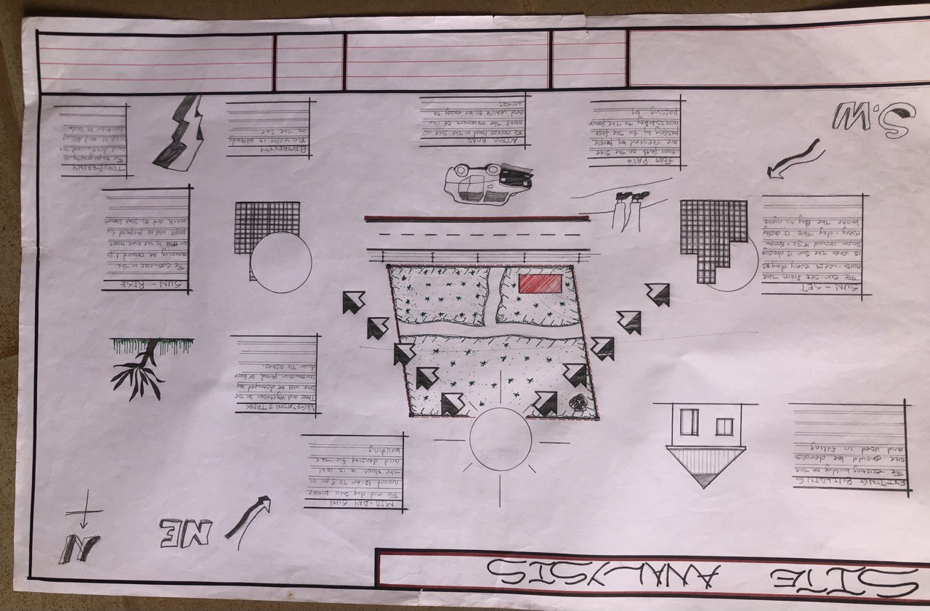

4.5.1 Climatic Data
The environmental and climatic conditions of the project site are analyzed to further understand the factors that will guide the achievement of a functional design.
Such factors are;
CLIMATIC DATA OF ILORIN
Ilorin falls under the climatic region referred to as guinea savannah and in the middle belt of the country. The monthly average temperature is quite uniform, having February and march as the hottest months, recording a higher average of about 45⁰c (about 85⁰f) July and august are the coolest (lowest monthly average temperature of 76⁰f) the town is under relative humidity figure of about 80% average.
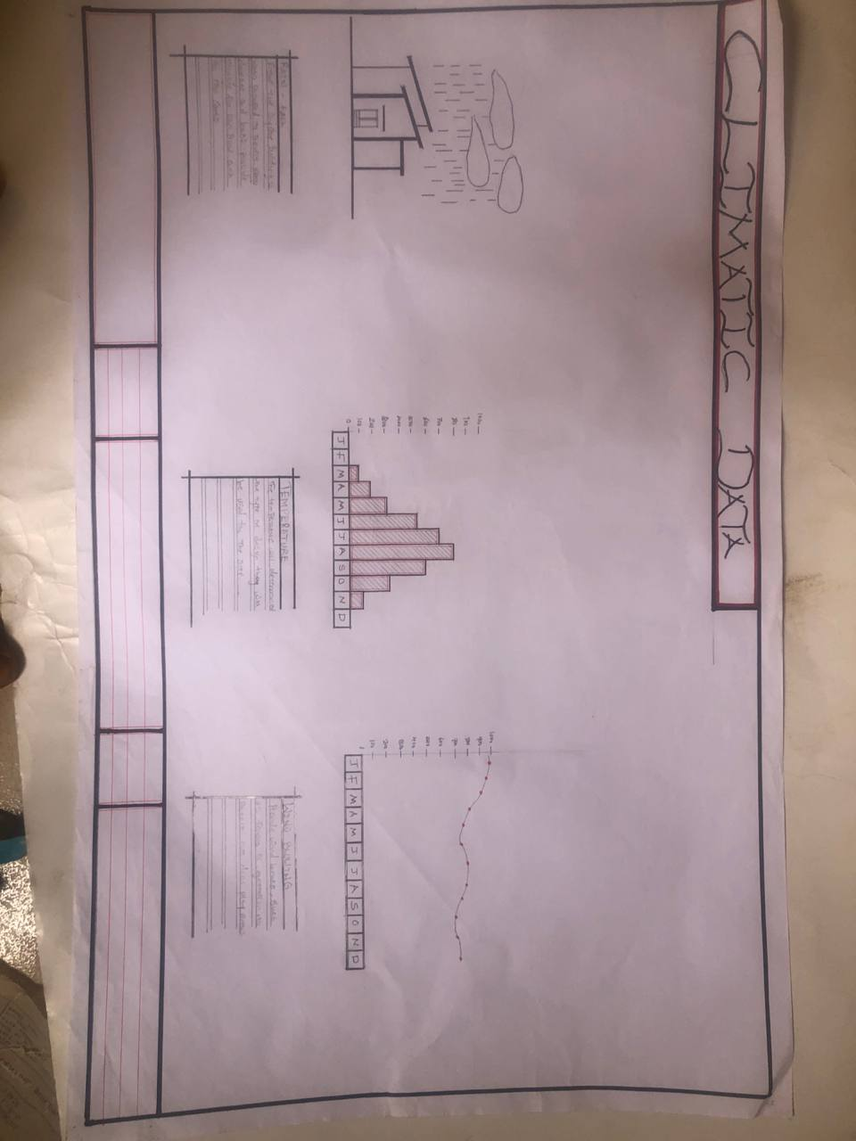

Plate 3.2. Climatic data

Plate 3.2. Average monthly temperature
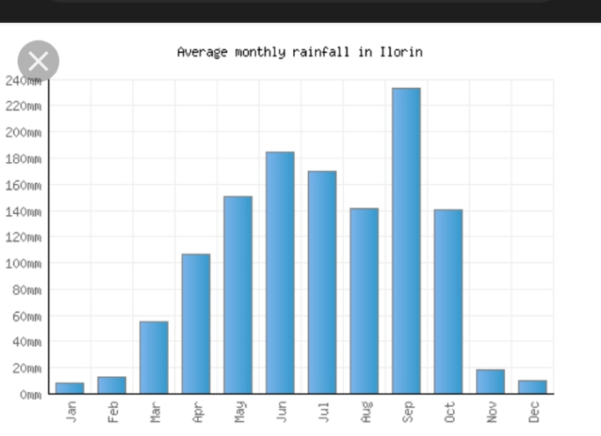
4.5.2 TEMPERATURE
The monthly temperature in Ilorin ranges between 12⁰c to 24⁰c, the annual range of temperature of the city is 18⁰c meanwhile the city experience it’s highest temperature between april and October every year.The southwest trade wind which carries moisture blows within april and October every year while the northeast trade wind which is dry and carries harmatan blows within February and march and April every year.The south west trade wind which carries moisture blows within October, November and January.
4.5.3 DAYLIGHT
The light is adequately and moderate in Ilorin throughout the year. The daylight is between the hours of 7.0 and 18.0GMT.

4.5.4 RELATIVE HUMIDITY
The importance of temperature influences that actual amount of water vapor present in air and this decide the moisture and carrying capacity of the air. It decides the rate
of evaporation and condensation and also affect the nature and type of cloud formation and precipitation as relative humidity is directly related to the temperature of the air, the highest humidity in the state is therefore experienced in the month of April.
WIND DIRECTION: the north-east trade wind blows undesirable cold wind, it is dry, dusty and bring harmattan which is prevalent between the month of march and November.
VEGETATION: Ilorin is in the guinea region of the country. The amount of rainfall that is normally experienced between February and November result into this type of vegetation cover over the area of the site.
The thick forest characterized by hard and soft timber with layers of vegetation covers or the low grass covers. The medium highest trees and trees at the highest level of the ground. The vegetation cover is identified with two shapes, the umbrella shapes and conical shape sharing both properties of the vegetation in forest and the region.
SOLAR PATH DIRECTIO: The sunrise from the east and set in the west, the high intensity of the sun normally experienced at this period the shading devices through the conservation and presentations of the existing natural featuring will surely reduce and combat the effect of this heat emission and transmission at the centre.

4.6 DESIGN CRITERIA In this type of design there is need for proper research using both the local (existing similar structure in the same country) and international structure as a case studies to inculcate the new ideas into the design in order to have a well functional conforming and unique structure that suit the international tastes. Some of the criteria are: Accommodation Analysis: I make provision for at least average number of people to be accommodated from two of my cases studies.
Source of supply: in this project design the structure is largely make use of artificial source of lightening and ventilations therefore there should be a provision for a standby source of electricity. Landscaping: the environment must be warmth landscaped for both the visitors and the occupant to feel amused within the environment. Shrubs used for landscape include. Functionality of the units; all the units should be well functional so as to make every activities to be ease i.e provision of internet facilities within the structure and a control office within the building also.
4.7 BRIEF ANALYSIS
In this type of project, it can be seen that some building are accompany by sub-units which are required in this project and these units form the design scope of this project which are listed below:
ENTRANCE
BOOKING/ SEARVERY
DIRECTOR OFFICE
DIRECTOR TOILET
ACCOUNTING AND SALES
EATING HALL
KITCHEN
CHANGING ROOM (MALE)
CHANGING ROOM (FEMALE)
CHIEF OFFICE
STORE MANEGE ( COOL AND DRY STORE)
DELIVARY BAY
EXIT/ OULOADING BAY
VISITORS TOILET

4.8 BUBBLE DIAGRAM
This is to show the problem that is on ground to solve by mentioning all the design brief that present in the proposed design are low all these can be related.
4.9 CONCEPTUAL DEVELOPMENT (SITE AND BUILDING)
The design concept of this project is based on the principle of FORM follows FUNCTION where the basic design is gotten through the use of bubble and functional relation diagram.
4.10 SITE CONCEPT
The site design was achieved by taking into considerations some environmental and physical features. They are orientation, circulation and zoning.
Orientation: the building is oriented in such a way that as much as possible direct sunlight is prevented from entering the building.
Circulation: the site is distinguished in such a way that allows for easy accessibility and circulation of pedestrian and vehicles. zoning: zoning of required functional spaces is done with respect to their various

CHAPTER FIVE

5.0 APPROACH TO THE DESIGN/DESIGN REALIZATION
5.1 PROJECT APPRAISAL
The smooth operation of the PROPOSED EATERY would depend largely on the availability of services such as lightning (mostly artificial), ventilation (mostly natural), electricity services plumbing and water services, fire services and drainage etc.
5.1.1 CONSTRUCTION METHODOLOGY AND MATERIAL
In construction of building, the skill and workmanship dose not only brings out the beauty but until the when specification detail of materials and construction method which had been adopted in this project are skillfully built are as followed.
5.2 SITE CLEARANCE
Trees in all the area where building is to cover would be cut down and carried away from the site in order to get the organic matter, and the top soil is also removed to a depth of 150mmm Both the clearing of the site can either be done manually or with the use of machine i.e bulldozer or grader.
5.3 FOUNDATION
In these project two type of foundation will be use which are strip and pad foundation. the strip which is the continue spread of concrete shall be use for the load bearing wall and the thickness shall be the same size as the block wall, and the spread will be three times side of the wall, the pad will be use and footing for all the base and also retaining wall of 30mm thick are adopted in some case like rakings in the main conference and will be reinforced.
5.4 STRUCTURAL SYSTEM
This is a horizontal surface design and constructed to accommodate and serve the purpose of supporting people furniture and equipment in the building.
.

5.5 FLOOR
The thickness for the floor slab will be 150mm in the floor, except the generator house which has 300mm thick for generator stand. the following finishing will be use for the project.
P.V.C Floor tiles- these are floor tiles made from thermal-plastic binder (vily 1), it is to be use in all available offices, reception, maintenance, V.VI.P, room, restaurant etc.
ceramic floor tiles: patterned glazed ceramic floor tiles of brown color will be use for the entire toilet and bath.
acoustic carpet underlay: sundown acoustic carpet underlay is a composite material using sundown tuff-mass as a barrier in weight of 1 to 2b and acoustic foam decouple. there is an option for a soft or firm acoustic foam layer that provide a comfortable feel. sundown carpet reduces noise radiating from carpet surface. It may be used alone or to supplement installation applied in spaces sundown carpet underlay is manufactured in 54’ with ¼ and ½ thickness.
5.6 WALLS
These are vertical continuous solid structure which is usually made by brick, stone. concretes, metals etc to serve the purpose of which it is desired. the walls would be a load bearing or non-load bearing walls. all the walls in the building are 225mm wall and it has been supported by columns a beams running vertically and horizontally for structural rigidity.
The walls of the main conference hall are slanted 10⁰ to the floor slab, they are made up of columns at 5.5m interval with a precast reinforced concrete blind of 5500x450x50mm thick arranged in a louver pattern, overlapped by 50mm to each other. all other meeting hall wall is claded with marble tiles because of its sound absorbent characteristics and of its aesthetics value, except the toilet which shall be tiled white and patterned grazed ceramic tile to door height.
The wall finishes for the building interior is marble honeycomb panels wall material as sound insulator within the various unit in the building.

5.7 ROOF
Roofs in building construction are constructed in order to protect the building from all the weather condition and the materials varies according to the materials available e.g steel roof or timber roof. steel roof used in this project as a result of large span and is been covered with asbestos roofing sheet with a pitched roof and hipped roof are adopted.

5.8 STEEL
This is metal which is made of alloy of carbon and iron having a very strength in both tension and compression but it is a very stiff material.
steel possess the capacity undergoing a consideration strain after the elastic limit before it fall. steel has the ability to carry dead/imposed load with its limit. it is used in the building construction industry for reinforcement of concrete, windows, and door frame, floor slab etc. it is a very versatile construction material.
5.9 CEILING
The material use for the project is an acoustic ceiling tile to reduce noise from the roof. the vacuum between the roof and the ceiling should be filled with rock wool material.
5.10 DOOR
These are solid barrier fixed at opening to serve the purpose of gaining and denying access into building and it can be used as security as well as fire barriers which had been adopted for use in the project.
5.11 STANDARD DOUBLE LEAVE SINGLE SWING GLAZED ALUMINIUM DOOR- This are door, which will serve the main entrance into the building this is composed of aluminum frame and glasses glazed.
PURPOSE NADE METAL DOOR -These types of door are provided in three-bed type for proper ventilation and lightening.
necessary place that is required.
FIRE CHECKED PURPOSE MADE DOOR – These type of door will be use in all the door ways in the building like the kitchen, conveniences these is necessary because there is the need to control the spreads of fire in the building.
ALUMINIUM
This is another material that is used in building construction industry and it is made up of alloyed mixed with other element to made a suitable structural material. they are usually corrosion resistance and very light compared to the weight of the steel and highly resistance to corrosion and it is used in the building construction for roofing sheet, partitioning frames, windows frames etc.
TIMBER
Timber is one of the earliest forms of concrete and other material and it is light in weight . it is sometimes used for structural aspect of the building having weight one sixteenth that of steel. timber is a very versatile material and can be used in conjunction with other materials such as steel without any issue arising. it can also be use for constructing room carcass, roof trusses, floor finishes, ceiling finishes, skirting and other building materials.
GLASS
These is another material used in the heating of soda line and sand to a temperature of which they melt and fuse to the stage it can be draw cast rolled on bed of molten tin to be flat glass. Glass can either be transparent or translucent and they come in different ways and types.
Clear Sheet Glass: This type of glass is usually transparent and has varying thickness and may cause optical distortion.
Wired Glass: This type of glass wire is usually embedded into it, it is glazing because the wire holds the glass together so as to reduce the danger of its breakage.
Double Gazing Units: This type of glass can either be transparent or translucent but usually very thick and comprises of float glass spaced apart and sealed around a dehydrated method which had been adopted in the project and are skillfully built.
Toughened Glass: This type of glass can either be transparent or translucent but usually very thick it can be broken into fragments and comparatively harmless pieces, it is usually used for doors and softly screens.
Pattern Glass: This type of glass is translucent because of the pattern or the texture of the glass. it could also be timed or plane.

WINDOW
These are openings found on walls and also on roofs so that day light can pass through, some transparent materials can also be used to allow passage of light and ventilation into the building. The following are the types of windows to be used in the projects.
Aluminum pivoted windows(tinted): this type of window will be used in the guest house and restaurant.
Aluminum pivoted window(plane): this type of window will be used in all other units.
5.12 SERVICES
5.13 VENTILATION
The major source of ventilation is a system of natural ventilation, which is centrally controlled. Efforts were made to ensure cross ventilation principle in the design, while the other source of ventilation is the artificial ventilation provided in the form of CENTRAL AIR CONDITIONING SYSTEM (AC)The various components are ventilated by ducts that are linked to the source of the ventilation.
5.14 PLUMBERING SERVICES
All the water is to be supplied and distributed to other areas through 50mm diameter 100mm and 150mm diameter. All the bath and showers tray and towel trays, while all the toilets will be provided with tissue rolls holder, man holes, septic tanks and soak away pits shall be placed in suitable location for easy maintenance.

LIGHTNING
Lightning is very important for accuracy, safety and productivity, for this proposal the use of natural lightning provided for by the use of windows on the surrounding walls, the natural light is complemented with artificial lights provided by means of varieties of light fittings.
FIRE SERVICES
In the electrical panel room, a fire control unit box is provided to serve each building on site and each building has its own electrical panel room which has/smoke detector which alert the people if there is outbreak of fire in any part of the building before damage is done to other part of the building. carbon oxide gas are positioned and strategic locations in the building.

DRAINAGE
The surface water are channeled into 600mm wide and 600mm deep covered drains with inspection chamber at strategic points and emptied into the main municipal city drain. separate drain system has been employed to drain of foul water from the water closets, surface water and pave areas.
5.15 SECURITY SERVICE
The entry and exits into the site have been fitted with cctv cameras, this is to monitor the movement of vehicles in and out of the site. The entrances will also be maintained with security men checking incoming and outgoing vehicles.
ELECTRICAL SERVICES
The power holding company of Nigeria (PHCN) mean which pass across the site shall be the major source of power supply into the building but an alternative source will however be provided which s generator and effective 3 phase line will be used and the connection will be armored cables while the internal distributions/connections would be conduit conduct piping.

5.16 SUMMARY
The design and operation of eateries play a crucial role in shaping customer experiences and satisfaction. Effective eatery design prioritizes functionality, aesthetics, and comfort, incorporating elements like proper ventilation, lighting, and seating arrangements. Food safety is also a critical concern, with improper handling and preparation of food posing significant risks to public healthTo ensure food safety, eateries should implement effective food handling and preparation practices, maintain a clean and hygienic kitchen environment, and provide staff with adequate training on food safety procedures. Additionally, eateries should focus on creating a welcoming atmosphere by incorporating comfortable seating, appropriate lighting, and décor that reflects the brand's identity. Leveraging technology can also help eateries streamline operations, including online ordering and payment systems, and kitchen equipment that can improve efficiency and reduce waste. Implementing sustainable practices, such as reducing food waste, using eco-friendly packaging, and sourcing ingredients from local suppliers, can also contribute to a positive brand image. Prioritizing customer service is also essential, with staff training on effective communication, conflict resolution, and customer engagement being critical to providing excellent service. Conducting regular customer feedback surveys can help eateries identify areas for improvement and make data-driven decisions to enhance their operations.By implementing these strategies, eateries can improve customer satisfaction.
5.17 RECOMMENDATION
Based on the analysis, several recommendations can be made to enhance the design and operation of eateries. Firstly, eateries should prioritize food safety by implementing effective food handling and preparation practices, maintaining a clean and hygienic kitchen environment, and providing staff with adequate training on food safety procedures. Secondly, eateries should focus on creating a welcoming atmosphere by incorporating comfortable seating, appropriate lighting, and décor that reflects the brand's identity. Thirdly, eateries should leverage technology to streamline operations, including online ordering and payment systems, and kitchen equipment that can improve efficiency and reduce waste. Additionally, eateries should consider implementing sustainable practices, such as reducing food waste, using eco-friendly packaging, and sourcing ingredients from local suppliers. Furthermore, eateries should prioritize customer service by providing staff with training on effective communication, conflict resolution, and customer arrangement.
By implementing these recommendations, eateries can improve customer satisfaction, increase efficiency, and maintain a competitive edge in the market. Moreover, eateries should conduct regular customer feedback surveys to identify areas for improvement and make data-driven decisions to enhance their operations. By doing so, eateries can create a positive and memorable dining experience for customers, ultimately driving business success and growth. Effective implementation of these recommendations can lead to increased customer loyalty, improved reputation, and long-term sustainability for eateries.
5.18 CONCLUSIONS
In conclusion, the design and operation of eateries play a vital role in shaping customer experiences and satisfaction. By prioritizing food safety, customer service, and sustainability, eateries can establish themselves as leaders in the industry and build a loyal customer base. Effective eatery design incorporates elements like proper ventilation, lighting, and seating arrangements, while also ensuring functionality and aesthetics. Implementing sustainable practices, leveraging technology, and providing excellent customer service can also contribute to a positive brand image and drive business success. Conducting regular customer feedback surveys can help eateries identify areas for improvement and make data-driven decisions to enhance their operations. Ultimately, a well-designed and well-operated eatery can create a positive and memorable dining experience for customers, driving business success and growth. By focusing on the needs and preferences of customers, eateries can build a loyal following and establish themselves as beloved gathering places in their communities. The importance of food safety cannot be overstated, and eateries must prioritize proper food handling and preparation practices to protect public health. By doing so, eateries can build trust with their customers and establish a reputation for quality and reliability. In today's competitive market, eateries must be innovative and adaptable to succeed. By staying ahead of trends and technologies, eateries can stay relevant and attract new customers. By prioritizing customer satisfaction, food safety, and sustainability, eateries can create a positive and lasting impact on their customers and the wider community. Overall, the design and operation of eateries require careful consideration of multiple factors, including food safety, customer service, sustainability, and aesthetics. By prioritizing these elements, eateries can create a positive and memorable dining experience for customers, driving business success and growth. With the right approach, eateries can become beloved institutions in their communities, providing a welcoming and enjoyable space for people to gather and share meals.

5.19 REFERENCES
1. Bitner, M. J. (1992). "Servicescapes: The Impact of Physical Surroundings on Customers and Employees." Journal of Marketing, 56(2), 57-71.
2. Kotler, P. (1973). "Atmospherics as a Marketing Tool." Journal of Retailing, 49(4), 48-64.
3. Meiselman, H. L. (2000). "The Context of Meals: The Case for a More Differentiated Understanding of Meals and Meal Functions." Food Service Technology, 1(2), 67-75.
4. Pizam, A. (2017). "International Encyclopedia of Hospitality Management." CABI.
5. Ryu, K., & Han, H. (2010). "The Effect of Food Experience on Customer Satisfaction and Loyalty in a Casual Dining Restaurant." Journal of Foodservice Management, 23(2), 157-173.
6. Schlosser, E. (2001). "Fast Food Nation: The Dark Side of the All-American Meal." Houghton Mifflin.
7. Suki, N. M. (2014). "Influence of Restaurant Service Quality and Food Quality on Customer Satisfaction and Loyalty." Journal of Foodservice Systems, 27(3), 331-344.
8. Tse, A. C. B., & Poon, W. C. (2012). "Food Safety in the Hospitality Industry." Journal of Foodservice Management, 25(1), 55-67.
9. Wansink, B. (2004). "Environmental Factors That Increase Food Intake and Consumption Volume of Unknowing Consumers." Annual Review of Nutrition, 24, 455-479.
10. Yuksel, A., & Yuksel, F. (2003). "Measurement of Tourist Satisfaction with Restaurant Services: A Segment-Based Approach." Journal of Vacation Marketing, 9(1), 52-68.
11. International Association of Culinary Professionals (IACP): A professional organization for culinary professionals, including bakers.
12. "The Science of Cooking" by Peter Barham: A book that explores the science behind cooking and baking.
13. "The Oxford Companion to American Food and Drink" by Andrew F. Smith*: A comprehensive reference work on American food and drink, including baking.
14. "The Joy of Cooking" by Irma S. Rombauer: A classic cookbook that includes a section on baking.
15. "Bakery Management" by Ronald F. Probst: A book that covers the business and management side of running a

LIST OFAPPENDIX
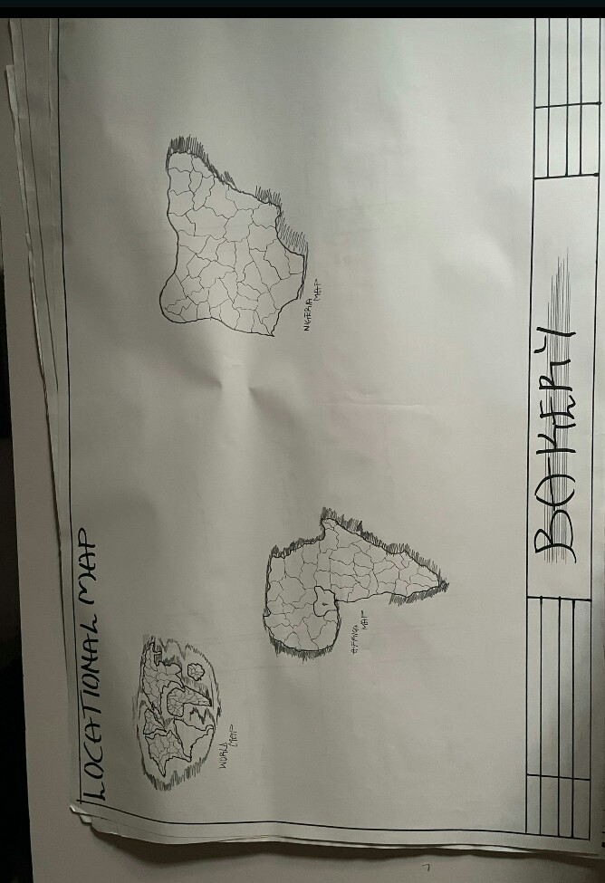
APPENDIX 1. SHOWING LOCATIONAL PLAN

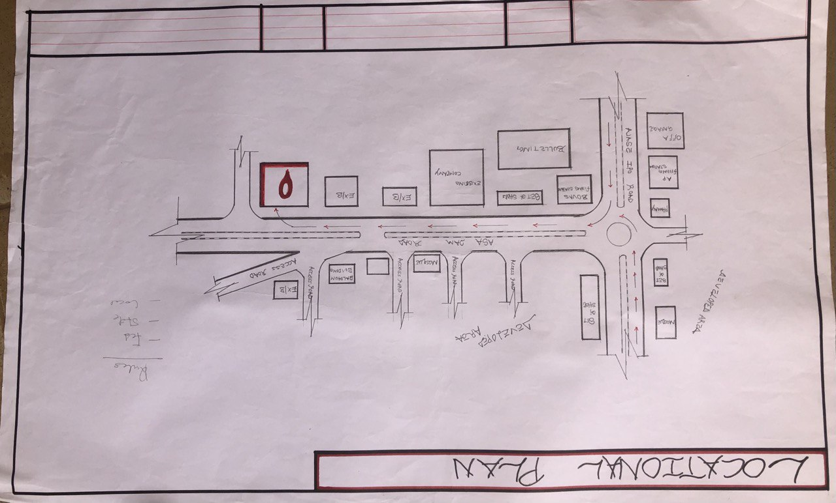
APPENDIX 2. SHOWING LOCATIONAL PLAN

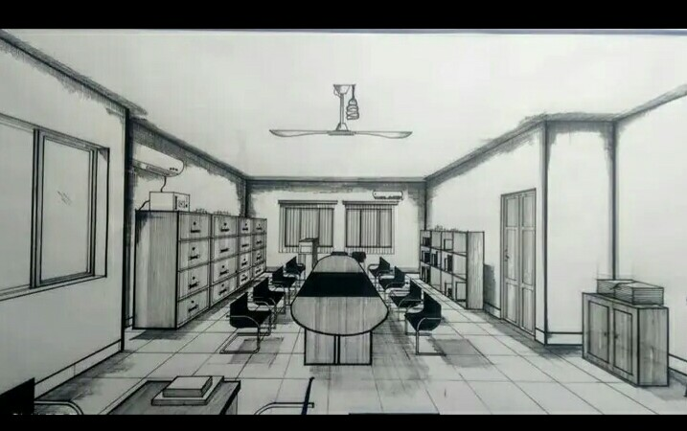
APPENDIX 3. SHOWING INTERNAL PASPECTIVE
APPENDIX 4. SHOWING SITE ANALYSIS

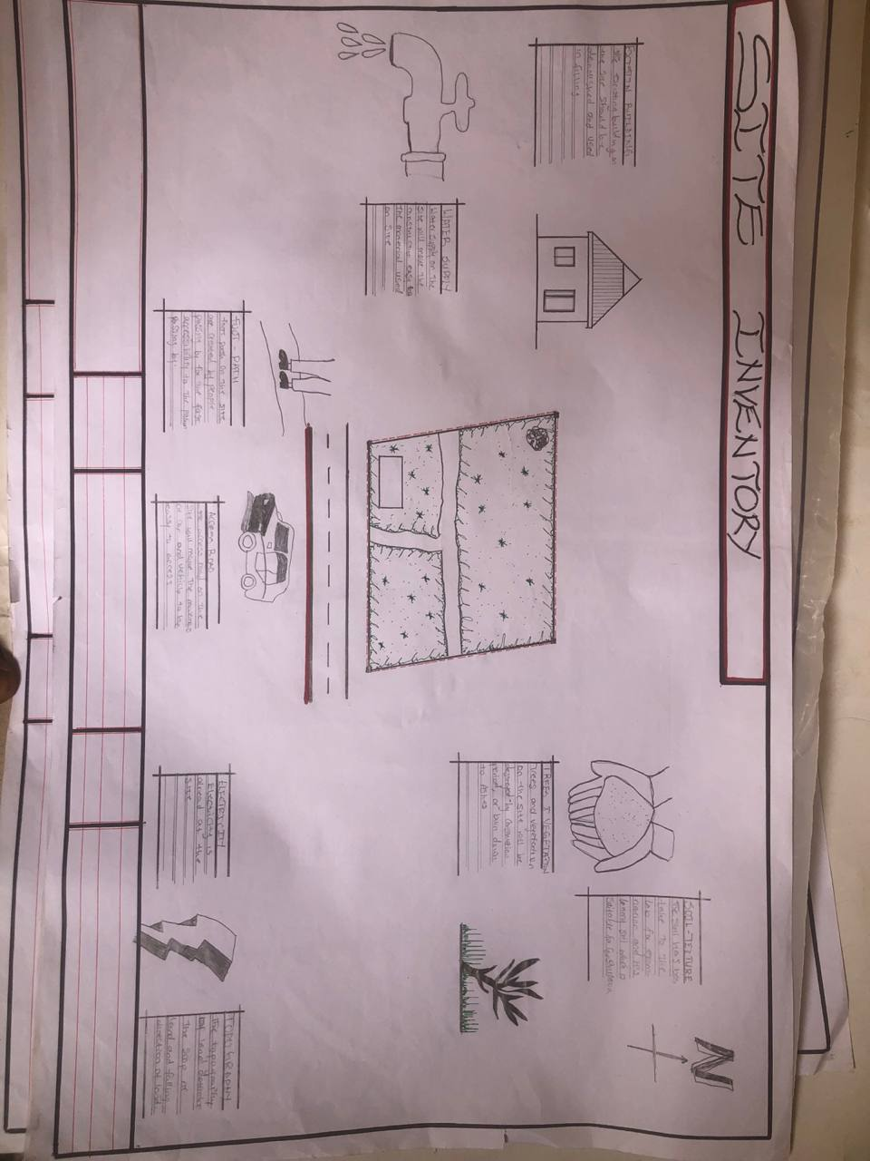
APPENDIX 5. SHOWING SITE INVENTOR

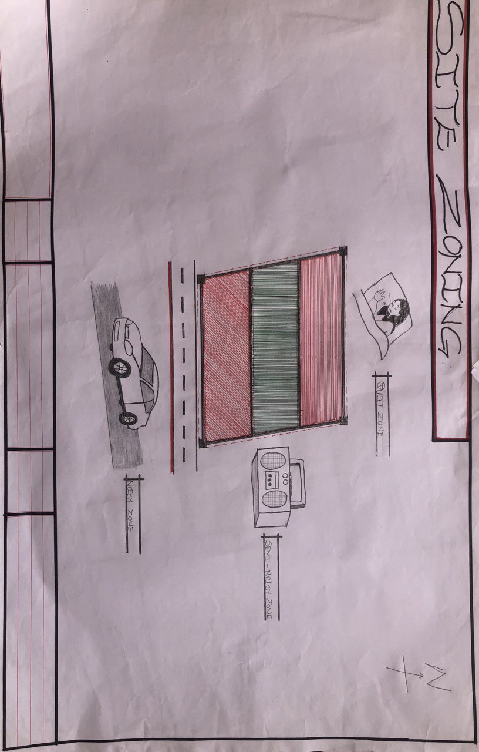APPENDIX 6. SHOWING SITE ZONING
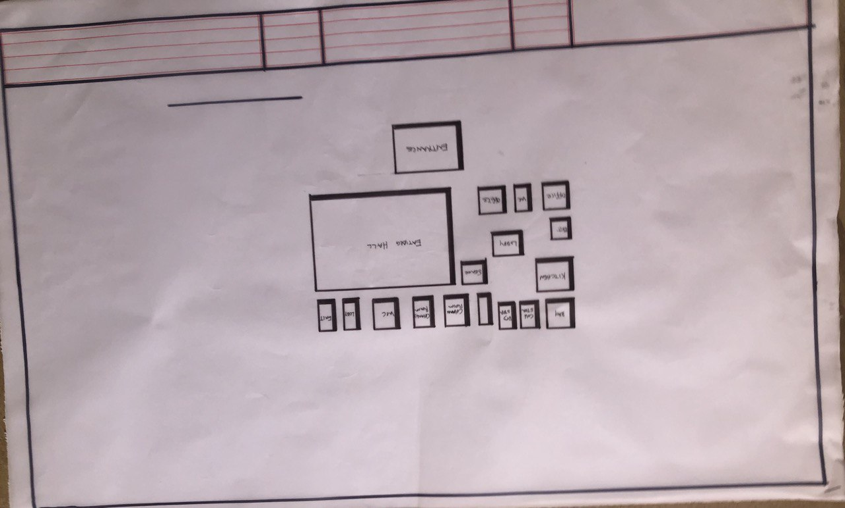

APPENDIX 7. SHOWING FLOW CHART

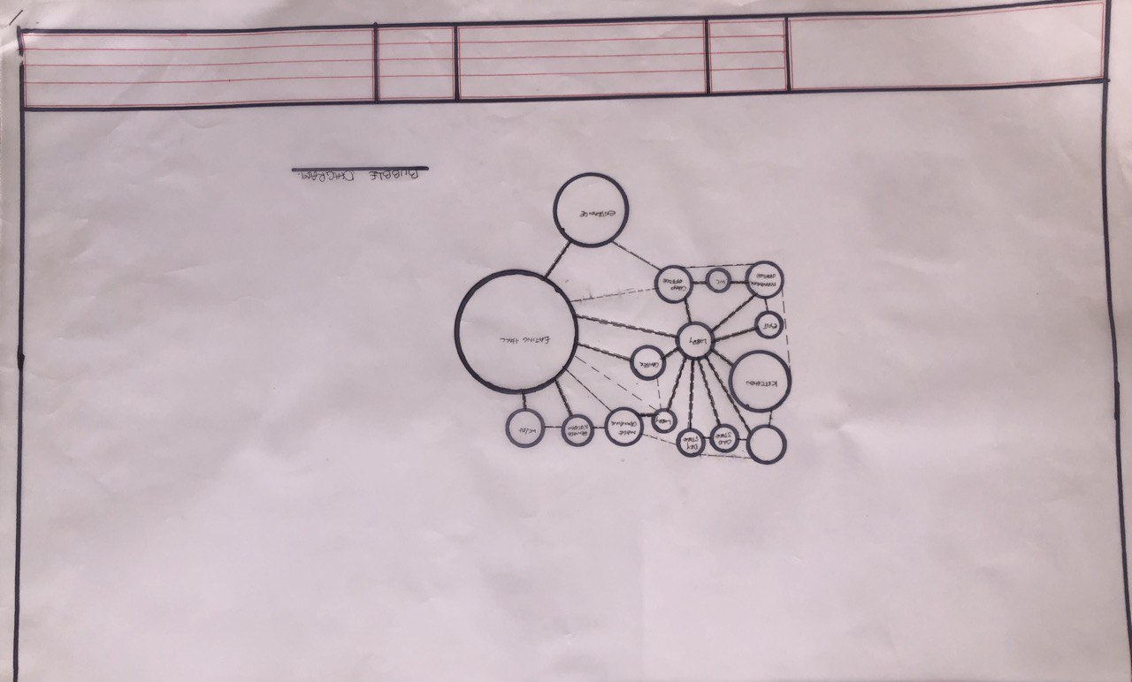

APPENDIX 8. SHOWING BUBBLE DIAGRAM

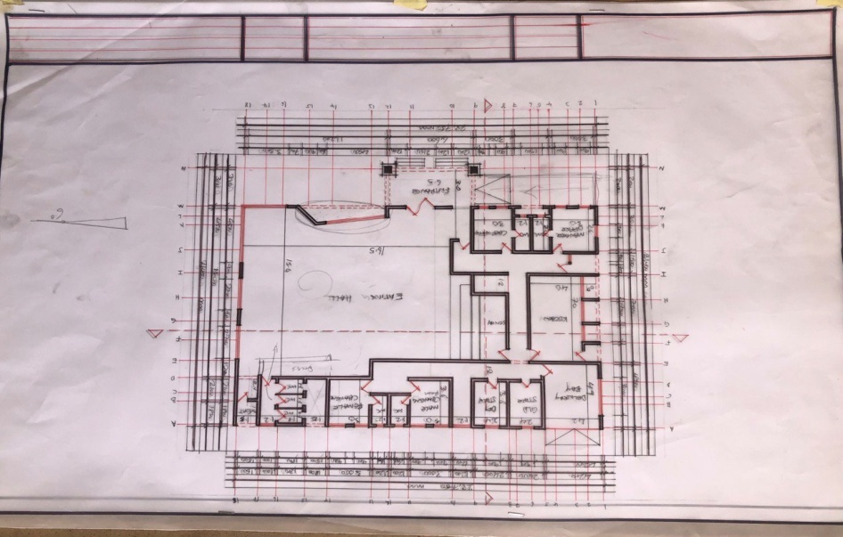

APPENDIX 9. SHOWING FLOOR PLAN

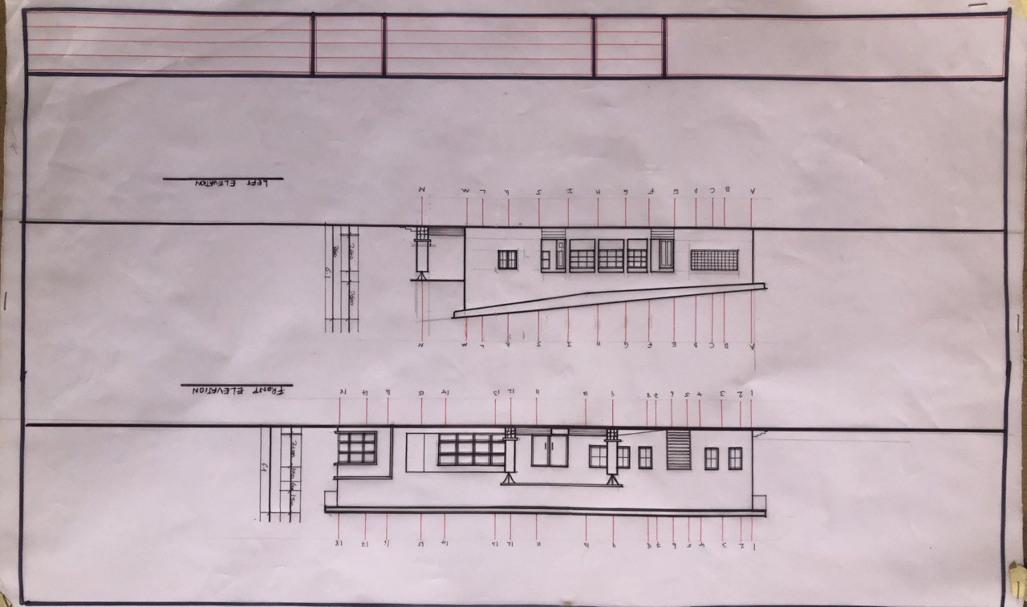
APPENDIX 10. SHOWING ELEVATIONS

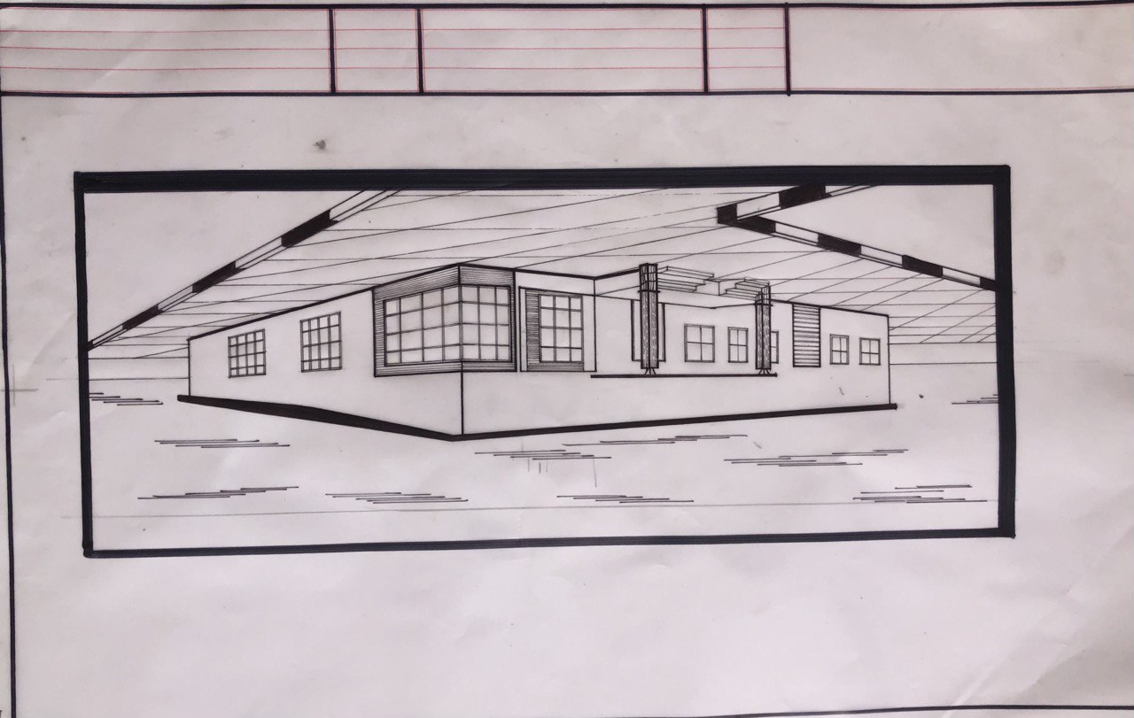

APPENDIX 11. SHOWING EXTERNAL PERSPECTIVE
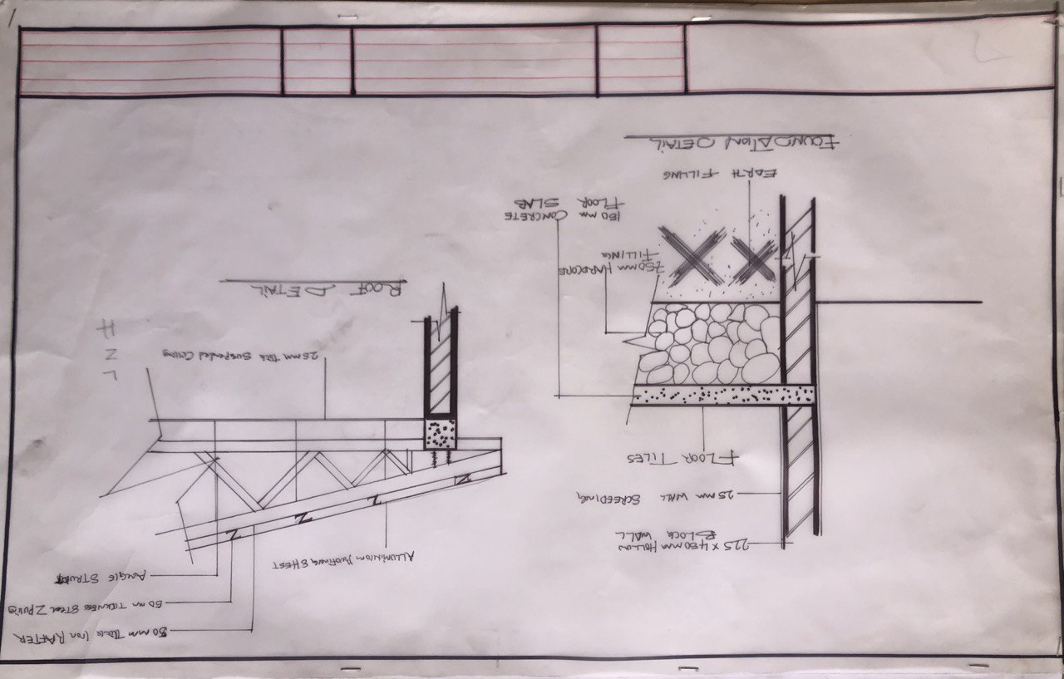 APPENDIX 12. SHOWING DETAILING
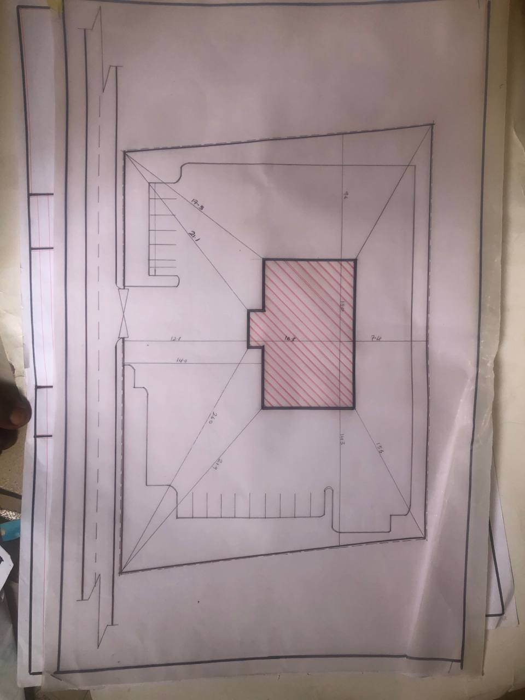APPENDIX 13. SHOWING SITE PLAN APPENDIX 14. SHOWING SITE PLAN

