A COMPUTERIZED FRAMEWORK FOR MARKET SURVEY REPORTING AND ANALYTICAL EVALUATION

BY
SULIAT OMOBOLANLE SULYMAN
ND/23/COM /PT/0381

SUBMITTED TO THE DEPARTMENT OF COMPUTER SCIENCE, INSTITUTE OF INFORMATION AND COMMUNICATION TECHNOLOGY
KWARA STATE POLYTECHNIC, ILORIN.

IN PARTIAL FULFILLMENT OF PART OF THE REQUIREMENTS FOR THE AWARD OF NATIONAL DIPLOMA (ND) IN COMPUTER SCIENCE

JUNE, 2025.

CERTIFICATION
This is to certify that this project research was written by, SULIAT OMOBOLANLE SULYMAN with Matriculation Number ND/23/COM/PT/0381. The project has been read and approved as meeting part of the requirements for the award of National Diploma in Computer Science

_________________________ __________________
MR. BOLAJI-ADETORO D.F. Date
Project Supervisor

_________________________ __________________
MR. OYEDEPO F.S. Date
Head of Department

_________________________ __________________
External Examiner Date

DEDICATION
I dedicate this project work to Almighty God who inspired me and directed my ways during my academic stay in the polytechnic.

.

ACKNOWLEDGEMENTS
The journey through this academic program has been both challenging and rewarding. Through all the trials and triumphs, I give all glory, honor, and adoration to the Almighty God for His unending grace, divine protection, and sustenance from the very first day I stepped into the academic world until this present moment. Without His mercy, I would not have come this far.
I wish to express my heartfelt gratitude to the Head of the Computer Science Department, Mr. Oyedepo F.S., for his unwavering support, fatherly guidance, and consistent encouragement throughout the course of my academic journey. His administrative leadership and personal interest in the success of students have been a source of great motivation to me.
My profound appreciation goes to my project supervisor, Mr. Bolaji-Adetoro D.F., for the invaluable role he played in the successful completion of this research project. His intellectual input, timely corrections, encouragement, and professional mentorship were instrumental in shaping the quality of this work. I consider it a great privilege to have worked under his supervision.
I also wish to extend my sincere appreciation to all the lecturers in the Department of Computer Science for their dedication to academic excellence and for imparting knowledge and discipline throughout my course of study. Each of you contributed uniquely to my academic and personal growth.
To my family, friends, and colleagues who stood by me in prayers, words of encouragement, and support during trying times, I say thank you.
Above all, I am grateful to everyone who, in one way or the other, contributed to the successful completion of this project.

TABLE OF CONTENTS
Title page i
Certification ii
Dedication iii
Acknowledgements iv
Abstract v
Table of contents vi

CHAPTER ONE: GENERAL INTRODUCTION
1.1 Background to the Study 1
1.2 Statement of the Problem 2
1.3 Aim and Objectives of the Study 2
1.4 Significance of the Study 3
1.5 Scope of the Study 3
1.6 Organization of the Study 3
CHAPTER TWO: REVIEW OF RELATED PAST WORK
2.1 Review of Related Works 5
2.2 Overview of Market Survey Reporting System 6
2.2.1 How to do Market Research in 4 steps: A lean approach to Marketing Research 6

2.2.1.1 Four common Market Research Methods 7

2.2.1.2 How to conduct Market Research (In a lean way) 11
CHAPTER THREE: RESEARCH METHODOLOGY AND ANALYSIS
- Research Methodology 18
- Analysis of the Existing System 18
- Problem of the Existing System 19
- Analysis of the Proposed System 19
- Advantage of the New System Over the Existing System 21
CHAPTER FOUR: DESIGN IMPLEMENTATION AND DOCUMENTATION OF THE SYSTEM
4.1 Design of the System 22
4.1.1 Output Design 22
4.1.2 Input Design 23
- Database Design 24
4.1.4 Procedure Design 25
- System Implementation 25
4.2.1 Choice of Programming Language 25
4.2.2 Hardware Support 26
4.2.3 Software Support 26
4.2.4 Implementation Techniques 26
4.3 System Documentation 27
4.3.1 Program Documentation 27
4.3.2 Operation the System 27
4.3.3 Maintaining the System 27
CHAPTER FIVE: SUMMARY, CONCLUSION AND RECOMMENDATION
5.1 Summary 28
5.2 Conclusions 28
5.3 Recommendation 29
References
APPENDICES
Program Flowchart of the proposed system
Source program listing

ABSTRACT
To provide a thorough analysis of the role of the internet in survey research and to discuss the implications of online surveys becoming such a major force in research. The paper is divided into four major sections: an analysis of the strengths and potential weaknesses of online surveys; a comparison of online surveys with other survey formats; a discussion on the best uses for online surveys and how their potential weaknesses may be moderated; and an overview of the online survey services being offered by the world’s largest research firms. If conducted properly, online surveys have significant advantages over other formats. However, it is imperative that the potential weaknesses of online surveys be mitigated and that online surveys only be used when appropriate. Outsourcing of online survey functions is growing in popularity. The paper provides a very useful source of information and impartial advice for any professional who is considering the use of online surveys. The paper synthesizes the vast literature related to online surveys, presents original material related to survey methodology, and offers a number of recommendations. Thus, this research work was developed using HTML, CSS, and JavaScript for its front end, PHP for the backend and MySQL for the database.

CHAPTER ONE
GENERAL INTRODUCTION
1.1 Background to the Study
Marketing has evolved beyond the traditional focus on selling products to encompass a broader scope of customer engagement and relationship management. It centers primarily on identifying and satisfying customer needs, thereby driving product development, promotional strategies, and customer retention efforts. Modern marketing strategies emphasize not only educating customers about product features but also persuading them to make purchases and ensuring long-term customer satisfaction and loyalty (Van, 2020). This shift acknowledges that retaining existing customers often yields greater profitability than acquiring new ones.
In contemporary marketing practice, data-driven decision-making has become crucial. Market survey reporting is a critical component in understanding consumer needs and preferences. It informs strategic decisions related to advertising, product development, pricing, and distribution (Evans, Jamal, & Foxall, 2020). By leveraging insights from survey data, businesses can tailor their offerings and marketing strategies to align with consumer expectations and market dynamics.
Market surveys are typically conducted using two main research approaches: qualitative and quantitative. Qualitative research provides exploratory insights into consumer behaviors and attitudes through open-ended methods such as focus group discussions. These methods, while rich in detail, lack statistical generalizability due to small sample sizes (Wright, 2019). In contrast, quantitative research employs structured instruments like questionnaires to gather statistically valid data from a larger and representative population. This data supports conclusive findings that can be generalized to the broader market (Wright, 2019).
Given the increased complexity of modern markets and the importance of consumer data, the development of a computer-based system for reporting and analyzing market survey data is essential. Such a system would improve data accuracy, streamline reporting processes, and enhance business intelligence for decision-making.
1.2 Statement of the Problem
Traditional market survey methods, including focus groups and manual data collection, often suffer from inefficiencies, lack of scalability, and delayed feedback, which hinder timely decision-making. Furthermore, these methods can be costly, time-consuming, and prone to human error. There is a pressing need for a technology-driven solution to support qualitative data gathering and analysis in an efficient and scalable manner.
This project addresses these challenges by developing a Windows-based application that utilizes qualitative survey techniques to capture and analyze consumer behavior and responses to specific products or services over a defined period. The application is designed to improve the speed, accuracy, and usability of market survey data collection and reporting, thereby enhancing the quality of marketing decisions.
1.3 Aim and Objectives of the Study
The primary aim of this study is A Computerized Framework for Market Survey Reporting and Analytical Evaluation. This system is intended to support companies in gaining competitive advantage through data-driven insights into market trends, consumer behavior, and product performance.
The specific objectives are:
- To enable the delivery of quality products and services that meet customer expectations at minimal cost.
- To promote optimal utilization of available resources in the production process aligned with market needs.
- To eliminate bottlenecks associated with traditional market research methods.
- To develop a user-friendly application for conducting and reporting market surveys.
1.4 Significance of the Study
The development of this application has significant implications for organizations engaged in product development, sales, and customer relationship management. By systematically capturing consumer feedback, the software helps organizations understand how customer perceptions impact product performance and overall sales. This insight is crucial for continuous product improvement and customer satisfaction.
The software will also facilitate:
- Improved quality and efficiency in service delivery.
- Enhanced managerial decision-making through real-time reporting.
- Increased agility and responsiveness to market trends.
- Better customer engagement and retention through personalized marketing.
By integrating customer data into a centralized database, the system provides a foundation for advanced analytics and supports strategic marketing initiatives.
1.5 Scope of the Study
What is required is a system that supports ‘judgmental’ survey, which takes the drudge out of retrieving and analyzing data, and which allows sales and marketing managers, finance managers and general managers to work cooperatively on their components of the forecasting, planning and review process, within a common, shared but secure systems environment.
1.6 Organization of the Report
This is the overall organizational structure of the work as presented in this project write-up. Chapter one of this project deals with the introduction to the general work in the project. It also entails the statement of the problem, aims and objectives of this project, the significance of the study, the scope and limitation of the study and organization of the report.
Chapter two focuses on the review related journals and books, historical background of the study, as well as computerization current state of the art.
Chapter three covers the methods used for data collection, description of the current procedure, problems of existing system, description of the proposed system and the basic advantages of the proposed web-based application.
Chapter four entails design, implementation and documentation of the system. The design involves the system design, output design form, input design form, database structure and the procedure of the system. The implementation involves the implementation techniques used in details, choice of programming language used and the hardware and software support. The documentation of the system involves the operation of the system and the maintenance of the system.
Chapter five contains with the summary, experience gained, conclusion and recommendation.

CHAPTER TWO
LITERATURE REVIEW
2.1 Review of Related Works
Carol, et al., (2021) wrote an article on “Reporting Guidelines for Survey Research: An Analysis of Published Guidance and Reporting Practices” We conducted a three-part project: (1) a systematic review of the literature (including ‘‘Instructions to Authors’’ from the top five journals of 33 medical specialties and top 15 general and internal medicine journals) to identify guidance for reporting survey research; (2) a systematic review of evidence on the quality of reporting of surveys; and (3) a review of reporting of key quality criteria for survey research in 117 recently published reports of self-administered surveys. Fewer than 7% of medical journals (n = 165) provided guidance to authors on survey research despite a majority having published survey-based studies in recent years. We identified four published checklists for conducting or reporting survey research, none of which were validated. We identified eight previous reviews of survey reporting quality, which focused on issues of non-response and accessibility of questionnaires. Our own review of 117 published survey studies revealed that many items were poorly reported: few studies provided the survey or core questions (35%), reported the validity or reliability of the instrument (19%), defined the response rate (25%), discussed the representativeness of the sample (11%), or identified how missing data were handled (11%).
The methods and platforms for administering surveys have undergone significant transformation over the past two decades, evolving from traditional paper-based approaches to sophisticated electronic and web-based systems. Magen and Roy (2020), in their work on Traditional Survey and Questionnaire Platforms, provide a historical overview of survey methods, highlighting the transition from paper-and-pencil interviewing (PAPI) to computer-assisted interviewing (CAI). Their study critically examines the strengths and limitations of both traditional and modern survey platforms, emphasizing the need to select appropriate methods based on the research topic, objectives, geographic scope, and available resources. The authors also discuss ethical considerations and data management challenges inherent in both approaches, arguing for more methodological research to address emerging complexities in survey administration.
In a complementary study, Joel and Anil (2021) explore the increasing relevance of online surveys in contemporary research practice. Their article, The Value of Online Surveys, offers a comprehensive analysis of the strengths and weaknesses of internet-based data collection methods. The authors highlight key advantages such as cost-efficiency, rapid data collection, and broader reach, while also acknowledging concerns around data quality, sampling bias, and technological access. Importantly, the paper offers guidelines for best practices in online survey administration and reviews major commercial platforms offered by global research firms. Joel and Anil stress that, although online surveys are powerful tools, they should be applied with caution and only when suitable for the research context. Their work serves as a valuable resource for practitioners and scholars considering the adoption of digital survey methodologies.
Further illustrating the application of market research in real-world contexts, Marko (2020), in A Concise Guide to Market Research, details Toyota’s strategic use of consumer insights in the development and launch of the Prius hybrid vehicle. Despite previous unsuccessful attempts by competitors like Honda and General Motors to introduce electric cars, Toyota undertook a bold innovation strategy by integrating petrol and electric engines into a single system. Market research played a crucial role in both product development and post-launch evaluation, particularly when expanding into the U.S. market. Toyota encountered consumer concerns related to design, size, and ergonomics, highlighting the importance of culturally contextualized market research. The case demonstrates how targeted surveys and feedback mechanisms can influence critical product decisions and inform global marketing strategies.
Together, these studies underscore the pivotal role of market and survey research in both academic inquiry and commercial practice. As survey methodologies continue to evolve, the integration of technological tools with sound research design becomes increasingly vital for accurate, ethical, and actionable data collection.
Alexandra and Linda (2019) Market Research For Value Chain Initiatives, T his toolkit is meant as a practical guide to conducting market research for value chain development programs. The toolkit focuses on the how-to of designing effective market research, choosing information collection tools, implementing those tools, and organizing the resulting information. It offers support to practitioners in the form of practical advice and worksheets that can be readily applied during market research. T his chapter provides an overview of the toolkit and presents the “pro-poor” value chain development approach, principles and vocabulary. Mennonite Economic Development Associates’ (MEDA)1 project in Peru, which is used as an example throughout the toolkit series, is also presented in some detail.
Gabriel et al, (2023) Market Research and the New Product Development Process, Market research is an important tool throughout all the steps that involve developing new products. Nevertheless, the inadequate use of the available research methodologies raises the probability of failure within innovation to be negotiated in the markets. Based on the stated, this article systematizes the main types of market research to be carried out along the stages of the product development process, as well as its stages and data analysis procedures. Initially, regarding the bibliographic research, it was possible to identify ve market research problems throughout the NPD stages: (i) identication of latent demands, (ii) identication of requirements valued by customers, (iii) concept testing, (iv) prototype testing and (v) evaluation of product performance with consumers. Therefore, to establish the appropriate research processes for each of the listed problems, a focus group was conducted with specialists. The proposed classification constitutes a framework that can be adopted for validation in further studies, because of the chosen research approach, the research results may lack generalizability. The synthesis proposed in this work contributes to guiding the managers who act directly in the processes of product innovation.
Sylvanus and Onwubiko (2024) Market Research as The Architect of Informed Marketing Planning and Decision Making in Business Organization: A Literature Review, This study is focused on market research as the architect of informed marketing planning and decision making in business organizations. The objectives of the study are to critically and contextually examine the development of a company or business through proper planning, organization and control of both human and material resources to satisfy all specific needs within the market at the right time, ascertain the satisfaction of customer’s specific needs through required product or service which should comply with a customer’s requirements and preferences when consumed, determine the economical degree of success or failure a company can have while being new to the market or otherwise introducing new products or services , thus providing certainty to all actions to be implemented, and determine the orientation or disposition of small-scale business owners/operators in terms of customer orientation versus company/profit orientation. The study identifies and exploits market research and its components, business needs for market research, business failure, marketing planning and marketing decision-making; highlights methods / techniques of conducting market research, examples of market research and the best practices for market research to deliver value to organizations that help shape strategy, uncover opportunities, reducing uncertainty and make data-driven decisions and a razor-sharp focus on efficient growth. The findings of the study are that new product development and launch needs adequate market research, the final design of a product and its positioning needs market research, market research only works when subjects are honest and open to participating and the viability of a new product and how it might perform in the real world is dependent on market research, and that the small business owners claim to be alert to customer complaints and are market-driven, among others. The study concluded that market research is vital in today’s business landscape as it is the compass that guides product development, marketing campaigns and expansion efforts, ensuring resources are invested wisely.

2.2 Overview of Market Survey Reporting System

2.2.1 How to do market research in 4 steps: a lean approach to marketing research
David Darmanin, one of Hotjar’s founders, launched two startups before Hotjar took off—but both companies crashed and burned. Each time, he and his team spent months trying to design an amazing new product and user experience, but they failed because they didn’t have a clear understanding of what the market demanded.
With Hotjar, they did things differently. Long story short, they conducted market research in the early stages to figure out what their consumers really wanted, and they made (and continue to make) constant improvements based on their research.
What is market research?
Market research (or marketing research) is any set of techniques used to gather information and better understand a company’s target market. Businesses use this information to design better products, improve user experience, and craft a marketing strategy that attracts quality leads and improves conversion rates.

Why is market research so valuable?
Without research, it is impossible to understand your users. Sure, you might have a general idea of who they are and what they need, but you have to dig deep if you want to win their loyalty.
Here’s why research matters…
- Obsessing over your users is the only way to win. If you don’t care deeply about it, you’ll lose potential customers to someone who does.
- Analytics gives you the ’what,’ but research gives the ‘why.’
- Big data, user analytics, and dashboards can tell you what people do at scale, but only research can tell you what they’re thinking and why they do what they do. For example, analytics can tell you that customers leave when they reach your pricing page, but only research can explain why.
- Research beats assumptions, trends, and so-called best practices.
Have you ever watched your colleagues rally behind a terrible decision? Bad ideas are often the result of guesswork, emotional reasoning, death by best practices, and defaulting to the Highest Paid Person’s Opinion (HiPPO). By listening to your users and, focusing on their customer experience you’re less likely to get pulled in the wrong direction.
v. Research keeps you from planning in a vacuum.
Your team might be amazing, but you and your colleagues simply can’t experience your product the way your customers do. Customers might use your product in a way that surprises you, and features that seem obvious to you might confuse them. Over-planning and refusing to test your assumptions is a waste of time, money, and effort because you will likely need to make changes once your untested plan gets put into practice.

2.2.1.1 Four common market research methods
There are lots of different ways one could conduct market research and collect customer data, but you don’t have to limit yourself to just one research method. Four common types of market research techniques include surveys, interviews, focus groups, and customer observation.
Which method you use may vary based on your business type: ecommerce business owners have different goals from SaaS businesses, so it’s typically prudent to mix and match these methods based on your particular goals and what you need to know.

1. Surveys: the most commonly used
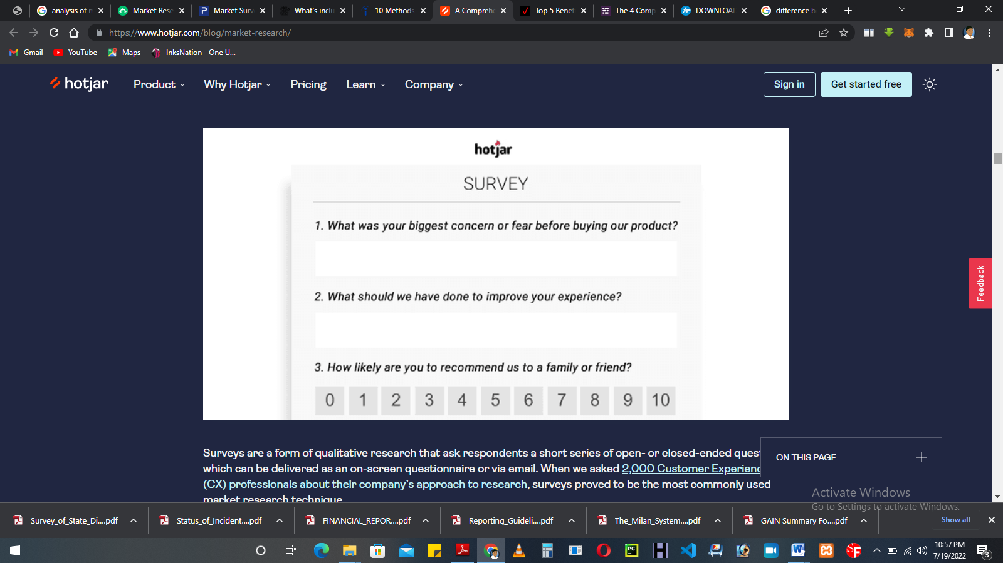
Fig 2.1: Surveys: the most commonly used
Surveys are a form of qualitative research that ask respondents a short series of open- or closed-ended questions, which can be delivered as an on-screen questionnaire or via email. When we asked 2,000 Customer Experience (CX) professionals about their company’s approach to research, surveys proved to be the most commonly used market research technique.
What makes online surveys so popular? They are easy and inexpensive to conduct, and you can do a lot of data collection quickly. Plus, the data is pretty straightforward to analyze, even when you have to analyze open-ended questions whose answers might initially appear difficult to categorize.

2. Interviews: the most insightful
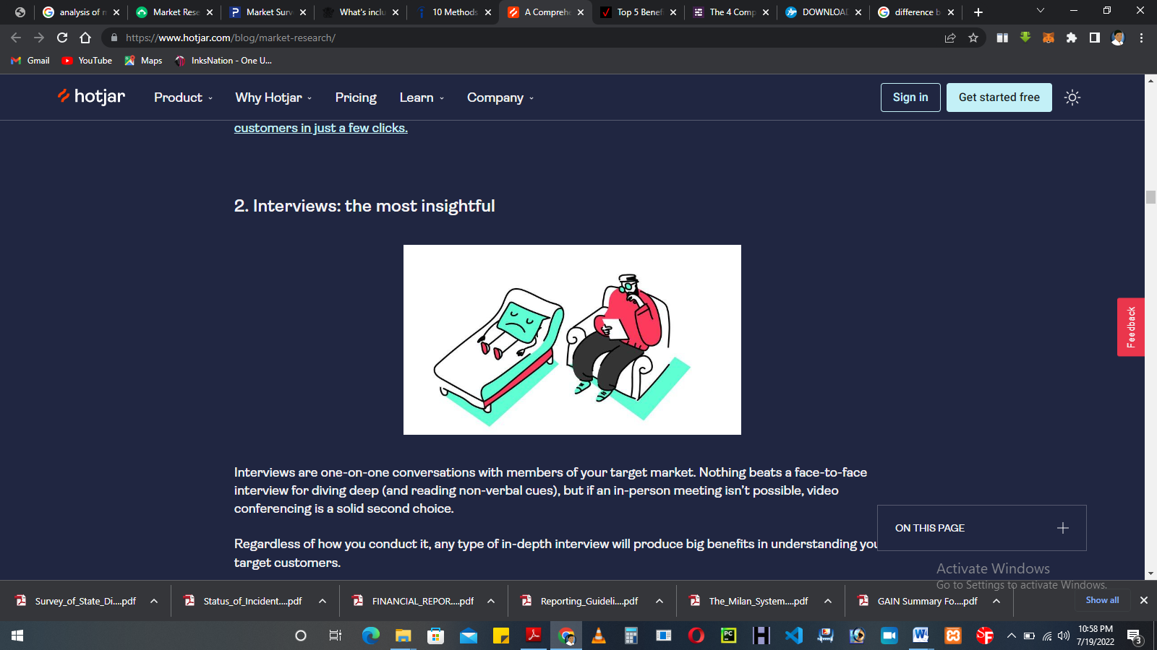
Fig 2.2: Interviews: the most insightful
Interviews are one-on-one conversations with members of your target market. Nothing beats a face-to-face interview for diving deep (and reading non-verbal cues), but if an in-person meeting isn’t possible, video conferencing is a solid second choice.
Regardless of how you conduct it, any type of in-depth interview will produce big benefits in understanding your target customers.

What makes interviews so insightful?
By speaking directly with an ideal customer, one will gain greater empathy for their experience, and you can follow insightful threads that can produce plenty of 'Aha!' moments.

3. Focus groups: the most dangerous
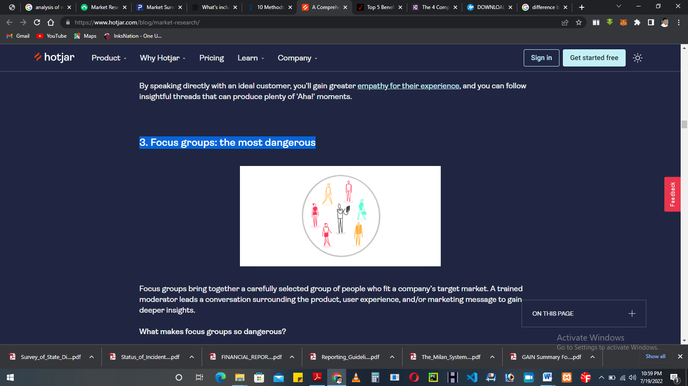
Fig 2.3: Focus groups: the most dangerous
Focus groups bring together a carefully selected group of people who fit a company’s target market. A trained moderator leads a conversation surrounding the product, user experience, and/or marketing message to gain deeper insights.
What makes focus groups so dangerous?
If one is new to market research, I wouldn’t recommend starting with focus groups. Doing it right is expensive, and if you cut corners, your research could fall victim to all kinds of errors. Dominance bias (when a forceful participant influences the group) and moderator style bias (when different moderator personalities bring about different results in the same study) are two of the many ways your focus group data could get skewed.

4. Observation: the most powerful
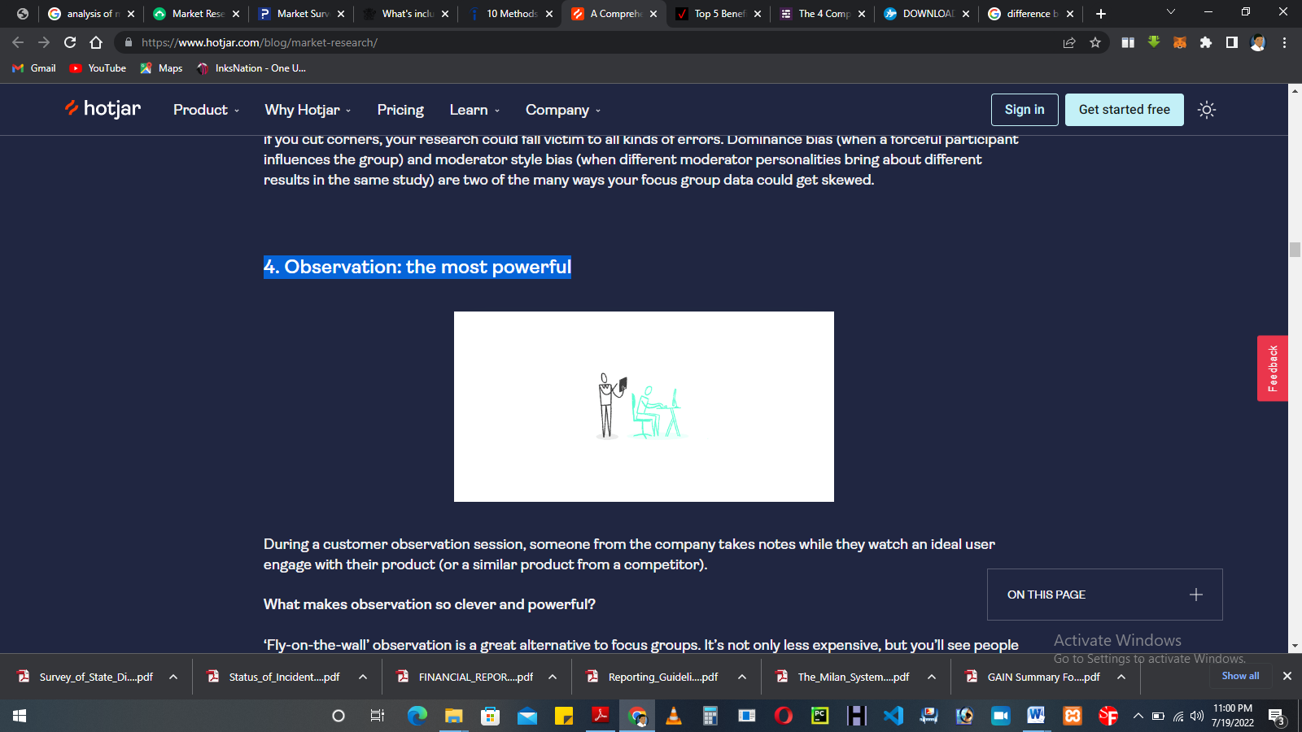
Fig 2.4: Observation: the most powerful
During a customer observation session, someone from the company takes notes while they watch an ideal user engage with their product (or a similar product from a competitor).

What makes observation so clever and powerful?
‘Fly-on-the-wall’ observation is a great alternative to focus groups. It’s not only less expensive, but you’ll see people interact with your product in a natural setting without influencing each other. The only downside is that you can’t get inside their heads, so observation is no replacement for customer surveys and interviews.

2.2.1.2 How to conduct market research (in a lean way)
The following four steps will give you a solid understanding of who your users are and what they want from a company like yours.

1. Create simple user personas
A user persona is a semi-fictional character based on psychographic and demographic data from people who use websites and products similar to your own.
How to get the data: use on-page or emailed surveys and interviews to understand your users.
How to do it right: whatever survey/interview questions you ask, they should answer the following questions about the customer:
- Who are they?
- What is their main goal?
- What is their main barrier to achieving this goal?

Pitfalls to avoid:
- Don’t ask too many questions!
Keep it to five or less (preferably three), otherwise, you’ll inundate them, and they’ll stop answering.
- Don’t worry too much about typical demographic questions
like age or background. Instead, focus on the role these people play (as it relates to your product) and their goals.
How Smallpdf did it: Smallpdf ran an on-page survey for a week or two and received 1,000 replies, which revealed that many of their users were administrative assistants, students, and teachers. Then they created simple user personas like this one for admins:
- Who are they?
Administrative Assistants.
- What is their main goal?
Creating Word documents from a scanned, hard-copy document or a PDF where the source file was lost.
- What is their main barrier to achieving it?
Converting a scanned PDF doc to a Word file.

2. Conduct observational research
Observational research involves taking notes while watching someone use your product (or a similar product).

Overt vs. covert observation
- Overt observation involves asking customers if they’ll let you watch them
use your product. (Smallpdf did this with administrative assistants.)
- Covert observation means studying users ‘in the wild’ without them knowing.
This only works if one sells a type of product that people use regularly, but it offers the purest observational data because people often behave differently when they know they’re being watched. (Smallpdf did this with university students.)
Tips to do it right:
- Record an entry in your field notes, along with a timestamp, each time an event occurs.
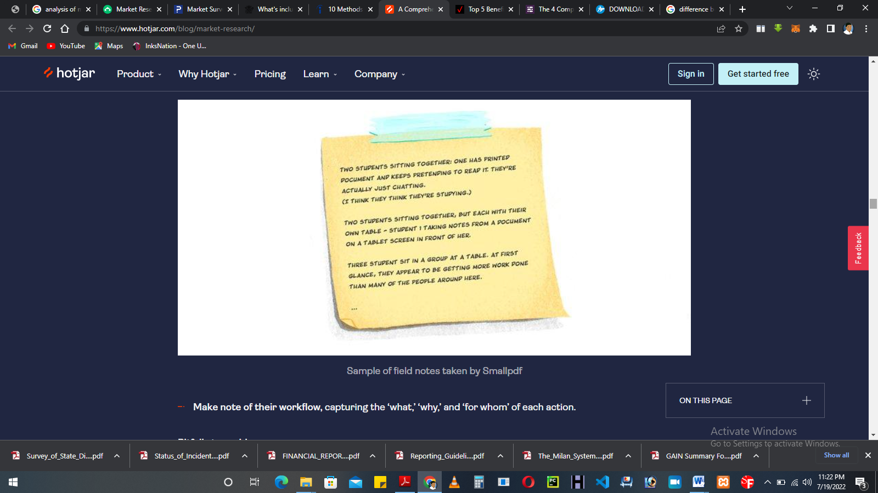
- Make note of their workflow, capturing the ‘what,’ ‘why,’ and ‘for whom’ of each action.
Pitfalls to avoid:
- Don’t record video or audio, regardless of your method (overt or covert). If they know you’re recording, it’ll make them nervous. And if they don’t know? It’s just plain creepy.
- Don’t forget to explain why you’d like to observe them (for overt observation).
They’re more likely to cooperate if you tell them you want to improve the product.
How Smallpdf did it: here’s how Smallpdf observed two different user personas.
- Observing students:
Kristina Wagner, an Interaction Designer from Smallpdf, went to cafes and libraries at two local universities and waited until she saw students doing PDF-related activities. Then she watched and took notes from a distance.
One thing that struck her was the difference between how students self-reported their activities vs. how they behaved (i.e., self-reporting bias). Students, she found, spent hours talking, listening to music, or simply staring at a blank screen rather than working. When she did find students who were working, she recorded the task they were performing and the software they were using (if she recognized it).
3. Conduct individual interviews
Interviews are one-on-one conversations with members of your target market. They allow you to dig deep and explore their concerns, which can lead to all sorts of revelations.
Tips to do it right:
- Act like a journalist, not a salesperson
. Rather than trying to talk your company up, ask people about their lives, their needs, their frustrations, and how a product like yours could help.
- Listen more, talk less.
Be curious.
- Ask ‘why?’ so you can dig deeper.
Get into the specifics and learn about their past behavior.
- Record the conversation
So you don’t have to take notes and can focus on the conversation. There are plenty of services that will transcribe recorded conversations for a good price.
Pitfalls to avoid:
Don’t ask leading or loaded questions.
- A leading question reveals bias on your part and pushes them in a certain direction (e.g., “Have you taken advantage of the amazing new features we just released?).
- A loaded question sneaks in an assumption which, if untrue, would make it impossible to answer honestly. For example, we can’t ask you, “What did you find most useful about this article?” without asking whether you found the article useful in the first place.
- Be cautious when asking opinions about the future (or predictions of future behavior). Studies suggest that people aren’t very good at predicting their future behavior. This is due to several cognitive biases, from the misguided exceptionalism bias (we’re good at guessing what others will do, but we somehow think we’re different), to the optimism bias (which makes us see things with rose-colored glasses), to the ‘illusion of control’ (which makes us forget the role of randomness in future events).
How Smallpdf did it: Kristina explored her teacher user persona by speaking with university professors at a local graduate school. She learned that the school was mostly paperless and rarely used PDFs, so for the sake of time, she moved on to the admins.
A bit of a letdown? Sure. But this story highlights an important lesson! Sometimes you follow a lead and come up short, so you have to make adjustments on the fly. Lean market research is about getting solid, actionable insights quickly so you can tweak things and see what works.
4. Analyze the data (without drowning in it)
The following techniques will help you wrap your head around the data without losing yourself in it. Remember, the point of lean market research is to find quick, actionable insights.

Flow model
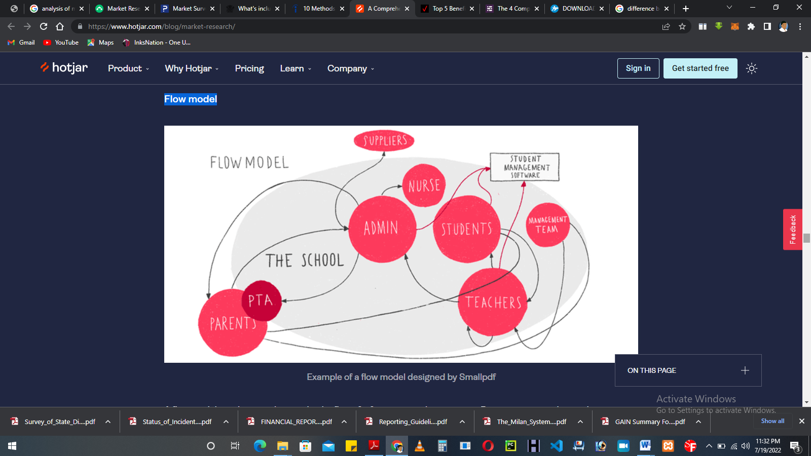
Example of a flow model designed by Smallpdf
A flow model is a diagram that tracks the flow of information within a system. By creating a simple visual representation of how users interact with your product and each other, you can better assess their needs.
You’ll notice that admins are at the center of Smallpdf’s flow model, which represents the flow of PDF-related documents throughout a school. This flow model shows the challenges that admins face as they work to satisfy their own internal and external customers.

Affinity diagram
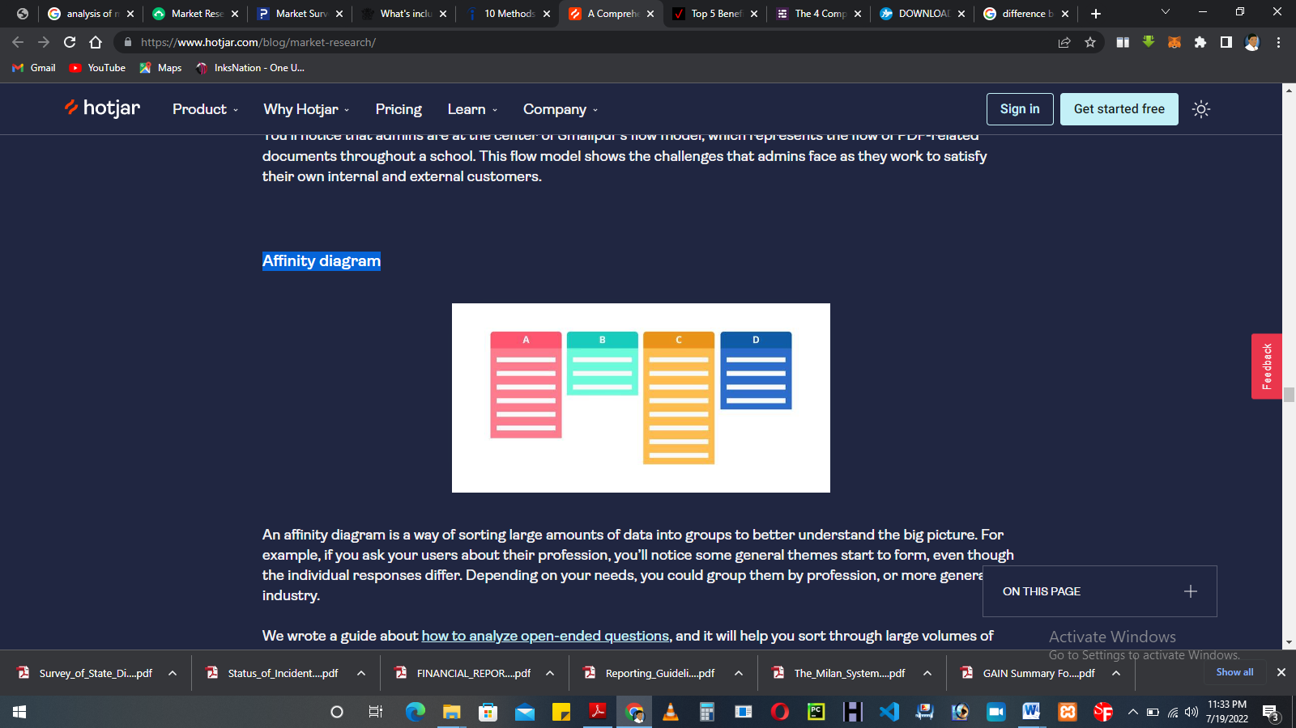
An affinity diagram is a way of sorting large amounts of data into groups to better understand the big picture. For example, if you ask your users about their profession, you’ll notice some general themes start to form, even though the individual responses differ. Depending on your needs, you could group them by profession, or more generally by industry.

Customer journey map
A customer journey map is a diagram that shows the way a typical prospect becomes a paying customer. It outlines their first interaction with your brand and every step in the sales cycle, from awareness to repurchase (and hopefully advocacy).
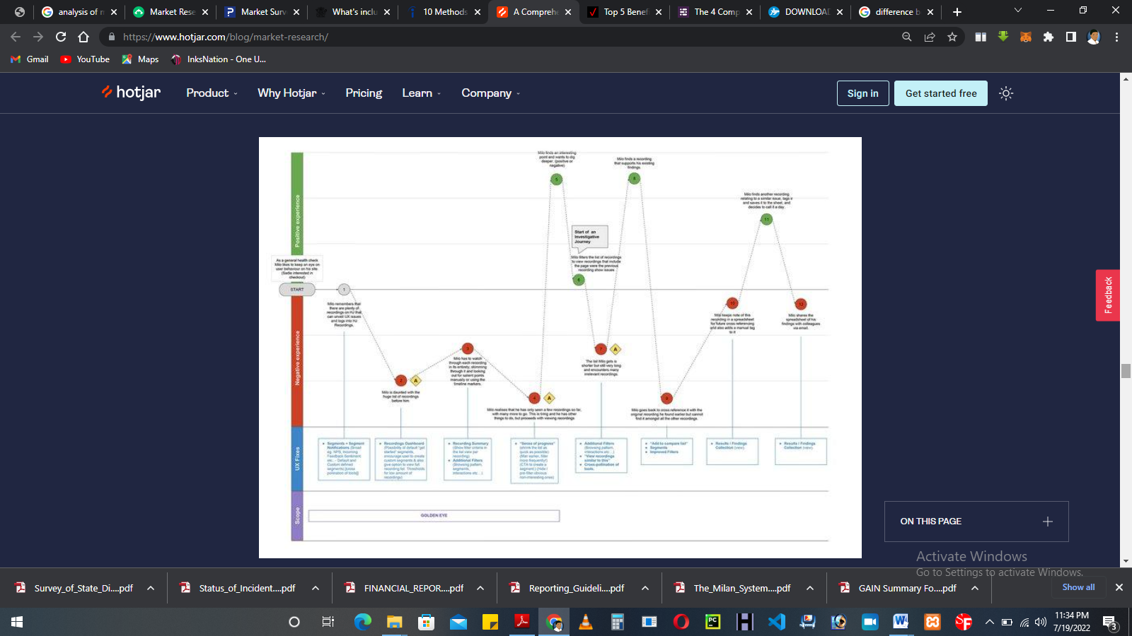
The above customer journey map, created by our team at Hotjar, shows many ways a customer might engage with our tool. Your map will be based on your own data and business model.

CHAPTER THREE
RESEARCH METHODOLOGY AND ANALYSIS OF THE EXISTING SYSTEM
- Research Methodology
This project software was implemented using HTML, CSS, and JavaScript for the front-end design, HTML (Hypertext Markup Language) will be used to structure the web application interface while CSS (Cascading Style Sheet) will be used to beautify the interface to make it more attractive and user friendly. JavaScript will be used to dynamically generate survey questions to customers and buyers. PHP (Hypertext Preprocessor) will be used for the server-side scripting language which will serve as intermediary between the database and the front-end data. PHP here serves as the server-side processor to process constraints, generate feasible output like report and make data available to all listening devices. MySQL will be used for the database management system.
3.2 Analysis of the existing system
Traditional surveys are used to provide more data on respondents, from basic demographic information (e.g., age, education) to social data (e.g., causes, activities). Survey design involves the planning of the whole survey project and the outlining of steps to take when conducting research. These are the steps that start from the formulation of the survey goals to the interpretation of the survey results. Depending on the existing state of knowledge about a problem being studied, different types of questions may be asked which require the use of different study designs.
Careful survey design can help researchers obtain the responses they want. For instance, a survey design should be limited to the extent necessary for respondents to understand questions or to stimulate the response so as to reduce measurement errors. Questionnaire design is a multistage process that requires attention to several details.

Traditional Survey Tools
The questionnaire is the primary data collection instrument in social, health, epidemiological, and other areas of research. Thus, researchers should take cognizance of question wording and sequencing, the appearance of the questionnaire, the mode of administration, and enhancing response rates to get the most out of data collection. Collection of data in traditional survey research has been laid on different methods which are the questionnaire, interview, panel survey, observation, and telephone interview. The characteristics of the target population, resources available, and sensitivity of the topic of interest determine the method of data collection chosen.
Market research has relied on explicitly given answers to survey questions for insight into people’s behavior. This is because business needs quick answers in order to make business decisions. Explicit methods comprise questionnaires, semantic differential, focus groups, in-depth interviews, thinking aloud, and rating scales.While explicit methods divulge information on motivations, values, and rational explanations, implicit methods divulge hidden and difficult information that is hard to verbalize (Nosek et al. 2011). Using both explicit and implicit methods enables comprehensiveness of research data.
- Problems of the existing system
The existing system has the following problems:
- it is slow in process.
- it is costly compared to the proposed system.
- answers gotten from respondents may get lost because it will be written somewhere on a paper.
- Analysis of the proposed system
Questionnaire surveys are a popular data collection method for academic or marketing research in a variety of fields. Face-to-face, telephone interviews and postal surveys are traditional approaches of completing questionnaire surveys. However, with the growing access to the internet facility globally, for example, internet penetration in Nepal, a low-income country, increased exponentially in the past two decades, from less than 50 users in 1995 to 11.9 million users (about 45% of total population) in 2015 and the price of technology devices (e.g. tablet computers, hardware) and software continuing to reduce, an novel internet-based data collection technique such as online questionnaire survey has become popular in recent years. Recently, qualitative data collection through online focus groups is also emerging, suggesting, research participants in the digital age can now interact with each other and the interviewer/facilitator in an online- multimedia setting.
Data collection through an online survey appears to have the potential to collect large amounts of data efficiently (i.e. with less error due to the lack transferring written data on to a computer), economically (as it requires low human resource efforts while collecting or managing data) and within relatively short time frames. Online survey approach is also very useful when collecting data from hard-to-reach populations such as lesbian, gay, bisexual and transgender (LGB&T) or travellers, etc. Moreover, people with certain conditions, such as HIV are often hard to access since they are stigmatized offline. Studying these sub-populations can be possible through an online survey approach as this may help access these hard to reach population by sending an invitation through a range of media and discussion platforms (e.g. social media, discussion fora).
Online survey approach provides convenience in several ways, for example, respondent can answer at a convenient time, respondent can take as much time as they need to response questions; and respondent can complete survey in multiple sessions. Similar to the paper-based survey; online questionnaire surveys are capable of question diversity (e.g. dichotomous questions, multiple-choice questions, scales), skip irrelevant questions for sub-groups in the sample (i.e. no pregnancy questions for men) and even collect an open-ended questions (qualitative data) through a free text box. Similarly, the construction of the online questionnaire can also be built to help better response rate for each item; for example, respondents must answer a question before advancing to the next question. This, however, might create an unfavourable situation to some research participants if they do not want to answer sensitive questions such as sexual behaviours or drug use. Unlike the paper postal survey, through this approach, follow up could be easy through email which enhance response rate.
An online survey questionnaire survey follows the same characteristics as the paper version of the survey. However, the data collection strategies have specific characteristics (e.g. technological, demographic, response rate) that affect their design and implementation. Online questionnaires can only produce valid and meaningful results if the: a) layout of the questionnaire and all its questions/items are clear and precise; b) if they are appropriately executed (for example, completing survey through a mobile app or via tablet might attract young generation but may not work well with elderly population); and c) if they are asked consistently across all respondents. Therefore, a careful consideration needs to be given while designing the online questionnaire survey. In this paper, we discuss: a) methodological aspect of online questionnaire survey; b) online survey planning and management; and c) ethical concern that may arises while using this option.
3.5 Advantages of the New System over the Existing System
The proposed system has the following advantages over the existing system:
i. Ease of Data Gathering:
The Internet is a vast virtual world that connects all kinds of people from around the globe. For this reason, a survey that requires a hundred or more respondents can be conducted faster via the Internet. The survey questionnaire can be rapidly deployed and completed by the respondents, especially if there’s an incentive that is given after their participation.
ii. Minimal Costs
Traditional survey methods often require you to spend thousands of dollars to achieve the optimal results. On the other hand, studies show that conducting an Internet survey facilitates low-cost and fast data collection from the target population. Sending email questionnaires and other online questionnaires are more affordable than the face-to-face method.
iii. Automation in Data Input and Handling
With online surveys, the respondents are able to answer the questionnaire by means of inputting their answers while connected to the Internet. Then, the responses are automatically stored in a survey database, providing hassle-free handling of data and a smaller possibility of data errors.

CHAPTER FOUR
DESIGN AND IMPLEMENTATION OF THE SYSTEM
4.1 Design of the system
The design of the system gives the details of the design components that make up the project application. The program design components discussed in this section are the output design, input design, database design and procedure design. Each of the section is explained as follows with a diagram.
4.1.1 Output design
The output design covers the mode output presentation of the program, description of the output interface and the specific output medium. The output interfaces are designed in a report form for better presentation and well formatted interpretation of its content. The medium of output varies depending on the choice of the program user.
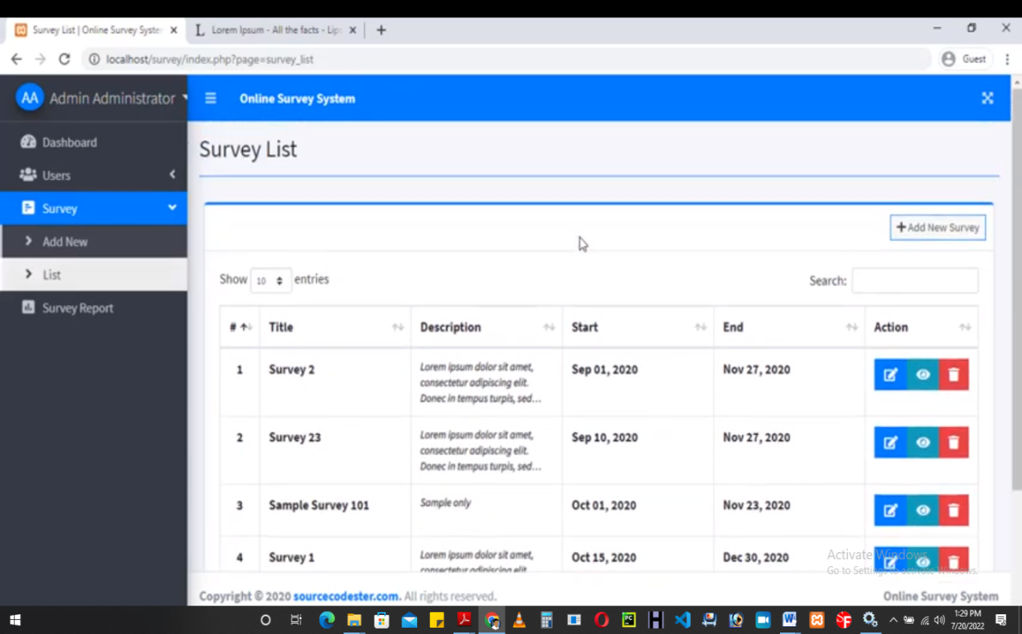
Fig 4.1: Survey List Page
This page displays all the survey on the system

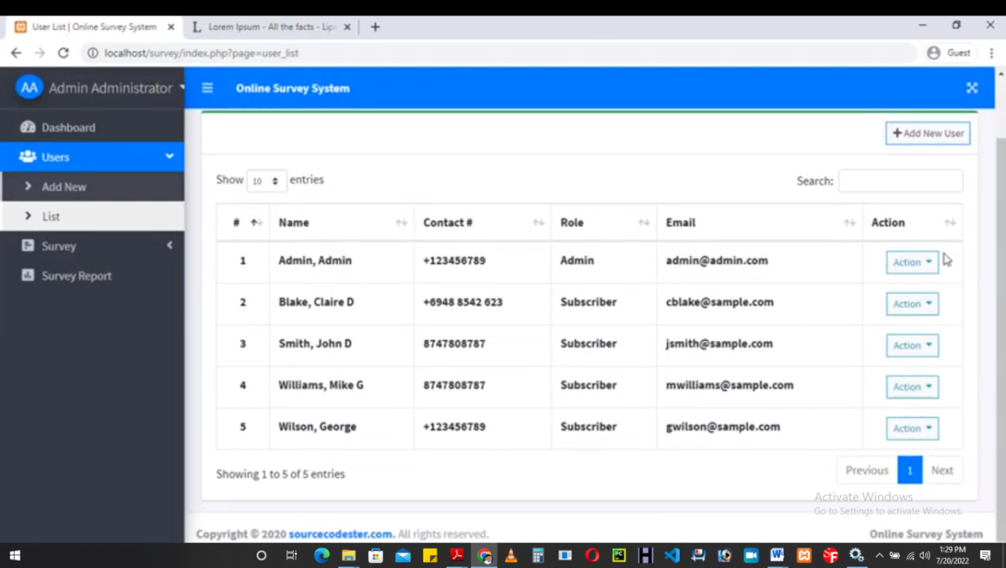
Fig 4.2: Users Page
This is where all users on the system are displayed
4.1.2 Input design
Input design refers to the format or the design of the input format on the screen. Inputs are necessary information needed for processing so as to produce the expected output of which are supplied through the keyboard. The input to the proposed system is shown below.

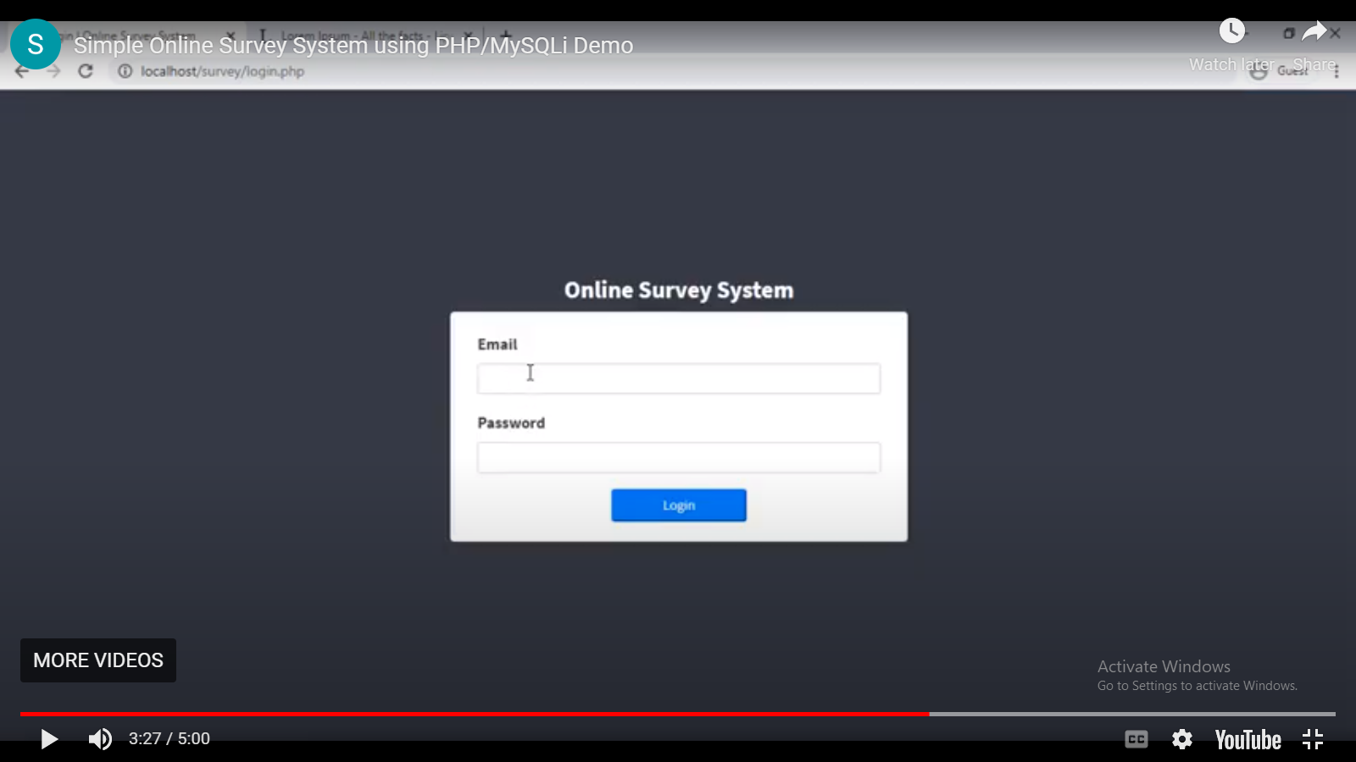
Fig 4.3: Admin and User Login Page
This is where the admin and users input their respective username and password

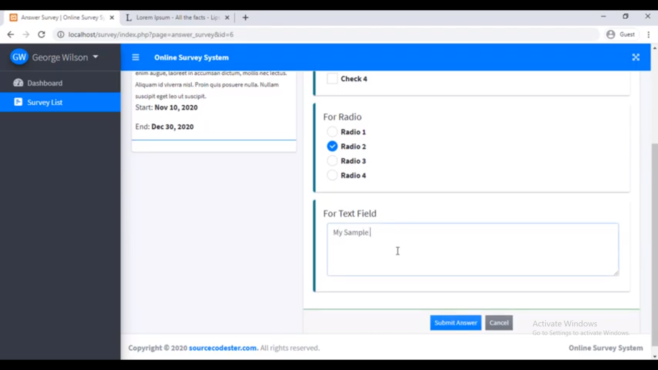
Fig 4.4: Survey input Area
This is where users input their respective survey questions set by the admin
4.1.3 Database design
The structure and organization of records in the tables in a database file is essential to be considered in designing a database driven application. The database files main record where house for keeping data and information relevant for this application.
The creation of the database is done using MySQL and file is named “survey_db”. It contains number of tables named as follows:
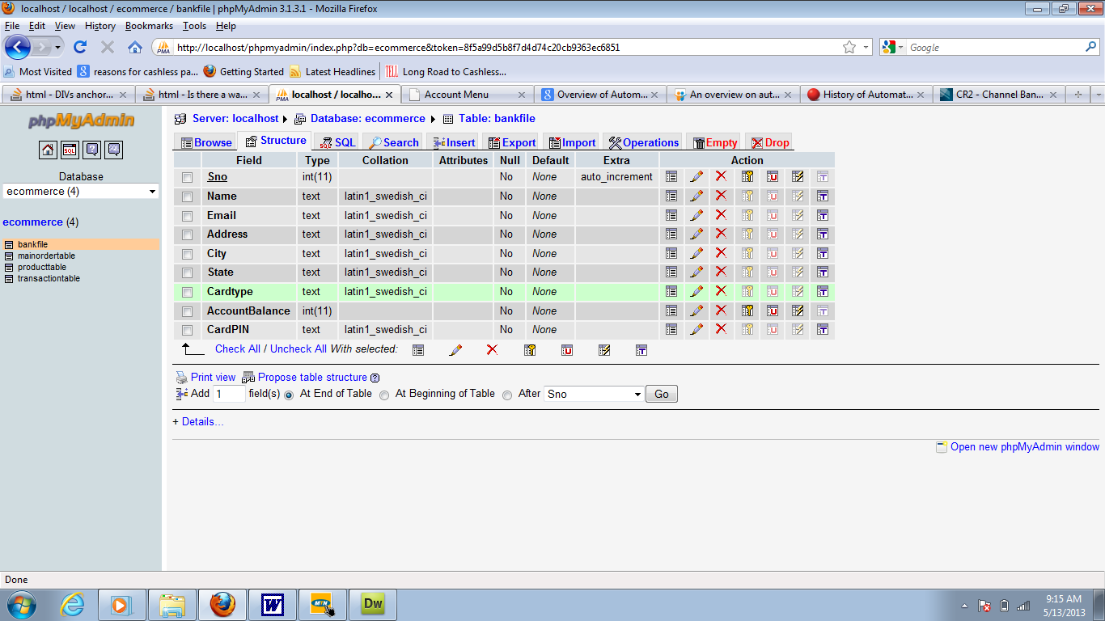
Fig 4.5: Users Table
This is the user’s database table
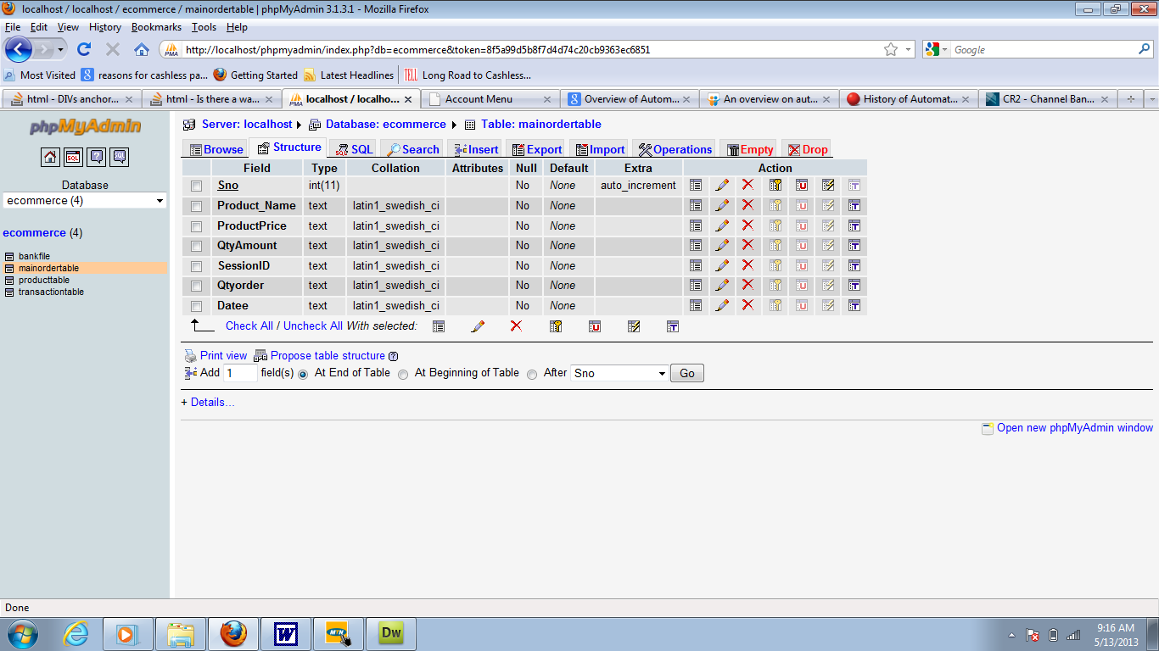
4.7: Survey Table
This is the survey database table
4.1.4 Procedure Design
This refers to the step by step method of using the proposed system. The proposed system comprises of the Login screen, Question screen, Logout screen etc.
4.2 System Implementation
This section presents the implementation of the different modules of the CBTS and the testing of these modules to ensure that they function in accordance with the Computer Based Testing System (CBTS) requirements.
4.2.1 Choice of Programming Language
The programming language used is PHP. PHP is a server side scripting that is used to develop static websites or dynamic websites or web applications. PHP stands for Hypertext Pre-processor, that earlier stood for Personal Home Pages.
PHP can only be interpreted on a server that has PHP installed. The client computer accessing the PHP scripts requires a web browser only.
Some features of PHP are:
- PHP is a server side scripting language (i.e you only need to install it on the server and client computers requesting for resources from the server do not need to have PHP installed; only a web browser would be enough).
- PHP has in-built support for working hand in hand with MySQL.
- PHP is easy to learn and runs efficiently on the server side.
- PHP runs on various platforms (Windows, Linux, Unix, Mac OS X, etc).
- Most web hosting servers support by default unlike other languages.
- PHP is regular updated to keep abreast with the latest technology trends.
4.2.2 Hardware support
The software application designed needed the following hardware for effective operation of the newly designed system:
i. Core 2 duo and above system with a processor speed of 500MHz.
ii. The Random-Access Memory (RAM) should be at least 500MB
iii. Enhanced Keyboard and Mouse.
iv. At least 80GB Hard Disk.
v. VGA or SVGA colored monitor to be able to achieve the effective user friendliness of the program
vi. An Uninterruptible Power Supply (UPS) Units
vii. Voltage Stabilizer: This facilitates the regulation of voltage needed by the computer system in order to avoid electrical damage of the system.
4.2.3 Software support
The software requirements for this system include:
i. A Windows 7, 8, or 10 Operating System.
ii. Structured Query Language (MySQL)
iii. PHP
iv. HTML
v. Apache server
4.2.4 Implementation techniques
The implementation is the process of putting theories into practice i.e all the system design being written are put to test and properly handed over. The language used for implementing this system is “PHP” and “MySQL” for the database for easy understanding, accessibility and efficiency in data management.
4.3 System documentation
4.3.1 Program documentation
Documentation is very important in the development of any software application. This is because documentation makes the software application easier to all users, and if an application is not well documented, it becomes difficult to use.

4.3.2 Operating the system
The program is packaged in a deployable package for easy installation on the server system. The program is started on the server system and accessed on the client system using the web browser.
Launch the web browser (i.e Google Chrome). At the start of the web browser, input the localhost URL and wait for the page to load which takes between 2-5 seconds (depending on the system speed) before the login form displays. The login form has spaces for the entry of username and password. The system accepts the user inputs, validates them and authenticates the user. Access is granted if the username and password match the correct specification and access is denied if otherwise.
The granting of user access displays the survey page which allows the respective users to answer out survey questions displayed and submit when done.

4.3.3 Maintaining the system
This is the act of effecting minor changes and corrections to an operational system to meet the requirements that arise in the normal course of events.
The task involved are essentially the summary of the functions defined in the system development and must be accomplished in accordance with the procedures for authorizing changes, making changes to the system and retesting it before the changed system is permanently put into full operations.
Any changes to the system must be properly documented for future referencing, in case there might be any problem arising from the changes. Moreover, the changes must be subject to approval of the administrator of the system.

CHAPTER FIVE
CONCLUSION AND RECOMMENDATIONS
5.1 Summary
Marketing concentrates primarily on the buyers, or consumers. After determining the customers’ needs and desires, marketers develop strategies that are designed to educate customers about a product’s most important features, persuade them to buy it, and then to enhance their satisfaction with the purchase. Where marketing once stopped with the sale, today businesses believe that it is more profitable to sell to existing customers than to new ones. As a result, marketing now also involves finding ways to turn one-time purchasers into lifelong customers. Marketing includes planning, organizing, directing, and controlling the decision-making regarding product lines, pricing, promotion, and servicing. In most of these areas marketing has overall authority; in others, as in product-line development, its function is primarily advisory. The project target on solving the problem of inefficiency and lack of effectiveness in focus group and individual market research or survey methods by developing a windows based application that uses qualitative (also called subjective or judgmental) survey techniques to report consumers behavior or reaction towards particular product(s) and/or service(s) of company over a reasonable period of time. The project is aimed at developing an application package for reporting and evaluating market survey to enhance company status in a competitive marketing and provides important information to identify and analyze the market size, consumer’s behaviour and periodic sales evaluation.
5.2 Conclusion
While initial forays were fraught with technical difficulties and methodological hurdles, recent developments have begun to expose the medium’s immense potential. The earliest online tools offered little more than the ability to deploy paper-based questionnaires to internet users. Today, tools and services are available with a wide range of feature sets at a wide range of price points. One or more of them are almost certain to meet the needs of any marketing research professional.

5.3 Recommendation
This research work works almost in every business to get new user’s or customer’s interest in a business. This research work should further be investigated to find out which tools will fit in for future market survey.

REFERENCES

Cobanoglu, P. (2013). Survey Methodology. Hoboken New Jersey: John Wiley & Sons, Inc.
Edwards, P. (2010). Questionnaires in clinical trials: guidelines for optimal design and administration. Trials 11: 2.
Evans, M., Jamal, A., & Foxall, G. (2020). Consumer Behaviour. Wiley.
Evans, S. (2015) Designing and Conducting Health Surveys. Hoboken (New Jersey): John Wiley & Sons, Inc.
Joel, T., & Anil, R. (2021). The Value of Online Surveys. Journal of Digital Research Methods, 18(2), 45–67.
Magen, H., & Roy, D. (2020). Traditional Survey and Questionnaire Platforms. In R. K. Silverman (Ed.), Modern Methods in Social Research (pp. 102–120). Academic Press.
Marko, S. (2020). A Concise Guide to Market Research: The Process, Data, and Methods Using IBM SPSS Statistics. Springer.
Van, et al. (2015) Design and use of questionnaires: a review of best practice applicable to surveys of health service staff and patients. Health Technol Assess 5: 1–256.
Van, R. (2020). Principles of Marketing Management. McGraw-Hill Education.
Wright, A. (2015) The EQUATOR Network and reporting guidelines: Helping to achieve high standards in reporting health research studies. Maturitas 63: 4–6.
Wright, R. (2019). Marketing Research: An Integrated Approach. Pearson Education.

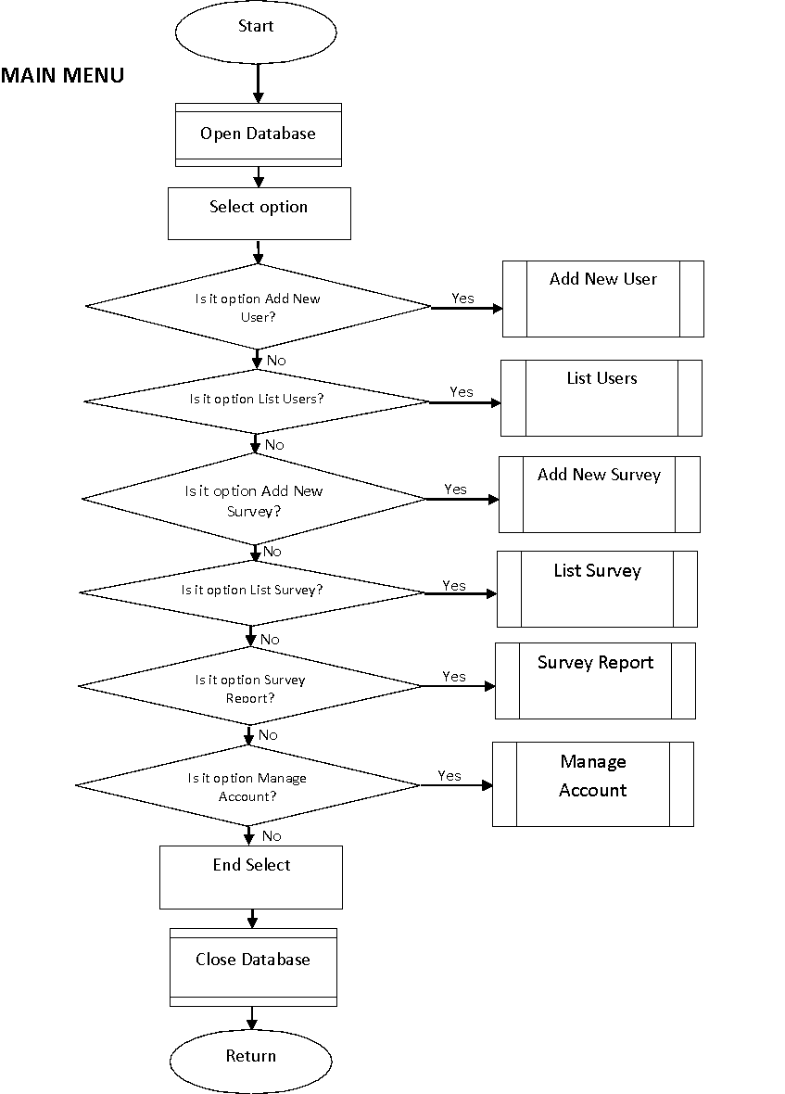

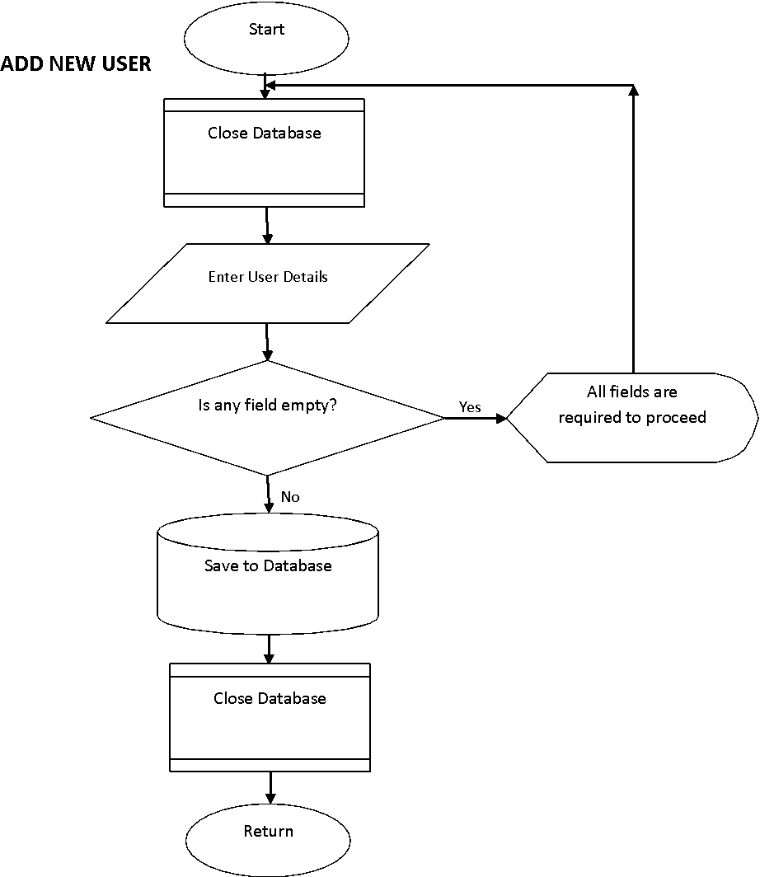

ADD SURVEY

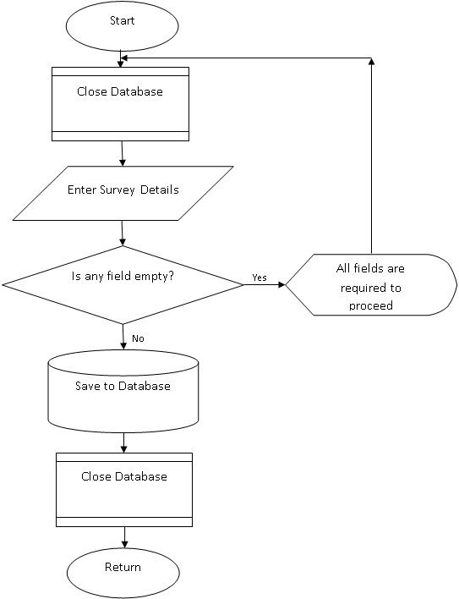

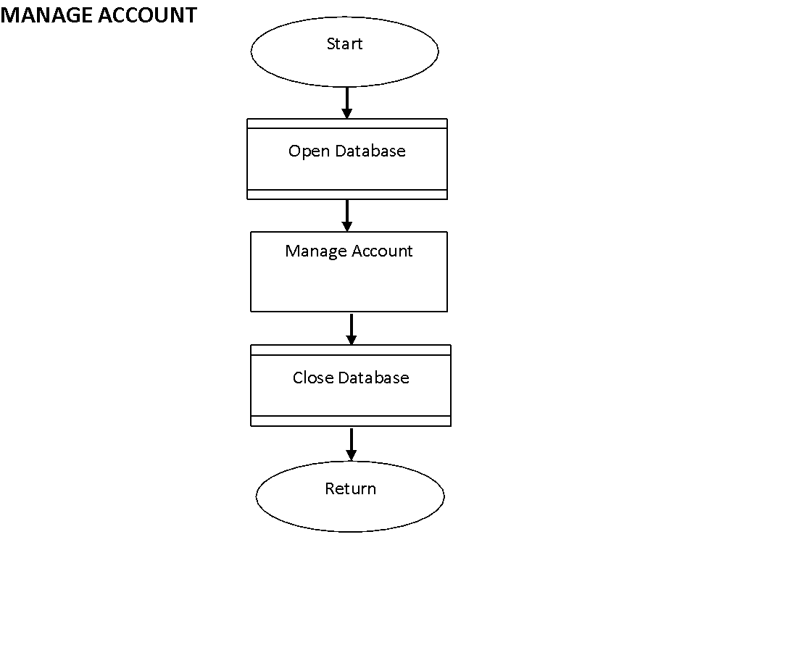

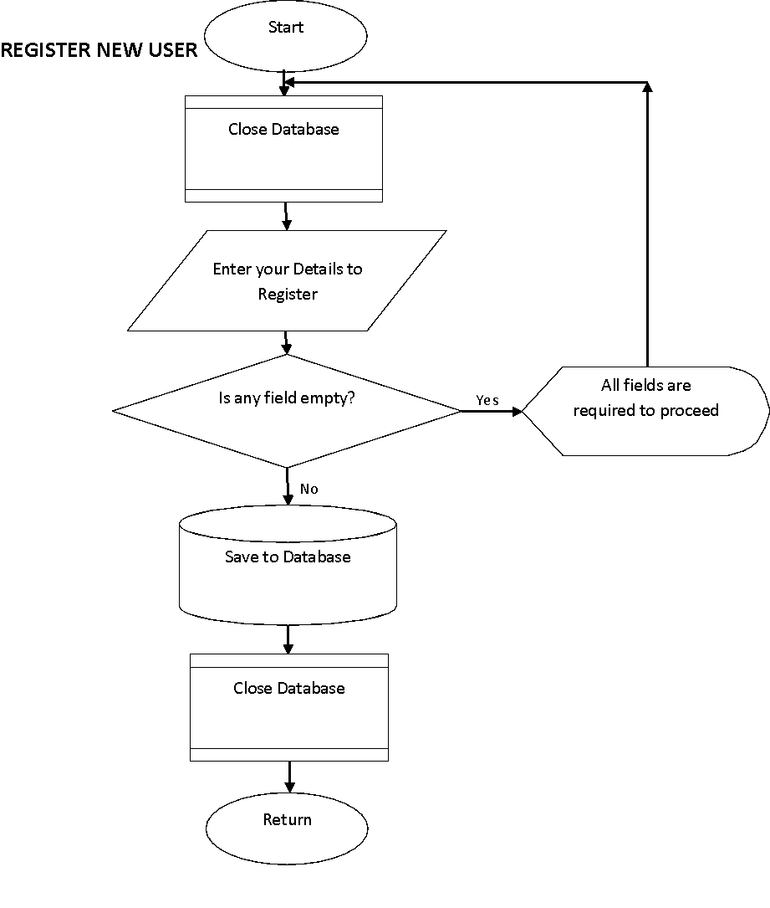

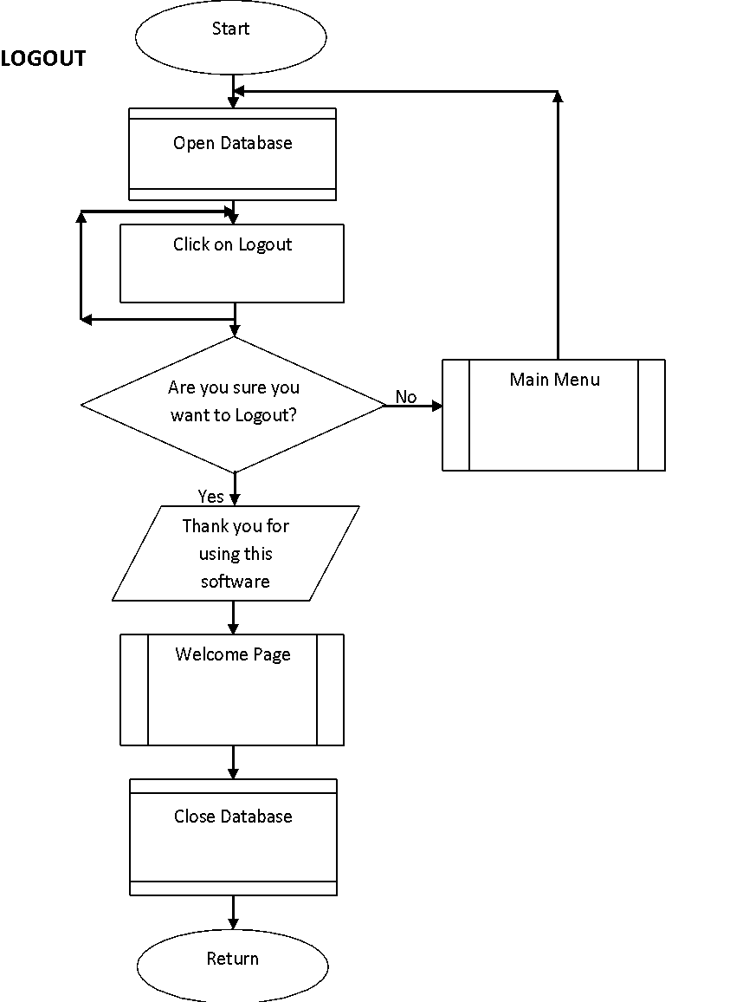

SOURCE CODE
<?php
session_start();
ini_set('display_errors', 1);
Class Action {
private $db;
public function __construct() {
ob_start();
include 'db_connect.php';
$this->db = $conn;
}
function __destruct() {
$this->db->close();
ob_end_flush();
}
function login(){
extract($_POST);
$qry = $this->db->query("SELECT *,concat(lastname,', ',firstname,' ',middlename) as name FROM users where email = '".$email."' and password = '".md5($password)."' ");
if($qry->num_rows > 0){
foreach ($qry->fetch_array() as $key => $value) {
if($key != 'password' && !is_numeric($key))
$_SESSION['login_'.$key] = $value;
}
return 1;
}else{
return 3;
}
}
function logout(){
session_destroy();
foreach ($_SESSION as $key => $value) {
unset($_SESSION[$key]);
}
header("location:login.php");
}
function save_user(){
extract($_POST);
$data = "";
foreach($_POST as $k => $v){
if(!in_array($k, array('id','cpass')) && !is_numeric($k)){
if($k =='password')
$v = md5($v);
if(empty($data)){
$data .= " $k='$v' ";
}else{
$data .= ", $k='$v' ";
}
}
}
$check = $this->db->query("SELECT * FROM users where email ='$email' ".(!empty($id) ? " and id != {$id} " : ''))->num_rows;
if($check > 0){
return 2;
exit;
}
if(empty($id)){
$save = $this->db->query("INSERT INTO users set $data");
}else{
$save = $this->db->query("UPDATE users set $data where id = $id");
}
if($save){
return 1;
}
}
function update_user(){
extract($_POST);
$data = "";
foreach($_POST as $k => $v){
if(!in_array($k, array('id','cpass','table')) && !is_numeric($k)){
if($k =='password')
$v = md5($v);
if(empty($data)){
$data .= " $k='$v' ";
}else{
$data .= ", $k='$v' ";
}
}
}
$check = $this->db->query("SELECT * FROM users where email ='$email' ".(!empty($id) ? " and id != {$id} " : ''))->num_rows;
if($check > 0){
return 2;
exit;
}
if(empty($id)){
$save = $this->db->query("INSERT INTO users set $data");
}else{
$save = $this->db->query("UPDATE users set $data where id = $id");
}

if($save){
foreach ($_POST as $key => $value) {
if($key != 'password' && !is_numeric($key))
$_SESSION['login_'.$key] = $value;
}
return 1;
}
}
function delete_user(){
extract($_POST);
$delete = $this->db->query("DELETE FROM users where id = ".$id);
if($delete)
return 1;
}
function save_page_img(){
extract($_POST);
if($_FILES['img']['tmp_name'] != ''){
$fname = strtotime(date('y-m-d H:i')).'_'.$_FILES['img']['name'];
$move = move_uploaded_file($_FILES['img']['tmp_name'],'assets/uploads/'. $fname);
if($move){
$protocol = strtolower(substr($_SERVER["SERVER_PROTOCOL"],0,5))=='https'?'https':'http';
$hostName = $_SERVER['HTTP_HOST'];
$path =explode('/',$_SERVER['PHP_SELF']);
$currentPath = '/'.$path[1];
// $pathInfo = pathinfo($currentPath);
return json_encode(array('link'=>$protocol.'://'.$hostName.$currentPath.'/admin/assets/uploads/'.$fname));

}
}
}
function save_survey(){
extract($_POST);
$data = "";
foreach($_POST as $k => $v){
if(!in_array($k, array('id')) && !is_numeric($k)){
if(empty($data)){
$data .= " $k='$v' ";
}else{
$data .= ", $k='$v' ";
}
}
}
if(empty($id)){
$save = $this->db->query("INSERT INTO survey_set set $data");
}else{
$save = $this->db->query("UPDATE survey_set set $data where id = $id");
}

if($save)
return 1;
}
function delete_survey(){
extract($_POST);
$delete = $this->db->query("DELETE FROM survey_set where id = ".$id);
if($delete){
return 1;
}
}
function save_question(){
extract($_POST);
$data = " survey_id=$sid ";
$data .= ", question='$question' ";
$data .= ", type='$type' ";
if($type != 'textfield_s'){
$arr = array();
foreach ($label as $k => $v) {
$i = 0 ;
while($i == 0){
$k = substr(str_shuffle(str_repeat($x='abcdefghijklmnopqrstuvwxyzABCDEFGHIJKLMNOPQRSTUVWXYZ', ceil(5/strlen($x)) )),1,5);
if(!isset($arr[$k]))
$i = 1;
}
$arr[$k] = $v;
}
$data .= ", frm_option='".json_encode($arr)."' ";
}else{
$data .= ", frm_option='' ";
}
if(empty($id)){
$save = $this->db->query("INSERT INTO questions set $data");
}else{
$save = $this->db->query("UPDATE questions set $data where id = $id");
}
if($save)
return 1;
}
function delete_question(){
extract($_POST);
$delete = $this->db->query("DELETE FROM questions where id = ".$id);
if($delete){
return 1;
}
}
function action_update_qsort(){
extract($_POST);
$i = 0;
foreach($qid as $k => $v){
$i++;
$update[] = $this->db->query("UPDATE questions set order_by = $i where id = $v");
}
if(isset($update))
return 1;
}
function save_answer(){
extract($_POST);
foreach($qid as $k => $v){
$data = " survey_id=$survey_id ";
$data .= ", question_id='$qid[$k]' ";
$data .= ", user_id='{$_SESSION['login_id']}' ";
if($type[$k] == 'check_opt'){
$data .= ", answer='[".implode("],[",$answer[$k])."]' ";
}else{
$data .= ", answer='$answer[$k]' ";
}
$save[] = $this->db->query("INSERT INTO answers set $data");
}
if(isset($save))
return 1;
}
function delete_comment(){
extract($_POST);
$delete = $this->db->query("DELETE FROM comments where id = ".$id);
if($delete){
return 1;
}
}
}

