IMPACT OF CUSTOMERS’ REWARD PROGRAMS ONCUSTOMERS’ LOYALTY IN RETAIL BUSINESS
(A CASE STUDY OF GOMOLA SUPERMARKET, ILORIN KWARA STATE)

BY:

RASAQ BARAKAT OYINDAMOLA

ND/23/BAM/PT/0230

BEING A RESEARCH PROJECT SUBMITTED TO DEPARTMENT BUSINESS ADMINISTRATION AND MANAGEMENT, INSTITUTE OF FINANCE AND MANAGEMENT STUDIES (IFMS) KWARA STATE POLYTECHNIC ILORIN.
IN PARTIAL FULFILMENT OF THE REQUIREMENT FOR THE AWARD OF NATIONAL DIPLOMA (ND) IN BUSINESS ADMINISTRATION AND MANAGEMENT.

JULY, 2025
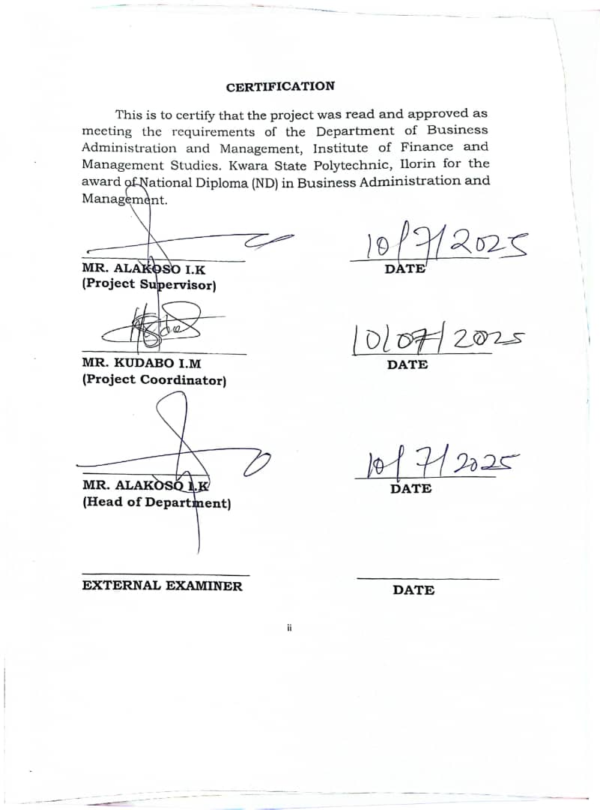
DEDICATION
This project is wholeheartedly dedicated my parents.

ACKNOWLEDGEMENT
My profound gratitude goes to Almighty ALLAH the most gracious, the most merciful for keeping and preserving his promises and covenant concerning my life till the end of this project work and for giving me the power and strength for going through these course successfully.
My special thanks goes to my supervisor Mr. Alakoso,i.k for her simplicity and support inspite of the rigour, also great support of whose unfailing advise and guide has proved successful.
My sincere appreciation goes to my beloved parents Mr and Mrs Rasaq, am forever indebted to them for their support financially, morally even with prayer. I pray onto Almighty ALLAH to make paradise your final aboard.

TABLE OF CONTENTS
Title page | i
Certification | ii
Dedication | iii
Acknowledgement | iv
Table of Contents | v
Abstract  CHAPTER ONE: INTRODUCTION | viii
1.0 Introduction | 1
1.1 Background to the Study | 1
1.2 Statement of the Problem | 3
1.3 Research Question | 5
1.4 Research Objectives | 5
1.5 Research Hypotheses | 5
1.6 Significance of the Study | 5
1.7 Scope of the Study | 6
1.8 Definition of Terms | 6
1.9 Plan of the Study  CHAPTER TWO: LITERATURE REVIEW | 6
2.0 Introduction | 8
2.1 Conceptual Clarification | 8
2.1.1 Concept of customer Reward Programs | 8
2.1.2 Types of Customer Reward Programs | 8
2.1.3 Types of Customer Reward Users | 11
2.1.4 Benefits of Customer Reward Programs | 12
2.1.5 Objectives of Customer Reward Programs | 13
2.1.6 Concept of Customer Loyalty | 14
2.1.7 Characteristics of Customer Reward Programs | 15
2.1.8 Dimension of Customer Reward Programs | 16
2.1.9 Stages of Customer Reward Programs | 17
2.1.10 Benefits of Customer Loyalty | 22
2.1.11 Bases of Customer Loyalty | 23
2.1.12 Factors Influencing Customer | 25
2.2 Theoretical Review | 28
2.2.1 Instant Gratification Theory | 28
2.2.2 Expectancy Theory | 29
2.3 Empirical Review  CHAPTER THREE: RESEARCH METHODOLOGY | 30
3.0 Introduction | 33
3.1 Research Design | 33
3.2 Population of the Study | 33
3.3 Sample Size and Sampling Technique | 33
3.4 Method of Data Collection | 34
3.5 Method of Data Analysis | 35
3.6 Historical Background | 35
CHAPTER FOUR: DATA PRESENTATION, ANALYSIS AND INTERPRETATION
4.0 Introduction | 36
4.1 Data presentation | 36
4.2 Presentation of Statistical data | 41
4.3 Test of Hypotheses | 47
4.4 Discussion of Findings | 50
CHAPTER FIVE: SUMMARY, CONCLUSION AND RECOMMENDATIONS
5.0 Introduction | 51
5.1 Summary | 51
5.2 Conclusion | 51
5.3 Recommendations | 52
References | 53

ABSTRACT
The problem that prompts the conduct of this research is the need to examine the effectiveness of customer reward programs in enhancing customer loyalty. The goal of this study is to obtain a deep understanding of the impact of customer reward programs on customer loyalty. The study was applied to Danco supermarket in Ilorin, Kwara State. The study examines the impact of independent variable; point system, price discount and non-monetary program on the dependent variable; customer loyalty. 80 questionnaires were distributed randomly to Danco supermarket customers and regression and correlation statistical tools were used to analyse the gathered data. The findings reveal that there is a significant impact of all the customer reward programs in enhancing and maintaining customer loyalty except point system. Organizations are recommended to adopt customer reward programs that will reflect the customer’s shopping preferences and values, in order to keep them loyal to the business and create a life time customer.

CHAPTER ONE
INTRODUCTION
1.1 Background to the Study
It is generally well known that customer reward programs often refer to as loyalty programs are valuable communication tools that promote positive behaviour of existing customers, and may later attract new ones. It is a way of businesses to gain a trust of customers and brand value. The reward programs collect and analyse customers’ preference and shopping priorities, identify and reward the best customers, along with choosing the appropriate communication methods (Clark, 2010).
Customer reward programs offer rewards, discounts and other special incentives, so it is a way to attract and retain customer. It encourages repeated purchase and brand loyalty (Clark, 2010). According to marketing literature, reward programs increase customer retention while increasing loyalty. Marketing literature has distinguished among many types of reward programs. Immediate rewards include financial benefit such as discount and promotional offers, while deferred benefits include non-cash reward such as vouchers and coupons (Mai, Nguyen & Nguyen, 2021).
The first usage of loyalty programs in business was many years ago originally in Germany, where price competition was disallowed by government. In 1981 was the first launched of loyalty programs by American Airlines and quickly used by other airlines and hotels, car rental companies, credit card organizations and retailers. As reported in the New York Times, Forrester Research found that across 12 industries, retailers are the most loyalty while others, like TV service providers and internet service providers proved more unsteady. Retail loyalty programs are offering points, rebates, discounts or combinations of them (Lewis, 2004).
Loyalty programs are considered part of a comprehensive customer relationship strategy. Loyalty programs are not only a tool to increase the organization’s loyal customers, but they are an opportunity to gather information about customer shopping habits and preferences. This information helps in customizing the organization’s services. Retailers recognized that without “customer database”, they were unable to identify the best customers and reward them for their preferable behaviour. The Loyalty Marketer's Association opined that due to the fact, that not all customers are potentially loyal customers, the ideal loyalty program would benefit only loyal and potential loyal customers. This means that the customers have first sorted into groups, and then to be approached in different ways. Customer loyalty programs should increase customer happiness and retention.
Loyalty induced positive attitude and behaviour such as repetitive support and purchases, and positive recommendation which influence other present and potential customers. Customer loyalty is vital to business performance as a loyal customer will generate a stable profit, balanced cash flow and enhanced company revenue’s (Aaker, 1991). According to Duffy (1998), companies in most industries are studying, evaluating or implementing customer reward strategies and programs aimed at cultivating strong relationships with their best customers. A loyal customer is an important asset for organization especially when it decreases the need to seek new customers. In fact, it is an indication that the company products and services are meeting the needs of customers and expectations (Rowley & Dawes, 1999).
According to Bowen and Chen (2001), it is commonly known that there is a positive relationship between customer loyalty and profitability. It is found that when a company retains just 5 percent more of its customers, profits increase by 25 percent to 125 percent (Bowen & Chen, 2001). According to Ndubisi (2004), there are more and more companies investing on retaining customer- firm relationships. Therefore, improving customer’s loyalty is an important task for business managers.
Customer loyalty is very important for the companies in the recent market environment. For the companies, customers are the core assets and companies can gain added value from customers only if they pay sufficient attention on customers (Rowley, 2005). The benefits of this are mutual and both companies and customers can be rewarded. From the perspective of companies, first, developing customer relationships bring companies’ invaluable resource. Second, it makes companies get more useful information about customers (Ndubisi, 2007). From another perspective of customers, first, loyal customers can help to reduce companies’ cost, for example the marketing cost and operational costs, etc. Second, customer can serve as a part-time employee who can offer her or his friends and relatives’ information about products. Customer loyalty have significant impact on companies’ development. Modern business environment is characterized with more intense competitions and companies are forced to build strong relationships with their customers to reach more profits (Ndubisi, 2007).
Customer loyalty is an important issue for the success of any retail organization, because it is known that drawing new customer is more expensive than keeping existing ones (Singh & Imran, 2012). Singh and Imran (2012) estimate that an average online retailer loses 25% of their customer every year, and a small increase in customer loyalty can increase profit by 25%. Relationship marketing aims to create life time customers because when customers have a relationship with a company, they are ready to forget any other competitors offer. Customers are motivated to do that because it gives them a greater efficiency in decision making, reduces the information processing, achieves a greater cognitive consistency in decisions, and reduces the perceived risks associated with future decisions (Singh & Imran 2012).
Takuma and mersini (2015), explained customer loyalty by two ways; behavioural and emotional. In behavioural loyalty the customer regularly and repeated purchase from the same seller or business organization and emotional loyalty is the outcome of a psychosomatic linking with the service or product relating to preference and component like encouraging attitude and commitment.
1.2 Statement of the Problem
In the rural business area, many retail outlets have overlooked the relevance of implementing customer reward programs as a tool to attract new customers and retain existing ones. On the other hand, in the developed cities where there is high competition between and among business firms, retailers offer several types of reward programs to increase sales of products, maintain standard market share and make reasonable profit necessary for the survival of the business firm.
Due to the rapid increase in competition in urban cities retail market, retailers offer several types of reward programs to increase sales of products through customer repurchase over a period of time. Jain and Singhal (2012) concluded that in spite of the predominant use of reward programs, there is inadequate affirmation on the long-standing effects of these programs and their efficiency is not well recognized.
Despite the wide spread of reward programs in modern market, there is little empirical research that focuses on the measurement of influence of these programs on customer retention. The key to measuring the influence of reward programs is that they work as dynamic incentive tool relying on providing benefits based on cumulative purchasing over time. Reward programs encourage consumers to shift from single-period purchasing decision to multiple-period purchasing decision. (Sima & Elham, 2015)
While many companies carried out customer reward programs, fewer than half of these are active. Key reasons for that are that the reward programs include lack of reward relevance, rigid reward structures, and poor-quality customer service. However, reward programs need to be designed with more targeted rewards, differ according to different groups of members based on their value, and they need to provide greater value at higher customer value tiers, by rewarding best customers to encourage higher spending levels. In order to do that the organization needs to understand their customer’s needs and behaviours, by creating customer profiles with relevant data on customer interactions to have a complete picture of a customer’s preferences. (Ray Shaw, 2015)
Previous studies had laid emphases on the activeness of customer reward programs and effectiveness of these programs in retaining customer. This study will examine the effectiveness of customer reward programs in enhancing customer loyalty.

1.3 Research Questions
This study is an attempt to investigate the impact of customer reward programs on customer loyalty. In the course of doing so, the following research questions will be addressed:
- Does point system have impact on customer retention?
- What is the impact of after sales service on customer loyalty?
iii. What is the impact of discount price program on customer repurchase?
1.4 Research Objectives
The general objective of this study is to examine the impact of customer reward programs on customer loyalty. In order to attain this objective, the research will address the following sub-objectives:
- To evaluate the impact of point system on customer retention.
ii. To analyze the impact of after sales service on customer loyalty.
iii. To assess the impact of discount price program on customer repurchase.
1.5 Research Hypotheses
In the course of this research effort, the following hypotheses will be tested:
H0₁: Point system have impact on customer retention.
H0₂: There is significant impact of after sales service on customer loyalty.
H0₃: There is significant impact of discount price program on customer repurchase.

1.6 Significance of the Study
This research is design to investigate the impact of customer reward programs on customer loyalty. The research will serve as a tool to clarify the role of customer reward programs and their impact on customer loyalty. It will also look into the most important impact of reward programs that affect customer loyalty and make recommendation about the most effective. This type of research will help to provide the proper recommendation for organizations and also serve as specialized scientific addition in the field of studying customer loyalty. 1.7 Scope of the Study
This research concentrates on the impact of customer reward programs on customer loyalty in small scale supermarket with emphasis on Gomola supermarket in Ilorin, Kwara State as a case study. The research covers the period of 2020 to 2023.
1.8 Definition of Terms
The following terms and concepts are defined as used in this study:
Customer: A customer is an individual or business that purchase goods and services from business organization.
Reward Programs: These are programs designed to increase customer engagement and purchases in exchange for discounts and other benefits.
Customer Loyalty: Customer loyalty describes an ongoing relationship between a company and their customer in which the customer is willing to repeatedly return to the company to conduct business.
1.9 Plan of the Study
Chapter one: The chapter will cover the introduction section of the study which will provide a brief overview of the topic ‘impact of customer reward programs on customer loyalty’. It will addresses the problem of the research, research questions, objective of the research study, hypotheses of the research, significance of the study, definition of key terms and plan of the study.
Chapter two: The chapter will cover literature review section of the study. It will dwell on the relevant past and present work on customer reward programs and customer loyalty. It also include identification and description of conceptual framework, theoretical framework and empirical review(theories, principles, generalization and research findings that are close related to customer reward programs and customer loyalty).
Chapter three: The chapter focuses on the processes and procedures used in gathering and analyzing data. The areas to be covered include research design, population of the study, sample size and sampling technique, method of data collection, method of data analysis and historical background of the case study.
Chapter four: In this chapter, data collected in the previous section will be presented, analyzed and interpreted. Hypotheses of the study will be tested and discussion of the findings will be presented.
Chapter five: This section of the research work will centered on summary of the research work, conclusion of the findings and recommendation will be made on the impact of customer reward programs on customer loyalty in small scale enterprises.

CHAPTER TWO
LITERATURE REVIEW
2.0 Introduction
This chapter dwells on the relevant previous and present work on customer reward programs and customer loyalty. It involves the identification and description of theories, principles, generalizations and research findings that are closely related to the study.
2.1 Conceptual Clarification
2.1.1 Concept of Customer Reward Program
A customer reward program, also known as customer loyalty program, is a strategy that helps retain customers and encourages them to continue purchasing from a company. Loyalty/reward programs are structured marketing efforts that reward, and therefore encourage, loyal buying behavior, which is potentially beneficial to the firm (Sharp & Sharp, 1997). The rewards programs are offered by a company to customers who frequently make purchases. A loyalty program may give a customer advanced access to new products, special sales coupons or free merchandise. Customers typically register their personal information with the company.
According to Wijaya (2008), customer reward program is a program offered to the customers to build an emotional bond to the company or the brand of company. Peiguss (2012), views loyalty programs as an incentive by providing benefits based on cumulative purchasing over time. Loyalty programs encourage consumers to shift from myopic or single-period decision making to dynamic or multiple-period decision making. These programs encourage repeat buying and improve retention rates by providing incentives for customers to purchase more frequently and in larger volumes.
Loyalty program is a technique of growing and maintaining the existing customers and supporting the rebuying through the incentive scheme (Doyle, 2013). Also, Rebecca (2019) assert that customer loyalty program is a marketing approach that recognizes and rewards customers who purchase or engage with the brand on a recurring basis. Customer reward program has been defined as a program run by a company that offers benefits to frequent customer. Those benefits may be in the form of discounts, rebates, free products, or other promotion. An effective customer reward program rewards customer who buy from the business on a regular basis, encouraging the customer to return frequently (Tara, 2022).
A loyalty program is a strategy in which a company provides its customer with rewards and discounts for being loyal. Its helps businesses retain existing customers and increase product sales (pulse, 2023).
2.1.2 Types of Customer Reward Programs
Organizations have rewarded the loyalty of preferred customers by enhanced services or price discounts. Recently, loyalty rewards programs have become applicable in several sectors businesses. Loyalty programs are structured marketing efforts that reward, and encourage loyal buying behavior which is potentially beneficial to the company. Specifically in retailing marketing it includes: point-based reward programs, tiered reward programs, paid reward programs etc.
- Points system: This is the most common type of reward program. Frequent customers earn points, which translate into some type of reward: discount, gifts, or special customer treatment, customer purchases toward a certain amount of points to redeem their reward. Reward programs based on service usage levels (frequent buyer programs) have become common in the transportation and hospitality industries. This type of loyalty program is most appropriate for businesses that encourage frequent, short-term purchases. Sephora’s Beauty Insider rewards program is a widely popular example of point reward system where customers earn reward based on a traditional point system.
- Tier reward system: This type of reward programs offer small rewards as a base offering for being a part of the program, and encourage repeated customers by increasing the value of the rewards as the customer moves up the loyalty ladder. The difference between points and tiered systems is that customers extract shortterm versus long-term value from the loyalty program. Tiered programs may work better for high commitment, higher price-point businesses like airlines, hospitality businesses, or insurance companies.
- Charge an upfront fee for VIP benefits: Charge one-time (or annual) customers to start collecting points by their purchases. Clearly this system is most applicable to businesses that thrive on frequent, repeat purchases. For an upfront fee, the customers are relieved of inconveniences that could impede future purchases. Example of this type of reward program is Designer Shoe Warehouse. DSW has long run VIP loyalty program that rewards customers with points for each purchase.
- Non-monetary programs: This involve providing value to customers in other ways than discount and cash rewards. Depending on the customer’s values, and on the industry, customers may find more value in non-monetary over discounts or cash rewards.
- Frequent buyer programs: Retailers offer the low free service to the customers if the number of purchases or the total purchase amount reaches a specific limit. This creates the tendency in the customers to make those counts of purchases or the total purchase value in order to get the offer. It increases the sale of product leading to customer loyalty over a period of time.
- Loyalty card program is an incentive plan that allows a retail business to gather information about its customers. Customers are offered product discounts, coupons, points toward merchandise or some other reward in exchange for their voluntary participation in the program. Another goal of a loyalty card program is to build repeat business by offering participating customers something that is not available to non-participating customers.
- Gift card or Certificates: Retailers have introduced gift vouchers with specific amount and validity of their company. With this gift card it fastens unclear the buyer to go to the retailer who has issued the gift card and spend the amount.
With the available amount of the gift card customer will buy the goods more than the cost and increase in selling of goods. If one likes the store and the availability of goods, then customers become regular one.
- Partner with another company to provide all-inclusive offers: Understanding customers’ lifestyle and their purchase process will help determine which company is a good fit as a partner to reward the loyal customers. Providing customers with valued services beyond what the company can offer will grow the companies’ network to reach their partners’ and customers.
- Return policy for loyal customer: The retailer offers the extended return policy to the Loyal Customers. This provides confidence to the customers as return is always a major concern of many.
- Bundle goods: The seller sells various goods or services with the main item at no extra cost (Singh & Khan, 2012).
2.1.3 Types of Customer Reward Programs Users
There are four types of customers regarding their attitudes to use loyalty programs.
- Never: Never consumers are those who are not affected by loyalty programs and their reward incentives in any way. These set of customers are not influence at all by loyalty reward programs.
- Light consumers are having reward program memberships and being influenced by their incentives, but only moderately. These users are relatively affected by loyalty programs and their reward incentives.
- Heavy consumers are highly influenced members of reward programs. The users in the group are influence by loyalty reward incentive to a great extent.
- Extreme consumers are customers who are addicted to or obsessed with loyalty programs. They place an uttermost value to reward incentives and this influence their buying decision to a large extent.

2.1.4 Benefits of Customer Reward Programs
Researches from previous studies proved that, only 12% - 15% of customers are loyal to a single retailer. This small number of loyal customers generate between 55% - 70% of company sales. Some food retailers find that 65%-95% of their sales go to members of loyalty programs. 53% of food retailers offer loyalty programs, 75% of the loyalty programs members used their loyalty cards at least weekly and 25% at least used them once a month. The retail marketing literature demonstrates several benefits for loyalty programs for both businesses and consumers.
For businesses, loyalty programs are profitable because:
  - The costs of serving loyal customers are less.
  - Loyal customers are low price sensitive.
  - Loyal customers spend more with the company.
  - Loyal customers pass on positive recommendations about their favorite brands to their friends and relatives.
  - Loyalty programs provide the company with a wealth of consumer information. While companies can evaluate different purchases, the use of a loyalty program gives additional information about the type of products that may be purchased together, and whether certain coupons are more effective than others.
  - Retaining customers is less expensive than acquiring new ones, and customer experience management is the most cost-effective way to drive customer satisfaction, customer retention and customer loyalty.
  - Loyal customers are more likely to purchase more, with a high-margin of supplemental products and services.
  - Loyal customers reduce costs associated with consumer education and marketing.
Also, Peter (2010) addresses thirteen business benefits of a loyalty initiative:
  - Retain existing customers.
  - Acquire new customers.
  - Move customers’ up-segment.
  - Win-back defected & churned customers.
  - Increase customer lifetime value.
  - Build relationships.
  - Create brand advocates.
  - Adjust pricing levels.
  - Responding to competitive challenges.
  - Select stock lines effectively.
  - Plan merchandising more intelligently.
  - Reduce promotional and advertising costs.
  - Aid in selecting new trading sites.
2.1.5 Objectives Customer Reward Programs
Reinatz (2004) summarizes the objectives for using customer reward programs as the following:
- Building true attitudinal and behavioral loyalty.
- Efficiency profits.
- Effectiveness profits.
Loyalty programs aim to retain the existing customers and encourage their loyalty, but loyalty to each company's objectives vary according to the company. Loyalty programs are:
- To reward loyal customers.
- To collect information in order to know who are the best customers.
- To manipulate the behavior of buyers, the promotion applies to an individual in order to encourage customers to try new products.
- To respond to competitors' actions (Margarita, 2016).
He further divided loyalty programs objectives into two groups:
- The main objectives are to develop consumer loyalty, build communication capabilities, provide support to other company departments, etc.
- The secondary objectives are to solve problems of the company, keeping in touch with the public, create additional opportunities to retain customers, improve company brand and so on.
He continued in his research work to clarify the main tasks of loyalty programs. Loyalty programs are employed to perform several and distinctive task which include:
      - To develop and strengthen the existing customer loyalty. First of all, to develop customer loyalty, organizations must thus meet customers' needs and provide benefits to its customers, which they will not get from the competitors.
      - To attract new buyers. This can be done by offering attractive benefits to attract those customers who have heard good feedback from the other participants of the loyalty program.
      - Create a customer database. To collect not only demographic data about the customers, but also about the behavior of buyers.
      - Provide information and support other departments of the organization. The customer loyalty program is directed towards the communication between the organization departments or sections of the people.
      - Loyalty programs provide participants with the opportunity to communicate. *The program can serve as a means of creating a direct and regular communication between the organization and its customers.
      - Provide the buyer with the added value, as well as to increase trade or the sale of services.
      - To improve the brand's image.

2.1.6 The Concept of Customer loyalty
In Oliver’s (1999) book, customer loyalty is defined as a deeply held commitment to rebuy or patronize a preferred product/service consistently in the future, thereby causing repetitive same-brand or same brand-set purchasing, despite situational influences and marketing efforts having the potential to cause switching behaviour. Also, Bose and Rao (2011) opined that in the business context, loyalty is the customer’s commitment to do business with a particular organization which effects in repeat purchases of goods and services of that organization.
According to Bobâlcă (2013), Loyalty can be analyzed both from the perspective of a company and a consumer. Customer relationship management and direct marketing research center on strategies and activities that a company must initiate in order to retain its customer’s portfolio. There are academic papers that present the loyalty concept as a result of marketing efforts. Bobalca opined that the two perspectives must be analyzed as a whole and not as distinct parts of the same process. The strategies developed by both national and international companies must be sustained by depth knowledge of the dimensions and factors affecting loyalty and also of the consequences of loyalty.
Customer loyalty has been perceived to be a behavioural concept entailing repeat buying of product or service measured as the series or share of purchases, referrals, magnitude of relationship or all of the above mingled together (Rai & Medha, 2013).
A single defining concept of loyalty does not exist. However the common view of the scholars is repeat purchase and retention of customer. While other definitions ignore the fact that there can be situational factor influencing customer to switch purchase to competitors and breach retention, Oliver’s definition recognizes situational influences and marketing efforts having the potential to cause switching behaviour.
For each company it is important to have regular, loyal customers who buy goods repeatedly, disseminate positive information, and will not buy an alternative goods of competitors, so it is important to know which category includes the classification of one or another buyer. The company should be able to meet customers' needs, encourage greater loyalty, and entering into new programs, that are in compliance with loyal customer’s needs.
2.1.7 Characteristics of Loyal Customer
A loyal customer is a natural or legal person who purchases goods or services and is not inclined to buy from competitors (Dudonis, 2012). Pranulis and Pajuodis (2012), describe loyal customers as a constant preference for certain goods (brand loyalty) and stores (loyalty to the place of purchase). A customer can be refer to as a loyal customer if he or she:
  - for a long time remains loyal to the company
  - buys new products offered by the company
  - creates a positive image of the company, attracting your friends to buy the goods
  - is insensitive to the actions of competitors
  - less sensitive to price changes
  - tolerates errors made by the company
  - willingly provides information
  - willing to share his ideas on improving the products and services
The buyer does not have to meet all the criteria, it depends on the situation, but it is necessary to fit any number of criteria so that a buyer could be called loyal. Loyalty, a commitment, which can be both emotional and rational. Rational loyalty leads to loyalty programs, the gifts, coupons, prizes, which encourages the customer to buy the company's products. However, such loyalty lasts as much as loyalty program. Emotional loyalty forms the positive experience of the company. Thus, the positive experience of receiving customers remains loyal buyers.

    - Dimensions of Customer Loyalty
In Ball, Coelho and Machas (2004) article, there are two customer loyalty dimensions to be discussed, which are behavior loyalty and attitude loyalty. Behavior loyalty is defined as repeated transactions or percentage of total transactions and total expenditures. It can be simply measured with observation approach. In contrast, attitude loyalty is defined as positive affect for relationship and desire for retaining relationship continuance.
As mentioned above, behavior loyalty is repeated purchase. It can offer advantages for companies. First, research on behavior loyalty can show the customer preference for a brand or product. Second, behavior loyalty can reflect a customer’s purchase intention. Last, behavior loyalty can retain companies’ profit through increasing market shares (Chaudhuri and Holbrook, 2001). However, according to Ball and his partners (2004), the research that combine behavior loyalty and attitude loyalty is more useful for practical purposes. As Oliver (1999) states in his article, attitude loyalty reflects customer’s cognitive, affective, and co-native predispositions to continue relating to the brand or company. In this process often involve customer commitment. Therefore, according to Ball and his partners (2004), combining of behavior loyalty and attitude loyalty is powerful. It can influence first, customer’s intention to recommend the brand or company to others; second, the horizontal communication among customers and mouthto-mouth communication; third, customer’s resistance to competitors’ offerings and persuasive tactics to attract new customers and buzz marketing.
    - Stages of customer Loyalty
For a better implementation of a customer loyalty strategy, understanding the customer is also important. In the following part, the methods of customer classification will be introduced. Because customer classification can better help companies visualize, analyze, and improve the behavior and profitability of customers (Curry, 2000). According to Torres-Moraga, Vasquez-parraga and Zamora-gonzalez (2008), customer can be classified into three categories. The first is recent customers. They adopt the product that best fits their needs or best appeals to them emotionally and cognitively. The second is more experienced but not highly experience customers. They adopt a range of brands on the basis of both value and price. The last is some highly experienced customers. They become loyal to a brand.
Moreover in Curry’s (2000) book, they mention that customer can be classified into five categories. There are varieties of customer classifying methods that have been introduced during the past decades. Based on the research of these customer classifying methods, a basic customer pyramid is introduced.

FIGURE 1 BASIC CUSTOMER PYRAMID


Active
Customer

Inactive Customer

Prospects

Suspects

The rest of the word

Source: Curry, (2000). The customer marketing method: how to implement and profit from customer relationship management.
- The first part is active customers. It means persons or companies that have purchased goods or services from your company within a given period.
- The second part is inactive customer. It means persons or companies that have purchased goods or services from your company in the past but not within the given period.
- The third part is prospects customer. It means persons or companies with whom you have some kind of relationship-but they have not yet purchased any goods or service.
- The fourth part is suspects. It means persons or companies that you could be able to serve with your products and services, but you do not yet have a relationship with them.
- The last part is the rest of the world. It means persons or companies that simply have no need or desire to purchase or use your products and services.
As mentioned above, according to Curry (2000), customer is classified to five categories. In these five parts, the active customer is more important. Therefore, Curry (2000) further classifies it to four parts in the following Standard Customer Pyramid.
FIGURE 2: STANDARD CUSTOMER PYRAMID


Source:

Curry

(2000).

The

customer

marketing

method:

how

to

implement

and

profit

from

customer

relationship

management.

Top

Big

Medium

Small

- The first part is defined as the “Top” customer. It refers to the top 1% of your active customers.
- The second part is defined as the “Big” customer. It means the next 4% of your active customers.
- The third part is defined as the “Medium” customer. It refers to the next 15% of your active customers.
- The last part is defined as the “Small” customer. It means the remaining 80% of your active customers.
The author’s classifying base is customer behavior critical, for example the sales avenue. The classifying makes the pyramid to be more helpful in understanding and analyzing customer behavior.
However, another author, Bakanauskas and Pilenienė (2009) differentiate customer loyalty into seven stages.
FIGURE 3: CUSTOMER LOYALTY STAGES

Suspect

Potential Users

Suspended Potential Users

Customer

A customer buy a first time

Advocat

Source: Bakanauskas &Pilelienė (2009).

- Suspect: This phase includes all those who might buy the organization's product or service.
- Potential users: Potential buyers are those who need the organization's products or services, and they can buy. While a potential user may not buy but he knows (have heard, read, was recommended by his acquaintances) about the organization.
- Suspended potential user: Suspended potential users are potential buyers, the organization does not know a way to understand that they do not or they will not buy the product or service.
- Customers: These buyers who buy everything the organization sells, if only it can be utilized.
- A customer buys a first-time: Buyer once purchased a product or service of organizations.
- A customer buys again: The buyer who purchased a product or service of organizations two or more times.
- Advocat: Clients regularly buy everything. Organization sells, if only it can use.

They go further in their research work to examine the four stages of loyalty which are cognitive loyalty, emotional loyalty, simple loyalty and action loyalty:
- Cognitive loyalty. The first buyers of the stage, which determines the proposal provided information - price, quality and so on. This is the weakest type of loyalty.
- Emotional loyalty. A positive attitude brand or product in question.
- Simple loyalty. Regulations loyalty accompanied by a desire to take action, to buy again. However, the buyer has some experience service or similar deficiencies may be looking for alternative proposals.
- Action loyalty. At this stage, buyers are looking for your favorite proposal, regardless of the efforts that may be required.
It can be seen that each author divides loyal customers in different ways, there is no single method under which the buyer could be classified. Customer classification is important as it allows:
- Identify the customers that are the most valuable part of the company.
- Develop measures to reduce the number of buyers who are not loyal.
- Assess customer loyalty in more detail.
- Simplify the goals and objectives of understanding of the management and employees who work with customers.
- Adjust the corporate culture to customer loyalty, goods and services need to become a major goal of the company.
Thus, the analysis of customer loyalty to specific features, found out that currently existing loyalty defines the terms that accurately describe a loyal buyer, but the summary of opinions of the authors on loyalty, one can define that customer loyalty is affection, giving preference to the company in its goods or services, long term ongoing repeat purchases, less sensitivity to price changes.
For every company that is trying to retain and attract new customers, it is useful to know the customer classification, as each buyer can be assigned to a certain stage. At different stages and different customer needs, they know the company is able to meet the customer's needs and encourage their loyalty.
2.1.10 Benefit of Customer Loyalty
From traditional perspective market share is the most important determinant of companies’ profit. Many companies have been involved in mergers and takeovers so that they can obtain economies of scale. In this way, they can reduce cost and increase profit (Hill & Alexander, 2000). However, there are also some companies to be exceptions. According to Hill and Alexander (2000), some companies who do not have the largest market share are more profitable than those with a bigger share. The reason of this is that they found customer loyalty is more profitable than market share. Customer loyalty can help companies to save money on a variety of costs, for instance:
Costs of advertising to attract new customers.
Costs of personal selling effort to new prospects.
Costs of setting up new accounts for new customers.
Costs of explaining business procedures to new clients.
Costs of inefficient behavior during the customers’ learning process. Furthermore, there are five more benefits of customer loyalty as mentioned by Duffy (2003) in his article ‘customer loyalty strategies’.
- The first is “referrals”. It means that customers who become familiar with your brand will not hesitate to recommend the brand to friends and neighbors.
- The second is “complain rather than defect”. It means that loyal customer will view the brand as theirs. When there are problems, thus they will contact with the company to make sure problems will be solved, but not defect.
- The third is “Channel migration”. It means loyal customers are more willing to purchase a brand through multiple channels, for example, the internet. Doing this can increase their total consumption and reduce your cost of doing business with them.
- The fourth is “Unaided awareness”. It means that loyal customers are much more likely to have your brand top of mind. It also helps with “referrals” and it helps bring other customers to your brand.
- The fifth is “greater awareness of brand assets”. It means that loyal customers tend to be more aware of some of the auxiliary benefits a brand offers. Greater awareness of customer has impact on retaining customer loyalty. These customers tended to stay with the brand longer because they felt they received better value For instance, a retailer found that loyal customers were more familiar with their free delivery service. This familiarity led to greater sales as a result of taking advantage of the free delivery.
2.1.11 Bases of Customer Loyalty
In Ndubisi’s (2007) article, four bases of customer loyalty strategy are mentioned, which are trust, commitment, conflict handling and communication. It is argued that the four identified underpinnings of relationship marketing are directly linked to and are capable of predicting customer loyalty.
- “Trust” has been defined as a willingness to rely on an exchange partner in whom one has confidence. It is also defined as the belief that a partner’s word or promise is reliable and a party will fulfill his obligations in the relationship. There are also some other definitions about trust, for example, the shared values (Morgan and Hunt, 1994), mutual goals, actions with positive outcomes and making and keeping promises.
- “Commitment” is another important determinant of the strength of a marketing relationship, and a useful construct for measuring the likelihood of customer loyalty and predicting future purchase frequency (Morgan and Hunt, 1994). According to him, commitment is higher among individuals who believe that they receive more value from a relationship. Highly committed customers should be willing to reciprocate effort on behalf of a firm due to past benefits received and highly committed firms will continue to enjoy the benefit of such reciprocity.
- “Communication” is also an important underpinning of customer loyalty strategy. It refers to the ability to provide timely and trustworthy information, which takes place during the pre-selling, selling, consuming and post-consuming stages. Companies should keep in touch with valued customers, provide timely and trustworthy information on service and service changes. It is the communicator's task in the early stages to build awareness, develop consumer preference (by promoting value, performance and other features), convince interested buyers, and encourage them to make the purchase decision. Communications also tell dissatisfied customers what the organization is doing to rectify the causes of dissatisfaction.
- “Conflict handling” is another important underpinning of customer loyalty. It is defined by Dwyer, Schurr and Oh (1987) as a supplier's ability to avoid potential conflicts, solve manifest conflicts before they create problems, and discuss solutions openly when problems do arise. In Ndubisi and Chan’s (2005) research, they found a significant relationship between conflict handling and customer loyalty, indirectly through trust and perceived relationship quality.

2.1.12 Factors Influencing Customer loyalty
The necessity for customer loyalty in businesses can’t be overemphasized as it plays a major role in ensuring the brand earns an advantage over competitive brands and generates consistent sales and more customers.
  - Quality Service: To get loyal customers to a company’s brand, the company has to offer them values that will keep them glued and committed to their brand, thereby gaining them over to their side. Quality is a major factor to how committed a customer stays. Customers are coming to you with problems at hand, certainly there is an expectation in their hearts for the problem to be resolved, and your performance towards delivering the solutions and how well you do so is the quality to them. Quality service to different customers differ, just as customers have things that can be managed, others have their standard. For instance, a customer can enjoy every quality product delivered and overlook the fact that the orders arrived late, while another customer would hold it against them for delivering the products so late. The various ratings in the different aspects of delivering a product, service and getting a customer’s problem solved all amounts into the quality of your service. The quality of your service is customer-specific, as such, what seems like top-quality to a customer might not be the same to another. Quality of service will lead to customer satisfaction, which will lead to continued patronage and then to customer loyalty. As a business, your ability to provide high standards of service across all areas consistently will give you an edge over your counterparts and also increase the loyalty rates of customers to your brand. As long as your customers are pleased and comfortable with your brand, they will rather remain with you than go elsewhere.
  - Price: Price in this context is the amount of money required to gain a product or service, or the cost required to be exchanged for a good or service. Even as an organization is striving to deliver quality service, maintaining a fair price should not be left out. To gain the loyalty of your customers and have them be loyal, it’s expected that you meet the standards of your customers in terms of price and quality. A lot of brands now offer very fair prices, but with terrible services. You must determine to give quality, while being fair with prices, this way your brand and your customer win together. People tend to gravitate towards brands with fair prices. Therefore, one factor that affects customer loyalty in Nigeria is prices. Have a fair pricing system, and your customer base will increase, and over time the loyalty rate will increase too. To help your brand, source for fair prices of things to buy, so that you don’t lose out in your fair sales too. Offering a high standard of service isn’t enough to attract loyal customers, there are people that will see this standard and afford it, but in a Nigerian economy, others will also have issues of funds, as such the services have to be of great quality and a fair price which will also give an edge over competitive brands.
  - Customer Service: This is the heart of every brand and should be treated with utmost care. Some companies employ services of customer loyalty brands or customer care brands to serve as their customer service agents. Whether you have in-house customer service agents or you outsource this role, you must see to it that your customers are well responded to, as this can influence a customer’s buying decision.
Brand Image: Every brand has an image or perception to the public, whether accurate or not. The view of a brand in the eyes of the customer goes a long way and majorly affects customer loyalty. In Nigeria, people have ideas and see their model brands in a certain light and will go all the way to defend them, even when they err. As a brand, your role is to deliberately structure how the public eyes view you. A positive image of your brand will drive customer loyalty well. The way personalities such as your employees, the government, stakeholders, competitors, the press and the entire public views you affects the way your brand is patronized and how many times it will be patronized. With brands that have specific niches like, food & beverage, clothing, banking and network providers, customers always draw closer to brands they feel safe with. Your public display tells a story, and your customers will interpret the way they deem fit therefore it’s important that you are particular about the story being told.
  - Convenience: When buying consumer products, many loyal customers stray simply because the store where they regularly buy your product ran out or doesn’t carry it anymore. They may still prefer your product, but after all, there are other brands in stock and they don’t have time to chase your product down.
  - Personal Relationships: The way customers are treated by third parties, such as salespersons, store clerks, or your own representatives can make or break customer loyalty. Many don’t buy your product so much as they “buy” the person who sold it to them.
  - Rewards: Customers want some consideration for continuing to do business with you, especially when they have other options. Offering savings, bonuses, and other forms of special attention to your loyal customers can not only keep them from going elsewhere but may be the reason they recommend you to their friends.
  - Community Outreach: When you stand for something beyond your product, when you support the causes important to your customers, and when you participate in their community, you build a bond of loyalty that is hard to break. This gives them a social reason to become and remain loyal.
Although, Margarita (2016) divided the factors influencing customer loyalty into three aspects:
1. Factors affecting loyalty in relation to the company, its products or services:
- Quality and the maximum value of the customer giving the product or service can provide a desire to re - purchase.
- Product / service.
-price, is also customer loyalty influencing factor, because the price is directly involved in the formation process of the value of the purchaser.
- Customer loyalty programs.
2. Loyalty influencing factors in conjunction with the development of relations:
-The establishment of close relations
• Relationship quality of previous experience, confidence.
3. Loyalty influencing factors in conjunction with buyers characteristics:
Personal characteristics influence customer loyalty formation yet little research - although it is recognized that some individuals because of their individual characteristics are more likely to become loyal, while others - less, such as: gender, age, income, involvement, perceived risk, attitudes, expectations, psychological characteristics.
There are also seven factors in the formation of loyalty to shop:
- Stores comfort
- Store assortment
- The quality of goods
- Staff service
- Supporting services
- The value of perception
- The overall impression of the store.
One of the factors forming the customer loyalty has not been found; this is a set number of actions directed to the buyer. Companies should develop and build long-term relationships with customers, as not only attracting new buyers, which will not guarantee profit (Margarita, 2016).

2.2. Theoretical Review
    - Instant Gratification Theory
Instant (or immediate) gratification is a term that refers to the temptation, and resulting tendency, to forego a future benefit in order to obtain a less rewarding but more immediate benefit. It’s a natural human urge to want good things and to want them NOW. It has almost certainly provided an evolutionary advantage for humans and their ancestors, as life for pre-modern humans hinged on decisions made and actions taken in the immediate far more than those intended for long-term gain.
Today, we live in a society where only 4% of digital ads are viewed for more than two seconds and two-minute commercial break feels like a lifetime. Customers want everything now and will not hand around waiting. One study of 67 million online users even found that when left waiting for just ten seconds for a video to load, over half abandoned the video altogether. Conditioning customer to keep seeking instant rewards is the key to keeping loyalty program growing for long term. Rewarding customers for nontransactional activities through loyalty program is a great way to show them immediate value for engaging with a brand.
    - Expectancy theory
Expectancy theory of motivation was postulated by Vroom in 1964. Expectancy theory of motivation is an example of a loyalty psychology theory which proposes that people are motivated to behave because they believe their actions will lead to their desired outcome. The theory states that individuals will be motivated if they believe that there is a positive correlation between efforts and performance, and that favorable performance will result in a desirable reward. This makes the desire to satisfy the need strong enough to make the effort worthwhile.
Vroom outlined three core variables in his theory; expectancy, instrumentality and valence. Expectancy involves the belief that increases in effort leads to increases in performance. Instrumentality involves the belief that an appropriate reward will be received for the right performance. Valence is the importance a person places on the outcome that is expected.
For the purpose of this research, expectancy theory of motivation will be adopted because the theory has a powerful part to play in the successful implementation of loyalty programs. It makes customers want to engage more if they know they will get something in return. Expectancy theory postulated that individual will behave or act in a specific way because they are motivated by a desirable result. A member will be motivated to engage with a loyalty program if they have the expectancy that their efforts will move them forward on a pathway towards accessing a reward (instrumentality) that satisfies an important need (valence). For loyalty program design, expectancy theory is a useful tool for empathizing with the members’ point of view. Focusing on the three core areas critical for motivation can help to clarify important and non-essential features, supporting the development of a simple yet sophisticated design. It is equally valuable when auditing existing programs, by directing the attention of the program operator to deficient aspects of the program which either blocks motivation, or doesn’t motivate sufficiently.
2.3 Empirical Review
East, Philip, Kathy and Wendy (2005), defined Consumer loyalty as a singular concept, usually as an attitude toward the loyalty object or as repeat patronage behavior. The definition may combine attitude and behavior in either an additive or an interactive expression. The authors argue that definitions of loyalty are useful if they predict phenomena such as recommendation, search and retention (loyalty outcomes). The findings of the study addressed that in there consumer fields, the combination measures of customer loyalty often perform poorly as predictors of loyalty outcomes compared with singular measures since recommendation is predicted by attitude but not by repeat patronage. Retention and search behavior are predicted better by repeat patronage than by attitude. The prediction of loyalty outcomes is not improved by the inclusion of an interaction term in the model. The combination concepts of loyalty are of limited value. And there is no form of loyalty that consistently predicts all the different loyalty outcomes and, so they abandon the idea of a general concept of loyalty.
Omar, Azrin and Sarah (2009), pointed out that the introduction of customer relationship marketing instruments by retailers has been strongly increased in recent years both in theory and practice. Loyalty programs have become a popular choice of marketing strategy by retailers who believe that loyalty programs are an important strategy and mechanism for retailers to build store traffic, increase basket size and increase frequency by creating deeper relationship with their customer. However, some members in the marketing industry have begun to question the effectiveness of loyalty programs in obtaining customers’ support and loyalty. The authors reported on the results of a preliminary study of the literature which has been conducted in an attempt to understand the issue and role of service quality in retail loyalty programs as well as factors that are important in loyalty program service quality.
Singh and Khan (2012) highlighted how short term actions with few modifications with the profit will turn into long term customer loyalty and hence long term benefit. The authors were focusing on understanding the customer retention and customer loyalty and their importance to the business. The authors also understand the approach of how to increase customer retention and customer loyalty towards the business. With the understanding of the behavior of the customers and satisfying them provides the benefit to the business in the long term. Establishing good relationship with the customers by providing better services will create customer loyalty and more visits over time. This will bring more profit to the business in long-term and will reduce the competition. The study also identified the strategies which attract the customers to the retailer and also understood the considerations to be done while implementing them. With this, it will help the business to gain customer retention and loyalty towards their business if they implement them diligently.
Sima and Elham (2015) postulated that according to the findings of their study all the loyalty programs are useful and important for building and maintaining customer retention. That means customer retention is benefited form the basis of all loyalty program initiatives. The major effect was for Tier system reward followed by charge Upfront fee for VIP benefits, and then point system, the weakest effect was for Nonmonetary programs.
Also in a research conducted by Dewi &Kusumawati (2018) on the effectiveness of price promo in affecting the customer satisfaction of online business reaches a conclusion that the program of discount price promo affects the customer decision on buying and the customer satisfaction.
Salihah Khairawati (2020) also concluded in his study that the customer loyalty programmes offered to consumers have an effect on customer satisfaction and loyalty. The results of the first hypotheses evaluation proves that customer loyalty program through Member card program significantly affects customer satisfaction. This is due to the provision of benefits, facilities and attractive offers to the member card holders. The promo price discount as a form of loyalty program does not affect customer satisfaction. This is possible, prices are not a major factor for consumers. The research proves that customer loyalty programmes through member cards and discount promo prices directly impact customer loyalty.

CHAPTER THREE
METHODOLOGY
3.0 Introduction
This chapter dwells on the procedures and methods used in gathering and analysing data. The sphere to be covered include research design, population of the study, sample size and sample technique, method of data collection, method of data analysis and historical background of the case study.
3.1 Research Design
Research design is a master plan, structure and strategy specifying the methods and procedures for collection and analysing of the needed data.
For the purpose of this study, descriptive research design was used. Descriptive research design focuses is to obtain information concerning the current status of a phenomena and to describe ‘what exists’ with respect to variables or conditions in a situation. Under this design, the subject is being observed in a completely natural and unchanged natural environment. 3.2 Population of the Study
Population is the entire aggregation of people from which sample can be drawn. It can also be seen as any identifiable and well specified group of individual. As obtained from the sales record of the case study, the population of this study is 100 customers.
3.3 Sample Size and Sampling Technique
A sample is any number of persons selected to represent the population according to some rule of plan. Thus a sample is a smaller representation of the population. Sample size is the number of selected individual from whom to obtain the require information and is usually denoted by the letter (n). Sampling size determination is the technique of electing the number of observation to include in the sample. Sample size is an important feature of any investigation or study in which the aim is to make inferences about the population from a sample. Taro Yamane (1967) sample size determination technique will be adopted for the purpose of the study.
Thus: n= N/1+N (e) ²
Where: n= Sample size
N= Population if the study e= Level of significance
1= unit (a constant)
Note. e= 0.05
Therefore, sample size:
= 100/1+100(0.05)²
=100/1+100(0.0025)
=100/1+0.25
=100/1.25
=80
The sample size derived from the use of the technique is 80.
Sampling is the procedure for drawing the sample from the population or selecting a few from a whole and coming to conclusion based on the finding of the few. As it is practically impossible to reach every member of the population as a result of logical problems. Sampling is used to derive the desired information about the population at the minimum cost and with the maximum reliability. Simple random sampling technique will be used for this study because of the relatively small size of the population and homogeneous nature of the population.
3.4 Method of Data Collection
The two commonly used research instruments for data collection are qualitative and quantitative instrument. Qualitative method is often used to elicit non-numeric data while quantitative method is used to obtain numeric data.
In this study, journals and project review has been used to obtain secondary data while structured interview and closed ended questionnaire will be used in order to elicit primary data from the respondent that will meet the objective of the research.
3.5 Method of Data Analysis
The method of data analysis used in this research is inferential statistics because it is a field of statistics that uses analytical tools for drawing conclusions about a population by examining random samples. Regression and correlation analysis was adopted specifically for this study. Regression analysis is used to shows the relationship between independent variable and dependent variable.
3.6 Historical Background of Gomola Supermarket
Gomola supermarket was established as a sole proprietorship business by Daniel
Chukwudebelu Uchechukwu in 2008. The supermarket was situated at 272, Ibrahim Taiwo Road, Ilorin the capital of Kwara State. DancoGomola supermarket has 1 manager, 6 sales representatives, 2 security officers, 3 stockiest, 1 customer-assistant all together making 13 employees. The supermarket is well stocked with varieties of home and kitchen items, foodstuff, biscuits and confectioneries, wine and beverages, beauty and fashion product etc. The supermarket is one of the most frequently patronise supermarket along Ibrahim Taiwo road.

CHAPTER FOUR
DATA PRESENTATION, ANALYSIS AND INTERPRETATION
4.0 Introduction
This chapter focused on the presentation, analysis and interpretation of the data collected from the field survey. It also covers hypothesis testing using statistical package for social science (SPSS) and discussion of findings discovered from the research work.
4.1 Data Presentation, Analysis and Interpretation
Data were analyzed in the write up through the use of statistical method. Tables were employed to represent the responses obtained from the survey and the interview and simple percentage was applied to make the analysis of data more meaningful for easy corrections.
The research questionnaire was administered to eighty (80) customers of Gomola Supermarket Ilorin which is the sample size obtained from the use of Tara Yamane sample size determination technique. Out of 80 questionnaires distributed, 60 were dully filled and returned.
Table 4.0 Analysis of Response Rate
Questionnaire | Frequency | Percentage%
Returned | 60 | 75
Not returned | 20 | 25
Total | 80 | 100
Source: Field Survey 2025

4.1.1. Demographic Representation of the Respondents Table 4.1.
Table 4.1.GENDER
 |  | Frequency | Percent | Valid Percent | Cumulative Percent
Valid | MALE | 34 | 56.2 | 56.2 | 56.2
Valid | FEMALE | 26 | 43.8 | 43.8 | 100.0
Valid | Total | 60 | 100.0 | 100.0
Source: Field survey, 2025
The table above shows the sex /gender proportion of the respondents. It could be seen that out of the 60 respondents, 34(56.2%) were males while 26 respondents (43.8%) were females. The Pie chart representing the results is therefore presented below.
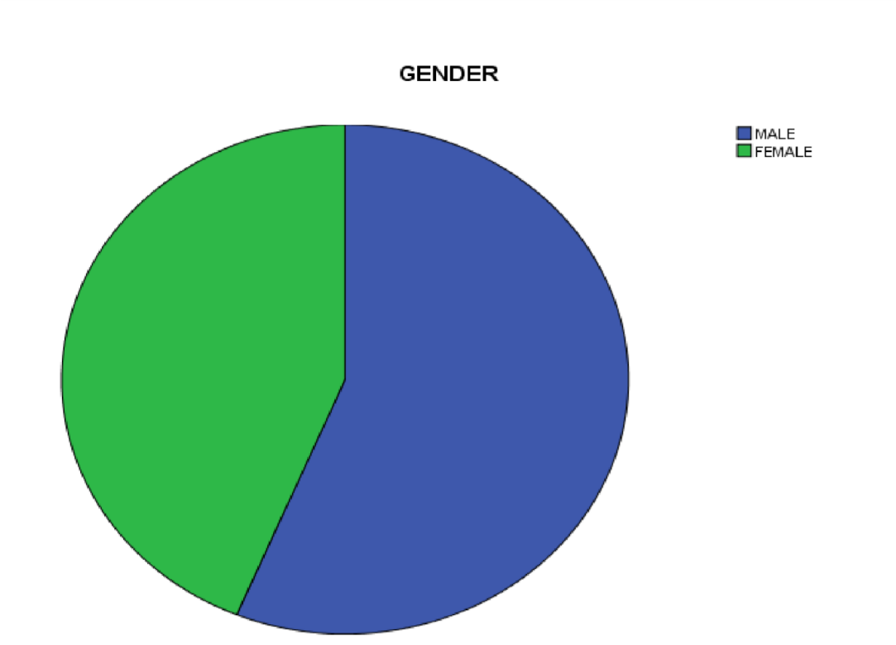
Source: SPSS data result, 2025
Table 4.2. MARITAL STATUS
 |  | Frequency | Percent | Valid Percent | Cumulative  Percent
Valid | SINGLE  MARRIED | 23 | 38 | 38  62 | 38
Valid | SINGLE  MARRIED | 37 | 62 | 38  62 | 100.0
Valid | Total | 60 | 100.0 | 100.0
Source: Field survey, 2025

Table 4.2. above shows the marital status of the respondents as 37 respondents were married representing 62.% while 23 respondents 38.% were single, nobody indicated to be widow or widower.
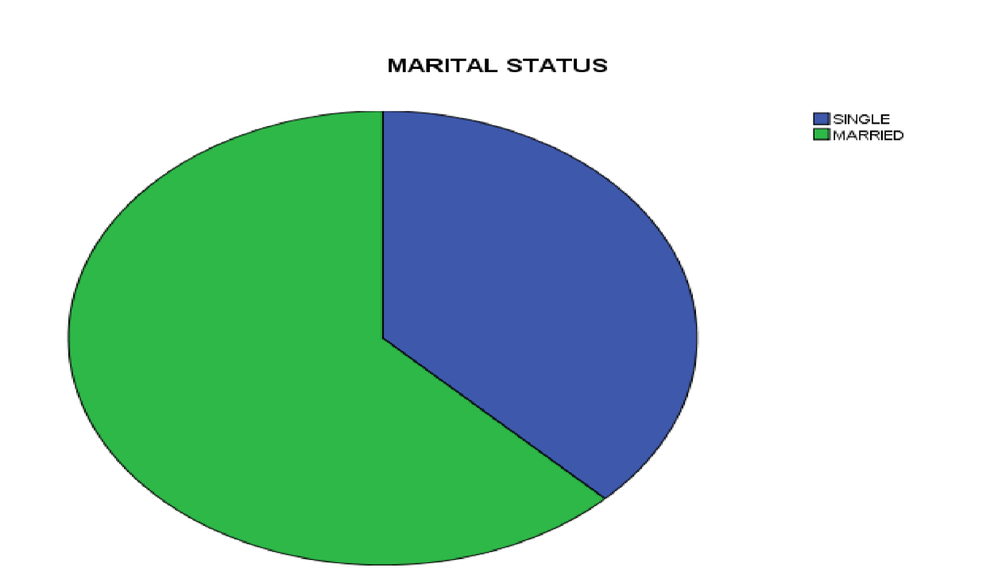
Source: SPSS data result, 2025
Table 4.3. Academic Qualification of the Respondents
 |  | Frequency | Percent | Valid Percent | Cumulative  Percent
Valid | OND/NCE  HND/BSC  POSTGRADUATE/PROFES | 9 | 15.6 | 15.6 | 15.6
Valid | OND/NCE  HND/BSC  POSTGRADUATE/PROFES | 28 | 46.9 | 46.9 | 62.5
 | SIONALS  Total | 23 | 37.5 | 37.5 | 100.0
 | SIONALS  Total | 60 | 100.0 | 100.0
Source: Field survey, 2025
Table 4.3 above shows that out of the total 60 respondents, 28 respondents representing 46.9% are the major dominant, 23 respondents (37.5%) has either postgraduate or professional qualifications while the remaining 9 respondents (15.6%) were national diploma certificate.
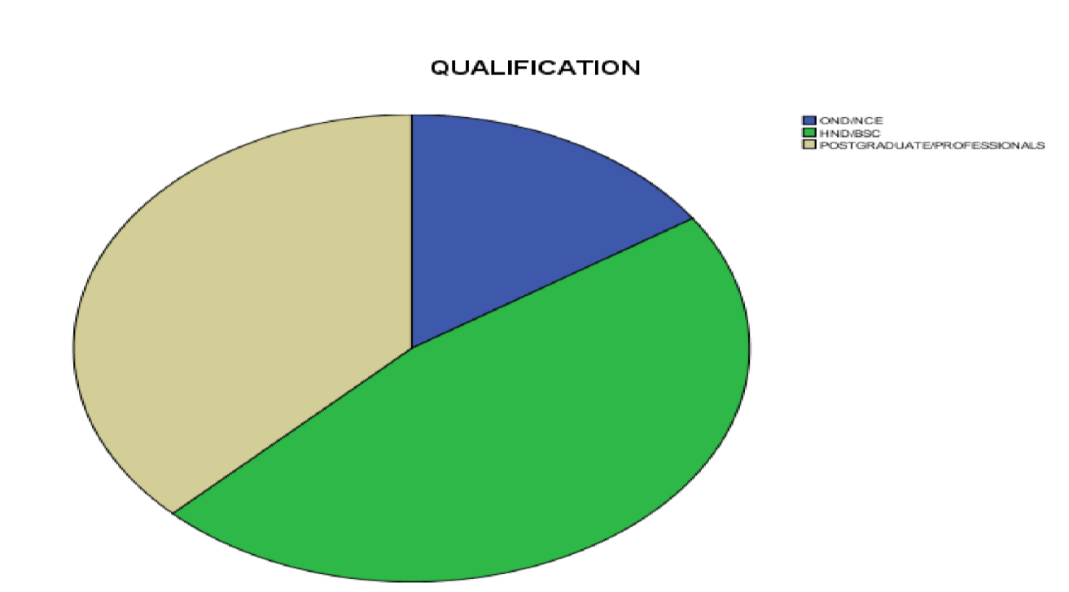
Source: SPSS data result, 2025
Table 4.5.AGE
 |  | Frequency | Percent | Valid Percent | Cumulative  Percent
Valid | 21-30 | 21 | 34.4 | 34.4 | 34.4
Valid | 31-40 41-ABOVE | 24 | 40.6 | 40.6  25.0 | 75.0
Valid | 31-40 41-ABOVE | 15 | 25.0 | 40.6  25.0 | 100.0
Valid | Total | 60 | 100.0 | 100.0
Source: Field survey, 2025

Table 4.5 shows that out of 60 respondents. 24 respondents were between the age of 31-
40yrs has 40.6% are the dominants, 21 respondents of 34.4% are between the age of 2130yrs, while, 15 respondent of 25.0% are between the age of 40 above.
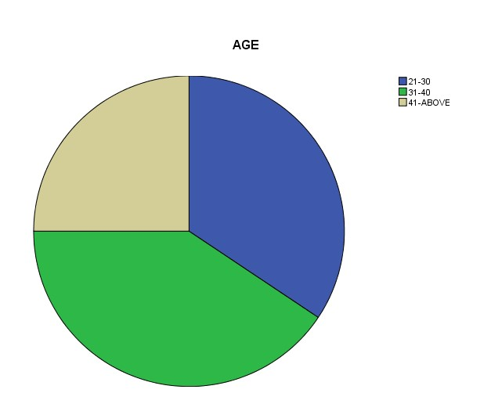

4.2. Presentation of statistical data
Table 4.2.1.
Question 1: Reward programmes adopted by Gomola Supermarket influences you to re-visit the store
 |  | Frequency | Percent | Valid Percent | Cumulative Percent
Valid | SD | 4 | 6.7 | 6.7 | 6.7  23.3 30.0  56.7  100.0
Valid | D | 10 | 16.7 | 16.7 | 6.7  23.3 30.0  56.7  100.0
Valid | N | 4 | 6.7 | 6.7 | 6.7  23.3 30.0  56.7  100.0
Valid | A | 16 | 26.7 | 26.7 | 6.7  23.3 30.0  56.7  100.0
Valid | SA | 26 | 43.3 | 43.3 | 6.7  23.3 30.0  56.7  100.0
Valid | Total | 60 | 100.0 | 100.0 | 6.7  23.3 30.0  56.7  100.0
Source: Field survey, 2025
Table 4.2.1. Shows that majority of the respondents representing 43.3% of the respondent population strongly agree to the fact that reward programs influence them to revisit the store. 26.7% agree, 16.7% disagree, 6.7 strongly disagree and 6.7 maintain a neutral position.
Table 4.2.2.
Question 2: Reward Packages Offered by Gomola Supermarket induce you to patronize them continuously
 | Frequency | Percent | Valid Percent | Cumulative Percent
Valid D | 8 | 13.3 | 13.3 | 13.3
U | 10 | 16.7 | 16.7 | 30.0
A | 16 | 26.7 | 26.7 | 56.7
SA | 26 | 43.3 | 43.3 | 100.0
Total | 60 | 100.0 | 100.0
Source: Field survey, 2025
Table 4.2.2 showcase that 43% of the respondent population strongly agree, 26.7% agree, 16.7% neutral and 13.3% disagree. This reveals that most of the respondents agree that reward packages offered by Gomola supermarket induce them to patronize them continuously
. Table 4.2.3.
Question 3: the value of the reward packages influences your buying decision
 |  | Frequency | Percent | Valid Percent | Cumulative Percent
Valid | SD | 2 | 3.3 | 3.3 | 3.3
Valid | U | 8 | 13.3 | 13.3 | 16.7
Valid | A | 30 | 50.0 | 50.0 | 66.7
Valid | SA | 20 | 33.3 | 33.3 | 100.0
Valid | Total | 60 | 100.0 | 100.0
Source: Field survey, 2025
Table 4.2.3 reveal that 50% of the respondents agree that the value of reward programs influence their buying decision, 33.3% strongly agree, 13.3% undecided and 3.3% strongly disagree.
Table 4.2.4.
Question 4 Gomola Supermarket adopt point system as as a means of rewarding their customers
 |  | Frequency | Percent | Valid Percent | Cumulative Percent
Valid | D | 32 | 53.3 | 53.3 | 53.3
Valid | U | 14 | 23.3 | 23.3 | 76.7
Valid | A | 10 | 16.7 | 16.7 | 93.3
Valid | SA | 4 | 6.7 | 6.7 | 100.0
Valid | Total | 60 | 100.0 | 100.0
Source: Field survey, 2025
Table 4.2.4 shows that 53.3% of the respondents’ population disagree that Gomola supermarket adopt point system as a means of rewarding them. 23.3% undecided, 16.7 agree while 6.7 strongly agree. This shows that majority of the respondent disagree.
Table 4.2.5.
Question 5: The point system adopted by Gomola supermarket glue you to make reparative purchase
 |  | Frequency | Percent | Valid Percent | Cumulative Percent
Valid | SD | 18 | 30.0 | 30.0 | 30.0
Valid | D | 18 | 30.0 | 30.0 | 60.0
Valid | U | 16 | 26.7 | 26.7 | 86.7
Valid | A | 6 | 10.0 | 10.0 | 96.7
Valid | SA | 2 | 3.3 | 3.3 | 100.0
Valid | Total | 60 | 100.0 | 100.0
Source: Field survey, 2025
Table 4.2.5 reveals that 30% of the respondent strongly disagree, 30% disagree, 36.7% undecided, 10% agree and 3.3% strongly disagree.

Table 4.2.6.
Question 6: The point rating used by Gomola supermarket trigger you to make reparative purchase.
 |  | Frequency | Percent | Valid Percent | Cumulative Percent
Valid | SD | 16 | 26.7 | 26.7 | 26.7
Valid | D | 14 | 23.3 | 23.3 | 50.0
Valid | U | 16 | 26.7 | 26.7 | 76.7
Valid | A | 6 | 10.0 | 10.0 | 86.7
Valid | SA | 8 | 13.3 | 13.3 | 100.0
Valid | Total | 60 | 100.0 | 100.0
Source: Field survey, 2025
Table 4.2.6 show that most of the respondent representing 26.7% of the respondent population strongly disagree and the same percentage hold undecided position, 23.3% disagree, 10% agree and 13.3% strongly agree.
Table 4.2.7.
Question 7: You are satisfied service rendered by the organization after sales.
 |  | Frequency | Percent | Valid Percent | Cumulative Percent
Valid | D | 3 | 5.0 | 5.0 | 5.0.
Valid | U | 12 | 20.0 | 20.0 | 25.0
Valid | A | 29 | 48.3 | 48.3 | 73.3
Valid | SA | 16 | 26.7 | 26.7 | 100.0
Total |  | 60 | 100.0
Source: Field survey, 2025
Table 4.2.7 shows that 48.3% agree, 26.7% strongly agree, 20% undecided and 5% disagree. Majority of the respondent agree that they are satisfy with after sales service as a non-monetary reward program.
Table 4.2.8.
Question 8: After sales service of Gomola supermarket is effective
 |  | Frequency | Percent | Valid Percent | Cumulative Percent
Valid | SD | 2 | 3.3 | 3.3 | 3.3  20.0  46.7  83.3  100.0
Valid | D | 10 | 16.7 | 16.7 | 3.3  20.0  46.7  83.3  100.0
Valid | U | 16 | 26.7 | 26.7 | 3.3  20.0  46.7  83.3  100.0
Valid | A | 22 | 36.7 | 36.7 | 3.3  20.0  46.7  83.3  100.0
Valid | SA | 10 | 16.7 | 16.7 | 3.3  20.0  46.7  83.3  100.0
Valid | Total | 60 | 100.0 | 100.0 | 3.3  20.0  46.7  83.3  100.0
Source: Field survey, 2025
Table 4.2.8 shows that 36.7% of the respondents agree, 26.7% undecided, 16.7% disagree, 16.7% strongly agree and 3.3% strongly disagree.
Table 4.2.9.
Question 9: The after sales service rendered motivate you to continue patronizing Gomola Supermarket.
 |  | Frequency | Percent | Valid Percent | Cumulative Percent
Valid | SD | 6 | 10.0 | 10.0 | 10.0
Valid | D | 14 | 23.3 | 23.3 | 33.3
Valid | U | 6 | 10.0 | 10.0 | 43.3
Valid | A | 20 | 33.3 | 33.3 | 76.7
Valid | SA | 14 | 23.3 | 23.3 | 100.0
Valid | Total | 60 | 100.0 | 100.0
Source: Field survey, 2025
Table 4.2.9 showcase that 33.3% of respondent agree that the after sales service rendered by Gomola supermarket motivate them to repurchase, 23.3% disagree, 23.3 strongly disagree, 10% strongly disagree and 10% undecided.
Table 4.2.10.
Question 10: Price discount offered by Gomola supermarket influence bulk purchase by customers.
 | Frequency | Percent | Valid Percent | Cumulative Percent
Valid SD | 4 | 6.7 | 6.7 | 6.7
D | - | 0 | 0 | 6.7
U | 12 | 20.0 | 20.0 | 26.7
A | 32 | 53.3 | 53.3 | 80.0
SA | 12 | 20.0 | 20.0 | 100.0
Total | 60 | 100.0 | 100.0
Source: Field survey, 2025
Table 4.2.10 shows that 53.3% agree, 20% undecided, 20% strongly agree and 6.7% strongly disagree.

Table 4.2.11.
Question 11: Price Discounts ByGomola Increase Your Purchase Ability
 | Frequency | Percent | Valid Percent | Cumulative Percent
Valid D | 8 | 13.3 | 13.3 | 13.3
U | 10 | 16.7 | 16.7 | 30.0
A | 16 | 26.7 | 26.7 | 56.7
SA | 26 | 43.3 | 43.3 | 100.0
Total | 60 | 100.0 | 100.0
Source: Field survey, 2025
Table 4.2.11 shows that 43.3 of the respondents strongly agree, 26.7% agree, 16.7% undecided and 13.3% disagree. This reveals that majority of the respondent agree that price discount increase their purchase ability.
Table 4.2.12.
Question 12: Gomola supermarket offer price discounts for product purchase in large quantities
 |  | Frequency | Percent | Valid Percent | Cumulative Percent
Valid | D | 23 | 48.3 | 48.3 | 48.3
Valid | U | 12 | 20.0 | 20.0 | 68.3
Valid | A | 3 | 5.0 | 5.0 | 73.3
Valid | SA | 16 | 26.7 | 26.7 | 100.0
Total |  | 60 | 100.0
Source: Field survey, 2025
Table 4.2.12 shows that most of the respondent disagree that Gomola supermarket offer price discount for goods purchase large quantities. 48.3% disagree, 26.7% strongly agree, 20% undecided and 5% agree.
4.3. Test of Hypothesis
Table 4.9.
Reliability Statistics
Cronbach's Alpha |  | N of Items
 | .862 | 16
Source: SPSS data result, 2025
The reliability table shows a significance coefficient of .862 which indicate that our data is reliable based on Cronbach’s Alpha of 0.7
Model specification
CL= Customers Loyalty
NP = Non-monetary program
PR= Point Rating
PRD = Price Discounts
Model Summary^{b}
Model | R | R Square | Adjusted R Square | Std. Error of the Estimate
1 | .774ª | .629 | .557 | .416
- Predictors: (Constant), NP, PR, PRD
- Dependent Variable: CL
An R show that our variables have over .774 % relationships on our model with R² shows overall contribution of .629% on customers’ loyalty to the organization. This indicates that for every customer loyalty, our attributable variable has variation of .629%, the remaining .381% covered the stochastic error term which was not included in our model.
Our adjusted R is .557
ANOVA^{b}
Model | Sum of Squares | Df |  | Mean Square | F | Sig.
1 Regression  Residual | 2.376  4.843  7.219 |  | 3 | .792 | 4.579 | .010ª
1 Regression  Residual | 2.376  4.843  7.219 |  | 28 | .173
Total | 2.376  4.843  7.219 |  | 31
- Predictors: (Constant), NP, PR, PRD
- Dependent Variable: CL
From the ANOVA statistics in table above, the processed data, which is the population parameters, had a significance level of 0.010 which shows that the data is ideal for making a conclusion on the population’s parameter as the value of significance (p-value) is less than 5% an indication that non-monetary reward, point rating and price discounts significantly influence customers loyalty and patronage in Gomola organization. The significance value was less than 0.05 an indication that the model was statistically significant.
Coefficientsª
Model | Unstandardized Coefficients |  | Standardized Coefficients | t | Sig.
Model | B | Std. Error | Beta | t | Sig.
1 (Constant)  NP | 2.308 | .674 |  | 3.425 | .002
1 (Constant)  NP | .103 | .101 | .162 | 1.021 | .004
PR | .331 | .107 | .492 | 3.099 | .316
PRD | .099 | .081 | .192 | 1.234 | .027
a. Dependent Variable: CL
The dependent variable being Customer loyalty (CL), with other independent variables is significance at 0.002. This means that for effective use of non-monetary reward (NP), point ratings (PR) and price discounts (PRD) are significance at 0.02 < 0.05 level of significance. It implies that for effective customers’ patronage, there is 98% coefficient of customers’ loyalty in the organization. Point rating (PR) shows an insignificance magnitude of .316 > 0.05 while both non-monetary program (NP) and price discounts (PRD) are significance at 0.004. 0.027 both < 0.05 level and also unit increase in nonmonetary reward and price discounts would lead to increase in customer loyalty of Gomola Supermarket Company by a factor of 0.004 and 0.027.
Correlations
 |  |  | Result and quality overall achieved | are | Anticipated price discount usually influence customer loyalty | the
Kendall's tau_b | Result and quality overall are achieved | Correlation  Coefficient | 1.000 |  | .016
Kendall's tau_b | Result and quality overall are achieved | Sig. (2-  tailed) | . |  | .004
Kendall's tau_b | Result and quality overall are achieved | N | 60 |  | 60
Kendall's tau_b | Anticipated price discount usually influences the customer loyalty | Correlation  Coefficient | .016 |  | 1.000
Kendall's tau_b |  | Sig. (2-  tailed) | .004 |  | .
Kendall's tau_b |  | N | 60 |  | 60
Source: SPSS Data Output, 2025
The table above shows the relationship between the price discount and overall customer patronage of the organization. Based on the result, it could be deduced that there is relationship between price discount and customers’ patronage of the organization as the result shows 0.04 < 0.05, therefore the alternate hypothesis is accepted. This simply mean that price discount and customers patronage is highly correlated. Thus, indicating that price discount lead to customers’ patronage and loyalty.
4.4 Discussion of Findings
From the analysis of the data gathered from this research work, it was discovered that there is significant impact of price discount program on customer re-purchase. The findings also revealed that non-monetary reward program (after sales service) has significant impact on customer loyalty as customer tend to glue to organization that offers effective and satisfying after sales service despite the fact that it does not involve any direct or indirect financial reward. The findings of this study therefore shows that there is significant impact of customer reward programs on customer loyalty.
CHAPTER FIVE
SUMMARY, CONCLUSION AND RECOMMENDATIONS
5.0 Introduction
This chapter dwells on the summary of the research work, conclusion of the findings and recommendation.
5.1 Summary
This research work centers on the impact of customer reward programs on customer loyalty, using Gomola supermarket in Ilorin, Kwara State as case study and the research covers the period of 2020 to 2023.
To examine the impact of reward programs in enhancing customer loyalty, the research work divided the study into five chapter which focus on introduction to the study, literature review, methodology, data presentation, analysis and discussion of findings, and summary, conclusion and recommendation.
From the outcome of data gathered through questionnaire and interview and analyzed using regression and correlation (SPSS) analytical tools, it reveals that discount price and non-monetary reward (after sales service) have significant impact in enhancing customer loyalty.
5.2 Conclusion
The success of firms in today’s competitive market environment largely depends on their ability to attract and retain loyal customers, because it is generally well known that there is a positive relationship between customer loyalty and profitability.
In conclusion, the result of the study showed that all customer reward programs are significant in building and upholding customer loyalty. Non-monetary reward and price discount according to the findings are more effective in increasing customer patronage and customer loyalty. The study maintain a neutral position regarding the effectiveness of point system as a reward program because the adopted case study do not adopt point system as a reward tool.
5.3 Recommendations
Organizations that have adopted reward programs as a means to reward and enhance the loyalty of their existing customer and attract new ones should improve in doing so and for organizations that has not, they should plan to do so because it has been hypothetically proven that customer reward programs have significant impact in enhancing customer loyalty. And in today’s world of intensive competition with rapid growth in information and technology which poses threats and opportunities to organizations, organizations must ensure to gain and maintain the loyalty of their customers in order to survive and ensure continuous profit.
Organizations must know how to initiate reward programs that will reflect the customer’s shopping attitudes and value, in order to keep them loyal to the business and create a life time customer. Firms need to keep using all forms of customer reward programs as the findings has reveal a vivid impact on customer loyalty. Due to the fact that customers differ in their preferences and values, the distinctive reward programs should be segmented according the preferences and values of the target customers. Reward programs should focus on retaining customers due to their role in recommending the company to their friends and relatives through the positive word of mouth. And retaining customers is less expensive than acquiring new ones. Customers should be duly informed about all available reward programs and how to go about it. A transparent feedback system should be develop and listening to customer views and suggestions.

REFERENCES
Aaker, D.A. (1991), Brand equity, New York NY: The free press.
Ball, D., Coelho, P.S &Machás, A. (2004). The role of communication and trust in explaining customer loyalty, European Journal of Marketing, Vol. 38 No. 9/10 pp. 1272-1293
Bobâlcă, C. (2013). Study of customers’ loyalty: dimensions and facets. Management Marketing, volume XI, issue 1/2013, p.p.104-114. 6.
Bose, S., & Rao, V.G. (2011). Perceived benefits of customer loyalty programs: Validating the scale in the Indian context. Management & Marketing Challenges for the Knowledge Society Vol. 6, No. 4, pp. 543-560.
Bowen, J.T. and Chen, S. (2001). The relationship between customer loyalty and customer satisfaction, International Journal of Contemporary Hospitality
Management, Vol. 13 No. 5 pp. 213-217
Bowen, J. & Shoemaker, S. (1998). "Loyalty: a strategic commitment", Cornell Hotel and Restaurant Administration Quarterly, Vol. 2 No. February, pp.12-25
Chaudhuri, A. & Holbrook, M.B. (2001), "The chain of effects from brand trust and brand affect to brand performance: the role of brand loyalty", Journal of Marketing, Vol. 65 No.2, pp.81-94.
Clark P (2010). “The 15 Business Benefits of a Loyalty Initiative”, The Wise Marketer.
Curry, J. (2000). The customer marketing method: how to implement and profit from customer relationship management, New York: Free Press
Duffy, D. L. (1998). Customer loyalty strategies, journal of consumer marketing, vol. 15 no.5 pp. 435-448
Duffy, D. L. (2003), Internal and external factors which affect customer loyalty, Journal of Consumer Marketing, vol. 20 No. 5 pp. 480-485
Dwyer, F.R., Schurr, P.H & Oh, S. (1987). "Developing buyer-seller relationships", Journal of Marketing, Vol. 51 No.1, pp.11-27.
East R, Philip G, Kathy H & Wendy L, (2005). “Consumer Loyalty: Singular, Additive or Interactive?” Australasian Marketing Journal 13 (2), p 10-26.
Hill, N. and Alexander J. (2000), Handbook of customer satisfaction and loyalty measurement, Aldershot: Gower.
Lewis Michael (2004). “The Influence of Loyalty Programs and Short-Term Promotions on Customer Retention” Journal of Marketing Research, Vol .XLI August 2004.
281-292.
Mai, N., Nguyen, N., & Nguyen, L. (2021). The Impact of Service Recovery on
Satisfaction and Word of Mouth of International Tourists towards Homestays: An Empirical Study in Vietnam. The Journal of Asian Finance, Economics and Business, 8(8), 593–600.https://doi.org/10.13106/jafeb 2021.vol8.no8.0593
Ndubisi, N.O. (2004). "Understanding the salience of cultural dimensions on relationship marketing, its underpinnings and aftermaths", Cross Cultural Management, Vol.
11 No.3, pp.70-89
Ndubisi, N.O. (2007). Relationship marketing and customer loyalty, Marketing
Intelligence & Planning, Volume 25 Number 1 pp. 98-106
Nguyen, L., Dang, M., Tat, T., & Tran, D. (2021). Revisiting Customer Complaint Intention: A Case Study of Mobile Service Users in Vietnam.Journal of Asian
Finance, Economics, and Business, 8(9), 121–130.
https://doi.org/10.13106/jafeb.2021.vol8. no9.0121
Oliver, R. L. (1999). Cognitive, affective, and attribute bases of the satisfaction response. Journal of Consumer Research, 20,418–430,
Omar, N. A., Azrin, M., & Sarah, H, (2009). “What Customers Really Want: Exploring Service Quality Dimensions in a Retail Loyalty Program”. Unitar E- Journal, Vol.5, No.1.
Ray, S. (2015). Traditional Loyalty Programs: Broken? Business Technology.
https://www.itwire.com/business-itnews/business-technology/itemlist/user/11234rayshaw
Reinatz W, Krafft M & Hoyer D. W (2004). “The Customer Relationship Management
Process: Its Measurements and Impact on Performance”, Journal of Marketing
Research, Vol. XLI
Rowley, J (2005). The four Cs of customer loyalty, Marketing Intelligence & Planning,
Volume 23 Issue 6 Page 574 – 581
Salihah, k. (2020). Effect of customer loyalty program on customer satisfaction and its impact on customer loyalty. Journal of business and social science, IJRBS VOL 9
NO 1 ISSN: 2147-4478
Sharp, B. & Sharp, A. (1997) “Loyalty Programs and their Impact on Repeat-purchase Loyalty Patterns”, International Journal of Research in Marketing, Vol 14, No. 5, p.473-486.
Sima, G.M and Elham, F.T. (2015). Impact of customer loyalty program on customer retention, international journal of business and social science, vol. 6, No. 8622191933
Singh R & Khan I (2012). “An Approach to Increase Customer Retention and Loyalty in B2C World”, International Journal of Scientific and Research Publications, Volume2, Issue 6.
Torres-Moraga, E., Vásquez-Parraga, A.Z. and Zamora-González, J. (2008). Customer satisfaction and loyalty: start with the product, culminate with the brand, Journal of Consumer Marketing, Vol. 25 No. 5 pp. 302-313
(http://blog.hubspot.com/blog/tabid/6307/bid/31990/7-Customer-Loyalty-Programs-ThatActually-AddValue.aspx)
(http://beyondphilosophy.com/customer-experience/customer-loyalty).
(http://searchcrm.techtarget.com/definition/loyalty-card-program)
(http://salesforce.com/blog/customer-loyalty-program-example-tip)
(http://study.com/academy/lesson/customer-loyalty- program-definition-purpose

