

KWARASTATEPOLYTECHNIC

DESIGN AND FABRICATION OF FORAGE CHOPPING MACHINE

BY

HND/23/MEC/FT/0013
HND/23/MEC/FT/0086
HND/23/MEC/FT/0087
HND/23/MEC/FT/0089
HND/23/MEC/FT/0090
HND/23/MEC/FT/0092
HND/23/MEC/FT/0187

A PROJECT REPORT SUBMITTED TO THE DEPARTMENT OF MECHANICAL ENGINEERING, INSTITUTE OF TECHNOLOGY, IN PARTIAL FULFILLMENT OF THE REQUIREMENT FOR THE AWARD OF HIGHER NATIONAL DIPLOMA (HND) IN MECHANICAL ENGINEERING TECHNOLOGY
ILORIN, NIGERIA

JULY, 2025

CERITIFICATION
The under signed certified that this project report is prepared by
AHMED SIKIRULLAHI AMOLEGBE HND/23/MEC/FT/0013
AIYEDATIWA PAUL ADESOJI HND/23/MEC/FT/0086
ADEBAYO TAYE HAMMED HND/23/MEC/FT/0087
AYINDE MUHAMMAD OLADIPUPO HND/23/MEC/FT/0089
KAREEM IBRAHIM OREOLUWA HND/23/MEC/FT/0090
AJAYI GODWIN ADETOMIWA HND/23/MEC/FT/0092
AJANI ISIAIAH AYOMIDE HND/23/MEC/FT/0187

Entitled: “DESIGN AND FABRICATION OF FORAGE CHOPPING MACHINE” meets the requirement of the Department of Mechanical Engineering for the award of Higher National Diploma (HND) in Mechanical Engineering.

ENGR. AYANTOLA A. A. DATE
Project Supervisor

ENGR. AYANTOLA A .A. DATE
Head of Department

ENGR.SALAMI HAMEED OLATEJU DATE
Project Coordinator

ENGR.(DR) OGUNDELE SAMUEL OLUGBANGA DATE
External Examiner

DEDICATION
We dedicated this project to Almighty Allah, our creator, our strong pillar, our source of inspiration, wisdom, knowledge and understanding. He has been the source of our strength throughout this programme and on His wings have we soared.
We also dedicated this work to our parents who have encouraged us all the way and whose encouragement has made sure that we give it all its takes to finish, we say thank you. Our love for you all can never be quantified. May Almighty Allah bless you all.

ACKNOWLEDGEMENTS
First and foremost, we give thanks to Almighty Allah, the creator of the universe for greatest protection and love been given to us as a privilege to start and complete the project programme.
If we are to use the whole pages of this book to thank us God for the grace He has shown us, for the mercies we have received, for his goodness and kindness, his work is more; indeed God has been so good to us all time.
We also appreciate the efforts and encouragement we have always received from our Energetic Lecturer, Engr. M. A. SALAHUDEEN for his moral assistance and fatherly advice rendered to us during the course of carrying out this project work. And to our Automotive Engineer, Engr. ISSA ABDULGANIYU, and to Engr. AYANTOLA A.A, Head of Department and others and all the workshop Instructor, God bless you all.
How on earth can we make it known to the world that God has given us the best set of combination of parents, we will remain forever grateful for investing so much on us, their encouragement, and piece of advice throughout the undergraduate days. May Almighty Allah continue to enrich your purse and may you reap the fruits of your labour (Amin).
Our appreciation also goes to our family’s, thanks for your love and kindness over us. We thank and appreciate the contributions of our lovely friends who have contributed directly or indirectly in completing this project. We pray may Almighty Allah bless you all (Amin).

TABLE OF CONTENTS
Title Page i
Certification ii
Dedication iii
Acknowledgement iv
Table of Contents v
List of Tables vii
List of Figure ix
Abstract xi
CHAPTER ONE
1.1 History of Animal Keeping 1
1.2 Method of Preparing Forage Feeds for Domesticated Animals 2
1.3 Recognizing the Pivotal Role of Efficient Forage Processing in
Modern Agriculture 7
1.4 Type of Equipment for Preparing Forage Feeds 9
1.5 Type of Forage Grasses 15
1.6 Aims and Objective of the Study 20
1.7 Scope of the Project 21
1.8 Problem Statement 22
CHAPTER TWO
2.1 Literature Review 25
2.2 Concept of Forage Chopper Machine 34
2.3 Types of Forage Chopper Machines 36
2.4 Components of a Forage Chopper Machine 41
2.5 Theoretical Framework 46
2.6 Research Gap 50
CHAPTER THREE
3.0 Material and Method 53
3.1 Material 53
3.2 Description of Component Part 55
3.3 Working Principle 60
3.4 Design Specification 73
3.5 Design Calculation 73
CHAPTER FOUR
4.0 Performance Evaluation 80
4.1 Results and Discussion 81
4.2 Description of Compare Part 93
CHAPTER FIVE
5.0 Conclusion 97
5.1 Recommendation 98
References 100

LIST OF TABLES
Table 1: Data gathered of the first treatment T₁ (3-inch Diameter Pulley)
with three replication 82
Table 2: Data gathered of the second treatment T₂ (4-inch Diameter Pulley)
with three replications 82
Table 3: Data gathered of the gathered of the third treatment T₃ (5-inch
Diameter Pulley) with three replications 83
Table 4: Throughput capacity of the forage chopper machine in kilograms
per hour obtained from three diameter pulleys in conducted in CRD experiment with three replications 84
Table 4a: Analysis of variance of table 4 (throughput capacity of the forage
chopper machine in kilogram per hour obtained from three diameter
pulleys conducted in CRD experiment with three replication) 84
Table 4b: DMRT of table 4a (throughput capacity of the forage chopper machine
on kilograms per hour obtained from three diameter pulleys conducted in CRD experiment with three replications 85
Table 5: Chopping capacity of the forage chopper machine in kilograms per hour obtained from three diameter pulleys conducted in CRD experiment with three replication 86
Table 5a: ANOVA table of table 5 (chopping capacity of the forage chopper
machine in kilograms per hour obtained from three diameter pulleys conducted in CRD experiment with three replications 86
Table 5b: DMRT of table 5a (chopping capacity of the forage chopper machine in kilogram per hour obtained from three diameter pulleys conducted in CRD experiment with three replication 87
Table 6: Chopping recovery of the forage chopper machine in kilogram per hour obtained from three diameter pulleys conducted in CRD experiment with three replications 88
Table 6a: ANOVA of table 6 (chopping recovery of the forage chopper machine in kilograms per hour obtained from three diameter pulleys conducted in CRD experiment with three replication 88
Table 7: Percent loss of the forage chopper machine in kilograms per hour obtained from three diameter pulleys conducted in CRD experiment with three replications 90
Table 7a: ANOVA of table 7 (percent loss of the forage chopper machine in kilogram per hour obtained from three diameter pulleys conducted in CRD experiment with three replication 90
Table 7b: DMRT table of table 7 (percent loss of the forage chopper machine in kg/hr obtained from three diameter pulleys conducted in CRD experiment with three replications) 90
Table 8: Machine efficiency of the forage chopper machine in kilogram per hour obtained from three different diameter pulleys in CRD experiment with three replications 92
Table 8a: ANOVA of table 8 (Machine Efficiency of the forage chopper machine in kilograms per hour obtained from three different diameter pulleys conducted in CRD experiment with three replications 92
Table 8b: DMRT table of table 8 (machine efficiency of the forage chopper machine in kilograms per hour obtained from three different diameter pulleys conducted in CRD experiment with three replications 93
LIST FIGURE
Figure 2.1: Developed Machine 27
Figure 2.1.2: The chopper with the motor and fore attached 30
Figure 2.1.3: Proto type of the chopper 31
Figure 2.1.4: Chopper machine and main parts 32
Figure 2.1.5: Main component of the forage chopper machine 34
Figure 2.2: Multiple blade rotary chopper 36
Figure 3.1: Electric motor 56
Figure 3.1.2: V-Belt drive 57
Figure 3.3.1: Modified fodder cutter machine 64
Figure 3.32: Modified fodder cutting machine 64
Figure 3.3.3: Hopper 2D views and its dimension 65
Figure 3.3.4: Hopper 3D view 65
Figure 3.3.6: Front view and dimension of pinion gear 66
Figure 3.3.7: 3D view of pinion gear 66
Figure 3.3.8: Front and dimension of gear 67
Figure 3.3.9: 3D view of gear 67
Figure 3.3.10: Front view and dimension of Gear Feed 67
Figure 3.3.11: 3D view of gear feed 67
Figure 3.3.12: Side view of blade 68
Figure 3.3.13: Top view of blade 68
Figure 3.3.14: 3D view of blade 68
Figure3.3.15: 2D view of housing 69
Figure 3.3.16: 3D view of housing 69
Figure 3.3.17: 2D view of feeding roller 69
Figure 3.3.18: 3D view of feeding roller 70
Figure 3.3.19: 3D view of case cover 70
Figure 3.3.20: Dimension of shear plate 70
Figure 3.3.21: 3D view of shear plate 70
Figure 3.3.22: Front view of joints 71
Figure 3.3.23: Top view supporting joints 71
Figure 3.3.24: 3D view of joint 71
Figure 3.3.25: 2D view of stand 72
Figure 3.3.26: 2d view of stand 72
Figure 3.3.27: 3D view of stand 72

ABSTRACT
Livestock population is the largest in Africa, however different factors or constraints limit the full exploitation of the agricultural sector in general and the livestock sub sector in particular. In the country, the availability, quality and quantity of feed has always been a challenge in the livestock sector. Poor feed resources management, especially those of the bulky and fibrous crop residue is one of the constraints. Forage chopping is considered to be part of crop residue management, a common process done by most local farmers in livestock feeding. This process is laborious and takes more. To alleviate this, using forage chopper is an important remedy. The primary goal of this study was to design, fabricate, and evaluate the performance of the forage chopper machine. The performance of the machine was evaluated using sorghum forage variety with treatments of the engine seed, feed rate and feed thickness using factorial design with three replications. The heights mean chopping capacity of (581.24 kg/h), the finest of (shortest) mean cut length (6.23 mm), the heights chopping efficiency of (0.97) and the mean lowest fuel consumption of (0.50 ml/s) was recorded. The operation speed was observed to be highly significant among the treatments, at significance level of 0.01. Based on the result obtained, it is recommended to use a power source with higher horse power and speed and electric motor in areas where electric power is available to avoid vibration.

CHAPTER ONE
1.1 HISTORY OF ANIMAL KEEPING
Forage grasses form the bedrock of livestock nutrition, providing essential sustenance for a diverse array of animals within agricultural systems (McDonald et al., 201 1). The practice of processing these grasses, primarily by reducing them into smaller, more manageable particles through chopping, offers significant advantages that profoundly influence livestock management and overall farm productivity.
Notably, chopped forage facilitates easier handling and distribution, streamlining feeding processes and substantially reducing the labor demands associated with manual feeding (Ogunlela & Mukhtar, 2009). Furthermore, the reduction in bulk achieved through chopping translates to substantial savings in storage space, effectively mitigating post-harvest losses and optimizing the utilization of valuable storage resources (2018). Perhaps most critically, the comminution of forage significantly enhances its digestibility for livestock, allowing for more efficient nutrient absorption in the digestive tract and consequently contributing to improved animal health, enhanced growth rates, and increased production efficiency (Van Soest, 1994). Beyond these direct benefits, the uniform particle size of chopped forage also enables more homogenous mixing with other feed components and supplements, ensuring a balanced and consistent dietary intake for animals, which is crucial for optimal nutrition and performance (Adesogan et al., 2014).
1.2 METHOD OF PREPARING FORAGE FEEDS FOR DOMESTICATED ANIMALS
Ensuring proper forage feed preparation is vital for the well-being and productivity of livestock (McDonald et al., 2011). Effective forage feed preparation is fundamental to maintaining the health and productivity of domestic animals by ensuring a consistent supply of nutritious feed, especially when fresh pasture is limited (Van Soest, 1994).
PRIMARY METHOD OF PRESERVING FORAGE FROM 1992 STATED AS FOLLOW:
1. HAY MAKING
Haymaking involves reducing the moisture content of fresh forage (grasses, legumes) to between15% and 20% to allow for safe long-term storage, thereby conserving essential nutrients (Ball et al.,2007).
The key stages in hay production include:
- Cutting: Forage is harvested at an optimal growth stage, typically around early flowering, to maximize its nutrient density (Undersander et al., 1991).
- Drying (Curing): The cut forage is spread in the field to dry naturally through exposure to solar radiation and wind. This often necessitates turning or tedding the hay to ensure uniform drying and prevent spoilage. The duration of this phase is heavily influenced by prevailing weather conditions.
- Raking: Once the forage has reached a partial state of dryness, it is gathered into windrows (rows) to facilitate further drying and preparation for the subsequent baling process.
- Baling: The dried hay is compressed and packaged into bales of varying sizes (e.g., small rectangular, large round, large rectangular) to simplify handling and storage.
- Storing: Hay bales are stored in dry, well-ventilated conditions to prevent the proliferation of molds and other forms of spoilage due to moisture accumulation.
2. SILAGE MAKING (ENSILTNG)
Silage production, or ensiling, is a method of preserving high-moisture forage (typically 60-70% moisture) through anaerobic fermentation (McDonald et al., 2011). This process relies on the activity of microorganisms to produce natural preservatives:
- Harvesting and Chopping: Forage is harvested at a relatively early stage of maturity and chopped into small pieces (1-3 cm) to promote effective compaction and the subsequent fermentation process.
- Ensiling: The chopped forage is rapidly transferred into an airtight storage structure, such as a silo (e.g., upright, bunker, bag, or tower).
- Compaction: The forage mass is tightly packed to expel air, creating the anaerobic environment essential for the dominance of lactic acid-producing bacteria.
- Sealing: The silo is hermetically sealed to prevent the ingress of air and water, which could impede the fermentation process and lead to spoilage.
- Fermentation: Under anaerobic conditions, lactic acid bacteria ferment the water-soluble carbohydrates present in the forage, producing lactic acid. This reduces the pH of the silage, effectively preserving it (McDonald et al., 2011). This phase typically spans several weeks.
- Storage and Feed-out: Once fermentation is complete, the silage can be stored for extended periods and fed to animals as required (McDonald et al., 2011). Careful management during feed- out is necessary to minimize spoilage due to air exposure.
3. GREEN CHOPPING
Green chopping involves the daily harvesting of fresh forage, which is then directly fed to animals without undergoing any drying or fermentation processes
- Harvesting: Forage is cut on a daily or as-needed basis using specialized forage harvesting equipment.
- Transportation: The freshly harvested forage is transported directly from the field to the location where the animals are housed.
- Feeding: The green chop is immediately distributed to the animals for consumption.
While this method maximizes the retention of nutrients present in the fresh forage, it is labor-intensive due to the requirement for daily harvesting and feeding and may not be practical for large-scale operations or during periods of limited forage availability (1).
4. PASTURING (GRAZING)
Pasturing, or grazing, represents the most natural method of forage consumption for many domestic animals, where they directly feed on growing plants in a designated pasture or rangeland (Allen et al., 2011).
- Pasture Management: This encompasses various practices aimed at maintaining healthy and productive pastures, including rotational grazing, weed control, and soil fertility management through fertilization (Allen et al., 2011).
- Animal Management: Maintaining an appropriate stocking rate, which balances the number of animals with the pasture’s carrying capacity, is crucial to prevent overgrazing and ensure sustainable pasture utilization (Allen et al., 2011).
In addition to the primary preservation methods, several processing techniques can be employed to enhance the utilization and palatability of forage:
- Chopping/Chaffing: Reducing the particle size of dry or green forage to improve ease of handling and minimize selective feeding by animals.
- Grinding: Further reduction of forage particle size, often utilized in the preparation of total mixed rations (TMR) or for pelleting. However, it’s important to note that excessively fine grinding can diminish the effective fiber content necessary for proper rurnen function in ruminant animals (Van Soest, 1994).
- Pelleting: Compressing ground forage into dense pellets, which can improve handling characteristics, reduce dustiness, and in some cases, enhance digestibility.
- Soaking/Reconstitution: Adding water to dry forages to soften them, thereby improving palatability and potentially digestibility.
- Mixing: Combining different types of forage or incorporating forage with concentrate feeds and other nutritional supplements to create a balanced ration tailored to the animals’ specific needs.
Steam Flaking: A process involving the application of steam and rollers to grains to improve their digestibility, this technique can also be applied to certain forage components in mixed rations.
The selection of the most appropriate forage preparation method:- This is influenced by a multitude of factors, including the type of forage being utilized, the prevailing climatic conditions, the available labor and equipment resources, storage capabilities, and the specific requirements of the animal species and production system. Often, a combination of these methods is implemented on a farm to ensure a consistent high-quality feed throughout the year.
1.3 RECOGNIZING THE PIVOTAL ROLE OF EFFICIENT FORAGE PROCESSING IN MODERN AGRICULTURE
This project endeavors to address the existing needs and challenges associated with this crucial task through the design, fabrication, and rigorous testing of a dedicated forage grass chopper machine. This undertaking will adopt a comprehensive and systematic approach, commencing with an exhaustive review of prevalent forage chopper designs currently available. This initial phase will involve a critical analysis of their operational principles, material composition, performance characteristics, and suitability for diverse agricultural contexts. Specifically, this review will focus on identifying key design parameters that significantly impact the chopping efficiency and operational performance, such as blade geometry, cutting speed, feed rate mechanisms, and power transmission systems (Kapila & Tiwari, 2011; Singh et al., 2015). Understanding the influence of these parameters is crucial for optimizing the machine’s performance in terms of throughput, power consumption, and the quality of the chopped forage. Complementary to this technical review will be a detailed investigation into the specific requirements and constraints faced by local farmers in Ibadan, Oyo, Nigeria. This crucial step will encompass a thorough understanding of the predominant types of forage grasses cultivated and utilized in the region, the readily available power sources for operating agricultural machinery, and the desired throughput capacities necessary to meet the demands of varying farm sizes and livestock populations (Akinola & Adeyemo, 2012). This farmer-centric approach will ensure that the developed machine is not only technically sound but also practically relevant and readily adaptable to the local agricultural landscape.
The subsequent design phase will prioritize the judicious selection of appropriate materials, striking a critical balance between performance, durability, and economic viability. High-strength steel alloys will be considered for the fabrication of key components such as the cutting blades and the main structural frame, ensuring the machine’s ability to withstand the rigors of continuous operation and maintain its structural integrity over an extended lifespan. To optimize the machine’s performance, rigorous engineering calculations will be performed to determine critical design parameters, including the optimal cutting blade angle for efficient shearing of various forage types, the most effective cutting mechanism to achieve the desired chop length and consistency, and a reliable and efficient power transmission system to transfer energy from the power source to the cutting mechanism. Integral to the design process will be the proactive incorporation of comprehensive safety features. Protective guards will be meticulously designed and integrated to shield operators from moving parts, while easily accessible emergency shut-off mechanisms will be implemented to ensure immediate cessation of operation in unforeseen circumstances, prioritizing operator safety throughout the machine’s lifecycle.
Following the detailed design phase, the project will proceed to the fabrication stage. This will involve the precise cutting, robust welding, and accurate machining of the individual components that constitute the forage chopper machine, adhering strictly to the finalized engineering blueprints and material specifications. The subsequent assembly process will bring these individual components together, culminating in the creation of the functional prototype.
The final stage of the project will involve a series of rigorous performance evaluations. The fabricated machine will be subjected to comprehensive testing to quantify its chopping efficiency across different types of forage grasses, determine its throughput rate in terms of the mass of forage processed per unit time, and assess its overall operational reliability and ease of use under realistic working conditions. The overarching goal of this project is to ultimately deliver a practical, efficient, and economically viable forage grass chopper machine that can provide tangible benefits to livestock farmers in Ibadan, Oyo, Nigeria, contributing to enhanced forage utilization, improved livestock productivity, and ultimately, a more sustainable and prosperous agricultural sector.
1.4 TYPE OF EQUIPMENT FOR PREPARING FORAGE FEEDS
Efficient forage feed preparation relies on a range of specialized equipment tailored to different preservation and processing methods (Kepner et al., 1998). The selection of appropriate machinery depends on factors such as the scale of operation, the type of forage, the chosen preservation technique (hay, silage, green chop), and available resources (labor, capital) (Buckmaster et al., 1989).
- Hay Making Equipment
Haymaking, the process of drying forage for storage, utilizes several key pieces of equipment:
- Mowers: These machines are essential for cutting standing forage. Different types are available based on efficiency and crop characteristics.
- Sickle Bar Mowers: Suitable for cutting finer grasses and are often used in smaller-scale operations (Chancellor, 1977).
- Disc Mowers: Designed for higher speed and efficiency in larger fields and with denser forage crops (Hunt, 2001).
- Drum Mowers: Known for their robust performance, particularly effective in cutting dense and lodged vegetation (Kline et al., 1992).
- Mower-Conditioners: Integrate cutting with conditioning mechanisms (rollers or flails) that crimp or crush the stems of the forage, accelerating the drying process by allowing moisture to escape more readily (Rotz & Abrams, 2003).
- Tedders: These machines are used to spread and turn the cut forage across the field, promoting more uniform and rapid drying through increased exposure to sunlight and air. They typically employ rotating tines to fluff the hay FAO (1987).
- Rakes: Once the hay has partially dried, rakes are used to gather it into windrows (elongated piles) to facilitate efficient baling. Common types include.
- Wheel Rakes (Side Delivery Rakes): Simpler in design and effective in relatively dry conditions FAO (1987).
- Rotary Rakes: Capable of handling wetter and heavier crops, forming consistent windrows suitable for modern balers (Hunt, 2001).
- Belt Rakes: Designed to gently move the hay, minimizing leaf loss, and are advantageous in irregularly shaped fields FAO (1987).
- Balers: These machines compress the dried hay into bales of various shapes and sizes for easier handling, storage, and transport (Kepner et al., 1998). The primary types include:
- Round Balers: Produce cylindrical bales, which are often more easily handled mechanically and can be wrapped for silage production (anaerobic fermentation) FAO (1987).
- Square Balers (Conventional and Large Square Balers): Produce rectangular bales that are more convenient for stacking and efficient for transport (Hunt, 2001).
- Bale Handling Equipment: A range of implements are used for moving and managing bales:
- Bale Spears/Forks: Attachments for tractors or loaders used to pierce and lift bales.
- Bale Wrappers: Machines designed to encase round or square bales in plastic film to create anaerobic conditions for silage production FAO (1987).
- Bale Accumulators: Devices that collect small square bales into larger, more manageable units in the field.
- Bale Wagons/Trailers: Used for transporting bales from the field to storage areas.
2. Silage Making Equipment
Silage production, which involves preserving moist forage through anaerobic fermentation, requires specialized machinery:
- Forage Harvesters (Choppers): These machines simultaneously cut standing forage and chop it into small, uniform particle sizes (typically 1-3 cm) to facilitate proper packing and fermentation in the silo FAO (1987). They are available in:
- Pull-Type (Towed): Drawn and powered by a tractor.
- Self-Propelled: More efficient for large-scale operations, featuring their own engine and drive system (Hunt, 2001).
- Headers for Forage Harvesters: Different cutting heads are designed to efficiently harvest various forage crops (e.g., direct-cut headers for grasses and legumes, row crop headers for maize) FAO (1987).
- Kernel Processors: Often integrated into maize silage harvesters, these devices crush the maize kernels to improve starch digestibility for livestock FAO (1987).
- Silage Wagons/Trailers: Used to collect the chopped forage as it is discharged from the harvester and transport it to the silo for ensiling.
- Silo Filling and Packing Equipment: Proper compaction to remove air is crucial for successful silage fermentation:
- Blowers: Used to pneumatically convey chopped forage into upright silos.
- Tractors with Loaders/Blades: Employed to spread and compact silage in bunker silos or silage piles. Dual wheels are often recommended to enhance compaction efficiency and safety Bernacki, H., Haman, J., & Kanafojski, C. Z (1987).
- Silage Packers: Specialized heavy machines designed for efficient and thorough compaction of silage in large bunker silos.
- Silage Balers and Wrappers: Systems that bale high-moisture forage (silage) into round or square bales, which are then immediately wrapped in airtight plastic to initiate and maintain anaerobic fermentation.
3. Green Chopping Equipment
Green chopping involves harvesting fresh forage and directly feeding it to animals:
- Forage Harvesters (Choppers): Similar to those used for silage, these machines cut and chop fresh forage, which is then directly loaded into wagons for immediate feeding Bernacki, H., Haman, J., & Kanafojski, C. Z(1987).
- Green Chop Wagons: Specialized trailers designed for the efficient transport of freshly harvested, chopped forage from the field to the livestock feeding area.
- Feeding Equipment: Can range from manual distribution to automated feeding systems depending on the scale of the operation.
4. Forage Processing Equipment
Beyond preservation, various equipments is used to further process forage to improve utilization and palatability:
- Chaff Cutters (Forage Choppers): Used to reduce the particle size of both dry and green forage, facilitating easier handling and reducing selective feeding by animals Bernacki, H., Haman, J., & Kanafojski, C. Z (1987).
- Hammer Mills/Grinders: Further reduce forage particle size to a finer consistency, commonly used in the preparation of total mixed rations (TMR) or for pelleting Ojha, T.P., & Michael, A.M(1987).
- Pellet Mills: Compress finely ground forage into dense pellets, which can improve handling, reduce dust, and sometimes enhance digestibility Ojha, T.P., & Michael, A.M (1987).
- Mixer Wagons (TMR Mixers): Combine chopped forage with other feed ingredients such as grains and supplements to create a nutritionally balanced total mixed ration for livestock Ojha, T.P., & Michael, A.M (1987). The specific array of equipment required for forage feed preparation is highly dependent on the individual farm’s needs, considering the scale of livestock operations, the types of forage grown, the chosen preservation and feeding strategies, and the economic and labor resources available (1987).
1.5 TYPE OF FORAGE GRASSES
Forage grasses are broadly categorized based on their primary growth period into cool-season and warm-season types (Ball et al., 2007). The optimal choice of forage grass for livestock production is contingent upon several factors, including the geographical location, prevailing climate, soil characteristics, and the specific nutritional requirements and preferences of the animals being raised (Barnes et al., 2003).
Cool-Season Forage Grasses
Cool-season grasses exhibit their most vigorous growth during the cooler periods of spring and fall, typically when temperatures are moderate and moisture is readily available. Their growth often diminishes or ceases during the hot summer months (Undersander et al., 1991). Common examples include:
- Ryegrass (Annual Lolium multiflorum and Perennial Lolium perenne): Renowned for its high palatability and nutritional value, ryegrass establishes quickly and demonstrates excellent regrowth potential. Perennial ryegrass can persist for multiple years under favorable climatic conditions (Casler & Duncan, 2003).
Cool-season grasses exhibit their most vigorous growth during the cooler periods of spring and fall, typically when temperatures are moderate and moisture is readily available. Their growth often diminishes or ceases during the hot summer months (Undersander et al., 1991). Common examples include:
- Timothy (Phleum pratense): A highly palatable and premium-quality hay grass, particularly favored for equine diets. It is a bunchgrass that thrives in cool, moist environments (Moser et al., 1996).
- Orchard grass (Dactylis glomerata): A productive bunchgrass exhibiting greater tolerance to drought and warmer temperatures compared to Timothy. With proper management, it maintains good forage quality throughout the growing season (Burns & Chamblee, 1979).
- Tall Fescue (Festuca arundinacea): A robust and persistent grass adaptable to a wide array of soil conditions and grazing pressures. Certain varieties may harbor endophytes that can negatively impact animal performance, hence the preference for endophyte-friendly cultivars (Ball et al., 2007).
- Kentucky Bluegrass (Poa pratensis): A highly palatable, sod-forming grass that withstands close grazing well. It is commonly found in pastures and thrives in cool, moist climates (Wedin, 1970).
- Brome grass (Smooth Bromus inermis and Meadow Bromus riparius): Palatable and productive grasses suitable for both hay and pasture systems. They generally exhibit good winter hardiness and drought tolerance (Carlson & Newell, 1985).
- Wheat grasses (Crested Agropyron cristatum, Intermediate Thinopyru m intermedium, Pubescent Thinopyrum intermedium var. trichophorum): Important forage options for drier, cooler regions, valued for their drought and winter tolerance (Rogler & Lorenz, 1983).
- Small Grains (Oats Avena sativa, Barley Hordeum vulgare, Rye Secale cereale, Triticale x Triticosecale): These annual cereal crops can be utilized as forage in cooler seasons, providing rapid growth and good nutritional content (National Research Council, 2001).
Warm-Season Forage Grasses
Warm-season grasses exhibit optimal growth during the hot summer months and typically enter dormancy as temperatures cool in the fall (Moore et al., 1993). Common examples include:
- Bermuda grass (Cynodon dactylon): A prevalent warm-season grass, particularly in tropical and subtropical zones. It is drought-tolerant and capable of high yields under proper management and fertilization, suitable for both pasture and hay production (Burton & Hanna, 1995).
- Bahia grass (Paspalum notatum): Another widely used warm-season grass known for its persistence and tolerance to low soil fertility and acidic conditions, primarily utilized for pasture (Watson & Ward, 1970).
- Dallis grass (Paspalum dilatatum): A productive warm-season perennial that performs well on fertile, moist soils, offering good grazing quality (Hoveland et al., 1971).
- Switch grass (Panicum virgatum): A native warm-season grass that is productive and versatile, used for pasture, hay, and increasingly for biofuel production, noted for its adaptability (Vogel, 2004).
- Native Prairie Grasses (Big Bluestem Andropogon gerardii, Indiangrass Sorghastrum nutans, Little Bluestem Schizachyrium scoparium, Eastern Gamagrass Tripsacum dactyloides): These native grasses of North American prairies offer good forage quality and ecological benefits, often employed in managed grazing systems (Samson & Knopf, 1994).
- Sorghum (Sorghum bicolor), Sudangrass (Sorghum sudanense), and their Hybrids: Fast-growing annual warm-season grasses with high biomass production, utilized for grazing, hay, and silage, but require careful management due to potential prussic acid poisoning under specific conditions (e.g., frost) (Ball et al., 2007).
- Pearl Millet (Pennisetum glaucum), Foxtail Millet (Setaria italica): Other warm-season annual grasses characterized by rapid growth and the ability to provide good summer forage (Baltensperger et al., 1993).
- Crab grass (Digitaria sanguinalis): A summer annual that can be a productive forage in certain regions, particularly in late summer (Pittman et al., 2001).
Key considerations when selecting forage grasses include:
- Climate: Matching grass species to the local temperature and rainfall patterns is essential for successful establishment and sustained production (Humphreys, 1978).
- Soil Type and Fertility: Different grasses exhibit varying requirements for soil type and nutrient availability (Tisdale et al., 1999).
- Growing Season: The length of the frost-free period and the desired periods of peak forage production should be considered (Wedin et al., 1995).
- Animal Species: Different livestock species may exhibit preferences for certain grasses and have varying nutritional demands (Van Soest, 1994).
- Management Practices: The intended grazing or hay production system will influence the suitability of different grass species (Allen et al., 2011).
- Persistence: Perennial grasses offer long-term forage production, whereas annual grasses require annual reseeding (Heath et al., 1985).
Utilizing a mixture of diverse forage grasses and legumes is often advantageous for enhancing pasture productivity, extending the grazing season, improving soil health, and providing a more nutritionally balanced diet for livestock (Frame, 1992). For specific recommendations tailored to the conditions in Ibadan, Oyo, Nigeria, consultation with local agricultural extension services or forage specialists is highly recommended, as they possess localized knowledge of optimal forage species for the region.
1.6 AIMS AND OBJECTIVE OF THE STUDY
The main objective of this paper is to design, fabricate, and assess the performance and cost- effectiveness of a forage grass chopper machine.
The specific objectives are to:
Clearly define the problem involves identify the core issue, gather relevant information, analyze the current situation, and specify the project’s scope.
Develop a solution which entails creating a plan to address the identified problem through brainstorming, research, and the design of a detailed approach with specific steps, resources, and timelines.
Measure and evaluate results which involves assessing the effectiveness of the implemented solution by setting up metrics, collecting and analyzing data, determining if project goals were achieved, and making necessary adjustments based on the findings.

1.7 SCOPE OF THE PROJECT
This comprehensive study undertakes the intricate process of conceiving and realizing a functional forage grass chopper machine, encompassing the meticulous design, skillful construction, and rigorous testing of a fully operational prototype. The investigation will delve into the judicious selection of suitable materials exhibiting the requisite strength and durability for sustained operation. Furthermore, it will meticulously document the entire fabrication process, detailing the methodologies employed in transforming raw materials into the final assembled machine. A critical component of this research involves a thorough assessment of the prototype’s performance characteristics, specifically its cutting efficiency in processing diverse varieties of forage grass, its throughput capacity in terms of biomass processed per unit time, and its overall operational effectiveness under various working conditions. The temporal scope of this study spans a significant five-year period, from 2019 to 2023 inclusive. The inclusion of the year 2019 reflects a retrospective timeframe extending five years prior to the concluding year of 2023, a duration chosen to provide a substantial window for observation and analysis. This timeframe is predicated on the understanding that such a period offers sufficient temporal depth to capture meaningful trends and insights relevant to the development and assessment of the forage chopper. It is important to note that the scope of this study will be deliberately circumscribed by the specific design specifications established for the prototype, the particular materials chosen for its construction, and the precise testing parameters defined within the inherent limitations and resources of the project.
1.8 PROBLEM STATEMENT
The cornerstone of successful livestock husbandry lies in the provision of high-quality and efficiently processed feed. Forage grasses, abundant in Nigeria, constitute a vital and often primary feed source for a diverse range of livestock, including cattle, sheep, and goats (Adesogan et al., 2014). The physical form in which forage is presented to animals significantly impacts its palatability, digestibility, and overall utilization, directly influencing animal health, growth rates, and ultimately, the economic viability of livestock farming (McDonald et al., 2011).
Traditional methods of forage preparation prevalent among small and medium-scale farmers in Ibadan and the broader Nigerian agricultural landscape often involve manual chopping using rudimentary tools such as machetes or knives (2018). While these methods may be accessible and require minimal initial investment, they are inherently characterized by several critical limitations. Firstly, they are exceptionally labor-intensive and time-consuming, placing a significant burden on farm labor resources, particularly during peak agricultural seasons when labor demands are already high (Manyong et al., 2003). This can lead to inefficiencies in overall farm operations and potentially limit the scale of livestock production that individual farmers can effectively manage.
Secondly, manual chopping typically results in inconsistent particle sizes and a heterogeneous mixture of forage. This lack of uniformity can lead to selective feeding by animals, where they preferentially consume the more palatable fractions while rejecting others, resulting in nutrient imbalances and reduced overall feed intake (Van Soest, 1994). Furthermore, the uneven chopping can hinder efficient mixing of forage with other feed supplements or concentrates, potentially compromising the nutritional balance of the animals’ diet.
Thirdly, manual forage processing often leads to significant material wastage. Inefficient cutting techniques can result in substantial losses of valuable forage biomass, reducing the overall feed availability from a given harvest and impacting the cost-effectiveness of livestock feeding (Ogunlela & Mukhtar, 2009). This wastage not only diminishes the nutritional resources available but also contributes to increased labor requirements for handling and disposal of unusable material.
The limitations inherent in manual forage processing directly impede the potential for enhanced livestock productivity in the region. Inefficient feed utilization translates to lower growth rates, reduced milk or meat production, and increased feeding costs per unit of animal output. Moreover, the drudgery associated with manual labor can discourage younger generations from engaging in agriculture, contributing to a decline in agricultural labor force and hindering the modernization of farming practices (Nweze, 2010).
While commercially available forage chopper machines offer a potential solution to these challenges, their adoption by small and medium-scale farmers in Ibadan and similar regions in Nigeria is often constrained by factors such as high initial purchase costs, limited access to financing, the need for reliable power sources which may be inconsistent in rural areas, and the potential complexity of operation and maintenance (Akinola & Adeyemo, 2012). Furthermore, the design and specifications of some commercially available models may not be optimally suited to the specific types of forage grasses commonly grown in the local environment or the unique operational requirements of smaller farm holdings.
Therefore, there exists a significant need for the development and fabrication of a forage grass chopper machine that is specifically tailored to the needs and Nigeria. Such a machine should prioritize affordability, ease of operation and maintenance, adaptability to locally available forage types, efficient processing to ensure optimal chop quality and minimal wastage, and potentially, the ability to operate on readily available or alternative power sources. Addressing this critical need through the development of an appropriate technology has the potential to significantly enhance forage utilization, improve livestock productivity, reduce labor demands, and contribute to the overall sustainability and profitability of livestock farming in the local agricultural sector.

CHAPTER TWO

2.1 LITERATURE REVIEW
Agriculture remains a vital sector in most developing economies, providing food, employment, and raw materials for industries (FAO, 2021). Among the various sub-sectors of agriculture, livestock farming plays a pivotal role. One of the major challenges faced by livestock farmers is the efficient processing of animal feed. Forage crops such as grasses, maize stalks, and legumes are commonly used to feed animals, but when provided in their unprocessed form, they often result in wastage and reduced feed intake by the animals (Okonkwo & Ezeano, 2019). To enhance the digestibility, intake, and overall utilization of forage, mechanical processing through chopping is essential.
A forage chopper machine is designed to cut green or dry fodder into small pieces that can be easily consumed and digested by livestock such as cows, goats, sheep, and rabbits. Chopped forage is also more suitable for mixing with other feed components and for storage, especially in silage production (Adebayo et al., 2020). Therefore, forage choppers contribute significantly to improving animal nutrition, health, and productivity.
In many rural communities, especially in developing countries like Nigeria, most small-scale farmers lack access to efficient and affordable forage chopping machines. Manual cutting with machetes or sickles is not only labor-intensive but also time-consuming and inefficient, often resulting in inconsistent forage sizes and injuries (Ibrahim & Garba, 2018). Consequently, there is an increasing need for locally fabricated, cost-effective, and user-friendly forage chopper machines to bridge this gap.
The fabrication of a forage chopper machine involves applying engineering principles in mechanical design, material selection, and production processes. These machines can be manually operated or powered by mechanical means such as electric motors or internal combustion engines. Key design considerations include the type of blade, chopping efficiency, machine durability, portability, safety, and maintenance requirements, Usman, A. M., Bello, A., & Musa, M. S. (2021). Design and fabrication of low-cost forage chopper machine for rural farmers. International Journal of Engineering Research and Applications, 11(2), 35–41.
This chapter explores various existing designs and studies related to forage chopper machines. It reviews their historical development, classification, operational principles, components, and technological advancements. Additionally, this chapter identifies areas where improvements can be made, particularly in making machines more accessible and sustainable for rural farmers. This review will serve as the foundation for the current research aimed at designing and fabricating an improved forage chopper machine suitable for local use.
A straw chopper is a mechanical device used to uniformly chop fodder into small pieces to mix it together with other grass and then feed it to livestock. The objective of this research was to design and develop an animal fodder chopping machine to be utilised by dairy farmers within their purchase range. The drawing of these machine parts was undertaken in AutoCAD software and the construction was performed in a local workshop. After development of this machine, performance tests were carried out on a farm. The chopping machine tests were carried out with commonly grown fodder (namely: straw, grass, and maize) in Bangladesh. The performance evaluation of the developed machine was carried out in terms of the chopping efficiency, machine productivity, and energy consumption. The economic analysis of the straw chopping machine was assessed by indicating the cost effectiveness to the poor farmers. Analysis of the data in regard to chopping efficiency and machine productivity varied from 93 to 96% and from 192 to 600 kg/h, respectively. The energy consumption during the chopping process ranged between 0.0025 and 0.01 kWh for the different types of fodder. The break-even point of the fodder chopping machine was 3 793 kg of cut straw and the payback period was within one year depending on the use.

Figure 2.1: Developed Machine
The existence of micro-scale goat farmers, with fewer than 15 goats, helps stabilize the rural economy through job creation and income distribution. However, the potential of micro farmers' resources is underdeveloped, which causes the economic added value of goat farming to be low. Goat farming on a micro-scale is generally carried out by families who mainly work as small farmers with limited financial capabilities and small amounts of installed electricity, and who rely on their husbands to meet their economic needs. In addition to the problem of human resources, the basic problem is the lack of availability of feed all the time. The availability of abundant feed in the rainy season is difficult to utilize during the dry season. Utilization of feed preservation technology is difficult to achieve due to limited financial capabilities, and it is not economically feasible to procure grass chopping machines as the initial process of feed preservation. Existing machines are generally suitable for use by larger-scale farmers with high procurement, propulsion, and operational costs. With this condition, every day the farmer must look for feed for the needs of that day. This has narrowed the space for micro-farmers to be able to develop other creative businesses, increasing income. Equally important, farmers will face difficulties in determining rest days for family activities and other social activities. In this applied research, the solution is formulated by designing a mini grass chopper machine that is suitable for meeting the needs of micro-scale goat breeders with the criteria that the machine is easy to operate by men or women, has small propulsion, is easy to maintain, and is inexpensive to procure.
A straw chopper is a mechanical device used to uniformly chop fodder into small pieces to mix it together with other grass and then feed it to livestock. The objective of this research was to design and develop an animal fodder chopping machine to be utilised by dairy farmers within their purchase range. The drawing of these machine parts was undertaken in AutoCAD software and the construction was performed in a local workshop. After development of this machine, performance tests were carried out on a farm. The chopping machine tests were carried out with commonly grown fodder (namely: straw, grass, and maize) in Bangladesh. The performance evaluation of the developed machine was carried out in terms of the chopping efficiency, machine productivity, and energy consumption. The economic analysis of the straw chopping machine was assessed by indicating the cost effectiveness to the poor farmers. Analysis
of the data in regard to chopping efficiency and machine productivity varied from 93 to 96% and from 192 to 600 kg/h, respectively. The energy consumption during the chopping process ranged between 0.0025 and 0.01 kWh for the different types of fodder. The break-even point of the fodder chopping machine was 3 793 kg of cut straw and the payback period was within one year depending on the use.
It presents a procedure for the design and dimensional optimization using finite elements analysis of a chopping drum from the forage harvester. The design and simulation of the forage chopper were achieved in Solid Works. The loads resulted during the simulation were used to perform stress analysis and to optimize the chopper's parts.
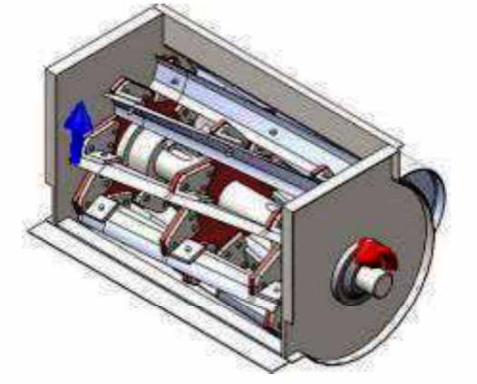

Figure 2.1.2: The chopper with the motor and fore attached
Ethiopia’s livestock population is the largest in Africa, however different factors or constraints limit the full exploitation of the agricultural sector in general and the livestock sub sector in particular. In the country, the availability, quality and quantity of feed has always been a challenge in the livestock sector. Poor feed resources management, especially those of the bulky and fibrous crop residue is one of the constraints. Forage chopping is considered to be part of crop residue management, a common process done by most local farmers in livestock feeding. This process is laborious and takes more. To alleviate this, using forage chopper is an important remedy. The primary goal of this study was to design, fabricate, and evaluate the performance of the forage chopper machine. The performance of the machine was evaluated using sorghum forage variety (Chelenko) with treatments of the engine seed, feed rate and feed thickness using factorial design with three replications. The heights mean chopping capacity of (581.24 kg/h), the finest of (shortest) mean cut length (6.23 mm), the heights chopping efficiency of (0.97) and the mean lowest fuel consumption of (0.50 ml/s) was recorded. The operation speed was observed to be highly significant among the treatments, at significance level of 0.01. Based on the result obtained, it is recommended to use a power source with higher horse power and speed and electric motor in areas where electric power is available to avoid vibration.

Figure 2.1.3: Proto type of the chopper
Maize and sorghum stalk considered among the most fodder materials in Ethiopia. Therefore the chop machine was adapted and evaluated. The research was conducted at Asella Agricultural Engineering Research Center (AAERC), Arsi Negelle and Zuway Dugda districts to evaluate the machine performance in terms of chopping efficiency, throughput capacity, cutting efficiency and fuel consumption at different speed of cutter shaft. The output of chopper was found to be remarkable achievement. The chopping efficiency was decreased from 97.28 to 92.43 % on maize stalk and 95 to 90.2 % on sorghum stalk as rpm increases from 1150 to 1850 respectively. Throughput capacity of chopper was increases from 8.13 to 12.6kg/min on maize stalk and 10.26 to 14.5 kg/min on sorghum stalk as rpm increases from 1150 to 1850 respectively. The mean of chopping length and cutting efficiency of 3.5 cm and 96.64 % on maize and also 2.53 cm and 97.63 % on sorghum stalk respectively.

Figure 2.1.4: Chopper Machine and Main Parts
This study is designed and fabricated in order to help people particularly farmers who engaged in forage in order for them to produce a voluminous forage in less time easily. The primary goal of this study was to design, fabricate, and evaluate the performance of the forage chopper machine. The study specifically aimed to evaluate the performance of the machine using three different diameter pulleys in terms of: 1) Throughput Capacity (kg/hr), 2) Chopping Capacity (kg/hr), 3) Chopping Recovery (%), 4) Machine Efficiency (%), and 5) Percent Loss (%). The sample used to evaluate the performance of the machine was a constant feeding rate of 500 grams of a freshly harvested Napier Grass (Pennisetum purpureum). There were three treatments namely T₁(3-inch diameter pulley), T₂ (4-inch diameter pulley), and T3(5-inch diameter pulley). Three replications for every treatment were used. During the data gathering, the time of chopping for every 500 grams of sample that was fed was measured. Also, the output or the chopped materials were sorted into two (accepted output and unaccepted output) and weighed using a weighing scale. The study revealed that the difference in diameter pulley greatly affected the chopping capability as well as the chopping uniformity of the machine. It was also observed during the data gathering that the use of bigger diameter on the machine gave much better result which led on much higher machine efficiency. The highest throughput capacity was the T3 (5-inch diameter pulley) that has the fastest speed among the three treatments. As to the chopping, the highest chopping capacity was T3 (5-inch diameter pulley) that has the faster speed among the three treatments. As to the chopping recovery, the highest chopping recovery was the T1 (3-inch diameter pulley) which has the slowest speed among the three treatments. The highest machine efficiency was the T3 (5-inch diameter pulley) which has the fastest speed among the three treatments. The highest percentage of loss was the T1 (3-inch diameter pulley) which has the slowest speed among the three treatments.

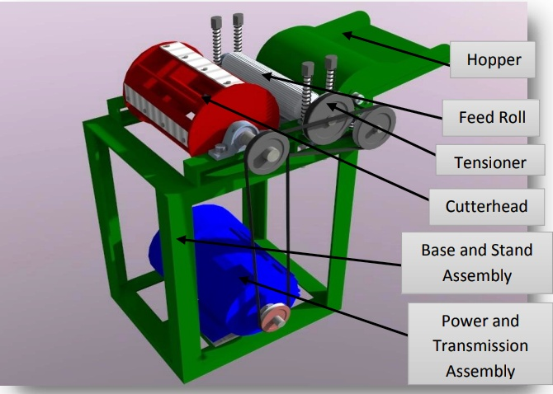

Figure 2.1.5: Main Component of the Forage Chopper Machine

2.2 CONCEPT OF FORAGE CHOPPER MACHINE
A forage chopper machine is a mechanized device used in agricultural settings to chop or shred forage crops such as grasses, sorghum, maize stalks, leguminous plants, and other fibrous materials into smaller, digestible pieces. These machines are vital in modern livestock farming because they significantly enhance the efficiency of feed utilization and reduce the physical labor involved in traditional forage processing methods (Okonkwo & Ezeano, 2019).
The primary purpose of a forage chopper machine is to prepare animal feed that meets nutritional and physical requirements suitable for the digestive systems of ruminant animals like cows, sheep, and goats. When forage is chopped into smaller sizes, it increases the surface area, making it easier for animals to chew and digest, thus improving nutrient absorption and minimizing feed wastage (Adebayo, Aluko, & Olanrewaju, 2020).
Traditionally, farmers used manual tools like machetes and sickles to cut forage. However, these methods are not only labor-intensive and time-consuming but also result in inconsistent forage lengths and higher risks of injuries (Ibrahim & Garba, 2018). The development of forage chopper machines addresses these issues by offering faster, safer, and more uniform processing of fodder.
The design and functionality of forage chopper machines can vary depending on the intended use, the scale of operation, and the available power source. They can be classified into the following categories:
- Manual Forage Choppers: Operated by hand using a crank or handle. Suitable for small-scale or subsistence farmers with limited resources. While cost-effective, they are limited in capacity and require significant human effort (Usman, Bello, & Musa, 2021).
- Motorized or Engine-Driven Forage Choppers: Powered by electric motors or internal combustion engines (petrol or diesel). These machines offer higher chopping efficiency, require less human labor, and can process large quantities of forage in a short period. They are ideal for medium- to large-scale farms.
- Tractor-Mounted or PTO-Driven Choppers: These are heavy-duty machines attached to and powered by a tractor’s power take-off (PTO) shaft. They are highly efficient and used primarily in commercial farming and industrial-scale livestock operations (Singh et al., 2021).
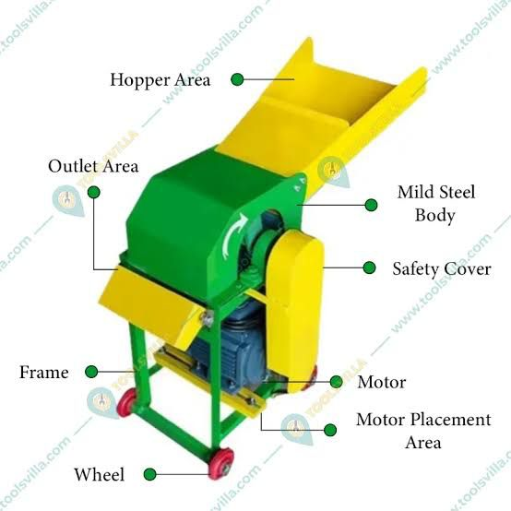
Regardless of the type, a typical forage chopper machine consists of the following main components: a feeding hopper or tray, a cutting unit (blades or knives), a rotating shaft, a transmission mechanism, a discharge outlet, a supporting frame or housing, and a power source. The interaction of these components results in efficient forage size reduction, contributing to better animal feed management and overall farm productivity (FAO, 2021).

Figure 2.2: Multiple Blade Rotary Chopper

2.3 TYPES OF FORAGE CHOPPER MACHINES
Forage chopper machines are categorized based on their mode of operation, source of power, size, capacity, and application. Understanding the different types of forage chopper machines is essential for selecting the right machine for a specific farming scale, available resources, and feed processing needs. The major types are:

Manual Forage Chopper Machines
Manual forage choppers are simple devices operated by human effort, typically using a hand crank or foot pedal. These machines are best suited for small-scale or subsistence farmers who may not have access to electricity or fuel-powered engines. Manual choppers are affordable, easy to maintain, and portable, but they are labor-intensive and limited in output (Ibrahim & Garba, 2018).
Features:
- No external power required
- Low maintenance cost
- Simple design and operation
- Suitable for chopping small quantities of forage
Limitations:
- Time-consuming and energy-draining
- Low productivity
- Unsuitable for large-scale operations

2. Motorized (Engine-Driven or Electric) Forage Chopper Machines
Motorized choppers use electric motors or internal combustion engines (petrol or diesel) as their power source. These machines are designed for medium- to large-scale operations where higher productivity is needed. The use of mechanical power significantly reduces labor and increases chopping speed and consistency (Adebayo et al., 2020).

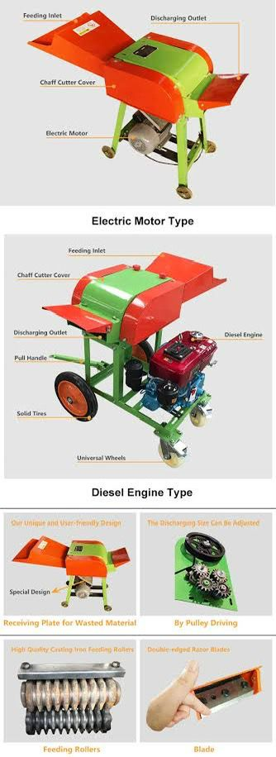

Types:
- Electric-Powered Choppers: Ideal for farms with access to electricity. They are quieter, environmentally friendly, and relatively low-maintenance.
- Petrol or Diesel Engine-Powered Choppers: Suitable for off-grid rural areas or where electricity is unreliable.

Features:
- High chopping capacity
- Less physical labor
- Uniform forage output
- More efficient and time-saving
Limitations:
- Higher initial cost
- Requires fuel or stable electricity
- Maintenance of engines/motors may be technical for rural farmers

3. Tractor-Mounted or PTO-Driven Forage Chopper Machines
These are high-capacity machines designed to be attached to tractors and powered by the tractor's Power Take-Off (PTO) shaft. They are commonly used in commercial livestock farming and agro-industrial settings (Singh et al., 2021). These choppers can handle large volumes of forage quickly and are often used in silage production.
Features:
- Extremely high output and efficiency
- Can be used directly in the field
- Designed for commercial farms
Limitations:
- Expensive and requires ownership of a tractor
- Requires skilled operation and regular maintenance
- Not suitable for smallholder farmers

4. Multi-Purpose or Combined Chopper-Grinder Machines
Some forage choppers are designed to perform additional functions such as grinding grains or mixing feed. These multi-purpose machines are useful in integrated livestock farms where different feed ingredients need to be processed simultaneously (Okonkwo & Ezeano, 2019).
Features:
- Versatile and time-saving
- Reduces the need for multiple machines
- Can chop, grind, and mix different feed components
Limitations:
- Complex design
- More expensive and may require specialized maintenance

5. Solar-Powered Forage Chopper Machines (Emerging Technology)
With the global emphasis on sustainable agriculture and renewable energy, solar-powered forage choppers are gaining attention. These machines use solar panels to generate electricity that powers the motor (FAO, 2021). They are especially valuable in off-grid locations.
Features:
- Environmentally friendly
- Ideal for rural, off-grid areas
- Low running cost after installation
Limitations:
- High initial cost of solar components
- Performance depends on weather and sunlight availability
The choice of forage chopper depends on multiple factors, including farm size, availability of power sources, financial capacity, and desired output. For small-scale farmers, manually operated or low-power motorized choppers may be most suitable. For larger operations, PTO-driven and motorized choppers offer the needed capacity. The continuous development of efficient, affordable, and locally fabricated choppers remains essential to support livestock productivity and sustainable agricultural development (Usman et al., 2021).

2.4 COMPONENTS OF A FORAGE CHOPPER MACHINE
A forage chopper machine is an assembly of various mechanical components that work together to chop forage materials efficiently. Understanding these components is essential for designing, fabricating, operating, and maintaining the machine. Each component plays a specific role, and the performance of the machine depends on the proper selection and integration of these parts. The major components of a typical forage chopper machine include:

1. Feeding Hopper or Tray
The feeding hopper is the inlet section where raw forage (grasses, maize stalks, legumes, etc.) is introduced into the machine. It guides the material toward the cutting blades and ensures user safety by keeping hands at a safe distance from the moving parts.
Key Features:
- Usually inclined for easier feed movement
- Made from mild steel or galvanized sheet to resist corrosion
- Designed to prevent forage from bouncing out during operation

2. Cutting Unit (Blades or Knives)
The cutting unit is the heart of the forage chopper. It consists of sharp rotating blades or knives mounted on a shaft. These blades cut the forage into uniform pieces. The type, number, sharpness, and angle of the blades greatly influence the chopping efficiency.
Types of Cutting Blades:
- Straight blades
- Curved/sickle-shaped blades
- Serrated blades
Key Considerations:
- Made from high-carbon steel or stainless steel for durability and sharpness retention
- Must be regularly sharpened and properly aligned
- Should be replaceable and easy to maintain

3. Rotating Shaft
The shaft holds and rotates the cutting blades. It is connected to the power source (manual crank, electric motor, or engine) via a transmission system. The shaft must be strong enough to withstand the torque and rotational forces generated during operation.
Features:
- Made of solid steel or alloy steel for strength
- Must be properly balanced to avoid vibration
- Supported by bearings at both ends

4. Power Source
The power source provides the mechanical energy needed to rotate the shaft and blades. It can vary based on the type and scale of the machine:
- Manual: Crank or pedal-powered for small-scale operations
- Electric Motor: Common in semi-urban and urban farms
- Petrol/Diesel Engine: Used where electricity is unavailable
- Tractor PTO: For high-capacity choppers used in large farms

Considerations:
- Power rating (measured in horsepower or kW) must match the blade and shaft requirements
- Should be fuel-efficient and easy to start

5. Transmission Mechanism
This system transfers power from the source to the rotating shaft. It includes components such as:
- Belts and Pulleys
- Chains and Sprockets
- Gear Systems
Purpose:
- To adjust speed and torque
- To ensure smooth and safe operation
- To isolate vibrations and protect the engine/motor

6. Discharge Outlet or Chute
After cutting, the chopped forage exits through the discharge chute or outlet. It can be vertical or horizontal depending on the design and allows the processed feed to fall into a collection container, wheelbarrow, or directly on the ground.
Design Features:
- Should prevent clogging
- Should be made of smooth metal for easy forage flow
- May include directional fins for better control

7. Frame or Structural Housing
The frame holds all components together and provides structural support. It is typically fabricated from steel angles, pipes, or square tubes.
Characteristics:
- Must be strong, stable, and rigid
- Should resist corrosion and mechanical stress
- Should include provisions for mounting the motor and protective covers

8. Safety and Protective Covers
For safe operation, forage choppers include safety covers or shields to enclose rotating parts like belts, pulleys, and blades. These prevent accidents and reduce exposure to dust and debris.

9. Wheels and Handles (Optional for Mobility)
For portable machines, wheels and handles are added to ease movement around the farm. These are especially useful for manually operated or motorized units.
Each of these components must be carefully designed, fabricated, and assembled to ensure the overall effectiveness, safety, and durability of the forage chopper machine. Proper integration of these parts leads to increased chopping efficiency, reduced energy consumption, and improved feed preparation for livestock. When sourcing materials for fabrication, local availability, cost, and mechanical properties should be considered to ensure affordability and sustainability for end users, especially smallholder farmers.

2.5 THEORETICAL FRAMEWORK
The theoretical framework provides the foundation upon which the fabrication and functional analysis of a forage chopper machine are based. It draws from engineering principles, mechanical theories, and agricultural processing systems that explain how the various components of the machine interact to deliver efficient chopping of forage materials. The following theories support the conceptual and practical development of a forage chopper machine:

Theory of Machines and Mechanisms
This theory involves the study of mechanical systems and their motion. It is concerned with the design and analysis of machine components like gears, pulleys, shafts, and linkages. In the context of forage chopper machines, this theory is applied in:
- The motion of the rotating shaft that drives the blades
- The transmission system that connects the motor to the chopping mechanism
- The interaction between feeding, cutting, and discharge processes
Application in Forage Chopper:
- Ensures efficient power transmission with minimal energy loss
- Helps determine appropriate speed ratios for optimal blade rotation
- Aids in achieving uniformity in chopped material

Energy Conversion Theory
Energy conversion theory explains how energy changes from one form to another. In forage choppers, mechanical energy (either from manual input, electric motors, or combustion engines) is converted into kinetic energy used by rotating blades to chop forage.
Application in Forage Chopper:
- Helps determine the type and size of power source required
- Guides the conversion efficiency from motor to mechanical action
- Informs power loss management during operation

Cutting Theory (Mechanics of Cutting)
This theory addresses the process of material separation using mechanical tools. It defines parameters such as cutting force, blade geometry, sharpness, and cutting angle.
Application in Forage Chopper:
- Determines blade material and sharpness requirements
- Influences the number of blades and their configuration
- Reduces wear and tear by optimizing cutting mechanics

Ergonomics and Safety Theory
Ergonomics relates to the design of equipment that ensures ease of use, safety, and comfort for the operator. This theory is critical in the fabrication of agricultural machines to reduce operator fatigue and minimize the risk of accidents.
Application in Forage Chopper:
- Informs the design of feeding trays and protective covers
- Ensures safe distances between moving parts and the operator
- Helps reduce vibration and noise to improve user experience

Agricultural Mechanization Theory
This theory emphasizes the use of machines in agriculture to reduce labor, increase productivity, and enhance efficiency. It promotes the local fabrication of cost-effective machines suited to rural and semi-urban farming systems.

Application in Forage Chopper:
- Encourages simplification of design to suit local fabrication
- Supports the use of affordable, locally sourced materials
- Aims to reduce post-harvest forage losses through improved processing

System Design Theory
System design theory involves the integration of individual components into a coherent system that performs a specific function. It considers factors like efficiency, reliability, cost, maintainability, and sustainability.
Application in Forage Chopper:
- Guides the design of an integrated chopping system
- Supports modularity for easy repair and upgrading
- Promotes durable and efficient system performance over time
The fabrication of a forage chopper machine is not just a mechanical task but is rooted in several theoretical constructs that guide its design, functionality, safety, and efficiency. These theories offer a robust foundation for understanding how the machine performs under different operating conditions and how it can be improved to meet specific agricultural needs. By applying these principles, the resulting machine becomes both technically sound and practically applicable in real-world farming environments, particularly in rural and developing regions where sustainable solutions are most needed.

2.6 RESEARCH GAP
Despite numerous studies and practical advancements in the design and use of forage chopper machines across various regions and institutions, there remain notable gaps in research and development, particularly in the context of local application, affordability, and sustainability in rural and semi-urban areas of developing countries like Nigeria. These gaps highlight the need for innovative solutions that align with local economic, technical, and agricultural realities.

1. Limited Local Fabrication and Design Customization
Many forage chopper machines used in developing countries are imported and not tailored to local forage types, power availability, or user capacity. Studies show a lack of locally fabricated machines that are simple, cost-effective, and easily repairable using available materials and skills. The gap exists in:
- Designing machines suited to local crops like Napier grass, maize stalks, and cassava leaves
- Using materials that are affordable and accessible in local markets
- Ensuring parts can be fabricated or replaced by local artisans

2. Inadequate Focus on Smallholder Farmers’ Needs
Most existing forage choppers cater to large-scale, mechanized farming systems. Smallholder farmers, who represent the majority of livestock producers in Nigeria, are often left out. There is insufficient research into:
- Low-cost, manually or solar-powered choppers
- Portable and compact designs suitable for small farms
- Machines that can be operated with minimal technical knowledge

3. Lack of Integration of Renewable Energy Sources
While solar-powered agricultural tools are gaining traction globally, there is a lack of research and prototypes focusing on solar-powered forage chopper machines in Nigeria. The integration of clean energy remains under-explored, especially in remote areas where grid electricity is unreliable or unavailable.

4. Insufficient Ergonomic and Safety Design Studies
Ergonomics and user safety have not been adequately addressed in many forage chopper designs. Accidents and user fatigue remain concerns, especially with manually operated or poorly shielded machines. The research gap includes:
- Ergonomic studies on hopper height and feeding angles
- Safety shields and emergency stop mechanisms
- Vibration and noise reduction in engine-powered units

5. Poor Documentation of Performance Metrics and Field Testing
There is limited empirical data available on the actual field performance of locally fabricated forage chopper machines. Many designs are built and used without comprehensive testing on:
- Cutting efficiency and blade durability
- Fuel or energy consumption per kilogram of forage
- Output consistency and user feedback analysis

6. Limited Multi-Functionality and Innovation
Most current forage choppers perform a single function: chopping. However, livestock farmers often require integrated machines that can chop, grind, and mix different feed components. This multi functionality has not been fully developed or made affordable for local use.
The fabrication of a forage chopper machine presents a unique opportunity to fill these gaps by:
- Developing a simple, efficient, and affordable design
- Using locally available materials and tools
- Ensuring ease of operation and maintenance
- Incorporating ergonomic and safety features
- Exploring renewable energy options such as solar
- Conducting real-world performance testing
This project aims to address these issues by producing a prototype forage chopper that meets the practical needs of smallholder farmers in Nigeria and similar regions, thus contributing to improved livestock feeding, reduced manual labor, and enhanced agricultural productivity.

CHAPTER THREE
3.0 MATERIAL AND METHOD
The main components forage chopper. Based on the findings of previous experiments conducted by Shahi et al. (2014), the diameter of the cutting cylinder was 300 mm. The length of the cutting cylinder was 430 mm due to the length of the feed rollers being 400 mm. Four cutting blades were positioned at a 90o angle on the cutting cylinder. Based on the findings of prior tests, the sharpness angle of these blades was determined to be 35degrees (Tavakoli Hashjin, 2003). Figure 2 depicts the blade's sharpness angle and helix angle. Because the length of the machine's cutting cylinder, stationery knife, and chassis width is determined by the feed rollers' length, the machine's design process began with the feed rollers. The feed rollers had a length of 400 mm and a diameter of 65mm, with a pipe with a diameter of 25 mm serving as the roller axis in the middle of each roller
3.1 Material
This study has been carried out for the designing and development of fodder cutting machines. The developed of the machine will be carried out in the Workshop of the Department of Farm Machinery and Power, University of Agriculture, Faisalabad.
3.1.1 Materials Selection for the Study
Based on the design calculation, appropriate semi-finished and finished materials for making the different component parts of the device were, selected. The selection of materials was made based on their quality, strength, affordability and availability of the material in the study area.
S/N | Components | Material
1 | Main Shaft | Mild Steel
2 | Worm &Worm Gear | Cast Iron
3 | Feed Rolls | Cast Iron/Mild Steel
4 | Cover plate | Cast Iron/Mild Steel
5 | Feed Roll Shaft | Cast Iron/Mild Steel
6 | Gears | Cast Iron
7 | Pulley | Cast Iron
8 | Blade | High Carbon Steel
9 | Legs | Mild Steel
10 | Leg Support | Mild Steel

Selection of Engine
A diesel engine was chosen and the specification on a name plate is:
Rated output = 4.41KW
Rated speed = 2600RPM
Net weight = 60Kg
Selections of Transmission Drives
The power transmission drove for the machine will be Vee belt and pulley which is suitable for medium machine (Khurmi 2006).
Materials specification and Cost Analysis
Table 1 shows the components’ name (item description), materials, quantity required, unit cost and total cost of the material to construct each component

S/N | DESCRIPTION OF ITEM | QTY | UNIT (N) | AMOUNT (N)
1. | Engine 7.5Hp (Petrol or Gas) | 1 | 170000 | 170000
2. | High carbon steel 2 × 2 | 5 | 20000 | 20000
3. | Angle iron (bar) 4×4 | 10 | 8000 | 80,000
4. | Mild steel shaft | 1 | 18000 | 18000
5. | 40mm diameter chopper shaft | 4 | 10,000 | 40,000
6. | Galvanized pipe 10mm diameter | 6 | 5000 | 30000
7. | F16 bearing | 2 | 3500 | 7000
8. | 4” Screen (sieve high carbon steel) | 1 | 200,000 | 200,000
9. | Pulley cast iron 1.5m | 1 | 4,000 | 4,000
10. | Pulley cast iron 10m | 1 | 3500 | 3500
 | TOTAL |  |  | 572,500

3.2 Description of Component Part
The major components of the existing fodder cutting machine include:
(i) Electric Motor
(ii) BV-Belt Drive
(iii) Fly Wheel
(iv) Blade
- Main shaft
- Worm and gears
- Feed rollers
- Shear plate
- Feeding trough
- stand
Electric Motor
Electric motor is an electrical machine that is used to change electrical energy into mechanical energy. For little load, as in family unit application in fans. Albeit customarily utilized as a part of settled speed benefit, enlistment engines are progressively being utilized with variable-recurrence drives (VFDs) in factor speed benefit. VFDs offer particularly critical vitality investment funds open doors for existing and forthcoming enlistment engines in factor torque divergent fan, pump and compressor stack application.
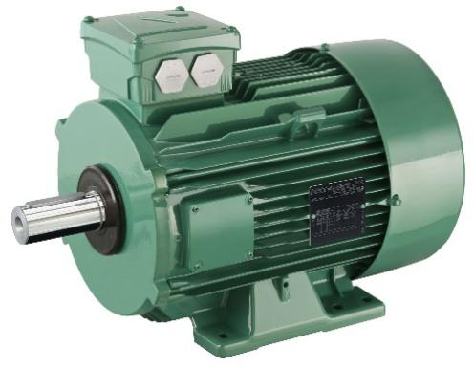

Figure 3.1: Electric Motor

BV-Belt Drive
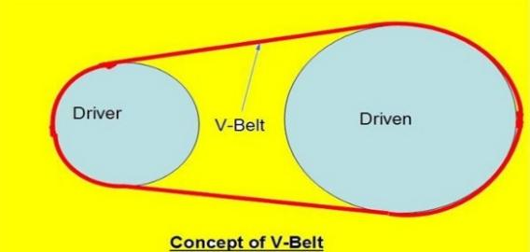
The V-belt has been in presence since the mid 1920's. As the years progressed, numerous changes are done in the utilization of material of V-belt development and fit as a fiddle too. Initially, V-belts appeared to supplant the level and round belts on car drives to guarantee more prominent unwavering quality. V belt drive plan is utilized to transmit control from engine to shaft which is associated with cutter system. The utilization of V-belts in different, permitted drives with a much factor scope of pull limit than any time in recent memory realistic utilizing single belt drives.

Figure 3.1.2: V-Belt Drive
Blade
Curved shape blades 1, 2 in number, are provided on a fodder cutter. These blades are made up of carbon steel or alloy steel. The function of the blade is to cut the fodder crops into smaller pieces suitable for animal feed. The blade is either fully or partially hardened. The length of the blade varies from 100-150 mm with a thickness in range of 2-2.50 mm. The cutting edge of the blade is made sharp by beveling it up to a length of 10mm. the blade is slightly curved towards its back.
Main Shaft:
This shaft made up of mild steel which is use for fitting the flywheel and transmitting the motion of the feeder roller through the worm and gear. The main shaft is strictly attached with the flywheel in its center whereas the other end is supported on a block through bearings. The length and diameter of the main shaft is kept about 40 and 3 cm respectively. The flywheel of fodder chopper rotates along its main shaft.
Worm and Gear:
These gears are used to transmit the power from flywheel main shaft to feed rollers. There are two gears placed on the upper side and other on the lower side of the worm. Each gear may have 11, 13 or 15 number of teeth’s. The worm is fitted on the main shaft and transmit power to both the gears when rotated through the main shafts. The pitch of the teeth on worm may varies with the length of the cutter of the fodder.
Feed Rollers:
There are two feed rollers, upper feed roller and lower feed roller, present in the fodder chopper. These rollers are made up of cast iron and have teeth’s on its periphery. The crop is first move between the rollers, which in turn grip the crop and then it move forward to the cutting head. The lower feed roller is fix while the upper feed roller is spring loaded which can move up and down depending upon the quantity of fodder being fed.
Shear Plate:
It is one of the component of the fodder chopper which is lie in the head assembly of the chopper. It gives support for the fodder crop being cut. The cutting of the fodder crop is done by the collectively mechanism of the shear plate and the blade. Shear plate is attach in front of the feed rollers. The clearance between the blade edge and shear plate is very critical for proper cutting. Clearance can be adjusted with the help of small bolts present on the flywheel arm.
Feeding Trough:
A feeding trough may be rectangular or trapezoidal in shape. It is made up of metallic sheet which is attached to the rare side of the shear plate and is generally hinged if needed. The minimum length of the trough is about 10cm. The crop is kept on the feeding trough for the support and is fed by pushing towards the cutting head.
Stand:
It is generally consist of four legs and is made up of angle iron. The whole machine is mounted over the legs. The minimum height of the stand is approximately 75cm from the ground level for easy feeding of the crop in standing posture of the user.

3.3 WORKING PRINCIPLE
A chopper machine, in the context of fabrication and food processing, works by using rotating blades to cut or chop materials into smaller pieces. The specific working principle varies depending on the type of chopper, but generally involves a feed mechanism to deliver material to the cutting assembly and a system for collecting the chopped product.
Here's a more detailed breakdown:
- Feed Mechanism:
- Forage choppers: Use feed rollers or belts to pull material (like grass or hay) into the cutting chamber.
Nut choppers: May use a conveyor belt to feed nuts into the cutting mechanism.
Meat bowl choppers: The bowl itself rotates to bring the meat into contact with the blades.
Organic choppers: May use a hopper to introduce organic waste to the cutting mechanism.
2. Cutting Assembly:
Rotating blades:
These blades, often made of high-speed steel, are the heart of the chopping process.

Fixed knives:
In some designs, stationary knives are positioned to work with the rotating blades to ensure efficient cutting.
Cutting cylinder:
This component houses the rotating blades and is often part of a larger casing.
3. Collection and Discharge:
Outlet:
Chopped material is discharged through a designated outlet, which may have screens to control particle size.
Vibration:
·Some machines use vibration to further separate and grade the chopped material.
Scrapers and chutes:
In some machines, scrapers and chutes are used to move the chopped material into collection containers.
4. Control and Adjustment:
Speed control:
Many choppers allow for adjustments to the speed of the cutting mechanism or the feed rate, which can affect the size of the chopped particles.
Screen adjustment:
Some machines have screens with different mesh sizes that can be used to control the size of the final product.
5. Safety Features:
Enclosures:
Many chopper machines have enclosures to protect the operator from the moving parts.
Interlocks:
Some machines have safety interlocks that shut down the machine if the enclosure is opened during operation.
Examples of chopper machine types and their principles:
Forage chopper:
Designed for cutting hay, grass, and other crops into small pieces for animal feed. Uses a combination of rollers and blades to feed and cut the material.
Nut chopper:
Designed for chopping nuts into various sizes for use in food products. Uses a conveyor and rotating blades to chop and screen the nuts.
Meat bowl chopper:
A high-speed machine used in meat processing to chop raw meat and mix ingredients. Uses a rotating bowl and blades to chop and blend the meat.
Organic chopper:
Designed to chop organic waste into smaller pieces for composting or other uses. Drawbacks of the existing machine:
Following are the drawbacks of the existing fodder chopper machine:-
1. Non uniform cutting of crops
2. Life risk
3. Old cutting technology
4. Less working capacity
3.4 Design modification of fodder cutting machine
The newly designed machine will consist of the following components:
(I) Electric Motor
(II) Belt Drive
(III) Shaft
(IV) Hopper
(V) Gear System
(VI) Blades
(VII) Housing
(VIII) Pulley
(IX) Side and Shear Plates
(X) Spike/Feeding Roller
(XI) Stand

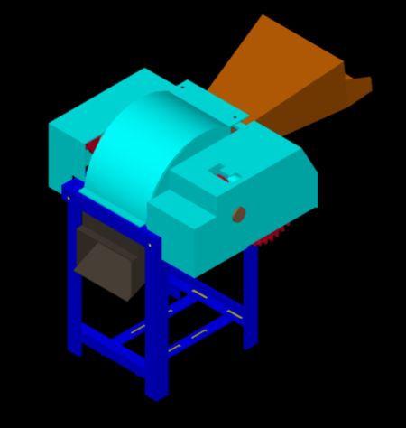

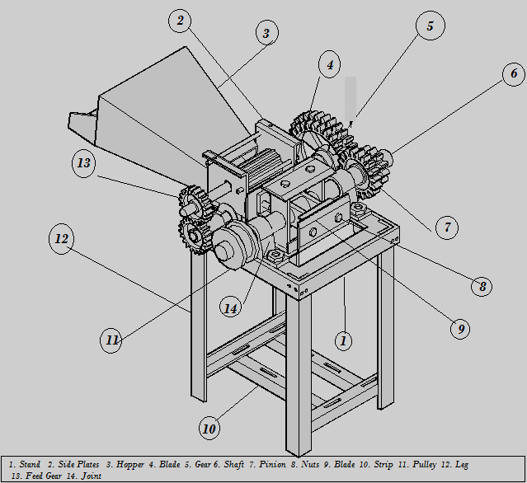
Fig.3.3.1 Modified Fodder Cutter Machine

Fig. 3.3.2 Modified Fodder Cutting Machine
Some of the newly developed machine parts are similar to the existing design like electric motor, BV-Belt drive, shaft, blade, stand which has already been discussed above. The details of the other machine parts is described below:

3.3.3 Hopper:
Hopper or Feeding Trough is used to feed fodder such as sugarcane, cutting grass etc. Hopper decides capacity of fodder cutter. The main purpose of hopper is provide direction to fodder and bring contact with cutting blade.
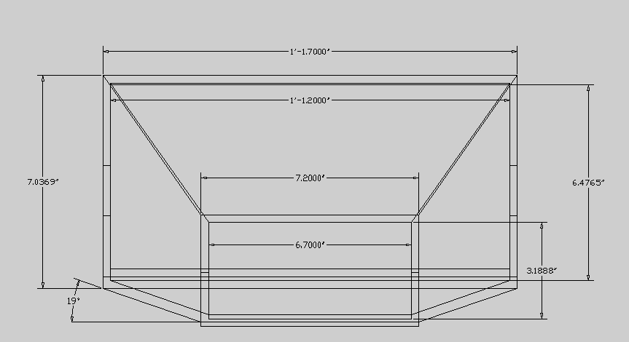 | 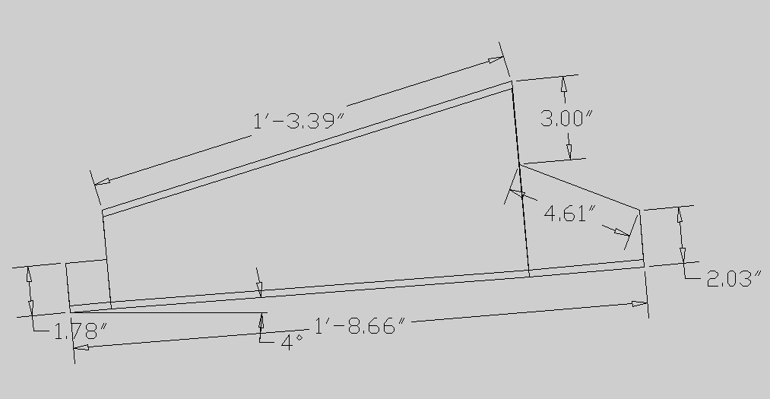
Fig.3.3.3 (Hopper 2D views and its dimension)

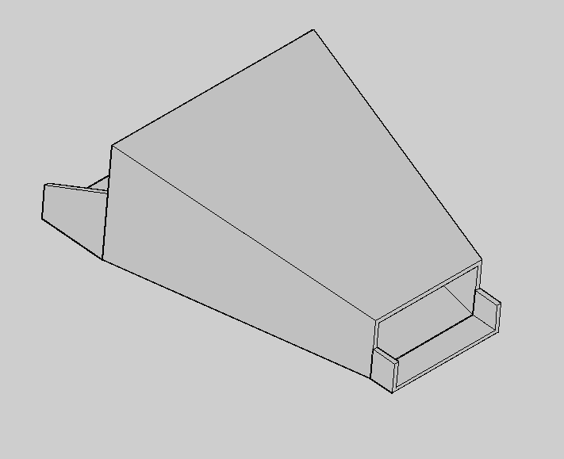

Fig.3.3.4 (Hopper 3D view)

3.3.4 Gear:
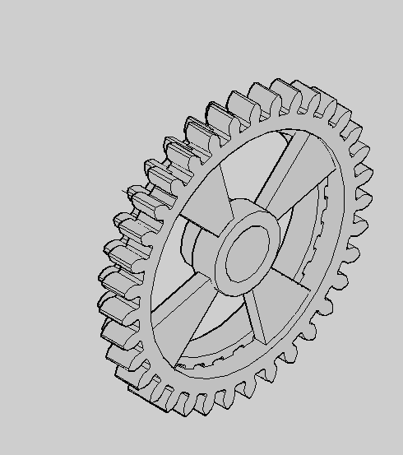
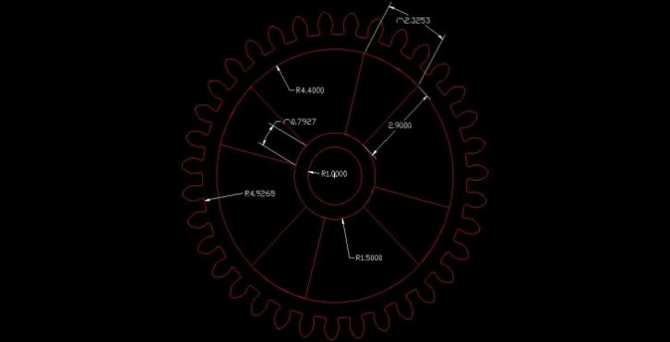
By changing the gear used, the speed can be adjusted to obtain various cutting lengths. These gears are used to transmit the power from main shaft to feeding rollers. There are six gears are used in this machine. First couple of gears have 12 and 35 number of teeth and second couple of gear have 18 and 30 number of teeth.

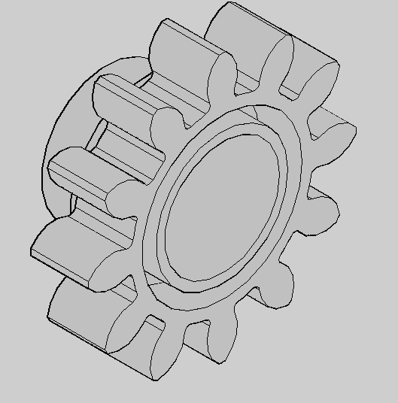
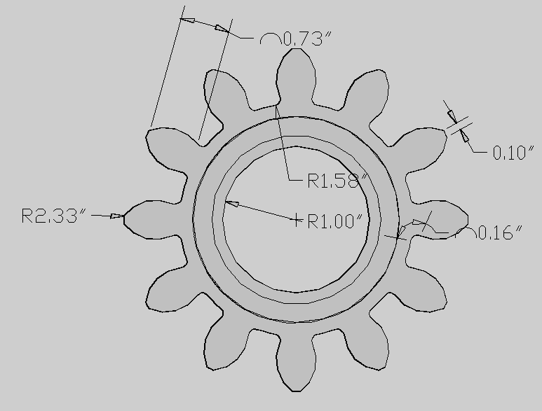

Fig. 3.3.6 (Front view and dimension of Pinion gear) Fig 3.3.7: (3D view of Pinion gear)

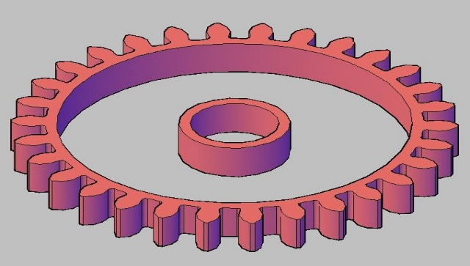
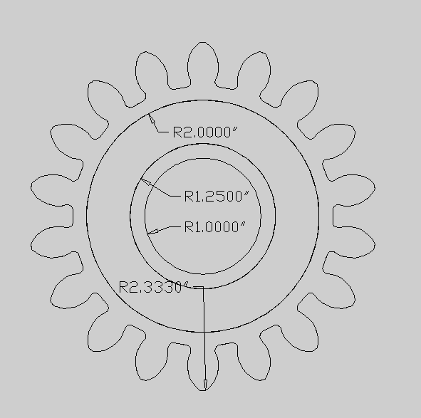

Fig. 3.3.8 (Front and dimension of gear) Fig.3.3.9 (3D view of gear)
3.3.5 Gear Feed:
These gears are used to transmit power from lower feeding roller to upper feeding roller.
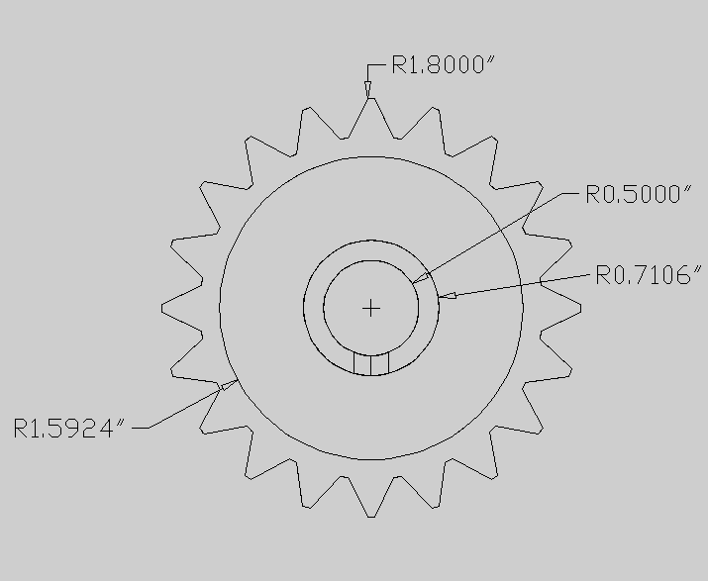 | 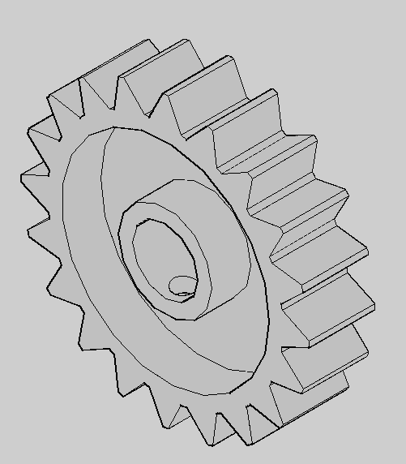
Fig.3.3.10 (Font view and dimension of Gear Feed) Fig.3.3.11 (3D view of gear Feed)
3.3.6 Blade:
These blades are made up of High carbon steel or alloy steel. The function of the blade is to cut the fodder crops into smaller pieces suitable for animal feed. There are four cutting blades used in this machine.
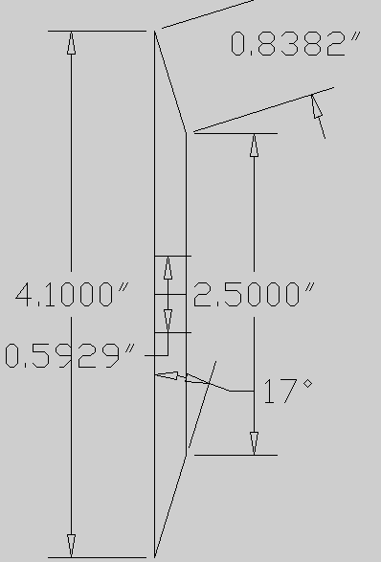 | 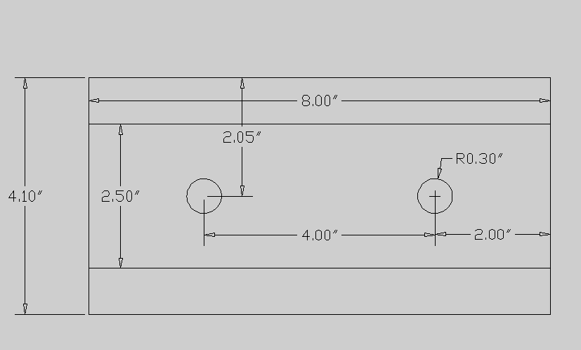
Fig.3.3.12 (Side view of Blade) Fig.3.3.13 (Top view of Blade)
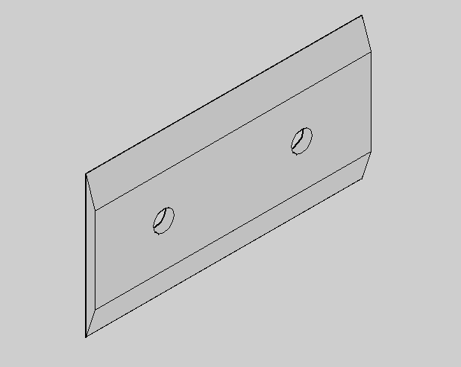
Fig.3.3.14 (3D view of blade)
3.3.7 Housing:
Housing covers the cutting sharp edge. Housing protects the person from not touching the cutting edges accidentally.
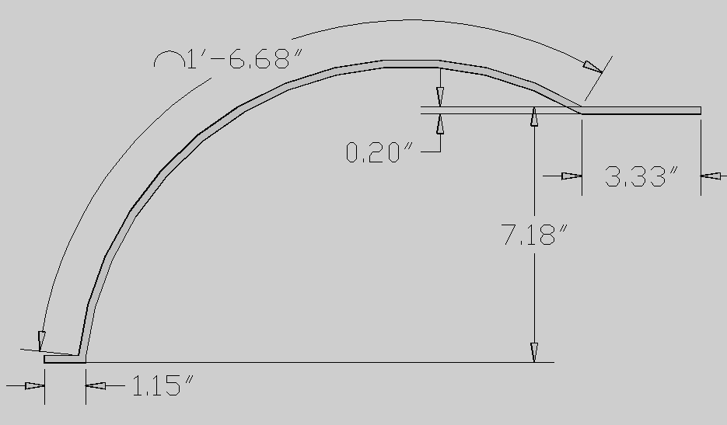 | 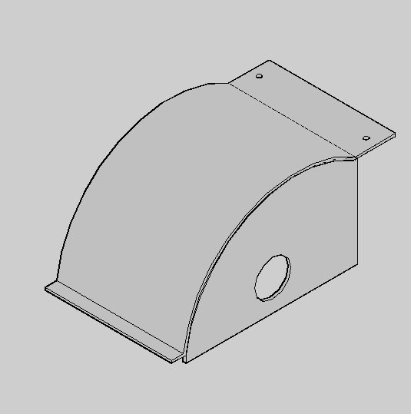
Fig.3.3.15 (2D view of Housing) Fig.3.3.16 (3D view of Housing)
3.3.8 Feeding Roller:
There are two feed rollers, upper feed roller and lower feed roller, present in the fodder chopper. These rollers are made up of cast iron and have teeth on its periphery. The crop is first feed to the rollers, which in turn grip the crop and then it move forward to the cutting blade. The lower feed roller is fix while the upper feed roller is spring loaded which can move up and down depending upon the quantity of fodder being fed.
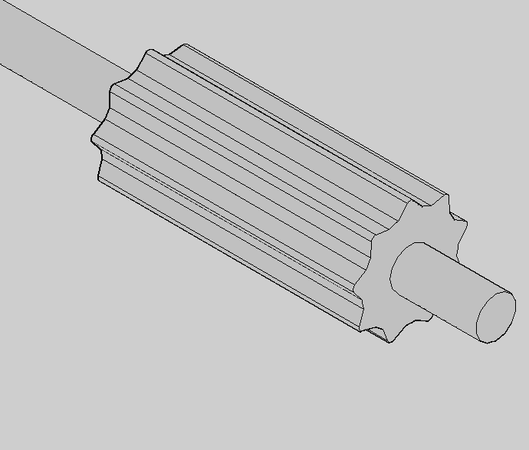
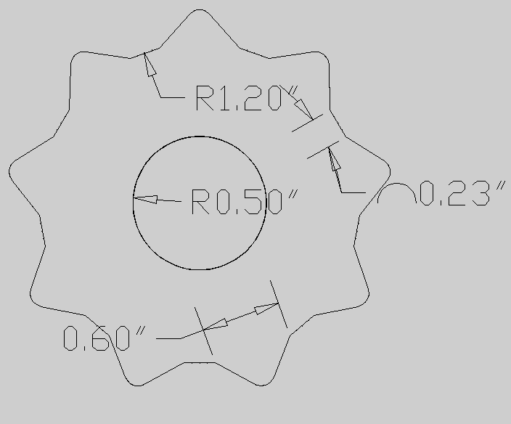

Fig.3.3.17 (2D view of feeding roller) Fig.3.3.18 (3D view of feeding roller)

3.3.9 Case Cover:
It is basically a metallic cover used to protect the machine from dust as well to avoid injuries. This is the main amendment made in our newly designed machine.
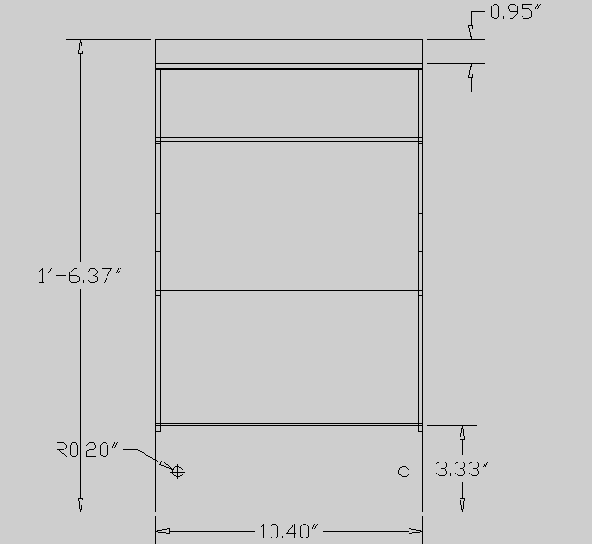
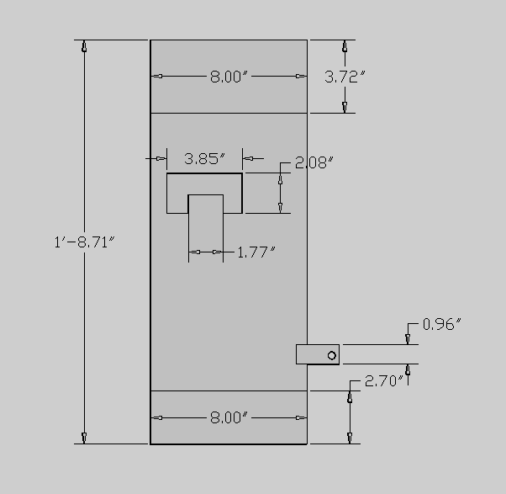

Fig. 3.3.18 (2D view of case cover) Fig. 3.3.19 (3D view of case cover)
3.3.10 Shear Plate:
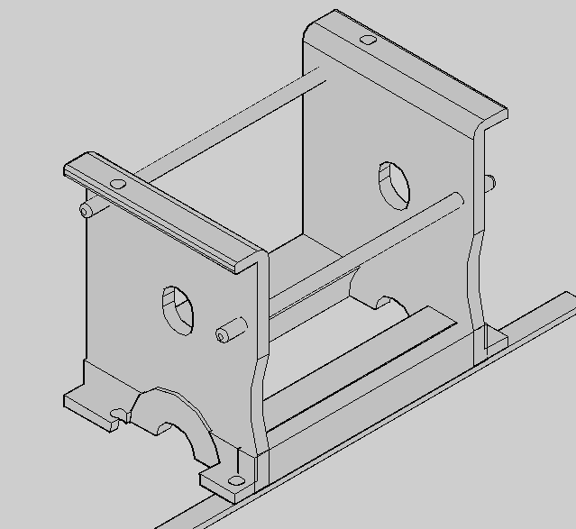
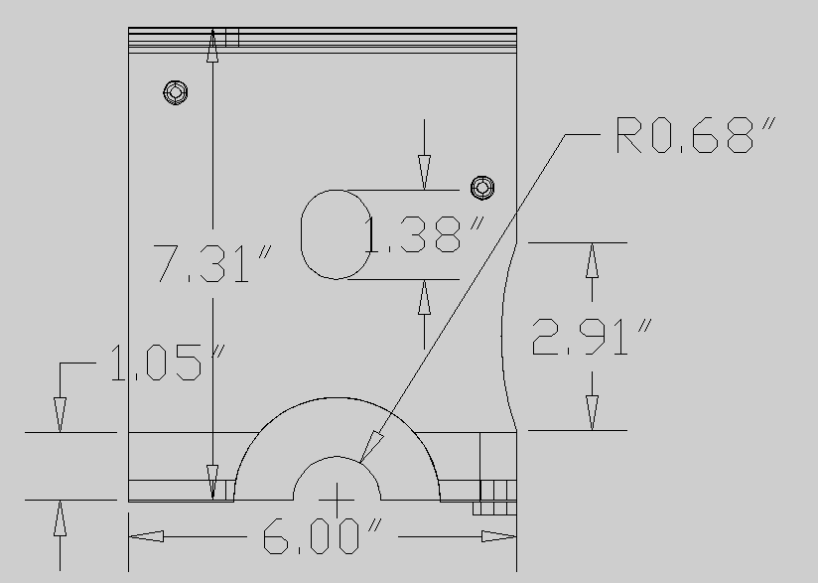
These are made up of hard metal steel plates. These plates act as the stationary member of the fodder cutting mechanism.
Fig.3.3.20 (Dimension of shear plate) Fig.3.3.21 (3D view of shear plate)

3.3.11 Joints:
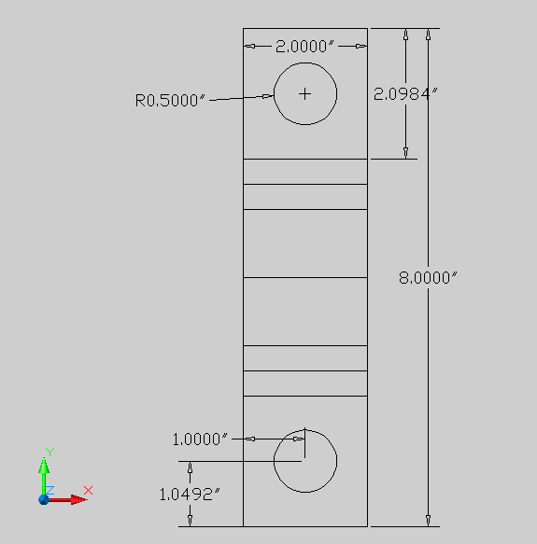
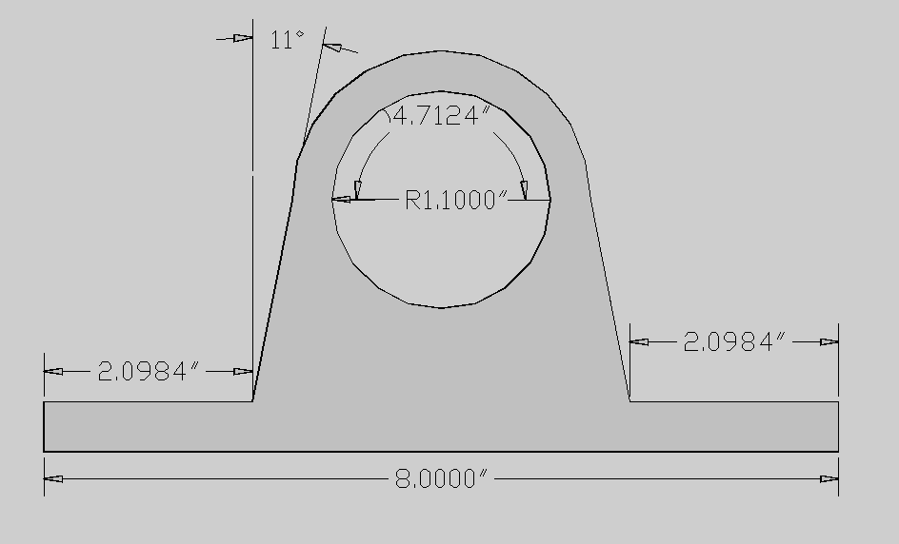
A joint is a rigid rod that allows the rod to "bend" in any direction, and is commonly used in shafts that transmit rotary motion. It consists of a pair of hinges located close together, oriented at 90° to each other, connected by a cross shaft.

Fig.3.3.22 (Front view of joints) Fig.3.3.23 (Top view supporting Joints)
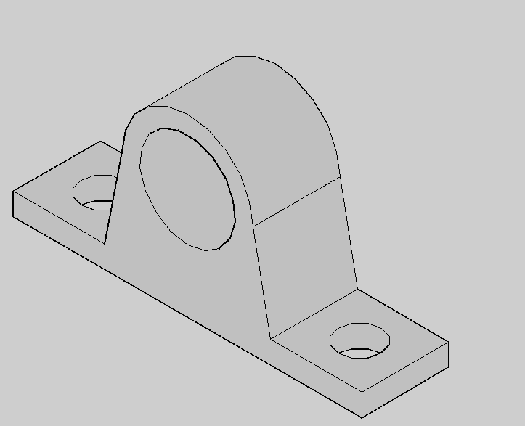

Fig.3.3.24 (3D view of joint)

3.3.12 Stand:
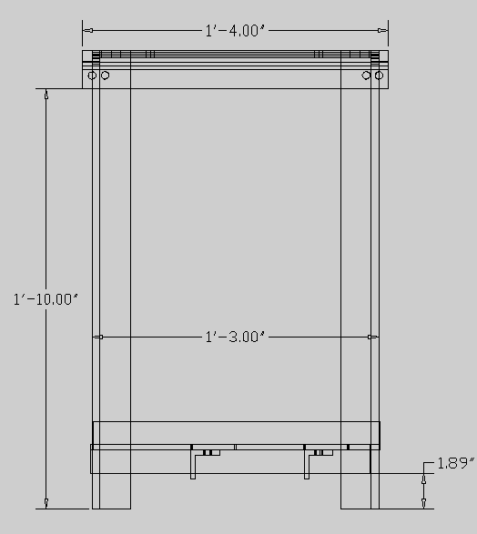
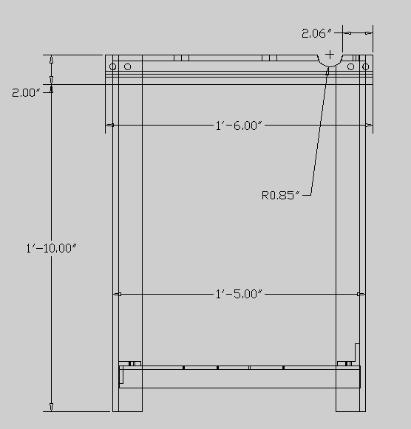
Stand of this machine consist of four legs. Legs supports whole of the machine’s parts. The leg made of mild steel. The dimension of stand 458 mm x 400 mm x 610 mm size.

Fig.3.3.25 (2D view of stand) Fig.3.3.26 (2D view of Stand)

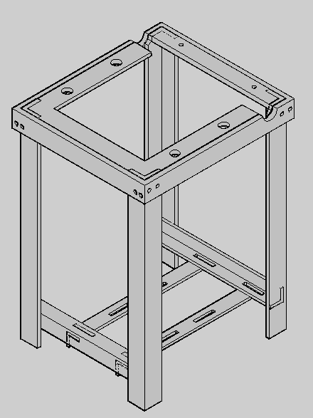

Fig.3.3.27 (3D view of Stand)

3.4 Design Specification
S/N | Type | Power Operated
1 | Type of Gear Box | Made by Cast Iron
2 | No of Rollers | 02
3 | No of Blades | 04
4 | Width of Mouth | 7.2inch
5 | Height of Mouth | 2.9 inch
6 | Output | 70-80kg/hr
7 | Approx. Weight | 80-90kg
8 | Motor speed | 1400 rpm
9 | Types of belt used | V-Belt drive

3.5 Design Calculation
This section presents design calculation for the shaft, belt, power input and power developed by the machine.
3.5.1 Shaft Design
This calculation is to determine the minimum shaft diameter that will be used by the chopping without failure. Bearing in mind that the shaft of the chopping camber will be subjected to circular moment. Therefore, tensional equation will be used to determine the suitable diameter of the shaft.
3.5.2 Torsion Shaft
To transmit energy by rotary, it is necessary to apply a turning force for a solid shaft of uniform circular cross section throughout its length, torsion theory state that,
$\frac{T}{J}= \frac{τ}{R}= \frac{GQ}{L}= \frac{M}{I}$ (Knurmi et al 2007) (3.5.1)
The poler moment of intertial of the shaft
$j= \frac{{πD}^{4}}{32}$ ………………. (3.5.2)
3.5.3 Average Power Transmission to the Shaft
The average power transmitted to the shaft is work done per minute. Consider a force F, acting tangentially on the shaft of radius R, if the shaft, due to this turning moment (F and R) start rotating at N.rpm, then work supplied to the shaft is equal to force times distance moved per second.
$P=Tω\left(r\right)=T\left(\frac{2πN}{00}\right)r$ (3.5.3)
3.5.4 Average Toque Transmitted to Shaft
Work done by the shaft for minute is equal to the average torque multiplied by the angle turned in a minute.
Average power $= \frac{2πNT}{60}$ ……………… (3.5.4)
Average torque $= \frac{average human power}{average vetocity }$ (3.5.5)
An average human power is one-tenth of a horse power. That is equivalent to 75N.
The shaft is expected to make 1.5rpm
From Equ (4) above,
$W= \frac{2πN}{60}= \frac{2 × π ×1.5}{60}=0.1570 rads/s$
From the Equation (5) the average torque:
$T= \frac{average human effort}{angular vetocity}$ (3.5.6)
$T= \frac{75}{0.1570}=477.71Nm$
Note: to determine the suitable diameter of the chopping machine, the maximum and not the average torque is considered. This is because the maximum shear stress developed is ensured to the safe limit.
$T_{max}=2 ×477.71 ×1999=955420Nmm$
From Equation (3.5.1)
$\frac{T}{J}= \frac{GQ}{L}$
Where,
$J= \frac{{πD}^{4}}{32}$
$\frac{T}{\frac{{πD}^{4}}{32}}= \frac{GQ}{L}$ (3.5.7)
Q = Angle of twist (assumed to be 1⁰)
$D= \sqrt[4]{\frac{955420 ×32 ×390 ×180}{0.8 × {10}^{5}n^{2}}}$
$D= \sqrt{2718264.331}$
D = 40.6mm = 41mm
3.5.5 Design for Vee Belt According to (Kurmin 2007)
$L=\frac{π}{2}\left(D_{2}+D_{1}\right)+2C\frac{(D_{2}-D_{1})^{2}}{4C}$ (3.5.8)
Data given
D₂ = 350mm
D₁ = $1/3$D₂ = 116.7mm
C = 0.85m = 850mm
Therefore
L = $\frac{3.142}{2}\left(350+116.7\right)+ 2\left(850\right)+ \frac{(350-116.7)}{4(850)}$
L = $1.571 \left(466.7\right)+ 1700+ \frac{54428.89}{3400}$
L = 733.2 + 1700 + 16.0
L = 2449.2mm
3.5.6 Power Output of the Machine According to Khurmi & Gupta 2010
Belt tension equation is given by $\frac{T_{1}}{T_{2}}=e\left(\frac{μφ}{sinB}\right)$ (3.5.9)
To get the value of T₁
T = T₁ = δ_{max} × a
A type V belt of area a
When T₁ is negligible
T = max belt tension
T₁= tight belt tension
δ = maximum shear stress of the belt = 7mPa = 7N/mm²
a = cross sectional area of belt = 375mm³
T₁ = δ_{max} × a
T₁ = 7 ×375 = 2625N
$φ=180-2$ (according to Khurmi et al 2007)
α = sin⁻¹ $\frac{r_{2}-r_{1}}{c}$
r₂ = $\frac{D_{2}}{2}$. D₂ = $\frac{350}{2}$= 175mm
r₁ = $1/3r_{2}$= 58.3
C = 450mm = 0.45m
Lap angle α = sin⁻¹⁺ $\frac{r_{2}-r_{1}}{c}$
α = $\frac{0.175-0.0583}{0.450}$
= $\frac{0.1167}{0.45}$ = 0.259
α = sin⁻¹ 0.0259 = 15⁰
α = 15⁰⁺
$$φ=180-2(15)$$)
=150^0
To convert it to radian
$$\left(φ×\frac{π}{180}\right)$$
$=150 ×\frac{3.142}{180}$
= 2.618 radian
Therefore
$\frac{T_{1}}{T_{2}}=e\left(\frac{φμ}{sinB}\right)=T_{2}=\frac{T_{1}}{e\left(\frac{μφ}{sinB}\right)}$ (3.5.10)
$β$ = grove angle pully 17.5
$μ$ = pulley belt contact of friction = 0.4
$φ$ = 2.618 radian
$$T_{2}=\frac{T_{1}}{e\frac{μφ}{sinB}}$$
$T_{2}=\frac{2625}{e\frac{0.4(2.618)}{sin17.5}}$
$$T_{2}=\frac{26.25}{e\frac{1.0472}{0.3}}$$
$$T_{2}=\frac{2625}{e^{3.49}}$$
$$T_{2}=\frac{2625}{32.786}$$
T₂ = 80.0N
3.5.7 Power Development by Machine According to (Khumin et al 2010)
Power P = TFr
Where T = torque = Fr
F = (T₁ – T₂)
ω = $\frac{2πN}{60}$ (3.5.11)
r = r₁ = 58.3mm = 0.0583m
t₁ = 2625N
t₂ = 80N
N = 3600rPm
P = (T₁ – T₂) r $\frac{\left(2πN\right)}{60}$
P = (2625 – 80) 0.0583 $\frac{\left(2×3.142×3600\right)}{60}$
P = 148.3735 × 377.04
P = 55942.7w
P = 55kw

CHAPTER FOUR

4.0 PERFORMANCE EVALUATION
After the data gathered, the following determinations were carried out:

Through put Capacity

The through put capacity was measured based on the sample’s input weight which is 500 grams divided by its chopping time in (kg/hr). The results were expressed as Replication1, Replication 2, and Replication 3. The mean value of the three measurements was also computed.

Chopping Capacity
The Chopping recovery was measured based on the weight of the accepted output divided by its chopping time. The results were expressed as Replication 1, Replication2, and Replication3. The mean value of the three measurements was also computed.

Chopping Recovery
The chopping recovery was measured based on the weight of the total output divided by its input weight multiplied by 100. The results were expressed as Replication1, Replication 2, and Replication 3.The mean value of the three measurements was also computed.

Percent Loss
Percent loss was computed based on the ratio if the difference of input weight and the accepted output weight divided by the input weight expressed in percent. The results were expressed as Replication 1, Replication 2, and Replication 3. The mean value of the three measurements was also computed.

Machine Efficiency
Chopping efficiency was computed based on the ratio of the accepted output and input. The results were expressed in percent. The results were expressed as Replication1, Replication2, and Replication3.The mean value of the three measurements was also computed.

Experimental Design and Data Analysis
The experimental design used in the calculation and analysis of statistical data are the Completely Randomized Design (CRD) and Duncan’s Multiple Range Test (DMRT). Analysis of Variance (ANOVA) was used to determine the differences among the treatment means.

4.1 RESULTS AND DISCUSSION
The variables or treatments of the study were the different diameter pulleys attached to the motor. Only one type of blade was used in the experiment. The treatments were T₁ (3-inch Diameter Pulley), T₂ (4-inch Diameter Pulley), and T₃ (5-inch Diameter Pulley). The weight of the Napier Grass in each trial is 500grams with different thickness and length. The procedures for getting the data were that the test material was feed into the machine’s hopper and was chopped. The chopping time and the output was then recorded. The outputs were classified as accepted and unaccepted. The classified outputs were weighed and recorded. The outputs were labeled according to the order of its treatments and replications. These processes were repeated three times for every treatment.
The tables below show the data that were gathered during the data gathering.
Table1: Data gathered of the first treatment T₁ (3-inch Diameter Pulley) with three replications.
Treatment Combination | Input(g) | Total Output(g) | Output Classification (g) |  | Total Losses(g) | Chopping Time(sec)
Treatment Combination | Input(g) | Total Output(g) | Accepted | Unaccepted | Total Losses(g) | Chopping Time(sec)
T₁R₁
T₁R₂
T₁R₃

Table 2: Data gathered of the second treatment T₂ (4 inch Diameter Pulley) with three replications.
Treatment Combination | Input(g) | Total Output(g) | Output Classification (g) |  | Total Losses(g) | Chopping Time(sec)
Treatment Combination | Input(g) | Total Output(g) | Accepted | Unaccepted | Total Losses(g) | Chopping Time(sec)
T₂R₁
T₂R₂
T₂R₃

Table3: Data gathered of the third treatment T₃ (5-inch Diameter Pulley) with three replications.
Treatment Combination | Input(g) | Total Output(g) | Output Classification (g) |  | Total Losses(g) | Chopping Time(sec)
Treatment Combination | Input(g) | Total Output(g) | Accepted | Unaccepted | Total Losses(g) | Chopping Time(sec)
T₃R₁
T₃R₂
T₃R₃

Through put Capacity
Through put capacity refers to the ratio of the input weight of Napier grass that was fed into the hopper and its chopping time.
Table 4 shows the Throughput Capacity of the Forage Chopper Machine fed by 500 grams of fresh harvest Napier grass with three (3) different treatments with three replications. As shown from the table that when the machine was loaded by the test material, T₃ has the highest Treatment Mean of Through put Capacity (488.42kg/hr), followed by T₂ (289.98kg/hr), and T₁ (202.49kg/hr). Subjecting the data to Analysis of Variance, Table 4 a shows a highly-significant treatment mean differences at 1% level of significance, which means that the three different sizes of pulley diameter affects significantly to the study of through put capacity.
The DMRT analysis in Table 4b shows that the Treatment T₂ (4-inch diameter pulley) and Treatment T₁ (3-inch diameter pulley) were significantly to differ Treatment T₃ (5-inch diameter pulley). Whereas, Treatment T₂ (4-inch diameter pulley) and Treatment T₁ (3-inch diameter pulley) were not significantly differ from each other.
This means that the chopping machine can have a highest throughput capacity when Treatment T₃ (5-inch diameter pulley) was used because of its fast rpm. Thus chopping time was faster. The DMRT also shows that whether Treatment T₂ (4-inch diameter pulley) and Treatment T₁ (3-inch diameter pulley) were used, the difference of the throughput capacity is negligible.
Table 4: Throughput Capacity of the Forage Chopper Machine in Kilograms per Hour Obtained from three Diameter Pulleys in Conducted in CRD Experiment with Three Replications
Treatments | Through put Capacity(Kg/hr) |  |  | Treatment Total | Treatment Mean
T₁(3”dia.pulley)
T₂(4”dia.pulley)
T₃(5”dia.pulley)
Grand Total
Grand Mean

Table 4a: Analysis of Variance of Table 4 (Throughput Capacity of the Forage Chopper Machine in Kilograms per Hour Obtained from three Diameter Pulleys Conducted in CRD Experiment with Three Replications)
Source of Variance | Degree of Freedom | Sum of Squares | Mean Squares | Computed F | Tabular F
 |  |  |  |  | 5% | 1%
Treatment | 2
Expt l Error | 6
Total | 8
CV = 15.85%
=highly significant 1% level
Table 4b: DMRT of Table 4a (Throughput Capacity of the Forage Chopper Machine in Kilograms per Hour Obtained from three Diameter Pulleys Conducted in CRD Experiment with Three Replications)
Treatment | Treatment Mean(Kg/hr)^{e} | DMRT
T₃(5inch-diameterpulley)
T₂(4inch-diameterpulley)
T₁(3inch-diameterpulley)

Treatment means having the same letter are not significantly different from each other at 5% significance level
Means of three replications

Chopping Capacity
Chopping Capacity of the machine is the ratio of the accepted output over the chopping time. Table 5 shows the Chopping Capacity of the Forage Chopper Machine when fed by 500grams of freshly harvested Napier Grass with three (3) different treatments with three replications. As shown from the table that when the machine was loaded by the test material, T₃ has the highest Treatment Mean of Chopping Capacity (450.42 kg/hr), followed by T₂ (258.31kg/hr), and T₁ (166.37kg/hr). Subjecting the data to Analysis of Variance, Table 5a shows a highly-significant treatment mean differences at 1% level of significance, which means that the three different sizes of pulley diameter affects significantly to the study of Chopping Capacity. The DMRT analysis (Table 5b) shows that the Treatment T₂ (4-inch diameter pulley) and Treatment T₁ (3-inch diameter pulley) were significantly differ to Treatment T₃ (5-inch diameter pulley). Also the table reveals that Treatment T₂ (4-inch diameter pulley) and Treatment T₁ (3-inch diameter pulley) were significantly differ from each other. This means that the machine can obtain a higher chopping capacity in Treatment T₃ (5-inch diameter pulley) compared to Treatment T₂ (4-inch diameter pulley) and Treatment T₁ (3-inch diameter pulley) because of its faster pm and higher value of acceptable output.
Table5: Chopping Capacity of the Forage Chopper Machine in Kilograms per Hour Obtained from three Diameter Pulleys Conducted in CRD Experiment with three Replication.
Treatments | Chopping Capacity(Kg/hr) |  |  | Treatment Total | Treatment Mean
T₁(3”dia.pulley)
T₂(4”dia.pulley)
T₃(5”dia.pulley)
Grand Total
Grand Mean

Table 5a: ANOVA Table of Table 5 (Chopping Capacity of the Forage Chopper Machine in Kilograms per Hour Obtained from three Diameter Pulleys Conducted in CRD Experiment with Three Replications)
Source of Variance | Degree of Freedom | Sum of Squares | Mean Squares | Computed F | Tabular F
 |  |  |  |  | 5% | 1%
Treatment | 2
Expt’ Error | 6
Total | 8
CV = 10.085%
= highly significant1%level
Table 5b: DMRT of Table 5a (Chopping Capacity of the Forage Chopper Machine in Kilograms per Hour Obtained from three Diameter Pulleys Conducted in CRD Experiment with Three Replications.)
Treatment | Treatment Mean(Kg/hr)^{e} | DMRT
T₃(5-inchdiameterpulley)
T₂(4-inchdiameterpulley)
T₁(3-inchdiameterpulley)

Treatment means having the same letter are not significantly different from each other at 5% significance level Means of three replications

Chopping Recovery
Chopping Recovery is the ratio of the total output and input material in percent. Table 6 shows the Chopping Recovery of the Forage Chopper Machine when fed by 500 grams of freshly harvested Napier Grass with three (3) different treatments with three replications. The table reveals that the Treatment T₁ has the highest Treatment Mean of Chopping Recovery (97%), followed by the T₂(96%), and T₃(95.66%). Subjected the data to Analysis of Variance, Table 6 a shows a Non-significant result of Treatment Means at 1% and 5% level of significance which means that the three different sizes of pulley diameter did not affect significantly to the study of Chopping Recovery.
Table 6. Chopping Recovery of the Forage Chopper Machine in Kilograms per Hour Obtained from three Diameter Pulleys Conducted in CRD Experiment with Three Replications.
Treatments | Chopping Recovery(%) |  |  | Treatment Total | Treatment Mean
T₁(3”dia.pulley)
T₂(4”dia.pulley)
T₃(5”dia.pulley)
Grand Total
Grand Mean

Table 6a. ANOVA of Table 6 (Chopping Recovery of the Forage Chopper Machine in Kilograms per Hour Obtained from three Diameter Pulleys Conducted in CRD Experiment With Three Replications.)
Source of Variance | Degree of Freedom | Sum of Squares | Mean Squares | Computed F | Tabular F
 |  |  |  |  | 5% | 1%
Treatment | 2
Expt’l Error | 6
Total | 8
Cv = 0.90%
^{ns} = not significant

Percent Loss
Percent loss is the ratio of the difference of the input weight and the accepted output weight divided by input weight expressed in percent. Table 7 shows the Percent Loss of the Forage Chopper Machine when fed by 500 grams of freshly harvested Napier Grass with three (3) different treatments with three replications. The table reveals that the Treatment T₁ (3-inch diameter pulley) has the highest Treatment Mean of Percent Loss which is (17.66%), followed by T₂ (11.13%), and T₃ (7.66%) respectively. Subjecting the data to Analysis of Variance, Table 7a shows a highly significant treatment mean differences at 1% level of significance, which means that the three different sizes of pulley diameter affects significantly to the study of Percent Loss. The DMRT analysis (Table 7b) reveals that Treatment T₂ (4-inch diameter pulley) and Treatment T₃ (5-inch diameter pulley) significantly differ to Treatment T₁ (3-inch diameter pulley). Also the table reveals that Treatment T₂ (4-inch diameter pulley) and Treatment T₃ (5-inch diameter pulley) does not significantly differ from each other. The Treatment T₁ has the highest Percentage Loss because it has the slowest revolution per minute (rpm) among the three treatments. It means that the faster the revolution per minute (rpm) the lesser the Percentage of loss.
Table 7. Percent Loss of the Forage Chopper Machine in Kilograms per Hour Obtained from three Diameter Pulleys Conducted in CRD Experiment with Three Replications.
Treatments | Percent Loss(%) |  |  | Treatment Total | Treatment Mean
T₁ (3-inchdia.pulley)
T₂ (4-inchdia.pulley)
T₃ (5-inchdia.pulley)
Grand Total
Grand Mean

Table 7a. ANOVA of Table7 (Percent Loss of the Forage Chopper Machine in Kilograms per Hour Obtained from three Diameter Pulleys Conducted in CRD Experiment with three Replications).
Source of Variance | Degree of Freedom | Sum of Squares | Mean Squares | Computed F | Tabular F
 |  |  |  |  | 5% | 1%
Treatment | 2
Expt’l Error | 6
Total | 8

Cv = 20.13%%
** = highly significant1%level
Table 7b. DMRT Table of Table 7 (Percent Loss of the Forage Chopper Machine in kg/hr Obtained from three Different Diameter Pulleys Conducted in CRD Experiment with three Replications.)
Treatment | Treatment Mean (%) ^{e} | DMRT
T₁(3-inchdiameterpulley)
T₂(4-inchdiameterpulley)
T3(5-inchdiameterpulley)
* Treatment means having the same letter are not significantly different from each other at 5% significance level
^{e} – Means of three replications

Machine Efficiency
Machine Efficiency is the ratio of the weight of the accepted output and input expressed in percent. Table 8 shows the Machine Efficiency of the Forage Chopper Machine fed by 500 grams of freshly harvested Napier Grass with three (3) different treatments with three replications. The table reveals that the Treatment T₃(5 inch-diameter pulley) has the highest Treatment Mean of Machine Efficiency which is (92.33%), followed by Treatment T₂ (88.86%), and Treatment T₁ (82.33%) respectively. Subjecting the data to Analysis of Variance, Table 8a shows a highly- significant treatment mean differences at 1% level of significance, which means that the three different sizes of pulley diameter affects significantly to the study of Machine Efficiency. The DMRT analysis (Table 8b) shows that the Machine Efficiency of Treatment T₂ (4-inch diameter pulley) does not significantly differ to Treatment T₃ (5-inch diameter pulley). Also the table reveals that Treatment T₁ (3-inch diameter pulley) significantly differ to Treatment T₂ (4-inch diameter pulley). It means that Machine Efficiency is lesser in Treatment T₁ which has a slower rpm compared to the remaining two Treatments. It also shows that the faster the rpm of the machine the better the result. Treatment T₃ (5-inch diameter pulley) and T₂ (4-inch diameter pulley) did not significantly differ from each other because they have both fast revolution per minute (rpm).
Table 8. Machine Efficiency of the Forage Chopper Machine in Kilograms per Hour Obtained from three Different Diameter Pulleys in CRDExperimentWithThreeReplications.

Treatments | Machine Efficiency(%) |  |  | Treatment Total | Treatment Mean
T₁ (3-inchdia.pulley)
T₂ (4-inchdia.pulley)
T₃ (5-inchdia.pulley)
Grand Total
Grand Mean

Table 8a. ANOVA of Table 8 (Machine Efficiency of the Forage Chopper Machine in Kilograms per Hour Obtained from three Different Diameter Pulleys Conducted in CRD Experiment with three Replications.)
Source of Variance | Degree of Freedom | Sum of Squares | Mean Squares | Computed F | Tabular F
 |  |  |  |  | 5% | 1%
Treatment | 2
Expt’l Error | 6
Total | 8

Cv = 2.78%%
** = highly significant1%level
Table 8b. DMRT Table of Table 8 (Machine Efficiency of the Forage Chopper Machine in Kilograms per Hour Obtained from three Different Diameter Pulleys Conducted in CRD Experiment with three Replications.)
Treatment | Treatment Mean (%)^{e} | DMRT
T₃ (5-inchdiameterpulley)
T₂ (4-inchdiameterpulley)
T₁ (3-inchdiameterpulley)
* Treatment means having the same letter are not significantly different from each other atsignificance level
5%
^{e} – Means of three replications
4.2 DESCRIPTION OF COMPARE PART
The Feed Roller
Cylindrical roll generally with protrusions or flutes, used to gather, compress and advance the crop into the cutter head. This Feed Roller is unique that it can adjust its clearance by moving vertically according to amount and volume to be fed into the hopper. This capability of the roller is due to its unique design by putting a two pair of spring each side of the shaft.
The Cutter head
Cutting rotor devices intend to cut the crop into short lengths with reasonable consistency within a range of optional settings.
Base and Stand Assembly
Base and stand assembly is considered as the backbone of the machine functioned to support mainly all the parts of the machine. This is made up of steel bars and heavy duty mild steel to assure the durability of the materials.
Power Transmission Assembly
Power transmission assembly is done by mechanical operation. This is made up of electric motor, belt, shaft and pulley.
Tensioner
Tensioner is used to tighten the belt to make a better grip between the pulley and the belt.
Design and Fabrication
The Forage Chopper Machine was fabricated at Seabreeze Machine Shop, Tambo Highway, Iligan City on March 2016. The design of the machine was based on the gathered information from the books and on the internet having the same concept as of forage chopper machine. On the basis of the related data gathered and with the data of the test material that was used. The design was based on the following criteria: (a) Availability of the materials, (b) Simplicity and ease of machine operation and repairs, (c) Adaptability of the machine to small-scale farm owners, and (d) Conformation to the PAES.

Parts of the Machine
The machine consisted of six (6) major components are as follows: (1) the feed hopper, (2) the feed roll, (3) the cutting assembly, (4) the frame stand assembly, (5) the power transmission assembly, and (6) the material outlet.
Materials and Instruments
The materials and instruments twere used in evaluating the machine are as follows: (1) Three different sizes of pulley diameter, (2) Weighing Scale, (3) Stopwatch, seconds: milliseconds, (4) Bolo, (5) Pen and Papers, (6) Sack, (7) Digital Camera, (8) Open and Adjustable wrenches, (9) Test Material (Napier grass).
Machine Operation
The forage chopper machine is generated by an electric motor which serves also as the heart of the machine having a speed of 1720 revolutions per minute (rpm). The electric motor is connected to pulleys of different sizes either driver or driven through the use of belts. The other parts of the machine are then functioning accordingly as to how fast the pulley is. Operating the forage chopper machine is simple. Just plug in the electric motor in the source, feed the forage 103 grass in the hopper and leave the rest in the machine. Just be sure to be attentive in operating the machine to prevent future complications. Unplug as soon as the operation is done.
Data Gathering Procedures
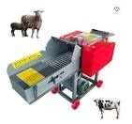
The following processes have been done in gathering the data are as follows: (1) All the necessary materials before testing the forage chopper machine must be gathered including all important tools needed in case of any adjustment to avoid failure in the operation, (2) The machine must run for a minute before feeding the desired grass to check the functionality of the machine and its parts, (3) A specific amount of forage grass will be feed at the hopper for chopping, (4) Never forget to jot down the time of the operation starts and ends, (5) The amount of the output after chopping must be weighed to any weighing scale, (6) After weighing, sort all the output and separate all the uncut grasses, (7) Again weigh the uncut grasses in any weighing scale, (8) Unplug the machine when notice any complication during the operation and as soon as the operation ends, (9) Repeat all the necessary instructions for the data gathering using other size of pulley diameter

CHAPTER FIVE

5.0 Conclusions
The study provides numerous critical findings demonstrating the performance and economic benefits of grass chopper equipment in sheep rearing. The chopper's fuel economy is the first conclusion. The machine uses 1 liter of fuel every 1.33 hours, which is efficient given livestock farming's constant feed processing need. Maintaining a constant engine speed of 3000rpm ensures fuel efficiency and consistent chopping performance. Running the machine for long periods with low fuel usage reduces operational expenses, allowing farmers to maximize profits while keeping a consistent supply of high-quality chopped grass for their sheep. The second conclusion concerns grass-chopping quality. Its 3000rpm engine speed is perfect for grass-chopping. The machine chops grass reliably at this pace, especially odot grass, a popular sheep feed. Odot grass, with a cutting length consistency of 46%, was optimal for feeding livestock due to its uniform size and digestibility. 3000 rpm is best for fuel efficiency for grass-chopping, but it makes the most noise at 102.1dB. This noise level is well beyond the acceptable threshold for continuous exposure, which may affect operator comfort and safety. Continuous exposure to such high noise levels without protection might damage hearing. Thus, personnel should wear earplugs or earmuffs when operating the machine at full speed. The machine's architecture could also be improved to reduce noise and preserve performance. The third conclusion emphasizes the economic benefits of sheep fattening with the chopper machine. The machine enhances feed preparation efficiency, resulting in a 513,750-rupiah monthly fattening profit per sheep. The sheep develop faster due to constant, high-quality feed, and the chopper machine reduces operational costs. Farmers maximize revenues with fuel efficiency, grass-chopping performance, and sheep productivity. The net profit per sheep throughout a five-month fattening cycle is 2,568,750 rupiahs, proving that grass cutter machines are profitable. Larger farms that fatten hundreds of sheep at once make much more money, helping them survive and succeed.
5.1 RECOMMENDATION
Recommendations are made to improve the performance of the machine as well as its efficiency. Recommendations with respect to my parameter areas follows: If ever you want a longer cut in forage crops to be feed, the use of higher speed in the feed roll is recommended. The speed of feed roll affects directly the length of cut of forage crops. The checking of the clearance between blades and the shear bar should be on a regular basis. During the conduct blade tends to move especially during along term used on the machine. The efficiency of cutting of forage does not only based on the machine’s speed itself but also on the blade and shear bar clearance. The teeth of the feed roll must be more emphasized to have a better grip of the forage stalks. The use of feed roll with much spikes is recommended. The use of wider opening on the material outlet is recommended so that the output material has no difficulty on its way out. The feeding table should be extended to not less than the length of an arm. This study might also become a reference for some students or researchers that are interested to conduct parallel study or propose another type of Forage Chopper Machine

REFERENCES
Adebayo, O. S., Aluko, O. B., & Olanrewaju, A. M. (2020). Development and performance evaluation of a motorized forage chopper for livestock feed. Nigerian Journal of Technological Development, 17(3), 72–78.

Adebayo, O. S., Aluko, O. B., & Olanrewaju, A. M. (2020). Development and performance evaluation of a motorized forage chopper for livestock feed. Nigerian Journal of Technological Development, 17(3), 72–78.

Adebayo, O. S., Aluko, O. B., & Olanrewaju, A. M. (2020). Development and performance evaluation of a motorized forage chopper for livestock feed. Nigerian Journal of Technological Development, 17(3), 72–78.

Bandiwadekar, C., Kamble, A., Vivek, G.Z.S., Patil, D.Y. (2016). Review Paper on Design & Development of Chaff Cutting Machine.

Bell, R. (2014).Conservation Agriculture for Small holders in Asia and Africa.

Chandrapal, S. (1997). Improved Fodder cutter.

“Cultivation and Utilization of Napier Grass”. http://www.kalro.org/fileadmin/publications/brochuresI/CultUtiliseNgrass.pdfRetrieved August 2016.

Dauda,S.M.,Ahmad,D.,Khalina,A.andJamarei,O(2015).EffectofCuttingSpeedonCuttingTorque andCuttingPowerofVaryingKenaf-StemDiametersatDifferentMoistureContents,38(4):549-561(2015).

Doughtie, V.L and Vallance, A. (1994). Design of Machine Elements, 4thEdition, Mc. Graw-hill Book., New York.

E.A.Lazaro,F.M.TurukaandN.S.Y.Mdoe(1999).IntroductionofForageChoppersinLivestock ProducionSystemsinTanzania,Volume4:90-91(1999).

Faires,V.M.(1999).DesignofMachineElements.4thEdition,McMillanCo.,NewYork.

FAO. (2021). The State of Food and Agriculture 2021: Making agrifood systems more resilient to shocks and stresses. Food and Agriculture Organization of the United Nations.

FAO. (2021). The State of Food and Agriculture 2021: Making agrifood systems more resilient to shocks and stresses. Food and Agriculture Organization of the United Nations.

FAO. (2021). The State of Food and Agriculture 2021: Making agrifood systems more resilient to shocks and stresses. Food and Agriculture Organization of the United Nations.

Fernandez,IanJude,etal.Design,ConstructionandEvaluationofChipping Machine,Thesis,Mindanao StateUniversity,MarawiCity,Unpubllished,2009

Gomez, K.A. and A.A Gomez (1990). Statistical Procedures for Agricultural Research. 2nd ed. An International RiceResearchBook.JohnWileyandSons,Inc.Singapore

H.Yokota,T.Okajima,M. Oshima(1991).Nutritive Value ofNapierGrass(PennisetumPurpureum Schum.)SilageEnsiledWithMolassesByGoats,Volume5(No.1)33-37.

http://www.veterinaryhub.com/economic-survey-of-pakistan-livestock-sector-
2013-2014/

Ibrahim, S., & Garba, M. (2018). Assessment of indigenous feed chopping techniques and the need for mechanization in northern Nigeria. Journal of Agricultural Engineering and Technology, 26(2), 50–58.

Ibrahim, S., & Garba, M. (2018). Assessment of indigenous feed chopping techniques and the need for mechanization in northern Nigeria. Journal of Agricultural Engineering and Technology, 26(2), 50–58.

Ibrahim, S., & Garba, M. (2018). Assessment of indigenous feed chopping techniques and the need for mechanization in northern Nigeria. Journal of Agricultural Engineering and Technology, 26(2), 50–58.

K.J.Shinners,R.G.Koegel,P.J.Pritzl(1991).AnUpwardCuttingCut-And-ThrowForageHarvesterto ReduceMachineEnergyRequirements,Volume34(6)

Karunya, M., Gowthami, E., Reddy, K.V.S.R., Pavani, I.S. (2015).Performance Studies On Power Operated Chaff Cutter With Paragrass Brachiariamutica.

Khope, P.B.,Modak, J.P. (2013).Design of experimentation for establishing empirical relationship of chaff cutting phenomenon energized by human powered flywheel motor.

Lazaro, E.A., Turuka, F.M., Mdoe, N.S.Y. (1997). Introduction of Forage Choppers in Livestock Production in Tanzania.

Mathur,S.M.andP.Singh(2004).ACylindricalChopperwithCrusherforWaterHyacinthVolumeand Biomass Reduction.

Mohan, D., Kumar, A., Patel, R., Varghese, M. (2004). Development of safer fodder-cutter machinesa case study from north India

Naseer, A.C., Azeem, M., Iqbal, M.Z., Asghar, A.C. (2015). Fodder Cutter Evaluation of Risk Factors.

“Napier Grass (Pennisetumpurpureum)”.http://www.Theroleandimportanceofnapie rgrassinthesmallholderdairyindustry.html.)RetrievedAugust2016

“Uses of Forage chopper”.http://www.full_story.php.html.RetrievedAugust2016.

Okonkwo, W. I., & Ezeano, C. I. (2019). Design considerations for small-scale forage processing equipment. Agricultural Mechanization in Africa, Asia and Latin

Okonkwo, W. I., & Ezeano, C. I. (2019). Design considerations for small-scale forage processing equipment. Agricultural Mechanization in Africa, Asia and Latin America, 50(3), 45–52.

Okonkwo, W. I., & Ezeano, C. I. (2019). Design considerations for small-scale forage processing equipment. Agricultural Mechanization in Africa, Asia and Latin America, 50(3), 45–52.

PNS/PAES 218:(2004). Agricultural Machinery– ForageChopper – Specifications. PNS/PAES219(2004).AgriculturalMachinery–ForageChopper–MethodsofTest. Tordillo, J.AS. (2009). Machine Design Reviewer. Cebu City, Philippines.

Singh, J. P., Kumar, R., & Yadav, R. S. (2021). Performance evaluation of a tractor-operated fodder cutter for silage production. International Journal of Agricultural Engineering, 14(1), 8–14.

Singh, J. P., Kumar, R., & Yadav, R. S. (2021). Performance evaluation of a tractor-operated fodder cutter for silage production. International Journal of Agricultural Engineering, 14(1), 8–14.

Usman, A. M., Bello, A., & Musa, M. S. (2021). Design and fabrication of low-cost forage chopper machine for rural farmers. International Journal of Engineering Research and Applications, 11(2), 35–41.
Usman, A. M., Bello, A., & Musa, M. S. (2021). Design and fabrication of low-cost forage chopper machine for rural farmers. International Journal of Engineering Research and Applications, 11(2), 35–41.

Usman, A. M., Bello, A., & Musa, M. S. (2021). Design and fabrication of low-cost forage chopper machine for rural farmers. International Journal of Engineering Research and Applications, 11(2), 35–41.

Y.YiljepandU.Mohammed(2005).“EffectofKnifeVelocityonCuttingEnergyandEfficiencyduring Impact Cutting of Sorghum Stalk.” Agricultural Engineering International: the CIGR EJournal.ManuscriptPM05004.Vol.VII.December,2005.

Zakiuddin, K.S., Modak, J.P. (2010). Application of pedal operated flywheel motor as an energy source for fodder chopper.

