TITLE PAGE
INVESTIGATION OF CAUSES OF CRACKS IN THE BUILDING WALLS AT BUDO-NUHU AREA, AIRPORT

By

Israel Ayodele BAMIDELE
ND/23/MPE/FT/0060

SUBMITTED TO:
THE DEPARTMENT OF MINERALS AND PETROLEUM RESOURCES ENGINEERING TECHNOLOGY INSTITUTE OF TECHNOLOGY, KWARA STATE POLYTECHNIC, ILORIN
IN PARTIAL FULFILLMENT OF THE REQUIREMENT FOR THE AWARD OF NATIONAL DIPLOMA (ND) IN MINERALS AND PETROLEUM RESOURCES ENGINEERING TECHNOLOGY

AUGUST, 2025

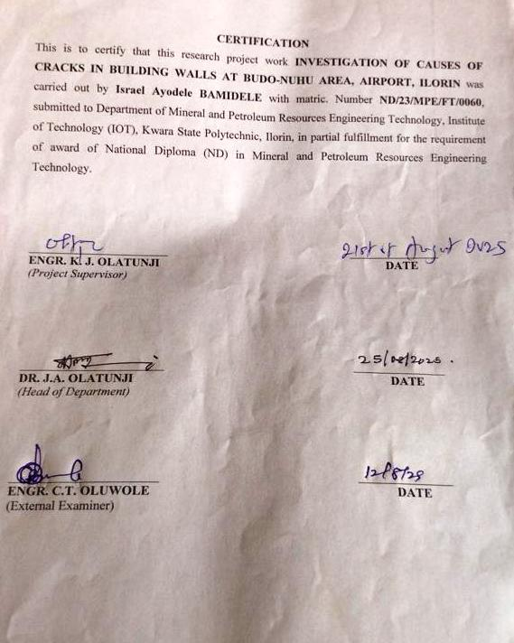

DEDICATION
I am delighted to dedicate this project to Almighty GOD, the creator of all universe who gave me the grace and opportunity to complete my ND program and this research, may His name be glorified.

ACKNOWLEDGEMENT

I exalt God of gods, King of kings, omnipotent God. I thank Him for His faithfulness. I thank Him for the protection against all evils; He is the same yesterday, today and forever. I thank Him for preserving my land; He is the one worthy of my adoration. The scripture says, “The horse is prepared for the day of battle, but the victory is of the Lord.” The Bible tells us “Unless the Lord builds a house, the work of the builders is useless. Unless the Lord protects a city, guarding it with sentries will do no good.”
My appreciation goes to my supervisor in person of Engr. Dr. Olatunji K.J. for a job well done and for his constructive criticisms. He is an epitome of an excellent supervisor.
I am grateful to my parents Mr. and Mrs. Bamidele and the entire family of Bamidele for their consistent and momentous support in terms of prayer, encouragement and financially.
I am also using this avenue to thank my H.O.D in person of Dr. Olatunji J.A. Also, my profound gratitude goes to my lecturers in person of Mr. Adelekan Engr. S. Agbalajobi. I pray that may God bless you all (Amen).
And I can't forget the people who well obliged me: Olagoke Oyakansola Shukurat, Bamidele Israel Ayodele, Ayinla ridwan Olabisi, Ibrahim Basambos Muhammad, Obatola Michael, Damilare. God bless you.

TABLE OF CONTENTS
Section | Page
Title Page | I
Certification | Ii
Dedication | Iii
Acknowledgement | Iv
Table of Contents | V
List of Tables | Vii
List of Figures | Viii
Abstract | Ix
CHAPTER ONE: INTRODUCTION | 1
1.0 Introduction | 1
1.1 Aims and Objectives | 2
1.2 Scope of the Study Area | 2
1.3 Problem Statements | 3
1.4 Justification of Study | 3
CHAPTER TWO: LITERATURE REVIEW | 4
2.0 Literature Review | 4
2.1 The Geotechnical Properties of Soil | 4
2.2 The Geophysical Methods of Subsurface Investigation | 7
2.3 Geotechnical Problems in Building Construction: A Detailed Review | 10
CHAPTER THREE: MATERIAL AND METHODOLOGY | 13
3.0 Material and Methodology | 13
3.1 Description of the Area | 13
3.2 Description of the Geotechnical Subsurface Properties of the Soil Using Geophysical Approach in the Study Area | 14
3.3 Determination of Geotechnical Subsurface Properties of Soil Using Geophysical Approach in the Study Area | 15
3.3.1 Atterberg Limits | 15
3.3.2 Shear Stress | 17
3.3.3 Sieve Analysis | 18
3.4 Investigating the Relationship Between the Properties and the Geophysical Properties of the Study Area | 19
CHAPTER FOUR: RESULT AND DISCUSSIONS | 20
4.0 Result and Discussions | 20
4.1 Geotechnical Properties of Soil in the Study Area | 20
4.1.1 Atterberg Limit | 20
4.1.2 Shear Stress | 21
4.1.3 Sieve Analysis | 23
4.2 Geophysical Properties of Soil in the Study Area | 25
4.3 Relationship Between Geotechnical and Geophysical Properties of the Soil | 27
CHAPTER FIVE: CONCLUSION AND RECOMMENDATIONS | 28
5.0 Conclusion and Recommendations | 28
5.1 Conclusion | 28
5.2 Recommendations | 29
References | 30

LIST OF TABLES

Table | Description | Page
Table 4.1 | Plasticity characteristics | 20
Table 4.2 | Shear stress of Sample A | 21
Table 4.3 | Shear stress of Sample B | 22
Table 4.4 | Shear stress of Sample C | 22
Table 4.5 | Percentage fraction of Sample A | 23
Table 4.6 | Percentage fraction of Sample B | 24
Table 4.7 | Percentage fraction of Sample C | 24
Table 4.8 | Lithologies and depth | 26

LIST OF FIGURES

Figure | Description | Page
Fig 3.1 | Map of Kwara State showing Ilorin South LGA | 13
Fig 3.2 | The map of study area | 14
Fig 3.3 | The picture of the Casagrande apparatus | 16
Fig 3.4 | The picture of the shear box and proving ring | 17
Fig 3.5 | The picture of sieve shaker, sieve pan and sieve lid | 18
Fig 4.1 | Normal Stress vs Shear stress (KN/m²) of Sample A | 21
Fig 4.2 | Normal Stress vs Shear stress (KN/m²) of Sample B | 22
Fig 4.3 | Normal Stress vs Shear stress (KN/m²) of Sample C | 23
Fig 4.4 | The resistivity of the first profile | 25
Fig 4.5 | The resistivity of the second profile | 25
Fig 4.6 | The resistivity of third Profile | 26

ABSRACT
This study investigates the geotechnical and geophysical properties of the subsurface of the soil in the Checking point area of Ilorin, Kwara state. The aim is to investigate the reason why buildings are cracking in the study area , standard geotechnical test were conducted on three samples which are labeled as (ABC)such as atterberg limits, sieve analysis and shear stress were conducted to determine the soil’s physical and mechanical behavior. The sieve analysis revealed that sample A is composed of very sandy Gravel soil, and sample B is gravelly sand soils and sample C is very sandy gravelly soil. Atterberg limit tests showed that sample A has a liquid limit of 27.5%plastic limit of 15.1% and plasticity index is 12.4%; sample B exhibited a liquid limit of 22.0%, plastic limit of 10.3%,plasticity index 24.5% , and sample C showed a liquid limit 24.5%, plastic limit of 11.5%. and plasticity index is 10.4%. Also the shear stress showed the angular fraction of sample A is 34 degree, sample B is 31 degree and sample C Angular fraction is 44 degree. Electrical resistivity imaging (ERI) method was carried out to evaluate subsurface condition and detect possible anomalies. The results revealed that the soil is predominantly sandy clay with moderate plasticity and fair to shear stress, indicating average load- bearing capacity. the geophysical data identified areas of low resistivity, suggesting zones of high moisture content or clayey layers. the combination of both methods provided a comprehensive under the subsurface conditions. This study emphasizes the importance of integrated soil investigation in minimizing construction failures and enhancing environmental planning.

CHAPTER ONE

1.0 INTRODUCTION
The subsurface of the earth is composed of various layers of soil, each with its own unique geophysical and geotechnical properties (Das,2010).
Understanding these properties, involves civil engineering, geology, hydrology and environmental Science. The geographical and geotechnical sublayers of the soil play a critical role in determining the behavior of the soil as those imposed by buildings, bridges and other infrastructure. (Kearney 2002; Das, 2010).
The geophysical sub-layers of the soil refers to the physical properties of the soil, such as its density porosity and permeability. These properties can be measured using a variety of geophysical techniques, including seismic and ground-penetrating radar. (Reynolds, 2012)
Geophysical survey help identify the sub-surface structures and properties of soil layers, while geotechnical investigations focus on the engineering properties of these layers. By integrating geophysical and geotechnical data, engineers and geologist can gain a comprehensive understanding of the sub-surface condition, which enables them to design safer, more efficient and more cost-effective infrastructure. ( Reynolds 2012; Sharma, 1997.)

1.1 AIMS AND OBJECTIVE
The aims of the topic is to determine why building are walls cracking in the study area and also to investigate in the study area.
Objectives

The objective carried out geophysical vertical sounding to investigate and carry out geotechnical test i.e sieve analysis atterberg limit and shear stress.

1.2 SCOPE OF THE STUDY
The study focuses on the geophysical and geotechnical evaluation of the subsoil layers in the study area. The scope of the study includes:
- A fields program to collect relevant geophysical data.
- Sample of soil and laboratory testing and taking analysis of collected sample.
iii. Interpretation of data

1.3 PROBLEM STATEMENT
Building cracks, are a common problem in the study area, this cracks can lead to structural damage, water infiltration and other hazard, the problem is often attributed to inadequate subsurface investigations and characterization of the soil properties, also particularly when the area is with expansive soil or unstable ground conditions.

1.4 JUSTIFICATION OF THE STUDY
The study is justified due to it providing valuable data on the geotechnical and geophysical properties of the soil in the study area, which is necessary for designing and constructing a stable building. The study will perform essential role to the development of more efficient methods for subsurface investigations.

CHAPTER TWO

2.0 LITERATURE REVIEW

2.1 GEOTECHNICAL PROPERTIES OF SOIL
Soil is complex, multiphase material that exhibits a wide range of geotechnical properties, including it’s strength, stiffness, compressibility and permeability. Understanding these properties is essential for designing and constructing safe and stable infrastructure, such as building, bridges and tunnels (Das 2010; Lambe and Whitman, 1979).
Strength properties
The strength properties of soil, including its compressive strength, tensile strength and shear strength are critical for designing and constructing infrastructure. Several studies have investigated the strength properties of different types of soil, including clay, silt, and sand,(Bishop and Henkel, 1963; Skempton, 1964; Holtz and kovacs,1981).
- The strength properties of soil depend on the type of soil, its density and it moisture content.
- The compressive strength of soil is its ability to withstand compressive forces without failing.
- The tensile strength of soil is it’s ability to withstand tensile forces without falling
- The shear strength of soil is its ability to withstand shear forces without failing (Das,2020).
Stiffness properties
The stiffness properties of soil, including its Young’s modulus and poissons ratio, are important for designing and constructing infrastructure that just withstand various types of loading. Several studies have investigated the stiffness properties of different types of soil, including clay, silt and sand (Jamiolkowski, 1985)
- The stiffness properties of soil depends on the type of soil. its density and its moisture content.
- The Young’s modulus of soil is a measure of its stiffness under compressive loading.
- The poissons ratio of soil is measure of its lateral strain under compressive loading,(Lamb and Whiteman, 1979).
Compressibility properties
The compressibility properties of soil including its compression index and swelling index are critical for designing and constructing infrastructure that must withstand various types of loading. Several studies have investigated the compressibility properties of different types of soil, including clay, silt and sand (Burland, 1990; Leroveil and Vaughan, 1990).
- The compressibility properties of soil depends on the type of soil, its density and its moisture content.
- The compression index of soil is a measure of its compressibility under compressive loading.
- The swelling index of soil is a measure of its swelling under compressive loading ( Das,2010; Lambe and Whiteman,1979).
Permeability properties
The permeability properties of soil, including its hydraulic conductivity and porosity, are important for designing and constructing infrastructure that must withstand various types of fluid flow. (Khanandhuang,1995;Mitchellandsoga,2005).
- The permeability properties of soil depend on the type of soil, its density, and moisture content.
- The hydraulic conductivity of soil is a measure of its ability to transmit ware under a given hydraulic gradient.
- The porosity of soil is a measure of its ability to store water.
2.2 GEOPHYSICAL METHODS OF SUB-SURFACE INVESTIGATION
Geophysical methods are non-invasive techniques used to investigate the sub-surface conditions of a site. These method are based on the principle of measuring the physical properties of the sub surface material, such as their density, magnetic susceptibility and electrical resistivity (Reynolds 2012; Kearney 2002).

Seismic Method
Seismic methods involve measuring the time it takes for seismic waves to travel through the sub surface materials. These methods can be issued to determine the depth and velocity of the sub surface materials, as well as their density and elasticity (Reynold 2012).
Reflection seismology: This method involves measuring the reflected seismic waves from the sub surface materials (Kearey, 2002).
Refractive seismology: This method Involves measuring the reflected seismic wave from the subsurface material (Reynolds, 2012).
Electrical Resistivity Tomography (ERT)
Electrical Resistivity Tomography (ERT) is a geophysical methods this involves measuring the electrical resistivity of the subsurface materials.
This method can be used to determine the depth and resistivity of the subsurface materials,as well as their moisture content and porosity (Reynolds,2012; Kearey 2002). There are several types of ERT methods including:
2D ERT: This method involves measuring the electrical resistivity of the subsurface materials in two dimension (Reynolds, 2012)
3D ERT: This method involves measuring the electrical resistivity of the subsurface materials in three dimensions.
Ground-penetrating Radar (GPR): GPR is a geophysical methods that involves measuring the reflected radar waves from the subsurface materials, This method can be used to determine the depth and velocity of subsurface materials, as well as their moisture content and porosity(Reynolds 2012; Sharma, 1997).there are several GPR methods including,
# 2D GPR: This method involves measuring the reflected radar waves from the subsurface materials in two dimensions (sharma, 1997).
# 3D GPR: This method involves measuring the reflected radar waves from the subsurface materials in three dimensions (Reynolds, 2012).
Magnetic Methods
Magnetic method involves measuring the magnetic susceptibility of the surface materials.
This method can be used to determine the depth and magnetic susceptibility of the subsurface materials as well as their money content and porosity (Reynold, 2012; Kearney2002).
There are several types of magnetic method including:
- Total fields magnetic survey: This method involves measuring the total magnetic fields of the subsurface material (Kearney, 2002).
- Gradient magnetic survey: This method involves measuring the gradient of the magnetic field of the subsurface materials (Reynold 2012).

2.3 GEOTECHNICAL PROBLEMS IN BUILDING CONSTRUCTION
Geotechnical problem can have a significant impact on building construction, leading to structural damage foundation failure and even collapse. (Das 2010)
These problems can arise from variety of sources including
Foundation problems
Foundation problem can occur when the soil or rock beneath the foundation is unable to support the weight of the building This can leads to settlements, cracking and even collapse of the building. (Lambe and Whiteman1979; Holtz and Kovacs; 1981).
Common foundation problem include:
- Soil settlement: soil settlement occur when the soil beneath the foundation compresses or settles causing the foundation to sink or shift (Das 2010).
- Soil erosion: soil erosion occurs when the soil beneath the foundation is washed or worm away ,causing the foundation to become unstable (Holtz and Kovacs,1981)
Landslide and slope stability problems
Landslide and slope stability problems can occur when the soil or rock on a slope become unstable leading to a landslide or slope failure (Huang 2009).
This can be caused by variety of factors including:
- Heavy Rainfall: Heavy rainfall can cause the soil or rock on a slope to become saturated leading to a landslide or slope failure (Lanbe and whiteman, 1979).
- Earthquakes: Earthquakes can cause the soil or rock on a slope to become unstable leading to landslide or slope failure (Kramer 1996).

Soil liquefaction problem
Soil liquefaction problem can occur when the soil became saturated with water and loses its strength leading to a loss of bearing capacity (Das 2010).
This can be caused by variety of factor including:
- Earthquakes: Earthquakes can cause the soil to become saturated with water and lose its strength leading to soil liquefaction (Kramer 1996).
- Flooding: flooding can cause the soil to become saturated with water and lose its strength leading to soil liquefaction (Lambe and whiteman,1979).
Expensive soil problem
Expensive soil problems can occurs when the soil expends and contract with changes in moisture content leading to structural damage and foundation problems (HoltzandKovacs,1981)
- Changes in moisture content: changes in moisture content can cause the soil to expand and contract ,leading to structural damage and foundation problems (Das 2010).
- Soil type: certain type of soil, such as sky soil, are prone to expensive behavior than other. (Lambe and whiteman, 1979).

CHAPTER THREE
3.0 MATERIAL AND METHODOLOGY
3.1 DESCRIPTION OF THE AREA
The study was conducted at checking point area in north central region of Nigeria. The checking point area is situated along a major highway leading into the city, serving as a major seeing and transport checkpoint. Geographically, Ilorin has between latitudes 8°24 and 8°36 N and longitude 14°30'E and 4°45'E.
The area experienced a tropical Savannah climate characterized by two main seasons. The rainy season (April to October). Average annual rainfall ranges from 100mm to 150mm and temperatures vary between 22°C and 35°C throughout the year.
Topographically, the area is generally flat to gently undulating, making its suitable for construction, road development and light agriculture. The dominant soil of the region is sandy loamy which supports moderate agricultural activities and drainages.
The checking point area is semi-urban with an increasing residential and commercial development. It is also an important transit zone, often experiencing heavy vehicles traffic due to it location on a major route into Ilorin.
The purpose of the study is to determine the geotechnical and physical properties of the soil within the checking point area.
Fig. 3.1 shows the location of the study area on the map of Asa LGA, Ilorin, Kwara State, Nigeria.
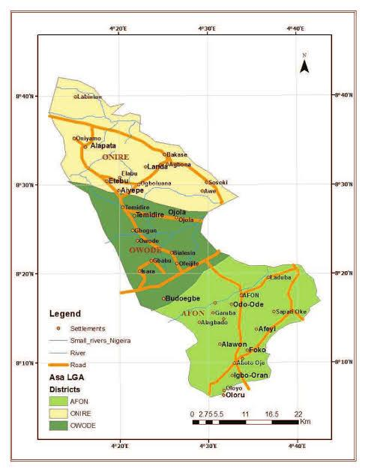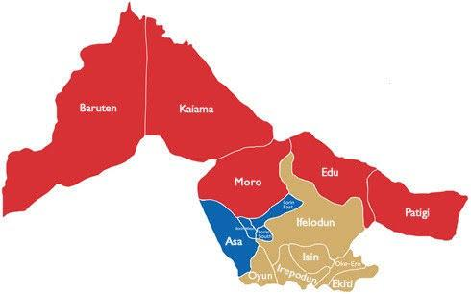
Fig. 3.1: the location of the study area on the map of Asa LGA, Ilorin, Kwara State, Nigeria.
Fig. 3.2 shows the picture of research team on field work.
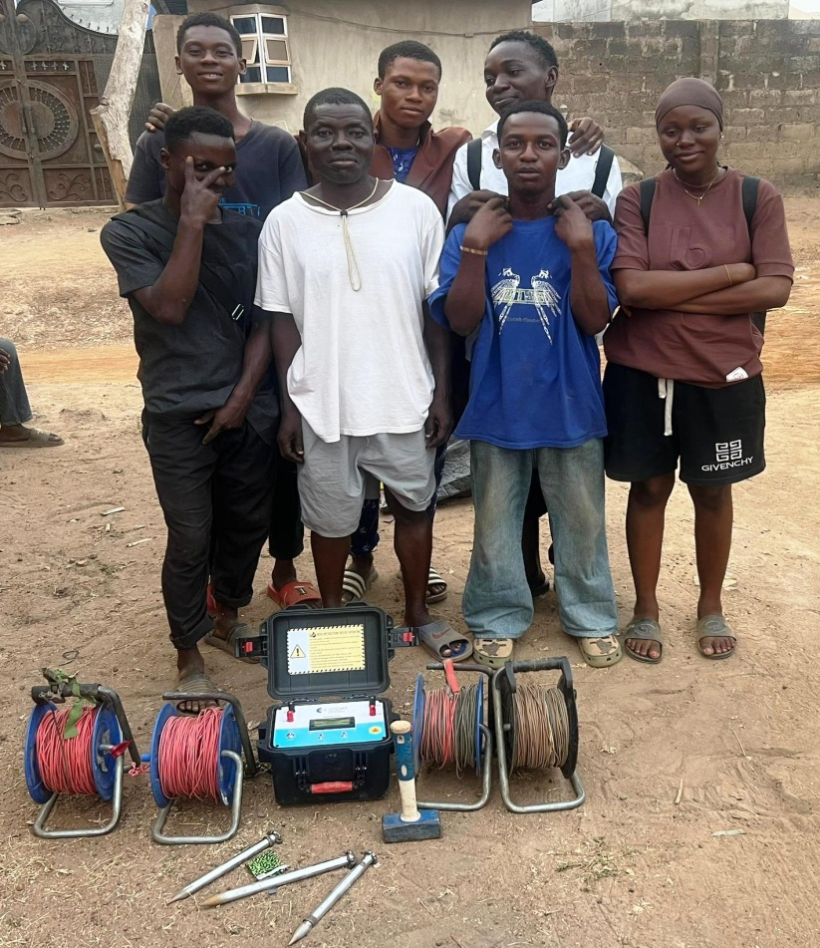
Fig. 3.2: Picture of research team on field work.
3.2 DESCRIPTION OF THE GEOTECHNICAL SUBSURFACE PROPERTIES OF THE SOIL USING GEOPHYSICAL APPROACH IN THE STUDY AREA
The geophysical approach to investigating geotechnical subsurface properties of soil involves the use of non-invasive method is evaluate the physical condition of subsurface material, this method help determine key soil properties such as density, moisture content, stiffness, stratification and depth to bedrock without the need for extensive drilling or sampling.
Material used in the study area
Material used are terrameter model Herojat plo
Electrodes cable clip, measuring meter, hammer, GPS instrument.
This following procedure were used for measuring the geophysical properties of the soil layers of the soil in the study area.
i. Site Preparations: the ground of the area was cleared and a straight line survey was selected where electrodes can be planted.
ii. Choosing an Electrode Configuration: there are different array types, but schlumberger array was used which has good depth penetration and high resolution.
iii. Electrode placement: Eight electrodes were used, four for current injection (c₁, c₂) and four for potential measurement (p₁, p₂). The electrodes were inserted to the ground along a straight line, also the electrodes was hammered deep to get high resolution.
iv. Connection of the cable: the electrodes were connected to the terrameter using color-cadel cables ensured tight connection good electrodes soil contact. Also the electrodes were placed at 5m current to 5m potential spacing.
v. Using of a handled GPS instrument: a hand GPS device was used in the study area to determine the latitude and longitude of the study area.
vi. Ground resistivity measurement: the terremeter was switched on and the electrode are set in spacing (AB/2) and (MN/2) set. The terremeter injects current (I) through the current electrodes and their voltage (V) across the potential electrodes were measured. The device calculates apparent resistivity (pa) using $Pa =K× \frac{V}{I}$ where (K) is the geometric factor depending on the spacing of the electrodes.
vii. Measuring electrodes spacing: To investigate deeper subsurface layers, the electrode spacings (AB/2 and MN/2) were increased. The spacing of the current electrodes was increased from 5 m to 10 m, along with adjustments to the potential electrodes. After taking the readings on the Terrameter, the spacing was further increased to 15 m, and additional readings were recorded. This approach helps to detect changes in subsurface resistivity, which are related to variations in soil layer composition, moisture content, and the presence of buried artifacts.
viii. Data recording: values of (AB/2), (MN/2) spacing, voltage (V), current (I) and apparent resistivity (Pa) were recorded. Measurements were also carried out two other profiles to create a 2D image of the subsurface.
ix. Data interpretation: the data taken were transferred to a computer for inversion using RES 20 INV software. The output resistivity or pseudo section showing different soil layers.

Fig 3.3 shows the terrameter model herojat
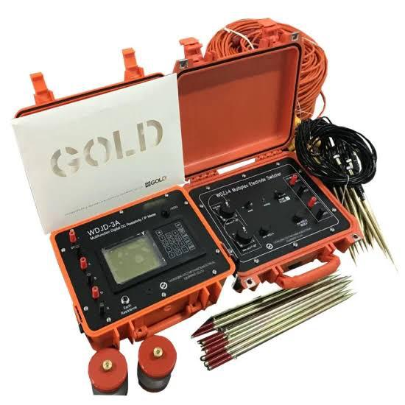
Fig. 3.3: Terrameter
3.3 DETERMINATION OF GEOTECHNICAL SUBSURFACE PROPERTIES OF SOIL USING GEOPHYSICAL APPROACH IN THE STUDY AREA.
3.3.1 Atterbery Limits
Apparatus used: Casagrande apparatus, weighing balance, 2 spatulas, oven, moisture cans, a mixing plate.
The atterbery limt are a basic measure of the critical water content of a fine grained soil, its shrinkage limit, plastic limit and liquid limit.
The atterbery limit can be defined as the liquid limit and plastic limit of a soil. These two limits are used internationally for soil identification, classification and strength correlation. When clay minerals as present in fined grained soil, the soil can be recorded in the presence of some moisture without crumbling. This cohesiveness caused by the absorbed water surrounding the clay particles.
Procedure
i. Little portion of the sample was mixed before adding more water into the laterite sample.
ii. The soil was rolled into the boll shape.
iii. The ball was cuts and we use our palm to rub it on a smooth surface until the water was removed and it formed to about 3mm diameter before it.
iv. The procedure was repeated for the other two samples.
v. the three tin can was measured separately with different samples in it.
vi. The weight of the tin was measured with each sample on it.
v. The weight of the new can was measured with sample in them.
Fig. 3.4 shows the picture of Oven, Casagrande apparatus and weighing balance Shear Stress
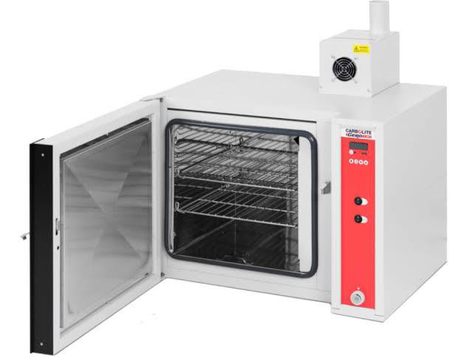
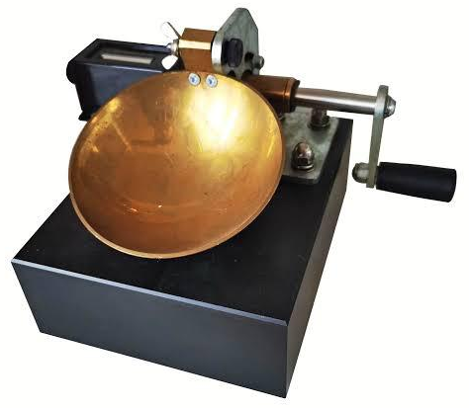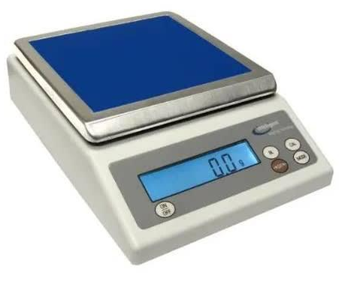
Fig. 3.4: The picture of Oven, Casagrande apparatus and weighing balance
Shear Stress
Shear stress is typically defined as a resistance in terms of effective internal fraction angle (Terzaghi et al., 1996).
Procedure.
i. The shear box was assembled
ii. The soil sample was field into the 60mm by 60mm box.
iii. The gear level was disengaged to the shear Machine and the soil sample was covered with the toothed perforated grid
iv. The box was covered and then loaded with frame and also 5kg of the slotted weight by balancing the bubble tube in the effective arm holding the weight.
v. The gear was then engaged and the machine is switch on.
vi. The Reading on the load guage were observed and taken down for every revolution of the displacement.
vii. The readings were taken with the load guage was observed to move backwards with further increase, the number of the revolution.
viii. The maximum reading on the load guages was observed and the gear level was disengaged.
ix. The machine was switch off and soil sample was unleaded sequentially the way it was loaded.
x. Soil was removed from the box and was replaced by a fresh sample. This was repeated for 10kg and 15kg of the slotted weight
Apparatus
- Direct shears balance
- Loading pad
- Loading frame.
- Loading Yoke
- proving ring capacity
- Dial guage accuracy 0.01mm, 2mm.
- Stratill or dynamic compaction devices.
- Spatulus.
Fig 3.5 shows the picture of the shear box and proving ring Sieve analysis
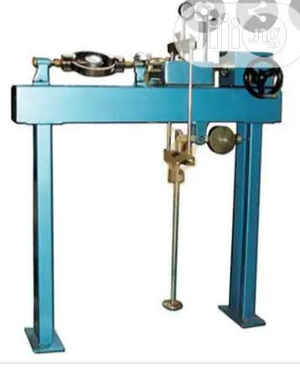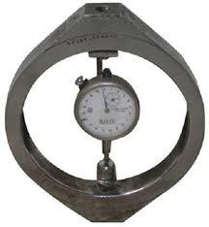
Fig 3.5: The picture of the shear box and proving ring Sieve analysis
Sieve analysis of a powder or granular material or particles dispersed in fluids a list of values or a mathematical function that defines the relative amount typically by mass of particles present according to size.
Apparatus
Sieve of different size
Sieve lid
Weighing balance
Sieve with pan
Sieve shocking machine.
Procedure
i. Each scene pan was clean with wash in case of any stick particles stock in between
ii. The weight of sieve pen was measured on the weighing balance
iii. The specimen was dried in the oven for 3-4 min to get the dried specimen
iv. The Specimen was weighed and recorded.
v. The sieve was arranged in order from the opening sieve to the last and larger opening sieve to the top.
vi. The recorded specimen was poured into the sieve as the smallest opening sieve to the last and larger opening sieve to the top.
vii. The shaker was a welled to with 5-10min and recorded the weight of each sieves and retrieving pen separately.
viii. The cumulative % was calculated for each sieve pen.
ix. The graph was plotted passing through the sieve size.

Fig. 3.6 shows the picture of sieve shaker, sieve pan and sieve lid
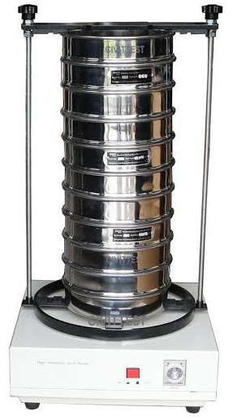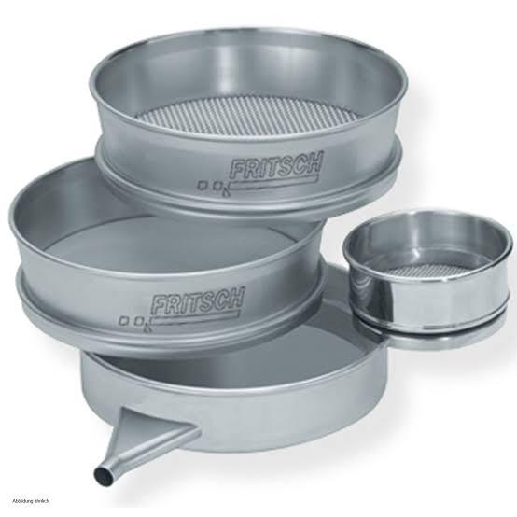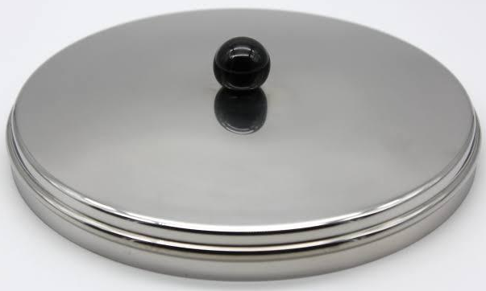
Fig. 3.6: The picture of sieve shaker, sieve pan and sieve lid
3.4 INVESTIGATING THE RELATIONSHIP BETWEEN THE PROPERTIES AND THE GEOPHYSICAL PROPERTIES OF THE STUDY AREA.
The relationship between geotechnical and geophysical properties of soil within the directing point area was analyzed by comparing geophysical reactivity data with laboratory geotechnical parameter.

CHAPTER FOUR

4.0 RESULT AND DISCUSSION
This chapter discusses the test conducted which includes: Atterberg limit, which comparies liquid limit, plastic limit, plasticity index sieve analysis and shear stress.

4.1 GEOTECHNICAL PROPERTIES OF SOIL IN STUDY AREA

4.1.1 ATTERBERG LIMIT
The table 4.1 shows plasticity characteristics of soil samples and collected
Table 4.1 Plasticity characteristics
Sample | Liqiud limit (%) | Plastic limit | Plastic index
Sample A | 27.5 | 15.1 | 12.1
Sample B | 22.0 | 10.3 | 11.7
Sample C | 25.0 | 12.9 | 12.1

The purpose of atterberg limit is to determine the percentage (%) of the classified soil, according to clay content. According to the classification of soil having liquid limit of less than 3.5% of equal 3.5% is classified as (CI) I.e low key. A soil having liquid limit above 3.5 and less than 50 or equal to 50% is classified (CL) i.e intermediate clay content, Also a soil with above 50% or 75% is classified as (CH) of high clay content soil having above 75% of liquid limit is classify has high clay content A soil having above 75% of liquid limit is classified as high clay content they are very difficult soil to work with because of their elasticity properties (Das, 2016).

4.1.2 SHEAR STREES
These tests simulate how soil will behave under shear laod
Table 4.2 shows shear stress of samples A
Table 4.2: Shear stress of sample A
Laod (kg) | Normal Stress  (KN/M²) | Load Dial  Reading | Shear Stress  (KN/M²)
5 | 188.0 | 232 | 112
10 | 324.3 | 646 | 311
15 | 460.5 | 961 | 463
20 | 596.8 | - | -

Shear stress of samples A
Fig 4.1 Shows the shear stress of sample A

Angel of friction = 31°

Normal stress (KN/$M^{2}$)
Fig 4.1: Shear Stress against normal stress (KN/$M^{2}$)
Table 4.2 shear stress of sample B
Table 4.2; Shows the shear stress sample B
Load (kg) | Normal Stress  (KN/M²) | Load Dial  Reading | Shear Stress  (KN/M²)
5 | 188.0 | 225 | 108
10 | 324.3 | 392 | 189
15 | 460.5 | 582 | 280
20 | 596.8 | - | -

Fig 4.2 shows normal stress of sample B

Angel of friction = 44°
Fig. 4.2: Normal Stress vs shear stress (KN/m²) of sample B

OOO

Table 4.3 shows the shear stress of sample C
Table 4.3; Shear stress of sample C

Laod (kg) | Normal Stress  (KN/M²) | Load Dial  Reading | Shear Stress  (KN/M²)
5 | 188.0 | 335 | 161
10 | 324.3 | 665 | 320
15 | 460.5 | 1007 | 485
20 | 596.8 | - | -

Fig 4.3 shows shear stress of sample C
Fig 4.3 shows the normal stress angle in fraction=34:
Fig. 4.3 shows normal stress vs shear stress of sample C
Angel of friction = 34°
Fig. 4.3: Normal Stress vs shear stress (KN/m²) of sample C

Soil can be classified based on their angle of internal fraction, it is one key parameters used to assess the shear strength of soil. This angle represents the resistance to sliding along internal surface within the soil mass. Soil are generally classified based on their internal fraction into different strength categories Angle of fraction between 10:- 20: is classified as very soft soil, angles of fraction 20:-35: is classified as medium stiff,above 35: is classified as hard soil. (Das 2016).

4.1.3 SIEVE ANALYSIS
Sieve analysis is used to determine the particular size distribution of soil.The result show soil particles are distributed across different sizes which helps in classifying soil fraction in sample A
The table 4.4 shows the percentage of the soil fraction in sample A
Table 4.4: Percentage of the soil fraction
Key | Sample | Depth (cm) | D10 | D30 | D60 | C4 | CC
 | A |  | 0.425 | 1.40 | 4.00 | 9.41 | 1.2
 | 63% | Gravel
 | 37% | Sand

Name: very sandy gravel soil
Classification: well graded gravel soil
Table 4.5 shows the percentage of the soil fraction in sample B
Table 4.5 Percentage fraction of sample B
Key | Sample | Depth (cm) | D10 | D30 | D60 | C4 | CC
 | B |  | 0.212 | 0.800 | 0.800 | 3.8 | 1.3
 | 11% | Gravel
 | 81% | Sand

Name: gravity sand soil
Classification: poorly graded sandy soil
Table 4.6 shows percentage of soil fraction in sample C
Table 4.6 Percentage fraction of sample C
Key | Sample | Depth (cm) | D10 | D30 | D60 | C4 | CC
 | C |  | 0.250 | 1.00 | 4.36 | 17.5 | 1.0
 | 55% | Gravel
 | 45% | Sand

Name: very sandy gravel
Classification: well graded gravel
According to the co-efficient of uniformity (CU) and co-efficient of curvature (CI).The (CU) for gravel must be greater than 4 while the must be between 1 and 3 for sandy the CU must be greater than 6 and the CU must also fall between land 3 for these parameter are use in engineering construction to classify and select suitable materials (Das, 2016).
The well-graded, sandy gravel soil provides good support and drainage, reducing the risk of foundation settlement and moisture movement which are common cause of wall-crack its suitable nature helps present uneven sinking of the building making cracks in wall less likely as long as the soil is properly compacted and foundation is well designed.

4.2 GEOPHYSICAL PROPERTIES OF SOIL IN STUDY AREA
This section shows raw resistivity valued collected on the field.
Fig 4.1; shows the raw resistivity of the first profile
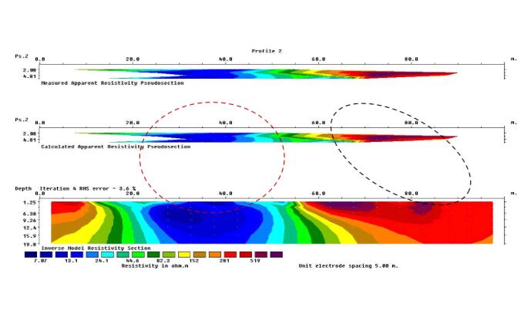
This data is acquired over 100 meter lateral spreading reaching the maximum depth of 2 meters. The survey has 10.1% error and the resistivity values ranges from 10.4 to 2061 ohms. There is an embedded of well compacted lateritic clay from 0m to 35m on the lateral extent and at 12meters denth, also from the top there are also a well dominant clay probably a loose sediment at the top from 70metets to 100 meters on the lateral extent and it trends downward to the depth of 19 meters (Aderemi ,2022).
Fig 4.2: The resistivity of the second profile
Fig 4.2; show the second profile
The data is acquired over 100 meter lateral spreading reaching the maximum depth of 2 meters. The survey has 3.6% error and the resistivity values ranges from 7.07 to 519 ohms. The area having the lowest resistivity value indicate the presence of clayey material or a loose clayey material which is seen at from 20m to 55m on the lateral spread and dipping to a19m depth, the high resistivity region might be a lateritic clay trending from 60m to 100m (Ajayi,2022).

Fig 4.3;show the third profile
This profile show has the RMS value of 4.4% and it spread from 0m to 100m with the maximum depth of 2 meters. The region is profile shows lateritic clay at 15m to 20m on the lateral spread with a depth of 12m, with a loose clay or clay particles surrounding it and it mostly dominated the profile (Aroyehun, 2018).
The blue colour signify clay or loose soil.
The green colour signify sand or fairly soil.
The red colour signify lateritic soil

Lithologies | Depth
Top Soil | 35,ohm-m
Clay | 10,ohm-m
Lateritic Clay | 201,ohm-m
Source: Telford,et,al 199; Keller and friscknecht, 1966, Olorun Femi and fawuyi, 1996.
The electricity resistivity imaging (ERI) data show variation in subsurface strength due to change in resistivity indicate weak, water logical or clay, soil which are more likely to cause foundation settlement and wall crack. High resistivity zone are stronger but may later create crack problem if they exist below weaker layers. Presence of mixed resistivity layers increases the risk of cracks due to uneven foundation behavior.(oyedele et al;2011)

4.3 RELATIONSHIP BETWEEN GEOTECHNICAL AND GEOPHYSICAL PROPERTIES OF SOIL IN THE STUDY AREA
The geotechnical and geophysical investigation revealed the clay content in the study area is high consequently the ground in the area is relatively unstable, which affect the load bearing capacity of the soil. The attribute the high conductivity of clay, which result in low resistivity (Sharma 1997; Telford et, al,1990).
Furthermore the results indicate that top soil layer is predominantly clayey, while the underlying layer consists of lateritic soil.
Furthermore the geophysical survey was conducted of a depth of 2 meters, which did not fully capture the lateral resistivity variations of the areaHowever the results indicated that the topsoil layer is predominantly clayey which the underlying layer consists of lateritic soil
Also the geotechnical shows that the angle of fraction of the area is classify stiff, nevertheless,the findings align with the geotechnical results; the upper soil layers is lateritic (Parasnis, 1997).

CHAPTER FIVE

5.0 CONCLUSION
This study investigate the subsurface characteristic of soil using both Geophysical and Geotechnical method within the selected area the integration of these method provided a comprehensive understanding of the soil profile and it's engineering properties.
The physical survey, specifically the electrical resistivity imaging (ERI)Revealed variation in the resistivity value which indicated different subsurface layers, these layers correspond to varying soil type such as laterite clay, Sandy soil, and possibly weathered rock. The interpretation of the resistivity data allowed for the identification of competent and weak zones within the subsurface.
The Geotechnical investigation which include laboratory tests such as the sieve analysis atterbery limits and shear stress provide critical information on the strength stability and bearing capacity of the soils.
Results showed that some layers had moderate to high bearing capacity suitable for construction, while others particularly those with high plasticity or moisture content, may require stabilization. Combining both methods proved to be higher effective in improving the reliability of subsurface Analysis. The geophysical survey gave a broad view of subsurface condition. while Geotechnical tests validated the physical and mechanical properties of the soul samples.
Combining both methods proved to be highly effective in improving the reliability or subsurface analysis. The geophysical survey gave a broad view of subsurface conditions while geotechnical tests validated the physical and mechanical properties of the soil sample

5.2 RECOMMENDATIONS
Base on the findings in the study area the recommendations are made up
1) Regular monitoring: sites with marginal or variable subsurface conditions should undergo routine monitoring especially during and after construction to ensure soil behavior remains stable over time
2) Foundation design: structural foundation in area with varying subsurface conditions should be designed based on specific soil properties of the study area to avoid settlement or failure
3) Soil improvement: area with weak or clayey soil exhibiting bearings capacity or high plasticity should be stabilized using Suitable techniques such as lime cement or other chemical additive before construction to activities.

REFERENCES
Ajayi, C. A. (2022). Geophysical foundation studies. P.22
Bishop, A. W., & Henkel. D. J. (1962). The measurement of soil properties in the triaxial test. Burland, J. B. (1990). On the compressibility and shear strength of natural clays. Geotechnique, 40(3), 329-378. Cited in Chapter 2, Section 2.1 (Compressibility Properties). P.3
Das, B. M. (2010). Principles of geotechnical engineering (7th ed.). Cengage Learning Note: Cited in Chapter 2, Section 2.1 (Strength Properties, Compressibility Properties) and Section 2.3 (Geotechnical Problems, Foundation Problems, Soil Liquefaction, Expansive Soil Problems).
Bowles, J. E. (1996), Foundation analysis and design Das, B. M. (2010). Principles of geotechnical engineering pp. 1, 3, 6
Das, B. M., & Sobhan, K. (2016). Principles of geotechnical engineering pp. 16, 20, 24
Holtz, R. D., & Kovacs, W. D. (1981). An introduction to geotechnical engineering. Prentice Hall Note: Cited in Chapter 2, Section 2.1 (Strength Properties) and Section 2:3 (Foundation Problems, Expansive Soil Problems).
Huang, Y. H. (2009). Pavement analysis and design (2nd ed.). Pearson. Note: Cited in Chapter 2, Section 2.3 (Landslide and Slope Stability Problems).
Jamiolkowski, M. (1985). New developments in field and laboratory testing of soils. Proceedings of the 11th International Conference on Soil Mechanics and Foundation Engineering. 1, 57-153.
Kearey, P. (2002). An introduction to geophysical exploration (3rd ed.). Blackwell Science. Note: Cited in Chapter 2, Section 2.2 (Seismic Method, Electrical Resistivity Tomography, Magnetic Methods).
Khan, I. A., & Huang, Y. H. (1995), Geotechnical engineering Principles and practices. Prentice Hall Note: Cited in Chapter 2, Section 2.1 (Permeability Properties).
Kramer, S. (1996), Geotechnical earthquake engineering. Prentice Hall. Note: Cited in Chapter 2, Section 2.3 (Landslide and Slope Stability Problems, Soil Liquefaction).
Lambe, T. W., & Whitman, R. V. (1979). Soil mechanics (2nd ed.). Wiley Note: Cited in Chapter 2, Section 2.1 (Strength Properties, Stiffness Properties, Compressibility Properties) and Section 2.3 (Foundation Problems, Landslide and Slope Stability Problems, Soil Liquefaction, Expansive Soil Problems).
Leroueil, S., & Vaughan, P. R. (1990). The general and congruent effects of structure in natural soils and Geotechnique weak rocks. Note: Cited in Chapter 2, Section 2.1 (Compressibility Properties). 40(3). 467-488.
Mitchell, J. K., & Soga, K. (2005), Fundamentals of soil behavior (3rd ed.). Wiley. Note: Cited in Chapter 2, Section 2.1 (Permeability Properties).
Reynolds, J. M. (2012). An introduction to applied and environmental geophysics (2nd ed.). Wiley-Blackwell. Note: Cited in Chapter 2, Section 2.2 (Seismic Method, Electrical Resistivity Tomography, Ground-Penetrating Radar, Magnetic Methods).
Sharma, P. V. (1997). Environmental and engineering geophysics. Cambridge University Press. Note: Cited in Chapter 2, Section 2.2 (Ground-Penetrating Radar).
Skempton, A. W. (1964). Long-term stability of clay slopes, Geotechnique, 14(2), 77-102. Note: Cited in Chapter 2, Section 2.1 (Strength Properties).
Keller, G. V., & Frischknecht, F. C. (1966). Electrical methods in geophysical prospecting. p. 23
Lambe, T. W., & Whitman, R. V. (1979). Soil mechanics. pp. 3.6
Olorunfemi, M. O., & Fawuyi, S. A. (1993). Aquifer types and the geoelectric/hydrogeologic characteristics of part of the central basement terrain of Nigeria (Niger State). Journal of African Earth Sciences, 16(3), 309-317. p. 23
Oyedele, A. A., Olorunfemi, M. O., & Ojo, J. S. (2011). Electrical resistivity investigation of subsurface conditions at a site in Akungba-Akoko, Southwestern Nigeria, for building foundation design. Journal of Emerging Trends in Engineering and Applied Sciences, 2(5), 841–846.
Parasnis, D. S. (1997). Principles of applied geophysics. p. 24
Sharma, P. V. (1997). Environmental and engineering geophysics. pp. 3, 5, 24
Telford, W. M., Geldart, L. P., & Sheriff, R. E. (1990). Applied geophysics. p. 23

