PHYTOCHEMICAL ANALYSIS AND ANTI BACTERIAL PROPERTIES OF GOURD BITTER [MOMORDICA CHARANTIA]

BY

IBRAHIM BARAKAT MOSUNMOLA
HND/23/SLT/FT/0179

DEPARTMENT OF SCIENCE AND LABORATORY TECHNOLOGY,
INSTITUTE OF APPLIED SCIENCE,
KWARA STATE POLYTECHNIC, ILORIN.

SUPERVISED BY
MR. YAHAYA GOGATA, MOHAMMED

JULY, 2025 SESSION

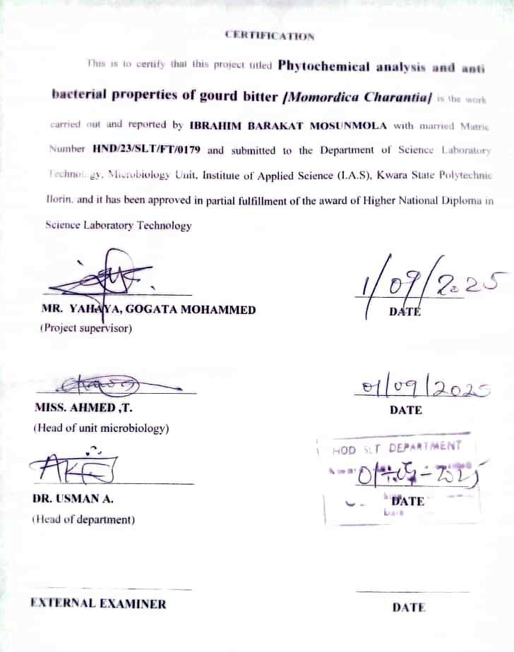

DEDICATION
To Almighty Allah, the sources of my strength and inspiration and also to my parents, whose unwavering support and encouragement have been my guiding light.
Thank you so much for believing in me

ACKNOWLEDGEMENT
"First and foremost, I give thanks to God for His blessings and guidance throughout this journey cause he's always good to me and without him I won't achieve anything in my academic session. I will be forever grateful to you.
I am immensely grateful to my parents for their unwavering love, support, and sacrifices for their money and time given to me, I pray to be able to pay you back abundantly. love you so much.
I would also like to express my heartfelt gratitude to my supervisor, Mr Yahaya Gogata for his support and guidance throughout this project your insightful feedback and encouragement have been invaluable in helping me achieve my goals. Thank you for been a remarkable supervisor.
My sincerely appreciation goes to Head of Department Dr.Usman.,Head of unit Miss.Ahmend T. and to all Microbiology unit lecturers from Dr.Olarongbe to the last lecturer thank so much for your teching, time,and guidance.
Lastly to my friends, thank you for your friendship, encouragement, and for always being there for me.

TABLE OF CONTENT
TITLE PAGE i
CERTIFICATION ii
DEDICATION iii
ACKNOWLEDGEMENT iv
TABLE OF CONTENT v
CHAPTER ONE: INTRODUCTION
1.1 BITTER GOURD: PLANT DESCRIPTION 1
1.2 NIGERIA HISTORY OF BITTER GOURD 2
1.3 BOTANICAL ANALYSIS 3
CHAPTER TWO: THE NUTRITIONAL ASPECT OF BITTER GOURD
2.1 NUTRITIONAL PROFILE 4
2.2 BIOACTIVE COMPOUNDS PRESENT IN BITTER GOURD 5
2.3 MEDICINAL IMPORTANT OF BITTER GOURD 5-15
CHAPTER THREE: METHODOLOGY OF GOURD BITTER
3.1 EXPERIMENTAL SITE 16
3.2 COLLECTION OF PLANT MATERIAL 16
3.3 PREPARATION OF LEAVE EXTRACTS 16
3.4 TEST FOR MICROOGANISM 16
3.5 INNOCULUM PREPARATION 17
3.6 PHYTOCHEMICAL ANALYSIS 17
3.7 PREPARATION OF EXTRACTS IMPREGNATED PAPER DISC 18
3.8 DETERMINATION OF ANTIBACTERIA ACTIVITY 19

CHAPTER FOUR: RESULT AND DISCUSSION
4.1 PHYSICAL APPEARANCE OF THE EXTRACT RECOVERED 20
4.2 PHYTOCHEMICAL SCREENING 20
4.3 DISCUSSION 21
4.4 CONCLUSION AND RECOMMENDATION 22
REFERENCE 23-24

CHAPTER ONE
INTRODUCTION
Bitter gourd (Momordica charantia L.) known also as bitter apple or bitter melon or balsam pear, is a tropical vine belonging to the order Cucurbitales, family Cucubitaceae and genus Momordica. The plant is cultivated as medicinal as well as vegetable crop widely in India, China and South East Asia (Behera et al. 2018). Even though whole plant is palatable in nature, bitter gourd is mainly grown for its fruit part. Fruits, flowers and young shoots are used as flavouring agents in various Asian dishes. Fruits are cooked with other vegetables especially in soups for the slight bitter taste. However, in Indian cuisines, fruits are mainly used after blanching or par boiling or soaking in salt water to reduce bitterness (Saeed et al. 2018). Fruits can also be canned or pickled or dehydrated in addition to cooking or deep frying. It is considered widely as a folk lore medicine against diabetes amongst the indigenous population of Asia, South America, India and East Africa (Joseph & Jini 2016). Apart from fruits, the roots, leaves and vines are used as a suppressant for tooth ache, diarrhoea and furuncle. Various products of bitter gourd like bitter gourd tea, which is known as gohyah or herbal tea made from dried slices of bitter gourd, is gaining popularity as herbal medicine (Jia et al. 2017). Researches have proved that bitter gourd contains an insulin like principle which is often being designated as plant insulin, which has positive effects in lowering the blood and urine glucose content (Janagal et al. 2018). It has also been shown to have anti-cholesterol (Saeed et al. 2018), anti-cancer (Bai et al. 2016), anti-dementia (Joshi et al. 2017), anti-bacterial & anti-fungal (Mahmood et al. 2019), antioxidant and anti-inflammatory (Bortolotti et al. 2019) activities. All part of the plants mainly the fruits and seeds, contain more than 60 phyto-medicines active against more than 30 diseases including cancer and diabetes (Kole et al. 2020). The present review covers nutritional aspects of bitter gourd plant, important nutraceutical properties attributed to the bitter gourd and various studies conducted to prove it.
1.1 BITTER GOURD: PLANT DESCRIPTION
In general, the plant is a monoecious slender, tendril climbing annual vine of almost 2 to 4 m high. The plant possesses characteristic leaves with serrate margins which typically giving a look like bites. Each plant has separate yellow coloured male and female flowers. Different varieties of bitter gourd have different shapes of fruits, being discoid or ovoid or ellipsoid to oblong and pointed towards the end (Kole et al. 2020). Usually fruits are 2 to 10 cm long. The exterior of the fruits are warty and the cross section is hollow with a thin layer of flesh. Flattened seeds and pith are seen in the central cavity which is surrounded by the thin flesh layer (Gupta et al. 2011). The immature fruits are whitish or pale green in colour whereas the mature ones can be seen in light green, green and dark green depending on the varieties and while ripening the colour turns to orange yellow. The fruit of bitter gourd takes 45 to 80 days to gets mature (Sorifa 2018). The seed of bitter gourd is 8 to 15 mm long which are straw coloured and they are covered with flesh: white in unripe fruits and red in ripened ones (Poolperm & Jiraungkoorskul 2017).
1.2 NIGERIA HISTORY OF BITTER GOURD
Bitter gourd also known as bitter melon, [MORMORDICA CHARANTIA] has a long history in Nigeria as a staple food, particularly in the south. It is believed to have originated in Africa and was likely domesticated in Asia, with evidence of it natural spread and cultivation across various regions including Nigeria.In Nigeria, it is known by various local names, depending on the region, the Yoruba’s call it ‘EJIRIN’ while the Hausa calls it’ GARAAFUNII’ and the Igbos calls it’ KAKAYI’.
1.3 BOTANICAL ANALYSIS
Around 47 mormordica species grow in Africa and another 12 species grows in Asia and australla [schefer and renner,2022]. Bitter gourd is a member of the family of curcurbitaceae.
It is herbaceous tropical and subtropical vine with the binomial nomenclature of mormordica charantia L. It is also vernacularly designated as bitter melon, bitter squash, balsam pear ,kerela ,bitter apple or wild cucumber in different countries and region . Bitter gourd is extensively cultivated in numerous Asian countries [especially china, india, japan, and Malaysia].
East Africa ,the carribean, the amazon,and some part of south American. It is also sown in the Yangtze part of River delta. For the fact that bitter gourd is monocious,both male and female flows are borne on the same plant. The oblong fruit which is named bitter gourd, matures 30-50 days after on set of the flowering as deoicted by changes in colour of the warty exterior from green to orange.
At the time the fruit has fully mature,the tender pericarp split into segment and curls back to expose the seeds. Bitter gourd has many varieties and cultivars,the fruit in the market are also seen in different shapes[cylindrical and lpump] and in different colours as well[e.g white, green, and dark grren].

CHAPTER TWO
THE NUTRITIONAL ASPECT OF BITTER GOURD
2.1 NUTRITIONAL PROFILE
Bitter gourd is an often discarded vegetable, due to its bitter taste despite the fact that it is a source of several key nutrients. It has a higher nutritional value than other cucurbits such as squash, pumpkin, cucumber and zucchini owing to its high mineral and vitamin content (Krawinkel & Keding 2016). The fruit is rich in vitamins namely vitamin A, vitamin E, thiamine, riboflavin, niacin, folate and vitamin C. Similarly, it also has high amount of potassium, iron, calcium, magnesium, phosphorous and zinc. It contains a good amount of dietary fibre. Detailed nutritional composition of bitter gourd fruit is given in Table 1.
The calorific value for leaf, fruit and seed were 213.26, 241.66 and 176.61 kcal / 100 g respectively (Joseph & Jini 2016). Vitamin C is one of the abundant compounds in the plant (Goo et al. 2016). It was pointed out that leaf contains an average of 205 mg/100 g DW and fruits contain an average of 2022 mg/100 g DW and also noted that the content was higher in young stage fruits. The seeds of bitter gourd also are a rich source of quality proteins and they meet amino acid requirements/standards laid down by FAO/WHO/UNU for preschool children. The detailed amino acid composition of bitter gourd fruit and seed protein is given in Table 2. The bitter gourd seeds contain 35 to 40% of oil with fatty acid profile containing monounsaturated fatty acids (3.33%), saturated fatty acids (36.71%) and poly unsaturated fatty acids (59.96%) (Saeed et al. 2018). Bitter gourd is one of the few edible fruit which contains conjugated α linolenic acid in its seeds. The presence of a long chain PUFA, α eleostearic acid has been reported in bitter gourd seed oil (Yoshime et al. 2016). They are one of the naturally best sources of chromium (5.65 mg / 100 g) and zinc (45.45 mg / 100 g) (Saeed et al. 2018).
2.2 BIOACTIVE COMPOUNDS PRESENT IN BITTER GOURD
The primary metabolites in bitter gourd are common sugars, proteins and chlorophyll while secondary metabolites are phenolics, carotenoids, curcubitane triterpenoids, alkaloids, saponins etc. Secondary metabolites are responsible for the nutraceuticals properties of bitter gourd which scarcely contribute to the nutritional value but produce beneficial physiological effects in the body (Daniel et al. 2014). Around 228 different compounds were identified from different parts of M. charantia (Nagarani et al. 2014) and the important compounds are given in Table 3.
Aqueous extract of bitter gourd contained carbohydrates, proteins, amino acids, sterols, flavonoids, phlobatannins, terpenoids, cardiac glycosides and saponins. Qualitative tests found out the presence of carbohydrates, proteins, amino acids, phenolics, saponins, sterols, alkaloids, cardiac glycosides, cholesterol and phlobatannins in the ethanolic extract of bitter gourd.
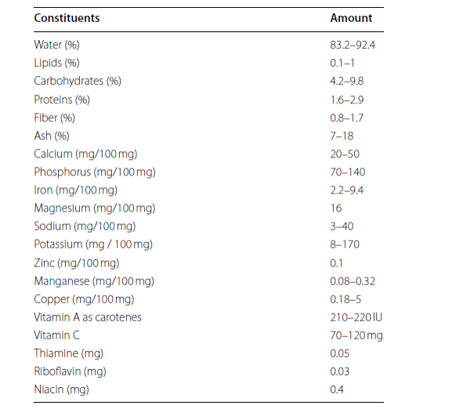
Table 1 Nutritional composition of bitter gourd (Adapted from Behera et al. 2018; Nagarani et al. 2016; Sorifa 2018; Saeed et al. 2018)

Table 2 Amino acid composition of bitter gourd mature fruit and seed (Adapted from Nagarani et al. 2016; Sorifa 2018)

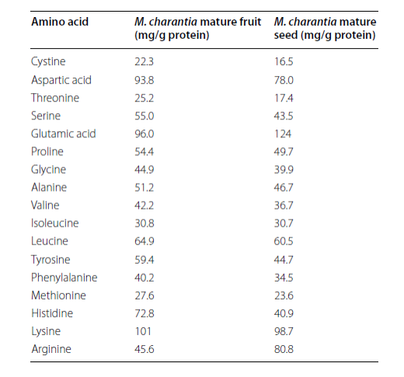

2.3 MEDICINAL IMPORTANT OF BITTERGOURD
Numerous researches have been conducted and proved the nutraceutical properties attributed to the bitter gourd. Some of the important properties, as shown in Fig. 1, are highlighted in the following section:
Anti‑ diabetic activity
Diabetes mellitus is a metabolic disease characterised by hyperglycaemia resulting from defects in insulin secretion, insulin action or both. M. charantia is a traditional remedy used since ages for management of diabetes in alternative and complementary medicine. Extensive research has been conducted to identify the compounds and the mechanism of anti-diabetic activity attributed to the bitter gourd is enlisted in Table 4.
Anticancer property
In last few decades, a number of preliminary trials have been conducted to reveal and establish the anti-cancer property of Momordica charantia. Studies suggest the role of bioactives in M.charantia in the regulation of cervical cancer, breast cancer, liver cancer, nasopharyngeal carcinoma, leukemia, colon cancer etc. Although several trials have been conducted in vitro and in vivo to explore the activity against carcinoma, systematic clinical trials are needed in cancer patients to establish the anti-cancer effects of M. charantia.
In vitro anticancer activity of ethanolic extract of M charantia whole fruit on cell lines representing breast and cervical carcinomas was established by Shobha et al. (2015). Cytotoxicity assay on HeLa (cervical cancer) and MCF 7 (breast cancer) cell lines showed 50% ethanolic extract is more potent based on IC50 value. The effect was directly attributed to the higher content of phenolic acids in the ethanolic extract. Güneş et al. (2019) also reported that the ethanolic whole fruit extract exhibited a higher anti-cancer activity. They investigated and compared the anti-carcinogenic effect of M. charantia fruits and seed extracts on human cancer cell lines which included lung cancer (A 549), breast cancer (MCF 7), chronic myeloid leukemia (K 562) and T cell leukemia (Jurkat cells). These were incubated with ethanol and acetone extracts of fruits and seeds of bitter gourd. Among the acetone and ethanolic seed and fruit extracts, ethanolic fruit extract showed the highest anti-tumour activity (90, 92, 85, and 87% against K562, A549, MCF 7 and Jukart cell lines respectively) and they suggested the ethanolic extract as a potential source for development of anti-cancer compounds.

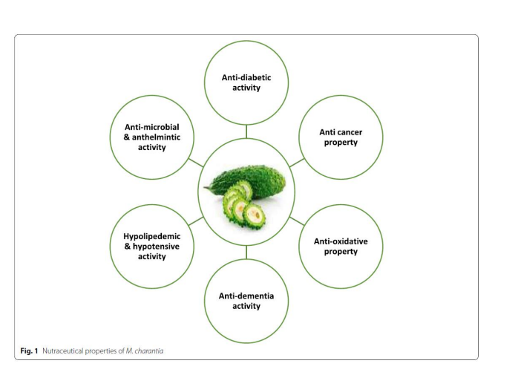

Fang et al. (2012) studied the activity of Momordica charantia lectin, a type of ribosome inactivating protein from bitter gourd on two nasopharyngeal carcinoma cell lines, NPC CNE 1 and CNE 2 using in vivo assay in nude mice. Lectin was purified from bitter gourd seeds. The protein showed potent cytotoxicity towards both the cell lines CNE 1 and CNE 2 at the half maximal inhibitory concentration (IC50) of 6.9 and 7.4 respectively. An intraperitoneal injection of lectin (1 mg/kg/d) led to an average remission of NPC xenograft tumours subcutaneously inoculated in mice. A similar study was also reported in which MAP 30 protein, isolated from bitter gourd seeds, promoted the apoptosis in liver cancer cells in vitro and in vivo. Inhibition in cell viability with an IC50 value of 28.6 μM for 24 hrs and 7.8 μM for 48 hrs was obtained in Hep G2 cells and the anti-tumour potential was also effective in Hep G2 bearing mice (Fang et al. 2019). Dia and Krishnan (2016) reported a novel anticancer peptide, BG-4 isolated from M. charantia seeds showed a trypsin inhibitory activity 8.6 times higher than soybean trypsin inhibitor, which can be a possible reason for BG-4 to cause cytotoxicity to human colon cancer cells HCT- 116 and HT-29 with median effective dose (ED50) values of 134.4 and 217 μg/ml respectively. The report was first to establish and anti-cancer potential of a novel bioactive peptide isolated from M charantia. However, in vivo models were not conducted to address the results. Similarly Bai et al. (2016) pointed out the potential of a triterpenoid from bitter gourd in inhibiting the growth of breast cancer cells by conducting an in vitro assay in MCF 7 and MDA MB- 231 breast cancer cell lines. The triterpenoid 3β, 7β, 25 -trihydroxycurcurbita 5,23 (E)- dien-19- al (TCD) was isolated from whole M. charantia plant. Suppression in proliferation of MCF-7 and MDAMB- 231 breast cancer cell lines with IC50 values at 72 h of 19 and 23 μMrespectively via a PPAR γ independent manner was established. Yung et al. (2016) suggested the use of crude bitter melon extract as a supplement to improve the efficacy of cisplastin based chemotherapy in ovarian cancer. Important studies showing anti-cancer activity of M.charantia are detailed in Table 5.
Anti‑oxidative property
Oxidative stress is the main cause for the development of various life style diseases including hypertension, diabetes, obesity etc. Researches are being conductedon the effect of M. charantia and specific compounds in it against oxidative stress, most of them showing bitter gourd has the potential antioxidant properties. Bitter gourd showed good anti-oxidant capacity in comparison with colocasia (Colocasia esculenta) (Gayathri 2016) and pumpkin (Curcubita pepo) (Hamissou et al. 2015). Various in vitro studies have been carried out to establish the antioxidative activity of M. charantia whole fruit pulp, extracts, seed powder, leaves and stem (Kubola & Siriamornpun 2018; Padmashree et al. 2016; Leelaprakash et al. 2015).
An in vivo study in mice fed with appropriate doses of bitter gourd polysaccharide showed that they would scavenge the peroxide free radicals produced in vivo, block the free radical chain reaction and play a certain role in anti-oxidation and anti-ageing processes. Superdioxide mutase is an important antioxidant defense in living cells by balancing the oxidation and anti-oxidation. Similarly, catalase protects cells from oxidative damage caused by hydroxyl anion. The level of malonidialdehyde reflects the severity of free radical attack. The in vivo measurement results showed that the high and medium doses (300 μg and 150 μg/g respectively) of bitter gourd polysaccharides had a significant increase in SOD and CAT activities in serum, liver and brain of mice and reduction in MDA in the same to an extent (Tsai et al. 2021). Chen and Huang (2019) assessed the effect of derivatization of bitter gourd polysaccharides, obtained by water extraction and ethanol precipitation and chemically modified by carboxymethylation and acetylation, on the anti-oxidant activities. The different chemical modification showed different enhancement on the antioxidant capacities of bitter gourd polysaccharide which was assessed by hydroxyl radical scavenging capacity and DPPH radical scavenging capacity and anti-lipid peroxidation capacity. Ekezie et al. (2016) synthesized zinc nanoparticles from ethanol extract of bitter gourd and evaluated in vitro anti-oxidant efficacy ofthe particles. The results of DPPH and superoxide scavenge assays indicated that the nanoparticles exhibit potent antioxidant activity. Similarly, a dose dependent scavenging activity was exhibited in the superoxide radical scavenging assay.
Aminah and Anna (2021) investigated the influence of ripening states on phenolics and the corresponding antioxidant potential of bitter melon fruits. No significant differences in the FRAP and DPPH value of bitter gourd on the ripening stages was reported. However, further clinical trials are required to prove the anti-oxidant activity of bitter gourd plant parts.3.4 Anti‑dementia activity
Neurodegenerative diseases are illnesses which affect the brain cells causing a miscommunication and there by leading to irreversible effects in movement, memory, speech and intelligence. These diseases are untreatable and are described by a degeneration of certain neurons in a progressive manner occurs due to certain metabolic or toxic stress (Valarmathi et al. 2020). Some examples for neurodegenerative diseases are dementias, Parkinson’s disease and PD related disorders, prion Disease, motor neuron diseases (MND), Huntington’s disease (HD), spinocerebellar ataxia (SCA) and spinal muscular atrophy (SMA). Dementia is the term used to depict a group of neurodegenerative disorders which affect the memory keeping power of the brain. Alzheimer’s disease, vascular dementia, Lewy body disease and frontotemporal dementia are some are the most common type of dementias. Various preclinical trials are being conducted to establish various neuroprotective effects particularly the anti -dementia activity of the compounds isolated from M. charantia.
Tamilanban (2018) isolated charantin from M. charantia and evaluated its neuropretective effect by in vitro studies performed in SH-SY5Y neuroblastoma cell lines. Charantin is a steroidal glycoside which exist as a mixture of sigmasterol gucoside and β sitosterol glucoside (Desai & Tatke 2015). The neuronal damage in cell lines was produced by MPP+ (1-methyl 4- phenylpyridinium) and tunicamycin, a bacterial toxin which causes endoplasmic reticulum stress which is common in Alzheimer’s and Parkinson’s diseases. The cell viability analysis and IC50 determination were performed by MTT assay and neuronal red uptake assay. The study revealed that charantin which was added at 8 hand 16 h after MPP+ treatment at a concentration of 1 mg/ ml showed a cell viability of 44 and 36% respectively. The positive effect was because of the possible free radical scavenging properties of charantin. Similar neuroprotective effect was found in tunicamycin induced neurotoxicity also. The percentage cell viability was found to be 35, 45 and 95% at 0.1, 0.5 and 1 mg/ml of charantin. The report was in accordance with another study conducted by Kuanhuta et al. (2016) in which charantin exhibited a high butyrylcholineesterase inhibitory activity. Gong et al. (2015) found out that M. charantia polysaccharide could protect against cerebral ischemia/reperfusion injury and the mechanism of protection could be at least in part attributed to the anti-oxidant activities proved by in vitro oxygen glucose deprivation (OGD) model. In another study, Ju and Kim (2018) also attributed the protective effect of M. charantia ethanol extract to the anti-oxidant and anti-apoptotic properties of bioactive compounds in the extract, against oxidative stress induced neuronal cell death. Oxidative stress was induced by hydrogen peroxide. M. charantia ethanol extract significantly reduced the H2O2 induced cell death in human neuroblastoma SK-N-MC cells.
In vivo studies establishing the effect of M. charantia are limited in regard to the memory impairment diseases. Miri et al. 2019 studied the effect of hydroalcoholic extract of M. charantia on the avoidance of memory alterations in mice using step-through model. The extract of the soaked plant was administered to the mice at doses of 10, 25, 50, 100 and 200 mg/kg by intragastric tube (gavage) method. A dosage of 25 mg/kg of extract indicated the ability to restore scopolamine induced memory corruption through step-through passive avoidance test. Pathakota et al. (2017) also demonstrated the anti-dementia activity of ethanol extract of bittergourd through inhibiting lipid peroxidation and decreasing acetylcholinesterase activity in brain in mice. Behavioural tests (rectangular maze test and Morris water test) were also conducted which showed a general decrease in the transfer latency in all ethanol extract treated groups compared to the control group in which the memory loss effect of scopolamine induction is prominent. A similar reverse amnesia effect in scopolamine induced rats was reported by Joshi et al. (2017) also, by providing a dose of 5 to 2000 mg per kg of bitter gourd paste. Huang et al. (2018) investigated the effect of combined treatment of M. charantia and lithium chloride, which also has some neuropretective effects against Alzheimer’s disease, in vitro and in vivo. They found out that combined treatment could be a potential strategy for the treatment of Alzheimer’s disease.
Hypolipidemic and hypotensive activity
Hyperlipidemia is a condition in which blood has abnormally high levels of lipids namely cholesterol and triglycerides mainly occur due to unhealthy food choices, chronic stress and obesity. It is considered as a potential risk factor for cardiovascular diseases. Researches are undergoing in exploring the role of bioactive ingredients from M. charantia fruit and its parts against this condition.
The possibility of using of M. charantia juice as a hypolipidemic agent was investigated by (Sharmin et al. 2017). Norwegian rats were fed with high fat diet and the hypolipidemic effect of M. charantia juice was compared to atorvastatin, a commonly used hypolipidemic drug. A reduction of serum total cholesterol, low density lipoprotein cholesterol and triglycerides was observed in bitter gourd juice fed group which was similar to those fed with the drug. Arshad et al. (2018) compared the hypolipidemic effect of ethanolic extract of over dried peel, flesh and seeds powder and concluded that bitter gourd seed is helpful in controlling the hyperlipidemia more than other bitter gourd components through rat model. Another such comparative study showed bitter gourd whole fruit powder had the highest hypolipidemic activity, when the bitter gourd skin, flesh and whole fruit powders were fed to rats. They also reported a slight increase in high density lipoprotein (Mahwish et al. 2018).
Studies are also reported specifically to establish the anti-hypertensive effect of M. charantia. Lestari and Mahayasih (2017) positively correlated the presence of phenolic compounds in bitter melon and increased anti-hypertensive activity. The study conducted was to examine the effect of bitter melon leaves extract and its fractions (n hexane, ethyl acetate and n butanol) against hypertension by checking the angiotensin converting enzyme inhibition activity using ACE kit – WST. They concluded that the ethyl acetate fraction from the 80% ethanolic extract of bitter melon leaves provided highest inhibition activity against Angiotensin Converting Enzyme with I50 value 4.29 μg/ml and the same fraction showed highest flavonoid and tannin content. The ethanolic and methanolic extracts of leaves inhibited the angiotensin 1 converting enzyme in vitro, higher activity being shown by methanolic extract. In another study of Tan and Gan (2016), a functional polysaccharide was isolated from lyophilised M. charantia fruits andantihypertensive activity was determined in vitro. The result showed that the isolated polysaccharide had a higher inhibitory activity (94.1%) in comparison to other polysaccharide sources such as almond, pistachio and chickpea (Joshi et al. 2017). Priyanto et al. (2015) identified two novel angiotensin 1 converting peptides, VY-7 and VG-8, from a thermolysin digest of bitter melon seed proteins and inhibitory activity was evaluated using ACE inhibitory assay. The study showed that the VY-7 showed the best IC50 value in vitro in a simulated gastro intestinal digestion and the inhibition type was competitive. Significant anti-hypertensive effect was also shown in vivo in which the average systolic blood pressure of spontaneously hyertensive rats reduced from 220 to 180 mmHg at 8 h after oral administration.
Anti‑microbial and anthelmintic activity
Bitter gourd is a folk lore medicine for various skin and stomach ailments owing to anti microbial activities and the potential of bitter gourd as an antimicrobial agent is proven (Braca et al. 2018; Saeed et al. 2018). The ethanol extract of leaves of M. charantia was found effective against proliferation of Eschericia coli, Staphylococcus aureus, Bacillus subtilis, Pseudomonas aeruginosa, Salmonella typhi, Klebsiella pneumonia (Leelaprakash et al. 2021; Ingle & Kapgatte 2018) and C. albicans (Jagessar et al. 2018). The inhibition activity observed was attributed to the presence of alkaloids, flavonoids, saponins, tannins, anthraquinones and terpenoids. Jagessar et al. (2018) observed that the antimicrobial activity was solvent dependent, in which ethanol extract being more potent than aqueous. Ingle and Kapgatte (2018) was also in accord with that. Mahmood et al. 2015 reported that the methanolic extract of ground bitter gourd fruit and seed pulp had antimicrobial activity against Staphylococcus aureus, Salmonella typhi, Pseudomonas aeruginoisa and Eschericia coli and against fungal strains Penicillium expansum and Aspergillus niger. Saengsai et al. (2015) isolated plumericin, an iridoid lactone from M charantia vine and proposed that its inhibition against Enterococcus faecalis and Bacillus subtilis was better than that of cloxacillin. In addition this, the extracts of leaf, fruit and seeds also reported to have anthelmintic activity against Ascaris suum, Ascaridia galli, Fasciola hepatica, Stellantchasmus falcatus, Strongyloides spp, Caenorhabditid elegans and Eisenia foetida in birds and mammals (Poolperm & Jiraungkoorskul 2017). Leaf extract of bitter gourd also reported to have activity against Aeromonas hydrophila, the most common bacteria that affect fresh water fish (Masithoh et al. 2019).
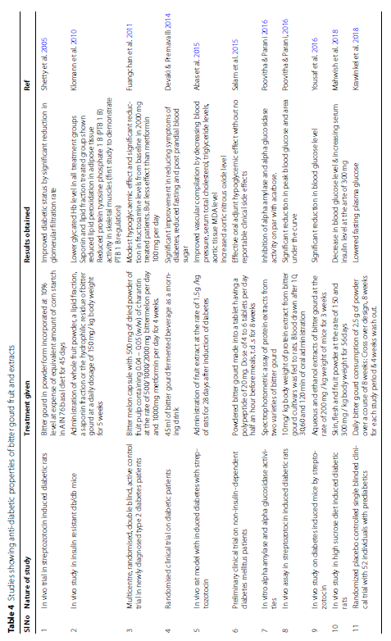
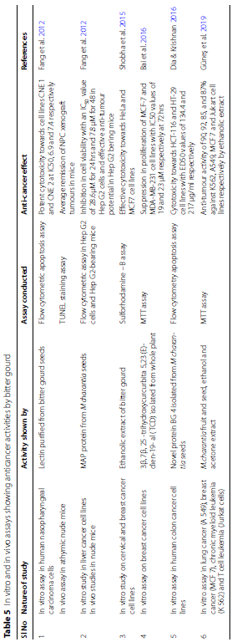

CHAPTER THREE
METHODOLOGY OF GOURD BITTER
3.1 EXPERIMENTAL SITE
The experimental was carried out in a Microbiology laboratory, Department of science laboratory technology, kwara state polytechnic.
3.2 COLLECTION OF PLANT MATERIAL
A fresh, high-quality with good germination of Momordica charantia leaves were collected for the extraction.the leaves were washed under running tap water to remove climate dust and any other foreign particles.the leaves were taken to a sterilized table and grinded in a mortal into a fine particles or powder.the powdered samples were sealed in a tote bag until the time of extraction.(Sutanto et al,2015).
3.3 PREPARATION OF LEAVE EXTRACTS
Three solvents were used in the preparation of leaf extracts(methanol, ethanol,and distilled water).three beaker were used and each contain 20g of the grinded plants material,60ml of each solvents were added.(The plant material was soaked in the beaker that contains 60ml of each solvent for 30min.tje soaked sample were transfer to the monster by spartular, using pistil to grand the sample to fine particles for each soaked sample,a funnel was used to transfer the granded sample into test tube and cotton wool was used to covered the test tube immediately to prevent air from entering).it was shaken thoroughly and left to soak for 5 days,during the period of 5 days it was shaken twice daily(morning and night). thereafter,it was filtered using whatman No1 filter paper.the solvents were placed in a water bath and leave to evaporate to make the final volume one-fifth of the original volume.it was stored in air tight bottle for further studies.(Jain and De et al,2016).
3.4 TEST FOR MICROORGANISMS
Three pathogenic bacteria (staphylococcus aureus, klebsiella pneumoniae,and salmonella typhi)were used during the present study and were obtained from microbiology laboratory of the department of science laboratory technology.,the culture were sub-cultured and obtained on nutrient agar slants and stored at 4°c(Tan et al,2015).
3.5 INNOCULUM PREPARATION
For standardizing the innoculum,the test organisms, were sub-culture on nutrient agar plate and incubated overnight, colony material from this overnight culture of the test organisms was taken with the aid of sterilized wire loop and transfered into a tube containing 5.0ml of normal saline until the turbidity was matched with 0.5(Tan et al,2015).
3.6 PHYTOCHEMICAL ANALYSIS
This test was done to find the presence of the active chemical such as alkaloids, flavonoids, glycosides,phenol, saponins, tannins,and terpenoid by the following processes(Sutanto et al,2015).
TEST FOR ALKALOIDS (Wagner's test)
Extract of the gourd bitter was evaporated to dryness and the residue was heated on a a boiling water both with 2% hydrochloric acid.after cooling the mixture was filtered and treated with a few drops of alkaloids reagent.the samples were then observed for the presence of the turbidity of yellow precipitation.(Kalal et al,2016).
TEST FOR FLAVONOIDS, (shinoda test)
4mg of extract solution was treated with 1.5ml of 50% methanol. the solution was warmed and metal magnesium was added and red color was observed for flavonoids orange color for flavonoids (Chakraborty et al,2020).
TEST FOR GLYCOSIDES
The extract solution in glacial acetic acid, few drops of ferric chloride and concentrated sulphur acid are added,and reddish brown colouration was observed at the junction of two laters and the blush green color in the upper layer(Patel et al,2019).

TEST FOR TERPENOIDS
4g of extract was treated with 0.5ml of acetic anhydride and 0.5ml of chloroform when concentrated solution of sulphuric acid was added slowly and red violet colour was observed(Zaini et al,2018).
TEST FOR SAPONINS(foam test)
2g of the powdered sample was boiled in 20ml of distilled water in a water bath of 10ml of the filterable was mixed with 5ml of distilled water shaken vigorously for a stable persistent broth.the following was mixed 3 drops of olive oil and shaken vigorously and then observed for the formation of the emulsion.(Le et al,2018).
TEST FOR PHENOLIC COMPOUNDS
4g of extracts was diluted in 5ml of distilled water and filtered to the filtrate 5% ferric chloride was added and observed for dark green color formation(Raj and Priya et al,2016).
TEST FOR REDUCING SUGAR
0.5ml of extract solution,1ml of water and 5-8 drops of Fehling's solution was added at hot and observed for brick red percipitate(Tan et al,2015).
3.7 PREPARATION OF EXTRACTS IMPREGNATED PAPER DISC
A paper puncher was used to punched out 100disc of 6mm diameter from whatman No1 filter paper,the disc were then sterilized by autoclaving at 121°c for 15min and then covered to cool.ten bijou bottles were used,four for the ethanol extracts another four for methanolic extracts the remaining two is for control both positive and negative,0.1g of extract was dissolved in 1ml of DSMO(dimethyl sulfoxide)which is equivalent to 100,000ug/ml to which 100disc were added and shaken to equilibrium so that each disc absorbed 0.001g equivalent to 1000ug/discs
0.5g of extracts was dissolved in 1ml of DMSO which is equivalent to 50,000ug/ml to which 100disc were added with the help of shaking at equilibrium each disc absorted 0.0005g equivalent to 500ug disc
0.5g of extracts was dissolved in 1ml of DSMO which is equivalent to 50.500ug/ml to which DMSO disc were added with the help of shaking at equilibrium each disc absorted 0.0005g equivalent to 5000ug disc
0.5g of extracts was dissolved in 1ml of DSMO which is equivalent to 12.500ug/ml to which 100disc were added with the help of shaking at equilibrium, each disc absorted 0.0012g which is equivalents to 125ug/ml these were stored and kept for further use
The positive control used was Ampiclox and it was dissolved with 1ml of DSMO after which 100 discs was added.the negative control was used 1ml of DSMO.((Tan et al,2015).
3.8 DETERMINATION OF ANTIBACTERIA ACTIVITY
The antibacterial activity of the leaf extracts was determined using agar disc diffusion method,the known procedure by Kirby.Bauer was adopted four nutrients agar plate was used for each bacteria innoculums. two for the ethanol extracts; one of it was divided into four parts each for different concentration of the extracts. the others were divided into two (one side for the positive control and the other for negative control).the same was done for the methanolic extracts.nutrients agar was incubated with the given microorganisms by spreading the bacteria inoculum on the media by the use of sterile swap stick. the extracts impregnated with disc containing different concentration of the gourd bitter extracts (100,000ug,50,000ug,22,000ug,and 12,500ug)was picked with sterile forceps, it was placed firmly on the surface of the inoculated.two control were used these are;the positive control disc of Ampiclox(500mg)and a negative control disc(with DMSO).both disc were then allowed for pre-diffusion time of 15 minutes and they were then inverted and incubated at 37°c for 24 hours and the diameter of the zone of inhibition formed was measured after incubation with the aid of meter rule to determine the effectiveness of the extracts on the test organisms.(Rezaei et al,2019).

CHAPTER FOUR
RESULT AND DISCUSSION
4.1 PHYSICAL APPEARANCE OF THE EXTRACT RECOVERED
Physical properties of the leaf extracts of momordica charantia
Extract | Weight of volume | Weight of colour
Texture
Sample used | Solvent used | Extracts recovered
Ethanot | 20g 200ml 4.59g | Darkbrown pungent
Methanolic | 20g 200ml 4.6g | Greenish pungent

The result showed the weight of plants sample used, the volume of the solvent, the volume of extracts recovered, the colour, odour and texture.
4.2 PHYTOCHEMICAL SCREENING
The result for phytochemical screening has shown in Table 2 shows that flavonoids and phenol are both present in ethanol and methanol extracts,alkaloids, saponnins,glycosides,and terpenoid are both absent in ethanol extract while tannins is absent in ethanol and present in methanol extracts.[Gong,j., et al,2015].
Extracts Phytochemical | Ethanol | Methanol
Alkaloids | - | -
Flavonoids | + | +
Glycosides | - | -
Phenol | + | +
Saponins | - | -
Tannis | - | -
Terpenoid | - | -

Antibacterial activity of methanolic extracts of Gourd Bitter Sensitivity test or methanolic extract against the organisms
Isolated | 1000 ug/dis | 500ug/dis | 250 ug/dis | Ampeol 5mg/dis | Dms  0
Staphylococcus | 21 | 09 | 12 | 32 | 00
Yaureu | 08 | 07 | 13 | 40 | 00
Websielda | 04 | 10 | 01 | 03 | 00
Pheumonic | 01 | 00 | 00 | 32 | 00
Sulmonemum | 03 | 07 | 04 | 32 | 00
Typhi | - | 01 | 03 | - | 00

Based on the experiment carried out on methanolic extracts of momoradica characteria against bacteria innoculum was observed that there was high in hibitory activity on staphylococcus aureus 21mm at concentration of 1000ug/disc, 9mm at 500ug/disc, 12mm at 250ugldisc. The positive control was 32mm and the negative control is o. the act extracts is higher than the positive control.
For yaureu it is low 8mm at the concentration of 1000ug/dis, 7mm at 500ug/dis and is highest 13mm at the concentration of 250ug/disc. The negative is O and the positive is 40mm, the positive is higher than the extracts.
There was low inhibitory activity on pneumonia 1mm at concentration of 1000ug/disc, O at 500ug/disc, O at 250ug/disc. The negative is O and the positive is 32mm.
For salmonella the lowest is at 1000ug/disc with 3mm, it was highest at 500ug/disc with 7mm and low at 250ug/disc with 4mm, the negative is O and the positive is 3mm. for typhi is O at 1000ug/disc, is lowest 1mm at 500ug/disc and highest at 250ug/dis with 3mm. the negative is O and the positive is also O.[Gupta,M., et al,2021].
4.3 DISCUSSION
The result of phytochemicals in the present investigation showed that the plant leaves contains components like tannins, saponins, phenol, alkaloids, glycosides, and flabournoids with terpenoid. The antibacterial activity of the methanolic extract or momordica charantia showed maximum zone of inhibition (21mm) against staphylococcus aureas, followed by salmonell typhi (3mm) and klebsiella pneumonia (4mm) at the above table shown that the exract is less effective against klebsiella and pneumonia. Staphylococcus, aureus and salmonella show the most sensitivity/active, with inhibition zones increasing as extract is less effective against klebsiella pneumonia and the control is more effective.
The presence of the phytochemical components may be responsible for the observed antimicrobial activity of the plane leaf extract. Alkaloid glycoside, and stercidal contribute to the phytochemical properties of memoridica charantial which strongly associated with hypogly cemic (blood sugar lowering) activity, cucurbitane-typetriterpenoids exhibit significant bioactivity, 5-hydroxytryptamine they are found in the plant and contribute to its physiological effects, carotenoid (Lutem and Lycopene) they are well documented in bitter gourd fruit extracts, lycopene is particularly linked to antibiotic and antitumor activities, highlighting the plant’s potential incancer chemoprevention. Also terpenoid and saponins contribute to the plant’s pharmacological effects and phenolics, flavonoids contribute to the plant’s as protection against oxidative stress[Saeed,F.et,al,2018].
4.4 CONCLUSION AND RECOMMENDATION
CONCLUSION
In conclusion, Bitter gourd (Momordica charantia) a widdy utilized medical plane, exhibit significant bioactive potential driven by its diverse phytochemical profile, bitter gourd is therapeutic pontential against bacterial pathogens is intrinsically tied to it phytochemical richness, particularly flavonoids, saponinss and phenolics while traditional extraction and qualitative methods provide foundational insights integrating quantitative assays with advanced analytical techniques is imperative for developing standardized herbal formulations.
RECOMMENDATION
- Further studies should be carried out on preplanning preparation.
- Cultivation practices, pest and disease management.
- Further studies should be carried out on advanced metabolite characterization
- Further studies should be carried out on extraction protocol optimization.

REFERENCE
Abas, R., Othman, F., & Thent, Z. C. (2015). Effect of Momordica charantia fruit extract on vascular complication in type 1 diabetic rats. EXCLI Journal, 14, 179.
Aminah, A., & Anna, P. K. (2021). Influence of ripening stages on physicochemical characteristics and antioxidant properties of bitter gourd (Momordica charantia). International Food Research Journal, 18(3), 865–900.
Bai, L. Y., Chiu, C. F., Chu, P. C., Lin, W. Y., Chiu, S. J., & Weng, J. R. (2016). A triterpenoid from wild bitter gourd inhibits breast cancer cells. Scientific Reports, 6(1), 22419. https://doi.org/10.1038/srep22419 Bortolotti, M., Mercatelli, D., & Polito, L. (2019). Momordica charantia, a nutraceutical approach for in related diseases. inflammatory Pharmacology, Frontiers 486. 10, https://doi.org/10.3389/fphar.2019.00486
Chen, F., & Huang, G. (2019). Extraction, derivatization and antioxidant activity of bitter gourd polysaccharide. International Journal of Biological Macromolecules, 141, 14–20.
Dia, V. P., & Krishnan, H. B. (2016). BG-4, a novel anticancer peptide from bitter gourd (Momordica charantia), promotes apoptosis in human colon cancer cells. Scientific Reports, 6(1), 33532.
https://doi.org/10.1038/srep33532
Fang, E. F., et al. (2016). Momordica charantia lectin, a type II ribosome inactivating protein, exhibits antitumor activity toward human nasopharyngeal carcinoma cells in vitro and in vivo. Cancer Prevention Research, 5(1), 109–121. https://doi.org/10.1158/1940-6207.CAPR-11-0203
Fuangchan, A., et al. (2021). Hypoglycemic effect of bitter melon compared with metformin in newly diagnosed type 2 diabetes patients. Journal of Ethnopharmacology, 134(2), 422–428.
Gong, J., et al. (2015). Momordica charantia polysaccharides protect against cerebral ischemia/reperfusion injury through inhibiting oxidative stress mediated c-Jun N-terminal kinase 3 pathway. Neuropharmacology, 91, 123–134.
Gupta, M., Sharma, S., Gautam, A. K., & Bhadauria, R. (2021). Momordica charantia Linn. (Karela): Nature’s silent healer. International Journal of Pharmaceutical Sciences Review and Research, 11(1), 32–37. Jia, S., Shen, M., Zhang, F., & Xie, J. (2017). Recent advances in Momordica charantia: Functional components and biological activities. International Journal of Molecular Sciences, 18(12), 2555.
Joseph, B., & Jini, D. (2016). Antidiabetic effects of Momordica charantia (bitter melon) and its medicinal potency. Asian Pacific Journal of Tropical Disease, 3(2), 93–102.
Klomann, S. D., Mueller, A. S., Pallauf, J., & Krawinkel, M. B. (2016). Antidiabetic effects of bitter gourd extracts in insulin-resistant db/db mice. British Journal of Nutrition, 104(11), 1613–1620.
Krawinkel, M. B., & Keding, G. B. (2016). Bitter gourd (Momordica charanto hyperglycemia. Nutrition Reviews, 64(7), 331–337. https://doi.org/10.1301/nr.2006.jul.331 Kuanhuta, W., et al. (2016). Novel cucurbitane triterpenoids and anti-cholinesterase activities of constituents from Momordica charantia. Natural Product Communications, 9(6), 765–769.Padmashree, A., Sharma, G. K., Semwal, A. D., & Bawa, A. S. (2021). Studies on the antioxygenic activity of bitter gourd and its fractions using various in vitro models. Journal of the Science of Food and Agriculture, 91(4), 776–782.
Poovitha, S., & Parani, M. (2016). In vitro and in vivo α-amylase and α-glucosidase inhibiting activities of protein extracts from two bitter gourd varieties. BMC Complementary and Alternative Medicine, 16(1), 1– 8.
Rezaei, S., Raftani, Z., & Mahdi, S. (2019). Nanoliposomal encapsulation of bitter gourd fruit extract as a rich source of health-promoting bioactive compounds. LWT - Food Science and Technology, 116, 108581.
https://doi.org/10.1016/j.lwt.2019.108581
Saeed, F., et al. (2018). Bitter melon (Momordica charantia): A natural healthy vegetable. International Journal of Food Properties, 21(1), 1270–1290. https://doi.org/10.1080/10942912.2018.1446023 Yung, M. M., et al. (2016). Bitter melon extract inhibits tumorigenicity and overcomes cisplatin-resistance in ovarian cancer cells through targeting AMPK signaling. Integrative Cancer Therapies, 15(3), 376–389.
https://doi.org/10.1177/1534735415611747

